**Data Loading using infomatica**

Download and install Secure Agent.

1. Open Administration and Select **Runtime Environment**.
2. On th Runtime environment page , click **Download Secure Agent**.

1. In the Download the Secure Agent dialog box, select the Windows 64-bit operating system platform and copy the install token.
2. 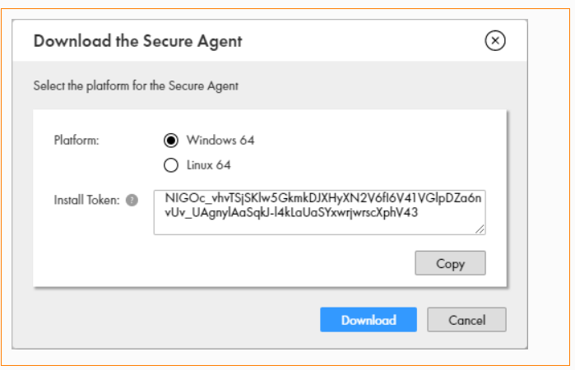
3. Click **Download**.
4. Run the insatllation program.
5. Specify the Secure Agent installation directory & click **Next** ,Install it.
6. Create a connection with **Type MYSQL.**

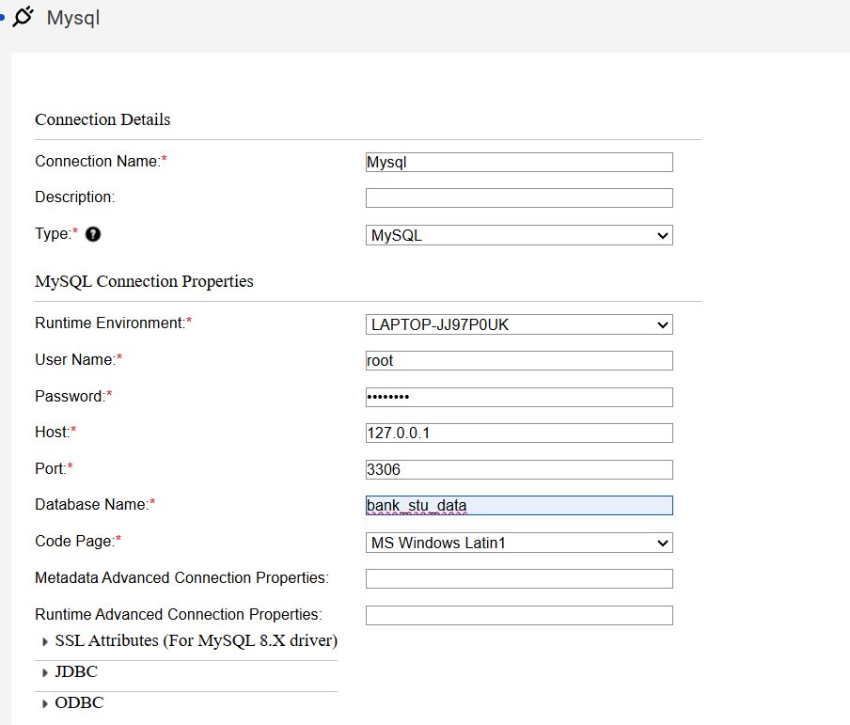

Provide User Name , Password , Host, Port and Database Name of MYSQL.

1. Now make a connection of type **Flat Files.**

1. Creation of Table in **MYSQL.**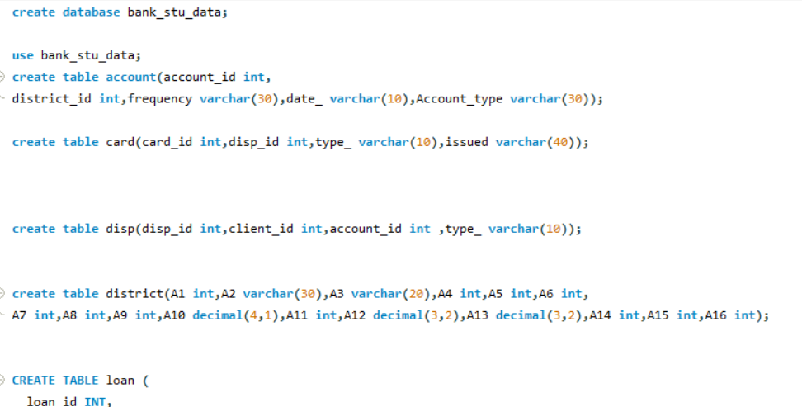
2. Now go to location on your local file and add a txt file in all the folder of data.A screenshot of a computer

   AI-generated content may be incorrect.
3. Add the csv file name to txt file.A screenshot of a computer

   AI-generated content may be incorrect.
4. Go to informatica cloud and open data integration to create a new mapping.A screenshot of a computer

   AI-generated content may be incorrect.
5. Add source and connection and flat file connection.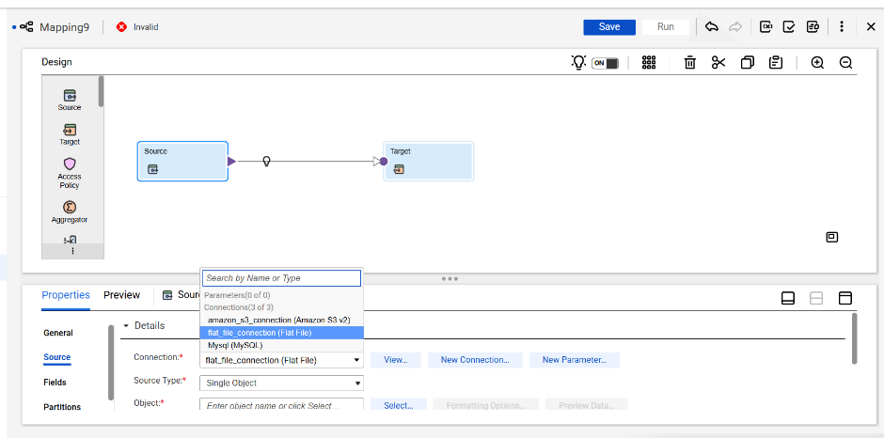
6. Similarly connect the target source to MYSQL connection.A screenshot of a computer

   AI-generated content may be incorrect.
7. Map the both table. A screenshot of a computer

   AI-generated content may be incorrect.