**Team ERD and Team Class Diagram**

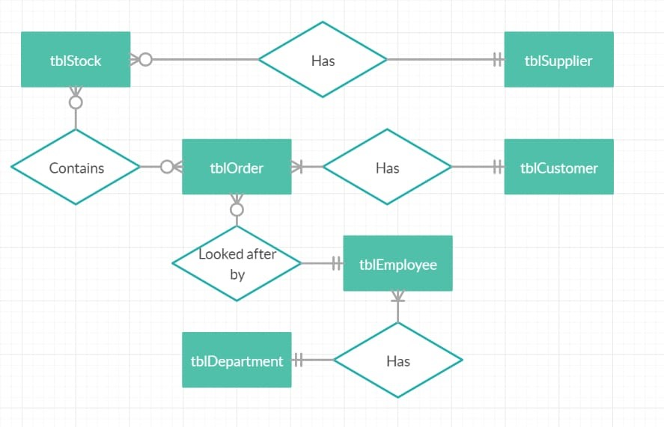

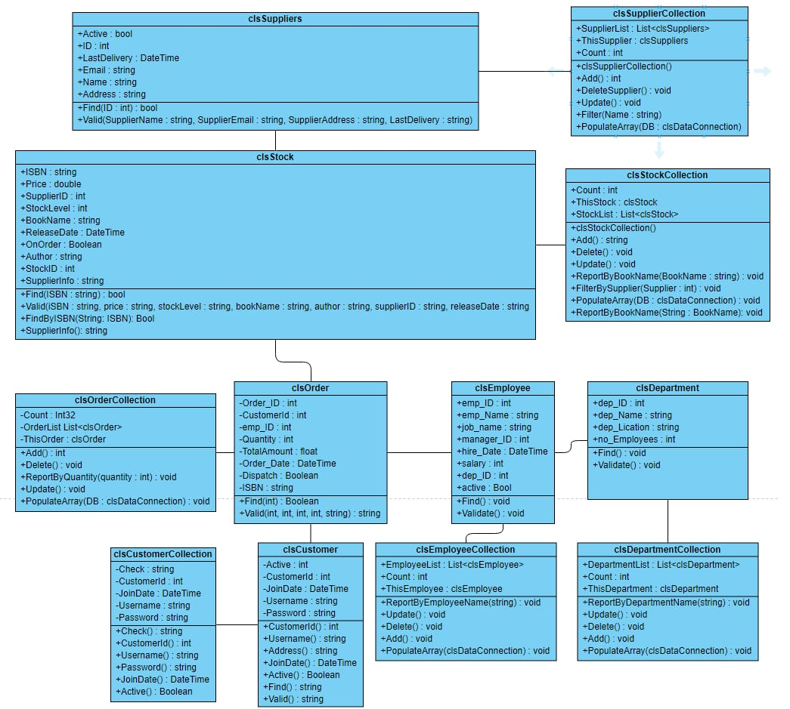

**Use Case Diagram**

Book Stock


**Book Stock**



**Order**

**Use Case Description**

|  |  |
| --- | --- |
| Use Case Name (Short two or three word name) | Edit Order |
| Use Case Description (Short description) | Staff can view order details |
| Use Case Author(s) (Who wrote this) | Monalisa |
| Actor(s) (Who does this) | Customer |
| Locations (Where does this happen) | Part of front end functionality |
| Primary pathway (What is the normal “happy path” for this use case?) | Editing order  User makes an order onto the system and the system accepts the order |
| Alternate pathways (What other paths are there that are not the “happy path”?) | User can add order in their basket |
| Exception pathways (What could possibly go wrong?) | Database connection fails  Error displayed to the user advising of connection problem |

|  |  |
| --- | --- |
| Use Case Name (Short two or three word name) | Delete Order |
| Use Case Description (Short description) | Users can delete order from their basket |
| Use Case Author(s) (Who wrote this) | Monalisa |
| Actor(s) (Who does this) | Customer |
| Locations (Where does this happen) | Part of front end functionality |
| Primary pathway (What is the normal “happy path” for this use case?) | Deleting order  Users can delete an order onto the system if they are not happy and the system accepts it and update with the stock |
| Alternate pathways (What other paths are there that are not the “happy path”?) | User has to cancel the order if they cannot remove or delete or which is dispatch |
| Exception pathways (What could possibly go wrong?) | Database connection fails  Error displayed to the user advising of connection problem |

|  |  |
| --- | --- |
| Use Case Name (Short two or three word name) | Update Order |
| Use Case Description (Short description) | Users can update order from the system |
| Use Case Author(s) (Who wrote this) | Monalisa |
| Actor(s) (Who does this) | Customer and employee |
| Locations (Where does this happen) | Front end and backend functionality |
| Primary pathway (What is the normal “happy path” for this use case?) | User can get update with the orders  Employees get figures of stock available and update on the system |
| Alternate pathways (What other paths are there that are not the “happy path”?) | Conflicts between updated numbers of orders and that can cause error in order quantity |
| Exception pathways (What could possibly go wrong?) | Database connection fails  Error displayed to the user advising of connection problem |

|  |  |
| --- | --- |
| Use Case Name (Short two or three word name) | List and filter order |
| Use Case Description (Short description) | Users views a list of staff in the system |
| Use Case Author(s) (Who wrote this) | Monalisa |
| Actor(s) (Who does this) | Customer |
| Locations (Where does this happen) | Frontend functionality |
| Primary pathway (What is the normal “happy path” for this use case?) | List orders  User enters the system  A list id displayed to the user at system start |
| Alternate pathways (What other paths are there that are not the “happy path”?) | There is no data in the system – a message is displayed saying so  User applies filter  A filtered list is displayed to the user  User clears filter  Full list is displayed to the user |
| Exception pathways (What could possibly go wrong?) | Database connection fails  Error displayed to the user advising of connection problem |