**Data Models**

Data models define how the logical structure of a database is modeled. Data models define how data is connected to each other and how they are processed and stored inside the system.

defines how data will be stored, accessed and updated in a database management system. While the **Relational Model** is the most widely used database model, there are other models too:

* Hierarchical Model
* Network Model
* Entity-relationship Model
* Relational Model

**1. Hierarchical Data Model :**  
Hierarchical [data model](https://www.geeksforgeeks.org/data-models-in-dbms/) is the oldest type of the data model. It was developed by IBM in 1968. It organizes data in the tree-like structure. Hierarchical model consists of the the following :

* It contains nodes which are connected by branches.
* The topmost node is called the root node.
* If there are multiple nodes appear at the top level, then these can be called as root segments.
* Each node has exactly one parent.
* One parent may have many child.

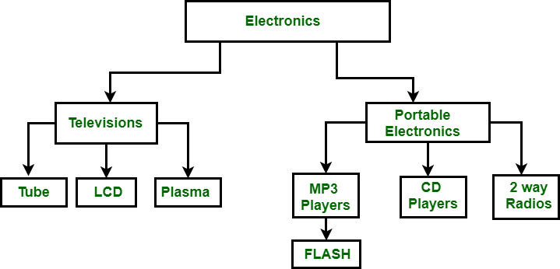

**Figure –** Hierarchical Data Model

In the above figure, Electronics is the root node which has two children i.e. Televisions and Portable Electronics. These two has further children for which they act as parent. For example: Television has children as Tube, LCD and Plasma, for these three Television act as parent. It follows one to many relationship.

**2. Network Data Model :**  
It is the advance version of the hierarchical data model. To organize data it uses directed graphs instead of the tree-structure. In this child can have more than one parent. It uses the concept of the two data structures i.e. Records and Sets.

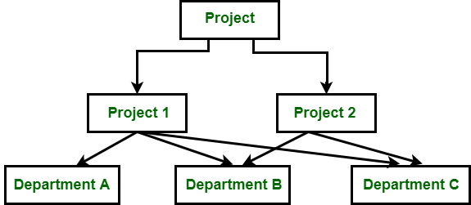

**Figure –** Network Data Model

In the above figure, Project is the root node which has two children i.e. Project 1 and Project 2. Project 1 has 3 children and Project 2 has 2 children. Total there are 5 children i.e Department A, Department B and Department C, they are network related children as we said that this model can have more than one parent. So, for the Department B and Department C have two parents i.e. Project 1 and Project 2.

**3. Relational Data Model :**  
The relational data model was developed by E.F. Codd in 1970. Their are no physical links as they are in the hierarchical data model. Following are the properties of the relational data model :

* Data is represented in the form of table only.
* It deals only with the data not with the physical structure.
* It provides information regarding metadata.
* At the intersection of row and column there will be only one value for the tuple.
* It provides a way to handle the queries with ease.

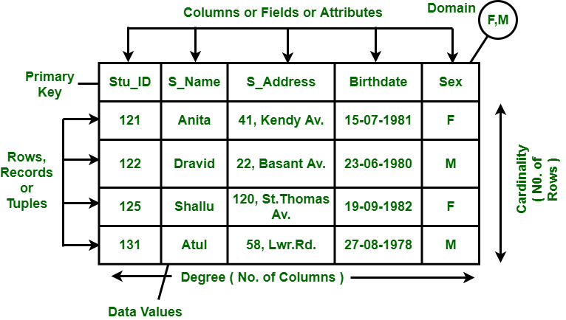

**Figure –** Relational Data Model

4. **Entity–relationship model (ER model)**

An **Entity–relationship model (ER model)** describes the structure of a database with the help of a diagram, which is known as **Entity Relationship Diagram (ER Diagram)**. An ER model is a design or blueprint of a database that can later be implemented as a database. The main components of E-R model are: entity set and relationship set.

* ER model stands for an Entity-Relationship model. It is a high-level data model. This model is used to define the data elements and relationship for a specified system.
* It develops a conceptual design for the database. It also develops a very simple and easy to design view of data.
* In ER modeling, the database structure is portrayed as a diagram called an entity-relationship diagram.

**For example,** Suppose we design a school database. In this database, the student will be an entity with attributes like address, name, id, age, etc. The address can be another entity with attributes like city, street name, pin code, etc and there will be a relationship between them.

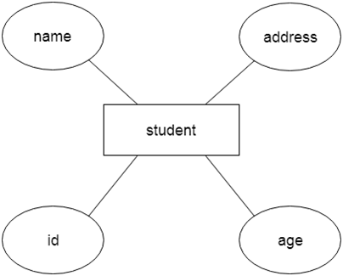

| **BASIS FOR COMPARISON** | **E-R MODEL** | **RELATIONAL MODEL** |
| --- | --- | --- |
| Basic | It represents the collection of objects called entities and relation between those entities. | It represents the collection of Tables and the relation between those tables. |
| Describe | Entity Relationship Model describe data as Entity set, Relationship set and Attribute. | Relational Model describes data in a table as Domain, Attributes, Tuples. |
| Relationship | E-R Model is easier to understand the relationship between entities. | Comparatively, it is less easy to derive a relation between tables in Relational Model. |
| Mapping | E-R Model describes Mapping Cardinalities. | Relational Model does not describe mapping cardinalities. |