CAPSTONE PROJECT REPORT
Ames Housing Data Analysis
Cleaning · Feature Engineering · Exploratory Data Analysis
2,930  Records  Home sales in Ames, Iowa | 82 → 78  Columns  After dropping sparse columns | 90  Engineered  Final features after Phase 2 | $179,957  Mean Price  Std dev: $76,062 (manual NumPy)

1. Introduction

This report documents a complete data analysis pipeline for the Ames Housing dataset — 2,930 home sales recorded in Ames, Iowa, with 82 original features covering lot size, neighbourhood zoning, construction quality, interior finishes, and final sale price. The pipeline was built across three phases in Python (pandas, NumPy, scikit-learn, matplotlib, seaborn) using Jupyter Notebooks.
Three core questions guided the project:
- What data quality issues exist in the raw dataset, and how should they be resolved?
- Which engineered features best capture the economic value of a property?
- What are the strongest predictors of sale price, and what patterns emerge?

2. Data Cleaning (01_cleaning.ipynb)

The raw dataset had 82 columns and 2,930 rows. After cleaning with the reusable clean_data() function, it was reduced to 78 columns — a clean, fully-imputed dataset with zero missing values. Four specific problems were resolved:
- Dropped Pool QC (2,917 missing), Misc Feature (2,824), Alley (2,732), and Fence (2,358) — all over 80 % empty.
- Filled remaining numerical gaps with the column median; categorical gaps with the mode.
- Checked for and removed duplicate rows; verified all SalePrice values > 0.
- Capped SalePrice at the 99th percentile to neutralise extreme outliers (Winsorization).

Post-Cleaning Checks (all passed)
- No null values remain in any column → df.isnull().any().any() = False
- All SalePrice values are greater than zero → True
- Column count after drops: 82 → 78 ✓

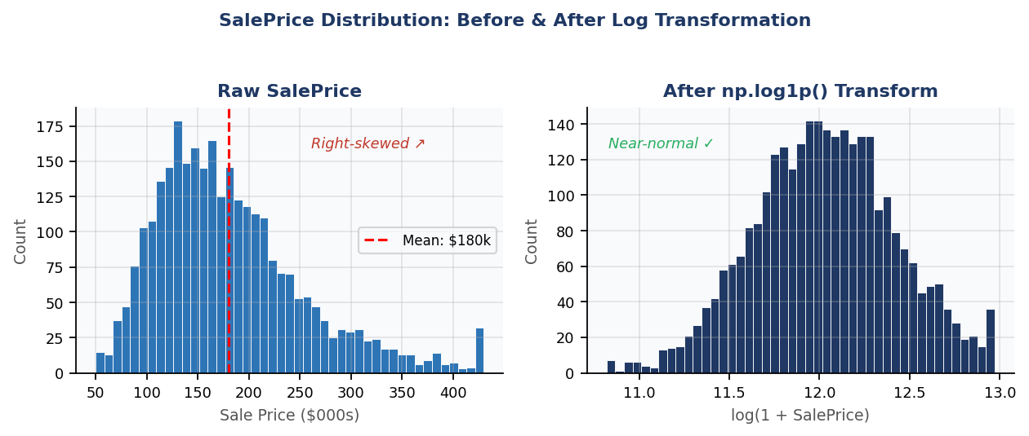
Figure 1 — SalePrice before & after np.log1p() transform. Real mean = $179,957, std = $76,062.

3. Feature Engineering (02_features.ipynb)

Phase 2 expanded the clean 78-column dataset to 90 engineered features, ready for analysis and modelling:
- One-Hot Encoding — MS Zoning and Sale Condition converted with pd.get_dummies(drop_first=True).
- Ordinal Encoding — Exter Qual mapped to integers: Ex=5, Gd=4, TA=3, Fa=2, Po=1.
- Ratio Feature — Price_per_SqFt = SalePrice ÷ Gr Liv Area — normalises value across property sizes.
- Interaction Feature — Qual_x_Area = Overall Qual × Gr Liv Area — captures the compound effect of luxury + space.
- Scaling — Gr Liv Area and Lot Area standardised with StandardScaler (zero mean, unit variance).
- Log Transform — SalePrice_Log = np.log1p(SalePrice) — produces near-normal distribution (Figure 1).
- Binning — Year Built split into: Old (≤1950), Recent (1951–2000), New (2001–2010).
- Redundancy removal — Dropped columns where Pearson r > 0.95 to reduce multicollinearity.

4. Key Findings (03_eda.ipynb)

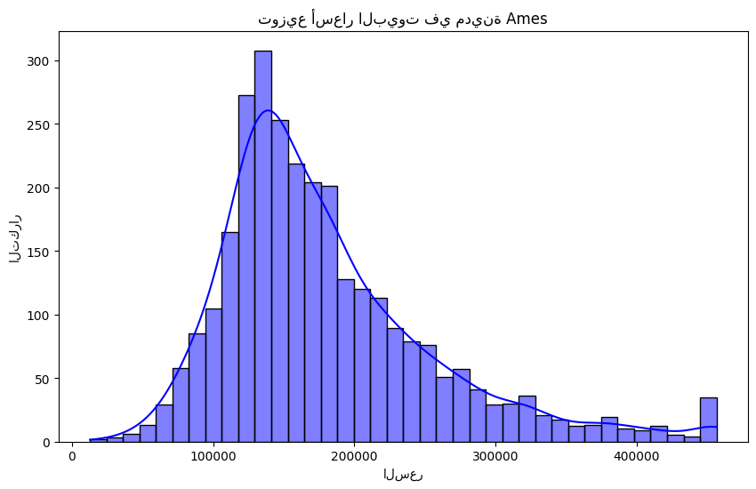  Figure 2 — SalePrice distribution. Most homes cluster in the mid-range; right tail present. | 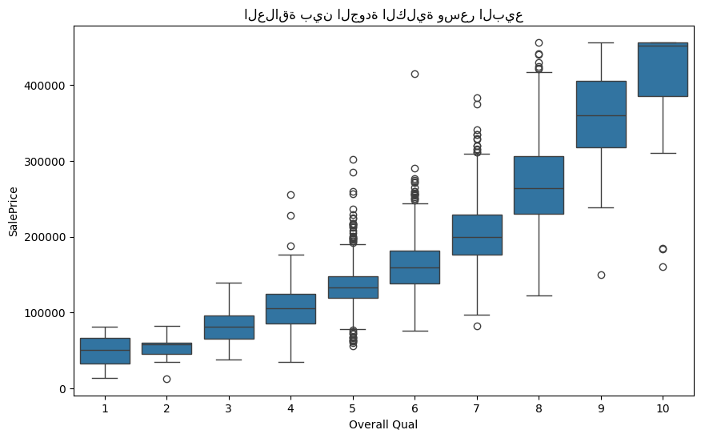  Figure 3 — Sale price by Overall Quality. Clear monotonic increase at every rating step.

Finding 1 — Quality is the #1 Predictor
The boxplot (Figure 3) shows a clear, monotonic relationship between Overall Quality and SalePrice — every step up the rating scale brings a significant jump in median price. This is confirmed by the heatmap (Figure 4) where Overall Qual and Qual_x_Area together dominate the top of the correlation ranking.

Finding 2 — Price is Concentrated in the Mid-Range
The histogram (Figure 2) shows that the majority of Ames home sales sit between roughly $100k–$250k, with a right tail of premium properties. The log-transform (Figure 1) normalises this distribution, making it suitable for linear modelling.

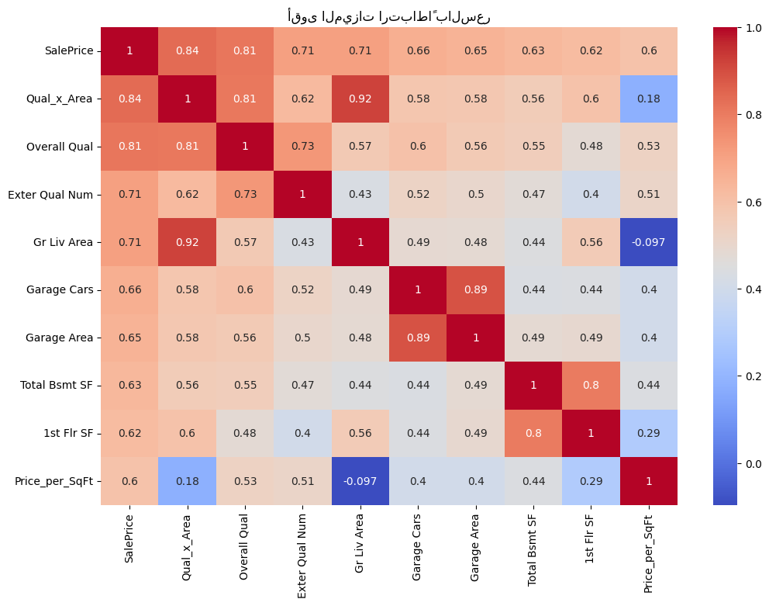
Figure 4 — Correlation heatmap of the top 10 features vs. SalePrice. Overall Qual, Qual_x_Area, and Gr Liv Area lead.

Finding 3 — Interaction Feature Adds Signal
Qual_x_Area — engineered in Phase 2 — appears near the top of the heatmap (Figure 4), confirming that combining quality and size captures variance that neither predictor explains alone. A large, low-quality home and a small, high-quality home may share a similar price; the interaction term distinguishes them.

Mathematical Verification (03_eda.ipynb)
- Mean SalePrice computed manually with NumPy: $179,956.70
- Standard deviation computed manually with NumPy: $76,061.61
- Both matched pandas .mean() and .std() exactly — confirming correct implementation.

5. Conclusion & Next Steps

The pipeline successfully cleaned and analysed the Ames Housing dataset, reducing it from 82 messy columns to a 90-feature engineered dataset backed by clear analytical evidence. Three factors consistently emerge as the primary drivers of sale price: overall construction quality, above-ground living area (especially combined with quality), and recency of construction.
Given more time, the natural next steps would be:
- Build a Linear Regression baseline to quantify each feature's marginal contribution to price.
- Apply a Random Forest or XGBoost model to capture non-linear interactions automatically.
- Use SHAP values to produce explainable, per-listing price predictions.
- Package the four best charts into a single Matplotlib dashboard for non-technical stakeholders.

