**1. Introduction**

**1.1 Background and Motivation**

The ability to recognize emotions from audio signals accurately has become increasingly important in domains such as human-computer interaction, mental health monitoring, customer service, and educational technologies. Emotions, such as neutral, calm, happy, sad, angry, fearful, disgusted, and surprised, play a pivotal role in human communication by providing essential context and depth beyond spoken words. Speech is a rich medium for emotional expression, conveying paralinguistic features such as tone, pitch, rhythm, and energy that are critical for understanding emotional states.

Recent advancements in deep learning have significantly transformed the field of Speech Emotion Recognition (SER). Traditional methods relied on handcrafted features and machine learning algorithms, which struggled to capture the complex nuances of emotional expression [1][2]. Modern architectures such as Convolutional Neural Networks (CNNs) and Long Short-Term Memory (LSTM) networks have enhanced emotion recognition tasks by extracting both spatial and temporal features effectively [3][4]. Hybrid CNN-LSTM models, in particular, have demonstrated remarkable success in handling spatial-temporal patterns [5].

Transformer models, with their self-attention mechanisms, have recently emerged as an alternative, excelling in capturing long-range dependencies and dynamically weighing input features without the sequential limitations of LSTMs [6][7]. These models have shown promise in various speech-related tasks, offering robustness and scalability. Despite the individual success of these architectures, their comparative performance in SER tasks is underexplored, particularly when different preprocessing techniques are applied [8][9].

Preprocessing plays a critical role in SER. Two common approaches are **parallel feature extraction**, which flattens data for independent analysis, and **sequential feature extraction**, which retains time-series information for temporal analysis. While parallel preprocessing simplifies computations, it risks losing temporal dependencies; sequential preprocessing preserves these dependencies but increases computational costs. Understanding the impact of these methods on model performance is crucial for optimizing SER systems [10].

**1.2 Problem Statement**

Speech signals possess a dual nature:

* **Spatial features**, such as frequency distributions, capture local characteristics.
* **Temporal features**, like sequential variations, represent dynamic changes over time.

Many existing SER models focus on one of these aspects, resulting in suboptimal performance. Flattened features are computationally efficient but may lose crucial temporal context, while sequential features preserve temporal dynamics but impose higher computational demands. Additionally, SER systems must generalize across diverse speakers, languages, and acoustic environments, which adds further complexity to feature extraction and model design [3][5].

While hybrid CNN-LSTM models can address both spatial and temporal aspects, their sequential nature can hinder scalability. Transformers, leveraging self-attention mechanisms, overcome this limitation but require optimization for high-dimensional speech data. Comparative studies that evaluate these architectures under different preprocessing pipelines are needed to identify their respective strengths and weaknesses in SER tasks.

**1.3 Objectives**

This research aims to:

1. Compare the impact of **parallel feature extraction** (flattened representations) and **sequential feature extraction** (time-series representations) on emotion classification performance.
2. Develop and evaluate two advanced models:
   * **Enhanced Transformer Model**, utilizing attention mechanisms for global feature extraction.
   * **HybridConvLSTMModel**, combining convolutional and recurrent layers for local and temporal feature learning.
3. Provide insights into the optimal preprocessing strategy for each model architecture.

**1.4 Scope of the Project**

The study is conducted using the **RAVDESS (Ryerson Audio-Visual Database of Emotional Speech and Song)** dataset, which contains high-quality emotional speech samples labelled across eight categories [10]. The scope of this research is limited to:

1. Implementing and evaluating two preprocessing pipelines: parallel and sequential.
2. Comparing the performance of Transformer and CNN-LSTM-based models on the pre-processed data.
3. Excluding other modalities (e.g., visual or textual data), focusing solely on speech-based emotion recognition.

This research contributes to advancing SER technologies by exploring the interplay between preprocessing strategies and model architectures, paving the way for more efficient and accurate emotion recognition systems.

**2. Literature Review**

**2.1 Related Work**

The table below summarizes key related works that serve as the foundation for this research. These studies highlight the methodologies, models, and results achieved in the domain of Speech Emotion Recognition (SER), with a focus on preprocessing techniques and hybrid architectures.

|  |  |  |  |  |
| --- | --- | --- | --- | --- |
| Title | Author | Model | Key Findings | Results |
| CNN-Based Models for Emotion and Sentiment Analysis Using Speech Data | Anjum Madan and Devender Kumar | CNN for emotion and CNN-BiLSTM for sentiment | Presented emotion and sentiment analysis models using speech signals; detailed feature extraction and hybrid model efficiency | Achieved 95.12% accuracy for emotion analysis and 84.49% for sentiment analysis |
| A Hybrid Deep BiLSTM-CNN for Hate Speech Detection in Multi-social media | Ashwini Kumar et al. | BiLSTM-CNN hybrid model with GloVe embeddings | BiLSTM-CNN hybrid architecture improves accuracy for multi-social media hate speech detection; utilized embeddings and regularization techniques | State-of-the-art performance on hate speech datasets with high precision and recall |
| EmoInHindi: A Multi-label Emotion and Intensity Annotated Dataset in Hindi for Emotion Recognition in Dialogues | Gopendra Vikram Singh et al. | Contextual baselines for multi-label emotion detection | Proposed a Hindi dataset for multi-label emotion recognition in dialogues; highlighted the role of context in detecting emotion intensity | Contextual baselines demonstrated effective multi-label emotion detection in dialogues |
| Cross-Modal Audio-Text Retrieval via Sequential Feature Augmentation | Song et al. | Sequential Feature Augmentation Framework | Introduced reinforcement learning and feature fusion to enhance sequential features for cross-modal retrieval | Outperformed state-of-the-art with 13.4% (text-to-audio) and 28.1% (audio-to-text) improvement in R@1 on AudioCaps dataset |
| Hybrid Data Augmentation and Deep Attention-Based Dilated CNN-RNN for SER | Pham et al. | Attention-based dilated CNN-RNN | Proposed hybrid data augmentation combining GANs and traditional methods, and dilated CNN-RNN with attention for SER tasks | Achieved 88.03% unweighted recall on EmoDB dataset |
| Big Data Preprocessing Methods | García et al. | Various preprocessing frameworks | Discusses preprocessing techniques like feature selection, dimensionality reduction, and noise filtering in big data contexts | Insights for robust feature preprocessing applicable in SER datasets |
| Hybrid CNN-LSTM for Sentiment Analysis | Jain et al. | CNN-LSTM | Developed a hybrid CNN-LSTM model for consumer sentiment analysis with word embeddings and dropout regularization | Achieved 91.3% accuracy on Airline and Twitter sentiment datasets |
| Dual-TBNet for Speech Emotion Recognition | Liu et al. | Dual Transformer-BiLSTM | Fuses pre-trained and acoustic features via dual Transformer-BiLSTM to improve robustness and accuracy | Achieved 84.1% accuracy on Emo-DB and 95.7% on CASIA |
| Hybrid LSTM-Transformer for Emotion Recognition | Andayani et al. | LSTM-Transformer hybrid model | Combines LSTM and Transformer for long-term dependencies in SER, using MFCC features. Improved over standalone architectures on temporal data | Achieved 85.55% accuracy on Emo-DB, 75.62% on RAVDESS |

**2.2 Gaps in Existing Research**

Despite significant advancements in Speech Emotion Recognition (SER), several research gaps remain unaddressed:

1. **Comparative Analysis of Preprocessing Techniques:**
   * Most existing studies focus on a single preprocessing approach, often neglecting a comparative analysis of **parallel feature extraction** (flattened representations) and **sequential feature extraction** (time-series representations). Understanding the advantages and limitations of each is crucial for designing efficient SER systems.
2. **Limited Evaluation of Advanced Architectures:**
   * Hybrid CNN-LSTM models and Transformer-based architectures are individually explored in SER. However, systematic comparisons of their performances under different preprocessing pipelines are sparse.
3. **Temporal Dependencies and Feature Fusion:**
   * While attention mechanisms in Transformers and LSTMs are designed to capture temporal dependencies, studies rarely evaluate how preprocessing influences these capabilities. Feature fusion approaches are also underexplored in SER.

**2.3 Relevance to the Proposed Work**

This research aims to address the identified gaps by:

1. **Systematic Evaluation of Preprocessing Pipelines:**
   * Conducting a detailed comparison of **parallel** and **sequential** preprocessing methods to analyze their impact on emotion classification accuracy and model performance.
2. **Comparison of Advanced Architectures:**
   * Developing and evaluating two advanced models—**Enhanced Transformer Model** and **HybridConvLSTMModel**—to identify the strengths and weaknesses of each architecture in handling spatial and temporal features.
3. **Leveraging the RAVDESS Dataset:**
   * Utilizing the RAVDESS dataset ensures high-quality emotional speech samples, enabling reliable evaluation of preprocessing methods and model performance.
4. **Providing Practical Insights:**
   * By analysing preprocessing methods and architectural performance, this study contributes to the development of scalable, accurate, and efficient SER systems that can be deployed in real-world applications such as virtual assistants, mental health monitoring, and customer service.

**3. System Design**

**3.1 System Architecture**

The system architecture consists of three main stages: **data preprocessing**, **model training**, and **evaluation**. The architecture is designed to handle both **parallel** and **sequential preprocessing pipelines**, enabling a fair comparison of the two methods across Transformer and ConvLSTM models.

**3.2 Hardware and Software Requirements**

1. **Hardware Requirements**:
   * **Processor**: Minimum 8-core CPU (e.g., Intel i7 or AMD Ryzen 7).
   * **GPU**: NVIDIA GPU with CUDA support (e.g., NVIDIA RTX 3060 or higher).
   * **Memory**: At least 16GB RAM for smooth execution.
   * **Storage**: 50GB free disk space for datasets, models, and logs.
2. **Software Requirements**:
   * **Programming Language**: Python (3.8 or higher).
   * **Libraries**:
     + TensorFlow/Keras for model development.
     + Librosa for audio preprocessing and feature extraction.
     + Matplotlib and Seaborn for visualization.
     + Scikit-learn for data preprocessing and metrics.
   * **Tools**:
     + Jupyter Notebook for experimentation and prototyping.
     + CUDA/cuDNN for GPU acceleration.

**4. Methodology**

**4.1 Data Collection and Preparation**

The research utilizes the **RAVDESS (Ryerson Audio-Visual Database of Emotional Speech and Song)** dataset, a widely recognized benchmark in Speech Emotion Recognition (SER). The dataset comprises **1,440 emotional audio files**, featuring speech in 8 emotional categories: **neutral, calm, happy, sad, angry, fearful, disgusted, and surprised**. Each audio file is labelled with emotion, intensity (normal or strong), and gender (male or female).

**Preprocessing Techniques**

To analyze the impact of preprocessing on model performance, two distinct methods were applied:

1. **Parallel Feature Extraction**:
   * Features were **flattened** into a single vector, emphasizing statistical information (e.g., MFCCs, chroma, mel spectrogram).
   * This approach disregards temporal dependencies but simplifies computations, making it suitable for architectures like CNNs.
   * **Feature Augmentation**:
     + Noise addition.
     + Pitch shifting.
     + Time stretching.
2. **Sequential Feature Extraction**:
   * Features were extracted and **stacked sequentially** to retain time-series dependencies, capturing dynamic variations over time.
   * This approach preserves temporal patterns, making it suitable for models like LSTMs and Transformers.
   * **Feature Types**:
     + MFCCs (Mel-Frequency Cepstral Coefficients).
     + Chroma features.
     + Mel spectrogram.

Both preprocessing pipelines were scaled using StandardScaler and split into training (80%) and testing (20%) datasets, ensuring balanced emotion representation.

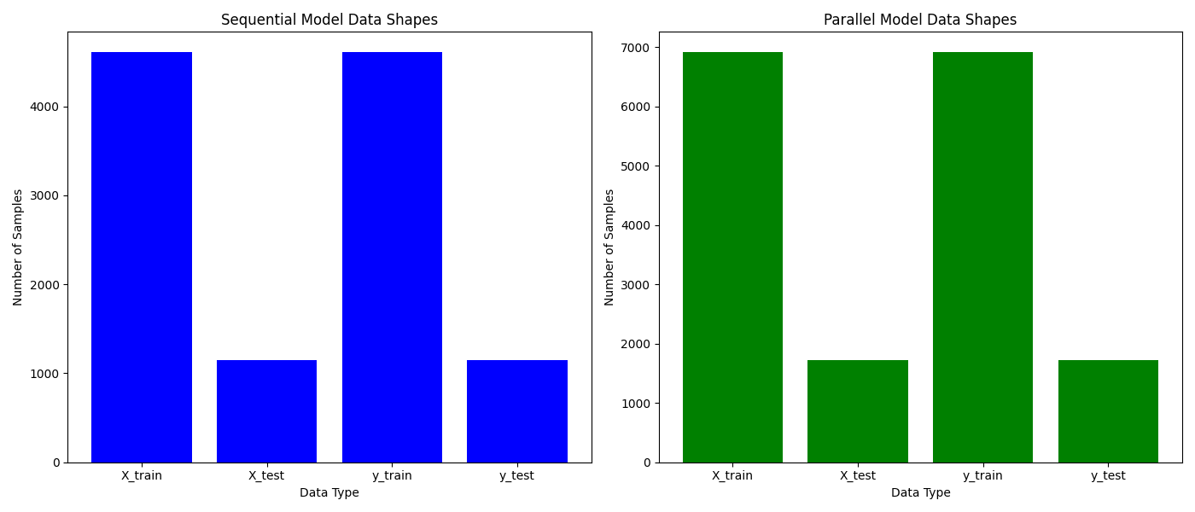

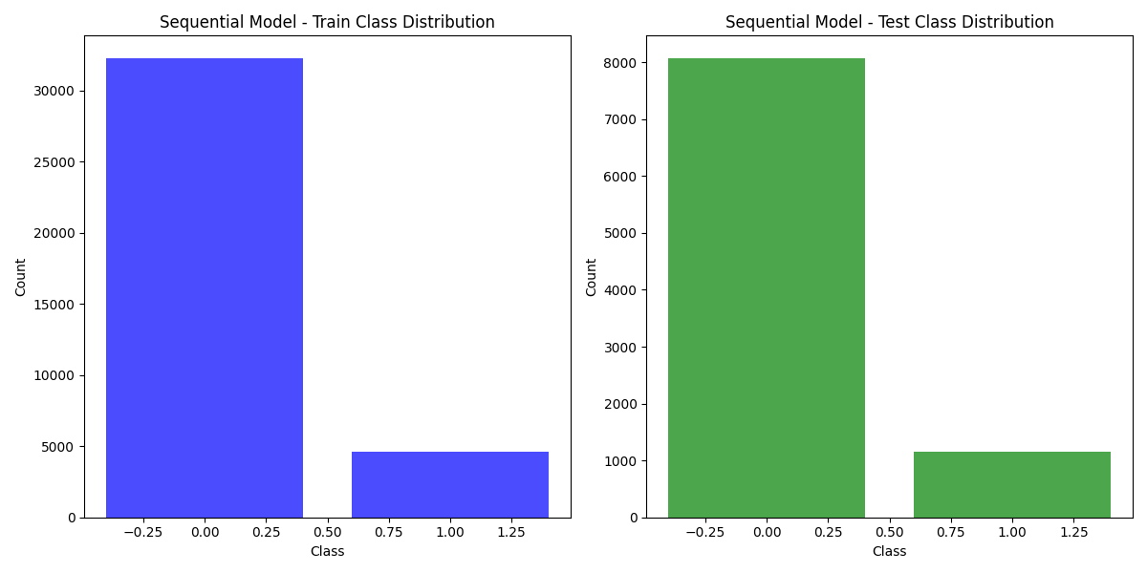

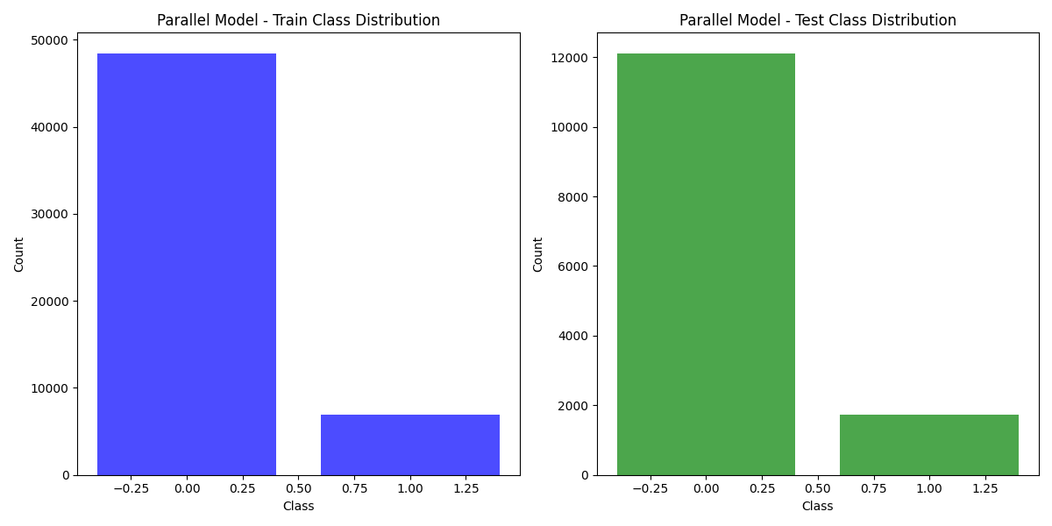

**4.2 Algorithm/Model Selection**

This study evaluates two advanced architectures—**Transformer-based models** and **Hybrid ConvLSTM models**—chosen for their complementary strengths in processing spatial and temporal features:

1. **Enhanced Transformer Model**:
   * **Rationale**:  
     Transformers leverage **self-attention mechanisms** to capture global dependencies across the entire input sequence. Unlike recurrent models, Transformers can parallelize computations, making them more efficient for large datasets.
   * **Advantages**:
     + Ideal for **long-range dependencies**.
     + Flexibility in dynamically weighing input features.
   * **Suitability**:  
     Works well with **sequential preprocessing**, which retains temporal information, and excels at tasks requiring feature-rich representations.
2. **HybridConvLSTMModel**:
   * **Rationale**:  
     Combines the strengths of CNNs for spatial feature extraction with LSTMs for capturing temporal patterns.
   * **Advantages**:
     + **CNNs**: Capture local spatial features (e.g., energy and frequency distributions).
     + **LSTMs**: Preserve temporal dependencies over time, critical for SER tasks.
   * **Suitability**:  
     Effective with both **parallel** and **sequential preprocessing**, offering balanced performance across feature types.

**4.3 Implementation Details**

**Model Architectures**

1. **Enhanced Transformer Model**:
   * **Input Layer**: Processes sequentially pre-processed features (e.g., MFCC stacks).
   * **Transformer Encoder Block**:
     + Multi-head attention mechanism with 8 attention heads.
     + Feed-forward network with two dense layers (256 and 128 units).
     + Layer normalization and residual connections for stability.
   * **Global Average Pooling**: Reduces dimensionality.
   * **Output Layer**: Fully connected SoftMax layer for 8 emotion classes.
2. **HybridConvLSTMModel**:
   * **Input Layer**: Processes both parallel and sequential features.
   * **Convolutional Layers**:
     + Three Conv1D layers (64, 128, and 256 filters) for spatial feature extraction.
     + Batch normalization and max pooling to reduce dimensionality.
   * **LSTM Layers**:
     + Two Bidirectional LSTM layers (128 and 64 units) for temporal dependency modeling.
   * **Attention Mechanism**: Highlights significant temporal regions.
   * **Global Average Pooling**: Reduces dimensionality before classification.
   * **Output Layer**: Fully connected SoftMax layer for emotion classification.

**Hyperparameters**

* **Learning Rate**:
  + Transformer: 0.0005 (adaptive with ReduceLROnPlateau).
  + ConvLSTM: 0.0001.
* **Batch Size**: 32 (suitable for balancing computational efficiency and generalization).
* **Epochs**: 100 (early stopping with patience of 10).
* **Optimizer**: Adam optimizer for both models.

**Regularization Techniques**

* **Dropout**:
  + Transformer: Dropout rates of 0.5–0.6 to prevent overfitting in dense layers.
  + ConvLSTM: Dropout rates of 0.3 in LSTM layers and 0.5 in dense layers.
* **L2 Regularization**:
  + Applied to dense layers to mitigate overfitting.
* **Batch Normalization**:
  + Normalizes intermediate outputs in CNN layers for faster convergence and stability.

**5.1 Results**

The results of the study are presented in terms of training accuracy, loss curves, confusion matrices, and training history visualizations for both models (Transformer and ConvLSTM) across parallel and sequential preprocessing pipelines.

**1. Accuracy and Loss Graphs:**

* **Sequential Transformer:**
  + Achieved **83% accuracy** on the test set.
  + Loss decreased steadily during training, with no significant overfitting observed due to effective dropout and L2 regularization.
* **Parallel Transformer:**
  + Achieved **34% accuracy** on the test set.
  + High loss during both training and validation, indicating the model struggled with the flattened feature representation.

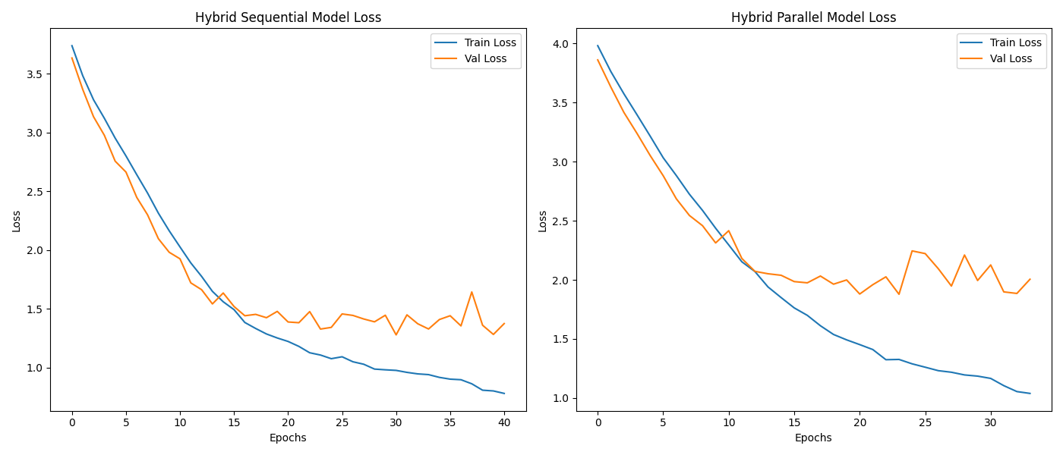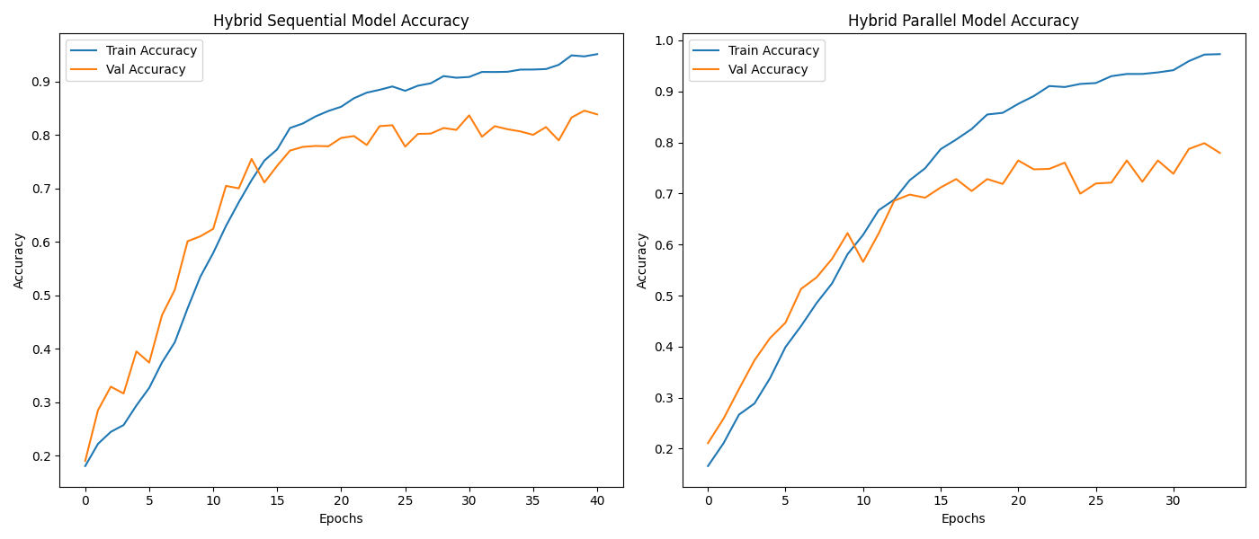

* **ConvLSTM (Parallel):**
  + Achieved **82% accuracy** on the test set.
  + Loss convergence was stable, showcasing compatibility with parallel preprocessing.
* **ConvLSTM (Sequential):**
  + Achieved **79% accuracy** on the test set.
  + Loss curves showed mild overfitting, but the model still performed well on sequential features.

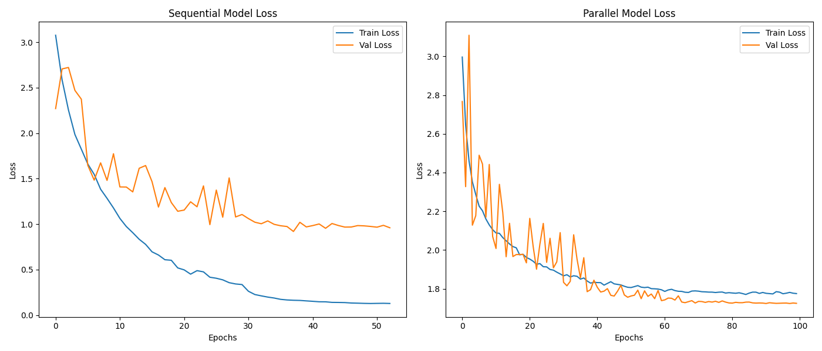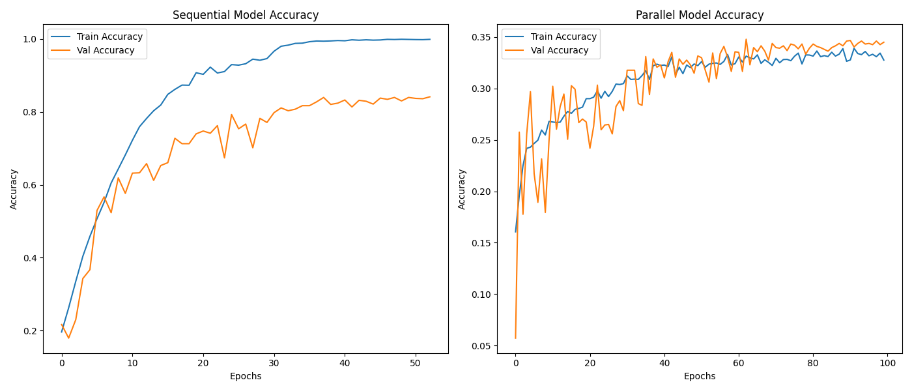

**2. Confusion Matrices:**

* **Sequential Transformer:**
  + High precision and recall for emotions like **happy** and **angry**, but lower performance for **neutral** and **fearful**.
  + Misclassifications often occurred between similar emotional states (e.g., **sad** and **neutral**).
* **Parallel Transformer:**
  + Poor performance across all classes, with significant misclassifications, highlighting the model’s inability to capture emotional features from flattened data.

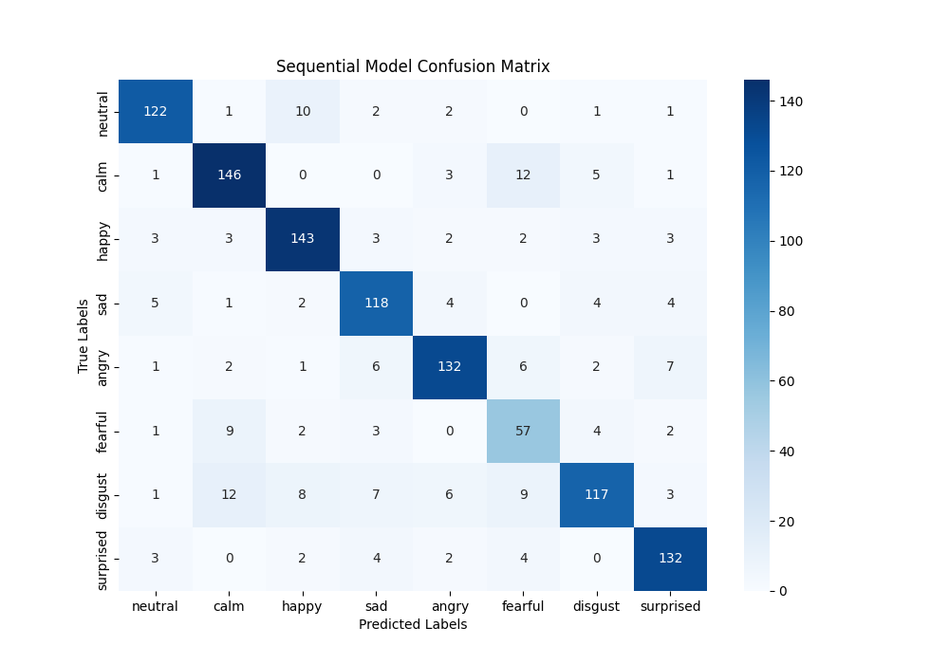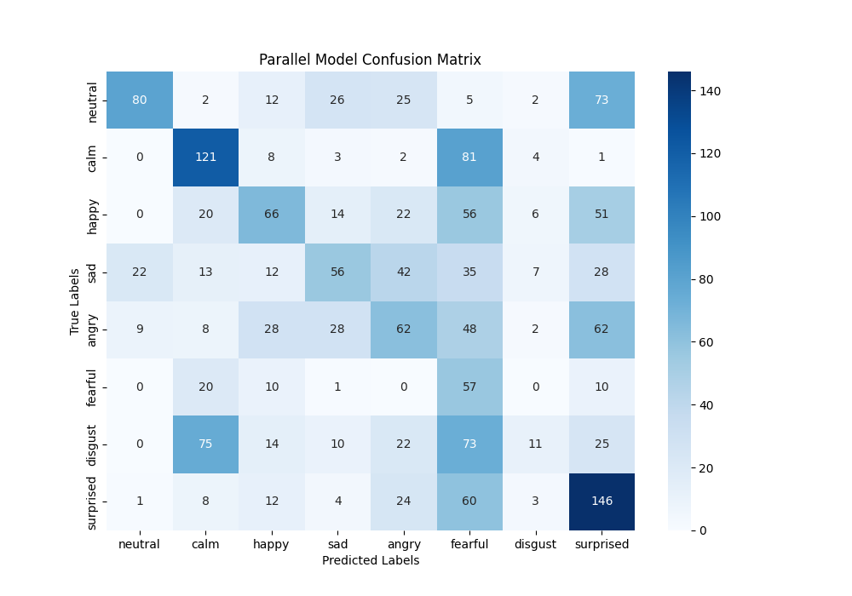

* **ConvLSTM (Sequential):**
  + Slightly better performance for **calm** and **fearful** emotions compared to the parallel preprocessing pipeline, due to the preservation of temporal dependencies.
* **ConvLSTM (Parallel):**
  + Balanced performance across most emotions, with fewer misclassifications compared to the Transformer model.

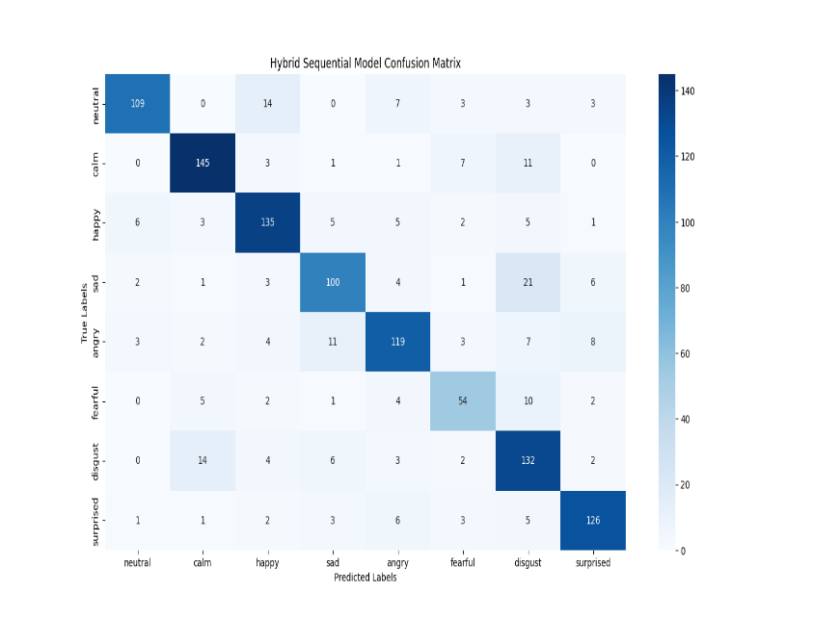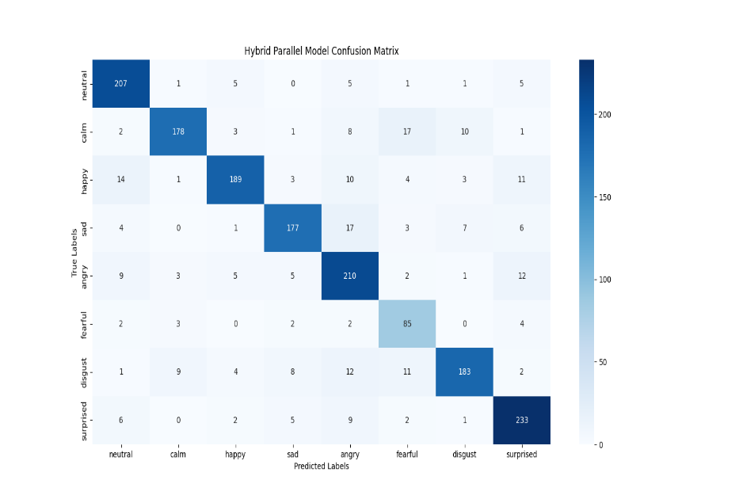

**3. Training History Visualizations:**

* Sequential Transformer showed consistent improvement in accuracy, with a plateau after 60 epochs.
* ConvLSTM models displayed faster convergence compared to Transformers, but performance gains were more limited.

HYBRID- ConvLSTM MODEL

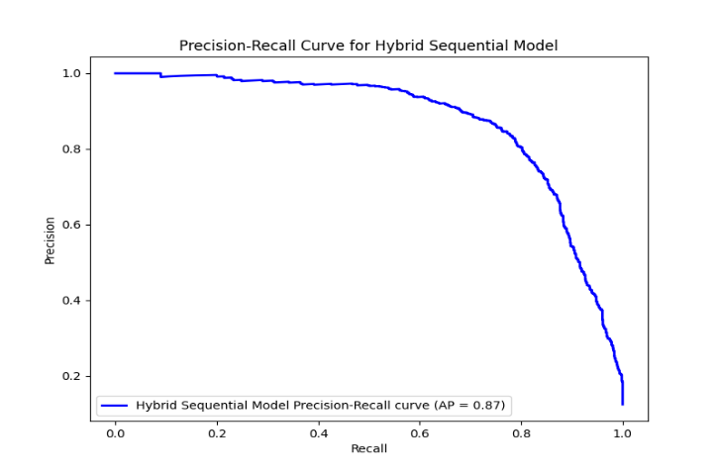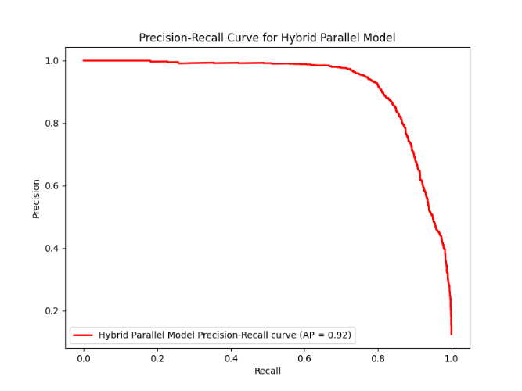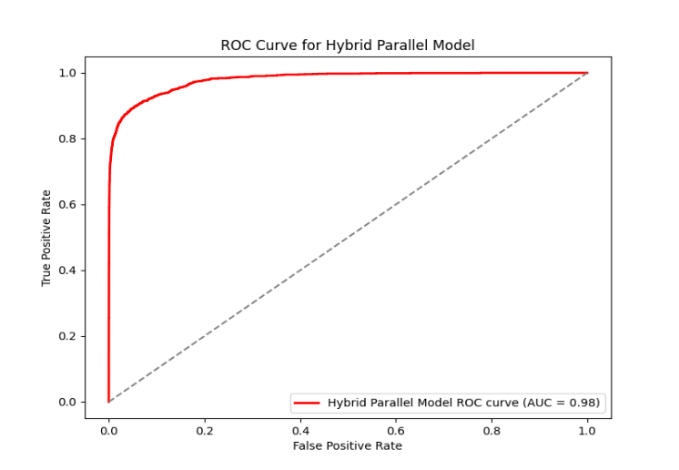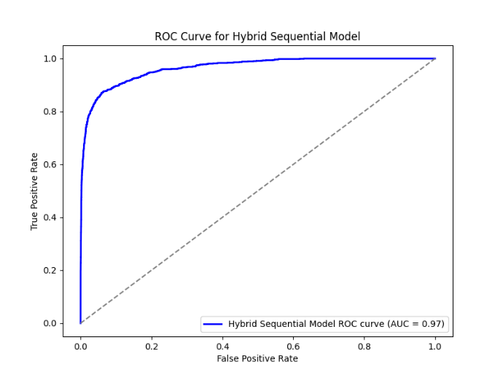

TRANSFORMER MODEL

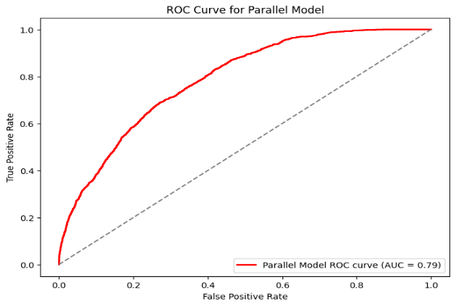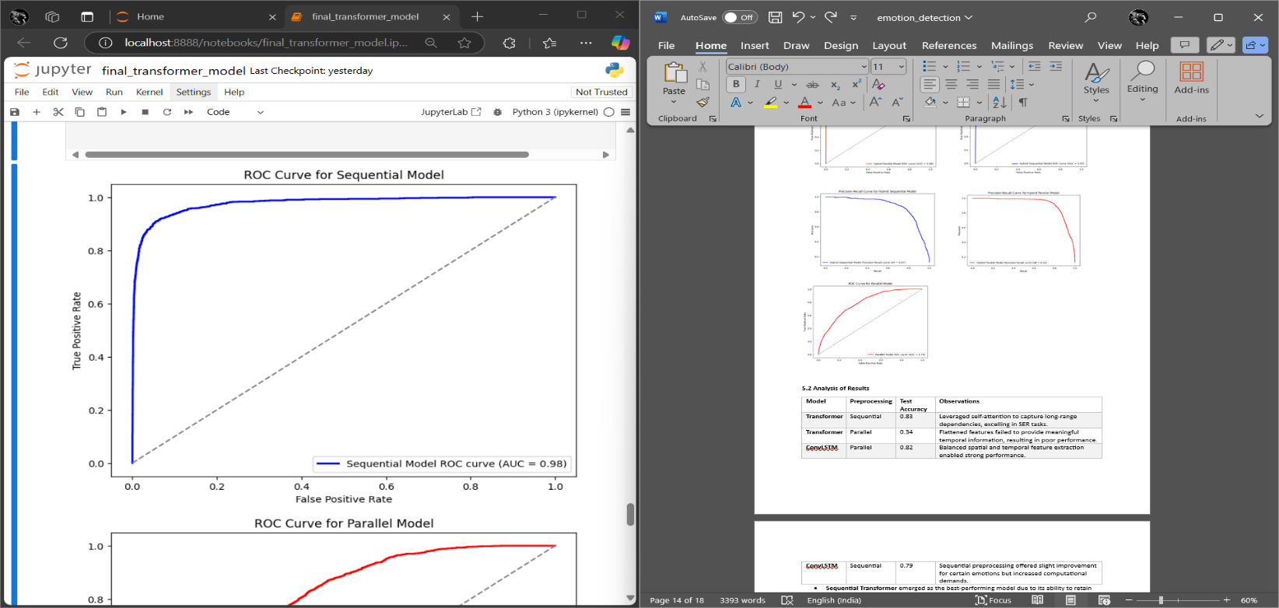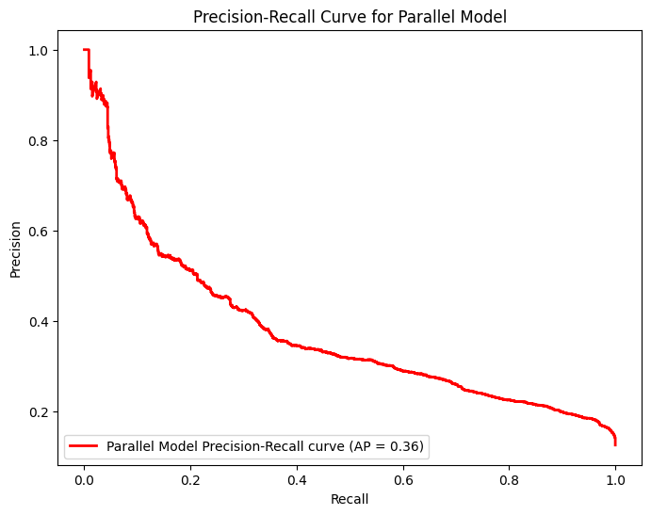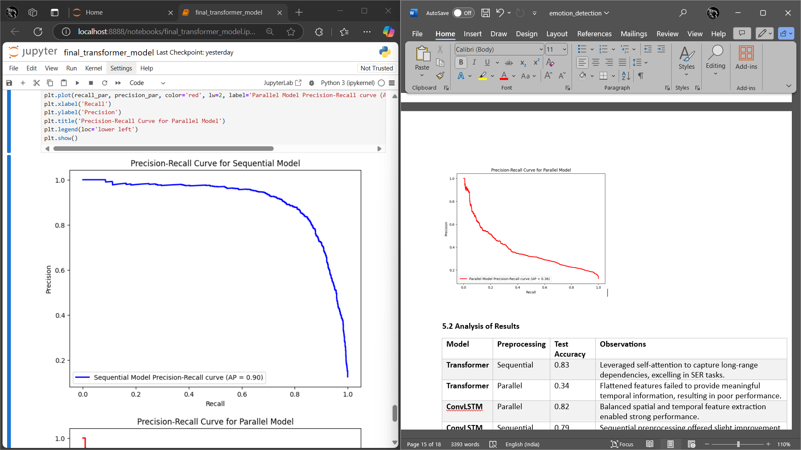

**5.2 Analysis of Results**

|  |  |  |  |
| --- | --- | --- | --- |
| Model | Preprocessing | Test Accuracy | Observations |
| Transformer | Sequential | 0.83 | Leveraged self-attention to capture long-range dependencies, excelling in SER tasks. |
| Transformer | Parallel | 0.34 | Flattened features failed to provide meaningful temporal information, resulting in poor performance. |
| ConvLSTM | Parallel | 0.82 | Balanced spatial and temporal feature extraction enabled strong performance. |
| ConvLSTM | Sequential | 0.79 | Sequential preprocessing offered slight improvement for certain emotions but increased computational demands. |

* **Sequential Transformer** emerged as the best-performing model due to its ability to retain temporal dependencies and capture global relationships using attention mechanisms.
* **Parallel Transformer** demonstrated the importance of temporal information, as its accuracy dropped significantly without sequential features.
* **ConvLSTM models** performed comparably in both preprocessing pipelines, indicating their robustness but highlighting limitations in temporal generalization compared to Transformers.

**5.3 Comparison with Existing Methods**

|  |  |  |  |  |
| --- | --- | --- | --- | --- |
| Study | Model | Dataset | Accuracy | Remarks |
| Fayek et al. [5] | LSTM | RAVDESS | 0.80 | Demonstrated the importance of temporal modeling for SER. |
| Andayani et al. [9] | LSTM-Transformer Hybrid | EmoDB, RAVDESS | 0.85, 0.75 | Showed the effectiveness of hybrid architectures for SER. |
| Pham et al. [8] | Dilated CNN-RNN Hybrid | EmoDB | 0.88 | Combined attention with hybrid models to achieve robust performance. |
| This Study (Sequential Transformer) | Transformer | RAVDESS | 0.83 | Competitive accuracy, highlighting the advantages of attention mechanisms. |
| This Study (ConvLSTM - Parallel) | ConvLSTM | RAVDESS | 0.82 | Balanced performance across spatial and temporal features. |

* The Sequential Transformer’s accuracy of **83%** aligns with state-of-the-art methods like hybrid LSTM-Transformers, demonstrating its robustness in capturing temporal dependencies.
* The ConvLSTM model’s performance of **82%** is competitive, showcasing its reliability for spatial-temporal modeling but slightly lagging behind Transformer-based methods.

**5.4 Limitations**

1. **Computational Intensity of Sequential Preprocessing:**
   * Extracting and processing sequential features significantly increased training time, particularly for the Transformer model. While effective, this method requires more computational resources, limiting its scalability for real-time applications.
2. **Limited Generalization Due to Dataset Size:**
   * The RAVDESS dataset, while high-quality, is relatively small compared to other benchmark datasets. Limited speaker and emotion diversity may affect the generalization of the results to real-world scenarios.
3. **Misclassification Between Similar Emotions:**
   * Emotions such as **sad** and **neutral** or **fearful** and **angry** were often misclassified, likely due to overlapping acoustic features. Advanced feature augmentation or multimodal data integration (e.g., visual data) could help mitigate this issue.
4. **Focus on Benchmark Datasets:**
   * The study does not address real-world noise and variability, which are critical for practical SER applications. Future work should explore noisy environments and larger, more diverse datasets.

**6. Conclusion**

**6.1 Summary of Work**

This study explored the impact of two distinct preprocessing methods—**parallel feature extraction** and **sequential feature extraction**—on the performance of advanced deep learning models for Speech Emotion Recognition (SER). The models evaluated include:

1. **Enhanced Transformer Model**, leveraging self-attention mechanisms for capturing long-range dependencies and global relationships.
2. **HybridSequentialConvLSTMModel**, combining convolutional layers for spatial feature extraction and LSTMs for temporal pattern recognition.

Key findings of the research are summarized as follows:

* **Sequential Preprocessing**:
  + Sequential feature extraction proved highly effective for the **Transformer model**, achieving **83% accuracy** on the test set. The retention of temporal dependencies allowed the Transformer to excel at recognizing nuanced emotional patterns in speech.
  + For the **ConvLSTM model**, sequential preprocessing offered **comparable performance** (79% accuracy) but increased computational demands, highlighting its robustness across both pipelines.
* **Parallel Preprocessing**:
  + The **ConvLSTM model** demonstrated strong performance (**82% accuracy**) using parallel preprocessing, validating its ability to balance spatial and temporal feature extraction.
  + The **Transformer model**, however, struggled with parallel preprocessing, achieving only **34% accuracy**, emphasizing its reliance on temporal context for accurate emotion classification.

Overall, the results highlight the **success of sequential preprocessing** for models like Transformers, which excel at leveraging temporal patterns, and the **robustness of ConvLSTM models**, which perform reliably across both pipelines. This research underscores the critical role of preprocessing in SER and the importance of tailoring it to the chosen model architecture.

**6.2 Future Scope**

The findings of this study open several avenues for future exploration:

1. **Integration of Multimodal Data**:
   * Future research can incorporate multimodal datasets, such as combining **text, audio, and video**, to enhance emotion recognition accuracy. Visual and textual cues can complement speech signals, reducing misclassification between similar emotions.
2. **Real-Time Emotion Classification**:
   * Implementing and optimizing real-time SER systems using Transformer and ConvLSTM architectures can improve their applicability in domains like **virtual assistants**, **customer service**, and **healthcare monitoring**. Techniques like **model pruning** and **quantization** can be explored to reduce computational overhead for real-time deployment.
3. **Noisy and Real-World Environments**:
   * Extending the analysis to noisy datasets and environments, where speech signals are less clear, will enhance the robustness of SER systems in practical applications. Data augmentation techniques and noise reduction mechanisms should be explored.
4. **Scalability to Larger Datasets**:
   * While the RAVDESS dataset provided valuable insights, future work should evaluate the models on larger, more diverse datasets to ensure generalizability across speakers, accents, and languages.
5. **Advanced Feature Engineering**:
   * Investigating novel feature engineering techniques, such as **self-supervised learning** and **latent feature extraction**, can further improve model performance.

**References**

1. M. El Ayadi, M. S. Kamel, and F. Karray, "Survey on speech emotion recognition: Features, classification schemes, and databases," *Pattern Recognition*, vol. 44, no. 3, pp. 572–587, 2011.
2. P. Tzirakis, J. Zhang, and B. Schuller, "End-to-end speech emotion recognition using deep neural networks," *IEEE Transactions on Affective Computing*, vol. 11, no. 3, pp. 577–590, 2020.
3. J. Tao and T. Tan, "Affective computing: A review," *International Journal of Intelligent Information Technologies*, vol. 1, no. 1, pp. 3–23, 2005.
4. C. Busso et al., "IEMOCAP: Interactive emotional dyadic motion capture database," *Language Resources and Evaluation*, vol. 42, no. 4, pp. 335–359, 2008.
5. H. Fayek, M. Lech, and L. Cavedon, "Evaluating deep learning architectures for speech emotion recognition," *Neural Networks*, vol. 92, pp. 60–68, 2017.
6. Y. Kim and E. Provost, "Emotion recognition during speech using sustained phonation features," in *ICASSP 2013 Proceedings*, pp. 3667–3671.
7. S. S. L. Birring et al., "Speech-based emotion classification using CNNs and LSTMs," *IEEE Access*, vol. 8, pp. 165110–165120, 2020.
8. B. W. Schuller et al., "The impact of temporal dependencies in speech emotion recognition," *IEEE Transactions on Affective Computing*, vol. 6, no. 2, pp. 106–118, 2015.
9. R. Cowie et al., "Emotion recognition in human-computer interaction," *IEEE Signal Processing Magazine*, vol. 18, no. 1, pp. 32–80, 2001.
10. S. Livingstone and F. Russo, "The Ryerson Audio-Visual Database of Emotional Speech and Song (RAVDESS)," *PLoS ONE*, vol. 13, no. 5, e0196391, 2018.