For and while: entry control loop

Do while: exit control loop

For: when the no of iterations is given

While: no of iterations not confirmed

~n= -(n+1)

Sizeof() is a operator

>> right shift = divide by 2

<< left shift = multiply by 2

% depends on the sign of Numerator

for(;;) {} -> infinite loop

if 2 conditions given in a loop : 2nd condition is considered

SWITCH:

* WE CAN USE DEFAULT ANYWHERE
* WE CAN USE VALID EXPRESSIONS
* NO DUPLICATE CASE
* CAN’T USE LOGICAL OPERATIONS IN CASE

printf(“%d%d”) -> garbage value

C++ code: 3 approaches

1. object oriented
2. object based
3. procedural

cout -> object of ostream class

<< : insertion operator

Character output stream – to display the output

Cin -> istream class

>> : extraction operator

Character input stream – to take the value from keyboard/user

Default modifier : private

Modifiers: private, public,

getline(cin ,<variable name>) : in order to get a string with space

cin.ignore() : to ignore the nextline

using namespace std:

namespace is a different topic

contains all the built-in functions

DSA : Efficient way of storing data – easy access

STORAGE CLASSES:

* AUTO
* STATIC
* EXTERN
* REGISTER

Expression: combination of operator and operands

Type casting: converting one type to another type

|  |  |
| --- | --- |
| Int | 4 |
| Float | 4 |
| Char | 1 |
| Double | 8 |
| Long | 4 |
| Long double | 16 |
| Short | 2 |

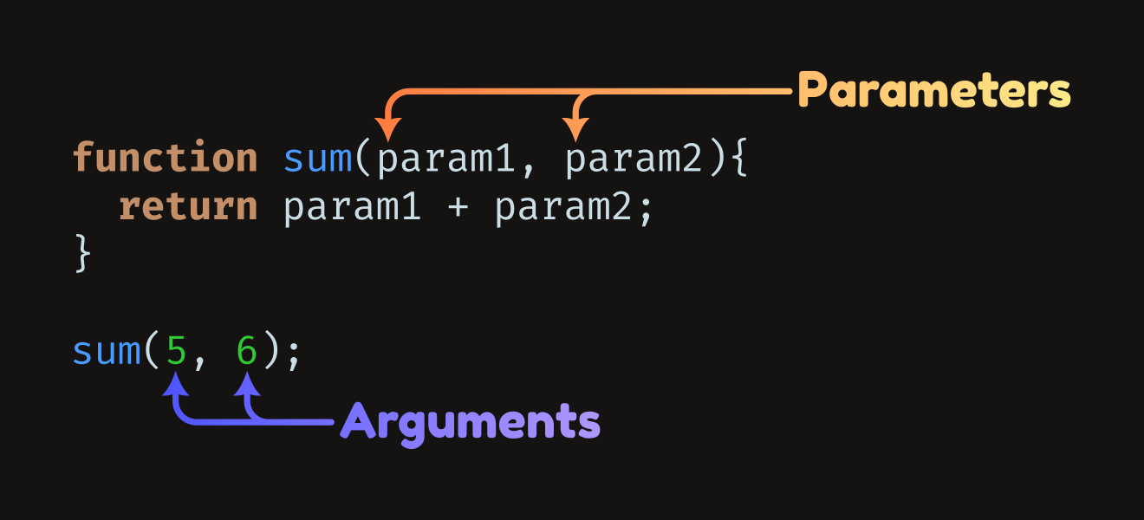

Types of functions:

User defined

Pre defined

Why do we need user defined function?

We can use them to perform tasks according to our requirements when predefined functions doesn’t fulfil our needs.

Function feature:

* Reusability
* Readability

Polymorphism:

It allows us to use same function in different ways.

Function overloading:

* It’s a compile time polymorphism, which allows us to pass different argument to same function resulting in different outputs based on inputs
* Static polymorphism
* When we may give different argument to same function.

Function overriding:

* It’s a runtime polymorphism, which allows us to modify the definition of a function of a parent class in order to get the desired output.
* Dynamic polymorphism

C++ is a compiled language

Sorting : arranging data in particular order(ascending/descendion)

Bubble sort

Selection sort

STL: Standart Temp Lib

Collection of library/algo, function and other components/data structure to simplify the c++ programming

Conatiners: used to store data in sequential manner to simplify your requirements.

* Sequence container
  + Vector:

It is in dynamic nature

* + Array: predefined function

Advantages: optimization, no need to write complete logic / code is short, data type is decided at runtime

Disadvantages: it is in static nature

* + Deque: double ended
  + list
* Associate container
  + Set
  + Multiset
  + Map
* Container adapter
  + Stack : LIFO

OPERATIONS: push, pop, top ( to see the top), empty

* + Queue: FIFO

Lambda function: are a way to define anonymous function objects, which are useful for short snippets of code that are used only once or for simple operations.

Allows to write inline, unnamed functions within the code.

Helps write function in single line.

[capture](parameters) -> return_type {

//function body

};

Capture: specifies which variables from the surrounding scope are captured and how

Eg:

auto add= [](int a, int b){ //int won’t work here ☹

return a+b;

}

for_each(begin, end, function) //will perform the function on all the elements btw start and end

ios_base::sync_with_stdio(false); //stop syncronysation with c

cin.tie(NULL);

cout.tie(NULL);

used to optimise the code