
A Report on

GridPulse
Urban Smart Electricity Consumer Assistance
and Energy Monitoring System
for
IDEA LAB-V (Course code: 12212506)
Theme: Urban System
of
Third Year (TE Sem-V)
Computer Engineering
Academic Year 2026-2027
by
Pawan Suryakant Tiwari
TE / CMPN-C
Roll no. 53
Under the guidance of
Dr. Uma Goradiya

AY 2026-2027
DEPARTMENT OF COMPUTER ENGINEERING
Certificate
This is to certify that Mr. Pawan Suryakant Tiwari, Class: TE CMPN/C, Roll No. 53, Exam Seat No. ____________, of Fifth Semester of Degree in Computer Engineering has completed the required Practicals / Term Work / Project in the subject IDEA LAB-V from the Department of Computer Engineering during the academic year 2026-2027 as prescribed in the curriculum.
Faculty in-Charge Date:
External Examiner Date:
Seal of
Institution

ACKNOWLEDGEMENT
I would like to express my sincere gratitude to Dr. Uma Goradiya for guiding me throughout my IDEA LAB-V project, “GridPulse: Urban Smart Electricity Consumer Assistance and Energy Monitoring System”. Her guidance helped me connect the Urban System theme with a practical application for monitoring electricity consumption and improving complaint handling.
I am thankful to the Head of the Department, Dr. Bhushan Kumar Nemade, for his encouragement and support. I also thank our Principal, Dr. Umesh Bhadade, for providing an environment that supports project development and practical learning.
I thank the Department of Computer Engineering for the laboratory facilities and academic resources that supported the development of the web prototype and the preparation of this report. I am also grateful to my classmates and friends for their suggestions during the project.
This project helped me apply frontend development, REST API design, data modelling, tariff calculations and workflow testing to an urban service problem. The experience strengthened my understanding of how a simple software system can make consumer information clearer and service requests easier to follow.
Pawan Suryakant Tiwari
TE / CMPN-C
Roll no. 53

INDEX
Sr. No | Name Of Topic | Page No
1 | Abstract | 1
2 | Theme and Problem Statement | 2
3 | Introduction | 3
4 | Literature Review | 4
5 | Existing Systems | 5
6 | Proposed Solution 1 | 6
7 | Proposed Solution 2 | 7
8 | Proposed Recommended Solution | 8
9 | Flow Diagram / Architecture of Proposed System | 9
10 | Technical Requirements (HW/SW) | 35
11 | Applications | 36
12 | Future Scope | 37
13 | Conclusion | 38
14 | References | 39

1. ABSTRACT
Electricity is a core urban service, but households often understand their consumption only after receiving a monthly bill. When the billed amount appears unusual, consumers must collect information, raise a complaint and coordinate a support visit. Utility staff also need a consolidated view of complaints and locality-level demand to plan their response. GridPulse brings these activities into one browser-based prototype under the Urban System theme.
The system combines live simulated meter readings, monthly bill estimation, budget-based suggestions, bill comparison, complaint tokens and online or offline consultation scheduling. Consumers can follow a complaint through Submitted, Under Review, In Progress and Resolved. Appointment mode changes are allowed until four hours before the assigned slot; offline is the default mode. The utility operations interface displays complaint categories, locality demand, support assignments and consultation schedules.
The prototype uses React and Vite for the frontend, FastAPI for the backend, and a MongoDB-compatible data layer. During local demonstration it uses an asynchronous in-memory store when MongoDB is unavailable. The bill estimate applies a seven-day consumption average and an illustrative slab tariff. A variance of Rs 150 or more is flagged for review. The software demonstrates the intended sensor-to-service workflow using simulated consumption rather than a physical smart meter.
Targeted verification covered tariff boundaries, complaint creation and progression, bill comparison and appointment locking. The project provides a practical base for connecting measured consumption with consumer support. Physical IoT integration, trained forecasting models, authenticated access and reliable external reminder delivery remain the next development steps.

2. Theme and Problem Statement

Theme: Urban System
The Urban System theme examines services that keep a city functioning and asks how observed operational patterns can guide a basic improvement. This project studies electricity consumption, billing queries and the coordination of consumer support. It connects household information with the utility’s view of complaints and demand.

Teacher Problem Statement
“Observe operational patterns in urban environments and demonstrate a very basic system for improvement.”

Project Problem Statement
Urban electricity consumers need a clear way to understand ongoing consumption, estimate monthly expenditure, identify unusual bills and obtain scheduled support. Utility teams need a shared view of complaint categories, pending cases, locality demand and consultation workloads. Separate monitoring and support activities make the complete consumer journey difficult to follow.

Operational Patterns Considered
• Daily consumption and periods of higher household demand.
• Monthly spending relative to a consumer-selected budget.
• Differences between the estimated amount and an entered bill.
• Complaint categories, locality distribution and pending support cases.
• Upcoming online and offline consultation appointments.

Alignment with Sustainable Development Goals
The intended applications support SDG 7 through better energy-use awareness, SDG 11 through accessible urban utility services, and SDG 12 through more informed consumption decisions. These are design objectives; the prototype does not establish measured city-wide energy savings.

3. Introduction
An electricity bill reflects accumulated consumption and the applicable tariff, while consumers make appliance-use decisions throughout the month. A household that can see recent usage and a running estimate has more opportunity to adjust consumption before the billing cycle ends. When the final bill differs from expectations, consumption history can also provide a useful starting point for a support discussion.
The original project idea combines two needs: energy monitoring and electricity consumer assistance. The consumer raises a ticket, receives a token and an appointment, and chooses an online consultation or an office visit. The four-hour mode-change rule gives staff time to plan the consultation. The proposed two-hour customer-service reminder supports preparation on both sides.
GridPulse implements this concept as a full-stack web prototype. Its citizen dashboard presents live telemetry, a monthly estimate, spending targets and bill verification. The complaint and appointment views make service requests visible. The operations interface provides charts, a complaint queue, staff assignment, a consumer directory and a shared consultation calendar.

Project Objectives
• Display current and historical consumption in a form a household can understand.
• Estimate monthly expenditure using an explicit and inspectable tariff calculation.
• Connect a suspected billing discrepancy with a traceable support ticket.
• Demonstrate appointment selection, default offline mode and the four-hour lock.
• Provide an operations view of complaint and demand patterns for utility staff.
The report describes alternative solutions, the recommended architecture, implemented modules, working screens and targeted test results. The demonstration uses sample consumers and simulated readings. It is an academic implementation of the service workflow rather than an operational utility billing platform.

4. Literature Review
Author(s) and Paper Title | Year / Source | Key Contribution and Relevance
Y. Wang, Q. Chen, T. Hong and C. Kang  Review of Smart Meter Data Analytics: Applications, Methodologies, and Challenges [1] | 2018  arXiv | Organises smart-meter analytics into descriptive, predictive and prescriptive tasks. Informs the separation of monitoring, forecasting and recommendations.
S. Arora and J. W. Taylor  Forecasting Electricity Smart Meter Data Using Conditional Kernel Density Estimation [2] | 2014  arXiv | Uses conditional density estimation to capture consumption seasonality and uncertainty. Supports future probabilistic forecasts instead of a single estimate.
A. Bansal et al.  Energy Consumption Forecasting for Smart Meters [3] | 2015  arXiv | Studies boosted decision-tree regression and time-series feature engineering. Offers a possible trained-model upgrade for the current baseline.
J. Kelly and W. Knottenbelt  The UK-DALE Dataset [4] | 2015  Scientific Data | Provides aggregate and appliance-level measurements from five homes. Shows why appliance attribution needs measured ground-truth data.
D. Murray, L. Stankovic and V. Stankovic  An Electrical Load Measurements Dataset of United Kingdom Households [5] | 2017  Scientific Data | Presents REFIT household and appliance measurements. Provides a candidate dataset for testing forecasting and disaggregation methods.

Summary and Research Gap
The reviewed work informs forecasting, load analysis and appliance-level measurement. GridPulse applies these ideas to an integrated consumer workflow: usage visibility, a spending target, bill comparison, a complaint token and a scheduled consultation. The research gap addressed here is this workflow integration in a demonstrable student prototype; it is not a claim that existing utilities lack digital complaint services.

5. Existing Systems

1. Utility Consumer Portals
MSEDCL’s Web Self Service provides billing and payment history, service requests, complaints and consumption-estimation tools [6]. Its consumer portal also links to complaint registration and tracking. These functions show that digital consumer assistance is already an established approach.
Study focus: a consumer still benefits from a single guided journey that connects an understandable usage estimate with a disputed amount, a support token and an appointment mode. The publicly reviewed material does not establish whether every existing portal offers GridPulse’s exact four-hour consultation rule or the same unified dashboard.

2. Smart Meter Monitoring Systems
Smart-meter applications provide granular readings that support load analysis and forecasting [1]. Their primary strength is visibility into consumption. A monitoring dashboard alone does not necessarily define staff assignment, appointment selection or the handling of a billing query.
Limitations for this project: physical installation, device communication, calibration and reliable telemetry must be arranged before a hardware demonstration can represent actual household usage.

3. Research Forecasting and Disaggregation Tools
Forecasting methods and datasets such as conditional kernel density estimation, UK-DALE and REFIT support analysis of household electricity use [2, 4, 5]. They supply methods or measurements rather than the complete consumer-service application required by this project.

Gap Identified
The opportunity is to demonstrate a low-cost web workflow that joins monitoring, a transparent cost estimate, budget guidance, discrepancy review and appointment-based complaint assistance. GridPulse complements these established approaches and provides a base for future integration.

6. Proposed Solution 1

Hardware Smart Meter and Dedicated Monitoring Dashboard
This approach installs a sensing device or uses an authorised smart-meter interface to collect electrical measurements. A microcontroller or gateway sends timestamped readings to a server, where a monitoring dashboard presents usage and estimates the monthly bill. Direct measurements make the consumption record more useful than manually entered estimates.
The approach is suitable when the main objective is verified energy monitoring. It can capture changes in household demand, support historical analysis and provide input for more advanced forecasting. However, sensing and communication must be calibrated and validated before the readings can support a billing discussion.

Advantages
• Measured readings can replace simulated telemetry.
• A continuous history supports usage analysis and forecasting evaluation.
• The device interface can be extended to alerts and power-quality monitoring.

Cons
• Requires hardware procurement, installation and device maintenance.
• Depends on reliable connectivity and synchronisation of timestamps.
• Electrical measurements require appropriate isolation and qualified installation.
• A monitoring-only dashboard does not complete the complaint and consultation workflow.
• Hardware delays can reduce the time available to demonstrate the web-service modules.
This option is retained as a future integration path. The present project uses a simulator so that the complete consumer assistance workflow can be developed and demonstrated without claiming physical-meter validation.

7. Proposed Solution 2

Mobile Consumer Support Application
A dedicated mobile application can allow consumers to raise tickets, upload a bill, receive notifications and choose a support appointment. Staff use a separate administration interface to review cases and maintain consultation schedules. This approach prioritises access from a phone and convenient communication.
Mobile delivery suits regular reminders and camera-based document capture. It can later support regional languages, offline forms and push notifications. However, building and maintaining an installed application adds distribution and update work, while utility staff still need a desktop-friendly console.

Advantages
• Convenient ticket creation and bill capture from a smartphone.
• Push notifications can support complaint updates and reminders.
• A mobile interface can improve access for consumers who mainly use phones.

Cons
• Separate application packaging and testing add development effort.
• Users must install the app and receive updates.
• External notification services and reliable delivery require integration.
• A support-only application does not by itself provide consumption forecasting.
• Staff require an additional interface for locality analytics and case management.
This approach is feasible as a later extension. A responsive web application offers a simpler starting point because consumers and utility staff can access the same system through a browser.

8. Proposed Recommended Solution

GridPulse Integrated Web System
The recommended solution combines energy monitoring and consumer assistance in a responsive web application. React provides the citizen and operations interfaces. FastAPI exposes JSON endpoints for authentication, telemetry, billing, budgets, complaints, appointments and reports. A MongoDB-compatible layer holds operational records, with an in-memory fallback for local demonstration.
The consumer sees simulated meter readings, an estimated bill and a budget status. If an entered bill differs from the estimate by at least Rs 150, the system flags it for review. A ticket receives a GP-prefixed token and an appointment. Offline is the default; the mode can change before the four-hour boundary. Utility staff review cases, change assignments and view aggregate patterns.

Pros
• Feasible within a semester because the workflow can run on a standard computer.
• Accessible from a browser without a separate installed consumer application.
• Connects energy awareness, expenditure planning and support handling.
• Explains the bill calculation through a visible slab breakdown.
• Provides a shared complaint queue and consultation calendar for operations.
• Allows simulated scenarios to demonstrate changing load and billing queries.
• Supports later replacement of simulated data with authorised meter readings.

Prototype Boundary
The current implementation demonstrates application behaviour. Its “AI” interface labels refer to the planned product concept: the implemented forecast is a seven-day-average baseline, advice is rule-based, and appliance shares are illustrative. Physical sensing, robust security, external reminders and validated predictive accuracy require further development.

9. Flow Diagram / Architecture of Proposed System

Three-Tier Architecture
The presentation layer contains React components and charts. The application layer receives HTTP requests through FastAPI routers and applies billing, budget and appointment rules. The data layer supplies consumer, complaint, notification and sample operational records. Telemetry and billing histories are generated by the simulator or returned as demonstration records.
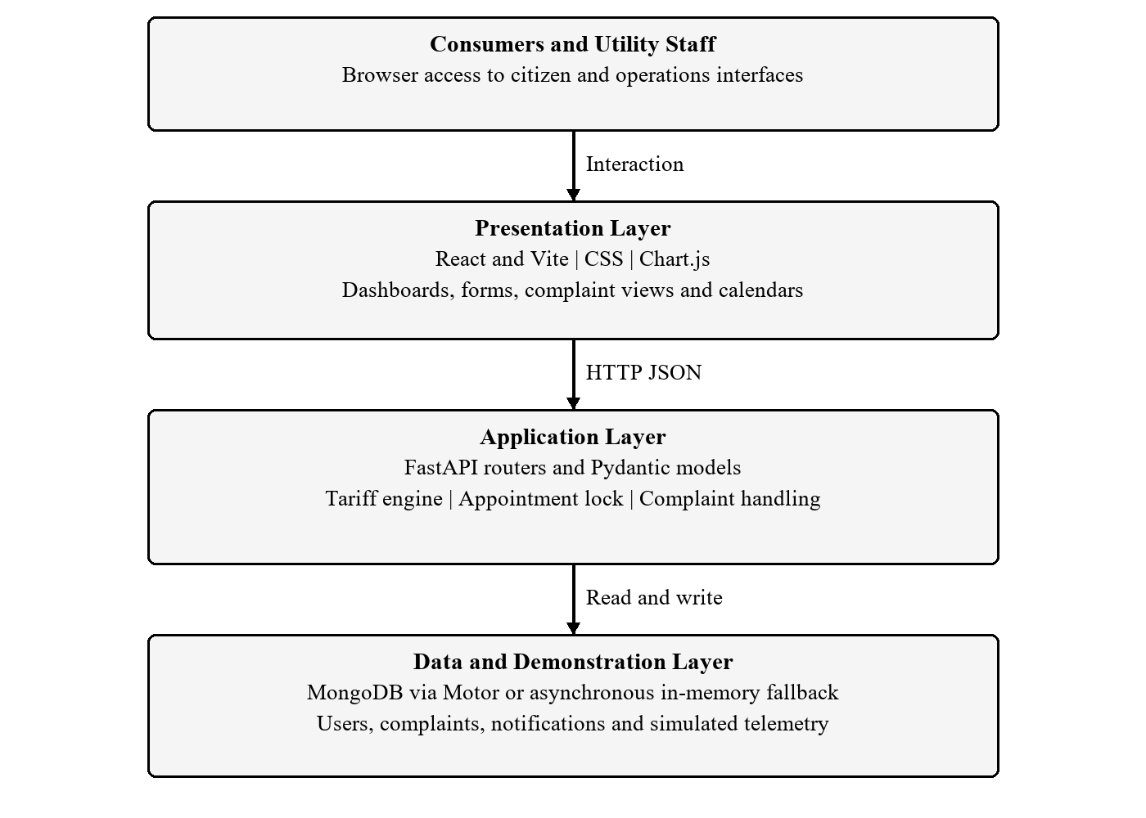
Fig. 1: Three-tier architecture of GridPulse

Consumer Service Flow Diagram
The diagram connects consumption information with a support request. A variance alert starts a review workflow; it does not establish that a utility bill is incorrect. The consumer may also raise a complaint directly for another electricity-related issue.
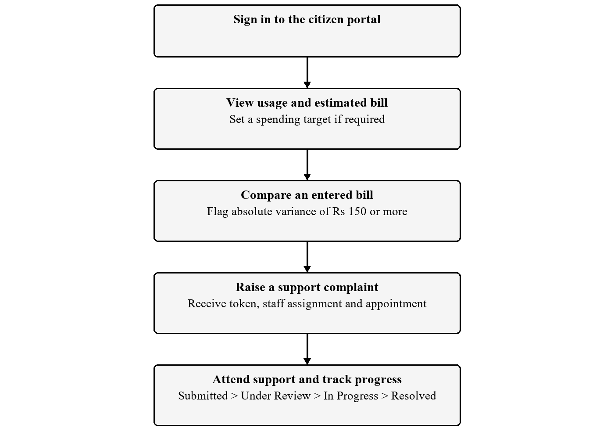
Fig. 2: Consumer monitoring and complaint handling flow

Appointment Rules and Complaint Status

Appointment Mode Selection
New complaints receive an appointment approximately 24 hours later. The default mode is offline. The backend rejects a mode update when the time remaining is four hours or less. The intended two-hour reminder is represented by demonstration alerts; no automated call, SMS or email service is connected.
Time Before Appointment | Intended Behaviour | Current Behaviour
More than 4 hours | Consumer can change online / offline mode. | Mode update accepted by the endpoint.
4 hours or less | Selected mode becomes locked. | Backend returns HTTP 400 for changes.
Around 2 hours | CSR and consumer receive a reminder. | UI demonstration flag uses a window up to 2.5 hours; delivery is not scheduled.
No selection | Offline visit is assumed. | Complaint model defaults to offline.

Complaint Status Sequence
The interface presents Submitted, Under Review, In Progress and Resolved as the expected sequence. The status endpoint updates the stored status and creates a notification. It currently accepts a free-text status value, so enforcing the complete transition sequence on the server is a future improvement.
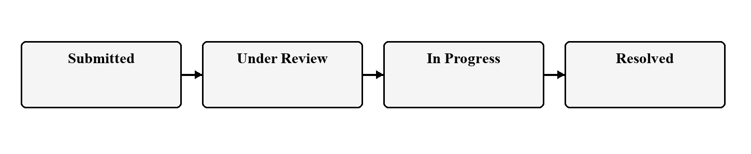
Fig. 3: Intended complaint status sequence

Use Case Diagram
The two main application views are the citizen portal and utility operations portal. The following diagram groups their available activities. Portal switching is provided for demonstration; these views should not be treated as proof of secure role enforcement.
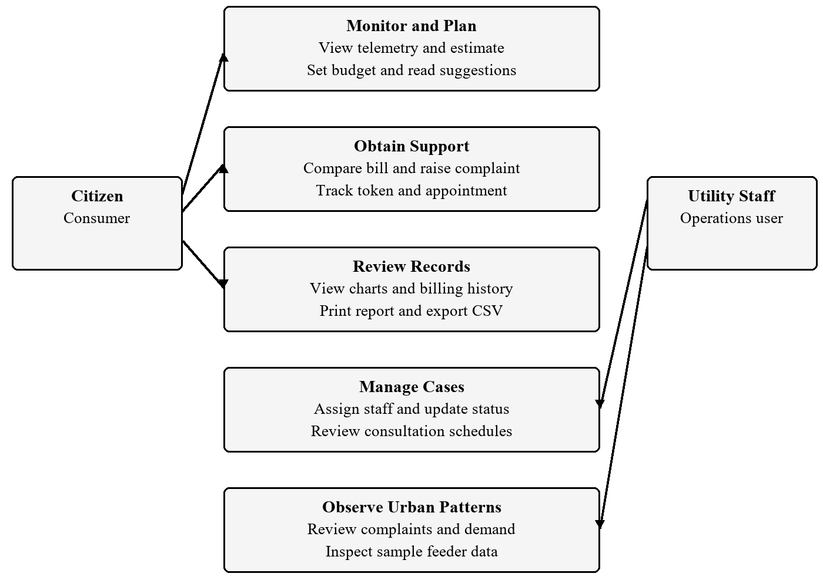
Fig. 4: Use cases for citizen and utility operations views

Database Design
The backend uses document collections rather than relational tables. Consumer email connects a user to complaint and notification records. Each complaint stores its appointment details, so the current design has no separate appointment collection. Telemetry histories are produced by the simulator; persistent measured histories remain a future data pipeline.
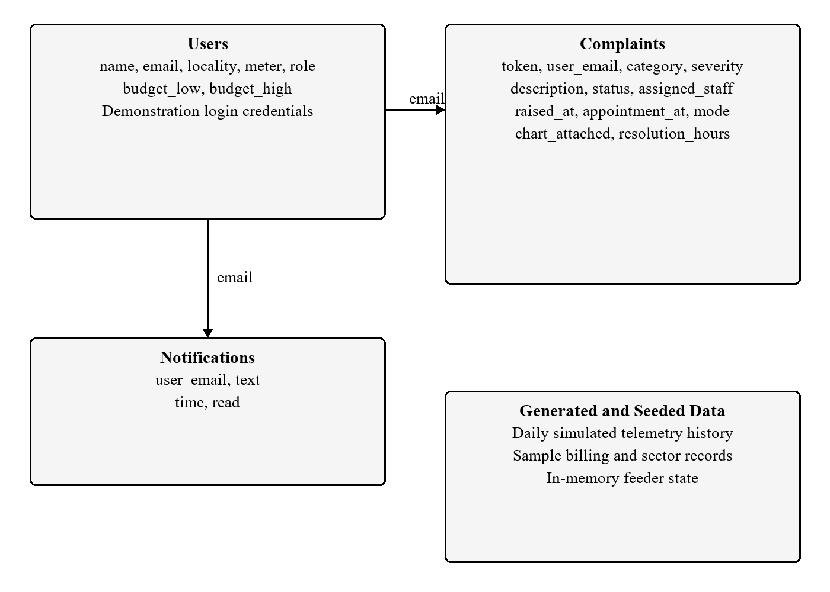
Fig. 5: Principal document records and logical associations
The associations shown are application-level lookups. Production work should add unique indexes for consumer identifiers and ticket tokens, timestamped status history, persistent meter readings and a durable appointment scheduler.

Functional Requirements
The following requirements retain the FR1-FR14 identifiers from the project specification. The implementation column distinguishes demonstrated behaviour from features that still require integration.
ID | Requirement | Prototype Implementation
FR1 | Registration and login | Email-based registration and demonstration login; secure production authentication pending.
FR2 | Live electricity monitoring | Simulated telemetry polled every 3 seconds; physical sensor pending.
FR3 | Monthly bill prediction | Seven-day average projected to the month; illustrative slab tariff.
FR4 | Budget suggestions | Consumer spending interval and rule-based advice; appliance shares are assumed.
FR5 | Complaint registration | Category, severity, description, consultation mode and evidence flag.
FR6 | Token generation | Random GP-prefixed token returned for each new complaint.
FR7 | Appointment scheduling | Slot assigned about 24 hours later; offline default and mode selection.
FR8 | Service reminders | Lock implemented; reminder flags demonstrated; calls and external delivery pending.
FR9 | Bill comparison | Absolute variance of Rs 150 or more produces an alert.
FR10 | Consumption reports | Sample usage charts and printable report; no trained AI or certified audit.
FR11 | Citizen dashboard | Usage, forecast, budget, verification, tickets and appointment views.
FR12 | Operations dashboard | Complaint statistics, demand charts, assignments and consumer views.
FR13 | Complaint tracking | Status update endpoint and visible progress indicators.
FR14 | Historical records | Six sample billing rows and CSV export; measured persistent history pending.

Non-Functional Requirements
These are the quality targets from the specification and the corresponding development priorities. They are not measured service-level results. A three-second polling interval does not establish a three-second page load or production capacity.
ID | Quality Target | Validation or Development Needed
NFR1 | Performance | Measure load time and endpoint latency; current telemetry polls every 3 seconds.
NFR2 | Availability | The 99% uptime target needs hosted monitoring and recovery testing.
NFR3 | Reliability | Use durable storage and backups; fallback data is lost on restart.
NFR4 | Security | Hash passwords, sign sessions, enforce backend roles and ownership, enable HTTPS.
NFR5 | Scalability | Load-test concurrent users; add indexes, bounded queries and deployment capacity.
NFR6 | Usability | Evaluate forms and terminology with consumers and support staff.
NFR7 | Maintainability | Retain modular routers, reusable components and central configuration.
NFR8 | Compatibility | Validate responsive layouts and workflows across target browsers and devices.
NFR9 | Forecast accuracy | The 90-95% aspiration requires real data, a defined metric and held-out evaluation.
NFR10 | Data integrity | Add input constraints, status rules, ownership checks and audit history.
NFR11 | Reminder reliability | Implement a scheduler, delivery provider, retries and delivery records.
NFR12 | Privacy | Apply consent, access controls, retention rules and protected data handling.

Current Validation Scope
The demonstrated checks cover selected functional rules on local sample data. Uptime, large-scale capacity, physical-meter accuracy, real forecasting accuracy and notification delivery have not been established by this test run.

Code Implementation

1. Frontend Components
App.jsx coordinates the citizen and operations tabs, current telemetry and modal state. AuthContext.jsx stores the demonstration user and manages login, theme and budget actions. Citizen components separate live meter readings, bill forecasts, spending targets, verification, tickets, appointments, reports and history. Admin components provide the operations overview, queue, calendar, directory and feeder view.

2. REST Integration
The shared api.js service sends JSON requests to the backend and exposes functions for each application module. The current request header uses a bearer value containing an email address. This identifies a demo consumer; it is not a signed access token. Backend authorization and password hashing are required before deployment.

3. Backend and Data Layer
main.py registers modular FastAPI routers under /api and initialises the database and sample records. Pydantic models describe request and response structures. database.py attempts a MongoDB connection through Motor and falls back to an asynchronous in-memory implementation if the server is unavailable. The local report demonstration used this fallback.

4. Telemetry and Forecast Logic
telemetry_sim.py generates live and historical sample readings. The frontend polls the live endpoint every three seconds. billing.py computes a recent seven-day average from generated history, multiplies it by the number of days in the current month, and passes projected units to tariff_engine.py.
The live scenario display and generated historical forecast are separate demonstration paths. A future integration should derive the forecast from the same persisted measured stream shown on the dashboard, with explicit treatment of missing readings and the billing-cycle dates.

Tariff Calculation and Main API Endpoints

Illustrative Tariff Used by the Prototype
Consumption Band | Rate
First 100 kWh | Rs 4.50 per kWh
Next 200 kWh | Rs 6.50 per kWh
Above 300 kWh | Rs 8.20 per kWh
Fixed charge | Rs 60 per month
Duty | 5% of the energy charge

For U projected kWh, the energy charge is 4.50 × min(U, 100) + 6.50 × min(max(U - 100, 0), 200) + 8.20 × max(U - 300, 0). The total is the energy charge plus Rs 60 and 5% duty on the energy charge. These are demonstration values, not a claim about any current utility tariff.
At 350 kWh, energy charges are Rs 450 + Rs 1,300 + Rs 410 = Rs 2,160. Duty is Rs 108 and the total is Rs 2,328. Forecasting uses full-precision daily averages before rounding projected units, so displayed rounded values may not reproduce every intermediate decimal.
Method | Endpoint under /api | Purpose
POST | /auth/login; /auth/register | Demonstration login and account creation
GET | /telemetry/live; /billing/forecast | Read live data and monthly estimate
POST | /billing/verify; /complaints | Compare an entered bill and create ticket
GET | /complaints; /appointments | Read support cases and appointments
PATCH | /appointments/{token}/mode | Apply the four-hour lock
PATCH | /complaints/{token}/status; /staff | Update case status or assignment
GET | /admin/overview; /reports/audit | Read operations data or sample report

User Interface

Public Pages
The following screens were captured from the running React frontend connected to the local FastAPI backend. They use seeded demo consumers and simulated energy data. Interface labels such as “AI Forecast” describe the prototype concept; their implemented behaviour is explained in the preceding sections.
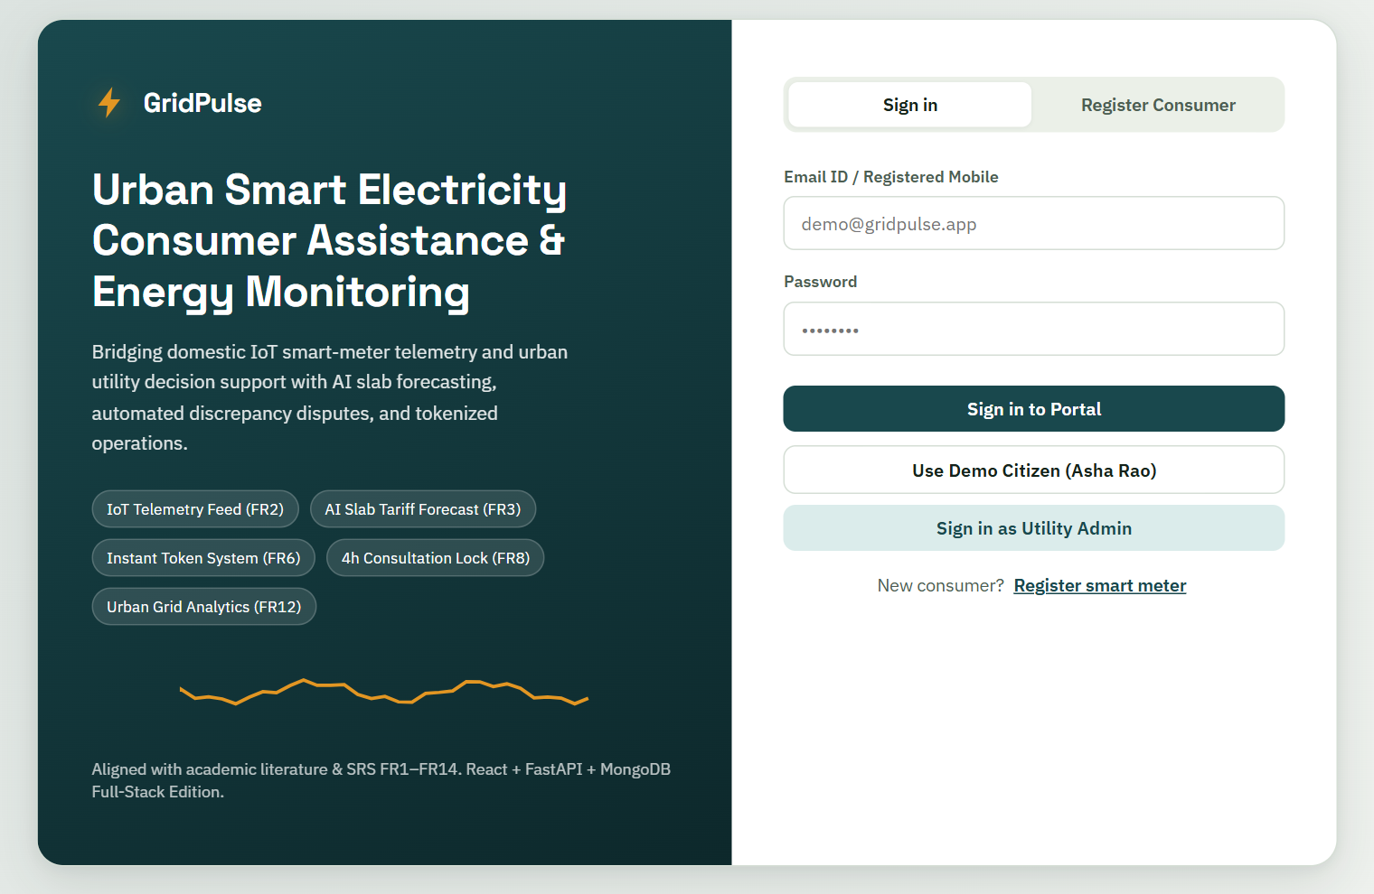
Fig. 6: GridPulse sign-in page with citizen and utility demo access
The sign-in form identifies the demonstration user and opens the associated portal. The two sample-account controls fill the login fields. Registration is available from the same page.

Consumer Registration
The registration form collects the consumer name, email address, locality and an optional meter identifier. A meter identifier is generated when none is supplied. New accounts receive the default spending interval and can then open the citizen dashboard.
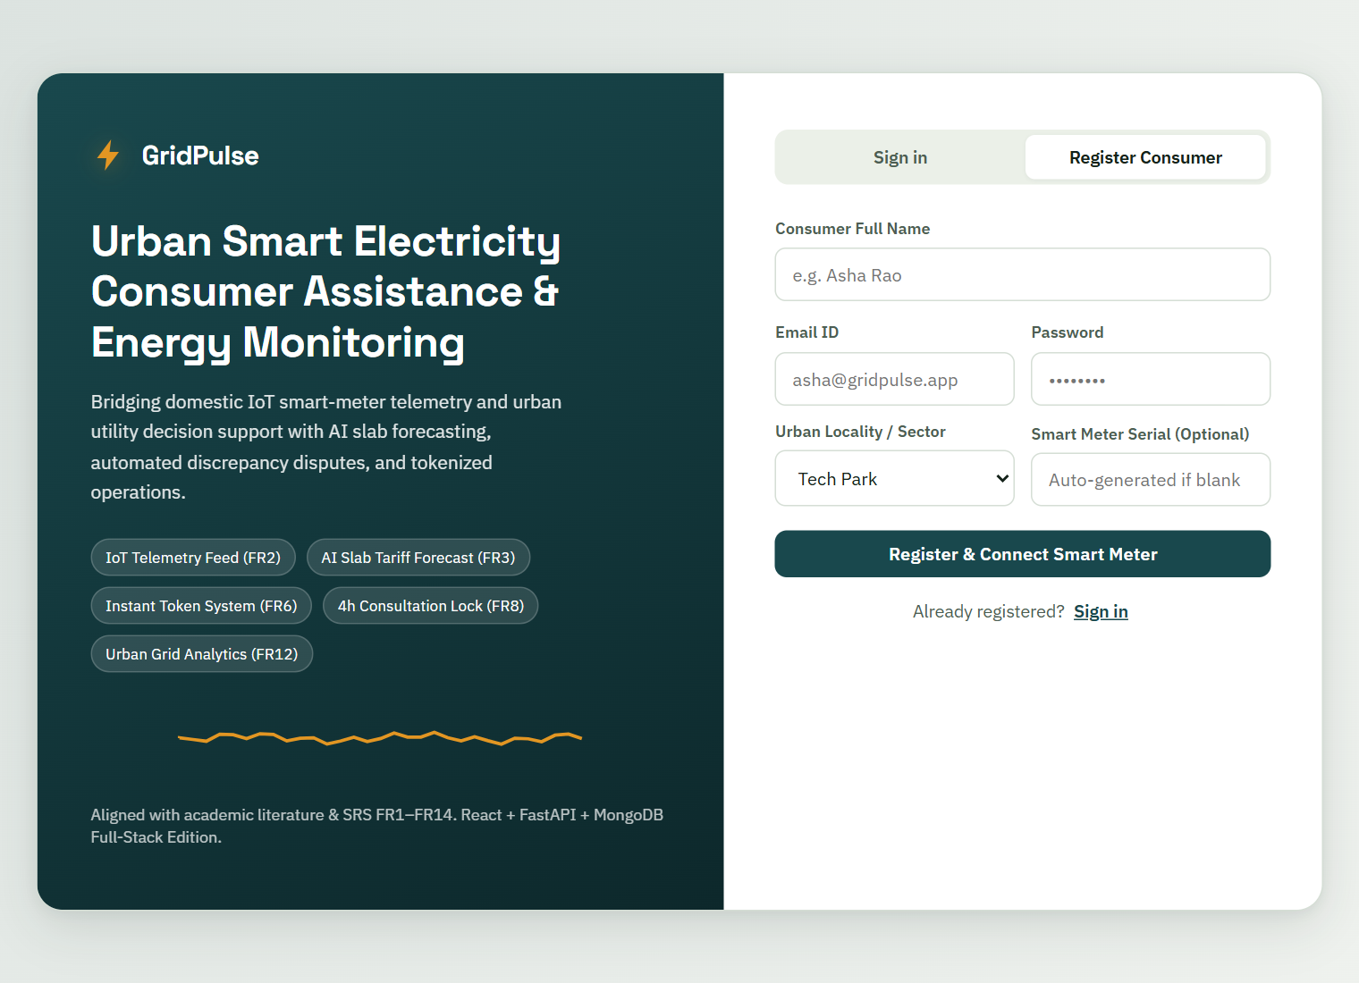
Fig. 7: Consumer registration with locality and meter details
Future registration should verify the relationship between a consumer and the meter. Input validation, account verification and password hashing are required before real consumer accounts are accepted.

Citizen Portal
The overview combines consumption visibility with a monthly estimate. The meter card shows the simulated demand, solar contribution, grid draw and electrical indicators. The estimate includes the applicable demonstration slab breakdown and billing-cycle progress.
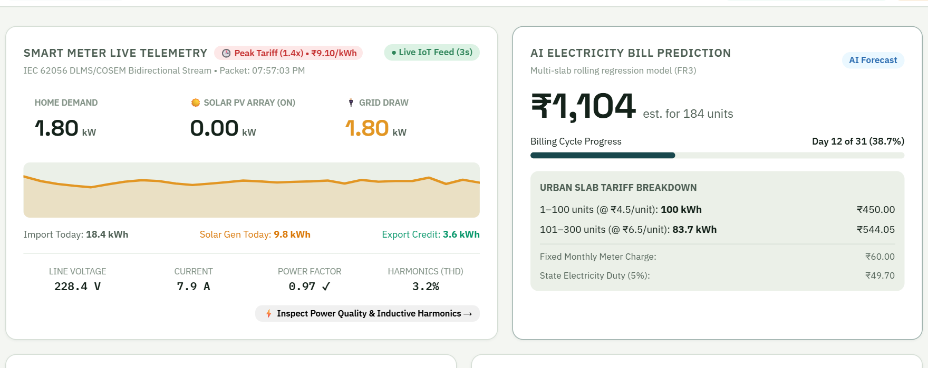
Fig. 8: Citizen dashboard with live telemetry and estimated bill

Budget Planner
A consumer enters a spending interval and the application compares the forecast with the upper limit. Suggestions are generated from rules. The appliance percentages are fixed illustrative shares, rather than readings from individual appliance sensors.
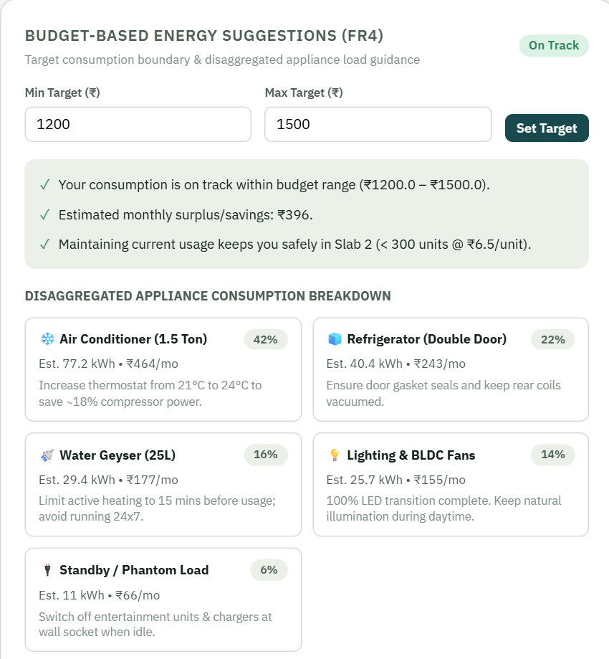
Fig. 9: Budget planner and appliance guidance using sample shares
The upper spending limit is used to decide whether the forecast is on track. When the estimate is above that limit, the response suggests a daily reduction target. These suggestions are explanatory rules and have not been evaluated as a personalised optimisation model.

Bill Verification and Complaint Tickets
An entered bill is compared with the forecast. In this captured example the Rs 1,680 sample bill is above the estimate, so the interface displays a discrepancy and a shortcut to raise a dispute. The comparison is a review aid and does not replace utility reconciliation.
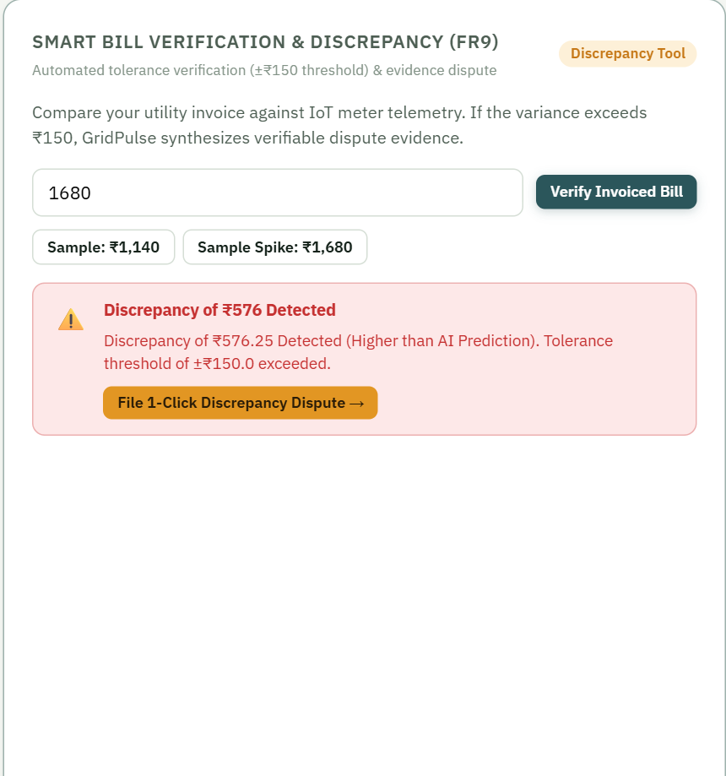
Fig. 10: Bill comparison alert for the demonstration invoice

Citizen Grievance Tickets
The ticket list displays the token, category, status and assigned support information. A complaint’s evidence flag and generated text are demonstration metadata; they do not establish a cryptographically verified meter record or an uploaded evidence package.
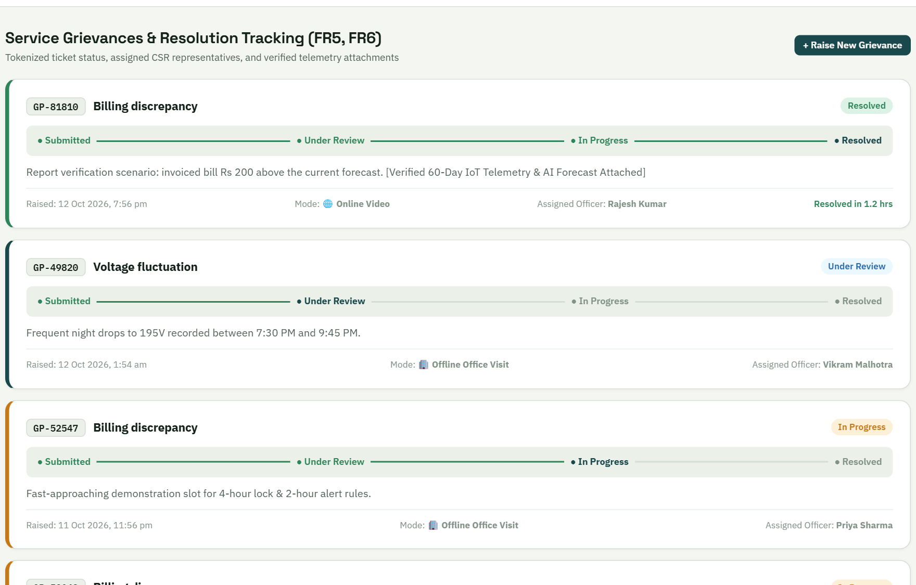
Fig. 11: Citizen grievance tickets and progress tracking
The progress indicator explains the expected support sequence. The report verification ticket was advanced through Under Review and In Progress to Resolved. Sample records and newly created test records can be viewed together in this demonstration.

Appointments and Consultation Mode
The appointments view shows the assigned support slot, online or offline mode and the lock state. The captured screen includes the approaching test appointment. A mode-change request is rejected by the backend once the four-hour limit is reached.
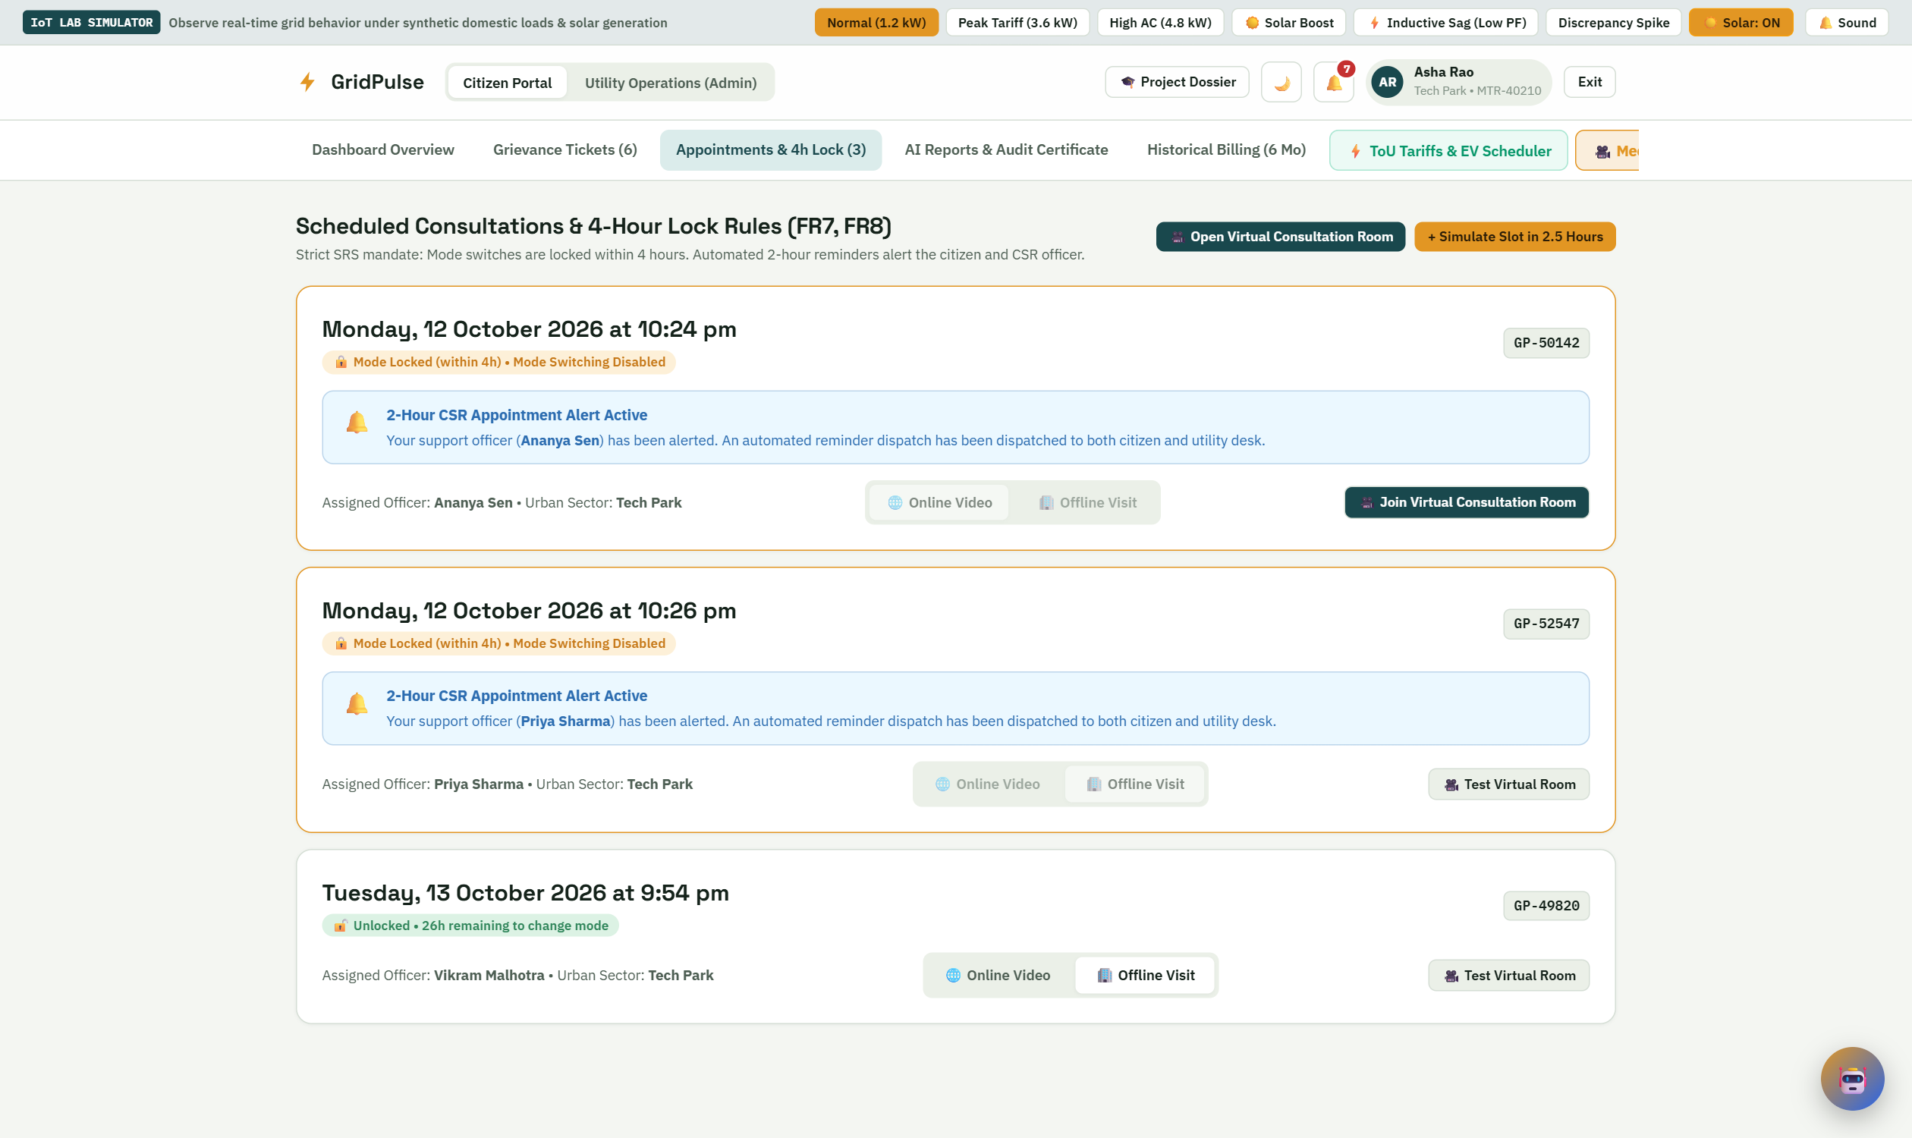
Fig. 12: Appointment list with consultation modes and locked slots

Demonstrated Scheduling Behaviour
• A new support complaint receives an appointment approximately 24 hours later.
• Offline is used when no consultation mode is supplied.
• The mode can change while more than four hours remain.
• An approaching sample appointment demonstrates the lock and reminder indicator.
An automated two-hour phone call and reliable SMS or email delivery are proposed extensions. The current simulator uses a reminder flag around 2.5 hours and does not constitute a delivery scheduler.

Consumption Reports and Billing History
The report view presents sample consumption charts and a printable household summary. Any audit grade, BEE-equivalent wording or compliance label visible in the demo interface is illustrative and has no certification status. The bill-history page contains six demonstration records and a CSV export control.
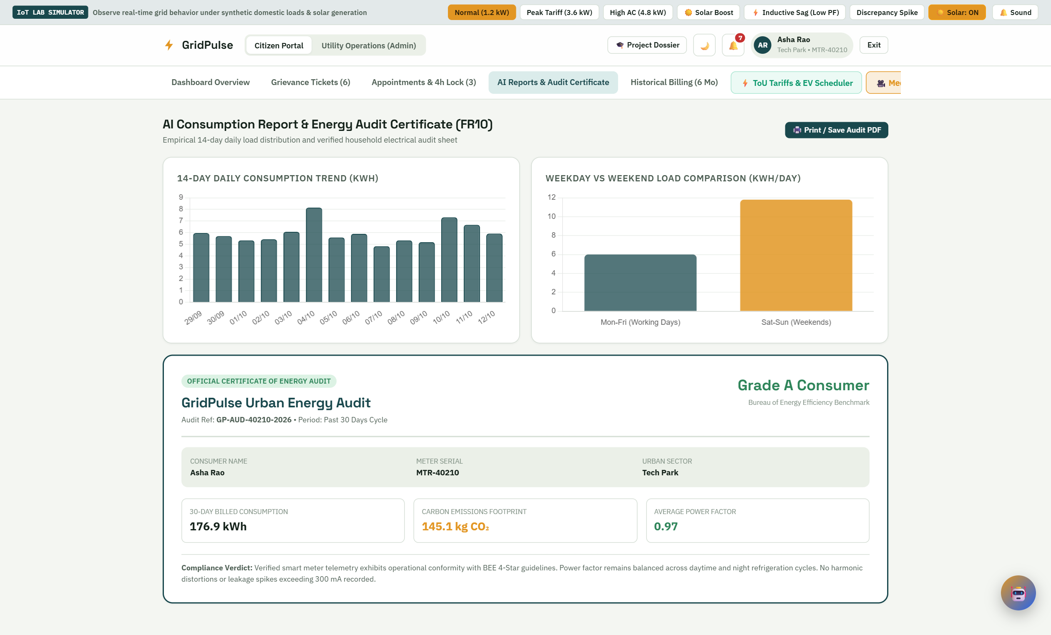
Fig. 13: Sample consumption report and printable household summary

Historical Billing Records
The history screen presents monthly units, predicted amounts, entered actual amounts and the difference between them. The six rows are fixed sample records used to illustrate comparison and export. They are not bills from a live utility account.
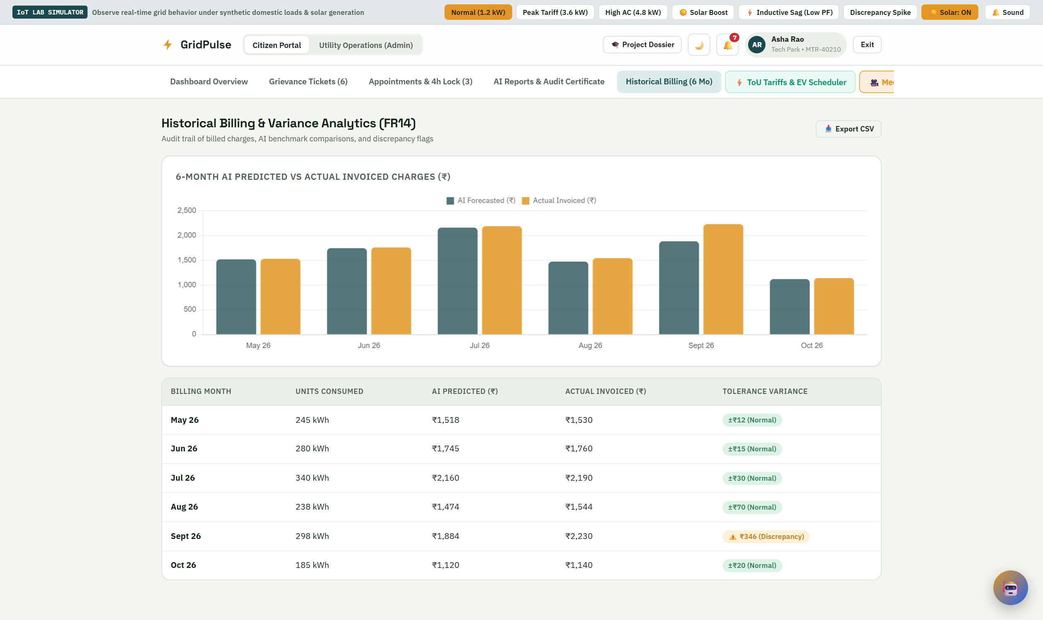
Fig. 14: Six-month sample billing history and variance indicators
A variance indicator helps the consumer identify a month to discuss with support. CSV export provides a portable record of the displayed demonstration table. A production version should load authenticated consumer-specific billing records from durable storage.

Utility Operations Portal
The operations dashboard groups complaint categories, locality demand and pending work. These screens illustrate how a utility could observe operational patterns, while the displayed demand and seeded cases remain demonstration data. Complaint totals may change as test cases are added.
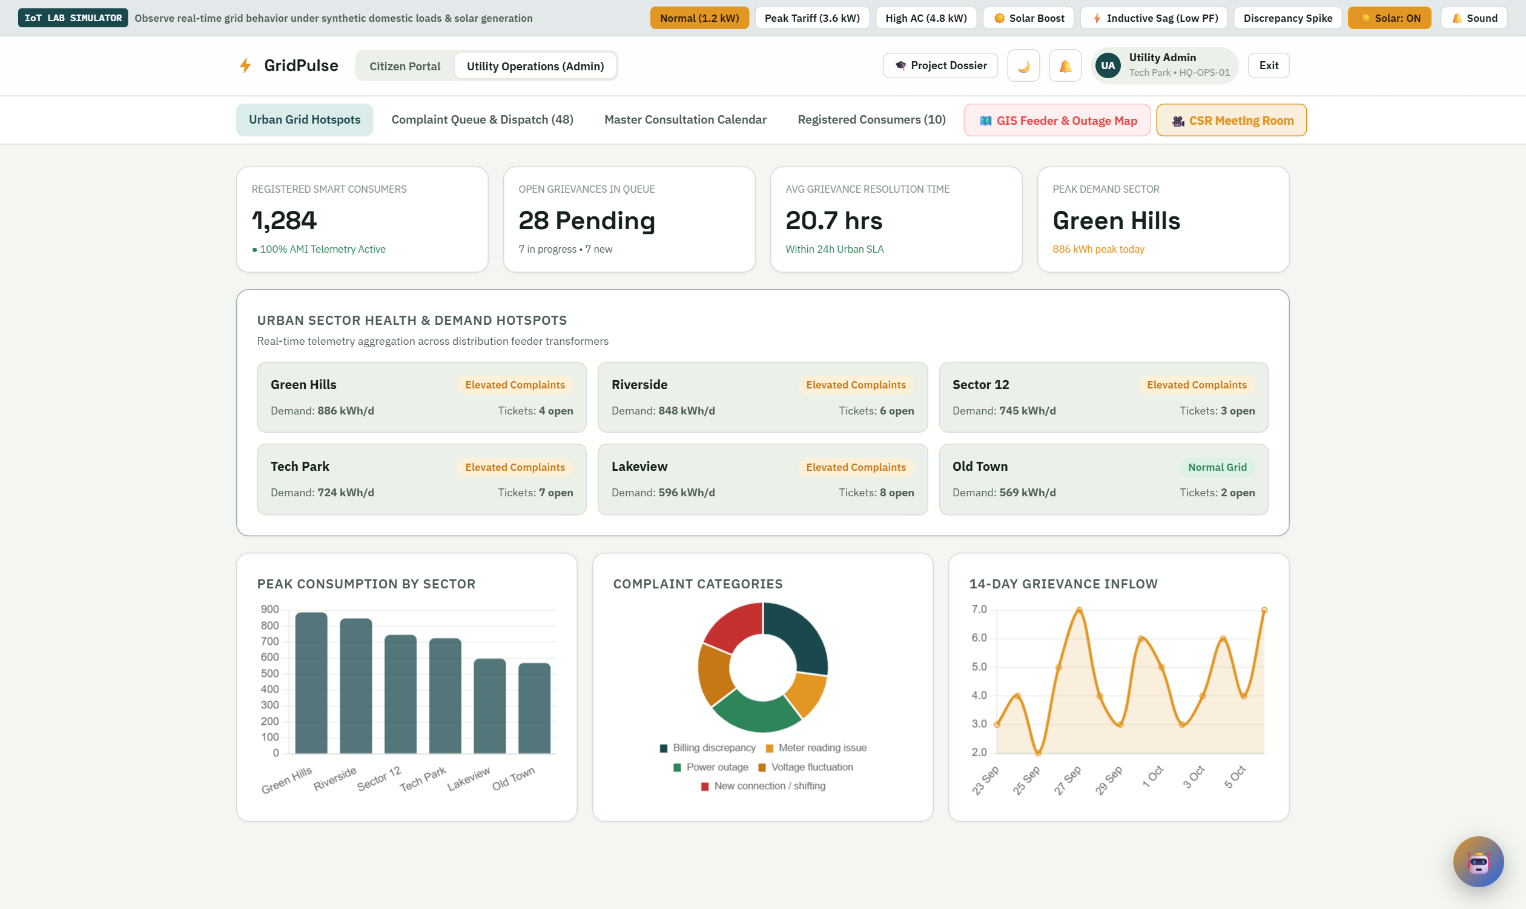
Fig. 15: Utility overview with complaint and demand analytics

Operational Use
• Review the distribution of support cases by category and locality.
• Identify pending work and support assignments.
• Compare the sample demand profiles of different urban localities.
• Open the complaint queue or calendar to inspect the associated cases.
The charts support a planning demonstration. They do not establish actual demand on a distribution network, measured city hotspots or a reduction in complaint resolution time.

Complaint Queue and Staff Dispatch
The operations queue lists support tickets with status and staff controls. It provides the case-management view corresponding to the consumer’s token. Staff reassignment and status updates are stored by the backend and notifications are added for the affected consumer.
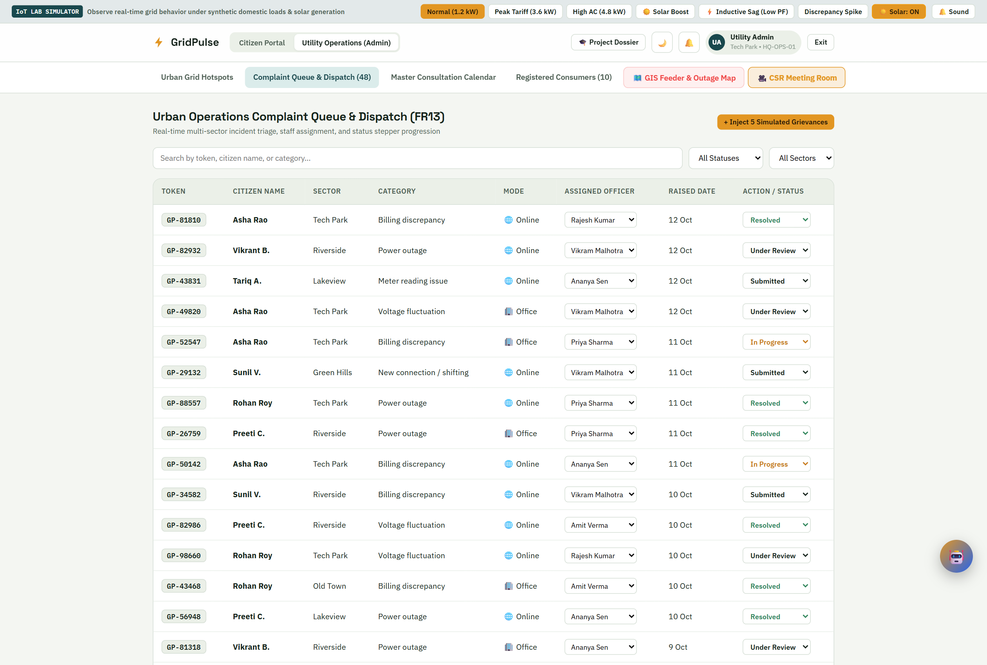
Fig. 16: Operations complaint queue and assignment controls

Traceability Improvements
The present record retains the current status and staff member. A production version should also retain an immutable event history showing who changed a case, what changed and when. Status values should be constrained to an enum and transitions validated against the intended workflow.
The current update endpoints are suitable for a local demonstration. Server-side role and ownership checks are needed before they can serve real consumer records.

Consultation Calendar and Consumer Directory
The shared calendar brings upcoming consultations into one staff view. The directory presents seeded consumer records with locality and meter details. These modules show how support workload and the consumer record can be accessed from the operations interface.
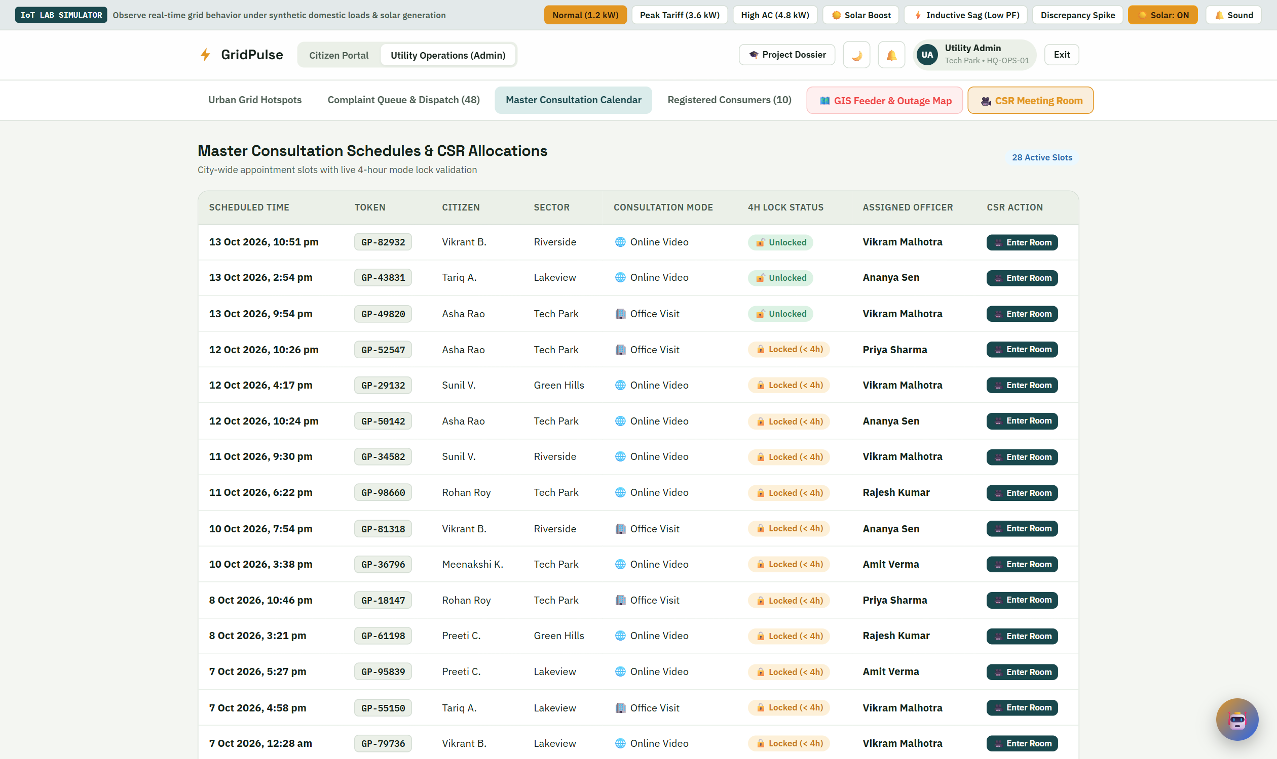
Fig. 17: Master consultation calendar for utility staff
The calendar is a consolidated view of support slots held on complaint records. Staff availability, conflict detection and reminder delivery would be added by a durable scheduling service.

Registered Consumer Directory
The directory displays consumer and meter information from the sample user collection. It illustrates the administrative context for a support request and allows the operator to review the associated locality and spending target.
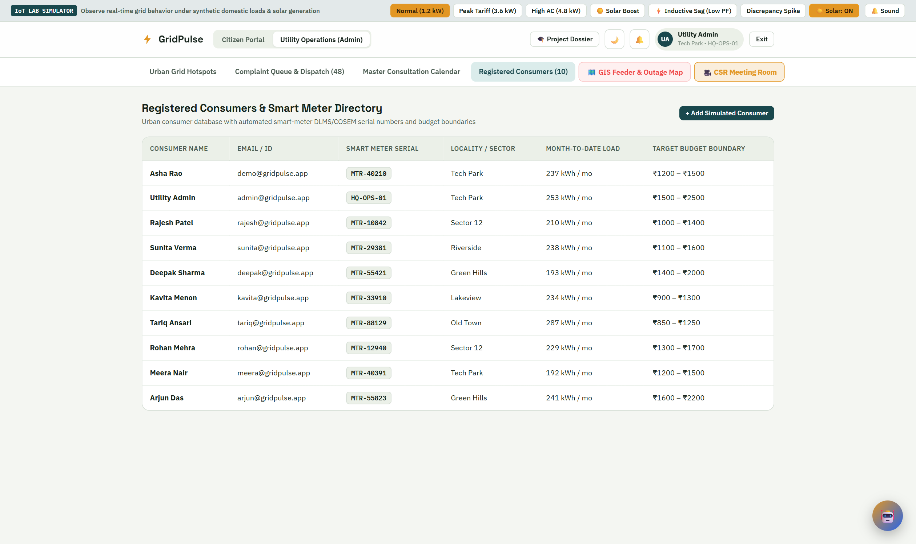
Fig. 18: Registered consumer directory using demo records
The records on this screen are demonstration consumers. Real directories should be restricted to authorised staff, with only the information needed for their work and a record of access to personal data.

Additional Smart Grid Demonstrations
The prototype also contains an illustrative feeder map and a time-of-use / EV scheduling screen. These extend the core consumer-service idea by showing locality-level assets and shifting flexible demand. The feeder locations, conditions, load values and tariff schedules are sample inputs rather than live distribution-network data.
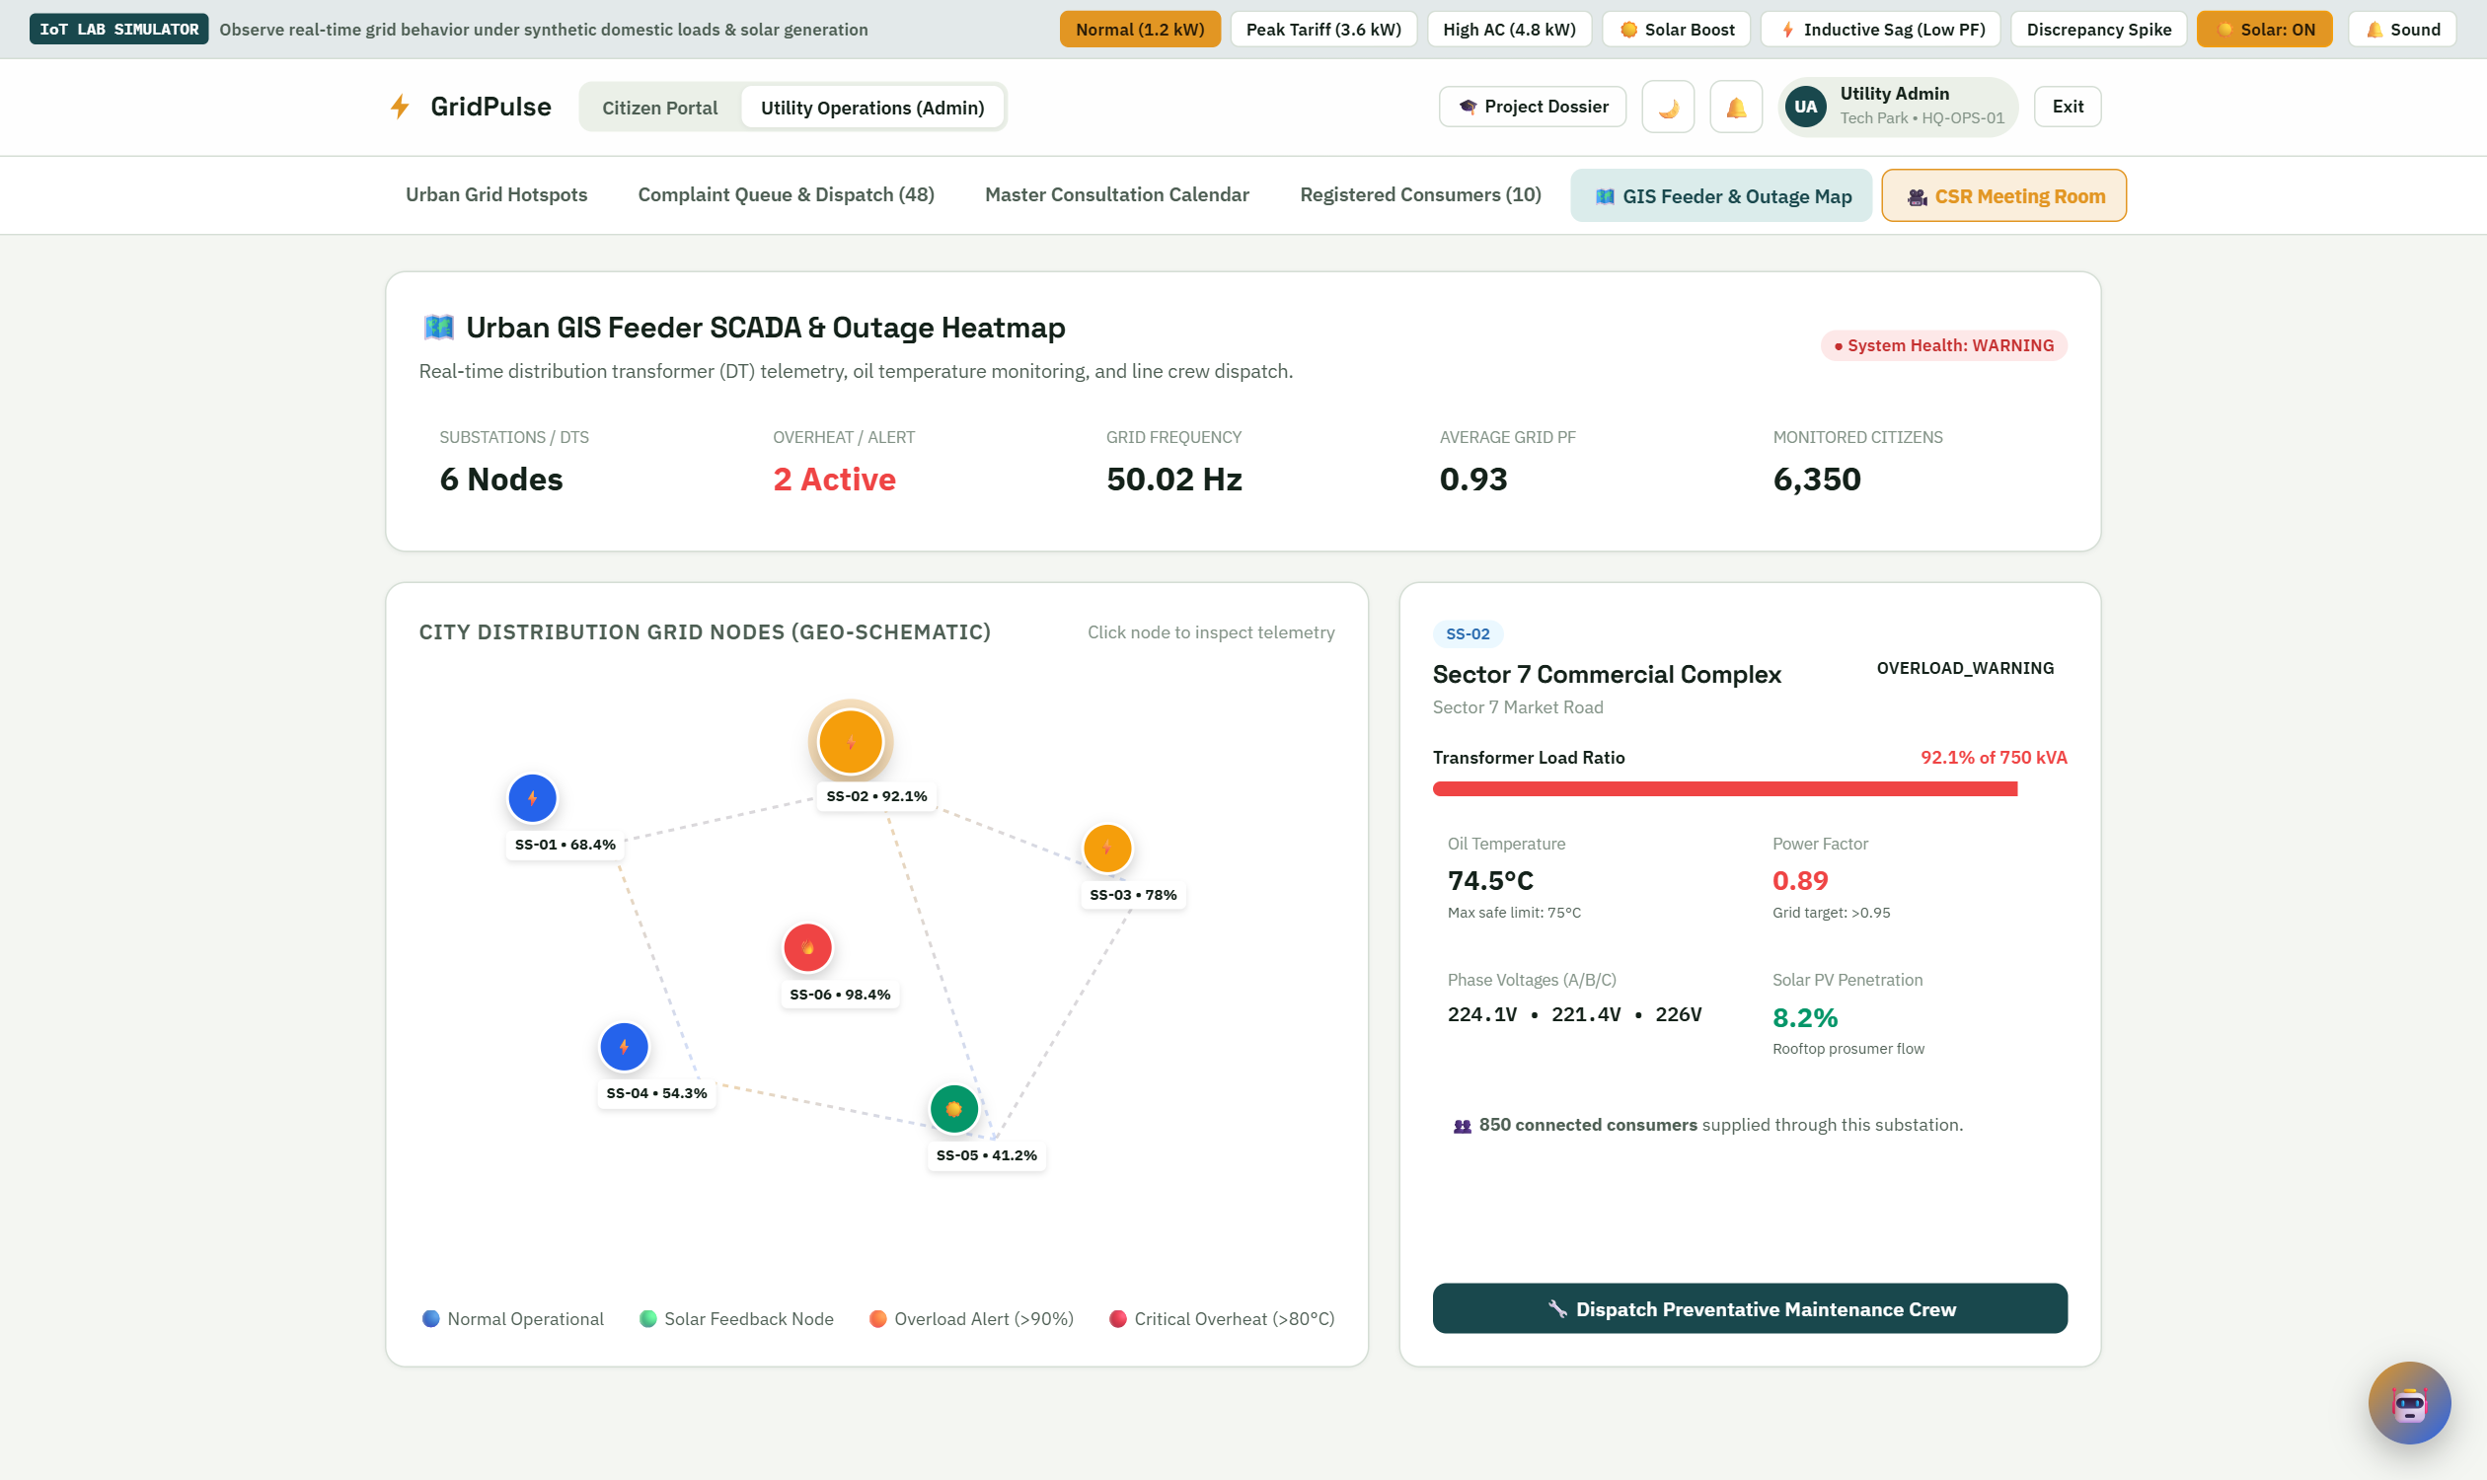
Fig. 19: Sample GIS feeder view and dispatch demonstration

Time of Use and EV Scheduling
This additional screen illustrates flexible-demand planning with sample time-of-use bands and an EV charging scheduler. It is separate from the basic slab-based monthly forecast. Displayed tariff bands are demonstration values and should be replaced by the applicable provider schedule in a real deployment.
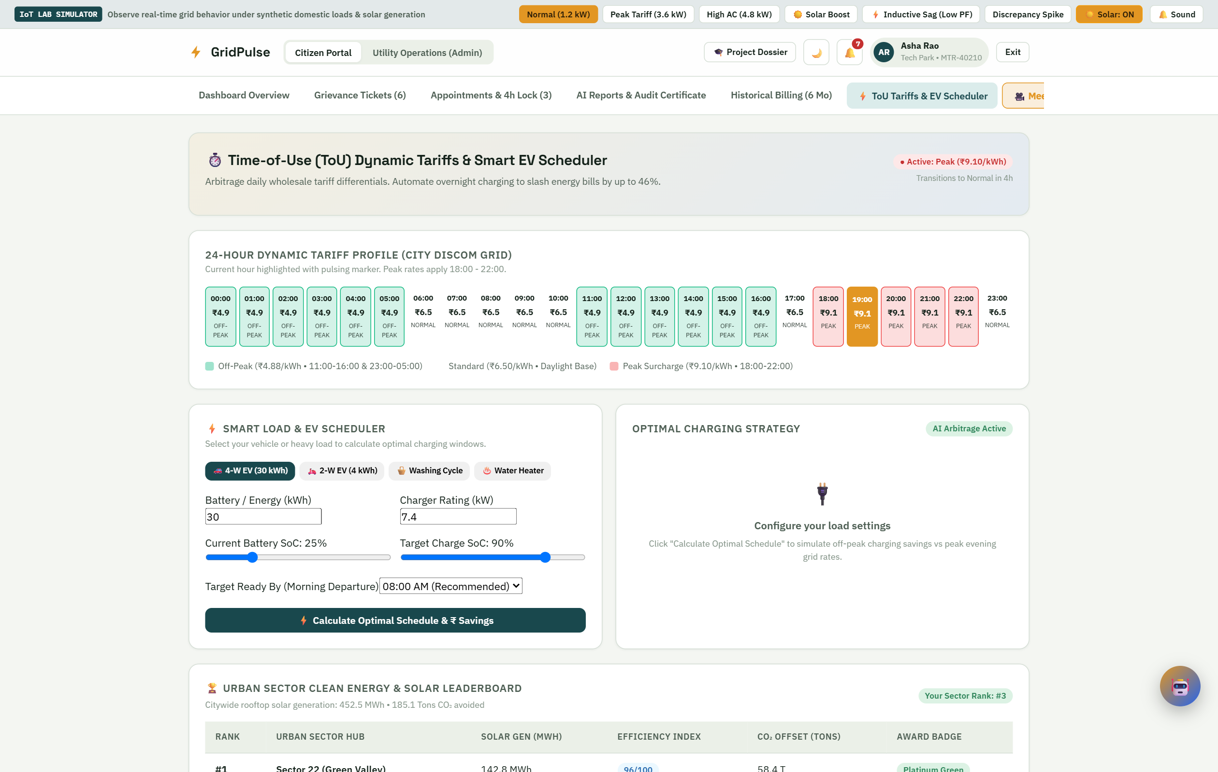
Fig. 20: Time-of-use and EV scheduling interface with sample inputs
The module demonstrates how a charging requirement can be considered alongside tariff periods. Its results are illustrative rather than a validated control schedule for a connected charger.

Test Case: Electricity Bill Discrepancy
The following scenario was executed against the running local backend on 12 October 2026 using the demo consumer. The backend was operating with its asynchronous in-memory fallback. The scenario verifies selected application rules, not utility billing accuracy.
Step | Action | Observed Result
1 | Sign in as demo citizen. | Valid credentials accepted; incorrect password returned HTTP 401.
2 | Request monthly forecast. | Estimate Rs 1103.75; projected usage 183.7 kWh.
3 | Compare a bill Rs 200 above estimate. | Variance alert returned by the verification endpoint.
4 | Create billing complaint. | Token GP-81810; Submitted status; offline default; staff and slot returned.
5 | Change mode outside the lock window. | Online mode accepted for the approximately 24-hour-away appointment.
6 | Apply review, progress and resolution updates. | Under Review, In Progress and Resolved updates accepted; resolved record retained.
7 | Create an approaching appointment. | Simulated slot within 2.5 hours marked locked.
8 | Attempt to change the locked mode. | Request rejected with HTTP 400.

Result
The executed scenario demonstrates the link from a bill variance to a support token, mode selection, case progression and the appointment lock. Complaint evidence is represented by metadata in the current model. A measured signed history and durable file attachments require further work.

Verification Results and Limitations
All 22 targeted checks in the report verification run passed. The checks cover health, login behaviour, four tariff points, the forecast response, five bill-variance cases, an invalid budget interval, complaint creation, mode changes, status updates, the simulated lock and retention of the resolved ticket.
Check | Expected Result | Observed
0 kWh | Rs 60.00 including fixed charge | Pass
100 kWh | Rs 532.50 | Pass
300 kWh | Rs 1,897.50 | Pass
350 kWh | Rs 2,328.00 | Pass
Variance Rs 0 and Rs 149 | No discrepancy | Pass
Variance Rs 150, Rs 200 and -Rs 150 | Discrepancy flagged | Pass
Budget upper bound below lower bound | HTTP 400 | Pass
Change mode more than 4 hours before slot | Accepted | Pass
Change mode within 4 hours | HTTP 400 | Pass
Resolved complaint | Retained in citizen query | Pass

Limitations of the Evaluation
The tests use deterministic rules and demonstration records. They do not measure forecast accuracy, energy savings, notification delivery, browser compatibility, accessibility, uptime or simultaneous-user capacity. The sequential complaint updates verify acceptance of the expected states; they do not prove that invalid transitions are rejected.
Security inspection found demonstration credentials and email-based identification, with incomplete backend role and ownership enforcement. The in-memory fallback is non-durable. No physical sensor, utility API, trained model or automated reminder-call provider was used in this report’s demonstration.

10. Technical Requirements (HW/SW)

Hardware Requirements
• A development computer with a modern multicore processor.
• 8 GB RAM recommended for running the frontend, backend and browser together.
• Storage for source files, installed packages and the database; additional capacity for future telemetry and evidence files.
• A desktop, laptop or smartphone with a modern browser for consumer access.
• Local network access for demonstration; reliable internet for remote hosting and external service integrations.

Software Requirements
Component | Technology Used
Frontend | React 19, Vite 8, JavaScript and CSS
Charts and icons | Chart.js and Lucide React
Backend | Python, FastAPI, Uvicorn and Pydantic
Database integration | MongoDB through Motor / PyMongo
Local fallback | Asynchronous in-memory MongoDB-compatible store
Communication | HTTP REST requests with JSON
Development tools | Code editor, Git, browser tools and API client
Runtime access | Frontend at port 5173; backend at port 8000

Future Hardware Integration
An authorised meter interface or suitably isolated sensing setup, microcontroller gateway and communication link would be needed to replace the simulator. Device readings must be calibrated and associated with the correct consumer, meter identifier and timestamps before they are used for comparisons.

11. Applications

Residential Electricity Consumers
Consumers can review recent usage, understand the current cost estimate and compare expenditure with a selected budget. A support ticket and appointment provide a visible path for discussing a billing query.

Utility Consumer Support Centres
A shared queue, staff assignment and consultation calendar can help staff organise support cases. The token links the consumer-facing status view with the internal handling record.

Housing Societies and Residential Complexes
With measured data and authorised access, the system could help residents understand individual usage and support facility managers in comparing common-area consumption over time.

Educational Campuses and Laboratories
The simulator offers a teaching demonstration of telemetry, forecasting baselines, tariffs, REST APIs and consumer-service workflows. Students can inspect the effect of changing tariff inputs and appointment rules without connecting to a live utility.

Urban Energy Planning Demonstrations
Aggregate complaint and demand views can illustrate how localities differ in support needs and energy use. A real application would require reliable source data, permission to aggregate it and clearly defined metrics.

Consumer Awareness and Flexible Demand
Budget guidance and time-of-use examples can explain how appliance schedules affect expenditure. The prototype’s suggestions and EV screen support this discussion; actual savings depend on measured behaviour and the applicable tariff.

12. Future Scope
• Physical meter integration: replace simulated readings with calibrated, timestamped data from an authorised interface.
• Validated forecasting: train and compare models with a clear baseline, separate test data and error metrics such as MAE and MAPE.
• Utility tariff configuration: support billing cycles, provider-specific slabs, approved charges and versioned tariff rules.
• Secure authentication: hash passwords, issue signed sessions, enforce backend roles and verify record ownership.
• Durable evidence: store consumption snapshots, bill documents and timestamped complaint event history.
• Reliable appointments: use staff availability, avoid slot conflicts and schedule the intended two-hour reminder.
• External notifications: connect SMS, email and customer-service calling, with retries and delivery logs.
• Regional language support: add Marathi and Hindi and test accessibility with consumers.
• Measured appliance guidance: use appliance sensors or validated disaggregation models instead of fixed shares.
• Hosted operations: add HTTPS, monitoring, backups, retention controls and recovery procedures.
The immediate priority is to connect the demonstrated workflow to reliable data and enforce access control. Advanced AI features and city-scale analytics should follow validation of the measurement, tariff and support foundations.

13. Conclusion
GridPulse demonstrates an integrated approach to an urban electricity-service problem: consumers need clearer usage information and an easier way to obtain support, while utility staff need a shared view of complaints and appointments. The web prototype brings simulated consumption, a transparent monthly estimate, spending targets, bill verification and token-based assistance into one application.
The implementation uses React, FastAPI and a MongoDB-compatible layer. The current forecast is a seven-day-average baseline followed by a slab calculation. A variance of Rs 150 or more triggers a review alert. The complaint workflow returns a token and appointment, defaults to offline support and blocks consultation-mode changes within four hours of the slot. Operations screens demonstrate support assignments, locality patterns and consultation planning.
The targeted local verification run passed all 22 checks, including tariff boundaries, bill-variance boundaries, complaint creation and the appointment lock. These results establish that selected software rules behave as described on sample data. They do not establish measured forecasting accuracy, actual utility bill errors or deployed service quality.
The project therefore meets the Urban System theme as a basic working demonstration that connects observed patterns with a service improvement. Physical sensing, secure access, persistent records, trained prediction and reliable external reminders will make the next version more suitable for real use. The present prototype provides a clear foundation for that work.

14. References
[1] Wang, Y., Chen, Q., Hong, T. and Kang, C. (2018). Review of Smart Meter Data Analytics: Applications, Methodologies, and Challenges. arXiv:1802.04117. https://arxiv.org/abs/1802.04117
[2] Arora, S. and Taylor, J. W. (2014). Forecasting Electricity Smart Meter Data Using Conditional Kernel Density Estimation. arXiv:1409.2856. https://arxiv.org/abs/1409.2856
[3] Bansal, A., Rompikuntla, S. K., Gopinadhan, J., Kaur, A. and Kazi, Z. A. (2015). Energy Consumption Forecasting for Smart Meters. arXiv:1512.05979. https://arxiv.org/abs/1512.05979
[4] Kelly, J. and Knottenbelt, W. (2015). The UK-DALE Dataset, Domestic Appliance-Level Electricity Demand and Whole-House Demand from Five UK Homes. Scientific Data, 2, 150007. https://doi.org/10.1038/sdata.2015.7
[5] Murray, D., Stankovic, L. and Stankovic, V. (2017). An Electrical Load Measurements Dataset of United Kingdom Households from a Two-Year Longitudinal Study. Scientific Data, 4, 160122. https://www.nature.com/articles/sdata2016122
[6] Maharashtra State Electricity Distribution Co. Ltd. Web Self Service and Consumer Portal. Billing history, service requests, complaints and consumption estimation. https://wssebill.mahadiscom.in/wss/images/WssHelp/Web_Self_Service_%28WSS%29.htm ; https://www.mahadiscom.in/en/consumer/consumer-portal-sitemap/

References Continued
[7] React. Official documentation for components, state and application interfaces. https://react.dev/
[8] FastAPI. Official framework documentation and API guidance. https://fastapi.tiangolo.com/
[9] MongoDB. Database Manual. https://www.mongodb.com/docs/manual/
[10] Project requirements document. Urban Smart Electricity Consumer Assistance and Energy Monitoring System. Functional requirements FR1-FR14 and non-functional requirements NFR1-NFR12. Supplied for IDEA LAB-V.
[11] GridPulse project implementation. React frontend and FastAPI backend, including tariff_engine.py, billing.py, complaints.py and appointments.py. Local source inspected and demonstrated on 12 October 2026.
[12] GridPulse report verification run. Twenty-two targeted checks on tariff calculations, bill-variance boundaries, complaint processing and appointment locking. Executed locally on 12 October 2026 with demo data.
Online references accessed on 12 October 2026. The literature review uses verified publications and open research records; the project requirements and implementation are the primary sources for the demonstrated workflow.

