**Step 1. Updating IP**

In the cyber_web folder you should update the attack.html file.

At the line 108 where it says: url: 'http://**192.168.1.100**:8080/execute_attack';

You should rewrite the IP address according to your client device.

(Don’t change the port 8080)



**Step 2. Updating IP**

In the cyber_web folder you should update the attack.py file.

At the line 68 where it says: client_socket.connect(('**192.168.1.102**', 12345))

You should rewrite the IP address according to the target device.

(Don’t change the port 12345)

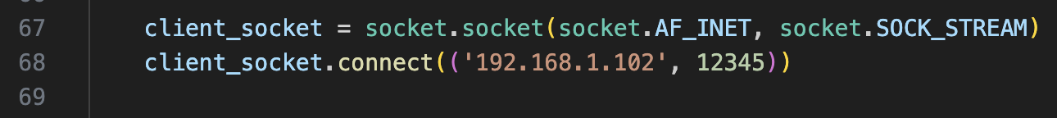

**Step 3. Installing Required Things**

You should run the commands below on your client device (terminal).

(One at a time)

$ pip3 install -r requirements.txt

$ python manage.py makemigrations

$ python manage.py migrate

**Step 4. Running the Application**

Type the command below to run the server on your client device’s browser.

​​$python manage.py runserver

**Step 5. Open a new tab http://localhost:8000**

**Step 6. Updating IP of server.py**

In the server.py file you should update “API Endpoint”.

At the line 8 where it says: url: 'http://**192.168.1.100**:8080/execute_attack';

You should rewrite the IP address according to your client device.

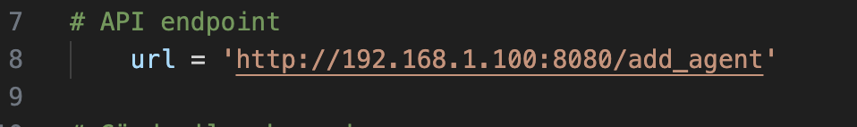

**Step 7. Updating Port Number of Agent**

In the server.py file you should update port number.

At the line 12 where it says: 'port': 9091;

You should write an unique port number which is not using from another agent.



**Step 8. Running server.py**

First place the server.py file to a directory on the target device and know the path to the server.py so you can write it when needed.

On the server(target) machine, create a systemd service to ensure the server script runs on boot.

Type:

$ sudo nano /etc/systemd/system/server.service

Then nano opens a server.service file for you.

Type:

[Unit]

Description=Start Server Script

After=network.target

[Service]

ExecStart=/usr/bin/python3 /path/to/server.py

WorkingDirectory=/path/to/

StandardOutput=inherit

StandardError=inherit

Restart=always

User=root

[Install]

WantedBy=multi-user.target

Replace /path/to/ with the actual path where server.py is located.

Reload the systemd daemon and start the service:

Type:(one at a time)

$ sudo systemctl daemon-reload

$ sudo systemctl start server.service

$ sudo systemctl enable server.service

After these commands are executed, your server.py should run on boots everytime.

You can check it by typing: “$ sudo systemctl status server.service”

Refresh the dashboard page and you should be good to go. If you don’t see the agent for the target device, try running this command: “$ sudo systemctl restart server.service”

(While the “python manage.py runserver” is active)