

Co-Ops

Nakarin Srijumrat, Patrice Delley, Luan Maliqi, Julia Orminska

2019

Manual

**Vector Racer**



Contents

1 Setup 2

1.1 Setup via Command Line 2

1.1.1 Server 2

1.1.2 Client 2

1.2 Lobby 3

1.2.1 Chat 4

2 Game 6

2.1 Game concept 6

2.2 Finishing a Lap 7

2.3 Playing field 8

2.4 Start of the game 9

2.5 Playing the game 10

2.6. Player leaves the roadway 11

2.7 End of the game 11

# 1 Setup

## Setup via Command Line

### 1.1.1 Server

First insert the path to the Vector Racer.jar into the command console. Then run it adding “server” and the port number 50505 as arguments:

*C:\ (path) java -jar “Vector Racer.jar” server <portNumber>*

### 1.1.2 Client

Insert the path to the Vector Racer.jar into the command console. Then run it adding “client”, the IP address, where the server is located, the port number 50505 as well as the desired username, as arguments.

*C:\ (path) java -jar “Vector Racer.jar” client <ip>:<portNumber> <desiredUsername>*

The client automatically establishes a connection to the server. As soon as you are connected the game will start in practice mode and you’re free to join a lobby.

## Lobby

Use the Menu Bar in order to join or create a lobby. Upon selecting Join Lobby… you will be prompted to join an existing lobby using a dropdown menu. You can also type the name of lobby manually.

If a manually typed in lobby with that name does not exist yet, a lobby will be created with said name and the player will automatically join the recently created lobby.

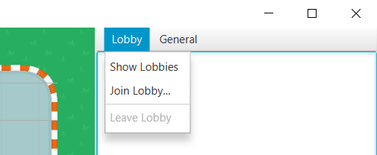

Figure 1: Menu Bar

When joining a lobby, the game remains in practice mode until all players are toggled ready using the corresponding button located below the chat.

The race starts when all players are ready.

### Chat

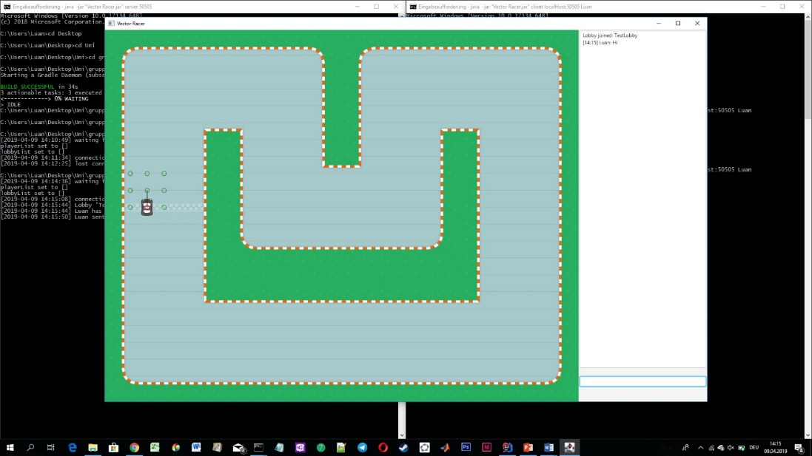

1

2

Figure 2: Game screen

The chat window is located on the right side of the game screen. The messages of all players in the chosen lobby are visible in the upper area of the window (1). Below that you can type your text in the input panel (2) and send it by pressing the enter key. This message is visible for all players in the same lobby.

The attempt of sending a message while not in a lobby results in an error message.

**Chat commands:**

To send a direct message to a specific player:

*/dmsg <recipientUsername> <message>*

To change the username:

*/nick <desiredUsername>*

To logout:

*/lout*

To display the current ping:

*/ping*

To force-start a race regardless of lobby member readiness:

*/race*

# 2 Game

## 2.1 Game concept

## 

3

2

1

Figure 3: Playing field and movement

Vector Racer is a competitive, turn-based racing game, where each player controls one vehicle.

The movement of a racer is defined by a grid-system. Each turn, the player has the possibility to choose one of nine vertices (2), which are given by the game. Depending on the selected vertex, the new vertices are calculated, and the player is again given the choice between nine vertices.

The speed of the vehicle is outlined by two-dimensional vectors (3).

The race is two laps in length.

The goal of the game is to finish a race ahead of other racers or rather to complete a circuit with a minimal number of turns.

Two to four players can play Vector Racer, choosing the most strategic path to be the first across the finish line.

## 2.2 Finishing a Lap

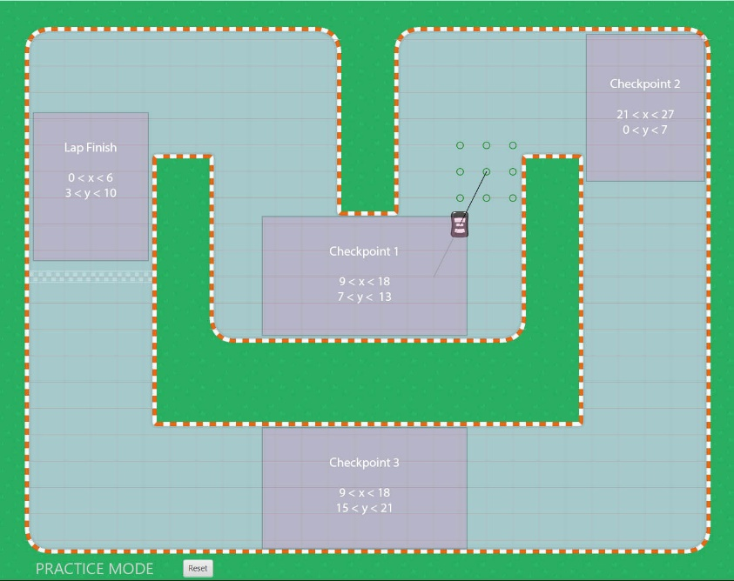

Figure 4: Checkpoints

For a lap to be valid, all 3 checkpoint areas must be entered in the given order before entering the lap finish zone.

## 2.3 Playing field

1

Figure 5: Playing field

The two-dimensional playing field consists of a racetrack with a finish line (1), which signals the end or the start of a lap.

The game is played from top-down view.

The course outlines feature bends ranging from sharp to wide curves.

## 2.4 Start of the game

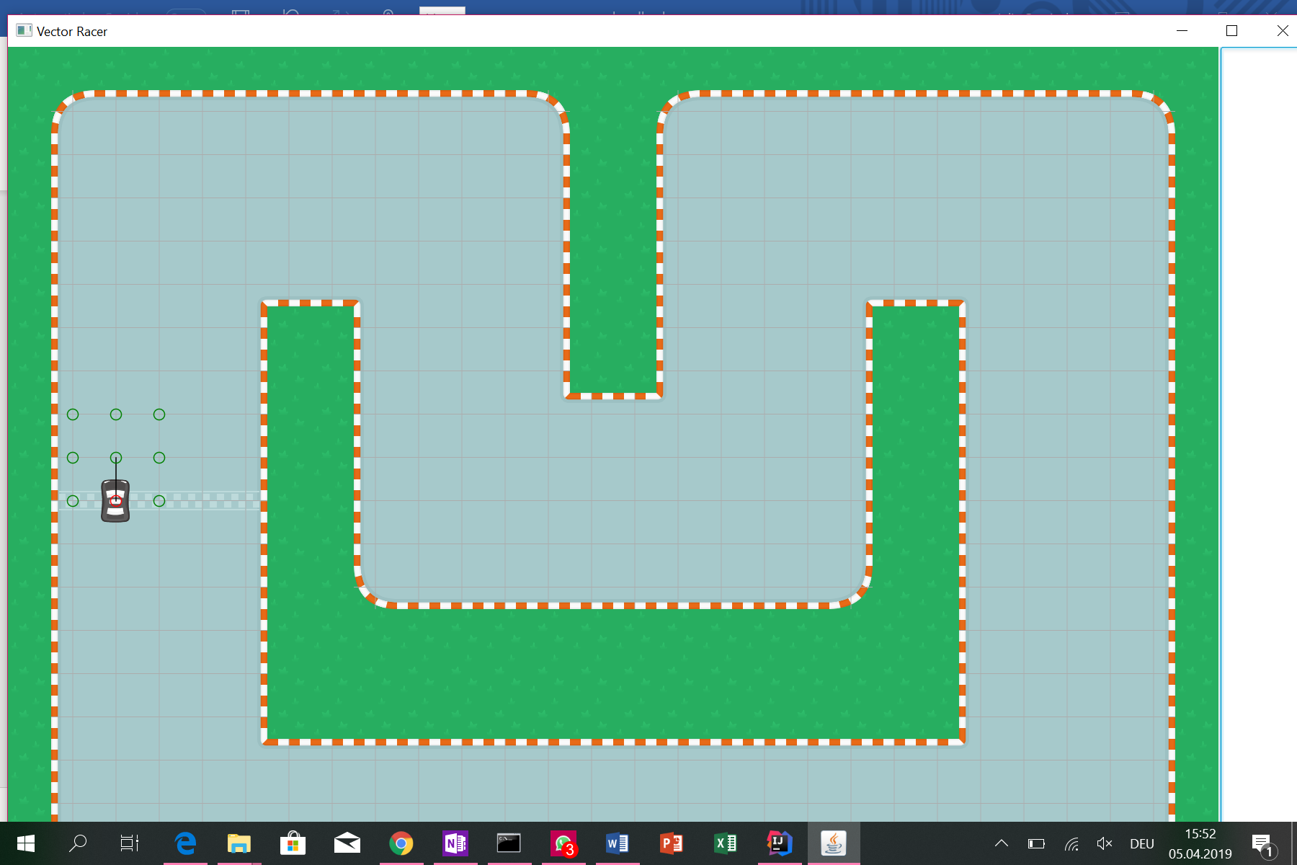  
  
Figure 6: Starting the game

1

Each player starts the race from the start/finish line (1).

## 2.5 Playing the game

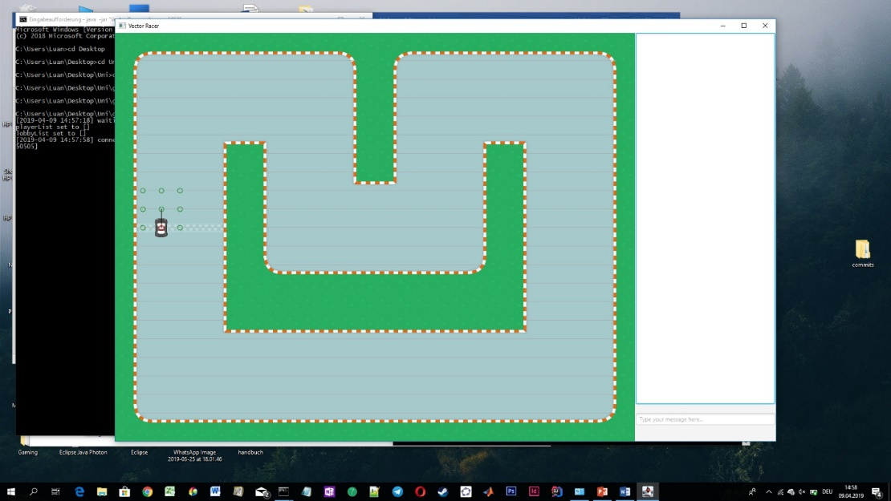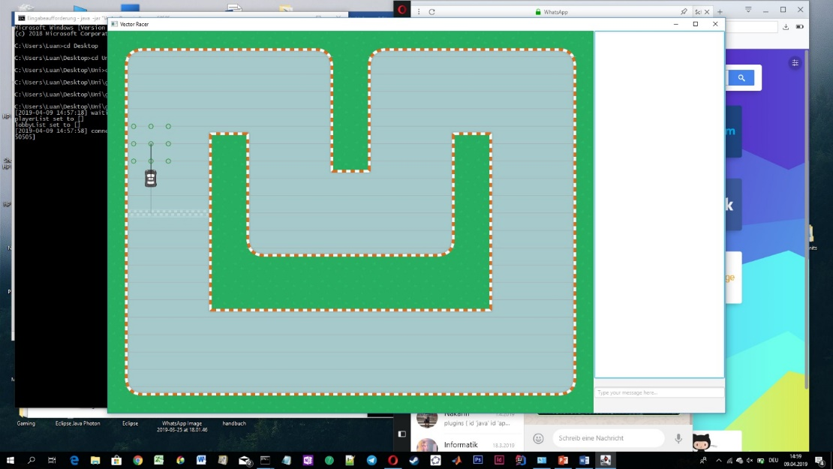

5

4

2

3

1

Figure 7, 8: Movement

In the first round the players select one of eight points (1), which are given by the game. The chosen point (2) represents the possible position of the own vehicle in the next turn.

After every player has made a choice, the vehicles appear at the selected points.

The next round begins and new nine points (3) are up for the election. Based on the covered distance in the previous turn (4) the game defines new points the player can reach. This is accomplished by the addition of that distance as a vector to the current position (5). The endpoint of the vector represents a possible position to get to. The remaining points stems from adjacent points of the endpoint on the grid.

## 2.6. Player leaves the roadway

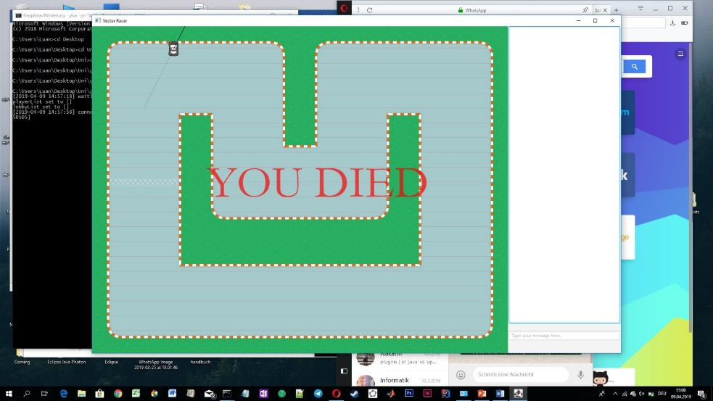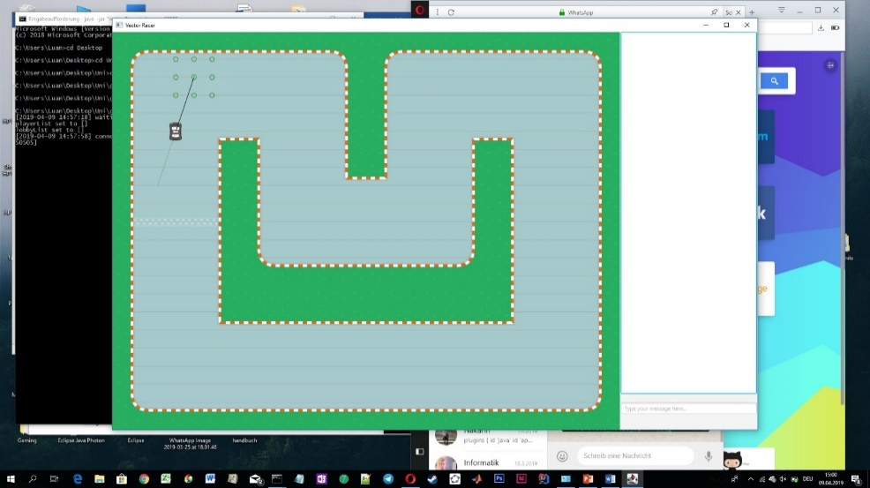

Figure 9, 10: Crossing the road line

Not being able to select a vertex located on the track results in disqualification.

## 2.7 End of the game

As soon as the last player reaches the finish line in the first lap, the game ends and a ranking will be displayed.