66130500059 Pawarit Samriang
INT305 Lab 12 Query

- Download Lab12_Query.zip and unzip the file
- Open a terminal and change directory to the folder “Lab12_Query” and run “npm install”
cd Lab12_Query
npm install

- Open VS Code, the file structure of Lab 13 as follows:
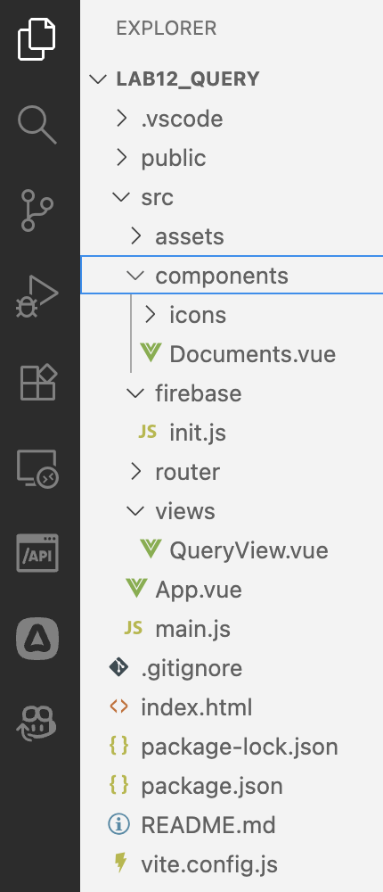

- Copy your init.js from Lab 11 and paste it in src/firebase/init.js

// Import the functions you need from the SDKs you need
import { initializeApp } from "firebase/app";
// TODO: Add SDKs for Firebase products that you want to use
// https://firebase.google.com/docs/web/setup#available-libraries
import { getFirestore } from "firebase/firestore" ;

// Your web app's Firebase configuration
const firebaseConfig = {
apiKey: "",
authDomain: "",
projectId: "",
storageBucket: "",
messagingSenderId: "",
appId: ""
};

// Initialize Firebase
const app = initializeApp(firebaseConfig);

// init firestore service
const db = getFirestore(app)

export default db

- Open src/App.vue, the source code is shown below:
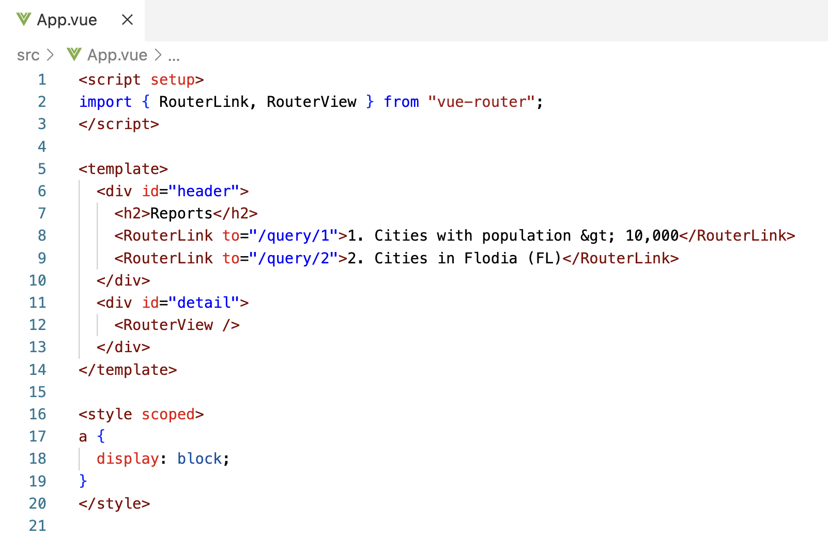

You can add more queries using <RouterLink> with dynamic route matching with Params as “/query/:id”.

- The route path /query will call the component QueryView.vue in the folder “src/views”
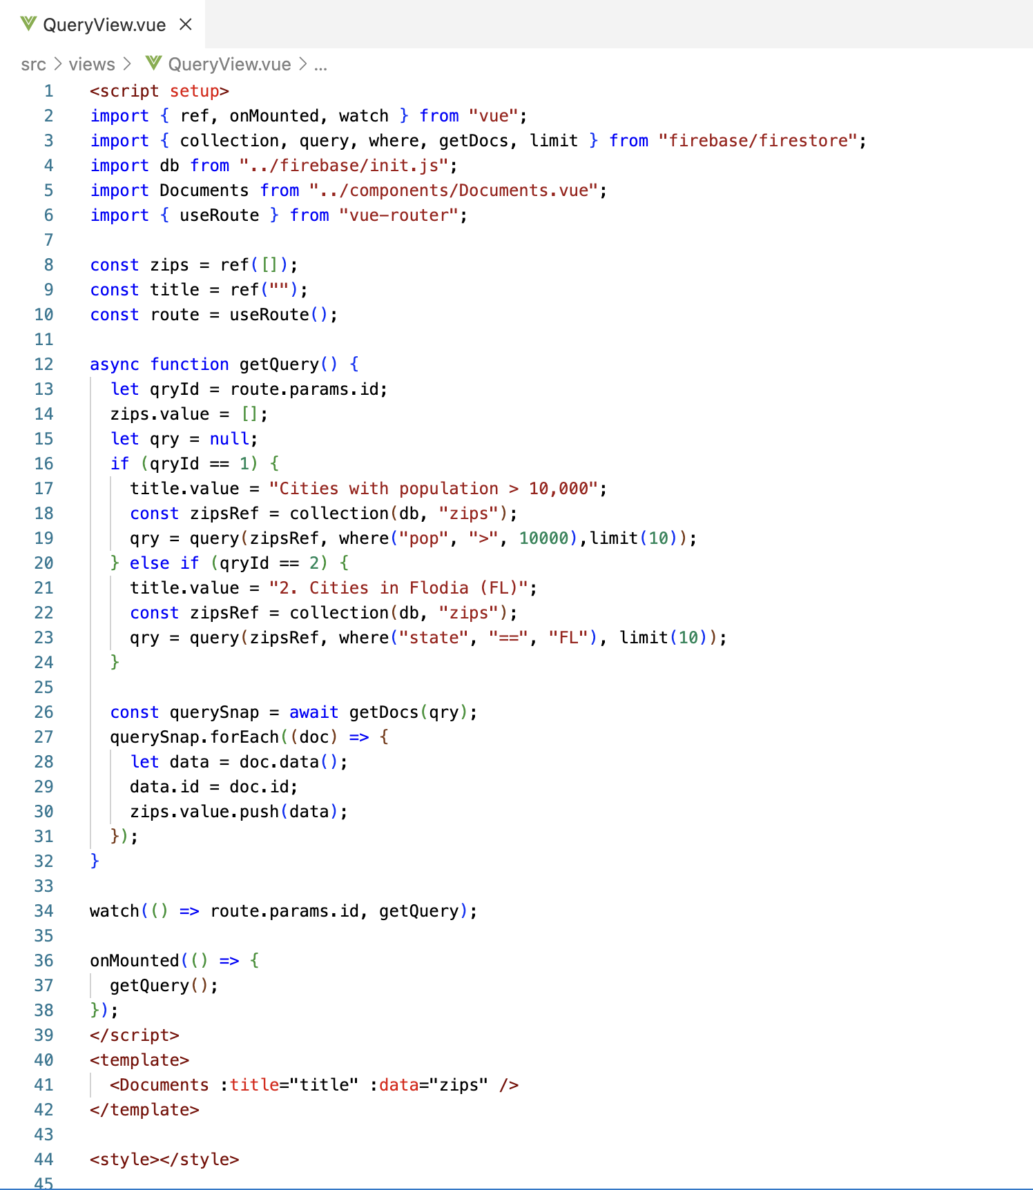

- Open src/components/Documents.vue, the source code is shown below:
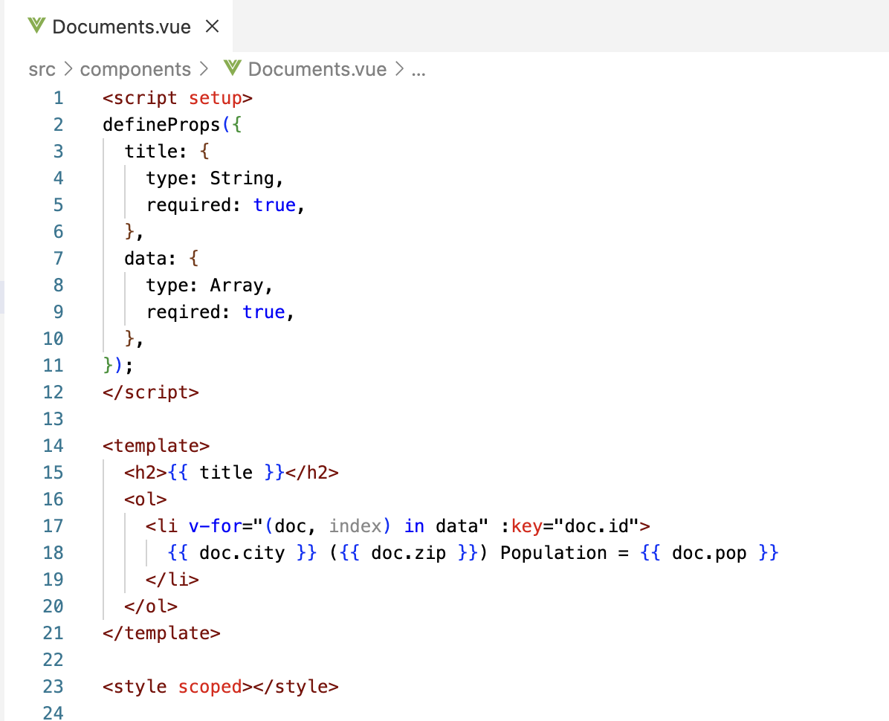

- Run the project.

$ npm run dev

Output
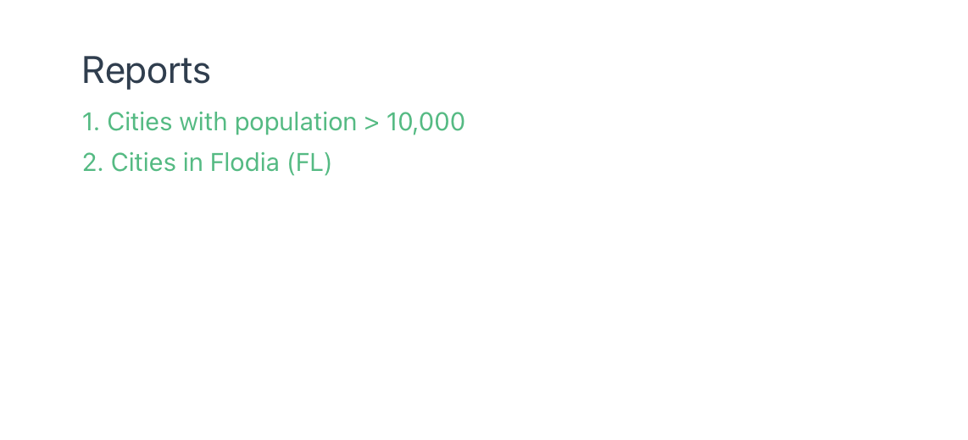

Report 1
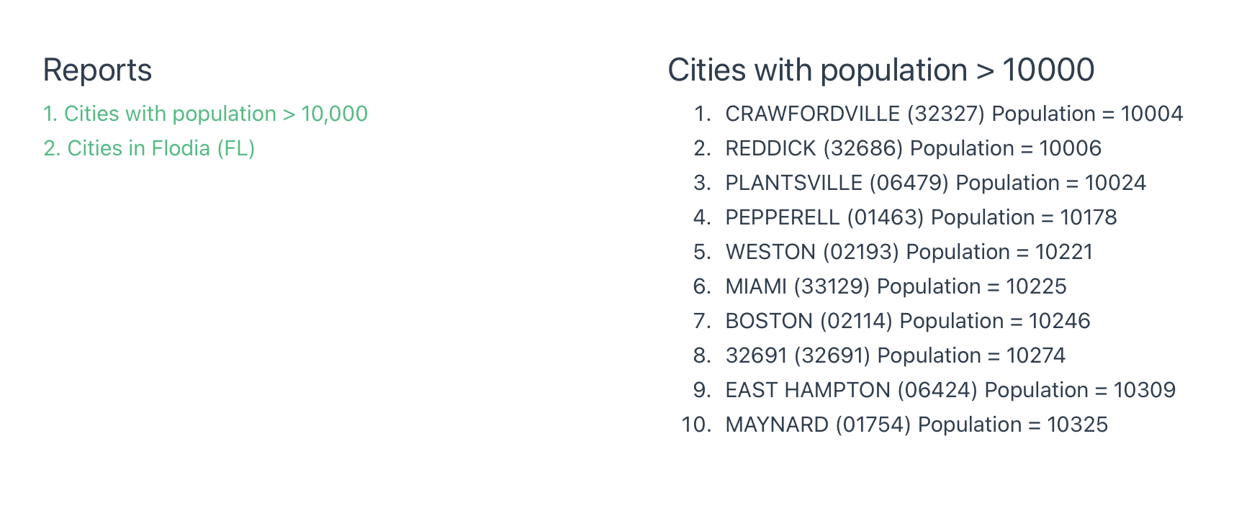

Report 2
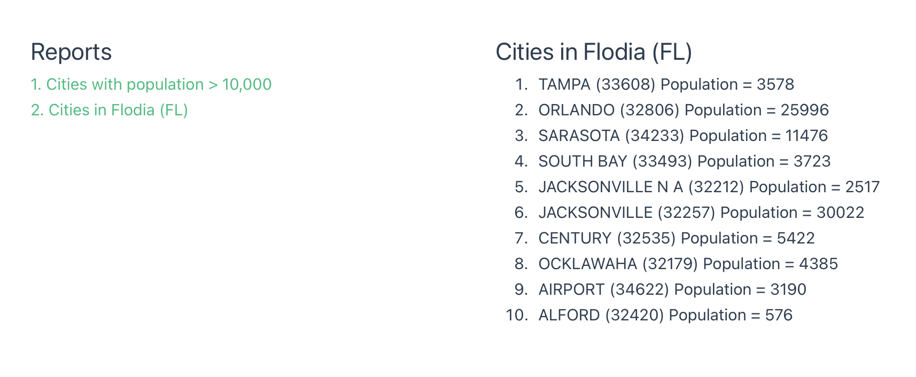

- Modify “src/App.vue” and “src/views/QueryView.vue” in order to retrieve data for the following queries: (Capture your output and Query source code for each report)
  - [Report 3] List zips in DC with population > 40000.
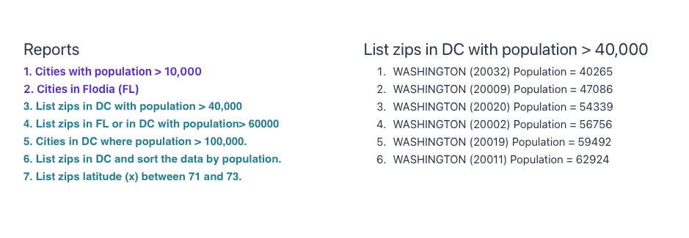

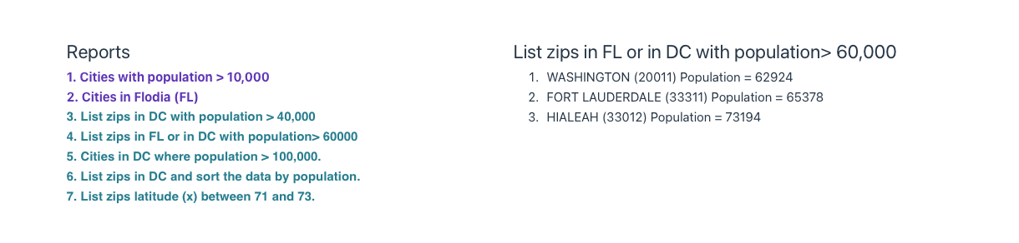
  - [Report 4] List zips in FL or in DC with population> 60000
  - [Report 5] List zips in DC or cities with population > 100000.
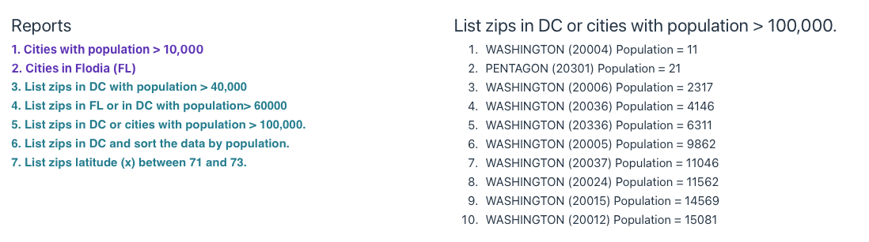

  - [Report 6] List zips in DC and sort the data by population.

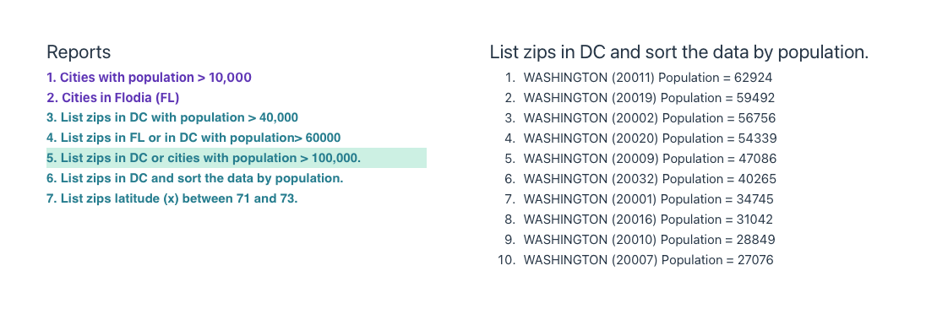
  - [Report 7] List zips latitude (x) between 71 and 73.

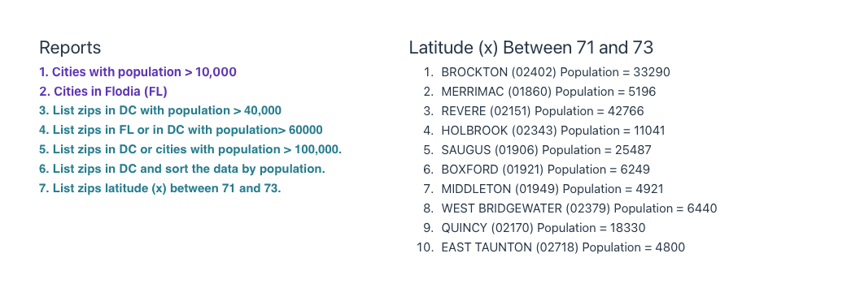
- To submit your work:
  - Copy the Lab12_Query.docx to the folder “Lab12_Query”.
  - Remove the folder “node_modules”
  - Rename the Lab12_Query to xxxxxxxxxxx
  - Compress it as xxxxxxxxxxx.zip.
  - Upload the zip file to LEB2.

