备注：此份配置示例针对Windows操作系统，MAC OS大部分应该是类似的（所有的cmd均使用对应的sh执行即可）

**一：启动Zookeeper**

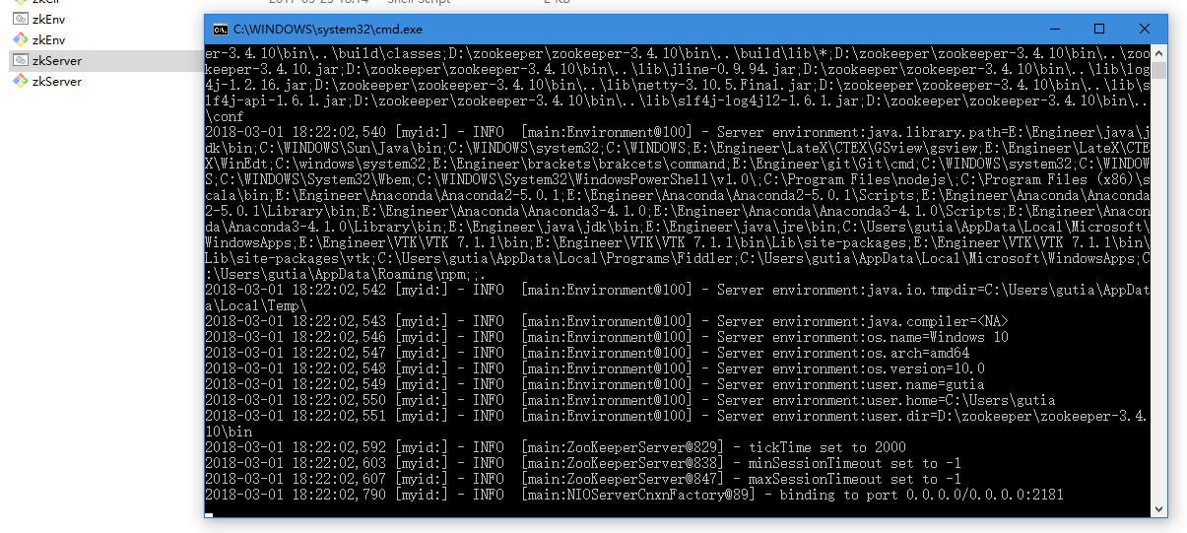

**二：启动pinpoint-service Bootstrap下的provider.java**

当出现以下内容时注册成功

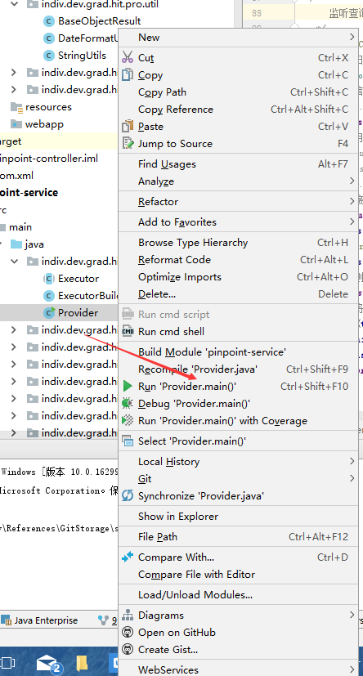

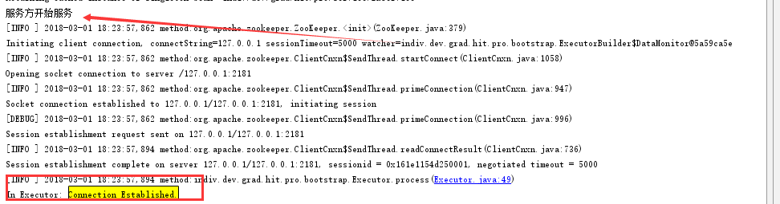

(p.s. In Executor： Connection Established 可能看不到，此时需要把之前关闭的log4j配置文件打开，

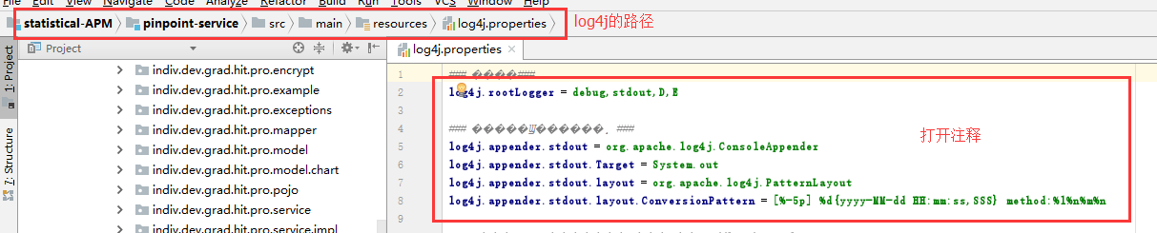

**三：当完成以上步骤时，基于Dubbo的服务端已经成功注册到Zookeeper上。接下来，将前端代码部署到pinpoint-web中**

注意：此时需要单机已有相应的Node、Npm和Anguar CLi环境

3.0 查看当前单机是否当前环境。 在CMD中分别键入以下命令

**Node: node -v (https://nodejs.org/zh-cn/)**

**Npm: npm -v**

**Angular cli: ng -v (https://github.com/angular/angular-cli/wiki)**

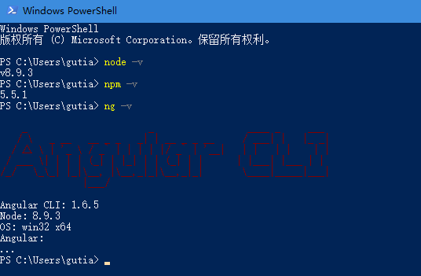

3.1． 进入terminal窗口，切换当前目录至statistical-web

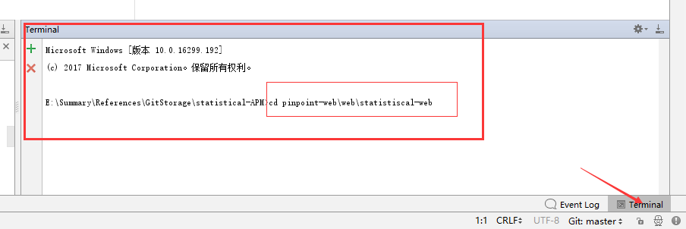

3.2 将pinpoint-web\web\statistical-web 下的前端代码部署到pinpoint-controller 下

键入命令: ng build. 该命令将会将前端代码部署到指定(.angular-cli.json中的outDir指定)目录下。

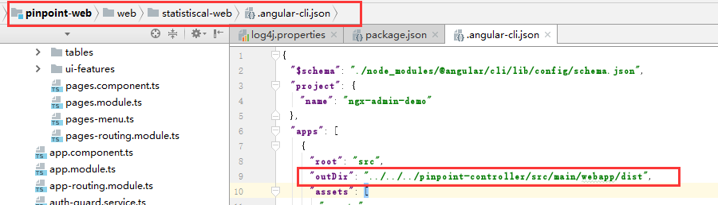

a):

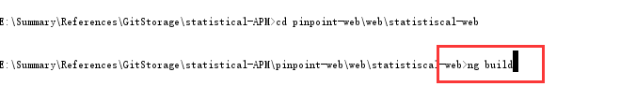

b): 编译完成后，会出现以下界面

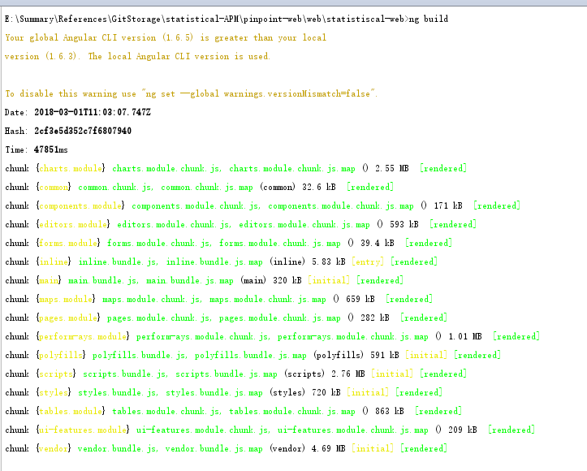

此时，在pinpoint-controller\src\main\webapp下，会出现部署好的目录dist

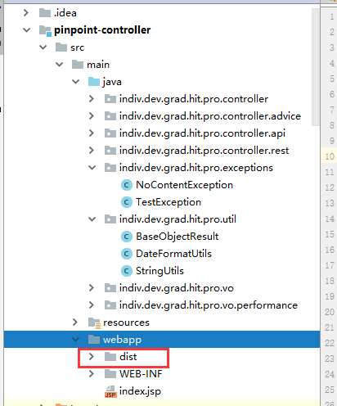

c. 进入dist目录，找到index.html 切换映射地址

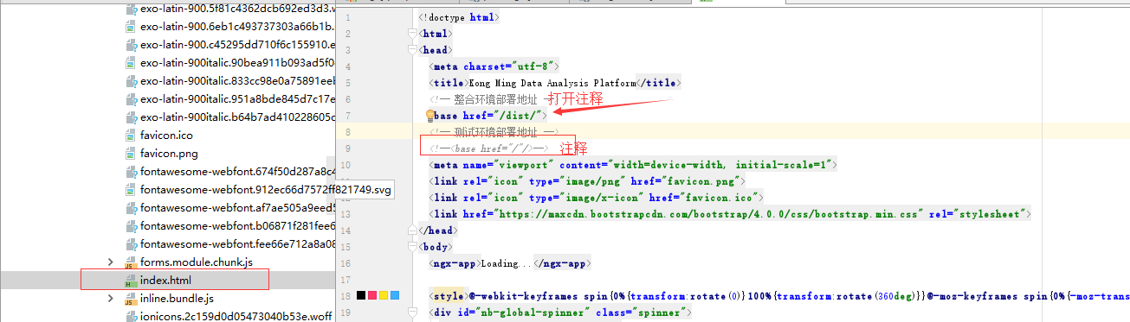

**四： 启动Tomcat**

启动tomcat，将dist打成war包

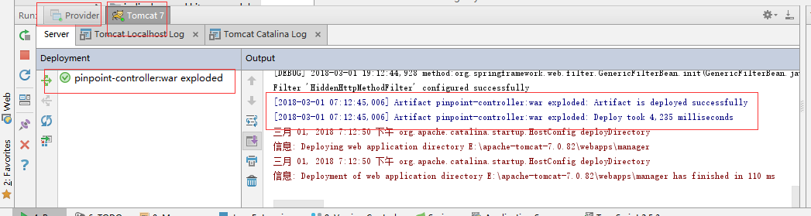

测试URL: localhost:8080/api/getAllApplications



["-sc-cert-create-prev","a-sc-cert-query-prev","acrm-server","acrm-ztc-ws","agree-dep-service","balance-server","bp-poi-na-web","bp-poi-server","capital-receiver","cert-public-api","common-poi-server","crm-dubbo","crm-http","crm-server","data-cube-web","ep-dubbo","fin-api-web","fss-agreement-web","fss-detail-server","fss-merchant-na-web","fss-merchant-web","image-server","KM-TEST","libra-webapp","mct-acl-web","mct-bdc-na","mct-bdc-web","mct-center-api","mct-center-web","mct-comment-web","mct-oprecord-search","message-comet","message-core","message-recevie","message-web","mkt-kingmeal","nas-api","niux-poi-api","niux-poi-web","niux-support","niux-support-ext","npc-dubbo","nuomi-bdc-dispatcher","nuomi-bdc-handler","nuomi-common-server","oc-dubbo","oc-web","order-server","order-web","payment-server","payment-web","pc-server","pc-web","poi-access-api","poi-na-web","poi-relation-api","qrcode-server","sale-app-api","sale-service-dubbo","sale-service-server","saler-visit-dubbo","saler-visit-web","sc-api","sc-cert-consumer","sc-cert-create","sc-cert-query","sc-cert-refund","sc-file","sc-mct-na","sc-mct-web","sc-poi-pc-web","sc-quartz","sc-server","sc-web","settlement-server","supplier-api","supplier-web","tkc-api","tuan-cert-make2","tuan-lbc-api","tuan-lbc-server","tuan-lbc-web","tuan-mct-web","tuan-shoppay-make","tuan-verify-nuomi","tuan-verify-web","va-mkt-kingmeal-prev","weblab-server"]

当成功返回时，所有的环境已经全部打通。

4.1 进入首页

<http://localhost:8080/dist/>

用户：[root@baidu.com](mailto:root@baidu.com)

密码： 123456

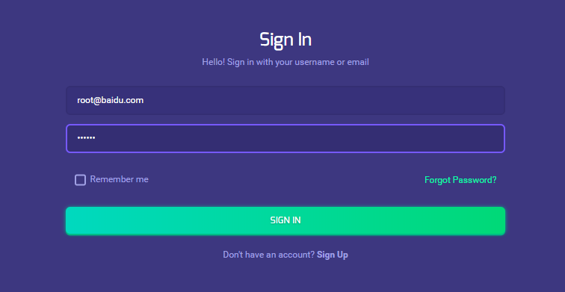

（p.s. Light – Custom 之间切换调色，建议Light）

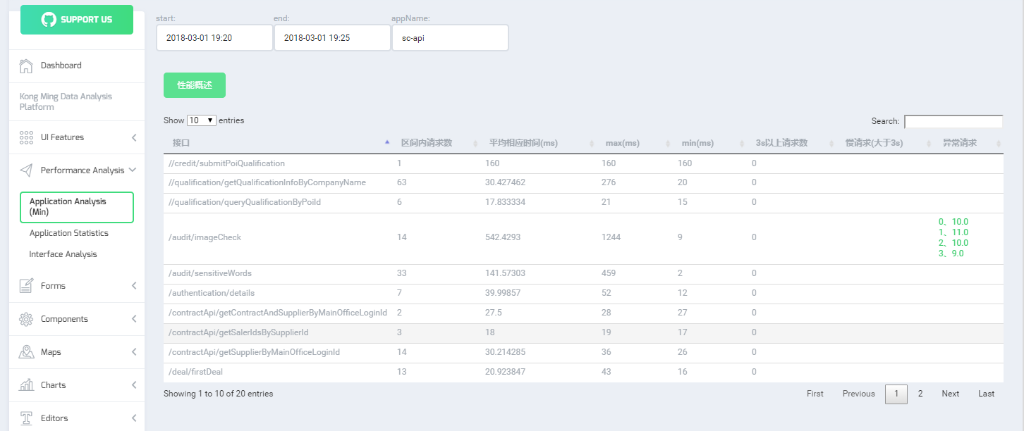

进入该界面后，其他的操作和当前线上操作完全一致

p.s. 自测时，所有数据和当前线上展示的数据完全一致，三个界面均没有出现数据不一致的问题，也能链接进入孔明调用链展示页面。

**五：后续迭代内容 图形化展示**

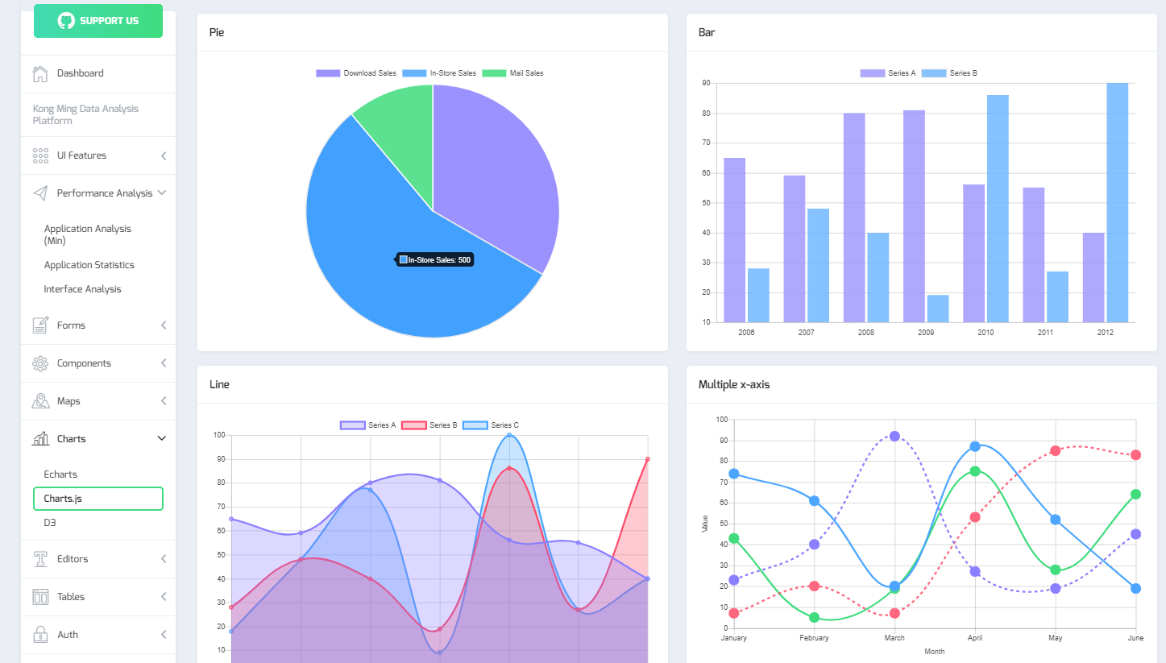

(可以考虑让后来的实习生继续跟进 😊 )