Simple document
Jeff Goldsmith
2023-09-12
library(tidyverse)
## ── Attaching core tidyverse packages ──────────────────────── tidyverse 2.0.0 ──
## ✔ dplyr 1.1.2 ✔ readr 2.1.4
## ✔ forcats 1.0.0 ✔ stringr 1.5.0
## ✔ ggplot2 3.4.3 ✔ tibble 3.2.1
## ✔ lubridate 1.9.2 ✔ tidyr 1.3.0
## ✔ purrr 1.0.2
## ── Conflicts ────────────────────────────────────────── tidyverse_conflicts() ──
## ✖ dplyr::filter() masks stats::filter()
## ✖ dplyr::lag() masks stats::lag()
## ℹ Use the conflicted package (<http://conflicted.r-lib.org/>) to force all conflicts to become errors
I’m an R Markdown document!

Section 1: First code chunk
Here’s a code chunk that samples from a normal distribution:
samp = rnorm(100)
length(samp)
## [1] 100
The mean of the sample is -0.0211

Section 2: Make a plot
This code is borrowed from last lecture; it creates a dataframe for plotting.
plot_df =
tibble(
x = rnorm(1000, sd = 0.5),
y = 1 + 2 * x + rnorm(1000)
)
Next up is a histogram of the x variable in plot_df.
ggplot(plot_df, aes(x = x)) + geom_histogram()
## `stat_bin()` using `bins = 30`. Pick better value with `binwidth`.
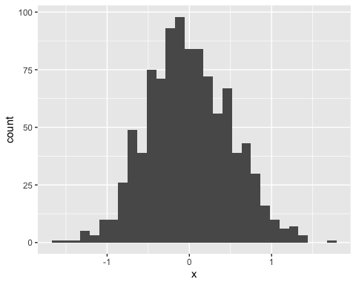
Lastly, I’ll do a scatterplot.
ggplot(plot_df, aes(x = x, y = y)) + geom_point()
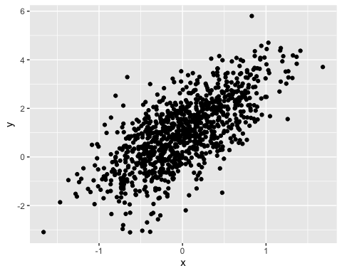
here’s a list:
- this is the first list thing
- here’s another list item

Section 3: Learning assessment!
This code chunk should create a dataframe comprised of: a numeric variable containing a random sample of size 500 from a normal variable with mean 1; a logical vector indicating whether each sampled value is greater than zero; and a numeric vector containing the absolute value of each element.
la_df =
tibble(
num_samp = rnorm(500, mean = 1),
log_vec = num_samp > 0,
abs_val = abs(num_samp)
)
ggplot(la_df, aes(x = abs_val)) + geom_histogram()
## `stat_bin()` using `bins = 30`. Pick better value with `binwidth`.
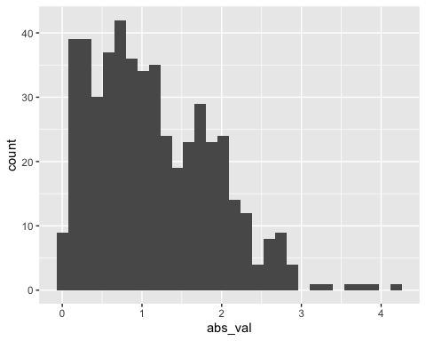

Section 4: Text formatting examples

Text formatting
italic or italic bold or bold code superscript² and subscript₂

Headings

1st Level Header

2nd Level Header

3rd Level Header

Lists
- Bulleted list item 1
- Item 2
  - Item 2a
  - Item 2b
- Numbered list item 1
- Item 2. The numbers are incremented automatically in the output.

Tables
First Header | Second Header
Content Cell | Content Cell
Content Cell | Content Cell

