EXIT vs RETURN:

Return 0 – indicates code does not have any program, successful execution

Return – keyword, previous step, fast

Exit – function, complete exit from program, slow

CRT – C Runtime

P2)Type Casting

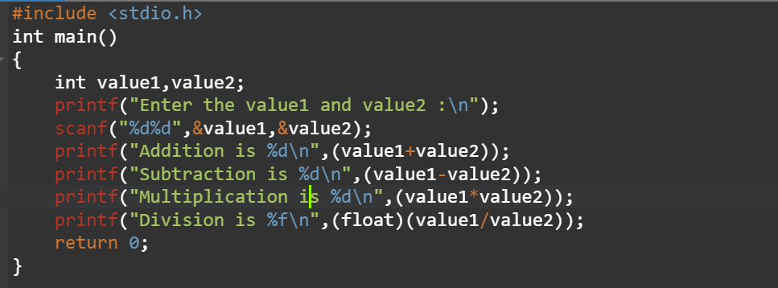

P3)

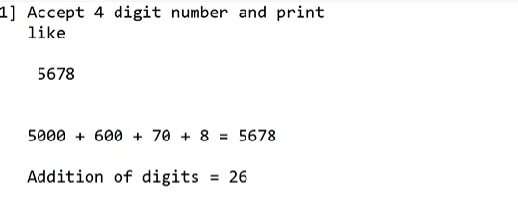

#include<stdio.h>

#include<conio.h>

#include<stdlib.h>

int main()

{

int num,count=0,sum,rem,r1,r2,r3,r4;

printf("Enter 4 digit number:"); //3456

scanf("%4d",&num);

r1=num%10;

num=num/10;

printf("%d\n",r1);

printf("%d\n",r1*1);

r2=num%10;

num=num/10;

printf("%d\n",r2);

printf("%d\n",r2*10);

r3=num%10;

num=num/10;

printf("%d\n",r3);

printf("%d\n",r3*100);

r4=num%10;

num=num/10;

printf("%d\n",r4);

printf("%d\n",r4*1000);

printf("%d\n",r1*1+r2*10+r3*100+r4*1000);

printf("addition of digit=%d",r1+r2+r3+r4);

}



#include <stdio.h>

int main()

{

int num1,num2;

printf("Enter the two numbers:\n");

scanf("%d%d",&num1,&num2);

num1 = num1 + num2;

num2 = num1 - num2;

num1 = num1 - num2;

printf("After swapping:\n");

printf("%d\n%d\n",num1,num2);

return 0;

}

**P4)SINGLE DIGIT OR NOT A SINGLE DIGIT NO**

#include<stdio.h>

int main(){

int ival1;

printf("\nEnter the value\n");

scanf("%d",&ival1);

if(ival1>=10 && ival1<=9){

printf("Single digit number has been entered");

}

else{

printf("Not a single digit number");

}

return 0;

}

**P5)Nested if statement**

#include<stdio.h>

int main(){

int ival1;

printf("\nEnter the value\n");

scanf("%d",&ival1);

if(ival1>=10 && ival1<=9){

printf("Single digit number has been entered");

}

else if(ival1>=10 && ival1<=99){

printf("Two digit number");

}

else if(ival1>=100 && ival1<=999){

printf("Three digit number");

}

else{

printf("number has more digits apart from 4");

}

return 0;

}



#include<stdio.h>

int main(){

int num1,num2,num3;

printf("\nEnter the value\n");

scanf("%d%d%d",&num1,&num2,&num3);

if(num1>num2 && num1>num3){

printf("First no is largest");

}

else if(num2>num3){

printf("Second number is largest");

}

else{

printf("Third number is largest");

}

return 0;

}



#include<stdio.h>

int main(){

int num1;

printf("\nEnter the value\n");

scanf("%d",&num1);

if(num1%2==0){

printf("Number is even.");

}

else{

printf("Number is odd.");

}

return 0;

}

**5]Menu driven program using switch statement.**

#include<stdio.h>

int main ()

{

int ival1,ival2,choice;

printf ("\nEnter the two numbers:\n");

scanf ("%d%d", &ival1,&ival2);

printf("\n1]Addition\n2]Subtraction\n3]Multiplication\n4]Division");

printf("Enter your choice:\n");

scanf("%d",&choice);

switch(choice){

case 1:

printf("Addition of two numbers:%d",(ival2+ival1));

break;

case 2:

printf("Subtraction of two numbers:%d",(ival1-ival2));

break;

case 3:

printf("Multiplication of two numbers:%d",(ival2*ival1));

break;

case 4:

printf("Division of two numbers:%f",(float)(ival1/ival2));

break;

default:

printf("Invalid choice");

}

return 0;

}

**6] SWITCH V]VEG- there are sub options N]NON VEG – there are sub options**

#include<stdio.h>

int main ()

{

char ch;

int choice2,choice3;

printf ("\nWhat you want?\n");

printf("\nV]Veg\nN]Non Veg\n");

scanf("%c",&ch);

switch(ch){

case 'V':

case 'v':

printf ("\nWhat veg item you want?\n");

printf("1]Dal rice\n2]Paneer thali\n3]Veg thali\n");

scanf("%d",&choice2);

switch(choice2){

case 1:

printf("Dal rice added!\n");

printf("Your Amount will be 100!");

break;

case 2:

printf("Paneer thali added!\n");

printf("Your Amount will be 200!");

break;

case 3:

printf("Veg thali added!\n");

printf("Your Amount will be 300!");

break;

default:

printf("Sorry this menu is not available!\n");

break;

}

break;

case 'N':

case 'n':

printf ("\nWhat non veg item you want?\n");

printf("1]chicken rice\n2]Paneer-chicken thali\n3]Non-Veg thali\n");

scanf("%d",&choice3);

switch(choice3){

case 1:

printf("chicken rice added!\n");

printf("Your Amount will be 250");

break;

case 2:

printf("Paneer-chicken thali added!\n");

printf("Your Amount will be 500");

break;

case 3:

printf("Non-Veg thali added!\n");

printf("Your Amount will be 600 ");

break;

default:

printf("Sorry this menu is not available!\n");

break;

}

break;

}

return 0;

}

**WHILE LOOP DEMONSTRATION:**

#include<stdio.h>

int main ()

{

int i = 10,j=0; //initialization

while (i>=0 && j<=10) //condition

{

printf("\nValue is %d %d", i,j);

i--; //decrement

j++; //increment

}

return 0;

}

**NUMBER OF TERMS CODE:**

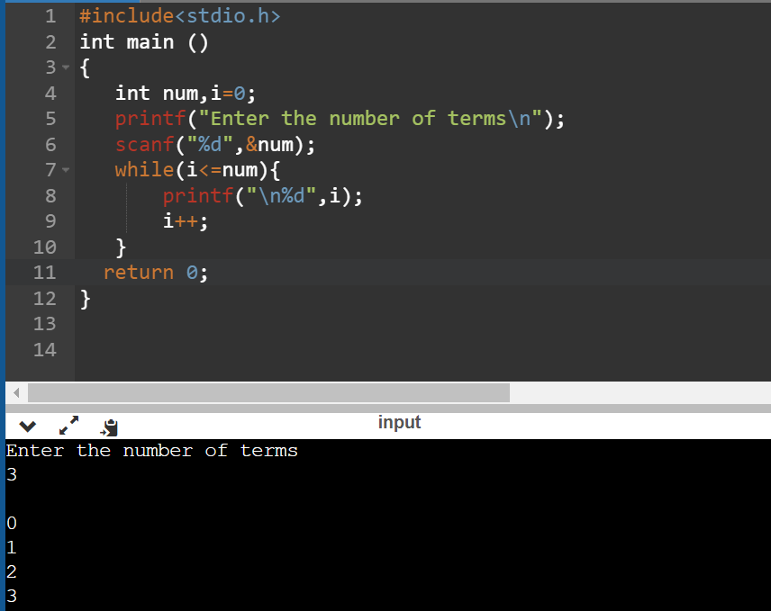

**TASK:**

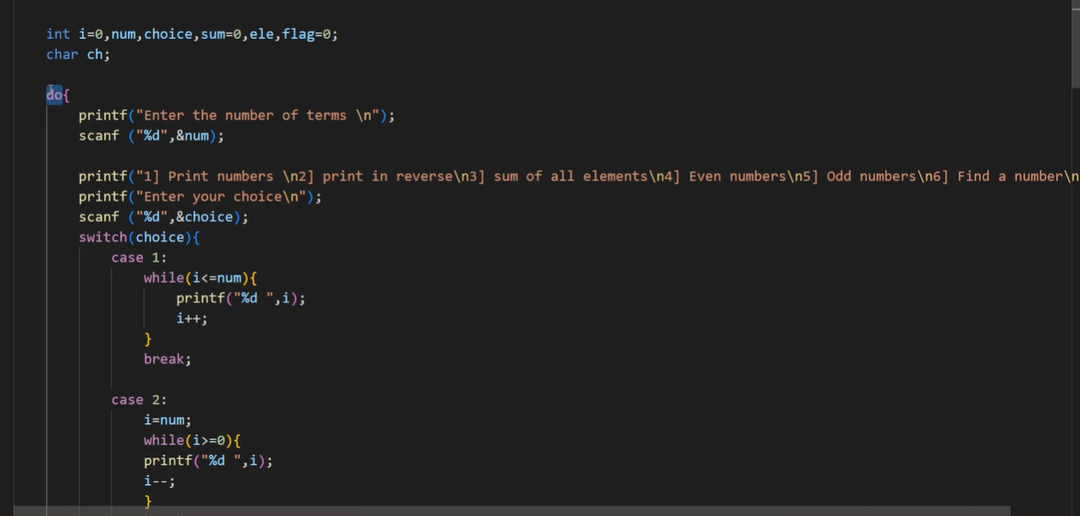

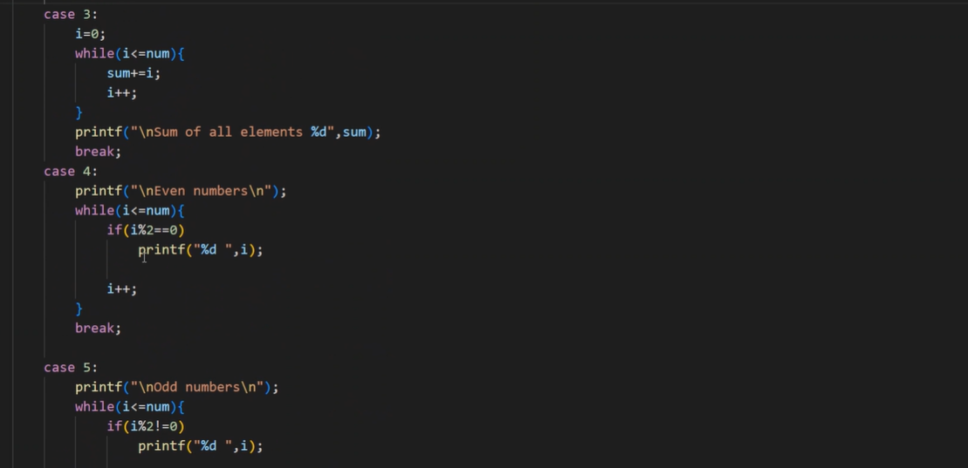

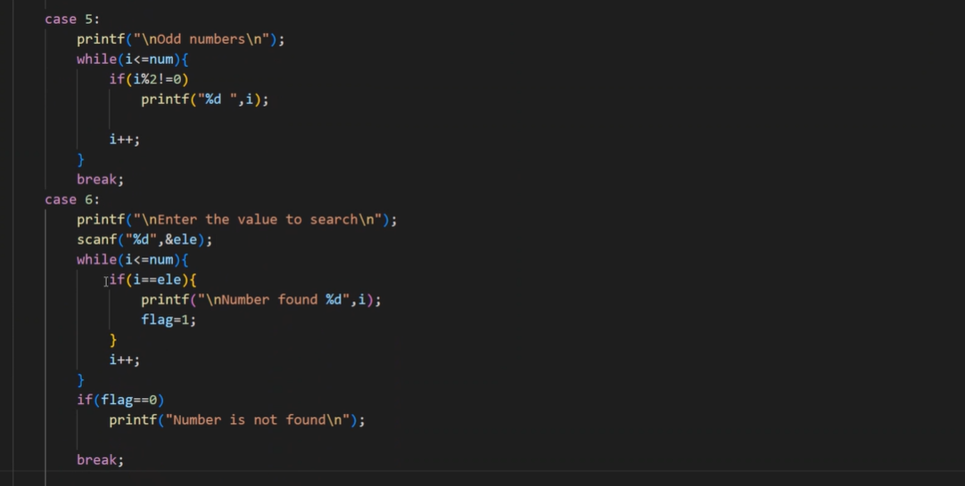

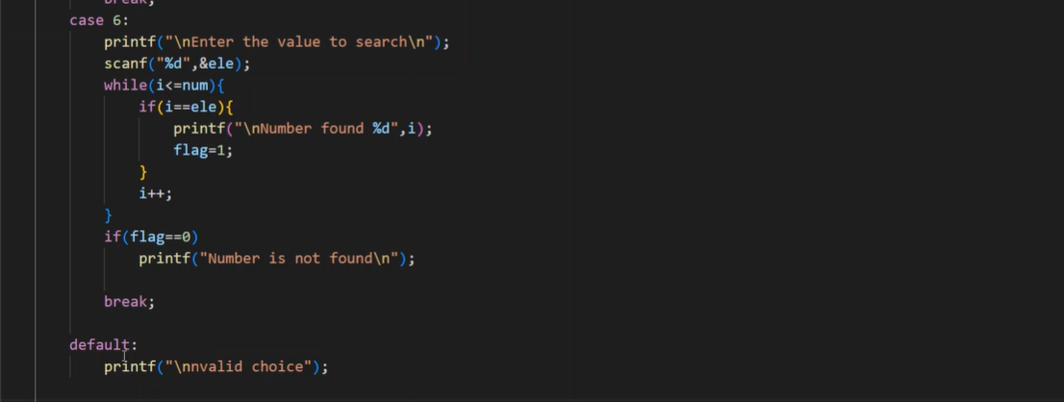

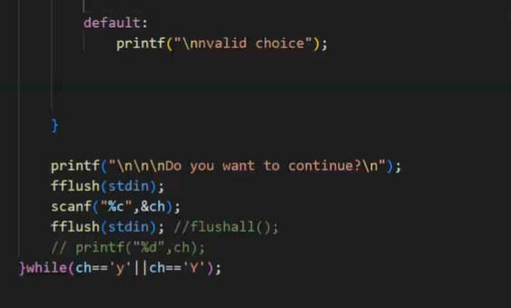

**WITHOUT FLUSH:**

Character will go into the ch array and

Enter key will also go into the buffer.

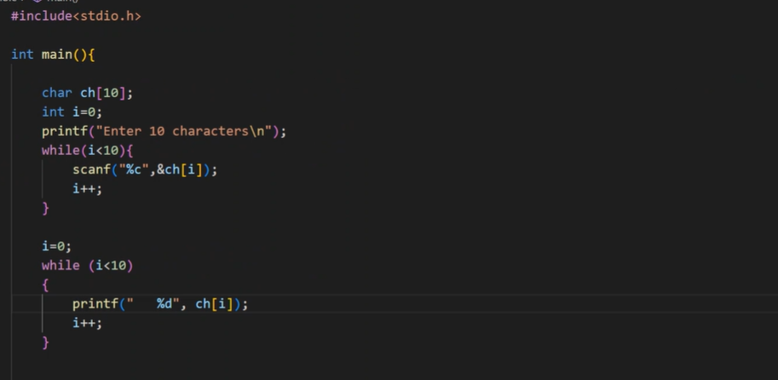

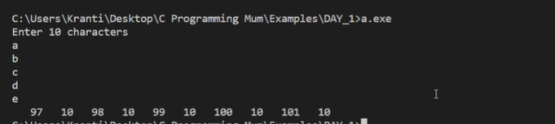

**WITH FLUSH:**

Flush all – will clear all buffers

Flush stdin will clear stdin buffer

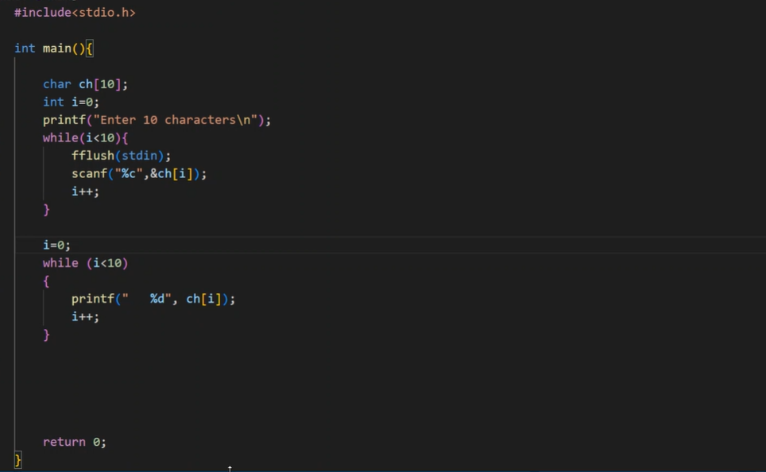

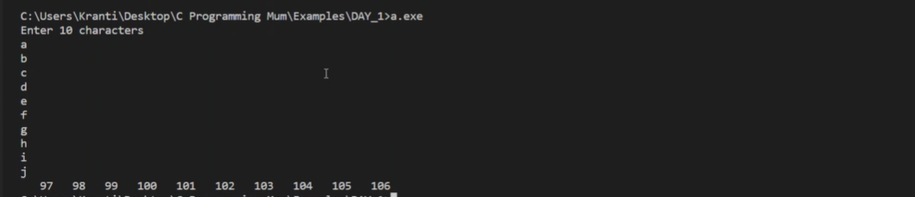

**DO WHILE**-if you want to print anything at least one time

**PRINTING 0-9 USING DIFFERENT LOOPS:**

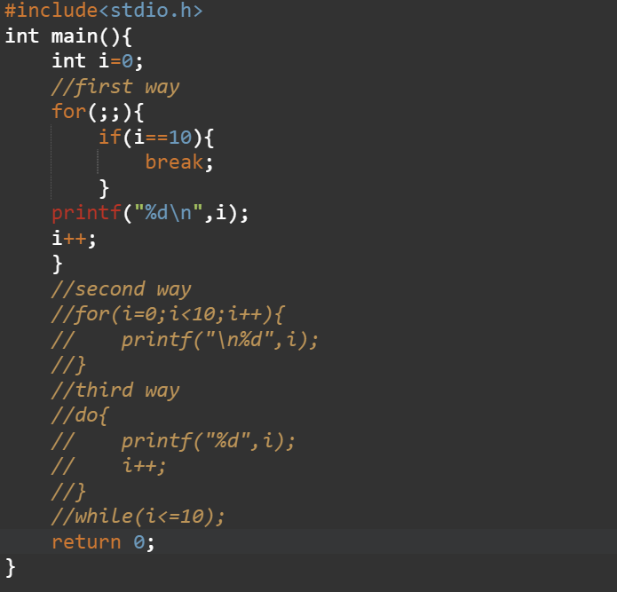

**THIS WILL PRINT LAST VALUE:**

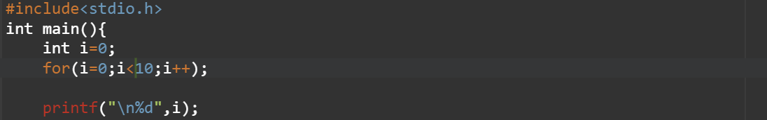



MATRIX FORMAT USING NESTED FOR LOOP:

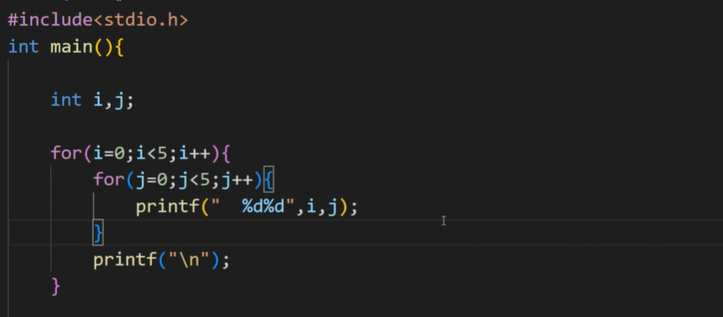

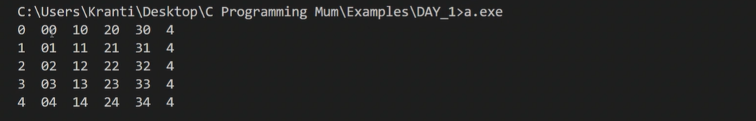

PATTERN PRINTING

1)

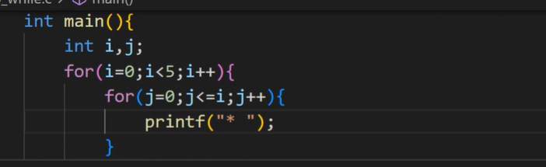

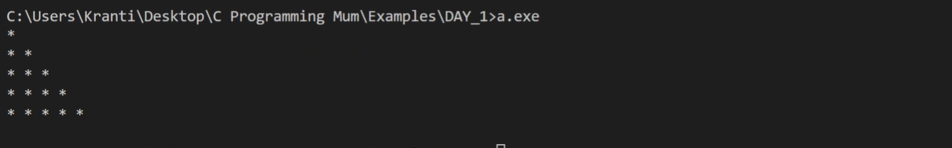

2)

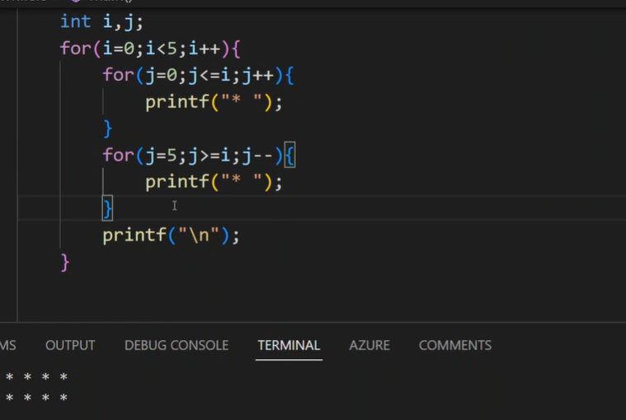

3)

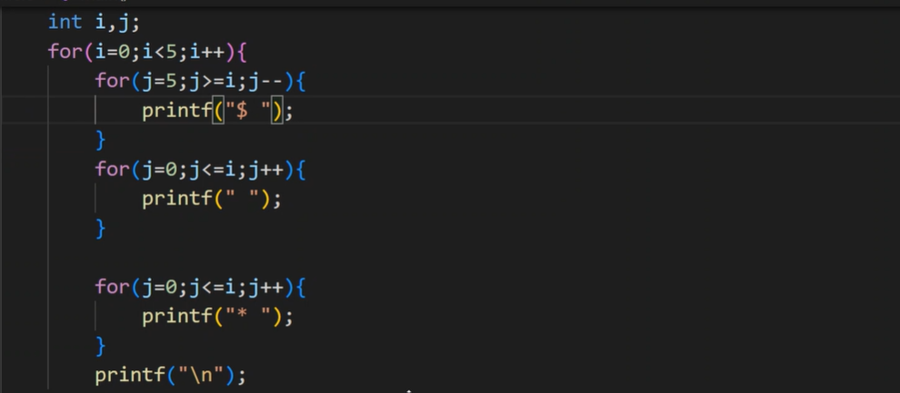

4)

