**20/12/2022(DAY-1)-LINUX**

<https://copy.sh/v86/?profile=linux26>

1)cat command: It is used to create the file with content.

2)Touch command: It is used to create a file without any content.

3)Ls-Listing files in reverse order: ls –r

Listing file and directory permissions with -l option : ls –l

Viewing Hidden files : ls –a

To display the directory tree of files and folders use : ls -R

4)Mkdir-create directory

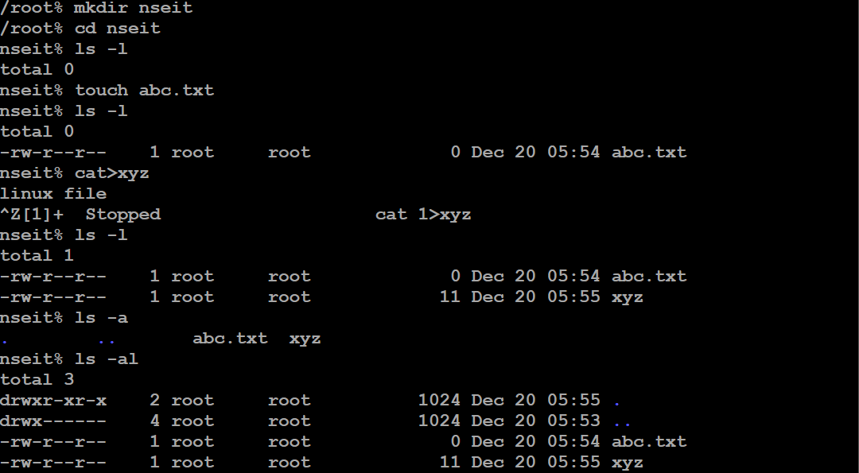

5)CD- change directory

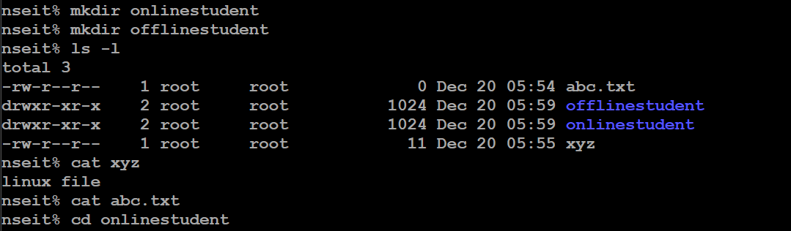

Cd .. – go back by one folder

Mkdir nseit

Cd nseit

Mkdir OfflineStudents

Mkdir OnlineStudents

Cd OfflineStudents

Cat >File3

This is File3

^Z

Cat>File4

This is File4

^Z

Cd ..

Cd OnlineStudents

Cat>File1

This is File1

^Z

Cat >File2

This is File2

^Z

To concat 2 files: 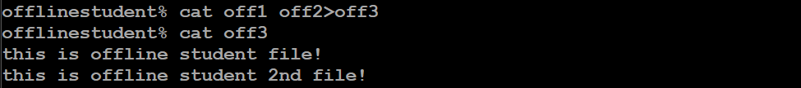

To copy the file:



Mv command as a rename:

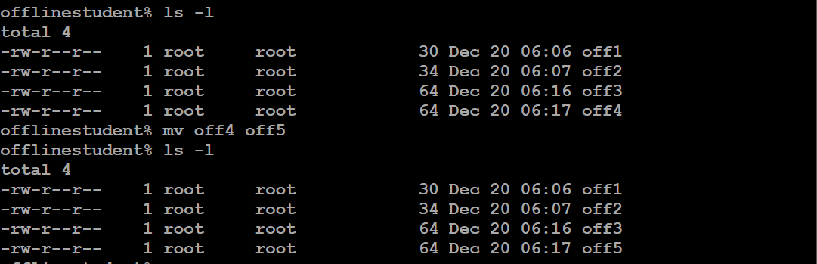

Mv command as a move to different folder:

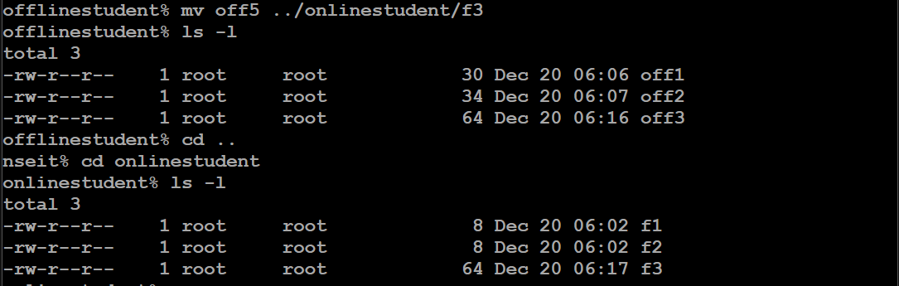

Rm – removal of file

Rmdir – removal of directory

Rmdir –rf : if directory has some content

Clear – clear the terminal

Activity:

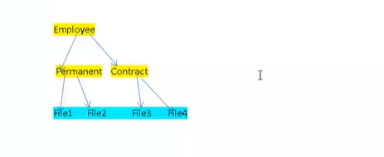

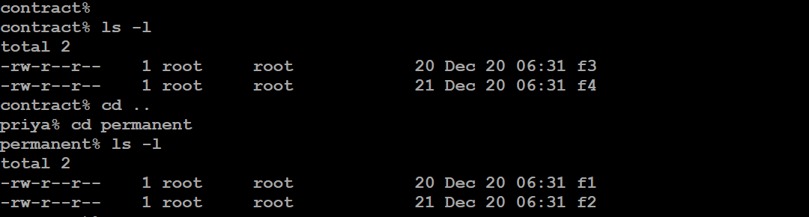

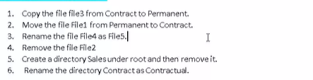

1.

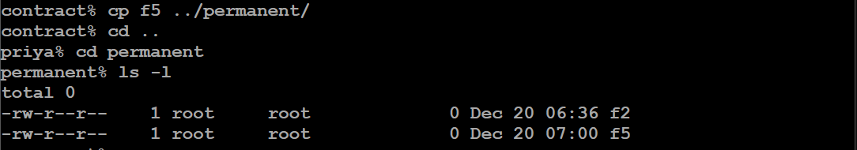

2. 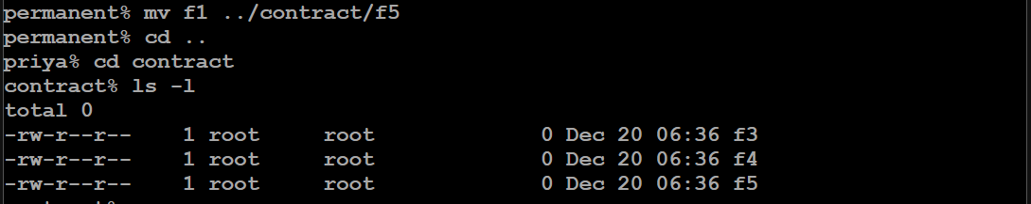

3.

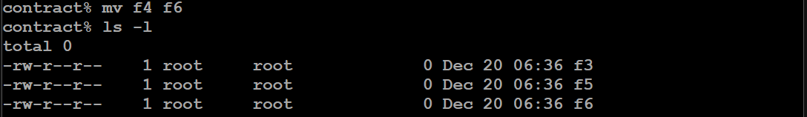

4.

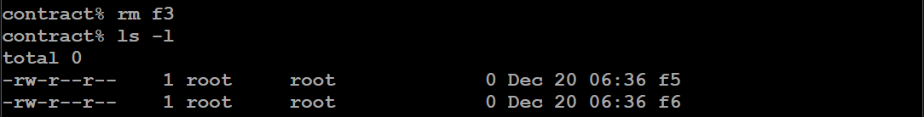

5.

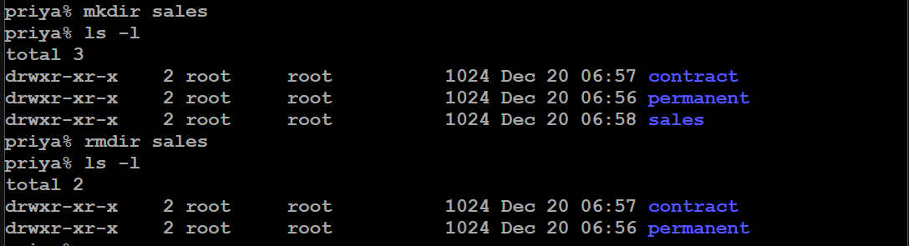

6.

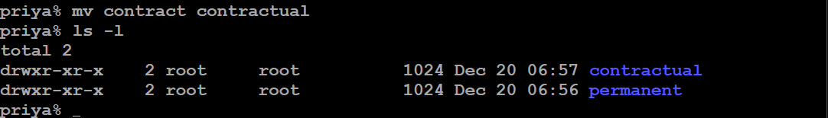

Cat>> : edit the content in the file

Vi filename : to enter into vi editor

Then you can add any data

For save and exit : first esc then colon then wq

:wq

:q

Hjkl

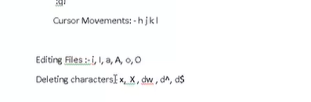

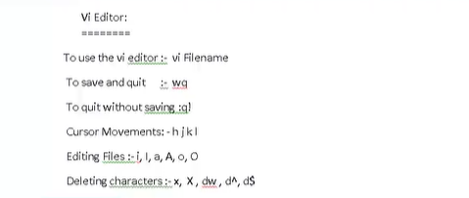

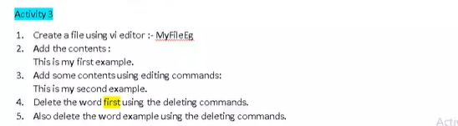

Q! – without saving

Permissions:

User-Group-Others

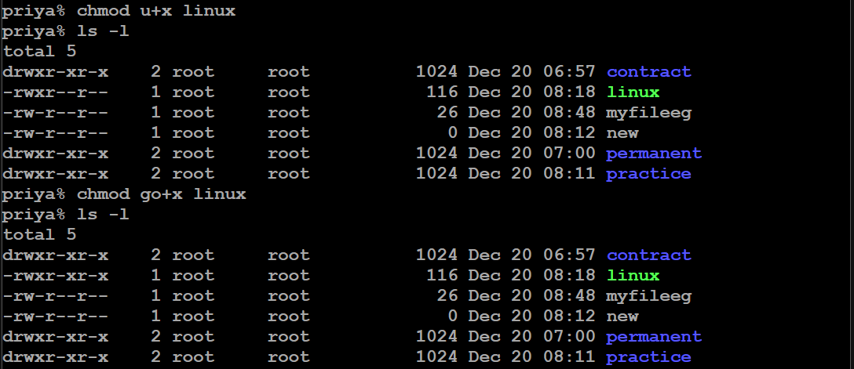

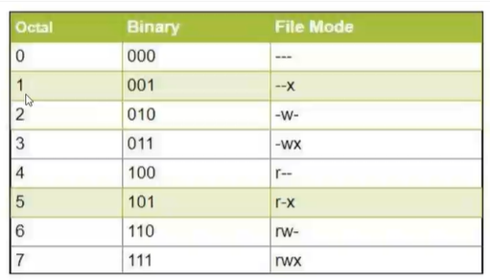

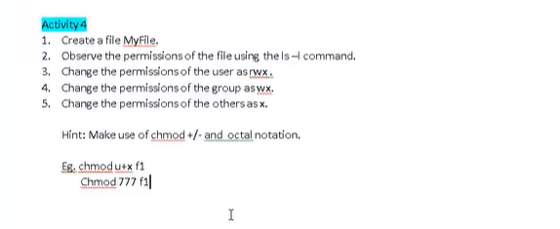

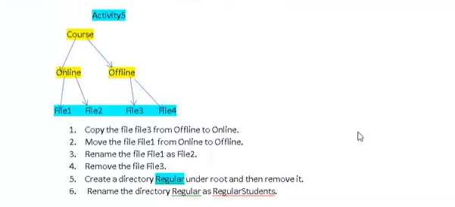

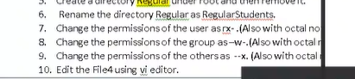

1.

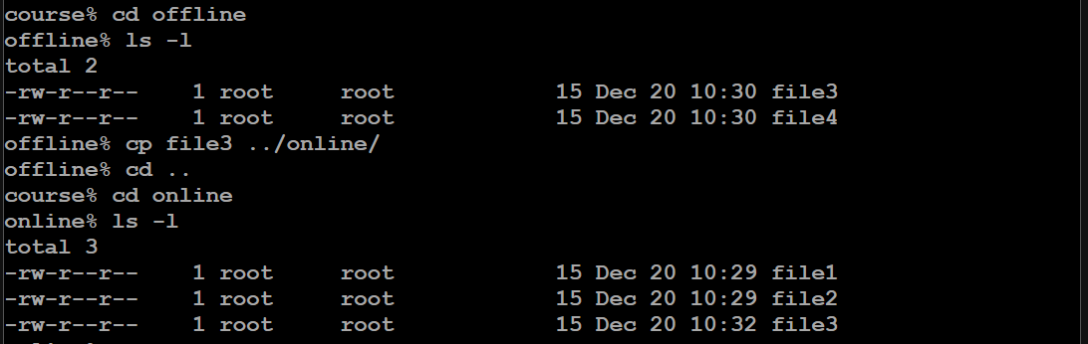

2.

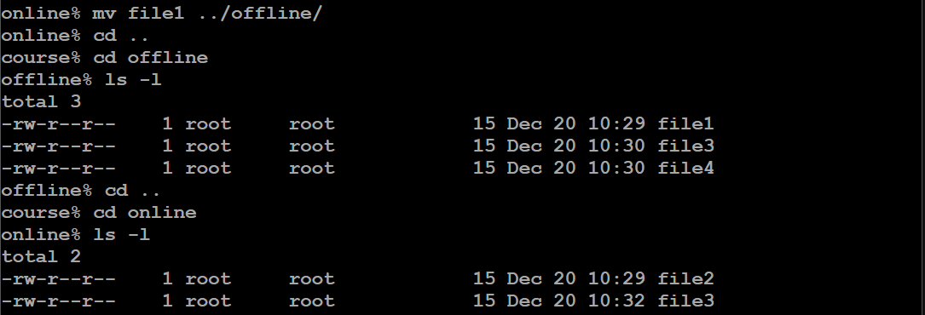

3.

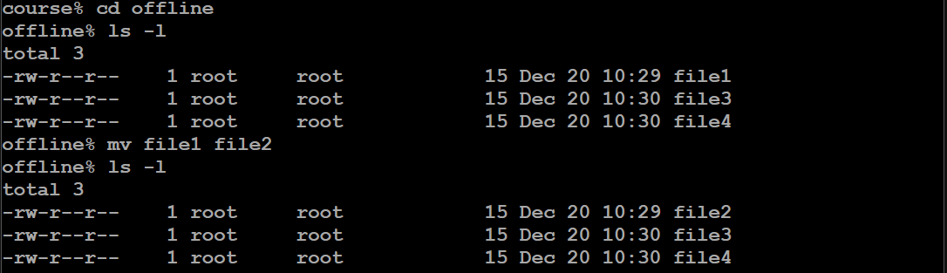

4.

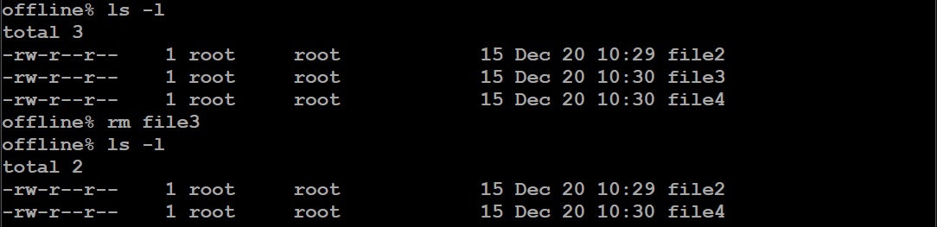

5.

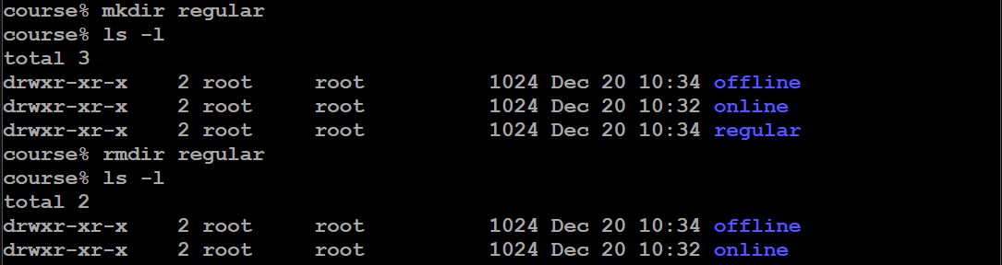

6.

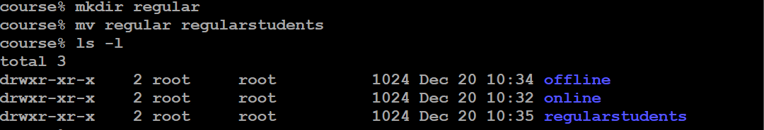

7.

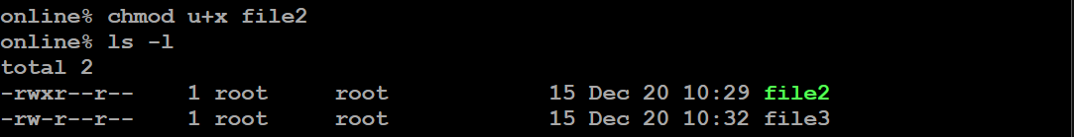

7,8,9 using octal

