Process-program in execution

Foreground and Background Process

Parent Process – created by user and may have multiple child process

Orphan process -

<https://www.geeksforgeeks.org/processes-in-linuxunix/>

echo

cal

who

shellscripts:

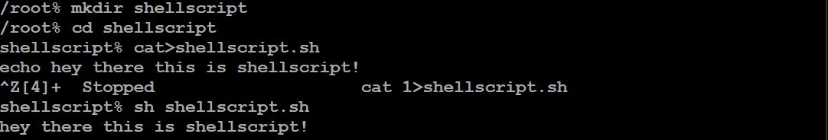

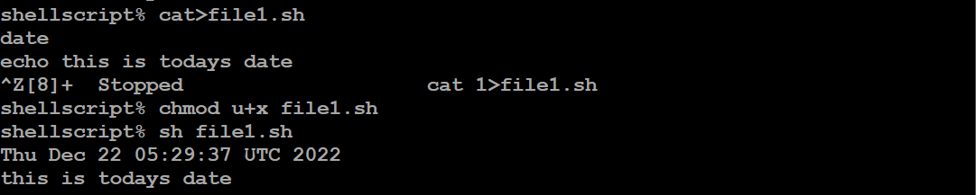

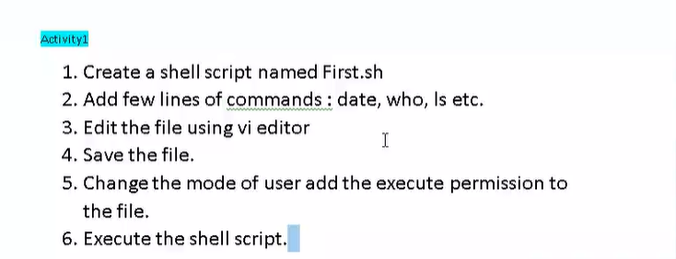

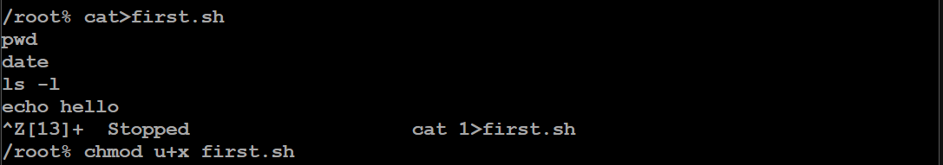

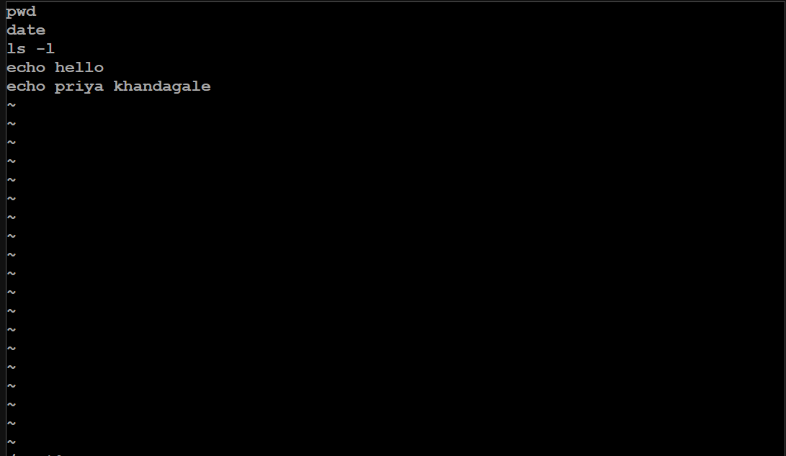

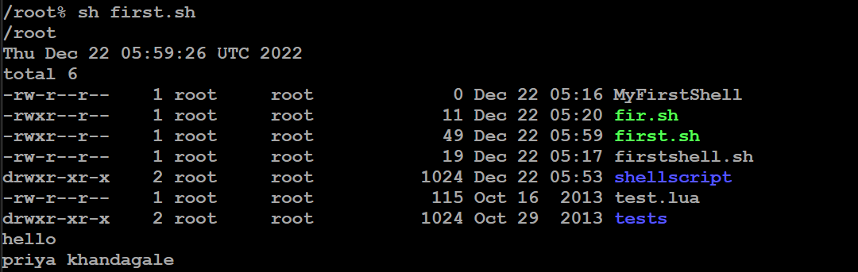

**Types of Redirection**

**1. Overwrite**

* “>” standard output
* “<” standard input

**2. Appends**

* “>>” standard output
* “<<” standard input

**3. Merge**

* “p >& q” Merges output from stream p with stream q
* “p <& q” Merges input from stream p with stream q

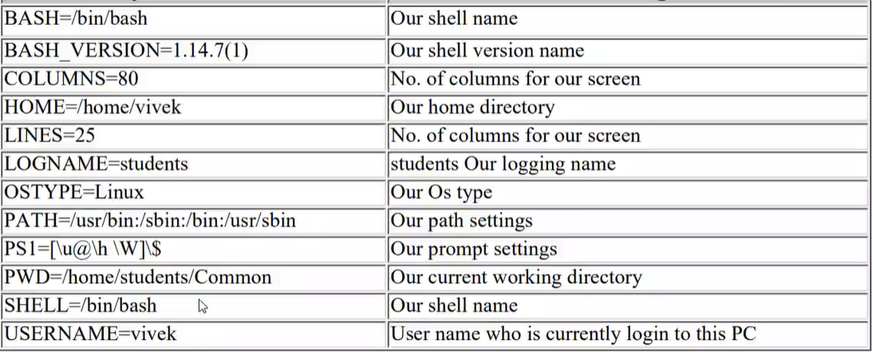

Variable declaration:



Activity 2:

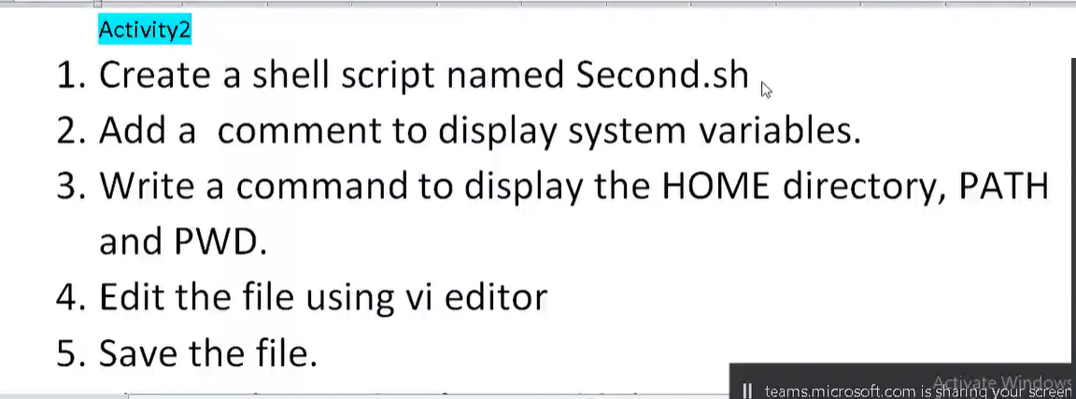

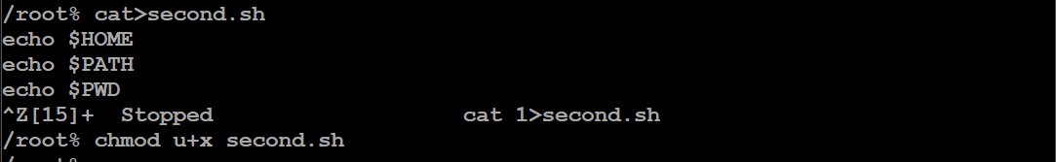

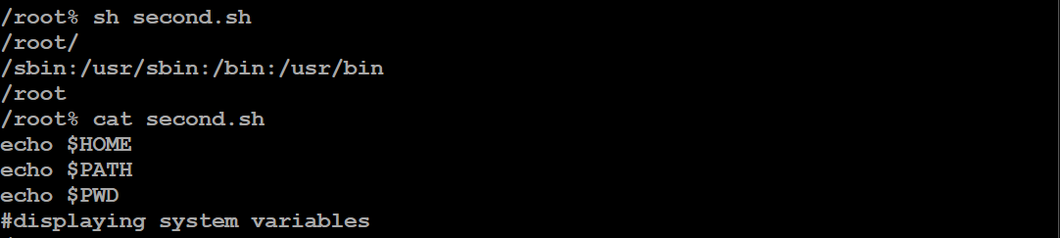

ECHO:

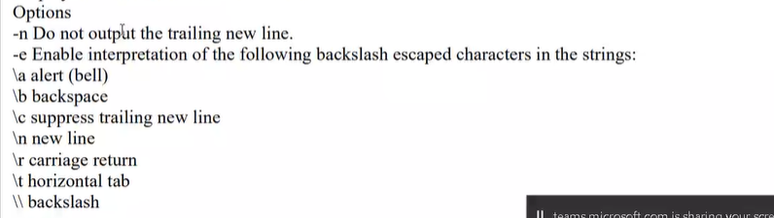



ACTIVITY 3:

IMPLEMENTATION OF ARITHMETIC EXPRESSIONS

(first 5 are working on online editor)

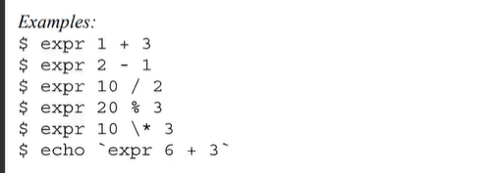

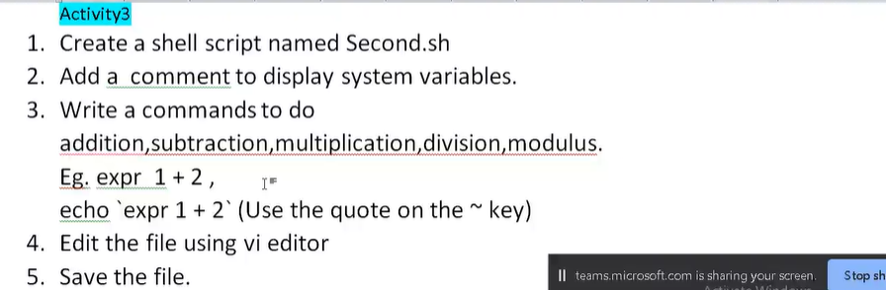

With echo for arithmetic expression:

` = ~ wala sign



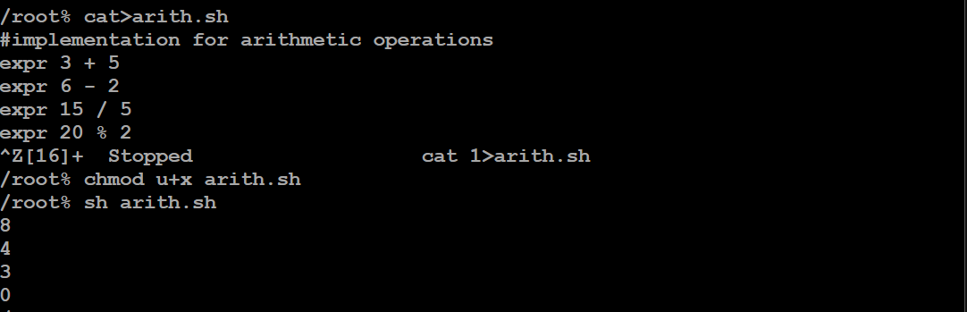

**ARITHMETIC EXPRESSION USING VARIABLES:**

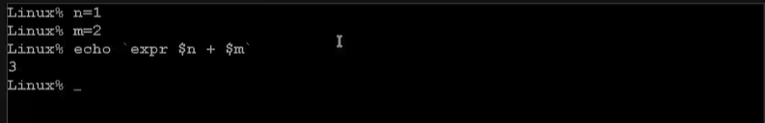

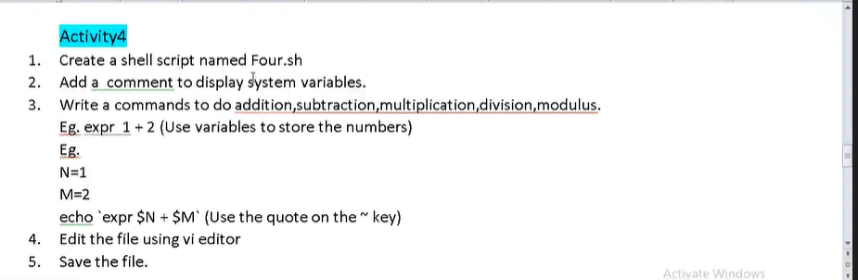

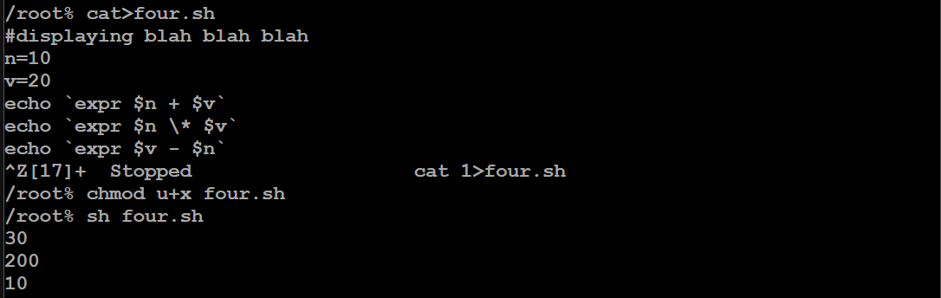

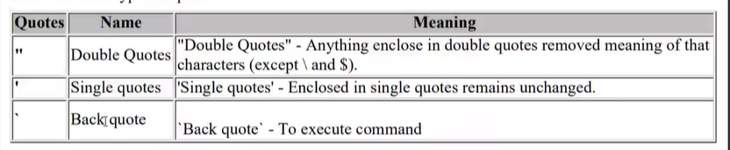

**READING INPUT VALUE USING read:**

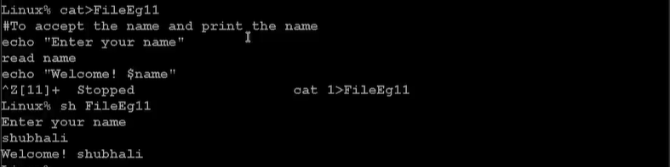

**LS WITH DIFFERENT FORMATTING OPTIONS**

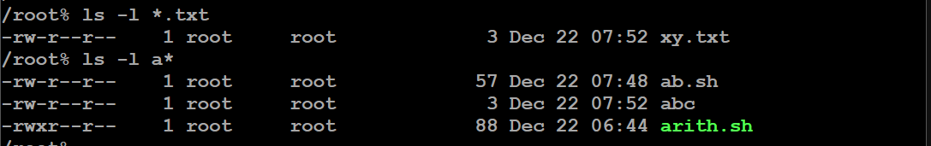



**ONE COMMAND MULTIPLE OPERATION**

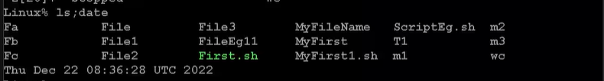

**COMMAND LINE ARGUMENTS:**

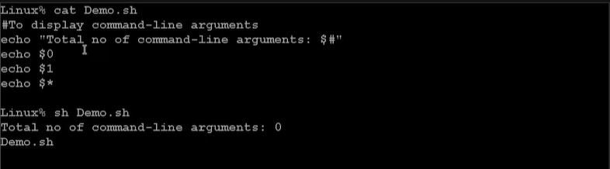

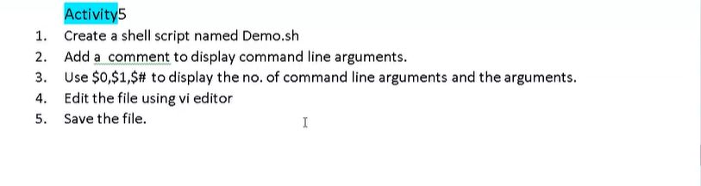

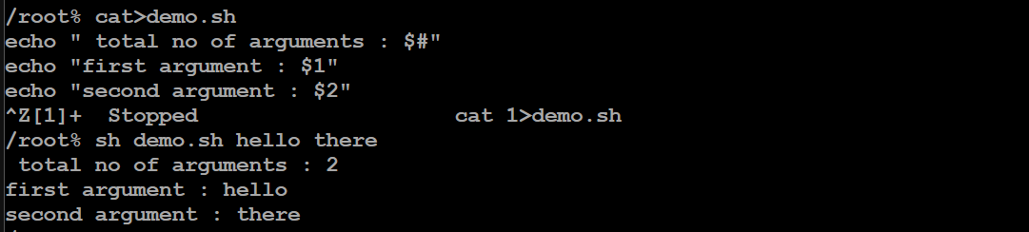

For all argument : $*

**SORT AND STORE IN ANOTHER FILE**

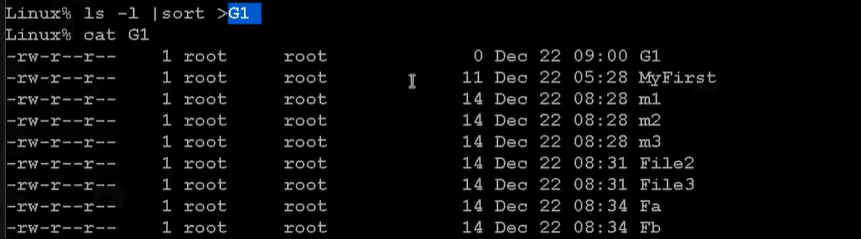

**DECISION MAKING:**

**IF CONDITION TO CHECK WHETHER FILE IS PRESENT OR NOT**

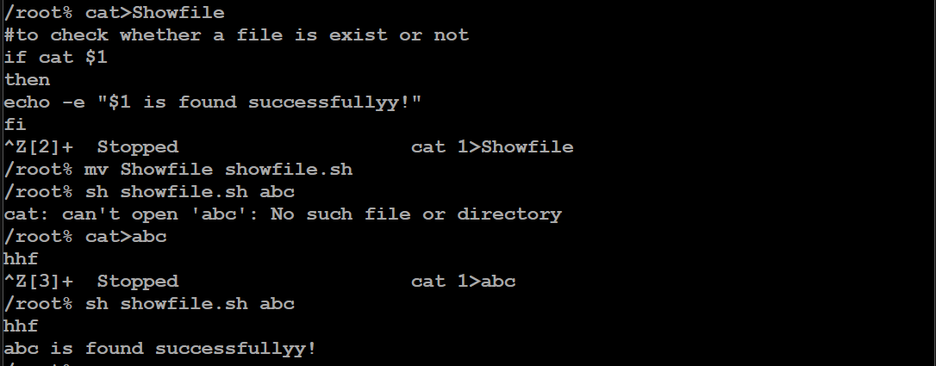

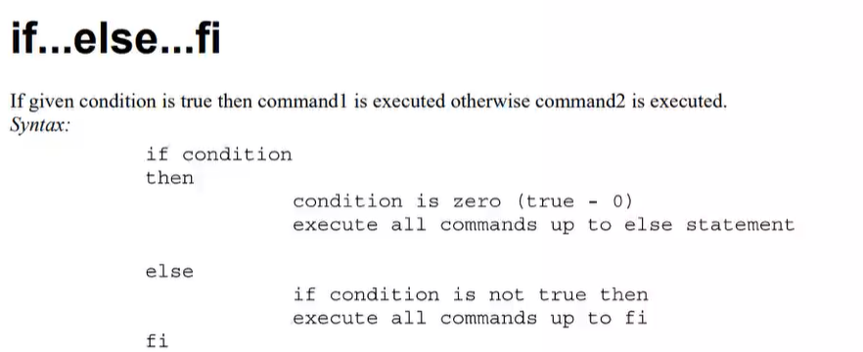

**SCRIPT TO CHECK WHETHER THE NO IS POSITIVE OR NEGATIVE:**

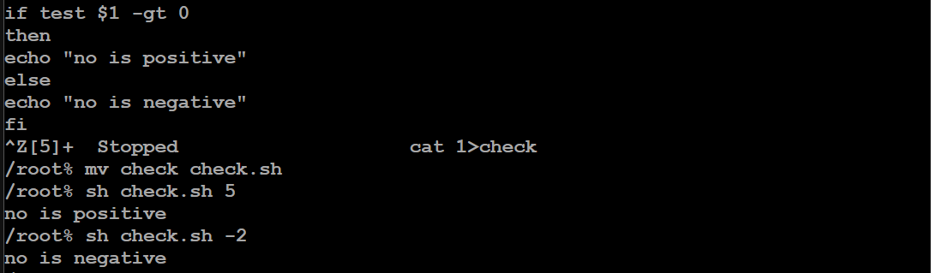

we can write [$1 –gt 0 ] instead of test..

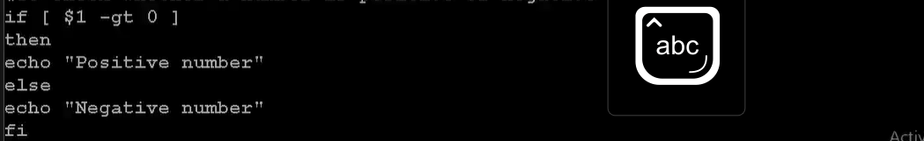

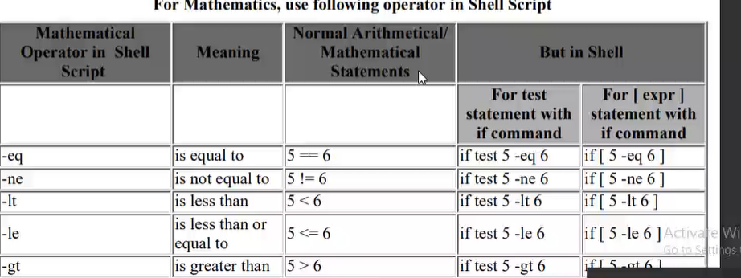

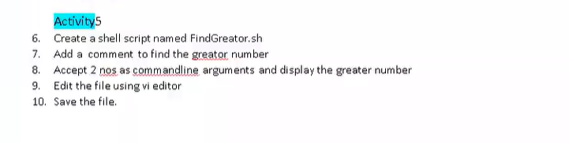

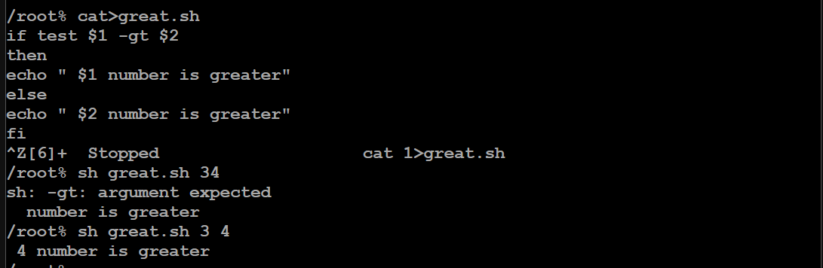

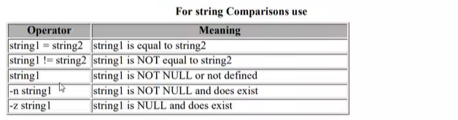

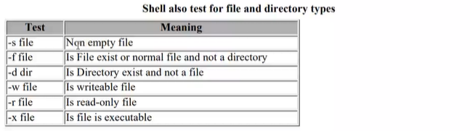

**Multiple if else:**

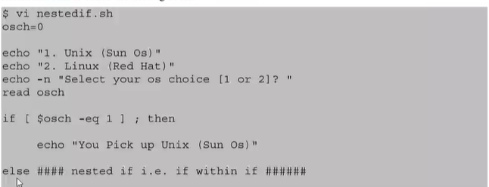

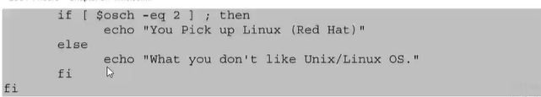

**NESTED IF ELSE CONDITION:**

