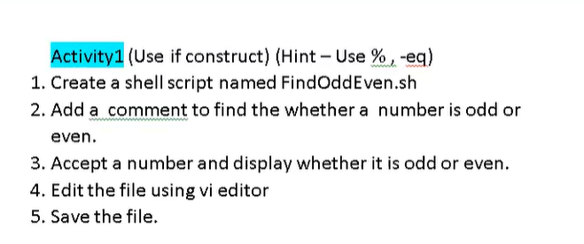

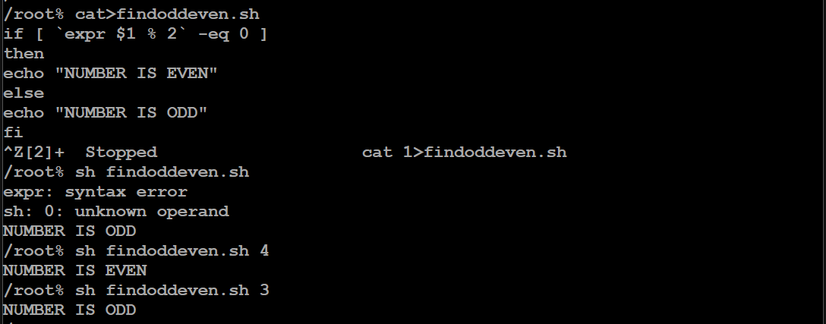

With read:

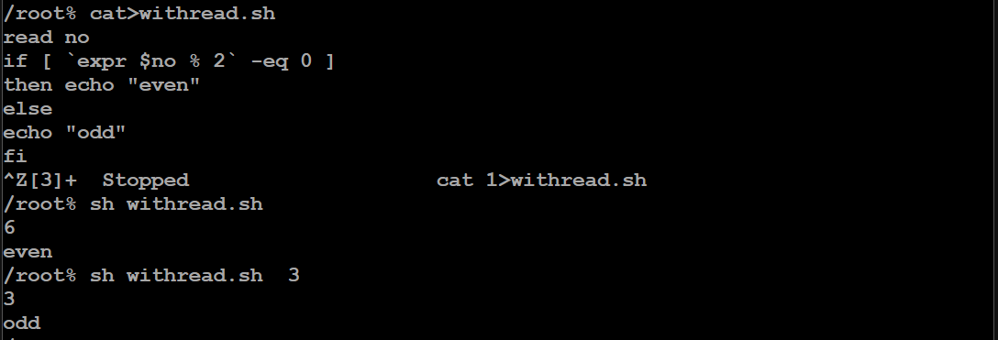

FOR EXAMPLE:

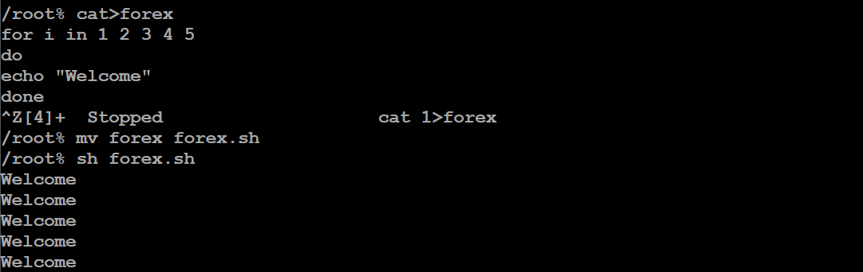

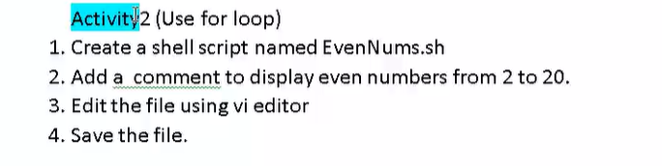

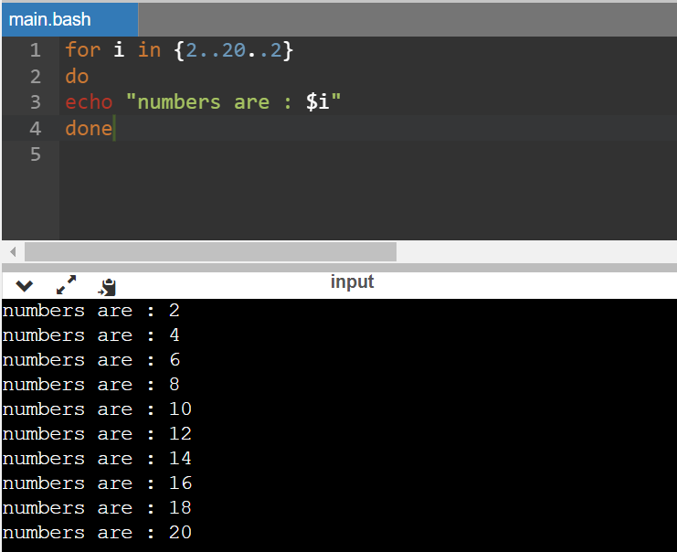

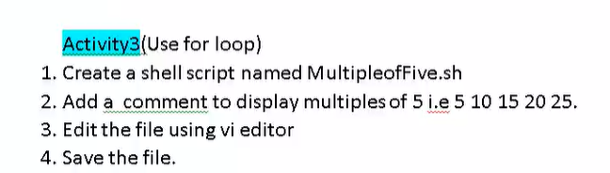

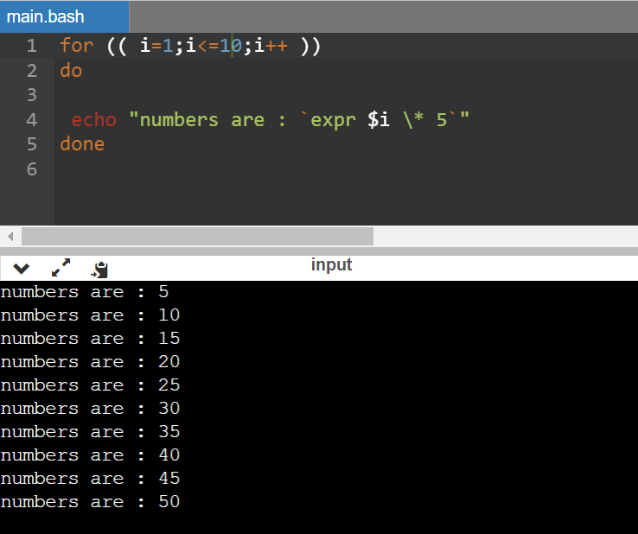

EXAMPLE FOR WHILE:

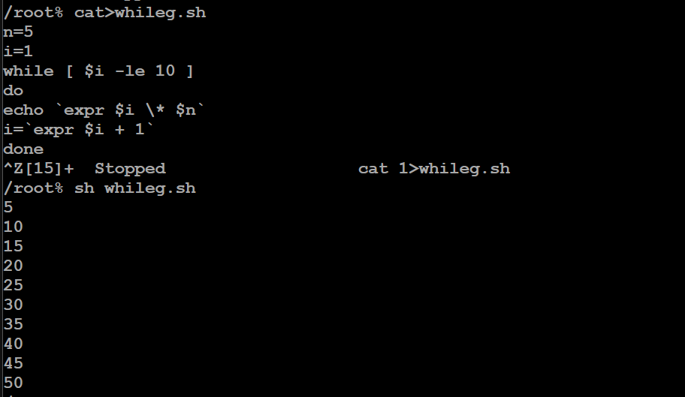

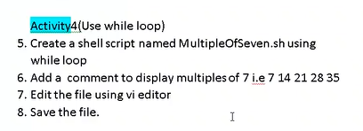

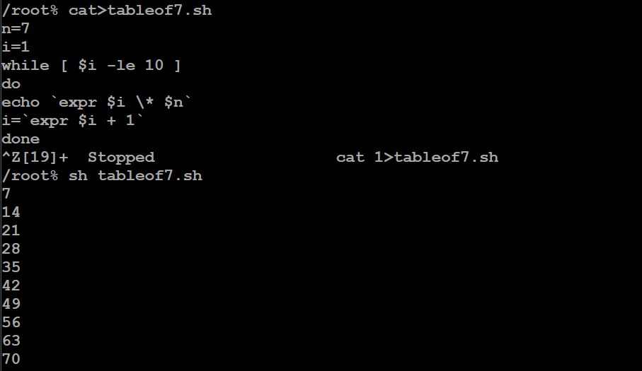

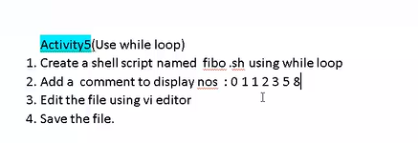

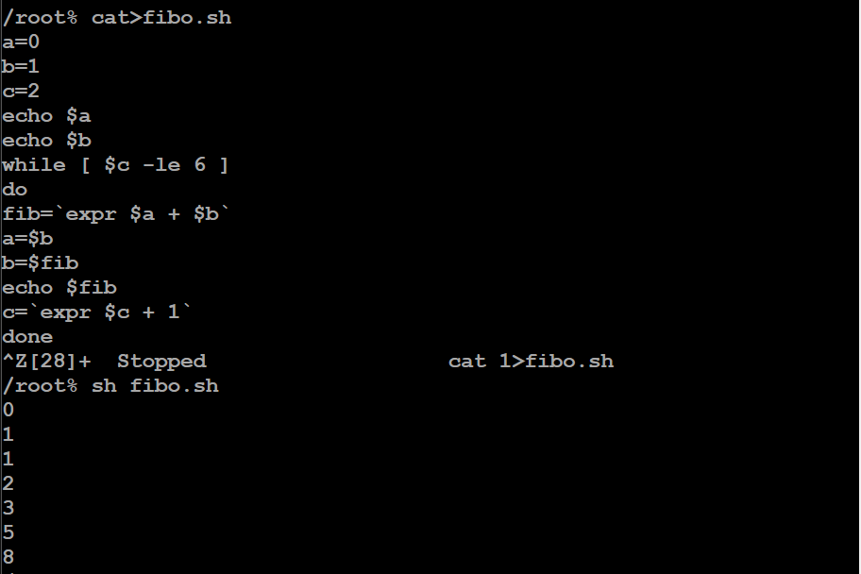

By using read:

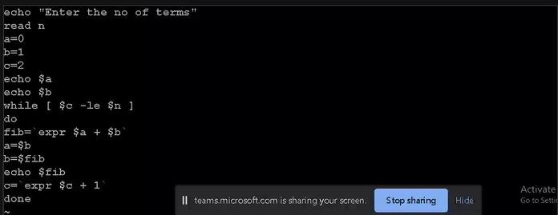

SWITCH EXAMPLE:

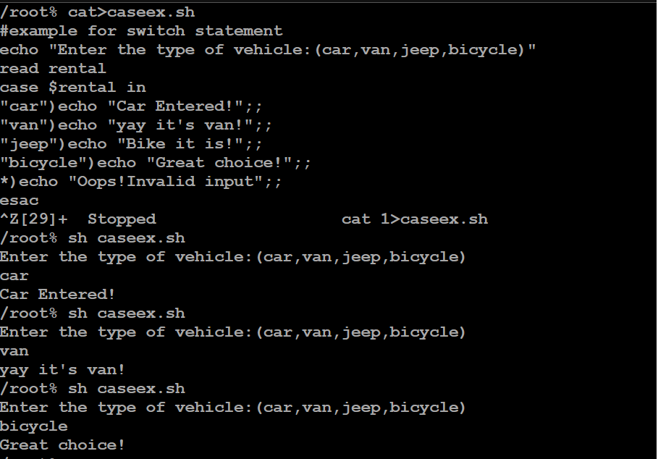

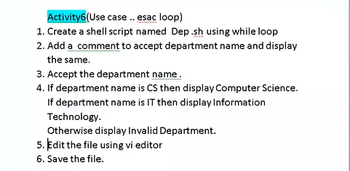

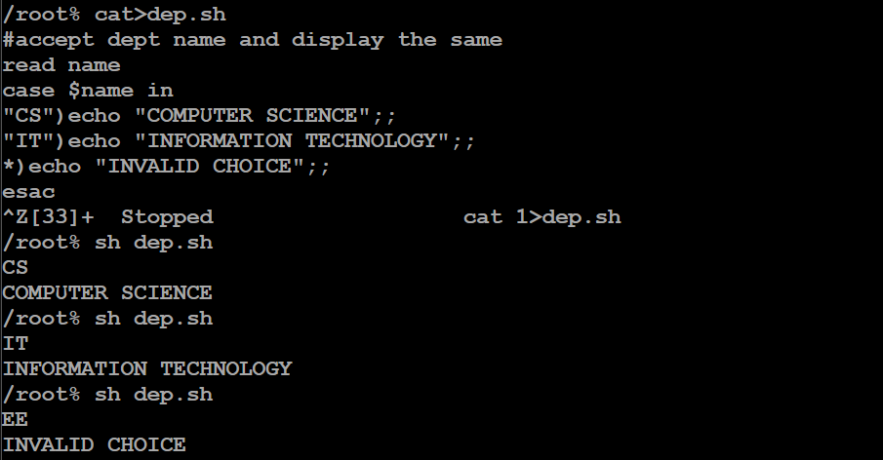

DEMONSTRATION OF && OPERATOR:

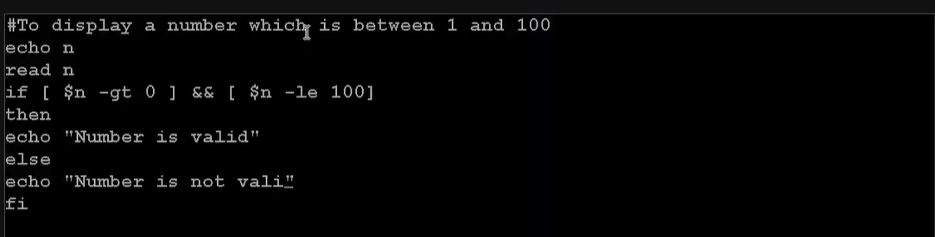

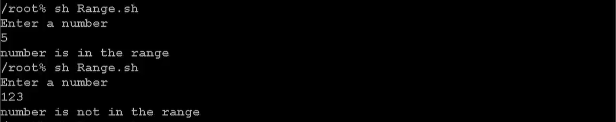

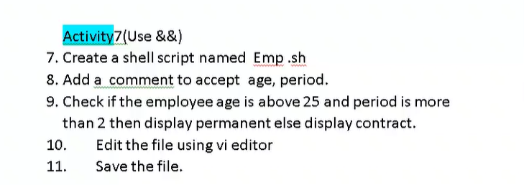

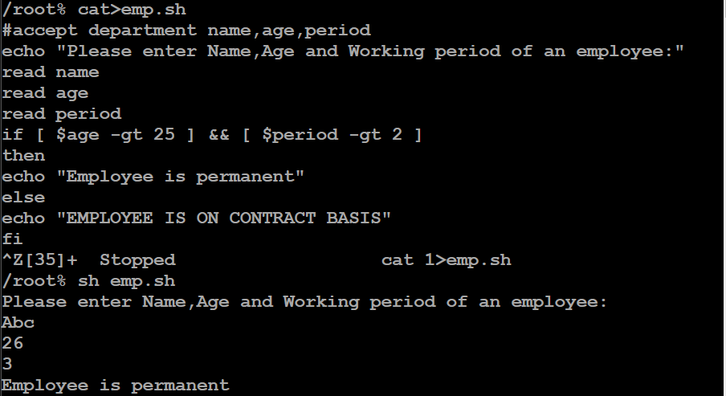

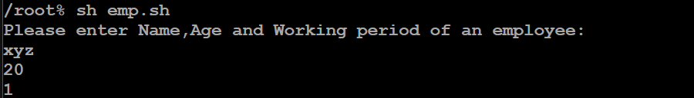

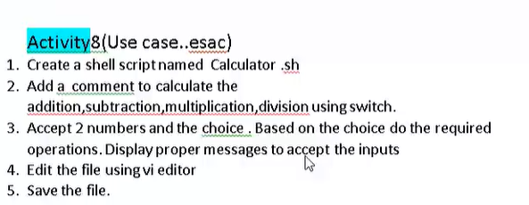

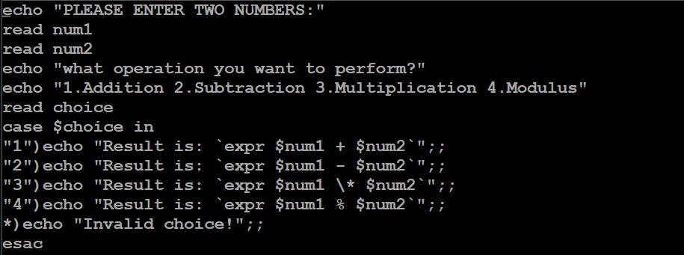

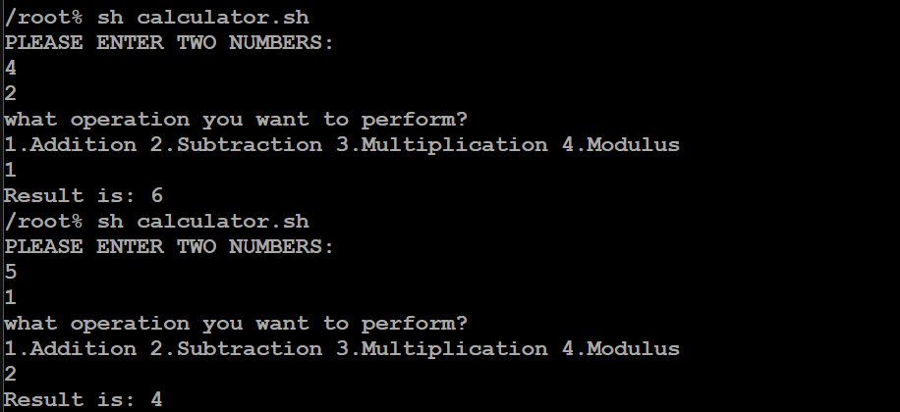

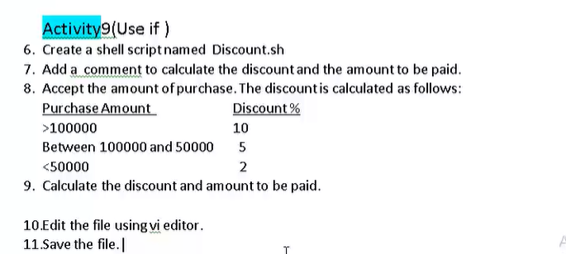

echo "Enter your purchase amount:"  
read tamt  
if [ $tamt -gt 100000 ]  
then  
echo "You are elligible for 10% discount!!!!"  
temp=$(($tamt / 100))  
damt=$(($temp * 10))  
echo "Your discount amt is:$damt"  
pamt=$(($tamt - $damt))  
echo "You need to pay only:$pamt"  
elif [ $tamt -lt 100000 ] && [ $tamt -gt 50000 ]  
then  
echo "You are elligible for 5% discount!!!!"  
temp=$(($tamt / 100))  
damt=$(($temp * 5))  
echo "Your discount amt is:$damt"  
pamt=$(($tamt - $damt))  
echo "You need to pay only:$pamt"  
elif [ $tamt -lt 50000 ]  
then  
echo "You are elligible for 2% discount!!!!"  
temp=$(($tamt / 100))  
damt=$(($temp * 2))  
echo "Your discount amt is:$damt"  
pamt=$(($tamt - $damt))  
echo "You need to pay only:$pamt"  
else  
echo "pls enter valid amount"  
fi

**PENDING**

Break command :

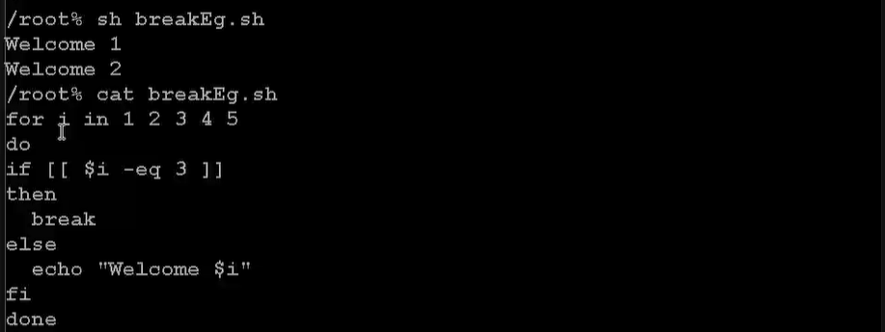

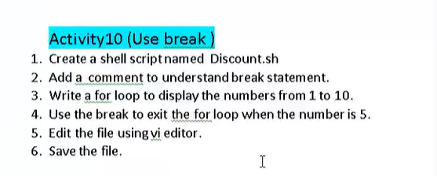

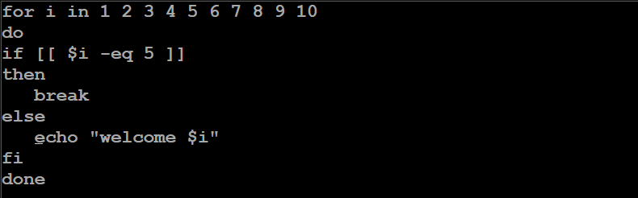

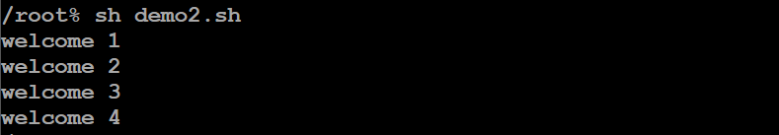

FILE OPERATION:

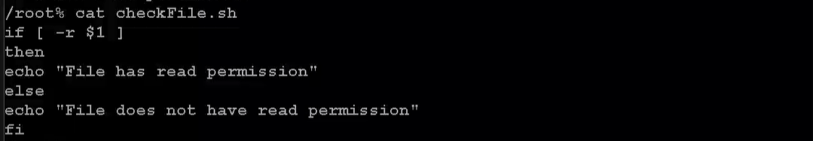

String comparison:

