ARRAY :

<https://www.geeksforgeeks.org/array-basics-shell-scripting-set-1/>



AWK= is basically for text processing,utility

AWK COMMAND TO FIND WITH SPECIFIC PATTERN:



SALARY GREATER THAN 200000:





BY NUMBERING:



TO PRINT ALL COLMUMNS WITH NUMBERING:



SORT FUNCTION WITH REVERSE :





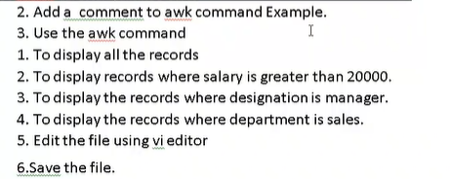





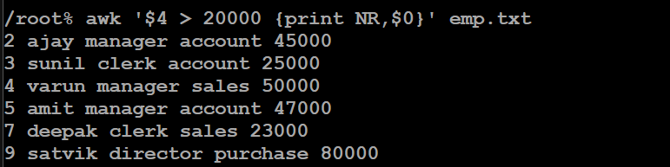





TO DISPLAY ALL RECORD FROM LINE NO . 3 to 6:









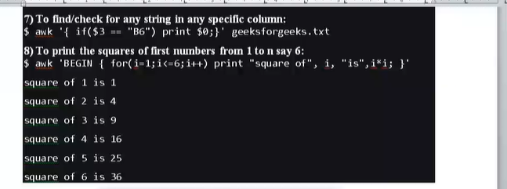

CONTENT WITH HEADING:



HEADER AND FOOTER FORMATTING:

BEGIN-header

END-footer



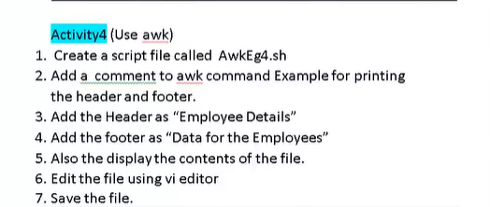









FORMATTING:



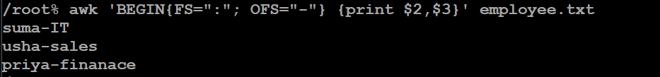

FIELDWIDTH:



IF condition:



**ACTIVITY:**

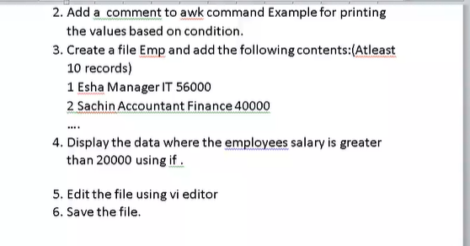

NF- last field



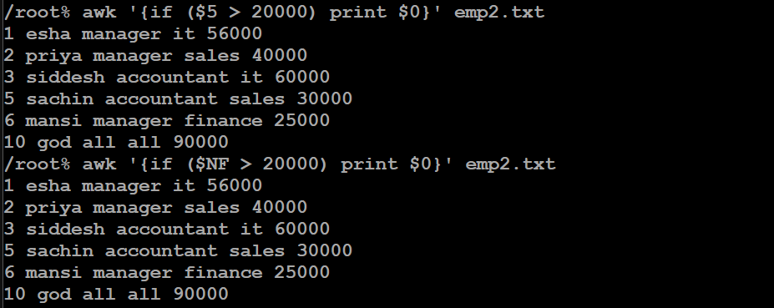

IF CONDITION :



TO PRINT SUM:





STEPS:

First create cat file with .sh

Use this command to convert it to awk files

Sales – user created numeric data is there

And in awk1 – awk code

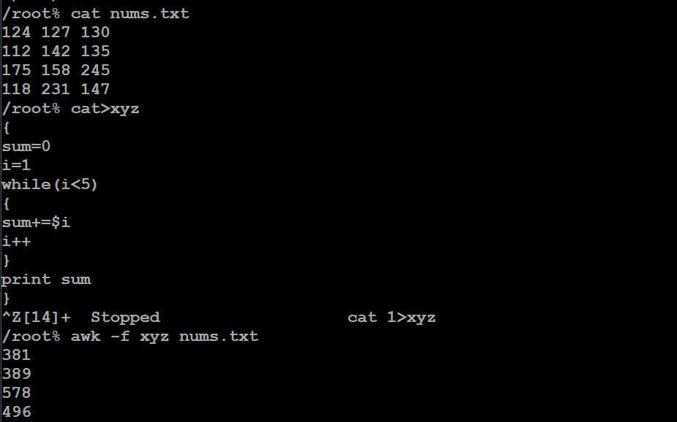

ACTIVITY:







Mam solution:



USING FOR:





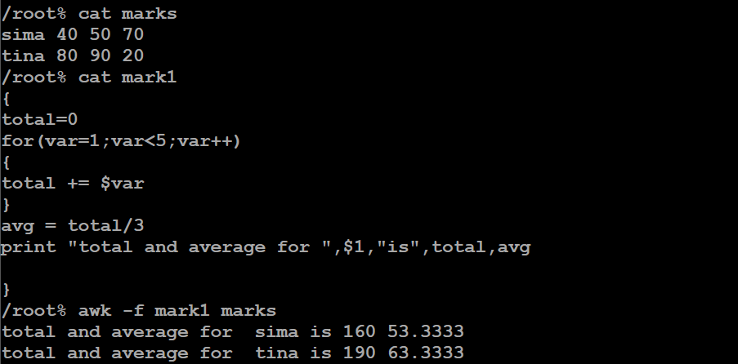

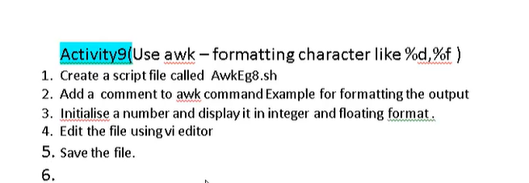





CODE FOR DUPLICATES:

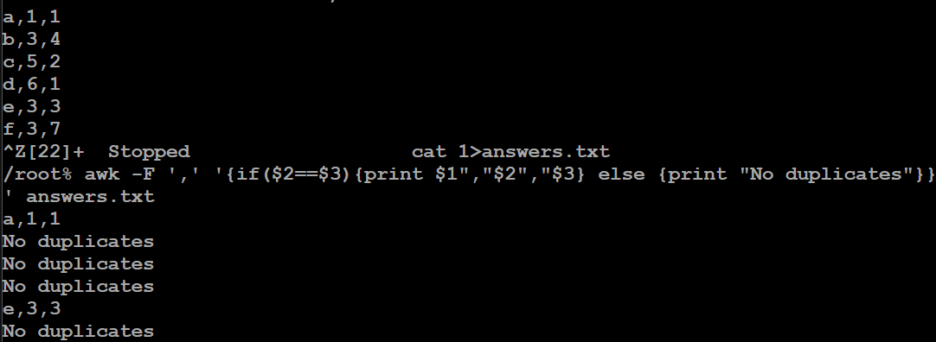

FORMATTING:

