TAR COMMAND:

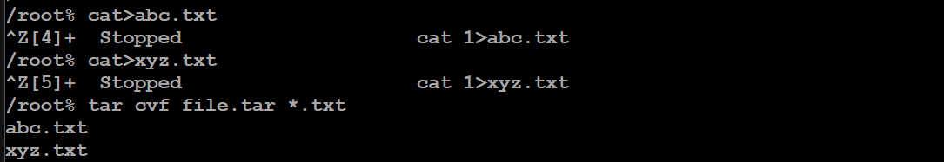

MAN COMMAND:

Provides manual



**REVISION ACTIVITIES:**

**ACTIVITY 1:**

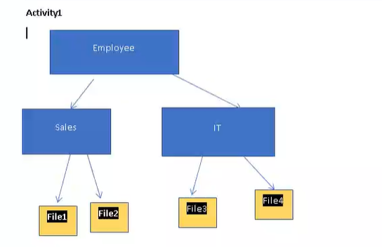

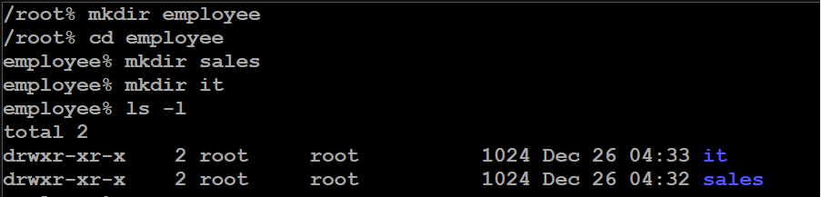

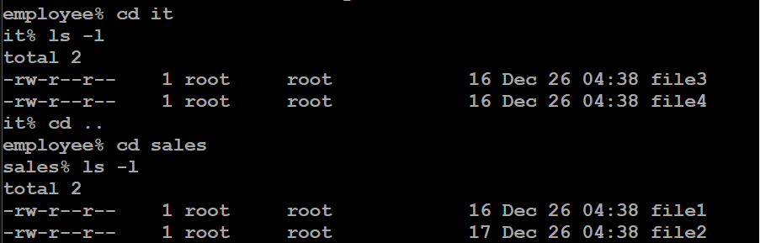

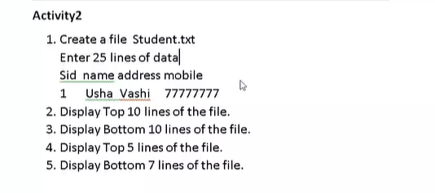

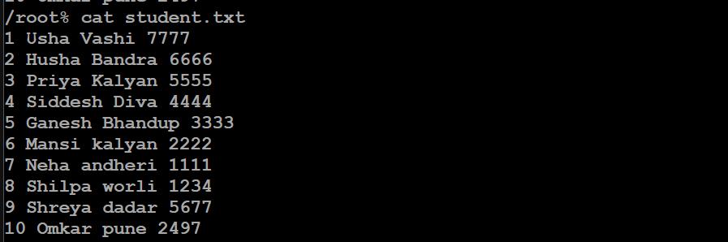

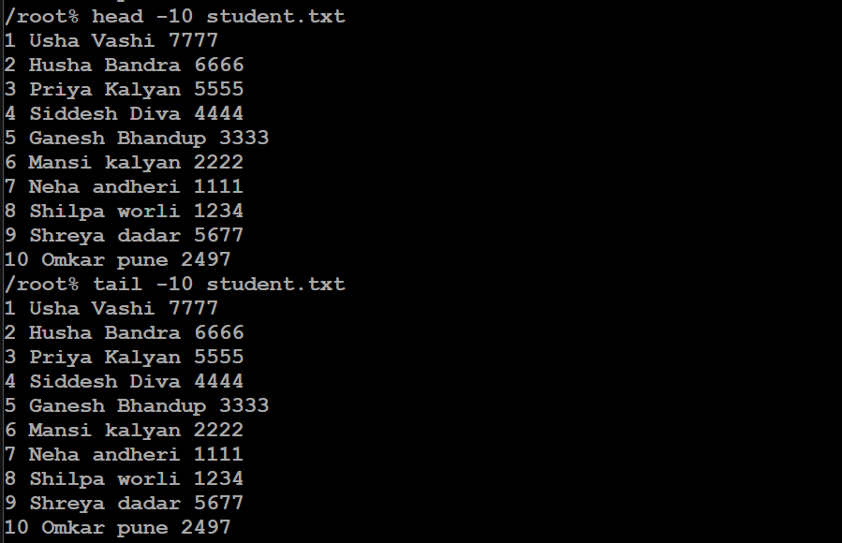

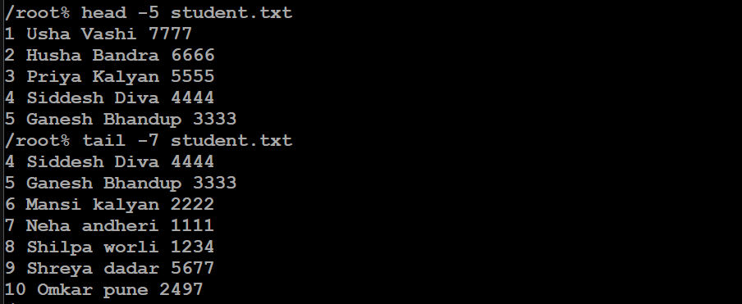



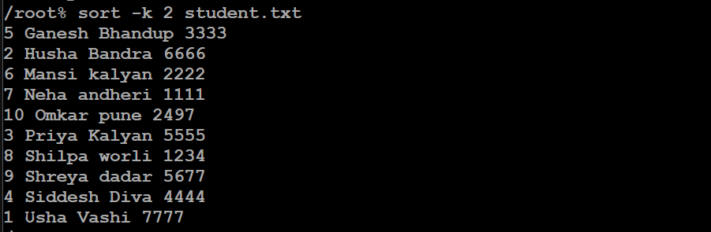

**(Without space it will also work)**

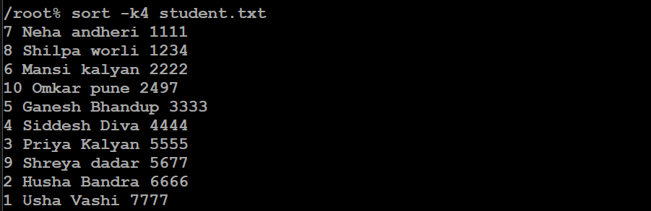

**(bydefault – r will print data in reverse order by considering first col)**

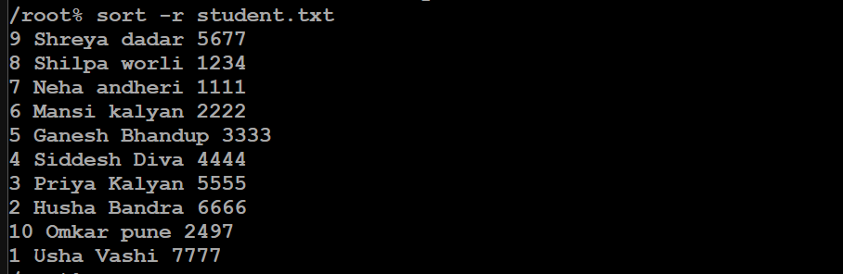

**-r – reverse –k – to specify column (reverse column 4 )**

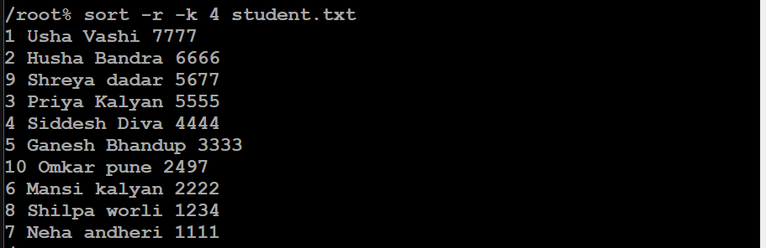



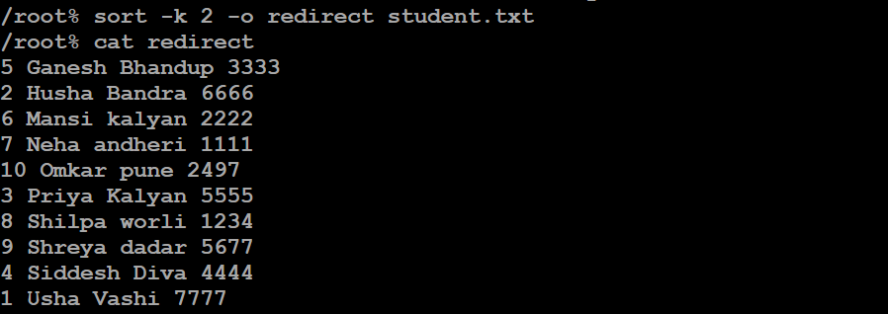

**We can use > to store to sorted result too.**

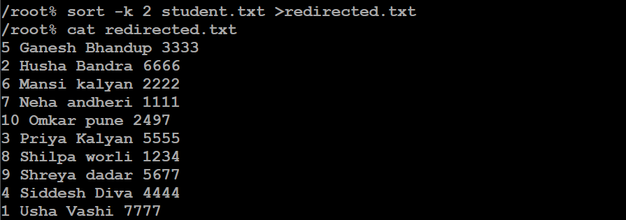

**ACTIVITY 3:**

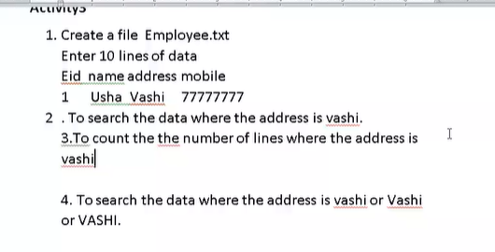





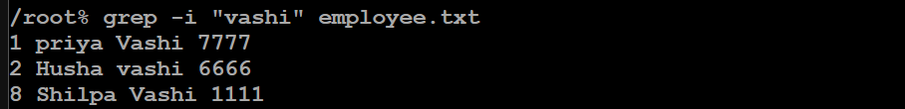

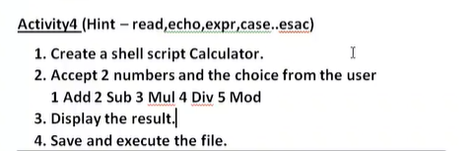

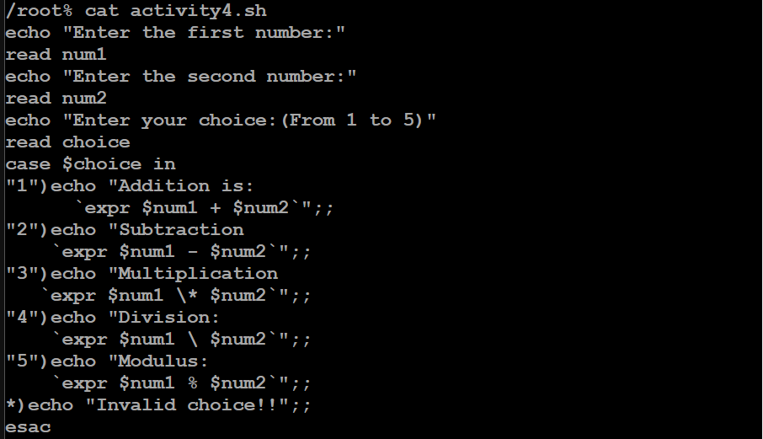

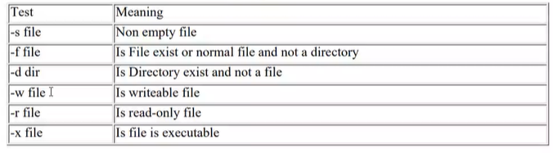

**ACTIVITY5 – file or directory check**

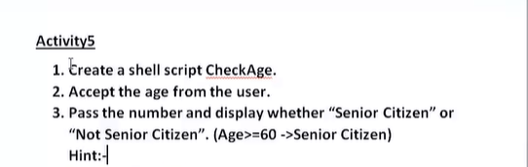

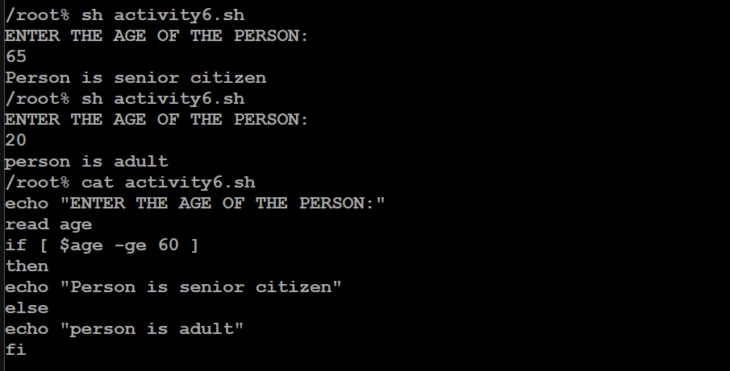

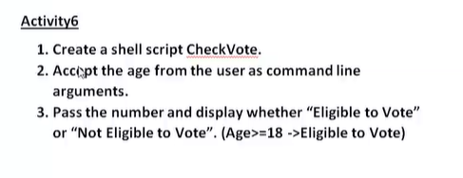

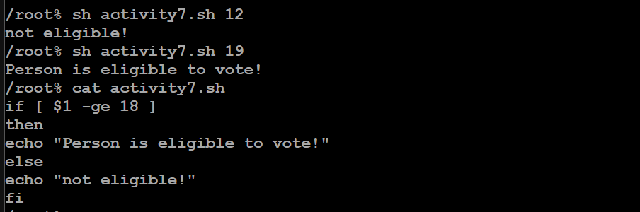

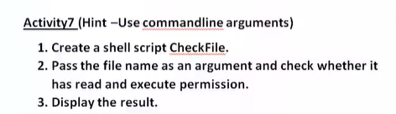

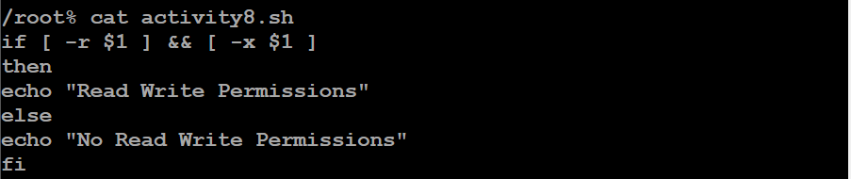

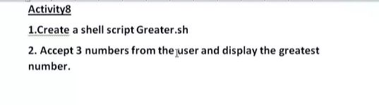

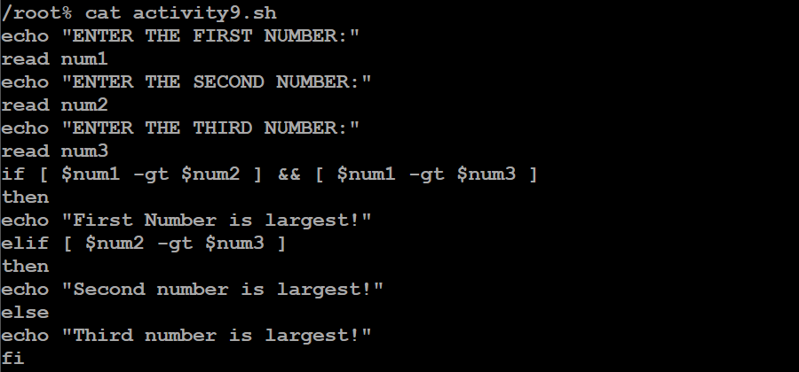

**WHILE ACTIVITY:**

**1)Numbers from 5 to 1:**

