Concepts of Operating System

Assignment 2

Part A

What will the following commands do?

1.echo "Hello, World!"



2. name="Productive"

We need to first create

**nano p1.sh**

write inside it

**name="Productive"**

**echo name**

come outside of it

bash p1

3. touch file.txt

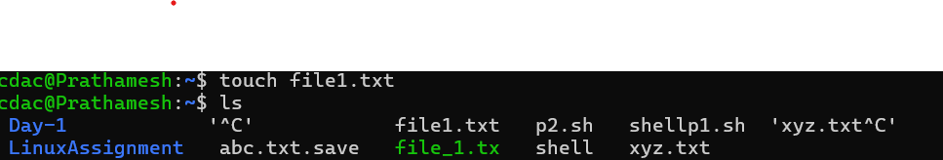

4. ls -a

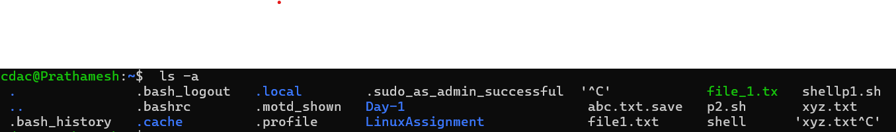

5. rm file.txt

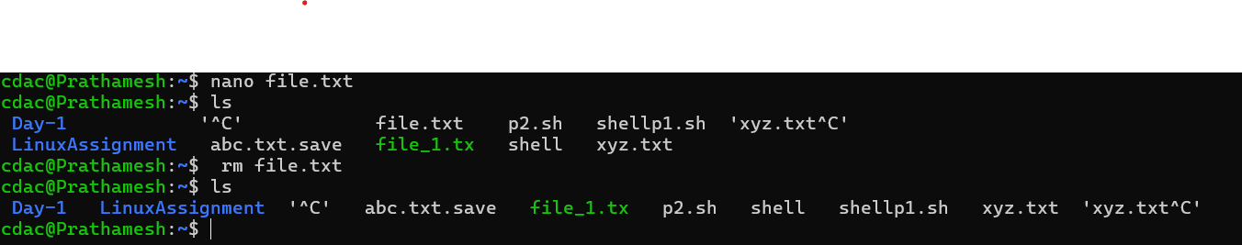

6. cp file1.txt file2.txt

Copy file1 data to file2

7. mv file.txt /path/to/directory/

To move file.txt from one directory to other directory

8. chmod 755 script.sh

It changes the file permission of script file

9. grep "pattern" file.txt

It will find pattern in file.txt

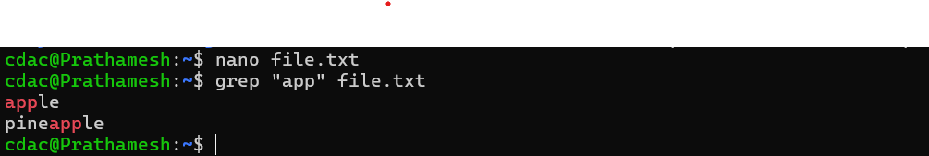

10. kill PID

It is used to terminate the program

11. mkdir mydir && cd mydir && touch file.txt && echo "Hello, World!" > file.txt && cat file.txt

Creates new directory mydir,change working directory to mydir,create file.txt inside mydir then write inside file.txt helloworld and display content of file.txt on terminal

12. ls -l | grep ".txt"

Output of first cmd passed as input to 2nd cmd,grep used to find patten

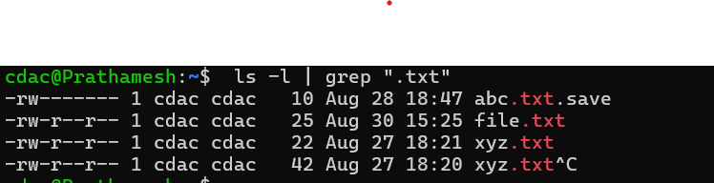

13. cat file1.txt file2.txt | sort | uniq

Concatenating file1 and file2 sorting it and then filtering out the unique values(only common)

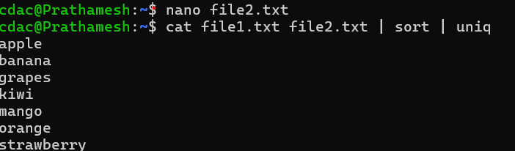

14. ls -l | grep "^d"

ls-l list out all the files and directories,grep finds all the words starting with letter ‘d’ and prints it out

15. grep -r "pattern" /path/to/directory/

Grep finds patterin in all files and directories and print it out

16. cat file1.txt file2.txt | sort | uniq –d

Concatenating file1 and file2 sorting it and then filtering out the duplicated values

17. chmod 644 file.txt

It makes the file readable by owner and others as well

18. cp -r source_directory destination_directory

Copies content of source directory to destination directory

19. find /path/to/search -name "*.txt"

It finds .txt files within directory mentioned

20. chmod u+x file.txt

Chmod modifies permission of file.txt to add execute for owner

21. echo $PATH

display directories in path