CHRONOSMATCH
Order Matching and Trade Management System
TECHNICAL PROJECT REPORT

Project Group | 28
Project Type | Python-based exchange simulation
Technology | Python • FastAPI • SQLite • Streamlit • Pytest
A modular application demonstrating order-book management,
price-time matching, REST API integration, and persistent data storage.

1. Project Overview
ChronosMatch is a Python-based exchange simulation that demonstrates how a trading application receives BUY and SELL orders, maintains an order book, matches compatible orders, records executions, and preserves order and trade information. The application combines a price-time-priority matching engine with a FastAPI backend, SQLite persistence, and a Streamlit dashboard.
The integrated implementation supports order creation and retrieval, cancellation of active orders, partial and complete execution, trade-history access, and restoration of persisted state during backend startup. The latest verified automated test run on the integrated main branch completed with 45 passing tests.

2. Problem Statement
Trading applications must process incoming BUY and SELL orders while maintaining accurate order information and applying consistent execution priorities. An unstructured approach can make it difficult to identify compatible orders, track partially filled quantities, and maintain reliable execution records.
ChronosMatch addresses these requirements through a structured order book, a matching engine that applies price-time priority, REST APIs for system interaction, and persistent storage for orders and trades.

3. Proposed System
Users submit orders through the Streamlit interface. FastAPI validates and routes requests to the order-processing components. The matching engine evaluates each incoming order against the active order book. Compatible orders are executed, trade records are generated, and filled and remaining quantities are updated. Any eligible unmatched quantity remains in the order book.
SQLite stores order and trade information. At backend startup, the database is initialized and persisted state is used to restore active orders and trade history.

4. Core Capabilities
- Price-time-priority order book for BUY and SELL orders.
- Complete and partial order execution with quantity and status updates.
- Cancellation of active orders while retaining previously executed trade records.
- REST API access to orders, trades, statistics, and order-book information.
- SQLite persistence and matching-engine recovery after backend restart.
- Streamlit interface for order entry, order management, order-book monitoring, and trade history.

5. System Architecture
ChronosMatch follows a modular, layered design. The dashboard communicates with the FastAPI backend through REST requests. The backend coordinates order processing through the order service and matching engine. The persistence layer stores orders and trades in SQLite. During startup, the recovery process reads persisted data and restores the engine's active state.
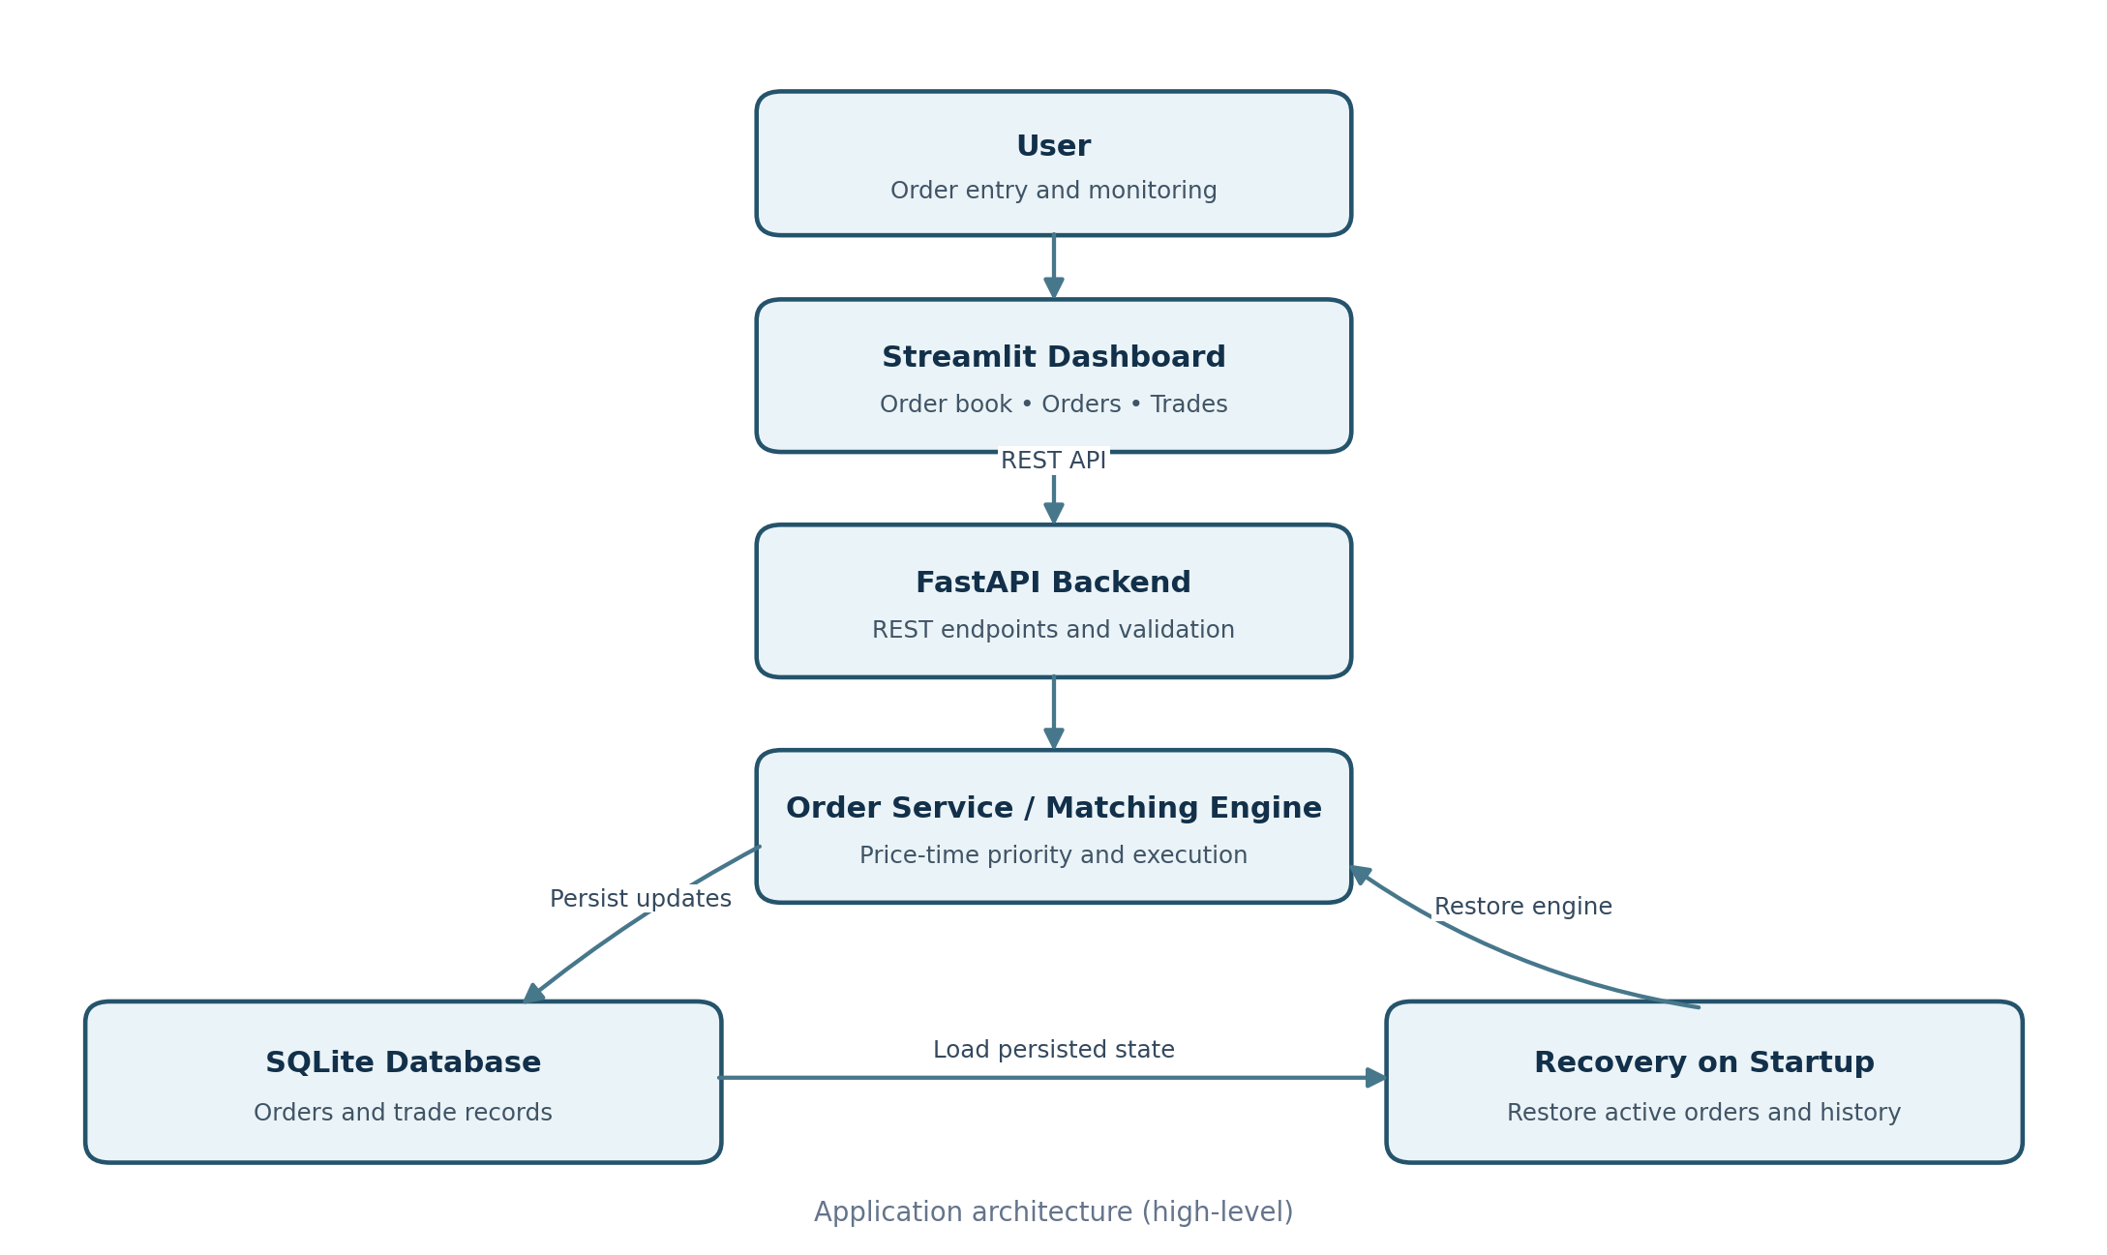
Figure 1. High-level architecture of the ChronosMatch application.

5.1 Component Responsibilities
- Streamlit dashboard: provides the user interface for order submission and monitoring.
- FastAPI backend: exposes REST endpoints and validates incoming requests.
- Order service and matching engine: coordinate order processing and apply matching rules.
- Order book: maintains active BUY and SELL orders according to price-time priority.
- SQLite repository: persists order and trade records and supports retrieval.
- Recovery process: restores active orders and trade history during backend startup.

6. Order Processing Workflow
The workflow below describes the lifecycle of an order from dashboard submission through validation, matching, persistence, and display of updated information.
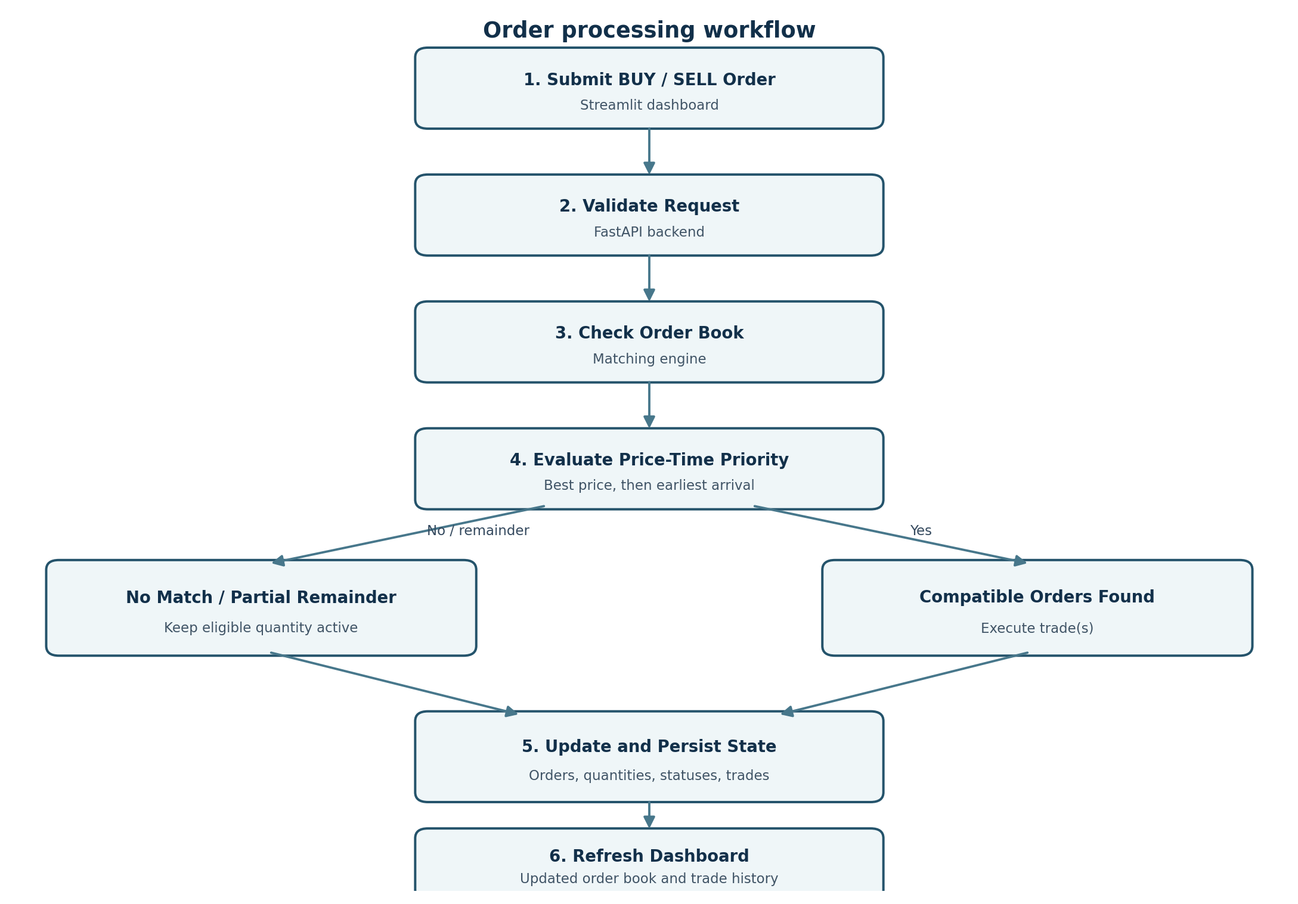
Figure 2. End-to-end order processing workflow.

6.1 Matching Rules
- BUY orders are prioritized by highest price first.
- SELL orders are prioritized by lowest price first.
- Orders at the same price are prioritized by arrival time.
- A match is possible when the best BUY price is equal to or greater than the best SELL price.
- The resting order's price is used as the execution price.
- Fully filled orders leave the active order book; partially filled orders retain their remaining quantity.

7. Implementation Details

7.1 Backend and Order Management
The backend is implemented in Python using FastAPI. It provides endpoints for creating orders, retrieving order details, cancelling active orders, accessing trade history, viewing trading statistics, and retrieving order-book information. Incoming requests are validated before being processed.

7.2 Persistence and Recovery
SQLite is used to persist order and trade information. The database layer supports initialization, order creation and updates, trade-record storage, and retrieval. During backend startup, persisted information is loaded to restore the matching engine's active state.

7.3 API Endpoint Reference
Method | Endpoint | Purpose
POST | /orders | Create an order
GET | /orders/{order_id} | Retrieve order details
DELETE | /orders/{order_id} | Cancel an order
GET | /trades | Retrieve trade history
GET | /stats | Retrieve trading statistics
GET | /orderbook/{symbol} | Retrieve the order book
GET | /orderbook/{symbol}/summary | Retrieve order-book summary
GET | /success | Check backend/database connectivity

7.4 Testing and Verification
The project uses pytest for automated testing and Postman for API checks. The latest verified test run on the integrated main branch completed with 45 tests passing.
- Order creation, retrieval, cancellation, and input validation.
- Matching behavior, price-time priority, and partial fills.
- Trade-history and order-book operations.
- Database repository operations and persistence.
- Recovery of persisted state after backend restart.

8. Streamlit Dashboard
The Streamlit dashboard is connected to the FastAPI backend and provides an interactive interface for working with the matching system. It exposes the main user-facing functions through four tabs: Order Book, Place Order, Manage Orders, and Trade History.
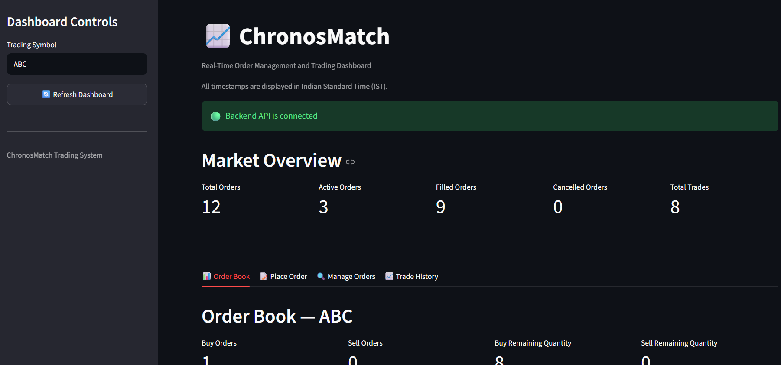
Figure 3. Previously shared ChronosMatch dashboard showing a connected backend and market overview.

8.1 Dashboard Functions
- Order Book: displays active BUY and SELL orders and remaining quantities.
- Place Order: allows users to submit BUY and SELL orders.
- Manage Orders: supports reviewing and managing submitted orders.
- Trade History: displays executed trade records.
- Market Overview: presents available order and trade statistics.
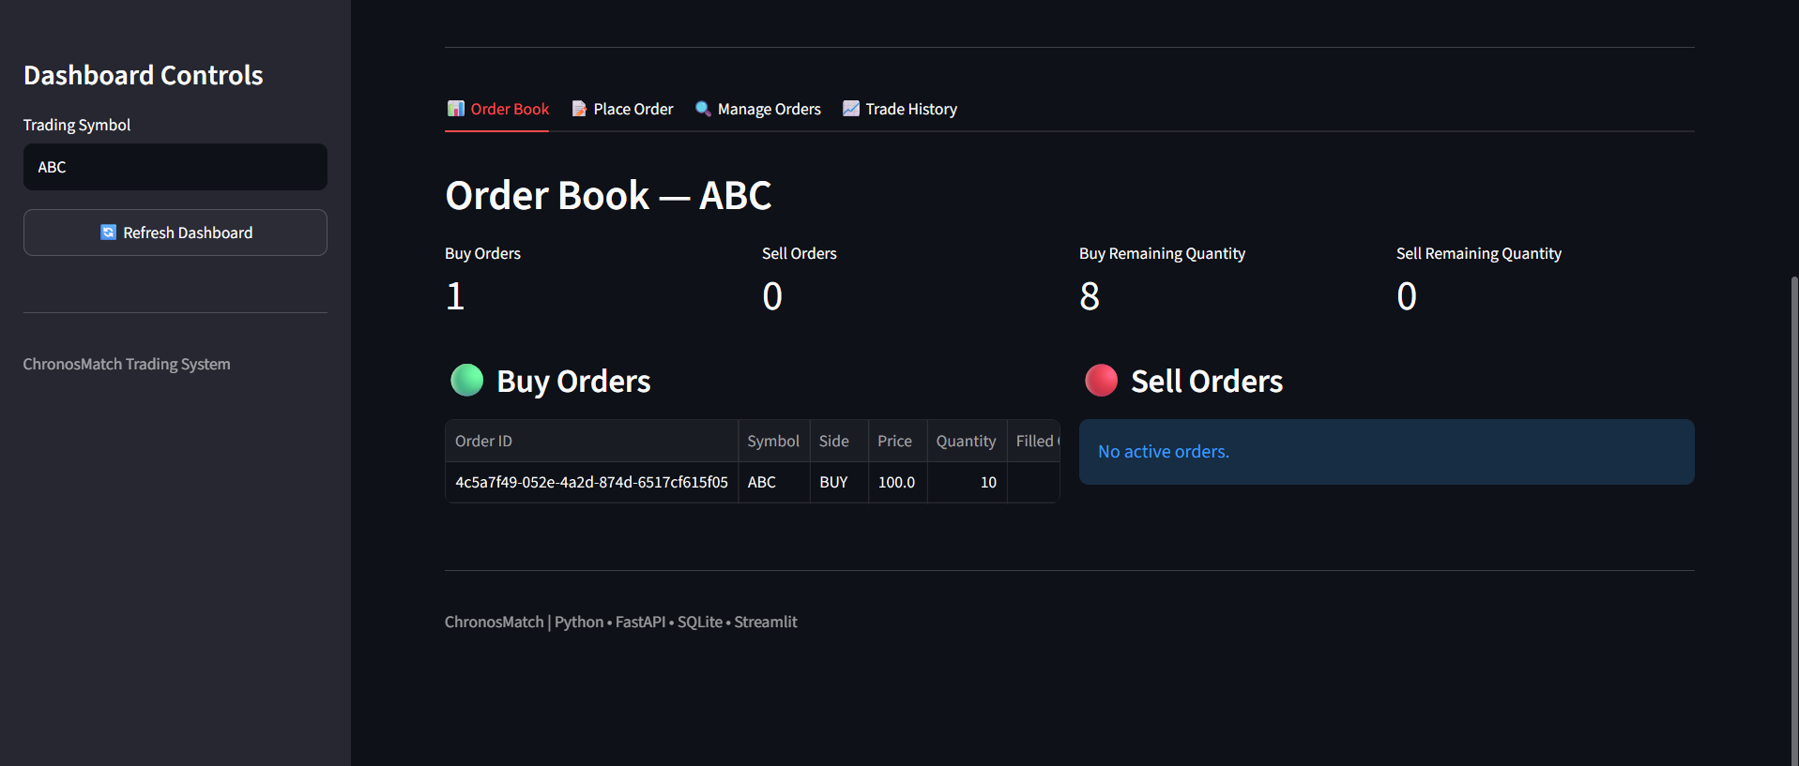
Figure 4. Order-book view from the previously shared dashboard.
Figure 5. Trade-history table from the previously shared project screenshots.

9. Technology Stack
Area | Technology
Programming language | Python
Backend framework / server | FastAPI / Uvicorn
Database | SQLite
Frontend | Streamlit
Data handling | Pandas
API communication | REST APIs / Requests
Testing | Pytest; Postman for API checks
Version control | Git and GitHub

10. Future Scope
- Profile matching latency and throughput under defined workloads.
- Evaluate data structures and processing approaches for improved efficiency.
- Assess scalability under larger order volumes and concurrent requests.
- Extend monitoring with execution metrics and operational statistics.
- Consider real-time dashboard updates, stronger API security, and deployment monitoring.
Performance and low-latency improvements remain areas for future measurement and optimization; the project does not claim verified high-frequency or zero-copy performance.

11. Conclusion
ChronosMatch delivers an integrated exchange simulation combining a price-time-priority matching engine, FastAPI backend, SQLite persistence, recovery functionality, and a Streamlit dashboard. The application supports order creation, retrieval, cancellation, trade execution, order-book maintenance, and access to persisted information.
The integrated implementation has been verified with 45 passing automated tests. It provides a modular foundation for further work on performance measurement, scalability, monitoring, security, and real-time interaction.
Project scope: ChronosMatch is an educational exchange simulation. It is not connected to a live trading venue and is not intended for real financial transactions.

