DEPT. OF FARM MACHINERY AND POWER ENGINEERING
The Department of Farm Machinery and Power Engineering was started with a vision to explore and cater the application of agricultural machinery and power sources to the field of agriculture for enhancing the efficiency, drudgery reduction and timeliness in operation. The department is created to pursue excellence in teaching, research and industrial collaborative activities with farmer involved on farm research and developments. The academic curriculum with Undergraduate program includes the study of basic principles and practical exposure on farm machinery starting from land preparation, sowing, intercultural, plant protection and harvesting operations. Laboratory / field experimental facilities on each operation would alleviate the knowledge in subject and assists on field machine servicing capabilities. Also PG/Ph.D. programs under the department provides the explicitness in the subjects of design of agricultural machinery, human safety, soil dynamics, traction mechanics, precession agriculture, testing & evaluation of farm machinery, robotics in agriculture and drone technology. Laboratory facilities on instrumentation, ergonomics, traction mechanics and field-testing cover insight understanding of the concepts. AUTOCAD, SOLIDWORKS and ANSYS software’s are equipped for complete design, modelling and stress analysis of farm machinery prior to prototyping.
Department is established with R&D facility on farm mechanization, under which custom hiring centre provides machinery on affordable rental basis to the farmers. Also Farm implements production unit was established in the department which involves in development and manufacturing of customized small hand tools/agricultural implements on order basis. A well-equipped workshop facility with CNC lathe and CNC milling machines assist in inherent development of agricultural machinery. Apart from these following are the laboratories available in the department.
- Farm Machinery Laboratory
Name of the Laboratory | Name of the Important Equipment/Instruments
Farm Machinery Laboratory | Knapsack sprayer, Hand compression sprayer, Mist blower, Hand operated castor thresher, Groundnut pod stripper, Axial flow thresher, Paddy reaper, Maize Sheller, Power Sprayer, Sub-soiler, Paddy thresher, ULV Sprayer, Post hole digger, 9 tyne cultivator (spring loaded), Boom sprayer, Disc plough, Battery operated cotton picker, Wheel type dibbler, Rotary mulcher, Groundnut digger shaker cum windrower, Mobile shredder, Foot operated sprayer, Rocking sprayer, Bucket scraper, Multi crop thresher (Electric motor operated), Rotavator, Rice transplanter (Riding type), Rice transplanter (walking type), Nursery raising machine, Seed cum fertilizer drill automatic, Reversible M.B. Plough, Rotary plough, Spider weeder, Multi crop ridge planter, Rotary slasher, Laser land leveler, Self propelled high clearance sprayer, Combine harvester (self propelled), Combine harvester (tractor mounted), Rigid tyne cultivator, John Deere 4 WD tractor along with hoe and bucket attachments, Mahindra 40 H.P, Escorts tractor, V.S.T Mini tractor, Power tiller
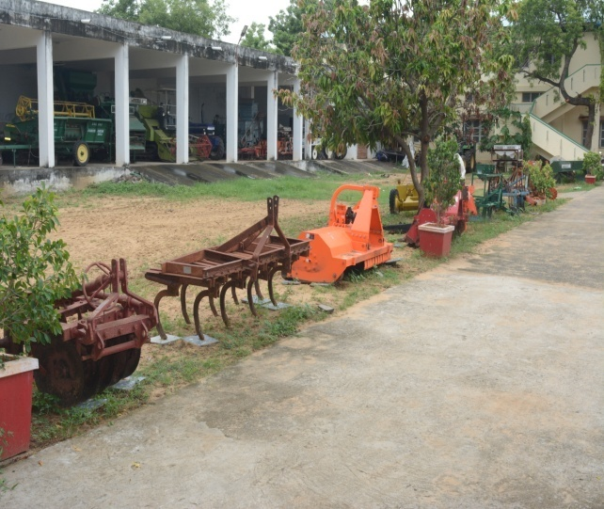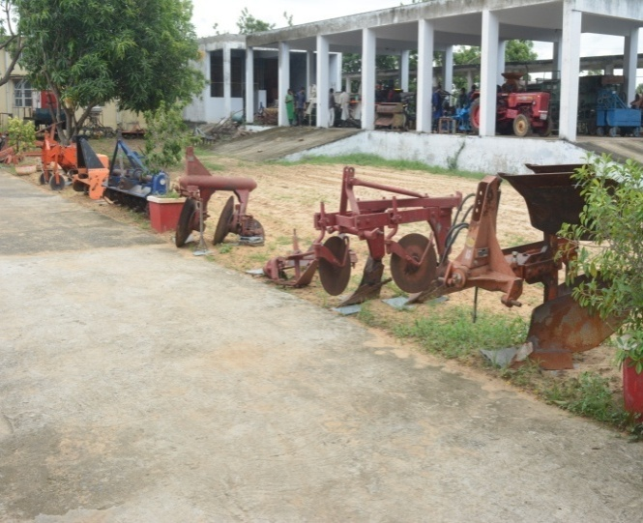

Farm Machinery Laboratory

- Farm Power Laboratory
Name of the Laboratory | Name of the Important Equipment/Instruments
Farm Power Laboratory | Cut models - Diesel engine (single cylinder), Tractor differential, Tractor steering, Rear axle assembly, Hydraulic brake, Master cylinder, Ignition system, Self starter, Distributor, Ignition Coil, Magneto, Synchromesh gear box, Constant mesh gear box, Steering gear box, diaphragm clutch system, multi plates clutch, Four wheel brake, cone clutch, mechanical brake system. LED Panels - Fuel injection system, Lubrication system, Gear box 8+2, Hydraulic system., Tractor cut section without wheel assemblies, etc.

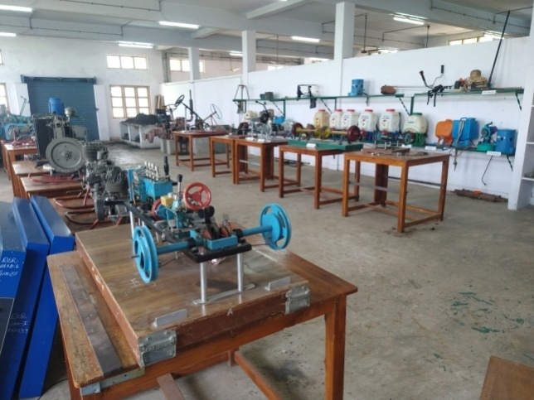
Farm Power laboratory
- Ergonomics Laboratory
Name of the Laboratory | Name of the Important Equipment/Instruments
Ergonomics Laboratory | Motorized treadmill, Digital heart rate monitor, Digital pulse monitor with finger sensor cable, Dual digital thermometer with core/skin temperature process, Electromyography unit, Ergo meter cycle, Bourdon tube pressure gauge (digital), , Speed measurement trainer, Torque cell transducer (10 kg), Strain measurement trainer (1 kg), Digital sound level meter, Digital vibration meter, etc.

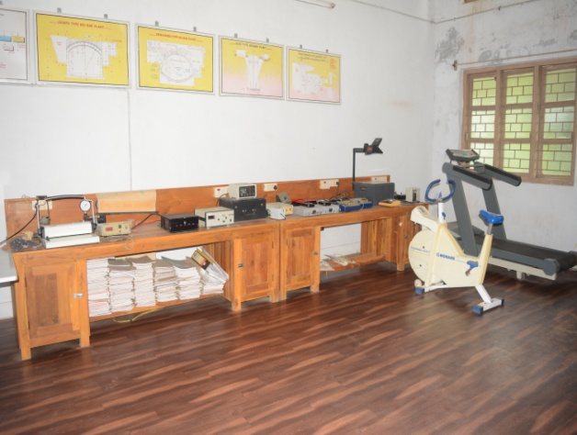
Ergonomics laboratory

- Advanced Workshop
Name of the Laboratory | Name of the Important Equipment/Instruments
Advanced Workshop | Lathe machines with all accessories and attachments, Spot welding machine (pedestal type), Welding Machine with transformer (600 AMPS air cooled) and accessories, Wooden work table (3’ X 8’), Bench grinder ½ HP, Lathe machines, Wood turning lathe, Shaper machine (18”), Air compressor, Iron cutting machine (14”), Hydraulic press, Shearing machine, Hydraulic hack saw machine with 2 hp motor, Hydraulic pipe bending machine, Stand drilling machine ½”, Pipe bending machine ( ½” to ¼”), Hand drilling machine (6 mm), Universal milling machine, Radial drilling machine 1” capacity, Heavy duty sheet bending machine (4’), CNC Lathe machine, CNC Milling machine, etc.

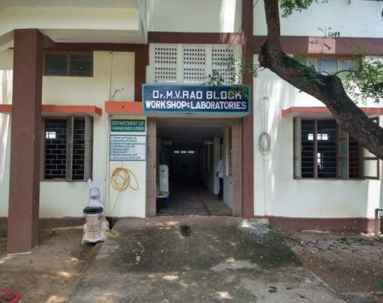
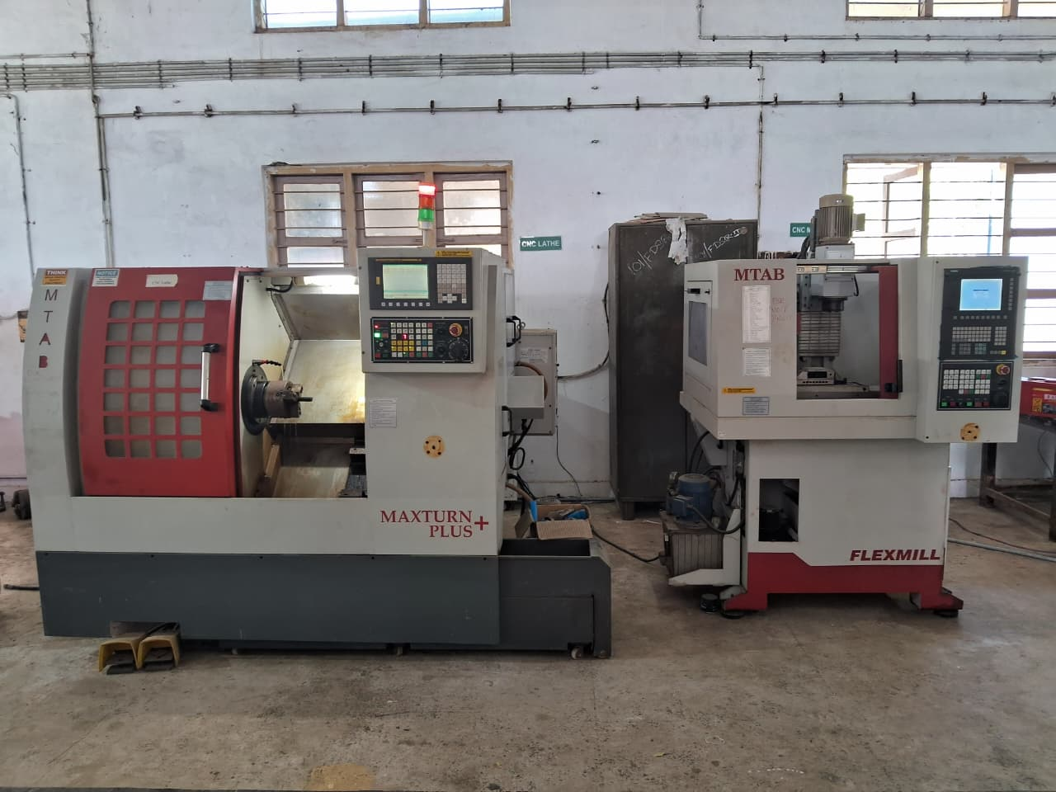

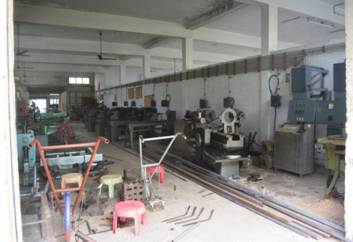
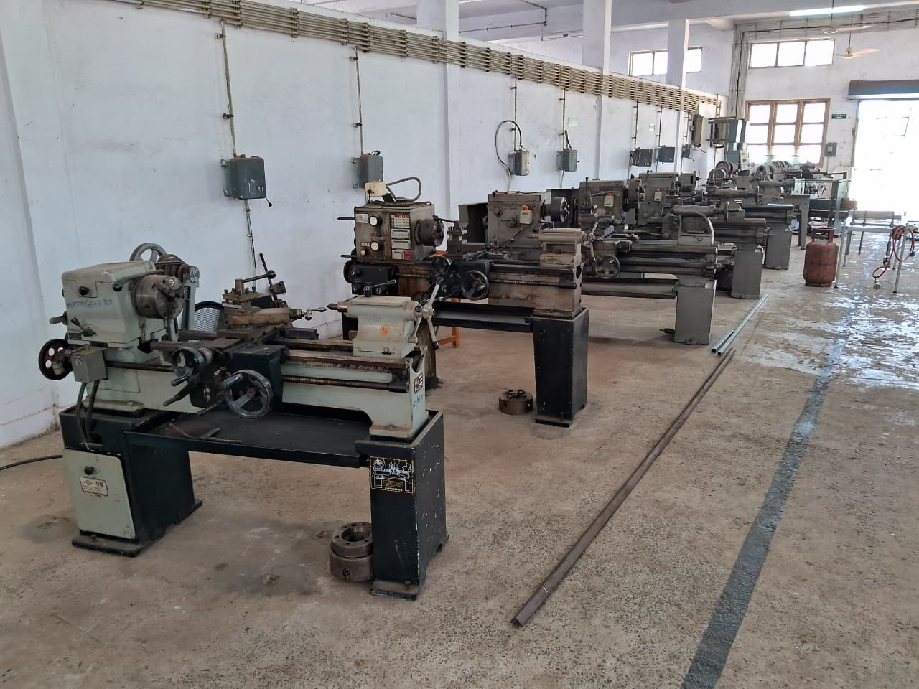

- Soil Dynamics Laboratory
Name of the Laboratory | Name of the Important Equipment/Instruments
Soil Dynamics Laboratory | Rectangular and circular soil bins, Force analysis instrumentation, S Type load cells (1 ton and 3 ton capacity), Digital force gauge, Digital and analogue tachometers, Cone penetrometer, Strain gauge (canti-lever type), Universal load cell (750 kg), Digital transducer indicator suitable for AG make universal load cell, Variable frequency drive motor (1.5 kW), etc.

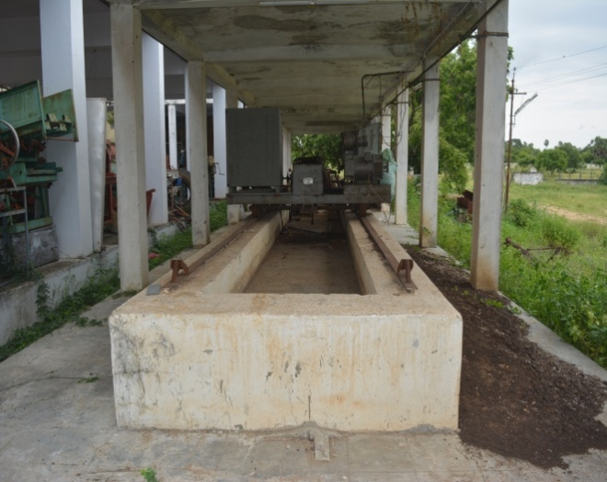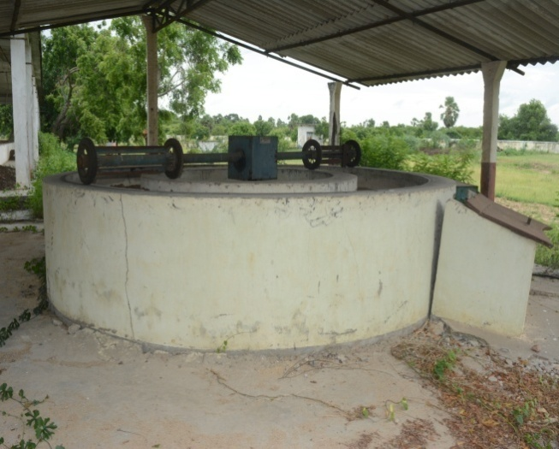
Soil Dynamics Laboratory
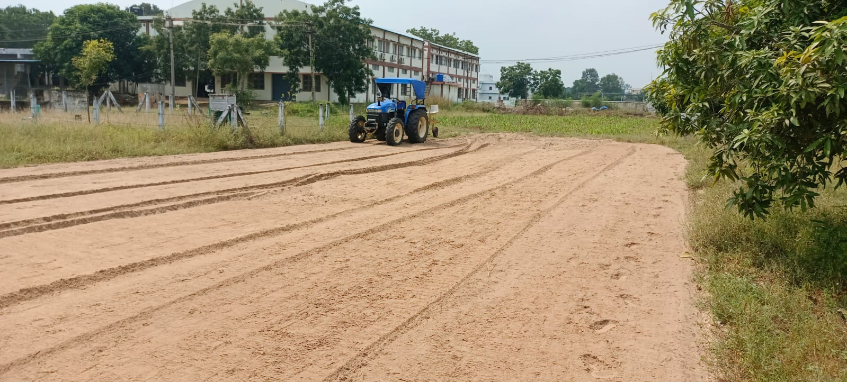
Field testing of developed machinery

Experiential Learning Programme Unit (ELP Unit):
Experiential Learning Programme (ELP) unit titled “ANGRAU Farm Implements Production Centre” was established during the academic year 2020-21 in the Dept. of Farm Machinery and Power Engineering, Dr.NTR College of Agricultural Engineering, Bapatla. Under this ELP unit, final year students of B.Tech. (Ag. Engg.) will undergo the course “Experiential Learning On-Campus (Student READY) – SRDY 482 (0+10)” for the duration of 10 weeks in the first semester of every academic year. Students will procure raw material and fabricate the small agricultural tools/implements by some initial investment. Later income will be generated by students through selling of these tools/implement to the local farmers or institutes. Thereby manufacturing and entrepreneurship skills will be developed among the final year students of B.Tech. (Ag. Engg.).
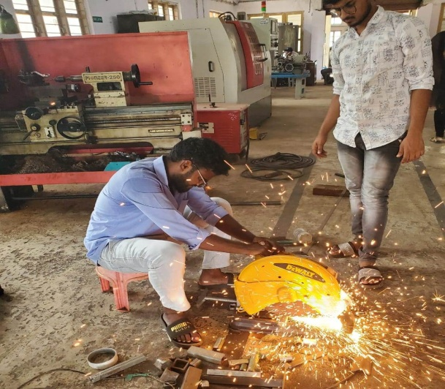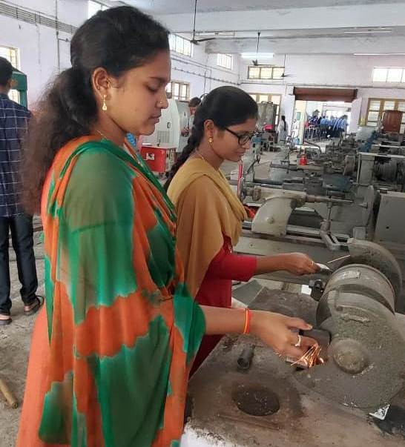
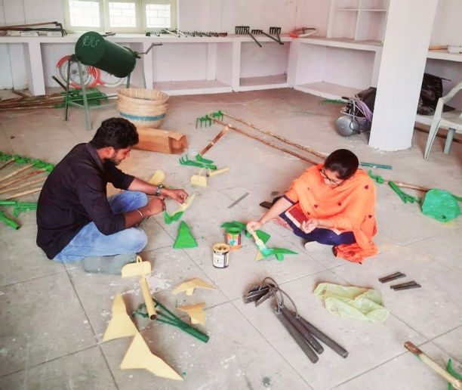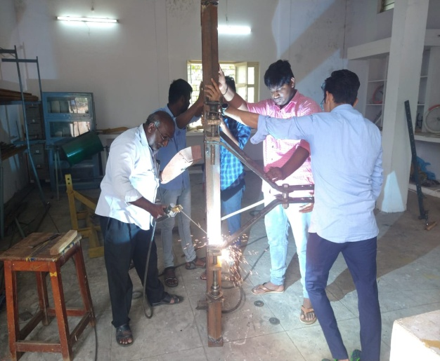
Students fabricating agricultural hand tools/implements under ELP

Department staff
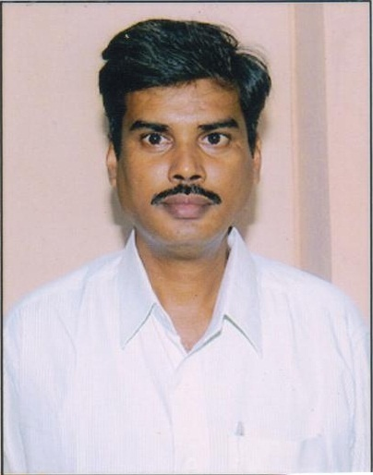
Dr. KVS RAMI REDDY
PROFESSOR & HEAD
9490845917
kvs.ramireddy@angrau.ac.in
View Profile

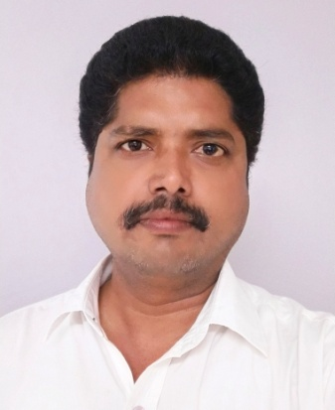
Dr. B. HARI BABU
ASSOCIATE PROFESSOR 9182780358
b.haribabu@angrau.ac.in
View Profile

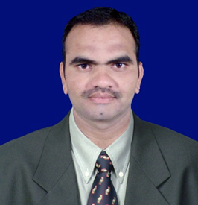 |  | 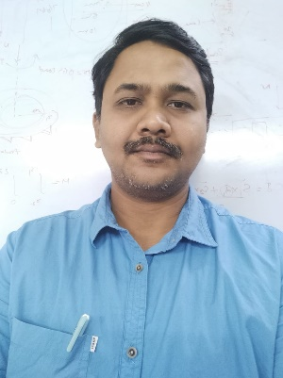
Dr. A. ASHOK KUMAR  ASSISTANT PROFESSOR 9177522213  a.ashokkumar@angrau.ac.in | Dr. D. VIJAY KUMAR  ASSISTANT PROFESSOR 9492686634  d.vijaykumar@angrau.ac.in | Dr. B. RAJ KIRAN  ASSISTANT PROFESSOR 8500220340  b.rajkiran@angrau.ac.in
View Profile | View Profile | View Profile

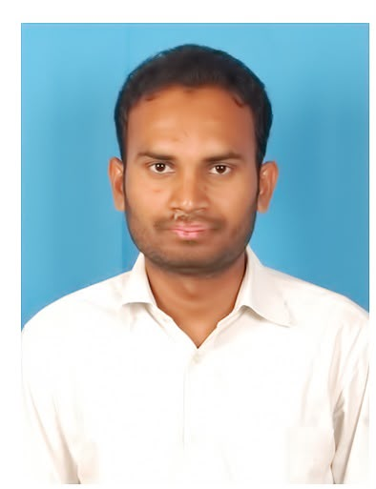
Er. N. KISHORE
ASSISTANT PROFESSOR
8500856998
n.kishore@angrau.ac.in
View Profile

Staff from AICRP ON FIM
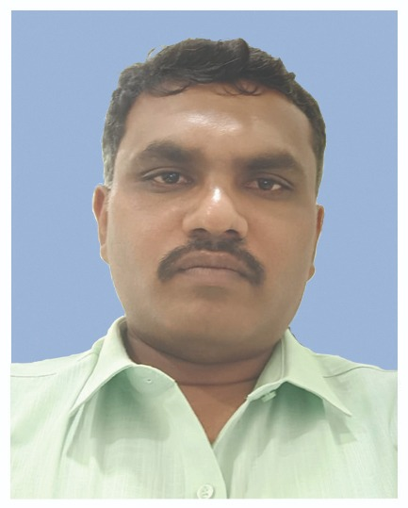
Dr. G.VEERA PRASAD
ASSISTANT PROFESSOR 9492686634
g.veeraprasad@angrau.ac.in
View Profile

FACULTY PROFILE

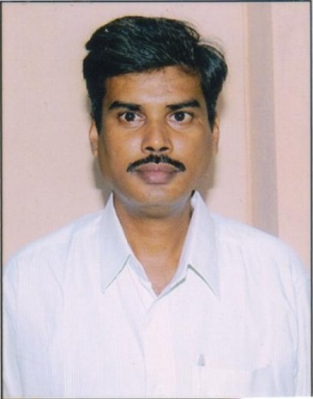  Dr. K V S RAMI REDDY  Professor (FMPE)  Dr. NTR College of Agricultural Engineering Bapatla | : | V S RAMI REDDY KALLAM
 | : | Email ID : kvs.ramireddy@angrau.ac.in  ksubbaramireddy@gmail.com  Phone: 9490845917
 |  | Department: Farm Machinery and Power Engineering (FMPE)
Ph. D in Farm Machinery and Power Engineering - 2017
Acharya N.G. Ranga Agricultural University
Title: Studies on Design, Development and performance evaluation of
tractor drawn rotary spider weeder for row crops
M.Tech in Farm Machinery and Power Engineering – 1998
MPKV ,Rahuri (M.S)
Title: Design, Development of an Axial flow blower suitable for tractor
mounted axial carrier sprayer for Grape vineyard.

B. Tech in Agricultural Engineering -1994
Acharya N.G. Ranga Agricultural University (APAU)
Title: Drying of raw and ripe banana equipment and product development .
Notable contributions | : | - Establishment of Farm Machinery, Farm power labs and CNC machines (Milling and Turning)at CAE, Bapatla.  - Preparation of Course materials, question bank to subjects DAE 312 for Diploma in Agricultural Engineering students.  - Author in preparation of Course material on FAMP 341,FAMP 342 and FAMP 442 as per IV deans committee guidelines.
Research Interests | : | - Precision farming technologies and instrumentation involved in agricultural machinery development
Professional recognition | : | - Acted as external evaluator for B.Tech final project evaluation for the colleges out of the university  - Acted as Chairman and members of Advisory committees for PG and Ph.D research Projects .
Research publications |  | International/National Journals : 25  Conference proceedings: 05  Books and Book chapters: -  Technical bulletins: 02  Popular articles: 03
Awards & Honours | : | - Life member in Andhra Agricultural Journal  - Life member in ISAE

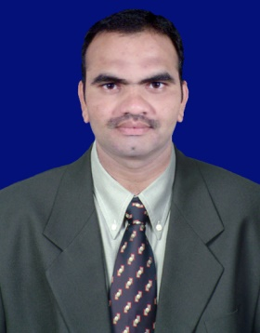  Assistant Professor | : | ARDUDRA ASHOK KUMAR
 | : | Email ID: a.ashokkumar@angrau.ac.in  Phone: 9177522213
 |  | Department: Farm Machinery and Power Engineering
Educational Qualification:
Doctor of Philosophy (Ph.D.) in Farm Machinery and Power Engineering
Year of completion: 2017
University: IIT Kharagpur, West Bengal
Title of the Thesis: Embedded Systems for Field Performance
Evaluation of Agricultural Tractors
Master of Technology (M.Tech) in Farm Machinery and Power Engineering
Year of completion: 2011
University: IIT Kharagpur, West Bengal
Title of the Thesis: Design of Digital Weight Transfer Display for
Agricultural Tractors
Bachelor of Technology (B.Tech) in Agricultural Engineering
Year of completion: 2009
University: Acharya N. G. Ranga Agricultural University, Lam, Guntur, Andhra Pradesh State
Title of the Thesis: Ergonomical Evaluation of Manually Operated
Weeders in Wet Land Condition
Notable contributions | : | - 9 years teaching experience in various subjects like Farm Machinery Equipment, Tractor Systems and Controls, Machine Design, Mechatronics, Mechatronics and Robotics in Agriculture, Artificial Intelligence etc.  - 5 years research experience as a Head of ICAR - AICRP on Farm Implements and Machinery Scheme, Bapatla.
Research Interests | : | Mechatronics, Application of Electronics in Agriculture, Robotics in Agriculture.
Professional recognition | : | 1. Life Member of Indian Society of Agricultural Engineers (ISAE)  2. Life Member of Indian Society of Agriculture & Horticultural  Research Development (ISAHRD)
Research publications |  | - International/National Journals : 43  - Conference proceedings: 14  - Books and Book chapters: 01  - Technical bulletins: 02  - Popular articles: 30
Awards & Honours | : | - Received Institution of Engineers India (IEI) “Young Engineer’s Award” in agricultural Engineering Discipline.  - Received ISAE-TAFE Student Gold Medal for the year 2019 for best PhD thesis.  - Received Young Scientist Award for contribution in the field of Farm Machinery and Power Engineering on the occasion of “ 4th International Conference on Innovations to Transform Agriculture, Horticulture & Allied Sectors” during 2023-24

  Assistant Professor | : | Er. D. Vijay Kumar
 | : | Email ID: d.vijayakumar@angrau.ac.in Phone: 9492686634
 |  | Department: Farm Machinery and Power Engineering
M.Tech (Farm Machinery and Power) Year of completion: 2010
Acharya NG ranga Agricultural University
Performance Evaluation Self-propelled Walking Behind Type Rice Transplanter in Krishna Western Delta Region of Andhra Pradesh
B.Tech (Agricultural Engineering) Year of completion: 2006
Acharya NG ranga Agricultural University
“Studies on Blanching of Banana, Carrot and Potato”
Notable contributions | : | - Associated in the design and development of (i) Aqua planter for groundnut and (ii) Groundnut planter cum herbicide sprayer at Agricultural Research Station, Anantapur, Andhra Pradesh.  - Popularization of seed to seed mechanization for groundnut in Anantapur District, Andhra Pradesh.  - Workshop and Farm Machinery laboratories were established at College of Agricultural Engineering, Madakasira, Andhra Pradesh.  - Supervised Eight (8) B.Tech. Research projects.
Research Interests | : | - Farm Mechanization in Dryland Agriculture.  - Straw Management Systems for Conservation Agriculture.
Professional recognition | : | - Life member in” Indian Society of Agricultural Engineers (ISAE)”.  - Life member in “The Andhra Agricultural Union - AAJ”.
Research publications |  | International/National Journals : 15  Conference proceedings: 5  Books and Book chapters: 2  Technical bulletins: --  Popular articles: 13
Awards & Honours | : | --

Dr. B. Raj Kiran  Assistant Professor (FMPE)  Dr. NTR College of Agricultural Engineering Bapatla | : | Raj Kiran Bakka
 | : | Email ID : b.rajkiran@angrau.ac.in  raj.be018@gmail.com  Phone: 9177345631
 |  | Department: Farm Machinery and Power Engineering (FMPE)
Ph. D in Farm Machinery and Power Engineering - 2022
Acharya N.G. Ranga Agricultural University
Title: Design and Development of automatic dibble transplanter for paper pot vegetable seedlings
M.Tech in Farm Machinery and Power Engineering – 2010
Indian Institute of Technology, Kharagpur
Title: Development of automatic speed control unit for inner rotor of self-propelled puddler
B. Tech in Agricultural Engineering -2008
Acharya N.G. Ranga Agricultural University
Title: Design and development of RBC flume for low discharge field channels
Notable contributions | : | - Development of drawing hall and infrastructural facilities at PAE, Kalikiri  - Establishment of Theory of Machinery Laboratory at CAE, Bapatla.  - Preparation of Course materials, question bank and answer keys to subjects DAE 141 & DAE 145 for Diploma in Agricultural Engineering students.  - Preparation of practical manual on Workshop Technology and Practices for UG students.  - Co- author in preparation of Course material on FAMP 241 and MECH 282 as per IV deans committee guidelines.  - Development of automatic dibble transplanter for paper pot seedlings  - Development of Vision based spot spraying herbicide applicator.
Research Interests | : | - Design of Agricultural and horticultural machinery  - Computer Aided Desing of Agricultural machinery  - Image processing and Deep learning techniques in precision farming technologies
Professional recognition | : | - Acted as moderator and question paper setter for various universities  - Acted as external evaluator for B.Tech final project evaluation for the colleges out of the university  - Reviewer in “International Journal of Agricultural sciences” – Bioinfo Publications.
Research publications |  | International/National Journals : 21  Conference proceedings: 07  Books and Book chapters: -  Technical bulletins: 02  Popular articles: 04
Awards & Honours | : | - Life member in Andhra Agricultural Journal  - Life member in ISAE  - Best paper presentation award for “Design and fabrication of prototype telescopic raising platform for harvesting oil palm fresh fruit bunches”
 | Brief Faculty Profile |  |  | 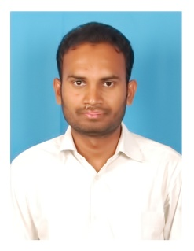
1. Name |  | : | Er. Kishore Nalabolu
2. Present Position |  | : | Assistant Professor, Department of Farm Machinery & Power Engineering
3. Postal Address |  | : | Dr. N.T.R. College of Agricultural Engineering, Bapatla – 522 101
4. Email Address |  | : | n.kishore@angrau.ac.in  kishorenalabolu@gmail.com
5. Phone Number |  | : | +91 8500856998, 9398431758
6. Date of Birth & Age |  | : | 06-07-1991 & 35 Years
7. Educational Qualifications |  | : | B-Tech: College of Agricultural Engineering, Bapatla  M-Tech: Indian Institute of Technology, Kharagpur with the Specialization of Farm Machinery and Power
8. Total Experience |  | : | 9 Years  - Worked as the Scientist (Agricultural Engineering) at the Agricultural Research Station, Ananthapuram in AICRP for Dryland Agriculture Scheme from 22.08.2017 to 08.07.2020 for 2 Years 10 months and 17 days  - Worked as the Assistant Professor in the Department of Farm Machinery and Power Engineering from 09.07.2020 to 08.05.2025  - Worked as the Scientist (Agricultural Engineering) at the Regional Agricultural Research Station (RARS), Lam, Guntur from 09.05.2025 to 04.04.2026  - Working as the Assistant Professor in the Department of Farm Machinery and Power Engineering at Dr. NTR CAE, Bapatla from 05.04.2026 to till date
9. Publications |  | : | International/National Publications: 10  Abstracts: 07  Technical Bulletins: 12  Popular Articles: 09  Training Manuals prepared: 02  Radio Talks delivered: 06  T.V. Programmes rendered: 04  Training Programmes organized: 13  Kisan Melas attended: 08
10. Technologies developed |  | : | 02  - Developed Bird Scarer for Millet crops  - Developed Diker mechanism for In-Situ Rainwater conservation
11. Number of U.G. Projects chaired |  | : | 05
12. Number of ELP units directed |  | : | 05
13. Awards/Recognitions |  | : | - MHRD Fellowship for the M. Tech degree after securing All India 40th Rank in GATE – 2014  - Outstanding team performance in the training module “Cultural Events (Men)” during 5th Foundation course for Faculty of Agricultural Universities (FOCFAU) organized by ICAR – NAARM, Hyderabad  - Awarded 3rd prize for outstanding presentation on the topic “Optimising Groundnut Productivity and Energy Budgeting through In Situ Water Harvesting under Rainfed Agriculture” in the 1st National Seminar on Emerging Trends in Agriculture and Allied Sciences: A Pathway to Food Security, organized by Encourage Society, Bangalore  - Awarded 2nd prize for outstanding presentation on the topic “Carbon Footprint and Intensity Indices reveal Emission Efficiency Gains in Rainfed Groundnut Intensification” in the 2nd National Seminar on Emerging Trends in Agriculture and Allied Sciences: A Pathway to Food Security, organized by Encourage Society, Bangalore  - Netaji Subhas – ICAR – International Fellowship by the Indian Council of Agricultural Research, New Delhi for the Ph.D. degree at the University of Nebraska – Lincoln  - Received Best Agri Engineer Award on 13th International Conference on “Agriculture, Horticulture, Forestry & Allied Sciences for sustainable Himalayan Ecosystems organized by ICAR – HFRI, Shimla
14. Memberships |  | : | - Life Member, Indian Society of Agricultural Engineers  - Fellow, Institution of Engineers  - Life Member, Indian Society of Dryland Agriculture  - Life Member, Indian Society of Agriculture and Horticulture Research Development
15. Additional Assignments |  | : | - Warden: 2 years from 01.06.2023 to 08.05.2025  - Officer i/c student activities: 2 years from 01.06.2021 to 31.05.2023  - Library In-charge: 1 year from 01.08.2020 to 31.05.2021  - College Reports: 1 year from 01.08.2020 to 31.05.2021 & 2 years from 01.06.2023 to 08.05.2025  - Transport Officer: 1 year from 15.07.2024 to 08.05.2025  - Building In-Charge: 1 year from 15.07.2024 to 08.05.2025  - Administrative Officer: 2 years and 8 months from 01.09.2022 to 08.05.2025  - Students Scholarships In-charge: 2 years from 01.06.2021 to 31.05.2025  - Officer i/c Advisory system: 5 years from July 2020 to April 2025  - Study tour coordinator for 2018 and 2022 admitted batches at CAE, Madakasira

