About the Department
Processing operations are undertaken to add value to agricultural materials after their production. The main purpose of agricultural processing is to minimise the qualitative and quantitative deterioration of the material after harvest. The various agricultural processing operations performed on various crops (cereals, pulses and oilseeds) are cleaning, grading, sorting, grading, sorting, drying, cooling, storage, milling, size reduction, expelling, mixing, blending, packaging, waste utilization, seed treatment etc. Hence cleaning of grains and other agricultural products is very important and should be performed before any further processing operation. Grading of cleaned seed is done to obtain good quality seed with higher germination and viability.
M.Tech. (Agricultural Engineering) PG program was started from the academic year 2006-07 onwards in the department of Processing and Food Engineering. PG students are provided with a monthly stipend of Rs.7000/. Ph.D. (Agricultural Engineering) program was initiated during the year 2012-13 in the Departments of, Processing and Food Engineering with a monthly stipend of Rs.10,000/-. ICAR specified syllabus is being followed for teaching M.Tech. (Agricultural Engineering) and Ph.D. (Agricultural Engineering) courses.
Laboratory infrastructure:
The Processing and Food Engineering department is having well equipped laboratories such as Department of Processing and Food Engineering
- Instrumentation Laboratory
- Process Engineering Laboratory
- Food Analysis Laboratory
- Food Microbiology Laboratory
- Environmental Control Laboratory
- Extrusion Processing Laboratory
Department of Processing and Food Engineering
Sl. No. | Name of the laboratory | Name of the Important Equipment/Instruments
1 | Instrumentation Laboratory | Unibloc moisture analyzer, Brookfield digital viscometer, PC based double beam UV-visible spectrophotometer, Freeze dryer, Electronic balance, pH meter, Digital LCD food thermometer, etc.
2 | Process Engineering Laboratory | Refrigerated centrifuge, Tablet making machine, Water bath incubator shaker, Vacuum filtration assembly with a vacuum pump, Vacuum oven, Digital bomb calorimeter, Oscilloscope, Function generator,Digital LCR meter, etc. Hollow fiber ultra-filtration membrane set,
3 | Food Analysis Laboratory | Automatic nitrogen protein estimation system, Automatic PC compatible solvent extraction system, Clevenger apparatus of oil heavier, oil lighter with heating mantles and voltage stabilizer, etc.
4 | Food Microbiology Laboratory | B.O.D. incubator, Laminar flow, chamber, Deep freeze up to -40 °C, etc.
5 | Environmental Control Laboratory | Environment chamber, etc.

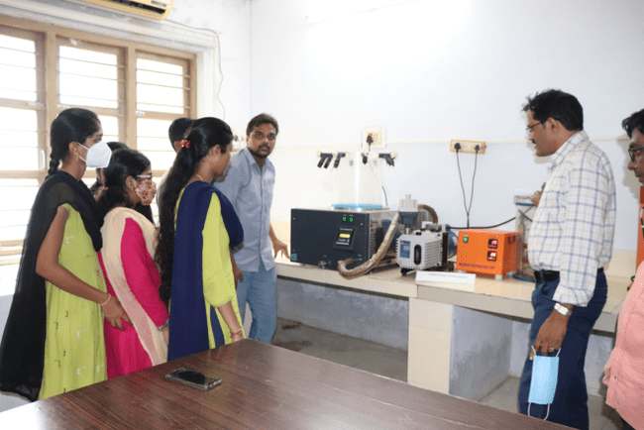 | 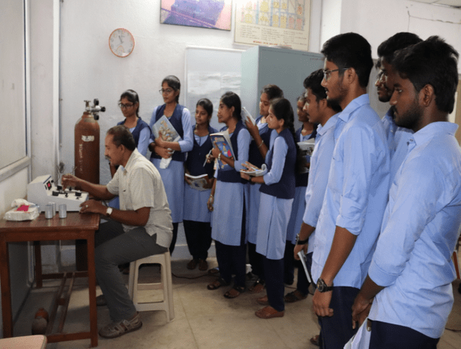
Instrumentation laboratory | Food Engineering laboratory
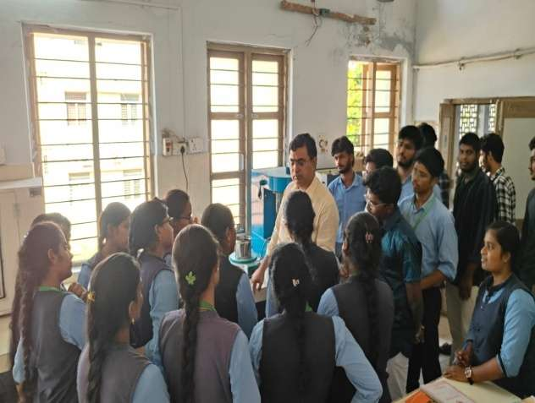 | 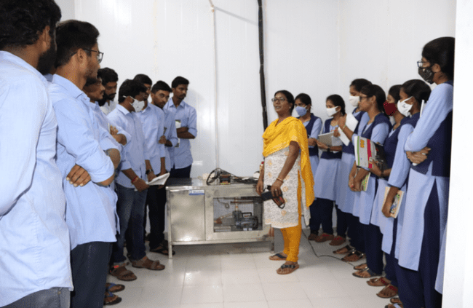
Process Engineering Laboratory | Fruit Ripening Chamber
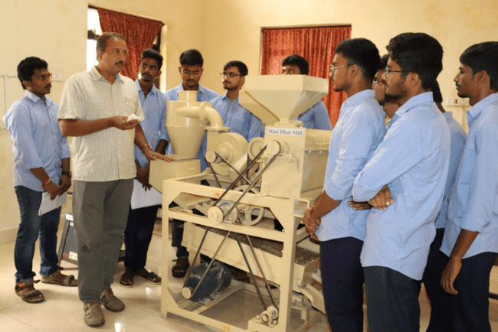
Experiential Learning Unit
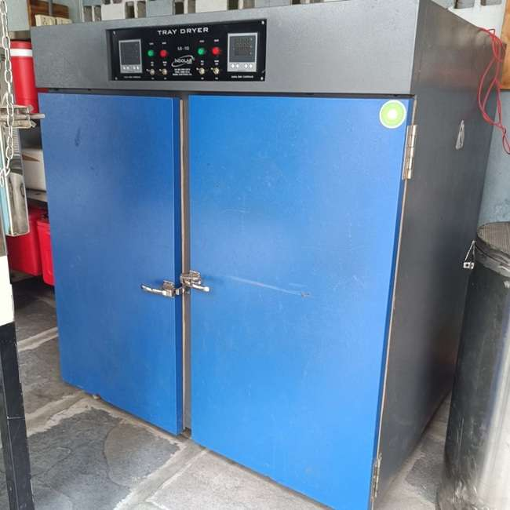
- Tray dryer

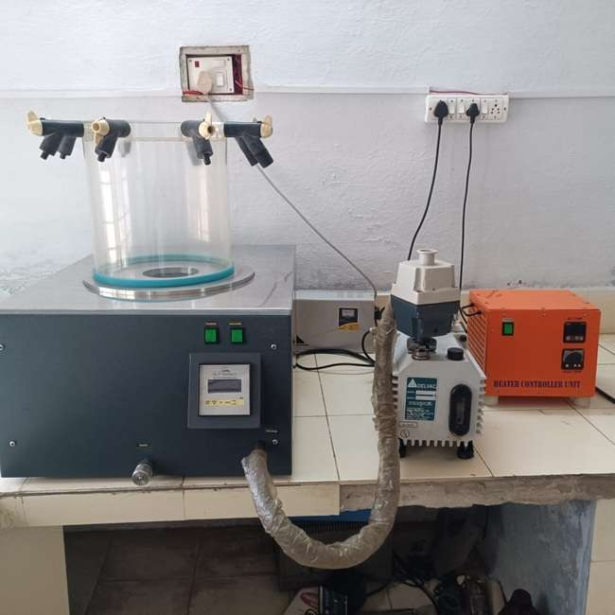
- Freeze Dryer or Lyophilizer
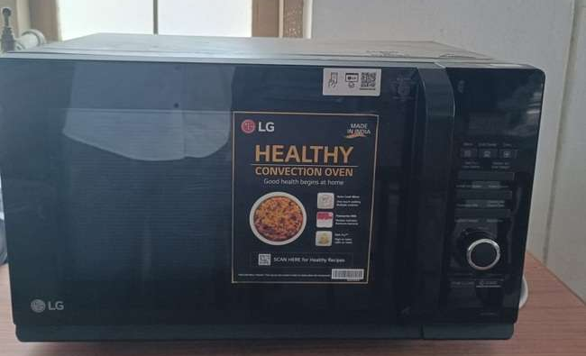
- Microwave Oven
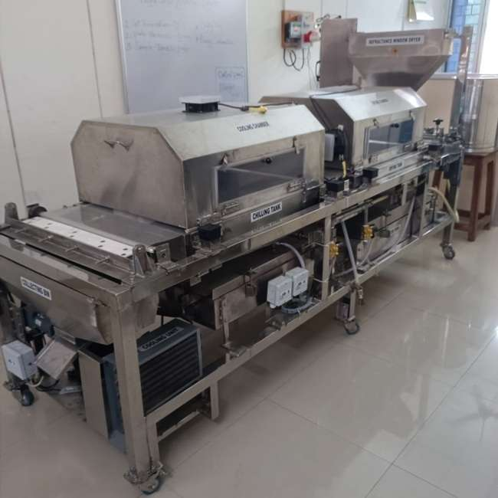
- IoT enabled Refractive Window Dryer

Fig 1. Dryers for drying experiments: (a) Tray dryer, (b) Freeze Dryer or Lyophilizer; (c)Microwave Oven; and (d)IoT enabled Refractive Window Dryer

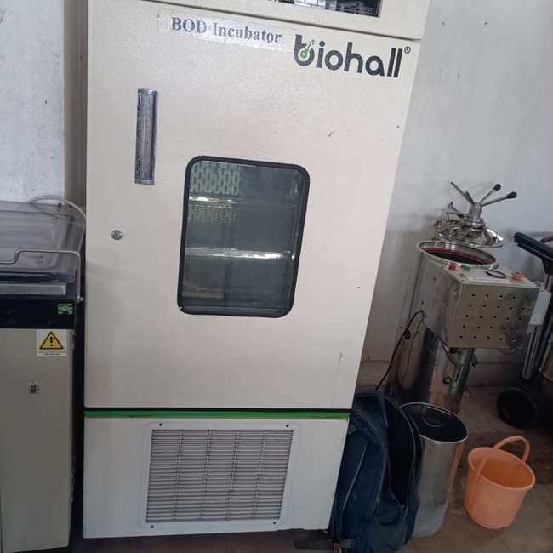
(a) BOD Incuabator and Autoclave
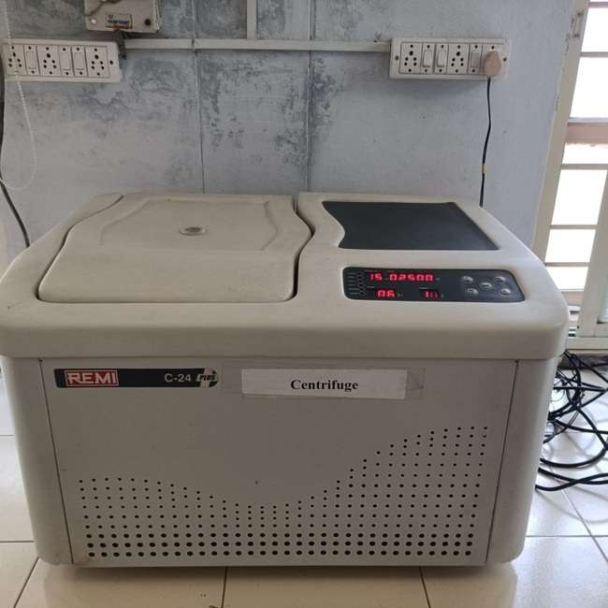
(b) Centrifuge
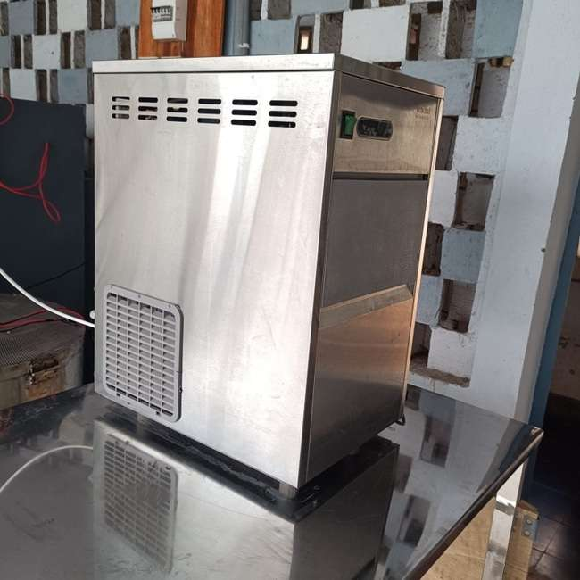
(c) Ice Flaking Machine
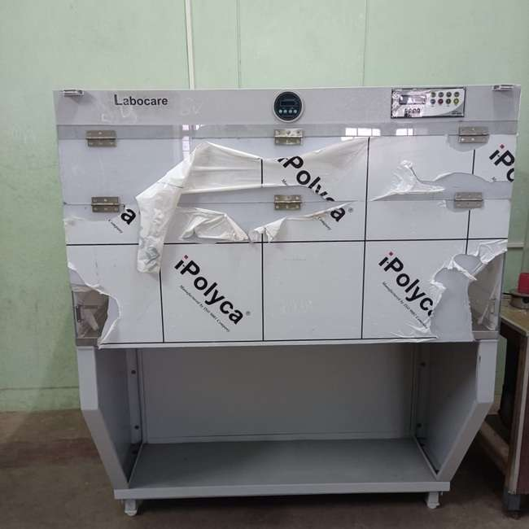
(d) Laminar Flow Chamber
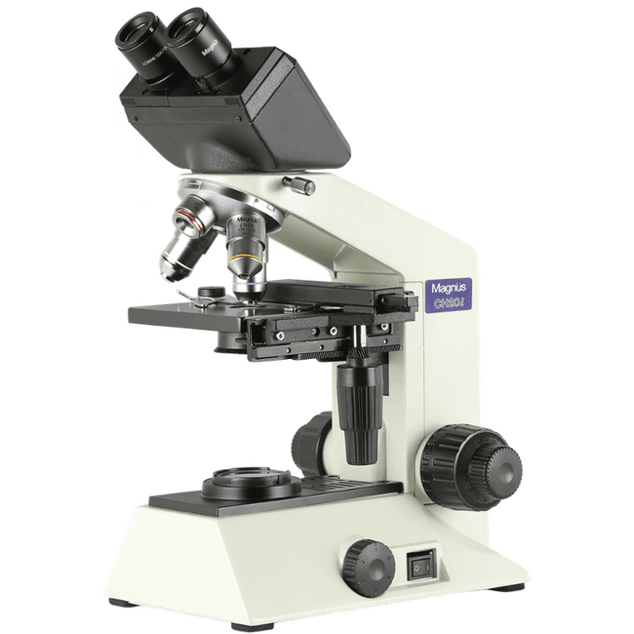
(e) Binocular Biological Microscope
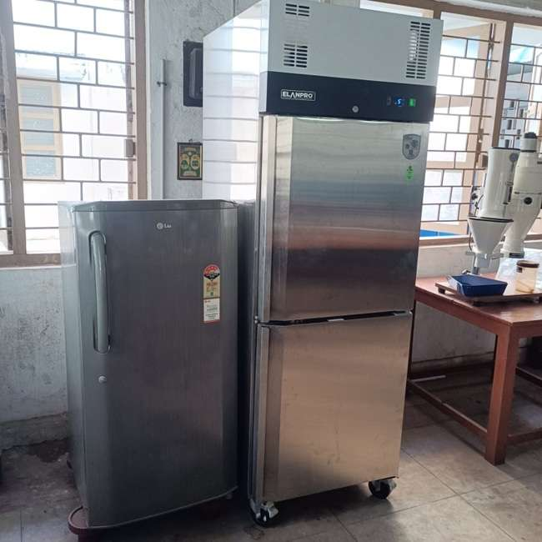
(f) Refrigerator

Fig 2. Equipment for Microbiology Work: (a)BOD Incuabator and Autoclave, (b) Centrifuge, (c) Ice Flaking Machine, (d) Laminar Flow Chamber, (e) Binocular Biological Microscope; and (f) Refrigerator

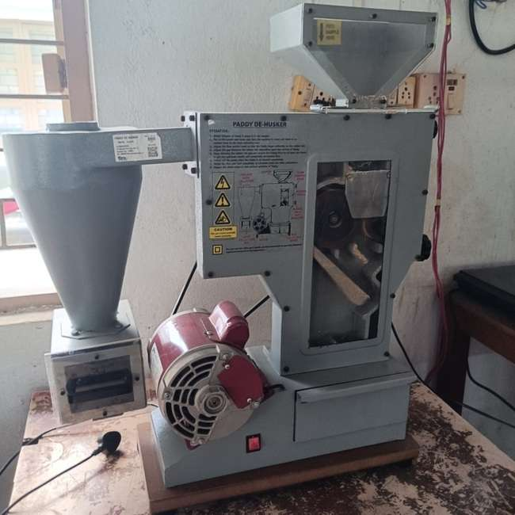
(a) Rubber Roll Sheller
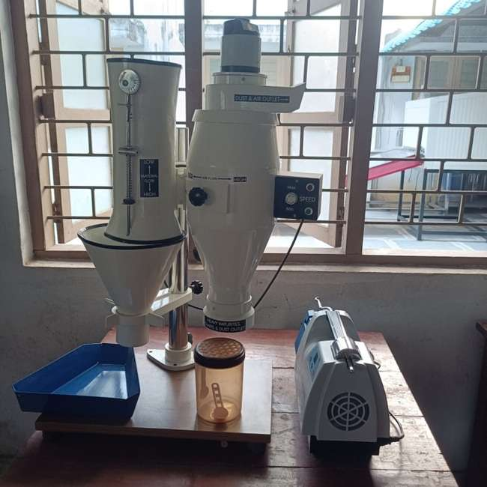
(b) Aspirator and Polisher
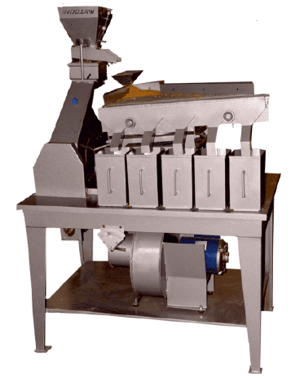
(c) Specific gravity separator

Fig 3. Rice Processing Equipment: (a) Rubber Roll Sheller; (b) Aspirator and Polisher; and (c) Specific gravity separator

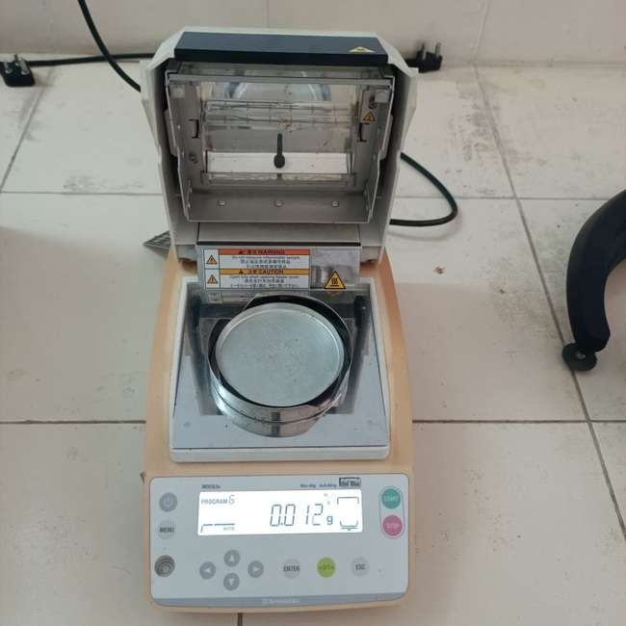
(a) Infrared Moisture meter
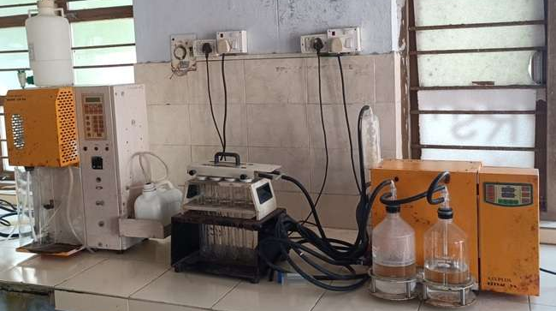
(b) KelPlus ProteinAnalyzer
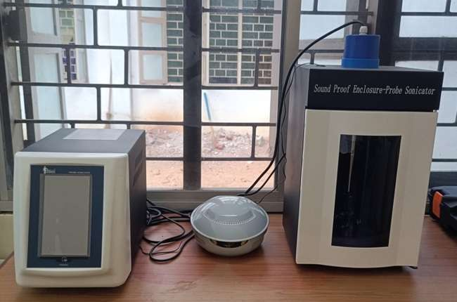
(c) Sonicator
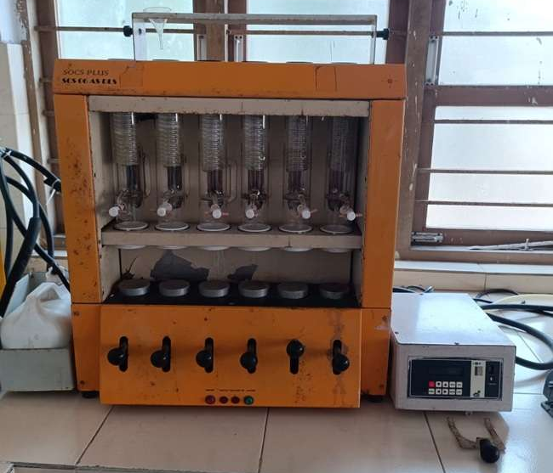
(d) Soxhlet apparatus
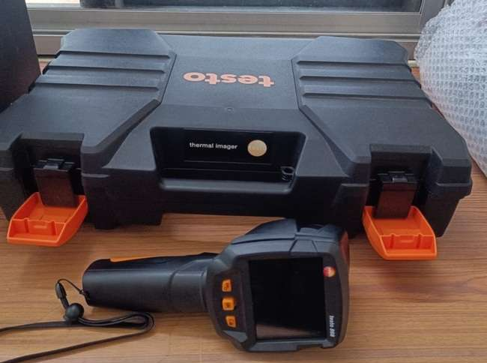
(e) Thermal Image Camera
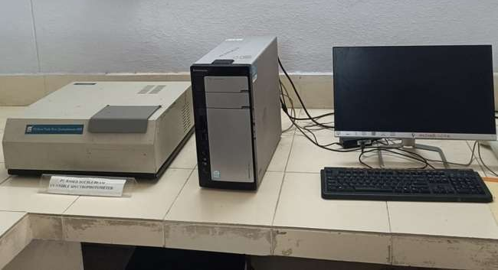
(f) UV Spectrophotometer
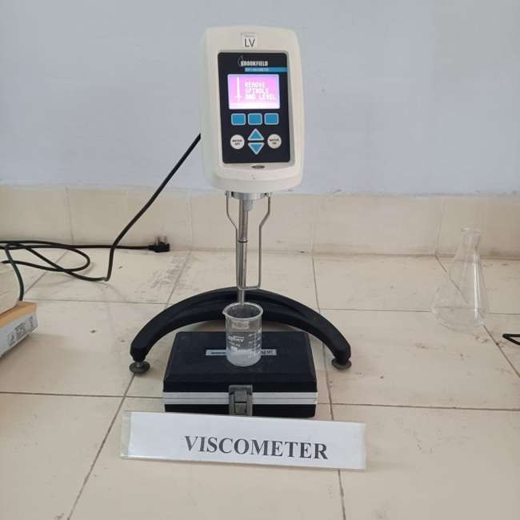
(g) Viscometer
(h)Colorimeter

Fig 4. Instruments and equipment: (a) Infrared Moisture meter, (b) KelPlus Protein Analyzer, (c) Sonicator, (d) Soxhlet apparatus, (e) Thermal Image Camera, (f) UV Spectrophotometer, (g) Viscometer, and (h) Colorimeter

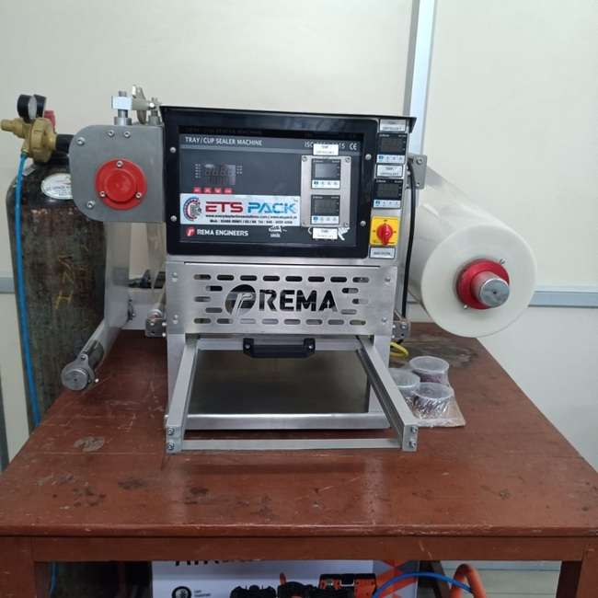
(a) Tray and Cup Seal Packaging Machine
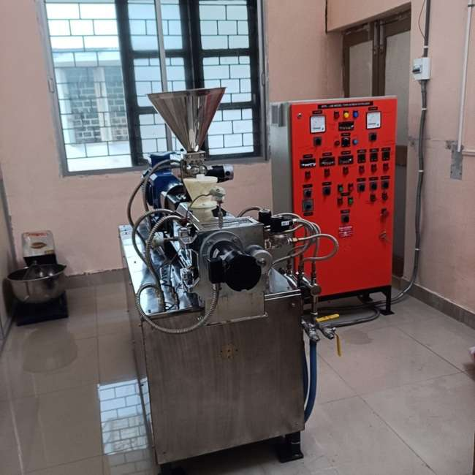
(b) Pilot Scale Twin Screw Extruder

Fig 5. Some other equipment: (a) Tray and Cup Seal Packaging Machine, and (b) Pilot Scale Twin Screw Extruder

Experiential learning units and Products
Some of the glimpses of ELP Products are
 | Gud Makhana |  | Instant Ragi Dosa Mix
 | 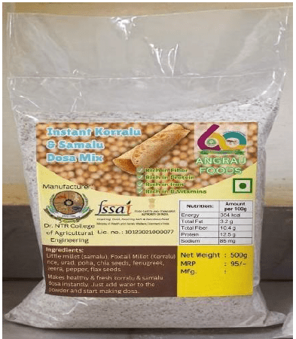  Instant Foxtail and Little millet Dosa mix |  | Ragi malt
 | 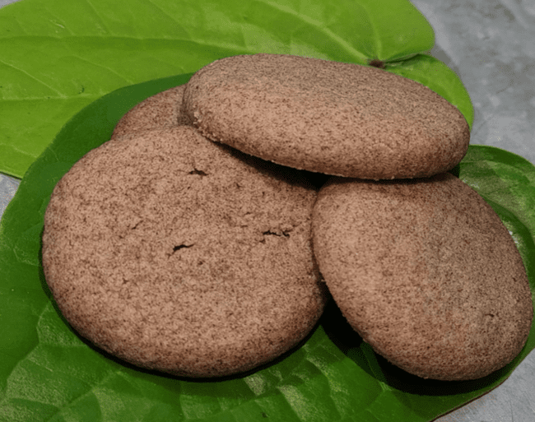  Finger Millet cookies |  | 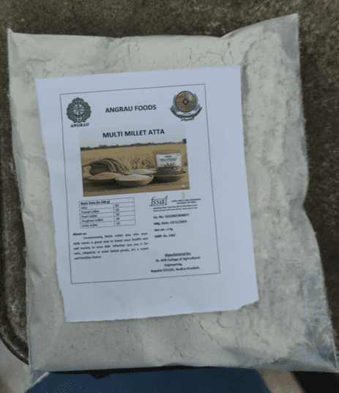  Multi millet atta
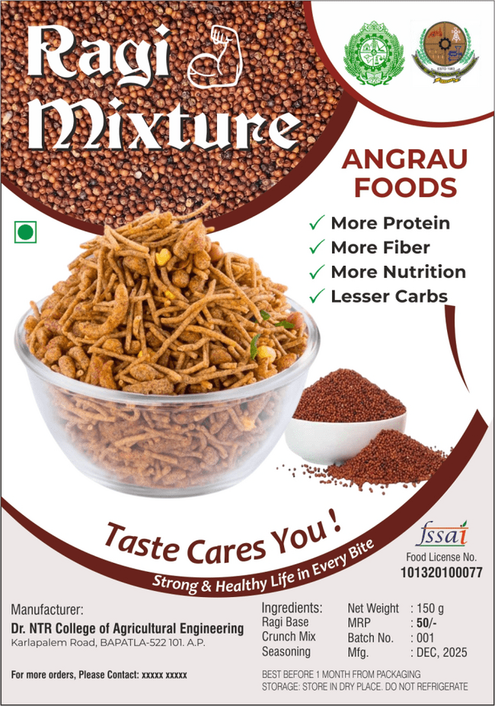  Ragi mixture |  | 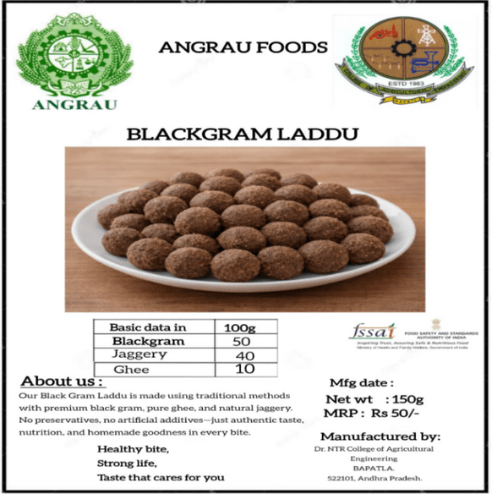  Black gram Laddu
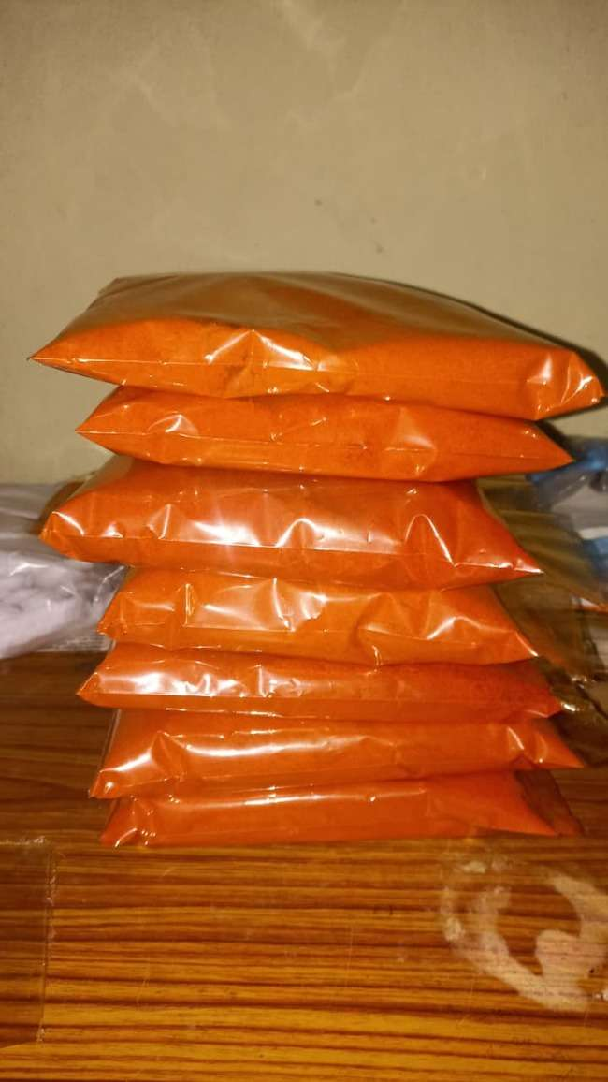  Chilli powder |  | 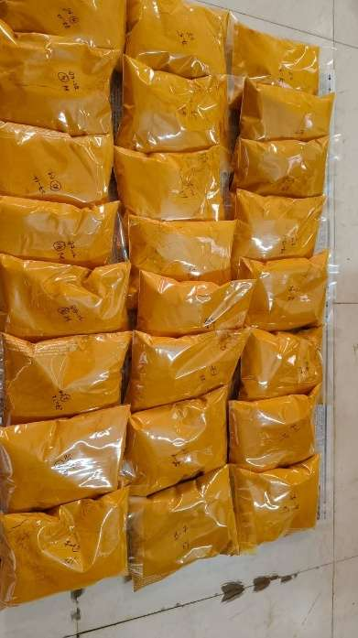  Turmeric powder

Department Staff
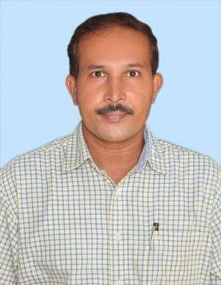
Dr. B. SREENIVASULA REDDY
PROFESSOR & HEAD
9618800819
b.sreenivasulareddy@angrau.ac.in
View Profile

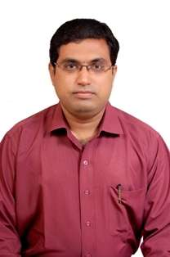 | 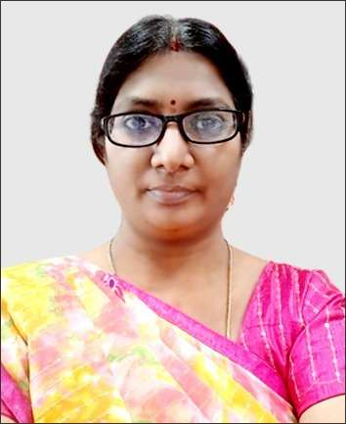 | 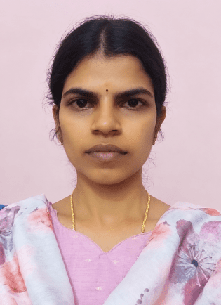
Dr. S. VISHNU VARDHAN  PROFESSOR 9440363112  vishnuvardhans@angrau.ac.in | Dr. K. LAVANYA  ASSOCIATE PROFESSOR 9182164437  k.lavanya@angrau.ac.in | Dr. B. PRAVALLIKA  TEACHING ASSOCIATE  9866486926  pravallikabogala@gmail.com
View Profile | View Profile | View Profile

STAFF FROM ICAR- AICRP ON POST HARVEST ENGINEERING & TECHNOLOGY SCHEME

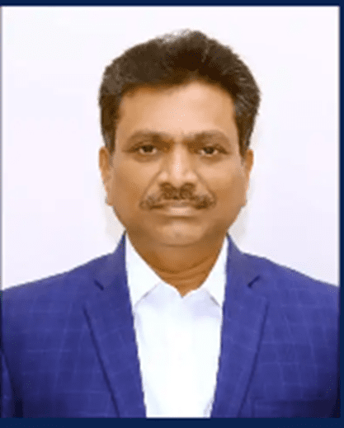 | 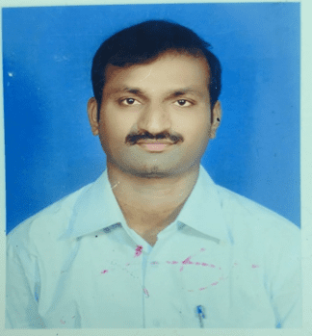
Dr. D.D. SMITH  PRINCIPAL SCIENTIST & HEAD  9949906751  dd.smith@angrau.ac.in | Dr. V.VASUDEVA RAO  SCIENTIST  9177101614  v.vasudevarao@angrau.ac.in
View Profile | View Profile

