Health Clinic
Dr. N.T.R. College of Agricultural Engineering, Bapatla, provides health care facilities within the campus through a dedicated Health Clinic established for the welfare of students, faculty, and staff members. The clinic functions as a primary healthcare support centre to address routine medical needs, provide first aid, and handle emergency health situations within the College premises. A qualified Medical Doctor is appointed on a contractual basis to provide medical consultation and treatment during scheduled college hours and whenever emergency situations arise. The health clinic ensures timely medical attention and basic healthcare services for students and staff members residing within the campus. To support medical services efficiently, both male and female staff nurses are available at the clinic for monitoring the health condition of students, administering prescribed medicines and injections, and assisting the doctor during consultations and emergencies. The clinic is also provided with bed facilities for observation, first aid, and temporary care of patients requiring rest and monitoring.
A systematic record maintenance mechanism is followed in the clinic. Details of medical consultations, prescriptions issued, and medicines dispensed are entered in a health register for future reference and monitoring of the health condition of individual students during subsequent visits. The Health Clinic is adequately equipped with essential medicines, emergency drugs, disposables, injections, digital and analog health monitoring instruments, oxygen cylinders, stretchers, wheelchairs, and refrigeration facilities for safe storage of injectable medicines and medical supplies. These facilities enable the clinic to effectively manage common illnesses, minor injuries, and emergency medical situations within the campus. The expenditure for medical facilities, medicines, and healthcare equipment is supported through ICAR Student Amenities funds and NUF (Non-Unit Fund) resources of the College. The College continuously strives to strengthen the healthcare support system to ensure the safety, well-being, and healthy academic environment for all students and staff members.
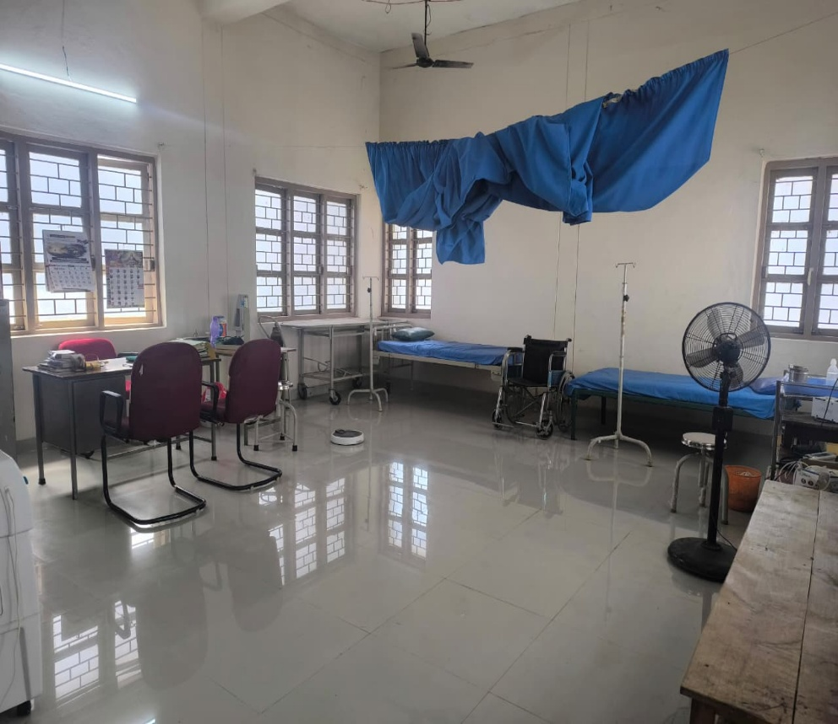
Fig 1. Bed facility in the health clinic
.
Health Clinic at Dr NTC College of Agricultural Engineering


