Library and Computer centre

Library creates a beautiful environment for the students to learn and grasp knowledge without any interference. Library is a valuable asset to the college and it is so spacious and contains many books, e-books, Book Bank Scheme, Reference section and journals (both Foreign and Indian), which have been published by both national and international authors. There are 11,934 books available in the library. And the library is updated with KOHA Library Management Software. The library offers computer books with CDs, dictionaries (Telugu to English and English to Telugu), handbooks, annual reports, General Studies and the World Atlas so that students can prepare for competitive exams, such as the UPSC, APPSC, BSRB Bank exams, GRE, GMAT, TOEFL, IELTS, GMAT, CAT etc. Apart from these, there is wide variety of Telugu and English daily newspapers and popular weekly & monthly magazines like Rythunestham, Annadata, Vyavasayam and competitive magazines are also being kept for students’ general reading.
There are fully air-conditioned UG and PG computer centers which provides highly interactive learning environment. Both UG and PG Computer rooms are well equipped with 40 and 15 computers having high end configuration with 40 MBPS Internet speed to utilize the electronic information, namely CeRA, CAB Abstracts, KrishiKosh, EBSCO, Indiastat, CRC Netbase e-books, CAB e-books, Elsevier e-books, CMIE, EPWRF India Times Series, EZ Proxy, DELNET, OPAC, etc. for the improvement of academic and research standards. The practical classes of “Computer Programming in C” AUTOCAD and “Computational methods through C Programming”, Library and Information services for U.G. and P.G. students used to conduct in computer centre. There are also other facilities like photocopying, computer printing and internet facility in college library which helps students in their academic activities
Dr. NTR CAE LIBRARY

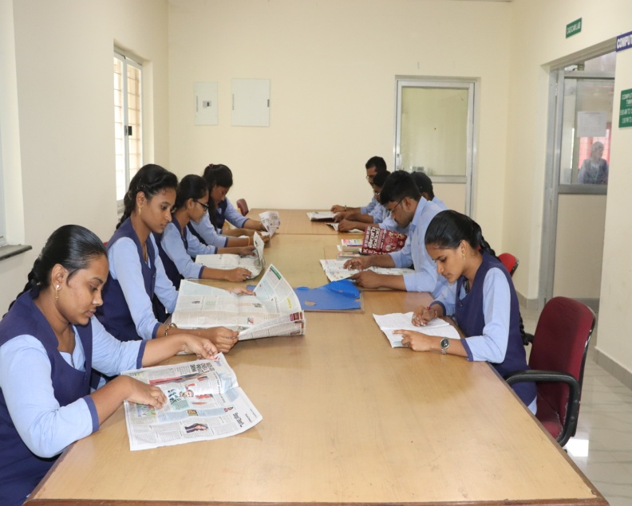  STUDENTS NEWS PAPER SECTION | 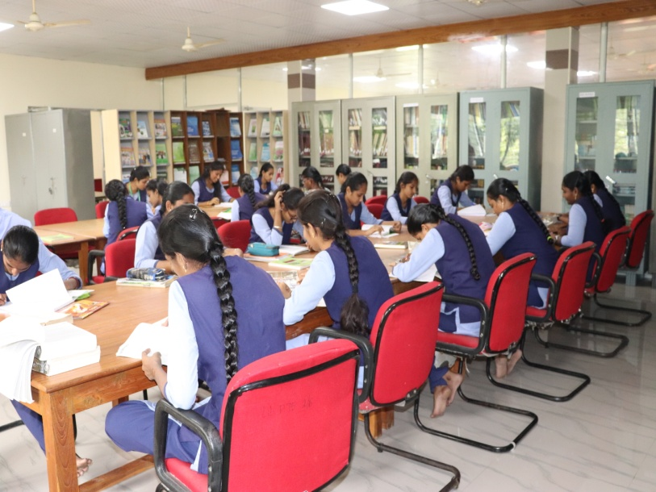  STUDENTS READING SECTION
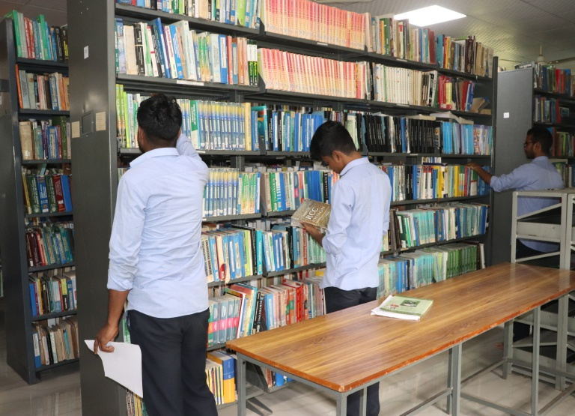  LIBRARY | 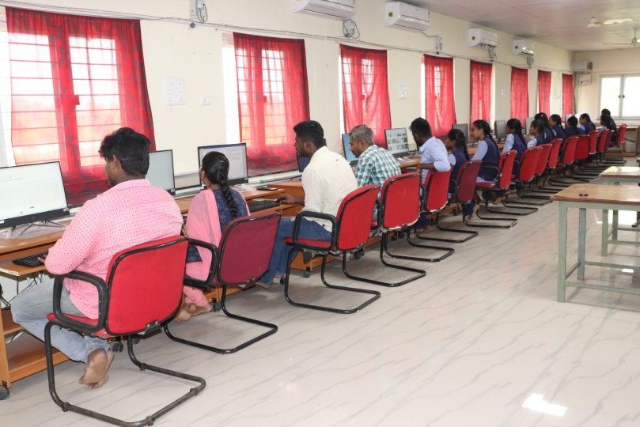  UP COMPUTER LAB AND DIGITAL LIBRARY
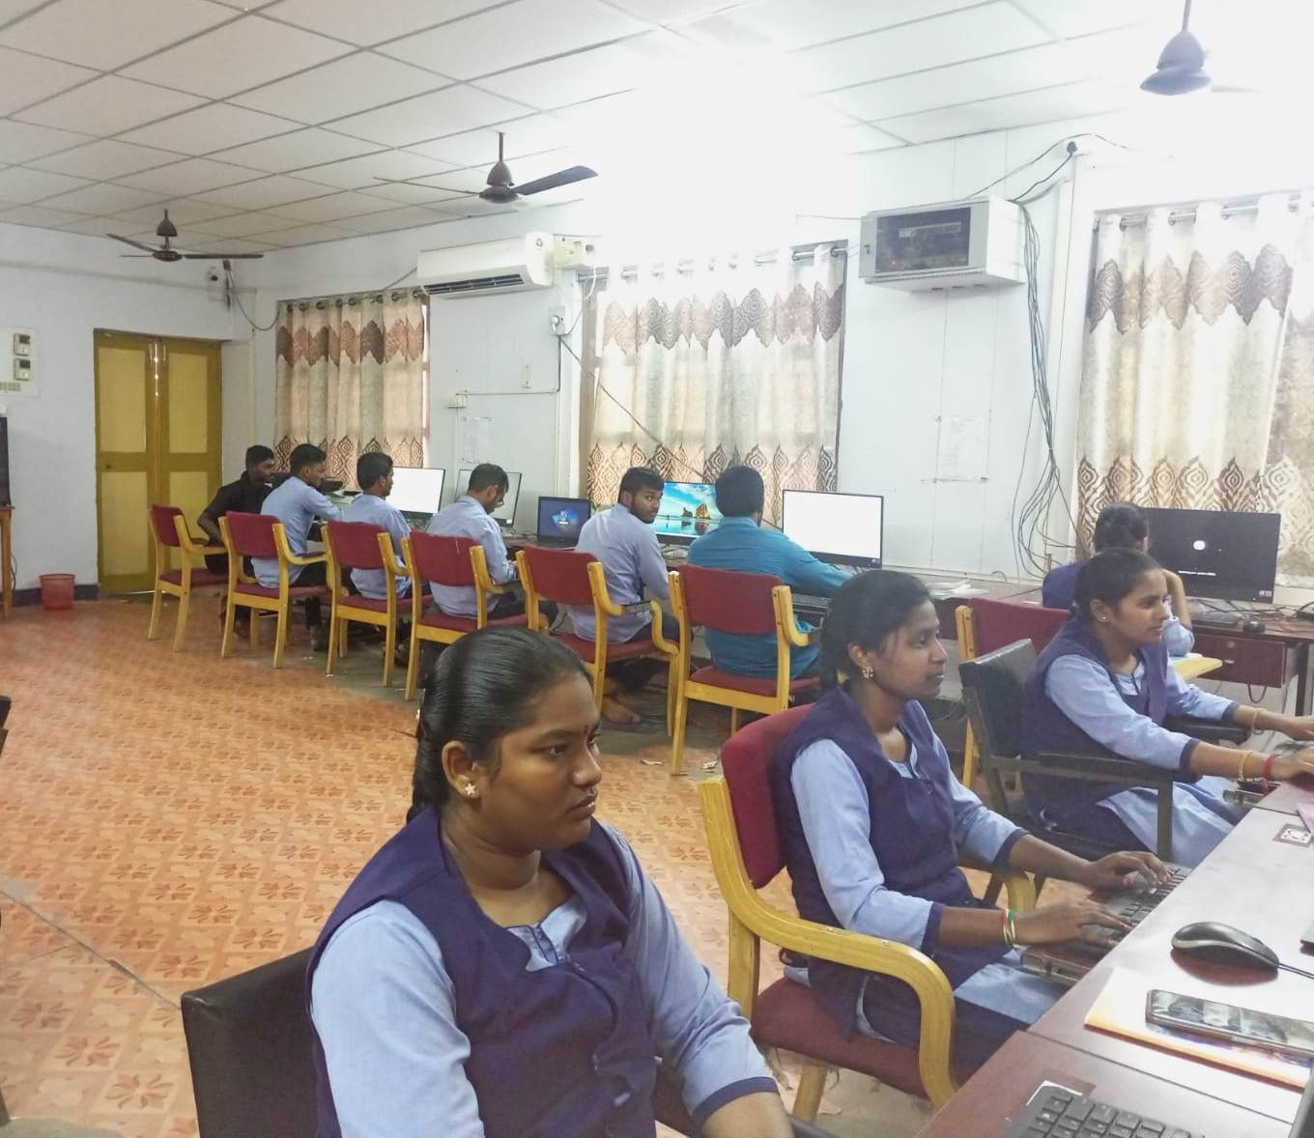

PG COMPUTER LAB
.

