Hostel facilities
Boys Hostel Facilities
The boy students of Dr. N.T.R. College of Agricultural Engineering, Bapatla, are accommodated in two hostels namely, Dr. K.L. Rao Hall of Residence and the New Boys Hostel. Together, these hostels provide a safe, comfortable, and student-friendly residential environment that supports the academic and personal well-being of undergraduate, postgraduate, and doctoral students. The two hostels collectively consist of 59 rooms with an accommodation capacity of approximately 177 students. At present, around 165 students belonging to UG, PG, and Ph.D. programmes are residing in the hostels. Most of the hostel rooms are spacious enough to comfortably accommodate four students. Each student is provided with an individual cot along with essential furniture such as cupboards, reading tables, and chairs to facilitate comfortable living and academic activities. The boys’ hostels are equipped with adequate dining and kitchen facilities to ensure proper boarding arrangements for students. The hostel mess contains large dining tables, sufficient seating arrangements, purified drinking water facilities, refrigerator, freezer, ceiling fans, and an LED television with a sound system for student recreation. An RO water purification plant and water coolers are also installed to provide safe and hygienic drinking water.
To support academic activities and digital learning, Wi-Fi connectivity is provided in the hostels, enabling students to access online learning resources, academic materials, and digital platforms. Reading rooms are also available within the hostel premises, where English and Telugu newspapers, magazines, and other reading materials are provided regularly for the benefit of students. The hostels are equipped with sufficient bathrooms and toilet facilities, which are maintained hygienically on a regular basis. Special attention has been given to accessibility and inclusiveness by providing disabled-friendly restrooms and ramp facilities for differently abled students in the New Boys Hostel. The College also encourages physical fitness, sports, and recreation among students. A gymnasium with essential exercise equipment is available in the boys’ hostel. Facilities for indoor games such as table tennis, chess, and carroms are provided for recreation and relaxation. Outdoor sports facilities including basketball, volleyball, badminton, cricket, and football grounds with running tracks are available adjacent to the hostels for regular sports and physical activities. To ensure the safety and security of students, CCTV cameras have been installed at strategic locations inside and outside the hostel premises. Continuous monitoring is carried out to regulate the movement of students and outsiders and to maintain discipline and security within the hostels. A senior male faculty member is designated as the Hostel Warden to supervise the routine administration, boarding and lodging arrangements, discipline, welfare, and overall well-being of the hostel students. The Warden closely monitors hostel activities and provides guidance and support to students whenever necessary. Overall, the boys’ hostels at Dr. N.T.R. College of Agricultural Engineering provide adequate residential, academic, recreational, and safety facilities, thereby creating a comfortable and conducive environment for student life and learning.
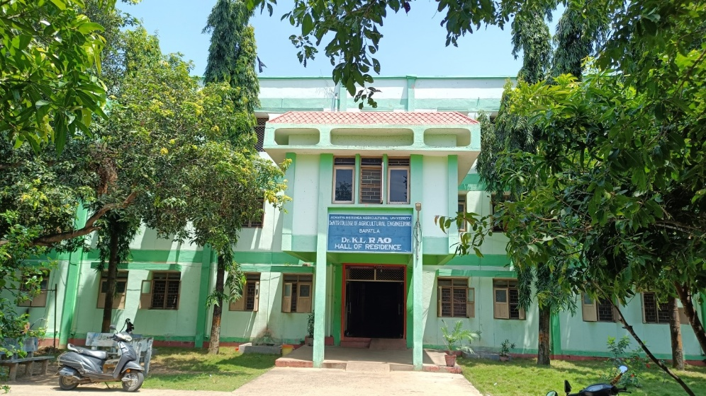
Fig 1. KL Rao Hall of residence (Old Boys hostel), Dr. NTR CAE, Bapatla
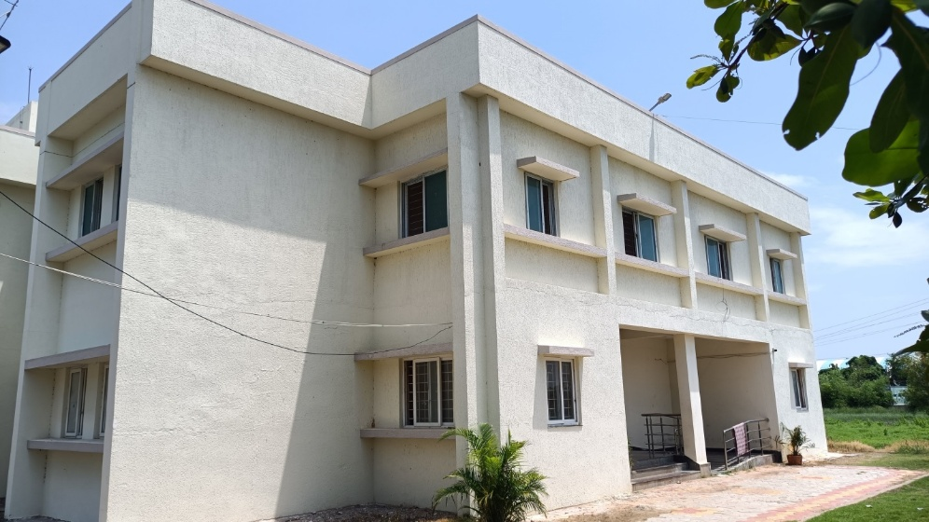
Fig 2. New Boys hostel, Dr. NTR CAE, Bapatla

Girls hostel
Hostel facility was providing to all B. Tech Agricultural Engineering girl’s students in Girls hostel campus including M. Tech and Ph. D students. There was main hostel building (inaugurated on 27/04/2015) has two floors with a capacity to accommodate 80 girl’s students in 23 rooms. One separate newly constructed hostel inaugurated on 31/12/2018 with 10 rooms is allotted for first year students. Three staff quarters were converted as student’s rooms with an accommodation facility of 40 students.
The hostel has decent modern dining hall, hot water facility fridge, inverter with battery and water dispensers in each wing for cool, hot and normal water. The students are served with the best quality food prepared at boy’s hostel as per the menu constantly changed by the students as per their requirement purely maintained by the student representatives. The girls hostel is fully protected with compound walls gates. Care takers, lady and gent watchman’s are caring students at all 24 hours a day. The hostel has Open Gym, Volley Ball court, Shuttle and Tennikoit courts for student’s physical fitness.
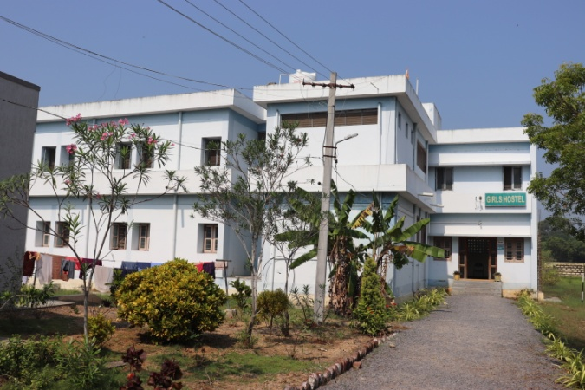  OLD GIRL’S HOSTEL | 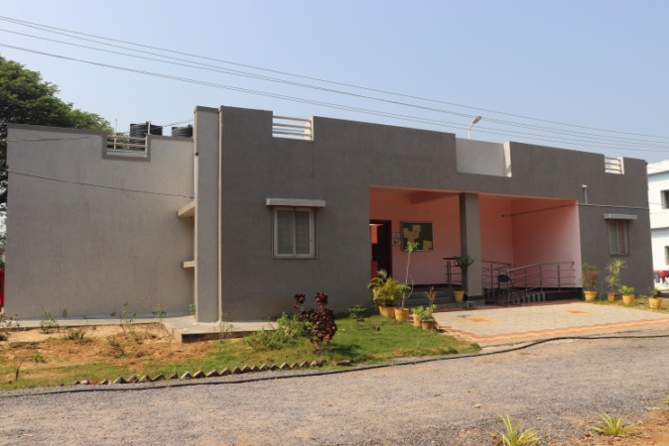  NABARD FUNDED GIRL’S HOSTEL
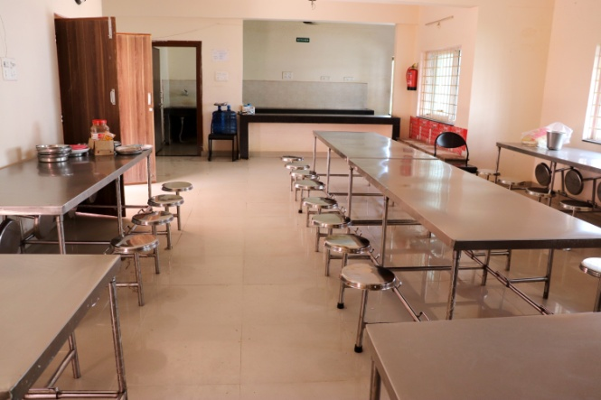  DINING HALL | 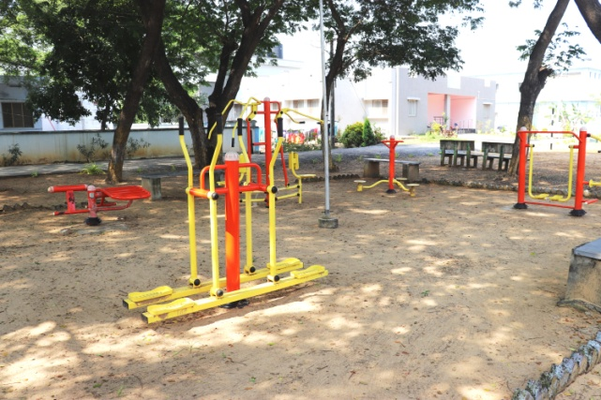  OUT DOOR GYM FOR GIRLS

