Cultural Centre
The College has established a dedicated Cultural Centre to promote holistic student development through cultural, literary, artistic and creative activities. The Centre provides infrastructure and institutional support for students to explore their talents, preserve cultural heritage, develop leadership and communication skills, and participate in university, state and national-level cultural events. Student clubs operating under the Centre provide sustained opportunities for engagement throughout the academic year. The activities and achievements of the Centre are systematically documented as part of the institutional student-development initiatives. The Centre will facilitate regular cultural activities and provide opportunities for students to participate in music, dance, drama, literary activities, visual arts, traditional arts, photography, film-making and other creative pursuits.
The Centre will also serve as a platform for preserving and promoting the rich Indian, Telugu and regional cultural heritage, while encouraging students to develop confidence, communication skills, teamwork, creativity and leadership abilities.
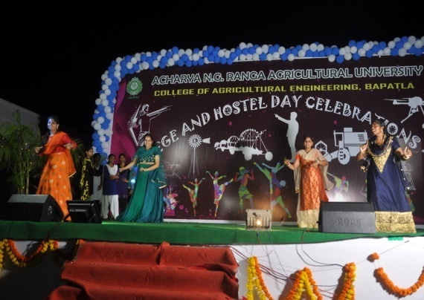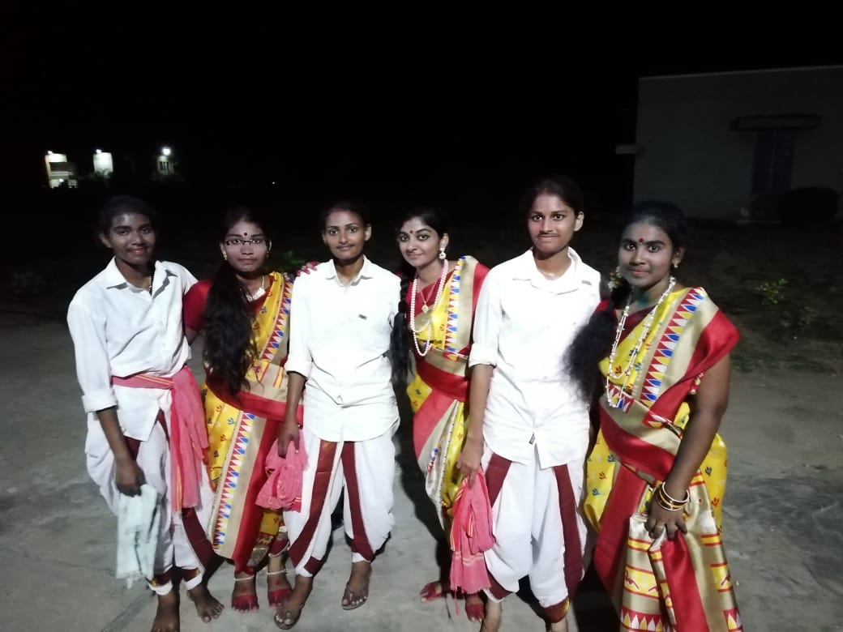
Cultural Program in the College Cultural Program – Inter-Collegiate
Sports and Games
Students practice the games daily in the evening under supervision of the Physical Director. There is one practical class in first year B.Tech. (Agricultural Engineering) to make the students conversant with rules and regulations of Physical Education. Boys Hostel is having a well-equipped Gym for improving the fitness of the students.
Sports and Games Infrastructural Facilities
Sl.No. | Name of game | Available infrastructure
1 | Cricket | Pitch
2 | Foot ball | Ground
3 | Ball Badminton | One outdoor Court (Separate for boys and girls)
4 | Indoor Gymnasium | Well-equipped Gym
5 | Table Tennis | Two Table Tennis Boards (Separate for boys and girls)
6 | Volley Ball | Two Volley Ball Courts (Separate for boys and girls)
7 | Shuttle Badminton | Shuttle Badminton courts
8 | Tennicoit | Tennicoit Court for girls
9 | Caroms | 4 indoor carom boards (Separate for boys and girls)
10 | Chess | 5 indoor Chess boards

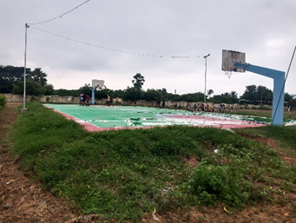 | 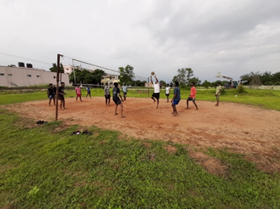
Basket Ball Court | Volley Ball Court
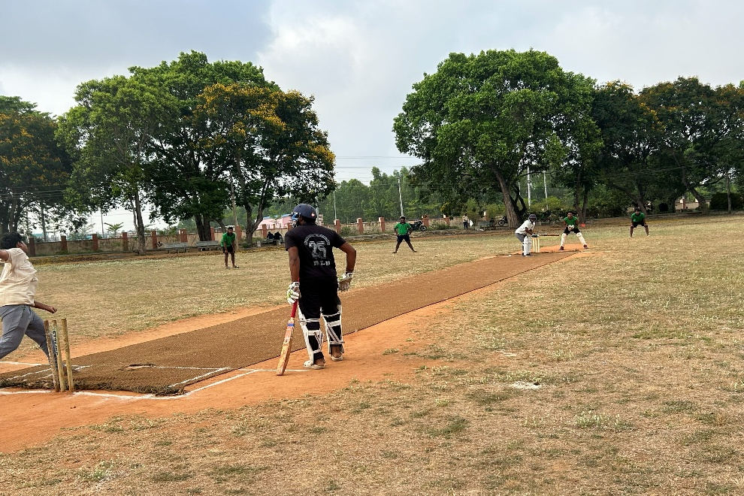 | 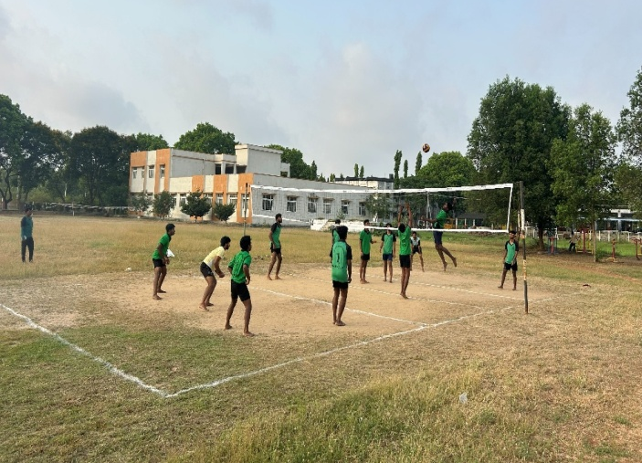
Cricket ground | Volley ball court
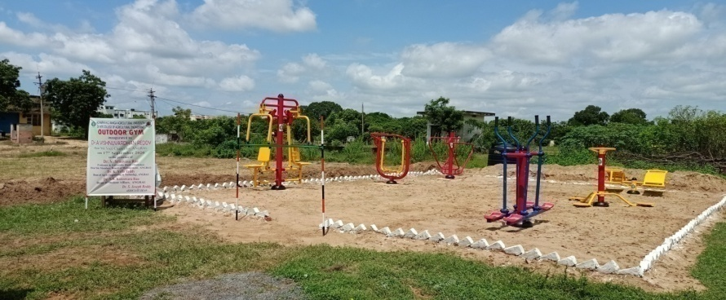
Open Gym Facilities
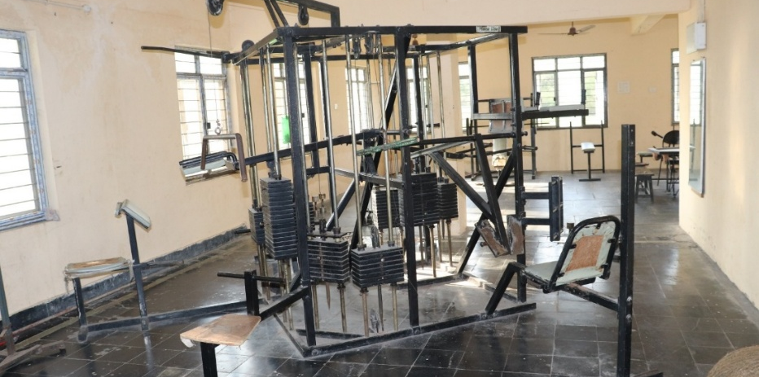
In door gymnasium

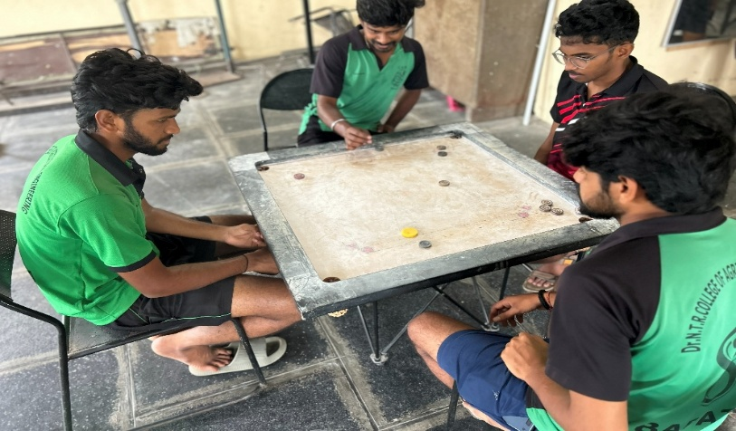
Carron board facility
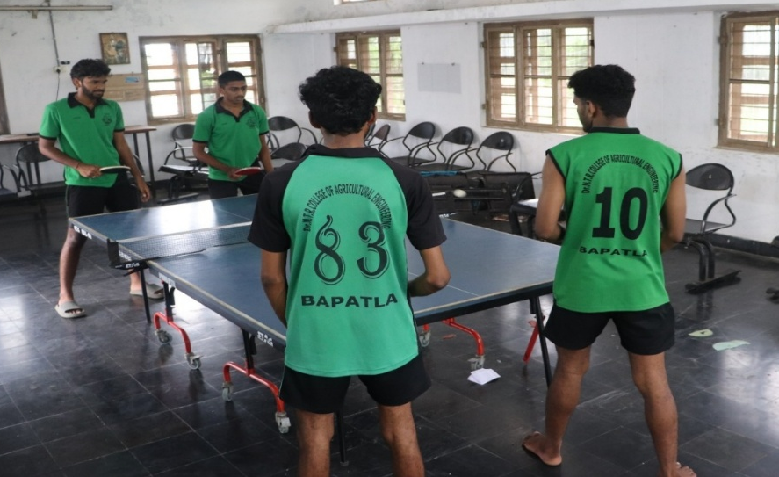
Table tennis facility

