Anti-Ragging Cell
College is having Anti-Ragging Cell, formulated every year, which consists of Associate Dean, Officer In-Charge of Student Activities as Convener, Deputy Superintendent of Police, Circle Inspector of Police, Mandal Revenue Officer, Advocate, Department Heads, Officer In-Charge of Academic Matters of UG and PG, faculty, Physical Director, students of II, III and Final Year B.Tech. (Agricultural Engineering), parents of the students, Reporters of Daily News Papers, Reporters of News Channels, Secretaries of NGOs, etc. This Cell monitors the any eventuality of the ragging case in the campus. Apart from Anti-Ragging Cell, there is a Disciplinary Action Committee existing in the College for taking any further action on the erring students.
- Strict measures to prevent ragging in the college have been undertaken.
- Ragging acts banners were displayed in college and hostels.
- Anti-ragging banners were displayed in college and hostels.
- Anti-ragging schedules were allotted to Staff, PG students and Final year students of college.
- Anti-ragging squads are formed.
- Anti-ragging committee is formed.
- One semi-transparent complaint is kept in main college building and hostels.
- Obtaining signatures from First year students stating whether there is ragging in hostels daily two times a day.
- Circulation of anti-ragging toll free number and mobile nos. of all the Teaching staff with First year students and their parents.
- Ragging affidavits (Annexure I – Student and Annexure II – Parent) from First year students and their parents were collected as a mandatory
- Round the clock monitoring system in place for preventing ragging in the campus.

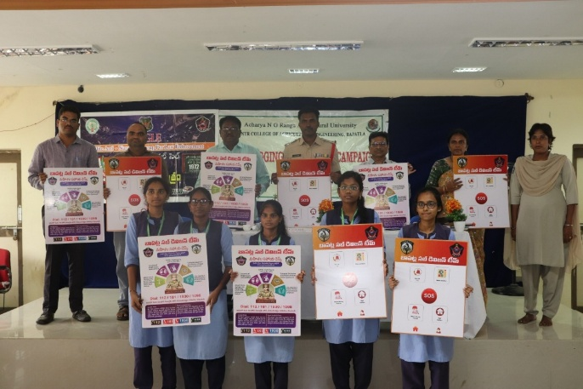  Fig 1. Release of anti-ragging poster by Associate Dean and Rural Sub Inspector of police, lawyer and students | 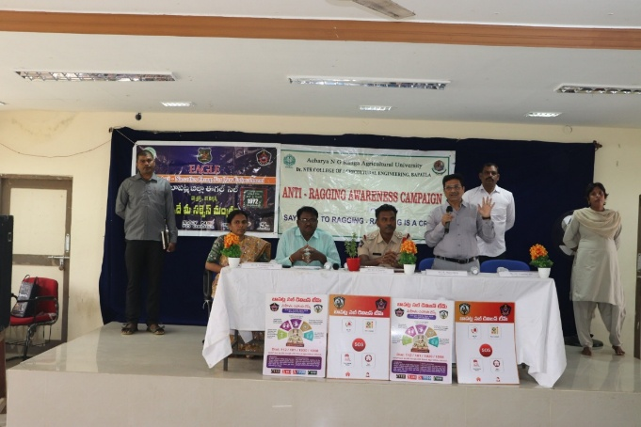  Fig 2. Associate Dean Addressing the students during anti-ragging awareness campaign
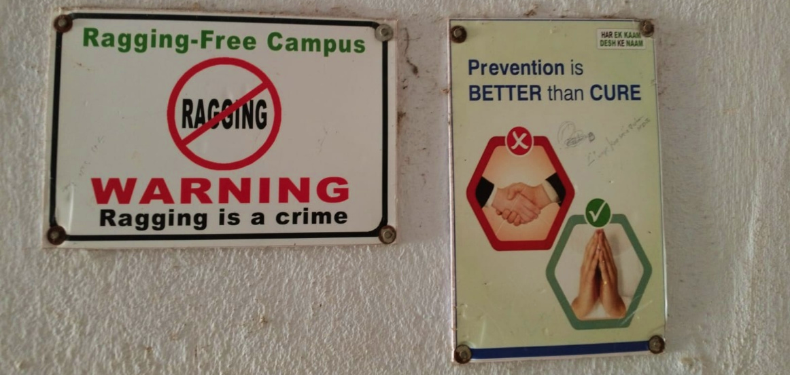
Fig 3. Anti ragging warning boards at classrooms
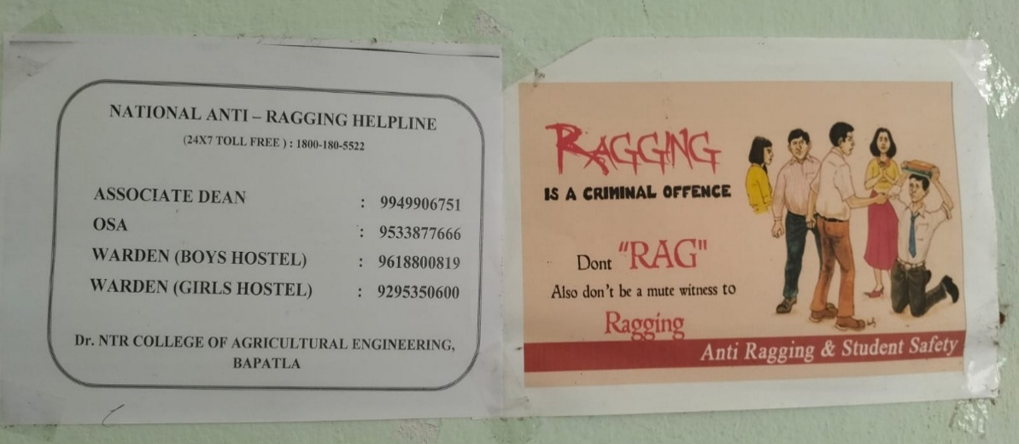
Fig 4. Anti to helpline, Associate Dean, warden phone numbers and anti-ragging poster display at corridors

