Dr NTR College of Agricultural Engineering, Bapatla
HISTORICAL BACKGROUND
Achaya NG Ranga Agricultural University (earlier Andhra Pradesh Agricultural University) had started a 4-year B.Tech (Agril. Engg.) Degree Programme in the Department of Agricultural Engineering, Agricultural College, Bapatla from the academic year 1983-84 considering the demand for Agricultural Engineering graduates in this state and it was shifted to new campus on NH-216 in Karlapalem road in May 1994.The foundation stone for construction of the building complex was laid by Dr.N.T.Rama Rao, the then Hon’ble Chief Minister of Andhra Pradesh on 24-02-1988 and were inaugurated in the new premises on 5-5-1994 by Sri K. Jana Reddy, the then Hon’ble Minister for Agriculture of Andhra Pradesh.
The college has the unique feature of being the only college offering B.Tech (Agril. Engg.) degree in Andhra Pradesh State till 2008. The annual intake of the students into the degree programme was only 20 in the initial year 1983-84 and later was raised to 61 in the subsequent years. The admissions are made through AP EAPCET conducted by the Government of Andhra Pradesh and also through the UG- level ICAR exam. Further, there is an addition quota of ICAR (20%) and 15% quota through lateral entry for diploma students in agricultural engineering.
. After shifting to the new campus, the College expanded rapidly both academically and physically. Many infrastructural facilities were added in terms of buildings and equipment for improving the academic status in agricultural engineering. The College celebrated its Silver Jubilee in the year 2008 during which a silver jubilee building was constructed for a spacious digital library, book library and two classrooms. This college was accredited by Indian Council of Agricultural Research, New Delhi during 1999-2000 in the first phase itself based on ICAR’s Review Team Report and during the subsequent phases also. The latest accreditation of ICAR for this College was in 2021-2026. The College was under the faculty of Agriculture until 2010 when a new Faculty of Agricultural Engineering and Technology was established by the University as per the provisions of the University Act. The College was renamed as Dr N.T.R. College of Agricultural Engineering (Dr NTRCAE) in the year 2018 in memory of Late Dr N.T. Rama Rao the then Chief Minister of combined Andhra Pradesh and who was the person laid foundation stone for the College building.
Today, the Dr. NTR College of Agricultural Engineering (CAE) is widely recognized as the Center for Academic Excellence (CAE) in quality education; need based research and transfer of technology to farmers for improving farm production. The lush green campus is spread over 25 acres with an infrastructure ranked among the best in the country and accredited by ICAR.
The courses being offered are based on ICAR’s V Deans’ Committee recommended syllabus to gear up towards equipping the students to meet the challenges that are being faced by the agricultural sector. The College has state-of-the-art infrastructure and facilities and the academic environment which combines academic rigor with high level of interaction with government departments in serving the farming community of the nation in general and the present state of Andhra Pradesh after bifurcation in particular. The driving force behind the high level of academic excellence and quality education is the dedicated team of over twenty core faculty drawn from different specializations.
B.Tech. (Agricultural Engineering) degree programme is supported by 6 departments as follows:
A. Farm Machinery and Power Engineering
B. Processing and Food Engineering
C. Irrigation and Drainage Engineering
D. Soil and Water Conservation Engineering
E. Renewable Energy Engineering
F. Basic Engineering and Applied Sciences

Number of the students completed graduation from the College so far: 1046

The land asset and use pattern of the campus is furnished below:
 | Details | Area (ha) |  |  | % to total area
A | Area under | Irrigated | Rainfed | Total | % to total area
A | i) Field crops | 2.43 |  | 2.43 | 25.5
A | ii) Orchard crops | 2.22 |  | 2.22 | 23.4
A | iii) Fodder crops
A | iv) Agro-forestry and other vegetation
A | Total area under (A) | 4.65 |  | 4.65 | 48.9
B | Area under
B | i) Roads, Buildings and Sheds |  |  | 2.43 | 25.5
B | ii) Fish tanks/ water bodies/ Canals/ Drains/Wells etc (Not included in A)
B | iii) Farming Systems Research
B | iii) Cultivable waste land
B | iv) Barren & Uncultivable land |  |  | 2.43 | 25.5
B | Total area under (B) |  |  | 4.86 | 51.1
C | Total area (A+B) |  |  | 9.51

The building complex comprises of the following five blocks.
- Visvesvaraya Bhavan & ELP Building :0.69 acre
- Dr. M.V. Rao Block :0.25 acres
(Workshop and Laboratories Block)
- Boys Hostel :0.64 acres
- Girls Hostel :0.34 acres
- Play grounds :12.50 acres
- Experimental plots & Fields :10.58 acres

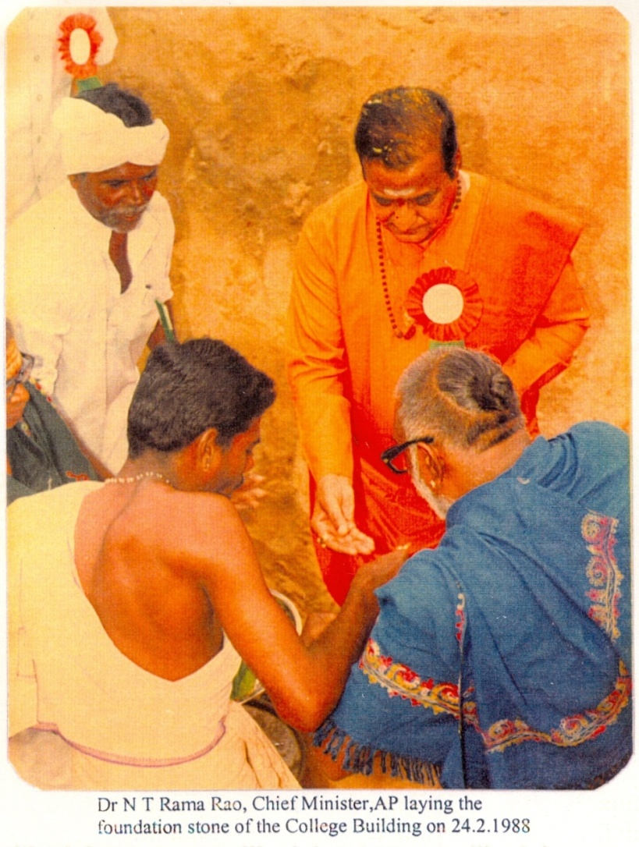

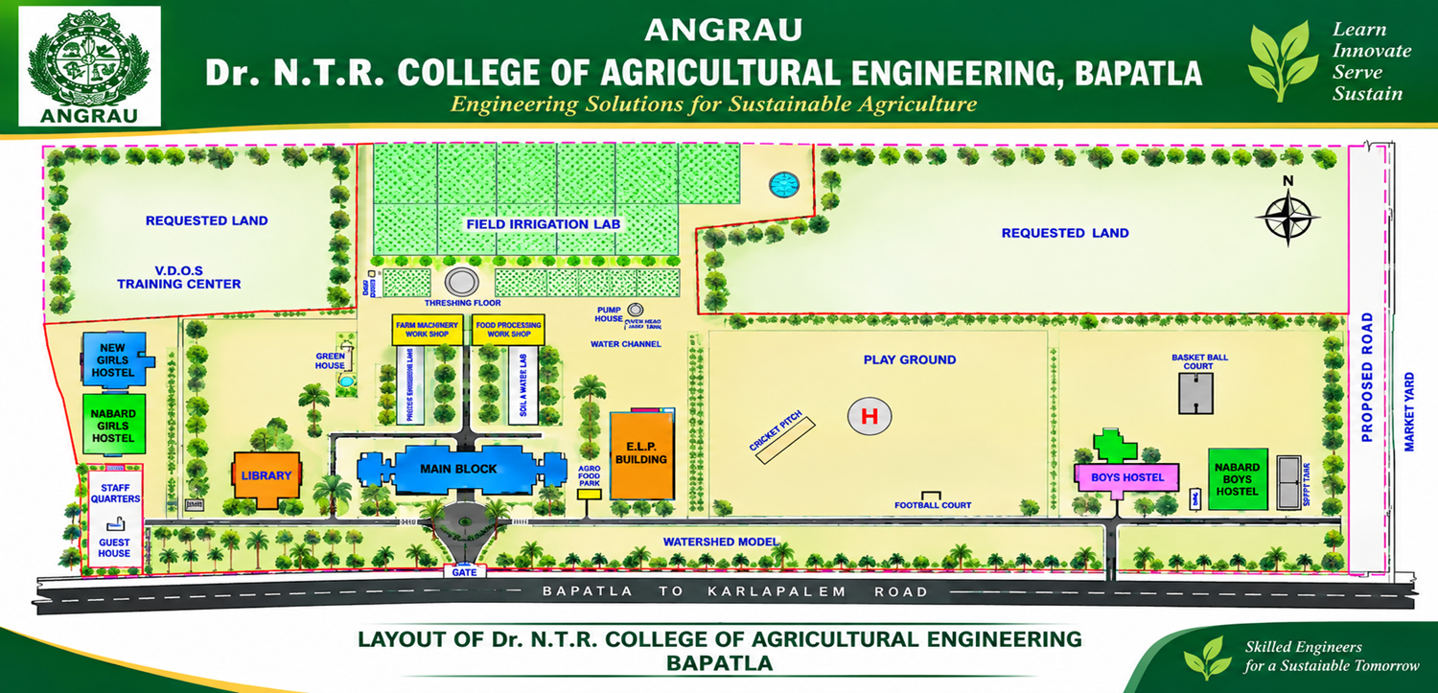

VISION
To make Dr NTR College of Agricultural Engineering, Bapatla an integrated center for academic excellence of agricultural engineering education known for its contribution to agriculture and allied fields in making agriculture more remunerative to farmers

MANDATE
To serve the farming community and enhance their quality of life through excellence in education, research, development and transfer of agricultural technologies

ORGANIZATIONAL STRUCTURE

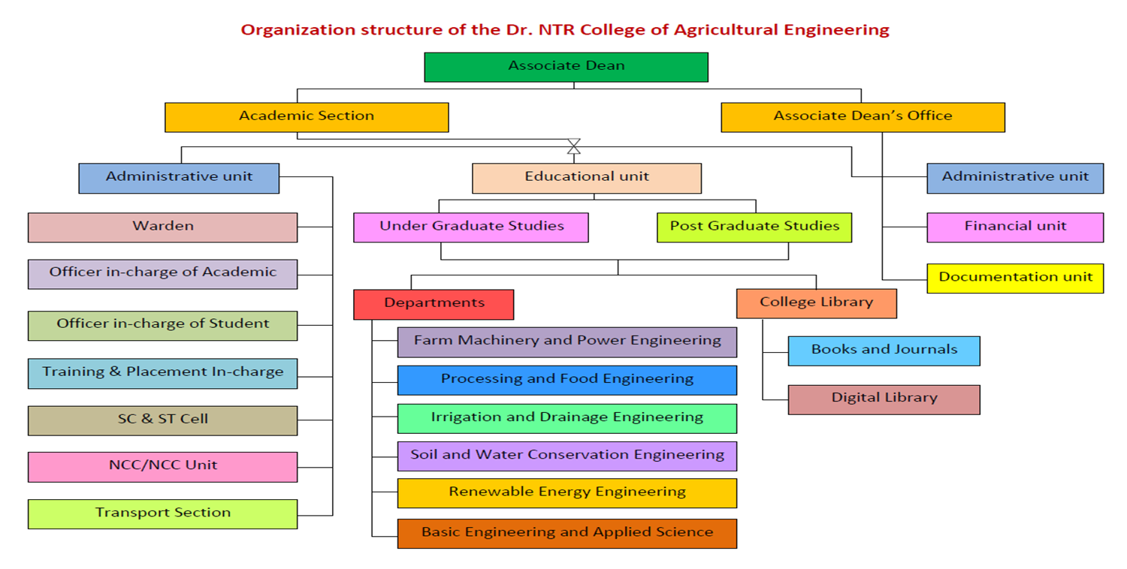

STATUS OF ACCREDITATION
Pl add the following in the order as attached
<GAZETTE NOTIFICATION >
<SELF STUDY REPORT OF COLLEGE>
<SELF STUDY REPORT OF B.TECH (AG ENGG)>
<SELF STUDY REPORT OF M.TECH (AG ENGG)>
<SELF STUDY OF PH.D. (AG ENGG)>

