Admission Process
Duration of the Programmes : Min : 4 Years , Max : 7 Years (from the data of Admission)
Criteria for admission: The students are admitted into all U.G courses based on their performance in the state level Common Entrance Test (EAMCET) conducted during the year of admission by the AP Sate Council of Higher Education, Government of Andhra Pradesh. The University shall invite applications from eligible candidates through notification in some of the leading news papers generally in the month of June (G.O.Ms.No.184, dated 20-08-1993 of Education (E.C.2) Department).
Admissions into the First Year B. Tech. (Agricultural Engineering) degree programme are carried out through the Andhra Pradesh Engineering, Agriculture and Pharmacy Common Entrance Test (AP EAPCET) conducted by the Government of Andhra Pradesh. The admission process is undertaken through the centralized counselling system implemented by the Andhra Pradesh State Council of Higher Education (APSCHE), ensuring transparency and adherence to the reservation policies prescribed by the Government of Andhra Pradesh. The approved intake capacity for the First Year B. Tech. (Agricultural Engineering) programme is 60 students per academic year. Out of these 60 seats, 60 percent (36 seats) are filled through the AP EAPCET Convener quota based on merit and reservation norms. The remaining 40 percent (24 seats) are allotted under the Farmers’ Quota in accordance with the policies and reservation guidelines of the Government of Andhra Pradesh, thereby providing opportunities to students from farming backgrounds to pursue professional education in agricultural engineering.
In addition to the regular intake, 20 percent supernumerary seats over and above the sanctioned intake are allotted to students nominated under the ICAR quota by the Indian Council of Agricultural Research (ICAR), New Delhi. These admissions are made at the national level, enabling students from different states of the country to join the programme and contribute to a diverse academic environment within the College. The College also provides an opportunity for diploma holders to pursue higher education through the lateral entry system. Candidates who have completed a three-year Diploma in Agricultural Engineering are eligible for admission directly into the Second Year of the B. Tech. (Agricultural Engineering) programme through the Andhra Pradesh Engineering Common Entrance Test (AP ECET) conducted annually by APSCHE, Government of Andhra Pradesh. For these lateral entry admissions, an additional 20 percent seats over and above the regular intake are reserved as per the prescribed norms.

Age: The candidates for admission into First Year Under Graduate courses in the University shall be required to have completed 17 years of age as on 31st December of the year of admission with an upper age limit of 22 years for all the candidates, 25 years in case of SC and ST candidates and 27 years for Physically challenged.
The eligible candidates shall be required to attend counseling in person perusing as per the notification in the News papers and be admitted to different U.G Programmes depending on their individual merit as determined by the rank' obtained in EAMCET following the presidential order (Regional allotment), the rule of reservation as per orders of the Government of Andhra Pradesh.
Reservation of Seats
Allocation of seats in favour of local candidates in relation to Local Area:
Out of total intake, 15% of seats shall be Un- reserved (UR). For these seats any candidate from AU/SVU region can compete with intermediate marks of A.P. Candidates from Osmania University (OU) region (Telangana State), also are eligible to compete for these seats with intermediate marks of Telangana State.
Admission to 85% of the seats, the seats shall be allocated in of 42 : 22 ratio in Andhra University and Sri Venkateswara University, respectively among the candidates in relation to local area.

Backwad Classes (BC) : 29% of seats are reserved under this category. ( BC-A -7%; BC-B – 10%; BC-C – 1%: BC-D – 7%; BC-E– 4 % ).
Scheduled Caste (SC) : 15%
Scheduled Tribe (ST) : 06%
Other Reservations:
- Defence Personnel (CAP) - 2%
- National Cadet Corps. (NCC) - 1%
- Games & Sports - 0.5%
- Differentially Abled (PH) - 3%
- 1% for Visually Handicapped
- 1% for Hearing Impaired
- 1% for Orthopedically Handicapped
Reservation of Seats for Women : In each course, 33^{1/3} % of the seats shall be reserved in favour of women candidates from each category. (G.O.Ms. No. 75 / Edn., dated 13-3-1996 of Govt. of A.P.)
Reservations for the candidates coming from families of Agriculturists cum Rural area:
- Forty (40) per cent of the seats in B.Sc. (Hons) Agriculture, B.Tech. (Agricultural Engineering), and B.Tech. (Food Technology) courses are reserved for candidates coming from families of Agriculturists actually engaged in agriculture and owning not less than 1 acre of land and who have studied for a minimum of 4 years in schools located in Non-Municipal areas.
- Candidates seeking admission under this category shall produce (i) a certificate in Form - I of application containing patta numbers and extent of land obtained from a Revenue Officer not below the rank of Mandal Revenue Officer of the Mandal Concerned or a certificate copy of Pattadar Pass Book issued by the Mandal Revenue Officer and (ii) also a Certificate in Form – II of Application from the Heads of Institutions that the candidate has studied for a minimum period of four years in Schools located in Non-Municipal areas during their period of study from 1st class to 12th class ( or Intermediate).
- Form - I and Form - II need to be filled in with the signatures of concerned officials viz., Mandal Revenue Officer / Tahsildar and concerned Head of Institution, respectively, along with office seal. Otherwise, the claim of the candidates under this category will be summarily rejected.
Admission To Foreign Students
The University encourages foreign students to seek admission into various undergraduate and postgraduate degree Programmes. Their application for admission should be routed through the Asst. Director General (HRD-II), Indian Council of Agricultural Research (ICAR), Krishi Anusandhan Bhavan, New Delhi- 110012.
The application should include complete details of academic record indicating courses studied, grades obtained, medium of instruction and research work conducted for the submission of a thesis/dissertation (in case of candidates seeking admission to postgraduate degree programmes only). The applications thus received are scrutinized and evaluated by the concerned department (faculty head) to determine the eligibility of the candidate for admission.
Students applying for admission to Ph.D degree programme, should obtain a valid Research Visa from the Ministry of Human Resource Development, Government of India.
The fee payable by foreign Students admitted to Any UG or PG degree programme should pay institutional fee of US $ 4000 / US$2000 for SAARC Countries annually in addition to the normal fees payable by the Indian Students.
Excellent amenities are available for foreign students like International Hostel, Internet Facility, Digital Library etc.

- B.Tech (Ag Engg)
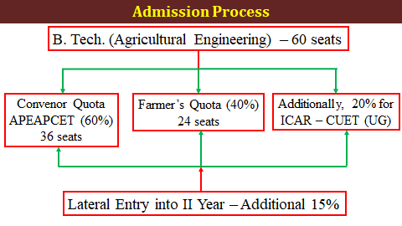
- PG & PhD Programmes
The admission into Master’s or Doctoral degree are based on the marks /rank obtained in ICAR’s All India Entrance Examination (AIEEA)/ ICAR’s All India Competitive Examination (AICE). The student applied for a subject group has to produce rank card in that subject group only. The weightage of the academic performance and AIEEA/AICE (ICAR) rank card / marks for admission is as follows:
- PG programme admission: The selection shall be based on the previous academic record at Undergraduate level and performance in AIEEA (ICAR) test and the weightage would be in the ratio of 30:70.
- For Doctoral Programme admission: The selection shall be based on the previous academic record at Undergraduate level, post graduate level, performance in AICE (ICAR) test and interview and would be in the ratio of 10:30:50:10.
- Qualifying marks: As per AIEEA/AICE (ICAR) rules, the candidate qualified and secured rank card in AIEEA/AICE (ICAR) are eligible for admission into master’s degree and Doctoral degree, respectively
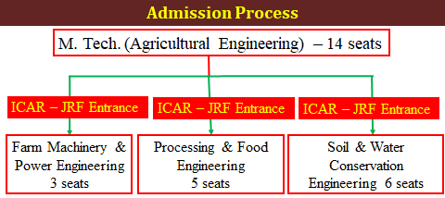
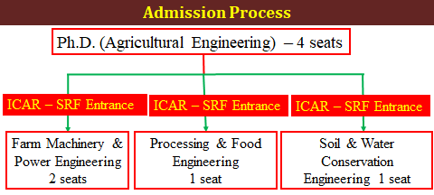

Fee Mechanism:
The fee for application, semester fee, special fee and other fee shall be prescribed by the university from time to time and the admission fee shall be paid by the candidate in person at the university campus at the time of counselling.

Registration Process:
Students who have received notification of admission from the university into various faculties will receive guidelines for the registration from the Associate Dean of the respective colleges.A registration and orientation program will be conducted by the Associate Dean of the college for the benefit of the students joining the university for the first time. The students in each batch shall have to register for the course offered and have to fill in the registration cards in person producing the identity card at the registration center on the day of registration. The academic section (undergraduate) of the college shall prepare a list of students who have registered for each course and send them course-wise to the teacher concerned within a week.

Academic Schedule Publication:
An approved academic calendar which provides the information of dates pertaining to the Registration of Course, Commencement of Instruction, Last date of Registration, Preparation Holidays, Semester Final Theory Examination and Commencement of Next Semester is communicated to the candidates after 10 days of the registration of semester.

