EXAMINATIONS – EVALUATION SYSTEM

UNDERGRADUATE PROGRAMME: B.Tech (Ag Engg)
The evaluation of the student in a course shall be based on his/ her performance in various kinds of examinations, records, class work and other types of exercises.
The detailed course outlines in each course shall be prepared by the concerned teacher(s) in consultation with the University Head of the Department/ Head of the Department, which will be made available to the students during the first week of the semester, A schedule of the mid-semester examinations of the academic programme shall be prepared by the Associate Dean and notified to the students at the beginning of each semester.

INTERNAL EVALUATION:

Mid semester examination:
There shall be one mid-semester examination to be conducted by the teacher offering the course after 50% of the working days are over in a semester. The duration of the mid-semester examination shall be for one and half (1 ½ hrs) hours. The marks allotted for mid-semester examination shall be 50.
The answer scripts of mid-semester examinations shall be evaluated by the concerned course teacher and shall be shown to the students. The students shall have the option to request the teacher for clarification of any doubts in scoring, provided that such clarification is requested for when the answer scripts are made available to them. This shall not apply for final examinations.

Final Practical examination:
Final practical examination shall be conducted in the last practical class of the semester for 50 marks. Marks for the practical examination shall be based on continuous evaluation of practical classes including class work and record for 25 marks; and a final practical examination shall be conducted for 25 marks which shall include a viva-voce examination.
EXTERNAL EVALUATION:

Semester Final Theory Examinations:
The semester final theory examinations shall be held in theory portion of the each course by the university at the end of each semester. Semester final examination in the theory portion shall be of two and half hours (2 ½ hrs) duration. The marks allotted for semester final theory examination shall be 100.
On the last day of semester final theory examinations, the Associate Dean shall send all the coded answer scripts of each course, year of study wise in sealed cover to the designated evaluation centre (constituent colleges in the University) and shall be evaluated by the course teacher of the evaluation center. After evaluation by the concerned course teacher, the marks award list of students shall be sent to the respective college by the Associate Dean of the evaluation centre.

POSTGRADUATE PROGRAMMES: M.Tech. & Ph.D.
During the semester, teacher in charge of a course shall hold different kinds of tests and assign to the student’s laboratory, library or field work. The students may also participate in seminars and submit term paper. The marks to be allotted between the theory and practical work shall be in the proportion of their respective credit hours. The weightage for theory and practical examinations may be as follows
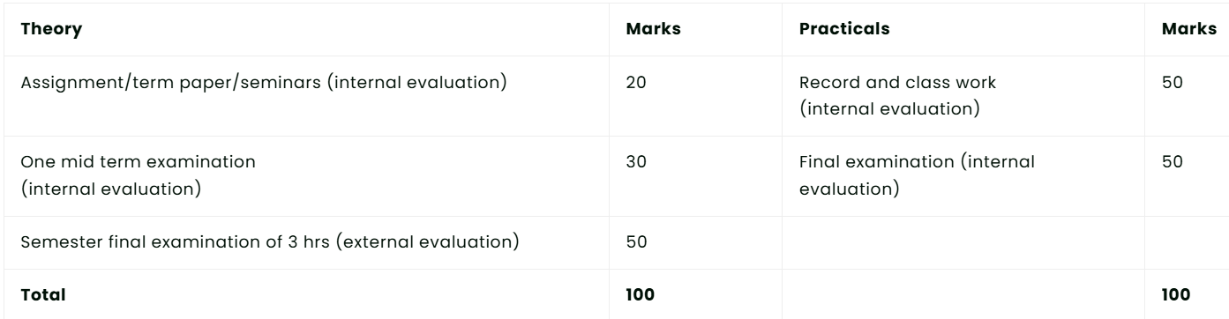
Each course may be evaluated @ 50 marks for each credit which may be finally reduced to 100 for awarding grade. In order to pass PG student must secure a minimum of 50% marks in both theory and practical final examination.

EXAMINATION SCHEDULES
1. Midterm examination after about 50 days from the commencement of the semester
2. semester final theory and practical examination at the end of the semester
3. A PG student getting a grade less than 6.00/10.00 in any course will be deemed to have failed in that course. However, student may not be required to study that course by repetition, but he/she may appear all examinations including semester final examination in that course when conducted next according to the regular schedule. In case of students, who have successfully completed all courses except failed course, the Associate Dean may permit re-examination during final semester (4th semester for M. Sc./5th semester for Ph. D.) or any subsequent semesters

MINIMUM CREDIT REQUIREMENT

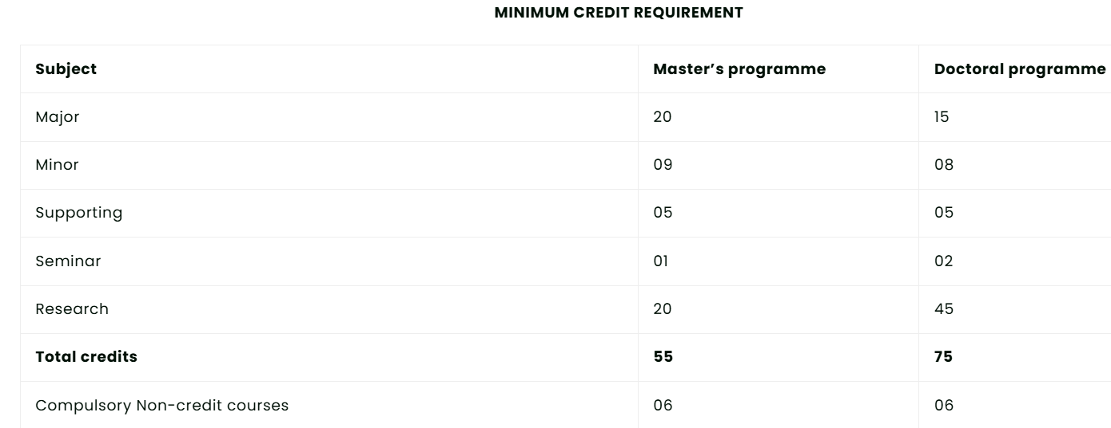
- After completion of all core courses (for M.Sc. students) and 75% of approved credit load, a qualifying /comprehensive examination comprising of both written and oral components may be conducted. In order to be eligible, the student should have secured OGPA of 6.50.
- The written test will precede the oral. 50% at master’s degree level and 70% at Ph. D level shall be the minimum marks for passing the written qualifying examination.
- The oral examination shall be conducted by the students advisory committee and an External Examiner either from another campus of this university of outside as nominated by the Dean PG studies.
- A student shall submit thesis for master’s degree and Ph. D. degree after completion of course work requirement, the required number of research credits and after passing the qualifying examination successfully.
- The thesis submitted by the student shall be sent to an external examiner for evaluation, for the Ph D degree, thesis shall be sent for evaluation to two external examiners from outside the University.
- A student of master’s degree and Ph. D. degree programme shall be eligible for the award of degree after completion of final oral (thesis) examination satisfactorily.

