ADMINISTRATION
VICE-CHANCELLOR
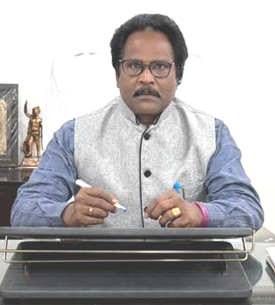
Dr. P.V.SATYANARAYANA
VICE-CHANCELLOR
vicechancellor@angrau.ac.in
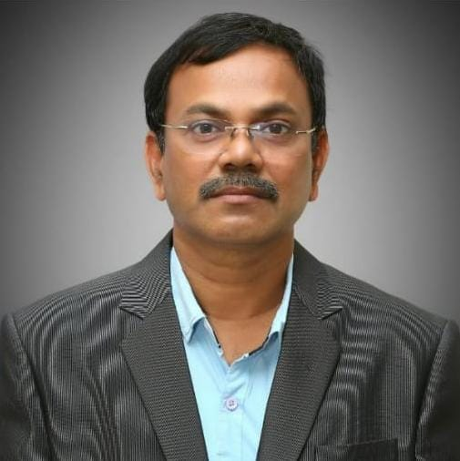
Dr. P.V.K. JAGANNADHA RAO
DEAN OF AGRI. ENGG & TECH
0863-2347102
deanaet@angrau.ac.in
View Profile

DEAN OF AGRICULTURAL ENGINERING& TECHNOLOGY

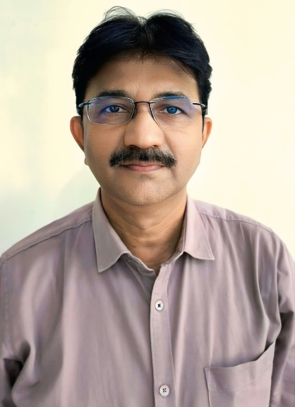
Dr. MOGAL SARDAR BAIG
9985589428
ad.caebpt@angrau.ac.in
View Profile

ADMINISTRATION SUPPORTING
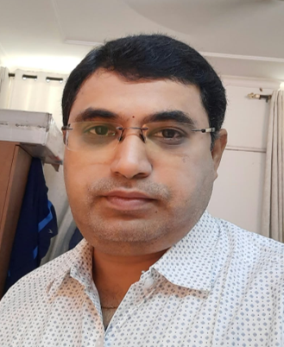 | 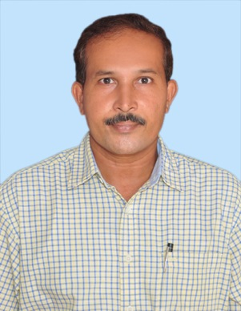 | 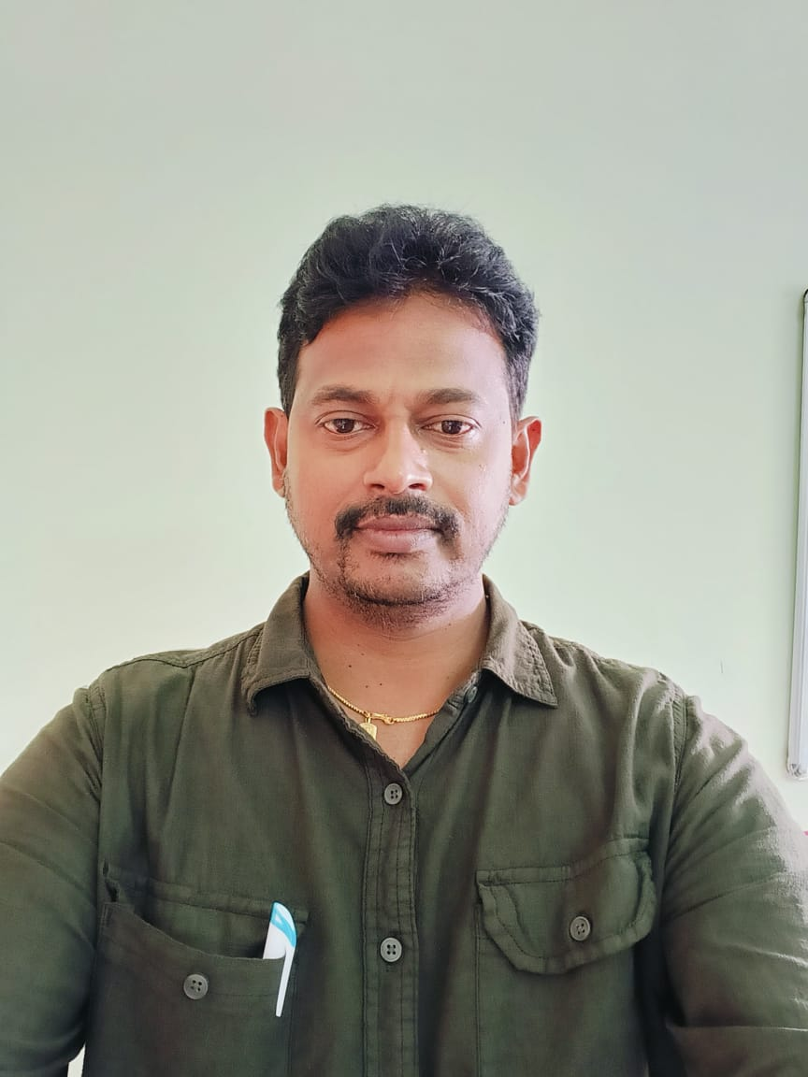
Dr. S. VISHNU VARDHAN  OFFICER INCHARGE OF ACADEMIC MATTERS (UG)  9440363112  oam.caebpt@angrau.ac.in | Dr. B. SREENIVASULA REDDY  OFFICER INCHARGE OF ACADEMIC MATTERS (PG)  9618800819  oampg.caebpt@angrau.ac.in | Dr. N. ASHOK KUMAR  ADDITIONAL OAM (UG)  8099479129  lib.caebpt@angrau.ac.in

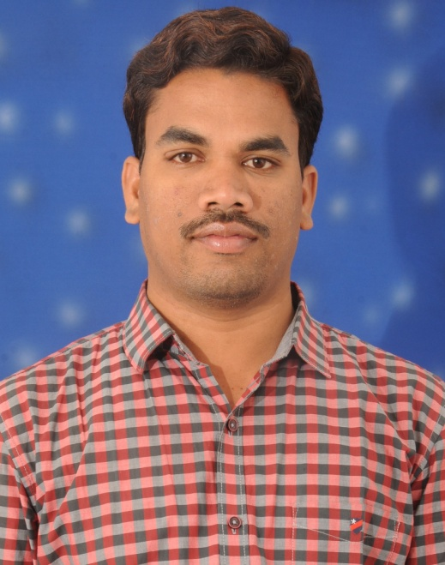 | 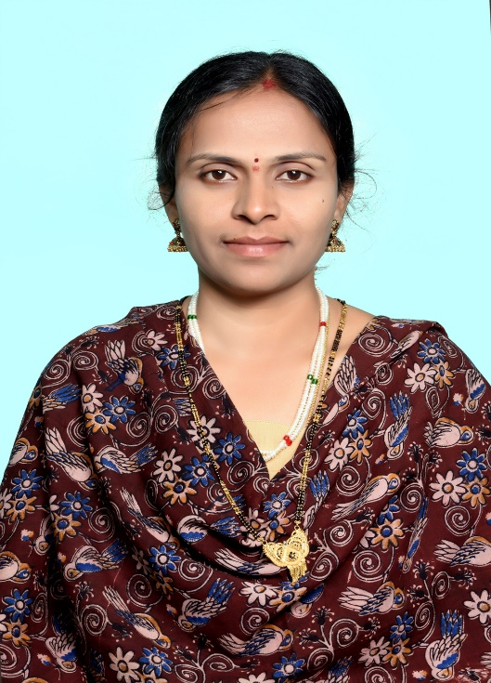
Dr. D.VIJAY KUMAR  WARDEN (BOYS HOSTEL)  9492686634  wardenboys.caebpt@angrau.ac.in | Dr. K. KRUPAVATHI  WARDEN (GIRLS HOSTEL)  9533877666  warden.caebpt@angrau.ac.in

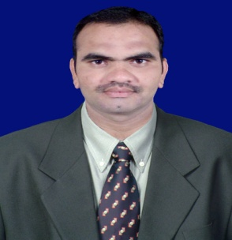 | 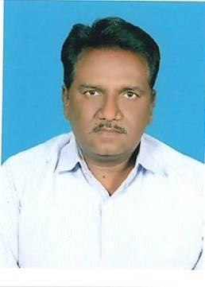 | 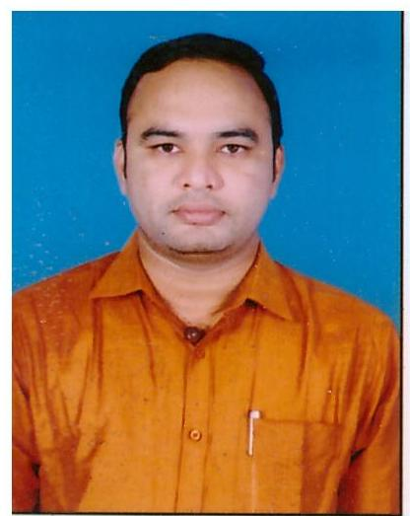
Dr. A. ASHOK KUMAR  OFFICER INCHARGE OF STUDENT AFFAIRS  9177522213  osa.caebpt@angrau.ac.in | Dr. G. RAVIBABU  TRAINING AND PLACEMENT OFFICER  9848186842  tpc.caebpt@angrau.ac.in | Dr. A. SRINIVASA RAO  TRANSPORT INCHARGE  8374647499  transport.caebpt@angrau.ac.in

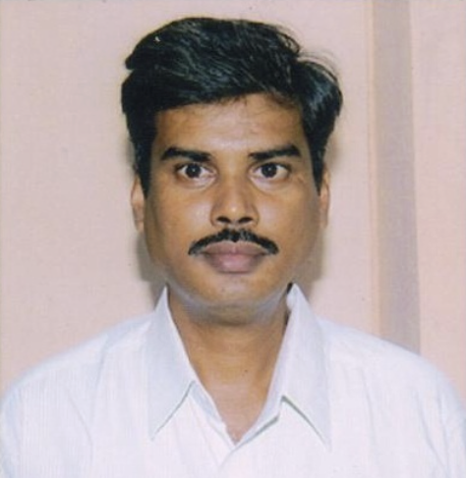 | 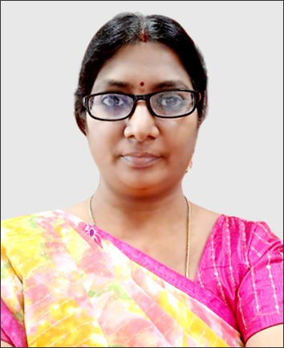
Dr. KVS RAMI REDDY  NSS PROGRAMME OFFICER-I  9490845917  nss.caebpt@angrau.ac.in | Dr. K. LAVANYA  NSS PROGRAMME OFFICER-II  9295350600  nss.caebpt@angrau.ac.in | Dr. N. ASHOK KUMAR  LIBRARY INCHARGE  8099479129  lib.caebpt@angrau.ac.in

Dr. K. LAVANYA  WOMEN PROTECTION CELL  9295350600  wpcell.caebpt@angrau.ac.in | Dr. D.VIJAY KUMAR  LABOUR INCHARGE  9492686634  d.vijaykumar@angrau.ac.in | Dr. S. VISHNU VARDHAN  IT WING INCHARGE  9440363112  vishnuvardhans@angrau.ac.in

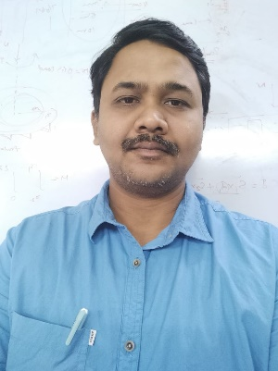 | 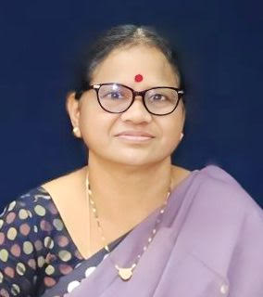
Dr. B. RAJ KIRAN  SC/ST CELL INCHARGE  8500880340  scstcell.caebpt@angrau.ac.in | Smt. V. PADMA TULASI  ADMINISTRATIVE OFFICER  8374243199  ao.caebpt@angrau.ac.in

