Department of Irrigation and Drainage Engineering
Natural Resource management is one of the important aspects of sustainable agriculture. Now a days, facing more problems like water scarcity, land degradation and pressure on agricultural lands due to development of urban areas and industries etc. There is a need to develop the methods for increasing the irrigation water use efficiency and land productivity. Water management and reclamation of saline and water logging soils in particular, face a considerable challenge in meeting the demands of increasing food production and security at both national and international level, soil protection, flood control and climate change. In this pursuit, to improve knowledge and skills to the UG and PG Students, the department of Irrigation and Drainage Engineering deals with the courses on Groundwater, wells and pumps, Irrigation engineering, Sprinkler and Micro irrigation Systems and Drainage engineering with the techniques of water management, rain water harvesting, surface and groundwater hydrology, watershed management and remote sensing applications etc. Some faculty are involving in reclamation of salt affected and waterlogged lands in irrigated agriculture and application of remote sensing and GIS techniques for performance assessment of the irrigation projects. All faculty well versed with the computer models related to soil and water engineering such as SURFER, CRIWAR, CROPWAT, DUFLOW, MODFLOW, DRAINMOD, SALTMOD and WINFLUME etc. The department has different laboratories such as wells and pumps laboratory, meteorology laboratory and filed irrigation laboratory with well established equipments such as hydraulic flume with re-circulation system, different types of cut models regarding pumps, display models regarding water management and irrigation engineering, different type of water measuring structures, micro irrigation systems, solar pumping, automatic weather station and other recent equipment/instruments. The department is working in the close coordination with the several projects like A P Water Management, APMIP etc.
The department has the following well established laboratories with state-of-the art equipment and facilities
1. Filed Irrigation Laboratory
2. Field Solar Pump Laboratory
3. Wells and Pumps Laboratory
4. Meteorology laboratory

Department of Irrigation and Drainage Engineering
Sl. No. | Name of the laboratory | Name of the Important Equipment/Instruments
1 | Field Irrigation Lab | Well irrigation system, Fields with drip irrigation system, Fertigation equipment, Soil moisture measuring devices, , Power weeder, Rain gauges, Evaporimeter, Automatic weather station, Hydraulic flume, Soil augers, Hot air oven, etc.
2 | Irrigation and Drainage Lab | Double ring infiltrometer, Soil moisture measuring devices (FDR), Parshall flumes, RBC flumes, Water meter, Current meter, Mole plough, Total station, GPS, Electronic theodolite, EC and pH meters etc.
3 | Well and Pumps Laboratory | Cut models of different pumps, Different impellers, Pumps, Motors, Solar pumping system, Water level recorders etc.

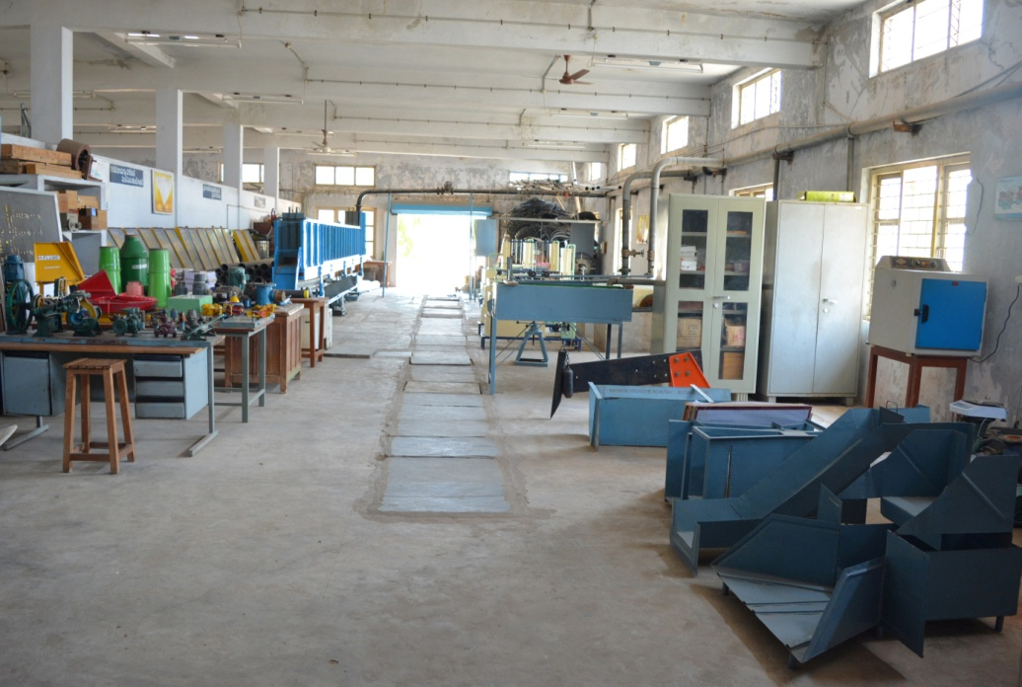
Irrigation and drainage laboratory
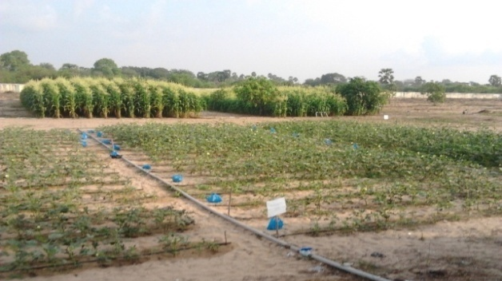 | 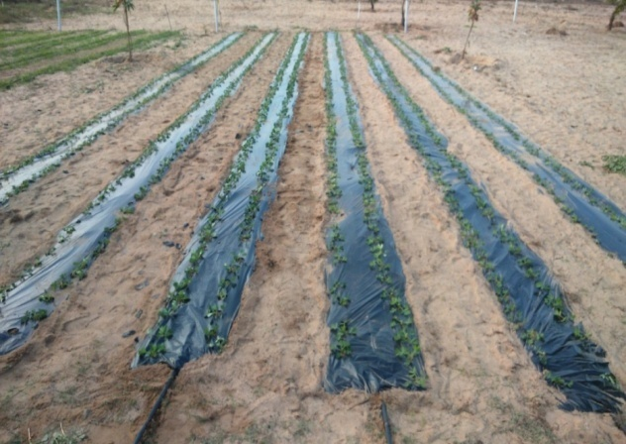
Field experiments at Field Irrigation lab in College of Agricultural Engineering, Bapatla
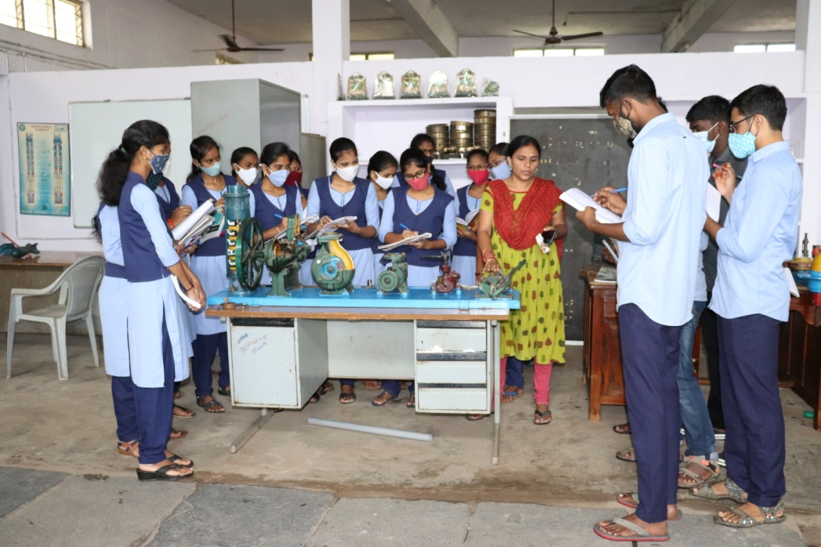
Cut models of various pumps

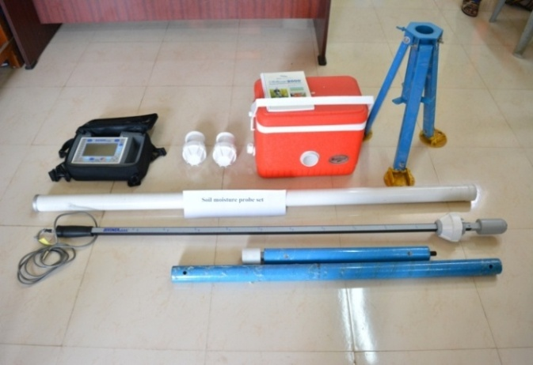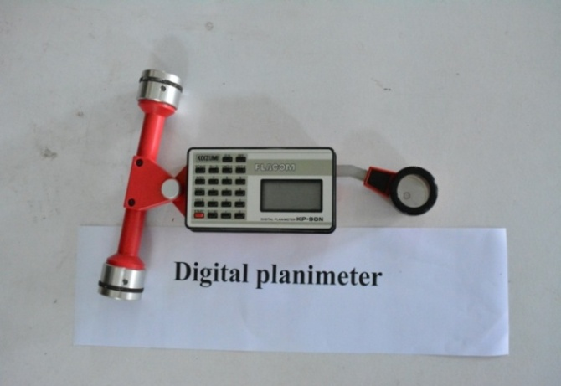
Soil Moisture Probe Digital Planimeter

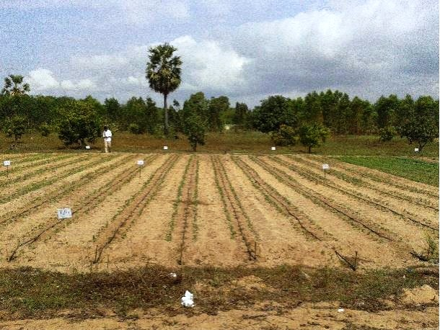
Drip Experimental plot at Field irrigation lab

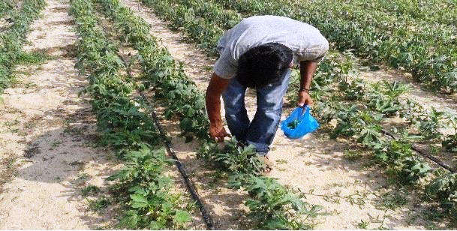
Harvesting of Bhendi from experimental plots at Field irrigation lab

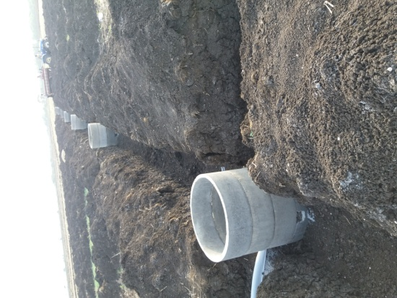
Installation of drainage system
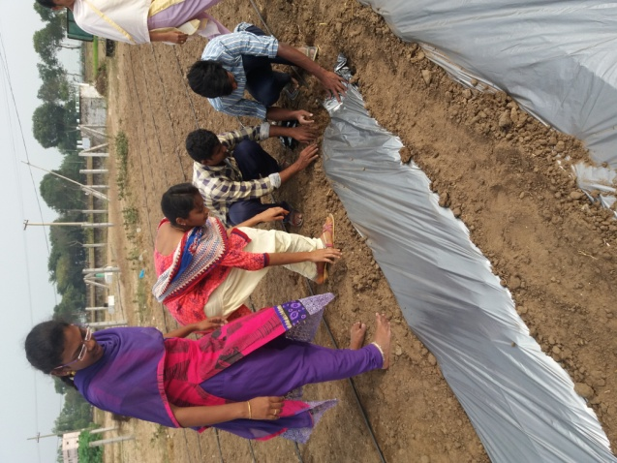
Laying of mulch in the field

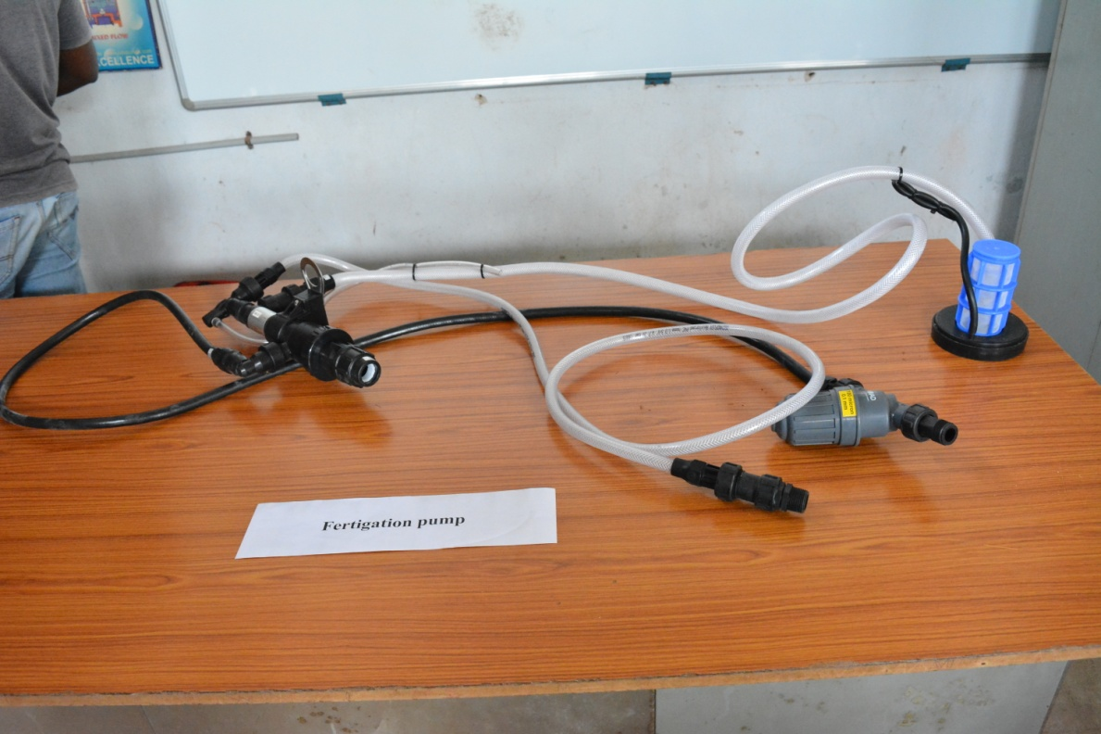
Fertigation pump

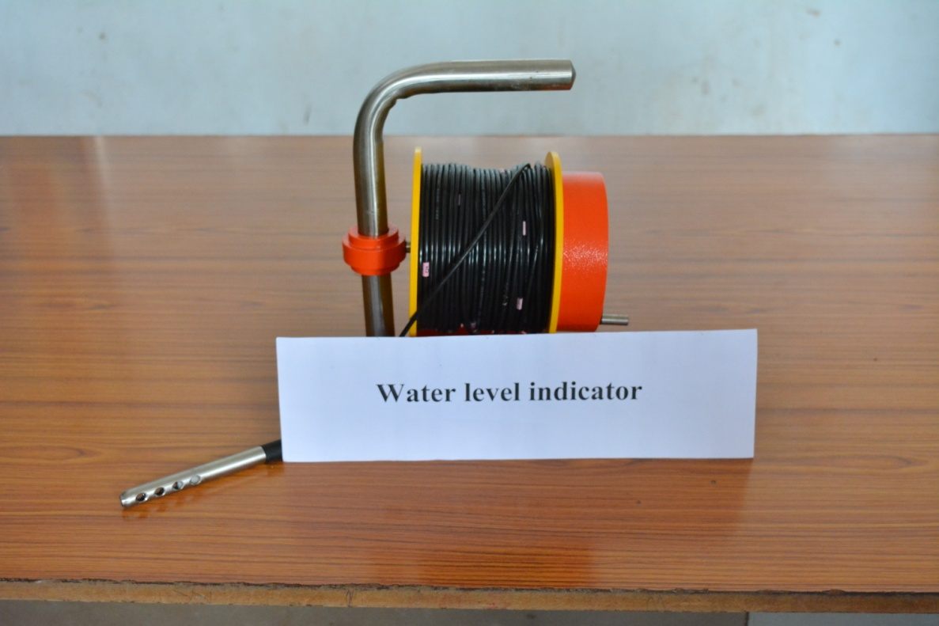
Water level indicator

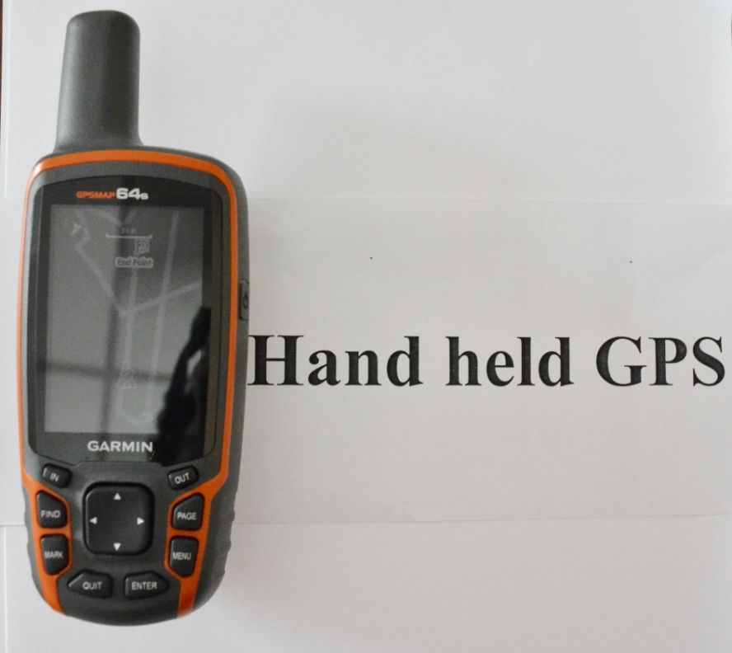
Hand held GPS

Department staff
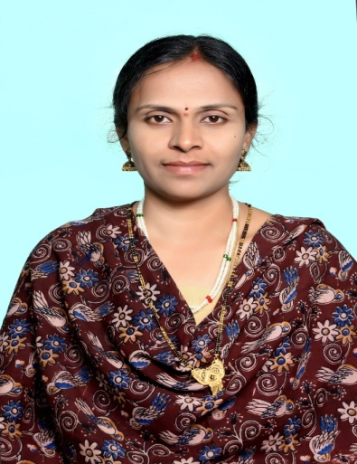
Dr. K. KRUPAVATHI
ASSOCIATE PROFESSOR & HEAD
9533877666
k.krupavathi@angrau.ac.in
View Profile

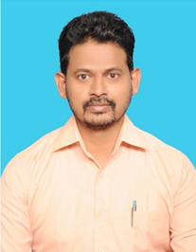 | 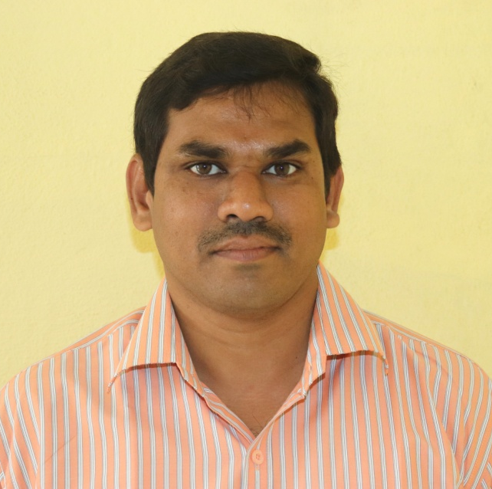
Dr. N.ASHOK KUMAR  ASSISTANT PROFESSOR  8555014523  n.ashokkumar@angrau.ac.in | Er. Ch. RATNA RAJU  ASSISTANT PROFESSOR 7337567544  Ch.ratnaraju@angrau.ac.in
View Profile | View Profile

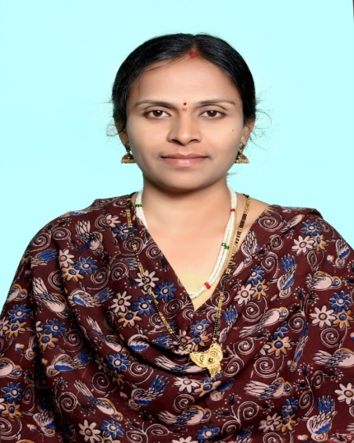  Associate Professor | : | Dr. (Mrs.) K. Krupavathi
 | : | Email ID: krupareddy572@gmail.com  Phone: 9533877666
 |  | Department of Soil and Water Engineering
Education
Doctor of Philosophy (Ph.D.) (Soil and Water Engg) (2019)
Acharya N. G. Ranga Agricultural University
DEVELOPMENT OF WATER - YIELD RESPONSE MODELS OF MAJOR CROPS IN KRISHNA CENTRAL DELTA FOR ENHANCING WATER USE EFFICIENCY USING GEOMATICS
Master of Technology (M.Tech) (Soil and Water Engineering) (2008)
Acharya N. G. Ranga Agricultural University
SOME FLOW CHARECTERISTICS OF SEMI CIRCULAR CONTRACTION CRITICAL FLOW FLUMES FOR LOW DISCHARGES UNDER DIFFERENT SUBMERGENCE CONDITIONS
Bachelor of Technology (B.Tech) (Agricultural Engineering) (2004)
Acharya N. G. Ranga Agricultural University>
PERFORMANCE EVALUATION OF METAL ROAD RING FOR TRACTOR CAGE WHEELS ON DIFFERENT ROADS
Notable contributions | : | - Developed Surveying and Levelling laboratory and practical facilities at College of Agricultural Engineering, Madakasira.  - Developed Soil and water engineering laboratory and practical facilities at College of Agricultural Engineering, Madakasira.  - Developed Soil and water engineering laboratory and practical facilities at College of Agricultural Engineering, Sangareddy.  - Established “Butterfly top low cost polyhouse” at College of Agricultural Engineering, Madakasira for research activities of students
Research Interests | : | - Remote sensing and GIS  - Automation in Irrigation
Professional recognition | : | Recognized as a WINNER in the IITB-ISRO-AICTE Mapathon, a competition of the FOSSEE Project, IIT Bombay in association with ISRO (Indian Space Research Organisation) and AICTE (All India Council for Technical Education) held between 7 Dec. to 22 Dec. 2020.
Research publications |  | International/National Journals :17  Conference proceedings: 01  Books and Book chapters: 03  Technical bulletins: 00  Popular articles: 07
Awards & Honours | : | - “Excellence in Teaching” for the year 2016-17 by Society for scientific development in agriculture and technology in ICAAS -2016 national seminar at Prof. Jaya Shankar Agricultural University, Hyderabad  - “Meritorious teacher award” for the year 2020 in 54th annual convocation of Acharya N. G. Ranga Agricultural University at Agricultural college, Bapatla

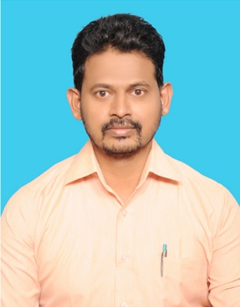  Assistant Professor | : | ASHOKKUMAR NARALASETTY
 | : | Email ID: n.ashokkumar@angrau.ac.in Phone: 8099479129
 |  | Department: Irrigation and Drainage Engineering
Education:
Doctor of Philosophy (Ph.D.) in Soil and Water Engineering
Year of completion: 2021
University: Acharya N. G. Ranga Agricultural University, Lam, Guntur, Andhra Pradesh State
Title of the Thesis: Assessment of Irrigation Potential and Optimization of Available Water Resources for Sustainable Agriculture in Anantapur District

Master of Technology (M.Tech) in Soil and water Engineering
Year of completion: 2006
University: University of Agricultural Sciences, Dharwad, Karnataka State
Title of the Thesis: Prioritization of subwatersheds based on geomorphological characteristics of Ag2 watershed in Krishna River Subcatchment (Karnataka)

Notable contributions | : | - 16 years teaching experience in various subjects like Watershed Hydrology, Soil and Water Conservation Engineering, Watershed Planning and Management, Water harvesting and soil conservation structures, Remote sensing and GIS Applications, Groundwater hydrology, Wells and pumps, Irrigation Engineering, Drainage Engineering, Fluid Mechanics and Open Channel Hydraulics, Engineering Mechanics, Design of Structures, Strength of Materials and Engineering drawing etc.
Research Interests | : | Irrigation and Drainage Engineering, Application of groundwater models, Land and water management, Watershed management, soil and water conservation, Remote Sensing and GIS etc.
Professional recognition | : | - Life member for The Andhra Agricultural Journal Since 2009  - Life member for Indian Society of Agricultural Engineers Since 2013  - Life member for Indian Association of Soil and Water Conservationists (IASWC) Since 2016  - Life member for Indian Association of Hydrologists Since 2016  - Life member for Indian society of Agriculture & horticulture Research Development (ISAHRD, Chandigarh, Punjab, India Since 2023
Research publications |  | International/National Journals: 16  Conference proceedings: 3  Books and Book chapters: 1  Study materials: 2  Technical bulletins/ Practical manuals: 2
Awards & Honours | : | - Received merit certificate in a national level e-quiz on “Awareness of Income tax for individuals” organized by the Department of Electronica and Communication Engineering on 20/7/2020.  - Received “Excellence Teaching Award” 4th International Conference “Innovation to Transform Agriculture, Horticulture and Allied Sectors” from 21st to 23rd June, 2023 Organized by Malla Reddy University. Hyderabad  and ISAHRD, Chandigarh.  - Received “BEST TEACHER AWARD” 1st International Agriculture Conference on Natural Vs Organic Farming: In Context to Bhartiya Agriculture” On 24 to 26th December, 2023 Organized by Gujrat Natural Farming and Science University, Anand, Hindustan Agricultural Research Welfare Society and IIMYU, Meerut.  - Received “Young Professional Award” 6th International Conference “Holistic innovations and technological advances for sustainable agriculture” from 4 to 6th March 2024 Organized by SR University. Warangal, SKLSSTHU, Hyderabad, Just Agriculture Group and ISAHRD, Chandigarh.

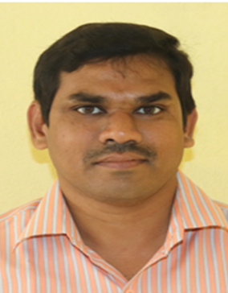  Assistant Professor | : | Er. Chebrolu Ratna Raju
 | : | Email ID ch.rathnaraju@angrau.ac.in : Phone: 7337567544
 |  | Irrigation and Drainage Engineering
Master of Technology (M.Tech):
Specialization: Soil and Water Engineering
Year of completion: 2011
University: ANGRAU
Title of the Thesis: CROP WATER REQUIREMENT – INDENTING AND SCHEDULING FOR KRISHNA WESTERN DELTA
Bachelor of Technology (B.Tech)
Specialization: Agricultural Engineering
Year of completion: 2009
University: ANGRAU
Title of the Thesis: Studies on Critical Flow Conditions in Semi- Circular Crested Weirs
Notable contributions | : | - Served as chairman to the B.Tech. (Ag. Engg.) student projects  - Served as the member of the AGRIENGGCET-2019 under the Chairperson of the Associate Dean, College of Agricultural Engineering, Madakasira  - Prepared the study materials for DAE-131 & DAE 341 courses of Ag. Engineering Polytechnics.
Research Interests | : | Watershed Management and Irrigation Water Management
Professional recognition | : | Member in Indian Society of Agricultural Engineering (ISAE)
Research publications |  | International/National Journals :8  Popular articles:3

