The Department of Renewable Energy Engineering is committed to advancing education, research, innovation, and technology transfer in the field of renewable and sustainable energy systems for agriculture and rural development. The Department focuses on harnessing renewable energy resources and developing efficient, economical, and environmentally sustainable technologies for agricultural production, processing, storage, and allied activities.
The Department integrates principles of solar, wind, biomass, biogas, small-scale hydropower, bioenergy, energy conservation, and emerging renewable energy technologies with agricultural engineering applications. Emphasis is placed on developing decentralized energy solutions that can reduce dependence on conventional fossil fuels, improve energy efficiency, and support sustainable agricultural and rural development.

2. Vision
To emerge as a centre of excellence in renewable energy engineering education, research, innovation, and technology transfer for sustainable agriculture and rural development.

3. Mission
- To impart quality education in renewable energy engineering and sustainable energy systems.
- To develop innovative renewable energy technologies for agricultural and rural applications.
- To promote efficient utilization and conservation of energy in agriculture and agro-processing.
- To undertake interdisciplinary research addressing emerging energy and environmental challenges.
- To develop decentralized and affordable energy solutions for farmers and rural communities.
- To facilitate entrepreneurship, incubation, technology transfer, and commercialization of renewable energy technologies.
- To create awareness regarding sustainable energy management and climate-resilient agricultural practices.

Academic Programmes
The Department contributes to undergraduate education in areas related to make students acquainted with the different renewable energy sources and to enable them to analyze and select the appropriate technology to meet the energy demand in different types of agricultural operations. Further, academic programme also emphasizes the different biomass sources, and the different thermo-chemical and bio-chemical processes for bio-energy and fuel production.
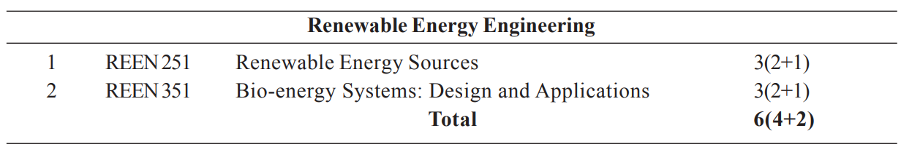
Practical components:
- Renewable Energy Sources
1 Demonstration of Solar data collection instruments
2 Demonstration of box type solar cooker
3 Demonstration of parabola type solar cooker
4 Demonstration of Solar water heating system
5 Demonstration of solar cabinet dryer and forced convective dryer
6 Demonstration of various functional components of SPV system
7 Demonstration of grid type and non-grid type solar photovoltaic systems
8 Design of solar photovoltaic system for domestic/industrial applications
9 Demonstration of solar green house
10 Demonstration/ study of functional components of WECS
11 Demonstration of different wind turbines (Horizontal and Vertical)
12 Demonstration of Janata type biogas plant
13 Demonstration of KVIC type biogas plant
14 Demonstration/visit to hydro power plant
15 Visit to solar park/wind energy turbine unit
16 Study of a fuel cell

- Bio Energy Systems Design
1 Study of anaerobic fermentation system
2 Study of gasification for industrial process heat
3 Study of biomass plantation procedures
4 Study of biomass harvesting methods
5 Determination of moisture content of biomass sample
6 Determination of Ash deformation and fusion temperature of biomass sample
7 Determination of calorific value of biomass sample
8 Study of working of different gasifiers
9 Study/visit of different types of furnaces
10 Study/visit of briquetting machines/industry
11 Study of drying process of biomass material
12 Study of size reduction process of biomass sample
13 Study of biodiesel production from jatropha seed
14 Testing of diesel engine with biodiesel/blended bio-fuel
15 Study of cost economics of bio-fuel
16 Visit to local industry which is utilizing producer gas for generating heat

Application of Renewable Energy in Agricultural Applications
The Department emphasizes the application of renewable energy technologies throughout the agricultural value chain:
Farm → Harvest → Processing → Storage → Transportation → Value Addition
Major applications include:
- Solar irrigation pumping
- Solar fencing and farm electrification
- Solar-powered agricultural machinery
- Renewable-energy-based drying
- Solar dehydration of fruits, vegetables and millets
- Biomass-based thermal systems
- Renewable-energy-based cold storage
- Solar-powered milk chilling
- Biogas-based farm energy systems
- Biomass gasifiers for decentralized electricity
- Renewable energy for food processing
- Waste-to-energy systems for agricultural residues

6. Research & Development
The Department is ready to undertake fundamental, applied, and translational research in renewable energy and agricultural energy systems.

Research thrust areas
- Solar energy conversion and utilization
- Renewable energy-based agricultural machinery
- Biomass conversion and value addition
- Agricultural waste-to-energy systems
- Energy-efficient agro-processing
- Solar drying and dehydration
- Renewable-energy-based cold chains
- Biogas and biomethane production
- Hybrid renewable energy systems
- Energy storage technologies
- Green hydrogen and emerging energy technologies
- Techno-economic and environmental assessment
- Carbon neutrality and climate-smart agriculture
- IoT-enabled renewable energy systems
- AI-based energy management and optimization

- 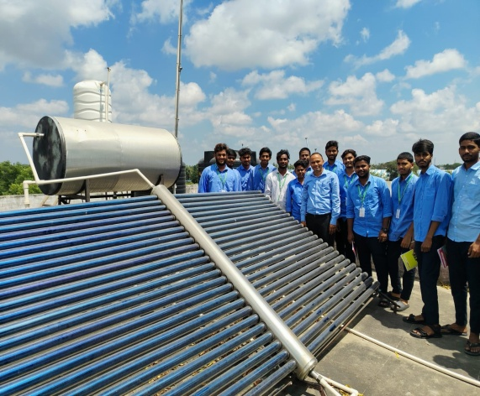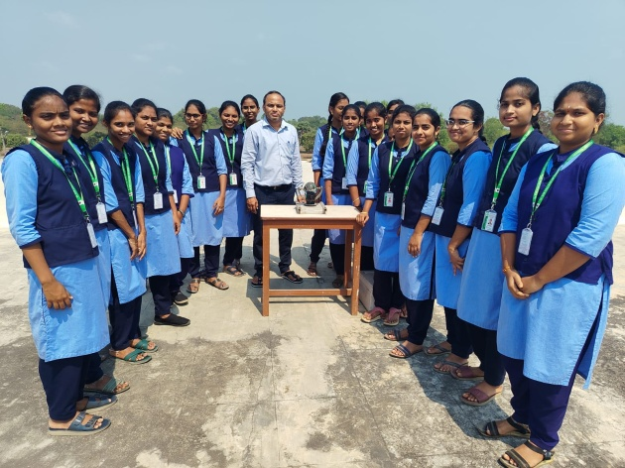

Field Demonstration Facilities
The Department may establish demonstration units such as:
- Solar PV power plant
- Solar water heater
- Solar dryer
- Solar cooker
- Solar irrigation pump
- Biomass briquetting unit (PHTC, Bapatla)
- Biomass gasifier

9. Extension & Outreach
The Department promotes the adoption of renewable energy technologies through:
- Farmer training programmes
- Skill development programmes
- Demonstration of renewable energy technologies
- Entrepreneurship development programmes
- Rural energy awareness campaigns
- Training on solar dryers and solar pumps
- Biomass utilization programmes
- Biogas technology demonstrations
- Energy conservation awareness programmes
- Training for rural youth and self-help groups

10. Entrepreneurship & Technology Transfer
The Department encourages students and rural entrepreneurs to develop enterprises based on renewable energy technologies.
Potential entrepreneurship areas include:
- Solar dryer fabrication
- Solar pump installation and servicing
- Solar PV system installation
- Biomass briquette and pellet production
- Biogas plant installation
- Biomass gasification
- Solar-powered cold storage
- Renewable-energy-based food processing
- Agricultural waste management
- Biochar production
- Energy auditing services
- Renewable energy equipment manufacturing and servicing

11. Industry & Institutional Collaboration
The Department seeks collaboration with:
- Renewable energy industries
- Solar PV manufacturers
- Agricultural machinery manufacturers
- Biomass and bioenergy industries
- Food-processing industries
- Energy service companies
- Government renewable-energy agencies
- Research institutions
- Start-ups and technology incubators
- Farmer producer organizations
- NGOs and rural development organizations
Collaborative activities may include joint research, consultancy, internships, field demonstrations, technology validation, student projects, industrial training, and technology commercialization.

Department staff

Dr. S. VISHNU VARDHAN
PROFESSOR & HEAD i/c
9440363112
vishnuvardhans@angrau.ac.in
View Profile
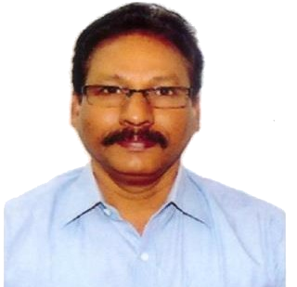
Dr. B. JOHN WESLEY
PROFESSOR
9441936374
b.johnwesley@angrau.ac.in
View Profile

Dr. A.SRINIVASA RAO
ASSISTANT PROFESSOR
8374647499
Arudra.srinivasarao@angrau.ac.in
View Profile

