Department of Soil and Water Conservation Engineering
The Department of Soil and Water Conservation Engineering is offering Post Graduate and Ph.D. courses besides offering courses to under graduate students in the College of Agricultural Engineering. The PG course was started in the year 2006 and Ph.D. course was started in the year 2013. The subjects offered for the UG students are as follows.
1. Watershed Hydrology
2. Soil and Water Conservation Engineering
3. Watershed Planning and Management
4. Water Harvesting and Soil Conservation Structures
The Department has made a model watershed in which the students are very well demonstrated all the watershed processes like stream orders, watershed characteristics, land treatments works like Bunding, terracing and trenching, various gully control structures, farm pond etc., The practical experiments like silt sampler, stage level recorders, in-situ-hydraulic conductivity measurement by auger hole method are conducted for the benefit of the students. Soil and Water Conservation Engineering laboratory equipped with working models of different equipment and also having display boards and banners showing the different Soil and Water Conservation methods.
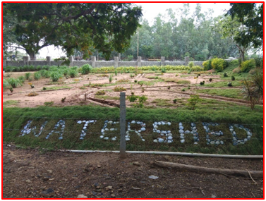
CAE Model Watershed with all component features
Sl. Name of the laboratory Name of the Important Equipment/Instruments No.
1 | Field Irrigation Lab | Well irrigation system, Fields with drip irrigation system, Green houses, Fertigation equipment, Soil moisture measuring sensors, Water meter, Current meter, Mole plough, Power weeder, Rain gauges, Evaporimeter, Automatic weather station, Hydraulic flume, Soil augers, Hot air oven,  etc.
2 | Well and Pumps Laboratory | Cut models of different pumps, Different impellers, Pumps, Motors, Solar pumping system, etc,
3 | Watershed | Watershed model, Farm pond, Soil and water conservation structures, etc.
4 | Soil and Water Conservation Engineering Lab | Double ring infiltrometer, Soil moisture measuring devices, Parshall flumes, RBC flumes, Total station, GPS, Electronic theodolite, etc.
5 | Hydroponics | A full-fledged hydroponics laboratory with all ative and passive equipment like linear and vertical NFT, DWC, Ebb and Flow system, Grow bag with drip,
Apart from Irrigation Field Laboratory of this College, agricultural land available in the Campus is being effectively utilized for field experiments pertaining to department. Very good Workshop is available with ultra-modern facilities in the College to cater the needs of the Department as and when required like fabrication of water measuring devices, etc. Apart from them, College is having Post Graduate Computer Laboratory to run AutoCAD, ProE, MATLAB, Catia, Statistical Software ‘R’, SAS, CROPWAT, CRIWAR, SURFER, SURDEV, WINFLUME, RS&GIS
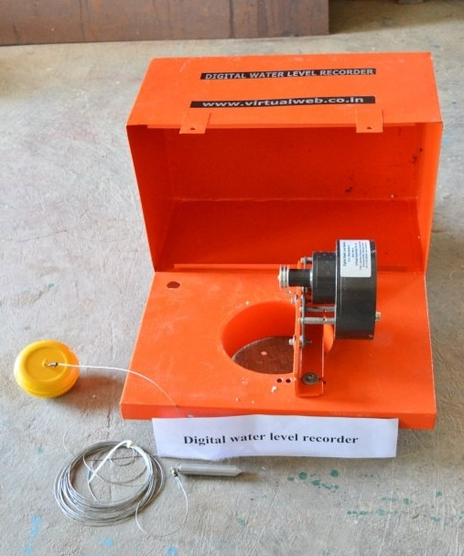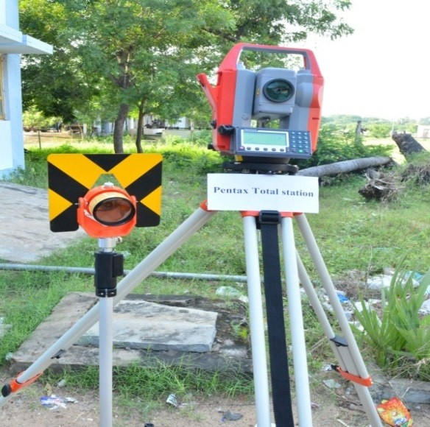

Digital Water Level Recorder Total Station
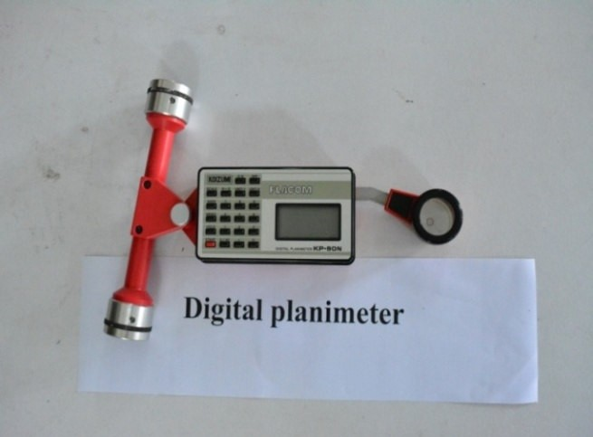
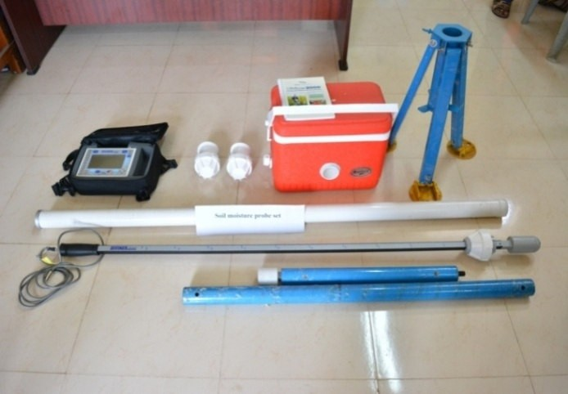
Soil Moisture Probe Digital Planimeter

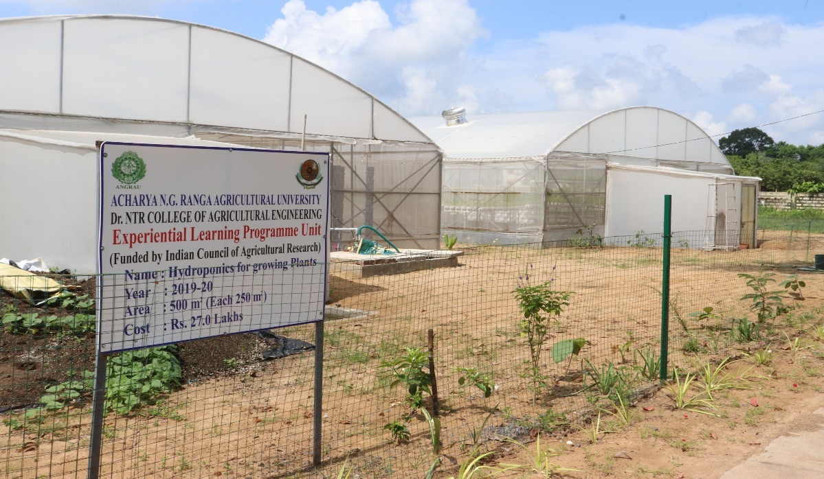

Fig. Poly houses for conduction various Ug, Pg, PhD research works

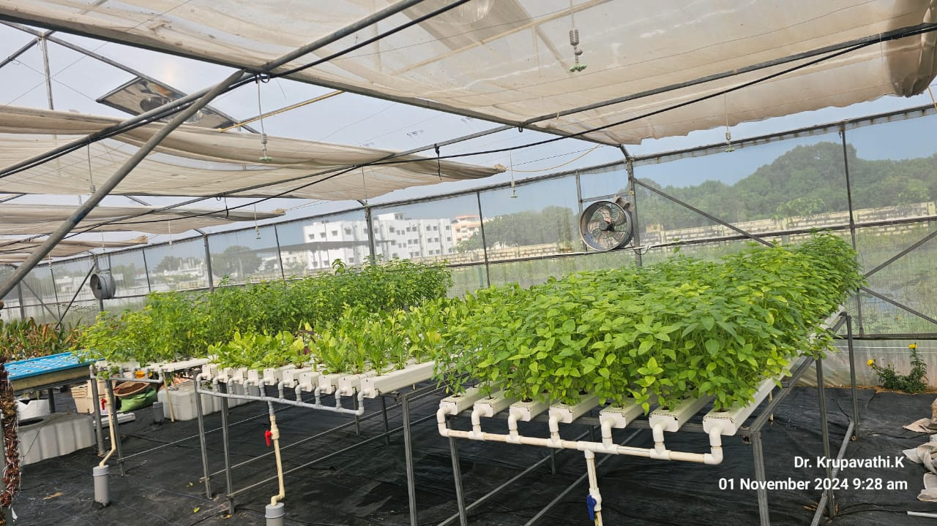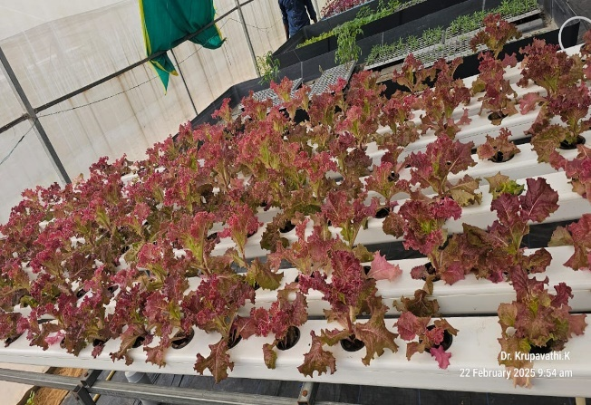
Linear (Horizontal) NFT Hydroponics units
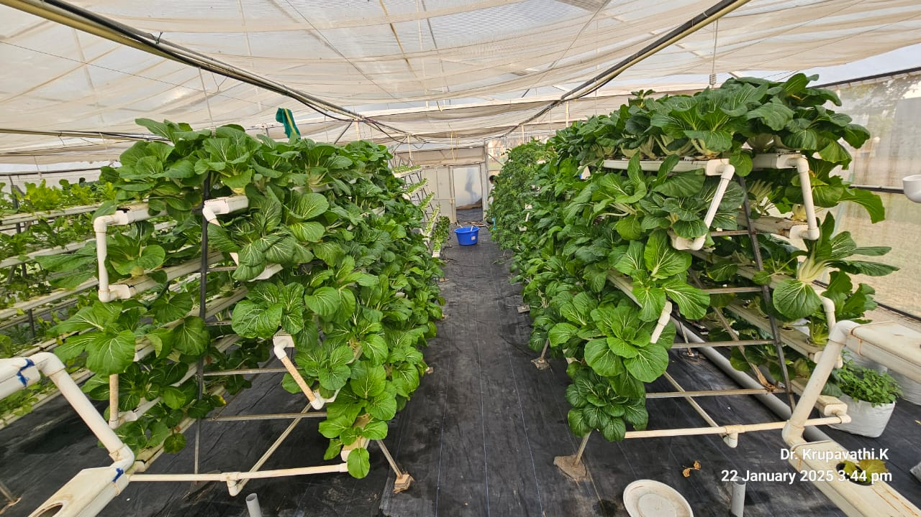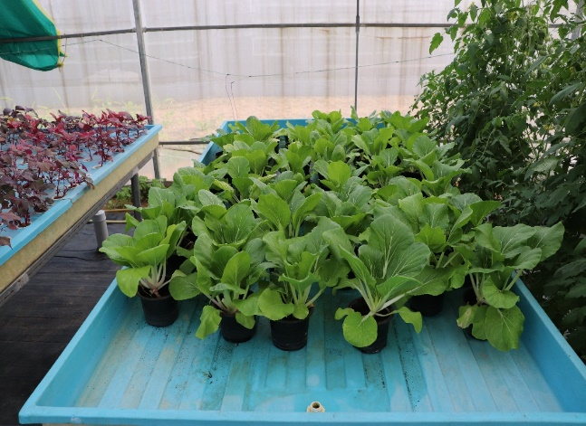
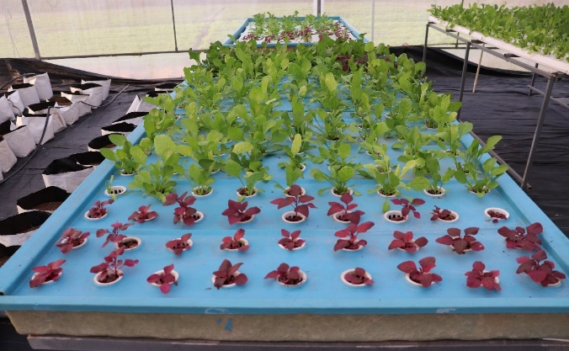
Vertical NFT Hydroponics units and EBB and Flow Hydroponics system
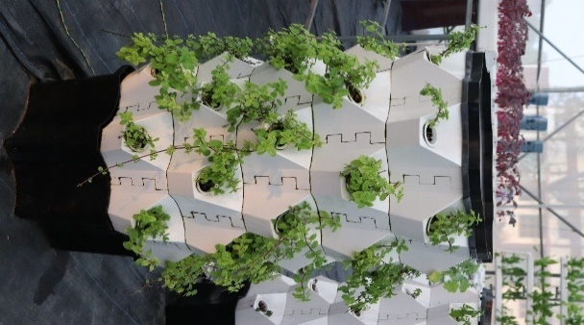

Deep water culture Hydroponics system and Nutri-grow towers aeroponics system

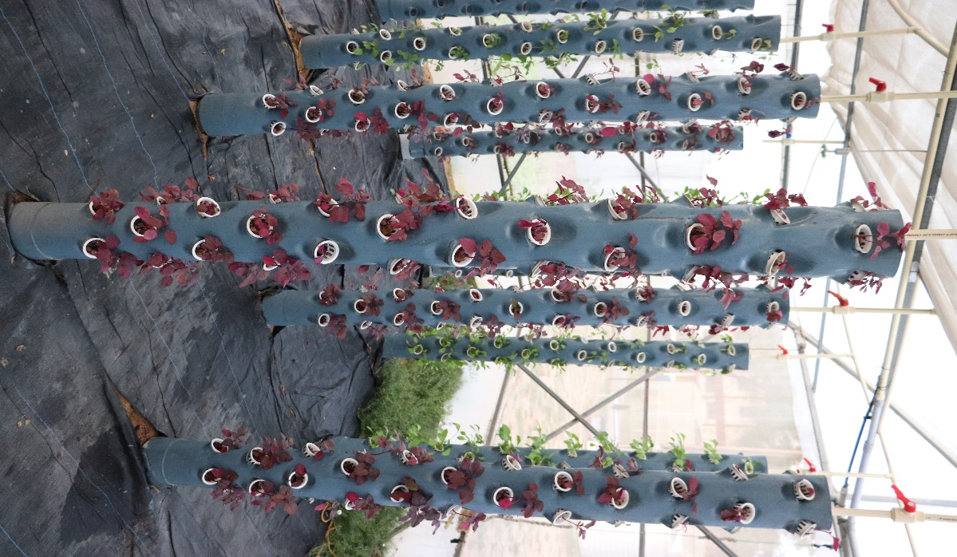
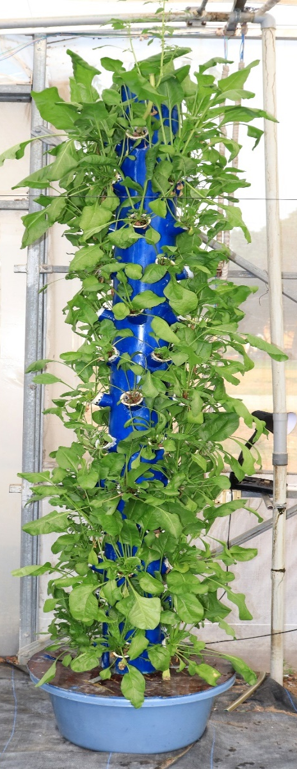
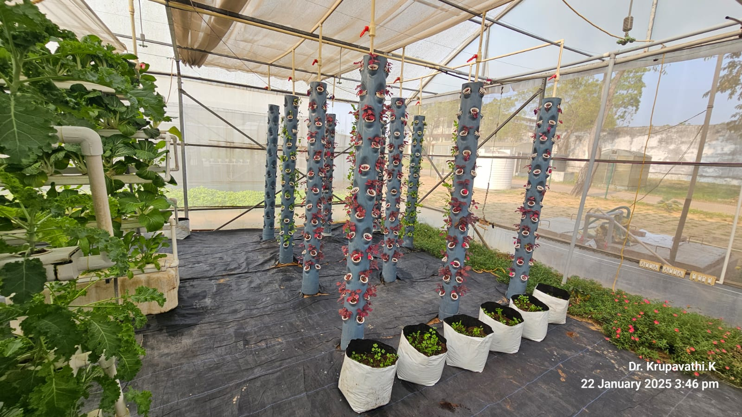
Aeroponics systems developed by Dr. N.T.R College od Agricultural Engineering, Bapatla
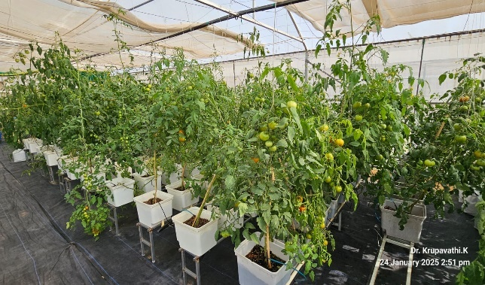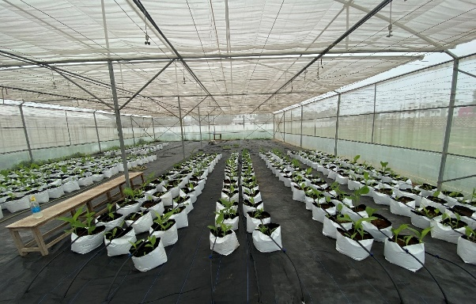
Dutch Bucket Hydronics system
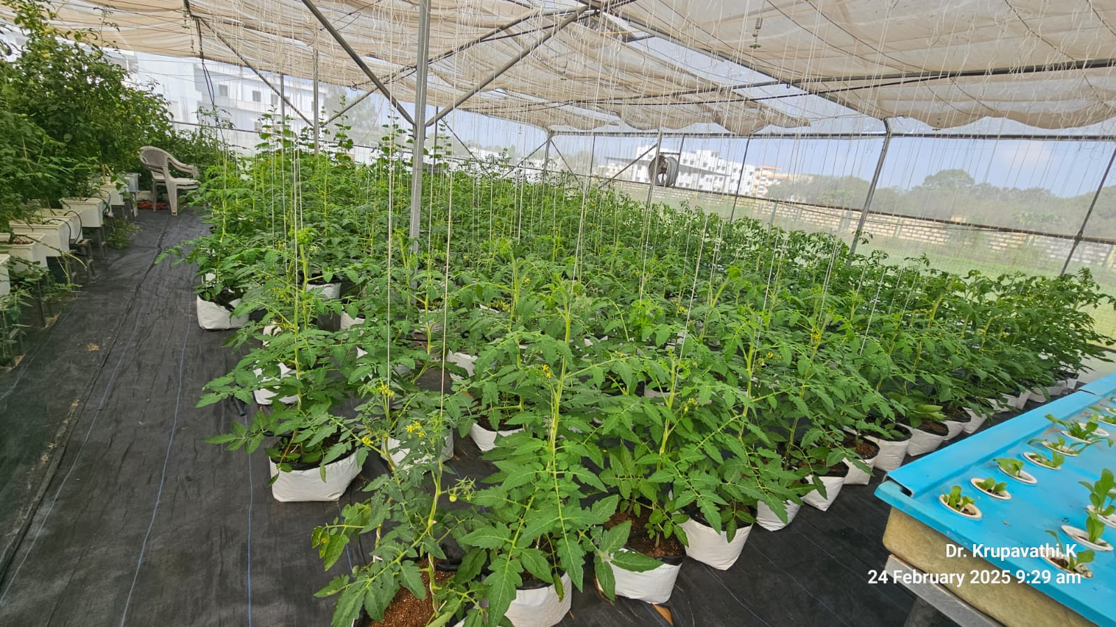
Grow bag system with drip irrigation

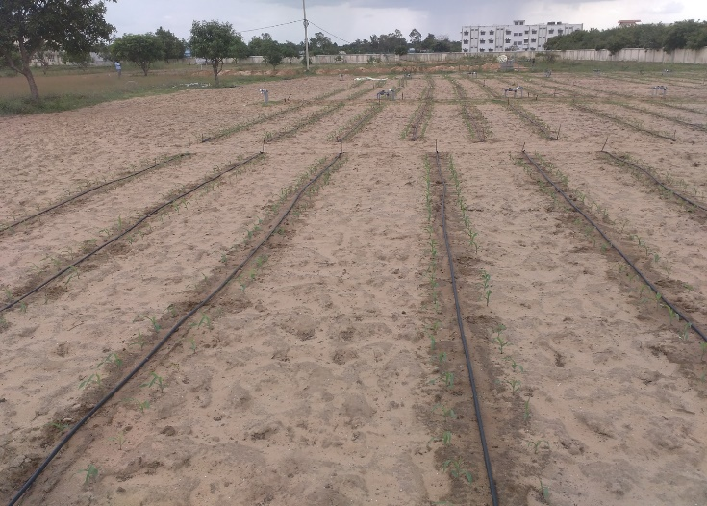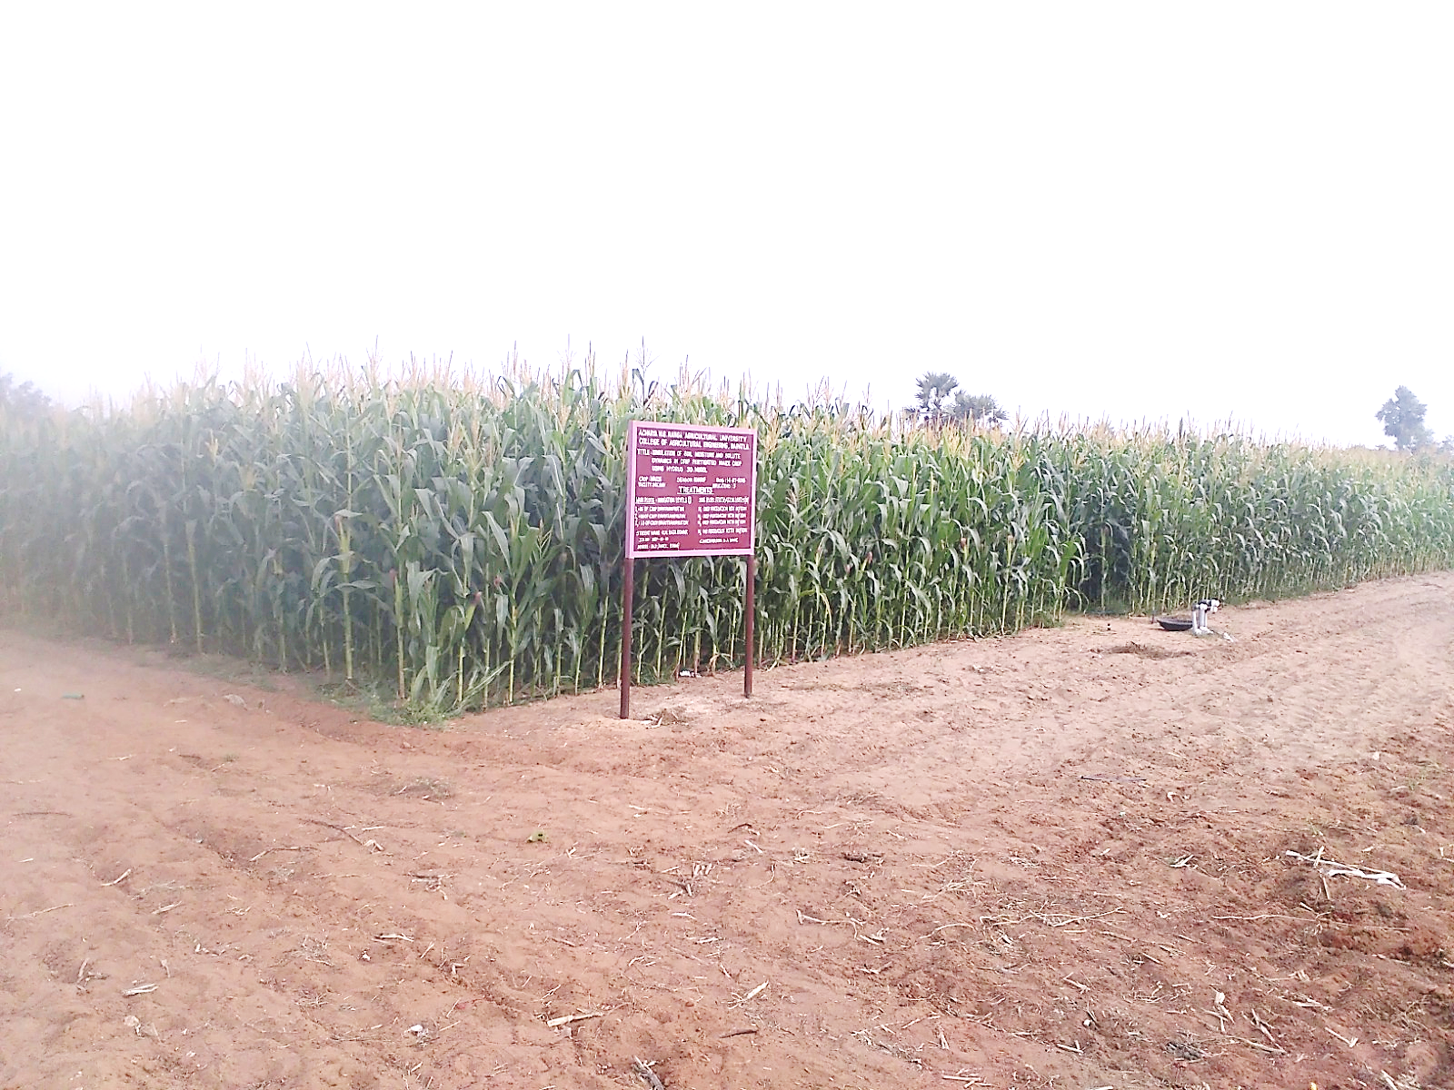
Irrigation Field Laboratory

The PG and Ph.D. students are specially undertaking their practical field problems related to
1. Design and Installation of Controlled and Sub Irrigation Systems
2. Use of HYDRUS-3D for nutrient transport modelling
3. Use of MODFLOW for ground water modelling
4. Pressurized Irrigation systems field experiments.
5. Use of remote sensing and GIS for erosion estimation
6. Use of remote sensing and GIS for runoff estimation
7. Use of remote sensing and GIS for crop condition assessment
8. Use of remote sensing and GIS for ET estimation and water production [-potential
9. Use of remote sensing and GIS for irrigation performance assessment.
10. Conjunctive use planning of surface and ground water resources
The dissertations submitted by the students are nevertheless on par with international standards and won appreciations from many subject matter specialists. The students are motivated and inspired the well qualified experienced Professors. Compared to other states, the students are qualifying in ICAR/JRF/SRF exams as well as NETs and bringing laurels to the Institute. The faculty and students are frequently provided with opportunity to update their skills by providing hands on training on the use of latest software tools by inviting eminents from all India and abroad as well.

DEPARTMENT STAFF DETAILS
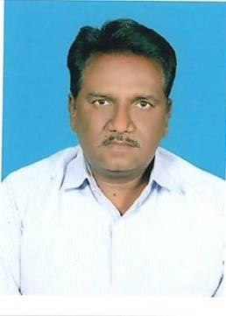
Dr. G. Ravi Babu
PROFESSOR & HEAD
9848572321
g.ravibabu@angrau.ac.in
View Profile

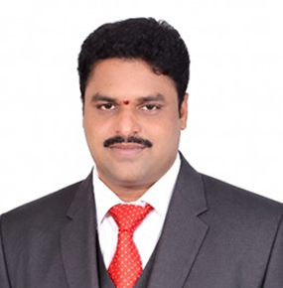 | 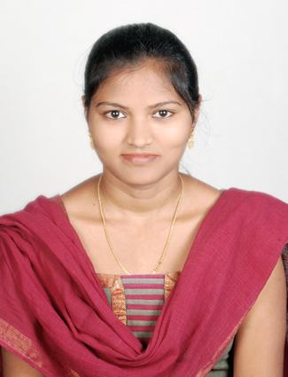
Dr. D. SAI GANGADHARA RAO  ASSISTANT PROFESSOR  8500087345  d.saigangadhararao@angrau.ac.in | Er. M. Karunya  ASSISTANT PROFESSOR  9490321440  m.karunya@angrau.ac.in
View Profile | View Profile

 | : | Name: Dr.G.Ravi Babu
 | : | Email ID: caemdks@gmail.com Phone no: 7702366113
 |  | Surface and ground water Management including Micro Irrigation and reclamation activities.
Associate Dean
Notable contributions | : | Development of polymer centrifugal pump, sensors in micro irrigation and WINFLUME for measuring water flows in canals. Experience of 13 years teaching and 8 years research. Guided to 25 students in M.Tech (Ag.Engg.) and Ph.D (Ag.Engg.)
Research Interests | : | Canal and coastal water management, Micro Irrigation and Ground Water
Professional recognition | : | Life Member ISAE Life Member IE Life Member AAJ
Research publications |  | International/National Journals: 41  Conference Proceedings:10 Books and Book chapters:4 Technical Bulletins:1 Popular articles:5
Awards & Honours | : | ANGRAU Meritorius Scientist Award in 2012  State Best Teacher Award 2023

Brief Profile
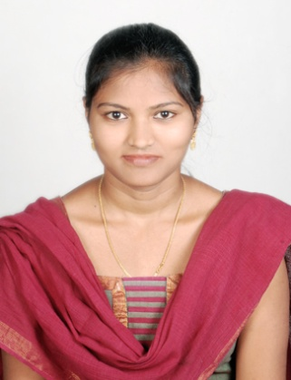

Name | : | MATHANGI KARUNYA
Designation | : | Assistant Professor
Department | : | Soil and Water Conservation Engineering
Phone No. | : | 9490321440
E-mail | : | karunya08cae@gmail.com
Education | Specialization | Year of completion | University / Board | Title of thesis
M.Tech (Agril.  Engg.) | Soil and Water Conservation Engineering | 2015 | ANGR Agricultural University , Hyderabad | STUDIES ON MOLE DRAINAGE TECHNOLOGY IN  WATERLOGGED BLACK SOILS
B.Tech (Agril.  Engg.) | Agricultural Engineering | 2012 | ANGR Agricultural University , Hyderabad | PERFORMANCE STUDIES ON POWER OPERATED CHAFF CUTTER  WITH PARAGRASS (BRACHIARIAMUTICA)

Notable Contributions | :
Research Interests | : | Irrigation and Drainage Systems
Professional recognition | : | -
Research publications | : | International/National Journals : 4  Conference proceedings:  Books and Book chapters:  Technical bulletins:  Popular articles: 2
Awards & Honours | : | -

