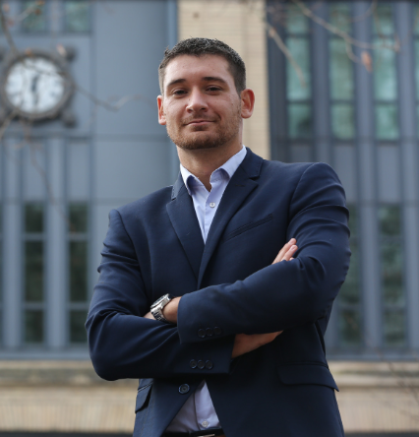
Prof. Dr. Pierre-Alexandre Balland

Chief Data Scientist
Centre for European Policy Studies

Visiting Professor
Harvard Kennedy School

Co-Founder & Director
AI World

E-mail: pierre-alexandre.balland@ceps.eu
Webpage: www.paballand.com

Professional Experience

Pierre-Alexandre Balland is a French economist and data scientist specializing in complex economic systems and artificial intelligence. He currently serves as Chief Data Scientist at the Centre for European Policy Studies (CEPS) in Brussels and Visiting Professor at Harvard University’s Growth Lab, where his work bridges cutting-edge AI research and real-world policy applications.

As Director of AI World (aiworld.eu), he leads the development of a global data observatory that integrates dozen of open datasets - from patents and publications to code repositories and investments - to map the evolution of the global AI ecosystem. His current research explores how AI agents can autonomously source, curate, and create new datasets, enabling more complete, transparent, and actionable intelligence for science, policy, and business.

Pierre-Alexandre ranks among the top 1% of most cited economists worldwide and frequently speaks at global technology and policy events such as Slush, VivaTech, Unleash World, and CEPS Ideas Lab. His prior academic appointments include positions at MIT, UCLA, Utrecht University and the Artificial & Natural Intelligence Toulouse Institute.

Relevant Scientific Papers

Balland, P.A., Broekel, T., Diodato, D., Giuliani, E., Hausmann, R., O’Clery, N. & Rigby, D. (2022) The new paradigm of economic complexity, Research Policy, 51 (3): 1-11.
Balland, P.A., Jara-Figueroa, C., Petralia, S., Steijn, M., Rigby, D., and Hidalgo, C. (2020) Complex Economic Activities Concentrate in Large Cities, Nature Human Behavior, 4: 248–254.
Balland, P.A., Boschma, R., Crespo, J. and Rigby, D. (2019) Smart Specialization policy in the EU: Relatedness, Knowledge Complexity and Regional Diversification, Regional Studies, 53 (9): 1252-1268.
Hidalgo, C., Balland, P.A., Boschma, R., Delgado, M., Feldman, M., Frenken, K., Glaeser, E., He, C., Kogler, D., Morrison, A., Neffke, F., Rigby, D., Stern, S., Zheng, S., and Zhu, S. (2018) The Principle of Relatedness, Unifying Themes in Complex Systems (IX): 451-457.
Petralia, S., Balland, P.A., and Rigby, D. (2016) Unveiling the geography of historical patents in the United States from 1836 to 1975, Nature Scientific Data, 3 (160074): 1-14.

