**Dr. Pierre-Alexandre Balland**

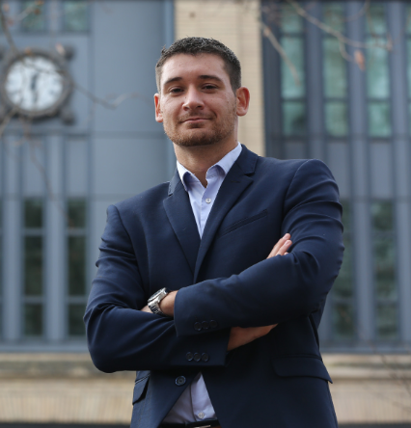

Pierre-Alexandre Balland currently serves as the **Chief Data**

**Scientist** at the **Centre for European Policy Studies** and

is a **Visiting Professor** at **Harvard University**.

Pierre-Alex is a leading expert on complex economic systems,

artificial intelligence, and blockchain technologies. He is one of

the most cited economists on **spatial economic development**

and the **smart specialisation strategy**.

He is a regular keynote speaker at global events for policy and

business leaders such as Slush & Unleash.

**Professional Experience**

Chief Data Scientist, **Centre for European Policy Studies** (2023-now)

Visiting Professor, **Harvard Kennedy School** (2024-now)

ESIR Expert Group, **European Commission** (2019-now)

Visiting Professor, **Artificial and Natural Intelligence Toulouse Institute** (2021-2024)

Assistant/Associate Professor, **Utrecht University** (2014-2024)

Visiting Professor, **Massachusetts Institute of Technology** (2018-2019)

Visiting Professor**, University of California, Los Angeles** (2016)

**Education**

Ph.D. in Economics, **University of Toulouse**

M.Sc. in Development Economics, **University of Toulouse**

B.Sc. in Economics, **University of Toulouse**

**Selected Publications**

The New Paradigm of Economic Complexity, *Research Policy* (2022) – 324 citations

Complex Economic Activities Concentrate in Large Cities, *Nature Human B.* (2020) – 531 citations

Smart Specialization Policy in the European Union, *Regional Studies* (2019) – 1025 citations

The Geography of Complex Knowledge, *Economic Geography* (2017) – 661 citations

Proximity and Innovation: From Statics to Dynamics, *Regional Studies* (2015) – 1040 citations

**Major Grants (>1M)**

European Ecosystem of Excellence in AI, *Google.org* (2024-2025)

ST4TE – Twin Transition in Europe, *Horizon Europe* (2024-2027)

PILLARS – Pathways to Inclusive Labour Markets, *Horizon 2020* (2021-2023)

TREND – Transition with Resilience for Evolutionary Development, *Horizon 2020* (2019-2024)

Resilient Cities, *JPI Urban Europe* (2014–2017)

**Selected Keynotes**

Slush, Helsinki (2024)

Unleash World, Paris (2024)

KÅKÅ|nomics Festival, Stavanger (2023)

Week of Innovative Regions in Europe, Paris (2022)