


Professional Association For Civil Engineering
NITK Surathkal

Optimization of Loads on Bridge

Mentor:
Ayush Seenam

Mentees:
Bidisha Koley
Rohit Meena
Sahitya Bhoyar
Trilok Nagar

Contents:
- Abstract
1.1 Summary of Objectives
1.2 Key Design Features
1.3 Overview
1.4 Findings
1.5 Conclusion
- Introduction
2.1 Background and Significance
2.2 Problem Statement
2.3 Objectives of the Project
2.4 Scope & Limitations
2.5 Research Methodology and Approach
3. Methodology
3.1 Problem Identification & Objective Definition
3.2 Conceptual Design of Bridge Models
3.3 Software Modelling in STAAD.Pro 2024
3.4 Load Definition and Application
3.5 Load Combinations
3.6 Structural Analysis
4. Loads and Load Combination
4.1 Introduction to Load Consideration
4.2 Types of Loads Considered
4.3 Load Combination
4.4 Implementation in STAAD.Pro
4.5 Importance of Load Combinations

- Comparative Analysis
5.1 Structural Performance Parameters
5.2 Material Properties and Behavior
5.3 Construction and Practical Considerations
5.4 Long-term Performance & Life-cycle Assessment
5.5 Real-Life Relevance - MG Setu Case Study
6. Conclusion
6.1 Performance Evaluation Summary
6.2 Cost,Durability & Maintenance Consideration
6.3 Real-World Validation - MGSetu
6.4 Final Assessment & Recommendations
7. Real Life Relevance of the Project
7.1 Aging Bridge Inventory & the Need for Rehabilitation
7.2 Seismic Safety & Regional Risk Awareness
7.3 Urbanization & the Demand for Rapid Infrastructure
Deployment
7.4 Climate Change & Environmental Durability
8. Deep Insight into MG Setu
8.1 Key Structural Issues Identified
8.2 Transition to Modular Steel Superstructure
8.3 Key Features of the Steel-Based Solution
8.4 Lessons Apllied to this Project

- Future Scope of the Project
  - Nonlinear and Time-Dependent Analysis
  - Fatigue and Fracture Analysis Under Repeated Loads
  - Life-Cycle Cost Analysis (LCCA) and Sustainability Assessment
  - Hybrid Bridge Systems and Advanced Materials
  - Seismic Isolation and Energy Dissipation Techniques
  - Integration with BIM and Digital Twin Technologies
  - Experimental Validation and Field Monitoring
  - Codal and Policy Implications

- Abstract
1.1 Summary of Objectives:
The primary objective of this project, titled “Optimization of Loads on a Bridge: A Comparative Study of RCC and Steel Structures,” is to evaluate and compare the structural performance, durability, and practicality of Reinforced Cement Concrete (RCC) and Structural Steel bridge systems under identical loading and geometric conditions. Using the real-world example of the Mahatma Gandhi Setu in Bihar, the project aims to provide data-driven insights into material selection and design optimization in bridge engineering.
The specific objectives are:
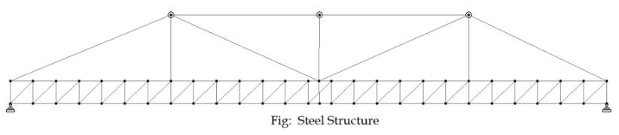
- To model and analyze two comparable bridge structures—one in RCC and the other in structural steel—using STAAD.Pro 2024, adhering to relevant Indian codes (IS 456:2000, IS 800:2007, IS 1893:2016, and IRC:6-2017).
- To simulate real-world load conditions including Dead Load (DL), Live Load (LL – IRC Class A), Wind Load (WL), and Seismic Load (EQ for Zone III), and assess their effects on bending moments, shear forces, and deflections.
- To conduct a performance-based comparison between RCC and steel bridges across parameters such as structural efficiency, self-weight, construction speed, seismic resistance, and long-term durability.
- To validate the simulation outcomes with a real-life case study of the Mahatma Gandhi Setu, analyzing its structural failures and the rationale behind its rehabilitation using modular steel spans.
- To assess life-cycle implications, including cost, maintenance, fatigue behavior, and retrofitting feasibility, in order to guide sustainable bridge design practices.
- To recommend optimized structural solutions for future bridge construction based on performance, resilience, and practicality in India’s infrastructure context.

1.2 Key Design Features:
This project involved the development of two parallel bridge models to evaluate and compare the structural behavior of Reinforced Cement Concrete (RCC) and Structural Steel under identical geometrical and loading conditions. Both models were created using STAAD.Pro 2024, a professional-grade structural analysis tool. The bridge configuration consisted of three continuous spans of 20 meters each, totaling 60 meters in length. Each model was designed with consistent geometry, support conditions, and loading scenarios to allow an unbiased comparison.
The RCC bridge used M30 grade concrete with beam elements for girders and plate elements for the deck, while the Steel bridge utilized Fe 345 structural steel configured as I-sections or channels in line with IS Handbook specifications. Codal provisions followed were IS 456:2000 for RCC, IS 800:2007 for steel structures, IS 1893:2016 for seismic analysis, and IRC:6-2017 for live loading criteria.
The bridges were subjected to a wide range of realistic loads including Dead Load (DL), Live Load (LL) as per IRC Class A, Wind Load (WL) in accordance with IS 875 Part 3, and Seismic Load (EQ) for Zone III. STAAD.Pro was used to define multiple load combinations such as DL + LL, DL + LL + WL, and DL + LL + EQ, enabling thorough analysis of internal forces and deformations.

1.3 Overview:

The project is rooted in the structural assessment and rehabilitation context of the Mahatma Gandhi Setu in Bihar—a 5.75 km long bridge over the Ganga River that suffered from severe degradation over the decades. Originally constructed in 1982 using prestressed RCC box girders, the Setu faced significant performance failures, including prestress loss, bearing malfunction, cracking from fatigue and stress corrosion, and pier buckling.
The practical failure of this concrete bridge, and its partial replacement with modular steel spans, prompted a systematic investigation into how RCC and Steel perform under similar loading conditions. This project seeks to validate whether steel not only solves many of the limitations of concrete bridges but also improves long-term performance, durability, and seismic resistance—critical factors for infrastructure sustainability in high-stress environments.
Through detailed modeling and simulation, this study attempts to answer questions regarding:
- Which material better withstands real-world loads?
- How do material properties affect deflection, fatigue, and seismic performance?
- What is the impact of material choice on cost, maintenance, and lifespan?

1.4 Findings:
The analysis revealed a distinct set of performance characteristics for each material type. RCC bridges are generally more economical during the initial construction phase due to the abundant availability of raw materials and skilled labor in most regions of India. However, when analyzed under load, the RCC bridge model exhibited significantly higher bending moments and shear forces, along with greater deflections, particularly under live and seismic load combinations. These results indicate reduced stiffness and a lower margin of safety under service conditions. The RCC bridge also had a substantially higher self-weight, which translated to greater foundational stress and increased long-term maintenance concerns.
In contrast, the steel bridge model outperformed the RCC bridge across multiple engineering parameters. The steel structure demonstrated lower internal forces, including reduced bending moments and shear forces, which directly implies a better ability to resist applied loads. Deflection values were also lower, indicating superior stiffness and structural integrity. Additionally, due to the modular and prefabricated nature of steel components, the construction timeline is considerably shorter, making it ideal for time-sensitive infrastructure projects. The steel bridge also exhibited superior seismic resilience, making it a more suitable choice for earthquake-prone regions like Bihar. Its lighter self-weight reduces the load on foundations and substructures, which is particularly advantageous for retrofitting existing structures or rehabilitating aging bridges.
In the specific context of Mahatma Gandhi Setu, the original prestressed concrete superstructure faced multiple critical failures, including corrosion-induced stress loss, bearing hinge malfunction, fatigue cracks, and box girder degradation. The decision to rehabilitate the bridge usi1ng modular steel spans was strategically sound. It led to reduced dead loads on the existing piers, allowed for quicker span replacement with minimal traffic disruption, and improved overall fatigue resistance and inspectability. Additionally, the use of steel improved the bridge’s durability in the water-laden and corrosion-prone environment of the Ganga River.

1.5 Conclusion:
This comparative study of RCC and Steel bridge structures clearly demonstrates that Steel bridges offer superior structural and lifecycle performance under modern engineering demands. Despite RCC’s lower initial cost and widespread usage, its long-term drawbacks include higher self-weight, limited ductility, slower construction, and vulnerability to environmental degradation—issues that were prominently observed in the Mahatma Gandhi Setu.
Conversely, Steel bridges provide:
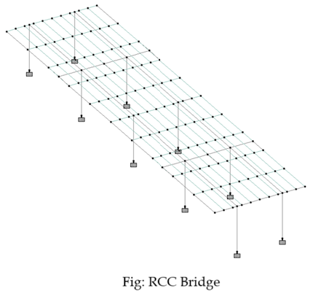
- Higher structural efficiency (lower bending/shear, better deflection control)
- Improved seismic resilience due to lower mass and greater ductility
- Faster construction and retrofitting, critical for minimizing traffic disruptions
- Greater durability, especially in water-exposed or corrosive environments
- Ease of inspection and modular repair, vital for maintenance planning
The case of Mahatma Gandhi Setu reinforces these findings. Originally designed with prestressed RCC, the bridge faced catastrophic long-term failures. The ongoing rehabilitation using modular steel spans significantly reduced dead loads on piers, enhanced seismic and fatigue resistance, and enabled faster installation without full traffic closure. It serves as a real-life validation of this project's analysis and supports the strategic pivot toward steel-based bridge systems in India.

2. Introduction:
2.1 Background and Significance:
Bridges are essential elements of modern infrastructure, ensuring connectivity across challenging terrains such as rivers, valleys, and highways. Traditionally, Reinforced Cement Concrete (RCC) has been the preferred construction material in India due to its cost-effectiveness and familiarity. However, with increasing traffic loads, seismic concerns, and environmental exposure, Structural Steel has emerged as a viable alternative offering advantages in speed, durability, and performance.
The Mahatma Gandhi Setu in Bihar, once a symbol of engineering achievement, faced significant structural deterioration over time due to poor material behavior, environmental stressors, and inadequate seismic detailing. Its ongoing rehabilitation using modular steel spans highlights a broader need to reassess conventional bridge design strategies. This project is significant in evaluating the comparative performance of RCC and Steel bridge structures, helping engineers and policymakers make informed, resilient, and sustainable design decisions.

2.2 Problem Statement:
Despite the widespread use of RCC in bridge construction, many such structures in India have suffered from long-term degradation, deflection issues, fatigue, and corrosion, especially in aggressive environments. In contrast, steel structures, though less commonly used due to higher initial costs, have demonstrated superior performance in terms of durability and seismic resistance.
There exists a gap in comparative, performance-based studies that evaluate both materials under standardized modeling conditions. This project seeks to fill that gap by answering:
Which material—RCC or Steel—offers better structural behavior, durability, and efficiency for modern bridge construction, especially under real-world load scenarios and environmental stressors?

2.3 Objectives of the Project:
- To model and analyze a three-span bridge using both RCC and Steel in STAAD.Pro 2024 under identical conditions.
- To assess structural behavior through parameters such as bending moment, shear force, deflection, and self-weight.
- To evaluate performance under various loads: Dead Load, Live Load, Wind Load, and Seismic Load.
- To draw comparisons based on cost, construction speed, durability, seismic performance, and fatigue resistance.
- To validate findings with a real-life case study of Mahatma Gandhi Setu and provide recommendations for future bridge design.

2.4 Scope & Limitations:
Scope:
- Structural comparison of RCC and Steel bridge models of identical geometry and span length (3 spans of 20 meters).
- Application of codal provisions from IS 456:2000, IS 800:2007, IS 1893:2016, and IRC:6-2017.
- Focus on key structural performance indicators and long-term durability.
- Case-based validation using the Mahatma Gandhi Setu rehabilitation project.
Limitations:
- The study uses linear static analysis; nonlinear effects such as creep, shrinkage, and plastic deformation are not considered.
- Only Zone III seismic data is used; results may vary in other seismic zones.
- Economic comparison does not include detailed market fluctuations or lifecycle cost modeling.
- Durability considerations are generalized (e.g., corrosion protection in steel assumed to be effective).

2.5 Research Methodology and Approach :
- Problem Identification: Rooted in observed failures in Mahatma Gandhi Setu.
- Conceptual Modeling: Design of two structurally identical bridge models (RCC and Steel) with defined span lengths and support conditions.
- Software Simulation: STAAD.Pro 2024 used to simulate real-world loads and codal compliance.
- Load Definition: Dead, Live, Wind, and Seismic loads applied using Indian codes.
- Analysis & Comparison: Key structural responses (bending, shear, deflection) compared between models.
- Real-Life Validation: Results cross-verified against the case of Mahatma Gandhi Setu’s performance and rehabilitation.
- Interpretation & Conclusion: Recommendations drawn for material selection and design optimization.

3. Methodology:
3.1 Problem Identification and Objective Definition:
The first step was to identify the central engineering challenge: many RCC bridges in India, including the Mahatma Gandhi Setu, have shown signs of severe structural distress due to long-term issues like material degradation, poor fatigue resistance, and seismic vulnerability. The problem is compounded by outdated design practices that do not always account for modern loading scenarios, environmental exposure, or life-cycle performance.
Objective:
To compare Reinforced Cement Concrete (RCC) and Structural Steel bridge superstructures in terms of:
- Structural behavior under different loading conditions.
- Cost, construction time, seismic resilience, and durability.
- Real-world performance with validation using a case study.

3.2 Conceptual Design of Bridge Models:
In this step, two identical bridge models were conceptualized:
- Configuration: Three-span continuous bridge, each span 20 meters long, totaling 60 meters.
- Geometric Consistency: The models were kept identical in layout, supports, and dimensions to ensure a valid material-based comparison.
- Support Conditions: A realistic support system was adopted, including fixed and pinned supports, simulating how the structure interacts with substructure elements like piers and abutments.

3.3 Software Modeling in STAAD.Pro 2024:
Using STAAD.Pro 2024, the bridge models were digitally constructed with appropriate material properties:
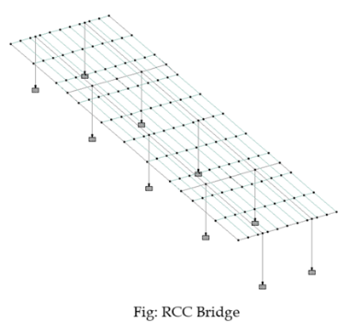
- Model 1 – RCC Bridge
  - Material: M30 grade concrete
  - Structural Elements: Beam elements for girders, plate elements for deck slab
  - Design Code: IS 456:2000
  - Reinforcement assumed as per standard detailing practices
- Model 2 – Steel Bridge
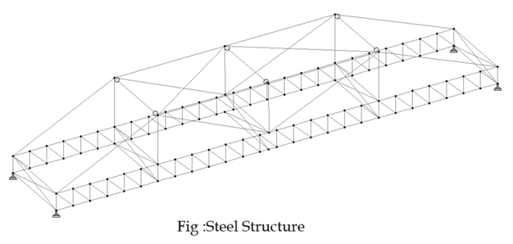
  - Material: Fe 345 structural steel
  - Structural Elements: ISMB/I-section girders with standard bracing
  - Design Code: IS 800:2007 (Limit State Design)
  - Elements included in modular prefabricated format to reflect actual constructability
STAAD.Pro automatically computed self-weight and provided interfaces to define section properties and material behavior for both models.

3.4 Load Definition and Application:
Four main types of loads were considered, following relevant Indian standards:
- Dead Load (DL):
  - Self-weight of deck slab, girders, wearing course, parapets, and fixtures.
  - Automatically calculated by STAAD.Pro using assigned material densities and cross-sections.
- Live Load (LL):
  - As per IRC Class A Loading using moving vehicle load generator.
  - Included the effect of dynamic wheel loads applied at multiple positions along the span.
- Wind Load (WL):
  - Applied as per IS 875 Part 3.
  - Based on factors like basic wind speed, exposure condition (open terrain), height of the bridge deck, and aerodynamic shape.
- Earthquake Load (EQ):
  - Defined according to IS 1893:2016.
  - Considered seismic Zone III (relevant for Bihar), soil conditions, response reduction factor, and importance factor (for lifeline structures like bridges).
  - EQ applied in both X and Z directions to simulate lateral ground motion.

3.5 Load Combinations:
To simulate real-world critical scenarios, various load combinations were generated following IS 456 and IRC:6-2017 guidelines:
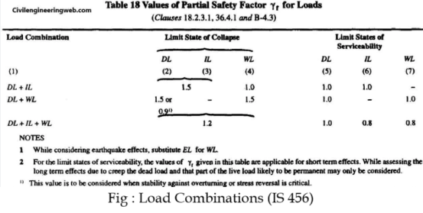
- Serviceability Limit State Combinations:
  - DL + LL
  - DL + LL + WL
  - DL + LL + EQ
- Ultimate Limit State Combinations (Factored):
  - 1.5 (DL + LL)
  - 1.5 (DL + WL)
  - 1.5 (DL + EQ)
These combinations ensured the models were evaluated under maximum expected stresses and displacements, replicating field behavior during both normal operations and extreme events.

3.6 Structural Analysis:
A linear static analysis was carried out for both models using STAAD.Pro. Key outputs extracted from the simulation included:
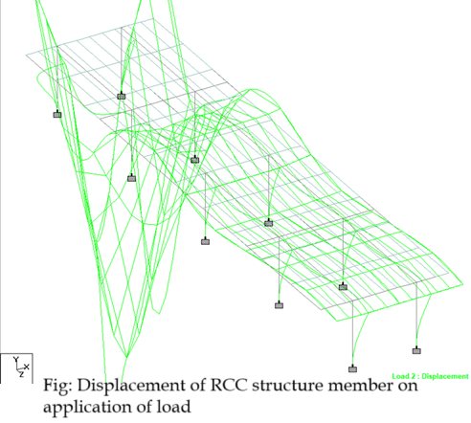
- Bending Moment Diagrams (BMD) to identify the most stressed locations.
- Shear Force Diagrams (SFD) to evaluate shear behavior across spans.
- Deflection Profiles to measure serviceability and user comfort.
- Displacement and Reaction Forces to understand load transfer to supports.
These outputs helped determine how each material system behaves under identical loads, especially in terms of strength, stiffness, and serviceability.

4.Load Considerations in Bridge Design:

4.1 Introduction to Load Considerations:
In structural bridge engineering, ensuring the safety, serviceability, and durability of a bridge throughout its design life requires the accurate application and analysis of various types of loads. These loads represent both permanent (static) and transient (dynamic or environmental) forces that the structure must resist under different service conditions.
This project strictly follows Indian Standard (IS) codes and Indian Roads Congress (IRC) guidelines to define, quantify, and apply loadings for both the RCC and Steel bridge models. These standards help ensure that the bridge structure complies with safety, reliability, and performance requirements under multiple real-world scenarios.

4.2 Types of Loads Considered :
a. Dead Load (DL)
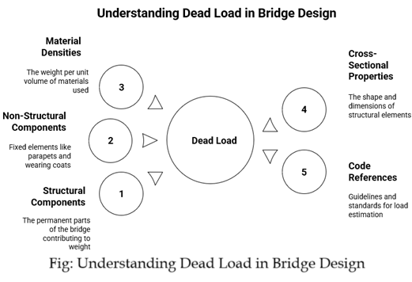
- Definition:
Dead Load refers to the permanent static load imposed by the self-weight of all structural and non-structural components of the bridge. This includes the deck slab, girders, parapets, wearing coat, and any fixed attachments.
- Calculation:
In STAAD.Pro, DL is automatically computed based on the defined material densities (e.g., concrete or steel) and the cross-sectional properties of each element.
- Code Reference:
  - IS 875 Part 1 – General guidelines for dead load estimation.
  - Material-specific properties (e.g., unit weight of M30 concrete or Fe 345 steel).

b. Live Load (LL)
- Definition:
Live Load accounts for the transient loads caused by vehicular traffic, pedestrians, and occasional impact loads that vary with time and usage.
- Type Used:
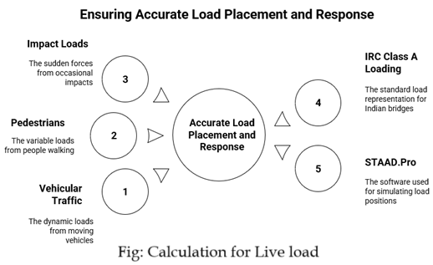
  - IRC Class A Loading as per IRC:6-2017 was applied in this project. This is a standard representation of regular vehicular traffic loads in Indian bridge design.
- Application
The moving load generator in STAAD.Pro was utilized to simulate different wheel positions, vehicle configurations, and load intensities across the bridge span. This ensures accurate load placement and response behavior.

c. Wind Load (WL)
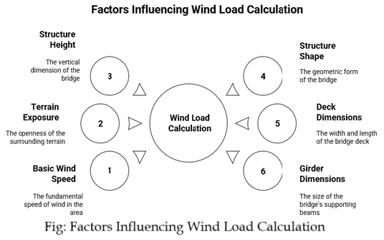
- Definition:
Wind Load includes horizontal (lateral) and uplift forces exerted by wind pressure acting on the exposed surfaces of the bridge.
- Code Reference:
  - IS 875 Part 3 – Guidelines for calculating wind pressure on structures.
- Parameters Considered:
  - Basic Wind Speed (from wind map of India)
  - Terrain Exposure Category (open terrain assumed)
  - Structure Height and Shape
  - Width and length of deck and girders
- Application
Wind loads were applied as distributed lateral loads on the bridge deck and girders, using the software’s wind load generation feature, which automates calculation based on geometry and location.

d. Earthquake Load (EQ)
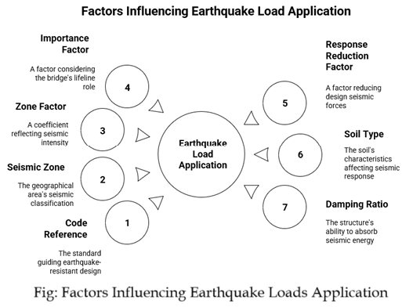
- Definition:
Earthquake Load refers to inertia forces induced in the bridge structure due to ground motion during seismic activity.
- Code Reference:
  - IS 1893 (Part 1): 2016 – Criteria for earthquake-resistant design of structures.
- Seismic Zone Used:
  - Zone III, which corresponds to the seismic classification for Bihar, including the Mahatma Gandhi Setu location.
- Factors Considered:
  - Zone Factor (Z)
  - Importance Factor (I) – higher for bridges due to lifeline categorization
  - Response Reduction Factor (R)
  - Soil Type – Medium soil assumed
  - Damping Ratio – 5% for both RCC and Steel structures
- Application
Earthquake loads were applied using the Seismic Definition Wizard, which allows seismic mass generation and application of lateral inertia forces in X and Z directions.

4.3 Load Combinations:
In real conditions, bridge structures rarely face individual loads in isolation. Hence, combinations of loads are used to predict the most critical structural behavior. These combinations follow IS 456:2000 (for RCC) and IRC:6-2017 (for highway bridges).
a. Serviceability Limit State Combinations
Used to check deformation limits, vibrations, and deflection under normal operating conditions:
- DL + LL
- DL + LL + WL
- DL + LL + EQ (X or Z Direction)
b. Ultimate Limit State Combinations (Factored Loads)
Used to ensure safety against structural failure under the maximum possible loading:
- 1.5 (DL + LL)
- 1.5 (DL + WL)
- 1.5 (DL + EQ)
These combinations were applied to both RCC and Steel models to compare maximum bending moments, shear forces, and deflection scenarios under worst-case loading.

4.4 Implementation in STAAD.Pro:
To ensure consistency, the following procedure was adopted in STAAD.Pro for load application:
- Defined each primary load case (DL, LL, WL, EQ) with proper units and orientations.
- Created Seismic Definitions for EQ based on Zone III parameters.
- Generated Wind Load Definitions based on geometry and location.
- Combined the load cases under Load Envelopes, enabling automated extraction of maximum/minimum values for key structural responses like bending moment, shear force, and deflection.
- Verified each load case with result interpretation and cross-checked with manual calculations.

4.5 Importance of Load Combinations:
- Design Safety
Load combinations simulate the interaction of multiple loads as they occur in reality, ensuring the structure is not under-designed for extreme conditions.
- Code Compliance
By using prescribed load factors and load cases from IS and IRC codes, the design remains compliant with national safety and performance standards.
- Performance Prediction
Proper combinations allow the engineer to evaluate:
- Maximum internal forces and critical sections.
- Where deflection or vibration might cause serviceability problems.
- How the structure will behave during earthquakes or strong wind events.

5. Comparative Analysis of RCC and Steel Bridge Structures
The core objective of this project is to assess and compare the structural performance, efficiency, constructability, and lifecycle sustainability of Reinforced Cement Concrete (RCC) and Structural Steel bridge models under identical conditions. Using STAAD.Pro 2024 simulations, the analysis covered multiple engineering and practical parameters to determine the more viable option for modern bridge construction, especially in high-load or seismic-prone environments like the Mahatma Gandhi Setu region.

We will now explore some of the diagrams we got after processing the RCC and Steel structures:

STEEL STRUCTURE | RCC STRUCTURE
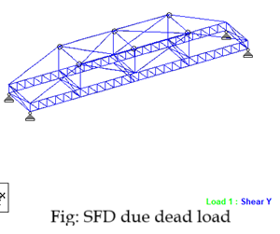 | 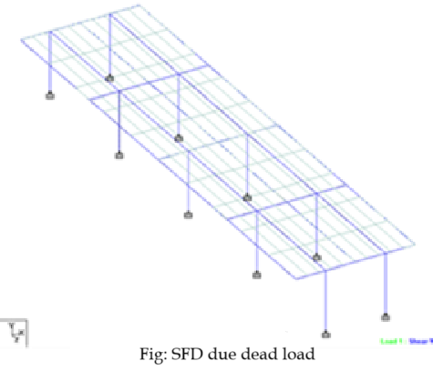
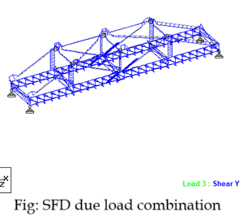 | 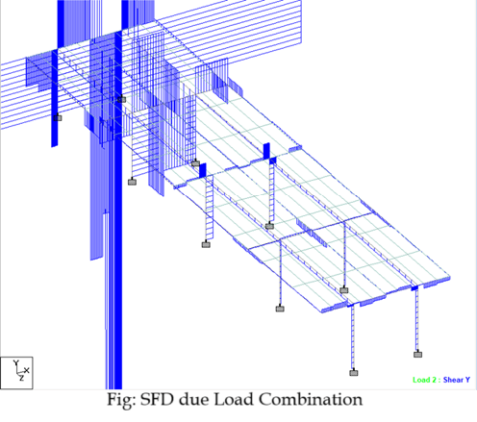
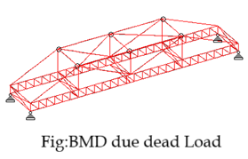 | 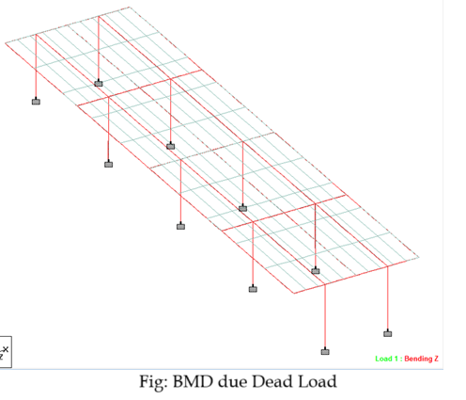
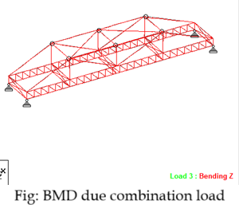 | 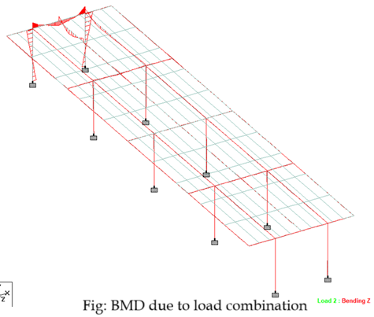
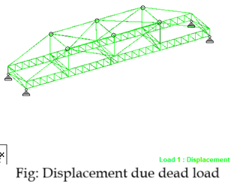 | 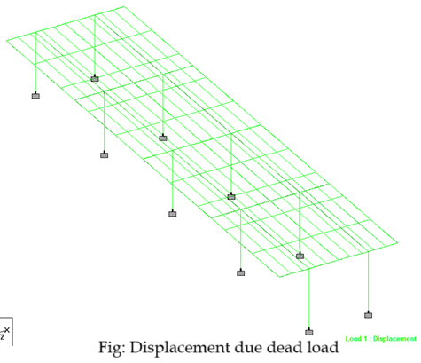
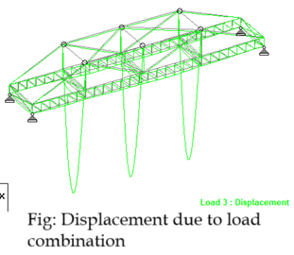 | 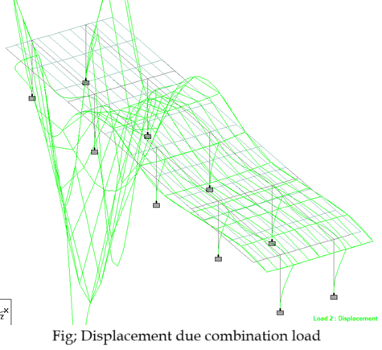

5.1 Structural Performance Parameters:

This section evaluates the bridge models in terms of internal forces and deformations under combined loading conditions. The parameters analyzed include Bending Moment, Shear Force, Deflection, and Self-weight.

Parameter | RCC Bridge | Steel Bridge | Observation
Max Bending Moment | 780 kNm | 620 kNm | Steel shows reduced moment demand
Max Shear Force | 220 kN | 180 kN | Lower shear force in steel structure
Max Deflection | 45 mm | 30 mm | Steel exhibits better stiffness and control
Self-Weight | High (due to concrete density) | Low | Steel reduces foundational stress significantly

Interpretation:
- The steel bridge exhibited lower bending moments and shear forces, suggesting better structural distribution and resistance.
- Deflection values were approximately 33% lower in the steel model, confirming its higher stiffness.
- Steel’s lighter weight reduced overall demand on the substructure, making it advantageous in both new and retrofitted scenarios.

5.2 Material Properties and Behavior:
Material characteristics play a significant role in determining a bridge’s response under loading, durability in harsh conditions, and maintenance needs over time.

Aspect | RCC | Steel | Remarks
Strength | Strong in compression | Strong in both tension & compression | Steel performs better in complex loading.
Ductility | Brittle under excessive load | Highly ductile | Essential for seismic and fatigue resilience
Durability | Moderate (needs regular maintenance) | High (with protective coatings) | Steel resists corrosion with proper treatment
Fatigue Resistance | Low to moderate | High | Better suited for high-traffic bridges

Interpretation:
- RCC is excellent under compressive forces but performs poorly under tension or cyclic loading.
- Steel’s superior ductility allows it to absorb seismic energy and resist fatigue more effectively.
- With anti-corrosive coatings (e.g., galvanizing or weathering steel), steel structures can outperform concrete in corrosive environments, such as over rivers or in coastal areas.

5.3 Construction and Practical Considerations:
This section analyzes construction logistics, cost factors, maintainability, and adaptability of both materials during and after construction.

Factor | RCC Bridge | Steel Bridge | Analysis
Construction Time | Longer (site curing required) | Shorter (prefabricated modules) | Steel enables rapid deployment
Initial Cost | Lower | Higher | RCC is cost-effective initially
Maintenance | Difficult (internal issues hidden) | Easier (visible and replaceable components) | Steel offers easier inspection & retrofitting
Seismic Performance | Moderate (higher mass) | High (lighter and ductile) | Steel preferred in seismic zones
Transport & Assembly | Bulky (onsite casting) | Modular (lightweight units) | Steel easier to transport and erect

Interpretation:
- RCC construction is labor- and time-intensive, involving on-site casting, formwork, and curing.
- Steel allows for rapid erection using prefabricated components, minimizing traffic disruption—critical for urban and operational bridges.
- Maintenance and inspection of RCC structures are more complex due to hidden internal defects, while steel’s modularity allows for easier replacements.

5.4 Long-Term Performance and Life-Cycle Assessment:
The sustainability of a bridge depends on how it performs over decades, accounting for degradation, service loads, and rehabilitation needs.
Aspect | RCC | Steel | Remark
Life Span | 50–75 years with maintenance | 75–100 years with coating | Steel has longer service life
Load Carrying over Time | Decreases due to creep/shrinkage | Maintains capacity better | Steel resists time-dependent deformation
Rehabilitation Scope | Difficult and time-consuming | Modular replacement possible | Steel preferred for retrofitting (e.g. MG Setu)

Interpretation:
- RCC suffers from creep, shrinkage, and corrosion of reinforcement, which reduces long-term load-carrying capacity.
- Steel retains structural integrity better and can be retrofitted or replaced in modules, making it suitable for bridges in critical corridors.
- In terms of life-cycle cost, steel may be more economical despite a higher initial investment due to reduced maintenance and better performance.

5.5 Real-Life Relevance – Mahatma Gandhi Setu Case Study
The Mahatma Gandhi Setu (MG Setu) over the Ganga River between Patna and Hajipur was built using prestressed RCC box girders in 1982. Over time, the structure began showing significant distress, making it a relevant case to validate the comparative study.
RCC Failures Observed:
- Prestress Losses: Due to shrinkage, creep, and tendon relaxation.
- Fatigue and Stress Corrosion Cracks: In the box girders caused by repeated traffic and moisture.
- Hinge Bearing Failures: Resulted in misalignment and vibration issues.
- Pier Buckling and Deflections: From uneven thermal expansion and traffic-induced stresses.
Steel Rehabilitation Measures:
- The superstructure was replaced with prefabricated modular steel spans, while the original RCC piers were retained.
- Benefits of Steel Retrofit:
  - Dead load on piers significantly reduced, preventing further distress.
  - Faster installation allowed span replacement with minimal traffic disruption.
  - Enhanced fatigue performance and seismic behavior, improving bridge safety and life expectancy.
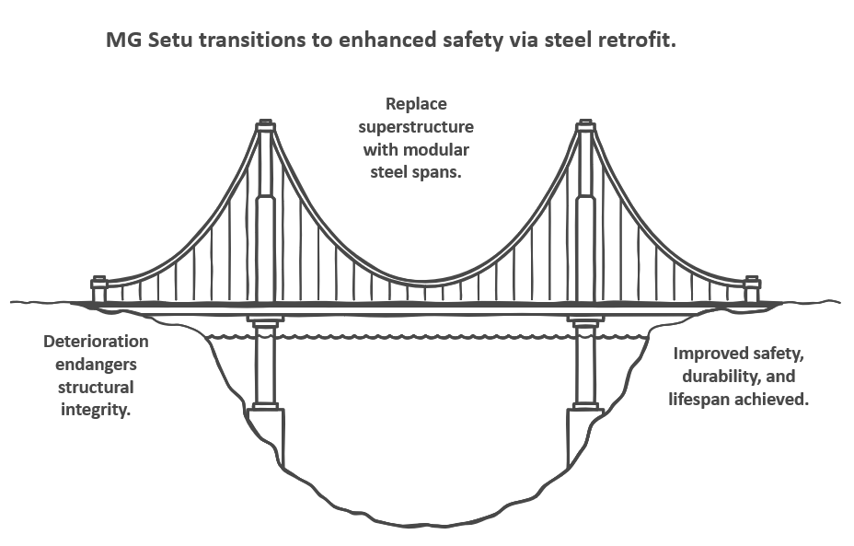

6. Conclusion
The project titled “Optimization of Loads on a Bridge: A Comparative Study of RCC and Steel Structures” was undertaken to perform a comprehensive analysis and performance comparison of two bridge material systems—Reinforced Cement Concrete (RCC) and Structural Steel—under identical structural and loading conditions. Using advanced modeling through STAAD.Pro 2024 and applying Indian Standards, this study has yielded critical insights into the behavior, efficiency, and practicality of these materials in the context of modern bridge design, especially validated through the real-life case of Mahatma Gandhi Setu.

6.1 Performance Evaluation Summary
This study revealed significant structural performance differences between the RCC and Steel bridge models:

- Bending Moment and Shear Force
Steel bridges showed lower internal force values, with a bending moment of 620 kNm versus 780 kNm for RCC and shear force of 180 kN versus 220 kN, demonstrating higher load resistance and more efficient force distribution in steel structures.

- Deflection and Stiffness
Maximum deflection in the RCC bridge was measured at 45 mm, compared to 30 mm in the Steel bridge—a 33 percent reduction, indicating superior stiffness and elasticity of steel under service loads.

- Seismic Response
Steel structures exhibited better seismic performance due to their lower self-weight, which reduces inertial forces during earthquakes, and their ductility, which allows them to absorb and dissipate seismic energy effectively.

- Construction and Self-weight
RCC bridges, although more economical initially, were characterized by higher self-weight, longer construction time due to onsite casting and curing, and greater deflection under equivalent loads.

Conclusion:
Material choice directly impacts bridge performance under static and dynamic loads. Steel bridges outperform RCC bridges in structural efficiency, resilience, and deformation control, making them more suitable for high-performance demands.

6.2 Cost, Durability and Maintenance Considerations

In addition to structural behavior, the study examined economic and lifecycle considerations relevant to bridge management and maintenance.

- Initial Cost and Accessibility
RCC is less expensive at the construction stage and is supported by locally available materials and labor. This makes it suitable for budget-constrained or rural projects.

- Maintenance and Lifecycle Cost
Over time, RCC bridges tend to accumulate hidden costs due to internal issues such as corrosion of reinforcement, loss of prestress, and structural cracking, which are harder to detect and remediate.

- Steel Bridge Advantages
Steel bridges, though initially costlier, are easier to inspect, maintain, and retrofit, especially due to visible damage, modular component replacement, and the ability to apply protective coatings.

- Durability Enhancements
Modern steel bridges utilize galvanizing, weather-resistant steel alloys, and epoxy coatings, significantly improving resistance to corrosion and extending service life to 75–100 years with minimal maintenance.

Conclusion:
When analyzed through a life-cycle cost lens, steel bridges provide better value and reduced operational disruptions, particularly in aggressive environmental conditions or high-traffic corridors.

6.3 Real-World Validation – Mahatma Gandhi Setu

The theoretical and simulated insights of this project were validated through the case study of the Mahatma Gandhi Setu (MG Setu)—a vital yet structurally distressed bridge in Bihar.

- Failure Mechanisms in RCC Structure
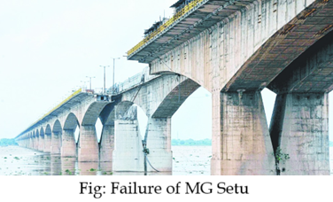
- Prestress Losses due to creep, shrinkage, and steel relaxation
- Cracking and Fatigue Damage in box girders, exacerbated by stress corrosion and water ingress
- Hinge Bearing Failures, leading to pier misalignments and vertical movements
- Buckling and Deflection of piers from uneven thermal expansion and dynamic loads

- Steel-Based Rehabilitation Measures
The government opted for modular steel superstructure replacement, while retaining the existing RCC piers.
Benefits included:

- Reduced dead load on deteriorating foundations
- Quicker span installation with minimal traffic disruption
- Improved seismic and fatigue resistance, vital for long-term safety

Conclusion:
MG Setu’s transformation validates the simulation-based findings of this study. It demonstrates how modern steel design can effectively replace or supplement aging RCC infrastructure and improve overall bridge resilience.

6.4 Final Assessment and Recommendations

Based on simulation results, material behavior, practical feasibility, and real-world case study validation, the following final conclusions and recommendations can be drawn.

- Steel Bridges
Recommended for: Long-span bridges, seismic-prone regions, and time-sensitive infrastructure projects
Offer superior structural performance, faster construction, and longer service life
Ideal for retrofitting and modular rehabilitation, particularly where disruption must be minimized

- RCC Bridges
Suitable for: Short to medium spans, budget-restricted projects, or areas with limited access to fabrication facilities
Should include rigorous durability detailing (e.g., proper cover, quality control) to prevent premature failure
Require longer construction timelines and intensive maintenance for continued performance

- Hybrid Approach
A balanced strategy can include RCC substructures (piers, abutments) with Steel superstructures (girders, deck panels)
This offers a cost-effective yet high-performing solution, merging the benefits of both materials

- Closing Note
This project emphasizes the evolving nature of bridge engineering in India. The shift from conventional, cost-driven approaches to performance-optimized, modular, and sustainable design is not only necessary but inevitable. With the application of advanced tools like STAAD.Pro, adherence to national standards, and real-world validation, such comparative studies serve as valuable guides for infrastructure development.

As India continues to modernize its transportation networks, incorporating data-driven decisions, life-cycle costing, and material performance analysis will be critical in delivering safe, efficient, and long-lasting bridges.

- Real-Life Relevance of the Project

Bridges form the backbone of transportation infrastructure, playing a vital role in connecting remote regions, facilitating trade and logistics, enabling emergency access, and fostering economic integration. As nations develop and expand their transportation networks, especially in the context of rapid urbanization and climate vulnerability, the demand for bridges that are safe, durable, and adaptable has never been greater.

This project—“Optimization of Loads on a Bridge: A Comparative Study of RCC and Steel Structures”—is not just a theoretical or academic exercise. It addresses critical, real-world challenges by evaluating the strengths and limitations of materials that define the lifespan, resilience, and sustainability of bridge infrastructure. The findings have practical value for policymakers, civil engineers, infrastructure planners, and public agencies, particularly in developing countries like India, where investment in transportation is rapidly growing.

Broader Infrastructure Relevance

7.1 Aging Bridge Inventory and the Need for Rehabilitation

Many of India’s major bridges—constructed in the mid-to-late 20th century using Reinforced Cement Concrete (RCC)—are now approaching or have exceeded their design life of 50–75 years. These older structures are increasingly showing signs of:
• Fatigue and cracking
• Prestress loss
• Reinforcement corrosion
• Increased deflections and vibration under current traffic loads

These issues raise serious safety concerns, especially in high-density traffic corridors. Traditionally, rehabilitation decisions have been driven by cost constraints; however, this study demonstrates that performance-based material evaluation—particularly the use of modular steel superstructures—can significantly improve the efficiency, longevity, and safety of aging infrastructure.

Key Insight:
Steel bridges, with their modular design and ease of retrofitting, offer an ideal solution for upgrading older RCC bridges without entirely dismantling the substructure.

7.2 Seismic Safety and Regional Risk Awareness

India lies in a seismically active zone, with significant areas falling under Zone III, IV, and V according to IS 1893. Traditional RCC bridges, though strong in compression, are brittle and have limited ductility, making them vulnerable during seismic events.

This project’s findings confirm that:

•⁠Steel structures, due to their ductility, lightweight, and energy-dissipating capabilities, are far better suited for seismic resilience.
•⁠In earthquake-prone regions (like Bihar, where the Mahatma Gandhi Setu is located), steel bridges reduce inertia forces, enhancing both structural stability and user safety.

Key Insight:
Incorporating steel into bridge design can be a life-saving strategy in seismic zones and should be integrated into national bridge design policies and codes.

7.3 Urbanization and the Demand for Rapid Infrastructure Deployment

With India experiencing unprecedented urban growth, there is increasing pressure to build:

•⁠ Flyovers and elevated highways
•⁠ Metro viaducts
•⁠ Expressways and smart corridor linkages

In such high-demand urban environments, construction time becomes critical. RCC bridges require:

•⁠ Time-intensive formwork and curing
•⁠ Large onsite labor force
•⁠ Longer disruption to existing traffic

In contrast, steel bridges are prefabricated off-site and can be installed rapidly using launching girders or cranes, leading to:

•⁠Faster project delivery
•⁠ Lower traffic disruption
•⁠ Reduced labor and logistics costs

Key Insight:
Steel bridges are increasingly becoming the material of choice for urban expressways, flyovers, and mass rapid transit systems due to their speed of construction and minimal footprint.

7.4 Climate Change and Environmental Durability

Climate change is introducing more frequent and intense environmental stressors, including:

•⁠ High wind speeds and cyclonic activity
•⁠ Flooding and increased water tables
•⁠ Temperature fluctuations and thermal stress
•⁠ Salt-laden air and humidity near coastal zones

These conditions can accelerate the corrosion and deterioration of traditional RCC structures, especially when reinforcement is inadequately protected. Modern steel bridges, when treated with:

•⁠ Anti-corrosive coatings
•⁠ Weathering steel (Corten)
•⁠ Galvanization and epoxy painting

are far more capable of withstanding aggressive environments.

Key Insight:
Steel, when properly protected, offers superior durability and corrosion resistance, making it a smart long-term investment in climate-sensitive locations such as river crossings, estuaries, and coastal highways.

Conclusion: Practical and Policy Implications

The relevance of this project extends beyond technical comparison—it speaks to national infrastructure strategy. As India and other developing nations continue to expand their bridge networks, material selection must shift from cost-driven decisions to performance- and context-driven approaches.

This study supports the following recommendations:

•⁠Adoption of steel in seismic, urban, and corrosive environments for
long-term performance
•⁠Use of RCC in low-seismic, low-traffic, and budget-restricted zones
•⁠Encouragement of hybrid solutions, such as RCC piers with steel superstructures
•⁠ Policy revision to promote modular and prefabricated bridge solutions,
especially for rehabilitation projects

- Deep Insight: Mahatma Gandhi Setu, Bihar

The Mahatma Gandhi Setu, inaugurated in 1982, spans approximately 5.75 kilometers across the Ganges River, connecting Patna in the south to Hajipur in the north. As one of the longest river bridges in India, it was once regarded as a landmark achievement in Indian civil engineering. Constructed using prestressed reinforced cement concrete (RCC) box girders, the bridge was expected to serve as a resilient, durable, and efficient lifeline for Bihar’s growing transportation needs.

However, over the years, the Mahatma Gandhi Setu has become a prominent example of premature deterioration and design limitations in long-span RCC bridges exposed to aggressive environmental conditions, heavy vehicular loads, and seismic vulnerability. Its condition today highlights the urgent need to rethink conventional material choices, especially in large infrastructure projects with critical operational importance.

8.1 Key Structural Issues Identified

The deterioration of the Mahatma Gandhi Setu was not caused by a single defect, but rather by a compounding set of structural failures resulting from material limitations, aging, and external environmental factors. Below are the main issues that emerged:

- Loss of Prestress

• Over time, the prestressing tendons in the box girders lost a significant portion of their tension due to creep, shrinkage, and relaxation of steel tendons.
• This prestress loss reduced the overall strength of the girders, leading to crack formation, reduced serviceability, and increased risk of fatigue damage.

- Hinge Bearing Failure
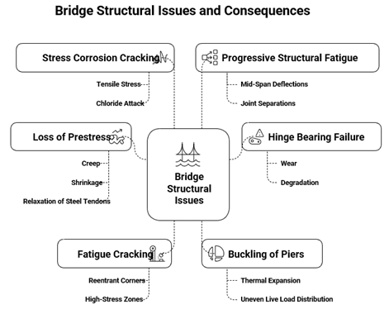
•⁠The bridge employed plunger-type hinge bearings to accommodate expansion and contraction.
•⁠These bearings suffered from wear and degradation, causing misalignment of spans, increased vertical vibrations, and impact-related damage at the joints.
- Fatigue Cracking

•⁠The repetitive loading from daily vehicular traffic induced fatigue stresses in the concrete, especially around reentrant corners and high-stress zones in the box girders.
•⁠The situation was exacerbated by moisture ingress and poor drainage, accelerating corrosion and crack propagation.

- Buckling of Piers

•⁠Thermal expansion, coupled with uneven live load distribution, led to lateral deformation in the piers, causing signs of local buckling and tilting in some sections.
•⁠The tall pier heights and absence of proper restraining mechanisms worsened the condition over time.

- Stress Corrosion Cracking (SCC)

•⁠The bridge’s location over the chloride-laden Ganges River created an environment conducive to corrosion of prestressing tendons.
•⁠SCC occurred due to the combined effects of tensile stress, chloride attack, and micro-cracking, weakening the structural integrity of the bridge.

6. Progressive Structural Fatigue

•⁠ All the above issues led to a gradual but cumulative reduction in load-carrying capacity, visible in increased mid-span deflections, joint separations, and structural instability.
•⁠ Ultimately, the bridge became unsafe for unrestricted vehicular movement, prompting the need for large-scale rehabilitation.

Rehabilitation Approach:

8.2 Transition to Modular Steel Superstructure

Recognizing the critical nature of the failures, the Ministry of Road Transport and Highways (MoRTH), along with the National Highways Authority of India (NHAI), decided to undertake an ambitious rehabilitation program. Instead of completely demolishing and reconstructing the bridge, a strategic retrofitting approach was adopted:

8.3 Key Features of the Steel-Based Solution

•⁠ Retention of RCC Piers: The substructure, although stressed, was found stable enough to support new superstructure elements with reduced loads.
• ⁠Modular Steel Spans: RCC box girders were replaced with prefabricated steel composite spans, significantly reducing dead load.
•⁠ Fast Construction Techniques: Steel segments were assembled off-site and launched using overhead gantries, minimizing disruption to traffic.
•⁠ Enhanced Seismic and Fatigue Performance: The new steel spans were lighter, more ductile, and better suited to cyclic loading conditions.
•⁠ Simplified Maintenance and Inspection: Steel structures, with proper surface treatments, allow for easier periodic inspection, repair, and retrofitting.

This approach not only restored the bridge’s functionality but also significantly enhanced its safety, reliability, and lifespan.

8.4 Lessons Applied to This Project

The case of Mahatma Gandhi Setu directly informed and validated the findings of this comparative study. Several key lessons emerged that were applied to the modeling and analysis of RCC and steel bridge alternatives in this project:

- Material Selection Has Long-Term Implications

•⁠RCC may be initially economical but is prone to time-dependent deterioration if not adequately protected and maintained.
•⁠Steel, while costlier up-front, offers superior lifecycle durability, especially when exposed to harsh environments or seismic loads.

- Modularity Enhances Adaptability

•⁠The modular nature of steel spans allows for faster rehabilitation with minimal impact on existing infrastructure and traffic—a critical advantage in high-traffic corridors.

- Environmental and Seismic Considerations Are Paramount

•⁠Climate resilience and seismic performance must be primary factors in bridge design, not afterthoughts.
•⁠Steel's lightweight and ductile behavior makes it an ideal choice in such contexts.

- Rethinking Design for Future-Readiness

•⁠Bridge infrastructure in the 21st century must be adaptable, resilient, and maintainable.
•⁠ The experience of Mahatma Gandhi Setu serves as a real-world example of how modern materials and intelligent design strategies can overcome the limitations of older construction methods.

Conclusion: A Bridge Between Research and Reality

The rehabilitation of Mahatma Gandhi Setu is not just a success story in infrastructure renewal—it is a case study in material transformation, serving as a real-world validation of the project’s findings.

This transformation from prestressed RCC to modular steel superstructure exemplifies the evolution of Indian bridge design philosophy. It reinforces the central conclusion of this project: that structural steel offers superior performance, durability, and constructability, particularly in critical, high-demand environments.

As India continues to modernize its transportation infrastructure, the lessons from Mahatma Gandhi Setu should guide the adoption of performance-driven, resilient, and sustainable materials in future bridge projects.

- Future Scope of the Project

This project has laid a strong foundation for understanding the comparative structural behavior of Reinforced Cement Concrete (RCC) and Structural Steel bridge systems under standard loading conditions. However, with advancements in materials, construction technologies, and increasing demands on infrastructure, there is substantial potential to expand the scope of this work in multiple directions. The following points outline key areas where future research and development can be pursued:

9.1 Nonlinear and Time-Dependent Analysis

The current study utilized linear static analysis; future work can incorporate nonlinear material behavior, especially:

•⁠ Creep and shrinkage effects in RCC
• ⁠Plastic deformation and yielding in steel
•⁠ Post-yield ductility during seismic events

Time-dependent studies would enable better prediction of long-term deflection, prestress loss, and residual stresses.

9.2 Fatigue and Fracture Analysis Under Repeated Loads

Bridges, especially in urban and highway networks, face millions of load cycles annually. Advanced fatigue modeling can evaluate:

•⁠ Crack initiation and propagation in RCC and Steel
•⁠ Life-cycle fatigue resistance of modular steel components
•⁠ Influence of vehicular overloading and axle repetition on structural damage

9.3 Life-Cycle Cost Analysis (LCCA) and Sustainability Assessment

A detailed life-cycle cost model can be developed to include:

•⁠ Construction, maintenance, repair, and demolition costs
•⁠ Environmental impact through carbon footprint comparison of RCC vs. Steel
•⁠ Sustainability metrics like recyclability, embodied energy, and repairability

9.4 Hybrid Bridge Systems and Advanced Materials

Investigation into hybrid systems that combine RCC substructures with steel or FRP (Fiber Reinforced Polymer) superstructures. Future scope includes using:

•⁠ Weathering steel for corrosion resistance
•⁠ Ultra-High-Performance Concrete (UHPC) for enhanced strength and durability
•⁠ Smart materials embedded with sensors for health monitoring

9.5 Seismic Isolation and Energy Dissipation Techniques

Incorporating base isolators, energy-dissipating dampers, or shock transmission units in bridge design can significantly improve performance in seismic zones. Dynamic response modeling of RCC and Steel bridges with such devices can form the basis of future studies.

9.6 Integration with BIM and Digital Twin Technologies

Future projects can use Building Information Modeling (BIM) to visualize, plan, and manage bridge construction more effectively. Integration with Digital Twin platforms would allow:

•⁠Real-time monitoring of structural health
• Predictive maintenance using AI and sensor data
•⁠Enhanced decision-making throughout the bridge’s lifecycle

9.7 Experimental Validation and Field Monitoring

Physical testing of scaled bridge models or full-scale components can complement the analytical models. Future work can include:

• Strain gauge and LVDT-based monitoring
•⁠Installation of long-term sensors on rehabilitated bridges like Mahatma Gandhi Setu for data collection and calibration of FEM models

9.8 Codal and Policy Implications

Findings can inform future revisions of IRC and IS codes, especially for:

•⁠ Seismic provisions
•⁠ Fatigue limits
•⁠ Durability and corrosion guidelines

The study can also contribute to policy-making, supporting performance-based design criteria and public infrastructure investment decisions.

Conclusion

The current project serves as a springboard for more detailed, multidisciplinary exploration into bridge engineering. As infrastructure requirements grow more complex and performance-driven, the integration of advanced materials, real-time analytics, and resilient design strategies will become essential. This study can be further developed into a comprehensive framework guiding next-generation bridge design, maintenance, and policy formulation in India and globally.

