**Ex:2**

**Activity_main.xml:**

<RelativeLayout xmlns:android="http://schemas.android.com/apk/res/android"

xmlns:tools="http://schemas.android.com/tools"

android:layout_width="match_parent"

android:layout_height="match_parent"

android:background="#f2f2f2"

android:padding="24dp"

tools:context=".MainActivity">

<!-- Card-style container -->

<LinearLayout

android:layout_width="match_parent"

android:layout_height="wrap_content"

android:layout_centerInParent="true"

android:orientation="vertical"

android:padding="24dp"

android:background="@drawable/card_background"

android:elevation="6dp">

<!-- Styled Text -->

<TextView

android:id="@+id/textView1"

android:layout_width="wrap_content"

android:layout_height="wrap_content"

android:text="Hello, Android!"

android:textColor="#333333"

android:textSize="24sp"

android:textStyle="bold"

android:layout_gravity="center_horizontal"

android:layout_marginBottom="32dp" />

<!-- Modern Buttons -->

<Button

android:id="@+id/button1"

android:layout_width="match_parent"

android:layout_height="wrap_content"

android:text="Change Font Size"

android:textSize="18sp"

android:backgroundTint="#6200EE"

android:textColor="#FFFFFF"

android:layout_marginBottom="16dp"

android:padding="12dp"

android:background="@drawable/rounded_button"/>

<Button

android:id="@+id/button2"

android:layout_width="match_parent"

android:layout_height="wrap_content"

android:text="Change Font Color"

android:textSize="18sp"

android:backgroundTint="#03DAC5"

android:textColor="#FFFFFF"

android:padding="12dp"

android:background="@drawable/rounded_button" />

</LinearLayout>

</RelativeLayout>

**MainActivity.java:**

package com.example.text;

import android.app.Activity;

import android.graphics.Color;

import android.os.Bundle;

import android.view.View;

import android.widget.Button;

import android.widget.TextView;

public class MainActivity extends Activity {

private Button btnChangeFontSize, btnChangeFontColor;

private TextView textView;

private float fontSize = 20f;

private int colorIndex = 1;

@Override

protected void onCreate(Bundle savedInstanceState) {

super.onCreate(savedInstanceState);

setContentView(R.layout.activity_main);

textView = findViewById(R.id.textView1);

btnChangeFontSize = findViewById(R.id.button1);

btnChangeFontColor = findViewById(R.id.button2);

btnChangeFontSize.setOnClickListener(v -> {

fontSize += 4;

if (fontSize > 36) fontSize = 20;

textView.setTextSize(fontSize);

});

btnChangeFontColor.setOnClickListener(v -> {

switch (colorIndex) {

case 1:

textView.setTextColor(Color.parseColor("#1E90FF")); // Dodger Blue

break;

case 2:

textView.setTextColor(Color.parseColor("#32CD32")); // Lime Green

break;

case 3:

textView.setTextColor(Color.parseColor("#FF6347")); // Tomato Red

break;

default:

textView.setTextColor(Color.parseColor("#800080")); // Purple

break;

}

colorIndex++;

if (colorIndex > 4) colorIndex = 1;

});

}

}

**Output:**

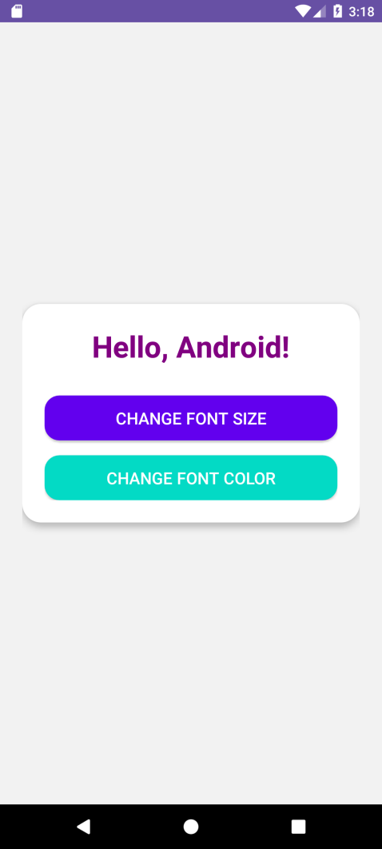

**Ex:3**

**Activity_main.xml:**

<?xml version="1.0" encoding="utf-8"?>

<androidx.constraintlayout.widget.ConstraintLayout

xmlns:android="http://schemas.android.com/apk/res/android"

xmlns:app="http://schemas.android.com/apk/res-auto"

xmlns:tools="http://schemas.android.com/tools"

android:id="@+id/constraintLayout"

android:layout_width="match_parent"

android:layout_height="match_parent"

android:background="#FAFAFA"

tools:context=".MainActivity">

<TextView

android:id="@+id/appTitle"

android:layout_width="wrap_content"

android:layout_height="wrap_content"

android:text="Addition App"

android:textSize="24sp"

android:textStyle="bold"

android:textColor="#6200EE"

app:layout_constraintTop_toTopOf="parent"

app:layout_constraintStart_toStartOf="parent"

app:layout_constraintEnd_toEndOf="parent"

android:layout_marginTop="40dp"/>

<EditText

android:id="@+id/editText1"

android:layout_width="0dp"

android:layout_height="wrap_content"

android:hint="Enter number 1"

android:inputType="number"

android:backgroundTint="#6200EE"

android:padding="14dp"

android:background="@drawable/edittext_background"

app:layout_constraintTop_toBottomOf="@id/appTitle"

app:layout_constraintStart_toStartOf="parent"

app:layout_constraintEnd_toEndOf="parent"

android:layout_marginTop="32dp"

android:layout_marginStart="24dp"

android:layout_marginEnd="24dp"/>

<EditText

android:id="@+id/editText2"

android:layout_width="0dp"

android:layout_height="wrap_content"

android:hint="Enter number 2"

android:inputType="number"

android:backgroundTint="#6200EE"

android:padding="14dp"

android:background="@drawable/edittext_background"

app:layout_constraintTop_toBottomOf="@id/editText1"

app:layout_constraintStart_toStartOf="parent"

app:layout_constraintEnd_toEndOf="parent"

android:layout_marginTop="20dp"

android:layout_marginStart="24dp"

android:layout_marginEnd="24dp"/>

<Button

android:id="@+id/button1"

android:layout_width="wrap_content"

android:layout_height="wrap_content"

android:text="Add Numbers"

android:textStyle="bold"

android:textColor="#FFFFFF"

android:backgroundTint="#6200EE"

android:padding="12dp"

android:layout_marginTop="28dp"

app:cornerRadius="12dp"

app:layout_constraintTop_toBottomOf="@id/editText2"

app:layout_constraintStart_toStartOf="parent"

app:layout_constraintEnd_toEndOf="parent"/>

</androidx.constraintlayout.widget.ConstraintLayout>

**MainActivity.java:**

package com.example.addition;

import android.os.Bundle;

import android.view.View;

import android.widget.Button;

import android.widget.EditText;

import android.widget.Toast;

import androidx.appcompat.app.AppCompatActivity;

public class MainActivity extends AppCompatActivity {

EditText t1, t2;

Button b1;

@Override

protected void onCreate(Bundle savedInstanceState) {

super.onCreate(savedInstanceState);

setContentView(R.layout.activity_main);

t1 = findViewById(R.id.editText1);

t2 = findViewById(R.id.editText2);

b1 = findViewById(R.id.button1);

b1.setOnClickListener(new View.OnClickListener() {

@Override

public void onClick(View v) {

String v1 = t1.getText().toString();

String v2 = t2.getText().toString();

if (v1.isEmpty() || v2.isEmpty()) {

Toast.makeText(MainActivity.this, "Please enter both numbers", Toast.LENGTH_SHORT).show();

return;

}

try {

int a = Integer.parseInt(v1);

int b = Integer.parseInt(v2);

int sum = a + b;

Toast.makeText(MainActivity.this, "Sum: " + sum, Toast.LENGTH_LONG).show();

} catch (NumberFormatException e) {

Toast.makeText(MainActivity.this, "Enter valid numbers", Toast.LENGTH_SHORT).show();

}

}

});

}

}

**Output:**

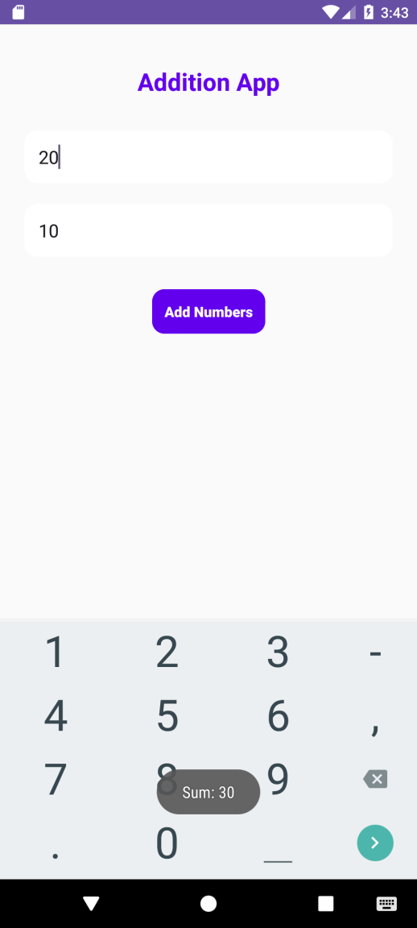

**Ex:4**

**activity_main.xml:**

<?xml version="1.0" encoding="utf-8"?>

<androidx.constraintlayout.widget.ConstraintLayout xmlns:android="http://schemas.android.com/apk/res/android"

xmlns:app="http://schemas.android.com/apk/res-auto"

xmlns:tools="http://schemas.android.com/tools"

android:layout_width="match_parent"

android:layout_height="match_parent"

tools:context=".MainActivity">

<EditText

android:id="@+id/etInput"

android:layout_width="0dp"

android:layout_height="wrap_content"

android:layout_marginTop="30dp"

android:hint="Enter number"

android:textSize="30sp"

android:inputType="number|text"

android:gravity="end"

android:importantForAccessibility="yes"

app:layout_constraintEnd_toEndOf="parent"

app:layout_constraintStart_toStartOf="parent"

app:layout_constraintTop_toTopOf="parent" />

<GridLayout

android:id="@+id/gridLayout"

android:layout_width="match_parent"

android:layout_height="wrap_content"

android:columnCount="4"

android:layout_marginTop="50dp"

app:layout_constraintEnd_toEndOf="parent"

app:layout_constraintStart_toStartOf="parent"

app:layout_constraintTop_toBottomOf="@id/etInput">

<Button

android:id="@+id/button1"

android:layout_width="0dp"

android:layout_height="wrap_content"

android:layout_columnWeight="1"

android:text="1"

android:textSize="30sp" />

<Button

android:id="@+id/button2"

android:layout_width="0dp"

android:layout_height="wrap_content"

android:layout_columnWeight="1"

android:text="2"

android:textSize="30sp" />

<Button

android:id="@+id/button3"

android:layout_width="0dp"

android:layout_height="wrap_content"

android:layout_columnWeight="1"

android:text="3"

android:textSize="30sp" />

<Button

android:id="@+id/buttonAdd"

android:layout_width="0dp"

android:layout_height="wrap_content"

android:layout_columnWeight="1"

android:text="+"

android:textSize="30sp" />

<Button

android:id="@+id/button4"

android:layout_width="0dp"

android:layout_height="wrap_content"

android:layout_columnWeight="1"

android:text="4"

android:textSize="30sp" />

<Button

android:id="@+id/button5"

android:layout_width="0dp"

android:layout_height="wrap_content"

android:layout_columnWeight="1"

android:text="5"

android:textSize="30sp" />

<Button

android:id="@+id/button6"

android:layout_width="0dp"

android:layout_height="wrap_content"

android:layout_columnWeight="1"

android:text="6"

android:textSize="30sp" />

<Button

android:id="@+id/buttonSubtract"

android:layout_width="0dp"

android:layout_height="wrap_content"

android:layout_columnWeight="1"

android:text="-"

android:textSize="30sp" />

<Button

android:id="@+id/button7"

android:layout_width="0dp"

android:layout_height="wrap_content"

android:layout_columnWeight="1"

android:text="7"

android:textSize="30sp" />

<Button

android:id="@+id/button8"

android:layout_width="0dp"

android:layout_height="wrap_content"

android:layout_columnWeight="1"

android:text="8"

android:textSize="30sp" />

<Button

android:id="@+id/button9"

android:layout_width="0dp"

android:layout_height="wrap_content"

android:layout_columnWeight="1"

android:text="9"

android:textSize="30sp" />

<Button

android:id="@+id/buttonMultiply"

android:layout_width="0dp"

android:layout_height="wrap_content"

android:layout_columnWeight="1"

android:text="*"

android:textSize="30sp" />

<Button

android:id="@+id/buttonClear"

android:layout_width="0dp"

android:layout_height="wrap_content"

android:layout_columnWeight="1"

android:text="C"

android:textSize="30sp" />

<Button

android:id="@+id/button0"

android:layout_width="0dp"

android:layout_height="wrap_content"

android:layout_columnWeight="1"

android:text="0"

android:textSize="30sp" />

<Button

android:id="@+id/buttonEquals"

android:layout_width="0dp"

android:layout_height="wrap_content"

android:layout_columnWeight="1"

android:text="="

android:textSize="30sp" />

<Button

android:id="@+id/buttonDivide"

android:layout_width="0dp"

android:layout_height="wrap_content"

android:layout_columnWeight="1"

android:text="/"

android:textSize="30sp" />

</GridLayout>

</androidx.constraintlayout.widget.ConstraintLayout>

**MainActivity.java:**

package com.example.calculator;

import android.os.Bundle;

import android.view.View;

import android.widget.Button;

import android.widget.EditText;

import androidx.appcompat.app.AppCompatActivity;

public class MainActivity extends AppCompatActivity {

private EditText etInput;

private String currentInput = "";

private String operator = "";

private double firstValue = 0.0;

private double secondValue = 0.0;

@Override

protected void onCreate(Bundle savedInstanceState) {

super.onCreate(savedInstanceState);

setContentView(R.layout.activity_main);

etInput = findViewById(R.id.etInput);

Button button1 = findViewById(R.id.button1);

Button button2 = findViewById(R.id.button2);

Button button3 = findViewById(R.id.button3);

Button button4 = findViewById(R.id.button4);

Button button5 = findViewById(R.id.button5);

Button button6 = findViewById(R.id.button6);

Button button7 = findViewById(R.id.button7);

Button button8 = findViewById(R.id.button8);

Button button9 = findViewById(R.id.button9);

Button button0 = findViewById(R.id.button0);

Button buttonAdd = findViewById(R.id.buttonAdd);

Button buttonSubtract = findViewById(R.id.buttonSubtract);

Button buttonMultiply = findViewById(R.id.buttonMultiply);

Button buttonDivide = findViewById(R.id.buttonDivide);

Button buttonEquals = findViewById(R.id.buttonEquals);

Button buttonClear = findViewById(R.id.buttonClear);

// Number buttons

View.OnClickListenernumberClickListener=new View.OnClickListener() {

@Override

public void onClick(View v) {

Button button = (Button) v;

currentInput += button.getText().toString();

etInput.setText(currentInput);

}

};

button1.setOnClickListener(numberClickListener);

button2.setOnClickListener(numberClickListener);

button3.setOnClickListener(numberClickListener);

button4.setOnClickListener(numberClickListener);

button5.setOnClickListener(numberClickListener);

button6.setOnClickListener(numberClickListener);

button7.setOnClickListener(numberClickListener);

button8.setOnClickListener(numberClickListener);

button9.setOnClickListener(numberClickListener);

button0.setOnClickListener(numberClickListener);

// Operator buttons

View.OnClickListener operatorClickListener = new View.OnClickListener() {

@Override

public void onClick(View v) {

Button button = (Button) v;

operator = button.getText().toString();

firstValue = Double.parseDouble(currentInput);

currentInput = "";

}

};

buttonAdd.setOnClickListener(operatorClickListener);

buttonSubtract.setOnClickListener(operatorClickListener);

buttonMultiply.setOnClickListener(operatorClickListener);

buttonDivide.setOnClickListener(operatorClickListener);

// Clear button

buttonClear.setOnClickListener(v -> {

currentInput = "";

firstValue = 0.0;

secondValue = 0.0;

operator = "";

etInput.setText("");

});

// Equals button

buttonEquals.setOnClickListener(v -> {

if (!currentInput.isEmpty()) {

secondValue = Double.parseDouble(currentInput);

double result = 0.0;

switch (operator) {

case "+":

result = firstValue + secondValue;

break;

case "-":

result = firstValue - secondValue;

break;

case "*":

result = firstValue * secondValue;

break;

case "/":

if (secondValue != 0) {

result = firstValue / secondValue;

} else {

etInput.setText("Error");

return;

}

break;

}

currentInput = String.valueOf(result);

etInput.setText(currentInput);

operator = "";

firstValue = result;

}

});

}

}

**Output:**

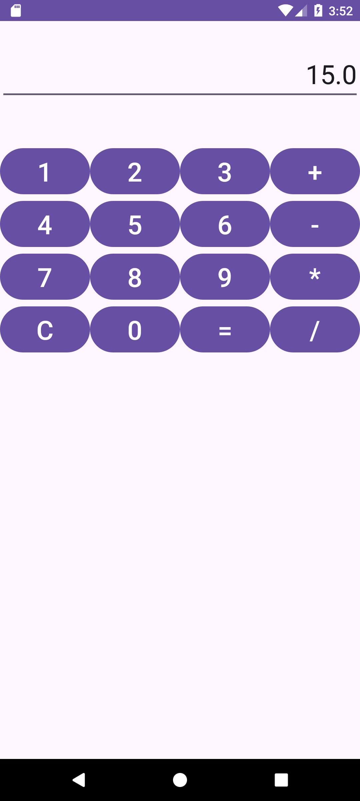

**Ex:5A**

**MainActivity.java:**

package com.example.ex5rect;

import android.graphics.Canvas;

import android.graphics.Color;

import android.graphics.Paint;

import android.os.Bundle;

import androidx.appcompat.app.AppCompatActivity;

import android.view.View;

public class MainActivity extends AppCompatActivity {

@Override

protected void onCreate(Bundle savedInstanceState) {

super.onCreate(savedInstanceState);

setContentView(new DrawingView());

}

public class DrawingView extends View {

private Paint paint;

public DrawingView() {

super(MainActivity.this);

paint = new Paint();

paint.setColor(Color.GREEN); // Set color for the rectangle

paint.setStrokeWidth(20); // Set stroke width

paint.setStyle(Paint.Style.STROKE); // Set the style to STROKE (only outline, not filled)

}

@Override

protected void onDraw(Canvas canvas) {

super.onDraw(canvas);

canvas.drawRect(100, 100, 500, 500, paint);

}

}

}

**Output:**

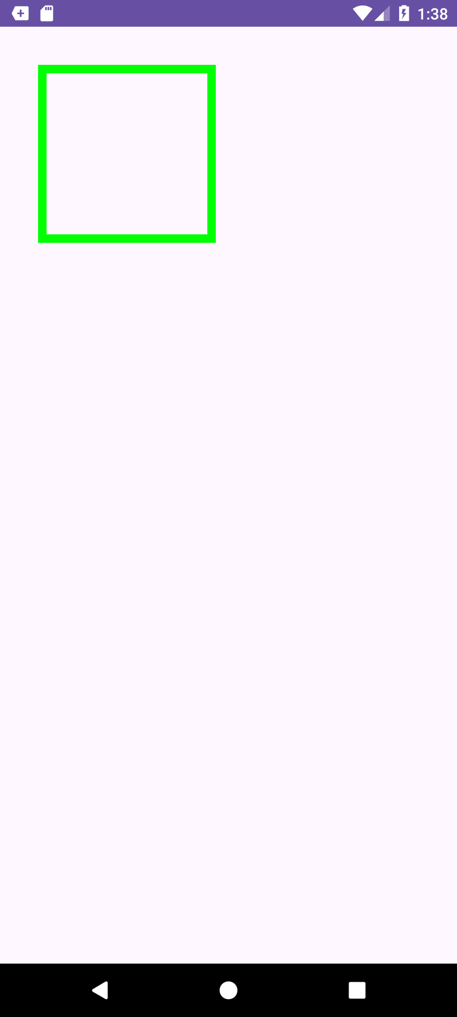

**Ex:5B**

**MainActivity.java:**

package com.example.ex5circle;

import android.graphics.Canvas;

import android.graphics.Color;

import android.graphics.Paint;

import android.os.Bundle;

import androidx.appcompat.app.AppCompatActivity;

import android.view.View;

public class MainActivity extends AppCompatActivity {

@Override

protected void onCreate(Bundle savedInstanceState) {

super.onCreate(savedInstanceState);

setContentView(new DrawingView());

}

public class DrawingView extends View {

private Paint paint;

public DrawingView() {

super(MainActivity.this);

paint = new Paint();

paint.setColor(Color.GREEN);

paint.setStyle(Paint.Style.FILL); )

}

@Override

protected void onDraw(Canvas canvas) {

super.onDraw(canvas);

int canvasWidth = canvas.getWidth();

int canvasHeight = canvas.getHeight();

int centerX = canvasWidth / 2;

int centerY = canvasHeight / 2;

int radius = 200;

canvas.drawCircle(centerX, centerY, radius, paint);

}

}

}

**Output:**

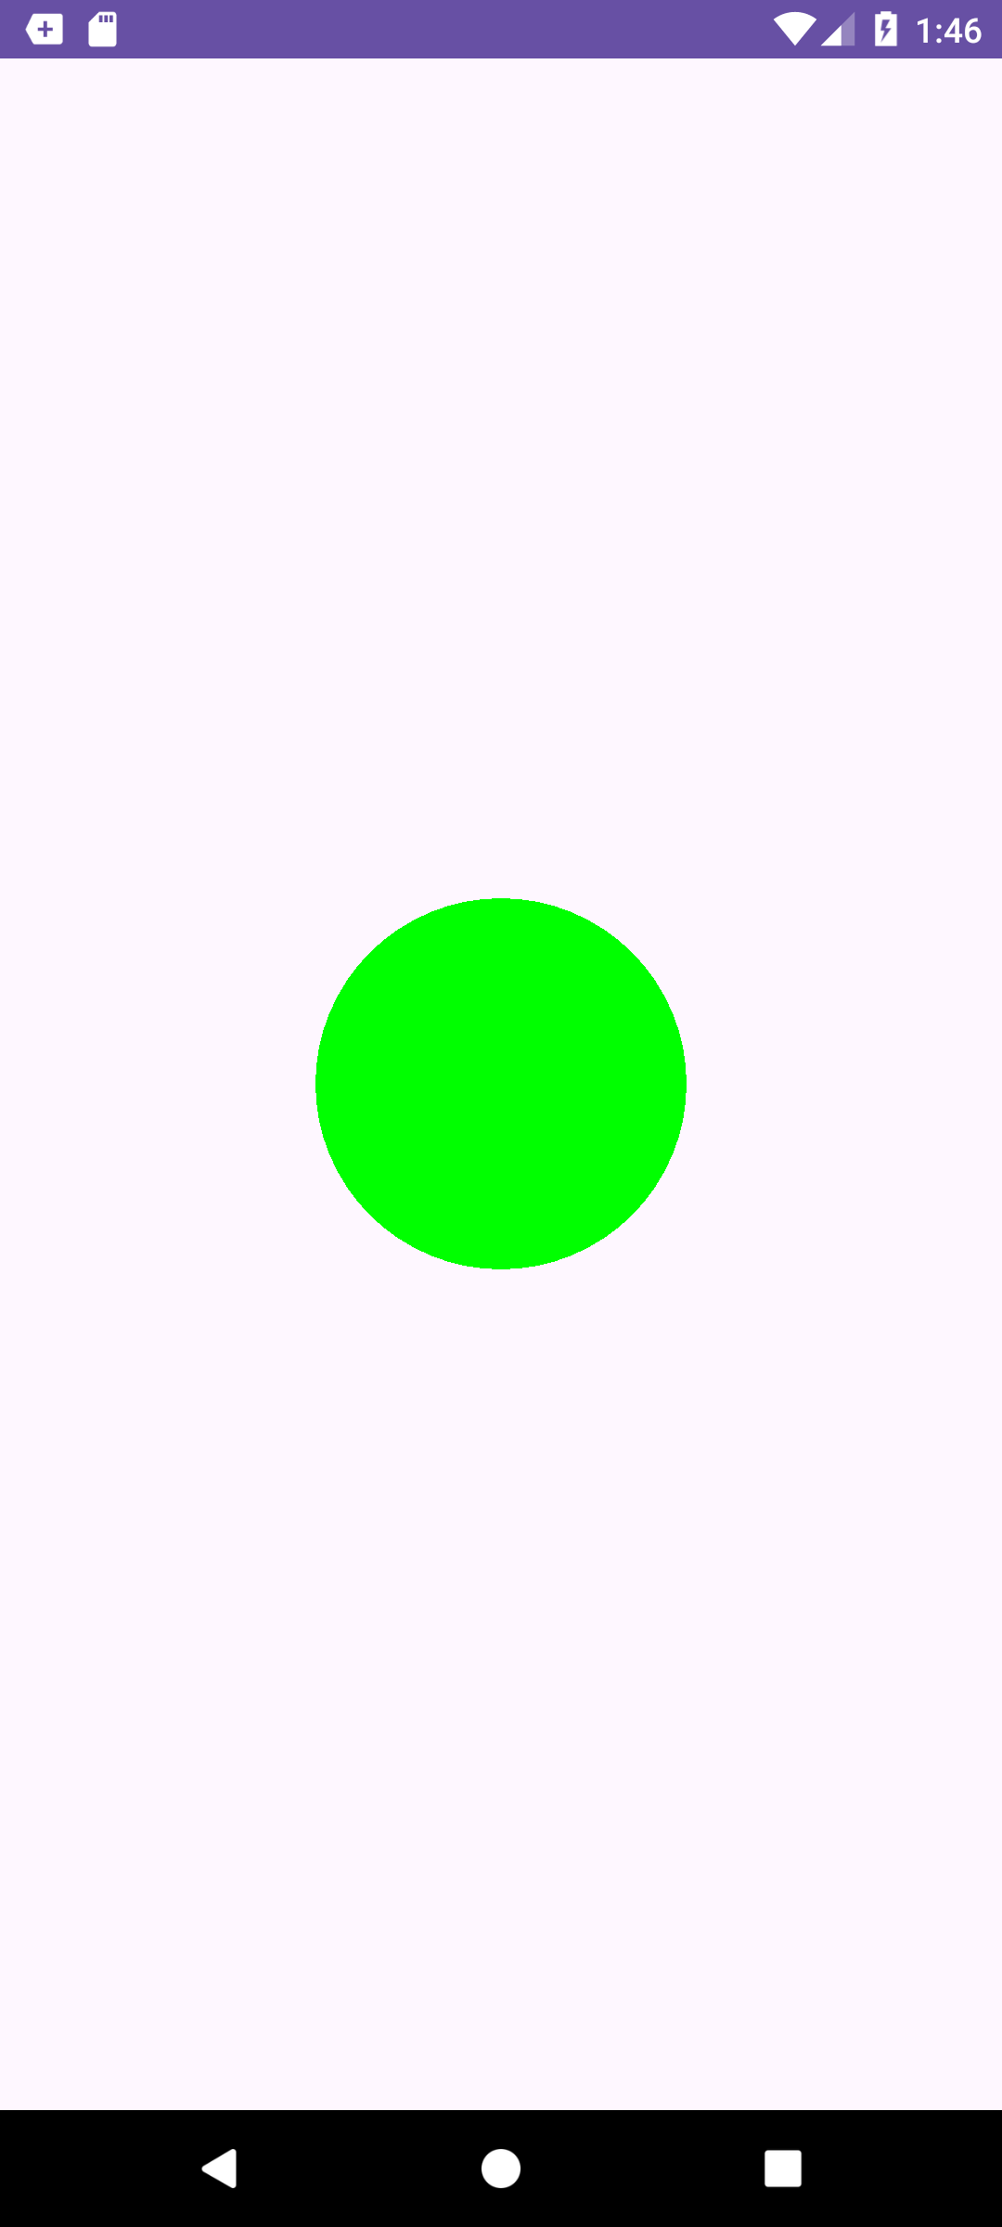

**Ex:6**

**activity_main.xml:**

<?xml version="1.0" encoding="utf-8"?>

<RelativeLayout xmlns:android="http://schemas.android.com/apk/res/android"

android:layout_width="match_parent"

android:layout_height="match_parent"

android:padding="16dp">

<TextView

android:id="@+id/titleText"

android:layout_width="wrap_content"

android:layout_height="wrap_content"

android:text="Student Details"

android:textSize="30sp"

android:layout_centerHorizontal="true"

android:layout_marginTop="20dp" />

<TextView

android:id="@+id/rollnoLabel"

android:layout_width="wrap_content"

android:layout_height="wrap_content"

android:text="Enter Rollno:"

android:textSize="20sp"

android:layout_below="@id/titleText"

android:layout_marginTop="40dp"

android:layout_alignParentStart="true" />

<EditText

android:id="@+id/Rollno"

android:layout_width="200dp"

android:layout_height="wrap_content"

android:inputType="number"

android:hint="Rollno"

android:textSize="20sp"

android:layout_toEndOf="@id/rollnoLabel"

android:layout_alignBaseline="@id/rollnoLabel"

android:layout_marginTop="10dp" />

<TextView

android:id="@+id/nameLabel"

android:layout_width="wrap_content"

android:layout_height="wrap_content"

android:text="Enter Name:"

android:textSize="20sp"

android:layout_below="@id/rollnoLabel"

android:layout_marginTop="40dp"

android:layout_alignParentStart="true" />

<EditText

android:id="@+id/Name"

android:layout_width="200dp"

android:layout_height="wrap_content"

android:inputType="text"

android:hint="Name"

android:textSize="20sp"

android:layout_toEndOf="@id/nameLabel"

android:layout_alignBaseline="@id/nameLabel"

android:layout_marginTop="10dp" />

<TextView

android:id="@+id/marksLabel"

android:layout_width="wrap_content"

android:layout_height="wrap_content"

android:text="Enter Marks:"

android:textSize="20sp"

android:layout_below="@id/nameLabel"

android:layout_marginTop="40dp"

android:layout_alignParentStart="true" />

<EditText

android:id="@+id/Marks"

android:layout_width="200dp"

android:layout_height="wrap_content"

android:inputType="number"

android:hint="Marks"

android:textSize="20sp"

android:layout_toEndOf="@id/marksLabel"

android:layout_alignBaseline="@id/marksLabel"

android:layout_marginTop="10dp" />

<Button

android:id="@+id/Insert"

android:layout_width="wrap_content"

android:layout_height="wrap_content"

android:text="Insert"

android:textSize="20sp"

android:layout_below="@id/Marks"

android:layout_marginTop="30dp"

android:layout_centerHorizontal="true" />

<Button

android:id="@+id/Delete"

android:layout_width="wrap_content"

android:layout_height="wrap_content"

android:text="Delete"

android:textSize="20sp"

android:layout_below="@id/Insert"

android:layout_marginTop="20dp"

android:layout_centerHorizontal="true" />

<Button

android:id="@+id/Update"

android:layout_width="wrap_content"

android:layout_height="wrap_content"

android:text="Update"

android:textSize="20sp"

android:layout_below="@id/Delete"

android:layout_marginTop="20dp"

android:layout_centerHorizontal="true" />

<Button

android:id="@+id/View"

android:layout_width="wrap_content"

android:layout_height="wrap_content"

android:text="View"

android:textSize="20sp"

android:layout_below="@id/Update"

android:layout_marginTop="20dp"

android:layout_centerHorizontal="true" />

<Button

android:id="@+id/ViewAll"

android:layout_width="wrap_content"

android:layout_height="wrap_content"

android:text="View All"

android:textSize="20sp"

android:layout_below="@id/View"

android:layout_marginTop="20dp"

android:layout_centerHorizontal="true" />

</RelativeLayout>

**MainActivity.java:**

package com.example.database;

import android.app.Activity;

import android.app.AlertDialog.Builder;

import android.content.Context;

import android.database.Cursor;

import android.database.sqlite.SQLiteDatabase;

import android.os.Bundle;

import android.view.View;

import android.view.View.OnClickListener;

import android.widget.Button;

import android.widget.EditText;

public class MainActivity extends Activity implements OnClickListener {

EditText Rollno, Name, Marks;

Button Insert, Delete, Update, View, ViewAll;

SQLiteDatabase db;

@Override

public void onCreate(Bundle savedInstanceState) {

super.onCreate(savedInstanceState);

setContentView(R.layout.activity_main);

Rollno = findViewById(R.id.Rollno);

Name = findViewById(R.id.Name);

Marks = findViewById(R.id.Marks);

Insert = findViewById(R.id.Insert);

Delete = findViewById(R.id.Delete);

Update = findViewById(R.id.Update);

View = findViewById(R.id.View);

ViewAll = findViewById(R.id.ViewAll);

Insert.setOnClickListener(this);

Delete.setOnClickListener(this);

Update.setOnClickListener(this);

View.setOnClickListener(this);

ViewAll.setOnClickListener(this);

db = openOrCreateDatabase("StudentDB", Context.MODE_PRIVATE, null);

db.execSQL("CREATE TABLE IF NOT EXISTS student(rollno VARCHAR, name VARCHAR, marks VARCHAR);");

}

public void onClick(View view) {

if (view == Insert) {

if (Rollno.getText().toString().trim().length() == 0 ||

Name.getText().toString().trim().length() == 0 ||

Marks.getText().toString().trim().length() == 0) {

showMessage("Error", "Please enter all values");

return;

}

db.execSQL("INSERT INTO student VALUES('" + Rollno.getText() + "','" + Name.getText() +

"','" + Marks.getText() + "');");

showMessage("Success", "Record added");

clearText();

}

if (view == Delete) {

if (Rollno.getText().toString().trim().length() == 0) {

showMessage("Error", "Please enter Rollno");

return;

}

Cursor c = db.rawQuery("SELECT * FROM student WHERE rollno='" + Rollno.getText() + "'", null);

if (c.moveToFirst()) {

db.execSQL("DELETE FROM student WHERE rollno='" + Rollno.getText() + "'");

showMessage("Success", "Record Deleted");

} else {

showMessage("Error", "Invalid Rollno");

}

clearText();

}

if (view == Update) {

if (Rollno.getText().toString().trim().length() == 0) {

showMessage("Error", "Please enter Rollno");

return;

}

Cursor c = db.rawQuery("SELECT * FROM student WHERE rollno='" + Rollno.getText() + "'", null);

if (c.moveToFirst()) {

db.execSQL("UPDATE student SET name='" + Name.getText() + "',marks='" +

Marks.getText() + "' WHERE rollno='" + Rollno.getText() + "'");

showMessage("Success", "Record Modified");

} else {

showMessage("Error", "Invalid Rollno");

}

clearText();

}

if (view == View) {

if (Rollno.getText().toString().trim().length() == 0) {

showMessage("Error", "Please enter Rollno");

return;

}

Cursor c = db.rawQuery("SELECT * FROM student WHERE rollno='" + Rollno.getText() + "'", null);

if (c.moveToFirst()) {

Name.setText(c.getString(1));

Marks.setText(c.getString(2));

} else {

showMessage("Error", "Invalid Rollno");

clearText();

}

}

if (view == ViewAll) {

Cursor c = db.rawQuery("SELECT * FROM student", null);

if (c.getCount() == 0) {

showMessage("Error", "No records found");

return;

}

StringBuffer buffer = new StringBuffer();

while (c.moveToNext()) {

buffer.append("Rollno: " + c.getString(0) + "\n");

buffer.append("Name: " + c.getString(1) + "\n");

buffer.append("Marks: " + c.getString(2) + "\n\n");

}

showMessage("Student Details", buffer.toString());

}

}

public void showMessage(String title, String message) {

Builder builder = new Builder(this);

builder.setCancelable(true);

builder.setTitle(title);

builder.setMessage(message);

builder.show();

}

public void clearText() {

Rollno.setText("");

Name.setText("");

Marks.setText("");

Rollno.requestFocus();

}

}

**Output:**

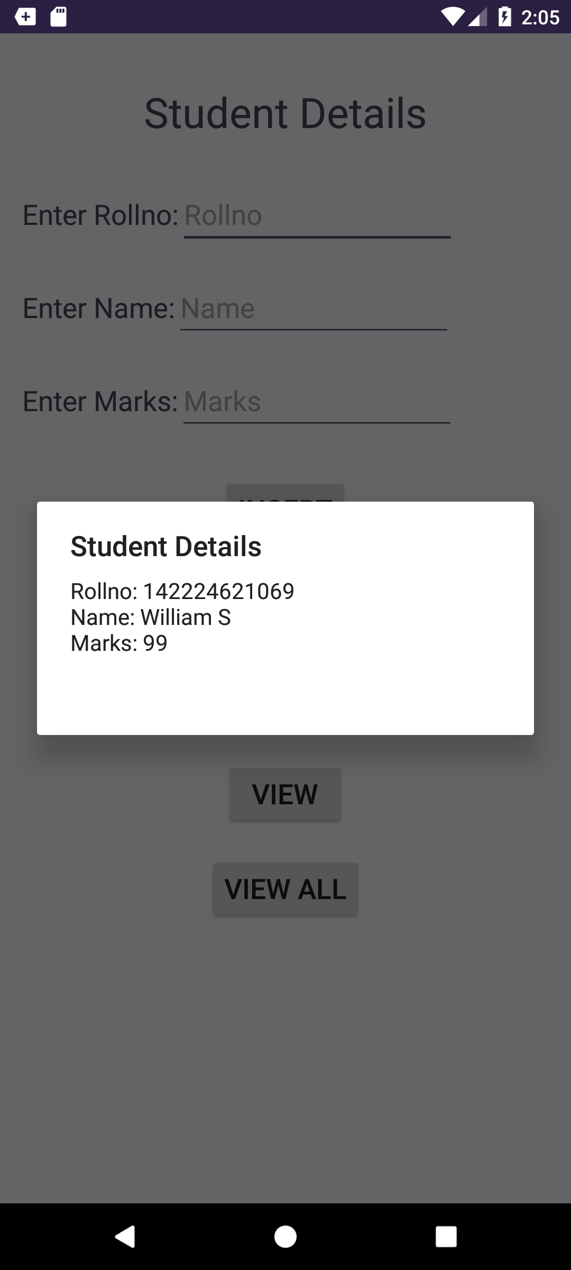

**Ex:8**

**activity_main.xml:**

<?xml version="1.0" encoding="utf-8"?>

<RelativeLayout xmlns:android="http://schemas.android.com/apk/res/android"

xmlns:tools="http://schemas.android.com/tools"

android:layout_width="match_parent"

android:layout_height="match_parent"

tools:context=".MainActivity">

<TextView

android:id="@+id/textView1"

android:layout_width="match_parent"

android:layout_height="wrap_content"

android:text="File content will appear here"

android:textSize="16sp"

android:padding="16dp" />

<EditText

android:id="@+id/editText1"

android:layout_width="match_parent"

android:layout_height="wrap_content"

android:hint="Enter text"

android:layout_below="@id/textView1"

android:layout_marginTop="20dp"

android:padding="16dp" />

<Button

android:id="@+id/button1"

android:layout_width="wrap_content"

android:layout_height="wrap_content"

android:text="Save Data"

android:layout_below="@id/editText1"

android:layout_marginTop="20dp"

android:layout_alignParentStart="true"

android:layout_marginStart="20dp"/>

<Button

android:id="@+id/button2"

android:layout_width="wrap_content"

android:layout_height="wrap_content"

android:text="Show Data"

android:layout_below="@id/editText1"

android:layout_marginTop="20dp"

android:layout_toEndOf="@id/button1"

android:layout_marginStart="20dp"/>

</RelativeLayout>

**MainActivity.java:**

package com.example.ex8;

import android.app.Notification;

import android.app.NotificationManager;

import android.content.Context;

import android.os.Bundle;

import android.widget.Button;

import android.widget.EditText;

import android.widget.TextView;

import android.widget.Toast;

import android.view.View;

import androidx.appcompat.app.AppCompatActivity;

import androidx.core.app.NotificationCompat;

import java.io.File;

import java.io.FileInputStream;

import java.io.FileOutputStream;

public class MainActivity extends AppCompatActivity {

Button b1, b2;

EditText e;

TextView tv;

String s;

FileOutputStream fout;

FileInputStream fin;

NotificationManager notificationManager;

@Override

protected void onCreate(Bundle savedInstanceState) {

super.onCreate(savedInstanceState);

setContentView(R.layout.activity_main);

tv = findViewById(R.id.textView1);

b1 = findViewById(R.id.button1);

b2 = findViewById(R.id.button2);

e = findViewById(R.id.editText1);

notificationManager = (NotificationManager) getSystemService(Context.NOTIFICATION_SERVICE);

clearFile();

b1.setOnClickListener(new View.OnClickListener() {

@Override

public void onClick(View view) {

s = e.getText().toString();

try {

// Write new data to the file

File file = new File(getExternalFilesDir(null), "myfile.txt");

fout = new FileOutputStream(file, true);

fout.write((s + "\n").getBytes());

fout.close();

Toast.makeText(getBaseContext(), "Data saved to SD card!", Toast.LENGTH_SHORT).show();

showNotification("Saved!", "Data saved successfully.");

} catch (Exception ex) {

ex.printStackTrace();

Toast.makeText(getBaseContext(), "Error saving file.", Toast.LENGTH_SHORT).show();

}

}

});

b2.setOnClickListener(new View.OnClickListener() {

@Override

public void onClick(View view) {

try {

File file = new File(getExternalFilesDir(null), "myfile.txt");

fin = new FileInputStream(file);

int c;

StringBuilder temp = new StringBuilder();

while ((c = fin.read()) != -1) {

temp.append((char) c);

}

fin.close();

tv.setText(temp.toString());

Toast.makeText(getBaseContext(), "File read successfully!", Toast.LENGTH_SHORT).show();

showNotification("Read!", "File read successfully.");

} catch (Exception ex) {

ex.printStackTrace();

Toast.makeText(getBaseContext(), "Error reading file.", Toast.LENGTH_SHORT).show();

}

}

});

}

private void clearFile() {

File file = new File(getExternalFilesDir(null), "myfile.txt");

if (file.exists()) {

if (file.delete()) {

Toast.makeText(getBaseContext(), "File cleared successfully.", Toast.LENGTH_SHORT).show();

} else {

Toast.makeText(getBaseContext(), "Error clearing the file.", Toast.LENGTH_SHORT).show();

}

}

}

private void showNotification(String title, String message) {

NotificationCompat.Builder builder = new NotificationCompat.Builder(this, "default")

.setSmallIcon(android.R.drawable.stat_notify_more)

.setContentTitle(title)

.setContentText(message)

.setPriority(NotificationCompat.PRIORITY_DEFAULT);

Notification notification = builder.build();

notificationManager.notify(1, notification);

}

}

**Output**

