**Computation Time Comparison between Old and New Kernels**

|  |  |  |  |
| --- | --- | --- | --- |
| **Computation Time Comparison** | | | |
| **Matrix Size ---->** | **8x8** | **16x16** | **32x32** |
| **Old Kernel** | 17.184 | 33.728 | 77.984 |
| **New Kernel** | 9.2 | 14.2 | 42.8 |
| **Difference** | 7.984 | 19.528 | 35.184 |
| **% Age Improve** | 46.46% | 57.89% | 45.12% |

**Click any of the Cell view Detailed Statistics of Each**

**OLD KERNEL 8 X 8**

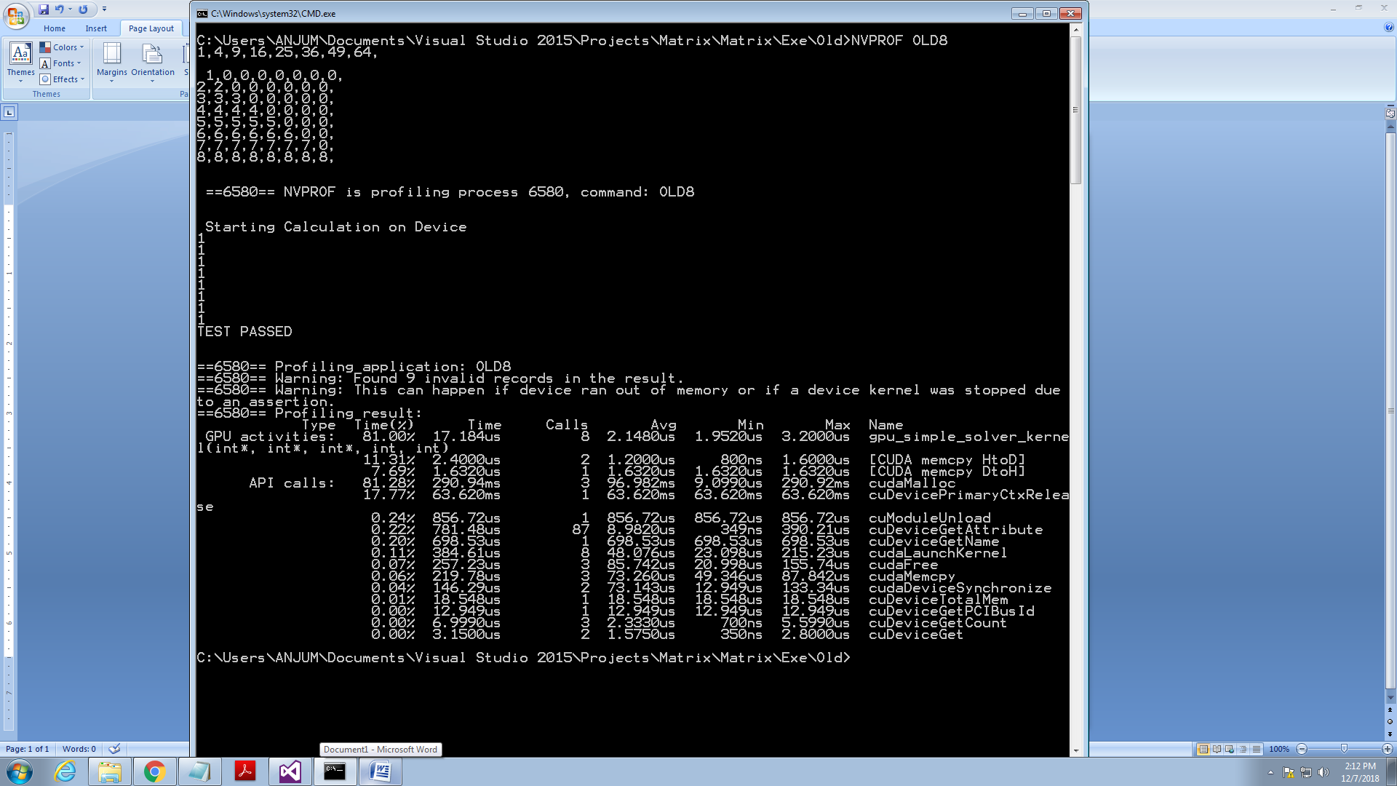

**<< Return Back**

**OLD KERNEL 16 X 16**

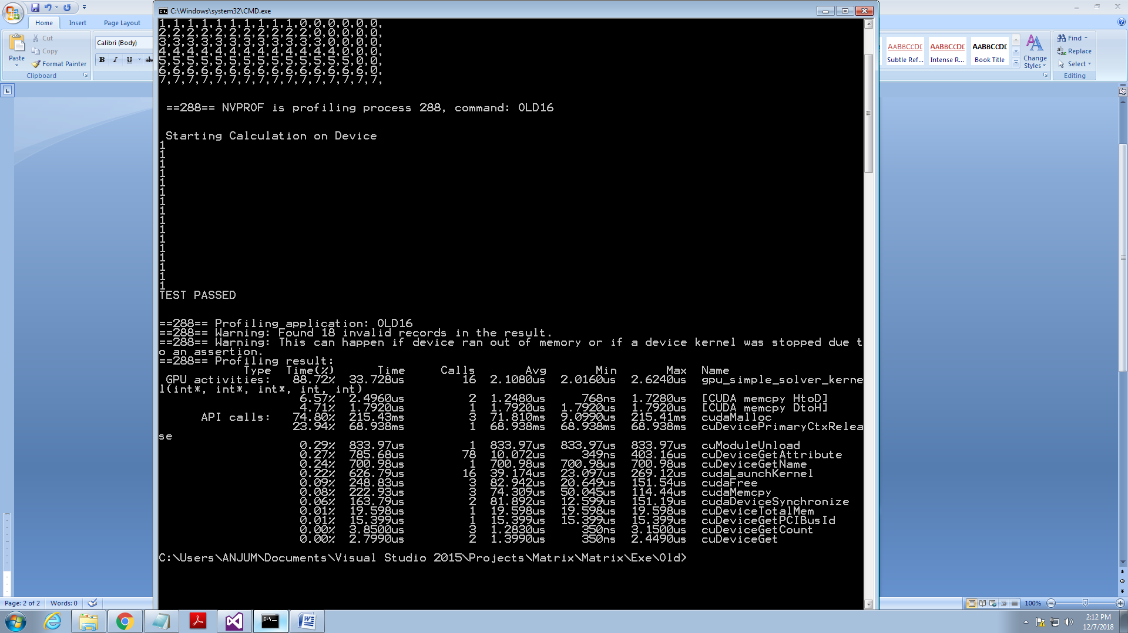

**<< Return Back**

**OLD KERNEL 32 X 32**

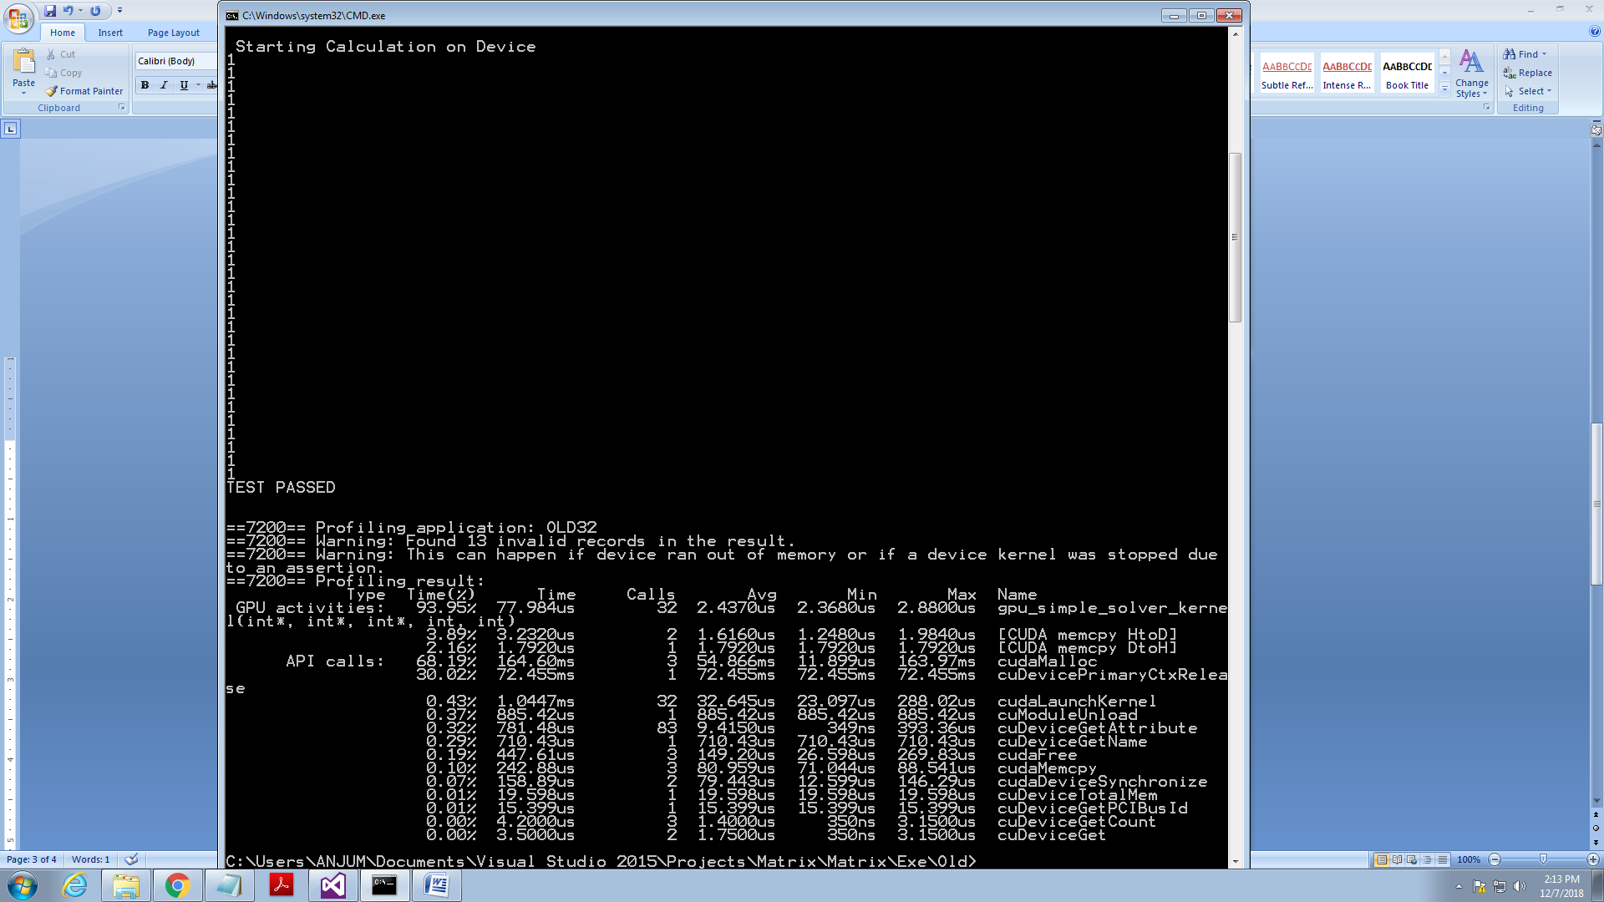

**<< Return Back**

**NEW KERNEL 8 X 8**

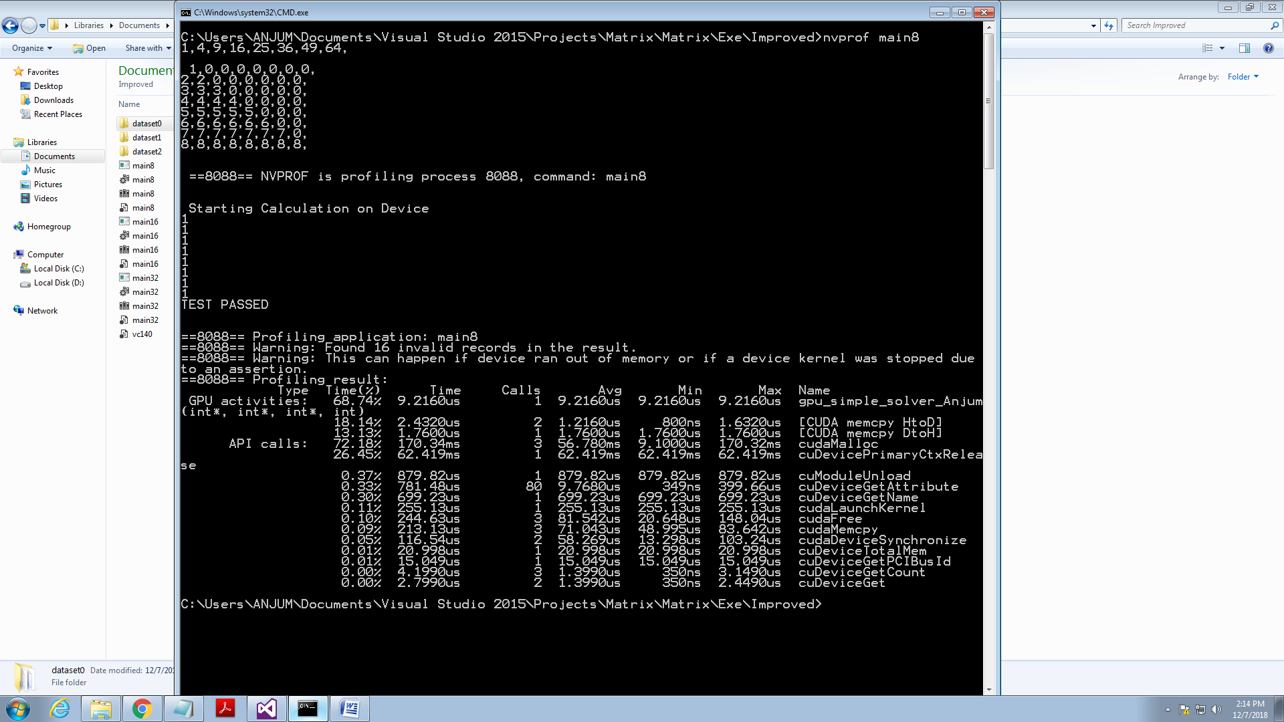

**<< Return Back**

**NEW KERNEL 16 X 16**

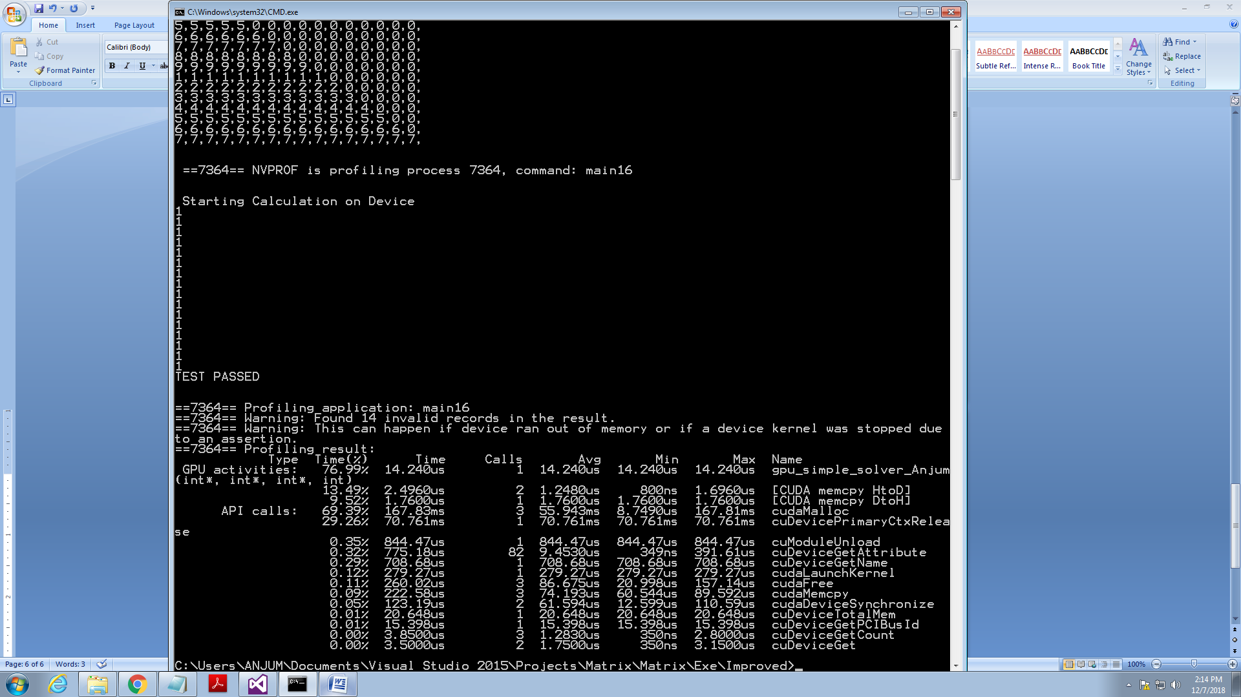

**<< Return Back**

**NEW KERNEL 32 X 32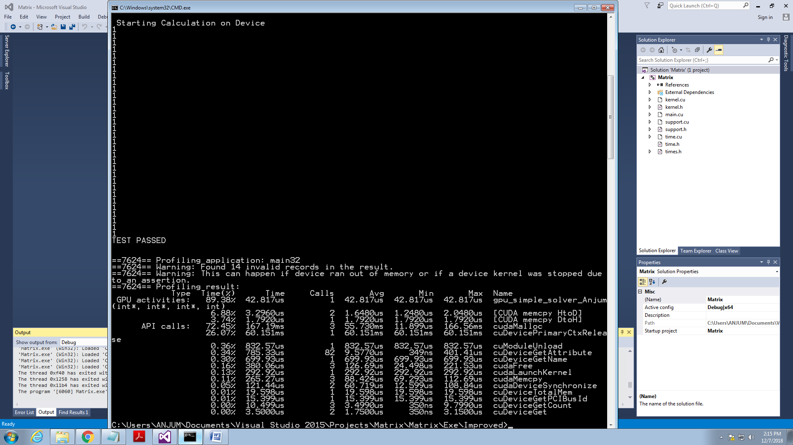<<Return Back**