Volume 05. Path Planning and Autonomous Navigation

Chapter 09. Semantic Navigation

09.1 Semantic Navigation Concepts
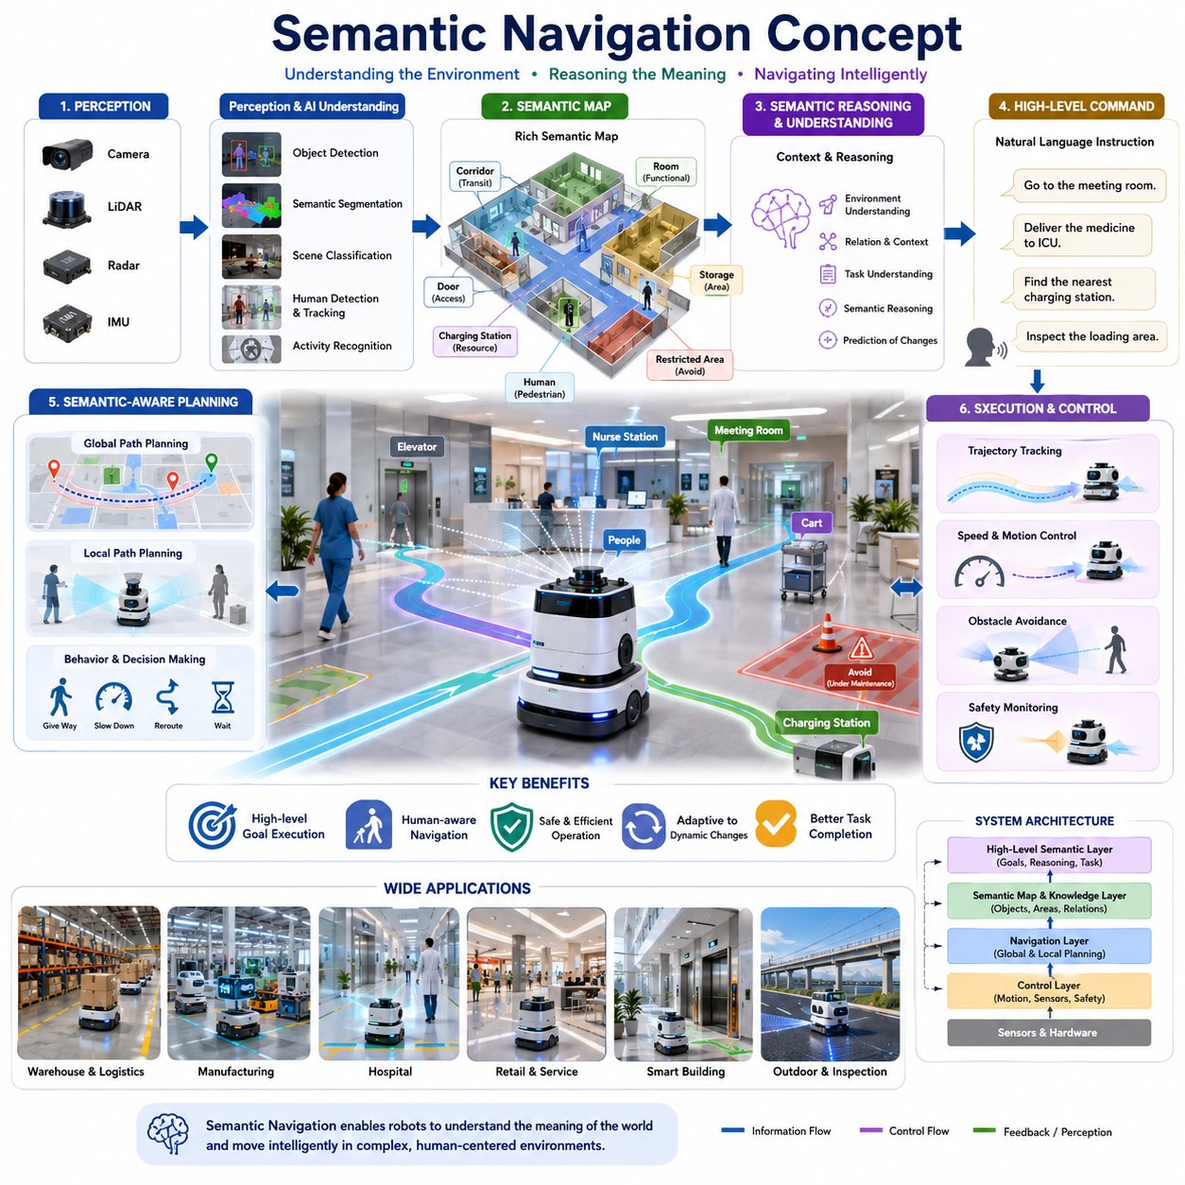
Semantic navigation represents a major evolution in autonomous robot navigation, moving beyond traditional geometric and metric path planning toward navigation systems that understand the meaning and context of the surrounding environment. Conventional navigation systems primarily rely on maps, coordinates, obstacle locations, and kinematic constraints to move a robot from one point to another. While such systems can successfully guide a robot through structured environments, they often lack the ability to understand what objects are, how spaces are used, and how humans interact with those spaces. Semantic navigation addresses this limitation by enabling robots to reason about environments in a manner that is closer to human understanding.
In human navigation, people rarely think in terms of coordinates or occupancy grids. Instead, they use semantic concepts such as rooms, corridors, doors, elevators, workstations, storage areas, charging stations, waiting rooms, and emergency exits. Humans naturally understand instructions such as “go to the meeting room,” “bring the package to the loading dock,” or “wait near the reception desk.” Semantic navigation seeks to provide robots with a similar capability by integrating environmental meaning into the navigation process. This allows robots to interpret high-level goals, understand context, and make intelligent decisions based on the purpose and characteristics of locations rather than relying solely on geometric information. Semantic navigation is positioned as a key component of advanced autonomous navigation systems within the broader navigation architecture of AMRs.
The foundation of semantic navigation lies in the combination of perception, localization, mapping, artificial intelligence, and decision-making systems. A semantic navigation system must first perceive its environment using sensors such as cameras, LiDARs, depth sensors, radar systems, and inertial measurement units. The raw sensor data is processed through perception pipelines that detect objects, classify environments, identify landmarks, and recognize human activities. The resulting information is transformed into semantic representations that enrich traditional maps with meaningful labels and contextual information. These enriched maps become the basis for navigation decisions.
A semantic map differs significantly from a conventional occupancy grid map. Traditional maps typically represent free space, occupied space, and unknown regions. Semantic maps extend this representation by attaching labels and attributes to environmental elements. A corridor may be identified as a transportation pathway, a warehouse shelf may be labeled as a storage location, and a hospital room may be recognized as a patient treatment area. Objects such as forklifts, carts, workers, charging stations, and doors may also be represented with semantic information. Through this process, the robot gains a deeper understanding of its operating environment.
The concept of semantic navigation is closely connected to scene understanding. Scene understanding refers to the ability of a robot to interpret the functional structure of its surroundings. Rather than viewing the world as a collection of disconnected sensor measurements, the robot recognizes meaningful relationships between objects, spaces, and activities. For example, a robot operating in a hospital can understand that beds are typically located inside patient rooms, nurses frequently move through specific corridors, and elevators provide access between floors. Such contextual knowledge enables more intelligent navigation strategies and improves operational efficiency.
One of the most important benefits of semantic navigation is the ability to execute high-level task instructions. Traditional navigation systems often require exact destination coordinates. In contrast, semantic navigation allows robots to understand abstract goals. A user may instruct a robot to “deliver medicine to the intensive care unit” or “inspect the loading area.” The robot interprets the semantic meaning of the destination, identifies the corresponding location within its map, and generates an appropriate navigation plan. This capability significantly improves human-robot interaction and reduces the complexity of robot deployment.
Semantic navigation also enhances path planning performance. Conventional path planners typically optimize metrics such as distance, travel time, energy consumption, or obstacle avoidance. Semantic navigation introduces additional considerations related to environmental meaning and operational context. A robot may prefer a corridor designated for logistics traffic rather than one intended primarily for pedestrians. It may avoid patient recovery areas in hospitals to reduce disturbances or choose designated industrial routes in factories to minimize interference with workers. By incorporating semantic information into cost functions, robots can generate paths that are not only physically feasible but also operationally appropriate.
Human-aware navigation is another critical aspect of semantic navigation. Robots frequently operate in environments shared with humans, including hospitals, warehouses, airports, shopping centers, and office buildings. Understanding human behavior and social norms becomes essential for safe and acceptable operation. Semantic navigation allows robots to recognize areas with high pedestrian activity, identify human workspaces, and understand the intended use of different regions. This knowledge enables robots to adapt their speed, maintain comfortable distances, yield when necessary, and navigate in a socially acceptable manner.
The integration of artificial intelligence plays a significant role in semantic navigation systems. Deep learning models are commonly used to perform object detection, semantic segmentation, scene classification, and activity recognition. Convolutional neural networks, transformer-based vision models, and multimodal foundation models can analyze complex sensory inputs and extract high-level semantic information. These AI systems enable robots to identify objects, understand environmental structures, and infer contextual relationships that would be difficult to encode manually.
Recent advances in foundation models have expanded the capabilities of semantic navigation even further. Vision-language models and vision-language-action systems can combine visual understanding with natural language reasoning. These models allow robots to interpret verbal instructions, associate language with physical environments, and perform navigation tasks guided by human communication. A robot can potentially understand instructions such as “go to the room next to the conference hall” or “find the nearest charging station near the maintenance workshop.” Such capabilities represent an important step toward more natural and intuitive human-robot collaboration.
Semantic navigation is particularly valuable in dynamic environments where environmental conditions continuously change. Traditional navigation systems may struggle when obstacles move, room layouts change, or operational priorities shift. Semantic understanding allows robots to reason about these changes more effectively. For example, if a corridor becomes temporarily blocked, the robot can identify alternative routes that maintain operational objectives. If a warehouse area is under maintenance, the robot can recognize restricted zones and adapt its navigation strategy accordingly.
Another important capability is semantic reasoning. Semantic reasoning enables robots to make decisions based on relationships and contextual knowledge rather than purely geometric calculations. For example, if a delivery destination is inaccessible, the robot may infer that an adjacent service desk can serve as an alternative drop-off location. If a charging station is occupied, the robot may identify nearby waiting areas and postpone charging until resources become available. Such reasoning capabilities increase autonomy and reduce the need for human intervention.
The development of semantic navigation systems often relies on hierarchical navigation architectures. At the lowest level, motion controllers manage wheel velocities, steering commands, and trajectory tracking. Above this layer, local planners handle obstacle avoidance and short-term motion decisions. Global planners generate routes across large environments. Semantic navigation operates at higher decision-making levels, providing contextual guidance and influencing planning strategies. This hierarchical approach allows semantic information to affect navigation decisions without compromising real-time control performance.
In industrial AMR deployments, semantic navigation offers significant operational advantages. Warehouse robots can distinguish between storage zones, loading docks, shipping areas, and employee workspaces. Manufacturing robots can understand production line structures, material flow routes, and safety-critical regions. Hospital robots can recognize patient rooms, nurse stations, operating theaters, and restricted medical areas. These semantic capabilities improve efficiency, reduce navigation errors, and enhance overall system reliability.
Outdoor autonomous robots also benefit from semantic navigation. In urban environments, robots can distinguish between sidewalks, roads, pedestrian crossings, parking lots, and building entrances. In agricultural applications, robots can recognize crop rows, irrigation infrastructure, equipment zones, and harvesting regions. For infrastructure inspection robots, including GPR-based inspection platforms, semantic understanding can identify utility corridors, maintenance access points, road sections, bridges, tunnels, and inspection targets. Such contextual awareness enables more effective mission execution and data collection.
Semantic navigation requires robust semantic map generation and maintenance. Semantic information must remain consistent as environments evolve over time. Long-term deployments often involve map updates, environmental changes, and evolving operational requirements. Therefore, semantic maps must support continuous learning, incremental updates, and automated validation processes. Cloud-based map management systems and fleet-level knowledge sharing can help maintain accurate semantic representations across multiple robots operating in the same environment.
Performance evaluation of semantic navigation extends beyond traditional navigation metrics. In addition to path length, travel time, localization accuracy, and obstacle avoidance performance, semantic navigation systems must be evaluated based on semantic understanding accuracy, object recognition reliability, contextual reasoning quality, human interaction effectiveness, and task completion success rates. Benchmarking frameworks often include tests involving high-level instruction following, semantic localization, scene understanding, and adaptive decision-making.
The future of semantic navigation is closely tied to developments in embodied AI, world models, and cognitive robotics. Emerging systems aim to create robots that can understand not only what exists in an environment but also why it exists, how it is used, and how it relates to ongoing tasks. Future robots may maintain dynamic world models that integrate geometric structures, semantic knowledge, human intentions, operational objectives, and environmental changes into a unified representation. Such systems will enable increasingly intelligent navigation behaviors that resemble human reasoning and situational awareness.
As autonomous mobile robots become more integrated into industrial facilities, hospitals, logistics centers, smart cities, and outdoor environments, semantic navigation will become a fundamental technology for next-generation robotic autonomy. It bridges the gap between low-level motion planning and high-level task understanding, allowing robots to move beyond simple obstacle avoidance and toward meaningful interaction with the world around them. Within the overall AMR navigation framework, semantic navigation serves as the critical layer that transforms navigation from coordinate-based movement into context-aware autonomous behavior, making robots more intelligent, adaptable, and capable of operating effectively in complex real-world environments.

09.2 Scene Understanding for Navigation
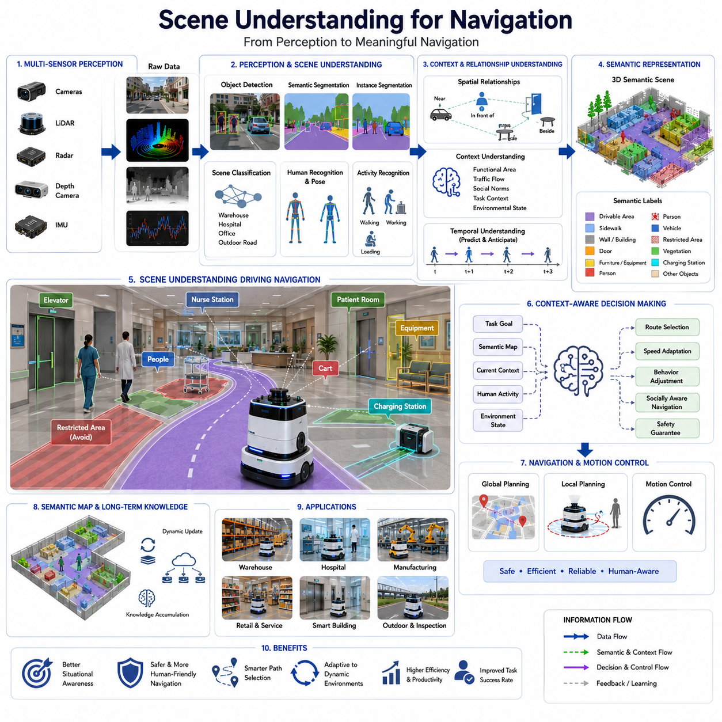
Scene understanding for navigation is one of the most important capabilities in modern autonomous mobile robots and intelligent robotic systems. While traditional navigation systems primarily focus on localization, mapping, obstacle detection, and path planning, scene understanding enables a robot to comprehend the meaning, structure, and context of its environment. Rather than perceiving the world as a collection of points, pixels, or geometric obstacles, a robot equipped with scene understanding can recognize objects, interpret relationships between environmental elements, understand functional areas, and make navigation decisions based on contextual knowledge. This capability serves as a critical bridge between low-level perception and high-level autonomous behavior, allowing robots to operate more intelligently in complex real-world environments.
In conventional navigation systems, a robot typically relies on occupancy maps, point clouds, or geometric representations of the environment. These representations are effective for collision avoidance and path planning, but they do not provide information about what objects are, why they exist, or how they should influence navigation decisions. A wall and a hospital bed may both appear as obstacles in a geometric map, yet they have completely different meanings and implications. Scene understanding addresses this limitation by assigning semantic meaning to environmental features and enabling robots to reason about their surroundings in a manner that resembles human understanding.
Humans naturally perform scene understanding when navigating through the world. When entering a building, people immediately recognize doors, hallways, staircases, offices, waiting areas, and emergency exits. They understand the intended function of these spaces and use that knowledge to make navigation decisions. A person looking for a conference room does not calculate coordinates but instead interprets environmental cues and contextual information. The goal of scene understanding in robotics is to provide similar cognitive capabilities to autonomous systems.
Scene understanding begins with environmental perception. Modern robots collect large amounts of data from multiple sensors, including RGB cameras, depth cameras, stereo vision systems, LiDAR sensors, radar sensors, ultrasonic sensors, thermal cameras, and inertial measurement units. These sensors capture different aspects of the environment, providing complementary information about geometry, appearance, motion, temperature, and spatial relationships. The raw sensor data serves as the foundation upon which scene understanding algorithms operate.
Visual perception plays a particularly important role in scene understanding. Cameras provide rich semantic information that allows robots to identify objects, recognize environments, and infer contextual relationships. Advances in computer vision have enabled robots to perform object detection, semantic segmentation, instance segmentation, scene classification, human recognition, and activity analysis with increasingly high accuracy. Deep learning models can process visual information and transform raw images into structured semantic representations that describe the environment in meaningful terms.
Object recognition is one of the fundamental components of scene understanding. The ability to identify and classify objects allows robots to understand what exists within the environment. A navigation system may recognize doors, elevators, chairs, desks, hospital beds, forklifts, pallets, carts, machinery, charging stations, and people. Each recognized object contributes semantic information that can influence navigation decisions. For example, identifying a charging station allows a robot to navigate for battery replenishment, while recognizing a pallet may indicate an obstacle that requires avoidance.
Beyond recognizing individual objects, scene understanding involves analyzing relationships between objects. Contextual relationships often provide information that cannot be obtained from object detection alone. A robot may recognize that a chair is located near a desk, that a bed is located within a patient room, or that a forklift is operating within a warehouse loading zone. Understanding these relationships enables the robot to infer the purpose of spaces and anticipate future events. Such contextual reasoning significantly improves navigation intelligence.
Scene classification represents another important aspect of scene understanding. Instead of focusing on individual objects, scene classification seeks to identify the overall type of environment. A robot may classify an area as a warehouse, office, hospital corridor, factory floor, parking lot, outdoor roadway, agricultural field, or maintenance facility. Different scene categories often require different navigation strategies. A robot operating in a crowded hospital corridor must behave differently from one navigating an industrial warehouse or an outdoor inspection route.
Semantic segmentation further enhances environmental understanding by assigning semantic labels to every pixel or point in an image or point cloud. Rather than simply detecting individual objects, semantic segmentation creates a detailed understanding of the entire scene. Roads, sidewalks, walls, floors, machinery, vegetation, vehicles, pedestrians, and work zones can all be identified and segmented. This detailed semantic representation allows navigation systems to distinguish traversable areas from restricted zones and optimize path planning based on environmental context.
Three-dimensional scene understanding extends these capabilities into spatial reasoning. Using LiDAR, depth cameras, stereo vision, and multi-sensor fusion systems, robots can construct detailed 3D models of their surroundings. These models provide information about object locations, shapes, dimensions, orientations, and spatial relationships. Three-dimensional understanding is particularly important in environments containing complex structures such as industrial facilities, warehouses, construction sites, hospitals, and outdoor infrastructure systems.
Human understanding represents a specialized component of scene understanding for navigation. Robots frequently share environments with humans, making it essential to recognize people and understand their activities. Human detection, tracking, pose estimation, gesture recognition, and behavior prediction allow robots to navigate safely and naturally around people. A robot can recognize whether a person is standing, walking, working, carrying equipment, or interacting with machinery. Such understanding enables socially aware navigation and improves both safety and user acceptance.
Activity recognition further enhances scene understanding by allowing robots to interpret ongoing actions within the environment. Rather than merely recognizing objects and people, activity recognition seeks to understand what is happening in the scene. In a warehouse, a robot may recognize loading operations. In a hospital, it may identify patient transport activities. In a factory, it may detect production workflows. Understanding activities enables navigation systems to anticipate environmental changes and adjust behavior proactively.
Temporal understanding is another critical aspect of scene interpretation. Environments are dynamic and continuously changing. Objects move, people change locations, doors open and close, and operational conditions evolve over time. Effective scene understanding requires not only recognizing the current state of the environment but also understanding how it changes. Temporal reasoning enables robots to predict future events, anticipate motion patterns, and generate more robust navigation strategies.
Context awareness emerges when scene understanding incorporates environmental knowledge, operational objectives, and task requirements. Context-aware robots can interpret environmental situations in relation to their current goals. For example, a delivery robot in a hospital may recognize that a particular corridor is crowded during visiting hours and choose an alternative route. Similarly, a warehouse robot may identify high-traffic loading areas and adjust its navigation strategy accordingly. Context awareness transforms navigation from reactive obstacle avoidance into intelligent decision-making.
Scene understanding also supports semantic localization. Traditional localization determines a robot's position within a coordinate system, whereas semantic localization identifies meaningful locations within an environment. A robot can determine that it is inside a conference room, near a charging station, beside an elevator, or within a storage area. This semantic positioning information enables more natural task execution and supports human-friendly communication.
The integration of scene understanding with semantic maps significantly enhances navigation performance. Semantic maps contain information about environmental structures, object categories, functional areas, and operational constraints. By continuously updating semantic maps based on scene observations, robots can maintain accurate and meaningful representations of changing environments. This dynamic semantic knowledge becomes a valuable resource for navigation, planning, and decision-making.
Artificial intelligence serves as the primary enabler of advanced scene understanding capabilities. Deep neural networks, transformer architectures, graph neural networks, and multimodal foundation models have dramatically improved the ability of robots to understand complex environments. Vision transformers can capture long-range contextual relationships, while multimodal models can combine visual, spatial, linguistic, and sensory information into unified environmental representations.
Recent developments in Vision-Language Models (VLMs) and Vision-Language-Action (VLA) systems have further expanded the scope of scene understanding. These models enable robots to connect visual observations with natural language descriptions and action planning. A robot can understand instructions such as “go to the room next to the reception desk” or “inspect the equipment near the maintenance area.” Such capabilities allow robots to operate using human-centered communication methods and significantly improve usability.
World models represent an emerging direction in scene understanding research. A world model is an internal representation that captures not only the current state of the environment but also the relationships, dynamics, and future evolution of environmental elements. By maintaining a continuously updated world model, a robot can reason about future scenarios, anticipate environmental changes, and make more intelligent navigation decisions. World models are expected to become a core component of next-generation autonomous navigation systems.
Industrial applications of scene understanding are extensive. In manufacturing facilities, robots can recognize production lines, machinery, storage zones, safety areas, and worker locations. In warehouses, robots can identify shelves, loading docks, inventory zones, and traffic corridors. In hospitals, robots can recognize patient rooms, nurse stations, operating theaters, pharmacies, and emergency departments. In outdoor inspection applications, robots can identify roads, bridges, utility infrastructure, maintenance zones, and inspection targets. These capabilities improve operational efficiency, safety, and mission effectiveness.
For outdoor autonomous robots, scene understanding is especially important because of environmental variability. Outdoor environments contain diverse terrain types, dynamic obstacles, changing weather conditions, varying lighting conditions, and complex infrastructure elements. A robot operating in such environments must distinguish roads from sidewalks, vegetation from obstacles, construction zones from normal traffic areas, and maintenance routes from restricted regions. Robust scene understanding enables safe and reliable operation under these challenging conditions.
Performance evaluation of scene understanding systems involves multiple dimensions. Accuracy of object detection, semantic segmentation quality, scene classification performance, human recognition reliability, contextual reasoning capability, and activity understanding effectiveness all contribute to overall system performance. Benchmarking frameworks often evaluate how well scene understanding improves navigation efficiency, safety, robustness, and task completion success rates.
As robotics continues to evolve toward embodied intelligence, scene understanding will become increasingly important. Future autonomous robots will not simply perceive objects but will understand environments at a conceptual level. They will recognize purposes, relationships, intentions, and operational contexts. By integrating perception, semantic reasoning, world models, and intelligent decision-making, scene understanding will transform navigation systems into cognitive systems capable of operating effectively in complex human-centered environments.
Ultimately, scene understanding serves as the cognitive foundation of semantic navigation. It enables robots to move beyond geometry-based navigation and toward meaningful environmental interaction. By understanding what exists in the environment, how environmental elements relate to one another, and how these relationships affect navigation objectives, robots can achieve higher levels of autonomy, safety, efficiency, and adaptability. As autonomous mobile robots become increasingly common in factories, hospitals, logistics centers, smart cities, agricultural environments, and infrastructure inspection applications, scene understanding will remain one of the most critical technologies enabling truly intelligent autonomous navigation.

09.3 Object-Aware Path Planning
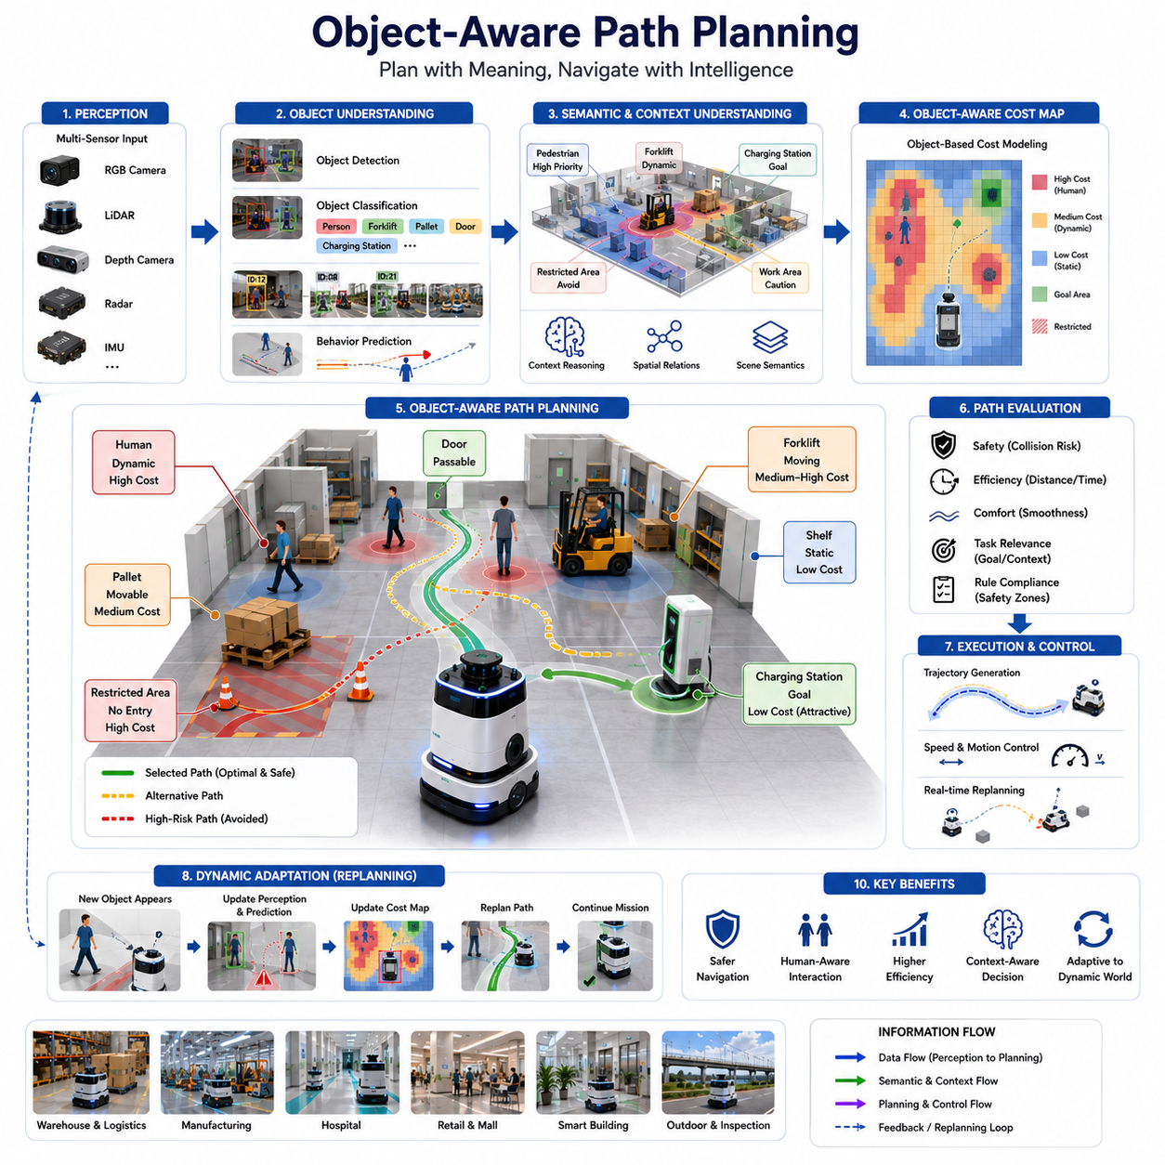
Object-Aware Path Planning is an advanced navigation methodology that enables autonomous robots to generate paths not only based on geometric obstacles and free-space information but also based on the semantic understanding of objects present in the environment. Traditional path planning algorithms primarily treat the environment as a collection of occupied and unoccupied regions. While this approach is effective for basic navigation tasks, it does not distinguish between different types of objects, their functions, their behaviors, or their potential impact on robot operations. Object-aware path planning addresses this limitation by incorporating object-level intelligence into the navigation process, allowing robots to make more informed, context-sensitive, and mission-oriented decisions.
In conventional navigation systems, a wall, a human, a forklift, a hospital bed, a charging station, and a pallet may all be represented as obstacles within a cost map. From a purely geometric perspective, these objects occupy physical space and must be avoided. However, in real-world environments, these objects have vastly different meanings, risks, movement patterns, and operational implications. A human may move unpredictably, a forklift may follow industrial traffic routes, a charging station may serve as a navigation goal, and a pallet may represent a temporary obstacle that can be relocated. Object-aware path planning recognizes these distinctions and incorporates them into the path generation process.
The fundamental objective of object-aware path planning is to enable robots to understand what objects are present in the environment and how those objects should influence navigation behavior. Rather than planning solely around geometry, the robot plans around meaning. This semantic awareness allows navigation systems to become more intelligent, safer, and more efficient in complex environments where interactions with objects are unavoidable.
Object-aware path planning begins with environmental perception. Modern autonomous robots rely on multiple sensors, including RGB cameras, depth cameras, stereo vision systems, LiDAR sensors, radar systems, ultrasonic sensors, thermal cameras, and inertial measurement units. These sensors continuously collect information about the surrounding environment. Raw sensor data is processed through perception pipelines that detect, classify, track, and analyze environmental objects. The resulting object information forms the foundation for semantic navigation decisions.
Object detection serves as the first stage of object-aware navigation. Deep learning-based object detection models identify objects within sensor data and assign class labels. A robot may recognize people, forklifts, vehicles, shelves, carts, machinery, doors, charging stations, workstations, elevators, hospital beds, wheelchairs, traffic cones, and numerous other environmental elements. Each recognized object contributes semantic information that influences path planning decisions.
Object classification extends beyond simple identification. Different object categories require different navigation responses. A stationary wall represents a permanent obstacle, while a human represents a dynamic entity that may change direction unexpectedly. A charging station may be considered a destination rather than an obstacle. A safety barrier may indicate restricted access, while an emergency exit may represent a critical navigation resource. Understanding these distinctions enables robots to assign different navigation priorities and behaviors to different object types.
Object tracking introduces temporal awareness into the navigation process. Dynamic objects move through the environment and continuously change their positions. Tracking algorithms estimate object trajectories, velocities, accelerations, and future positions. By predicting future object motion, robots can proactively adjust their navigation plans instead of merely reacting to immediate obstacles. This predictive capability significantly improves navigation smoothness and safety.
One of the key innovations in object-aware path planning is the concept of object-based cost maps. Traditional cost maps assign navigation costs based primarily on obstacle proximity. Object-aware cost maps extend this concept by assigning costs based on object type, behavior, operational significance, and safety requirements. Areas near humans may receive higher navigation costs than areas near static equipment. Regions surrounding moving forklifts may be assigned dynamic safety zones. Areas containing sensitive equipment may be marked as restricted navigation zones. Through object-aware cost modeling, navigation decisions become more aligned with real-world operational requirements.
Human-aware navigation represents one of the most important applications of object-aware path planning. In environments shared with humans, robots must navigate safely, comfortably, and socially appropriately. Object-aware systems recognize people as unique entities that require special consideration. Rather than treating humans as obstacles, robots understand them as dynamic participants within the environment. Navigation systems may maintain larger safety distances, reduce speed near pedestrians, yield right-of-way, or select alternative routes to minimize interference with human activities.
Industrial environments present additional challenges that benefit from object-aware planning. Manufacturing facilities, warehouses, logistics centers, and ports contain diverse objects with distinct operational functions. Forklifts follow transportation routes, pallets occupy storage areas, automated conveyors create movement constraints, and production machinery defines safety boundaries. Object-aware navigation allows robots to understand these operational structures and generate paths that align with industrial workflows. This results in improved efficiency, reduced congestion, and enhanced safety.
Hospitals provide another compelling example of object-aware navigation. Medical environments contain numerous object categories with different priorities and navigation implications. Hospital beds, wheelchairs, medical carts, nurses, doctors, patients, and emergency equipment all influence navigation behavior. A robot delivering medicine may prioritize routes that minimize disruption to patient care areas while avoiding congested corridors and respecting medical safety protocols. Object-aware planning enables robots to operate effectively within these highly sensitive environments.
Object-aware path planning is closely related to semantic mapping. Semantic maps store information about object identities, locations, categories, relationships, and functional roles. As robots move through the environment, they continuously update semantic maps with newly observed object information. These maps provide long-term environmental knowledge that supports navigation decisions across multiple missions and operational scenarios.
Three-dimensional object understanding further enhances navigation intelligence. Using LiDAR point clouds, depth sensing, stereo vision, and sensor fusion technologies, robots can estimate object dimensions, shapes, orientations, and spatial configurations. Understanding the three-dimensional structure of objects allows navigation systems to evaluate traversability, clearance margins, and collision risks more accurately. This capability is particularly important in environments containing large machinery, narrow corridors, shelving systems, and irregular obstacles.
Contextual reasoning represents a higher level of object-aware intelligence. Rather than considering objects individually, contextual reasoning examines relationships among objects and environmental conditions. A robot may recognize that a pallet located beside a loading dock is likely part of an active logistics operation. A wheelchair positioned near a patient room may indicate ongoing patient transport activities. A forklift approaching an intersection may signal increased traffic risk. Such contextual understanding enables more intelligent navigation decisions.
Object behavior prediction is another essential component of advanced path planning systems. Dynamic objects often exhibit predictable behavior patterns. Pedestrians tend to follow walkways, forklifts operate along designated industrial routes, and vehicles move according to traffic rules. By learning and modeling these behavior patterns, robots can anticipate future environmental states and generate safer navigation plans. Predictive navigation reduces sudden maneuvers and improves operational efficiency.
Artificial intelligence plays a central role in object-aware path planning. Deep neural networks, convolutional neural networks, transformer architectures, graph neural networks, and multimodal AI systems provide the computational foundation for object recognition, tracking, classification, and reasoning. These technologies allow robots to interpret complex sensory data and convert it into actionable navigation knowledge.
Recent advances in foundation models have significantly expanded the capabilities of object-aware navigation systems. Vision-Language Models and Vision-Language-Action models can understand both visual scenes and natural language instructions. These systems enable robots to interpret commands such as “avoid the maintenance area,” “deliver supplies near the nurse station,” or “follow the route around heavy machinery.” Such capabilities combine object understanding with mission-level reasoning.
Object-aware path planning is particularly valuable in dynamic environments where environmental conditions change continuously. Construction sites, logistics centers, hospitals, airports, shopping malls, and smart cities all contain dynamic objects that influence navigation decisions. Traditional navigation systems often struggle to adapt efficiently to these changing conditions. Object-aware systems continuously update environmental understanding and modify navigation strategies accordingly.
Outdoor autonomous robots benefit significantly from object-aware planning. Urban environments contain pedestrians, bicycles, vehicles, traffic signs, construction equipment, street furniture, and infrastructure elements. Agricultural robots encounter crops, irrigation systems, tractors, workers, and terrain features. Infrastructure inspection robots may navigate around utility equipment, maintenance vehicles, road barriers, and construction zones. Object-aware understanding enables safe and efficient operation across these diverse outdoor scenarios.
For infrastructure inspection platforms such as GPR-based underground utility inspection robots, object-aware path planning provides substantial advantages. Inspection missions often involve operation near roads, bridges, utility corridors, traffic lanes, construction equipment, pedestrians, and maintenance crews. By recognizing and understanding these objects, robots can optimize inspection routes while maintaining safety and minimizing disruption to surrounding activities. Object-aware navigation can also support intelligent prioritization of inspection targets and adaptive mission planning.
Multi-robot systems also benefit from object-aware navigation principles. In fleet environments, robots themselves become tracked objects within the navigation framework. Each robot can share object information, environmental observations, and navigation intentions with other robots through fleet management systems. Shared object awareness improves traffic coordination, collision avoidance, congestion management, and overall fleet efficiency.
The integration of object-aware planning with behavior planning creates more sophisticated navigation systems. Behavior planners can use object information to select appropriate navigation modes. A robot may choose cautious navigation near pedestrians, efficient transportation behavior within logistics corridors, precise docking behavior near charging stations, or inspection-focused navigation around infrastructure assets. Object awareness provides the contextual information necessary for adaptive behavioral decision-making.
Simulation and digital twin environments play an important role in developing object-aware navigation systems. Virtual environments allow developers to model diverse object categories, complex interactions, dynamic scenarios, and rare edge cases. Simulation-based testing enables extensive validation before deployment in real-world environments, reducing development risks and improving system reliability.
Performance evaluation of object-aware path planning extends beyond traditional navigation metrics. In addition to path length, travel time, and obstacle avoidance success rates, developers must evaluate object recognition accuracy, object tracking reliability, semantic understanding quality, human interaction performance, safety compliance, and mission completion effectiveness. These metrics provide a more comprehensive assessment of navigation intelligence.
Future developments in object-aware path planning are expected to leverage embodied AI, world models, multimodal reasoning, and large-scale foundation models. Future robots will not simply recognize objects but understand their purposes, relationships, operational significance, and future behavior. Navigation systems will increasingly reason about environments at a conceptual level, integrating perception, prediction, planning, and decision-making into unified cognitive architectures.
As autonomous robots become more deeply integrated into factories, hospitals, logistics facilities, smart cities, transportation hubs, agricultural operations, and infrastructure inspection systems, object-aware path planning will become a foundational technology for intelligent autonomy. By combining object understanding with navigation intelligence, robots gain the ability to move safely, efficiently, and purposefully through complex environments while interacting naturally with people, equipment, and operational processes. Within the broader framework of semantic navigation, object-aware path planning serves as a critical mechanism that transforms navigation from obstacle avoidance into intelligent environmental interaction, enabling the next generation of autonomous robotic systems.

09.4 Human-Centered Navigation
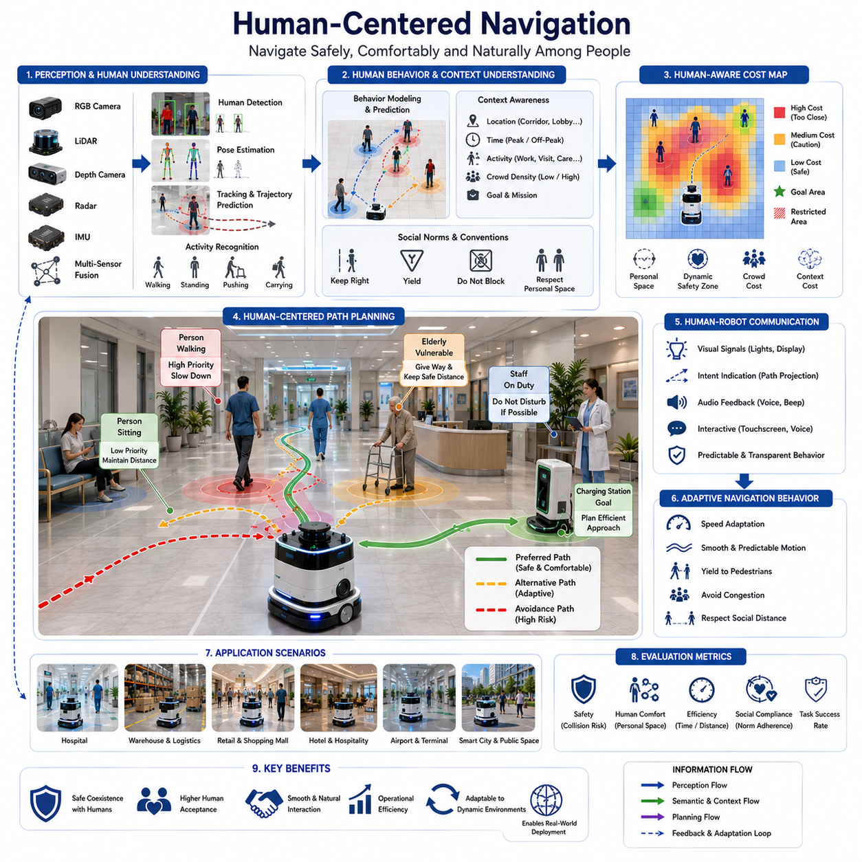
Human-Centered Navigation is a navigation paradigm that enables autonomous robots to move safely, efficiently, and naturally within environments shared with people. Unlike traditional navigation systems that focus primarily on obstacle avoidance and path optimization, human-centered navigation incorporates human behavior, social conventions, environmental context, and user expectations into the decision-making process. The objective is not simply to prevent collisions but to ensure that robot movements are comfortable, predictable, socially acceptable, and aligned with human activities. As autonomous mobile robots become increasingly common in hospitals, warehouses, airports, shopping centers, office buildings, hotels, factories, and smart cities, the ability to navigate harmoniously among people has become a critical requirement for successful deployment.
Traditional robot navigation systems typically treat all obstacles similarly. Whether the obstacle is a wall, a box, a machine, or a person, the navigation system often focuses on maintaining a safe geometric distance and avoiding collisions. While this approach is sufficient in highly structured industrial environments, it is inadequate in human-centered spaces where social interactions and human comfort play important roles. Humans are not static obstacles. They move unpredictably, change directions, communicate intentions through body language, and expect other entities within their environment to follow certain social norms. Human-centered navigation seeks to address these challenges by enabling robots to understand and respond appropriately to human presence and behavior.
The foundation of human-centered navigation begins with human perception. Robots must first be capable of reliably detecting and identifying people within their environment. Modern perception systems utilize RGB cameras, depth cameras, LiDAR sensors, radar systems, thermal imaging sensors, and multi-sensor fusion technologies to recognize human presence. Advanced computer vision algorithms and deep learning models allow robots to distinguish humans from other objects, estimate human positions, track movement, and recognize individual behaviors. Accurate human perception is essential because all subsequent navigation decisions depend upon a correct understanding of human locations and activities.
Human detection alone is not sufficient. Effective navigation requires understanding how humans move through an environment. Human tracking systems continuously estimate positions, velocities, movement directions, and trajectories. By observing motion patterns over time, robots can predict where individuals are likely to move in the near future. Such predictive capabilities allow navigation systems to make proactive decisions rather than merely reacting to immediate situations. Predictive navigation reduces abrupt maneuvers and improves overall interaction quality.
Human behavior modeling represents a critical aspect of human-centered navigation. People do not move randomly. Their movements are influenced by goals, environmental structures, social interactions, and cultural norms. A person walking through a hospital corridor behaves differently from a person shopping in a retail store or working in a factory. Human-centered navigation systems attempt to model these behavioral patterns and incorporate them into navigation planning. By understanding likely human actions, robots can anticipate future environmental states and generate safer and more socially appropriate paths.
One of the most important concepts in human-centered navigation is personal space. Humans naturally maintain invisible comfort zones around themselves during social interactions. The size and shape of these zones vary depending on context, culture, activity, and individual preferences. When robots enter these personal spaces unnecessarily, people may experience discomfort or anxiety. Human-centered navigation systems incorporate personal space models into cost maps and path planning algorithms, ensuring that robots maintain appropriate distances from nearby individuals whenever possible.
The concept of social navigation extends beyond personal space. Human societies follow implicit rules governing movement and interaction. People typically walk on specific sides of corridors, yield in certain situations, avoid blocking entrances, and adjust movement based on crowd behavior. Human-centered navigation aims to emulate these social conventions. Robots can follow designated pedestrian traffic patterns, avoid obstructing pathways, wait for people to pass through narrow passages, and move in ways that align with local social expectations. Such behavior significantly improves human acceptance of robotic systems.
Context awareness plays a central role in determining appropriate navigation behavior. Human-centered navigation systems must understand not only where people are but also what they are doing. A nurse transporting medication through a hospital requires different navigation considerations than a visitor walking through a lobby. A factory worker operating machinery requires different treatment than an employee sitting at a workstation. Understanding context enables robots to adapt navigation behavior based on environmental situations and operational priorities.
Human activity recognition enhances contextual understanding. By analyzing posture, movement patterns, gestures, and interactions, robots can infer ongoing activities. A person standing still may be waiting, while a person carrying equipment may be actively performing a task. Groups of people engaged in conversation may require different navigation treatment than individuals walking alone. Recognizing these activities allows robots to make more intelligent decisions and avoid disrupting human workflows.
Crowd-aware navigation represents an important extension of human-centered navigation. Many real-world environments contain groups of people rather than isolated individuals. Hospitals, airports, shopping centers, train stations, and public facilities often experience varying crowd densities. Robots operating in these environments must understand crowd dynamics and adapt accordingly. Crowd-aware systems analyze pedestrian flow patterns, identify congested regions, estimate crowd density, and predict collective movement behaviors. This information allows robots to select efficient and socially acceptable routes through crowded environments.
Safety remains the highest priority in human-centered navigation. While social acceptability and efficiency are important, ensuring human safety is fundamental. Safety mechanisms typically include dynamic safety zones, speed adaptation, emergency stop systems, collision prediction algorithms, and redundancy measures. Safety zones often expand when robots move at higher speeds and contract when operating slowly. Dynamic safety systems continuously adjust navigation parameters based on environmental conditions and human proximity.
Speed adaptation is another essential feature of human-centered navigation. Humans naturally expect robots to move more cautiously in crowded or sensitive environments. A robot may travel quickly in an empty warehouse corridor but reduce its speed significantly when approaching pedestrians or operating near patients in a hospital. Speed modulation enhances both safety and perceived comfort while maintaining operational efficiency.
Human-centered navigation is particularly important in healthcare environments. Hospitals contain vulnerable populations, including patients, elderly individuals, medical staff, and visitors. Robots operating within hospitals must navigate quietly, safely, and respectfully. They must avoid disturbing patients, interfering with medical procedures, or obstructing emergency pathways. Human-centered navigation enables robots to recognize sensitive areas, adapt behaviors accordingly, and integrate seamlessly into healthcare workflows.
Retail and service environments present unique human interaction challenges. Customers often move unpredictably, stop suddenly, change directions, and interact with products. Robots operating in stores, malls, hotels, and service facilities must exhibit highly adaptive navigation behavior. Human-centered navigation allows service robots to approach customers appropriately, avoid interrupting conversations, and maintain comfortable distances during interactions.
Industrial facilities also benefit from human-centered navigation despite their structured nature. Modern factories increasingly adopt collaborative work models where humans and robots share operational spaces. Human-centered navigation allows autonomous mobile robots to transport materials, deliver components, and perform inspection tasks without interfering with workers. By understanding human activities and operational workflows, robots can improve productivity while maintaining safe collaboration.
Communication between humans and robots plays an increasingly important role in navigation systems. Human-centered robots often communicate intentions through visual indicators, displays, lights, sounds, projected paths, or natural language interactions. For example, a robot may indicate its intended direction before turning, display a waiting signal when yielding to pedestrians, or provide verbal notifications when approaching crowded areas. Such communication improves predictability and reduces uncertainty during interactions.
Artificial intelligence significantly enhances human-centered navigation capabilities. Deep learning models enable human detection, pose estimation, behavior prediction, activity recognition, and social interaction analysis. Transformer-based architectures and multimodal AI systems can combine visual, spatial, temporal, and contextual information to generate comprehensive models of human behavior. These AI-driven capabilities allow robots to operate effectively in increasingly complex human environments.
Recent advances in foundation models have introduced new possibilities for human-centered navigation. Vision-Language Models and Vision-Language-Action systems allow robots to understand both visual scenes and human instructions. Robots can interpret commands such as “follow me,” “wait here,” “avoid the patient area,” or “deliver supplies to the nurse station.” By combining language understanding with navigation intelligence, robots become more accessible and intuitive for human users.
Human-centered navigation is closely connected to semantic navigation and scene understanding. Understanding the environment requires recognizing both physical structures and human activities. Semantic maps often contain information about workspaces, waiting areas, restricted zones, pedestrian corridors, meeting rooms, and service locations. Navigation systems use this semantic knowledge to select routes that align with human expectations and operational requirements.
Outdoor environments introduce additional challenges for human-centered navigation. Sidewalks, crosswalks, public parks, campuses, transportation hubs, and smart city infrastructures contain highly dynamic pedestrian behavior. Robots operating outdoors must understand traffic rules, pedestrian priorities, social norms, and environmental constraints. Human-centered navigation enables robots to coexist safely and naturally within public spaces.
For autonomous inspection robots, including GPR-based infrastructure inspection systems, human-centered navigation remains highly relevant. Inspection robots often operate near roads, construction sites, utility workers, maintenance crews, and public spaces. Human-centered navigation allows these robots to perform inspection tasks while minimizing disruption to ongoing activities. By recognizing workers, equipment operators, and pedestrians, robots can adapt routes and behaviors to maintain safety and operational efficiency.
Multi-robot systems further increase the complexity of human-centered navigation. Multiple robots sharing an environment with humans must coordinate not only with people but also with one another. Fleet management systems can optimize robot traffic, reduce congestion, and ensure that human comfort remains a priority. Shared situational awareness enables robots to collectively adapt to changing human activities and environmental conditions.
Simulation environments and digital twins play a crucial role in developing human-centered navigation systems. Real-world human behavior is highly diverse and difficult to model completely. Simulation allows researchers and engineers to test navigation algorithms across thousands of scenarios involving varying crowd densities, movement patterns, environmental layouts, and interaction conditions. These simulations help identify potential safety issues and improve navigation robustness before deployment.
Performance evaluation of human-centered navigation extends beyond traditional navigation metrics such as path length and travel time. Additional metrics include human comfort, social compliance, interaction quality, safety performance, task success rates, crowd navigation efficiency, and user acceptance. Human feedback often becomes an important component of evaluation because navigation quality is ultimately judged by the people who share the environment with robots.
The future of human-centered navigation will likely be shaped by embodied AI, world models, multimodal reasoning systems, and advanced cognitive robotics. Future robots will not only detect and avoid people but also understand human intentions, emotional states, social relationships, and collaborative goals. Navigation systems will evolve from reactive motion planners into intelligent social agents capable of participating naturally in human environments.
As autonomous mobile robots become increasingly integrated into hospitals, logistics centers, factories, airports, hotels, universities, smart cities, and public infrastructure systems, human-centered navigation will become a fundamental requirement rather than an optional enhancement. The success of future robotic systems will depend not only on their ability to reach destinations efficiently but also on their ability to coexist harmoniously with people. Human-centered navigation provides the framework that enables robots to move safely, respectfully, predictably, and intelligently within human-centered environments, making it one of the most important components of next-generation autonomous navigation systems.

09.5 AI-Based Environment Reasoning
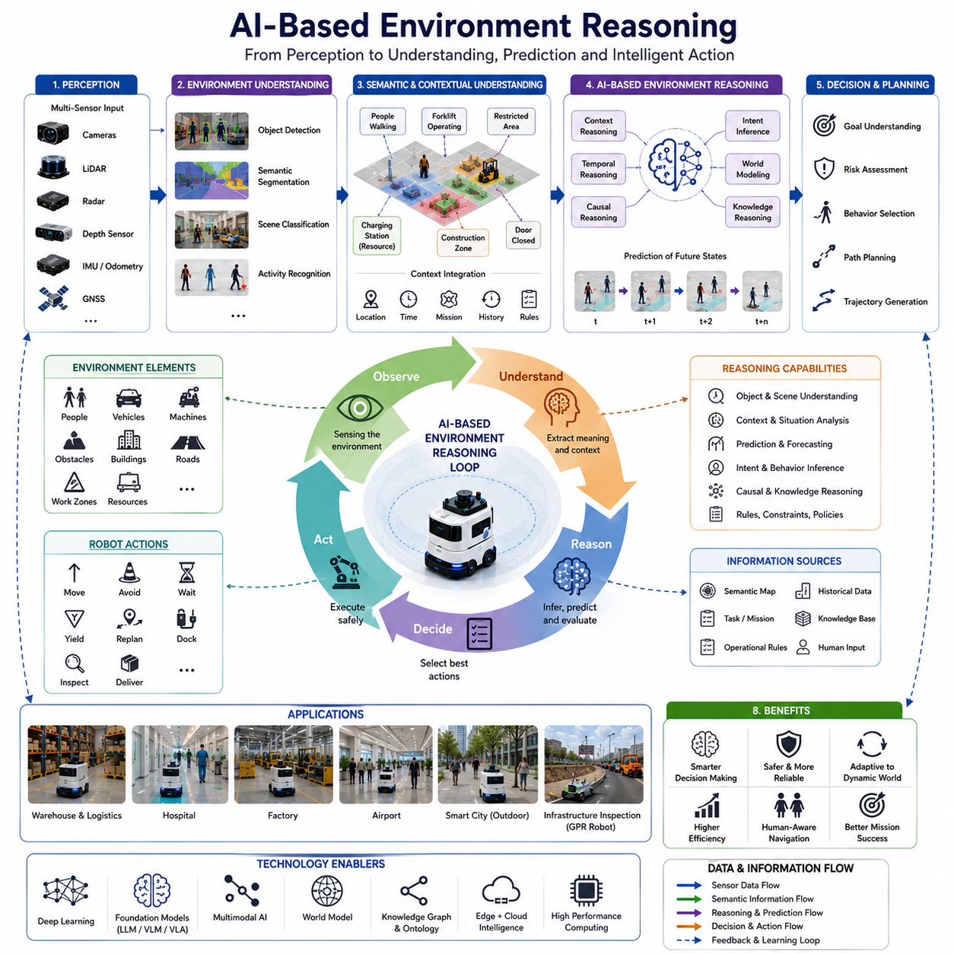
AI-Based Environment Reasoning is an advanced capability that enables autonomous robots to understand, interpret, predict, and reason about their surrounding environment using artificial intelligence. Traditional navigation systems primarily focus on localization, mapping, obstacle avoidance, and path planning based on geometric information. While these systems can successfully move a robot from one location to another, they often lack the ability to understand why environmental events occur, what the implications of those events may be, and how future situations might evolve. AI-based environment reasoning addresses these limitations by allowing robots to transform sensory observations into meaningful knowledge, contextual understanding, and intelligent decision-making. This capability forms one of the most important foundations of semantic navigation within modern autonomous mobile robot systems. It serves as a bridge between perception and cognition, enabling robots to move beyond reactive navigation toward intelligent autonomous behavior.
Environment reasoning begins with perception. Robots continuously collect large volumes of data from cameras, LiDAR sensors, radar systems, depth sensors, thermal cameras, ultrasonic sensors, GNSS receivers, IMUs, and other sensing devices. These sensors provide information about objects, obstacles, terrain, human activities, environmental structures, and dynamic events. However, raw sensor data alone has limited value. AI-based reasoning systems transform these observations into structured knowledge that can support navigation and decision-making.
The first step in environment reasoning involves environmental understanding. The robot must recognize what exists within its surroundings and classify environmental elements into meaningful categories. Deep learning models perform object detection, semantic segmentation, scene classification, activity recognition, and contextual analysis. Through these processes, the robot can identify people, vehicles, machinery, workstations, buildings, roads, corridors, elevators, charging stations, safety zones, and other relevant entities. Environmental understanding converts sensory information into semantic information that can be used by higher-level reasoning systems.
Semantic understanding extends beyond object recognition. A robot must understand not only what objects are present but also what those objects mean within a particular context. A forklift operating inside a warehouse represents an active logistics process. A group of workers gathered around machinery may indicate ongoing maintenance activities. A closed door may restrict access to a particular area. A charging station may represent an operational resource rather than an obstacle. AI-based reasoning enables robots to interpret these meanings and incorporate them into navigation decisions.
Contextual reasoning represents one of the most powerful aspects of AI-based environment understanding. Context refers to the relationships between objects, activities, environmental conditions, operational goals, and historical information. The same object may require different navigation responses depending on context. A person standing in a corridor may simply be waiting, while a person directing traffic may influence route selection. A vehicle parked beside a road may be harmless, whereas a moving vehicle approaching an intersection may represent a significant navigation risk. AI systems use contextual information to distinguish between such situations and select appropriate behaviors.
Environment reasoning requires the integration of multiple sources of information. Modern AI systems combine visual information, spatial data, temporal observations, semantic maps, operational rules, and mission objectives into unified representations. Multimodal reasoning architectures allow robots to process diverse forms of information simultaneously. A robot may combine camera imagery, LiDAR geometry, semantic labels, task instructions, and environmental history to generate a comprehensive understanding of its current situation.
Temporal reasoning is a critical component of environment understanding. Environments are not static. Objects move, people change locations, weather conditions evolve, and operational situations continuously change. Effective reasoning systems must understand how environmental conditions develop over time. Temporal reasoning enables robots to analyze sequences of observations, identify trends, recognize patterns, and predict future events. Rather than responding only to the current state of the environment, robots can anticipate future conditions and adapt proactively.
Prediction plays a central role in AI-based environment reasoning. Predictive models estimate how objects, people, vehicles, and environmental states are likely to evolve in the future. Pedestrians may continue walking along a corridor. Forklifts may follow industrial transportation routes. Vehicles may approach intersections. Weather conditions may affect outdoor visibility. By predicting future states, robots can generate safer and more efficient navigation plans. Predictive reasoning significantly improves decision-making quality in dynamic environments.
Human behavior reasoning represents a particularly important application of AI-based reasoning. Humans exhibit complex and sometimes unpredictable behavior. AI models can analyze movement patterns, social interactions, gestures, body posture, and contextual information to infer human intentions. A person approaching an elevator likely intends to enter it. A worker carrying equipment may be engaged in maintenance activities. A group of people gathered in a corridor may create temporary congestion. Understanding human intentions enables robots to navigate more naturally and safely within human-centered environments.
Scene understanding provides another foundation for environment reasoning. Scene understanding involves interpreting the overall structure and purpose of an environment. A robot operating in a hospital must recognize patient rooms, nursing stations, waiting areas, operating rooms, and emergency corridors. In a warehouse, the robot must understand storage zones, loading docks, transportation routes, and inventory locations. Scene understanding provides the contextual framework within which reasoning occurs.
World models represent an emerging paradigm for advanced environment reasoning. A world model is an internal representation of the environment that captures not only current observations but also environmental dynamics, object relationships, causal structures, and future possibilities. Rather than relying solely on immediate sensor inputs, robots can reason using a continuously updated internal model of the world. This approach enables long-term planning, hypothetical reasoning, and adaptive decision-making.
Causal reasoning extends environmental intelligence even further. Traditional AI systems often identify correlations, but advanced reasoning systems seek to understand cause-and-effect relationships. For example, a robot may infer that congestion near a loading dock is caused by active unloading operations. It may recognize that a blocked corridor results from maintenance activities. Understanding causality allows robots to make more accurate predictions and select more effective navigation strategies.
Knowledge-based reasoning combines learned AI models with structured knowledge representations. Semantic maps, ontologies, rule-based systems, operational procedures, and domain-specific knowledge bases provide additional context for decision-making. A hospital robot may understand that emergency routes should remain unobstructed. A factory robot may recognize restricted safety zones around heavy machinery. Knowledge-based reasoning allows robots to apply organizational rules and operational policies during navigation.
Large Language Models have introduced new opportunities for environment reasoning. LLMs can process natural language instructions, contextual information, operational constraints, and environmental descriptions to support high-level reasoning tasks. When integrated with perception systems, LLMs enable robots to interpret complex instructions such as “deliver supplies to the nearest available nurse station while avoiding crowded areas” or “inspect the maintenance zone after workers have completed repairs.” These capabilities significantly enhance robot flexibility and autonomy.
Vision-Language Models and Vision-Language-Action systems further expand reasoning capabilities. These multimodal models integrate visual understanding, language comprehension, and action planning into unified architectures. A robot can observe its environment, interpret human instructions, understand contextual relationships, and generate appropriate navigation actions. This integration represents a major step toward embodied intelligence.
AI-based environment reasoning is particularly valuable in dynamic and unstructured environments. Construction sites, hospitals, logistics centers, airports, agricultural fields, industrial facilities, and urban environments contain continuously changing conditions. Traditional rule-based systems often struggle to adapt effectively in such scenarios. AI reasoning systems continuously learn, update environmental models, and adjust behaviors based on new observations.
Outdoor autonomous navigation presents unique reasoning challenges. Environmental conditions vary significantly due to weather, lighting, traffic, terrain, and human activity. An outdoor robot must reason about road conditions, pedestrian movements, construction zones, utility infrastructure, vegetation, and weather impacts. AI-based reasoning enables robust navigation despite environmental uncertainty and variability.
For GPR-based infrastructure inspection robots, environment reasoning provides substantial operational benefits. Inspection missions often occur in environments containing roads, vehicles, construction equipment, maintenance crews, utility infrastructure, pedestrians, and temporary work zones. AI reasoning allows robots to understand operational context, prioritize inspection targets, adapt routes dynamically, and coordinate safely with surrounding activities. Environmental reasoning can also support intelligent mission planning by considering inspection objectives, environmental constraints, and operational priorities simultaneously.
Multi-robot systems benefit greatly from shared environment reasoning. Individual robots can contribute observations to a common environmental knowledge base. Fleet-level reasoning systems can combine information from multiple robots to create more comprehensive environmental models. Shared reasoning improves traffic coordination, task allocation, congestion management, and operational efficiency. Cloud-based fleet intelligence enables collective understanding that exceeds the capabilities of individual robots.
Behavior planning systems rely heavily on environment reasoning outputs. High-level navigation decisions often depend on understanding environmental conditions, human activities, operational priorities, and future predictions. Environment reasoning provides the contextual information necessary for behavior selection, route planning, safety management, and task execution. Without reasoning capabilities, behavior planning remains limited to reactive decision-making.
Simulation and digital twin technologies play an important role in developing AI reasoning systems. Digital twins provide realistic virtual environments where reasoning algorithms can be trained, tested, and validated. Simulations allow robots to encounter diverse scenarios, rare events, and edge cases that may be difficult to observe in real-world operations. These environments support continuous improvement of reasoning capabilities before deployment.
Evaluation of AI-based environment reasoning requires more than traditional navigation metrics. Performance assessment includes semantic understanding accuracy, contextual reasoning quality, prediction reliability, decision consistency, adaptability, mission effectiveness, and safety performance. Benchmarking frameworks increasingly evaluate how well robots understand environmental meaning rather than simply measuring movement performance.
Future developments in AI-based environment reasoning are expected to be closely connected with embodied AI, cognitive robotics, foundation models, world models, and artificial general intelligence technologies. Future robots will reason not only about what exists in the environment but also about why events occur, what goals other agents may have, and how environmental situations are likely to evolve. These systems will integrate perception, memory, reasoning, planning, learning, and action into unified cognitive architectures.
As autonomous mobile robots become more deeply integrated into factories, hospitals, logistics centers, smart cities, transportation systems, agricultural operations, and infrastructure inspection platforms, AI-based environment reasoning will become a foundational technology for intelligent autonomy. It transforms navigation from a geometric problem into a cognitive process, enabling robots to understand environmental meaning, anticipate future conditions, make informed decisions, and interact intelligently with the world around them. Within the broader framework of semantic navigation, AI-based environment reasoning serves as the cognitive engine that converts perception into knowledge and knowledge into intelligent autonomous action, making it one of the most important technologies for the next generation of autonomous robotic systems.

09.6 Language-Guided Navigation
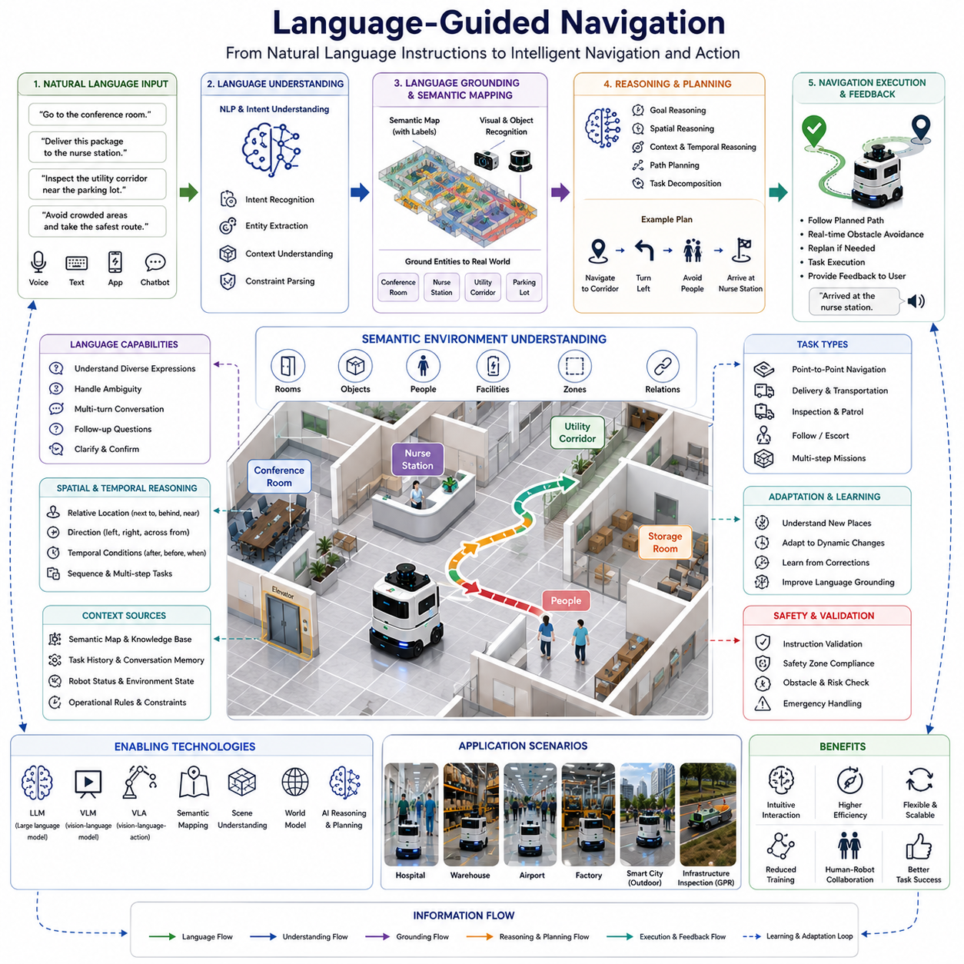
Language-Guided Navigation represents one of the most significant advancements in autonomous robotics, enabling robots to navigate environments using natural language instructions provided by humans. Traditional navigation systems typically require predefined coordinates, structured mission plans, manually selected destinations, or explicit waypoint definitions. While these methods are effective in controlled environments, they create a gap between human communication and robotic operation. Humans naturally describe destinations and tasks using language rather than coordinates. People say “go to the conference room,” “deliver this package to the nurse station,” or “inspect the utility corridor near the parking lot.” Language-guided navigation seeks to bridge this gap by allowing robots to understand, interpret, and execute navigation tasks expressed in natural human language. This capability represents a critical step toward intuitive human-robot interaction and forms a core component of semantic navigation systems.
The fundamental objective of language-guided navigation is to transform linguistic instructions into executable navigation actions. Unlike traditional navigation systems that operate primarily on geometric representations of space, language-guided navigation combines perception, semantic understanding, reasoning, mapping, and decision-making to connect language with physical environments. The robot must understand both what the user intends and how that intention relates to the current environment. This requires the integration of multiple artificial intelligence technologies, including natural language processing, computer vision, semantic mapping, scene understanding, world modeling, and autonomous navigation.
Natural language serves as the primary interface between humans and robots. Human language is rich, flexible, and context-dependent. A user may provide precise instructions such as “go to Room 301” or more ambiguous commands such as “go to the nearest meeting room.” People may also describe locations relative to other objects, saying “go to the office next to the elevator” or “inspect the area behind the loading dock.” Language-guided navigation systems must interpret these instructions accurately despite variations in wording, grammar, context, and user intent.
The process begins with natural language understanding. The robot receives spoken or written instructions through voice recognition systems, text interfaces, mobile applications, or conversational agents. Natural language processing models analyze the instruction to identify goals, destinations, constraints, actions, priorities, and contextual information. The system extracts semantic meaning from the language and converts it into structured representations that can be processed by navigation algorithms.
Intent recognition plays a central role in language-guided navigation. The robot must determine what the user wants to accomplish. An instruction such as “go to the maintenance area” implies a navigation goal. A command such as “follow the technician” indicates a dynamic target. A request such as “inspect all charging stations on this floor” involves a sequence of navigation and inspection tasks. Understanding user intent allows the robot to select appropriate navigation strategies and operational behaviors.
Entity recognition is another important component of language understanding. Language instructions often contain references to specific objects, locations, people, rooms, equipment, or environmental features. The robot must identify these entities and connect them to corresponding representations within its semantic map. For example, terms such as conference room, charging station, warehouse aisle, patient room, elevator, maintenance workshop, and inspection zone must be associated with actual physical locations in the environment.
Grounding language in the physical world is one of the most challenging aspects of language-guided navigation. Language grounding refers to the process of connecting linguistic concepts to real-world objects and locations. A robot may understand the phrase “go to the red machine near the storage area,” but it must also identify which machine is being referenced and determine its location within the environment. Grounding requires the integration of perception systems, semantic maps, object recognition algorithms, and contextual reasoning mechanisms.
Semantic maps provide the environmental knowledge necessary for language grounding. Traditional maps represent geometry and occupancy information. Semantic maps extend these representations by incorporating labels, object categories, room names, functional areas, and contextual relationships. When a user instructs the robot to navigate to a nurse station, storage room, inspection area, or charging dock, the robot can locate the corresponding semantic entity within its map and generate an appropriate navigation plan.
Scene understanding further enhances language-guided navigation. Environmental observations provide additional context that supports instruction interpretation. A robot operating in a hospital may recognize patient rooms, nurse stations, waiting areas, pharmacies, and emergency departments. A warehouse robot may identify loading docks, storage shelves, workstations, and transportation corridors. This environmental understanding allows the robot to associate language with real-world structures and improve navigation accuracy.
Context plays a critical role in interpreting language instructions. Human communication often relies on shared contextual knowledge. A command such as “go to the usual delivery location” assumes familiarity with operational routines. Instructions such as “inspect the area we discussed earlier” depend on conversational history. Context-aware navigation systems maintain memory of previous interactions, operational tasks, and environmental conditions to resolve ambiguity and improve instruction interpretation.
Spatial reasoning is an essential capability for language-guided navigation. Humans frequently describe locations using relative spatial relationships rather than absolute coordinates. Instructions may include expressions such as next to, behind, in front of, across from, near, inside, outside, above, below, or between. Robots must understand these spatial concepts and reason about their geometric implications. Spatial reasoning enables robots to locate destinations that are defined relative to other environmental features.
Temporal reasoning also contributes to effective navigation. Some instructions involve time-dependent conditions. A user may request that a robot “wait until the corridor is clear before proceeding” or “deliver supplies after the maintenance work is completed.” Such commands require the robot to understand temporal relationships, monitor environmental conditions, and execute actions at appropriate times.
Large Language Models have significantly expanded the capabilities of language-guided navigation. Traditional natural language processing systems relied heavily on predefined rules and structured grammars. Modern LLMs can understand diverse language styles, complex instructions, implicit assumptions, and contextual references. These models provide robust language understanding across a wide range of navigation scenarios and user interactions.
Vision-Language Models extend these capabilities by combining language understanding with visual perception. VLMs allow robots to interpret instructions in relation to visual observations. A robot can understand commands such as “go to the room with the blue sign” or “inspect the equipment shown in this image.” By integrating language and vision, robots achieve more flexible and context-aware navigation behavior.
Vision-Language-Action architectures represent a further evolution of language-guided navigation. These systems directly connect perception, language understanding, reasoning, and action generation within a unified framework. Instead of treating language processing and navigation planning as separate modules, VLA systems enable end-to-end decision-making. A robot can interpret an instruction, understand its environment, reason about possible actions, and generate navigation commands within a single integrated architecture.
AI-based reasoning is closely intertwined with language-guided navigation. Human instructions are often incomplete or ambiguous. A user may say “take the safest route” or “avoid crowded areas.” The robot must reason about what constitutes safety or congestion in the current environment. AI reasoning systems analyze environmental conditions, operational constraints, and mission objectives to resolve ambiguities and generate appropriate navigation plans.
Human-centered navigation benefits significantly from language guidance. Natural language allows users to communicate preferences, priorities, and constraints that may not be captured by traditional navigation parameters. For example, hospital staff may request that a robot avoid patient recovery areas, while warehouse managers may instruct robots to prioritize high-efficiency transportation routes. Language provides a flexible mechanism for expressing human intent and operational requirements.
Multi-step task execution is another important aspect of language-guided navigation. Many real-world instructions involve sequences of actions rather than simple point-to-point navigation. A user may instruct a robot to “go to the storage room, collect the equipment, and deliver it to the maintenance workshop.” The robot must decompose this instruction into multiple navigation goals, task transitions, and operational actions. Task planning systems work closely with language understanding modules to manage such complex workflows.
Language-guided navigation is particularly valuable in dynamic environments where operational requirements change frequently. Hospitals, airports, logistics centers, hotels, factories, campuses, and smart cities all contain evolving tasks and environmental conditions. Rather than requiring manual reconfiguration of navigation systems, operators can simply communicate new objectives using natural language. This flexibility significantly improves usability and operational efficiency.
Outdoor autonomous robots also benefit from language-guided navigation. Inspection robots, patrol robots, agricultural platforms, and infrastructure monitoring systems often operate in large-scale environments where precise coordinate-based instructions may be impractical. Language-based commands such as “inspect the utility corridor beside the road” or “monitor the irrigation system near the western field” provide intuitive methods for directing robot activities.
For GPR-based underground utility inspection robots, language-guided navigation offers substantial advantages. Infrastructure operators can specify inspection targets using operational terminology rather than geographic coordinates. Commands such as “inspect the utility line near the bridge,” “survey the road section adjacent to the maintenance area,” or “revisit yesterday's anomaly location” can be interpreted and executed efficiently. Language interfaces simplify mission planning and improve field usability.
Multi-robot systems can also leverage language-guided coordination. Fleet managers may assign tasks using high-level language commands such as “send the nearest robot to the loading dock” or “dispatch inspection robots to all utility corridors.” Language-based fleet control provides intuitive management interfaces while allowing underlying systems to optimize task allocation and navigation planning automatically.
Safety remains a critical consideration in language-guided navigation. Natural language instructions must be validated against operational constraints, environmental conditions, and safety requirements. A user request should not override safety protocols or regulatory restrictions. Navigation systems therefore combine language understanding with rule-based safety validation to ensure safe operation under all circumstances.
Simulation and digital twin environments provide valuable platforms for developing and validating language-guided navigation systems. Virtual environments allow researchers to test language understanding, navigation behavior, environmental reasoning, and human-robot interactions across thousands of scenarios. Simulation accelerates development while reducing deployment risks.
Performance evaluation of language-guided navigation extends beyond conventional navigation metrics. Evaluation criteria include instruction understanding accuracy, language grounding success rate, task completion effectiveness, contextual reasoning quality, user satisfaction, interaction efficiency, and robustness to linguistic variability. These metrics measure how effectively robots translate human communication into successful navigation outcomes.
Future developments in language-guided navigation are expected to be driven by foundation models, embodied AI, world models, multimodal reasoning systems, and cognitive robotics. Future robots will engage in conversational navigation, clarify ambiguous instructions, negotiate task objectives, explain navigation decisions, and collaborate naturally with human users. Navigation systems will increasingly resemble intelligent assistants capable of understanding both language and environmental context at a human-like level.
As autonomous robots become more deeply integrated into industrial facilities, hospitals, logistics networks, transportation systems, smart cities, agricultural operations, and infrastructure inspection platforms, language-guided navigation will become a fundamental interface for human-robot collaboration. It transforms navigation from a coordinate-driven engineering process into a communication-driven cognitive process. By connecting natural language with environmental understanding, reasoning, and autonomous action, language-guided navigation enables robots to operate in a manner that is more intuitive, accessible, flexible, and aligned with human expectations. Within the broader framework of semantic navigation, language-guided navigation serves as the primary communication channel between human intent and robotic autonomy, making it one of the most transformative technologies in the future of intelligent robotics.

09.7 Semantic Map Integration
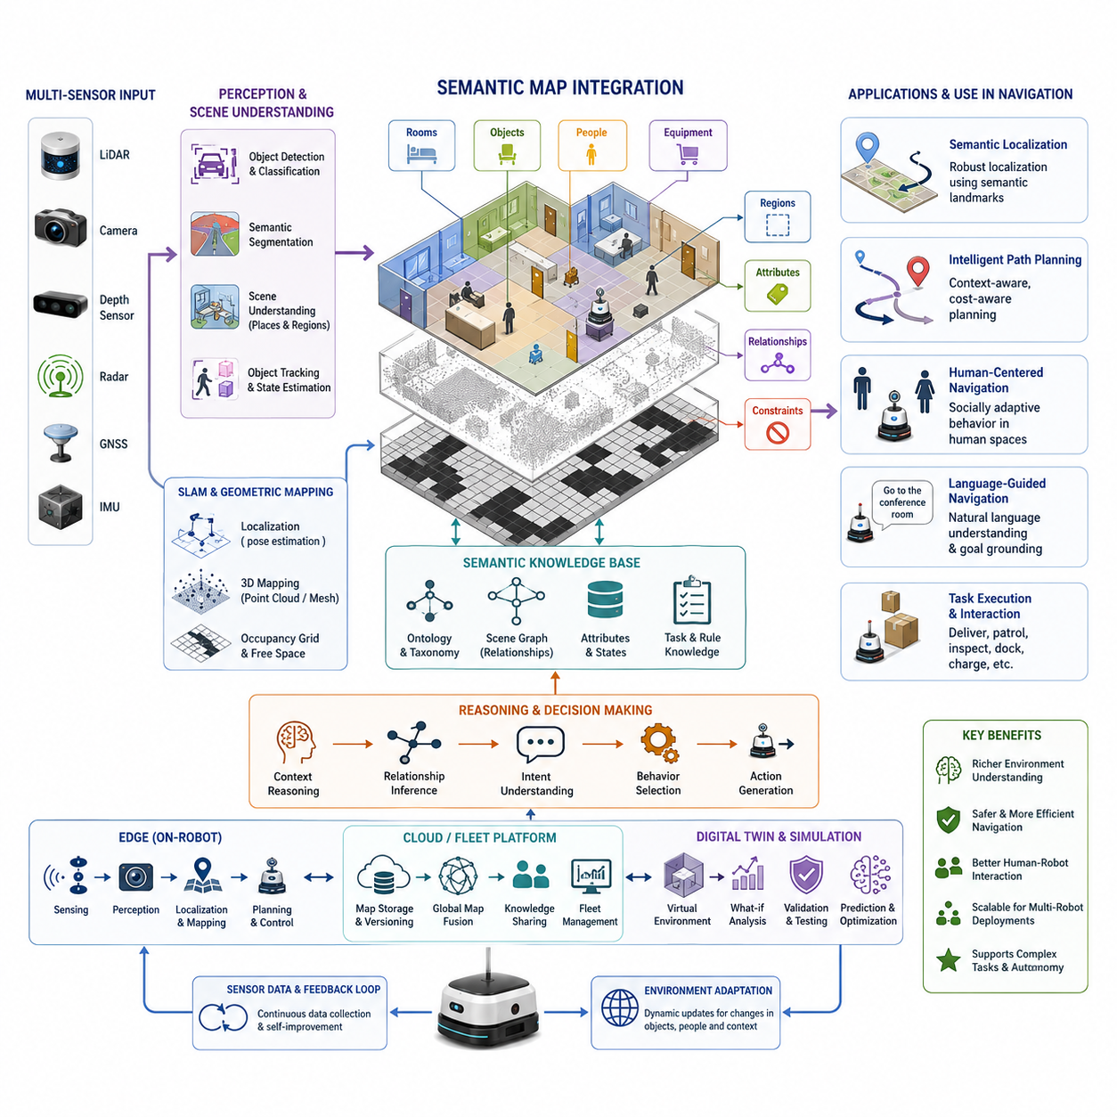
Semantic Map Integration is the process of combining geometric maps, localization information, perception outputs, environmental knowledge, and contextual understanding into a unified navigation framework that allows autonomous mobile robots to move through the world in a manner that resembles human reasoning. Within the broader field of semantic navigation, semantic map integration serves as the bridge between low-level spatial representations and high-level decision-making systems. While traditional navigation systems rely primarily on occupancy grids, point clouds, topological graphs, and localization estimates, semantic map integration enriches these representations with meaningful information about objects, places, activities, accessibility, operational constraints, and contextual relationships. This integration transforms a robot from a machine that merely avoids obstacles into an intelligent system capable of understanding and interacting with its environment in a goal-oriented manner. The chapter “09_07_Semantic_Map_Integration” belongs to the Semantic Navigation section of the autonomous navigation framework and follows the progression from scene understanding, object-aware navigation, human-centered navigation, AI-based environment reasoning, and language-guided navigation. It represents the stage where all semantic knowledge is consolidated into a usable operational map for autonomous behavior.
Traditional maps describe where things are located. Semantic maps describe what those things are, how they are related, and how they should influence navigation decisions. Semantic map integration therefore involves merging multiple information layers into a coherent structure. These layers typically include geometric maps generated by SLAM systems, object maps generated by perception systems, topological connectivity maps, environmental annotations, human activity zones, traffic rules, operational constraints, and task-specific knowledge. The integrated map becomes a shared knowledge base that supports perception, planning, localization, decision making, human-robot interaction, and long-term autonomy.
The foundation of semantic map integration begins with geometric mapping. Robots first generate spatial representations using LiDAR, cameras, depth sensors, radar, GNSS, IMU measurements, or combinations of these sensing modalities. These maps define the physical structure of the environment including walls, corridors, doors, obstacles, terrain surfaces, and navigable spaces. However, geometric information alone cannot distinguish between a hospital room and a storage room, nor can it determine whether a detected object is a person, a forklift, a hospital bed, or a pallet. Semantic integration addresses this limitation by attaching labels and attributes to spatial entities.
Object recognition systems play a major role in semantic map construction. Modern perception pipelines use deep learning models to detect and classify objects within the environment. Detected objects become semantic landmarks that are inserted into the map. A robot operating inside a hospital may identify patient rooms, nurse stations, medicine cabinets, elevators, wheelchairs, hospital beds, and waiting areas. In a warehouse environment, the robot may identify racks, pallets, forklifts, loading docks, charging stations, conveyor systems, and work zones. These semantic labels become persistent elements of the map and provide contextual meaning that influences navigation decisions.
Semantic map integration also incorporates scene understanding. Instead of viewing an environment as a collection of independent objects, the robot learns relationships among those objects. A corridor connects multiple rooms. An elevator provides access between floors. A docking station serves as a charging location. A loading area is associated with logistics operations. Understanding these relationships allows robots to reason about their surroundings in a structured manner. Scene graphs are often used to represent these relationships, where nodes correspond to objects or locations and edges represent semantic connections. Such representations enable advanced reasoning and facilitate efficient path planning.
An important aspect of semantic map integration is the fusion of perception outputs collected over time. Real-world environments are dynamic and continuously changing. Objects may move, disappear, or be replaced. Temporary obstacles may appear. Human activity patterns may vary throughout the day. Semantic mapping systems must therefore maintain consistency while adapting to environmental changes. Long-term semantic integration involves updating object states, tracking changes, removing outdated information, and preserving stable environmental knowledge. This capability is particularly important for industrial robots operating continuously over months or years.
Localization systems benefit significantly from semantic map integration. Traditional localization algorithms match sensor observations against geometric features such as corners, walls, and point cloud structures. Semantic localization extends this concept by incorporating object identities and environmental context. Recognizing a reception desk, an elevator entrance, or a storage rack provides additional localization cues that improve robustness in challenging environments. Semantic landmarks often remain stable even when geometric observations are partially occluded or degraded by environmental conditions.
Path planning becomes substantially more intelligent when semantic information is integrated into the navigation stack. Conventional planners focus on minimizing distance, travel time, or energy consumption. Semantic planners consider additional contextual factors. A hospital robot delivering medication may prefer routes that avoid crowded waiting areas. A security robot may prioritize patrol routes through sensitive zones. A warehouse robot may avoid high-traffic forklift corridors during peak operating hours. Semantic map integration enables planners to incorporate these considerations into cost functions and decision-making processes.
Human-centered navigation relies heavily on semantic maps. Humans naturally interpret environments based on meaning rather than geometry. People think in terms of offices, hallways, meeting rooms, entrances, exits, kitchens, and workspaces. For robots to operate effectively alongside humans, they must develop a similar understanding. Semantic integration enables robots to identify socially significant spaces and adapt behaviors accordingly. The robot may reduce speed in populated areas, yield right-of-way in narrow corridors, or avoid interrupting human activities in designated work zones. Such behavior improves safety, acceptance, and operational effectiveness.
Language-guided navigation is another application enabled by semantic map integration. Humans often provide navigation instructions using semantic descriptions rather than coordinates. Commands such as “Go to the conference room,” “Deliver this package to the pharmacy,” or “Wait near the elevator” require the robot to interpret linguistic references and connect them to physical locations. Semantic maps provide the knowledge layer that translates language into navigation objectives. Natural language processing systems extract entities from user commands, and semantic map databases resolve those entities into specific navigational goals.
The integration architecture for semantic maps typically consists of several interconnected modules. Perception modules detect and classify environmental features. SLAM modules generate geometric maps and estimate robot poses. Semantic extraction modules assign labels to detected objects and locations. Knowledge representation modules store semantic information in databases, graphs, or hierarchical structures. Reasoning modules infer relationships and contextual information. Navigation modules consume semantic knowledge to generate plans and execute actions. Together, these components form an integrated semantic navigation framework capable of operating in complex environments.
Multi-sensor fusion is essential for reliable semantic map integration. Individual sensors possess limitations. Cameras provide rich semantic information but may suffer from lighting variations. LiDAR delivers accurate geometry but limited semantic understanding. Radar offers robustness under adverse weather conditions but lower resolution. GNSS provides global positioning but may be unavailable indoors. By combining multiple sensor modalities, robots can construct more accurate and reliable semantic maps. Sensor fusion algorithms align observations from different sources and generate unified environmental representations that support robust navigation.
Industrial environments present unique challenges for semantic map integration. Factories, warehouses, ports, airports, hospitals, and outdoor facilities often contain large-scale dynamic environments with diverse operational requirements. Robots operating in these settings must integrate semantic information related to workflows, restricted zones, equipment locations, traffic patterns, and safety regulations. For example, an industrial AMR may distinguish between pedestrian walkways, forklift routes, hazardous material zones, maintenance areas, and production lines. Such distinctions directly influence navigation strategies and operational safety.
Outdoor semantic mapping introduces additional complexities. Unlike structured indoor environments, outdoor environments contain variable terrain, changing weather conditions, moving vehicles, pedestrians, vegetation, and seasonal variations. Semantic integration must account for roads, sidewalks, intersections, crosswalks, parking areas, construction zones, and natural features. Outdoor autonomous robots require semantic understanding to navigate safely and efficiently while complying with traffic regulations and operational constraints.
Semantic map integration also supports digital twin architectures. Digital twins maintain virtual representations of physical environments and continuously synchronize with real-world observations. Semantic maps provide contextual understanding within these digital representations. Robots can share semantic information with cloud platforms, fleet management systems, and simulation environments. This integration enables predictive planning, operational monitoring, collaborative robotics, and large-scale deployment management.
Cloud-edge architectures further enhance semantic map integration capabilities. Edge computing platforms perform real-time perception, localization, and navigation functions. Cloud platforms manage long-term map storage, global knowledge sharing, fleet coordination, and large-scale semantic reasoning. This distributed architecture allows robots to maintain real-time responsiveness while benefiting from centralized knowledge repositories and computational resources. For large industrial deployments, semantic map updates generated by one robot can be shared with the entire fleet, improving collective situational awareness.
Artificial intelligence plays a growing role in semantic map integration. Deep learning models extract semantic information from sensor data. Foundation models provide generalized scene understanding capabilities. Vision-language models enable robots to connect visual observations with linguistic concepts. Large language models contribute reasoning capabilities that help interpret environmental context and user instructions. These AI technologies are gradually transforming semantic maps from static knowledge repositories into dynamic reasoning systems capable of supporting increasingly sophisticated autonomous behaviors.
Validation and testing of semantic map integration systems require comprehensive evaluation methodologies. Metrics include semantic classification accuracy, object localization precision, map consistency, localization robustness, navigation success rates, task completion efficiency, and human interaction quality. Testing must cover diverse environmental conditions, dynamic scenarios, sensor failures, and long-term operational deployments. Simulation environments, digital twins, laboratory experiments, and field trials all contribute to verifying system performance and reliability.
Future developments in semantic map integration will likely focus on richer environmental understanding, lifelong learning, collaborative knowledge sharing, and foundation-model-based reasoning. Future robots may continuously learn from experience, update semantic knowledge autonomously, and share environmental understanding across fleets operating at global scale. World models capable of predicting future environmental states may become tightly integrated with semantic maps, enabling proactive navigation strategies. Semantic representations may evolve from static annotations into dynamic knowledge systems that combine perception, reasoning, prediction, and planning within a unified framework.
Ultimately, semantic map integration represents a critical milestone in the evolution of autonomous navigation. It enables robots to understand not only the geometry of the world but also its meaning, purpose, and operational context. By combining spatial representations with semantic knowledge, robots gain the ability to reason about environments in ways that are increasingly similar to human cognition. This capability forms the foundation for intelligent navigation systems that can operate safely, efficiently, and autonomously across hospitals, factories, warehouses, smart cities, outdoor infrastructure, logistics networks, and future embodied AI ecosystems. The integration of semantic knowledge into navigation maps is therefore not merely an enhancement of existing mapping technologies but a fundamental step toward truly intelligent autonomous machines capable of understanding and interacting with the world around them.

09.8 Semantic Navigation Testing
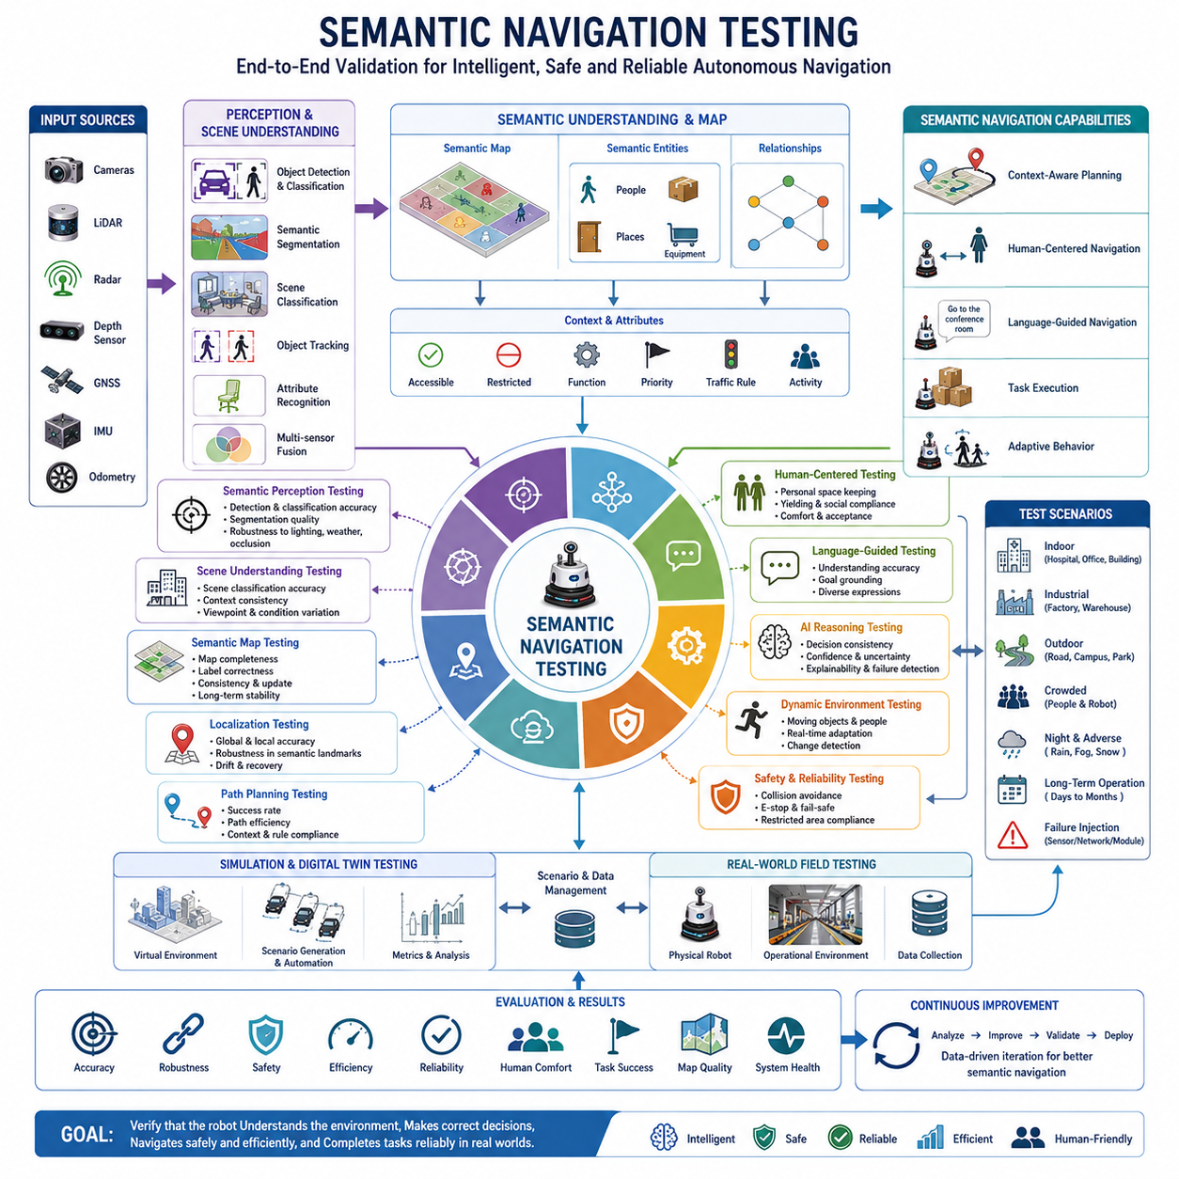
Semantic Navigation Testing is the systematic process of evaluating, validating, and verifying the performance, safety, robustness, intelligence, and operational reliability of semantic navigation systems in autonomous mobile robots. As navigation technologies evolve beyond traditional geometric path planning toward context-aware and meaning-driven decision making, testing methodologies must also evolve to ensure that robots can correctly interpret semantic information, understand environmental context, reason about objects and human activities, and execute navigation tasks safely and efficiently. Semantic navigation testing serves as the final verification stage of the semantic navigation development cycle, ensuring that all components of scene understanding, object-aware navigation, human-centered navigation, AI-based reasoning, language-guided navigation, and semantic map integration function together as a coherent autonomous system. Within the overall navigation architecture, semantic navigation testing represents the bridge between development and deployment, transforming research prototypes into reliable industrial products capable of operating in real-world environments.
Traditional navigation testing primarily focuses on localization accuracy, obstacle avoidance performance, path efficiency, and motion control stability. While these metrics remain important, semantic navigation introduces additional dimensions that must be evaluated. A robot is no longer required only to determine where it should move. It must also understand why it should move there, what environmental factors influence its decisions, how human activities affect navigation behavior, and whether its interpretation of semantic information is correct. Testing therefore expands from physical navigation performance to cognitive navigation performance.
The foundation of semantic navigation testing begins with semantic perception validation. Before a robot can reason about its environment, it must accurately identify and classify environmental entities. Cameras, LiDAR systems, radar sensors, depth cameras, and multimodal perception systems generate observations that are processed through object detection, semantic segmentation, scene classification, and object tracking algorithms. Testing must verify that these systems consistently recognize people, vehicles, doors, elevators, corridors, workstations, charging stations, equipment, and other relevant environmental features.
Object recognition accuracy becomes particularly important because semantic navigation decisions often depend directly on classification results. Misclassifying a pedestrian as a static obstacle may result in inappropriate navigation behavior. Misidentifying a restricted area as an accessible zone may create safety hazards. Semantic testing therefore evaluates precision, recall, detection confidence, classification stability, and robustness across varying environmental conditions.
Scene understanding validation represents another critical component of semantic navigation testing. Unlike simple object recognition, scene understanding evaluates whether the robot correctly interprets the broader environmental context. A robot operating in a hospital must distinguish between patient care areas, waiting rooms, operating theaters, emergency corridors, and staff-only zones. A warehouse robot must differentiate loading docks, storage aisles, forklift lanes, maintenance areas, and pedestrian pathways.
Testing procedures verify that scene classifications remain accurate under varying viewpoints, lighting conditions, occupancy levels, and operational scenarios. The robot must demonstrate the ability to maintain contextual understanding even when individual objects become temporarily occluded or environmental conditions change significantly.
Semantic map verification is one of the most important aspects of system-level validation. Semantic maps serve as the knowledge foundation for navigation reasoning. Errors within semantic maps propagate directly into navigation decisions. Testing therefore evaluates map completeness, consistency, correctness, update mechanisms, and long-term stability.
Validation engineers must verify that semantic labels are correctly associated with physical locations, that object relationships are represented accurately, and that dynamic updates preserve map integrity. Long-duration testing is particularly important because semantic maps must remain reliable over weeks, months, or years of continuous operation.
Human-centered navigation testing evaluates how effectively robots interact with people during navigation activities. Modern service robots, hospital robots, delivery robots, and industrial AMRs increasingly operate in shared human environments. Navigation performance is therefore measured not only by efficiency but also by social acceptability.
Human-centered testing evaluates interpersonal distance maintenance, yielding behavior, corridor sharing, crowd navigation, waiting behavior, speed adaptation, and social compliance. The robot must demonstrate behavior that humans perceive as safe, predictable, comfortable, and cooperative. Evaluation often includes both quantitative measurements and subjective user assessments.
Language-guided navigation testing focuses on the robot's ability to interpret and execute natural language instructions. Human operators rarely communicate using coordinates or technical map references. Instead, they provide instructions such as “Go to the conference room,” “Wait near the elevator,” or “Deliver this package to the pharmacy.”
Testing scenarios evaluate the entire language understanding pipeline. Natural language processing systems must correctly identify destinations, semantic references, contextual constraints, and task objectives. The navigation system must then translate linguistic concepts into actionable navigation goals. Validation includes both predefined instructions and open-ended language interactions that simulate real operational environments.
AI-based environmental reasoning introduces another layer of complexity that requires dedicated testing methodologies. Semantic navigation systems increasingly rely on machine learning models, vision-language models, foundation models, and reasoning engines to make navigation decisions. Unlike deterministic algorithms, AI-based systems may exhibit probabilistic behavior and context-dependent decision making.
Testing frameworks therefore evaluate decision consistency, reasoning transparency, confidence estimation, failure detection, uncertainty management, and explainability. Engineers must verify that AI-driven navigation decisions remain safe and appropriate across a wide range of environmental conditions.
Context-aware navigation testing examines whether the robot appropriately adapts its behavior according to environmental circumstances. A robot may travel at different speeds depending on whether it is operating in a crowded hallway, a restricted industrial zone, or an open warehouse. It may select alternative routes based on time-of-day conditions, operational priorities, or human activity levels.
Testing scenarios intentionally vary contextual factors to verify adaptive behavior. The robot must demonstrate appropriate responses without sacrificing safety, efficiency, or mission completion performance.
Multi-sensor semantic fusion testing evaluates the integration of information from cameras, LiDAR, radar, GNSS, IMU sensors, depth cameras, and other perception systems. Since semantic navigation depends on accurate environmental understanding, sensor fusion quality directly affects navigation reliability.
Validation procedures examine synchronization accuracy, data consistency, temporal alignment, calibration stability, sensor redundancy performance, and fault tolerance. Engineers often introduce controlled sensor failures to verify that the system can maintain acceptable navigation performance despite degraded sensing capabilities.
Dynamic environment testing is particularly important because semantic navigation systems must operate in environments that continuously change. People move, objects are relocated, doors open and close, vehicles enter and leave operational areas, and temporary obstacles appear unexpectedly.
Testing scenarios include moving pedestrians, forklifts, service vehicles, mobile equipment, construction zones, temporary barriers, and environmental changes. The robot must continuously update its semantic understanding and adapt navigation decisions in real time without compromising safety.
Industrial semantic navigation testing requires specialized validation procedures. Manufacturing facilities, warehouses, airports, hospitals, ports, logistics centers, and smart city deployments each present unique operational requirements. Industrial testing verifies that semantic understanding aligns with operational workflows and business objectives.
For example, a hospital robot may need to prioritize emergency routes during critical situations. A logistics robot may require dynamic route adjustments based on warehouse traffic conditions. A security robot may need enhanced attention to restricted areas and access control zones. Testing ensures that semantic navigation supports these operational requirements effectively.
Outdoor semantic navigation testing introduces additional challenges associated with weather, lighting, terrain variability, and environmental complexity. Robots operating outdoors must interpret roads, sidewalks, intersections, traffic signals, construction zones, vegetation, parked vehicles, and moving traffic.
Testing programs therefore include daytime and nighttime operations, rain conditions, fog, snow, dust, glare, shadows, seasonal changes, and varying traffic densities. Robust performance across these conditions is essential for reliable outdoor deployment.
Simulation-based testing provides a highly efficient environment for semantic navigation validation. Modern digital twins and simulation platforms allow engineers to create diverse environments, generate rare edge cases, and evaluate system performance under controlled conditions. Thousands of scenarios can be executed automatically without exposing physical robots to operational risks.
Simulation environments support large-scale testing of semantic reasoning, object recognition, navigation behaviors, human interactions, and failure recovery strategies. Digital twins further enable validation against realistic operational models that closely mirror deployment environments.
Real-world field testing remains indispensable despite advances in simulation technology. Physical deployments expose robots to environmental uncertainties, sensor imperfections, human behaviors, infrastructure variability, and operational conditions that may not be fully captured in simulations. Field testing validates the transferability of semantic navigation capabilities from laboratory environments to practical deployments.
Long-term autonomy testing evaluates the ability of semantic navigation systems to operate continuously over extended periods. Industrial robots may function for thousands of hours annually. Semantic maps must remain consistent, AI models must maintain performance, and navigation behaviors must remain stable despite environmental changes.
Testing programs therefore include multi-day, multi-week, and multi-month operational evaluations. These assessments identify degradation mechanisms, semantic drift, data accumulation challenges, and maintenance requirements.
Safety validation is perhaps the most critical aspect of semantic navigation testing. Safety testing evaluates collision avoidance performance, emergency stop functionality, restricted area compliance, human protection mechanisms, fail-safe behaviors, and recovery procedures. Since semantic navigation often influences decision making at a high level, incorrect semantic interpretations can potentially create safety risks.
Testing frameworks therefore incorporate hazard analysis, fault injection, safety scenario generation, and regulatory compliance verification. Safety validation must demonstrate that the robot remains safe even when semantic understanding is partially incorrect or incomplete.
Performance benchmarking provides objective measurements that enable comparison across navigation systems. Common semantic navigation metrics include semantic classification accuracy, scene understanding accuracy, localization robustness, navigation success rate, path efficiency, task completion time, human comfort metrics, reasoning accuracy, language interpretation accuracy, and semantic map consistency.
Benchmarking datasets and standardized evaluation procedures facilitate repeatable comparisons among different algorithms, architectures, and system implementations. These benchmarks support technology selection, development prioritization, and performance optimization.
Cloud-connected semantic navigation systems require additional testing related to communication reliability, map synchronization, fleet knowledge sharing, cloud-edge coordination, and distributed decision making. Testing verifies that robots maintain operational effectiveness during communication interruptions and that synchronization mechanisms preserve consistency across fleet deployments.
Future semantic navigation testing will increasingly incorporate foundation models, embodied AI systems, world models, multimodal reasoning engines, and autonomous learning capabilities. Testing methodologies will evolve from evaluating predefined behaviors toward validating adaptive intelligence, lifelong learning performance, collaborative reasoning, and self-improving navigation systems.
As robots become more capable of understanding environmental meaning, predicting future events, reasoning about human intentions, and adapting to changing operational conditions, testing frameworks must likewise evolve to assess these advanced capabilities. Future validation systems may themselves utilize artificial intelligence to generate test scenarios, identify weaknesses, and automatically evaluate robot performance.
Ultimately, semantic navigation testing serves as the quality assurance foundation for intelligent autonomous mobility. It ensures that semantic understanding translates into safe, reliable, efficient, and context-aware navigation behavior. Through comprehensive evaluation of perception, reasoning, mapping, planning, human interaction, language understanding, and operational performance, semantic navigation testing transforms advanced research concepts into deployable autonomous systems. As autonomous robots become increasingly integrated into factories, hospitals, warehouses, transportation networks, smart cities, and public environments, rigorous semantic navigation testing will remain essential for ensuring that robots can understand not only where they are going, but also the meaning and purpose of their actions within the world they inhabit.

