Volume 05. Path Planning and Autonomous Navigation

Chapter 14. Elevator and Door Integration

14.1 Building Integration Overview
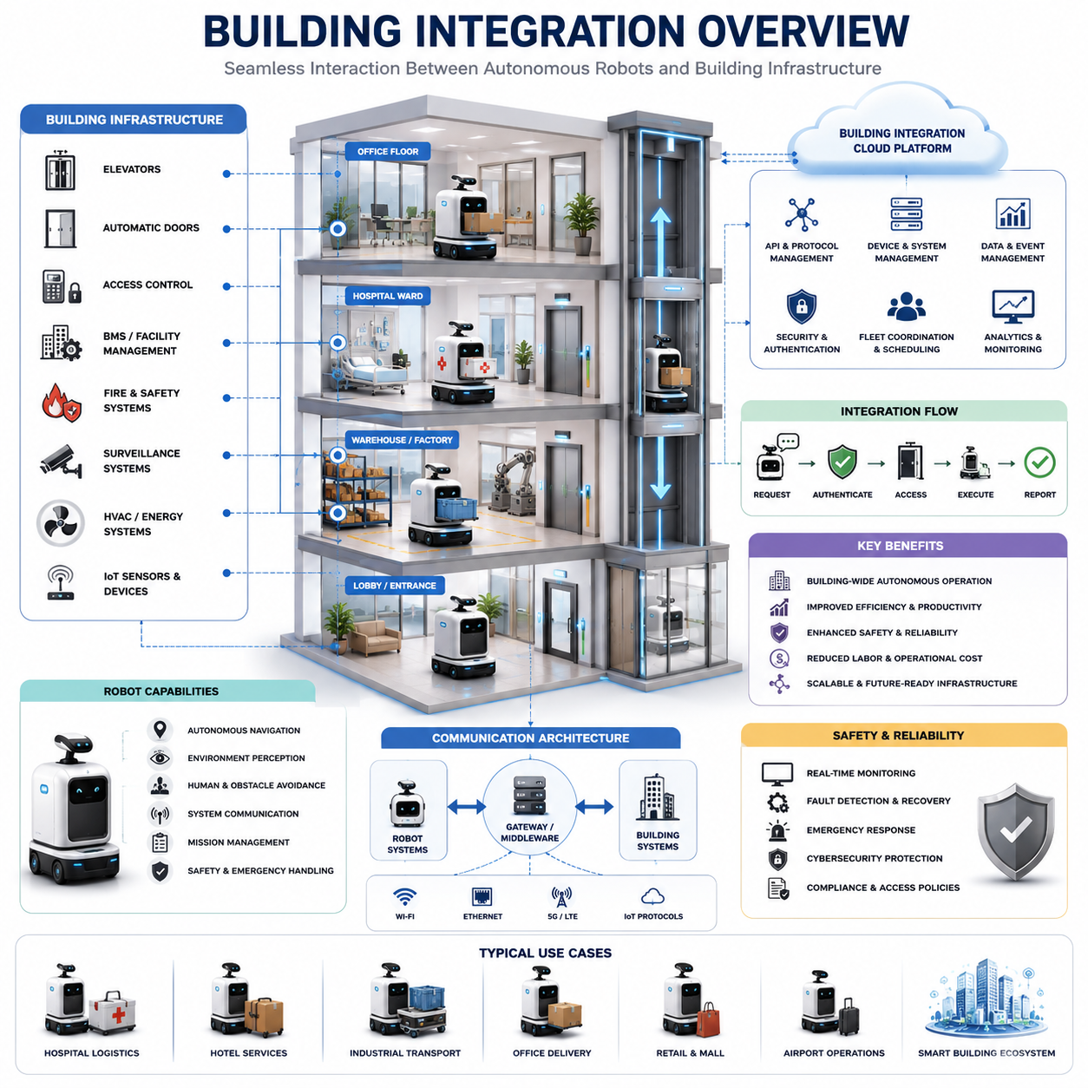
Building integration is one of the most important enabling technologies for the widespread deployment of Autonomous Mobile Robots (AMRs) in real-world facilities. While robot navigation inside a single open floor is a mature technology, true autonomous operation across an entire building requires seamless interaction between robots and building infrastructure. Elevators, automatic doors, access control systems, security checkpoints, building management systems, fire safety systems, and facility operation platforms must work together as part of a unified robotic ecosystem. Building integration transforms a mobile robot from an isolated autonomous machine into a fully connected operational entity capable of performing useful tasks throughout complex multi-floor environments. This capability is particularly important in hospitals, hotels, airports, shopping malls, office towers, factories, logistics centers, research campuses, and smart city facilities where robots must travel across multiple floors and pass through controlled access areas while maintaining safety, reliability, and operational efficiency. The chapter “14_01_Building_Integration_Overview” serves as the foundation for understanding how autonomous robots become integrated participants within intelligent buildings and modern facility infrastructures.
Traditional robot navigation systems primarily focus on localization, mapping, path planning, obstacle avoidance, and motion control. However, in real deployments, navigation alone is insufficient. A robot may successfully reach an elevator lobby but still be unable to complete its mission if it cannot communicate with the elevator system. Likewise, a robot may navigate accurately to a hospital ward but become blocked by secured doors or access-controlled zones. Building integration addresses these operational barriers by allowing robots to interact digitally with infrastructure systems. Through software interfaces, communication protocols, cloud services, and local control mechanisms, robots can request elevator access, open automatic doors, verify security permissions, reserve navigation corridors, and coordinate with facility management systems. As a result, robots can execute end-to-end workflows without requiring human intervention.
Modern buildings contain numerous subsystems that operate independently. These include elevators, escalators, automatic doors, HVAC systems, access control systems, surveillance systems, fire alarm systems, emergency response systems, energy management systems, and occupancy monitoring systems. Building integration establishes a communication framework that enables robots to interact with these systems in a standardized and secure manner. Rather than treating the building as a passive environment, integrated robots view the building as an active digital platform that provides services, information, and operational support. This shift represents a major evolution in autonomous robotics and smart building technologies.
Elevator integration is often considered the most critical building integration capability. In multi-floor environments, elevators act as vertical transportation infrastructure. Without elevator access, robot operations become restricted to a single floor, severely limiting deployment value. Elevator integration enables robots to automatically call elevators, request specific destination floors, verify cabin availability, enter and exit elevators safely, and resume navigation upon arrival. This process requires coordination between localization systems, navigation planners, perception modules, safety controllers, and elevator communication interfaces. The robot must determine its position relative to the elevator entrance, predict door opening events, detect passenger movement, and execute precise motion control during boarding and exiting operations. Successful elevator integration transforms isolated floor-level robots into building-wide autonomous service systems.
Automatic door integration represents another fundamental requirement. Many buildings contain numerous doors separating corridors, departments, warehouses, laboratories, offices, and restricted zones. These doors may use motion sensors, access control readers, push-button activation systems, or centralized building automation controllers. Robots must be capable of requesting door access through digital communication channels. The integration framework may involve wireless communication, Ethernet-based protocols, IoT gateways, programmable logic controllers, or cloud-connected building management systems. Once access permission is granted, the robot coordinates its navigation behavior with the door opening process, ensuring smooth and safe passage without collisions or unnecessary waiting.
Access control integration becomes particularly important in hospitals, research laboratories, pharmaceutical facilities, data centers, and industrial manufacturing plants. These facilities often contain zones with different security levels. Robots must authenticate themselves before entering controlled areas. Digital credentials, role-based permissions, mission authorization tokens, and cybersecurity mechanisms are commonly used to establish trust between robots and facility infrastructure. The robot's identity may be verified through centralized authentication services, allowing access decisions to be made dynamically based on operational requirements and security policies. This approach enables robots to operate safely within environments that require strict regulatory compliance and controlled access procedures.
Hospital environments provide some of the most advanced examples of building integration. Hospital logistics robots frequently transport medications, laboratory samples, medical equipment, linens, meals, and waste materials throughout large healthcare facilities. These robots must navigate across multiple floors, interact with elevators, access secure pharmacy zones, coordinate with automatic doors, and comply with infection control procedures. Building integration enables these workflows by creating seamless communication between robot fleets and hospital infrastructure systems. Robots can receive priority elevator access during urgent deliveries, avoid restricted areas during emergencies, and coordinate with facility management systems to ensure operational continuity. Such integration significantly improves hospital efficiency while reducing manual labor requirements.
Hotel service robots also rely heavily on building integration technologies. Delivery robots transporting food, beverages, luggage, or guest amenities must move between floors autonomously. Elevator integration allows robots to travel from service areas to guest rooms. Access control integration enables robots to enter designated zones while maintaining guest privacy and security. Hotel management systems can automatically generate robot tasks based on guest requests, and robots can provide delivery status updates through mobile applications or room management systems. Building integration therefore creates a seamless guest experience while improving operational efficiency for hotel staff.
Industrial facilities present unique building integration challenges due to their scale, complexity, and safety requirements. Manufacturing plants often contain multiple production areas separated by automated doors, safety gates, and controlled access zones. Autonomous robots must coordinate with factory automation systems, manufacturing execution systems, warehouse management systems, and safety infrastructure. Building integration allows robots to interact with these systems while maintaining compliance with industrial safety standards. For example, robots may receive temporary access permissions to enter production zones, synchronize movement with automated machinery, or coordinate material transport activities with factory scheduling systems.
Communication architecture plays a central role in building integration. Various communication models can be used depending on facility requirements and infrastructure capabilities. Direct communication allows robots to interact with building devices through local network interfaces. Middleware-based architectures introduce gateway services that translate between robot protocols and building protocols. Cloud-centric architectures use centralized platforms to coordinate interactions between robots and infrastructure systems. Hybrid architectures combine local control with cloud-based supervision, offering both low latency and scalable management. The selection of communication architecture depends on factors such as reliability, security, scalability, interoperability, and operational complexity.
Standardization is increasingly important as robot deployments become more widespread. Historically, building integration projects were implemented using custom interfaces tailored to specific facilities. While effective for individual deployments, such approaches limit scalability and increase maintenance costs. Industry efforts now focus on developing standardized communication frameworks that enable robots from different manufacturers to interact with building infrastructure through common interfaces. Standardized APIs, middleware platforms, and interoperability frameworks simplify deployment, reduce integration costs, and accelerate adoption across diverse facilities.
Cybersecurity represents a critical consideration in building integration. Connected robots become part of the broader building information technology ecosystem, increasing potential attack surfaces. Unauthorized access to elevator systems, door controllers, or building management systems could create significant operational and safety risks. Consequently, building integration architectures must incorporate robust cybersecurity measures including authentication, authorization, encryption, certificate management, network segmentation, intrusion detection, and security monitoring. Secure communication channels protect both robot operations and building infrastructure while ensuring compliance with organizational cybersecurity policies.
Reliability and fault tolerance are equally important. Building infrastructure components may occasionally become unavailable due to maintenance activities, communication failures, hardware malfunctions, or emergency situations. Robots must detect these conditions and execute appropriate recovery behaviors. If an elevator becomes unavailable, alternative routes may need to be selected. If a door controller fails, the robot may request assistance from facility personnel or reroute its mission. Robust building integration frameworks therefore include health monitoring, fault detection, redundancy mechanisms, and recovery strategies to ensure continued operation under adverse conditions.
Safety remains the highest priority throughout all building integration activities. Robots must never compromise human safety while interacting with building infrastructure. Elevator boarding and exiting operations require continuous monitoring of passenger movement and cabin occupancy. Automatic door traversal must ensure that humans are not obstructed or endangered. Emergency events such as fire alarms, evacuation procedures, or facility lockdowns require robots to suspend normal operations and follow predefined safety protocols. Integration with emergency management systems allows robots to respond appropriately during abnormal situations, supporting both safety and operational resilience.
The emergence of smart buildings is accelerating the importance of building integration technologies. Modern facilities increasingly incorporate IoT devices, cloud platforms, digital twins, occupancy analytics, and intelligent automation systems. Robots are becoming active participants within these digital ecosystems. Rather than functioning as isolated machines, robots contribute data, consume building services, and collaborate with other intelligent systems. Building integration therefore serves as a foundational component of future smart facility architectures where physical infrastructure and autonomous systems operate as a unified intelligent environment.
Digital twin technology further enhances building integration capabilities. A digital representation of the facility allows robots to access real-time information about building status, occupancy patterns, elevator availability, door states, maintenance activities, and operational constraints. By combining digital twin information with navigation intelligence, robots can make more informed decisions and optimize mission execution. This integration improves efficiency, reduces travel time, and enhances overall system reliability.
Fleet management systems also benefit from building integration. Multiple robots operating within the same facility can coordinate access to elevators, doors, and shared resources through centralized fleet controllers. Elevator reservations, traffic scheduling, congestion management, and mission prioritization can be optimized at the fleet level. This coordination becomes increasingly important as robot populations grow and facilities transition toward large-scale autonomous operations. Fleet-level building integration enables efficient utilization of infrastructure resources while minimizing delays and operational conflicts.
Looking toward the future, building integration will become a standard requirement for nearly all large-scale autonomous robot deployments. Advances in smart building technologies, cloud computing, artificial intelligence, IoT connectivity, and digital infrastructure will continue to expand integration possibilities. Robots will interact seamlessly with elevators, doors, security systems, facility management platforms, energy systems, and urban infrastructure. Buildings themselves will evolve into intelligent environments designed to support autonomous machines as naturally as they support human occupants. Building integration therefore represents not merely a technical feature but a fundamental architectural principle for the next generation of autonomous robotic systems. Within the broader context of autonomous navigation, building integration bridges the gap between robot autonomy and real-world operational effectiveness, enabling robots to function as fully connected participants in modern intelligent facilities.

14.2 Elevator Communication Protocols
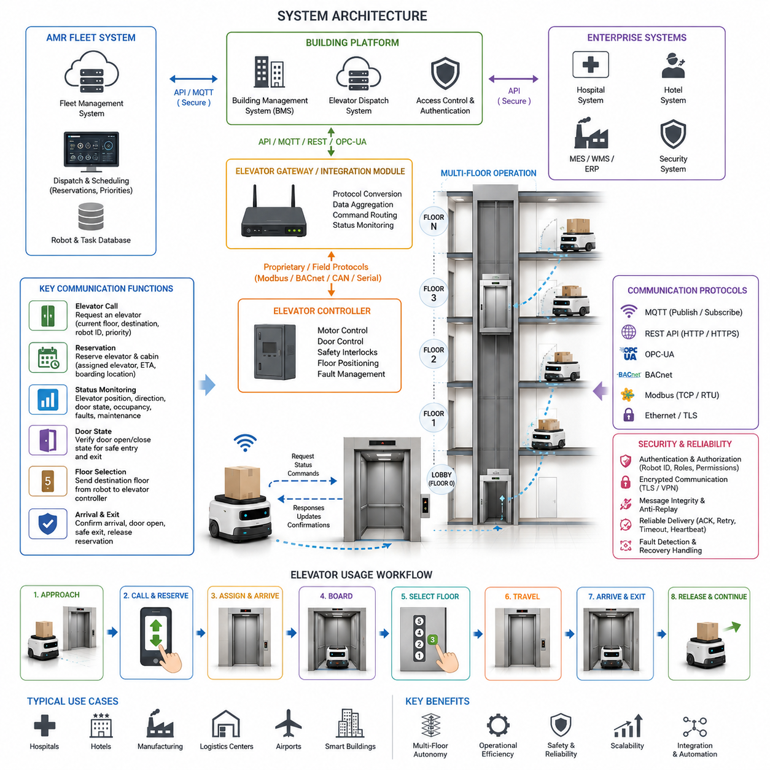
Modern Autonomous Mobile Robots (AMRs) are increasingly required to operate across multiple floors within large facilities such as hospitals, hotels, office towers, manufacturing plants, logistics centers, airports, and smart buildings. While navigation technologies enable robots to move autonomously within a floor, true building-wide autonomy requires seamless interaction with elevator systems. Elevator communication protocols serve as the critical interface between robotic platforms and building transportation infrastructure, allowing robots to request elevators, verify availability, reserve cabins, select destination floors, monitor elevator status, and safely enter and exit elevator cars. Elevator communication has therefore become one of the most important enabling technologies for multi-floor autonomous navigation systems. The development of reliable elevator communication protocols transforms isolated floor-level robots into building-wide autonomous service systems capable of performing end-to-end logistics and transportation tasks.
The primary objective of elevator communication protocols is to establish a secure and deterministic communication channel between the AMR fleet management system, robot navigation stack, building management system, and elevator controller. This communication infrastructure allows robots to coordinate their movement with elevator operations while maintaining safety, efficiency, and compliance with building regulations. Without such integration, robots would require human intervention whenever a floor transition becomes necessary, significantly limiting operational efficiency and reducing the value of autonomous deployment.
A typical elevator communication architecture consists of multiple layers. At the lowest level lies the elevator controller responsible for managing motor operation, door control, safety interlocks, floor positioning, and passenger requests. Above the controller resides an elevator gateway or integration module that exposes communication interfaces suitable for robotic applications. The gateway communicates with a building management system, elevator dispatch system, or cloud integration platform. The AMR fleet management system interacts with these services through standardized protocols and APIs. Individual robots communicate with the fleet manager or directly with elevator gateways depending on deployment requirements. This layered architecture separates navigation functions from elevator control functions while preserving operational safety.
Communication protocols may vary significantly depending on elevator manufacturers, building age, regional regulations, and integration requirements. Traditional elevator systems often rely on proprietary serial communication interfaces that were originally designed for maintenance personnel rather than robotic integration. Modern elevator systems increasingly provide Ethernet-based interfaces, REST APIs, MQTT services, OPC-UA interfaces, BACnet connectivity, Modbus communication, or dedicated robotic integration SDKs. Some advanced smart buildings provide digital twin environments where elevator resources can be managed as network-accessible services.
The most fundamental elevator communication function is elevator calling. When a robot approaches an elevator lobby, it transmits a request containing its current floor, desired destination floor, robot identification number, priority level, and operational status. The elevator management system evaluates current elevator availability, traffic conditions, cabin occupancy, maintenance status, and dispatch schedules before assigning an elevator. Once assigned, the system communicates the elevator identifier, estimated arrival time, cabin location, and reservation status back to the robot. The robot then navigates to the designated boarding location and prepares for elevator entry.
Elevator reservation mechanisms play a critical role in reliable robotic transportation. Unlike human passengers who can dynamically adapt to changing conditions, robots require predictable operating conditions for safe navigation. Reservation protocols allow robots to secure elevator resources before arrival, reducing uncertainty and minimizing waiting time. Reservation systems may support exclusive cabin access, shared passenger access, or dynamic allocation depending on operational requirements. In hospital environments, robots carrying medical supplies may receive higher scheduling priority than routine logistics tasks. Similarly, emergency transportation robots may obtain temporary priority access during critical situations.
Status monitoring is another essential component of elevator communication. Continuous updates allow robots to monitor elevator movement, door state, cabin occupancy, current floor position, destination queue, fault conditions, and maintenance status. Real-time status information enables robots to make informed navigation decisions and respond appropriately to changing conditions. If an elevator unexpectedly becomes unavailable due to maintenance or fault conditions, the robot can automatically replan its route, select an alternative elevator, or request assistance from fleet management software.
Door state communication represents a particularly important safety function. Before entering an elevator, the robot must verify that elevator doors are fully open and that entry conditions are safe. Sensors on the robot may independently verify door position, but protocol-based confirmation provides an additional layer of validation. Door state messages typically include indicators such as opening, open, closing, closed, obstructed, and fault conditions. Combining protocol information with onboard perception systems improves reliability and reduces the likelihood of navigation errors.
Floor selection communication enables robots to specify destination floors after entering an elevator cabin. Traditional elevators rely on human interaction with physical buttons, whereas integrated robotic systems issue digital destination requests through communication interfaces. The elevator controller receives the requested destination floor and updates its dispatch logic accordingly. The robot then monitors progress toward the target floor through continuous status updates. Upon arrival, the robot receives confirmation that the correct floor has been reached and that doors are available for safe exit.
Authentication and access control are critical considerations in elevator communication systems. Many facilities restrict access to specific floors for security reasons. Elevator protocols must therefore support role-based access control, robot identity verification, digital certificates, authentication tokens, and encrypted communication channels. Each robot may possess unique credentials that determine which floors can be accessed and under what operational conditions. Hospitals, government facilities, research laboratories, and data centers frequently require strict access management to prevent unauthorized movement between secure zones.
Cybersecurity has become increasingly important as elevator systems evolve into connected infrastructure components. Elevator communication protocols must protect against unauthorized access, message tampering, replay attacks, denial-of-service attacks, and network intrusion attempts. Modern implementations employ Transport Layer Security (TLS), Virtual Private Networks (VPNs), secure authentication mechanisms, certificate-based trust models, and encrypted communication channels. Security monitoring systems continuously evaluate network activity to detect anomalies and potential threats. Cybersecurity requirements are particularly stringent in critical infrastructure, healthcare environments, and defense-related facilities.
Message reliability is another key design consideration. Elevator communication systems must operate predictably even under network congestion, temporary connectivity loss, or hardware failures. Reliable communication protocols incorporate acknowledgment messages, retry mechanisms, timeout monitoring, heartbeat signals, and fault recovery procedures. If a communication failure occurs during elevator operations, predefined fallback strategies ensure safe robot behavior. For example, a robot may halt movement, maintain its current position, request assistance, or transition to a predefined recovery state.
Several communication technologies are commonly used in elevator integration projects. Ethernet-based communication offers high bandwidth, low latency, and compatibility with modern networking infrastructure. MQTT provides lightweight publish-subscribe messaging suitable for large-scale robot fleets. REST APIs simplify integration with cloud-based fleet management systems. OPC-UA supports industrial interoperability and structured information modeling. BACnet integration enables interaction with building automation systems. Modbus remains common in industrial environments where legacy equipment continues to operate. The choice of protocol depends on facility requirements, vendor support, scalability objectives, and regulatory constraints.
In large facilities containing multiple elevators, advanced dispatch coordination becomes necessary. Multi-elevator communication protocols enable robots to interact with centralized elevator management systems capable of optimizing resource utilization across an entire building. Intelligent dispatch algorithms consider elevator locations, passenger traffic, robot priorities, predicted demand, energy efficiency objectives, and operational constraints. The result is improved throughput, reduced waiting time, and enhanced overall building efficiency.
Hospital deployments represent one of the most demanding use cases for elevator communication protocols. Medical logistics robots transport medications, laboratory samples, meals, linens, medical equipment, and waste materials between departments located on different floors. Elevator integration must support high reliability, infection control procedures, priority scheduling, and 24-hour operation. Communication systems often integrate directly with hospital management platforms to coordinate logistics workflows and ensure timely delivery of critical materials.
Hotel applications introduce additional operational requirements. Service robots may deliver food, beverages, amenities, luggage, and housekeeping supplies to guest rooms across multiple floors. Elevator protocols must support guest privacy, smooth operation, and efficient coordination with hospitality management systems. Elevator interactions should occur transparently without disrupting guest experiences. Integration with hotel property management systems can further optimize robot task scheduling and resource allocation.
Manufacturing facilities use elevator communication protocols to connect production areas, warehouses, assembly lines, and storage zones distributed across multiple floors. Industrial robots may transport raw materials, components, tools, and finished products throughout the facility. Communication systems must support high throughput, predictable performance, and integration with Manufacturing Execution Systems (MES), Warehouse Management Systems (WMS), and Enterprise Resource Planning (ERP) platforms.
Fleet management integration provides centralized coordination of elevator usage across multiple robots. The fleet manager maintains awareness of robot locations, task assignments, elevator status, traffic patterns, and operational priorities. By coordinating elevator requests centrally, fleet management software can reduce congestion, improve utilization efficiency, and prevent conflicts among robots competing for limited elevator resources. Predictive scheduling algorithms may reserve elevator capacity in advance based on anticipated transportation demands.
Simulation environments are commonly used to validate elevator communication protocols before deployment. Digital twins of buildings, elevators, and robot fleets enable engineers to evaluate performance under realistic operating conditions. Simulation scenarios may include network failures, elevator faults, high traffic conditions, emergency situations, cybersecurity incidents, and large-scale fleet operations. Validation activities help identify integration challenges and verify system robustness before deployment in production environments.
Fault handling and recovery procedures are essential components of elevator communication architectures. Elevators may become unavailable due to maintenance activities, emergency operations, power failures, communication interruptions, or mechanical faults. Robust protocols define clear recovery workflows that enable robots to detect abnormal conditions, notify fleet management systems, replan routes, select alternative transportation resources, and maintain safe operational states. Comprehensive fault management significantly improves overall system availability and reliability.
As smart building technologies continue to evolve, elevator communication protocols are becoming increasingly intelligent and service-oriented. Future systems are expected to integrate artificial intelligence, predictive traffic management, cloud-native building services, digital twins, and autonomous infrastructure coordination. Elevators may dynamically collaborate with robot fleets, building automation systems, security platforms, and energy management systems to optimize overall facility performance. The convergence of robotics and intelligent building infrastructure will create highly autonomous environments where robots move seamlessly across floors, departments, and operational zones with minimal human intervention.
Ultimately, elevator communication protocols serve as the foundation of multi-floor robotic autonomy. They enable safe, reliable, and scalable interaction between robots and vertical transportation systems while supporting operational efficiency, cybersecurity, fault tolerance, and regulatory compliance. As AMR deployments expand across hospitals, hotels, factories, airports, logistics centers, and smart cities, elevator communication technologies will remain a critical component of building-wide autonomous mobility systems and a key enabler of next-generation robotic infrastructure.

14.3 Automatic Door Integration
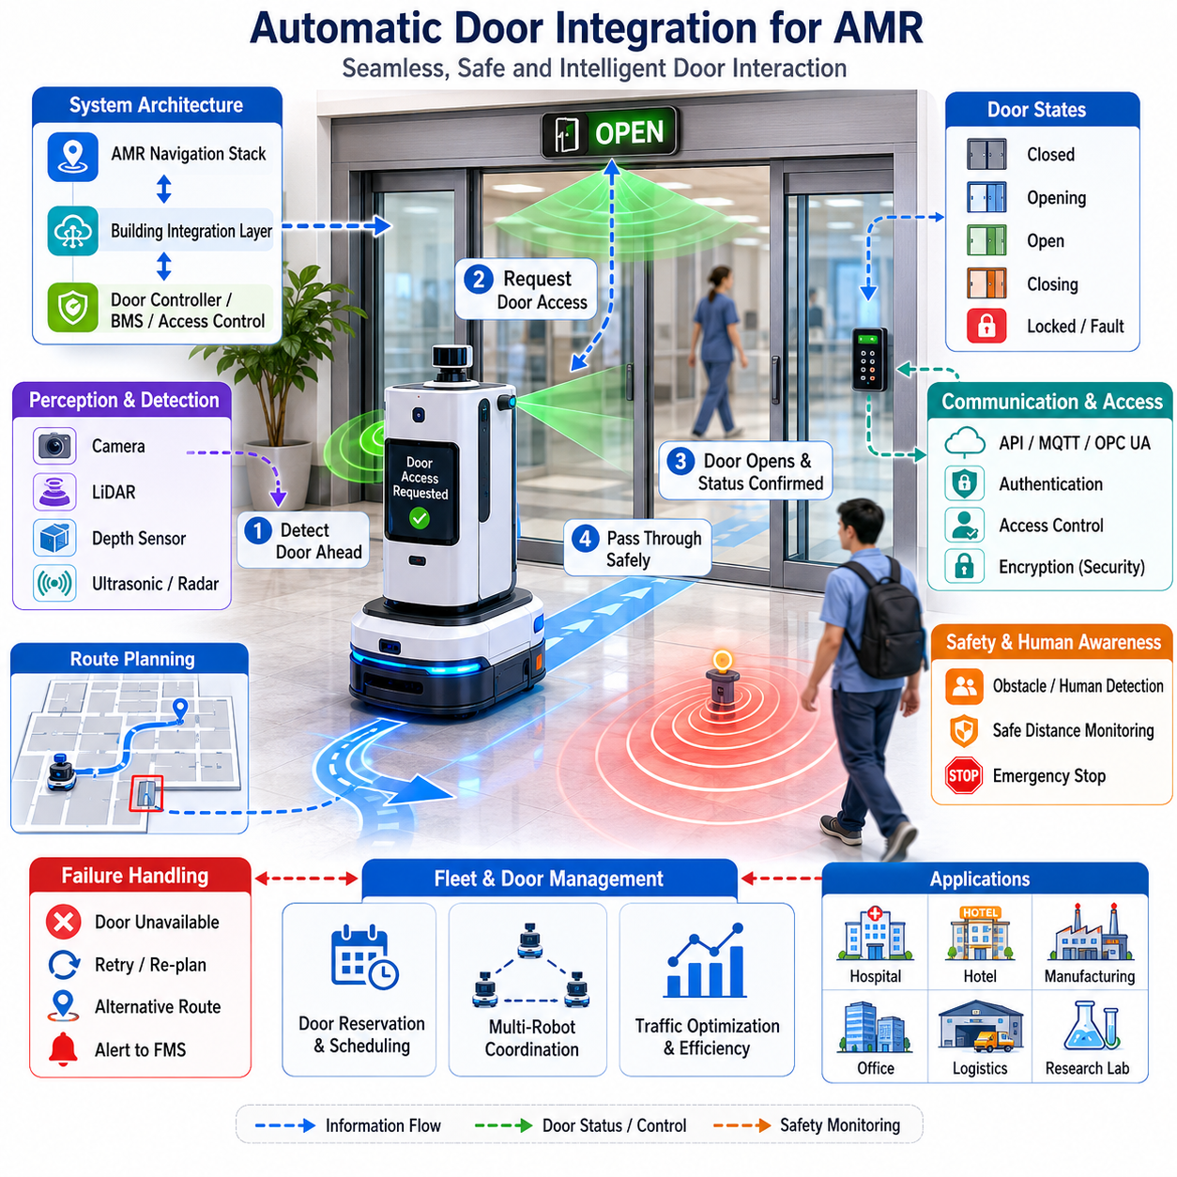
Automatic door integration is a critical capability for modern Autonomous Mobile Robots (AMRs) operating in complex indoor environments such as hospitals, hotels, office buildings, manufacturing facilities, research laboratories, airports, logistics centers, and smart buildings. While navigation systems often focus on localization, mapping, path planning, obstacle avoidance, and fleet coordination, the practical deployment of robots frequently encounters physical barriers that interrupt autonomous movement. Among these barriers, automatic doors represent one of the most common and operationally significant interfaces between robots and building infrastructure. Successful robot deployment requires seamless interaction with automatic doors so that robots can move freely between rooms, corridors, restricted zones, and service areas without human intervention. Automatic door integration therefore becomes a fundamental component of building-aware navigation systems and an essential element of end-to-end autonomous operation. This topic belongs to the Elevator and Door Integration section of autonomous navigation systems and serves as a bridge between robot intelligence and smart building infrastructure.
In traditional facilities, automatic doors are designed primarily for human users. Motion sensors, push buttons, RFID access systems, and safety devices are configured around human movement patterns. Robots introduce a different set of requirements because they may travel at lower speeds, approach doors from unusual angles, carry payloads that change their dimensions, or require precise timing for safe passage. As a result, simply placing robots into buildings with existing automatic doors often leads to operational challenges. Robots may fail to trigger motion sensors, arrive before doors are fully open, lose localization during door transitions, or encounter unexpected delays that disrupt navigation schedules. Effective automatic door integration addresses these issues through coordinated communication, sensing, control, and safety mechanisms.
The primary objective of automatic door integration is to allow robots to request, monitor, utilize, and verify door operations autonomously. The robot should be capable of recognizing the presence of a door, determining its current state, requesting access when necessary, waiting for confirmation that the door is open, passing through safely, and confirming successful completion of the transition. This process must be performed reliably under varying environmental conditions while maintaining safety for humans and compliance with building regulations.
A typical automatic door integration architecture consists of several interconnected subsystems. The robot navigation stack communicates with a building integration layer, which acts as an intermediary between the robot and building automation systems. The building integration layer interfaces with door controllers, access control systems, facility management systems, and security infrastructure. Communication may occur through wired Ethernet networks, wireless Wi-Fi connections, industrial protocols, cloud-based APIs, or dedicated IoT gateways. The architecture enables robots to interact with doors as intelligent infrastructure components rather than passive environmental objects.
Door state awareness forms the foundation of autonomous interaction. Robots must understand whether a door is open, closed, opening, closing, locked, unavailable, or experiencing faults. This information may be obtained through direct communication with door controllers or indirectly through perception systems. Modern smart buildings often provide door status information through building management systems. In older facilities where digital integration is unavailable, robots may rely on sensors such as cameras, LiDAR systems, depth sensors, radar units, or ultrasonic sensors to estimate door states. Sensor fusion techniques improve reliability by combining multiple sources of information and reducing uncertainty.
Door detection is another important capability. Before a robot can interact with a door, it must identify the door within its environment model. During mapping and localization processes, doors are typically represented as semantic landmarks within navigation maps. Semantic mapping systems classify environmental elements according to their functional roles, allowing robots to recognize doors as navigational resources rather than ordinary obstacles. Semantic maps may contain metadata such as door location, door type, access permissions, opening direction, operating schedule, and communication interfaces. This enriched information enables intelligent navigation decisions and efficient route planning.
Several types of automatic doors are commonly encountered in real-world deployments. Sliding doors are among the most robot-friendly because they create wide openings and minimize interference with robot trajectories. Swing doors introduce additional complexity because their motion creates dynamic obstacles that must be modeled and predicted. Revolving doors present significant challenges due to continuous motion and limited robot compatibility. Folding doors, high-speed industrial doors, cleanroom airlock doors, and security access doors each require specialized integration strategies. The navigation system must account for the operational characteristics of each door type and adapt its behavior accordingly.
Communication protocols play a central role in modern door integration systems. Robots may communicate with doors using REST APIs, MQTT messaging systems, OPC UA protocols, Modbus interfaces, BACnet building automation protocols, or custom vendor-specific APIs. Through these interfaces, robots can send door opening requests, receive status updates, verify authorization credentials, and monitor operational health. Standardized communication frameworks improve interoperability and reduce deployment complexity across different building environments.
The door request process typically begins when the navigation planner predicts an upcoming door crossing. Rather than waiting until the robot reaches the door, the system proactively initiates communication to reduce delays. The robot transmits a request containing its identification, destination, estimated arrival time, and access credentials. The door controller validates the request and determines whether access should be granted. Upon approval, the controller initiates the opening sequence and transmits status updates back to the robot. The robot adjusts its speed to synchronize arrival with door availability, thereby minimizing waiting time and improving operational efficiency.
Timing coordination is essential for smooth operation. If the robot arrives too early, it may block traffic or experience unnecessary delays. If it arrives too late, the door may begin closing before passage is complete. Advanced navigation systems use predictive motion planning and estimated time-of-arrival calculations to coordinate robot movement with door operation schedules. This synchronization improves throughput and reduces energy consumption for both robots and building infrastructure.
Access control integration becomes particularly important in secure facilities. Hospitals, pharmaceutical manufacturing sites, research laboratories, government facilities, and data centers often implement strict access policies. Robots must authenticate themselves before entering restricted areas. Authentication mechanisms may include digital certificates, API tokens, RFID credentials, secure wireless authentication, encrypted communications, or centralized identity management systems. Access permissions may vary depending on robot type, task assignment, operational schedule, or organizational policies.
Cybersecurity considerations are increasingly important as building systems become more connected. Unauthorized access to door control systems could create significant safety and security risks. Therefore, communication between robots and door controllers should employ secure authentication, encrypted data transmission, role-based access control, network segmentation, intrusion detection systems, and security auditing mechanisms. Cybersecurity must be integrated into system architecture from the beginning rather than added as an afterthought.
Robot perception remains important even when digital communication is available. The robot should independently verify that a door is open before attempting passage. Visual perception systems can detect door positions, estimate opening widths, and identify obstacles that may interfere with traversal. LiDAR sensors provide accurate geometric measurements, while depth cameras contribute three-dimensional environmental understanding. Multi-sensor fusion improves robustness under varying lighting conditions and environmental disturbances.
Path planning behavior near doors differs from general corridor navigation. The robot must approach doors with appropriate alignment, speed, and positioning. Misalignment can lead to collisions with door frames or moving door panels. Navigation algorithms often define specialized approach zones that guide robots into optimal positions before crossing. These zones account for robot dimensions, payload size, localization uncertainty, and door geometry. Dynamic trajectory planning continuously adjusts motion as new sensor information becomes available.
Safety is a primary consideration in automatic door integration. Doors represent dynamic environmental elements whose motion can create potential hazards. Robots must predict door movements and maintain safe distances during opening and closing operations. Safety-certified sensors monitor the interaction zone and prevent dangerous situations. If unexpected obstacles or people appear near the door, the robot may pause, replan its path, or abort the crossing operation. Human safety always takes priority over operational efficiency.
Human-robot coexistence introduces additional complexity. Doors are shared resources used simultaneously by people and robots. The navigation system must anticipate human behavior, avoid blocking pedestrian traffic, and communicate its intentions clearly. Visual indicators, audio notifications, display screens, and signaling lights may help humans understand robot actions. Human-aware navigation algorithms reduce interference and improve acceptance of robotic systems in public environments.
Failure handling mechanisms are essential for maintaining reliability. Automatic doors may become unavailable due to power failures, mechanical faults, communication errors, sensor malfunctions, or maintenance activities. When failures occur, robots must detect the problem and respond appropriately. Recovery strategies may include retrying communication, selecting alternative routes, requesting human assistance, reporting incidents to fleet management systems, or entering safe waiting states. Robust recovery procedures significantly improve overall system availability.
Fleet-level door management becomes increasingly important when multiple robots operate within the same facility. A single door may serve dozens or hundreds of robot crossings each day. Traffic coordination systems manage access requests, schedule crossings, prevent congestion, and optimize resource utilization. Reservation-based systems allow robots to book door access windows in advance, reducing conflicts and improving throughput. Fleet management platforms maintain global awareness of door status and coordinate robot activities accordingly.
Hospital environments provide one of the most important application domains for automatic door integration. Service robots transport medications, laboratory samples, meals, linens, waste materials, and medical equipment throughout healthcare facilities. These tasks require frequent movement through automatic doors connecting wards, operating rooms, laboratories, pharmacies, and support areas. Reliable door integration significantly improves operational efficiency and reduces staff workload. Hospital deployments also demonstrate the importance of infection control, access management, and patient safety considerations.
Hotels represent another significant deployment environment. Service robots delivering food, amenities, luggage, and housekeeping supplies must navigate through automatic doors connecting lobbies, service corridors, conference areas, and guest facilities. Integration with building automation systems enables seamless guest services and enhances overall operational effectiveness.
Manufacturing facilities utilize automatic door integration to support material transport robots operating between production lines, warehouses, inspection stations, and shipping areas. Industrial environments often employ high-speed doors, safety interlocks, and environmental separation zones that require specialized integration approaches. Reliable operation contributes directly to productivity and workflow optimization.
Testing and validation activities are critical before deployment. Door integration systems must be evaluated under a wide range of operating conditions, including varying traffic levels, network delays, sensor failures, power interruptions, and emergency scenarios. Performance metrics may include door crossing success rate, average waiting time, communication latency, recovery effectiveness, safety compliance, and operational availability. Comprehensive testing ensures that robots can operate reliably in real-world environments over extended periods.
Simulation platforms provide valuable tools for development and validation. Digital twin environments model robots, doors, building infrastructure, human traffic, and communication systems. Engineers can evaluate integration strategies, identify potential issues, optimize control algorithms, and verify safety requirements before physical deployment. Simulation significantly reduces development risk and accelerates deployment timelines.
Future developments in automatic door integration will be driven by advances in smart buildings, IoT technologies, cloud robotics, artificial intelligence, and digital twins. Doors will increasingly become intelligent infrastructure components capable of predictive operation, self-diagnostics, adaptive behavior, and autonomous coordination with robotic fleets. AI-driven building systems may anticipate robot arrivals, optimize traffic flow, and dynamically allocate resources to maximize efficiency. Integration with broader building ecosystems will enable seamless interaction among robots, elevators, doors, HVAC systems, lighting controls, security systems, and facility management platforms.
Ultimately, automatic door integration transforms isolated navigation capabilities into true building-scale autonomy. By enabling robots to interact intelligently with architectural infrastructure, organizations can unlock higher levels of automation, operational efficiency, scalability, and service quality. As smart buildings and autonomous robots continue to evolve together, automatic door integration will remain a foundational technology supporting the next generation of intelligent indoor mobility systems.

14.4 Multi-Floor Navigation
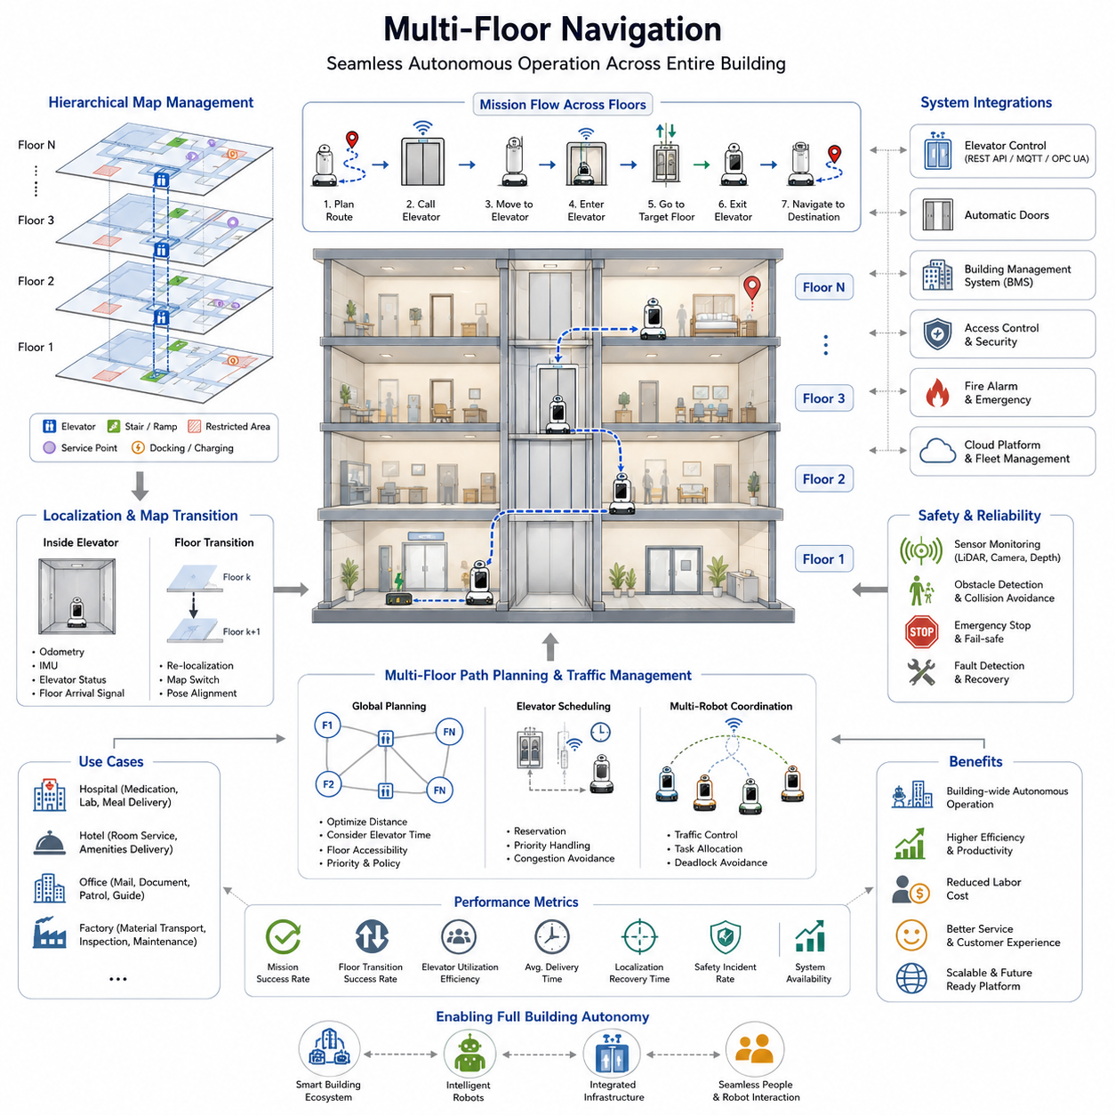
Multi-floor navigation is one of the most advanced capabilities required for modern Autonomous Mobile Robots (AMRs) operating in large buildings such as hospitals, hotels, shopping malls, airports, office complexes, logistics centers, and smart factories. Traditional robot navigation systems are often designed for operation within a single floor or a single mapped environment. However, real-world service robots must frequently move between multiple floors to complete delivery tasks, inspection missions, security patrols, maintenance activities, and customer service operations. Multi-floor navigation extends conventional navigation systems by integrating localization, mapping, path planning, building infrastructure communication, elevator coordination, automatic door control, and mission management into a unified framework. Within the building integration architecture of autonomous robots, multi-floor navigation represents the bridge between local robot mobility and facility-wide operational intelligence. The concept is positioned as a critical component within Elevator and Door Integration systems and enables robots to become true building-wide autonomous agents rather than isolated floor-level machines.
The fundamental objective of multi-floor navigation is to allow a robot to autonomously travel from any location in a building to any other location regardless of floor boundaries. From the perspective of a human user, requesting a robot to deliver medicine from a pharmacy on the first floor to a patient room on the seventh floor should appear as a simple task. Internally, however, the robot must execute a complex sequence of operations. It must localize itself within the current floor map, generate a route to the nearest elevator, request elevator service, navigate to the elevator entrance, verify elevator arrival, enter the elevator safely, communicate the destination floor, maintain localization while inside the moving elevator, exit at the correct floor, transition to the destination floor map, re-establish precise localization, and continue navigation toward the final goal. Every step must be performed reliably and safely under dynamic real-world conditions.
The architecture of a multi-floor navigation system begins with hierarchical map management. Instead of representing an entire building as a single monolithic map, the building is divided into floor-specific maps. Each floor contains its own localization framework, semantic information, obstacle layers, navigation corridors, restricted areas, docking stations, service points, and operational zones. A higher-level building map maintains the relationships between floors and the connections established by elevators, stairways, ramps, and service corridors. This hierarchical mapping approach significantly reduces computational complexity while allowing large-scale deployment across buildings containing dozens of floors and thousands of rooms.
Map transitions are among the most important functions of multi-floor navigation. When a robot moves from one floor to another, the localization system must seamlessly transition between independent coordinate systems. Each floor may possess its own local coordinate frame generated during SLAM operations. The navigation framework therefore requires transformation relationships between floors so that the robot can maintain a consistent global understanding of its location within the building. Building-level reference coordinates are often established to unify floor maps and simplify route planning across the entire facility.
Localization challenges become particularly significant during elevator travel. Conventional localization methods depend heavily on environmental features such as walls, corridors, doors, and landmarks. Inside an elevator, these features may disappear or become insufficient for reliable positioning. The robot therefore relies on a combination of wheel odometry, IMU measurements, elevator communication messages, floor arrival notifications, and time-based motion estimation to maintain awareness during transit. Once the elevator reaches the target floor, the robot must rapidly reacquire environmental features and verify that it has arrived at the correct destination before resuming navigation.
Elevator integration forms the core operational mechanism of multi-floor navigation. Modern elevators increasingly support communication interfaces that allow external systems to request elevator services. Robots communicate with elevator controllers using protocols such as REST APIs, MQTT, OPC UA, BACnet, Modbus TCP, proprietary manufacturer interfaces, or middleware integration platforms. Through these interfaces, the robot can request elevator arrival, reserve elevator usage, select destination floors, receive status updates, and monitor elevator availability. Elevator communication eliminates the need for physical interaction with elevator buttons and significantly improves operational reliability.
A typical elevator mission begins when the fleet management system identifies that the destination lies on a different floor. The navigation planner computes an optimal route to an elevator that minimizes travel distance, waiting time, and congestion. The robot then travels to the elevator waiting area while continuously monitoring elevator status. Once the elevator arrives, sensors verify door opening conditions and cabin availability. The robot enters the elevator using carefully controlled motion profiles designed to prevent collisions with passengers and building infrastructure.
Safe elevator entry and exit require specialized navigation behaviors. Elevator cabins often represent constrained environments with limited maneuvering space. Precision localization is necessary to align the robot correctly before entering. LiDAR sensors, depth cameras, visual markers, AprilTags, QR codes, and semantic landmarks may be used to support accurate positioning. The navigation controller must generate smooth trajectories that account for door boundaries, cabin dimensions, passenger movement, and obstacle avoidance requirements. Similar procedures are executed when exiting the elevator at the destination floor.
Mission planning across multiple floors introduces additional complexity compared to conventional path planning. The navigation system must consider not only physical distance but also elevator travel time, elevator availability, passenger traffic patterns, floor accessibility restrictions, and operational priorities. In large hospitals, for example, certain elevators may be reserved for patient transport, emergency services, or medical staff. Service robots must intelligently select elevators based on current operational constraints. Dynamic route optimization enables robots to adapt when elevators become unavailable or congested.
Semantic building understanding significantly enhances multi-floor navigation performance. Rather than treating elevators merely as navigation nodes, semantic maps represent elevators as functional building assets with attributes such as capacity, operating schedules, accessibility characteristics, priority levels, and service restrictions. The robot can reason about these semantic properties when selecting routes and making navigation decisions. Semantic understanding also allows robots to interpret human instructions such as “deliver this package to the fifth-floor conference room” or “go to the pharmacy on the second floor.”
Hospital environments represent one of the most demanding applications of multi-floor navigation. Medical facilities often contain multiple buildings, numerous elevators, restricted zones, intensive care units, operating rooms, pharmacies, laboratories, and patient wards distributed across many floors. Service robots must transport medication, meals, laboratory samples, linens, waste materials, and medical supplies while complying with strict operational protocols. Multi-floor navigation enables continuous autonomous operation throughout the entire hospital infrastructure, reducing labor costs and improving service efficiency.
Hotel service robots also depend heavily on multi-floor navigation capabilities. Delivery robots transport food, beverages, toiletries, and customer packages to guest rooms located on various floors. The robot receives service requests through hotel management systems, navigates to service stations, uses elevators autonomously, accesses guest corridors, and completes deliveries without human intervention. Integration with elevator systems and automatic doors allows robots to function as autonomous hospitality assistants.
Office buildings present another important deployment scenario. Robots may perform mail delivery, document transport, security patrols, visitor guidance, cleaning support, and facility inspections. Multi-floor navigation allows a single robotic platform to serve the entire building rather than being restricted to a single floor. Fleet management systems can coordinate multiple robots operating across large office complexes while dynamically balancing workloads and optimizing travel efficiency.
Industrial facilities increasingly deploy multi-floor autonomous robots for manufacturing logistics, warehouse operations, equipment inspection, and predictive maintenance. Production facilities often include multiple levels connected by freight elevators and industrial lifts. Robots equipped with advanced navigation systems can move materials between floors, perform scheduled inspections, collect sensor data, and support maintenance operations. Integration with manufacturing execution systems further enhances operational coordination.
Traffic management becomes increasingly important as the number of robots operating within a building grows. Multiple robots may simultaneously request elevator access, creating potential congestion and scheduling conflicts. Fleet-level traffic optimization systems coordinate elevator usage through reservation mechanisms and priority scheduling algorithms. High-priority missions such as medical deliveries can receive preferential elevator access, while routine logistics tasks may be scheduled during lower-demand periods. Such coordination significantly improves system throughput and operational efficiency.
Cloud-based building management integration provides an additional layer of intelligence. Robots communicate with centralized facility management platforms that maintain real-time awareness of elevator status, door conditions, occupancy levels, maintenance schedules, and emergency situations. This information enables proactive route planning and dynamic adaptation to changing building conditions. Cloud-based architectures also support analytics, performance monitoring, predictive maintenance, and long-term operational optimization.
Safety remains the highest priority throughout multi-floor navigation operations. Elevator doors represent dynamic hazards that require continuous monitoring. The robot must verify safe entry conditions before movement and immediately stop if unexpected obstacles appear. Emergency stop mechanisms, safety LiDAR systems, depth sensing technologies, collision avoidance algorithms, and fail-safe communication protocols work together to ensure safe operation in public environments. Functional safety requirements often follow international standards governing autonomous mobile robots and service robotics platforms.
Failure handling strategies are essential because building infrastructure may occasionally malfunction. Elevator communication links may fail, elevators may become unavailable, doors may not open as expected, or localization errors may occur during floor transitions. Robust recovery mechanisms allow the robot to retry operations, select alternative elevators, request human assistance, notify fleet management systems, or safely pause operations until conditions are restored. These recovery procedures significantly improve system reliability in real-world deployments.
Simulation environments play a crucial role during development and validation. Digital twins of buildings allow engineers to evaluate multi-floor navigation algorithms under realistic conditions before deployment. Elevators, doors, corridors, human traffic, and building layouts can be modeled accurately within simulation platforms. Extensive testing helps identify edge cases and validate safety behaviors before robots operate in live facilities.
Performance metrics for multi-floor navigation include mission completion rate, elevator utilization efficiency, floor transition success rate, localization recovery time, average delivery duration, navigation accuracy, safety incident frequency, and system availability. Continuous monitoring of these metrics provides valuable insights into operational performance and supports ongoing optimization efforts.
As autonomous robots become more deeply integrated into smart buildings, multi-floor navigation will evolve beyond simple elevator usage. Future systems will incorporate advanced building intelligence, predictive traffic management, AI-driven route optimization, digital twins, semantic reasoning, and collaborative interactions between robots and building infrastructure. Buildings themselves may become active participants in robot navigation by providing localization assistance, route recommendations, occupancy information, and predictive scheduling services.
The long-term vision of multi-floor navigation is the creation of fully autonomous building ecosystems in which robots move seamlessly across floors, departments, and facilities while coordinating with elevators, doors, security systems, energy management systems, and human occupants. In such environments, robots become integral components of the building infrastructure, delivering services efficiently, safely, and continuously. Multi-floor navigation therefore serves as a foundational technology that transforms autonomous mobile robots from localized machines into facility-wide intelligent agents capable of operating across complex vertical environments and supporting the next generation of smart buildings, hospitals, hotels, factories, and urban infrastructure systems.

14.5 Precise Positioning for Elevators
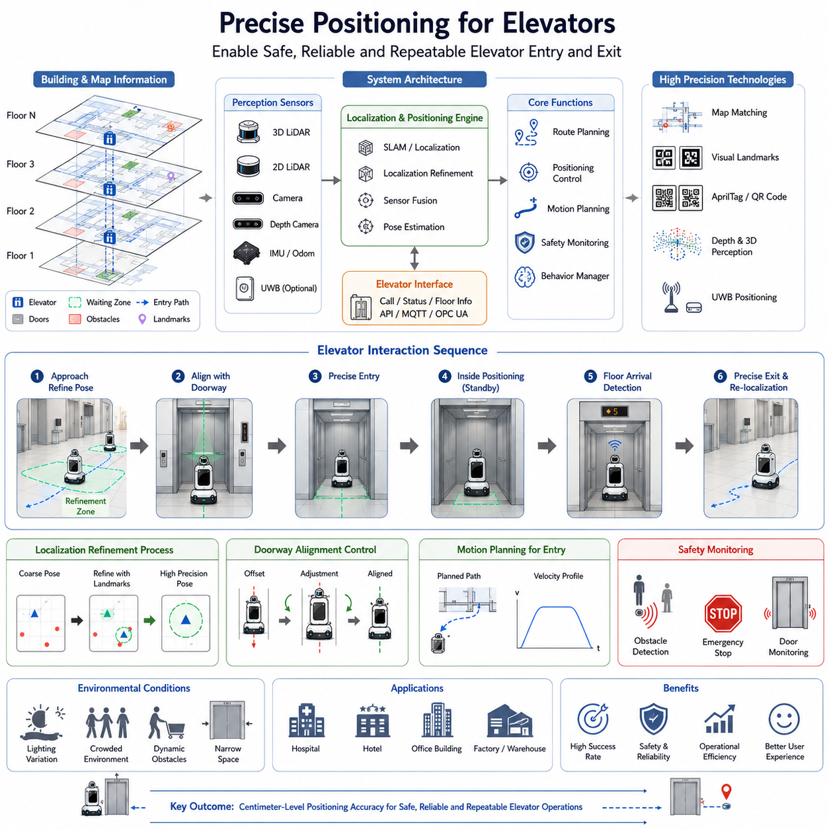
Precise positioning for elevators is one of the most critical technologies within autonomous mobile robot navigation systems operating in multi-floor buildings. While global navigation, path planning, localization, and elevator communication enable robots to travel throughout a facility, the actual success of elevator usage depends heavily on the robot's ability to position itself with extremely high accuracy before entering and exiting the elevator cabin. Even a navigation system capable of achieving decimeter-level accuracy in corridors may fail when interacting with elevators because elevator operations require centimeter-level positioning precision. Elevator entrances represent constrained, dynamic, and safety-critical environments where small positioning errors can lead to navigation failures, collisions, mission interruptions, passenger inconvenience, and reduced operational reliability. Consequently, precise elevator positioning has become a dedicated subsystem within advanced building-integrated robotic platforms.
The fundamental objective of elevator positioning is to ensure that a robot can repeatedly align itself with the elevator entrance, navigate through the doorway safely, occupy an appropriate location within the elevator cabin, and subsequently exit the elevator accurately upon arrival at the destination floor. Unlike conventional navigation tasks where minor deviations may be acceptable, elevator interactions impose strict spatial constraints. The width of the elevator doorway may only exceed the robot width by a limited margin. Additionally, passengers, carts, wheelchairs, medical equipment, luggage, and other dynamic obstacles may occupy portions of the available space. Under such conditions, navigation precision becomes directly linked to safety and operational effectiveness.
A typical autonomous robot begins the elevator interaction sequence long before reaching the elevator itself. During route planning, the navigation system identifies elevator locations as special infrastructure nodes within the semantic map. These nodes contain detailed information regarding elevator geometry, doorway dimensions, waiting zones, entry trajectories, cabin layouts, and preferred stopping positions. As the robot approaches the elevator area, it transitions from standard corridor navigation to a high-precision positioning mode specifically designed for elevator operations.
High-precision positioning begins with localization refinement. Conventional localization systems based on LiDAR SLAM, Visual SLAM, GNSS-denied localization, or multi-sensor fusion may achieve position accuracy ranging from several centimeters to tens of centimeters depending on environmental conditions. While sufficient for general navigation, such accuracy may not guarantee reliable elevator interaction. Therefore, additional localization refinement methods are employed as the robot approaches the elevator.
LiDAR-based positioning remains one of the most widely adopted approaches. Modern AMRs often utilize high-resolution 2D safety LiDARs and 3D LiDAR sensors to detect elevator door frames, wall structures, corner features, and surrounding geometric landmarks. By matching live sensor observations against pre-mapped elevator environments, the robot can estimate its position with significantly greater accuracy than standard localization techniques. The rigid and highly structured geometry of elevator entrances provides ideal reference features for localization refinement.
Visual positioning techniques provide another powerful layer of precision. Cameras mounted on the robot detect visual landmarks near elevator entrances, including door edges, wall patterns, signs, markers, floor indicators, and architectural features. Computer vision algorithms identify these landmarks and estimate relative pose information. Advanced systems employ deep learning-based feature extraction networks capable of operating under varying lighting conditions. Vision-based positioning can often compensate for localization errors that arise when LiDAR observations are partially obstructed by pedestrians or temporary obstacles.
Many commercial deployments incorporate artificial landmarks specifically designed for robotic navigation. QR codes, AprilTags, ArUco markers, fiducial markers, reflective targets, and custom visual tags are installed near elevator entrances. These markers provide highly reliable reference points that can be detected quickly and accurately by onboard cameras. The robot calculates its position relative to the marker and uses this information to align itself precisely with the elevator doorway. Such systems are commonly found in hospitals, hotels, and logistics facilities where operational reliability is prioritized over architectural aesthetics.
Depth cameras further enhance positioning performance by providing three-dimensional information about the surrounding environment. Depth measurements allow robots to estimate the exact location of elevator doors, wall boundaries, floor transitions, and obstacles. Combining depth information with visual features creates robust localization solutions capable of maintaining precision even in challenging environments.
Ultra-Wideband (UWB) positioning systems are increasingly being integrated into modern buildings to support robotic operations. UWB anchors installed throughout the facility provide highly accurate indoor positioning measurements. Elevator zones can be equipped with dedicated UWB reference points that allow robots to achieve sub-decimeter localization accuracy. Such infrastructure-based positioning systems complement onboard perception and provide redundancy in environments where visual or LiDAR features may be unreliable.
The concept of localization refinement zones is frequently employed in advanced navigation architectures. As the robot approaches an elevator, it enters a predefined positioning zone. Within this zone, navigation speed is reduced, sensor update rates are increased, and localization algorithms switch to high-precision modes. Additional computational resources may be allocated to pose estimation, ensuring maximum positioning accuracy before elevator interaction begins.
Doorway alignment is among the most challenging aspects of elevator positioning. The robot must align its orientation precisely with the elevator entrance to ensure smooth entry. Even small angular errors can cause the robot to drift toward the door frame during entry. Therefore, alignment controllers continuously adjust the robot's heading using feedback from LiDAR, vision systems, and inertial sensors. Advanced control algorithms employ closed-loop feedback mechanisms to minimize both translational and rotational errors before movement through the doorway begins.
Motion planning for elevator entry differs significantly from standard navigation. Traditional navigation systems prioritize obstacle avoidance and path efficiency, whereas elevator entry prioritizes precision and safety. Specialized motion planners generate smooth trajectories that guide the robot toward the center of the doorway while maintaining appropriate clearance from surrounding structures. Velocity profiles are carefully controlled to prevent abrupt movements that could reduce positioning accuracy.
Once inside the elevator cabin, the robot must occupy a designated parking position. This position is typically selected to maximize passenger space, maintain safe distances from doors, and ensure efficient exit upon arrival. Precise positioning inside the cabin is particularly important in crowded environments where multiple passengers may enter and exit during elevator travel.
Maintaining localization inside the elevator introduces additional technical challenges. Traditional localization systems may experience degradation because elevator cabins provide limited environmental features. The robot therefore relies on a combination of wheel odometry, IMU measurements, cabin geometry recognition, and elevator communication data. Sensor fusion algorithms estimate the robot's position throughout the elevator journey and prepare the system for re-localization upon arrival.
Elevator floor arrival detection is another essential component of precise positioning systems. Robots must determine exactly when the elevator reaches the target floor. Building communication interfaces often provide floor arrival notifications directly from elevator controllers. However, robust systems typically combine multiple sources of information, including elevator status messages, visual floor indicators, door opening detection, inertial measurements, and timing models. Redundant detection mechanisms improve reliability and reduce the likelihood of navigation errors.
Upon reaching the destination floor, the robot must execute a controlled exit maneuver. Before moving, it verifies that the correct floor has been reached and that the doorway is clear. Localization systems immediately begin searching for floor-specific landmarks to establish accurate positioning within the destination map. Once localization confidence exceeds predefined thresholds, the robot proceeds through the doorway and transitions back to standard navigation mode.
Human-aware positioning represents an increasingly important aspect of elevator navigation. Elevators are shared spaces where robots interact closely with people. The robot must account for passenger movement, social behavior, accessibility requirements, and personal space considerations. Human-aware navigation algorithms adjust positioning strategies dynamically to avoid obstructing passengers and to create comfortable interactions.
In hospital environments, precise positioning becomes particularly critical. Medical robots frequently transport medications, laboratory samples, blood products, and sensitive equipment between floors. Elevator navigation failures can disrupt healthcare workflows and delay critical deliveries. Consequently, hospital deployments often employ multiple redundant positioning technologies including LiDAR, vision, markers, depth sensing, and building infrastructure integration to maximize reliability.
Hotels present a different set of requirements. Service robots delivering food, amenities, and guest packages must operate in aesthetically designed environments where visible infrastructure modifications may be limited. Positioning systems therefore rely more heavily on natural visual landmarks, semantic mapping, and advanced perception algorithms. The robot must achieve high positioning accuracy while remaining unobtrusive to guests.
Industrial facilities often utilize freight elevators, heavy-duty lifts, and material transport systems. These environments may involve large payload robots, autonomous forklifts, towing AMRs, and inspection platforms. Precise positioning is necessary not only for safe operation but also for alignment with loading docks, conveyor systems, and automated material handling equipment integrated with elevator infrastructure.
Safety remains the highest priority throughout elevator positioning operations. Multiple layers of protection are typically implemented. Safety LiDAR sensors continuously monitor surrounding areas for obstacles. Emergency stop mechanisms remain active at all times. Collision avoidance systems evaluate potential hazards before and during movement. Doorway crossing operations are interrupted immediately if unexpected obstacles are detected. These safety mechanisms ensure compliance with industrial and service robot safety standards.
Failure handling and recovery strategies play a crucial role in maintaining operational robustness. Positioning errors may result from sensor failures, localization drift, environmental changes, temporary obstructions, communication issues, or unexpected building conditions. Recovery procedures include re-localization attempts, alternative positioning strategies, fallback sensor utilization, remote operator assistance, and mission replanning. Robust recovery capabilities significantly improve long-term deployment reliability.
Simulation and digital twin technologies are widely used during system development. Engineers create detailed virtual representations of elevator environments, including doorway geometries, cabin layouts, passenger traffic patterns, and sensor characteristics. Simulation allows extensive testing of positioning algorithms under thousands of scenarios before deployment in real-world facilities. Such testing reduces development risk and accelerates system validation.
Performance evaluation metrics for elevator positioning include positioning accuracy, alignment error, entry success rate, exit success rate, localization recovery time, docking precision, mission completion rate, passenger interference incidents, and overall operational reliability. Continuous monitoring of these metrics enables data-driven optimization and long-term system improvement.
Future elevator positioning systems will increasingly leverage artificial intelligence, semantic understanding, multimodal sensor fusion, and intelligent building infrastructure. Vision-language models may enable robots to understand elevator environments semantically. Building digital twins may provide predictive information regarding elevator availability and passenger traffic. Smart buildings may actively support robot positioning by broadcasting localization references and environmental updates. Advanced embodied AI systems may further improve the robot's ability to interact naturally with complex elevator environments.
Ultimately, precise positioning for elevators serves as the foundation that enables reliable multi-floor autonomy. Without accurate positioning, even the most advanced navigation, mapping, and communication systems cannot guarantee successful elevator interactions. By combining high-precision localization, sensor fusion, intelligent motion planning, safety mechanisms, and building integration technologies, modern autonomous robots can navigate elevators with a level of reliability approaching that of experienced human operators. As smart buildings and autonomous service robots continue to evolve, precise elevator positioning will remain a fundamental enabling technology supporting large-scale deployment across hospitals, hotels, factories, airports, office towers, logistics centers, and future intelligent infrastructure systems.

14.6 Hospital and Hotel Applications
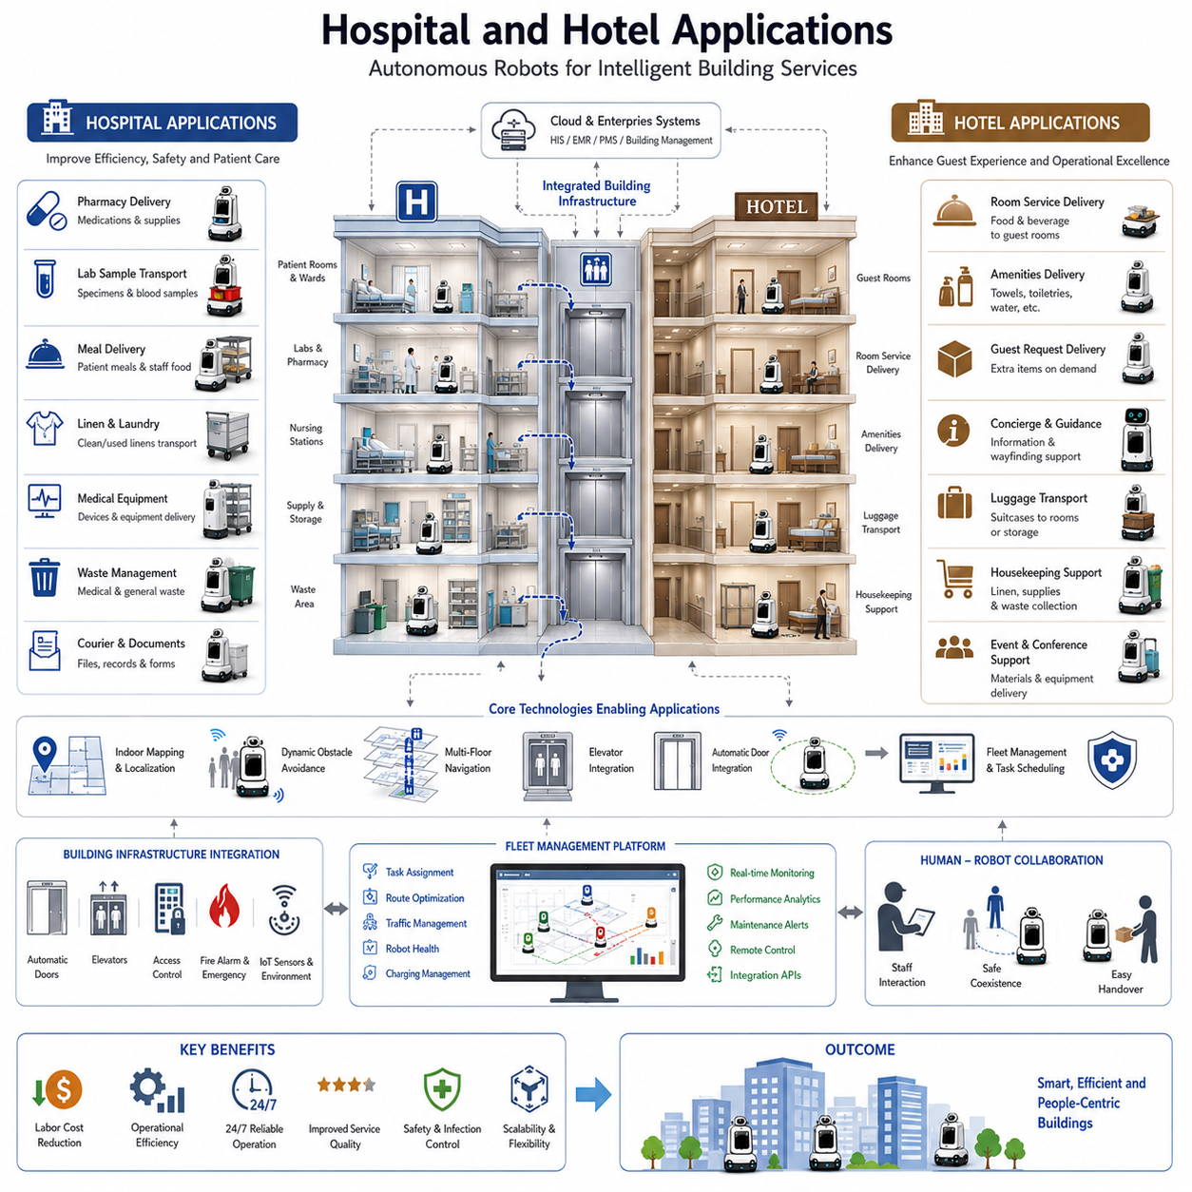
Hospital and hotel environments represent two of the most mature and commercially successful deployment domains for Autonomous Mobile Robots (AMRs). While both industries operate within large multi-floor buildings and require reliable autonomous transportation, their operational objectives, workflow characteristics, user expectations, safety requirements, and infrastructure constraints differ significantly. Nevertheless, both sectors rely heavily on advanced building integration technologies, including automatic door integration, elevator communication, multi-floor navigation, precise elevator positioning, fleet management systems, and intelligent task scheduling. As a result, hospitals and hotels have become primary drivers of innovation in indoor autonomous robotics and serve as important reference models for future smart building ecosystems.
The adoption of autonomous robots in hospitals has accelerated rapidly due to increasing labor shortages, rising operational costs, growing healthcare demands, and the need to improve service quality while minimizing human workload. Modern hospitals operate continuously twenty-four hours a day and involve complex logistics activities across multiple departments and floors. Medical supplies, pharmaceuticals, laboratory samples, blood products, meals, linens, medical equipment, waste materials, and patient-related items must be transported safely and efficiently throughout the facility. These repetitive transportation tasks consume significant amounts of staff time and often divert healthcare professionals from direct patient care activities.
Hospital service robots are designed to automate these logistical operations. Rather than replacing healthcare workers, they function as intelligent assistants that handle routine transportation activities. By assuming responsibility for repetitive delivery missions, robots allow nurses, pharmacists, laboratory technicians, and support staff to focus on higher-value clinical responsibilities. This operational model improves efficiency while enhancing patient care quality.
One of the most common hospital applications involves pharmaceutical delivery. Hospital pharmacies frequently receive medication requests from inpatient wards, intensive care units, emergency departments, surgical centers, and outpatient clinics. Traditionally, hospital staff manually transport medications between departments. Autonomous robots can receive delivery requests directly from hospital information systems, retrieve medication containers from designated pickup stations, navigate through corridors, utilize elevators autonomously, and deliver the medications to their destinations. This reduces delivery times while improving traceability and accountability.
Laboratory sample transportation represents another important application. Blood samples, tissue specimens, diagnostic materials, and laboratory test samples often require rapid delivery between collection points and laboratory facilities. Delays can affect diagnostic processes and patient outcomes. AMRs provide predictable transportation schedules and continuous operation, helping hospitals improve laboratory workflow efficiency and turnaround times.
Meal delivery systems have become increasingly popular in large healthcare facilities. Hospitals prepare thousands of meals daily for patients, visitors, and staff. Autonomous robots can transport meal carts from kitchen facilities to nursing stations and patient care areas. Integration with elevators and automatic doors allows robots to travel across multiple floors without human assistance, significantly reducing labor requirements while ensuring timely meal distribution.
Linen and laundry logistics constitute another major operational burden within hospitals. Clean linens must be distributed throughout the facility while used linens must be collected and transported to processing areas. Autonomous robots can perform these repetitive logistics tasks efficiently and continuously, improving operational productivity while reducing physical workload for support personnel.
Waste transportation is particularly well suited to robotic automation. Hospitals generate various categories of waste, including general waste, medical waste, biohazard materials, and recyclable materials. Autonomous robots equipped with secure transport containers can move waste safely between departments and disposal facilities while minimizing human exposure and improving compliance with safety protocols.
Medical equipment delivery and retrieval also benefit significantly from robotic automation. Portable diagnostic devices, infusion pumps, monitoring equipment, wheelchairs, and other resources are frequently shared among departments. AMRs can transport equipment between locations on demand, reducing equipment search times and improving resource utilization.
The integration of hospital robots with hospital information systems creates a highly coordinated operational environment. Robots communicate with Electronic Medical Records (EMR), Hospital Information Systems (HIS), Pharmacy Information Systems (PIS), Laboratory Information Systems (LIS), and Resource Management Systems. These integrations allow robots to receive tasks automatically, update delivery status in real time, and participate directly in hospital workflows.
Hospitals impose particularly stringent requirements on navigation reliability. Service interruptions can directly impact patient care. Consequently, hospital robots typically employ multiple layers of redundancy including LiDAR-based localization, visual positioning systems, semantic mapping, elevator communication interfaces, safety LiDARs, emergency stop mechanisms, and fleet management platforms. The objective is to achieve near-continuous operation with extremely high mission success rates.
Infection control has become an increasingly important consideration in healthcare robotics. Autonomous robots can reduce unnecessary human contact and minimize cross-department traffic. During infectious disease outbreaks, robots can transport supplies, medications, and laboratory samples while limiting staff exposure. Some healthcare robots additionally incorporate ultraviolet disinfection systems, air purification technologies, and environmental monitoring capabilities.
Hospital navigation presents unique challenges due to highly dynamic environments. Patients, visitors, nurses, physicians, wheelchairs, stretchers, mobile medical equipment, and emergency response teams continuously move throughout the facility. Robots must therefore employ advanced human-aware navigation strategies that prioritize safety, social compliance, and operational efficiency. Dynamic obstacle avoidance systems must perform reliably even during periods of heavy traffic.
Emergency situations introduce additional complexity. During emergencies, certain corridors or elevators may become temporarily unavailable. Robots must respond appropriately by yielding to emergency personnel, rerouting around restricted zones, or suspending operations when required. Integration with building management systems allows robots to receive emergency notifications and adapt their behavior accordingly.
While hospitals focus primarily on operational logistics and clinical support, hotel applications emphasize customer service, guest experience, operational efficiency, and brand differentiation. The hospitality industry has increasingly adopted autonomous service robots as a means of improving service availability while addressing labor shortages and rising operational costs.
Hotel delivery robots are among the most visible examples of service robotics. Guests frequently request amenities such as towels, toiletries, bottled water, snacks, beverages, chargers, and room service items. Traditionally, hotel staff manually deliver these items to guest rooms. Autonomous robots can receive requests from hotel management systems, retrieve requested items from service areas, navigate through hotel corridors, utilize elevators autonomously, and deliver items directly to guest rooms.
The integration of robots into hotel operations creates new service models. Guests may interact with robots through mobile applications, room tablets, voice assistants, or front desk systems. Delivery requests are automatically routed to the fleet management platform, which assigns tasks to available robots. Once a delivery is completed, guests receive notifications confirming arrival.
Room service delivery represents one of the fastest growing robotic applications within hotels. Food and beverage deliveries often involve significant labor costs, particularly during peak hours. Autonomous robots can transport meals directly from kitchens to guest rooms while maintaining delivery quality and reducing staff workload. Integration with elevators and automatic doors enables completely autonomous service across multiple floors.
Hotels increasingly utilize robots for concierge support functions. These robots may provide navigation assistance, answer frequently asked questions, guide guests to facilities, provide local information, and support multilingual communication. Although many concierge robots remain stationary, mobile robotic platforms are becoming increasingly capable of escorting guests through hotel facilities.
Luggage transportation is another emerging application. Large hotels and resorts often require staff to transport luggage between storage areas, reception desks, and guest rooms. Autonomous mobile robots equipped with secure cargo compartments can assist with these tasks while improving operational efficiency and reducing physical strain on employees.
Housekeeping support presents significant opportunities for automation. Hotels must continuously distribute cleaning supplies, collect linens, transport waste, and replenish guest amenities. Robots can automate many of these logistics activities, allowing housekeeping staff to focus on room preparation and guest-facing responsibilities.
Guest experience remains a central consideration in hospitality robotics. Unlike industrial environments, hotels emphasize aesthetics, comfort, and customer satisfaction. Robots operating in hotels must exhibit smooth motion, quiet operation, attractive design, and socially appropriate behavior. Navigation algorithms must prioritize guest comfort while maintaining operational efficiency.
Hotel robots frequently operate in environments with highly variable traffic patterns. Check-in periods, conference events, breakfast service, and evening activities can create temporary congestion. Advanced fleet management systems dynamically adjust routing strategies to accommodate changing traffic conditions and maintain service quality.
Multi-floor navigation plays a critical role in both hospitals and hotels. These facilities often contain numerous floors connected by elevators, service corridors, restricted zones, and access-controlled areas. Reliable elevator integration allows robots to function as building-wide service platforms rather than floor-specific systems. Autonomous elevator operation significantly expands the range and value of robotic services.
Building management system integration further enhances operational effectiveness. Robots can communicate with access control systems, automatic doors, elevator controllers, security systems, fire alarm systems, and facility management platforms. This integration allows robots to navigate complex environments while complying with building policies and operational constraints.
Fleet management becomes increasingly important as deployment scale grows. Large hospitals may operate dozens or even hundreds of robots simultaneously. Similarly, major hotel chains may deploy fleets of service robots throughout their properties. Fleet management platforms coordinate task assignment, route optimization, traffic management, charging schedules, maintenance planning, and performance monitoring.
Cybersecurity is a critical consideration in both industries. Hospitals manage sensitive patient information, while hotels process guest information and operational data. Robot communication systems must comply with security standards, protect sensitive information, and maintain secure connections with enterprise systems.
Performance metrics differ somewhat between hospital and hotel deployments. Hospitals emphasize delivery reliability, response time, operational availability, workflow efficiency, and patient support outcomes. Hotels focus more heavily on guest satisfaction, service response time, operational cost reduction, staff productivity, and brand differentiation. Despite these differences, both sectors require exceptionally reliable autonomous operation.
Artificial intelligence continues to expand the capabilities of service robots in healthcare and hospitality environments. Advanced perception systems improve navigation reliability. Predictive scheduling algorithms optimize fleet utilization. Natural language interfaces enable intuitive human-robot interaction. Vision-language models enhance contextual understanding and service quality. These technologies are gradually transforming robots from simple delivery platforms into intelligent service assistants.
The future of hospital and hotel robotics will likely involve deeper integration with smart building infrastructure, digital twins, cloud-based operations, and enterprise management systems. Robots will collaborate with elevators, doors, building sensors, facility management platforms, and AI-driven operational systems to create highly automated service ecosystems. Hospitals may eventually operate autonomous logistics networks that manage supplies, medications, equipment, and waste continuously throughout the facility. Hotels may provide fully automated guest service experiences supported by intelligent robotic fleets operating around the clock.
Ultimately, hospitals and hotels demonstrate the practical value of building-integrated autonomous robotics. Both industries benefit from reduced labor demands, improved operational efficiency, enhanced service quality, and increased scalability. By combining multi-floor navigation, elevator integration, precise positioning, intelligent fleet management, and advanced artificial intelligence, autonomous robots are becoming essential components of modern healthcare and hospitality infrastructure. As technology continues to mature, these applications will serve as foundational models for the broader adoption of service robotics across smart buildings, commercial facilities, and future intelligent cities.

14.7 Safety and Failure Handling
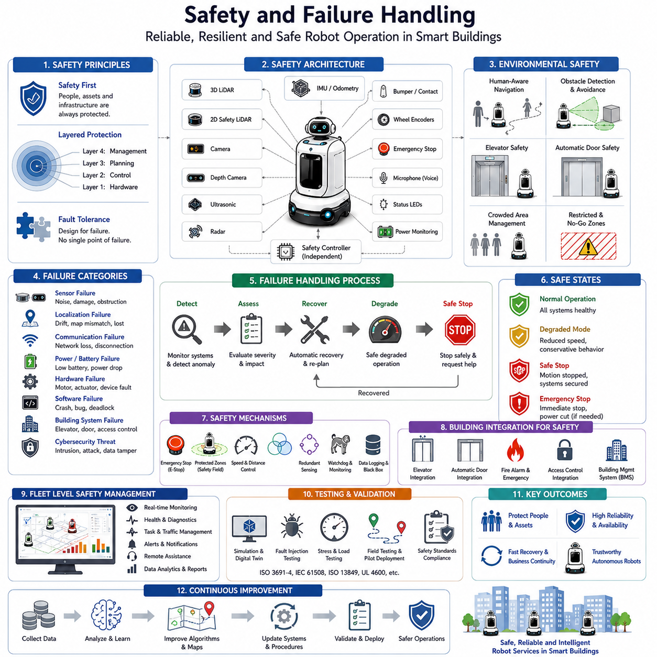
Safety and Failure Handling is one of the most critical components of building-integrated autonomous mobile robot systems. While advanced navigation, elevator communication, automatic door integration, multi-floor navigation, and fleet management enable robots to perform complex missions throughout large facilities, these capabilities can only be deployed successfully when supported by a comprehensive safety and fault management framework. In environments such as hospitals, hotels, office buildings, airports, shopping malls, logistics centers, and industrial facilities, robots operate in close proximity to people, equipment, vehicles, infrastructure systems, and sensitive operational processes. Consequently, the ability to prevent accidents, detect abnormal situations, recover from failures, and maintain safe operation under all circumstances is fundamental to the successful deployment of autonomous service robots.
Safety within building-integrated robotics begins with the principle that every subsystem must be designed with fault tolerance in mind. A robot cannot assume that sensors will always function correctly, communication links will always remain available, elevators will always respond as expected, or navigation maps will always accurately represent the environment. Real-world deployments inevitably encounter unexpected events. Therefore, safety engineering focuses not only on preventing failures but also on ensuring that failures do not lead to hazardous situations.
The operational environment of a building-integrated robot is inherently dynamic and unpredictable. People continuously move through corridors, enter and exit elevators, open doors unexpectedly, reposition furniture, transport equipment, and create temporary obstacles. Building systems themselves may experience maintenance activities, power interruptions, network outages, software updates, or mechanical failures. The robot must continuously evaluate environmental conditions and adapt its behavior accordingly.
A fundamental principle of robotic safety is the concept of layered protection. Instead of relying on a single safety mechanism, modern robots employ multiple independent layers of safety systems. If one layer fails, additional layers continue protecting the environment and surrounding people. This multi-layered architecture significantly reduces the probability of catastrophic failures and improves overall system reliability.
Sensor redundancy forms one of the primary layers of protection. Safety-critical robots often utilize multiple sensing technologies simultaneously, including 2D safety LiDARs, 3D LiDARs, RGB cameras, depth cameras, ultrasonic sensors, radar systems, IMUs, wheel encoders, bumper sensors, and emergency stop circuits. Each sensor type offers different strengths and weaknesses. By combining multiple sensing modalities, the robot can maintain situational awareness even if one sensor becomes unavailable or provides degraded performance.
Obstacle detection and collision avoidance represent the first line of operational safety. Safety LiDARs continuously monitor areas surrounding the robot and define protective zones based on vehicle speed, direction, and operational mode. When an object enters a warning zone, the robot may reduce speed. When an object enters a critical safety zone, the robot immediately initiates emergency braking. These responses occur independently of high-level navigation software and are typically managed by certified safety controllers.
Human-aware navigation significantly enhances safety in populated environments. Unlike industrial automation systems operating in isolated areas, building service robots share space with people. The robot must recognize pedestrians, predict movement patterns, maintain appropriate social distances, and behave in ways that appear safe and comfortable to human occupants. Advanced perception systems utilize artificial intelligence to distinguish people from other objects and adapt navigation strategies accordingly.
Elevator integration introduces unique safety challenges. Elevator doors represent moving mechanical systems that can create hazardous situations if not monitored correctly. Before entering an elevator, the robot must verify that the doors are fully open, the cabin is properly aligned, and no obstacles are blocking the entrance. During entry and exit operations, continuous monitoring is required to detect unexpected human movement or environmental changes. If any anomaly is detected, the robot must immediately stop and reassess the situation.
Automatic door integration requires similar safety considerations. Doors may fail to open, close unexpectedly, become obstructed, or experience communication failures. The robot must verify door status continuously and maintain safe distances until the opening sequence is confirmed. In cases where door operation deviates from expected behavior, the robot must suspend movement and initiate recovery procedures.
Multi-floor navigation creates additional complexity because the robot transitions between multiple maps, coordinate systems, infrastructure services, and operational zones. Errors occurring during floor transitions may result in localization uncertainty, incorrect floor identification, or navigation inconsistencies. To address these challenges, robots employ validation mechanisms that verify floor identity, elevator arrival status, localization confidence, and environmental consistency before resuming autonomous operation.
Localization safety plays a critical role in reliable navigation. Autonomous robots continuously estimate their position using LiDAR SLAM, Visual SLAM, odometry, IMU measurements, semantic landmarks, and map matching algorithms. However, localization systems may experience drift, sensor degradation, environmental changes, or temporary loss of reference features. The robot must continuously evaluate localization confidence levels and determine whether positioning accuracy remains within acceptable safety limits.
When localization confidence falls below predefined thresholds, the robot may enter a degraded operating mode. In this mode, vehicle speed is reduced, navigation decisions become more conservative, and additional localization procedures are initiated. If localization cannot be restored, the robot transitions into a safe stop state and requests assistance from the fleet management system or human operators.
Communication failures represent another major category of operational risk. Building-integrated robots depend on communication links with fleet management systems, cloud services, elevator controllers, automatic doors, access control systems, and building management platforms. Wireless networks may experience congestion, interference, signal degradation, or complete outages. Therefore, robots must be capable of operating safely even when communication services become unavailable.
Local autonomy is an essential design principle for communication fault tolerance. While cloud services provide coordination and optimization capabilities, safety-critical decisions must remain available locally on the robot. Emergency braking, obstacle avoidance, safety monitoring, and core navigation functions continue operating even during network disruptions. This architecture ensures that communication failures do not immediately compromise safety.
Battery and power management are equally important components of failure handling. Autonomous robots operating in large buildings may travel considerable distances throughout the day. Battery depletion occurring during elevator travel, mission execution, or emergency situations can create significant operational challenges. Continuous battery monitoring allows the robot to predict remaining operating time and proactively schedule charging operations before critical energy levels are reached.
If battery levels decline unexpectedly, the robot initiates emergency energy management procedures. Non-essential systems may be disabled, mission priorities may be adjusted, and navigation routes may be modified to reach the nearest charging station. In severe cases, the robot enters a controlled safe shutdown sequence while preserving diagnostic information for recovery.
Hardware failures are inevitable during long-term operation. Sensors, processors, motors, communication devices, batteries, and mechanical components all experience wear and eventual degradation. Predictive maintenance systems continuously monitor hardware health indicators such as temperature, vibration, current consumption, communication quality, processing load, and actuator performance. Early detection of abnormal conditions enables preventive maintenance before failures affect operations.
Software failures present equally significant risks. Navigation algorithms, perception systems, communication middleware, cloud interfaces, fleet management services, and building integration software contain millions of lines of code. Unexpected software conditions may produce crashes, deadlocks, memory leaks, or incorrect behaviors. Robust software architectures employ watchdog mechanisms, process monitoring systems, fault isolation techniques, automatic recovery procedures, and redundant service architectures to mitigate these risks.
Cybersecurity has emerged as a critical safety consideration for connected robotic systems. Building-integrated robots exchange information with multiple external systems, creating potential attack surfaces. Unauthorized access, malicious software, network intrusions, and data manipulation could potentially affect robot behavior. Secure communication protocols, encryption technologies, authentication mechanisms, access control policies, and cybersecurity monitoring systems help protect robotic operations against digital threats.
Emergency stop systems remain the ultimate safety mechanism within autonomous robots. Emergency stop circuits are typically implemented independently of navigation software and remain operational even during software failures. Emergency stop commands may be triggered by onboard safety systems, physical emergency buttons, building management systems, fleet operators, or remote supervisory platforms. Once activated, the robot immediately removes drive power and enters a safe state.
Fire alarms, building evacuations, and emergency response events require specialized operational procedures. Building management systems may notify robots of emergency conditions through integrated communication interfaces. Upon receiving such notifications, robots may stop operations, clear corridors, avoid restricted zones, move to designated safe locations, or suspend mission execution until conditions normalize.
Failure handling strategies typically follow a structured hierarchy. The first objective is failure prevention through robust design and continuous monitoring. If prevention is unsuccessful, early fault detection mechanisms identify abnormal conditions before hazards develop. Recovery algorithms then attempt to restore normal operation automatically. If recovery fails, the robot transitions into a safe degraded mode. Finally, if safe operation cannot be guaranteed, the system performs a controlled safe shutdown and requests human intervention.
Fleet-level failure management extends safety beyond individual robots. Fleet management systems continuously monitor robot status, mission progress, battery health, communication quality, localization confidence, and infrastructure availability. Centralized monitoring enables coordinated responses to building-wide incidents and supports proactive operational management.
Hospitals require particularly stringent safety standards because failures may affect patient care. Medication deliveries, laboratory sample transportation, and medical logistics operations must maintain exceptionally high reliability. Consequently, hospital robots often employ additional redundancy layers, enhanced monitoring systems, and rigorous validation procedures.
Hotels prioritize guest safety and customer experience. Service interruptions may affect guest satisfaction and operational reputation. Therefore, hotel robots emphasize smooth recovery behavior, graceful failure handling, unobtrusive operation, and rapid restoration of service capabilities.
Industrial facilities introduce additional safety requirements related to heavy equipment, autonomous vehicles, forklifts, material handling systems, and hazardous operational environments. Building-integrated robots operating in these facilities must comply with industrial safety regulations while maintaining compatibility with facility-wide automation systems.
Testing and validation play essential roles in safety assurance. Simulation environments, digital twins, hardware-in-the-loop testing, fault injection testing, stress testing, and field validation programs are used extensively to evaluate robot behavior under abnormal conditions. Thousands of failure scenarios may be evaluated before deployment to verify that recovery mechanisms function correctly.
Performance metrics for safety systems include incident rates, emergency stop frequency, obstacle avoidance success rates, recovery success rates, communication availability, localization reliability, mission completion rates, mean time between failures, and mean time to recovery. Continuous analysis of these metrics enables ongoing improvement and supports long-term operational reliability.
The future of robotic safety will increasingly incorporate artificial intelligence, predictive analytics, digital twins, and smart building integration. AI-based anomaly detection systems will identify subtle indicators of impending failures before they become operational problems. Digital twins will simulate potential failure scenarios in real time. Smart buildings will actively support robotic safety by sharing environmental information, infrastructure status, occupancy data, and emergency notifications.
Ultimately, Safety and Failure Handling serves as the foundation upon which all building-integrated robotic capabilities depend. Autonomous navigation, elevator integration, multi-floor operation, fleet management, and intelligent services can only be trusted when supported by robust safety engineering and comprehensive fault management systems. As robots become increasingly integrated into hospitals, hotels, office buildings, airports, factories, and smart cities, safety and failure handling will remain the most important factors determining deployment success, operational acceptance, and long-term reliability.

14.8 Building Integration Testing
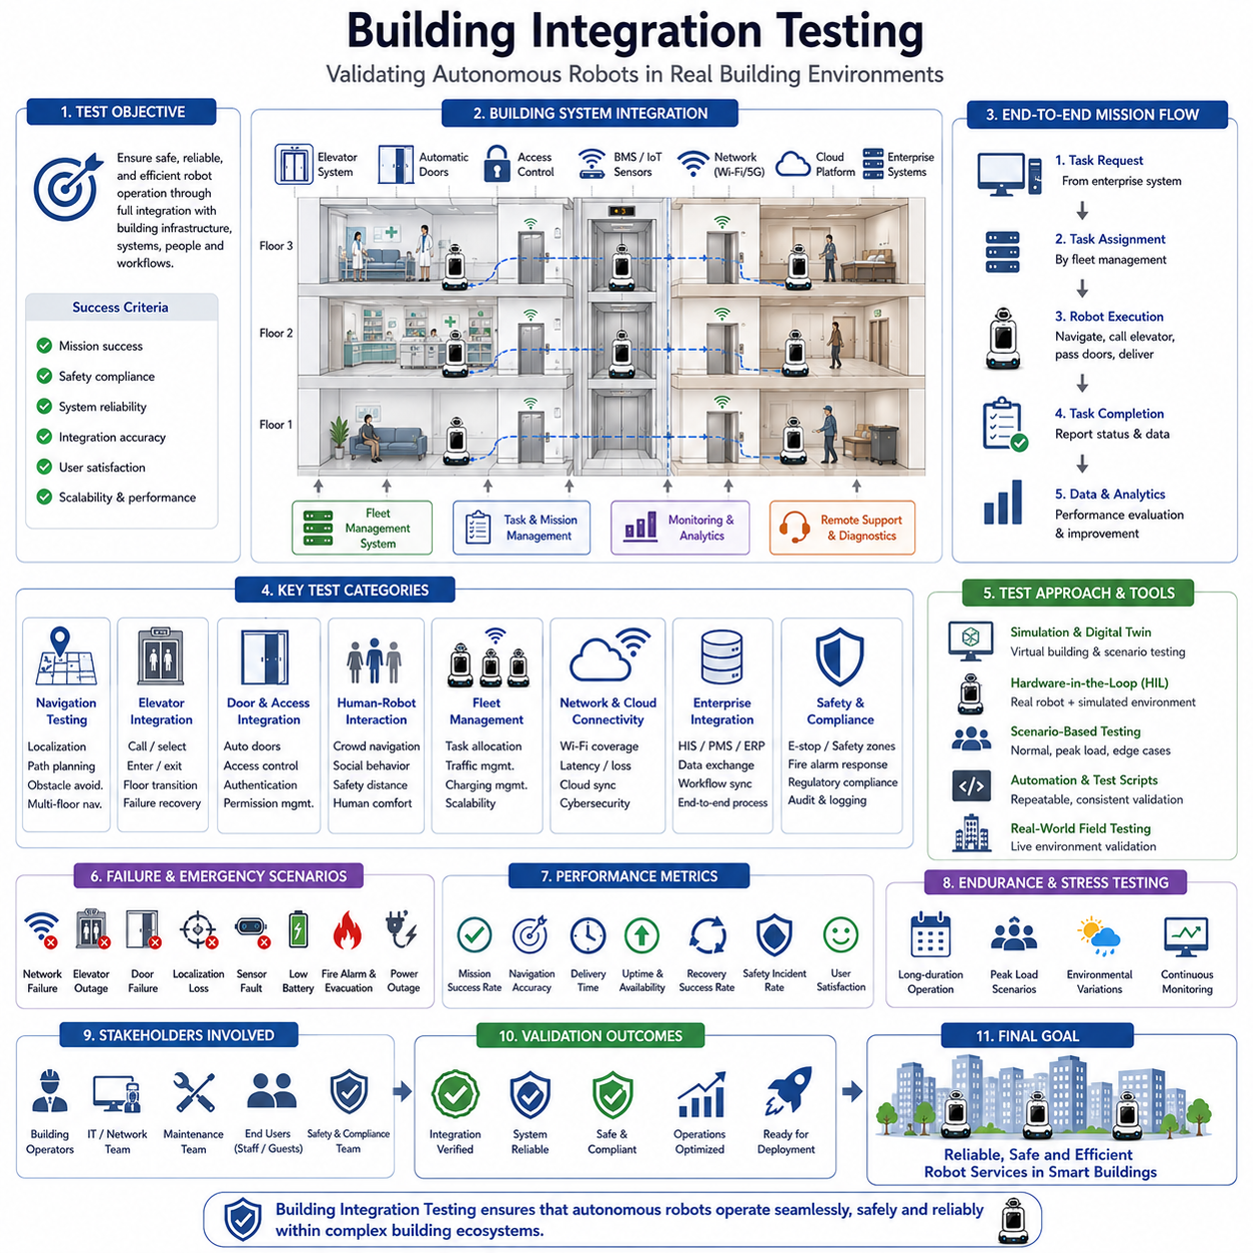
Building Integration Testing represents the final and most comprehensive validation stage of an autonomous mobile robot deployment within a real-world facility. While individual subsystems such as navigation, localization, perception, elevator communication, automatic door integration, fleet management, safety systems, and cloud connectivity may be tested independently during development, true operational success can only be verified when all components operate together within an integrated building environment. Building Integration Testing evaluates the robot as a complete cyber-physical system interacting with building infrastructure, human occupants, operational workflows, enterprise software systems, and dynamic environmental conditions. The objective is not simply to verify that individual functions work correctly, but to ensure that the entire autonomous ecosystem performs reliably, safely, efficiently, and consistently under real operational conditions.
Modern autonomous robots rarely operate as isolated machines. They function as active participants within intelligent buildings. A delivery robot in a hospital may interact with elevators, automatic doors, access control systems, pharmacy software, hospital information systems, fleet management platforms, Wi-Fi networks, cloud servers, and human operators during a single mission. Likewise, a hotel service robot may communicate with property management systems, guest service applications, room delivery platforms, elevator controllers, security systems, and building automation networks. Building Integration Testing verifies that these complex interactions operate correctly under both normal and abnormal operating conditions.
The testing process typically begins with infrastructure verification. Before autonomous operation can be evaluated, all building systems intended to interact with the robot must be validated individually. Elevator communication interfaces must respond correctly to requests. Automatic door controllers must receive and execute commands reliably. Access control systems must grant or deny permissions appropriately. Network infrastructure must provide sufficient coverage and stability. Building management systems must expose required data and services. Any deficiencies identified during infrastructure validation must be resolved before integrated testing proceeds.
A critical aspect of Building Integration Testing involves end-to-end mission validation. Unlike subsystem testing, which focuses on individual functions, end-to-end testing evaluates complete operational workflows. A representative mission might begin with a task request generated by an enterprise system, followed by task assignment through a fleet management platform. The robot then receives the mission, plans a route, navigates through corridors, requests elevator access, transitions between floors, passes through secured doors, reaches its destination, completes the delivery, reports task completion, and returns to a standby location. Every stage of this process must be verified as a continuous operational sequence.
Navigation validation remains one of the primary testing objectives. Robots must demonstrate reliable localization and navigation performance throughout the building. Testing typically includes movement through narrow corridors, open spaces, crowded areas, intersections, service zones, loading areas, and multi-floor environments. Performance metrics include navigation accuracy, path efficiency, mission completion rates, localization stability, obstacle avoidance success rates, and recovery behavior during unexpected situations.
Multi-floor navigation testing receives particular attention because it represents one of the most complex aspects of building-integrated robotics. Robots must repeatedly travel between floors using elevators while maintaining localization confidence and mission continuity. Testing verifies floor identification accuracy, elevator selection logic, transition reliability, map switching performance, and localization recovery after floor changes. Hundreds or even thousands of elevator transitions may be performed during validation programs to establish statistical confidence in system reliability.
Elevator integration testing evaluates communication, positioning, timing, and operational coordination. The robot must successfully request elevators, monitor elevator status, enter cabins safely, select destination floors, detect arrival, and exit accurately. Testing includes normal operation as well as abnormal scenarios such as delayed elevators, unavailable elevators, communication interruptions, door obstructions, and unexpected passenger activity. Recovery procedures are validated to ensure robust operation under real-world conditions.
Automatic door integration testing verifies the robot’s ability to interact with building access points. The robot must request door opening, confirm successful operation, pass safely through doorways, and continue navigation without interruption. Test scenarios include standard automatic doors, access-controlled doors, double-door systems, sliding doors, swing doors, and emergency exit routes. Failure scenarios such as communication timeouts, door malfunctions, partial openings, and sensor failures are also evaluated.
Access control integration is particularly important in hospitals, laboratories, data centers, industrial facilities, and secure office environments. Robots may require permission to enter restricted areas while maintaining compliance with organizational security policies. Testing verifies authentication mechanisms, credential management, authorization workflows, audit logging, and access restrictions. The objective is to ensure that robots can operate efficiently without compromising facility security.
Human-robot interaction testing forms a major component of integrated validation. Buildings are populated by people with diverse behaviors, mobility characteristics, and expectations. Robots must operate safely and comfortably around pedestrians while maintaining mission efficiency. Testing evaluates human-aware navigation, social behavior, obstacle avoidance, crowd management, elevator sharing, corridor passing behavior, and emergency yielding procedures. Human participants are often included in testing programs to assess real-world interactions.
Fleet management testing becomes essential when multiple robots operate within the same facility. Modern deployments frequently involve dozens or even hundreds of robots sharing infrastructure resources. Testing evaluates task allocation algorithms, traffic management systems, charging coordination, elevator scheduling, congestion avoidance, deadlock prevention, and overall fleet efficiency. Scenarios involving peak operational loads help identify bottlenecks and scalability limitations.
Building network performance significantly influences robotic operations. Autonomous robots rely on wireless communication for fleet coordination, cloud connectivity, infrastructure integration, monitoring, and data exchange. Testing therefore includes Wi-Fi coverage analysis, network roaming behavior, bandwidth utilization, latency measurements, packet loss evaluation, and failover performance. Network resilience is assessed under varying traffic conditions to ensure reliable operation.
Cloud integration testing validates communication between robots, cloud services, analytics platforms, digital twins, remote monitoring systems, and enterprise applications. Data synchronization, mission management, telemetry transmission, software updates, diagnostics, and remote control capabilities are evaluated. Particular attention is given to cybersecurity, authentication, encryption, and data privacy requirements.
Enterprise software integration testing verifies interactions with operational systems. Hospitals may integrate robots with Hospital Information Systems, Electronic Medical Records, Pharmacy Systems, Laboratory Information Systems, and Resource Management Platforms. Hotels may connect robots with Property Management Systems, Guest Service Platforms, Housekeeping Systems, and Reservation Systems. Industrial facilities may integrate with Manufacturing Execution Systems, Warehouse Management Systems, and Enterprise Resource Planning platforms. End-to-end workflow validation ensures seamless operational integration.
Safety testing represents the most important aspect of Building Integration Testing. Safety validation includes obstacle detection, emergency stop functionality, collision avoidance, protective field monitoring, speed control, access restrictions, fire alarm response, evacuation procedures, and fault handling mechanisms. Testing must demonstrate that safety systems function correctly under all foreseeable operating conditions.
Emergency scenario testing is particularly important because failures often occur under stressful and unpredictable circumstances. Robots must respond appropriately to fire alarms, power outages, network failures, elevator outages, blocked pathways, localization failures, sensor malfunctions, and building emergencies. Recovery procedures are evaluated to ensure that robots maintain safe behavior even when normal operation cannot continue.
Failure injection testing provides valuable insights into system robustness. Engineers intentionally introduce faults such as communication losses, sensor failures, localization degradation, software crashes, infrastructure outages, and battery anomalies. Observing robot behavior during these scenarios helps validate recovery mechanisms and identify weaknesses before deployment.
Environmental testing evaluates robot performance under varying conditions. Lighting changes, reflective surfaces, crowded environments, seasonal decorations, temporary construction activities, furniture rearrangements, and weather-related influences may affect perception and navigation. Testing across diverse conditions helps ensure long-term operational reliability.
Hospital deployment testing typically includes medication delivery workflows, laboratory sample transport, meal distribution, waste collection, linen logistics, and medical equipment transportation. Validation focuses on reliability, infection control compliance, operational continuity, and integration with healthcare workflows. Since patient care may depend on robotic services, extremely high reliability standards are often required.
Hotel deployment testing emphasizes guest experience, service quality, and operational efficiency. Delivery robots are evaluated for room service operations, amenity delivery, concierge support, luggage transportation, housekeeping assistance, and guest interactions. User acceptance testing often includes guest surveys and operational feedback to assess customer satisfaction.
Industrial building testing introduces additional complexity due to heavy equipment, forklifts, material handling systems, hazardous zones, and production workflows. Validation must ensure compatibility with industrial safety standards and facility automation systems. Particular attention is paid to operational reliability and workflow integration.
Digital twin technologies increasingly support Building Integration Testing. Virtual representations of buildings allow engineers to simulate robot behavior before physical deployment. Elevators, doors, corridors, people, and infrastructure systems can be modeled accurately, enabling extensive testing under controlled conditions. Simulation reduces risk while accelerating validation efforts.
Hardware-in-the-loop testing provides another powerful validation methodology. Real robot hardware interacts with simulated building environments, allowing developers to evaluate integrated behavior without requiring continuous access to physical facilities. This approach supports rapid iteration and early fault detection.
Performance benchmarking plays a central role in validation programs. Key performance indicators typically include mission success rates, navigation accuracy, elevator utilization efficiency, localization confidence, delivery times, task completion rates, charging efficiency, network availability, recovery success rates, and safety incident frequency. These metrics provide quantitative evidence of system readiness.
Long-duration endurance testing evaluates reliability over extended operational periods. Robots may operate continuously for weeks or months while engineers monitor performance, hardware health, software stability, battery degradation, communication quality, and maintenance requirements. Endurance testing often reveals issues that are not visible during short-term evaluations.
Regulatory compliance testing ensures adherence to applicable standards and guidelines. Depending on the deployment environment, testing may address safety regulations, cybersecurity requirements, healthcare standards, accessibility requirements, data privacy regulations, and building codes. Compliance validation is often necessary before commercial deployment.
User acceptance testing represents the final stage before operational deployment. Building operators, facility managers, maintenance personnel, healthcare staff, hotel employees, and end users evaluate the system under realistic conditions. Feedback from these stakeholders helps identify usability improvements and operational refinements.
The future of Building Integration Testing will increasingly leverage artificial intelligence, digital twins, cloud analytics, automated validation frameworks, and continuous operational monitoring. AI-driven testing platforms may automatically generate thousands of test scenarios, identify potential failure modes, and optimize deployment configurations. Real-time digital twins may continuously validate system performance even after deployment, supporting predictive maintenance and operational optimization.
Ultimately, Building Integration Testing serves as the bridge between laboratory development and real-world deployment. It transforms individual technologies into a fully operational autonomous ecosystem capable of functioning safely and reliably within complex buildings. By validating navigation, infrastructure integration, human interaction, fleet management, safety systems, enterprise connectivity, and failure recovery as a unified system, Building Integration Testing ensures that autonomous robots can successfully support hospitals, hotels, office buildings, airports, logistics centers, industrial facilities, and future smart cities. It is the final proof that autonomous robots are ready to become trusted components of intelligent building infrastructure and large-scale operational environments.

