Volume 05. Path Planning and Autonomous Navigation

Chapter 18. Safety Zone Control

18.1 Safety Zone Concepts
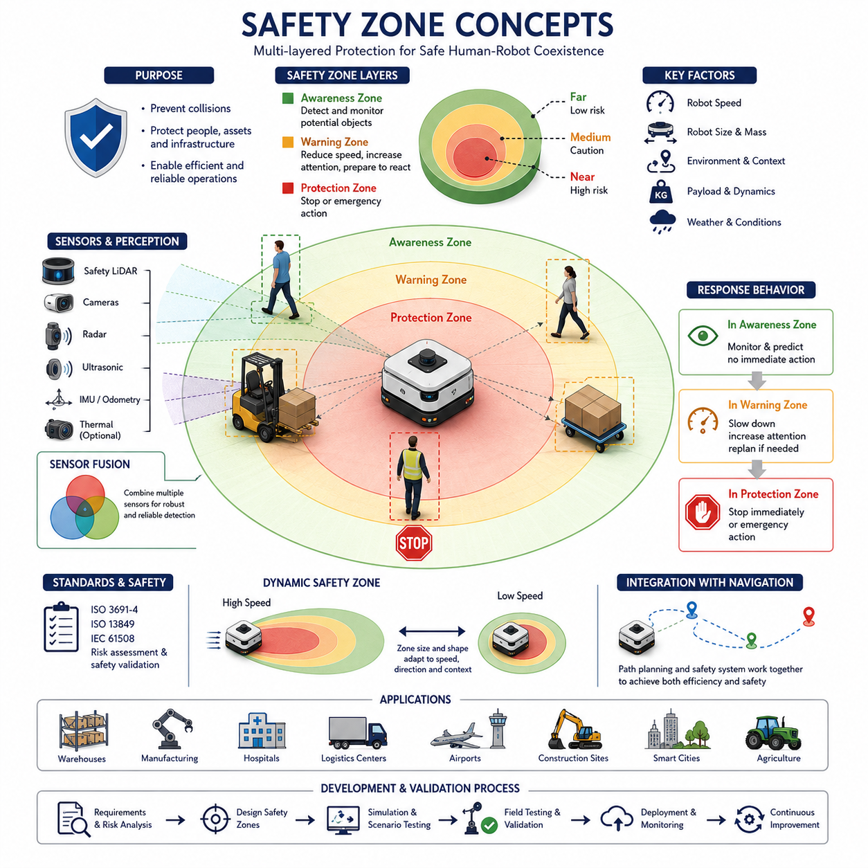
Safety Zone Concepts form one of the most important foundations of autonomous mobile robot navigation and operational safety. As autonomous robots become increasingly common in factories, warehouses, hospitals, logistics centers, airports, construction sites, smart cities, and outdoor industrial environments, the ability to create, monitor, and enforce safe operating spaces around the robot becomes essential. Safety zones serve as invisible protective boundaries that continuously evaluate the relationship between the robot, nearby humans, vehicles, infrastructure, and environmental obstacles. These zones allow the robot to maintain safe operation while preserving productivity, efficiency, and user confidence.
A safety zone can be defined as a dynamically or statically generated spatial region surrounding a robot in which specific safety behaviors are enforced. When an object enters the defined zone, the robot responds according to predefined safety policies. These responses may include reducing speed, changing trajectory, increasing monitoring sensitivity, issuing warnings, stopping motion, or executing emergency procedures. The concept is simple in principle but becomes highly sophisticated when implemented in real-world autonomous systems operating in dynamic and unpredictable environments.
Historically, industrial automation relied on physical barriers such as fences, cages, safety gates, and isolated work cells to protect workers from moving machinery. Traditional industrial robots operated within fixed areas and rarely interacted directly with humans. Modern AMRs and autonomous robots fundamentally change this paradigm because they are designed to coexist with people in shared environments. As a result, safety must be achieved through intelligent perception, real-time monitoring, and adaptive behavior rather than solely through physical separation.
The primary objective of a safety zone is collision prevention. A robot moving through an environment must continuously estimate potential risks associated with nearby objects. Humans may walk unexpectedly into the robot's path. Forklifts may emerge from intersections. Doors may open suddenly. Equipment may be temporarily placed in navigation corridors. Safety zones provide a structured framework that allows the robot to react before dangerous situations occur.
Modern safety architectures often implement multiple layers of safety zones. The outermost zone typically functions as an awareness zone. Objects entering this area are monitored, but no immediate action may be required. The robot begins evaluating potential interactions and predicting future motion. A middle zone often serves as a warning zone. When objects enter this region, the robot may reduce speed, increase sensor update frequency, or prepare alternative navigation strategies. The innermost zone is generally considered a protection zone. Entry into this zone may trigger immediate stopping behavior or emergency safety actions.
The size and shape of safety zones depend on many factors. Robot speed is one of the most influential variables. A robot traveling at high speed requires greater stopping distance and therefore larger protective zones. Conversely, a robot operating at low speed can safely function with smaller zones. This relationship between velocity and safety distance forms the basis of dynamic safety zone control, which is explored further in later chapters.
Robot dimensions also influence safety zone design. A compact indoor delivery robot operating in hospital corridors requires different safety boundaries than a heavy outdoor industrial platform transporting large payloads. Large robots possess greater momentum, longer stopping distances, and increased collision energy, all of which require expanded safety margins.
Environmental characteristics significantly affect safety zone requirements. Structured environments such as warehouses typically provide predictable traffic patterns and controlled pedestrian movement. Safety zones can therefore be optimized for efficiency. In contrast, public environments such as hospitals, shopping centers, campuses, and smart cities involve highly unpredictable human behavior. Safety zones in these environments must prioritize caution and adaptability.
The concept of safety zones extends beyond simple distance measurements. Modern autonomous systems increasingly incorporate contextual awareness into safety calculations. A human walking parallel to the robot may present minimal risk, whereas a human walking directly toward the robot requires greater attention. Similarly, a stationary obstacle presents different risks compared to a rapidly moving vehicle. Advanced safety systems therefore evaluate not only position but also velocity, acceleration, trajectory, intent, and behavioral context.
Sensor technology plays a critical role in safety zone implementation. Safety LiDAR systems are among the most common technologies used to establish protective fields around autonomous robots. These sensors continuously scan the environment and detect objects entering predefined regions. Multiple safety zones can be configured within the LiDAR field of view, enabling graduated responses as objects approach the robot. Additional sensors such as RGB cameras, depth cameras, radar systems, ultrasonic sensors, thermal cameras, and three-dimensional LiDARs further enhance environmental awareness.
Sensor fusion greatly improves safety zone reliability. Individual sensors may experience limitations under certain conditions. Cameras may be affected by poor lighting. LiDAR performance may degrade in heavy rain or dust. Radar may have reduced spatial resolution. By combining information from multiple sensor modalities, the robot can maintain accurate safety monitoring even when environmental conditions become challenging.
Human-centered safety represents a particularly important application of safety zone concepts. Humans are inherently unpredictable and may behave differently depending on age, experience, distraction level, physical condition, or environmental context. Safety systems must account for these uncertainties. For example, robots operating in hospitals may encounter patients using wheelchairs, walkers, or crutches. Robots in logistics centers may interact with workers carrying large packages that partially obstruct their visibility. Human-aware safety zones incorporate these considerations to provide enhanced protection.
The concept of protective separation distance is central to collaborative robotic safety. Protective separation distance refers to the minimum distance required between a robot and a human to ensure that a collision can be avoided even under worst-case conditions. This distance depends on robot speed, human speed, sensor detection latency, processing latency, communication delays, braking performance, and safety margins. International standards provide guidance for calculating appropriate separation distances in collaborative environments.
Functional safety standards play a major role in safety zone design. Industrial robots and AMRs must comply with safety regulations that define acceptable risk levels and required safety performance. Standards such as ISO 3691-4, ISO 13849, IEC 61508, and related frameworks establish requirements for safety-rated monitoring systems, emergency stopping functions, protective fields, and risk reduction measures. Compliance with these standards ensures that safety zone implementations meet industry expectations and regulatory requirements.
Dynamic environments require dynamic safety zones. Unlike static safety fields, dynamic safety zones continuously adapt to changing conditions. Robot speed, steering angle, payload characteristics, terrain conditions, obstacle density, and environmental complexity may all influence safety zone geometry. For example, a robot moving forward at high speed may require an elongated protective field extending far ahead of the vehicle. During slow maneuvering operations, the field may shrink to allow efficient navigation through confined spaces.
Outdoor autonomous robots face additional safety challenges. Uneven terrain, slopes, vegetation, weather conditions, and mixed traffic environments create uncertainty that is rarely encountered indoors. Outdoor safety zones often incorporate larger margins to compensate for localization uncertainty, perception limitations, and variable stopping performance. Autonomous agricultural robots, construction robots, and infrastructure inspection robots frequently operate in environments where safety zone adaptation becomes essential.
Heavy-payload AMRs present unique safety considerations because kinetic energy increases with both mass and velocity. A robot carrying several hundred kilograms or towing multi-ton loads possesses significantly different risk characteristics compared to lightweight service robots. Safety zone calculations must account for increased braking distances, reduced maneuverability, trailer dynamics, and load stability constraints. These factors often result in larger protective fields and more conservative safety policies.
Navigation systems and safety systems must work together closely. Navigation algorithms seek efficient paths that minimize travel time and maximize operational productivity. Safety systems prioritize risk reduction and collision prevention. Successful autonomous robot design requires balancing these objectives. Excessively conservative safety zones may reduce productivity by causing frequent stops and unnecessary slowdowns. Overly aggressive configurations may increase operational risk. Achieving optimal performance requires careful engineering and validation.
Artificial intelligence increasingly contributes to safety zone management. Machine learning models can classify objects, predict human motion, estimate intent, and identify potentially hazardous situations before they develop. AI-enhanced safety systems may distinguish between workers, visitors, forklifts, carts, vehicles, animals, and infrastructure. This contextual understanding enables more intelligent safety decisions while maintaining strict safety requirements.
Simulation environments provide valuable tools for safety zone development and validation. Engineers can evaluate safety strategies across thousands of scenarios before field deployment. Virtual testing allows systematic examination of corner cases, rare events, sensor failures, communication disruptions, and unexpected human behaviors. Simulation accelerates development while reducing operational risk during testing phases.
Field validation remains essential despite advances in simulation technology. Real-world environments contain complexities that are difficult to reproduce completely in virtual models. Comprehensive testing programs evaluate safety zone performance under representative operating conditions. Validation activities typically include pedestrian interactions, vehicle encounters, corridor navigation, intersection crossing, emergency stopping, obstacle avoidance, and degraded sensor scenarios.
Future safety zone systems will become increasingly intelligent, adaptive, and predictive. Emerging technologies such as foundation models, embodied AI, digital twins, cloud robotics, and cooperative perception will enable robots to understand environmental context at unprecedented levels. Rather than merely reacting to detected obstacles, future systems will anticipate human intentions, predict environmental changes, coordinate with nearby robots, and proactively manage risk before hazards emerge.
As autonomous mobile robots continue expanding into industrial, commercial, healthcare, transportation, agricultural, and smart-city applications, safety zone concepts will remain a cornerstone of reliable autonomous operation. Effective safety zone design combines perception, control, functional safety engineering, human factors, regulatory compliance, and intelligent decision-making into a unified framework that protects people, equipment, infrastructure, and mission objectives. Through careful implementation and continuous refinement, safety zones enable autonomous systems to operate efficiently while maintaining the highest standards of operational safety and public trust.

18.2 Dynamic Safety Zone Control
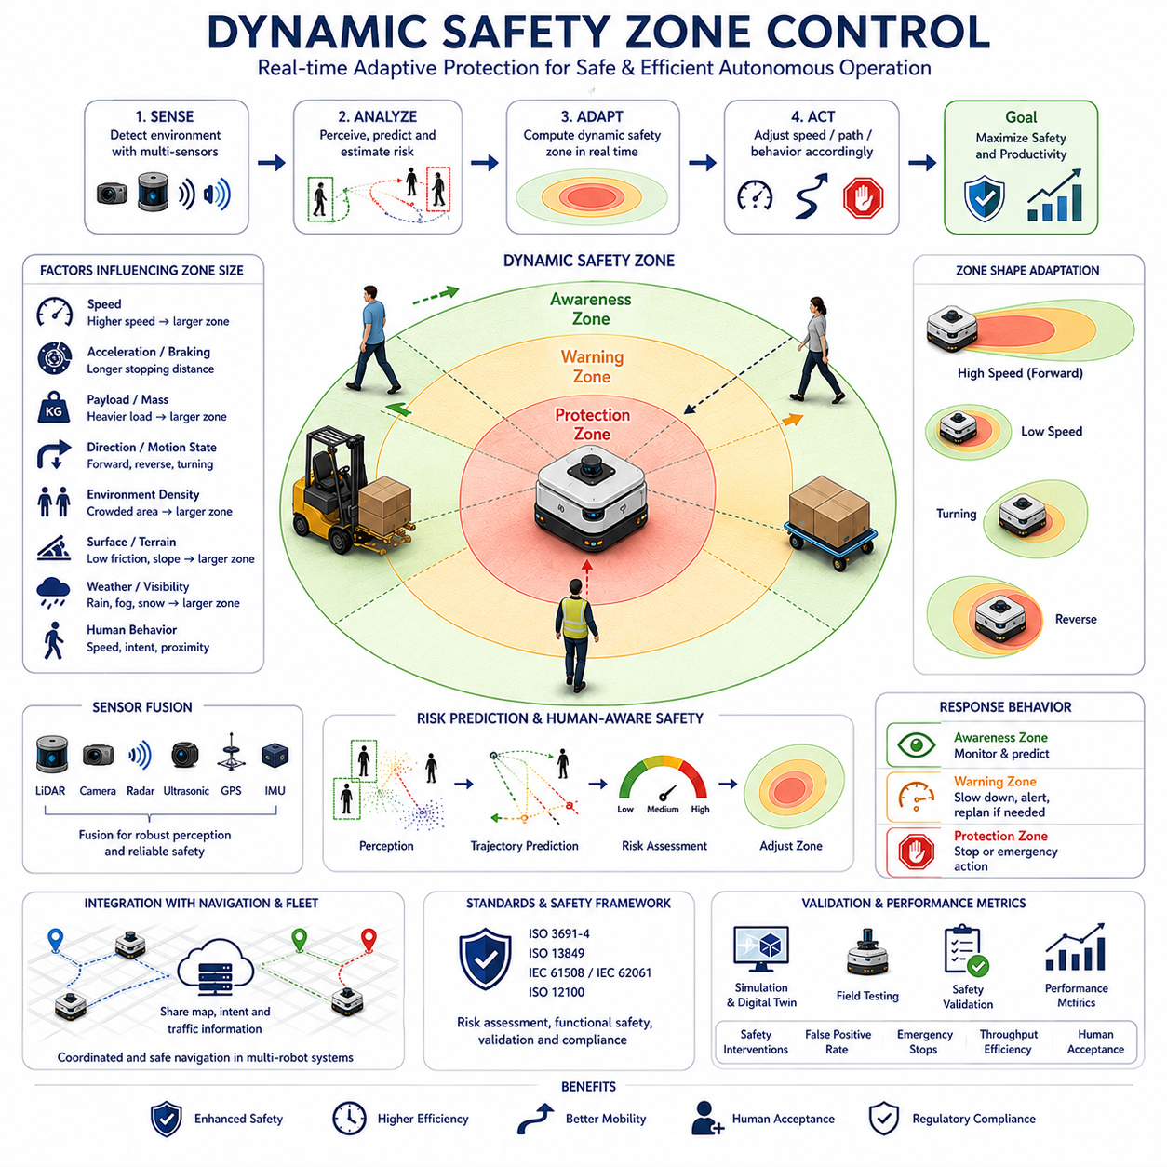
Dynamic Safety Zone Control is one of the most critical technologies in modern autonomous mobile robots, enabling robots to adapt their protective safety boundaries continuously according to changing operational conditions. Unlike traditional static safety zones that maintain fixed dimensions regardless of environmental changes, dynamic safety zones automatically expand, contract, reshape, and reposition themselves in real time. This adaptive behavior allows autonomous robots to achieve both high operational safety and high productivity while operating in complex environments shared with humans, vehicles, and other robots.
As AMRs move through factories, warehouses, hospitals, airports, logistics centers, construction sites, agricultural fields, and smart city environments, they encounter continuously changing situations. Robot speed changes, payload conditions vary, environmental complexity fluctuates, and human activities remain highly unpredictable. A fixed safety zone designed for worst-case scenarios often results in excessive conservatism, reducing efficiency and limiting throughput. Dynamic Safety Zone Control addresses this challenge by continuously calculating the appropriate protection region based on the current operating state of the robot and its environment.
The fundamental principle behind Dynamic Safety Zone Control is that risk is not constant. A robot moving at 0.3 m/s inside a narrow hospital corridor presents a different level of risk than the same robot traveling at 3 m/s across an outdoor industrial facility. Similarly, a robot carrying a lightweight package behaves differently from a heavy-duty towing platform transporting several tons of cargo. Since operational risk changes continuously, safety protection mechanisms must also adapt dynamically.
A dynamic safety zone can be viewed as an intelligent virtual safety bubble surrounding the robot. This protective bubble changes its dimensions according to real-time operational parameters. When risk increases, the bubble expands to provide additional safety margins. When risk decreases, the bubble contracts to improve maneuverability and operational efficiency. The objective is to maintain the optimal balance between safety and productivity at all times.
Robot velocity is one of the most influential factors affecting dynamic safety zone generation. Higher vehicle speeds require longer stopping distances and greater reaction times. Consequently, the forward safety zone expands significantly as speed increases. The robot must reserve sufficient space to detect hazards, evaluate potential collisions, execute braking commands, and come to a complete stop before contact occurs. As speed decreases, the required stopping distance becomes shorter, allowing the safety zone to shrink accordingly.
Acceleration and deceleration characteristics further influence safety zone calculations. A robot capable of aggressive braking may require a smaller safety zone than a robot with limited braking performance. However, braking performance itself may vary depending on environmental conditions. Wet surfaces, slippery floors, loose gravel, mud, snow, ice, or uneven terrain may reduce braking effectiveness and increase stopping distance. Dynamic safety systems continuously account for these variations when determining protective boundaries.
Payload characteristics represent another important consideration. The mass of the robot directly affects its kinetic energy and stopping capability. Heavy payload robots possess greater momentum and therefore require larger safety zones. A towing AMR transporting a six-ton trailer behaves significantly differently from an empty platform moving through the same environment. Dynamic safety algorithms continuously adjust protection distances according to measured or estimated payload conditions.
Robot direction and motion state also affect safety zone geometry. During forward motion, the highest collision risk typically exists in front of the robot. Consequently, dynamic safety fields often extend farther in the forward direction than toward the sides or rear. During reversing operations, the safety zone shifts to emphasize rearward protection. During turning maneuvers, additional safety margins may be introduced on the inside or outside of the turning radius depending on vehicle kinematics and expected trajectory behavior.
Modern Dynamic Safety Zone Control systems rarely use simple circular protection regions. Instead, they employ adaptive geometric models that reshape the safety field according to vehicle motion and environmental context. Safety zones may appear elliptical, rectangular, trapezoidal, polygonal, or highly irregular depending on the application. These flexible geometries allow the robot to maintain effective protection while maximizing navigational efficiency.
Environmental awareness significantly enhances dynamic safety zone performance. Dense pedestrian areas require larger and more conservative safety fields than isolated industrial corridors. Hospital environments often contain vulnerable individuals such as patients, elderly people, or medical staff carrying equipment. Warehouses may contain forklifts, carts, and automated machinery moving at varying speeds. Dynamic safety systems continuously evaluate environmental conditions and modify protective boundaries accordingly.
Human-aware safety control represents one of the most advanced applications of dynamic safety zone technology. Human behavior is inherently uncertain and difficult to predict. A person standing still presents relatively low risk, whereas a person running toward the robot may require immediate intervention. Advanced perception systems estimate human position, velocity, acceleration, orientation, posture, and likely future motion. These predictions allow safety zones to adapt proactively rather than reactively.
Predictive safety modeling extends dynamic safety control beyond simple object detection. Instead of responding only to current object locations, modern systems estimate future collision probabilities. Trajectory prediction algorithms evaluate where humans, vehicles, robots, and obstacles are likely to move over the next several seconds. If projected trajectories indicate potential conflicts, safety zones expand preemptively to maintain sufficient separation distances.
Sensor technology provides the foundation for Dynamic Safety Zone Control. Safety-rated LiDAR sensors remain the most widely deployed technology for monitoring protective fields. These sensors continuously scan surrounding environments and detect intrusions into predefined safety regions. However, modern systems increasingly integrate multiple sensing modalities including 3D LiDAR, RGB cameras, stereo cameras, depth sensors, radar systems, ultrasonic sensors, GNSS receivers, IMUs, and thermal cameras.
Sensor fusion significantly improves reliability and robustness. Individual sensors may experience limitations under specific environmental conditions. Cameras may suffer from low-light conditions or glare. LiDAR may experience reduced performance in fog, rain, dust, or snow. Radar may provide lower spatial resolution. By combining information from multiple sensor sources, robots achieve more reliable environmental awareness and more accurate safety zone adaptation.
Artificial intelligence is increasingly integrated into Dynamic Safety Zone Control architectures. Machine learning models can classify objects, predict human intent, estimate collision probability, and identify abnormal situations. Deep learning systems can distinguish between workers, visitors, forklifts, delivery carts, autonomous robots, vehicles, animals, and infrastructure elements. This semantic understanding allows safety systems to apply context-specific protective strategies.
For example, a robot may maintain a larger safety distance around humans than around stationary infrastructure. A moving forklift may trigger more aggressive safety responses than a stationary pallet. Vulnerable individuals such as children, elderly persons, or wheelchair users may receive additional protection margins. AI-enhanced safety systems enable intelligent differentiation while maintaining compliance with safety requirements.
Dynamic Safety Zone Control is closely connected to robot navigation systems. Path planning modules continuously generate optimal trajectories toward mission objectives. Safety systems monitor these trajectories and ensure that navigation decisions remain within acceptable risk limits. When safety constraints conflict with navigation goals, safety functions always take precedence. This hierarchical control architecture ensures that productivity never compromises operational safety.
Multi-robot environments introduce additional complexity. In modern logistics facilities, hospitals, and manufacturing plants, dozens or even hundreds of robots may operate simultaneously. Dynamic safety systems must account not only for humans and static obstacles but also for other autonomous robots. Fleet management systems coordinate robot movements while local safety controllers maintain independent protective boundaries around each vehicle.
Cloud-based fleet management platforms increasingly contribute to dynamic safety optimization. Centralized traffic management systems maintain awareness of global facility conditions and can distribute information regarding congestion, restricted zones, temporary hazards, or high-risk areas. Individual robots incorporate this information into their local safety zone calculations, improving both safety and efficiency across the entire fleet.
Outdoor autonomous robots face particularly challenging dynamic safety requirements. Environmental conditions can change rapidly due to weather, lighting, terrain conditions, vegetation growth, construction activities, or traffic patterns. Outdoor robots frequently operate with higher speeds and greater localization uncertainty than indoor systems. Consequently, dynamic safety zones must adapt continuously to account for these uncertainties.
Rough terrain environments introduce additional considerations. Wheel slip, uneven surfaces, slopes, loose materials, and variable traction conditions affect vehicle controllability and braking performance. Dynamic safety algorithms integrate terrain classification, traction estimation, and vehicle stability information to maintain appropriate safety margins. On steep slopes, safety zones may be enlarged to account for increased stopping distances and potential stability risks.
Heavy industrial robots require particularly sophisticated safety zone calculations. Large outdoor platforms, autonomous forklifts, towing robots, and infrastructure inspection vehicles often possess significant mass and momentum. A heavy-duty autonomous platform carrying hundreds of kilograms of payload may require substantially larger safety zones than lightweight service robots. Dynamic control algorithms continuously account for vehicle mass distribution, payload stability, center-of-gravity changes, and kinetic energy characteristics.
Functional safety standards provide the regulatory framework for Dynamic Safety Zone Control implementation. Standards such as ISO 3691-4, ISO 13849, IEC 61508, IEC 62061, and ISO 12100 establish requirements for safety-rated monitoring systems, risk assessment methodologies, protective field validation, and emergency response mechanisms. Compliance with these standards ensures that dynamic safety systems achieve acceptable levels of reliability and risk reduction.
Verification and validation are essential components of dynamic safety system development. Engineers must evaluate safety performance across thousands of operational scenarios, including normal conditions, abnormal situations, sensor failures, communication disruptions, emergency events, and unexpected human behaviors. Both simulation-based testing and real-world validation play critical roles in demonstrating system safety.
Digital twin technology has emerged as a powerful tool for Dynamic Safety Zone Control development. High-fidelity virtual environments allow engineers to evaluate safety algorithms under diverse operating conditions before field deployment. Simulations can reproduce rare corner cases, high-risk interactions, and large-scale operational scenarios that would be difficult or expensive to recreate physically.
Performance metrics for Dynamic Safety Zone Control extend beyond collision avoidance alone. Key indicators include safety intervention frequency, false-positive rates, false-negative rates, emergency stop occurrences, operational efficiency, average travel time, throughput, human acceptance, and regulatory compliance. Successful systems achieve high safety performance while minimizing unnecessary interruptions to productivity.
Future Dynamic Safety Zone Control systems will become increasingly predictive, intelligent, and collaborative. Advances in AI, foundation models, embodied intelligence, cooperative perception, cloud robotics, and edge computing will allow robots to anticipate hazards long before they become immediate threats. Rather than reacting solely to detected objects, future systems will understand environmental context, predict human intentions, coordinate with nearby robots, and proactively manage risk across entire facilities.
As autonomous robots continue expanding into factories, hospitals, logistics centers, smart cities, agricultural operations, transportation networks, and infrastructure inspection applications, Dynamic Safety Zone Control will remain a cornerstone technology. It provides the critical mechanism through which robots can safely share space with humans while maintaining high levels of autonomy and operational efficiency. By continuously adapting protection boundaries according to real-time conditions, Dynamic Safety Zone Control enables the next generation of intelligent robotic systems to operate safely, reliably, and productively in increasingly complex environments.

18.3 Speed and Distance-Based Safety
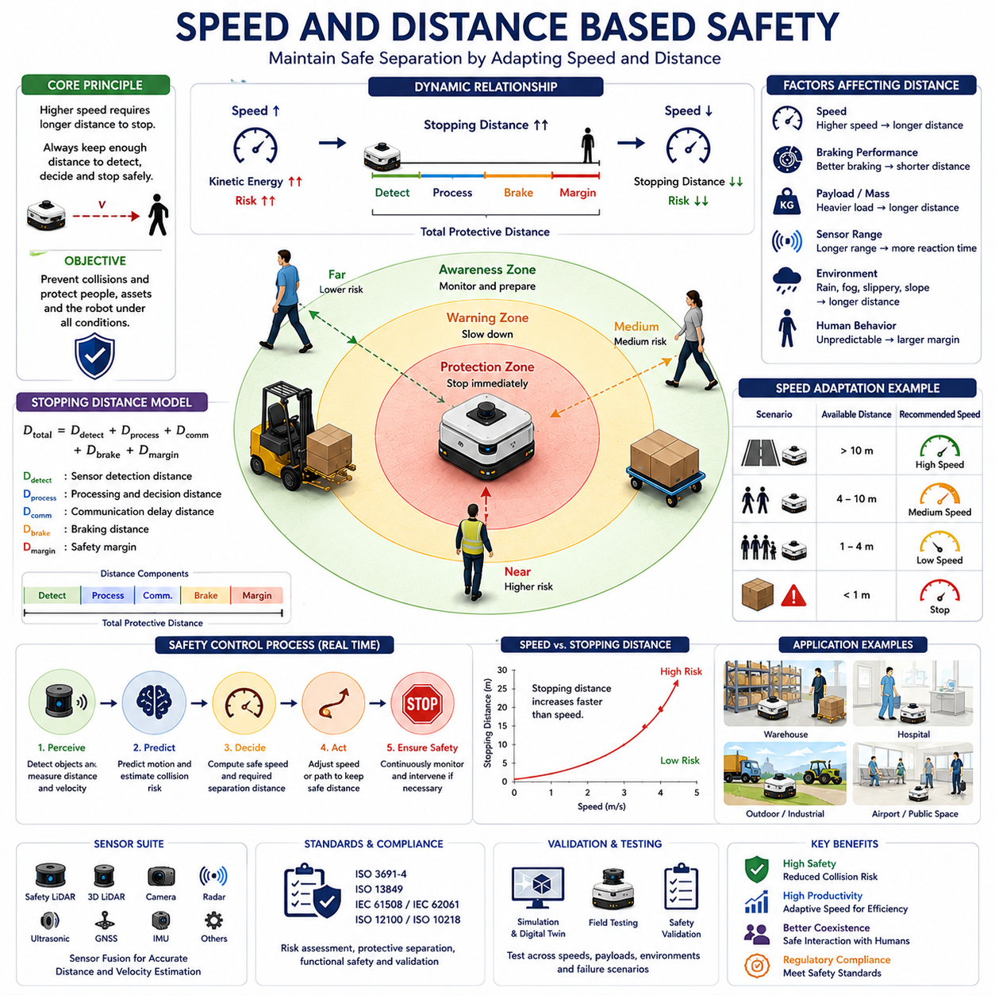
Speed and Distance Based Safety is one of the most fundamental principles in autonomous mobile robot safety engineering. It establishes the relationship between robot velocity, stopping distance, reaction capability, and protective separation requirements. The core objective of this safety methodology is to ensure that an autonomous robot always maintains sufficient distance from people, vehicles, obstacles, and infrastructure so that potential collisions can be avoided under all operating conditions. As AMRs become increasingly common in factories, warehouses, hospitals, logistics centers, airports, construction sites, agricultural facilities, and smart city environments, speed and distance-based safety has become a cornerstone of modern robot safety architectures.
The concept originates from a simple physical reality. Every moving object possesses momentum and kinetic energy. As velocity increases, both momentum and kinetic energy increase significantly. Consequently, the risk associated with a moving robot grows as its speed rises. A robot traveling at a slow walking pace can stop relatively quickly, whereas a robot moving at higher speeds requires greater distance and more time to come to a complete stop. Safety systems must continuously account for this relationship to maintain acceptable levels of operational risk.
In autonomous robotic systems, safety cannot rely solely on obstacle detection. The robot must not only identify hazards but also ensure that enough space exists to react appropriately. Speed and Distance Based Safety provides the framework for calculating the minimum protective separation distance required between the robot and surrounding objects. This separation distance ensures that the robot can detect a potential hazard, process sensor information, make a decision, initiate braking, and come to a complete stop before contact occurs.
The relationship between speed and stopping distance is governed by the laws of motion. As speed increases, stopping distance does not increase linearly. In many cases, stopping distance grows significantly faster than velocity because kinetic energy is proportional to the square of speed. A robot moving twice as fast may require substantially more than twice the stopping distance depending on braking characteristics and environmental conditions. Consequently, safety systems must dynamically adjust protection distances whenever robot velocity changes.
Stopping distance itself consists of multiple components. Detection distance represents the space required for sensors to identify a hazard. Processing distance accounts for the time required to analyze sensor data and evaluate risk. Communication distance reflects delays associated with transmitting information between system components. Braking distance represents the physical distance required for the robot to decelerate and stop. Safety margins are added to account for uncertainties and unexpected conditions. The total protective distance is therefore the sum of several independent safety factors.
Sensor performance directly influences speed and distance calculations. A robot equipped with high-resolution safety LiDAR systems may detect hazards at greater distances than a robot relying on short-range sensors. Longer detection ranges provide more reaction time and potentially allow higher operational speeds while maintaining equivalent safety levels. Conversely, limited sensor range may require reduced speeds to ensure adequate stopping capability.
Environmental conditions play a major role in determining safe operating distances. Indoor warehouse environments typically provide stable flooring, predictable lighting, and controlled traffic patterns. Under such conditions, safety distances can be optimized for efficiency. Outdoor environments introduce significantly greater uncertainty. Rain, snow, fog, dust, mud, vegetation, and changing illumination can affect both perception performance and vehicle dynamics. Safety systems must account for these factors by increasing protective distances whenever uncertainty rises.
Robot braking performance represents another critical variable. Different robot platforms exhibit different deceleration capabilities depending on vehicle mass, motor characteristics, brake system design, tire properties, and terrain conditions. A lightweight hospital delivery robot may stop quickly on smooth flooring, whereas a heavy industrial towing robot carrying multiple tons of cargo may require significantly longer stopping distances. Speed and Distance Based Safety continuously incorporates these platform-specific characteristics into safety calculations.
Payload conditions further complicate stopping distance estimation. As payload mass increases, robot inertia increases correspondingly. Heavy loads generate larger momentum and require greater braking force to achieve the same deceleration rate. Autonomous forklifts, towing AMRs, cargo robots, and outdoor industrial vehicles frequently experience substantial changes in payload conditions throughout their operational cycles. Dynamic safety systems therefore continuously adjust protective distances according to real-time payload measurements.
Human safety remains the primary motivation behind speed and distance based protection systems. Humans behave unpredictably and may suddenly enter the robot's path without warning. Workers may be distracted, carrying large objects, using mobile devices, or moving quickly through shared workspaces. Hospital patients, visitors, children, and elderly individuals may exhibit behaviors that are difficult to anticipate. Safety systems must therefore assume worst-case scenarios when calculating protective separation distances around humans.
The concept of Protective Separation Distance is widely used in collaborative robotics and AMR safety engineering. This distance represents the minimum allowable separation between a robot and a person such that a collision can be avoided even if both parties move unexpectedly. Protective Separation Distance calculations typically incorporate robot speed, human approach speed, sensor response time, controller latency, braking performance, and safety factors specified by regulatory standards.
Dynamic speed adaptation is a natural extension of Speed and Distance Based Safety. Rather than maintaining a constant velocity throughout all operating conditions, modern robots continuously adjust their speed according to available free space and perceived risk. When operating in open areas with excellent visibility and low obstacle density, higher speeds may be permitted. As available separation distance decreases, the robot automatically reduces speed to maintain safe stopping capability.
This adaptive behavior significantly improves operational efficiency. A robot traveling through a wide industrial corridor can move faster than a robot navigating a crowded hospital hallway. By continuously balancing speed and distance, autonomous systems maximize productivity while preserving safety requirements. This capability is particularly important in large-scale facilities where throughput and operational efficiency directly impact business performance.
Safety zone control and speed-based safety are closely interconnected. Dynamic safety zones expand and contract according to robot velocity. At high speeds, larger safety zones provide greater protective distances. At lower speeds, safety zones shrink, allowing more efficient operation in confined environments. This relationship forms the foundation of many modern safety-rated navigation systems.
Advanced perception systems significantly enhance speed and distance based safety performance. Modern robots utilize combinations of safety LiDARs, 3D LiDARs, RGB cameras, depth cameras, radar systems, ultrasonic sensors, GNSS receivers, IMUs, and thermal sensors. These sensors provide comprehensive environmental awareness that enables accurate estimation of object positions, velocities, and trajectories.
Sensor fusion further improves safety reliability. Individual sensors possess limitations under certain operating conditions. Cameras may struggle in low-light environments. LiDAR performance may be affected by rain or dust. Radar provides robust performance under adverse weather conditions but often offers lower spatial resolution. Combining multiple sensor modalities improves confidence in environmental perception and supports more accurate distance calculations.
Artificial intelligence increasingly contributes to speed and distance based safety systems. Machine learning models can classify objects, predict trajectories, estimate intent, and identify unusual situations. AI-based systems can distinguish between humans, forklifts, carts, robots, vehicles, infrastructure elements, and temporary obstacles. Different object categories may require different safety responses and separation distances.
For example, a stationary wall presents a predictable obstacle that requires relatively simple avoidance behavior. A moving forklift introduces greater uncertainty and may require larger safety margins. Humans typically receive the highest level of protection due to their unpredictable behavior. AI-enhanced perception enables more intelligent and context-aware safety decisions while maintaining regulatory compliance.
Predictive safety modeling extends traditional distance calculations by incorporating future risk assessment. Rather than considering only current positions, advanced systems estimate future trajectories for all detected objects. Predicted collision probabilities influence speed regulation and protective distance calculations. If future trajectory intersections are likely, the robot can begin slowing down before a dangerous situation develops.
Speed and Distance Based Safety becomes even more important in outdoor autonomous robots. Outdoor platforms frequently operate at higher speeds than indoor robots and often encounter mixed traffic environments involving pedestrians, bicycles, vehicles, machinery, and animals. Long stopping distances, changing terrain conditions, and environmental uncertainties require highly sophisticated safety calculations.
Heavy-duty industrial robots represent another challenging application domain. Autonomous forklifts, towing robots, mining vehicles, agricultural machines, and infrastructure inspection platforms often possess substantial mass and kinetic energy. These systems require larger protective distances and more conservative speed management strategies to ensure safe operation. Dynamic calculations continuously account for vehicle mass, payload distribution, terrain conditions, and environmental complexity.
Multi-robot environments introduce additional considerations. In facilities containing dozens or hundreds of autonomous robots, each robot must maintain safe distances not only from humans and static obstacles but also from other autonomous vehicles. Fleet management systems coordinate traffic flow while local safety controllers independently enforce separation requirements. This layered approach improves both safety and operational efficiency.
International safety standards provide guidance for implementing Speed and Distance Based Safety. Standards such as ISO 3691-4, ISO 13849, IEC 61508, IEC 62061, ISO 12100, and ISO 10218 establish requirements for risk assessment, protective separation distances, braking performance, safety-rated monitoring functions, and emergency stop mechanisms. Compliance with these standards is essential for commercial deployment of autonomous robotic systems.
Validation and testing play crucial roles in ensuring system effectiveness. Engineers evaluate safety performance through simulation, laboratory testing, controlled field trials, and operational deployments. Testing scenarios typically include varying speeds, payload conditions, environmental factors, sensor failures, communication disruptions, and unexpected human behaviors. Comprehensive validation ensures that calculated safety distances remain effective under real-world conditions.
Digital twin technologies increasingly support safety validation activities. High-fidelity virtual environments enable engineers to evaluate thousands of operational scenarios before physical deployment. Rare edge cases, complex traffic situations, and hazardous interactions can be analyzed safely and repeatedly. Simulation results complement real-world testing and accelerate system development.
Performance evaluation extends beyond collision avoidance alone. Important metrics include safety intervention frequency, emergency stop occurrences, false positive rates, false negative rates, throughput efficiency, average travel time, braking effectiveness, human acceptance, and regulatory compliance. Effective Speed and Distance Based Safety systems achieve high safety performance while minimizing unnecessary productivity losses.
Future developments in this field will likely integrate foundation models, embodied AI, cooperative perception, cloud robotics, edge intelligence, and predictive world models. Autonomous robots will increasingly understand environmental context, anticipate hazards, predict human intentions, and coordinate safety decisions across entire fleets. Speed and distance calculations will evolve from reactive measurements toward proactive risk management frameworks.
As autonomous robots continue expanding into industrial, commercial, healthcare, transportation, agricultural, and smart city applications, Speed and Distance Based Safety will remain one of the most important principles governing safe operation. By continuously balancing velocity, stopping capability, environmental awareness, and protective separation requirements, autonomous systems can safely coexist with humans while achieving high levels of productivity, reliability, and operational efficiency. This balance between mobility and protection forms the foundation of safe autonomous navigation and represents a key enabler of future robotic ecosystems.

18.4 Safety LiDAR Integration
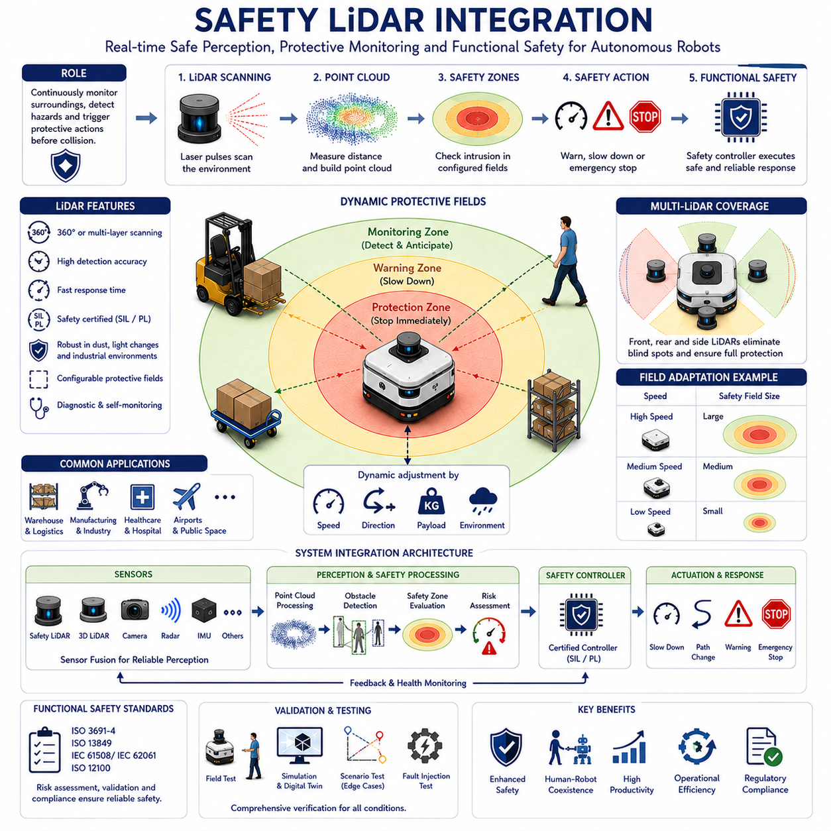
Safety LiDAR Integration is one of the most important technologies in modern autonomous mobile robot systems, serving as the foundation of real-time obstacle detection, collision prevention, protective field monitoring, and functional safety implementation. As autonomous robots increasingly operate in environments shared with humans, vehicles, machinery, and infrastructure, the need for reliable and certified safety sensing has become essential. Safety LiDAR systems provide the capability to continuously monitor the surrounding environment, identify potential hazards, and initiate protective actions before dangerous situations can develop. Through the integration of safety-certified laser scanning technology with navigation, perception, control, and functional safety systems, autonomous robots can achieve high levels of safety while maintaining operational efficiency.
Unlike conventional perception sensors that primarily support navigation and environmental understanding, Safety LiDAR devices are specifically designed and certified for safety-related applications. Their primary purpose is not merely to detect objects but to guarantee a defined level of risk reduction. These sensors are developed according to strict functional safety standards and provide deterministic, reliable, and validated safety outputs that can be trusted by safety controllers and emergency stop systems.
The fundamental operating principle of a Safety LiDAR is based on laser ranging technology. The sensor emits laser pulses across a predefined scanning field and measures the time required for reflected light to return from surrounding objects. By continuously scanning the environment, the system generates a two-dimensional or three-dimensional representation of nearby obstacles. The resulting distance measurements allow the robot to determine whether an object has entered a predefined safety zone and whether protective actions are required.
One of the key advantages of Safety LiDAR technology is its ability to create configurable protective fields around a robot. Rather than relying on fixed mechanical barriers, Safety LiDAR establishes virtual safety boundaries that can be monitored continuously. These boundaries define regions within which different safety behaviors are activated. The outer region may function as a monitoring area, the intermediate region may trigger speed reduction, and the innermost region may initiate emergency stopping procedures. This layered safety approach enables gradual risk mitigation while preserving productivity.
Modern autonomous robots typically utilize multiple safety fields simultaneously. A monitoring field provides early awareness of approaching objects and allows the robot to anticipate potential hazards. A warning field introduces precautionary actions such as speed reduction or trajectory adjustment. A protection field serves as the final barrier against collision and activates emergency stop mechanisms whenever an intrusion occurs. The ability to define multiple protective layers provides flexibility in balancing operational efficiency with safety requirements.
Safety LiDAR integration begins with sensor placement and mechanical design. Proper positioning is essential for maximizing visibility and minimizing blind spots. In most AMRs, Safety LiDAR units are installed near the perimeter of the vehicle to achieve unobstructed coverage of the surrounding environment. The mounting height must be selected carefully to ensure reliable detection of humans, equipment, pallets, vehicles, and other obstacles. Improper mounting locations may create shadow regions where hazards cannot be detected effectively.
Many industrial robots employ multiple Safety LiDAR units to achieve comprehensive coverage. A single scanner may provide sufficient protection for simple indoor applications, but larger robots often require several sensors positioned at different locations. Front-mounted scanners protect the forward travel direction, rear-mounted units monitor reversing operations, and side-mounted sensors provide lateral coverage during turning maneuvers. Multi-sensor configurations significantly reduce blind spots and improve overall safety performance.
Safety LiDAR systems are particularly important in environments where humans and robots share operational space. Traditional industrial automation relied heavily on physical barriers and restricted access zones. Modern AMRs operate directly alongside workers in warehouses, factories, hospitals, and logistics facilities. In these collaborative environments, Safety LiDAR continuously monitors human proximity and ensures that protective separation distances are maintained at all times.
The integration of Safety LiDAR with dynamic safety zone control significantly enhances system performance. Instead of relying on fixed protection fields, modern robots dynamically adjust safety zones according to speed, direction, payload, environmental conditions, and operational context. As vehicle speed increases, protective fields automatically expand to account for longer stopping distances. During low-speed operations, safety zones contract to improve maneuverability within confined spaces. Safety LiDAR provides the real-time environmental measurements necessary to support these adaptive safety strategies.
Speed-dependent field switching represents one of the most common applications of Safety LiDAR integration. The robot continuously monitors its velocity and selects appropriate safety field configurations based on operating conditions. At high speeds, larger protective fields are activated. During precision docking, parking, or loading operations, smaller safety fields may be selected to allow operation in tight spaces while maintaining safety compliance.
Safety LiDAR integration is closely linked to functional safety architecture. Safety-certified controllers receive information from Safety LiDAR devices and execute predefined protective actions when hazards are detected. Communication between sensors and safety controllers must satisfy stringent reliability requirements. Fail-safe communication protocols ensure that safety functions remain operational even in the presence of hardware failures, communication errors, or software malfunctions.
Functional safety standards play a critical role in Safety LiDAR deployment. International standards such as ISO 3691-4, ISO 13849, IEC 61508, IEC 62061, and ISO 12100 establish requirements for safety sensor performance, risk assessment procedures, protective field validation, and emergency stop functionality. Safety LiDAR systems are typically certified to specific Safety Integrity Levels (SIL) or Performance Levels (PL), providing measurable assurance regarding their reliability and effectiveness.
The integration of Safety LiDAR with robot navigation systems enables intelligent and proactive safety behavior. Navigation software continuously generates planned trajectories toward mission objectives, while Safety LiDAR monitors the environment for potential conflicts. If an obstacle enters the planned path, the navigation system can replan its trajectory. If the risk level exceeds acceptable limits, the safety system intervenes and overrides navigation commands. This hierarchical control structure ensures that safety always takes priority over productivity.
Obstacle detection performance is one of the most important characteristics of Safety LiDAR systems. Industrial environments contain a wide variety of object types, including humans, forklifts, pallets, carts, machinery, walls, doors, containers, and temporary obstacles. Safety LiDAR must reliably detect these objects under all expected operating conditions. Detection performance depends on factors such as object size, reflectivity, distance, angle, and environmental conditions.
Environmental robustness represents another critical requirement. Industrial facilities often contain dust, smoke, moisture, vibration, temperature fluctuations, and electromagnetic interference. Outdoor applications introduce additional challenges including rain, snow, fog, direct sunlight, vegetation, and uneven terrain. Safety LiDAR systems must maintain reliable operation despite these environmental disturbances. Advanced optical filtering, signal processing, and self-diagnostic mechanisms help ensure consistent performance under challenging conditions.
Sensor fusion has become increasingly important in modern Safety LiDAR integration architectures. Although Safety LiDAR provides highly reliable distance measurements, no individual sensor technology is perfect under all conditions. Cameras offer rich visual information, radar provides robustness under adverse weather conditions, ultrasonic sensors support close-range detection, and 3D LiDAR contributes detailed environmental mapping. By combining information from multiple sensing modalities, robots achieve improved situational awareness and greater overall safety.
Artificial intelligence is beginning to play a larger role in Safety LiDAR integration. Traditional Safety LiDAR systems primarily detect the presence of objects within predefined fields. AI-enhanced systems can classify detected objects, estimate intent, predict future motion, and assess risk levels. For example, the system may distinguish between a stationary pallet, a moving forklift, a walking worker, or a hospital patient. This contextual understanding enables more intelligent safety decisions while maintaining strict safety requirements.
Human-aware safety represents a particularly important application area. Human movement is inherently unpredictable, and people may behave differently depending on workload, distraction level, visibility, physical condition, and environmental context. Safety LiDAR integration enables continuous monitoring of human proximity and supports dynamic adjustment of robot behavior. The robot may reduce speed when humans are nearby, increase separation distances in crowded environments, or stop completely when necessary.
Predictive collision avoidance extends Safety LiDAR capabilities beyond simple intrusion detection. Rather than responding only to current object positions, advanced systems analyze motion trajectories and estimate future collision probabilities. This predictive approach allows the robot to react earlier and more smoothly. Instead of abrupt emergency stops, the robot may gradually reduce speed or modify its path before a dangerous situation develops.
Large-scale industrial deployments often require integration between Safety LiDAR systems and fleet management platforms. In facilities containing dozens or hundreds of robots, safety information may be shared across the fleet. Centralized traffic management systems can coordinate robot movements, identify congested areas, and distribute hazard information. Local Safety LiDAR systems continue to provide independent protection while benefiting from broader environmental awareness.
Outdoor autonomous robots present additional challenges for Safety LiDAR integration. Agricultural robots, construction vehicles, infrastructure inspection platforms, and outdoor logistics robots frequently operate in highly dynamic environments. Terrain irregularities, vegetation, weather conditions, and long-range obstacle detection requirements necessitate advanced sensor configurations and adaptive safety strategies. Safety LiDAR often operates alongside radar, GNSS, cameras, and inertial sensors to provide comprehensive protection.
Heavy industrial robots and towing AMRs require particularly robust safety systems. Vehicles carrying hundreds of kilograms of payload or towing multi-ton trailers possess substantial kinetic energy and long stopping distances. Safety LiDAR integration must account for vehicle mass, load distribution, braking performance, and operational speed when defining protective fields. Dynamic field adaptation becomes especially important in these applications.
Verification and validation are essential components of Safety LiDAR integration. Comprehensive testing must demonstrate that safety functions operate correctly under all expected conditions. Validation activities typically include obstacle detection testing, protective field verification, emergency stop response measurement, fault injection testing, environmental robustness evaluation, and operational field trials. Simulation and digital twin environments increasingly complement physical testing by enabling large-scale scenario analysis.
Performance monitoring continues throughout the operational lifecycle of the robot. Diagnostic systems continuously evaluate sensor health, communication integrity, environmental conditions, and safety function performance. Predictive maintenance strategies can identify potential issues before failures occur, improving reliability and reducing operational risk.
Future Safety LiDAR systems will become increasingly intelligent, adaptive, and interconnected. Advances in semiconductor technology, AI-based perception, edge computing, cloud robotics, cooperative sensing, and digital twins will enable more sophisticated safety architectures. Future robots may share safety information with other robots, infrastructure systems, vehicles, and cloud platforms to achieve collective situational awareness. Rather than operating as isolated safety devices, Safety LiDAR systems will become integral components of distributed safety ecosystems.
As autonomous robots continue expanding into manufacturing, logistics, healthcare, transportation, agriculture, smart cities, and infrastructure inspection applications, Safety LiDAR Integration will remain one of the most critical enabling technologies. By combining certified safety sensing, real-time environmental monitoring, intelligent decision-making, and functional safety principles, Safety LiDAR provides the foundation for safe human-robot coexistence. Its role extends far beyond obstacle detection, serving as a central element in the creation of autonomous robotic systems that are both highly productive and fundamentally safe.

18.5 Human-Aware Safety Behavior
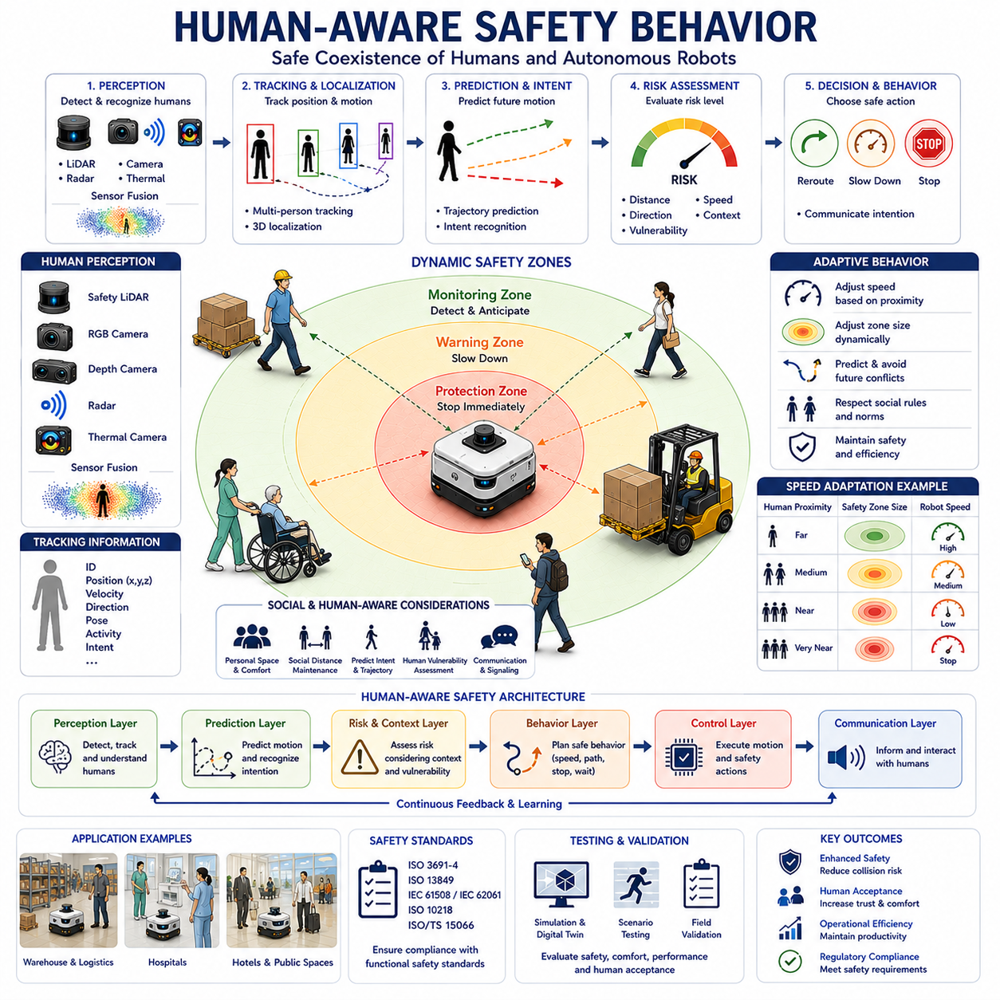
Human-Aware Safety Behavior is a critical component of modern autonomous mobile robot systems that enables robots to safely coexist, collaborate, and interact with humans in shared environments. Unlike traditional industrial automation systems that operate inside fenced and isolated workspaces, modern AMRs are increasingly deployed in factories, warehouses, hospitals, airports, hotels, shopping centers, logistics facilities, office buildings, campuses, and smart cities where humans and robots continuously share the same operational space. In these environments, safety cannot be achieved solely through physical barriers or simple obstacle avoidance mechanisms. Instead, robots must understand human presence, recognize human behavior, predict human intentions, and adapt their own actions accordingly. Human-Aware Safety Behavior provides the framework that allows autonomous systems to achieve this objective while maintaining both operational efficiency and regulatory compliance.
The fundamental principle behind Human-Aware Safety Behavior is that humans are fundamentally different from static obstacles. Walls, pallets, machinery, and infrastructure typically remain stationary or move in predictable ways. Humans, however, are dynamic, intelligent, and often unpredictable. A person may suddenly change direction, stop unexpectedly, become distracted, run across a corridor, step backward without looking, carry large objects that obstruct visibility, or interact with other people in ways that are difficult to anticipate. As a result, autonomous robots must employ safety strategies specifically designed for human interaction rather than relying solely on traditional obstacle avoidance techniques.
The evolution of human-aware robotics reflects broader changes in industrial automation. Early industrial robots operated inside safety cages and were physically separated from workers. Human access was restricted whenever robots were active. As robotic technology evolved, industries increasingly demanded systems capable of operating alongside humans without sacrificing productivity. Collaborative robotics, service robotics, healthcare robotics, logistics automation, and autonomous mobile robots emerged as solutions to these requirements. Human-Aware Safety Behavior became one of the key technologies enabling this transition from isolated automation to shared-space autonomy.
At the core of Human-Aware Safety Behavior lies human detection and recognition. Before a robot can respond appropriately to human activity, it must first identify the presence of people within its environment. Modern AMRs typically utilize multiple sensing modalities to achieve reliable human detection. Safety LiDAR systems provide precise distance measurements and protective field monitoring. RGB cameras capture visual information that supports human classification. Depth cameras provide three-dimensional spatial understanding. Radar sensors offer robust detection under adverse environmental conditions. Thermal cameras can identify human heat signatures even in low-visibility environments. Sensor fusion techniques combine these complementary capabilities to achieve reliable human perception across diverse operational conditions.
Human detection alone is insufficient for advanced safety behavior. The robot must also understand where people are located relative to its own position and motion trajectory. Human localization algorithms estimate the precise position of individuals within the environment. These systems continuously update human location information and maintain awareness of multiple people simultaneously. In crowded environments such as hospitals, airports, and logistics facilities, dozens of individuals may be present within the robot's sensing range. Effective Human-Aware Safety Behavior requires robust tracking capabilities capable of maintaining accurate information regarding each person's location and movement.
Human tracking extends perception beyond simple detection. Once a person has been identified, the robot continuously monitors their motion characteristics over time. Tracking algorithms estimate velocity, acceleration, direction of movement, orientation, and behavioral patterns. This information allows the robot to distinguish between individuals who are stationary, walking, running, approaching, moving away, or crossing the robot's intended path. Accurate tracking provides the foundation for predictive safety decision-making.
Human motion prediction represents one of the most important capabilities within Human-Aware Safety Behavior systems. Humans rarely move randomly. Their behavior often follows patterns that can be estimated using trajectory prediction models. By analyzing current position, velocity, body orientation, gaze direction, environmental context, and historical movement patterns, the robot can estimate likely future motion. These predictions allow the robot to anticipate potential conflicts before they occur rather than merely reacting after a hazardous situation has already developed.
Intent recognition further enhances safety performance. Human behavior often reflects underlying goals and intentions. A worker carrying a package toward a loading area exhibits different behavior from a visitor walking through a public corridor. A nurse moving between hospital rooms follows different movement patterns than a patient receiving medical treatment. Advanced AI-based perception systems increasingly incorporate intent recognition capabilities that help robots understand why people are moving in particular ways. This contextual understanding enables more intelligent and proactive safety responses.
Personal space awareness is another critical aspect of Human-Aware Safety Behavior. Humans naturally maintain personal comfort zones during social interactions. When robots violate these comfort zones, people may experience discomfort, anxiety, or reduced trust in the system. Human-aware navigation algorithms therefore incorporate social distance models that account for cultural norms, environmental context, and individual behavior. The robot not only avoids collisions but also respects human comfort and social expectations.
Social navigation represents an extension of personal space awareness into broader human-centered behavior. In shared environments, robots must move in ways that people perceive as natural and predictable. Abrupt stops, aggressive maneuvers, unnecessary proximity, and erratic behavior can reduce user acceptance even when physical safety is maintained. Human-aware robots therefore adjust speed, trajectory, acceleration, and positioning to align with human expectations. The objective is to create interactions that feel comfortable, intuitive, and trustworthy.
Dynamic safety zones play a central role in Human-Aware Safety Behavior. Safety zones surrounding the robot are continuously adjusted based on human presence and activity. When people are nearby, protective fields may expand to provide additional safety margins. In crowded environments, speed limits may be reduced automatically. If a person enters a critical protection zone, the robot may slow down, stop, or reroute itself to maintain safe separation distances. These adaptive safety mechanisms allow robots to balance productivity with human protection.
Speed adaptation is particularly important when operating around people. High-speed motion may be acceptable in isolated industrial corridors, but lower speeds are typically required when humans are present. Human-aware systems continuously evaluate proximity, crowd density, predicted trajectories, and environmental complexity to determine appropriate operating speeds. This dynamic speed control reduces collision risk while maintaining efficient operation.
Human vulnerability assessment introduces another layer of sophistication. Not all individuals possess the same physical capabilities or safety requirements. Children, elderly individuals, hospital patients, wheelchair users, visually impaired persons, and individuals carrying heavy loads may require additional protection. Human-Aware Safety Behavior systems increasingly incorporate vulnerability assessment mechanisms that adjust safety margins according to the characteristics of nearby individuals.
Hospitals provide particularly important examples of Human-Aware Safety Behavior applications. Hospital environments contain patients, nurses, doctors, visitors, medical equipment, and emergency personnel moving simultaneously through shared corridors. Patients may exhibit reduced mobility, cognitive impairments, or unpredictable behavior. Human-aware robots operating in these environments must prioritize patient safety while remaining responsive to dynamic operational demands. Adaptive speed control, expanded safety zones, predictive collision avoidance, and context-aware navigation become essential capabilities.
Warehouse and manufacturing environments present different challenges. Workers frequently carry packages, operate forklifts, push carts, and perform manual tasks. Human-aware robots must understand workplace activities and adapt accordingly. For example, a worker loading materials may have limited situational awareness. The robot may therefore increase separation distance or alter its path to reduce risk. Human-Aware Safety Behavior supports safe collaboration without requiring workers to modify their normal activities significantly.
Artificial intelligence increasingly enhances Human-Aware Safety Behavior systems. Deep learning models support human detection, pose estimation, activity recognition, trajectory prediction, and intent understanding. Vision-language models and multimodal AI architectures further improve contextual understanding. These technologies allow robots to interpret complex human behaviors and respond appropriately under diverse operational conditions.
Human pose estimation represents a particularly valuable capability. Rather than simply detecting a person's location, pose estimation algorithms analyze body posture, limb position, and movement dynamics. This information provides insights into human activities and intentions. A person bending down, reaching for an object, turning around, or preparing to walk may require different safety responses. Pose-aware safety systems provide more nuanced and context-sensitive protection.
Predictive collision avoidance builds upon human perception and behavioral understanding. Instead of responding solely to current positions, the robot estimates future trajectories for both itself and nearby humans. Potential conflicts are identified before they become immediate hazards. This predictive approach enables smoother, less disruptive interventions. Rather than triggering abrupt emergency stops, the robot can gradually reduce speed, modify its path, or adjust timing to avoid conflicts proactively.
Communication and signaling contribute significantly to Human-Aware Safety Behavior. Humans feel more comfortable when robot actions are understandable and predictable. Visual indicators, lights, displays, sounds, projected paths, and other communication mechanisms help convey robot intentions. By informing people about planned movements and safety states, robots can reduce uncertainty and improve trust.
Human-aware behavior is closely linked to international safety standards and regulations. Standards such as ISO 3691-4, ISO 13849, IEC 61508, ISO 10218, and ISO/TS 15066 provide guidance regarding human-robot interaction, protective separation distances, functional safety requirements, and collaborative operation. Compliance with these standards is essential for ensuring safe deployment in commercial and industrial environments.
Testing and validation of Human-Aware Safety Behavior require comprehensive evaluation across diverse operational scenarios. Simulation platforms, digital twins, laboratory testing environments, and field deployments are used to assess system performance. Engineers evaluate detection accuracy, tracking reliability, trajectory prediction quality, intervention effectiveness, human acceptance, false alarm rates, and overall safety performance. Validation must demonstrate that the system behaves appropriately under both normal and abnormal conditions.
Future Human-Aware Safety Behavior systems will become increasingly sophisticated as advances in AI, embodied intelligence, foundation models, cooperative perception, and cloud robotics continue to mature. Future robots may understand human emotions, recognize stress levels, interpret social interactions, predict group behavior, and coordinate safety decisions across entire fleets. Rather than merely avoiding collisions, autonomous systems will actively support safe, comfortable, and productive human-robot coexistence.
As autonomous robots expand into hospitals, factories, warehouses, transportation hubs, smart cities, retail environments, and public spaces, Human-Aware Safety Behavior will remain one of the most important enabling technologies. By combining advanced perception, behavioral understanding, predictive modeling, adaptive safety control, and human-centered design principles, robots can safely operate alongside people while maintaining efficiency and productivity. This capability represents a fundamental step toward the realization of truly intelligent autonomous systems capable of integrating seamlessly into human environments and daily life.

18.6 Industrial Safety Regulations
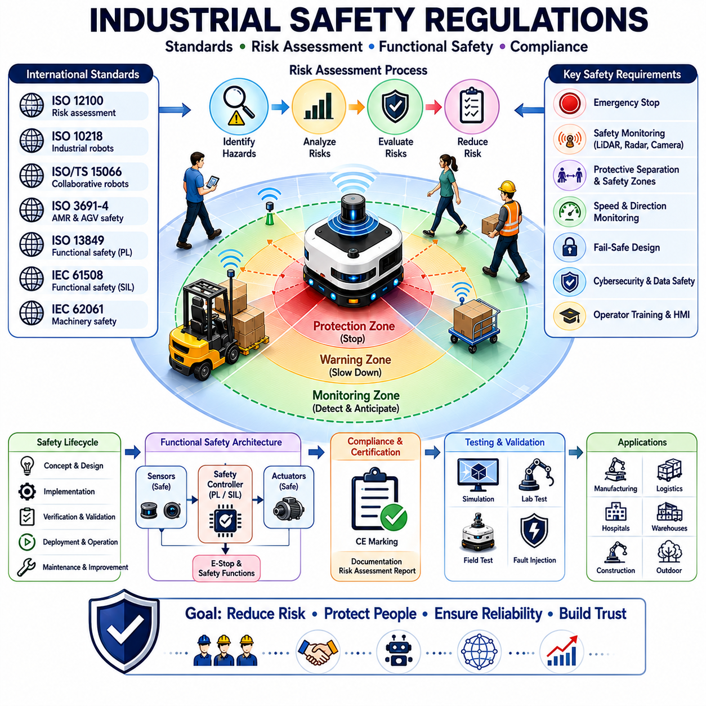
Industrial Safety Regulations form the legal, technical, and operational foundation for the safe design, development, deployment, operation, and maintenance of autonomous mobile robots (AMRs), automated guided vehicles (AGVs), collaborative robots, industrial robots, autonomous forklifts, towing robots, service robots, and outdoor autonomous systems. As robotics technology continues to expand into manufacturing, logistics, healthcare, transportation, agriculture, construction, mining, and smart city applications, regulatory compliance has become one of the most important requirements for successful commercialization and deployment. Industrial safety regulations ensure that robotic systems operate in a manner that minimizes risk to human life, protects equipment and infrastructure, supports reliable operation, and provides confidence to operators, facility managers, customers, and regulatory authorities.
The fundamental purpose of industrial safety regulations is risk reduction. Every robotic system introduces potential hazards due to motion, energy transfer, mechanical interaction, electrical systems, software behavior, and environmental uncertainty. Safety regulations provide structured methodologies for identifying hazards, evaluating risks, implementing protective measures, and verifying that acceptable safety levels are achieved. Rather than eliminating all risk, which is often impossible in practical engineering systems, safety regulations aim to reduce risk to a level that is considered acceptable according to industry standards and societal expectations.
The evolution of industrial safety regulations has closely followed the development of automation technologies. Early industrial machinery primarily relied on mechanical safeguards such as physical barriers, guards, interlocks, and emergency stop buttons. As electronic control systems became widespread, safety regulations expanded to include electrical safety, programmable control systems, and automated machinery. The introduction of industrial robots created new challenges because robots could move autonomously and interact with their environment in complex ways. Modern AMRs introduce even greater complexity because they navigate dynamically through environments shared with humans. Consequently, industrial safety regulations have evolved into comprehensive frameworks covering hardware, software, sensors, communication systems, artificial intelligence, and operational procedures.
Risk assessment serves as the cornerstone of nearly all industrial safety regulations. Before a robotic system can be deployed, engineers must systematically identify potential hazards and evaluate the likelihood and severity of associated risks. Hazards may include collisions, crushing events, entanglement, electrical shock, fire, loss of control, communication failures, sensor failures, cybersecurity breaches, and unexpected system behavior. Risk assessment methodologies provide structured approaches for determining which hazards require mitigation and what protective measures should be implemented.
One of the most widely recognized international standards in industrial safety is the family of standards developed by the International Organization for Standardization (ISO). These standards establish globally accepted requirements and best practices for machinery safety, robot safety, functional safety, and risk management. Compliance with ISO standards is often essential for market acceptance, certification, and regulatory approval in many regions around the world.
ISO 12100 serves as one of the foundational standards for machinery safety. It provides general principles for risk assessment and risk reduction applicable to a wide range of industrial equipment. The standard establishes methodologies for identifying hazards, evaluating risks, and selecting appropriate protective measures. Many robot-specific safety standards build upon the principles established by ISO 12100.
Industrial robots are commonly governed by ISO 10218, which defines safety requirements for industrial robot systems and robot integration. This standard addresses robot design, safeguarding measures, emergency stop functions, protective devices, operating modes, and risk assessment procedures. Although originally developed for stationary industrial robots, many of its principles remain relevant to modern robotic systems.
Collaborative robotics introduced new safety challenges because humans and robots intentionally share workspaces. ISO/TS 15066 was developed to address collaborative robot operation and provides guidance regarding force limits, pressure thresholds, human contact considerations, and protective separation distances. This specification supports the safe implementation of human-robot collaboration in industrial environments.
For autonomous mobile robots and automated guided vehicles, ISO 3691-4 has emerged as one of the most important safety standards. This standard specifically addresses driverless industrial trucks and autonomous mobile robots. It defines requirements related to obstacle detection, safety monitoring, emergency stopping, speed control, navigation systems, protective field monitoring, functional safety architecture, and risk reduction measures. ISO 3691-4 has become a key regulatory reference for AMR manufacturers and integrators worldwide.
Functional safety plays a central role in modern industrial safety regulations. Functional safety focuses on ensuring that safety-related control systems operate correctly in response to inputs and failures. Rather than relying solely on physical protection, functional safety ensures that electronic, programmable, and software-based systems contribute effectively to risk reduction. Functional safety has become particularly important as robotics systems increasingly depend on sensors, software, artificial intelligence, and networked communication.
IEC 61508 is widely recognized as the foundational functional safety standard for electrical, electronic, and programmable electronic systems. It introduces concepts such as Safety Integrity Levels (SILs), systematic failure analysis, lifecycle management, verification procedures, and safety validation. Many industry-specific safety standards are derived from IEC 61508 and adapt its principles to particular application domains.
In machinery and robotics applications, ISO 13849 is one of the most commonly applied functional safety standards. It focuses on safety-related parts of control systems and introduces the concept of Performance Levels (PLs). Engineers use ISO 13849 to design and validate safety functions such as emergency stop systems, protective field monitoring, safety interlocks, speed monitoring, and safety-rated motion control. Performance Levels provide measurable indicators of reliability and risk reduction capability.
IEC 62061 complements ISO 13849 by providing an alternative functional safety framework specifically focused on machinery safety systems. Many industrial robotics projects use one or both standards depending on application requirements, customer expectations, and certification objectives.
Emergency stop systems represent a critical requirement across virtually all industrial safety regulations. Every autonomous robot must provide mechanisms that allow hazardous motion to be stopped quickly and reliably. Emergency stop devices must be clearly visible, easily accessible, and capable of overriding normal operational commands. Regulatory requirements typically specify performance characteristics, response times, fault tolerance, and validation procedures for emergency stop systems.
Safety monitoring functions are another key regulatory requirement. Modern AMRs frequently employ safety LiDAR systems, safety cameras, radar sensors, and protective field monitoring technologies. Industrial safety regulations define how these systems should be integrated, validated, and maintained. Safety sensors must provide reliable detection performance, fail-safe behavior, diagnostic capabilities, and appropriate safety certifications.
Speed and separation monitoring has become increasingly important in collaborative robotic environments. Rather than physically separating humans and robots, modern systems often rely on dynamic safety zones and protective separation distances. Regulatory frameworks provide methodologies for calculating safe distances based on robot speed, human approach speed, sensor performance, braking capability, and system response times. These calculations form the basis for many Human-Aware Safety Behavior systems.
Cybersecurity is emerging as a significant aspect of industrial safety regulation. Autonomous robots increasingly rely on wireless communication, cloud connectivity, remote monitoring, software updates, and distributed control architectures. Cybersecurity vulnerabilities can create safety hazards by disrupting robot operation, modifying safety parameters, or interfering with communication systems. Modern regulatory frameworks increasingly recognize the relationship between cybersecurity and safety, requiring organizations to address both domains simultaneously.
Artificial intelligence introduces new regulatory challenges. Traditional safety standards were developed primarily for deterministic control systems whose behavior could be fully specified and verified. AI-based systems often rely on probabilistic models, machine learning algorithms, and adaptive decision-making processes. Regulatory authorities and standards organizations are actively developing methodologies for evaluating AI safety, validation procedures, explainability requirements, and risk management frameworks suitable for intelligent robotic systems.
Human factors engineering is another essential component of industrial safety regulations. Safe robot operation depends not only on technology but also on human behavior, operator training, workplace procedures, maintenance practices, and organizational culture. Regulations often require training programs, operating instructions, warning labels, maintenance procedures, incident reporting mechanisms, and continuous safety improvement processes.
Workplace safety regulations vary across different countries and regions. In the United States, organizations such as the Occupational Safety and Health Administration establish workplace safety requirements and enforcement mechanisms. In Europe, machinery regulations, CE conformity requirements, and harmonized standards govern industrial equipment deployment. Other regions maintain their own regulatory frameworks while often incorporating internationally recognized standards.
The CE marking process represents an important regulatory requirement for robotic systems entering many international markets. Manufacturers must demonstrate conformity with applicable directives, standards, and regulatory requirements. Technical documentation, risk assessments, safety analyses, validation reports, and conformity declarations form essential components of the certification process.
Safety validation and verification activities are mandatory elements of regulatory compliance. Engineers must demonstrate that safety functions perform as intended under expected operating conditions and foreseeable failure scenarios. Validation typically includes simulation testing, laboratory testing, field trials, fault injection testing, environmental testing, and performance verification. Documentation plays a critical role throughout this process because regulatory authorities often require evidence supporting safety claims.
Industrial safety regulations also address the complete lifecycle of robotic systems. Safety considerations begin during concept development and continue through design, implementation, testing, deployment, operation, maintenance, modification, and decommissioning. Lifecycle safety management ensures that risk reduction measures remain effective as systems evolve over time.
Safety documentation forms a major component of regulatory compliance. Hazard analyses, risk assessments, safety requirements specifications, safety architecture descriptions, verification reports, validation records, maintenance procedures, operator manuals, and training materials must often be maintained throughout the operational life of the system. Comprehensive documentation supports audits, certifications, incident investigations, and continuous improvement efforts.
The rapid growth of autonomous robotics is driving ongoing evolution within the regulatory landscape. New standards are being developed to address autonomous decision-making, machine learning, cloud robotics, cooperative perception, multi-robot systems, and human-centered AI. Regulatory organizations are working to ensure that innovation can proceed while maintaining appropriate levels of safety and public trust.
Digital twins and simulation technologies are increasingly being incorporated into regulatory compliance processes. High-fidelity virtual environments allow engineers to evaluate safety performance across thousands of scenarios before deployment. These tools support risk assessment, validation, operator training, and safety certification activities while reducing development costs and accelerating deployment timelines.
Future industrial safety regulations will likely become more integrated, adaptive, and data-driven. Real-time safety monitoring, predictive risk assessment, continuous certification, AI-assisted compliance verification, and cloud-based safety management may become common components of future regulatory frameworks. Safety systems will increasingly combine traditional engineering approaches with intelligent monitoring and predictive analytics.
As autonomous mobile robots continue to expand across manufacturing, logistics, healthcare, transportation, agriculture, mining, construction, infrastructure inspection, and smart city applications, Industrial Safety Regulations will remain the foundation upon which safe and reliable robotic systems are built. By providing structured methodologies for risk assessment, functional safety, human protection, system validation, and lifecycle management, these regulations enable organizations to deploy advanced robotic technologies with confidence. Ultimately, industrial safety regulations serve not only as compliance requirements but also as essential enablers of sustainable, scalable, and trustworthy robotic innovation.

18.7 Emergency Stop and Recovery
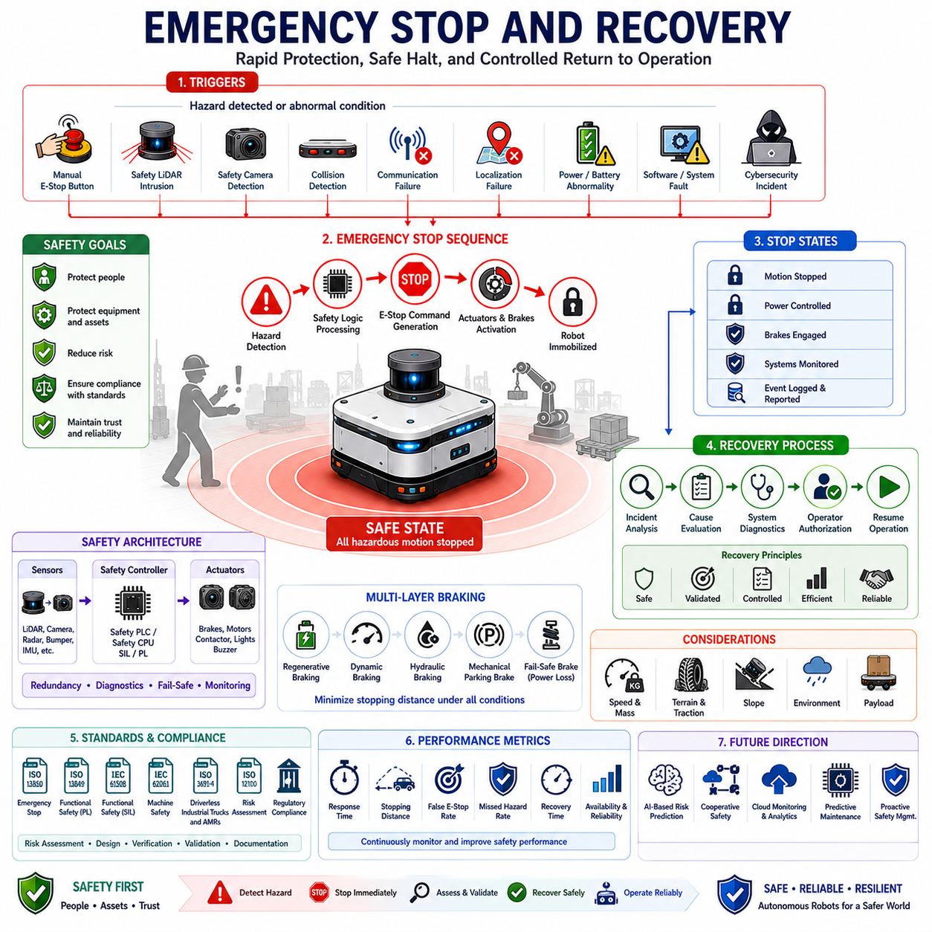
Emergency Stop and Recovery is one of the most essential safety mechanisms in autonomous mobile robot systems, providing the final layer of protection when hazardous conditions, unexpected failures, or potentially dangerous situations occur. Regardless of how advanced a robot’s perception, navigation, planning, and control systems may be, there will always be circumstances in which immediate interruption of robot motion becomes necessary. Emergency Stop and Recovery functions are therefore designed to ensure that autonomous systems can rapidly transition from operational states to safe states and subsequently return to normal operation in a controlled, validated, and risk-managed manner.
The primary objective of an Emergency Stop system is to prevent harm to humans, equipment, infrastructure, products, and the robot itself. In industrial environments, robots frequently operate near workers, machinery, storage systems, transport vehicles, and valuable assets. Unexpected obstacles, sensor failures, software errors, communication disruptions, environmental hazards, or human actions can create conditions where continued robot motion presents unacceptable risk. Emergency Stop mechanisms provide an immediate means of eliminating that risk by halting hazardous movement as quickly and reliably as possible.
The concept of Emergency Stop has existed in industrial machinery for decades. Traditional manufacturing equipment utilized large red emergency stop buttons that operators could activate whenever dangerous conditions were observed. As automation evolved, emergency stop functions expanded beyond manually activated switches to include safety-rated electronic systems capable of automatically detecting hazardous situations and initiating protective actions without human intervention. Modern autonomous robots incorporate both manual and automated emergency stop capabilities as part of their overall functional safety architecture.
Emergency Stop systems are fundamentally different from normal operational stopping functions. A normal stop occurs as part of routine robot behavior, such as reaching a destination, waiting at an intersection, yielding to another vehicle, or pausing for task execution. These actions are planned, controlled, and expected. An emergency stop, in contrast, occurs when safety is threatened and immediate intervention is required. The primary goal is risk reduction rather than operational efficiency.
The effectiveness of an Emergency Stop system depends heavily on response time. The period between hazard detection and complete robot immobilization must be minimized. This response includes hazard recognition, safety logic processing, command generation, actuator response, braking system activation, and physical deceleration. Every millisecond contributes to overall stopping performance, particularly in high-speed or high-mass robotic systems.
Stopping distance represents one of the most important parameters in Emergency Stop design. Even after an emergency stop command is issued, the robot requires a finite distance to come to rest. This distance depends on vehicle speed, payload mass, braking capability, traction conditions, terrain characteristics, and environmental factors. Safety engineers must ensure that emergency stopping performance remains adequate under all expected operating conditions.
Autonomous mobile robots typically employ multiple mechanisms capable of triggering emergency stops. Manual emergency stop buttons remain one of the most visible and universally recognized methods. These devices are strategically positioned on the robot and sometimes within the operating environment to allow immediate human intervention. Emergency stop buttons are designed to be highly visible, easily accessible, and mechanically reliable. Once activated, they typically require deliberate reset procedures before operation can resume.
Safety LiDAR systems frequently serve as automated emergency stop triggers. These sensors continuously monitor predefined protection fields surrounding the robot. If a person, vehicle, object, or obstacle enters a critical safety zone, the LiDAR immediately communicates with safety controllers to initiate an emergency stop sequence. This capability enables rapid response to dynamic hazards that may not be visible to human operators.
Safety cameras provide another important source of emergency stop activation. Advanced vision systems can detect humans, machinery, vehicles, hazardous objects, and unsafe situations within the robot’s operating environment. When dangerous conditions are identified, safety-rated image processing systems can generate stop commands independently of navigation or mission-control software.
Collision detection systems provide an additional protective layer. Despite sophisticated perception and planning capabilities, physical contact may occasionally occur. Bumper sensors, force sensors, torque sensors, accelerometers, and vibration monitoring systems can detect unexpected impacts and immediately trigger emergency stopping functions. This approach minimizes secondary damage and prevents escalation of hazardous situations.
Communication failures frequently represent another trigger category. Autonomous robots increasingly depend on wireless communication, fleet management systems, cloud services, remote supervision, and distributed coordination architectures. Loss of critical communication links may create uncertainty regarding robot state or environmental conditions. Many safety architectures therefore incorporate communication monitoring functions that automatically initiate emergency stops when critical communication channels fail.
Localization failures can also necessitate emergency stopping. Autonomous navigation depends on accurate knowledge of robot position and orientation. Significant localization uncertainty may increase collision risk and compromise safe operation. Modern AMRs continuously monitor localization confidence and can enter safe-stop states when positioning accuracy falls below acceptable thresholds.
Power system abnormalities represent another important safety concern. Battery failures, voltage instability, power distribution faults, overheating conditions, and electrical anomalies can compromise robot operation. Emergency stop functions may be activated automatically to prevent uncontrolled behavior and protect both the robot and surrounding personnel.
Software faults present unique challenges in autonomous robotic systems. Navigation failures, memory corruption, processing overloads, unexpected exceptions, algorithmic instability, and artificial intelligence errors may all create unsafe conditions. Functional safety architectures therefore incorporate watchdog systems, redundancy mechanisms, health monitoring functions, and safety supervisors capable of initiating emergency stops whenever abnormal software behavior is detected.
Cybersecurity incidents are becoming increasingly relevant to Emergency Stop strategies. Unauthorized access, malicious commands, communication interference, data corruption, or cyberattacks may introduce safety risks. Modern safety frameworks increasingly integrate cybersecurity monitoring with emergency response mechanisms to address these emerging threats.
The design of emergency stop systems must comply with internationally recognized safety standards. Standards such as ISO 13850, ISO 13849, IEC 61508, IEC 62061, ISO 3691-4, and ISO 12100 define requirements related to emergency stopping functions, safety integrity, performance levels, reliability, diagnostics, and validation procedures. Compliance with these standards ensures that emergency stop systems achieve appropriate levels of safety performance and fault tolerance.
Functional safety principles play a central role in Emergency Stop implementation. Safety-related hardware and software components must be designed to achieve specific reliability targets. Redundancy, fault detection, fail-safe design, diagnostic coverage, and systematic verification activities help ensure that emergency stop functions remain available when needed.
Emergency stopping is particularly important for high-energy robotic systems. Heavy-duty AMRs, autonomous forklifts, towing robots, construction robots, mining vehicles, agricultural platforms, and outdoor autonomous systems often possess substantial kinetic energy. These systems require carefully engineered braking mechanisms and advanced stopping strategies to ensure safe operation under all conditions.
Braking systems themselves may employ multiple layers of protection. Dynamic braking, regenerative braking, hydraulic braking, electromagnetic braking, mechanical parking brakes, and fail-safe braking systems may operate together to achieve reliable stopping performance. In many designs, mechanical brakes automatically engage whenever power is removed, ensuring safe immobilization even during complete electrical failures.
Environmental conditions significantly influence emergency stop performance. Wet surfaces, icy terrain, loose gravel, mud, uneven ground, steep slopes, and variable traction conditions can affect stopping distances and vehicle stability. Safety engineers must account for these factors during system design and validation to ensure reliable operation under real-world conditions.
Recovery following an emergency stop is equally important. Stopping a robot safely represents only the first phase of incident management. Before operation can resume, the system must determine why the emergency stop occurred, verify that hazards have been eliminated, confirm that all safety systems remain functional, and ensure that restarting the robot does not introduce additional risks.
Recovery procedures typically begin with incident assessment. Operators, supervisors, or automated diagnostic systems analyze the triggering event and determine its cause. The nature of the recovery process depends on the underlying issue. A temporary obstacle intrusion may require only a brief inspection, whereas hardware failures or software faults may necessitate more extensive corrective actions.
Safety validation forms an essential part of recovery operations. Before motion is re-enabled, the robot must verify the health and functionality of all critical safety components. Sensors, controllers, actuators, communication systems, localization modules, braking systems, and power systems may undergo automated diagnostic checks to confirm readiness for operation.
Human authorization is often incorporated into recovery procedures. Many industrial environments require manual confirmation before a robot can resume motion following an emergency stop. This requirement prevents automatic restarts that could surprise nearby workers or reintroduce hazards before conditions have been properly evaluated.
Recovery planning becomes particularly important in fleet-based robotic environments. When one robot experiences an emergency stop, neighboring robots may need to reroute around the affected area. Traffic management systems, fleet supervisors, and centralized control platforms coordinate recovery activities to maintain overall system efficiency while preserving safety.
Context-aware recovery strategies are increasingly common in modern AMR systems. Rather than simply resuming previous operations, advanced robots evaluate current environmental conditions, traffic density, human activity, and mission priorities before determining how to restart safely. This adaptive approach reduces the likelihood of repeated incidents and improves operational resilience.
Artificial intelligence is beginning to enhance emergency stop and recovery systems. Machine learning models can analyze historical incidents, identify recurring failure patterns, predict emerging risks, and recommend corrective actions. AI-based diagnostics may accelerate root-cause analysis and improve recovery efficiency while maintaining strict safety requirements.
Digital twin technology provides powerful tools for Emergency Stop validation and optimization. Virtual environments allow engineers to simulate hazardous scenarios, evaluate stopping performance, analyze recovery procedures, and validate safety architectures before deployment. Rare or dangerous events can be studied repeatedly without exposing personnel or equipment to actual risk.
Performance metrics for Emergency Stop and Recovery systems extend beyond stopping capability alone. Important measures include response time, stopping distance, false activation rate, missed hazard rate, diagnostic accuracy, recovery duration, operational availability, safety compliance, and incident recurrence frequency. Effective systems achieve rapid intervention while minimizing unnecessary disruptions to productivity.
Future Emergency Stop and Recovery systems will become increasingly intelligent, predictive, and autonomous. Advances in artificial intelligence, edge computing, cooperative perception, cloud robotics, predictive maintenance, and digital safety management will enable robots to identify risks earlier, intervene more effectively, and recover more efficiently. Rather than functioning solely as reactive protection mechanisms, future systems will become proactive safety management platforms capable of continuously monitoring operational risk and preventing incidents before emergency stopping becomes necessary.
As autonomous robots continue expanding into manufacturing, logistics, healthcare, transportation, agriculture, mining, construction, infrastructure inspection, and smart city environments, Emergency Stop and Recovery will remain one of the most critical elements of robotic safety architecture. By providing reliable mechanisms for hazard mitigation, fault management, operational recovery, and risk control, these systems ensure that autonomous robots can operate safely, responsibly, and effectively in increasingly complex real-world environments. Emergency Stop and Recovery therefore serves not merely as a safety feature, but as a foundational capability that enables trust, acceptance, and large-scale deployment of autonomous robotic technologies.

18.8 Safety Zone Testing
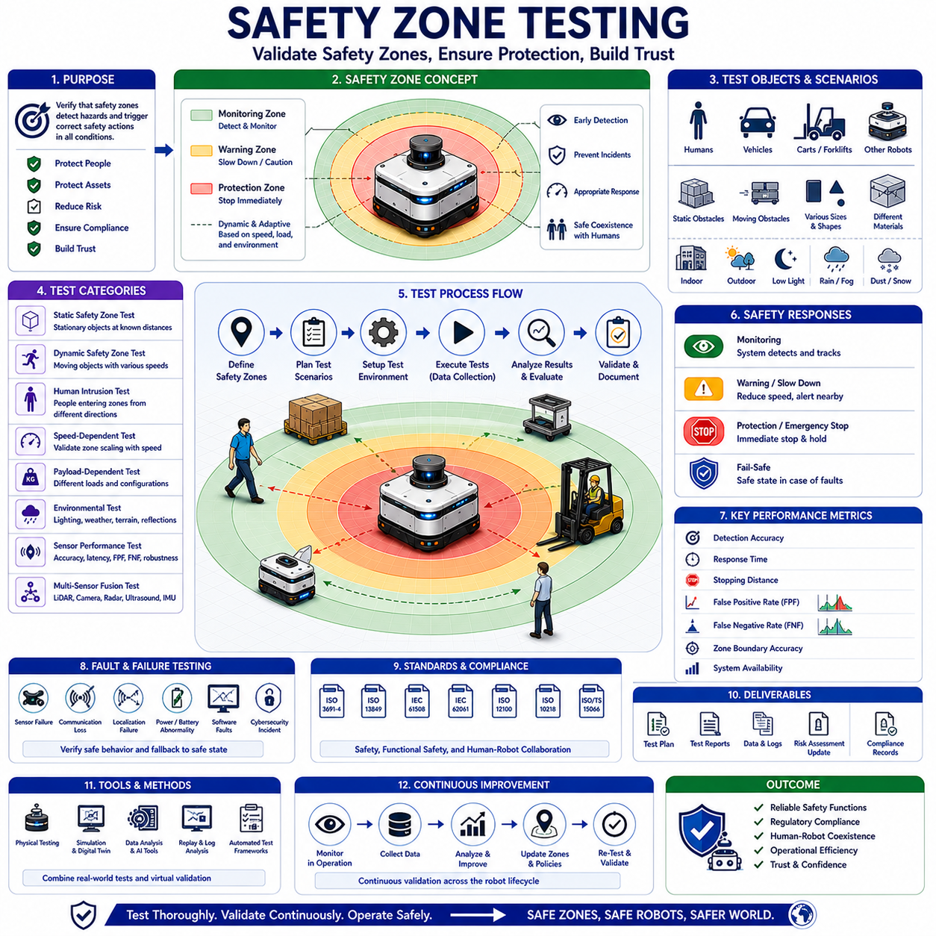
Safety Zone Testing is a critical validation process within autonomous mobile robot development that ensures safety zones operate correctly under all expected operating conditions. Safety zones serve as virtual protective boundaries surrounding a robot, defining areas where specific safety behaviors such as monitoring, warning, speed reduction, collision avoidance, emergency stopping, and protective intervention are activated. Because these zones directly influence human safety and regulatory compliance, they must be thoroughly tested, validated, and documented before deployment. Safety Zone Testing verifies that safety functions perform as intended, that sensor systems accurately detect intrusions, and that robots consistently respond to hazardous situations in a safe and predictable manner.
The primary objective of Safety Zone Testing is to confirm that the robot can reliably detect objects, humans, vehicles, and obstacles entering predefined safety regions and initiate appropriate protective actions within required response times. A safety zone is only effective if its boundaries are accurately defined, continuously monitored, and properly linked to the robot’s safety control architecture. Testing therefore focuses not only on detection performance but also on the complete chain of safety-related functions, including sensing, processing, decision-making, communication, braking, and system recovery.
Modern autonomous robots frequently operate in environments shared with humans. Warehouses, manufacturing plants, hospitals, airports, shopping centers, logistics facilities, and smart city environments all require robots to move safely around people. Safety zones provide the foundation for this coexistence by creating dynamic protective spaces that adapt to operational conditions. Safety Zone Testing ensures these protections remain effective regardless of environmental complexity, traffic density, or mission requirements.
The concept of safety zones originates from risk assessment and protective separation distance principles. Engineers first identify potential hazards associated with robot operation and then define protective regions designed to reduce those risks. These regions are typically divided into multiple layers. Monitoring zones provide early awareness of approaching objects. Warning zones trigger precautionary actions such as speed reduction. Protection zones activate emergency stop mechanisms when immediate danger exists. Testing verifies that each zone performs according to its intended function.
Static safety zone testing is often the first phase of validation. During these tests, stationary objects are positioned at known distances and locations relative to the robot. Engineers verify that safety sensors correctly identify object presence and activate the appropriate safety response when objects enter specific zones. The measured activation points are compared against predefined safety field boundaries to ensure accuracy. Repeated testing confirms consistency and repeatability across multiple operating cycles.
Dynamic safety zone testing introduces moving objects into the environment. Humans, robotic platforms, vehicles, carts, forklifts, and simulated obstacles move through safety fields while the robot remains stationary or in motion. Dynamic testing evaluates the ability of the system to detect moving hazards, estimate trajectories, and respond appropriately. Because real-world environments contain continuous motion, dynamic testing is essential for validating practical safety performance.
Human intrusion testing represents one of the most important categories of Safety Zone Testing. Test personnel intentionally enter safety zones under controlled conditions to verify system response. The robot must detect human presence, trigger appropriate warnings, reduce speed when required, and initiate emergency stopping before protective separation distances are violated. These tests provide confidence that the robot can safely operate in environments where people and machines coexist.
Human-aware safety testing extends beyond simple intrusion detection. Modern robots increasingly incorporate predictive behavior analysis, intent recognition, and social navigation capabilities. Testing therefore evaluates how the robot responds to various human behaviors, including walking, running, standing, turning, bending, carrying objects, crossing paths, and approaching from different directions. The objective is to ensure that safety responses remain effective despite the complexity and unpredictability of human behavior.
Speed-dependent safety zone testing is particularly important for autonomous mobile robots. Safety zones often expand and contract based on vehicle speed. Higher speeds require larger protective distances due to increased stopping distances, while lower speeds permit smaller safety fields that improve maneuverability. Testing verifies that safety field transitions occur correctly and that field dimensions accurately reflect current operating conditions. Engineers evaluate safety performance across the full range of robot speeds.
Payload-dependent testing addresses another critical factor affecting safety performance. As payload mass increases, stopping distances increase correspondingly. Heavy-duty industrial robots, autonomous forklifts, towing robots, and logistics platforms may experience significant variations in payload conditions. Safety zone testing evaluates system performance under different load scenarios to confirm that protective distances remain adequate regardless of payload weight.
Environmental testing is essential because real-world conditions can significantly influence sensor performance and safety system effectiveness. Indoor facilities may contain varying lighting conditions, reflective surfaces, dust, smoke, and moving machinery. Outdoor environments introduce rain, fog, snow, direct sunlight, vegetation, temperature variation, and uneven terrain. Safety Zone Testing evaluates sensor reliability and safety performance across these diverse environmental conditions.
Safety LiDAR systems are frequently the primary sensors used for safety zone monitoring. Consequently, LiDAR-specific testing plays a major role in validation activities. Engineers evaluate detection accuracy, field configuration correctness, response time, false positive rates, false negative rates, and environmental robustness. Objects of different sizes, shapes, materials, and reflectivities are introduced into safety fields to assess detection consistency.
Safety camera testing complements LiDAR validation. Vision-based safety systems must accurately detect humans, vehicles, machinery, and obstacles under varying lighting conditions. Testing includes daylight operation, low-light environments, shadow conditions, glare scenarios, and partially occluded targets. Advanced AI-based safety systems may also undergo object classification and behavior recognition testing.
Radar-based safety systems require separate validation procedures. Radar offers advantages in adverse weather conditions where optical sensors may experience reduced performance. Testing evaluates radar detection capability under rain, fog, snow, dust, and other challenging environmental conditions. Multi-sensor fusion architectures are then tested to verify that combined perception systems achieve higher overall safety performance than individual sensors alone.
Sensor fusion testing has become increasingly important as autonomous robots integrate multiple sensing technologies. Modern safety architectures often combine Safety LiDAR, cameras, radar, ultrasonic sensors, GNSS receivers, and inertial measurement units. Testing evaluates how information from these sensors is fused, validated, and utilized by safety controllers. Engineers assess consistency, redundancy, fault tolerance, and robustness across diverse operational scenarios.
Emergency stop validation forms a major component of Safety Zone Testing. Whenever an object enters a critical protection zone, the robot must initiate emergency stopping procedures within specified response times. Testing measures detection latency, processing delays, communication delays, braking response, stopping distance, and overall intervention effectiveness. These measurements are compared against regulatory requirements and design specifications.
Braking performance testing is closely linked to emergency stop validation. Safety systems rely on accurate estimates of stopping distance when defining protection fields. Testing therefore evaluates braking performance under different speeds, payload conditions, terrain characteristics, and environmental factors. Engineers ensure that actual stopping distances remain within acceptable limits and that safety margins are maintained.
Functional safety verification represents another key aspect of Safety Zone Testing. Safety functions must operate correctly not only during normal conditions but also when faults occur. Engineers intentionally introduce faults such as sensor failures, communication interruptions, controller errors, power anomalies, and localization failures. The robot must detect these faults and transition to safe states without creating additional hazards.
Fail-safe testing validates system behavior under abnormal conditions. Safety architectures are designed so that failures result in safe outcomes rather than unsafe operation. For example, loss of communication between a Safety LiDAR and safety controller should trigger protective actions rather than allowing continued operation. Testing confirms that fail-safe principles are consistently implemented throughout the system.
Localization-aware safety testing evaluates the relationship between positioning accuracy and safety zone operation. Autonomous robots depend on reliable localization to navigate safely. Significant positioning uncertainty may compromise safety zone effectiveness. Testing verifies that safety systems appropriately respond to degraded localization performance and maintain protective behavior under uncertain conditions.
Cybersecurity-related safety testing is becoming increasingly important. Networked robotic systems may be exposed to communication disruptions, unauthorized access attempts, software manipulation, or data corruption. Testing evaluates how safety systems respond to cybersecurity incidents and verifies that protective functions remain operational even when network-related anomalies occur.
Fleet-level safety testing examines safety zone interactions in multi-robot environments. Large facilities often deploy dozens or hundreds of robots operating simultaneously. Safety Zone Testing evaluates robot-to-robot interactions, traffic coordination, congestion management, and cooperative safety behaviors. Each robot must maintain its own safety protections while functioning effectively within the broader fleet ecosystem.
Human acceptance testing provides valuable insights into practical safety performance. Although a safety system may satisfy technical requirements, human operators and facility personnel must also feel comfortable working alongside robots. Testing therefore includes user observations, behavioral studies, operator feedback, and workplace acceptance evaluations. These activities help optimize safety zone behavior for both safety and usability.
International standards play a central role in Safety Zone Testing methodologies. Standards such as ISO 3691-4, ISO 13849, IEC 61508, IEC 62061, ISO 12100, ISO 10218, and ISO/TS 15066 establish requirements for protective separation distances, safety monitoring functions, emergency stopping performance, functional safety validation, and collaborative operation. Testing procedures are often designed specifically to demonstrate compliance with these standards.
Documentation represents a critical outcome of Safety Zone Testing activities. Engineers generate test plans, validation reports, risk assessment updates, performance measurements, incident analyses, and compliance records. These documents support certification processes, regulatory reviews, customer acceptance, and long-term safety management.
Simulation-based testing has become increasingly valuable for validating safety zones. Digital twins and virtual environments allow engineers to evaluate thousands of operational scenarios before physical deployment. Rare events, edge cases, and hazardous conditions can be examined repeatedly without risk to personnel or equipment. Simulation results complement physical testing and significantly accelerate development cycles.
Artificial intelligence is beginning to transform Safety Zone Testing itself. Machine learning tools can analyze large volumes of test data, identify hidden failure modes, detect performance trends, and optimize safety configurations. AI-assisted validation may improve testing efficiency while increasing coverage of complex operational scenarios.
Future Safety Zone Testing methodologies will likely become more automated, data-driven, and continuous. Instead of relying solely on pre-deployment validation, robots may continuously monitor their own safety performance throughout operational life. Real-time diagnostics, predictive analytics, cloud-based safety monitoring, and digital certification frameworks could enable continuous assurance of safety compliance.
As autonomous robots continue expanding into industrial, commercial, healthcare, transportation, agricultural, infrastructure inspection, and smart city applications, Safety Zone Testing will remain one of the most important activities in the development lifecycle. By systematically validating protective fields, sensor performance, functional safety mechanisms, emergency responses, and human-robot interactions, Safety Zone Testing ensures that autonomous systems can operate safely, reliably, and efficiently in complex real-world environments. It provides the evidence necessary to demonstrate regulatory compliance, achieve user trust, and support the widespread adoption of autonomous robotic technologies.

