Volume 05. Path Planning and Autonomous Navigation

Chapter 01. Navigation Fundamentals

01.1 What is Robot Navigation?
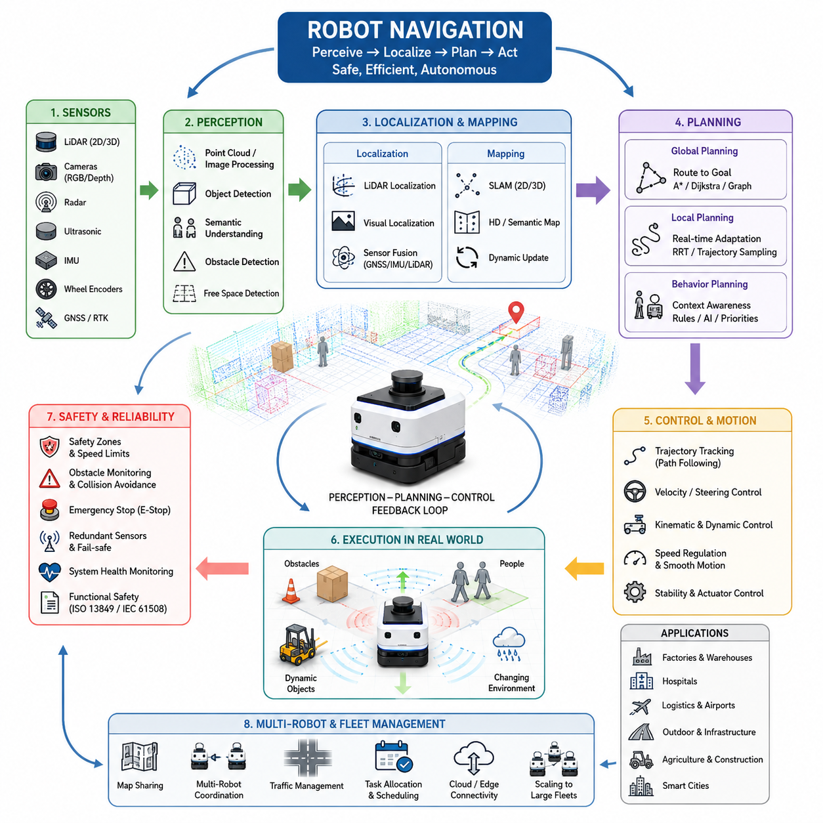
Robot navigation is one of the most fundamental capabilities that transforms a machine from a remotely controlled device into an autonomous system capable of operating in the real world. In the context of Autonomous Mobile Robots (AMRs), navigation refers to the complete process through which a robot understands its environment, determines its own location, plans a route toward a destination, and continuously controls its motion while avoiding obstacles and responding to environmental changes. Navigation is therefore much more than simply moving from one point to another. It is an integrated decision-making process that combines perception, localization, mapping, path planning, motion control, obstacle avoidance, and behavioral reasoning into a unified autonomous system. This topic serves as the foundation of the entire Navigation Fundamentals section and provides the conceptual basis for all subsequent discussions on localization, mapping, path planning, trajectory optimization, behavior planning, fleet navigation, and autonomous mobility.
The concept of robot navigation originates from a simple question: how can a robot determine where it is and where it should go? Humans naturally navigate using vision, memory, spatial awareness, and reasoning. When entering a building, a person can identify hallways, doors, elevators, and landmarks, creating a mental model of the environment. Robots must achieve similar capabilities using sensors, algorithms, and computational models. Unlike humans, robots rely on technologies such as LiDAR, cameras, radar, ultrasonic sensors, GNSS receivers, IMUs, wheel encoders, and depth sensors to perceive the world. The navigation system processes these sensor inputs and converts them into actionable information that allows autonomous movement.
Robot navigation can be viewed as the integration of three fundamental questions. The first question is localization: “Where am I?” The robot must continuously estimate its position and orientation within the environment. The second question is planning: “Where should I go?” The robot must determine a safe and efficient route to the destination. The third question is control: “How do I get there?” The robot must generate motor commands and steering actions that follow the planned route while maintaining safety and stability. Together, these three questions define the core framework of autonomous navigation.
In modern AMR systems, navigation is typically divided into several interconnected layers. At the lowest level, sensor systems gather information from the environment. These sensors may include two-dimensional LiDARs for obstacle detection, three-dimensional LiDARs for spatial mapping, RGB cameras for visual understanding, depth cameras for geometric measurements, GNSS receivers for outdoor positioning, and inertial sensors for motion estimation. Sensor data is then processed through perception pipelines that identify obstacles, free space, semantic objects, and environmental features. The resulting information becomes the basis for localization and mapping algorithms.
Localization is a critical component of navigation because a robot cannot effectively plan or move without knowing its current position. Localization algorithms estimate the robot’s pose, which includes both position and orientation. Indoor robots frequently use LiDAR-based localization, visual localization, or SLAM-based localization. Outdoor robots may combine GNSS, RTK corrections, LiDAR localization, inertial navigation, and visual landmarks. The accuracy of localization directly affects navigation performance. Even small localization errors can cause significant path deviations, docking failures, or collisions.
Mapping provides the spatial representation that allows robots to understand their surroundings. A map can be as simple as a two-dimensional occupancy grid or as complex as a high-definition semantic world model. Maps contain information about obstacles, free space, structural boundaries, and environmental features. Navigation algorithms use maps to determine traversable areas and identify potential hazards. Depending on the application, maps may be static, dynamic, local, global, semantic, or continuously updated through SLAM systems.
Path planning is the process of generating a route from the current location to a target destination. A path planner analyzes the environment and determines a sequence of movements that satisfy safety, efficiency, and operational constraints. Classical path planning algorithms include Dijkstra, A*, and graph-based search methods. More advanced techniques include Rapidly Exploring Random Trees (RRT), Probabilistic Roadmaps (PRM), trajectory optimization methods, and AI-driven planning approaches. The planner must account for obstacles, vehicle dimensions, turning radius limitations, dynamic constraints, and mission objectives.
Path planning itself can be divided into global planning and local planning. Global planning operates over large maps and generates an overall route toward the destination. Local planning focuses on immediate surroundings and adapts the robot’s movement in real time. Global planners prioritize route optimality, while local planners prioritize safety and responsiveness. Together, they enable robots to navigate efficiently while responding to unexpected environmental changes.
Motion control converts navigation decisions into physical movement. Once a path has been generated, the robot must follow it accurately. Motion controllers calculate steering angles, wheel velocities, acceleration commands, braking actions, and actuator outputs. The control system must account for the robot’s kinematic and dynamic properties. Different robot platforms require different control approaches. Differential-drive robots, Ackermann-steering vehicles, omnidirectional robots, skid-steering platforms, and articulated towing robots each have unique motion characteristics that influence navigation behavior.
Obstacle avoidance is another essential aspect of navigation. Real-world environments are rarely static. People walk through hallways, vehicles cross roads, objects are moved unexpectedly, and environmental conditions continuously change. Navigation systems must detect obstacles, predict their movements, assess collision risks, and generate avoidance maneuvers. Advanced navigation systems incorporate dynamic obstacle tracking, human-aware navigation, safety zones, and predictive collision avoidance strategies to ensure safe operation.
Safety is a central requirement in robot navigation. Industrial robots often operate near human workers, medical staff, patients, customers, or public pedestrians. Navigation systems must comply with functional safety requirements and regulatory standards. Safety mechanisms may include emergency stop systems, safety LiDARs, dynamic speed reduction zones, obstacle proximity monitoring, fail-safe braking, redundant sensing architectures, and continuous system health monitoring. A navigation system that reaches its destination efficiently but compromises safety cannot be considered successful.
The complexity of navigation increases significantly when robots operate in outdoor environments. Indoor navigation typically occurs within structured spaces where walls, corridors, and landmarks remain relatively stable. Outdoor environments introduce additional challenges such as changing weather, variable lighting conditions, GNSS signal degradation, uneven terrain, vegetation, moving vehicles, pedestrians, construction zones, and large-scale operating areas. Outdoor navigation therefore often requires sensor fusion approaches that combine GNSS, LiDAR, vision, IMU, and semantic perception technologies.
Modern navigation systems increasingly incorporate artificial intelligence. Traditional navigation methods rely heavily on geometric algorithms and handcrafted rules. AI-based navigation systems introduce learning capabilities that allow robots to adapt to complex environments. Machine learning can improve obstacle classification, semantic understanding, behavioral decision-making, trajectory prediction, and environment interpretation. Large-scale world models and foundation models for robotics are beginning to influence how future navigation systems reason about their surroundings.
Another important aspect of navigation is behavior planning. Navigation is not merely about reaching a destination; it also involves determining appropriate actions during operation. For example, a hospital delivery robot may need to wait for a crowded elevator, yield to medical personnel, avoid restricted areas, and prioritize emergency routes. An industrial towing robot may need to coordinate with forklifts, obey traffic rules, and manage trailer dynamics. Behavior planning adds context-awareness and decision-making capabilities that extend beyond simple path following.
Multi-robot navigation introduces additional complexity. In modern factories, hospitals, warehouses, airports, and logistics centers, dozens or even hundreds of robots may operate simultaneously. These robots share maps, coordinate routes, avoid collisions, and participate in fleet-level traffic management. Navigation systems must therefore support communication, scheduling, resource allocation, congestion management, and cooperative decision-making. Fleet-level navigation transforms navigation from an individual robot problem into a system-wide optimization challenge.
Simulation plays a major role in navigation development. Before deploying robots in real environments, engineers often validate navigation algorithms using simulation platforms such as Gazebo, Isaac Sim, and digital twin environments. Simulation enables large-scale testing, failure analysis, parameter tuning, and safety verification without risking physical equipment. Modern navigation development workflows typically combine simulation testing with real-world field validation to ensure reliability and robustness.
Navigation performance can be evaluated using several metrics. Common performance indicators include localization accuracy, path efficiency, trajectory smoothness, travel time, obstacle avoidance success rate, computational latency, energy consumption, safety compliance, and mission completion rate. These metrics help engineers quantify navigation quality and identify areas for improvement. High-performance navigation systems achieve a balance between efficiency, safety, reliability, scalability, and computational feasibility.
The evolution of robot navigation reflects the broader evolution of robotics itself. Early mobile robots relied on predefined paths and simple obstacle sensors. Modern autonomous robots can build maps, localize themselves, understand semantic environments, coordinate with fleets, and make intelligent decisions in dynamic situations. Future navigation systems are expected to integrate real-time world models, cloud-based intelligence, large-scale semantic understanding, embodied AI, and advanced reasoning capabilities. Robots may eventually navigate environments with human-level adaptability, understanding not only geometry but also context, intent, and social interactions.
Within the overall AMR development architecture, navigation serves as the bridge between perception and action. Sensors provide awareness of the environment, navigation transforms that awareness into decisions, and control systems execute those decisions through physical motion. Without navigation, perception data remains passive information and motion systems lack purposeful direction. Navigation therefore represents the central intelligence layer that enables autonomous behavior.
As the scope of autonomous robotics expands from warehouses and factories to hospitals, smart cities, farms, industrial plants, airports, logistics hubs, and outdoor infrastructure inspection systems, navigation becomes increasingly important. Advanced navigation capabilities are essential for achieving reliable autonomy, large-scale deployment, operational efficiency, and safe human-robot coexistence. Understanding the principles of robot navigation is therefore the first step toward mastering autonomous mobile robotics and forms the conceptual foundation for all subsequent topics in localization, mapping, path planning, obstacle avoidance, behavior planning, fleet management, and future intelligent robotic systems.

01.2 Localization and Path Planning
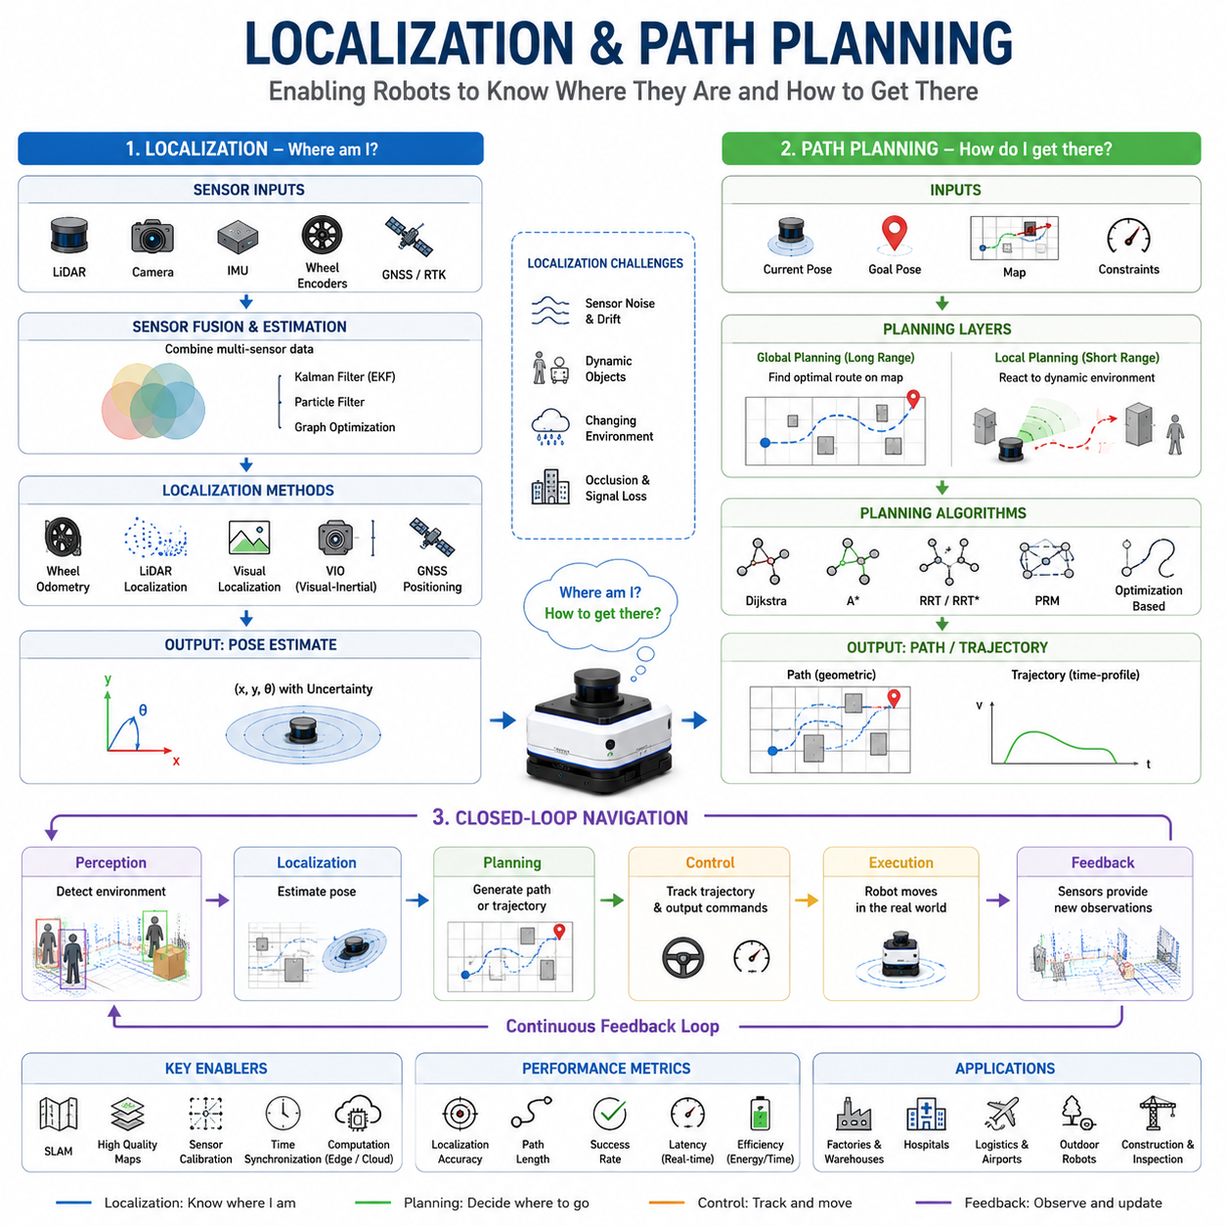
Localization and path planning are two of the most fundamental capabilities in autonomous robot navigation. Together, they enable a robot to understand where it is, determine where it needs to go, and decide how to reach its destination safely and efficiently. While perception provides awareness of the surrounding environment and motion control executes movement commands, localization and path planning form the central decision-making layer that transforms sensor data into purposeful autonomous motion. Without accurate localization, a robot cannot determine its position relative to the world. Without effective path planning, a robot cannot determine how to reach a desired destination. The integration of these two functions lies at the heart of every successful Autonomous Mobile Robot (AMR) deployment.
Localization is the process of estimating a robot’s position and orientation within an environment. In robotics, position alone is not sufficient. A robot must know both its location and its heading direction, collectively referred to as its pose. Pose estimation allows the robot to understand its relationship to surrounding objects, maps, landmarks, and destinations. Every navigation decision depends on the accuracy of this pose estimate. If localization becomes inaccurate, even the most advanced planning algorithms may generate incorrect routes or unsafe behaviors.
The localization problem can be described as answering a simple question: “Where am I?” However, solving this question computationally is one of the most challenging problems in robotics. Real-world environments contain uncertainty, sensor noise, changing conditions, and dynamic objects. A robot must continuously combine information from multiple sensors while compensating for errors and disturbances. Localization therefore becomes a probabilistic estimation problem rather than a deterministic calculation.
One of the earliest localization methods is dead reckoning. Dead reckoning estimates current position by integrating previous movements over time. Wheel encoders measure wheel rotations, and the robot calculates displacement and orientation changes based on kinematic models. While dead reckoning is computationally efficient and easy to implement, it accumulates errors over time. Small measurement inaccuracies gradually grow into significant position drift, making dead reckoning unsuitable as a standalone localization method for long-duration missions.
To reduce drift, modern robots incorporate inertial measurement units (IMUs). IMUs provide acceleration and angular velocity measurements that help estimate changes in motion. Although IMUs improve short-term localization performance, they also suffer from bias accumulation and sensor drift. Consequently, wheel odometry and inertial measurements are often fused together to achieve more robust motion estimation.
Localization accuracy improves significantly when robots utilize environmental observations. LiDAR-based localization compares observed laser scans against previously constructed maps. By matching environmental features, the robot can determine its pose relative to known structures. This approach is widely used in industrial AMRs because it provides high accuracy and robustness under varying lighting conditions. In warehouse environments, factories, hospitals, and logistics centers, LiDAR localization often serves as the primary positioning technology.
Vision-based localization uses cameras to recognize visual landmarks, textures, and environmental features. Cameras offer rich environmental information and enable semantic understanding in addition to geometric positioning. Visual localization can operate using monocular cameras, stereo cameras, RGB-D sensors, or advanced visual-inertial systems. Modern Visual SLAM systems combine visual observations with inertial measurements to provide accurate localization even in complex environments.
Outdoor robots frequently utilize Global Navigation Satellite Systems (GNSS) for localization. GNSS receivers estimate global position using satellite signals. Standard GNSS typically provides meter-level accuracy, while Real-Time Kinematic (RTK) systems improve positioning precision to the centimeter level. However, GNSS signals can be degraded by buildings, tunnels, dense vegetation, atmospheric effects, and multipath reflections. Consequently, outdoor robots often combine GNSS with LiDAR, cameras, IMUs, and wheel odometry through sensor fusion techniques.
Sensor fusion is one of the most important concepts in modern localization systems. No individual sensor can provide perfect information under all conditions. Wheel encoders suffer from slippage. IMUs accumulate drift. Cameras are affected by lighting conditions. LiDAR performance can degrade in adverse weather. GNSS signals may become unavailable in urban environments. Sensor fusion algorithms combine multiple information sources to achieve greater robustness and reliability than any single sensor could provide.
Probabilistic estimation methods play a central role in localization. The Kalman Filter and its variants provide efficient solutions for estimating system states under uncertainty. Extended Kalman Filters accommodate nonlinear motion models commonly encountered in robotics. Particle Filters represent localization uncertainty using multiple pose hypotheses and are particularly effective in global localization scenarios where the robot’s initial position may be unknown. These probabilistic approaches allow robots to maintain accurate position estimates despite noisy measurements and incomplete information.
Localization becomes even more complex in dynamic environments. Industrial facilities, hospitals, airports, and public spaces contain moving people, vehicles, carts, and temporary obstacles. Environmental features may appear, disappear, or change over time. Robust localization systems must distinguish between stable landmarks useful for positioning and transient objects that should be ignored. Advanced localization algorithms incorporate semantic understanding to identify reliable environmental features while filtering out dynamic elements.
Simultaneous Localization and Mapping, commonly known as SLAM, represents one of the most significant advances in autonomous navigation. SLAM enables robots to build maps while simultaneously localizing within those maps. Rather than relying on pre-existing environmental information, a robot can autonomously explore unknown areas and create its own representation of the world. SLAM has become a foundational technology for autonomous robotics, enabling deployment in environments where maps are unavailable or continuously changing.
While localization answers the question of where the robot is, path planning answers the question of where the robot should go and how it should get there. Path planning involves generating a sequence of movements that guide the robot from its current location to a desired destination while satisfying safety, efficiency, and operational constraints.
Path planning begins with defining a goal location. The navigation system must then analyze the environment and identify feasible routes that connect the current position to the destination. These routes must avoid obstacles, respect robot kinematics, minimize travel costs, and satisfy mission objectives. Depending on the application, path planning may prioritize shortest distance, minimum travel time, energy efficiency, safety margins, or operational productivity.
One of the most widely used path planning algorithms is Dijkstra’s algorithm. Dijkstra systematically explores all possible paths and guarantees the discovery of the shortest route. While highly reliable, Dijkstra can become computationally expensive in large environments. To improve efficiency, many navigation systems utilize the A* algorithm, which introduces heuristic guidance to focus the search toward the destination. A* maintains optimality under appropriate heuristic conditions while significantly reducing computational requirements.
Grid-based planning represents the environment as a collection of discrete cells. Each cell contains information about occupancy, traversal cost, and obstacle status. Grid-based methods are intuitive and compatible with occupancy maps generated by SLAM systems. However, large environments can produce massive grids that require substantial computational resources.
Graph-based planning represents navigable environments as interconnected nodes and edges. Graph representations are highly efficient for large-scale navigation because they abstract environmental structure into compact mathematical forms. Road networks, corridors, warehouse aisles, and transportation infrastructures are often represented using graph models.
Sampling-based planning methods such as Rapidly Exploring Random Trees (RRT) and Probabilistic Roadmaps (PRM) address challenges associated with high-dimensional configuration spaces. These methods are particularly useful for robots with complex kinematic constraints or articulated structures. Instead of exhaustively exploring every possible state, sampling-based planners generate representative samples that efficiently approximate feasible paths.
Path planning can be divided into global planning and local planning. Global planning operates over the entire map and generates a route from the current location to the destination. This route typically considers static environmental structures and long-range objectives. Global planning emphasizes optimality and strategic route selection.
Local planning operates in real time using current sensor observations. It focuses on immediate surroundings and adapts robot behavior to dynamic conditions. Local planners respond to moving obstacles, temporary hazards, traffic congestion, and unexpected environmental changes. They continuously modify trajectories while preserving overall mission objectives.
The relationship between localization and path planning is deeply interconnected. Path planning depends on accurate localization to determine the robot’s starting position. Localization depends on successful navigation to maintain consistent environmental observations. Errors in localization directly influence planning performance. If the robot believes it is located several meters away from its actual position, planned routes may intersect obstacles or miss important navigation targets.
Navigation systems therefore continuously exchange information between localization and planning modules. Localization updates refine position estimates. Planning algorithms generate routes based on these estimates. Motion controllers execute planned trajectories. Sensor observations provide feedback that updates localization. This closed-loop architecture enables autonomous operation under uncertain real-world conditions.
Trajectory generation extends traditional path planning by incorporating time-dependent motion constraints. A path specifies geometric movement through space, whereas a trajectory specifies both spatial and temporal characteristics. Trajectory planners consider velocity limits, acceleration constraints, steering capabilities, passenger comfort, energy efficiency, and safety requirements. Modern autonomous systems increasingly rely on trajectory optimization rather than purely geometric path planning.
Safety considerations strongly influence path planning decisions. Industrial robots operating near humans must maintain safe distances, reduce speed in crowded areas, and comply with functional safety regulations. Human-aware navigation introduces additional constraints that account for social behavior, personal space, visibility, and interaction preferences. Safe navigation often requires selecting routes that are not necessarily the shortest but provide greater operational reliability and human acceptance.
Multi-robot environments introduce further planning complexity. Fleet management systems coordinate multiple robots that share maps, corridors, intersections, elevators, and charging stations. Path planning must consider traffic flow, task priorities, congestion management, and collision avoidance among robots. Centralized fleet managers and distributed coordination algorithms work together to optimize system-wide performance.
Modern AI technologies are increasingly influencing localization and path planning. Deep learning models enhance feature extraction, semantic understanding, place recognition, and environmental interpretation. Foundation models and embodied AI systems are beginning to integrate perception, reasoning, localization, and planning into unified architectures. Future navigation systems may rely less on handcrafted rules and more on learned representations of the world.
Simulation platforms such as Isaac Sim, Gazebo, and digital twin environments have become essential tools for developing localization and path planning systems. Engineers use simulation to validate algorithms, analyze failures, optimize parameters, and evaluate performance under diverse scenarios before field deployment. Simulation reduces development cost while improving safety and reliability.
As autonomous robots expand into factories, hospitals, warehouses, airports, farms, construction sites, smart cities, and infrastructure inspection applications, the importance of localization and path planning continues to grow. These technologies form the core intelligence that allows robots to transform perception into purposeful action. Accurate localization provides situational awareness, while effective path planning transforms that awareness into safe and efficient movement. Together, they establish the foundation upon which all higher-level navigation capabilities are built, enabling autonomous systems to operate reliably in increasingly complex and dynamic environments.

01.3 Global vs Local Navigation
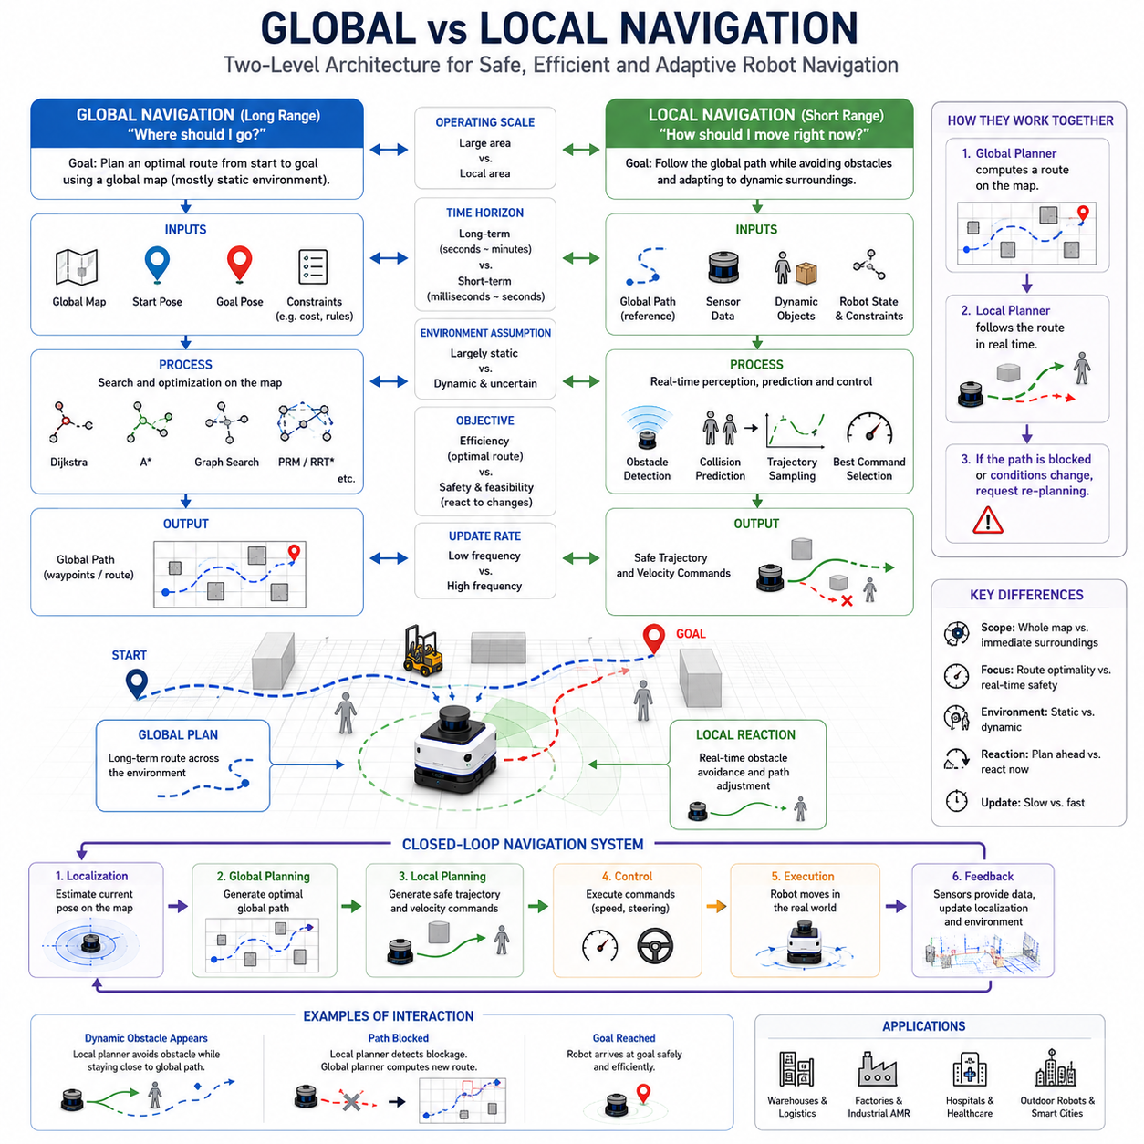
Global navigation and local navigation are two fundamental components of autonomous robot navigation systems. Together they enable robots to move intelligently through complex environments while maintaining safety, efficiency, and adaptability. Although both functions contribute to the same objective of guiding a robot from its current position to a desired destination, they operate at different spatial scales, time horizons, and decision-making levels. Understanding the distinction between global and local navigation is essential for designing robust Autonomous Mobile Robot (AMR) systems capable of operating in real-world industrial, commercial, and outdoor environments.
At the highest level, global navigation is concerned with long-range route planning across an entire environment, while local navigation focuses on real-time movement within the robot’s immediate surroundings. Global navigation answers the question, “What is the best route to reach the destination?” Local navigation answers the question, “How should I move right now to safely follow that route?” The two systems work together continuously, creating a hierarchical navigation architecture that combines strategic planning with tactical execution.
A useful analogy can be found in human driving. Before beginning a journey, a driver typically determines an overall route using a map or navigation application. This route may include highways, intersections, and major roads leading to the destination. This process resembles global navigation. However, while driving, the driver must also respond to nearby vehicles, pedestrians, road construction, traffic signals, and unexpected hazards. These real-time reactions resemble local navigation. Both levels are necessary for successful travel.
Global navigation operates using a map-based representation of the environment. The navigation system uses a known map to calculate a path between the robot’s current location and the destination. This map may be a two-dimensional occupancy grid, a topological map, a graph-based representation, a semantic map, or a high-definition map depending on the application. The objective of global planning is to generate an efficient route that avoids known obstacles while minimizing travel cost according to predefined optimization criteria.
Global navigation generally assumes that the environment is largely static. Walls, buildings, permanent structures, road boundaries, corridors, and work zones are considered stable elements of the environment. Because these features change infrequently, they can be incorporated into a global map and used for long-term route planning. The resulting path often represents the shortest route, the fastest route, the safest route, or a combination of these objectives.
Several classical algorithms are commonly used for global navigation. Dijkstra’s algorithm systematically explores all possible routes and guarantees the shortest path. A* improves computational efficiency through heuristic guidance toward the destination. Graph-based search algorithms represent navigable areas as nodes and edges, enabling efficient route calculation in large environments. More advanced approaches may incorporate probabilistic planning, optimization techniques, or AI-driven route generation.
The output of global navigation is usually a geometric path composed of waypoints, poses, or route segments. This path represents the desired route through the environment but does not directly account for every real-time obstacle the robot may encounter during execution. Consequently, global planning provides strategic guidance rather than direct motion commands.
Local navigation operates at a completely different level. Instead of considering the entire environment, local navigation focuses on the robot’s immediate surroundings. It continuously processes sensor data from LiDARs, cameras, radars, depth sensors, ultrasonic sensors, and other perception systems. The objective is to generate safe motion commands that allow the robot to follow the global path while adapting to current environmental conditions.
Unlike global navigation, local navigation assumes that the environment is dynamic and uncertain. People may suddenly walk into the robot’s path. Vehicles may cross intersections. Equipment may be temporarily placed in corridors. Environmental conditions may change unexpectedly. Local navigation must therefore react quickly to maintain safe operation.
A local planner receives the global path as a reference and attempts to follow it while avoiding obstacles and satisfying motion constraints. The planner continuously evaluates possible trajectories, predicts future collisions, and selects the safest and most efficient movement strategy. Because these calculations occur in real time, local planning algorithms must be computationally efficient and highly responsive.
One of the most widely used local planning approaches is the Dynamic Window Approach (DWA). DWA evaluates candidate velocity commands based on safety, obstacle avoidance, path alignment, and goal progress. Another popular method is the Timed Elastic Band (TEB) planner, which optimizes trajectories while considering timing constraints, obstacle locations, and robot kinematics. More advanced systems may employ Model Predictive Control (MPC), reinforcement learning, or AI-based decision-making algorithms.
The distinction between global and local navigation becomes particularly important in environments containing dynamic obstacles. Consider a warehouse robot delivering materials across a factory floor. The global planner may generate an optimal route through a corridor based on the facility map. However, if a worker temporarily blocks the corridor, the local planner must slow down, stop, or navigate around the worker while still attempting to follow the overall route. Once the obstacle disappears, the robot can return to the globally planned path.
Another important difference lies in the frequency of operation. Global navigation typically operates at lower frequencies because environmental structure changes slowly. Route calculations may occur once every few seconds or only when significant changes occur. Local navigation operates at much higher frequencies, often updating multiple times per second. Rapid updates are necessary for responding to moving obstacles and changing environmental conditions.
Global navigation and local navigation also differ in their optimization objectives. Global planning focuses primarily on route efficiency. It attempts to minimize distance, travel time, energy consumption, operational cost, or other mission-level objectives. Local planning focuses primarily on safety and feasibility. Even if a locally generated trajectory is slightly longer or less efficient, it may be preferred if it improves safety and reduces collision risk.
The interaction between global and local navigation forms a hierarchical control architecture. The global planner provides strategic guidance by identifying a desired route. The local planner translates that route into executable motion commands while adapting to real-world conditions. Feedback from sensors continuously updates both layers. If local planners repeatedly encounter obstacles that prevent progress, the global planner may be instructed to generate a new route.
This process is commonly known as replanning. Replanning occurs when environmental conditions invalidate the current route. In a warehouse, an aisle may become blocked by equipment. In an outdoor environment, a road may become inaccessible due to construction. In a hospital, a corridor may become unavailable because of emergency activities. When such situations occur, the navigation system must calculate alternative routes that satisfy operational requirements.
Localization plays a critical role in both global and local navigation. Global planners require accurate position estimates to determine the robot’s location on the map. Local planners require precise pose information to evaluate nearby obstacles and generate safe trajectories. Localization errors can negatively affect both planning layers. If the robot’s estimated position deviates significantly from reality, the global planner may select incorrect routes and the local planner may generate unsafe motions.
Map quality is another important factor influencing navigation performance. Global navigation depends heavily on accurate environmental maps. Errors in map generation can lead to incorrect route planning and operational failures. Local navigation is less dependent on perfect maps because it relies heavily on real-time sensor observations. Nevertheless, local planners still benefit from accurate environmental information and contextual awareness.
Indoor and outdoor navigation systems often emphasize different aspects of global and local navigation. Indoor robots typically operate in highly structured environments where global maps are accurate and stable. As a result, global planning often plays a dominant role. Outdoor robots operate in larger and more dynamic environments where local adaptation becomes increasingly important. Weather conditions, terrain variations, pedestrians, vehicles, and changing infrastructure require sophisticated local navigation capabilities.
The rise of semantic navigation is introducing additional layers of intelligence into both global and local planning. Traditional navigation systems primarily consider geometric information such as walls, obstacles, and free space. Semantic navigation incorporates contextual understanding. A robot may recognize doors, elevators, workstations, charging stations, emergency exits, pedestrian zones, or restricted areas. This semantic knowledge enables more intelligent route selection and behavioral adaptation.
Human-aware navigation further extends local navigation capabilities. In environments shared with people, robots must consider social behavior in addition to physical obstacle avoidance. Humans expect robots to maintain comfortable distances, avoid abrupt movements, yield when appropriate, and behave predictably. Human-aware local planners incorporate social constraints that improve safety and acceptance in public and industrial environments.
Multi-robot systems introduce additional challenges for both global and local navigation. Fleet-level navigation systems coordinate routes among multiple robots to avoid congestion, collisions, and deadlocks. Global planners may reserve pathways or allocate traffic priorities across an entire facility. Local planners continue to manage immediate interactions between robots and dynamic obstacles. Effective coordination requires communication between navigation layers operating at both fleet and individual robot levels.
Modern artificial intelligence technologies are increasingly influencing navigation architectures. Machine learning models improve perception accuracy, obstacle classification, trajectory prediction, and semantic understanding. Reinforcement learning approaches enable robots to learn navigation behaviors through experience. Foundation models and embodied AI systems are beginning to integrate perception, localization, planning, and decision-making into unified architectures capable of more adaptive and intelligent behavior.
Simulation environments such as Isaac Sim, Gazebo, Webots, and digital twins provide valuable platforms for studying the interaction between global and local navigation. Engineers can evaluate route planning performance, obstacle avoidance behavior, replanning strategies, and system robustness under diverse operating conditions. Simulation enables extensive testing before deployment in real-world environments, reducing risk and improving reliability.
As autonomous robots become increasingly common in factories, warehouses, hospitals, airports, smart cities, farms, construction sites, and infrastructure inspection applications, the integration of global and local navigation becomes even more important. Large-scale deployments require navigation systems capable of balancing long-term efficiency with short-term adaptability. Robots must follow strategic routes while continuously responding to changing environmental conditions.
Ultimately, global navigation and local navigation should not be viewed as competing approaches but as complementary components of a unified navigation framework. Global navigation provides long-range intelligence and mission-level optimization. Local navigation provides real-time responsiveness and operational safety. Together they form the foundation of modern autonomous mobility systems, enabling robots to navigate complex environments with reliability, efficiency, and adaptability. The successful integration of these two navigation layers represents one of the most important achievements in autonomous robotics and serves as the cornerstone of advanced AMR navigation architectures.

01.4 Map-Based Navigation
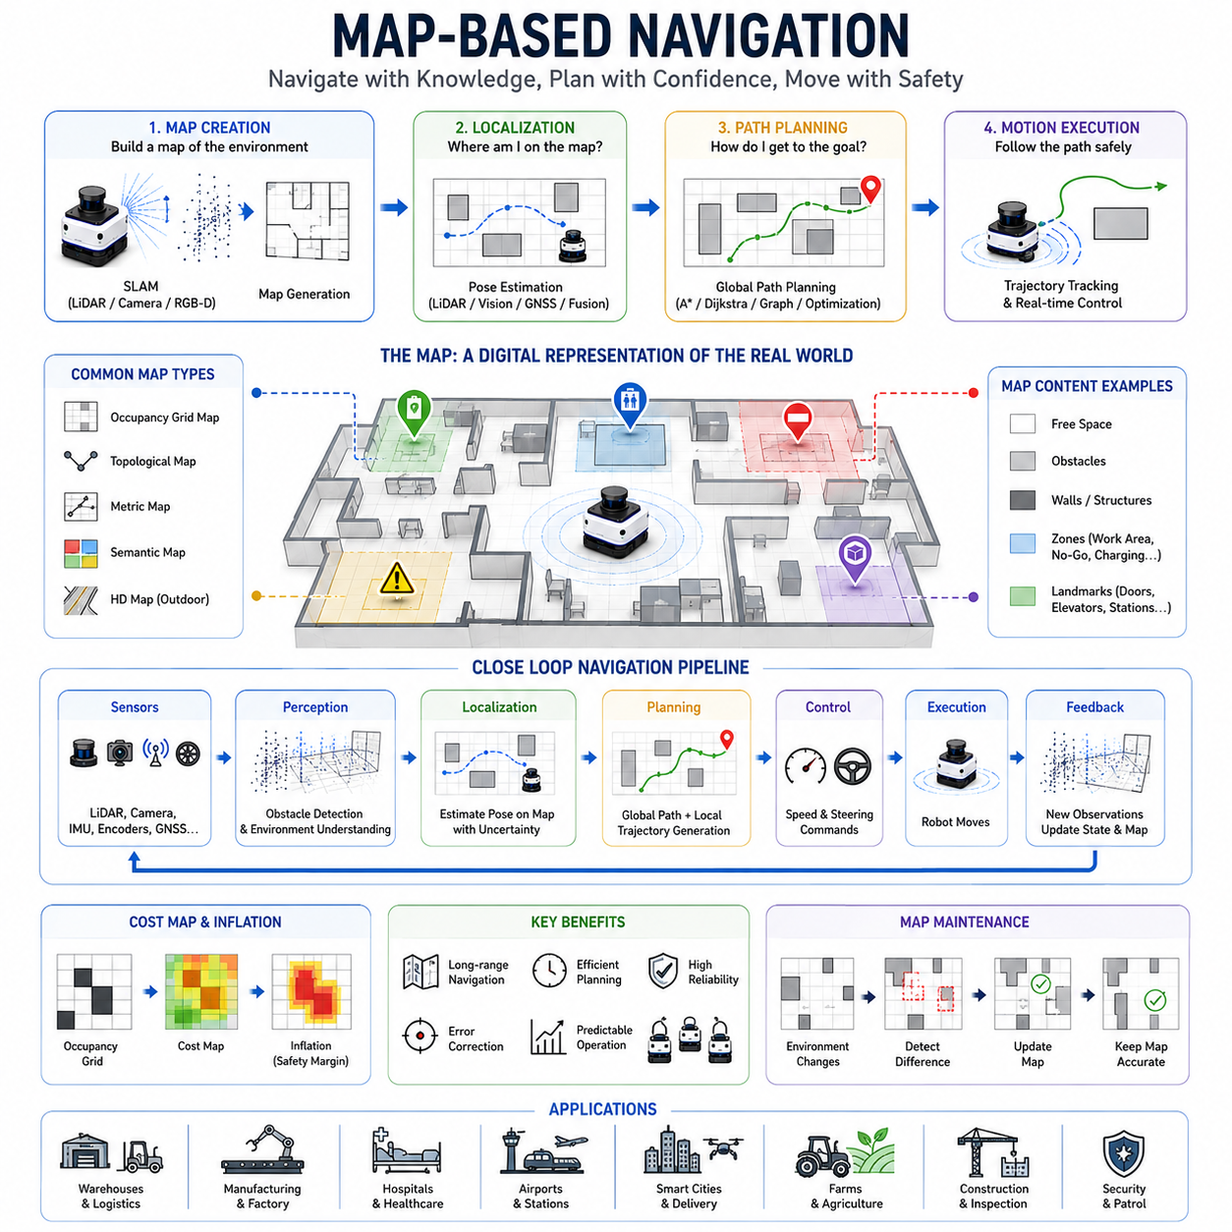
Map-based navigation is one of the most important and widely adopted navigation paradigms in autonomous robotics. It enables a robot to move intelligently within an environment by utilizing a previously constructed spatial representation of the world. Rather than relying solely on immediate sensor observations or reactive obstacle avoidance, a map-based navigation system leverages knowledge of the surrounding environment to determine its location, plan routes, predict future movement possibilities, and execute navigation tasks with a higher degree of efficiency and reliability. In modern Autonomous Mobile Robots (AMRs), map-based navigation serves as the foundation upon which localization, path planning, obstacle avoidance, traffic management, and mission execution are built.
The fundamental concept of map-based navigation is relatively simple. A robot first acquires or generates a map of its environment. This map acts as a digital representation of the physical world. During operation, the robot continuously estimates its position within the map and uses this information to determine how to move toward a destination. The map provides context that extends beyond the robot’s immediate field of view, allowing navigation decisions to be made using both local observations and global environmental knowledge.
Humans naturally use map-based navigation in everyday life. When traveling to an unfamiliar location, a person often consults a map application, identifies their current position, determines the destination, and follows a route suggested by the navigation system. The person does not rely solely on visible surroundings but instead uses an abstract representation of the environment to guide movement. Autonomous robots perform a similar process, although the representation is mathematical rather than cognitive.
Map-based navigation is fundamentally composed of four major elements. The first element is the map itself. The second element is localization, which determines the robot’s position within the map. The third element is path planning, which calculates a route from the current position to the destination. The fourth element is motion execution, which enables the robot to physically follow the planned route while responding to environmental conditions.
The quality of the map directly influences navigation performance. A high-quality map provides accurate spatial information, clearly identifies navigable areas, and contains sufficient detail for reliable localization and planning. Poor map quality can lead to localization failures, incorrect route generation, navigation inefficiencies, and safety risks. Consequently, map creation is often considered one of the most critical stages in the development of autonomous navigation systems.
Several types of maps are commonly used in robotics. The most widely used representation is the occupancy grid map. An occupancy grid divides the environment into small cells and assigns each cell a probability indicating whether it is occupied by an obstacle or free for traversal. Occupancy grids are intuitive, computationally efficient, and highly compatible with LiDAR-based mapping and navigation systems. Many indoor AMRs rely heavily on occupancy grid maps because they provide a straightforward representation of walls, corridors, equipment, and obstacles.
Another important map representation is the topological map. Rather than storing detailed geometric information, a topological map represents the environment as a network of connected locations. Nodes represent meaningful places such as rooms, intersections, workstations, or charging stations, while edges represent navigable connections between them. Topological maps are efficient for large-scale navigation because they reduce computational complexity and focus on connectivity rather than precise geometry.
Metric maps provide precise geometric measurements of the environment. These maps preserve accurate spatial relationships and support detailed path planning and localization. Most SLAM-generated maps belong to this category. Metric maps are particularly useful in environments where precise positioning is required, such as docking stations, automated warehouses, manufacturing facilities, and hospital corridors.
As navigation systems become more advanced, semantic maps are increasingly being adopted. Semantic maps extend traditional geometric representations by incorporating contextual information about objects and locations. Instead of representing only walls and obstacles, a semantic map may identify elevators, doors, charging stations, work areas, emergency exits, pedestrian zones, storage racks, and restricted areas. This additional knowledge allows robots to make more intelligent navigation decisions.
High-definition maps represent another important category, particularly in outdoor autonomous systems. HD maps contain highly detailed information about roads, lanes, signs, landmarks, traffic infrastructure, terrain characteristics, and environmental features. Autonomous vehicles and outdoor mobile robots frequently use HD maps to achieve centimeter-level navigation accuracy in large-scale environments.
Once a map exists, localization becomes the next critical component of map-based navigation. Localization determines where the robot is located within the map. This process typically involves comparing current sensor observations with stored map information. For example, a LiDAR scanner may observe surrounding walls and compare them to a previously generated occupancy map. By finding the best match, the robot can estimate its position and orientation.
Map-based localization provides significant advantages over pure odometry. Wheel encoders and IMUs accumulate errors over time due to sensor noise, wheel slippage, and environmental disturbances. By continuously referencing a map, the robot can correct these accumulated errors and maintain accurate position estimates during extended missions.
Localization techniques used in map-based navigation vary depending on the sensing technology. LiDAR localization uses scan matching techniques to align current sensor observations with stored maps. Visual localization relies on image features, landmarks, and scene recognition. GNSS-based localization references global coordinate systems and is commonly used in outdoor environments. Sensor fusion approaches combine multiple localization methods to achieve greater robustness and accuracy.
Path planning is another essential function enabled by map-based navigation. Once the robot knows its position within the map, it can calculate a route toward a destination. Because the map provides knowledge of obstacles, corridors, pathways, and environmental structure, planning algorithms can identify efficient routes before movement begins. This capability distinguishes map-based navigation from purely reactive navigation approaches.
Global path planning typically operates on the map level. Algorithms such as Dijkstra, A*, graph search, and optimization-based planners calculate routes that minimize travel distance, travel time, energy consumption, or operational cost. The resulting path often consists of waypoints or trajectory segments that guide the robot toward its objective.
Map-based planning offers several important advantages. First, it allows long-range navigation across environments that extend far beyond the robot’s immediate sensor range. Second, it enables optimization because the planner can evaluate multiple possible routes before selecting the most suitable one. Third, it improves mission predictability because routes are generated using known environmental information rather than purely reactive behaviors.
The concept of cost maps plays a central role in map-based navigation. A cost map extends the basic occupancy map by assigning traversal costs to different areas. Obstacles typically receive extremely high costs, while free space receives low costs. Additional costs may be assigned to narrow passages, high-risk areas, crowded zones, slopes, rough terrain, or safety-sensitive locations. Path planners use cost maps to generate routes that balance efficiency and safety.
Inflation layers are frequently applied to cost maps to account for robot dimensions and safety margins. Since robots occupy physical space, planning directly adjacent to obstacles may create collision risks. Inflation layers expand obstacle boundaries to create buffer zones, ensuring that generated paths maintain safe clearance from surrounding objects.
Despite the advantages of map-based navigation, maps are rarely perfect representations of reality. Real environments change over time. Furniture may be moved, pallets may be relocated, doors may be opened or closed, construction may occur, and temporary obstacles may appear unexpectedly. Consequently, modern navigation systems combine map-based planning with real-time perception and obstacle avoidance.
This integration creates a hierarchical navigation architecture. The map provides global environmental knowledge and strategic planning capabilities. Sensors provide real-time situational awareness. Local planners bridge these two layers by adapting planned routes to current conditions. The result is a navigation system capable of both long-term planning and short-term responsiveness.
Dynamic environments present unique challenges for map-based navigation. Hospitals, airports, logistics centers, factories, and public spaces contain constantly changing obstacles and moving people. Static maps alone cannot represent these dynamic elements. Therefore, navigation systems must continuously update local environmental representations while maintaining consistency with the global map.
Map maintenance becomes increasingly important as deployment duration increases. Long-term autonomous operation requires maps to remain accurate despite environmental changes. Some systems periodically rebuild maps, while others perform continuous map updates using online SLAM techniques. Advanced systems may maintain multiple map versions or adapt maps dynamically based on operational observations.
Outdoor map-based navigation introduces additional complexity. Unlike indoor environments, outdoor spaces may span large geographic regions and contain variable terrain, changing weather conditions, vegetation growth, seasonal changes, and dynamic infrastructure. Outdoor robots often combine GNSS positioning, LiDAR mapping, visual localization, and HD maps to achieve reliable navigation performance.
Multi-floor navigation systems frequently utilize map-based approaches as well. Buildings with elevators, stairways, and multiple levels require specialized map structures capable of representing vertical transitions. Navigation systems must understand not only horizontal movement but also how to transition between floors while maintaining localization continuity.
Fleet-level navigation also relies heavily on maps. In large facilities containing dozens or hundreds of robots, maps provide a common spatial framework shared by all vehicles. Fleet management systems use maps to coordinate routes, manage traffic flow, prevent congestion, allocate tasks, and optimize overall operational efficiency. Shared maps enable robots to operate cooperatively within a unified navigation ecosystem.
Artificial intelligence is increasingly enhancing map-based navigation. Machine learning models improve map generation, semantic labeling, environmental understanding, and localization robustness. Deep learning techniques assist in place recognition, landmark detection, obstacle classification, and map maintenance. Emerging embodied AI systems may eventually learn navigation strategies directly from semantic world models rather than relying solely on manually designed navigation pipelines.
Digital twins and simulation platforms have become valuable tools for map-based navigation development. Environments created in Isaac Sim, Gazebo, and other simulation systems allow engineers to generate maps, validate localization algorithms, test planning strategies, and evaluate navigation performance before field deployment. These virtual environments significantly reduce development costs and accelerate system validation.
The future of map-based navigation is likely to involve increasingly rich environmental representations. Traditional occupancy maps will gradually evolve into semantic world models that combine geometry, context, behavior prediction, and environmental understanding. Robots will not only know where obstacles are located but also understand what those obstacles represent, how they behave, and how navigation strategies should adapt accordingly.
As autonomous robots expand into warehouses, factories, hospitals, logistics hubs, airports, farms, construction sites, smart cities, and infrastructure inspection applications, map-based navigation will continue to serve as a foundational technology. It provides the environmental awareness, spatial understanding, and planning capability necessary for reliable autonomous operation. By combining accurate maps, robust localization, intelligent path planning, and real-time adaptation, map-based navigation enables robots to move purposefully, safely, and efficiently through complex real-world environments. Ultimately, it represents one of the most important pillars of modern autonomous mobility and remains central to the development of future intelligent robotic systems.

01.5 Reactive Navigation
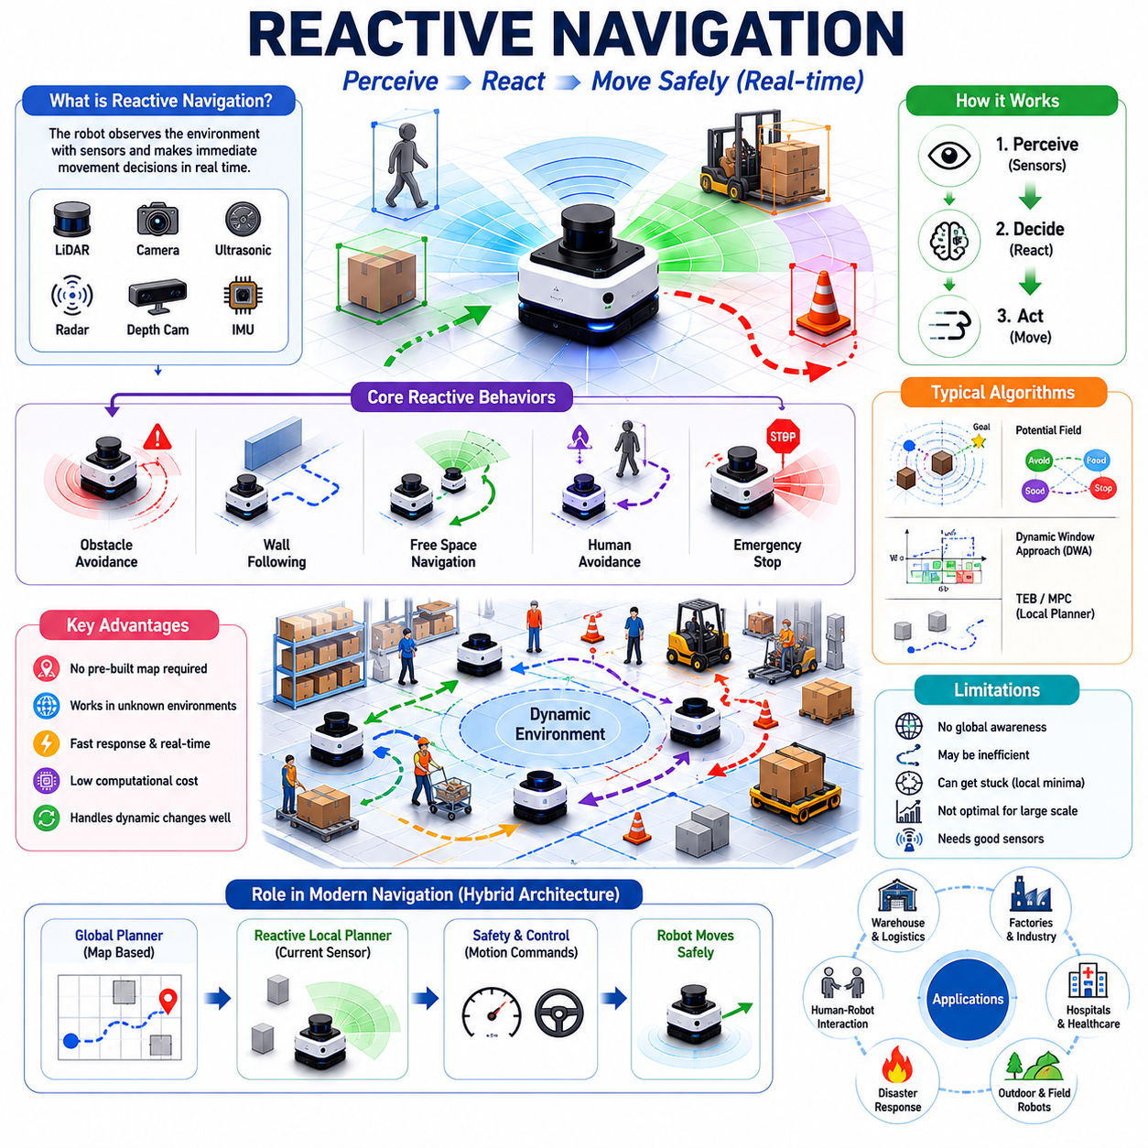
Reactive navigation is one of the most fundamental navigation paradigms in autonomous robotics. Unlike map-based navigation, which relies on prior knowledge of the environment, reactive navigation enables a robot to make movement decisions directly from current sensor observations. The robot continuously perceives its surroundings, evaluates nearby obstacles and free space, and generates immediate motion commands without necessarily relying on a global map or long-term path plan. Reactive navigation is therefore often described as a perception-driven navigation approach in which behavior emerges from real-time interactions between the robot and its environment. It represents one of the earliest forms of autonomous navigation and continues to play a critical role in modern robotic systems.
The central principle of reactive navigation is simple: observe the environment, respond to what is currently visible, and continuously adapt movement as conditions change. Rather than asking, “What is the optimal route through the entire facility?” a reactive navigation system asks, “What is the safest and most appropriate action right now?” This distinction makes reactive navigation highly responsive and computationally efficient, particularly in environments where conditions change rapidly.
Human behavior provides a useful analogy. Imagine walking through a crowded airport terminal. Although you may have a destination in mind, much of your movement is determined by immediate observations. You avoid people walking toward you, move around luggage left on the floor, slow down when the crowd becomes dense, and change direction when obstacles appear unexpectedly. These moment-to-moment decisions are examples of reactive navigation. Humans constantly combine perception and action without calculating a complete path through the entire environment.
In robotics, reactive navigation emerged before the widespread adoption of advanced mapping and localization systems. Early autonomous robots possessed limited computational resources and lacked the capability to construct detailed maps. Instead, they relied on simple sensor inputs and rule-based responses. Despite their simplicity, these systems demonstrated that meaningful autonomous behavior could emerge from direct sensor-action relationships.
One of the major advantages of reactive navigation is that it does not require a preexisting map. A robot can operate in unknown environments without performing extensive mapping procedures. This capability is particularly valuable in exploration missions, disaster response scenarios, military operations, planetary exploration, agricultural applications, and other situations where environmental information may be unavailable or continuously changing.
Reactive navigation relies heavily on perception systems. Sensors continuously observe the environment and provide information about nearby obstacles, free space, surface conditions, and dynamic objects. Common sensors include LiDAR, ultrasonic sensors, depth cameras, stereo cameras, radar systems, RGB cameras, infrared sensors, and proximity sensors. The quality of sensor information directly influences navigation performance because decisions are based almost entirely on current observations.
Obstacle avoidance is the most recognizable application of reactive navigation. When an obstacle appears in the robot’s path, the navigation system immediately generates corrective actions. The robot may slow down, stop, steer away, or select an alternative local trajectory. Unlike map-based planning systems that calculate routes over large areas, reactive obstacle avoidance focuses on short-term safety and immediate collision prevention.
One of the earliest reactive navigation methods is the potential field approach. In this method, the goal generates an attractive force that pulls the robot toward the destination, while obstacles generate repulsive forces that push the robot away. The resulting motion is determined by the combined effect of these virtual forces. Potential field methods are conceptually elegant and computationally efficient, making them attractive for real-time navigation applications.
Despite their simplicity, potential field methods suffer from several limitations. Local minima represent one of the most significant challenges. A robot may become trapped in locations where attractive and repulsive forces balance each other, preventing further progress toward the goal. Engineers have developed numerous variations and enhancements to address these issues, but local minima remain a fundamental challenge in force-based navigation methods.
Behavior-based navigation represents another important category of reactive navigation. Rather than computing explicit paths, behavior-based systems organize robot actions into independent behavioral modules. Typical behaviors may include obstacle avoidance, wall following, target seeking, corridor traversal, human avoidance, and emergency stopping. Each behavior generates motion recommendations, and a coordination mechanism determines the final action.
Behavior-based navigation gained significant attention through the subsumption architecture developed in mobile robotics research. In this framework, higher-level behaviors can be overridden by lower-level safety behaviors. For example, a robot may be moving toward a goal, but obstacle avoidance immediately takes control if a collision risk is detected. This layered structure provides robustness and responsiveness while maintaining relatively simple system design.
Wall-following behavior is one of the most common reactive navigation strategies. When operating in unknown environments, robots may follow walls until a path toward the destination becomes available. Wall following has proven particularly effective in indoor environments such as corridors, tunnels, and structured industrial spaces. It also serves as a useful recovery behavior when more sophisticated navigation methods encounter difficulties.
Reactive navigation systems often use free-space detection as a primary decision-making mechanism. Sensors identify traversable regions in front of the robot, and motion commands are generated to steer toward open areas. This approach allows robots to move safely even without explicit knowledge of environmental structure. Modern depth cameras and LiDAR systems significantly enhance free-space detection capabilities by providing dense geometric information about the surrounding environment.
Dynamic environments represent one of the strongest use cases for reactive navigation. Warehouses, hospitals, airports, factories, and public spaces contain continuously changing obstacles. People move unpredictably, vehicles enter and exit work zones, equipment is relocated, and temporary barriers appear unexpectedly. Reactive navigation excels in these situations because it prioritizes current observations rather than relying solely on precomputed plans.
Human-aware navigation extends reactive navigation concepts to environments shared with people. Humans behave differently from static obstacles. They move unpredictably, change direction suddenly, and respond to social interactions. Human-aware reactive navigation systems continuously monitor human motion and adjust robot behavior accordingly. The robot may reduce speed, increase safety distance, yield right of way, or modify its trajectory to maintain socially acceptable behavior.
Sensor latency and computational latency significantly influence reactive navigation performance. Because decisions are made in real time, delays between sensing and action can reduce safety and effectiveness. High-speed robots require low-latency perception pipelines, fast obstacle detection algorithms, and efficient control loops. System designers must carefully balance computational complexity against response time requirements.
Reactive navigation typically operates within a local reference frame. The robot focuses on nearby obstacles and immediate movement opportunities rather than considering the entire environment. This local perspective enables rapid decision-making but also introduces limitations. A robot may successfully avoid nearby obstacles yet fail to identify globally efficient routes. Consequently, purely reactive systems may exhibit inefficient or repetitive behaviors in complex environments.
The distinction between reactive navigation and deliberative navigation is particularly important. Deliberative navigation relies on reasoning, planning, mapping, and optimization. Reactive navigation relies on immediate perception and action. Deliberative systems emphasize long-term optimization, while reactive systems emphasize short-term responsiveness. Modern autonomous robots generally combine both approaches to achieve balanced performance.
Hybrid navigation architectures have become the dominant approach in contemporary robotics. In these systems, global planners generate long-term routes using maps and localization information. Reactive navigation modules operate simultaneously to handle dynamic obstacles and unexpected environmental changes. The combination provides both strategic intelligence and tactical adaptability.
Local planners used in modern robot navigation systems often incorporate reactive principles. Algorithms such as the Dynamic Window Approach (DWA), Timed Elastic Band (TEB), and various Model Predictive Control (MPC) frameworks continuously evaluate local environmental conditions while generating motion commands. Although these planners may utilize information from global paths, their real-time decision-making processes are fundamentally reactive.
Outdoor navigation presents unique challenges for reactive systems. Terrain conditions, weather effects, vegetation, animals, vehicles, and pedestrians create highly dynamic environments. Reactive navigation helps robots adapt to unexpected conditions that may not be represented in maps. Agricultural robots, outdoor inspection robots, autonomous delivery vehicles, and defense platforms often rely heavily on reactive behaviors to maintain operational safety.
Reactive navigation also plays an important role in safety systems. Emergency stopping mechanisms, collision avoidance systems, safety LiDAR controllers, and protective field monitoring systems are inherently reactive. These systems prioritize immediate hazard response over mission objectives. If a person enters a protected safety zone, the robot must react instantly regardless of its planned route or current task.
Multi-robot environments introduce additional reactive navigation requirements. Robots operating in shared spaces must continuously monitor nearby robots and adjust their behavior accordingly. Even when fleet-level coordination exists, local reactive responses remain necessary to prevent collisions caused by communication delays, localization errors, or unexpected movements.
Artificial intelligence is increasingly enhancing reactive navigation capabilities. Deep learning models improve obstacle recognition, free-space estimation, human motion prediction, and environmental understanding. Reinforcement learning enables robots to learn reactive behaviors through trial and error within simulation environments. Vision-language-action models may eventually allow robots to combine semantic reasoning with reactive control in highly complex environments.
Simulation platforms such as Isaac Sim, Gazebo, Webots, and digital twins provide valuable environments for developing and validating reactive navigation systems. Engineers can create dynamic obstacle scenarios, evaluate response times, analyze failure modes, and optimize control parameters before deployment in real-world environments. Simulation significantly improves safety and accelerates development cycles.
The limitations of reactive navigation become apparent when operating in large-scale environments requiring long-term planning. A robot relying solely on reactive behaviors may become trapped in dead ends, repeatedly circle obstacles, or fail to identify efficient routes. Because it lacks global environmental awareness, it cannot reason about distant opportunities or future consequences. This limitation explains why modern navigation systems rarely rely exclusively on reactive methods.
Nevertheless, reactive navigation remains indispensable in autonomous robotics. Even the most advanced map-based navigation systems depend on reactive behaviors for collision avoidance, safety monitoring, dynamic obstacle handling, and real-time adaptation. The ability to respond immediately to environmental changes is essential for reliable operation in real-world conditions.
As autonomous robots continue expanding into warehouses, factories, hospitals, logistics centers, farms, smart cities, construction sites, and infrastructure inspection applications, reactive navigation will remain a foundational capability. It provides the responsiveness, adaptability, and safety necessary for operation in unpredictable environments. When integrated with localization, mapping, path planning, behavior planning, and artificial intelligence, reactive navigation becomes a powerful component of a comprehensive autonomous navigation architecture. Rather than serving as a replacement for planning-based methods, reactive navigation functions as the real-time execution layer that allows robots to interact safely and intelligently with the constantly changing world around them.

01.6 Motion Control and Tracking
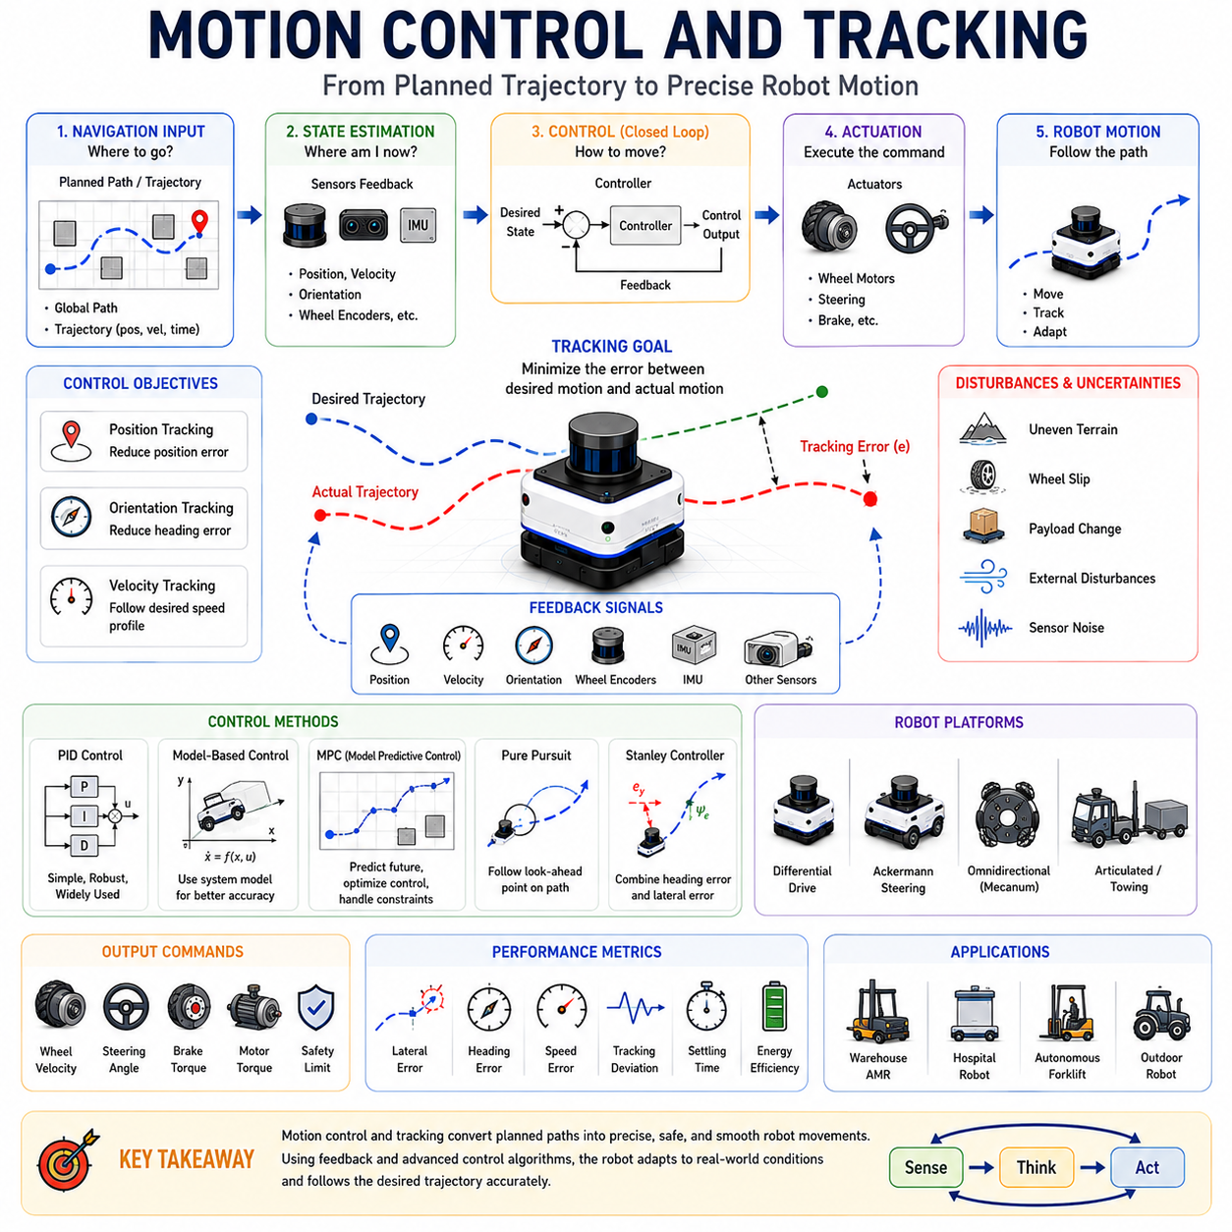
Motion control and tracking form the final execution layer of an autonomous navigation system. While localization determines where the robot is and path planning determines where the robot should go, motion control determines how the robot physically moves to follow the planned path. A navigation system may generate a perfectly optimized trajectory, but without an effective control system the robot cannot accurately execute the desired motion. Consequently, motion control and tracking serve as the bridge between high-level navigation decisions and low-level actuator commands. They transform planned trajectories into wheel velocities, steering commands, motor torques, braking actions, and other physical control outputs that drive the robot through the environment.
The purpose of motion control is to minimize the difference between the desired motion and the actual motion of the robot. This difference is commonly referred to as tracking error. Tracking errors may occur due to wheel slip, uneven terrain, sensor inaccuracies, actuator limitations, dynamic disturbances, payload variations, environmental interactions, and modeling uncertainties. The control system continuously measures these errors and generates corrective actions that keep the robot aligned with its intended path.
Motion tracking refers to the process of following a predefined trajectory or path as accurately as possible. A path typically specifies a sequence of spatial positions, while a trajectory specifies both position and timing information. The tracking system must therefore ensure that the robot reaches the correct locations while also maintaining appropriate velocity, acceleration, and orientation profiles. Successful tracking requires accurate feedback, robust control algorithms, and reliable actuator performance.
The importance of motion control becomes evident when considering real-world robotic systems. Industrial AMRs operate in narrow warehouse aisles, hospital delivery robots navigate crowded corridors, autonomous forklifts transport heavy loads, and outdoor autonomous vehicles travel across rough terrain. In all these applications, even small tracking errors can lead to collisions, docking failures, reduced efficiency, or safety risks. Motion control ensures that navigation plans are executed safely and reliably under varying operating conditions.
The motion control problem can be viewed as a closed-loop feedback system. The navigation planner provides a desired path or trajectory. Sensors measure the robot’s current state, including position, velocity, orientation, and other relevant variables. The controller compares the current state with the desired state and calculates corrective control actions. These actions are applied through motors, steering systems, brakes, or other actuators. The resulting motion is measured again, creating a continuous feedback cycle that repeats throughout operation.
Feedback is one of the most important concepts in motion control. Without feedback, a robot would operate in an open-loop manner, assuming that every command produces exactly the intended result. In reality, external disturbances and system uncertainties make open-loop control unreliable. Feedback enables the robot to detect deviations and automatically compensate for them. This capability dramatically improves tracking accuracy and operational robustness.
Position tracking is one of the most common control objectives. The robot attempts to reach specific target positions while minimizing positional error. In path-following applications, position tracking ensures that the robot remains close to the planned route. Position errors are typically measured relative to the nearest point on the path or trajectory and are used as inputs to the control algorithm.
Orientation tracking is equally important. A robot must not only be at the correct location but also face the correct direction. Orientation errors can cause significant navigation problems, particularly during docking, trailer coupling, pallet handling, charging operations, elevator entry, and narrow passage navigation. Motion controllers therefore continuously regulate both translational and rotational motion.
Velocity control represents another fundamental aspect of motion control. Navigation systems often specify desired velocities along different segments of a path. The controller must ensure that actual velocity follows the desired profile while respecting acceleration limits, actuator constraints, and safety requirements. Smooth velocity regulation improves passenger comfort, reduces mechanical wear, minimizes energy consumption, and enhances overall system stability.
Acceleration control becomes increasingly important in high-performance autonomous systems. Sudden acceleration changes can cause instability, wheel slip, cargo movement, passenger discomfort, and increased mechanical stress. Motion control systems therefore frequently incorporate acceleration constraints and jerk minimization techniques to ensure smooth operation.
The kinematic characteristics of a robot significantly influence motion control design. Different robot architectures require different control approaches. Differential-drive robots, Ackermann-steering vehicles, omnidirectional robots, skid-steering platforms, articulated vehicles, and towing robots each possess unique motion constraints. Controllers must account for these constraints when generating motion commands.
Differential-drive robots are among the most common mobile robot platforms. Motion is controlled through independent left and right wheel velocities. Steering occurs by adjusting the speed difference between the two sides. Differential-drive control is relatively simple but requires careful handling of rotational dynamics and wheel slip effects.
Ackermann-steering vehicles, commonly used in outdoor autonomous robots and autonomous vehicles, introduce additional complexity. These systems utilize steering mechanisms similar to conventional automobiles. Motion controllers must manage steering angles, vehicle curvature, lateral dynamics, and turning constraints. Accurate path tracking often requires sophisticated vehicle models and predictive control strategies.
Omnidirectional robots offer greater maneuverability because they can move in multiple directions without changing orientation. However, this flexibility introduces additional control complexity. Controllers must coordinate multiple wheel actuators while maintaining stability and tracking accuracy.
Towing AMRs present particularly challenging control problems. The dynamics of the trailer significantly influence system behavior. Forward motion may be relatively straightforward, but reverse motion introduces nonlinear instability. Trailer articulation angles must be carefully controlled to prevent jackknifing and ensure accurate tracking. Advanced control algorithms are often required to manage towing operations safely and efficiently.
One of the most widely used control techniques in robotics is the Proportional-Integral-Derivative (PID) controller. PID controllers generate control outputs based on position errors, accumulated errors over time, and error rate changes. Their simplicity, effectiveness, and ease of implementation have made them a standard component of industrial control systems. Despite the emergence of more advanced methods, PID controllers remain widely used in mobile robotics.
Proportional control generates corrective actions proportional to the current error. Larger errors produce stronger corrections. Integral control compensates for persistent steady-state errors by accumulating error history. Derivative control predicts future error trends based on error rate changes and helps reduce overshoot and oscillations. Together, these three components provide stable and responsive control behavior.
Although PID controllers are effective in many applications, they have limitations when dealing with highly nonlinear systems, dynamic environments, or complex vehicle dynamics. Consequently, more advanced control techniques are frequently employed in modern autonomous robots.
Model-based control incorporates mathematical representations of robot dynamics into the control process. By predicting future system behavior, model-based controllers can generate more accurate control actions. These methods often improve tracking performance, particularly in systems operating at higher speeds or under significant dynamic constraints.
Model Predictive Control (MPC) has gained considerable attention in autonomous navigation. MPC predicts future system states over a finite planning horizon and optimizes control actions accordingly. The controller explicitly considers constraints such as steering limits, acceleration bounds, obstacle proximity, and dynamic stability requirements. This predictive capability makes MPC particularly suitable for autonomous vehicles and advanced mobile robots.
Pure Pursuit is another widely used path-tracking algorithm. The controller identifies a target point located ahead of the robot along the planned path and generates steering commands that guide the robot toward that point. Pure Pursuit is computationally efficient and performs well in many practical applications. However, tracking performance depends on selecting appropriate look-ahead distances.
The Stanley Controller represents another important path-tracking method, particularly in autonomous vehicle applications. This controller combines heading error and lateral position error to generate steering commands. Stanley-based tracking has demonstrated strong performance in both structured and unstructured outdoor environments.
Lateral control and longitudinal control are often treated as separate subsystems. Lateral control manages steering and path-following accuracy, while longitudinal control regulates speed and acceleration. Separating these control functions simplifies system design and allows specialized optimization of each component.
Tracking performance is influenced by numerous environmental factors. Uneven terrain, slippery surfaces, wind disturbances, tire deformation, wheel slip, payload shifts, mechanical wear, and sensor noise can all degrade tracking accuracy. Robust control systems must compensate for these uncertainties while maintaining stable operation.
Wheel slip represents one of the most common challenges in mobile robot control. When wheels lose traction, commanded motion no longer corresponds directly to actual movement. Slip can occur on wet surfaces, loose gravel, mud, snow, sand, or steep slopes. Motion controllers often integrate slip detection mechanisms and traction control strategies to mitigate these effects.
Outdoor robots encounter additional challenges due to terrain variability. Unlike indoor environments with relatively smooth floors, outdoor environments contain slopes, potholes, curbs, rocks, vegetation, and uneven surfaces. Controllers must adapt continuously to changing terrain conditions while preserving path-tracking performance.
Motion control also plays a critical role in safety. Safe operation requires speed regulation, emergency braking, stability monitoring, rollover prevention, and collision mitigation. Controllers must enforce operational limits and respond immediately when hazardous conditions arise. Safety-related control functions often operate independently of higher-level navigation systems to ensure rapid response times.
Human-aware motion control introduces additional requirements in shared environments. Robots operating near people must move predictably, smoothly, and comfortably. Abrupt maneuvers may startle pedestrians or create unsafe situations. Consequently, controllers often incorporate social navigation constraints that prioritize natural and understandable behavior.
Multi-robot systems require coordinated motion control as well. Even when fleet managers assign routes and schedules, individual robots must execute those plans accurately while responding to nearby robots and dynamic obstacles. Local control systems therefore contribute directly to overall fleet efficiency and safety.
Artificial intelligence is increasingly influencing motion control and tracking. Machine learning techniques can improve system identification, adaptive parameter tuning, disturbance estimation, and predictive modeling. Reinforcement learning has demonstrated the ability to learn complex control policies directly from experience. Emerging embodied AI systems may eventually integrate perception, planning, and control into unified learning-based architectures.
Simulation environments such as Isaac Sim, Gazebo, Webots, CARLA, and digital twins provide powerful tools for developing and validating motion control systems. Engineers can evaluate tracking accuracy, stability margins, controller robustness, and safety performance under diverse operating conditions before deploying robots in real-world environments. Simulation significantly reduces development costs while improving reliability.
Performance evaluation is an essential part of motion control engineering. Common metrics include position error, orientation error, velocity error, trajectory deviation, overshoot, settling time, control effort, energy consumption, ride comfort, stability margins, and mission completion success rate. These metrics help engineers quantify controller performance and identify areas for improvement.
As autonomous robots become increasingly common in warehouses, hospitals, factories, logistics centers, farms, construction sites, infrastructure inspection systems, and smart cities, the importance of motion control and tracking continues to grow. Navigation systems can only be as effective as their ability to execute planned motions accurately. Motion control transforms navigation intelligence into physical action, ensuring that robots move safely, efficiently, and reliably in complex real-world environments.
Ultimately, motion control and tracking represent the final step in the autonomous navigation pipeline. Localization determines where the robot is, path planning determines where it should go, and motion control determines how it gets there. Together, these components form a complete navigation architecture that enables autonomous robots to operate with precision, safety, and adaptability across a wide range of applications.

01.7 Navigation Error and Drift
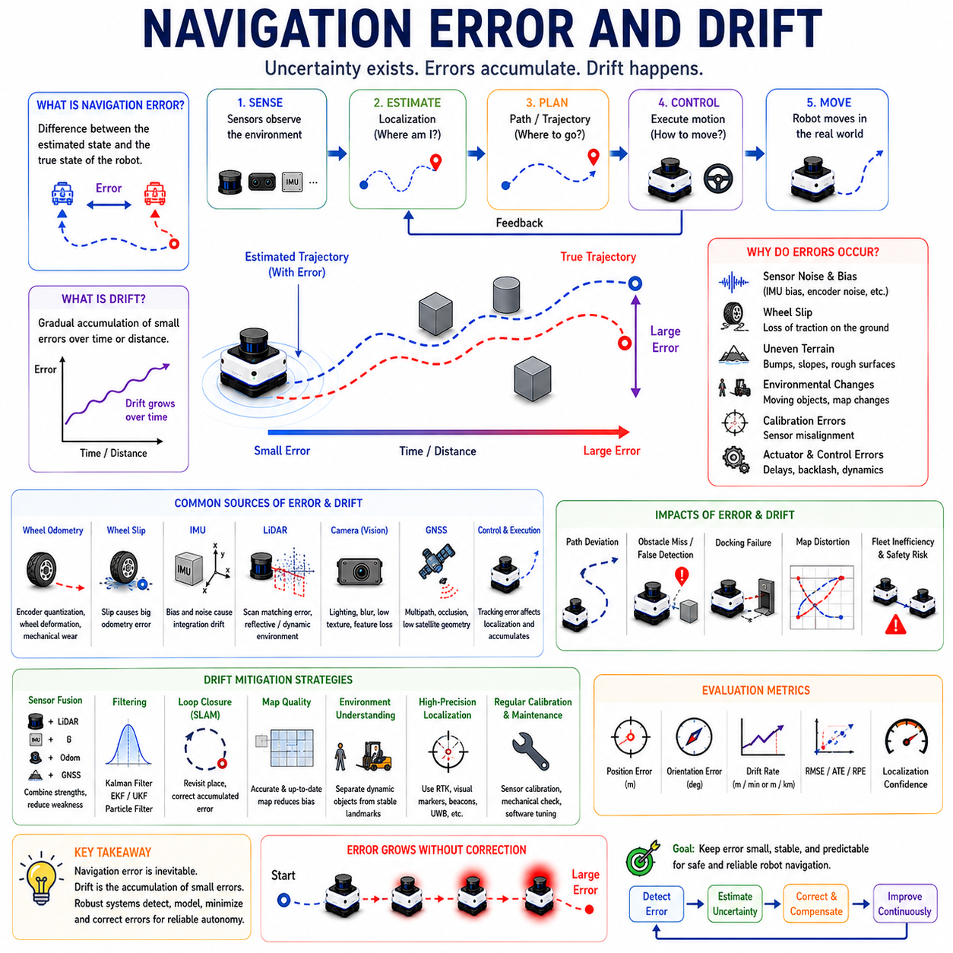
Navigation error and drift are among the most important challenges in autonomous robot navigation. Regardless of how advanced a robot’s sensors, algorithms, maps, or control systems may be, navigation is never perfectly accurate. Every measurement, calculation, and motion execution process contains uncertainty. Over time, these uncertainties accumulate and produce deviations between the robot’s estimated state and its actual state. These deviations are collectively referred to as navigation errors, while the gradual accumulation of such errors over time is known as drift.
Understanding navigation error and drift is essential because they directly influence localization accuracy, path-following performance, obstacle avoidance effectiveness, docking precision, fleet coordination, and overall mission success. A robot may possess an accurate map and a sophisticated path planner, but if its position estimate drifts significantly from reality, navigation performance will degrade rapidly. Consequently, error analysis and drift mitigation are fundamental components of every autonomous navigation system.
Navigation error can be defined as the difference between the robot’s estimated state and its true state. The state typically includes position, orientation, velocity, acceleration, and other motion-related variables. Since the true state is often unknown during operation, navigation systems estimate it using sensor measurements and mathematical models. Errors arise whenever these estimates differ from reality.
In practical terms, navigation error may appear as a robot believing it is several centimeters away from its actual location, facing a slightly different direction than expected, or moving at a velocity that differs from the commanded value. Small errors may appear insignificant initially, but their impact often grows over time. Even a minor orientation error can eventually result in large positional deviations after long-distance travel.
Drift is a special type of navigation error characterized by gradual accumulation. Unlike sudden errors caused by sensor failures or environmental disturbances, drift develops slowly as small inaccuracies accumulate over time. A robot may begin a mission with highly accurate localization, yet after several hours of operation, its estimated position may differ significantly from its true position due to accumulated drift.
One of the most common sources of drift is wheel odometry. Wheel encoders estimate robot movement by measuring wheel rotations. The navigation system converts these rotations into position and orientation estimates using kinematic models. However, wheel measurements are never perfectly accurate. Tire deformation, uneven surfaces, wheel slip, mechanical wear, and encoder quantization introduce small errors into each measurement. Although individual errors may be negligible, they accumulate continuously during operation.
Wheel slip represents one of the largest contributors to odometry drift. When wheels lose traction, rotational measurements no longer correspond directly to actual movement. A wheel may rotate without producing equivalent forward motion, or the robot may slide laterally despite limited wheel rotation. Slip commonly occurs on wet floors, polished surfaces, gravel, sand, mud, snow, ramps, and uneven terrain. In outdoor environments, wheel slip often becomes the dominant source of navigation error.
Inertial Measurement Units (IMUs) provide another important source of navigation information. IMUs measure acceleration and angular velocity, allowing robots to estimate changes in motion. Although IMUs offer high-frequency updates and excellent short-term accuracy, they are susceptible to bias errors and sensor noise. Integrating these measurements over time inevitably produces drift. Even tiny biases can lead to substantial position errors after extended operation.
Gyroscope drift is particularly significant in navigation systems. Small orientation errors accumulate continuously and gradually alter the robot’s estimated heading. Since positional calculations depend heavily on orientation estimates, heading drift often causes substantial long-term localization errors. A heading error of only one degree can produce several meters of positional deviation over long travel distances.
Accelerometer drift introduces additional challenges. Position estimates derived from acceleration measurements require double integration, making them extremely sensitive to measurement noise and bias. Consequently, inertial navigation systems typically require periodic correction from external references such as maps, landmarks, GNSS signals, or visual observations.
LiDAR-based navigation systems experience different types of errors. Although LiDAR sensors generally provide highly accurate geometric measurements, environmental conditions can affect performance. Reflective surfaces, transparent materials, dust, fog, rain, smoke, and dynamic obstacles may introduce measurement inaccuracies. Scan-matching algorithms can occasionally align observations incorrectly, resulting in localization errors that propagate through the navigation system.
Visual navigation systems are similarly vulnerable to environmental influences. Cameras depend heavily on lighting conditions, texture availability, and environmental visibility. Bright sunlight, shadows, reflections, motion blur, low-light conditions, repetitive textures, and weather effects can reduce localization accuracy. Visual feature extraction may fail under challenging conditions, leading to tracking loss or position drift.
Global Navigation Satellite Systems (GNSS) introduce another category of navigation error. Standard GNSS receivers often exhibit meter-level positioning errors due to atmospheric effects, satellite geometry, signal noise, and multipath reflections. Urban canyons, tunnels, dense forests, and large industrial structures further degrade GNSS performance. Even Real-Time Kinematic (RTK) systems, which achieve centimeter-level accuracy under ideal conditions, remain vulnerable to signal interruptions and correction failures.
Sensor fusion is widely employed to reduce navigation error and drift. Different sensors possess different strengths and weaknesses. Wheel encoders provide accurate short-term motion estimates but accumulate drift. IMUs offer high-frequency updates but suffer from bias accumulation. LiDAR and cameras provide environmental references but depend on external conditions. GNSS offers global positioning but may experience signal degradation. By combining these sensors, navigation systems can compensate for individual weaknesses and improve overall accuracy.
Kalman Filters are among the most commonly used tools for navigation error reduction. These algorithms estimate system states by combining sensor measurements with mathematical motion models. Kalman Filters continuously update position estimates while accounting for measurement uncertainty and process noise. Extended Kalman Filters and Unscented Kalman Filters further extend this approach to nonlinear robotic systems.
Particle Filters provide an alternative probabilistic framework for localization. Rather than maintaining a single position estimate, Particle Filters represent multiple hypotheses about the robot’s location. These hypotheses evolve as sensor measurements become available. This approach is particularly effective in environments where localization ambiguity exists or initial position uncertainty is large.
Simultaneous Localization and Mapping (SLAM) systems address drift through continuous map-based correction. As a robot revisits previously observed locations, SLAM algorithms detect loop closures and use them to correct accumulated errors. Loop closure represents one of the most powerful mechanisms for long-term drift reduction. By recognizing that a previously visited location has been encountered again, the navigation system can adjust its internal map and position estimates to improve consistency.
Loop closure is especially important in large-scale environments. Without periodic correction, odometry drift accumulates indefinitely. Over long missions, maps become distorted, and localization accuracy deteriorates. Successful loop closure detection allows the system to distribute corrections throughout the map, reducing accumulated errors and improving overall navigation accuracy.
Map quality significantly influences navigation error. Inaccurate maps introduce systematic localization biases. Environmental changes further complicate the situation. Furniture may be relocated, warehouse shelves may move, doors may change state, construction may alter layouts, and temporary obstacles may appear unexpectedly. These discrepancies between stored maps and actual environments can reduce localization reliability and increase navigation errors.
Dynamic environments introduce additional challenges. Moving people, forklifts, vehicles, carts, and equipment continuously alter sensor observations. Localization algorithms must distinguish between stable environmental features and transient objects. Failure to perform this separation effectively may cause erroneous position estimates and increased drift.
Motion control errors also contribute to navigation inaccuracies. Even when localization is accurate, imperfect path tracking can cause deviations from planned trajectories. Steering errors, actuator delays, motor response limitations, mechanical backlash, tire deformation, and control system imperfections all affect navigation performance. Tracking errors may subsequently influence localization estimates, creating feedback effects throughout the navigation system.
Environmental conditions play a major role in navigation accuracy. Indoor environments generally provide stable surfaces and predictable structures, reducing error sources. Outdoor environments introduce additional complexity through weather changes, uneven terrain, vegetation, lighting variations, wind disturbances, and seasonal transformations. These factors significantly increase uncertainty and make error management more challenging.
Heavy payloads create another source of navigation error. As payload mass changes, vehicle dynamics change as well. Acceleration response, braking performance, steering behavior, wheel slip characteristics, and suspension behavior may all vary. Navigation systems designed for unloaded conditions may exhibit increased errors when operating under heavy loads unless appropriate compensation mechanisms are implemented.
Navigation error becomes particularly critical during precision operations. Docking stations, charging interfaces, elevator entry, trailer coupling, pallet handling, automated parking, and robotic manipulation all require high positional accuracy. Errors that may be acceptable during normal navigation become unacceptable in these scenarios. Consequently, many systems employ specialized high-precision localization techniques during final approach operations.
Safety considerations require continuous monitoring of navigation error. Autonomous robots operating near humans must maintain reliable position estimates. Excessive localization uncertainty can increase collision risk and compromise safe operation. Safety systems therefore often monitor localization confidence and trigger protective actions when uncertainty exceeds predefined thresholds.
Error modeling plays a fundamental role in navigation system design. Engineers characterize sensor noise, actuator uncertainty, environmental disturbances, and computational limitations to predict system performance. Statistical models help estimate expected error growth and identify conditions likely to produce navigation failures. These models support algorithm design, system validation, and risk assessment.
Simulation provides valuable tools for studying navigation error and drift. Platforms such as Isaac Sim, Gazebo, CARLA, Webots, and digital twins allow engineers to inject controlled sensor noise, wheel slip, environmental disturbances, and localization errors into virtual systems. By analyzing system responses under controlled conditions, developers can evaluate robustness and optimize error mitigation strategies before real-world deployment.
Field testing remains essential because real environments contain complexities that are difficult to reproduce in simulation. Engineers often perform long-duration navigation trials, repeated route tests, docking accuracy evaluations, loop closure experiments, and outdoor validation campaigns to quantify navigation performance under operational conditions.
Navigation accuracy is typically evaluated using several metrics. Position error measures the difference between estimated and true position. Orientation error measures heading deviations. Drift rate quantifies how quickly errors accumulate over time or distance traveled. Root Mean Square Error (RMSE), Absolute Trajectory Error (ATE), Relative Pose Error (RPE), localization confidence, and mission completion accuracy are commonly used performance indicators.
Artificial intelligence is increasingly being applied to navigation error reduction. Machine learning models improve sensor calibration, anomaly detection, landmark recognition, uncertainty estimation, and drift compensation. Deep learning techniques can identify environmental features that provide stable localization references and reject observations likely to produce errors. Future navigation systems may continuously learn from operational experience and adapt their error models dynamically.
As autonomous robots expand into warehouses, hospitals, factories, airports, farms, construction sites, smart cities, logistics networks, and infrastructure inspection applications, managing navigation error and drift becomes increasingly important. Reliable navigation depends not only on generating paths and executing motions but also on understanding uncertainty and continuously correcting accumulated errors.
Ultimately, navigation error and drift are unavoidable aspects of autonomous robotics. Every sensor, actuator, algorithm, and environment introduces uncertainty. The objective of modern navigation systems is not to eliminate error entirely, which is impossible, but rather to detect, model, minimize, and compensate for errors sufficiently to maintain safe, reliable, and accurate operation. Understanding the mechanisms of navigation error and drift is therefore essential for designing robust autonomous systems capable of performing effectively in real-world environments.

01.8 Navigation Performance Metrics
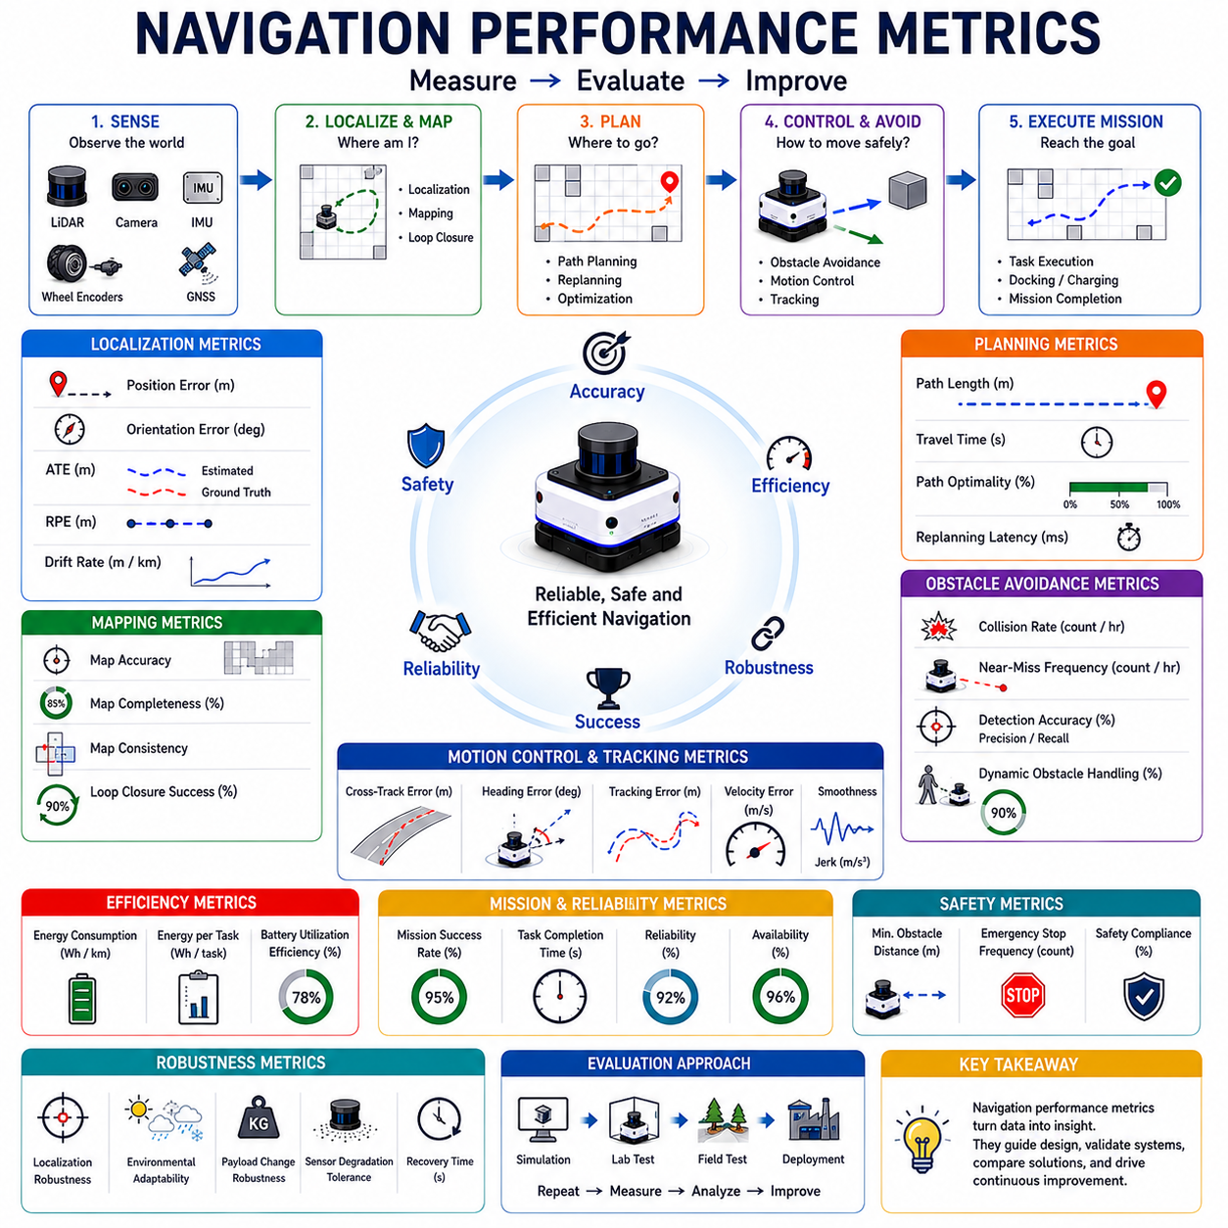
Navigation performance metrics provide the quantitative foundation for evaluating autonomous robot navigation systems. While navigation algorithms may appear effective during demonstrations or simulations, objective performance metrics are necessary to determine whether a system truly meets operational requirements. In autonomous robotics, performance cannot be judged solely by whether a robot reaches its destination. Engineers must evaluate how accurately, safely, efficiently, robustly, and consistently the robot completes navigation tasks under varying environmental conditions. Navigation performance metrics transform subjective observations into measurable indicators that support system design, validation, optimization, benchmarking, and deployment decisions.
The purpose of navigation performance evaluation is to answer a fundamental question: how well does the navigation system perform compared to its intended objectives? Different applications may prioritize different performance characteristics. A warehouse AMR may emphasize efficiency and throughput. A hospital delivery robot may prioritize safety and reliability. An outdoor infrastructure inspection robot may require robustness under challenging environmental conditions. Regardless of the application, performance metrics provide a common framework for assessing navigation quality.
Navigation performance evaluation typically encompasses multiple subsystems, including localization, mapping, path planning, obstacle avoidance, motion control, safety management, and mission execution. Since navigation is a complex interaction among these components, no single metric can fully describe overall performance. Instead, engineers evaluate a collection of complementary metrics that together provide a comprehensive understanding of system behavior.
Localization accuracy is one of the most important navigation performance indicators. Since nearly all navigation decisions depend on position estimates, localization quality directly influences overall navigation effectiveness. Localization accuracy measures the difference between the robot’s estimated position and its true position. Smaller errors indicate higher localization performance. Accurate localization enables reliable path planning, obstacle avoidance, docking, fleet coordination, and task execution.
Position error is commonly measured using Euclidean distance between estimated and ground-truth locations. In indoor industrial environments, localization errors may be expected to remain within a few centimeters. Outdoor systems operating over larger areas may tolerate larger errors depending on mission requirements. Position accuracy is often evaluated continuously throughout a mission rather than at isolated points.
Orientation accuracy represents another critical localization metric. Even if positional accuracy is high, orientation errors can significantly affect navigation performance. Docking operations, trailer coupling, pallet handling, charging station alignment, elevator entry, and narrow corridor navigation often require highly accurate orientation estimates. Orientation error is typically expressed in degrees or radians and evaluated relative to known reference orientations.
Absolute Trajectory Error (ATE) is widely used in robotics research and SLAM evaluation. ATE measures the deviation between the estimated trajectory and the true trajectory over an entire navigation mission. Rather than evaluating isolated position estimates, ATE assesses overall trajectory consistency. Lower ATE values indicate more accurate long-term localization performance.
Relative Pose Error (RPE) focuses on short-term motion estimation accuracy. Instead of comparing entire trajectories, RPE evaluates local movement consistency between consecutive poses. This metric is particularly useful for analyzing drift behavior and motion estimation performance over shorter intervals.
Drift rate is another essential navigation metric. Drift refers to the accumulation of localization errors over time or distance traveled. Drift rate quantifies how quickly these errors grow. A navigation system with low drift maintains accurate localization over extended missions, while a system with high drift may gradually lose positional accuracy. Drift is often expressed in meters per kilometer traveled, percentage of traveled distance, or positional error growth per unit time.
Mapping performance is equally important in navigation evaluation. Maps serve as the environmental foundation for localization and path planning. Map accuracy measures how closely the generated map corresponds to the actual environment. Mapping errors may result in localization failures, inefficient routing, obstacle misidentification, and navigation instability.
Map completeness evaluates whether the navigation system successfully captures all relevant environmental features. Missing walls, corridors, obstacles, or structural elements reduce navigation reliability. Completeness is especially important in large-scale environments where partial maps may limit operational coverage.
Map consistency measures how accurately different sections of a map align with one another. Loop closure performance significantly influences consistency. Poor loop closure handling can produce distorted maps, duplicated structures, and geometric inconsistencies that negatively affect navigation performance.
Path planning performance focuses on route generation quality. One of the most common metrics is path length. Shorter paths generally indicate more efficient navigation, although the shortest path is not always the safest or most practical. Path length is often compared against theoretically optimal routes to evaluate planning efficiency.
Travel time provides another important planning metric. While path length measures distance, travel time reflects operational efficiency. Congestion, obstacle avoidance, speed limitations, acceleration constraints, and environmental conditions all influence travel time. In many industrial applications, reducing mission duration is a primary objective.
Path optimality evaluates how closely a planned route approaches the best possible solution according to defined criteria. Depending on the application, optimality may consider distance, energy consumption, safety margins, traffic flow, terrain difficulty, or operational cost.
Replanning performance is increasingly important in dynamic environments. Real-world conditions frequently invalidate existing routes. Effective navigation systems must detect environmental changes and generate alternative paths efficiently. Replanning latency measures the time required to calculate new routes when circumstances change.
Obstacle avoidance performance represents another major category of navigation evaluation. Collision rate measures how frequently navigation failures result in physical contact with obstacles. Ideally, collision rates should approach zero in operational environments.
Near-miss frequency provides additional insight into safety performance. Even when collisions do not occur, repeated near-collision situations may indicate inadequate obstacle avoidance behavior. Monitoring near misses helps identify safety concerns before actual incidents occur.
Obstacle detection accuracy evaluates how reliably the system identifies environmental hazards. False negatives occur when obstacles are missed, potentially leading to collisions. False positives occur when safe regions are incorrectly classified as obstacles, reducing navigation efficiency. Both types of errors affect overall system performance.
Dynamic obstacle handling performance is particularly important in environments shared with people and vehicles. Robots must detect moving objects, predict future trajectories, and generate safe avoidance behaviors. Metrics often include prediction accuracy, avoidance success rate, minimum separation distance, and response time.
Motion control and trajectory tracking performance significantly influence navigation quality. Tracking error measures the difference between planned and actual motion. Smaller tracking errors indicate more precise execution of navigation commands. Tracking accuracy directly affects docking performance, maneuverability, and operational efficiency.
Cross-track error measures lateral deviation from the intended path. This metric is widely used in autonomous vehicles, outdoor robots, and industrial AMRs. Maintaining low cross-track error ensures that robots remain close to planned trajectories.
Heading error quantifies orientation deviations during path following. Excessive heading errors can cause unstable behavior, inefficient motion, and navigation failures. Controllers are typically optimized to minimize both cross-track and heading errors simultaneously.
Velocity tracking accuracy evaluates how well actual speeds follow desired speed profiles. Consistent velocity tracking improves energy efficiency, ride quality, and control stability. Velocity errors may indicate actuator limitations, controller deficiencies, or environmental disturbances.
Smoothness is an increasingly important navigation metric. Smooth trajectories reduce mechanical wear, improve passenger comfort, protect transported payloads, and enhance safety. Smoothness is often evaluated using acceleration profiles, jerk measurements, steering rate changes, and trajectory curvature continuity.
Energy efficiency represents a critical operational consideration for mobile robots. Navigation systems influence battery consumption through route selection, speed regulation, acceleration management, and obstacle avoidance behavior. Energy efficiency metrics typically evaluate energy consumed per distance traveled, per task completed, or per mission executed.
Battery utilization efficiency becomes particularly important for large fleets of autonomous robots. Improved navigation efficiency can significantly reduce charging requirements, increase operational availability, and lower overall operating costs.
Mission success rate serves as one of the most comprehensive navigation performance indicators. A mission is considered successful when the robot reaches its destination while satisfying operational requirements and avoiding unacceptable failures. Success rate integrates the combined effects of localization, planning, control, obstacle avoidance, and environmental adaptation.
Task completion time measures the duration required to complete navigation objectives. In logistics and manufacturing environments, shorter completion times often translate directly into higher productivity and throughput.
Reliability metrics evaluate consistency across repeated missions. A navigation system that performs exceptionally well once but inconsistently thereafter may not be suitable for deployment. Reliability assessments often involve repeated testing under identical conditions to quantify performance variability.
Robustness measures a navigation system’s ability to maintain acceptable performance despite disturbances and uncertainty. Environmental changes, sensor degradation, payload variations, weather conditions, communication disruptions, and dynamic obstacles all challenge robustness. Robust systems continue operating effectively despite such challenges.
Availability represents another important operational metric. Availability measures the percentage of time during which navigation functionality remains operational. Frequent navigation failures, localization loss events, or planning interruptions reduce system availability and impact productivity.
Recovery performance evaluates how effectively the navigation system responds to failures. Even advanced systems occasionally encounter localization loss, blocked routes, sensor faults, or unexpected environmental conditions. Recovery metrics assess detection speed, recovery success rate, and time required to resume normal operation.
Safety metrics are among the most critical navigation performance indicators. Collision frequency, emergency stop activations, minimum obstacle clearance, human safety compliance, and risk exposure are commonly monitored. Safety performance often takes precedence over efficiency metrics in environments shared with humans.
Human-aware navigation introduces additional evaluation criteria. Social acceptance, comfort distance maintenance, pedestrian interaction quality, predictability, and perceived safety become important factors when robots operate in public environments.
Fleet-level navigation performance requires specialized metrics. Throughput measures the number of completed tasks over time. Traffic efficiency evaluates congestion levels and route coordination quality. Resource utilization assesses how effectively navigation systems allocate robots to tasks and routes.
Simulation-based evaluation has become increasingly important in navigation development. Platforms such as Isaac Sim, Gazebo, Webots, CARLA, and digital twins enable large-scale performance testing under controlled conditions. Simulation supports repeatability, scalability, and safe exploration of failure scenarios.
However, simulation results alone are insufficient. Real-world validation remains essential because actual environments introduce complexities that are difficult to model accurately. Consequently, navigation systems are typically evaluated through a combination of simulation experiments, laboratory testing, controlled field trials, and operational deployment studies.
Benchmark datasets and standardized evaluation procedures provide additional value. Common benchmarks enable objective comparisons among navigation algorithms developed by different research groups and companies. Standardized metrics facilitate reproducibility and accelerate technological progress.
Artificial intelligence is increasingly contributing to navigation performance analysis. Machine learning techniques can identify performance degradation patterns, predict navigation failures, optimize controller parameters, and adapt navigation strategies dynamically. Future autonomous systems may continuously evaluate their own performance and automatically adjust behavior to maintain optimal operation.
As autonomous robots become more common in warehouses, hospitals, factories, logistics centers, airports, farms, construction sites, infrastructure inspection systems, and smart city applications, navigation performance metrics become increasingly important. Reliable deployment requires objective evidence that navigation systems satisfy operational requirements under realistic conditions.
Ultimately, navigation performance metrics provide the quantitative language through which navigation systems are designed, evaluated, improved, and certified. They enable engineers to move beyond subjective impressions and rigorously assess system behavior. By measuring localization accuracy, drift, mapping quality, planning efficiency, obstacle avoidance effectiveness, tracking precision, energy consumption, safety performance, robustness, and mission success, engineers can develop navigation systems capable of operating safely and reliably in complex real-world environments. These metrics therefore form the foundation of continuous improvement and technological advancement in autonomous robot navigation.

