Volume 05. Path Planning and Autonomous Navigation

Chapter 25. Future of Autonomous Navigation

25.1 Foundation Models for Robotics
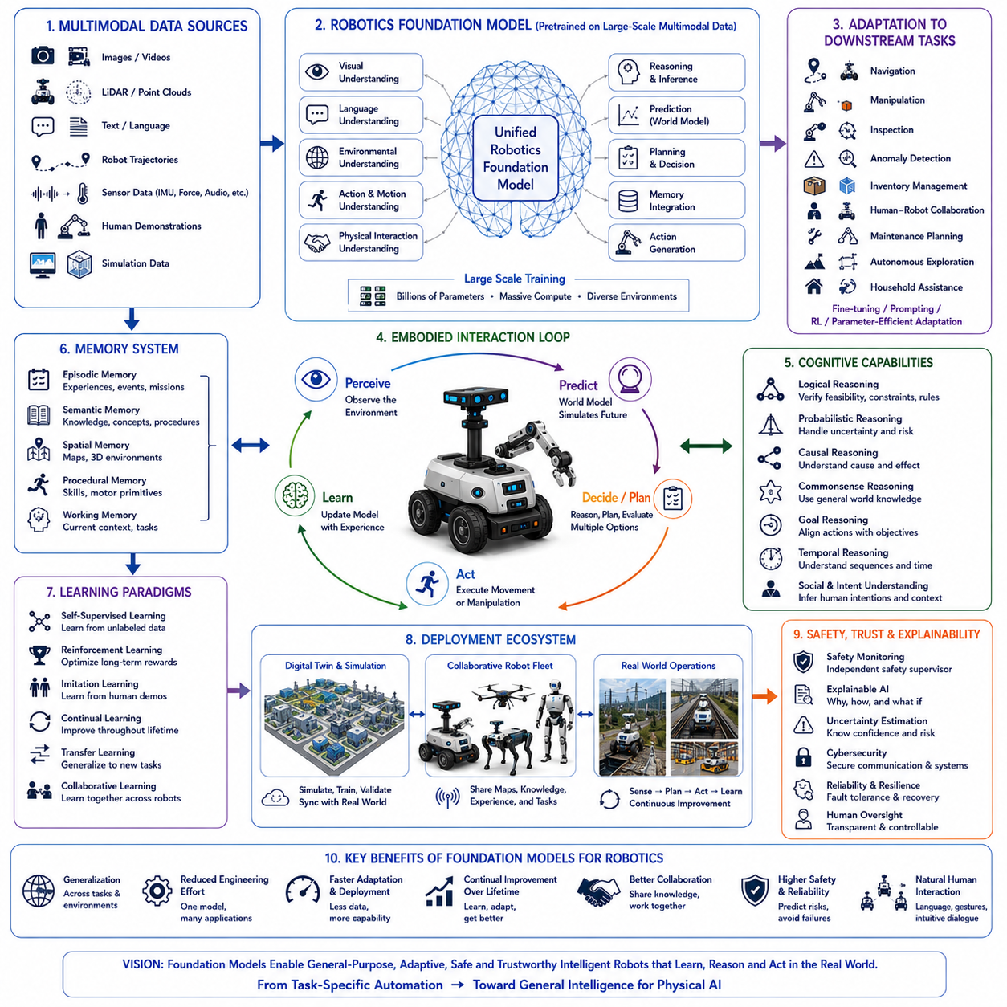
Foundation models for robotics represent one of the most significant transitions in the history of autonomous systems because they transform robots from task-specific machines into general-purpose intelligent agents capable of learning, reasoning, adapting, and operating across many environments. Earlier robotic systems were typically designed for narrowly defined applications such as industrial manipulation, warehouse transportation, mobile inspection, or household cleaning. Each application required its own perception algorithms, navigation software, manipulation strategies, and control policies. These systems often performed exceptionally well within carefully engineered environments but struggled when transferred to new tasks or unfamiliar surroundings. Foundation models introduce a different paradigm in which a single large-scale model acquires broad knowledge from diverse data sources before being adapted to many downstream robotic applications.
The concept of a foundation model originates from large-scale pretraining followed by efficient adaptation. Instead of developing independent models for every robotic capability, engineers first train a general model using enormous collections of multimodal data that include images, videos, language, robot trajectories, sensor observations, simulation experiences, and human demonstrations. The resulting model develops general representations of objects, environments, actions, physical interactions, spatial relationships, and human intentions. Specific robotic tasks are then solved through fine-tuning, prompting, reinforcement learning, or parameter-efficient adaptation rather than constructing entirely new models.
Unlike conventional robotics pipelines, foundation models attempt to unify perception, language understanding, reasoning, planning, memory, prediction, and action generation inside a common computational framework. Traditional robotic architectures frequently separate localization, mapping, object detection, motion planning, manipulation planning, obstacle avoidance, and task scheduling into individual software modules. Each module communicates through predefined interfaces while optimizing only its local objective. Foundation models instead encourage shared representations across multiple cognitive functions, allowing information learned in one domain to improve performance in others.
Scale is one of the defining characteristics of foundation models. These models are trained using billions of parameters, massive computational infrastructure, and datasets collected from numerous environments. Large-scale learning enables statistical generalization beyond individual tasks. Rather than memorizing isolated examples, foundation models learn abstract representations describing geometry, semantics, physics, language, causality, and environmental dynamics. These generalized representations allow robots to perform tasks they have never encountered explicitly during training while requiring significantly less task-specific engineering.
Multimodal learning forms the core of robotics foundation models. Physical robots continuously observe the world through cameras, LiDAR, radar, inertial sensors, tactile sensing, force feedback, microphones, GPS receivers, joint encoders, torque sensors, thermal cameras, and numerous additional sensing modalities. Foundation models integrate these heterogeneous observations into unified latent representations where relationships among vision, language, motion, sound, touch, and environmental context become naturally connected. Such multimodal integration allows robots to reason more comprehensively than systems relying upon individual sensor streams.
Vision-language models have become an important precursor to robotics foundation models. These systems learn associations between visual observations and natural language descriptions by analyzing enormous image-text datasets. As a result, robots inherit semantic understanding allowing recognition of objects, activities, environments, affordances, and human intentions using ordinary language. Instead of recognizing only predefined object categories, foundation models understand broader concepts such as damaged equipment, hazardous areas, maintenance tools, emergency exits, pedestrian activity, and operational procedures.
Language becomes a universal interface connecting humans with robotic intelligence. Human operators increasingly communicate using natural conversation instead of specialized command syntax. Instructions such as “Inspect the northern transformer after checking the nearby cooling system, but avoid maintenance workers if they are present,” require simultaneous language understanding, environmental grounding, temporal reasoning, semantic mapping, and task planning. Foundation models translate these high-level instructions into executable robotic behaviors while preserving contextual meaning throughout mission execution.
Embodied learning distinguishes robotics foundation models from purely language-based systems. Physical intelligence requires understanding how actions influence future observations through interaction with the environment. Robots therefore learn not only from images and text but also from movement, manipulation, force interaction, locomotion, sensorimotor feedback, and environmental response. Every executed action generates additional training information linking perception, prediction, action, and consequence. Embodied learning allows robots to understand physics through experience rather than symbolic description alone.
World models increasingly complement robotics foundation models by providing predictive simulation capability. Rather than reacting solely to current observations, robots internally predict multiple future scenarios before selecting actions. Candidate navigation routes, manipulation strategies, collaborative behaviors, inspection plans, and recovery procedures are evaluated through internal simulation. Predictive reasoning significantly improves safety, efficiency, energy management, and long-term mission success while reducing unnecessary physical experimentation.
Memory systems become substantially more powerful when integrated with foundation models. Episodic memory preserves previous missions, environmental conditions, failures, successes, and interactions. Semantic memory accumulates engineering knowledge, operational procedures, equipment characteristics, and environmental concepts. Spatial memory continuously refines semantic maps through accumulated exploration. Working memory maintains immediate conversational context and active planning information. Together these memory systems transform isolated task execution into continuous lifelong knowledge accumulation.
Generalization represents one of the primary advantages of robotics foundation models. Traditional robotic software often performs well only within environments similar to those encountered during development. Foundation models instead learn transferable knowledge supporting adaptation across factories, hospitals, warehouses, farms, smart cities, transportation systems, infrastructure inspection sites, construction environments, and domestic settings. Although domain adaptation remains necessary, prior knowledge substantially reduces retraining effort while accelerating deployment into previously unseen operational scenarios.
Transfer learning allows pretrained knowledge to support numerous downstream applications. A foundation model initially trained for object understanding may subsequently contribute to navigation, manipulation, inspection, anomaly detection, inventory management, collaborative robotics, autonomous exploration, or maintenance planning. Shared internal representations reduce computational redundancy while enabling knowledge acquired in one application domain to improve performance elsewhere.
Parameter-efficient adaptation further reduces deployment cost. Instead of retraining billions of parameters for every customer or environment, modern adaptation methods modify only small subsets of model parameters or employ lightweight adapters preserving most pretrained knowledge. This approach significantly decreases computational expense while enabling rapid customization according to industrial requirements, regulatory constraints, operational procedures, or customer-specific infrastructure.
Self-supervised learning provides enormous advantages because manually labeling robotic datasets remains expensive and time consuming. Robots naturally collect multimodal observations throughout everyday operation. Relationships among images, motion, force, language, localization, environmental dynamics, and future observations create abundant supervisory signals without requiring extensive human annotation. Foundation models exploit these naturally occurring correlations to improve continuously throughout deployment.
Reinforcement learning complements foundation model pretraining by optimizing sequential decision making. While pretraining provides broad prior knowledge, reinforcement learning refines policies according to mission objectives, safety constraints, operational efficiency, collaboration quality, and long-term reward. Large-scale simulation environments enable millions of interactions before transferring optimized behaviors toward physical robotic platforms through sim-to-real adaptation techniques.
Human demonstration remains another valuable knowledge source. Demonstration data capture expert manipulation, navigation, inspection, maintenance, assembly, and collaborative procedures. Foundation models learn general behavioral priors from diverse demonstrations rather than memorizing individual trajectories. Consequently, robots imitate underlying strategies instead of reproducing exact movements, allowing adaptation to changing environments while preserving operational objectives.
Digital twins play an increasingly important role during foundation model development. High-fidelity virtual environments generate enormous quantities of diverse robotic experience under varying weather conditions, terrain characteristics, lighting environments, infrastructure configurations, equipment failures, human activities, and communication conditions. Simulation complements physical data collection while exposing robots to rare but safety-critical situations difficult to reproduce experimentally.
Multirobot learning significantly expands available training data. Heterogeneous robots operating across factories, logistics centers, construction sites, agricultural fields, hospitals, ports, airports, and urban infrastructure collectively generate enormous experience datasets. Foundation models aggregate knowledge acquired by many robotic platforms into unified representations benefiting every participating system. Experience sharing accelerates learning while reducing redundant exploration.
Reasoning capabilities become increasingly sophisticated through foundation model architectures. Logical reasoning verifies task feasibility and procedural consistency. Probabilistic reasoning estimates uncertainty arising from perception and prediction. Causal reasoning distinguishes genuine physical relationships from statistical coincidence. Commonsense reasoning incorporates everyday environmental knowledge. Goal reasoning aligns action selection with mission objectives while balancing competing operational constraints. These complementary reasoning processes produce substantially more reliable autonomous behavior than isolated decision algorithms.
Planning evolves beyond deterministic trajectory generation toward cognitive task organization. Foundation models decompose high-level objectives into executable subtasks while continuously adapting according to changing observations. Navigation planning, manipulation planning, inspection scheduling, resource allocation, collaborative coordination, and contingency management become interconnected within unified planning architectures. Continuous replanning maintains mission progress despite unexpected environmental change.
Context awareness allows robotic behavior to remain sensitive to operational circumstances. Environmental conditions, organizational procedures, human activity, weather, battery reserves, communication quality, regulatory requirements, and mission priorities all influence behavior generation. Foundation models interpret identical instructions differently depending upon surrounding context, enabling flexible adaptation instead of rigid rule execution.
Collaborative intelligence emerges naturally because foundation models share common semantic representations among multiple robots. Information regarding navigation, object recognition, environmental hazards, infrastructure status, maintenance history, communication quality, and task allocation becomes immediately understandable across heterogeneous robotic platforms. Collaborative planning therefore requires substantially less manual interface engineering than previous distributed robotic systems.
Explainability remains essential despite increasing model complexity. Human operators require understandable explanations describing why robots selected particular actions, modified plans, requested clarification, or identified anomalies. Foundation models increasingly generate natural language explanations summarizing influential observations, uncertainty estimates, predicted consequences, safety considerations, and reasoning pathways. Transparent communication improves trust, certification, debugging, regulatory compliance, and collaborative operation.
Safety supervision remains independent of learned intelligence. Although foundation models generate increasingly capable behaviors, dedicated safety systems continue validating localization quality, actuator integrity, environmental hazards, cybersecurity status, communication reliability, sensor confidence, and operational constraints before permitting physical execution. Learned intelligence therefore operates within carefully engineered safety boundaries rather than replacing traditional functional safety mechanisms.
Evaluation of robotics foundation models requires substantially broader benchmarks than conventional robotics. Performance includes perception accuracy, language understanding, semantic grounding, navigation robustness, manipulation success, reasoning quality, planning effectiveness, memory utilization, continual learning, transfer capability, energy efficiency, collaboration quality, explainability, safety, resilience, computational efficiency, and adaptation across previously unseen environments. Comprehensive evaluation reflects integrated cognitive capability rather than isolated algorithmic performance.
A representative deployment illustrates robotics foundation models within a nationwide intelligent infrastructure management system responsible for railways, electrical substations, renewable energy facilities, industrial complexes, transportation corridors, and smart cities. Thousands of heterogeneous autonomous robots continuously collect multimodal observations including images, LiDAR scans, thermal measurements, environmental sensing, operational logs, maintenance reports, and human interactions. A unified robotics foundation model integrates these diverse experiences into shared representations supporting navigation, inspection, manipulation, anomaly detection, maintenance prediction, collaborative planning, and conversational interaction. Human operators communicate using natural language while foundation models interpret mission objectives, decompose tasks, generate adaptive plans, predict future operational states, and coordinate robotic fleets. World models evaluate candidate behaviors before execution, reducing operational risk through predictive simulation. Digital twins synchronize continuously with physical infrastructure, allowing reinforcement learning and self-supervised learning to improve behavioral policies without interrupting ongoing operations. Knowledge acquired by inspection robots immediately benefits logistics robots, maintenance robots, security robots, and collaborative mobile manipulators through common foundation model representations. Unexpected environmental changes including severe weather, infrastructure degradation, communication failures, or emergency events trigger autonomous replanning while preserving safety and mission priorities. Throughout long-term deployment, episodic memory accumulates operational experience, semantic memory expands engineering knowledge, spatial memory refines infrastructure maps, and continual learning updates model capability without catastrophic forgetting. Consequently, the robotic ecosystem becomes progressively more intelligent, reliable, adaptive, efficient, and trustworthy across years of autonomous operation.
This example demonstrates that robotics foundation models represent far more than larger neural networks. They establish a unified computational substrate connecting multimodal perception, language understanding, embodied interaction, world models, reasoning, planning, memory, continual learning, transfer learning, self-supervised adaptation, reinforcement learning, collaborative intelligence, digital twins, explainability, and safety within integrated cognitive architectures. As computational resources, multimodal datasets, simulation technology, embodied learning, world modeling, and physical AI continue advancing together, robotics foundation models will increasingly replace collections of isolated task-specific algorithms with broadly capable intelligent systems able to understand new environments, adapt through experience, collaborate naturally with humans, predict future events, and autonomously solve previously unseen problems. They will therefore become one of the fundamental technologies enabling scalable Physical AI across manufacturing, logistics, healthcare, agriculture, infrastructure inspection, transportation, disaster response, smart cities, planetary exploration, and countless future autonomous robotic applications.

25.2 End-to-End AI Navigation
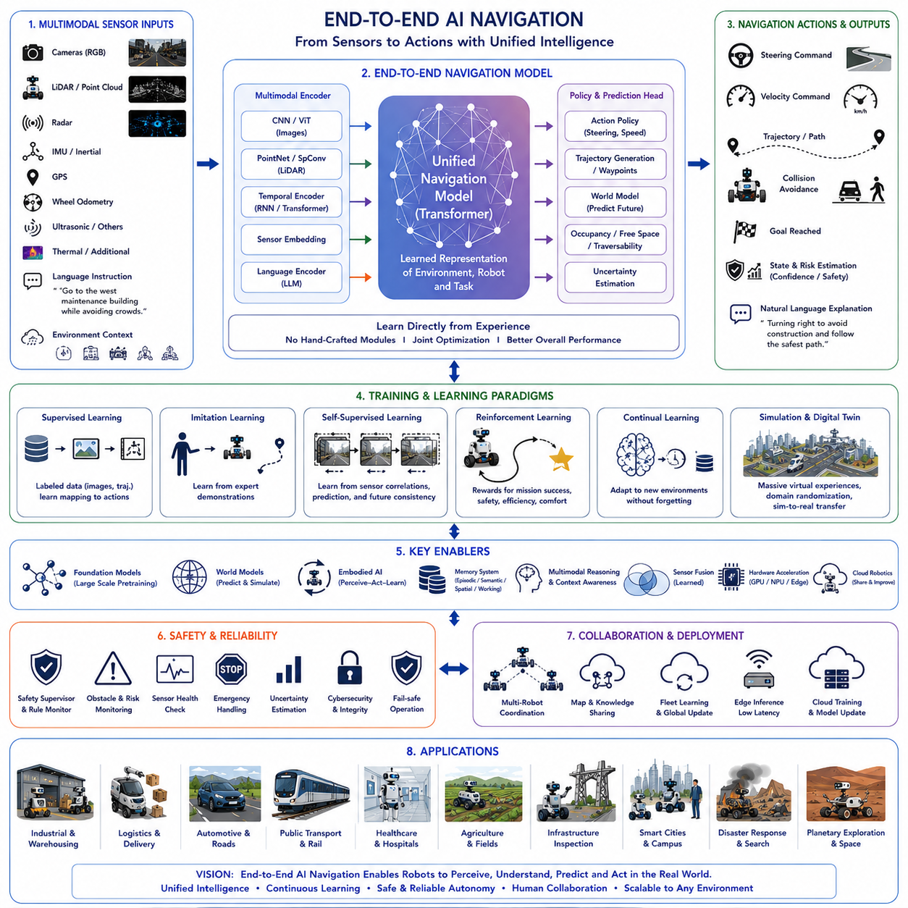
End-to-end AI navigation represents a major shift in autonomous robotics by replacing modular navigation pipelines with unified learning architectures. Instead of designing perception, localization, mapping, planning, and control independently, a single AI model learns the complete navigation process directly from experience. This approach allows robots to optimize overall navigation performance rather than improving isolated software components.
Traditional navigation systems divide the navigation problem into multiple sequential modules. Cameras and LiDAR collect observations, localization estimates the robot position, mapping constructs the environment, planning generates trajectories, and controllers execute movement. Every module has its own algorithms, interfaces, parameters, and optimization objectives. While this architecture provides interpretability and engineering flexibility, it often suffers from accumulated errors and complex system integration.
End-to-end learning removes many intermediate representations by directly mapping sensor observations to navigation actions. Images, point clouds, inertial measurements, GPS data, wheel encoders, language instructions, and environmental context become inputs to a unified neural network. The output consists of steering commands, wheel velocities, motion trajectories, navigation policies, or high-level action sequences. The model automatically learns the relationships connecting perception and control.
The motivation behind end-to-end navigation comes from biological intelligence. Humans rarely separate perception, localization, planning, and motor control into independent cognitive modules. Instead, visual perception, memory, body awareness, prediction, and movement continuously interact during navigation. Learning emerges through repeated sensorimotor experience rather than manually engineered computational pipelines. End-to-end AI attempts to capture similar principles within robotic systems.
Deep neural networks provide the computational foundation for end-to-end navigation. Convolutional neural networks extract visual features from cameras. Vision Transformers capture long-range visual relationships. Recurrent networks preserve temporal continuity. Graph neural networks model spatial structures. Multimodal transformers integrate diverse sensor information into shared latent representations supporting robust decision making across changing environments.
Sensor fusion becomes significantly more efficient because multiple sensing modalities are learned jointly rather than processed independently. Cameras, LiDAR, radar, IMU, GPS, ultrasonic sensors, thermal cameras, tactile sensing, and wheel odometry contribute complementary information. The neural network automatically determines the relative importance of each sensor according to environmental conditions, sensor reliability, and navigation objectives.
Visual navigation is one of the earliest successes of end-to-end learning. Cameras directly observe roads, corridors, obstacles, pedestrians, terrain, signs, and environmental appearance. Instead of explicitly constructing semantic maps before planning, neural networks learn navigation-relevant visual representations supporting safe movement. Visual features become optimized specifically for navigation rather than generic object recognition.
LiDAR continues to play a critical role in many end-to-end systems. Point clouds provide accurate geometric understanding independent of lighting conditions. Neural architectures process three-dimensional structures while combining them with visual appearance and motion information. The resulting representations support obstacle avoidance, free-space estimation, traversability prediction, and robust navigation under adverse weather and illumination.
Temporal learning distinguishes intelligent navigation from instantaneous perception. Navigation decisions depend upon historical observations, previous actions, accumulated experience, and future expectations. Sequential neural architectures learn temporal dependencies connecting past environmental changes with future navigation requirements. Memory therefore becomes an intrinsic component of end-to-end decision making.
Foundation models increasingly enhance end-to-end navigation through large-scale multimodal pretraining. Instead of learning navigation entirely from task-specific datasets, robots inherit broad visual, linguistic, semantic, and physical knowledge acquired from enormous multimodal corpora. Fine-tuning adapts these pretrained models toward autonomous navigation while preserving extensive prior knowledge about objects, environments, and human activities.
Language-conditioned navigation extends end-to-end learning beyond autonomous movement. Human operators specify destinations and mission objectives through natural language rather than predefined coordinate systems. Instructions such as “Move toward the western maintenance building while avoiding crowded walkways” require semantic understanding, environmental grounding, reasoning, and adaptive planning. Unified models translate language directly into executable navigation behavior.
World models further strengthen end-to-end architectures by introducing predictive reasoning. Rather than selecting actions solely according to current observations, robots internally simulate possible future outcomes before acting. Candidate navigation strategies are evaluated according to predicted safety, efficiency, energy consumption, uncertainty, and mission success. Prediction therefore complements reactive perception within unified navigation policies.
Embodied AI provides the conceptual foundation for end-to-end navigation. Intelligence emerges through interaction among perception, movement, environmental feedback, and accumulated experience. Every action changes future observations, while every observation influences subsequent actions. Learning therefore occurs within continuous perception-action loops instead of isolated computational stages. Navigation becomes an active cognitive process rather than sequential information processing.
Reinforcement learning provides one of the primary optimization methods for end-to-end navigation. Robots receive rewards according to successful mission completion, collision avoidance, energy efficiency, comfort, operational safety, and long-term task performance. Rather than manually specifying navigation rules, designers define optimization objectives while learning algorithms discover effective behavioral policies through extensive interaction with simulation and physical environments.
Imitation learning offers another efficient training strategy. Human demonstrations capture expert navigation behavior across diverse environments including warehouses, hospitals, urban streets, agricultural fields, factories, and industrial inspection sites. End-to-end models learn navigation policies directly from demonstrations, significantly reducing manual engineering while preserving human expertise within autonomous decision making.
Self-supervised learning substantially reduces dependence upon manually labeled navigation datasets. Robots naturally collect synchronized observations while operating. Consecutive images, motion estimates, inertial measurements, wheel movements, and environmental changes provide abundant supervisory signals. Neural networks learn predictive representations from these relationships without requiring expensive annotation procedures.
Simulation plays an indispensable role during end-to-end navigation development. Digital twins reproduce roads, factories, warehouses, buildings, weather, lighting, terrain, pedestrians, vehicles, and dynamic obstacles with high fidelity. Millions of navigation episodes become available before physical deployment. Domain randomization and sim-to-real adaptation subsequently transfer learned behaviors toward real robotic platforms.
Generalization remains one of the greatest research challenges. End-to-end models must operate reliably within environments never encountered during training. Differences in weather, infrastructure, lighting, sensor noise, terrain, obstacle appearance, and human behavior all influence navigation performance. Robust foundation models, extensive datasets, domain adaptation, continual learning, and multimodal sensing collectively improve generalization across unseen environments.
Interpretability presents another important challenge. Classical navigation systems expose explicit maps, trajectories, localization estimates, and planning outputs. End-to-end neural networks instead produce navigation decisions through complex internal representations that may be difficult to interpret. Explainable AI therefore becomes increasingly important for understanding decision processes, validating safety, debugging failures, and satisfying regulatory requirements.
Functional safety remains essential despite increased AI capability. Independent safety supervisors continue monitoring localization confidence, obstacle proximity, sensor integrity, actuator status, communication reliability, and emergency conditions. Learned navigation policies operate within certified safety boundaries rather than replacing conventional functional safety architectures. Safe autonomy therefore combines learned intelligence with deterministic safety verification.
Context awareness enables navigation policies to adapt according to operational circumstances. Mission objectives, battery reserves, weather conditions, traffic density, organizational priorities, human activity, regulatory constraints, and infrastructure conditions all influence navigation decisions. The same physical environment may require substantially different behavior depending upon current operational context.
Memory architectures increasingly support long-term navigation capability. Episodic memory preserves previous missions and encountered situations. Semantic memory stores environmental knowledge and operational concepts. Spatial memory continuously refines maps through repeated exploration. Working memory maintains current navigation context during real-time reasoning. Together these memory systems improve long-term autonomy through accumulated operational experience.
Collaborative navigation extends end-to-end learning toward robotic fleets. Multiple robots exchange environmental observations, semantic maps, localization information, predicted hazards, traversability estimates, and navigation experience. Knowledge acquired by one robot rapidly benefits every robot sharing the same foundation model. Fleet intelligence therefore improves much faster than isolated individual learning.
Cloud robotics further expands learning capability by combining edge intelligence with centralized knowledge sharing. Individual robots perform low-latency inference locally while periodically synchronizing experiences with cloud-based foundation models. Global updates subsequently improve navigation policies deployed across thousands of distributed robotic platforms operating within diverse environments worldwide.
Energy-aware navigation becomes naturally integrated into end-to-end optimization. Neural networks learn relationships among terrain characteristics, actuator efficiency, battery consumption, environmental resistance, computational workload, and mission duration. Navigation policies therefore optimize both mobility and resource utilization simultaneously rather than treating energy management as an independent subsystem.
Human-aware navigation receives increasing attention as robots enter shared environments. End-to-end models learn socially acceptable movement by observing human demonstrations and large-scale interaction datasets. Navigation behaviors incorporate interpersonal distance, pedestrian flow, collaborative workspaces, accessibility considerations, and implicit social conventions while maintaining operational safety.
Multimodal reasoning allows navigation decisions to combine visual appearance, geometric structure, semantic understanding, language instructions, environmental history, predictive simulation, and contextual information. Instead of depending upon isolated perception algorithms, integrated reasoning generates coherent navigation strategies considering multiple information sources simultaneously.
Continuous learning enables navigation policies to improve throughout deployment. Robots incorporate newly collected experience without catastrophic forgetting of previously acquired knowledge. New infrastructure, seasonal weather patterns, changing traffic behavior, evolving operational procedures, and emerging environmental conditions continuously refine navigation capability during real-world operation.
Hardware acceleration plays a crucial role in practical deployment. Modern GPUs, AI accelerators, specialized inference processors, edge computing platforms, and optimized neural architectures enable real-time execution of large multimodal models. Efficient inference ensures that advanced navigation intelligence satisfies strict latency, energy, and reliability requirements required by autonomous robotic systems.
Evaluation of end-to-end navigation extends beyond path accuracy alone. Comprehensive benchmarks include collision avoidance, mission completion, localization robustness, energy efficiency, computational performance, environmental adaptation, recovery capability, uncertainty estimation, human interaction quality, explanation accuracy, generalization, safety compliance, and long-term operational reliability. Integrated evaluation reflects the holistic nature of learned navigation behavior.
A representative deployment illustrates end-to-end navigation within a nationwide autonomous railway inspection network. Mobile inspection robots continuously receive synchronized camera images, LiDAR scans, IMU measurements, GPS observations, thermal imagery, weather information, infrastructure databases, maintenance schedules, and natural language mission instructions. A unified multimodal foundation model directly transforms these heterogeneous observations into navigation actions while simultaneously predicting future environmental states through an integrated world model. Rather than constructing separate localization, mapping, planning, and control pipelines, the end-to-end architecture jointly optimizes perception, reasoning, prediction, decision making, and motion generation according to mission objectives and safety constraints. Digital twins generate millions of inspection scenarios involving rain, snow, fog, damaged tracks, construction activity, communication failures, dynamic obstacles, and degraded sensor performance before deployment. Reinforcement learning refines long-term navigation strategies while self-supervised learning continuously incorporates new operational experience collected throughout daily inspections. Collaborative robotic fleets exchange semantic maps, traversability estimates, anomaly observations, and navigation knowledge through cloud robotics infrastructure. Human operators communicate using natural language while explainable AI provides transparent descriptions of navigation decisions, predicted risks, confidence estimates, and recovery strategies. Independent functional safety supervisors continuously validate every navigation command before execution. Consequently, the robotic inspection ecosystem gradually becomes more intelligent, adaptive, reliable, efficient, and trustworthy throughout years of autonomous operation.
This example demonstrates that end-to-end AI navigation represents considerably more than replacing traditional navigation software with larger neural networks. It establishes an integrated cognitive architecture combining multimodal perception, foundation models, world models, embodied intelligence, reinforcement learning, imitation learning, self-supervised learning, continual adaptation, collaborative robotics, cloud intelligence, explainable AI, functional safety, and lifelong learning into unified navigation systems. As robotics foundation models, multimodal reasoning, digital twins, embodied AI, hardware acceleration, predictive world models, and Physical AI continue advancing together, end-to-end navigation will increasingly replace fragmented software pipelines with holistic cognitive systems capable of understanding complex environments, adapting through experience, collaborating naturally with humans, predicting future situations, and autonomously navigating across manufacturing, logistics, healthcare, transportation, agriculture, infrastructure inspection, disaster response, smart cities, planetary exploration, and numerous future autonomous robotic applications. End-to-end AI navigation will therefore become one of the central enabling technologies supporting the next generation of intelligent Physical AI systems.

25.3 Cloud-Native Robot Navigation
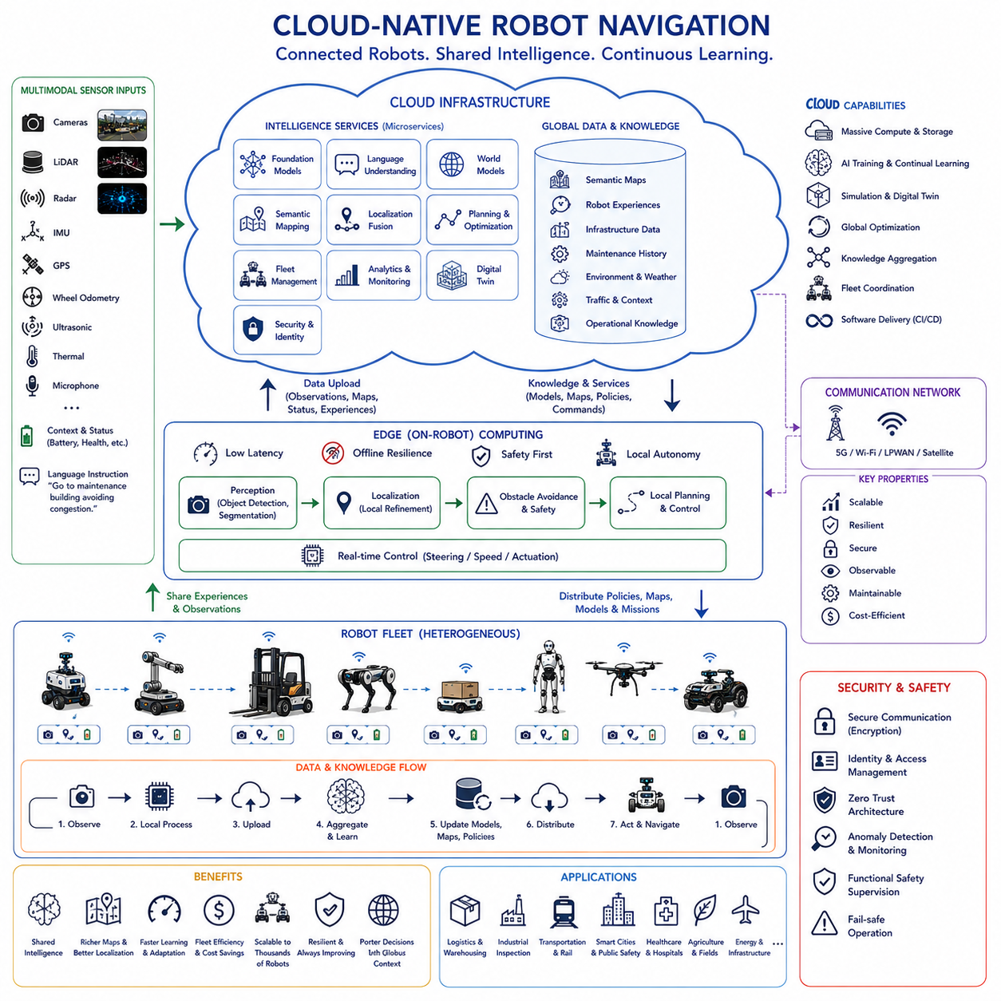
Cloud-native robot navigation represents the convergence of cloud computing, distributed intelligence, edge AI, robotics, and autonomous navigation into a unified computing paradigm. Rather than treating each robot as an isolated autonomous machine, cloud-native navigation views every robot as part of a continuously connected intelligent ecosystem where perception, planning, learning, mapping, optimization, and fleet coordination are shared across distributed computing resources. This architecture allows robots to benefit from collective intelligence while maintaining real-time autonomy at the edge.
Traditional autonomous navigation systems perform nearly all computation onboard the robot. Localization, perception, mapping, obstacle avoidance, planning, and control are executed using embedded processors installed inside individual robots. Although this architecture minimizes communication dependency, computational resources remain limited, knowledge sharing is difficult, and updating navigation capabilities across large robotic fleets requires considerable engineering effort. Cloud-native navigation addresses these limitations by distributing intelligence across edge devices, cloud infrastructure, and robotic platforms.
The cloud-native philosophy originates from modern software engineering principles including microservices, containerization, scalability, continuous deployment, distributed computing, and service-oriented architecture. Rather than implementing navigation as one monolithic application, navigation capabilities become collections of loosely coupled services that communicate through standardized APIs. Individual services evolve independently while remaining interoperable across heterogeneous robotic platforms.
Cloud computing provides virtually unlimited computational resources supporting robotics workloads impossible to execute entirely onboard mobile robots. Large foundation models, world models, digital twins, reinforcement learning, semantic mapping, multimodal reasoning, predictive analytics, and fleet optimization require substantial computational power. Cloud infrastructure enables these advanced capabilities while reducing hardware complexity on individual robots.
Edge computing complements cloud computing by executing latency-sensitive operations close to physical robots. Obstacle avoidance, emergency braking, local perception, motion control, localization refinement, and safety supervision continue operating on onboard computers even when communication with cloud services becomes temporarily unavailable. Cloud-native navigation therefore balances centralized intelligence with decentralized autonomy according to operational requirements.
Hybrid intelligence emerges naturally through cloud-edge collaboration. Immediate decisions requiring millisecond responses remain at the edge, while computationally intensive reasoning, long-term planning, global optimization, knowledge integration, and model training execute within cloud infrastructure. This division allows robots to achieve both real-time responsiveness and large-scale cognitive capability without sacrificing operational safety.
Cloud-native navigation continuously synchronizes knowledge among distributed robotic fleets. Every robot contributes newly acquired environmental observations, semantic maps, localization corrections, obstacle information, traversability estimates, infrastructure updates, and operational experience. Shared cloud services aggregate this information into continuously improving global knowledge bases benefiting every connected robotic platform.
Semantic mapping becomes significantly richer within cloud-native systems. Instead of maintaining isolated local maps, robots collaboratively construct large-scale semantic representations covering factories, hospitals, warehouses, ports, airports, campuses, transportation systems, industrial facilities, smart cities, and public infrastructure. Individual observations contribute to continuously evolving shared maps incorporating geometry, semantics, operational knowledge, maintenance history, environmental conditions, and accessibility information.
Collaborative localization improves positioning accuracy through distributed knowledge sharing. Multiple robots simultaneously observe overlapping environments while exchanging localization estimates, landmark observations, sensor corrections, and map updates. Cloud services integrate these observations into globally consistent localization frameworks supporting robust navigation even within complex or GPS-denied environments.
Fleet management becomes tightly integrated with navigation rather than existing as a separate supervisory system. Cloud-native architectures simultaneously optimize robot assignments, navigation routes, charging schedules, traffic management, mission priorities, maintenance planning, communication resources, and operational efficiency. Navigation therefore becomes part of comprehensive fleet intelligence rather than isolated path planning.
Foundation models benefit enormously from cloud-native deployment. Large multimodal models frequently exceed the computational capacity available on embedded robotic hardware. Cloud services host these foundation models while edge systems execute lightweight inference, caching, or distilled versions supporting low-latency operation. Continuous synchronization maintains consistency between centralized intelligence and distributed robotic execution.
Language-guided navigation naturally fits cloud-native architectures because natural language understanding frequently requires large language models and extensive knowledge bases. Human operators communicate with robots using conversational language while cloud-hosted foundation models interpret instructions, resolve ambiguity, retrieve operational knowledge, and generate high-level navigation objectives subsequently refined by edge navigation systems.
World models become significantly more capable through cloud-native computing. Large-scale predictive simulations evaluate weather evolution, traffic patterns, infrastructure degradation, pedestrian movement, equipment failures, environmental hazards, communication quality, and resource availability. Predictive reasoning generated in the cloud continuously informs local navigation decisions executed at the robotic edge.
Digital twins represent one of the strongest applications of cloud-native robotics. Virtual replicas continuously synchronize with physical environments using sensor data collected by distributed robotic fleets. Every navigation mission updates the digital twin while simulated experiences improve navigation policies before deployment. Physical and virtual environments therefore evolve together within continuous feedback loops.
Continuous learning becomes practical through cloud-native infrastructure. Individual robots collect multimodal operational experience during everyday navigation. These experiences synchronize with centralized learning systems where reinforcement learning, self-supervised learning, imitation learning, and foundation model adaptation continuously improve navigation capability. Updated policies subsequently propagate throughout the robotic fleet without requiring manual software installation.
Model deployment becomes significantly more efficient using cloud-native DevOps methodologies. Navigation software, perception models, localization algorithms, planning services, and reasoning modules are continuously tested, validated, versioned, monitored, and deployed using automated software pipelines. New navigation capabilities therefore become available rapidly while preserving operational stability through staged rollout procedures.
Microservice architectures improve maintainability and scalability. Navigation functionality becomes separated into localization services, semantic mapping services, route planning services, traffic coordination services, perception services, language services, fleet management services, diagnostic services, monitoring services, and analytics services. Independent development teams evolve these components without disrupting overall system integration.
Containerization further simplifies deployment across heterogeneous robotic hardware. Containers encapsulate navigation services together with required software libraries, runtime dependencies, operating environments, and communication interfaces. Robots with different processors, operating systems, or hardware configurations therefore execute identical navigation services while minimizing compatibility challenges.
Service discovery enables robots to dynamically locate available cloud services during operation. Navigation systems automatically identify localization servers, mapping services, semantic databases, language processing modules, optimization engines, and fleet coordinators according to network availability and operational requirements. Dynamic service allocation significantly increases system flexibility within changing computational environments.
Distributed databases store continuously evolving navigation knowledge. Maps, trajectories, infrastructure descriptions, maintenance records, environmental observations, traffic statistics, operational logs, and robot experiences become accessible across the entire robotic ecosystem. Consistent distributed storage ensures every authorized robotic platform benefits from accumulated organizational knowledge.
Streaming data pipelines enable continuous information exchange among robots and cloud infrastructure. Sensor observations, navigation status, anomaly reports, localization updates, mission progress, battery condition, communication quality, and environmental changes stream continuously through event-driven architectures supporting near real-time decision making across distributed robotic fleets.
Observability becomes increasingly important within cloud-native robotics. Monitoring systems continuously evaluate navigation latency, localization accuracy, communication performance, service availability, computational utilization, hardware health, anomaly frequency, safety interventions, model confidence, and operational efficiency. Comprehensive observability simplifies debugging while improving reliability and predictive maintenance.
Cybersecurity receives greater attention because cloud-native robots continuously exchange operational information across communication networks. Secure authentication, encrypted communication, access control, software integrity verification, intrusion detection, identity management, zero-trust networking, and continuous security monitoring become essential components of cloud-native navigation infrastructure protecting both robotic platforms and organizational assets.
Resilience remains fundamental despite increasing cloud dependency. Cloud-native navigation never assumes perfect communication availability. Robots continue safe operation using onboard perception, localization, planning, and control whenever connectivity becomes degraded. Cloud services enhance capability without becoming mandatory for immediate operational safety. Graceful degradation therefore becomes a defining architectural principle.
Context-aware navigation benefits from cloud-scale information integration. Weather forecasts, infrastructure maintenance schedules, temporary construction zones, pedestrian density, logistics demand, organizational priorities, emergency events, regulatory changes, and energy pricing all become available to navigation systems through cloud services. Robots therefore make decisions using substantially richer contextual information than locally observable environments alone.
Collaborative intelligence expands beyond navigation itself. Robots performing logistics, inspection, maintenance, cleaning, delivery, healthcare, agriculture, construction, and security all contribute useful environmental knowledge supporting collective navigation. Shared semantic understanding transforms independently operating robots into cooperative intelligent ecosystems continuously improving through mutual experience.
Cloud-native navigation also supports heterogeneous robotic fleets. Mobile manipulators, autonomous forklifts, quadrupeds, humanoids, warehouse robots, outdoor inspection vehicles, drones, and service robots share common cloud infrastructure despite possessing different mobility mechanisms and operational objectives. Unified navigation services reduce software duplication while encouraging knowledge transfer across robotic domains.
Energy optimization becomes more sophisticated because cloud infrastructure maintains global awareness of fleet activity. Charging station availability, mission urgency, traffic congestion, battery degradation, electricity pricing, and operational priorities collectively influence navigation planning. Fleet-wide optimization therefore improves resource utilization while extending operational lifetime.
Explainable AI integrates naturally into cloud-native systems because cloud infrastructure stores historical observations, planning decisions, reasoning traces, uncertainty estimates, and operational context. Human operators receive understandable explanations describing why navigation policies changed, why routes were modified, why tasks were reassigned, and how environmental observations influenced decision making. Transparent explanations improve trust and operational accountability.
Scalability distinguishes cloud-native navigation from earlier robotic architectures. Organizations no longer redesign software when expanding from ten robots to thousands. Elastic cloud infrastructure dynamically allocates computational resources according to fleet size, workload, environmental complexity, and operational demand. Navigation capability therefore grows proportionally with robotic deployment while maintaining consistent architectural principles.
Evaluation of cloud-native navigation extends beyond conventional navigation metrics. Performance includes cloud latency, edge responsiveness, synchronization efficiency, service availability, scalability, distributed consistency, collaborative mapping accuracy, fleet coordination quality, communication robustness, cybersecurity resilience, software deployment efficiency, model update reliability, operational continuity, and long-term organizational learning in addition to traditional navigation success and safety.
A representative deployment illustrates cloud-native navigation within a nationwide intelligent transportation and infrastructure management network supervising railways, electrical substations, renewable energy facilities, logistics hubs, industrial complexes, ports, airports, and smart cities. Thousands of heterogeneous autonomous robots continuously collect multimodal sensor observations while executing local perception, localization, obstacle avoidance, and safety supervision at the edge. Simultaneously, cloud infrastructure aggregates semantic maps, operational knowledge, maintenance history, infrastructure conditions, weather forecasts, traffic information, language interactions, and fleet telemetry into globally shared knowledge services. Foundation models hosted within cloud infrastructure interpret natural language mission requests, generate high-level objectives, retrieve engineering knowledge, and coordinate collaborative fleet behavior. World models simulate future environmental conditions before distributing predictive guidance toward edge navigation systems. Digital twins synchronize continuously with physical infrastructure while reinforcement learning and self-supervised learning improve navigation policies through accumulated operational experience. Every robot contributes new observations enriching semantic maps and predictive models immediately available across the entire robotic ecosystem. Service-oriented microarchitectures enable continuous software deployment without interrupting ongoing operations, while distributed databases preserve organizational memory accumulated over years of autonomous activity. Independent safety supervisors maintain certified functional safety regardless of communication quality, ensuring robots continue safe operation during temporary cloud disconnection. Consequently, the cloud-native navigation ecosystem becomes progressively more intelligent, adaptive, scalable, reliable, and efficient as collective knowledge accumulates throughout long-term deployment.
This deployment demonstrates that cloud-native robot navigation represents considerably more than connecting robots to remote servers. It establishes an integrated distributed intelligence architecture combining cloud computing, edge AI, foundation models, world models, digital twins, multimodal perception, semantic mapping, collaborative localization, continual learning, microservices, containerization, distributed databases, streaming analytics, fleet optimization, explainable AI, cybersecurity, resilience, and functional safety into unified robotic ecosystems. As cloud infrastructure, communication networks, edge computing, robotics foundation models, Physical AI, multimodal reasoning, and distributed autonomous systems continue advancing together, cloud-native navigation will increasingly replace isolated robotic intelligence with globally connected cognitive infrastructures capable of learning collectively, adapting continuously, sharing knowledge instantly, coordinating heterogeneous fleets, and autonomously supporting manufacturing, logistics, healthcare, agriculture, transportation, infrastructure inspection, disaster response, smart cities, planetary exploration, and countless future robotic applications operating at unprecedented scale.

25.4 Real-Time Global World Models
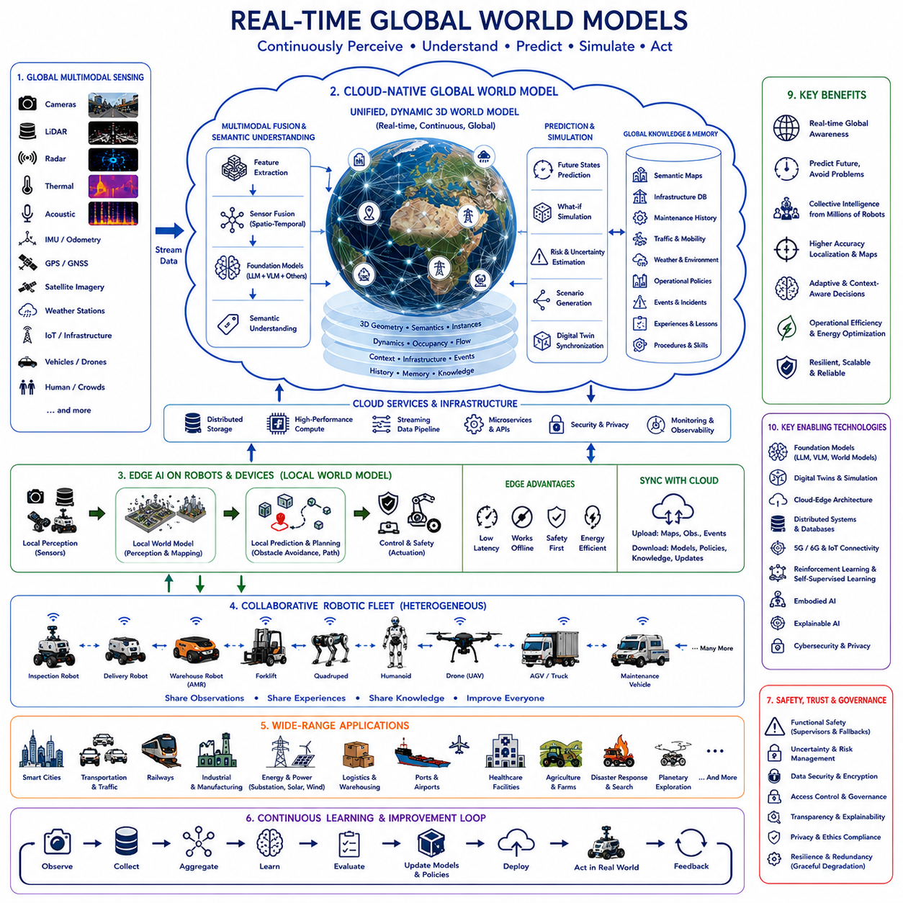
Real-time global world models represent one of the most ambitious developments in Physical AI because they extend traditional world models from individual robots to globally shared, continuously updated digital representations of the physical world. Instead of modeling only the immediate surroundings of a single robot, these systems integrate observations collected from millions of sensors, robots, vehicles, infrastructure devices, satellites, and cloud services into a unified dynamic representation of reality. The objective is not merely to store environmental information but to continuously understand, predict, and simulate the evolving state of the physical world in real time.
Conventional robotic world models are generally local in both space and time. A robot builds an internal representation of nearby obstacles, free space, semantic objects, and predicted motion using onboard sensors. Although highly effective for local navigation, these models remain limited by sensor range, computational capacity, and individual experience. Real-time global world models overcome these limitations by integrating distributed observations from numerous autonomous systems operating simultaneously across large geographic regions.
The concept combines robotics, cloud computing, edge AI, distributed sensing, multimodal foundation models, digital twins, large-scale simulation, and continuous learning into a unified cognitive infrastructure. Every connected robot becomes both a consumer and a producer of world knowledge. Local observations improve the global model, while the continuously refined global model improves the performance of every participating robot. Intelligence therefore becomes collective rather than individual.
Unlike static digital maps, global world models continuously evolve. Roads become blocked, weather changes, infrastructure degrades, equipment ages, people move, traffic fluctuates, vegetation grows, construction progresses, and operational priorities shift throughout the day. The world model continuously assimilates new observations while removing outdated information. Reality becomes represented as an evolving dynamic process rather than a fixed spatial database.
Multimodal sensing provides the foundation for constructing global world models. Cameras capture visual appearance. LiDAR measures geometry. Radar observes motion under adverse weather. Thermal cameras detect temperature anomalies. Acoustic sensors recognize environmental events. GPS and inertial sensors estimate movement. Satellite imagery provides large-scale coverage. Weather stations contribute atmospheric conditions. IoT devices monitor infrastructure. Together these heterogeneous sensing modalities describe the physical world from complementary perspectives.
Sensor fusion occurs across both space and time. Information collected by different robotic platforms operating in separate locations becomes integrated into coherent global representations. Observations collected minutes, hours, or days apart contribute to long-term environmental understanding while recent measurements preserve current operational awareness. The model therefore maintains both historical memory and real-time situational awareness simultaneously.
Cloud-native infrastructure enables world models to scale globally. Massive distributed databases store semantic maps, infrastructure descriptions, environmental observations, maintenance records, transportation networks, operational policies, weather information, and historical experience. High-performance cloud computing continuously updates predictive models while supporting thousands or millions of simultaneous robotic clients accessing shared world knowledge.
Edge computing ensures that global intelligence remains practical for real-time robotics. Robots maintain local world models capable of independent operation while periodically synchronizing with global cloud services. Immediate navigation decisions continue executing locally, whereas computationally intensive reasoning, prediction, large-scale optimization, and knowledge integration occur within cloud infrastructure. This hybrid architecture balances responsiveness with computational capability.
Foundation models dramatically improve the semantic richness of global world models. Rather than storing only geometric information, foundation models interpret environmental meaning using language, visual understanding, engineering knowledge, operational procedures, and commonsense reasoning. Buildings become hospitals, warehouses, substations, factories, schools, or transportation hubs rather than anonymous geometric structures. Roads become emergency routes, maintenance corridors, restricted areas, or pedestrian zones depending upon operational context.
Language provides an intuitive interface for interacting with global world models. Human operators ask natural questions regarding environmental conditions, navigation constraints, infrastructure status, maintenance history, weather evolution, operational priorities, or predicted risks. Large language models retrieve relevant knowledge while integrating semantic understanding, spatial reasoning, and temporal prediction into conversational responses supporting both robotic autonomy and human decision making.
World models extend beyond perception by incorporating predictive simulation. Every environmental state serves as the starting point for numerous possible future scenarios. Traffic evolution, pedestrian movement, weather progression, equipment degradation, structural fatigue, energy demand, communication quality, and mission execution are continuously simulated. Predictive capability enables robots to avoid future problems rather than merely reacting after they occur.
Digital twins provide virtual environments synchronized continuously with physical reality. Every robot, sensor, infrastructure component, vehicle, and operational process updates corresponding virtual representations. Changes occurring within physical systems immediately influence digital twins, while simulation results improve future operational planning. Physical and virtual environments therefore remain tightly coupled through continuous bidirectional information exchange.
Temporal reasoning becomes increasingly important because environments change continuously. Global world models preserve long-term historical information describing seasonal variation, maintenance history, traffic patterns, weather cycles, infrastructure aging, operational schedules, and human activity. Simultaneously they emphasize recent observations supporting immediate operational decisions. Intelligent reasoning therefore combines historical trends with current situational awareness.
Memory architectures become substantially richer than traditional robotic mapping systems. Episodic memory preserves individual operational events. Semantic memory stores generalized environmental knowledge. Spatial memory continuously refines global maps. Procedural memory records successful operational strategies. Predictive memory captures expected future evolution. Together these complementary memory systems transform world models into continuously expanding organizational knowledge repositories.
Collaborative mapping becomes a natural consequence of globally shared world models. Thousands of heterogeneous robots simultaneously explore warehouses, factories, railways, ports, airports, hospitals, agricultural fields, highways, smart cities, industrial facilities, and public infrastructure. Every observation contributes incremental refinement to shared semantic maps immediately benefiting every connected autonomous system.
Collaborative localization also improves substantially. Rather than estimating position independently, robots utilize globally maintained landmark databases, semantic features, infrastructure geometry, and collective localization corrections accumulated from numerous previous observations. Position estimation therefore becomes progressively more accurate as additional robots contribute experience over time.
Context awareness distinguishes global world models from conventional mapping systems. Navigation decisions depend not only upon geometry but also upon weather forecasts, maintenance schedules, regulatory changes, emergency situations, pedestrian density, energy availability, communication quality, organizational priorities, and infrastructure health. Context continuously modifies interpretation of identical physical environments according to current operational circumstances.
Embodied AI contributes experiential knowledge unavailable through remote sensing alone. Physical interaction reveals terrain friction, surface compliance, wheel slip, actuator load, vibration, accessibility, manipulation feasibility, structural stability, and operational difficulty. Robots therefore enrich global world models through direct physical experience complementing visual observation and environmental sensing.
Reinforcement learning continuously improves predictive world models through accumulated operational experience. Successful navigation strategies, recovery procedures, inspection policies, resource allocation methods, and collaborative behaviors generate long-term reward signals refining future prediction accuracy. Continuous learning transforms world models from passive databases into adaptive cognitive systems improving throughout deployment.
Self-supervised learning further accelerates world model development. Every observation naturally predicts subsequent observations. Motion predicts visual change. Environmental conditions predict sensor behavior. Infrastructure characteristics predict maintenance requirements. These naturally occurring relationships provide abundant supervision without requiring extensive manual annotation. World models therefore improve autonomously as robotic ecosystems expand.
Uncertainty estimation becomes an essential capability. Every environmental observation includes measurement uncertainty arising from sensor noise, communication latency, weather conditions, localization error, or incomplete coverage. Rather than assuming perfect information, world models explicitly represent confidence levels supporting risk-aware planning, robust navigation, and adaptive decision making under incomplete knowledge.
Scalability presents significant engineering challenges. Millions of robots continuously generating multimodal observations produce enormous data volumes. Efficient storage, distributed indexing, intelligent compression, incremental updates, semantic retrieval, and prioritized synchronization become fundamental requirements. Cloud-native distributed architectures provide elasticity allowing computational resources to scale according to operational demand.
Cybersecurity becomes increasingly important because globally shared world models influence critical physical infrastructure. Secure authentication, encrypted communication, software integrity verification, anomaly detection, identity management, access control, zero-trust networking, and continuous monitoring protect shared environmental knowledge from accidental corruption and malicious manipulation. Trustworthy information becomes essential for safe autonomous operation.
Resilience ensures continued operation despite communication failures or partial information loss. Individual robots preserve local world models supporting independent navigation whenever cloud connectivity becomes unavailable. Once communication resumes, accumulated observations synchronize automatically with the global model. Distributed architecture therefore tolerates network interruptions while maintaining operational continuity.
Explainable AI becomes essential because world models increasingly influence high-level autonomous decision making. Human operators require understandable explanations describing why predictions changed, why navigation routes were modified, why infrastructure risks increased, or why maintenance priorities shifted. Transparent reasoning strengthens trust, supports certification, simplifies debugging, and improves collaborative human supervision.
Ethical considerations become increasingly significant as global world models integrate large quantities of environmental and human activity data. Privacy protection, responsible data governance, fairness, transparency, accountability, and regulatory compliance must accompany technical capability. World models should enhance societal benefit while respecting legal and ethical constraints regarding data collection and autonomous decision making.
Interoperability enables heterogeneous robotic platforms to share common world knowledge despite differences in hardware, mobility, sensing, and operational objectives. Standardized semantic representations, communication protocols, coordinate systems, map formats, ontology definitions, and service interfaces ensure robots from different manufacturers contribute effectively to common global cognitive infrastructure.
Energy optimization benefits substantially from globally shared knowledge. Weather predictions, terrain conditions, charging infrastructure, electricity pricing, traffic congestion, mission urgency, battery health, and fleet activity become integrated into predictive planning. Robots therefore optimize both navigation and long-term operational sustainability using information unavailable through local sensing alone.
Evaluation of real-time global world models extends beyond mapping accuracy. Performance includes semantic consistency, prediction accuracy, synchronization latency, scalability, collaborative localization quality, knowledge freshness, uncertainty estimation, simulation fidelity, resilience, cybersecurity, explainability, continual learning, interoperability, computational efficiency, and long-term operational improvement across large autonomous ecosystems.
A representative deployment illustrates a global world model supporting nationwide railway infrastructure, electrical substations, renewable energy facilities, logistics centers, industrial parks, ports, airports, highways, and smart cities. Millions of distributed sensors, autonomous inspection robots, maintenance vehicles, drones, weather stations, IoT devices, surveillance systems, and satellite observations continuously update a unified cloud-native world model. Foundation models transform multimodal observations into semantic knowledge describing infrastructure condition, operational context, environmental evolution, maintenance history, transportation activity, human behavior, and engineering relationships. World models simulate future weather, traffic, equipment degradation, structural fatigue, communication quality, energy demand, and mission execution before recommending adaptive navigation strategies. Digital twins synchronize physical infrastructure with large-scale virtual simulation environments supporting reinforcement learning, self-supervised learning, and predictive maintenance. Collaborative robotic fleets share semantic maps, localization corrections, traversability estimates, anomaly observations, operational experience, and mission outcomes through distributed cloud services. Edge AI maintains safe autonomous operation during communication interruptions while cloud infrastructure continuously improves predictive models using accumulated global knowledge. Explainable AI communicates prediction rationale, uncertainty, confidence estimates, environmental changes, and operational recommendations through natural language supporting both autonomous robots and human operators. Throughout years of deployment, every observation contributes to continuously expanding organizational intelligence, allowing the entire robotic ecosystem to become progressively more adaptive, predictive, reliable, efficient, and resilient.
This example demonstrates that real-time global world models represent far more than larger digital maps or centralized databases. They establish continuously evolving cognitive infrastructures combining distributed sensing, multimodal perception, foundation models, world models, digital twins, cloud computing, edge AI, collaborative mapping, predictive simulation, continual learning, embodied intelligence, semantic reasoning, explainable AI, cybersecurity, interoperability, uncertainty estimation, and Physical AI into globally shared representations of the physical world. As communication networks, cloud infrastructure, robotics foundation models, multimodal reasoning, distributed autonomous systems, digital twins, and embodied AI continue advancing together, real-time global world models will become one of the fundamental technologies enabling future intelligent robotic civilizations where millions of autonomous systems collectively perceive, understand, predict, and continuously improve their shared understanding of the physical world across manufacturing, logistics, healthcare, agriculture, transportation, infrastructure inspection, disaster response, smart cities, planetary exploration, and countless future Physical AI applications.

25.5 Autonomous Navigation for Humanoids
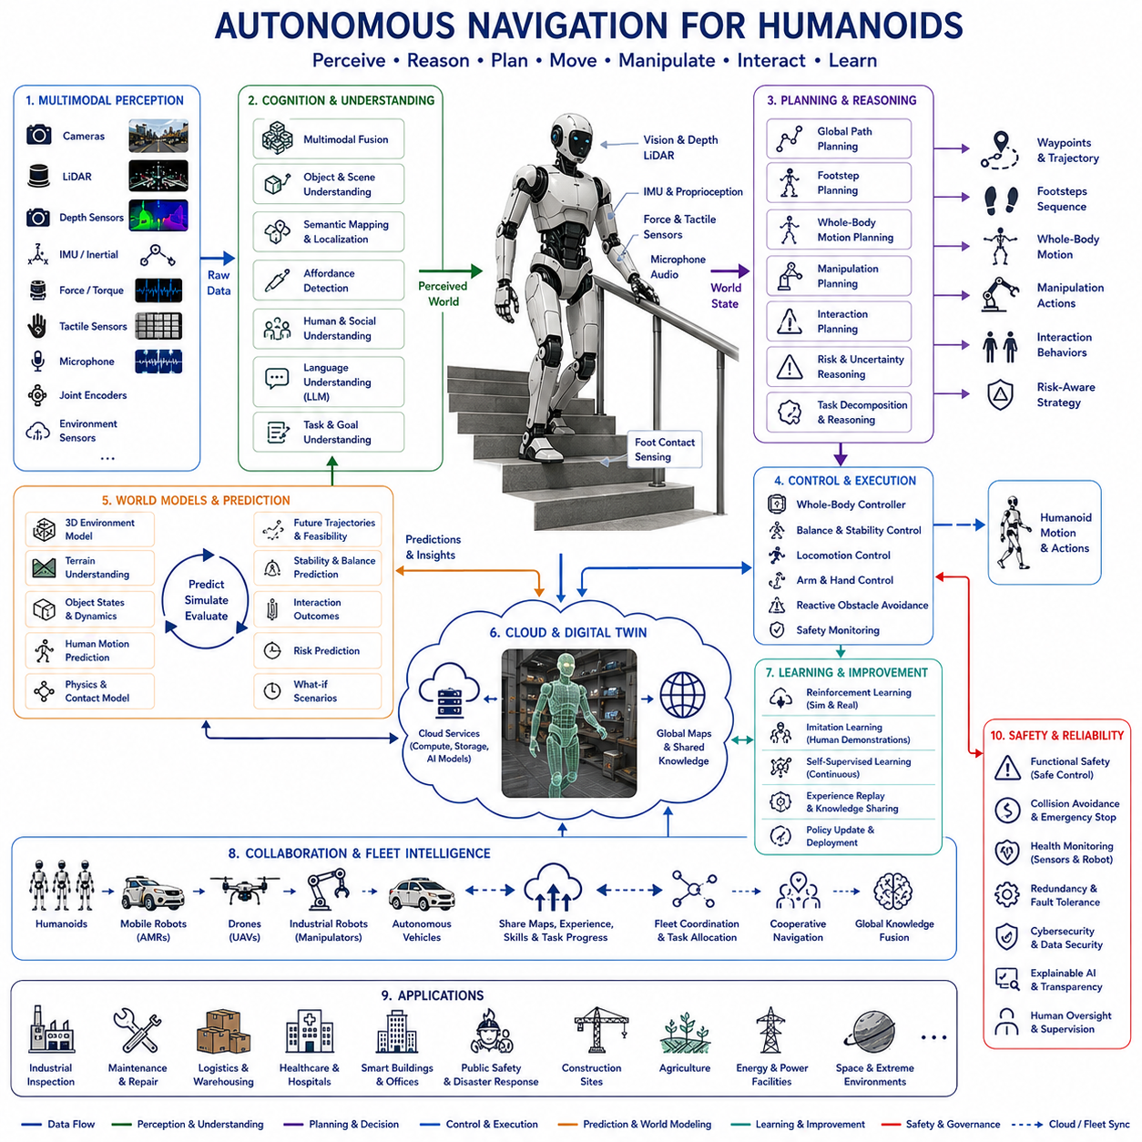
Humanoid robots introduce a fundamentally different navigation problem from wheeled mobile robots because navigation is no longer limited to moving a vehicle through an environment. A humanoid must coordinate perception, balance, whole-body motion, manipulation, environmental interaction, and social behavior simultaneously. Autonomous navigation therefore becomes a comprehensive embodiment problem in which locomotion, cognition, reasoning, and physical interaction are tightly integrated. Rather than simply avoiding obstacles, humanoids continuously decide where to step, how to maintain stability, how to interact with surrounding objects, and how to accomplish complex tasks while moving through environments originally designed for humans.
Traditional mobile robots typically assume relatively simple motion constraints. Wheeled robots move primarily on flat floors, forklifts operate in warehouses, and autonomous vehicles travel along roads. Humanoid robots inherit the mobility characteristics of humans, enabling them to climb stairs, traverse uneven terrain, step over obstacles, squeeze through narrow passages, open doors, operate elevators, manipulate tools, and navigate spaces inaccessible to conventional mobile platforms. This expanded mobility dramatically increases environmental complexity while simultaneously expanding operational capability.
The motivation for humanoid navigation originates from the structure of human environments. Nearly every building, factory, hospital, office, home, transportation system, and industrial facility has been designed around human body dimensions and human locomotion capabilities. Door handles, staircases, ladders, control panels, tools, furniture, machinery, switches, cabinets, and safety equipment all assume bipedal operation. Rather than redesigning infrastructure for robots, humanoid navigation seeks to enable robots to adapt naturally to existing environments.
Locomotion forms the physical foundation of humanoid navigation. Stable bipedal walking requires continuous coordination of body posture, foot placement, center of mass, momentum, joint torques, ground reaction forces, and environmental contact. Unlike wheeled robots that maintain continuous ground support, humanoids repeatedly transition through dynamically unstable phases during every walking cycle. Navigation therefore depends upon both global path planning and continuous balance control.
Dynamic stability represents one of the defining challenges. A humanoid constantly predicts whether future body motion will remain physically stable while executing planned navigation trajectories. Whole-body controllers estimate center of pressure, zero moment point, capture point, angular momentum, and body dynamics in real time. Navigation planning therefore becomes tightly coupled with biomechanical stability rather than existing as an independent software module.
Perception requirements are considerably broader than traditional navigation. Humanoid robots continuously interpret floor conditions, stair geometry, step height, obstacle shape, surface friction, handrail availability, object affordances, human activity, environmental semantics, and free-space accessibility. Cameras, LiDAR, depth sensors, IMUs, force sensors, tactile sensing, joint encoders, microphones, and environmental sensors jointly construct rich multimodal representations supporting both locomotion and manipulation.
Multimodal sensor fusion enables humanoids to understand environments at both geometric and semantic levels. Visual information identifies objects and people. Depth sensing reconstructs three-dimensional structure. Force sensing detects physical contact. Tactile sensing recognizes surface interaction. Audio sensing identifies environmental events. Joint proprioception measures body configuration. Together these sensing modalities create comprehensive situational awareness supporting adaptive whole-body navigation.
Foundation models increasingly serve as the cognitive core of humanoid navigation. Large multimodal models integrate language understanding, visual reasoning, commonsense knowledge, engineering procedures, spatial reasoning, and physical interaction into unified representations. Rather than recognizing isolated objects, humanoids understand functional relationships among tools, furniture, infrastructure, people, operational procedures, and environmental context. Navigation therefore becomes knowledge-guided rather than purely geometry-driven.
Language-guided navigation allows humans to communicate naturally with humanoid robots. Instructions such as “Walk upstairs, enter the control room, inspect the emergency panel beside the generator, and return through the maintenance corridor” require semantic understanding, environmental grounding, memory retrieval, reasoning, task decomposition, and adaptive navigation. Large language models translate these high-level goals into coordinated locomotion and manipulation behaviors.
World models substantially improve humanoid navigation by enabling predictive reasoning before physical movement. Candidate walking trajectories, body motions, manipulation sequences, and interaction strategies are internally simulated prior to execution. Future body balance, collision risk, environmental accessibility, human interaction, and task feasibility are evaluated through predictive simulation. Planning therefore becomes proactive rather than reactive.
Embodied AI provides the conceptual foundation for humanoid navigation because intelligence emerges through continuous interaction among perception, movement, manipulation, environmental feedback, and accumulated experience. Every step changes future observations, while every physical interaction provides new information regarding terrain, object properties, body dynamics, and environmental constraints. Navigation therefore becomes an active learning process driven by embodied experience.
Whole-body planning distinguishes humanoid navigation from conventional mobile robotics. Navigation decisions simultaneously coordinate foot placement, upper-body posture, arm movement, head orientation, visual attention, manipulation readiness, balance recovery, and environmental interaction. Motion planning therefore optimizes the entire body rather than only vehicle trajectory. Whole-body optimization enables natural movement through cluttered and dynamically changing environments.
Footstep planning becomes a specialized navigation problem unique to legged robots. Every walking sequence requires selecting stable footholds satisfying kinematic reachability, dynamic stability, obstacle avoidance, surface friction, terrain geometry, and future task requirements. Adaptive footstep generation continuously updates walking plans according to changing environmental conditions while preserving long-term navigation objectives.
Terrain understanding plays an increasingly important role. Humanoid robots classify surfaces according to slope, roughness, deformability, slipperiness, compliance, stability, and traversability. Uneven terrain, loose gravel, wet floors, stairs, ladders, ramps, grass, sand, rubble, and damaged infrastructure all require different locomotion strategies. Foundation models integrate visual appearance with physical prediction to estimate terrain properties before contact occurs.
Manipulation and navigation become inseparable during complex missions. Humanoids frequently open doors, push carts, move obstacles, operate switches, carry equipment, hold handrails, press elevator buttons, manipulate tools, and interact with machinery while navigating. Planning therefore coordinates locomotion and manipulation within unified behavioral policies rather than treating them as independent robotic capabilities.
Human-aware navigation becomes essential because humanoids operate in close proximity to people. Navigation behavior incorporates interpersonal distance, body language, gaze direction, crowd movement, workplace etiquette, accessibility requirements, collaborative interaction, and implicit social conventions. Safe navigation therefore includes social intelligence alongside physical collision avoidance.
Collaborative navigation extends toward heterogeneous robotic ecosystems. Humanoids exchange semantic maps, localization information, environmental observations, manipulation knowledge, and task progress with mobile robots, drones, industrial manipulators, autonomous vehicles, and cloud infrastructure. Shared knowledge enables coordinated operation across multiple robotic platforms possessing complementary capabilities.
Cloud-native architectures significantly enhance humanoid navigation by distributing intelligence across onboard computing and cloud infrastructure. Immediate balance control, perception, and locomotion remain onboard, while foundation models, world models, digital twins, semantic reasoning, fleet coordination, and large-scale optimization execute within cloud services. This hybrid architecture combines real-time responsiveness with virtually unlimited computational resources.
Digital twins continuously synchronize physical humanoids with virtual simulation environments. Every navigation episode updates corresponding digital representations describing body dynamics, environmental interaction, infrastructure condition, and operational experience. Reinforcement learning, imitation learning, and self-supervised learning subsequently improve locomotion policies using accumulated simulation and real-world observations before deploying updated capabilities back to physical robots.
Reinforcement learning enables humanoids to optimize walking efficiency, balance recovery, obstacle negotiation, energy consumption, manipulation coordination, and long-term mission success through repeated interaction. Large-scale simulation produces millions of locomotion experiences impossible to collect physically. Learned policies subsequently transfer toward physical humanoids through sim-to-real adaptation supported by foundation models and world models.
Imitation learning accelerates navigation development by incorporating human demonstrations. Motion capture systems, teleoperation, wearable sensors, and expert demonstrations provide examples of natural walking, climbing, recovery, manipulation, collaborative movement, and workplace operation. Humanoids learn behavioral principles rather than memorizing exact joint trajectories, allowing adaptation across previously unseen environments.
Self-supervised learning continuously improves navigation throughout deployment. Every walking sequence generates relationships among vision, proprioception, force sensing, environmental response, and body dynamics. These naturally occurring sensor correlations provide abundant learning signals without manual annotation. Navigation policies therefore improve autonomously as humanoids accumulate operational experience over months and years.
Energy-aware locomotion becomes increasingly important because humanoids consume substantially more energy than wheeled robots. Navigation policies jointly optimize path length, walking speed, body posture, manipulation effort, terrain difficulty, battery consumption, and mission duration. Intelligent locomotion therefore balances operational efficiency with physical capability while maximizing useful working time.
Functional safety remains indispensable despite advances in AI capability. Independent safety supervisors continuously verify actuator integrity, balance margins, sensor health, communication reliability, joint limits, collision avoidance, emergency stopping, and environmental hazards before permitting physical execution. Learned navigation policies operate within certified safety boundaries ensuring predictable behavior under unexpected conditions.
Explainable AI improves trust in humanoid operation by generating understandable explanations describing navigation decisions, balance adjustments, route modifications, manipulation choices, uncertainty estimates, and recovery behaviors. Human supervisors therefore understand not only what actions humanoids perform but also why those actions were selected under changing environmental conditions.
Generalization represents one of the primary research objectives. Humanoid robots must operate successfully within homes, hospitals, warehouses, factories, transportation terminals, power plants, construction sites, agricultural facilities, disaster environments, offices, and public infrastructure without extensive environment-specific engineering. Foundation models, world models, multimodal learning, continual learning, and embodied experience collectively support this broad adaptation capability.
Scalability extends humanoid navigation beyond isolated robots toward organizational intelligence. Knowledge acquired by one humanoid becomes immediately available to entire fleets through cloud-native knowledge sharing. Walking strategies, semantic maps, manipulation procedures, infrastructure knowledge, safety experience, and operational best practices continuously propagate across globally distributed robotic systems.
Evaluation of humanoid navigation extends far beyond conventional path-following benchmarks. Performance includes walking stability, dynamic balance, energy efficiency, terrain adaptability, manipulation coordination, human interaction quality, semantic understanding, task completion, recovery capability, prediction accuracy, multimodal reasoning, cloud synchronization, continual learning, explainability, safety compliance, and long-term operational reliability. Comprehensive evaluation reflects the integrated nature of embodied autonomous intelligence.
A representative deployment illustrates autonomous humanoid navigation within a nationwide intelligent infrastructure management system supporting power plants, railway stations, airports, logistics centers, industrial facilities, hospitals, government buildings, and smart cities. Humanoid robots receive multimodal observations from cameras, LiDAR, depth sensors, force sensors, tactile sensing, microphones, IMUs, and cloud services while continuously synchronizing with global semantic maps and digital twins. Foundation models interpret natural language maintenance requests, engineering documentation, operational procedures, and environmental context before decomposing high-level missions into coordinated locomotion, manipulation, inspection, and reporting behaviors. World models simulate future walking trajectories, body balance, environmental interaction, equipment accessibility, and operational risks before every major movement. Whole-body controllers maintain dynamic stability while adaptive footstep planners negotiate stairs, uneven terrain, damaged infrastructure, narrow corridors, ladders, elevators, and crowded public spaces. Collaborative cloud-native infrastructure enables humanoids to exchange navigation experience, semantic knowledge, maintenance history, infrastructure observations, and recovery strategies with autonomous mobile robots, drones, and centralized operational systems. Reinforcement learning, imitation learning, self-supervised learning, and digital twins continuously improve locomotion capability using accumulated operational experience without interrupting ongoing field deployment. Independent functional safety systems supervise every movement while explainable AI communicates navigation rationale, confidence estimates, uncertainty, predicted risks, and recovery strategies through natural language interfaces supporting human supervisors. Over years of continuous deployment, every successful mission enriches shared organizational knowledge, allowing humanoid fleets to become progressively more adaptive, reliable, efficient, collaborative, and capable across increasingly diverse operational environments.
This example demonstrates that autonomous navigation for humanoids represents considerably more than extending wheeled robot navigation toward bipedal locomotion. It establishes a comprehensive embodied intelligence architecture integrating multimodal perception, foundation models, world models, embodied AI, whole-body control, footstep planning, semantic reasoning, language understanding, reinforcement learning, imitation learning, self-supervised learning, cloud-native robotics, digital twins, collaborative intelligence, explainable AI, functional safety, and continual learning into unified cognitive systems. As robotics foundation models, Physical AI, embodied reasoning, cloud computing, multimodal world models, digital twins, and humanoid hardware continue advancing together, autonomous humanoid navigation will increasingly enable robots to operate naturally within human environments while performing complex physical work, collaborating safely with people, adapting continuously through experience, and supporting manufacturing, logistics, healthcare, public infrastructure, disaster response, agriculture, transportation, construction, planetary exploration, and countless future applications requiring truly general-purpose embodied intelligence.

25.6 Smart City Robot Ecosystems
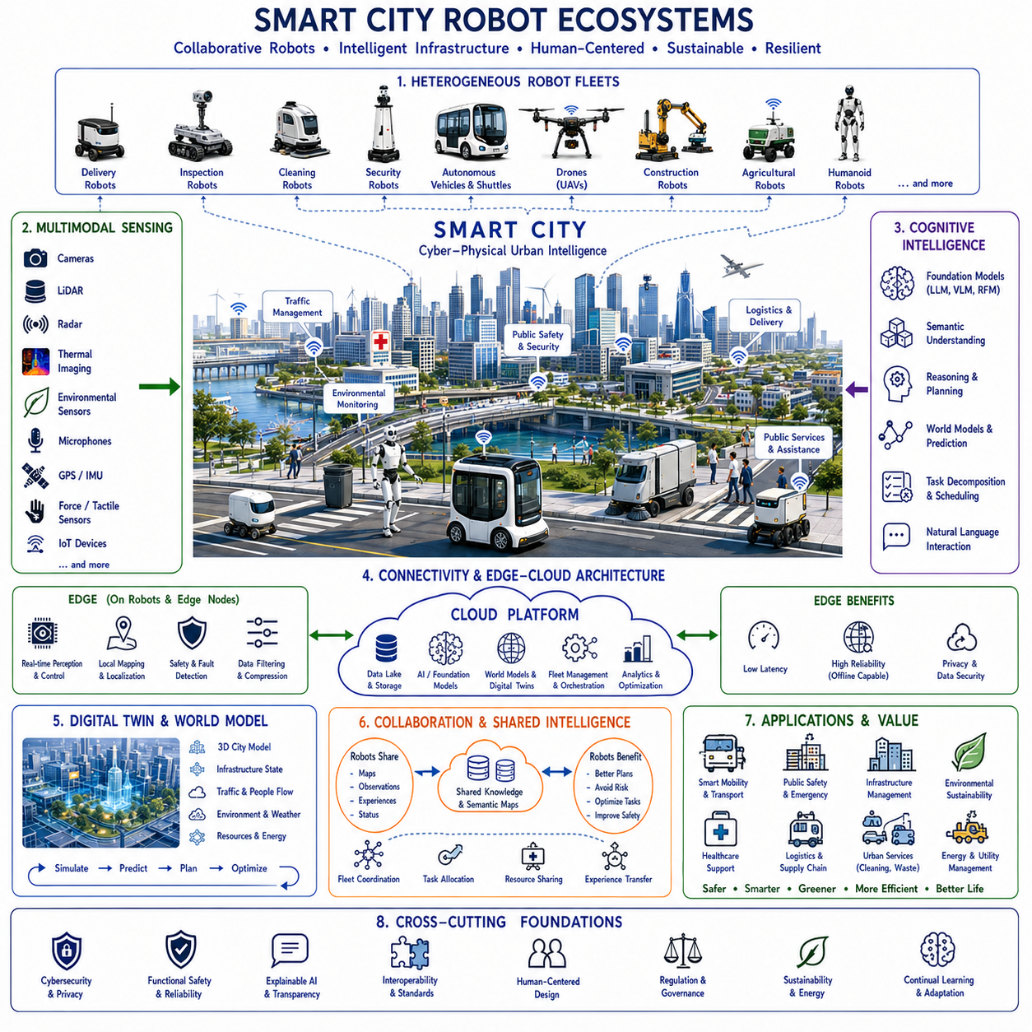
Smart city robot ecosystems represent the evolution of autonomous robotics from individual intelligent machines into large-scale collaborative urban infrastructures. Rather than viewing robots as isolated service providers performing independent tasks, smart city ecosystems integrate heterogeneous robotic platforms, cloud intelligence, edge computing, digital twins, foundation models, communication networks, public infrastructure, and human organizations into continuously coordinated urban intelligence. The city itself gradually becomes an intelligent cyber-physical system where robots, infrastructure, and people cooperate to improve safety, efficiency, sustainability, resilience, and quality of life.
Traditional robotic deployments usually focus on individual applications such as warehouse logistics, hospital delivery, security patrol, street cleaning, or infrastructure inspection. Each robotic system operates independently using dedicated software, proprietary maps, isolated communication channels, and separate operational management. Although these systems successfully automate individual tasks, they rarely exchange knowledge or coordinate decisions across organizational boundaries. Smart city robot ecosystems eliminate these silos by establishing shared cognitive infrastructure supporting collaborative intelligence among diverse autonomous systems.
The motivation for smart city robot ecosystems originates from rapid urbanization and increasing societal complexity. Modern cities contain transportation networks, utility infrastructure, hospitals, schools, airports, ports, factories, commercial districts, residential communities, emergency services, environmental monitoring systems, and public safety organizations. These interconnected systems continuously generate enormous amounts of information requiring real-time perception, prediction, coordination, and adaptive decision making. Autonomous robots become distributed physical agents extending digital intelligence into the real urban environment.
Unlike conventional smart city platforms that primarily collect data from fixed infrastructure, robot ecosystems introduce active mobility into urban intelligence. Mobile robots continuously explore environments, inspect infrastructure, transport materials, monitor environmental conditions, assist people, collect high-resolution observations, perform maintenance, and respond to unexpected events. Their mobility dramatically expands spatial coverage while enabling direct physical interaction with the environment rather than passive sensing alone.
Heterogeneous robotic fleets form the operational foundation of urban ecosystems. Autonomous delivery robots manage last-mile logistics. Inspection robots monitor bridges, tunnels, railways, pipelines, and electrical substations. Cleaning robots maintain public facilities. Security robots patrol transportation hubs and commercial districts. Autonomous buses and shuttles support mobility. Construction robots assist infrastructure projects. Agricultural robots manage urban farming. Drones monitor traffic, disasters, and environmental conditions. Humanoid robots perform complex maintenance and public assistance tasks requiring human-like mobility and manipulation.
Every robotic platform contributes unique sensing capability. Cameras observe visual conditions. LiDAR measures three-dimensional geometry. Radar detects movement in adverse weather. Thermal cameras identify abnormal heat signatures. Environmental sensors measure air quality, temperature, humidity, vibration, and noise. GPS, inertial sensors, and communication networks continuously estimate location and coordination. Together these sensing modalities create comprehensive multimodal awareness spanning the entire urban environment.
Multimodal sensor fusion enables robots to interpret cities far beyond geometric mapping. Infrastructure becomes semantically meaningful rather than merely spatial. Roads become transportation corridors, emergency access routes, pedestrian zones, maintenance areas, or construction sites according to operational context. Buildings become hospitals, schools, factories, residential complexes, power facilities, or logistics centers. Foundation models integrate visual observations, language, engineering knowledge, regulations, and commonsense reasoning into unified urban understanding.
Foundation models increasingly become the cognitive core of smart city ecosystems. Large multimodal models understand infrastructure semantics, operational procedures, public services, maintenance documentation, transportation regulations, emergency protocols, environmental knowledge, and human communication. Rather than solving isolated robotic tasks, foundation models coordinate reasoning across thousands of heterogeneous robots simultaneously operating throughout metropolitan environments.
Cloud-native robotics provides the computational infrastructure supporting urban-scale intelligence. Immediate perception, obstacle avoidance, localization, and safety control execute onboard individual robots, while large-scale reasoning, fleet optimization, semantic mapping, world modeling, predictive analytics, foundation model inference, and organizational knowledge management execute within cloud infrastructure. This hybrid architecture balances real-time responsiveness with virtually unlimited computational capability.
Edge AI ensures operational resilience despite communication uncertainty. Every robot preserves sufficient onboard intelligence to continue safe operation during temporary network interruptions. Once communication resumes, accumulated observations synchronize with centralized cloud services. Distributed intelligence therefore maintains operational continuity while continuously benefiting from globally shared knowledge.
Digital twins establish continuously synchronized virtual representations of entire cities. Buildings, transportation systems, utility infrastructure, public facilities, robots, vehicles, environmental conditions, energy systems, and human activity continuously update corresponding digital models. Urban planners evaluate future infrastructure changes through simulation before physical deployment. Operational decisions therefore become increasingly predictive rather than reactive.
World models significantly expand urban intelligence by predicting future environmental evolution. Traffic congestion, pedestrian movement, weather progression, energy demand, infrastructure degradation, emergency incidents, construction schedules, pollution distribution, and public transportation utilization are continuously simulated. Robots therefore navigate according to anticipated future conditions instead of responding only to current observations.
Collaborative mapping enables multiple robotic fleets to construct continuously evolving semantic city models. Every delivery mission, inspection activity, maintenance operation, cleaning route, or security patrol contributes new environmental observations. Shared maps immediately improve navigation, planning, localization, and operational efficiency for every connected robotic platform regardless of manufacturer or application domain.
Collaborative localization similarly benefits from globally shared observations. Robots continuously exchange landmark recognition, semantic features, infrastructure geometry, localization corrections, and environmental changes. Position estimation therefore becomes progressively more accurate as additional robotic systems contribute operational experience throughout months and years of deployment.
Human-centered design remains fundamental because cities ultimately exist for people rather than robots. Autonomous systems respect pedestrian movement, accessibility requirements, privacy, public safety, cultural norms, workplace procedures, and legal regulations. Human-aware navigation enables robots to operate naturally within crowded urban environments while minimizing disruption and maximizing social acceptance.
Natural language interaction significantly improves accessibility. Citizens request public services, navigation assistance, infrastructure information, emergency support, transportation guidance, or maintenance reporting through conversational interfaces. Large language models interpret these requests while coordinating appropriate robotic resources according to operational priorities, environmental context, and available capabilities.
Embodied AI allows robots to contribute knowledge unavailable through fixed sensors alone. Physical interaction reveals terrain quality, infrastructure condition, surface friction, equipment accessibility, structural stability, environmental hazards, manipulation feasibility, and operational complexity. Every robot therefore expands collective understanding through direct physical experience rather than passive observation.
Reinforcement learning continuously optimizes ecosystem-wide performance rather than isolated robotic behavior. Resource allocation, traffic coordination, energy management, collaborative inspection, maintenance scheduling, emergency response, logistics routing, and service quality improve through accumulated operational experience. Learning therefore occurs across the entire urban ecosystem rather than within individual robots alone.
Self-supervised learning further accelerates knowledge acquisition. Continuous multimodal observations naturally generate predictive relationships among vision, infrastructure state, environmental evolution, traffic flow, human activity, weather conditions, and operational outcomes. Massive urban datasets therefore improve foundation models without requiring extensive manual annotation or handcrafted engineering rules.
Continual learning enables cities themselves to become progressively more intelligent. Infrastructure upgrades, seasonal weather patterns, evolving transportation networks, demographic changes, regulatory updates, and operational experience continuously refine predictive models. Smart city ecosystems therefore adapt organically as urban environments evolve over years and decades.
Fleet coordination extends beyond individual organizations. Municipal governments, transportation authorities, utility companies, logistics providers, healthcare systems, emergency responders, construction contractors, environmental agencies, and commercial enterprises share selected operational knowledge while preserving security and organizational autonomy. Interoperable robotic ecosystems maximize public benefit through coordinated resource utilization.
Interoperability becomes essential because smart cities inevitably contain robots produced by numerous manufacturers. Standard communication protocols, semantic ontologies, coordinate systems, service interfaces, cybersecurity frameworks, and shared mapping standards enable heterogeneous robotic platforms to cooperate effectively despite differing hardware, software, sensing capabilities, and operational objectives.
Cybersecurity represents a critical architectural requirement. Smart city robot ecosystems directly influence transportation, energy distribution, communications, healthcare, emergency response, and public safety. Secure authentication, encrypted communication, identity management, software integrity verification, anomaly detection, zero-trust networking, continuous monitoring, and resilient system architecture protect critical infrastructure against both accidental failures and malicious attacks.
Functional safety remains independent from AI decision making. Certified safety supervisors continuously verify robot health, actuator integrity, localization confidence, communication quality, environmental hazards, collision avoidance, emergency stopping capability, and operational boundaries. Learned AI behaviors always execute within deterministic safety constraints protecting both people and infrastructure.
Explainable AI strengthens public trust by providing transparent reasoning regarding navigation choices, maintenance priorities, emergency responses, resource allocation, infrastructure recommendations, environmental predictions, and collaborative decisions. Citizens, operators, regulators, and government agencies therefore understand not only system behavior but also the reasoning supporting autonomous decision making.
Energy-aware coordination becomes increasingly important as robotic fleets expand. Charging infrastructure, renewable energy availability, electricity pricing, battery health, transportation demand, operational urgency, and environmental conditions jointly influence fleet scheduling. Ecosystem-wide optimization minimizes energy consumption while maximizing operational productivity and long-term sustainability.
Environmental sustainability becomes an explicit optimization objective. Robotic ecosystems continuously monitor air quality, water quality, urban heat islands, waste management, biodiversity, emissions, noise pollution, and energy efficiency. Autonomous systems support environmental restoration while simultaneously improving transportation efficiency, infrastructure maintenance, and public services. Smart cities therefore evolve toward more sustainable urban ecosystems.
Scalability distinguishes true ecosystems from isolated deployments. Architectural principles remain consistent whether supporting one district, an entire metropolitan region, or interconnected national infrastructure. Cloud-native services dynamically allocate computational resources according to robotic population, communication demand, sensing volume, and operational complexity. Urban intelligence therefore expands naturally without fundamental architectural redesign.
Evaluation extends far beyond conventional robotic performance metrics. Smart city ecosystems measure collaborative efficiency, public service quality, environmental sustainability, transportation optimization, infrastructure reliability, emergency response effectiveness, energy efficiency, citizen satisfaction, cybersecurity resilience, interoperability, semantic consistency, predictive accuracy, continual learning, scalability, and long-term societal benefit in addition to individual robotic navigation performance.
A representative deployment illustrates a nationwide smart city robot ecosystem integrating transportation hubs, railway networks, airports, ports, hospitals, logistics centers, industrial facilities, renewable energy infrastructure, government buildings, universities, commercial districts, and residential communities. Thousands of heterogeneous robots continuously synchronize with cloud-native infrastructure through high-speed communication networks while collecting multimodal observations from cameras, LiDAR, radar, environmental sensors, thermal imaging, drones, IoT devices, autonomous vehicles, and intelligent infrastructure. Foundation models transform these observations into semantic urban knowledge describing transportation conditions, infrastructure health, environmental quality, public safety, maintenance requirements, operational priorities, and citizen services. World models continuously simulate future traffic, weather evolution, infrastructure degradation, emergency events, resource utilization, and population movement before distributing predictive guidance toward robotic fleets. Digital twins synchronize physical cities with virtual environments supporting reinforcement learning, self-supervised learning, infrastructure planning, emergency preparedness, and predictive maintenance. Collaborative robotic fleets exchange semantic maps, localization corrections, environmental observations, maintenance experience, operational procedures, and mission outcomes through standardized cloud services. Humanoid robots perform complex maintenance, autonomous vehicles optimize transportation, drones monitor large-scale infrastructure, inspection robots evaluate structural integrity, logistics robots coordinate supply chains, and public service robots assist citizens through natural language interaction. Independent functional safety systems supervise every autonomous action while explainable AI provides transparent reasoning supporting human operators, government agencies, and public oversight. Throughout years of deployment, every observation contributes to continuously expanding collective urban intelligence, allowing entire cities to become progressively safer, more efficient, more resilient, more sustainable, and increasingly capable of supporting both human society and autonomous robotic infrastructure.
This deployment demonstrates that smart city robot ecosystems represent considerably more than deploying large numbers of autonomous robots throughout urban environments. They establish integrated cyber-physical intelligence architectures combining heterogeneous robotics, foundation models, world models, cloud-native computing, edge AI, digital twins, multimodal perception, collaborative mapping, semantic reasoning, continual learning, explainable AI, cybersecurity, interoperability, functional safety, and Physical AI into continuously evolving intelligent cities. As communication networks, robotics foundation models, embodied AI, cloud infrastructure, digital twins, autonomous transportation, multimodal reasoning, distributed sensing, and collaborative robotic systems continue advancing together, smart city robot ecosystems will become one of the defining technological foundations supporting future intelligent civilizations where humans, robots, infrastructure, and artificial intelligence cooperate seamlessly to create safer, healthier, more sustainable, and more resilient urban environments across every aspect of modern society.

25.7 AGI and Autonomous Machines
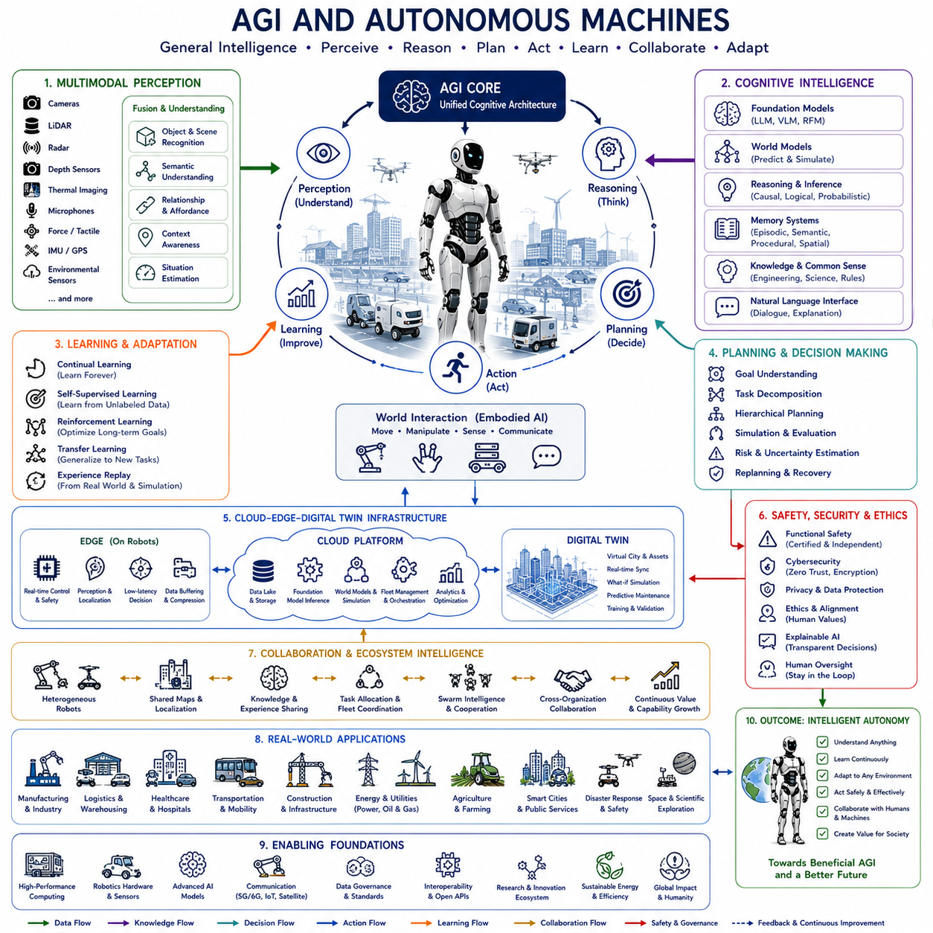
Artificial General Intelligence (AGI) fundamentally transforms autonomous machines from specialized automation systems into general-purpose cognitive agents capable of learning, reasoning, planning, adapting, and acting across an extremely broad range of environments and tasks. Traditional autonomous machines are typically designed for specific applications such as warehouse logistics, autonomous driving, industrial inspection, or robotic manipulation. AGI extends these capabilities beyond narrow domains by enabling machines to acquire transferable knowledge, solve unfamiliar problems, understand abstract concepts, and continuously improve through experience. Autonomous machines therefore evolve from task-oriented tools into intelligent partners capable of operating effectively in highly dynamic and previously unseen environments.
Conventional automation relies heavily on predefined rules, handcrafted algorithms, engineered workflows, and task-specific machine learning models. While these approaches perform extremely well under known operating conditions, they often struggle when environments become uncertain, incomplete, ambiguous, or rapidly changing. AGI-based autonomous machines instead emphasize adaptability, general reasoning, and continual learning. Rather than memorizing fixed solutions, they develop reusable knowledge structures that can be transferred across multiple domains and operational contexts.
General intelligence differs fundamentally from narrow intelligence because it enables flexible problem solving rather than optimized performance for a single task. A warehouse robot using conventional AI may excel at pallet transportation but fail when required to inspect equipment or communicate naturally with workers. An AGI-enabled autonomous machine understands both physical and semantic aspects of the environment, allowing it to switch among logistics, inspection, maintenance, navigation, communication, planning, and collaboration without requiring separate engineering for every individual capability.
The motivation for AGI in autonomous machines arises from the increasing complexity of real-world environments. Industrial facilities, transportation networks, hospitals, construction sites, power plants, agricultural systems, smart cities, disaster zones, and planetary exploration all contain unpredictable events that cannot be completely represented through manually programmed rules. Machines capable of continuously learning, reasoning, and adapting become essential for operating safely and effectively under such uncertainty.
Perception becomes significantly richer within AGI-enabled machines. Instead of recognizing isolated objects, AGI systems understand relationships among people, infrastructure, tools, machines, environmental conditions, operational procedures, and organizational objectives. Cameras, LiDAR, radar, depth sensors, tactile sensing, force sensing, thermal imaging, microphones, GPS, inertial sensors, environmental sensors, and communication networks collectively generate multimodal representations describing not only physical geometry but also functional meaning and contextual significance.
Multimodal foundation models provide the perceptual and cognitive backbone supporting AGI. Language, vision, audio, spatial reasoning, physical interaction, engineering knowledge, scientific understanding, mathematical reasoning, and commonsense knowledge become integrated within unified representations. Autonomous machines therefore interpret environments holistically rather than processing independent sensor streams through isolated algorithms.
Reasoning represents one of the defining characteristics separating AGI from conventional AI. Autonomous machines no longer respond only through learned statistical associations or predefined behaviors. Instead, they analyze causal relationships, evaluate multiple hypotheses, simulate future outcomes, estimate uncertainty, compare alternatives, justify decisions, and revise conclusions as new evidence becomes available. Reasoning transforms perception into purposeful intelligent action.
World models become central to AGI-enabled autonomy because intelligent decision making requires internal representations of environmental dynamics. Rather than reacting immediately to sensor observations, autonomous machines construct predictive models describing objects, agents, infrastructure, physical processes, temporal evolution, and causal interactions. Candidate actions are evaluated through internal simulation before physical execution, significantly improving safety, efficiency, and robustness.
Foundation models and world models complement one another naturally. Foundation models provide broad semantic understanding acquired from large-scale data, while world models provide predictive understanding grounded in physical interaction and environmental dynamics. Together they enable autonomous machines to connect abstract reasoning with real-world behavior, allowing language-based planning to become physically executable.
Embodied AI forms another essential component of AGI because intelligence emerges through interaction with the physical world. Autonomous machines continuously refine understanding through movement, manipulation, sensing, experimentation, and environmental feedback. Physical experience provides information unavailable through passive observation alone, including friction, compliance, force interaction, object affordances, mechanical constraints, and dynamic environmental behavior.
Memory architecture becomes substantially more sophisticated than conventional robotic software. Episodic memory preserves operational experience. Semantic memory stores generalized knowledge. Procedural memory records successful action policies. Spatial memory maintains environmental representations. Long-term memory accumulates organizational knowledge over years of deployment. Working memory supports immediate reasoning during active tasks. These complementary memory systems enable autonomous machines to learn continuously without forgetting previous knowledge.
Continual learning allows AGI systems to improve throughout operational life. Instead of requiring periodic retraining by human engineers, autonomous machines update knowledge using everyday experience. New environments, novel equipment, changing regulations, seasonal variations, infrastructure modifications, and unexpected operational situations all contribute to continuous capability growth. Learning therefore becomes an ongoing autonomous process rather than a discrete engineering activity.
Self-supervised learning significantly accelerates knowledge acquisition because enormous amounts of unlabeled operational data naturally become available during autonomous operation. Future observations predict current observations. Physical interaction predicts environmental response. Language predicts action. Sensor fusion predicts missing modalities. These naturally occurring predictive relationships continuously improve internal models without extensive manual annotation.
Reinforcement learning enables autonomous machines to optimize long-term decision making through accumulated experience. Successful navigation strategies, manipulation skills, maintenance procedures, collaborative behaviors, resource allocation, energy management, and mission execution generate reward signals guiding policy improvement. Rather than optimizing isolated actions, reinforcement learning develops strategies maximizing long-term operational effectiveness across diverse environments.
Planning evolves from deterministic path generation into hierarchical cognitive decision making. High-level objectives become decomposed into intermediate goals, executable actions, contingency plans, recovery procedures, resource allocation strategies, and collaborative workflows. AGI systems continuously revise plans according to changing environmental conditions while preserving long-term mission objectives.
Natural language interaction fundamentally changes human-machine collaboration. Operators communicate goals using ordinary conversation rather than specialized programming languages or predefined command interfaces. AGI-enabled machines interpret instructions, ask clarifying questions, explain reasoning, summarize operational progress, describe uncertainty, recommend alternatives, and coordinate collaborative problem solving through conversational dialogue.
Human-centered autonomy becomes increasingly important because AGI systems operate alongside people rather than replacing them entirely. Autonomous machines recognize human intentions, emotional context, workplace procedures, organizational priorities, accessibility requirements, cultural norms, and collaborative roles. Safe and productive cooperation therefore depends upon social intelligence in addition to technical capability.
Cloud-native computing substantially expands AGI capability by providing virtually unlimited computational resources. Immediate perception, safety control, and low-latency decision making remain onboard, while foundation model inference, world model simulation, digital twins, fleet coordination, organizational knowledge management, and large-scale optimization execute within cloud infrastructure. Hybrid cloud-edge intelligence enables sophisticated reasoning without compromising real-time responsiveness.
Digital twins continuously synchronize physical autonomous machines with virtual simulation environments. Every mission updates virtual representations describing equipment condition, environmental evolution, operational experience, infrastructure changes, and maintenance history. Simulation supports reinforcement learning, predictive maintenance, policy evaluation, safety verification, and system optimization before deployment into physical environments.
Collaborative intelligence distinguishes future AGI systems from isolated robots. Multiple autonomous machines exchange semantic knowledge, world models, localization information, operational experience, maintenance procedures, task allocation, environmental observations, and predictive insights through shared cloud infrastructure. Knowledge acquired by one machine immediately becomes available throughout globally distributed robotic ecosystems.
Swarm intelligence further extends collaboration beyond pairwise coordination. Large robotic populations collectively solve tasks impossible for individual machines. Inspection, environmental monitoring, logistics optimization, disaster response, infrastructure maintenance, planetary exploration, and large-scale manufacturing benefit from decentralized coordination emerging through communication, shared knowledge, and adaptive collective behavior.
Context awareness allows AGI systems to interpret identical physical environments differently according to operational circumstances. Weather conditions, organizational priorities, regulatory requirements, maintenance schedules, emergency situations, energy availability, communication quality, human activity, and mission urgency continuously influence decision making. Context therefore becomes an integral component of intelligent autonomy rather than external metadata.
Explainable AI becomes essential as AGI systems assume increasingly complex responsibilities. Human supervisors require understandable explanations describing why plans changed, why risks increased, why alternative strategies were rejected, how uncertainty influenced decisions, and what evidence supported conclusions. Transparent reasoning improves trust, certification, debugging, regulatory compliance, and effective human oversight.
Functional safety remains fundamentally independent from AGI reasoning. Certified safety supervisors continuously verify actuator integrity, communication reliability, sensor health, localization confidence, collision avoidance, operational boundaries, emergency stopping capability, and environmental hazards before permitting execution. AGI expands capability without replacing deterministic safety mechanisms protecting people and critical infrastructure.
Cybersecurity becomes increasingly critical because AGI systems integrate cloud infrastructure, communication networks, shared knowledge bases, digital twins, and distributed autonomous machines. Secure authentication, encrypted communication, software integrity verification, anomaly detection, identity management, zero-trust networking, resilient distributed architectures, and continuous monitoring protect organizational knowledge and physical infrastructure against malicious interference.
Ethical considerations become inseparable from AGI deployment. Autonomous machines increasingly influence employment, privacy, public safety, healthcare, transportation, environmental management, resource allocation, and governmental services. Responsible development therefore requires fairness, transparency, accountability, human oversight, regulatory compliance, privacy protection, and alignment with societal values throughout the entire system lifecycle.
Scalability transforms AGI from individual intelligent machines into organizational intelligence. Knowledge accumulated through one deployment propagates rapidly across globally distributed fleets operating in factories, hospitals, logistics centers, transportation systems, construction sites, energy infrastructure, agricultural facilities, and smart cities. Organizational capability therefore improves continuously through collective learning rather than isolated engineering effort.
Generalization remains one of the defining objectives of AGI research. Autonomous machines should operate effectively within environments never encountered during training while transferring previously acquired knowledge toward unfamiliar problems. Rather than requiring domain-specific programming, AGI systems leverage abstract reasoning, foundation models, world models, embodied experience, and continual learning to adapt naturally across diverse operational contexts.
Evaluation of AGI-enabled autonomous machines extends far beyond conventional robotics benchmarks. Performance includes reasoning quality, knowledge transfer, planning capability, continual learning, multimodal understanding, collaboration, explainability, uncertainty estimation, safety, cybersecurity, energy efficiency, adaptability, long-term autonomy, human interaction, ethical compliance, and organizational knowledge growth. Comprehensive evaluation reflects the integrated nature of general-purpose embodied intelligence.
A representative deployment illustrates AGI-enabled autonomous machines operating across nationwide transportation infrastructure, manufacturing facilities, hospitals, logistics centers, renewable energy plants, ports, airports, government institutions, disaster response organizations, and smart cities. Heterogeneous robotic fleets continuously synchronize through cloud-native infrastructure while collecting multimodal observations from cameras, LiDAR, radar, tactile sensing, thermal imaging, environmental sensors, autonomous vehicles, drones, IoT devices, satellites, and digital infrastructure. Foundation models integrate engineering knowledge, natural language, scientific reasoning, operational procedures, maintenance documentation, regulatory policies, and environmental semantics into unified cognitive representations. World models continuously simulate future infrastructure conditions, weather evolution, equipment degradation, traffic dynamics, human activity, energy demand, communication quality, and mission execution before generating adaptive plans. Digital twins synchronize physical assets with predictive simulation environments supporting reinforcement learning, continual learning, safety verification, predictive maintenance, and long-term optimization. Autonomous machines collaboratively exchange semantic knowledge, operational experience, localization corrections, maintenance strategies, recovery procedures, and environmental observations through shared cloud services while independently preserving functional safety through certified onboard supervisors. Explainable AI continuously communicates planning rationale, uncertainty estimates, confidence levels, operational tradeoffs, and recovery strategies to engineers, operators, regulators, and organizational decision makers through natural language interaction. Over years of deployment, every successful mission expands collective organizational knowledge, enabling autonomous machine ecosystems to become progressively more adaptive, predictive, resilient, collaborative, efficient, and capable across increasingly diverse physical environments.
This deployment demonstrates that AGI and autonomous machines represent considerably more than applying larger AI models to existing robotic systems. They establish integrated cognitive architectures combining foundation models, world models, embodied AI, multimodal perception, continual learning, reinforcement learning, self-supervised learning, digital twins, cloud-native robotics, collaborative intelligence, natural language reasoning, explainable AI, functional safety, cybersecurity, organizational memory, and Physical AI into unified intelligent agents capable of understanding, reasoning, learning, planning, adapting, and acting across virtually unlimited domains. As robotics foundation models, embodied intelligence, multimodal reasoning, cloud computing, distributed autonomous systems, digital twins, real-time world models, and AGI research continue advancing together, autonomous machines will gradually evolve from specialized industrial automation into broadly capable cognitive partners supporting manufacturing, logistics, healthcare, transportation, construction, scientific research, environmental protection, disaster response, public infrastructure, planetary exploration, and countless future applications requiring truly general-purpose physical intelligence.

25.8 Future AMR Navigation Roadmap
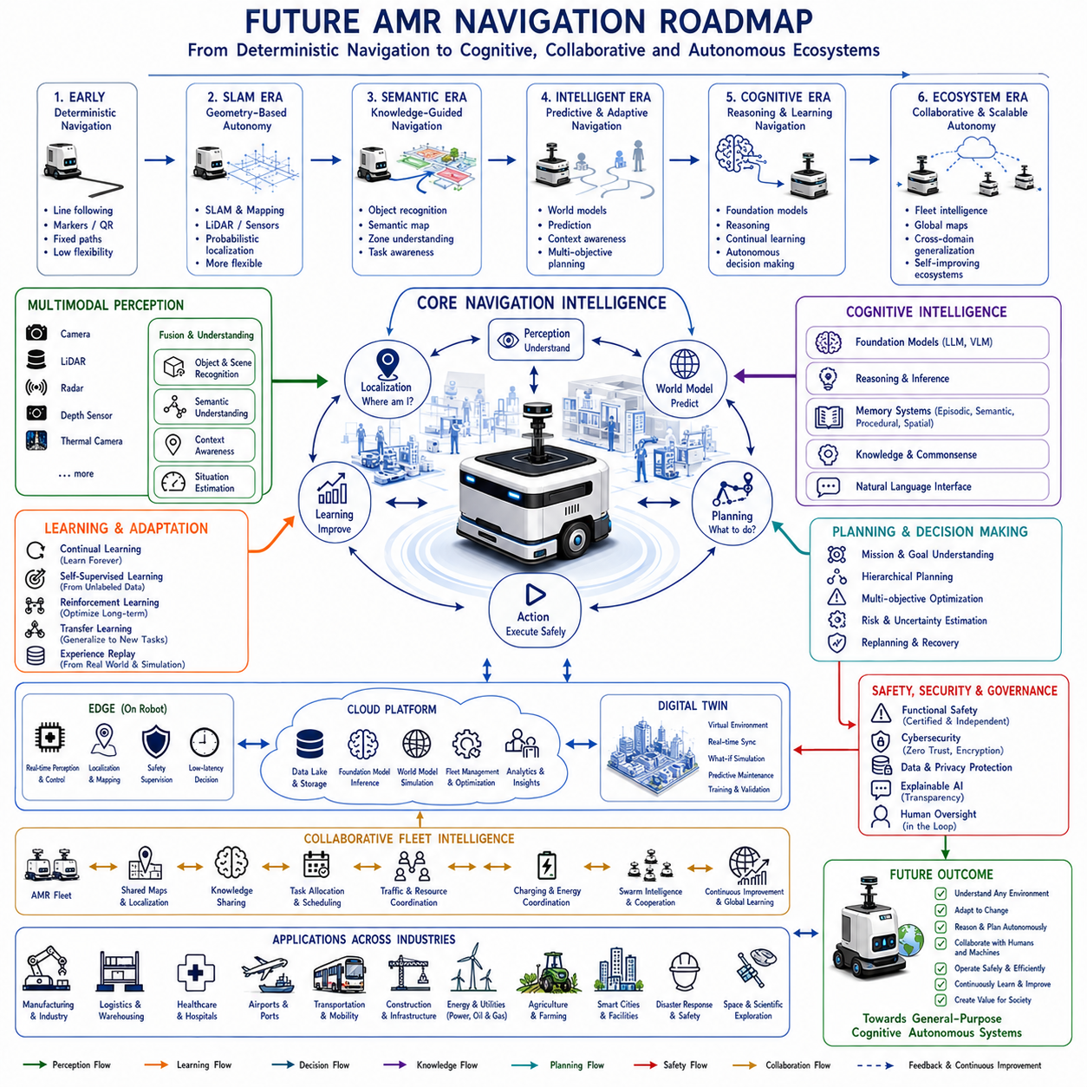
Autonomous Mobile Robot (AMR) navigation has evolved from simple line-following systems into intelligent autonomous platforms capable of understanding complex environments, collaborating with humans, adapting to uncertainty, and continuously improving through learning. The future roadmap of AMR navigation extends far beyond incremental improvements in localization or obstacle avoidance. It represents the convergence of robotics, artificial intelligence, cloud computing, digital twins, foundation models, embodied intelligence, and large-scale autonomous ecosystems. Future AMRs will become cognitive physical agents capable of reasoning, planning, communicating, and cooperating across highly dynamic environments while maintaining reliable real-time operation.
The first stage of AMR evolution focused primarily on deterministic navigation. Early mobile robots relied on magnetic tape, reflective markers, QR codes, or predefined paths to move through structured industrial environments. Navigation algorithms emphasized repeatability rather than adaptability. Environmental uncertainty required extensive human engineering, and even relatively small changes often demanded complete remapping or software modification. These systems demonstrated reliable automation but possessed little environmental understanding beyond geometric localization.
The second generation introduced simultaneous localization and mapping, commonly known as SLAM. LiDAR, cameras, inertial sensors, wheel encoders, and probabilistic estimation enabled robots to localize themselves while constructing maps of previously unknown environments. Navigation became significantly more flexible because robots no longer depended exclusively on fixed infrastructure. Nevertheless, these systems remained largely geometry-driven. Objects were treated primarily as obstacles rather than meaningful components of operational environments.
The third generation incorporates semantic understanding into navigation. Foundation models, multimodal perception, and large-scale visual-language learning allow robots to recognize not only where objects exist but also what they represent and how they should be used. Corridors become transportation routes, charging stations become operational resources, maintenance rooms become restricted workspaces, and emergency exits become safety infrastructure. Navigation therefore transitions from geometric movement toward knowledge-guided decision making.
Future AMRs will increasingly depend upon multimodal perception. Cameras provide visual understanding. LiDAR reconstructs three-dimensional geometry. Radar enables operation under adverse weather and poor visibility. Depth sensors estimate local structure. Thermal imaging identifies abnormal equipment conditions. Force sensing supports physical interaction. Environmental sensors monitor air quality, vibration, temperature, humidity, and hazardous conditions. Audio sensing identifies alarms and human communication. These sensing modalities collectively construct comprehensive environmental awareness extending beyond traditional mapping.
Sensor fusion will become progressively more intelligent rather than simply combining measurements mathematically. Future perception systems will reason across modalities by integrating visual semantics, physical geometry, temporal evolution, engineering knowledge, operational procedures, and contextual information into unified environmental representations. Robots will interpret entire operational situations rather than isolated sensor observations.
Localization will evolve from purely geometric positioning toward semantic localization. Instead of recognizing only walls and corners, robots will identify workstations, production lines, storage areas, elevators, laboratories, inspection equipment, emergency facilities, human workspaces, and operational zones. Semantic localization substantially improves robustness because meaningful environmental features remain recognizable even when physical layouts undergo moderate changes.
Navigation planning will similarly evolve from shortest-path optimization toward mission-aware planning. Future AMRs will simultaneously consider safety, operational priority, energy consumption, traffic density, maintenance schedules, environmental conditions, human activity, organizational objectives, and collaborative resource utilization while selecting navigation strategies. Planning therefore becomes multidimensional rather than purely geometric.
Foundation models represent one of the most transformative technologies within future AMR navigation. Large multimodal models integrate language understanding, engineering documentation, procedural knowledge, commonsense reasoning, visual perception, and operational experience into unified cognitive representations. Instead of programming individual navigation behaviors manually, operators specify high-level objectives using natural language while foundation models generate adaptive navigation strategies consistent with organizational goals.
Language-guided navigation dramatically simplifies human-robot interaction. Instructions such as “Inspect all emergency exits on the second floor, avoid production areas during shift changes, recharge when battery falls below twenty percent, and prioritize maintenance requests near Building B” become directly executable through semantic reasoning. Language therefore becomes a universal interface connecting organizational intent with autonomous robotic behavior.
World models fundamentally improve navigation reliability by enabling robots to predict future environmental evolution. Internal simulations estimate traffic flow, human movement, equipment operation, obstacle dynamics, weather influence, energy availability, communication quality, and mission progression before executing physical actions. Predictive navigation significantly reduces unnecessary motion, operational delays, and collision risk.
Embodied AI extends navigation beyond movement into intelligent physical interaction. Future AMRs continuously improve understanding through manipulation, environmental contact, sensor feedback, operational experience, and experimentation. Physical interaction reveals friction, surface quality, accessibility, equipment condition, structural constraints, and environmental behavior unavailable through passive sensing alone. Navigation therefore becomes tightly integrated with physical understanding.
Continual learning enables navigation systems to improve throughout operational life. Every completed mission contributes new knowledge regarding infrastructure, environmental variability, operational efficiency, equipment behavior, traffic patterns, and human collaboration. Rather than requiring periodic retraining by robotics engineers, future AMRs autonomously refine navigation policies using accumulated operational experience.
Self-supervised learning further accelerates capability growth. Massive operational datasets naturally generate predictive relationships among vision, localization, environmental dynamics, infrastructure condition, semantic understanding, and successful task completion. These naturally occurring learning signals eliminate much of the manual annotation traditionally required for robotic perception systems.
Reinforcement learning enables robots to optimize long-term navigation performance through accumulated operational experience. Policies gradually improve route selection, congestion avoidance, charging behavior, collaborative scheduling, recovery strategies, energy management, inspection sequencing, and mission completion efficiency. Learning therefore optimizes complete operational workflows rather than isolated navigation actions.
Hierarchical planning becomes increasingly important as mission complexity grows. High-level organizational objectives are decomposed into operational goals, navigation tasks, manipulation sequences, inspection procedures, collaborative workflows, contingency plans, and executable control commands. Each planning level continuously exchanges information while preserving overall mission consistency despite changing environmental conditions.
Cloud-native robotics provides virtually unlimited computational resources supporting future navigation. Low-latency localization, safety supervision, perception, and motion control remain onboard, while foundation model inference, world model simulation, digital twins, semantic mapping, fleet optimization, predictive analytics, and organizational knowledge management execute within distributed cloud infrastructure. Hybrid intelligence balances responsiveness with computational scalability.
Edge AI ensures resilient operation despite communication uncertainty. Future AMRs preserve sufficient onboard intelligence to continue safe autonomous operation during temporary cloud disconnection. Once connectivity returns, accumulated operational experience synchronizes automatically with shared knowledge repositories, allowing continuous organizational learning without interrupting ongoing missions.
Digital twins establish continuously synchronized virtual environments supporting predictive navigation. Every physical mission updates digital infrastructure models describing facility condition, traffic patterns, equipment availability, environmental changes, operational history, maintenance records, and organizational knowledge. Simulation validates navigation strategies before deployment while continuously improving predictive models.
Collaborative navigation transforms isolated robots into intelligent fleets. Multiple AMRs exchange semantic maps, localization corrections, operational experience, environmental observations, maintenance knowledge, traffic information, charging schedules, and task assignments through shared communication infrastructure. Collective intelligence enables fleet-wide optimization impossible for independently operating robots.
Interoperability becomes essential because future facilities will contain robots produced by numerous manufacturers. Standard communication protocols, semantic ontologies, mapping formats, coordinate systems, cybersecurity frameworks, fleet interfaces, and service APIs enable heterogeneous robotic platforms to cooperate regardless of hardware architecture or software implementation. Open ecosystems substantially accelerate technological innovation.
Human-aware navigation continues expanding beyond collision avoidance. Future AMRs recognize pedestrian intention, workplace etiquette, collaborative workflows, accessibility requirements, safety regulations, emotional context, organizational priorities, and social interaction. Navigation therefore optimizes both physical efficiency and human comfort while maintaining safe collaboration throughout complex workplaces.
Context-aware decision making significantly enhances adaptive navigation. Production schedules, maintenance activities, emergency situations, weather conditions, shift changes, infrastructure availability, energy pricing, communication quality, organizational priorities, and environmental uncertainty continuously influence navigation policies. Context becomes an integral component of intelligent decision making rather than supplementary information.
Energy-aware navigation becomes increasingly important as robotic fleets expand. Battery health, charging station availability, renewable energy generation, electricity pricing, mission urgency, traffic congestion, environmental conditions, and fleet demand jointly determine navigation strategy. Ecosystem-wide optimization simultaneously minimizes operational cost and environmental impact while maximizing long-term productivity.
Cybersecurity remains indispensable because future navigation increasingly depends upon cloud infrastructure, digital twins, shared knowledge, communication networks, and collaborative robotic ecosystems. Secure authentication, encrypted communication, software integrity verification, anomaly detection, zero-trust networking, resilient distributed architectures, and continuous monitoring protect both digital information and physical operational infrastructure.
Functional safety remains fundamentally independent from learning systems. Certified safety supervisors continuously monitor localization confidence, actuator health, sensor integrity, communication quality, obstacle detection, emergency stopping capability, operational boundaries, and environmental hazards. Learned navigation policies always execute within deterministic safety constraints ensuring predictable behavior even under unexpected conditions.
Explainable AI becomes increasingly valuable as navigation decisions become more sophisticated. Future AMRs explain route modifications, risk assessments, traffic avoidance, charging decisions, collaborative scheduling, uncertainty estimates, and recovery behaviors through natural language. Operators therefore understand not only what robots are doing but also why particular navigation strategies have been selected.
Scalability transforms navigation from individual robotic capability into organizational infrastructure. Knowledge accumulated by one robot immediately becomes available throughout globally distributed fleets operating across warehouses, factories, hospitals, airports, logistics centers, transportation systems, construction sites, energy facilities, agricultural operations, and smart cities. Organizational intelligence continuously expands through collective operational learning.
Generalization represents the ultimate objective of future navigation research. Rather than engineering navigation systems separately for warehouses, hospitals, airports, manufacturing plants, construction sites, or public infrastructure, future AMRs leverage foundation models, world models, embodied learning, continual adaptation, and semantic reasoning to operate naturally across diverse environments with minimal domain-specific engineering.
Evaluation frameworks will evolve beyond traditional navigation metrics. Localization accuracy, path efficiency, obstacle avoidance, and mission completion remain important, but future evaluation additionally measures semantic understanding, reasoning capability, collaborative intelligence, continual learning, adaptability, explainability, cybersecurity resilience, functional safety, energy efficiency, cloud integration, digital twin synchronization, organizational knowledge growth, and long-term operational autonomy.
A representative future deployment illustrates nationwide autonomous navigation infrastructure connecting manufacturing facilities, logistics centers, hospitals, airports, ports, railway stations, renewable energy plants, government buildings, research laboratories, construction projects, agricultural operations, and smart cities through cloud-native robotic ecosystems. Thousands of heterogeneous AMRs continuously collect multimodal observations from cameras, LiDAR, radar, thermal sensors, environmental monitoring systems, IoT infrastructure, autonomous vehicles, drones, and intelligent facilities while synchronizing with digital twins and global semantic maps. Foundation models integrate language, engineering knowledge, maintenance documentation, operational procedures, environmental semantics, organizational objectives, and historical experience into unified cognitive representations. World models continuously simulate future traffic conditions, infrastructure evolution, equipment degradation, weather progression, energy demand, communication quality, and mission execution before generating adaptive navigation strategies. Collaborative robotic fleets exchange semantic knowledge, localization improvements, environmental observations, charging schedules, operational experience, maintenance procedures, and predictive insights through standardized cloud services while preserving deterministic functional safety using independent onboard supervisory systems. Explainable AI communicates navigation rationale, confidence estimates, uncertainty analysis, operational tradeoffs, and recovery strategies through natural language interfaces supporting engineers, operators, facility managers, and organizational leadership. Over years of deployment, every successful navigation mission expands collective organizational knowledge, allowing entire robotic ecosystems to become progressively more adaptive, predictive, resilient, efficient, collaborative, and capable across continuously evolving physical environments.
This roadmap demonstrates that future AMR navigation extends far beyond incremental improvements in localization algorithms or path planning techniques. It establishes integrated cognitive navigation architectures combining multimodal perception, semantic understanding, foundation models, world models, embodied AI, continual learning, reinforcement learning, self-supervised learning, cloud-native robotics, edge AI, digital twins, collaborative intelligence, human-aware navigation, explainable AI, cybersecurity, functional safety, interoperability, and Physical AI into unified autonomous systems capable of understanding, reasoning, learning, predicting, collaborating, and adapting across virtually unlimited operational domains. As robotics foundation models, embodied intelligence, multimodal reasoning, cloud computing, real-time simulation, distributed robotic ecosystems, and AGI technologies continue advancing together, future AMR navigation will evolve from reliable autonomous mobility into comprehensive cognitive autonomy supporting manufacturing, logistics, healthcare, transportation, construction, infrastructure management, environmental protection, disaster response, agriculture, scientific exploration, and every future application requiring intelligent physical interaction with the real world.

