Volume 05. Path Planning and Autonomous Navigation

Chapter 23. Industrial Case Studies

23.1 Warehouse AMR Navigation
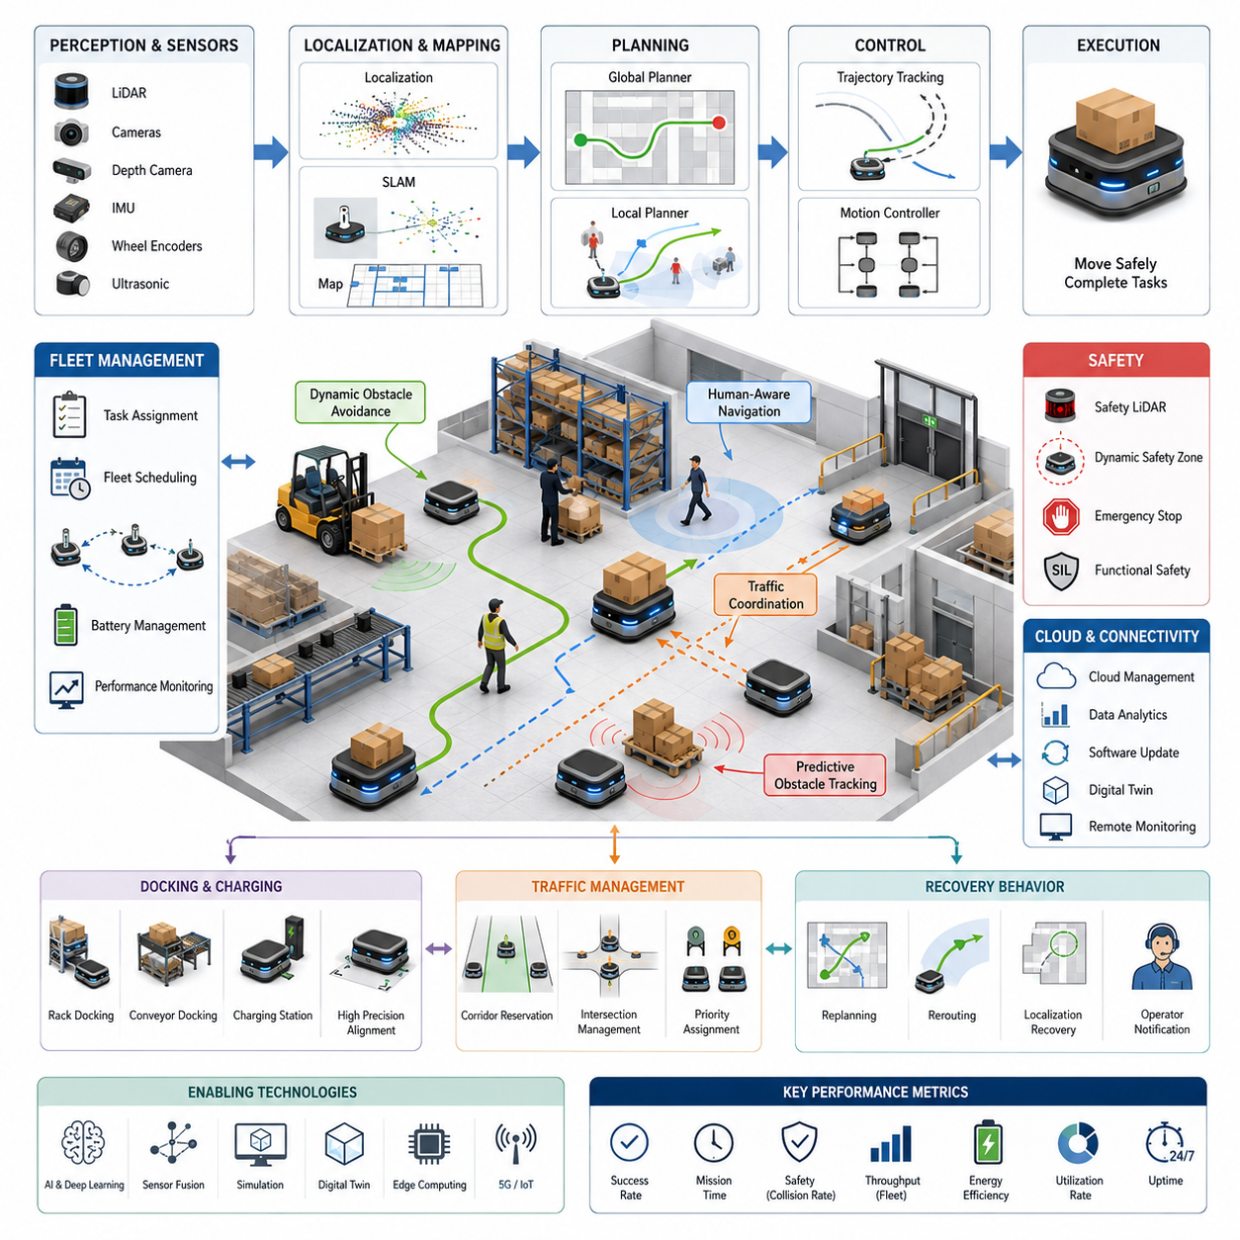
Warehouse Autonomous Mobile Robot (AMR) navigation represents one of the most mature and commercially successful applications of autonomous robotics. Modern warehouses increasingly rely on fleets of intelligent mobile robots to transport inventory, replenish storage locations, support order fulfillment, and coordinate logistics operations with minimal human intervention. Unlike laboratory environments or structured production cells, warehouses present dynamic, large-scale, and continuously changing operational spaces where hundreds of humans, forklifts, conveyor systems, pallets, and other robots interact simultaneously. Successful warehouse navigation therefore requires far more than simple path planning. It demands the seamless integration of perception, localization, mapping, planning, control, fleet coordination, safety management, and cloud-based operational intelligence.
The primary objective of warehouse navigation is to move goods efficiently while maintaining safety, reliability, and high system throughput. Warehouse AMRs transport storage bins, pallets, cartons, shelves, or production materials between receiving stations, storage areas, picking zones, packaging stations, and shipping docks. Every navigation decision directly affects operational efficiency because travel time contributes significantly to overall order fulfillment performance. Consequently, warehouse navigation algorithms are optimized not only for collision avoidance but also for minimizing transportation time, reducing traffic congestion, balancing fleet utilization, and maximizing warehouse productivity.
Unlike Automated Guided Vehicles (AGVs), which generally follow predefined magnetic tapes, QR codes, or embedded guidance systems, warehouse AMRs generate their own navigation decisions using onboard perception and localization systems. This flexibility allows warehouses to modify storage layouts, introduce temporary work areas, relocate shelves, or reorganize production lines without reconstructing physical guidance infrastructure. Such adaptability has become increasingly valuable as e-commerce and modern manufacturing demand rapidly changing warehouse configurations.
A warehouse navigation system typically consists of several tightly integrated subsystems. The perception layer continuously observes the environment using multiple sensors including LiDAR, RGB cameras, depth cameras, ultrasonic sensors, IMUs, wheel encoders, and occasionally radar. Localization algorithms estimate the robot's precise position within a warehouse map. Mapping systems maintain digital representations of aisles, storage racks, workstations, charging stations, restricted areas, and temporary obstacles. Global planners generate long-distance routes toward assigned destinations, while local planners continuously modify trajectories according to nearby dynamic obstacles. Motion controllers convert planned trajectories into precise wheel commands that safely move the robot through the warehouse.
Localization forms one of the most fundamental capabilities of warehouse navigation. Modern warehouses often contain long repetitive aisles with highly similar visual appearances, making localization particularly challenging. AMRs typically employ two-dimensional LiDAR SLAM combined with wheel odometry and inertial sensing to estimate their position accurately. Loop closure techniques continuously correct accumulated drift by recognizing previously visited locations. Some warehouses additionally deploy artificial landmarks such as QR codes, AprilTags, or reflective markers to improve localization robustness in visually repetitive environments.
Map representations are carefully optimized for industrial operation. Static maps include permanent structures such as walls, storage racks, pillars, elevators, charging docks, fire exits, safety zones, and production equipment. Dynamic map layers incorporate temporary obstacles, parked forklifts, movable pallets, maintenance areas, construction zones, and temporarily closed aisles. Modern navigation systems maintain these map layers separately, allowing temporary environmental changes without modifying the permanent facility map.
Global path planning determines efficient routes between mission start and destination locations. Warehouse environments naturally resemble graph structures composed of corridors, intersections, storage aisles, loading areas, and transportation zones. Algorithms such as Dijkstra, A*, Hybrid A*, and graph-based search efficiently compute optimal routes while considering travel distance, expected traffic density, safety restrictions, and operational priorities. Cost maps assign traversal penalties to narrow passages, congested intersections, human work areas, or energy-intensive slopes, allowing planners to optimize routes beyond simple shortest-distance criteria.
Local path planning continuously adapts global routes to immediate environmental conditions. Warehouses contain numerous dynamic obstacles including workers, forklifts, carts, autonomous robots, and moving inventory. Local planners such as Dynamic Window Approach (DWA), Timed Elastic Band (TEB), Model Predictive Control (MPC), and optimization-based planners evaluate feasible trajectories that satisfy robot kinematic constraints while avoiding collisions. Replanning occurs multiple times per second, enabling smooth navigation despite constantly changing surroundings.
Obstacle detection represents another essential component. Industrial AMRs continuously identify static obstacles such as pallets, boxes, machinery, shelving units, and structural columns while simultaneously tracking moving obstacles including humans, forklifts, and other robots. Sensor fusion combines LiDAR point clouds, depth images, RGB object detection, and ultrasonic ranging into unified obstacle representations. This redundancy improves reliability under challenging lighting conditions, partial occlusions, reflective surfaces, and varying environmental complexity.
Human-aware navigation has become increasingly important as collaborative warehouses integrate robots and workers within shared operational spaces. Unlike simple obstacle avoidance, human-aware navigation predicts pedestrian motion, estimates walking intent, respects personal space, reduces approach speed, and generates socially acceptable trajectories. Robots slow down near workers, avoid sudden directional changes, maintain comfortable separation distances, and yield when necessary. These behaviors improve both operational safety and user acceptance.
Warehouse navigation frequently involves narrow aisles where simultaneous bidirectional traffic becomes difficult. Fleet management systems therefore coordinate robot movement through traffic scheduling, corridor reservation, intersection management, and dynamic priority assignment. Instead of independently competing for shared pathways, robots negotiate access through centralized or distributed traffic management algorithms. Such coordination prevents deadlocks, minimizes congestion, and significantly improves fleet throughput.
Traffic optimization extends beyond collision avoidance. Large warehouse deployments may include hundreds or even thousands of robots simultaneously transporting inventory. Fleet-level navigation continuously analyzes warehouse traffic patterns, predicts congestion, balances transportation loads across alternative corridors, and dynamically reroutes robots to maintain efficient material flow. Cloud-based optimization systems maintain global awareness unavailable to individual robots, enabling significantly higher overall operational efficiency.
Task assignment and navigation are closely coupled within warehouse logistics. Navigation planners consider not only travel distance but also robot battery levels, payload capacity, current location, maintenance status, charging schedules, and predicted traffic conditions. Fleet management systems assign missions to robots capable of completing transportation tasks most efficiently while minimizing empty travel and balancing workload across the entire fleet.
Warehouse docking requires particularly high positioning accuracy. Robots frequently dock with storage shelves, conveyor systems, robotic picking stations, elevators, charging stations, pallet transfer systems, and automated production equipment. Docking generally combines coarse global navigation with high-precision local positioning using LiDAR reflectors, fiducial markers, visual alignment, or short-range localization sensors. Final positioning accuracy often reaches only a few millimeters to ensure reliable mechanical engagement.
Automatic charging represents another critical navigation function. Fleet management continuously monitors battery status and predicts future energy requirements based on scheduled missions. When appropriate, robots autonomously navigate toward charging stations without interrupting warehouse operations. Intelligent charging schedulers prevent congestion by distributing charging demand across multiple charging docks while maximizing fleet availability.
Warehouse navigation increasingly incorporates semantic understanding rather than relying solely on geometric information. Semantic maps distinguish storage racks, human workstations, emergency exits, loading docks, hazardous areas, quality inspection stations, packaging zones, and restricted maintenance areas. Semantic navigation allows robots to reason about the operational meaning of locations rather than treating every free space identically. This capability supports more intelligent decision-making, context-aware behaviors, and efficient mission execution.
Modern warehouse robots also employ behavior planning above traditional path planning. Behavior planners determine whether robots should yield, overtake slower traffic, wait temporarily, reroute, request corridor reservations, pause for pedestrians, or initiate recovery behaviors after navigation failures. State machines, behavior trees, hierarchical planners, and increasingly AI-based decision systems coordinate these higher-level operational strategies.
Dynamic obstacle avoidance becomes particularly challenging during peak warehouse operation. Forklifts carrying heavy pallets, workers manually transporting goods, automated conveyor systems, robotic picking arms, and autonomous cleaning robots all create continuously evolving traffic conditions. Prediction algorithms estimate future obstacle trajectories several seconds ahead, allowing proactive rather than purely reactive avoidance. Such predictive navigation reduces unnecessary stopping while improving both efficiency and safety.
Recovery behaviors are essential because industrial environments rarely remain perfectly predictable. Temporary aisle blockages, misplaced inventory, sensor degradation, localization failures, communication interruptions, or unexpected construction activities may invalidate planned routes. Recovery systems automatically attempt local replanning, global rerouting, localization recovery, obstacle reassessment, or operator notification before mission failure occurs. Robust recovery significantly increases operational uptime.
Warehouse navigation increasingly benefits from digital twins. Digital warehouse models synchronize continuously with physical operations, providing accurate simulation environments for testing navigation software before deployment. Engineers evaluate new traffic strategies, storage layouts, robot behaviors, fleet sizes, and scheduling algorithms within virtual environments, greatly reducing deployment risk and improving operational planning.
Simulation plays an indispensable role throughout navigation development. Platforms such as Gazebo, Isaac Sim, Webots, and industrial digital twin environments simulate warehouse layouts, robot fleets, dynamic obstacles, sensor characteristics, and communication networks. Simulation enables safe evaluation of thousands of navigation scenarios, including rare corner cases difficult to reproduce experimentally. Sim-to-real validation subsequently verifies transfer performance under actual warehouse conditions.
Performance evaluation extends far beyond measuring path length. Industrial warehouse navigation is assessed using navigation success rate, average mission completion time, localization accuracy, docking precision, obstacle avoidance reliability, collision rate, energy consumption, battery utilization, traffic efficiency, fleet throughput, mean recovery time, communication latency, computational load, and overall warehouse productivity. These metrics collectively determine practical deployment readiness.
Safety remains the highest operational priority. Warehouse robots frequently operate near humans while transporting heavy payloads. Safety LiDAR continuously monitors protective fields surrounding the robot. Dynamic safety zones adjust according to vehicle speed, payload weight, stopping distance, and environmental complexity. Emergency stop systems immediately halt robot motion whenever safety thresholds are exceeded. Functional safety architectures conform to industrial standards while maintaining reliable operation under sensor failures or communication disruptions.
Cloud connectivity significantly expands warehouse navigation capabilities. Centralized fleet management continuously collects operational data from every robot, analyzes warehouse-wide traffic patterns, predicts maintenance requirements, distributes software updates, and optimizes task scheduling. Edge computing handles real-time navigation locally while cloud infrastructure performs computationally intensive optimization, machine learning, and long-term operational analysis.
Artificial intelligence increasingly enhances warehouse navigation beyond conventional algorithmic methods. Deep learning improves obstacle recognition, semantic scene understanding, human behavior prediction, free-space detection, anomaly identification, and localization robustness. Reinforcement learning explores improved navigation strategies under complex traffic conditions, while Foundation Models gradually enable robots to interpret high-level language instructions and perform context-aware reasoning during navigation.
Future warehouse navigation will likely combine world models, multimodal perception, large-scale Foundation Models, and cloud-native fleet intelligence into unified autonomous logistics platforms. Robots will increasingly predict future warehouse traffic, understand operational context, coordinate collaboratively with humans, optimize entire logistics networks rather than individual routes, and continuously improve navigation behavior through lifelong learning from operational experience.
From an engineering perspective, warehouse AMR navigation represents the integration of nearly every major robotics discipline. Accurate perception, reliable localization, efficient mapping, intelligent planning, precise motion control, robust communication, fleet optimization, functional safety, cloud computing, and artificial intelligence all operate simultaneously to produce reliable autonomous transportation. The true success of warehouse navigation therefore depends not on any individual algorithm but on the seamless interaction of these interconnected subsystems.
As global logistics continues expanding through e-commerce, smart manufacturing, and automated distribution, warehouse AMR navigation will become an increasingly central technology supporting modern supply chains. Advances in AI, perception, digital twins, semantic understanding, and autonomous fleet coordination will continue transforming warehouse robots from simple transportation devices into intelligent physical agents capable of reasoning, adapting, collaborating, and autonomously optimizing logistics operations across large-scale industrial environments.

23.2 Hospital Robot Navigation
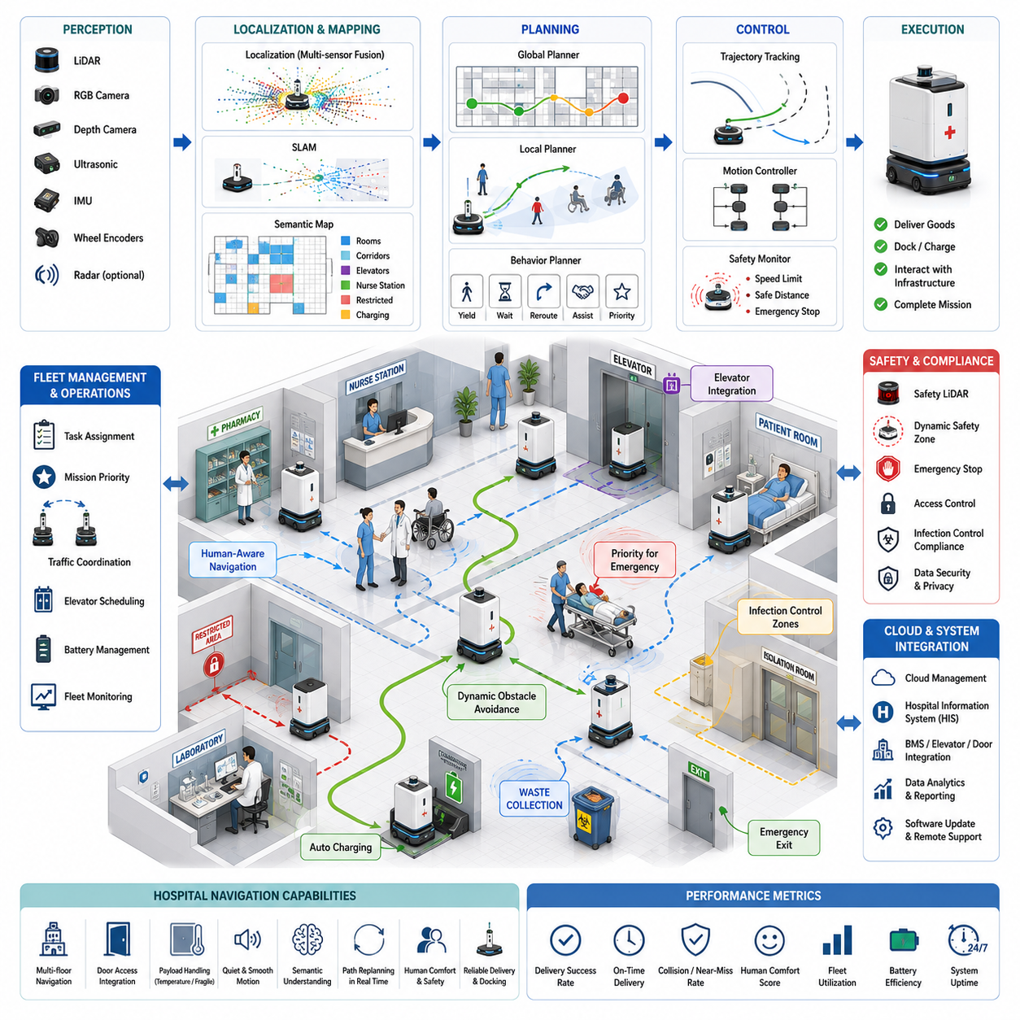
Hospital Robot Navigation represents one of the most demanding applications of autonomous mobile robotics because hospitals are dynamic, safety-critical, and highly human-centered environments. Unlike warehouses or factories where infrastructure and traffic patterns are relatively predictable, hospitals contain constantly changing pedestrian traffic, emergency situations, vulnerable patients, medical equipment, and strict operational regulations. Autonomous Mobile Robots (AMRs) operating in hospitals must transport medicine, laboratory samples, blood products, sterile instruments, meals, medical waste, linens, and pharmaceutical supplies while ensuring patient safety, maintaining infection control standards, and minimizing disruption to clinical workflows. Consequently, hospital navigation extends beyond conventional obstacle avoidance and requires a comprehensive integration of perception, localization, semantic understanding, human-aware planning, safety monitoring, fleet coordination, and intelligent decision-making.
The primary objective of hospital robot navigation is to provide reliable, safe, and efficient transportation services throughout complex healthcare facilities. Modern hospitals operate continuously twenty-four hours a day, requiring frequent movement of critical supplies between pharmacies, laboratories, operating rooms, intensive care units, emergency departments, inpatient wards, imaging centers, sterilization facilities, and storage rooms. Many of these transportation tasks are repetitive but time-sensitive. Automating these logistics operations allows healthcare professionals to devote more attention to patient care while reducing operational costs and improving hospital efficiency.
Unlike industrial facilities, hospitals are designed primarily for people rather than machines. Corridors are occupied by patients, visitors, nurses, physicians, emergency responders, wheelchairs, stretchers, hospital beds, cleaning carts, and mobile medical equipment. Navigation algorithms must therefore prioritize human safety and comfort above transportation efficiency. Hospital robots should move predictably, communicate their intentions clearly, maintain comfortable interpersonal distances, reduce unnecessary noise, and avoid causing anxiety among patients or interfering with medical procedures.
A hospital navigation architecture typically consists of multiple interacting subsystems. Perception continuously observes the surrounding environment using LiDAR, RGB cameras, depth cameras, ultrasonic sensors, inertial measurement units, wheel encoders, and occasionally radar. Localization determines the robot's precise position within a digital hospital map. Mapping systems represent rooms, corridors, elevators, nurse stations, operating rooms, emergency exits, restricted areas, and service corridors. Global planning computes efficient long-distance routes, while local planning continuously adapts trajectories according to dynamic pedestrian behavior. Motion controllers execute planned trajectories while satisfying safety constraints and maintaining smooth robot motion.
Localization presents unique challenges inside hospitals. GPS signals are unavailable indoors, and long corridors often exhibit repetitive architectural features that complicate visual localization. Furthermore, hospitals continuously change due to temporary medical equipment, movable furniture, mobile partitions, and construction activities. Most hospital robots therefore employ multi-sensor localization combining two-dimensional LiDAR SLAM, wheel odometry, inertial sensing, and occasionally visual landmarks such as AprilTags or QR codes. Sensor fusion algorithms continuously estimate robot position while compensating for accumulated drift and temporary sensor degradation.
Hospital maps contain significantly richer semantic information than conventional occupancy grids. In addition to walls and corridors, semantic maps identify patient rooms, intensive care units, operating theaters, radiology departments, pharmacies, laboratories, waiting areas, nurse stations, restricted medical zones, emergency evacuation routes, sterilization rooms, hazardous waste collection areas, medication storage, and charging stations. Semantic understanding allows robots to reason about the purpose and operational characteristics of different hospital spaces rather than merely navigating through empty geometric regions.
Navigation priorities differ substantially depending on the operational context. Delivering emergency blood products to an operating room requires different planning strategies than transporting clean linens or collecting laboratory specimens. High-priority medical missions may receive preferential access through corridors and elevators, while lower-priority deliveries automatically yield to emergency traffic. Intelligent mission planning therefore integrates clinical priorities, transportation urgency, delivery deadlines, and hospital operational policies into route selection.
Global path planning generates routes connecting hospital departments through interconnected corridors, elevators, service passages, and public areas. Algorithms such as A*, Dijkstra, Hybrid A*, graph search, and hierarchical planners optimize routes according to travel distance, expected congestion, accessibility restrictions, elevator availability, infection control policies, and emergency traffic conditions. Cost maps assign higher traversal costs to crowded waiting rooms, intensive care corridors during visiting hours, or sensitive clinical environments where robot traffic should be minimized.
Local path planning continuously modifies trajectories according to nearby environmental changes. Hospitals contain numerous dynamic obstacles including healthcare workers, patients with limited mobility, visitors, wheelchairs, stretchers, hospital beds, portable imaging devices, cleaning equipment, and autonomous service robots. Local planners such as Dynamic Window Approach, Timed Elastic Band, Model Predictive Control, and optimization-based trajectory generators evaluate safe motion commands while satisfying robot kinematic constraints and maintaining comfortable interactions with surrounding people.
Human-aware navigation represents one of the defining characteristics of hospital robotics. Robots must understand not only where people currently stand but also how they are likely to move in the near future. Pedestrian prediction algorithms estimate walking direction, speed, group behavior, and interaction patterns. Robots proactively slow down near elderly patients, increase separation from wheelchairs, avoid approaching children unexpectedly, and yield to medical personnel responding to emergencies. Such socially aware behaviors improve safety while enhancing public acceptance of autonomous robots.
Comfort is nearly as important as safety within healthcare environments. Abrupt acceleration, sudden braking, aggressive turning, or excessive operating noise may disturb resting patients or interfere with sensitive medical procedures. Hospital robots therefore employ smooth trajectory generation with acceleration, deceleration, jerk, and rotational velocity constraints. Motion profiles prioritize comfort and predictability rather than maximizing travel speed.
Elevator integration represents a particularly important capability for multi-floor hospitals. Robots must autonomously request elevators, wait appropriately, enter safely, position themselves without obstructing passengers, recognize destination floors, and exit efficiently after arrival. Modern hospital infrastructure increasingly provides robot-accessible elevator interfaces through building automation systems, enabling seamless vertical transportation across multiple departments.
Door interaction introduces another operational challenge. Hospital robots encounter automatic sliding doors, swing doors, secured access points, fire doors, and isolation room entrances. Integration with building management systems enables robots to request door access electronically while maintaining security policies. For manually operated doors, robots may require human assistance or specially designed robotic manipulation systems.
Infection control strongly influences navigation behavior. Hospitals often classify areas according to contamination risk, sterilization requirements, and patient isolation status. Navigation systems incorporate these operational constraints by restricting robot movement through sterile operating theaters, quarantine zones, or isolation wards unless specifically authorized. Delivery routes may intentionally avoid cross-contamination between infectious and sterile areas, supporting hospital infection prevention protocols.
Transportation payloads vary widely across hospital logistics operations. Robots deliver pharmaceuticals requiring temperature control, fragile laboratory specimens requiring vibration reduction, blood products demanding strict timing, sterile surgical instruments requiring contamination protection, meals requiring thermal insulation, and medical waste requiring secure containment. Navigation algorithms may adjust acceleration limits, route selection, or priority according to payload characteristics.
Obstacle detection combines multiple sensing modalities to achieve robust perception under diverse hospital conditions. LiDAR provides reliable geometric obstacle detection regardless of illumination. RGB cameras identify people, wheelchairs, stretchers, medical carts, and signage. Depth cameras estimate free space and detect low-profile obstacles. Ultrasonic sensors enhance close-range safety around transparent surfaces or difficult reflective objects. Sensor fusion integrates these complementary observations into consistent environmental representations.
Behavior planning coordinates higher-level decision-making beyond simple path generation. Robots determine when to wait for congested corridors to clear, when to reroute around temporary obstacles, when to yield at intersections, when to request operator assistance, and when to interrupt low-priority missions in response to emergency transportation requests. State machines, behavior trees, and increasingly AI-based reasoning systems govern these complex operational decisions.
Fleet management becomes essential as hospitals deploy increasing numbers of service robots. Multiple robots simultaneously transport medications, laboratory samples, meals, linens, waste, and equipment throughout the facility. Fleet coordination prevents congestion, schedules elevator usage, allocates transportation tasks, balances battery utilization, reserves narrow corridors, and optimizes hospital-wide logistics efficiency. Centralized management maintains global awareness unavailable to individual robots while preserving distributed autonomy for local navigation.
Battery management integrates closely with mission scheduling. Hospital operations continue continuously throughout day and night, requiring high robot availability. Fleet management predicts future transportation demand, battery consumption, charging opportunities, and mission priorities. Robots autonomously visit charging stations during periods of reduced workload while ensuring sufficient fleet capacity remains available for urgent clinical transportation.
Emergency response introduces unique navigation requirements. During fire alarms, medical emergencies, disaster response, or hospital evacuation procedures, robots immediately modify operational behavior according to predefined emergency protocols. Depending on hospital policy, robots may safely stop, relocate to designated parking areas, assist emergency logistics, or immediately clear evacuation routes. Integration with hospital emergency management systems ensures coordinated response during critical incidents.
Communication infrastructure plays a crucial role throughout hospital navigation. Wireless networks connect robots with fleet management servers, hospital information systems, building automation platforms, electronic medical record systems, elevator controllers, door access systems, and maintenance monitoring services. Reliable communication enables coordinated logistics while protecting patient privacy and operational continuity.
Cybersecurity represents an increasingly important consideration because hospital robots interact with sensitive healthcare infrastructure. Secure communication protocols, encrypted data transmission, authenticated device access, software integrity verification, and network segmentation protect navigation systems from cyber threats while ensuring compliance with healthcare information security regulations.
Digital twins increasingly support hospital navigation development and operation. Virtual hospital models synchronize continuously with physical facilities, enabling engineers to evaluate navigation algorithms, optimize robot deployment, simulate emergency procedures, analyze traffic patterns, and test new operational workflows before implementation. Digital twins reduce deployment risk while supporting continuous operational improvement.
Simulation remains indispensable throughout system development. Platforms such as Gazebo, Isaac Sim, Webots, and hospital-specific digital twins reproduce complex healthcare environments including pedestrian traffic, elevators, dynamic obstacles, clinical equipment, and emergency scenarios. Large-scale simulation enables validation across thousands of navigation situations that would be impractical or unsafe to reproduce experimentally within active hospitals.
Artificial intelligence significantly enhances hospital navigation beyond conventional robotics algorithms. Deep learning improves person detection, wheelchair recognition, free-space segmentation, semantic scene understanding, anomaly detection, and localization robustness. Machine learning predicts pedestrian behavior, estimates corridor congestion, identifies temporary environmental changes, and supports adaptive route optimization. Foundation Models may eventually enable robots to interpret natural language instructions from healthcare professionals while reasoning about hospital operational context.
World Models represent another promising direction for hospital robotics. Instead of reacting solely to current observations, robots develop predictive internal models estimating future pedestrian movement, elevator availability, corridor congestion, clinical workflow evolution, and transportation demand. Predictive reasoning enables proactive navigation decisions that reduce delays and improve hospital logistics efficiency.
Hospital navigation performance is evaluated using numerous quantitative metrics beyond traditional path length. Researchers measure navigation success rate, localization accuracy, delivery completion time, collision frequency, near-miss events, human comfort, docking precision, battery efficiency, fleet throughput, elevator utilization, recovery success rate, communication reliability, computational latency, mission priority compliance, and overall healthcare logistics performance. These metrics collectively determine practical deployment readiness.
Functional safety remains the highest engineering priority throughout hospital navigation. Safety-certified LiDAR continuously monitors protective fields surrounding the robot. Dynamic safety zones adjust according to vehicle speed, payload weight, surrounding pedestrian density, and stopping distance. Emergency stop systems immediately halt robot motion whenever safety thresholds are exceeded. Redundant sensing, fail-safe controllers, diagnostic monitoring, and continuous self-testing ensure dependable operation even during hardware failures.
The future of hospital robot navigation will integrate multimodal perception, semantic reasoning, world models, cloud-connected fleet intelligence, Foundation Models, digital twins, and lifelong learning into unified healthcare logistics platforms. Robots will increasingly understand clinical workflows, anticipate transportation demand, coordinate naturally with healthcare professionals, optimize hospital-wide logistics, and continuously improve operational performance through accumulated experience.
From an engineering perspective, hospital robot navigation represents one of the most comprehensive demonstrations of autonomous robotics. Accurate perception, reliable localization, semantic mapping, intelligent planning, human-aware interaction, robust communication, fleet coordination, cybersecurity, functional safety, cloud computing, and artificial intelligence operate simultaneously to support safe and efficient healthcare logistics. The true value of hospital navigation therefore lies not merely in autonomous movement but in enabling hospitals to deliver higher-quality patient care by intelligently automating complex logistical operations while maintaining the highest standards of safety, reliability, and human-centered design.

23.3 Towing AMR Case Study
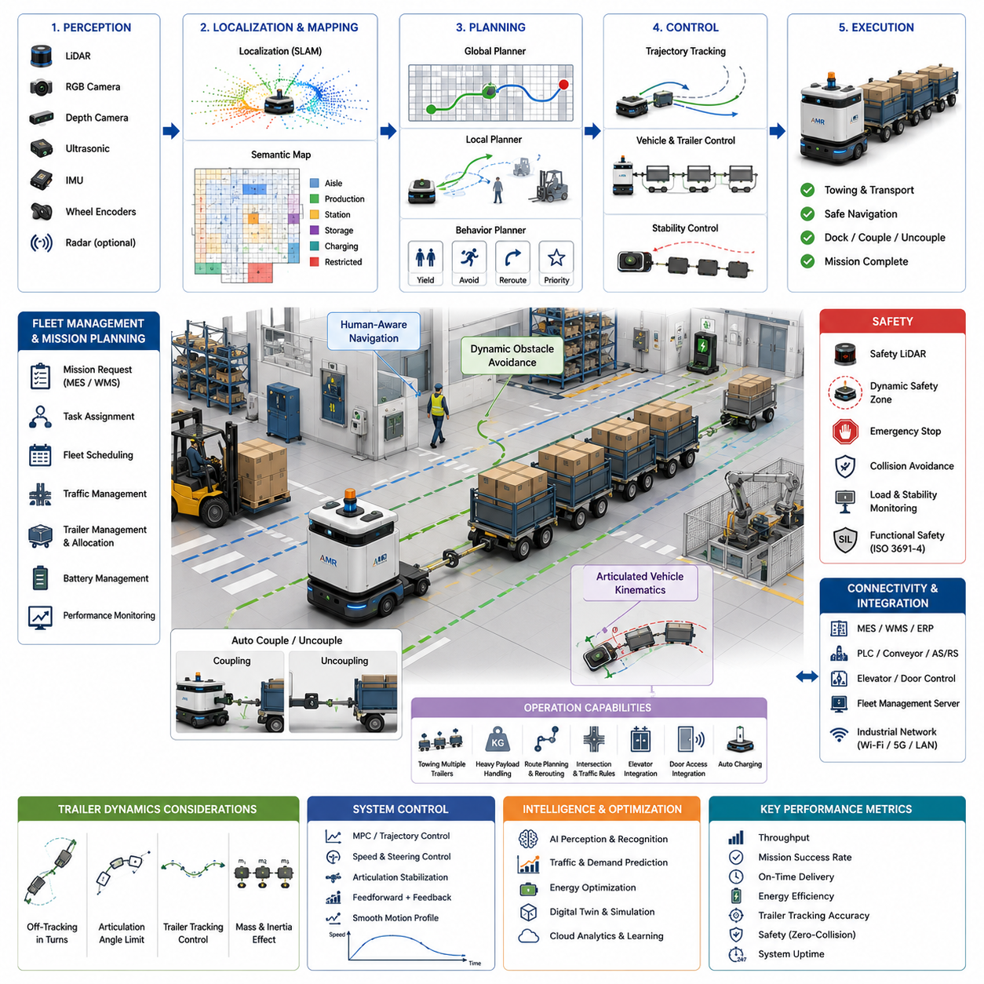
Towing Autonomous Mobile Robots (AMRs) represent one of the most practical and economically valuable categories of industrial mobile robotics. Unlike unit-load AMRs that transport shelves or carts directly, towing AMRs are designed to pull one or multiple passive carts, trailers, or wheeled carriers through manufacturing plants, warehouses, hospitals, airports, and logistics centers. This transportation method significantly reduces infrastructure cost because passive carts contain no motors, batteries, sensors, or onboard computers. Instead, intelligence is concentrated within the towing vehicle, allowing dozens or even hundreds of passive carts to share a much smaller fleet of autonomous towing robots. As a result, towing AMRs provide an attractive balance between flexibility, scalability, operational efficiency, and total cost of ownership.
The fundamental objective of a towing AMR is to automate repetitive material transportation while maintaining safe operation in dynamic industrial environments. Typical missions include transporting raw materials from receiving docks to production lines, moving semi-finished products between manufacturing cells, delivering finished goods to packaging stations, supplying assembly components to workstations, collecting empty containers, and returning reusable carts for subsequent loading. Since these logistics operations occur continuously throughout industrial facilities, transportation efficiency has a direct impact on manufacturing throughput and operational productivity.
Unlike conventional Automated Guided Vehicles (AGVs), which generally follow fixed magnetic tapes or embedded guide wires, modern towing AMRs rely on autonomous navigation using simultaneous localization and mapping (SLAM), onboard perception, dynamic path planning, and intelligent fleet management. This infrastructure-free navigation enables production layouts to change without modifying physical guidance systems, allowing manufacturers to rapidly reconfigure production lines according to changing product demand. Such flexibility has become increasingly important in smart manufacturing environments characterized by high product variety and shorter production cycles.
A typical towing AMR consists of several tightly integrated subsystems including perception, localization, navigation, vehicle control, trailer management, fleet coordination, communication, safety monitoring, and mission planning. Perception systems continuously observe the surrounding environment using multiple sensors such as LiDAR, RGB cameras, depth cameras, ultrasonic sensors, inertial measurement units, wheel encoders, and occasionally radar. Localization algorithms estimate the robot's precise position within factory maps. Navigation systems compute collision-free trajectories, while vehicle controllers execute smooth motion that maintains trailer stability. Fleet management coordinates multiple towing robots operating simultaneously across large industrial facilities.
Trailer towing introduces unique dynamic challenges absent in conventional mobile robots. Unlike a single rigid vehicle, a towing system consists of multiple articulated bodies connected through mechanical couplings. The trailer continuously follows the towing vehicle while exhibiting its own dynamic behavior. During acceleration, braking, or turning, the trailer experiences delayed responses due to inertial forces, coupling geometry, rolling resistance, and payload distribution. Consequently, navigation algorithms must consider not only the trajectory of the towing vehicle but also the predicted motion of every connected trailer.
Articulated vehicle kinematics play a central role in towing AMR design. As the towing robot changes direction, the trailer follows a different path determined by hitch geometry and articulation angle. During sharp turns, trailer wheels cut inside the path traveled by the towing vehicle, a phenomenon commonly known as off-tracking. Path planning therefore includes trailer geometry, articulation constraints, and minimum turning radius to ensure that neither the towing robot nor the trailer collides with surrounding infrastructure.
Long trailer trains further increase system complexity. Many industrial facilities require a single towing robot to pull multiple carts simultaneously. Each additional trailer introduces another articulation joint whose dynamics influence the entire vehicle train. Small steering errors accumulate along the trailer chain, potentially causing instability or excessive lateral deviation. Modern towing AMRs therefore limit articulation angles, optimize turning trajectories, and continuously estimate trailer positions throughout vehicle motion.
Localization remains essential for reliable transportation. Most indoor towing AMRs employ two-dimensional LiDAR SLAM combined with wheel odometry and inertial sensing. Since towing robots frequently operate in repetitive industrial environments containing long corridors and similar storage racks, localization systems employ loop closure, landmark recognition, and sensor fusion to maintain centimeter-level positioning accuracy over extended operating periods.
Industrial maps contain considerably more information than simple obstacle representations. Semantic maps distinguish production cells, loading stations, unloading stations, storage areas, charging docks, maintenance zones, emergency exits, pedestrian crossings, safety fences, forklift lanes, and restricted regions. Navigation systems utilize these semantic layers to generate operationally appropriate routes rather than merely shortest-distance trajectories.
Mission planning determines how transportation tasks are executed throughout production facilities. Manufacturing execution systems assign transportation requests specifying pickup location, destination, trailer type, payload weight, delivery priority, and required completion time. Fleet management allocates missions according to robot location, battery status, towing capacity, trailer availability, predicted traffic conditions, and overall workload balancing. Intelligent scheduling minimizes empty travel while maximizing fleet utilization.
Trailer coupling and decoupling represent important operational capabilities. Automated hitch mechanisms allow towing robots to connect and disconnect trailers without human intervention. Vision systems, LiDAR alignment, fiducial markers, and short-range localization sensors guide precise docking maneuvers. Mechanical locking systems verify secure trailer attachment before transportation begins, while diagnostic monitoring continuously checks coupling integrity throughout operation.
Payload characteristics significantly influence vehicle dynamics. Heavy trailers require longer braking distances, lower acceleration, reduced cornering speeds, and greater traction forces. Fragile payloads impose additional constraints on vibration, jerk, and lateral acceleration. Navigation controllers automatically adjust motion profiles according to trailer mass, center of gravity, payload sensitivity, and floor conditions to maintain transportation safety while maximizing efficiency.
Path planning differs substantially from that used by conventional AMRs. Standard planners typically optimize trajectories for a single rigid vehicle. Towing planners instead evaluate the future motion of both towing robot and trailers. Algorithms incorporate articulated vehicle models, trailer swept paths, curvature constraints, and obstacle clearance requirements. Model Predictive Control, optimization-based trajectory generation, lattice planning, Hybrid A*, and kinodynamic search methods are commonly employed for articulated vehicle navigation.
Local obstacle avoidance remains active throughout transportation. Dynamic obstacles including pedestrians, forklifts, other AMRs, manually pushed carts, and temporary storage pallets frequently appear along transportation routes. Local planners continuously modify trajectories while respecting articulation limits and maintaining trailer stability. Unlike conventional robots, abrupt steering corrections may destabilize trailers, making predictive obstacle avoidance especially important.
Human-aware navigation becomes increasingly critical because towing AMRs often transport large payloads through shared industrial environments. Robots reduce speed near workers, maintain larger safety distances when towing long trailer trains, predict pedestrian movement, and avoid aggressive maneuvers. Visual indicators, audible notifications, projected warning lights, and human-machine interfaces communicate robot intentions, improving workplace safety and operator confidence.
Traffic management plays a central role in large manufacturing facilities containing numerous autonomous vehicles. Fleet management coordinates corridor reservations, intersection priorities, one-way traffic policies, overtaking restrictions, and dynamic rerouting to prevent congestion and deadlock. Since towing robots occupy greater physical space than ordinary AMRs, traffic scheduling explicitly considers trailer length, turning radius, and maneuvering requirements.
Battery management becomes particularly important for heavy transportation. Towing large payloads significantly increases energy consumption compared to unloaded operation. Fleet management predicts energy usage based on mission distance, trailer weight, floor gradients, traffic conditions, and expected acceleration profiles. Intelligent charging schedules maintain fleet availability while minimizing transportation interruptions.
Motion control combines longitudinal velocity regulation, steering control, articulation stabilization, and trailer tracking into a unified control architecture. Feedforward compensation predicts trailer motion during acceleration and cornering, while feedback controllers correct deviations using articulation angle sensors, inertial measurements, wheel encoders, and localization updates. Advanced controllers employ Model Predictive Control to optimize future vehicle behavior over finite planning horizons while satisfying vehicle and trailer constraints.
Safety represents the highest engineering priority. Towing robots frequently transport payloads weighing hundreds or even thousands of kilograms. Safety LiDAR continuously monitors protective zones surrounding both towing vehicle and trailers. Dynamic safety fields expand automatically according to vehicle speed, payload mass, trailer length, and stopping distance. Emergency stop systems coordinate braking across the towing vehicle while preventing trailer instability. Functional safety architectures comply with industrial safety standards through redundant sensing, fail-safe control systems, continuous diagnostics, and safety-certified software.
Industrial communication integrates towing AMRs with Manufacturing Execution Systems, Warehouse Management Systems, Enterprise Resource Planning software, programmable logic controllers, conveyor systems, automated storage systems, elevators, automatic doors, and fleet management servers. Standard industrial communication protocols enable seamless interoperability between autonomous transportation and broader manufacturing automation infrastructure.
Digital twins increasingly support towing AMR deployment. Virtual manufacturing environments accurately reproduce production layouts, traffic patterns, trailer dynamics, material flows, and robot fleets. Engineers evaluate fleet size, transportation policies, production scheduling, trailer allocation, and navigation algorithms before physical deployment. Digital twins reduce commissioning time while enabling continuous optimization throughout operational life.
Simulation plays an indispensable role during development and validation. Platforms such as Gazebo, Isaac Sim, Webots, and industrial digital twin environments model articulated vehicle dynamics, trailer motion, sensor characteristics, factory infrastructure, and dynamic industrial traffic. Large-scale simulation enables systematic evaluation across thousands of transportation scenarios, including rare failure cases difficult to reproduce experimentally.
Artificial intelligence increasingly enhances towing AMR capabilities. Deep learning improves pallet recognition, trailer identification, free-space segmentation, semantic scene understanding, obstacle classification, and anomaly detection. Machine learning predicts traffic congestion, estimates trailer dynamics under varying payloads, identifies abnormal mechanical behavior, and optimizes fleet scheduling. Reinforcement learning explores energy-efficient driving strategies, while Foundation Models may eventually enable robots to interpret high-level logistics instructions expressed in natural language.
World Models provide another promising direction for future towing systems. Rather than responding solely to current observations, robots construct predictive internal representations estimating future traffic flow, trailer behavior, obstacle motion, battery consumption, production schedules, and logistics demand. Predictive reasoning enables proactive navigation, reducing congestion while improving manufacturing throughput.
Cloud-connected fleet intelligence continuously analyzes operational data collected from every towing robot. Long-term analytics identify traffic bottlenecks, optimize transportation routes, predict maintenance requirements, evaluate battery degradation, monitor trailer utilization, and recommend facility layout improvements. Cloud computing complements edge autonomy by performing computationally intensive optimization without compromising real-time vehicle safety.
Performance evaluation extends beyond conventional navigation metrics. Engineers measure mission completion rate, transportation throughput, localization accuracy, trailer tracking error, docking precision, articulation stability, obstacle avoidance success, energy consumption, fleet utilization, average delivery time, trailer coupling success rate, communication reliability, computational latency, payload handling performance, system uptime, and overall logistics productivity. These metrics collectively determine industrial deployment readiness.
Maintenance and reliability remain critical considerations because towing AMRs frequently operate continuously in demanding industrial environments. Predictive maintenance systems monitor motor current, gearbox vibration, wheel wear, battery health, hitch mechanisms, articulation joints, steering actuators, and sensor performance. Early fault detection minimizes unexpected downtime while extending equipment lifetime.
Future towing AMRs will increasingly integrate multimodal perception, world models, semantic reasoning, digital twins, cloud-native fleet intelligence, Foundation Models, and lifelong learning into unified autonomous logistics platforms. Robots will understand production context, anticipate transportation demand, coordinate collaboratively with human workers, optimize factory-wide material flow, and continuously improve operational efficiency through accumulated experience.
From an engineering perspective, towing AMRs demonstrate how autonomous robotics extends beyond navigation into complete industrial logistics automation. Accurate perception, reliable localization, articulated vehicle dynamics, intelligent planning, predictive control, fleet coordination, safety engineering, cloud computing, and artificial intelligence operate simultaneously to deliver robust material transportation across complex manufacturing facilities. As factories continue adopting Industry 4.0, smart manufacturing, and autonomous production systems, towing AMRs will become increasingly important as intelligent physical infrastructure connecting every stage of industrial material flow while enabling safer, more flexible, and highly efficient manufacturing operations.

23.4 Autonomous Forklift Case Study
Autonomous forklifts represent one of the most technologically advanced categories of industrial mobile robotics because they combine autonomous navigation with heavy-load material handling. Unlike conventional Autonomous Mobile Robots (AMRs), which primarily transport carts or pallets already positioned for pickup, autonomous forklifts actively interact with storage infrastructure by lifting, stacking, retrieving, transporting, and placing palletized goods. They therefore integrate mobile robotics, precision manipulation, industrial safety engineering, warehouse management, fleet coordination, perception, and artificial intelligence into a unified autonomous logistics platform. As global warehouses, manufacturing plants, ports, and distribution centers continue pursuing Industry 4.0 and smart logistics, autonomous forklifts are becoming an essential component of fully automated material handling systems.
The primary objective of an autonomous forklift is to transport palletized materials safely, efficiently, and accurately without requiring continuous human operation. Typical applications include unloading trailers at receiving docks, moving pallets to warehouse storage, replenishing production lines with raw materials, transferring semi-finished products between manufacturing cells, supplying assembly stations, organizing inventory, supporting cross-docking operations, and loading finished products onto outbound trucks. Because forklifts perform nearly every stage of industrial material movement, improvements in autonomous forklift technology directly increase warehouse throughput, labor efficiency, safety, and operational flexibility.
Conventional manual forklifts remain one of the leading sources of industrial workplace accidents due to operator fatigue, limited visibility, excessive speed, unstable loads, and human error. Autonomous forklifts significantly reduce these risks by maintaining consistent operational behavior, continuously monitoring the surrounding environment, enforcing safe operating speeds, and applying standardized loading procedures. Rather than replacing human expertise entirely, autonomous forklifts increasingly assume repetitive transportation tasks while allowing skilled operators to supervise higher-level logistics activities.
Unlike Automated Guided Vehicles (AGVs), which typically follow predefined guidance infrastructure, autonomous forklifts employ infrastructure-free navigation based on simultaneous localization and mapping (SLAM), sensor fusion, semantic understanding, and dynamic path planning. This flexibility allows warehouse layouts to evolve without reinstalling magnetic tapes, guide wires, or optical markers. Storage locations, production lines, temporary work zones, and inventory arrangements can therefore change according to operational requirements while autonomous forklifts continue navigating reliably.
A typical autonomous forklift architecture consists of perception, localization, mapping, navigation, load handling, mast control, vehicle control, fleet management, safety monitoring, communication, and mission planning subsystems. Perception continuously observes the surrounding environment using LiDAR, RGB cameras, stereo or depth cameras, ultrasonic sensors, inertial measurement units, wheel encoders, and occasionally radar. Localization estimates vehicle position within warehouse maps. Navigation computes collision-free transportation routes, while specialized load handling controllers precisely manipulate forks, mast height, tilt angle, and pallet engagement. Fleet management coordinates multiple forklifts simultaneously operating throughout large logistics facilities.
Material handling fundamentally distinguishes autonomous forklifts from ordinary mobile robots. Forklift operation involves approaching pallets, aligning forks precisely with pallet openings, adjusting fork spacing, controlling insertion depth, lifting heavy loads vertically, maintaining load stability during transportation, positioning loads accurately at destination locations, and safely withdrawing forks after placement. Each of these operations requires precise perception, millimeter-level positioning accuracy, and coordinated motion between vehicle movement and mast manipulation.
Pallet detection represents one of the most important perception challenges. Warehouses contain pallets of varying sizes, materials, colors, damage conditions, and loading configurations. Computer vision algorithms identify pallet openings, estimate pallet orientation, determine fork insertion positions, and detect damaged pallet structures that could compromise safe lifting. Three-dimensional perception combines LiDAR point clouds with depth imaging to estimate pallet geometry even under partial occlusion or varying illumination.
Fork alignment requires exceptional positioning precision. Even small lateral or angular errors may prevent successful pallet engagement or damage stored goods. Autonomous forklifts therefore perform coarse navigation toward target locations followed by high-precision local alignment using vision-based localization, LiDAR reflectors, fiducial markers, or depth-based pose estimation. Fine positioning controllers continuously adjust vehicle orientation until fork insertion satisfies predefined geometric tolerances.
Mast control introduces additional complexity beyond ordinary mobile robot navigation. The forklift mast controls vertical lifting, fork tilt, side shifting, and occasionally fork extension. Coordinated manipulation maintains load stability while minimizing oscillation during lifting and transportation. Motion planners synchronize vehicle movement with mast operations to reduce cycle time without compromising safety or load integrity.
Load stability remains a central engineering consideration. Heavy palletized goods elevate the vehicle center of gravity, increasing rollover risk during acceleration, braking, and turning. Dynamic stability controllers continuously estimate load mass, center of gravity, mast height, vehicle speed, steering angle, and inertial forces. Motion profiles automatically reduce acceleration, turning velocity, and travel speed whenever heavy or elevated loads increase stability risk.
Localization inside warehouses presents unique challenges due to repetitive storage aisles, moving inventory, temporary obstacles, and continuously changing operational layouts. Most autonomous forklifts employ two-dimensional LiDAR SLAM combined with wheel odometry and inertial sensing for robust localization. Sensor fusion compensates for wheel slip caused by heavy loads while loop closure techniques continuously correct accumulated positioning errors during extended operation.
Warehouse maps contain multiple semantic layers beyond simple obstacle geometry. Semantic maps distinguish storage racks, receiving docks, shipping docks, pallet storage locations, loading bays, charging stations, maintenance areas, pedestrian crossings, forklift-only corridors, emergency exits, hazardous material storage, restricted zones, and automated conveyor interfaces. Semantic understanding enables forklifts to reason about warehouse operations rather than merely computing shortest-distance paths.
Mission planning integrates closely with Warehouse Management Systems and Manufacturing Execution Systems. Transportation requests specify pallet identity, storage location, destination, priority level, inventory status, handling constraints, and delivery deadlines. Fleet management allocates tasks according to vehicle location, battery capacity, lifting capability, fork configuration, current workload, and expected traffic conditions. Intelligent scheduling minimizes empty travel while maximizing fleet productivity.
Global path planning computes efficient transportation routes throughout warehouse infrastructure. Algorithms including A*, Hybrid A*, graph search, lattice planning, and optimization-based planners evaluate travel distance, expected congestion, vehicle dimensions, turning radius, pallet size, and operational priorities. Cost maps discourage travel through crowded pedestrian areas, narrow aisles, temporary maintenance zones, or regions experiencing heavy traffic.
Local planning continuously adapts vehicle trajectories according to nearby environmental changes. Dynamic obstacles include warehouse workers, manually operated forklifts, autonomous mobile robots, pallet jacks, cleaning equipment, moving inventory, and temporary storage containers. Local planners generate smooth collision-free trajectories while respecting vehicle kinematics, load stability constraints, mast configuration, and safety margins surrounding elevated payloads.
Human-aware navigation represents a critical safety requirement because autonomous forklifts frequently operate near warehouse personnel. Unlike conventional obstacle avoidance, human-aware planning predicts pedestrian movement, maintains comfortable safety distances, reduces vehicle speed near workers, avoids aggressive maneuvers, and communicates intended motion through visual indicators, warning lights, audible notifications, and human-machine interfaces. Such socially acceptable behavior significantly improves workplace safety and operator confidence.
Traffic management becomes increasingly important as warehouses deploy mixed fleets containing autonomous forklifts, towing robots, pallet transport AMRs, manual forklifts, and human workers. Fleet management coordinates intersection priorities, corridor reservations, one-way traffic policies, overtaking restrictions, elevator scheduling, and dynamic rerouting to prevent congestion and maximize transportation throughput. Centralized traffic optimization complements decentralized local obstacle avoidance to maintain efficient warehouse operation.
Battery management directly influences operational availability. Heavy lifting and long transportation distances significantly increase energy consumption compared with ordinary AMRs. Fleet management predicts battery usage based on payload weight, lifting frequency, travel distance, floor gradients, expected waiting time, and transportation schedules. Autonomous charging enables forklifts to recharge during periods of reduced demand while preserving sufficient fleet capacity for high-priority logistics operations.
Docking and pallet placement require particularly high positioning accuracy. Autonomous forklifts frequently interface with warehouse racks, conveyors, automated storage and retrieval systems, production lines, shipping docks, and truck trailers. Vision-guided positioning, LiDAR localization, and short-range sensing achieve centimeter-level or even millimeter-level accuracy during final pallet placement. Precise docking reduces mechanical wear while improving loading efficiency.
Trailer loading introduces additional operational complexity. Autonomous forklifts must safely enter trailers, compensate for varying lighting conditions, uneven floor surfaces, trailer movement, and limited maneuvering space. Perception systems adapt to changing illumination while localization algorithms maintain accurate positioning despite reduced environmental features inside enclosed trailers.
Obstacle detection combines multiple complementary sensing modalities. LiDAR provides accurate geometric obstacle detection independent of ambient illumination. RGB cameras classify people, forklifts, pallets, vehicles, and warehouse equipment. Depth cameras estimate free space and obstacle geometry. Ultrasonic sensors improve close-range perception around transparent surfaces or reflective materials. Sensor fusion integrates these heterogeneous observations into consistent world representations supporting robust navigation under diverse industrial conditions.
Artificial intelligence increasingly enhances perception and operational efficiency. Deep learning improves pallet recognition, rack detection, object classification, free-space segmentation, semantic scene understanding, anomaly detection, and localization robustness. Machine learning predicts warehouse traffic patterns, estimates pallet availability, identifies damaged inventory, optimizes transportation scheduling, and supports predictive maintenance through continuous equipment monitoring.
World Models represent an emerging capability for autonomous forklifts. Rather than reacting solely to current sensor observations, predictive world models estimate future warehouse traffic, pallet availability, loading dock occupancy, production demand, battery consumption, and fleet workload. Predictive reasoning enables forklifts to proactively optimize transportation decisions before congestion or operational bottlenecks occur.
Digital twins have become essential throughout autonomous forklift deployment. Virtual warehouse environments reproduce storage infrastructure, rack geometry, forklift dynamics, traffic flow, inventory movement, and operational schedules. Engineers evaluate fleet size, storage layouts, navigation algorithms, traffic policies, and warehouse workflows before physical implementation. Digital twins reduce commissioning costs while supporting continuous optimization throughout facility operation.
Simulation provides safe validation across thousands of operational scenarios. Platforms including Gazebo, Isaac Sim, Webots, and industrial digital twin systems model vehicle dynamics, mast operation, pallet handling, sensor characteristics, warehouse infrastructure, human movement, and rare failure conditions. Sim-to-real validation subsequently confirms that simulation-trained systems transfer reliably into real industrial environments.
Communication infrastructure integrates autonomous forklifts with Warehouse Management Systems, Manufacturing Execution Systems, Enterprise Resource Planning software, programmable logic controllers, automated storage systems, conveyor networks, elevator controllers, loading dock management systems, and cloud-based fleet management servers. Standard industrial communication protocols ensure interoperability across heterogeneous warehouse automation systems.
Cybersecurity has become increasingly important because autonomous forklifts participate directly in critical industrial operations. Secure communication channels, encrypted operational data, authenticated device access, software integrity verification, network segmentation, and continuous intrusion monitoring protect logistics infrastructure from cyber threats while ensuring uninterrupted warehouse operation.
Functional safety remains the highest engineering priority. Autonomous forklifts transport heavy payloads capable of causing severe accidents if improperly controlled. Safety-certified LiDAR continuously monitors protective fields surrounding both vehicle and load. Dynamic safety zones automatically expand according to vehicle speed, payload mass, mast height, braking distance, and surrounding pedestrian density. Emergency stop systems coordinate braking while maintaining load stability. Redundant sensing, fail-safe controllers, continuous diagnostics, and safety-certified software collectively satisfy industrial functional safety standards.
Performance evaluation extends well beyond simple navigation metrics. Engineers measure mission completion rate, pallet handling success, fork alignment accuracy, load placement precision, localization accuracy, transportation throughput, collision frequency, energy efficiency, fleet utilization, battery performance, docking accuracy, traffic efficiency, recovery success rate, computational latency, communication reliability, equipment availability, and overall warehouse productivity. Together these metrics determine practical deployment readiness.
Predictive maintenance significantly improves long-term operational reliability. Continuous monitoring of motor current, gearbox vibration, mast actuators, hydraulic systems, fork wear, steering mechanisms, wheel condition, batteries, sensors, and lifting assemblies enables early fault detection before catastrophic failures occur. Maintenance scheduling therefore becomes data-driven rather than reactive, reducing downtime while extending equipment lifetime.
Future autonomous forklifts will increasingly integrate multimodal perception, semantic reasoning, world models, digital twins, Foundation Models, cloud-native fleet intelligence, and lifelong learning into unified autonomous warehouse platforms. Vehicles will understand operational context, anticipate logistics demand, coordinate naturally with human workers, optimize facility-wide material flow, and continuously improve performance through accumulated operational experience.
From an engineering perspective, autonomous forklifts represent one of the most comprehensive demonstrations of Physical AI within industrial automation. Accurate perception, reliable localization, semantic understanding, precision manipulation, intelligent planning, predictive control, fleet coordination, safety engineering, cloud computing, artificial intelligence, and warehouse management operate simultaneously to automate one of the most fundamental processes in industrial logistics. As global manufacturing and distribution continue evolving toward fully autonomous operations, autonomous forklifts will serve as intelligent physical infrastructure connecting production, storage, transportation, and supply chain management into highly efficient, flexible, and safe industrial ecosystems.

23.5 Outdoor Patrol Robot Case Study
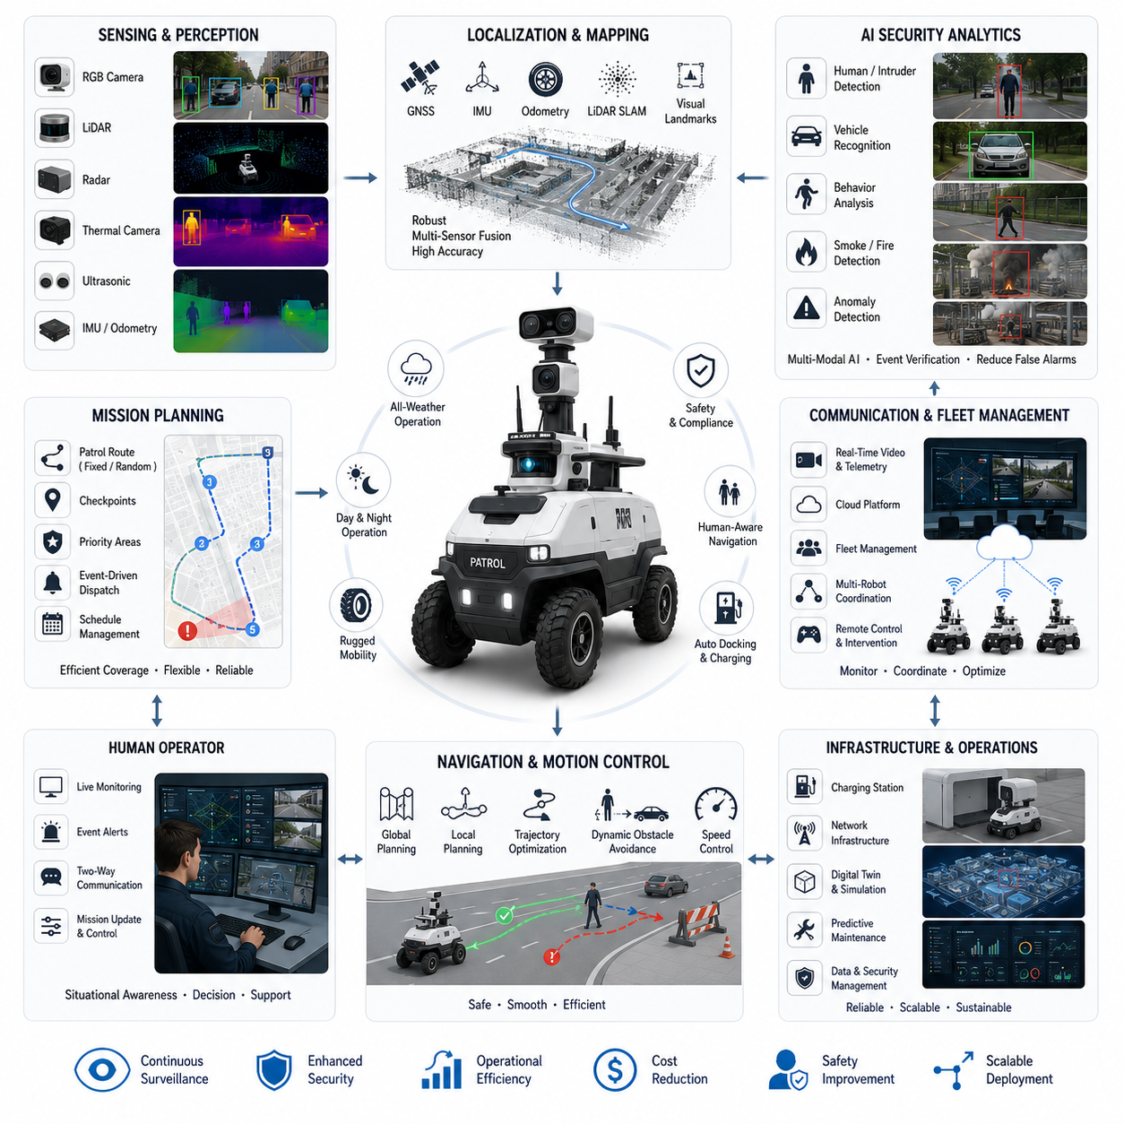
The outdoor patrol robot represents one of the most demanding applications of autonomous navigation because it must continuously operate in large, dynamic, and unpredictable environments while maintaining high levels of safety, reliability, and mission effectiveness. Unlike indoor autonomous mobile robots that rely on structured layouts, stable lighting, and relatively controlled traffic, outdoor patrol robots must navigate changing weather, uneven terrain, varying illumination, moving vehicles, pedestrians, animals, construction zones, and numerous unexpected environmental events. A successful patrol robot therefore combines robust perception, accurate localization, intelligent behavior planning, resilient hardware, and fleet-level operational management into a unified autonomous system capable of long-duration deployment.
A typical deployment begins with defining the patrol objectives. Security organizations, industrial facilities, logistics terminals, airports, ports, power plants, campuses, military bases, railways, residential complexes, and smart cities all require continuous monitoring over wide geographical areas. Human patrols are expensive, inconsistent, and often exposed to hazardous situations, particularly during nighttime operations or severe weather. Outdoor patrol robots complement human security personnel by performing repetitive surveillance tasks with consistent performance while allowing operators to focus on higher-level decision making. Instead of replacing humans entirely, these robots function as autonomous force multipliers capable of expanding operational coverage while reducing labor intensity.
The robot itself is designed around an all-weather mobile platform capable of traversing outdoor surfaces including asphalt roads, concrete sidewalks, gravel paths, compacted soil, parking lots, and moderately uneven terrain. The chassis incorporates sufficient ground clearance, suspension, traction control, and weather-resistant enclosures to ensure reliable operation throughout seasonal changes. Large pneumatic tires improve ride stability and reduce vibration transmitted to onboard sensors. Waterproof connectors, sealed electronics compartments, temperature management systems, and corrosion-resistant materials allow continuous deployment under rain, dust, snow, and high humidity conditions. Battery capacity is selected to support several hours of autonomous patrol before automatic docking and charging.
Reliable localization is one of the most critical components of outdoor autonomy. While Global Navigation Satellite Systems provide absolute positioning across large outdoor environments, satellite reception alone cannot satisfy the precision requirements of autonomous navigation. Signal blockage, multipath reflections near buildings, tree canopies, tunnels, and bridges introduce localization errors that may exceed acceptable safety margins. Therefore, GNSS measurements are fused with inertial measurement units, wheel odometry, LiDAR-based localization, visual landmarks, and simultaneous localization and mapping algorithms. Multi-sensor fusion continuously estimates the robot's position even when one sensing modality temporarily becomes unreliable. The localization system dynamically evaluates confidence levels and adjusts navigation behavior according to positioning uncertainty.
Perception integrates multiple complementary sensors to construct a comprehensive understanding of the surrounding environment. High-resolution RGB cameras provide visual recognition of people, vehicles, animals, infrastructure, and security events. Depth cameras estimate nearby obstacle geometry while LiDAR generates precise three-dimensional spatial measurements independent of ambient lighting. Radar contributes robust detection during rain, fog, dust, or darkness where optical sensors may degrade. Ultrasonic sensors protect close-range maneuvering around obstacles during docking or confined navigation. Thermal cameras may additionally identify overheating equipment, unauthorized human presence in darkness, or potential fire hazards. Sensor fusion combines these heterogeneous observations into a unified environmental representation that supports both navigation and security monitoring.
Environmental perception extends beyond simple obstacle detection. Semantic understanding enables the robot to classify roads, sidewalks, crosswalks, fences, gates, buildings, vegetation, parked vehicles, traffic signs, and designated patrol checkpoints. The navigation system recognizes regions that require reduced speed, increased caution, or prohibited entry. Construction areas, temporary barriers, or emergency vehicles trigger dynamic replanning rather than causing mission failure. Human-aware navigation predicts pedestrian movement and generates socially acceptable trajectories that avoid startling nearby individuals while maintaining safe separation distances. Context-aware behavior significantly improves acceptance when robots operate in public environments.
Mission planning divides the patrol route into multiple checkpoints connected through globally optimized navigation paths. Patrol schedules may follow fixed sequences, randomized routes, priority-based inspections, or event-driven dispatch depending on operational objectives. Fixed routes maximize consistency for routine surveillance, whereas randomized patrols improve security effectiveness by preventing predictable movement patterns. Event-driven missions interrupt normal patrol schedules whenever alarms, sensor anomalies, or operator requests require immediate investigation. After completing the assigned inspection, the robot automatically resumes its interrupted patrol without requiring manual intervention.
The navigation architecture typically employs hierarchical planning. A global planner computes efficient routes across the entire operational map using digital maps generated during deployment. Local planners continuously react to moving obstacles, temporary road closures, pedestrians, bicycles, maintenance vehicles, and unexpected environmental changes. Trajectory optimization considers vehicle kinematics, steering limitations, acceleration constraints, braking distance, and passenger safety if additional equipment is carried. Dynamic obstacle avoidance executes in real time while preserving overall mission efficiency and minimizing unnecessary detours.
Security monitoring represents the primary mission objective. Multiple onboard AI models continuously analyze incoming sensor streams to detect abnormal situations. Human detection distinguishes authorized personnel from suspicious intruders according to predefined operational policies. Vehicle recognition identifies unauthorized parking, illegal access, or abandoned vehicles. Behavioral analysis recognizes loitering, climbing fences, fighting, falling individuals, smoke generation, fire outbreaks, weapon-like objects where appropriate, and other predefined security events. Industrial facilities may additionally monitor equipment overheating, liquid leakage, hazardous material spills, or restricted-area violations. Rather than relying on a single AI model, specialized neural networks collaborate through sensor fusion to reduce false alarms while increasing detection reliability.
Whenever an abnormal event is detected, the robot performs autonomous investigation procedures. Instead of immediately transmitting an alarm, the system first verifies the observation using multiple viewpoints or multiple sensing modalities whenever possible. The robot may reposition itself to obtain a clearer camera angle, zoom a pan-tilt camera toward the detected object, activate auxiliary lighting during nighttime, or collect additional thermal imagery before escalating the incident. Confidence estimation algorithms determine whether the observation satisfies predefined reporting thresholds. This verification stage substantially reduces unnecessary operator workload caused by false detections.
Communication infrastructure connects field robots with centralized fleet management systems. High-bandwidth wireless networks transmit compressed video streams, sensor telemetry, localization status, battery information, mission progress, health diagnostics, and security events. Cloud services archive operational logs while edge computing performs latency-sensitive perception and navigation. Operators supervise multiple robots simultaneously through a centralized dashboard displaying live robot locations, patrol progress, detected incidents, equipment health, communication quality, and environmental conditions. Bidirectional communication allows remote intervention whenever operators need to manually inspect suspicious situations or modify mission priorities.
Fleet management becomes increasingly important when multiple patrol robots simultaneously operate across large facilities. The fleet management system allocates patrol regions, balances workloads, prevents redundant coverage, and coordinates traffic among robots sharing common pathways. Collision avoidance extends beyond individual robots to fleet-level scheduling that minimizes congestion at intersections, charging stations, gates, and narrow corridors. Robots automatically exchange localization information, planned trajectories, and operational status to support cooperative navigation. If one robot becomes unavailable due to maintenance or charging, neighboring robots dynamically redistribute unfinished patrol segments to preserve complete site coverage.
Energy management significantly influences operational availability. Patrol scheduling considers battery capacity, travel distance, terrain difficulty, payload weight, weather conditions, and anticipated computational load. Instead of waiting until batteries become critically depleted, intelligent scheduling predicts future energy consumption and inserts autonomous charging sessions without compromising mission completion. Opportunity charging during low-demand periods further increases fleet utilization. Battery management systems continuously monitor cell voltage, temperature, charging efficiency, and long-term health to maximize operational lifespan while maintaining safety.
Reliability engineering addresses the reality that outdoor environments inevitably introduce failures. Cameras may become partially obstructed by mud or rain droplets. LiDAR windows accumulate dust. GNSS reception temporarily disappears near tall buildings. Wireless communication experiences intermittent degradation. Dynamic fault monitoring detects abnormal sensor behavior and automatically switches to redundant sensing whenever possible. Graceful degradation strategies ensure the robot continues operating safely despite partial failures. When localization uncertainty exceeds acceptable thresholds, the robot reduces speed, increases safety margins, or safely stops until localization confidence recovers. Self-diagnostic software continuously evaluates sensor health, computational resources, communication quality, storage utilization, and actuator performance throughout each mission.
Weather adaptation distinguishes outdoor robots from indoor systems. Heavy rain reduces camera visibility while snow modifies terrain appearance and wheel traction. Fog decreases optical sensing range. Strong sunlight produces glare and deep shadows that challenge visual perception. Wind may influence lightweight obstacles or affect directional microphones. Environmental monitoring continuously estimates current weather conditions and dynamically adjusts perception algorithms, navigation speed, braking distance, sensor weighting, and mission planning accordingly. In severe weather beyond certified operational limits, the robot automatically returns to a protected docking station or designated shelter until environmental conditions improve.
Nighttime patrol introduces additional sensing challenges but also provides unique operational advantages. Infrared illumination, thermal cameras, high-sensitivity image sensors, and intelligent exposure control maintain reliable perception under low-light conditions. Artificial intelligence compensates for reduced visual information by increasing reliance on LiDAR, radar, and thermal sensing. Automatic lighting systems activate only when necessary to preserve energy while minimizing disturbance to nearby residents. Thermal anomaly detection becomes particularly valuable during nighttime because temperature differences between objects become more distinguishable.
Human-robot interaction remains essential even in highly autonomous deployments. Security personnel can dispatch robots toward reported incidents, request live video from specific locations, define temporary exclusion zones, or manually guide robots during unusual situations. The robot communicates its intentions using visual indicators, audio announcements, display panels, or projected navigation paths to improve predictability for nearby pedestrians. Emergency stop interfaces remain immediately accessible to ensure compliance with industrial safety regulations.
Digital twins significantly improve deployment efficiency. Before field installation, engineers construct virtual models of operational environments that reproduce roads, buildings, vegetation, lighting conditions, weather patterns, and traffic behavior. Simulation enables validation of navigation algorithms, patrol schedules, AI detection models, communication performance, battery endurance, and failure recovery procedures under thousands of synthetic scenarios that would be prohibitively expensive to reproduce physically. Once deployed, operational telemetry continuously updates the digital twin, enabling predictive maintenance, mission optimization, and performance analysis throughout the robot's operational lifetime.
Performance evaluation measures both navigation quality and security effectiveness. Navigation metrics include localization accuracy, route completion rate, average patrol speed, obstacle avoidance success, docking reliability, battery utilization, mission completion time, and autonomous recovery frequency. Security metrics evaluate detection precision, recall, false alarm rate, incident response time, investigation quality, operator workload reduction, and overall surveillance coverage. Long-term operational statistics provide quantitative evidence supporting continuous software improvement and future hardware evolution.
A representative industrial deployment illustrates the integration of these technologies. Consider a large logistics terminal operating twenty-four hours per day across several square kilometers. Multiple autonomous patrol robots continuously monitor warehouses, parking areas, loading docks, perimeter fences, access gates, and utility infrastructure. During normal operation, robots follow optimized patrol routes while inspecting equipment, verifying gate status, monitoring pedestrian safety, and detecting unauthorized vehicle movement. One robot identifies an individual approaching a restricted perimeter during nighttime. The onboard AI initially detects human presence using visible cameras, confirms the observation through thermal imaging, and estimates trajectory using LiDAR tracking. Rather than immediately triggering a high-priority alarm, the robot autonomously repositions itself to obtain additional evidence while maintaining a safe distance. Confidence increases after multi-sensor verification, and the robot transmits synchronized video, thermal imagery, localization coordinates, and incident metadata to the central control center. Nearby patrol robots automatically adjust their routes to increase surveillance coverage around the affected region while operators assess the situation. Security personnel receive comprehensive situational awareness before arriving at the scene, significantly reducing response time and improving operational safety.
This case study demonstrates that successful outdoor patrol robots are not simply mobile surveillance cameras. They represent integrated autonomous systems combining robust mobility, resilient localization, multi-modal perception, intelligent navigation, AI-based security analytics, fleet coordination, cloud connectivity, autonomous recovery, predictive maintenance, and long-duration operational management. As foundation models, world models, multimodal reasoning, and embodied artificial intelligence continue to mature, future outdoor patrol robots will transition from executing predefined patrol routes toward understanding mission objectives, interpreting complex environmental contexts, predicting potential security risks before incidents occur, and collaborating naturally with both human operators and other autonomous systems. These capabilities will transform outdoor patrol robots into proactive intelligent guardians capable of continuously protecting critical infrastructure, industrial facilities, transportation networks, and smart cities with levels of consistency, scalability, and situational awareness that substantially exceed conventional manual patrol operations.

23.6 GPR Robot Navigation
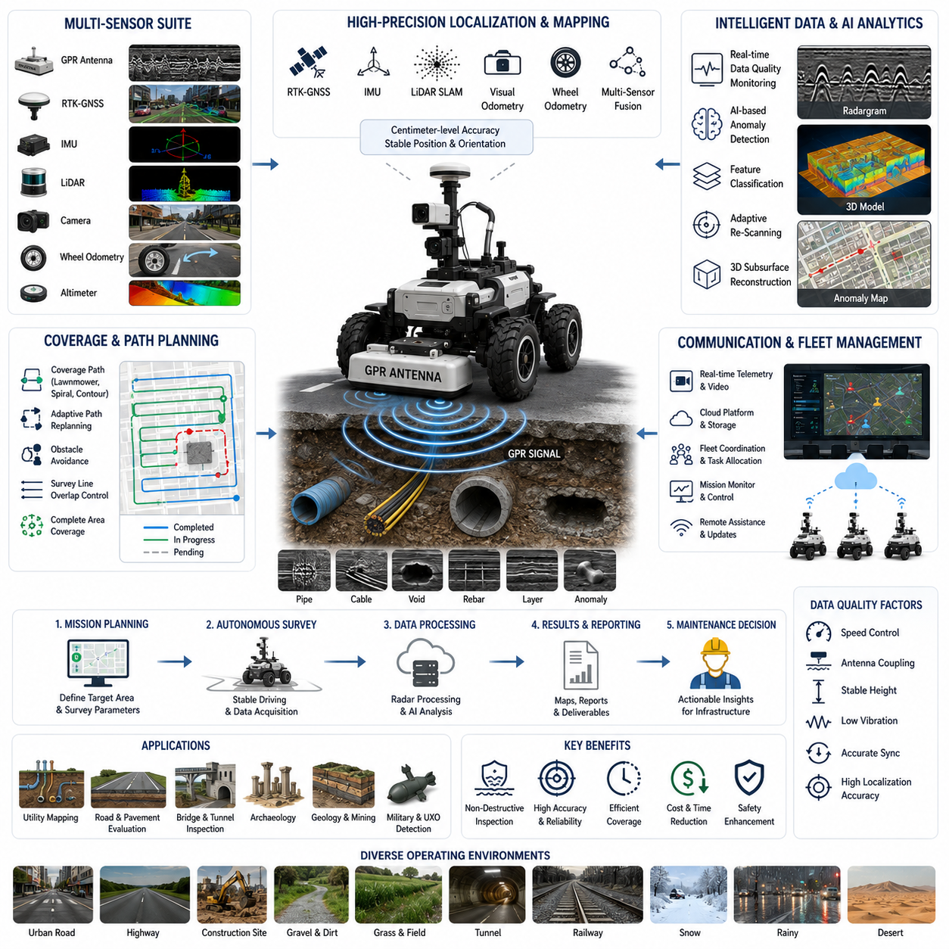
Ground Penetrating Radar (GPR) robots represent a specialized class of autonomous mobile systems designed to inspect, map, and analyze subsurface structures without physically excavating the ground. Unlike conventional outdoor patrol or logistics robots that primarily interact with the visible environment, GPR robots must simultaneously understand both the surface through which they navigate and the hidden underground structures that constitute the primary mission objective. This dual-layer perception problem introduces unique challenges in navigation, sensing, localization, motion control, data synchronization, and mission planning. Successful GPR robot navigation therefore requires close integration between autonomous mobility, high-precision positioning, subsurface sensing, environmental understanding, and intelligent data management.
A typical GPR mission begins by defining the inspection objective rather than simply selecting a destination. The robot may be deployed to detect underground utility pipes, electrical cables, communication conduits, water distribution networks, sewer systems, buried storage tanks, unexploded ordnance, archaeological remains, pavement deterioration, sinkholes, voids beneath roads, reinforced concrete structures, or geological anomalies. Each application demands different sensor configurations, survey resolutions, driving speeds, antenna frequencies, and navigation strategies. Consequently, mission planning becomes tightly coupled with sensing requirements, ensuring that navigation behavior directly supports data quality rather than merely minimizing travel distance.
The operational environment of GPR robots is considerably more diverse than that of traditional industrial autonomous mobile robots. Inspection missions may occur on city streets, highways, airport runways, railway corridors, bridges, tunnels, industrial facilities, construction sites, agricultural land, mining areas, military bases, or archaeological excavation zones. Surface conditions vary continuously between asphalt, concrete, gravel, soil, grass, sand, mud, snow, and uneven terrain. Weather conditions further influence traction, visibility, and electromagnetic signal quality. Therefore, the navigation system must remain robust across highly variable environmental conditions while preserving the positional accuracy necessary for meaningful subsurface mapping.
Robot mobility directly influences radar data quality. Unlike many delivery robots that prioritize rapid transportation, GPR robots emphasize stable, repeatable, and vibration-minimized movement. Excessive acceleration, sudden steering, wheel slip, or chassis oscillation introduces measurement distortions that degrade radar image reconstruction. Motion control therefore incorporates smooth trajectory generation, velocity regulation, suspension optimization, and terrain-adaptive driving behavior. The robot continuously monitors wheel slip, vehicle pitch, roll, vibration levels, and antenna stability to maintain consistent sensing conditions throughout the survey.
Localization requirements for GPR robots are substantially more demanding than those of ordinary navigation systems. Since underground anomalies must later be excavated or inspected by engineers, every detected feature requires highly accurate geographical coordinates. Positioning errors of several centimeters may lead to incorrect excavation sites or misidentification of underground utilities. Consequently, localization combines Real-Time Kinematic Global Navigation Satellite Systems (RTK-GNSS), inertial measurement units, wheel odometry, LiDAR-based localization, visual odometry, simultaneous localization and mapping, and sometimes total station measurements for areas where satellite reception is unavailable. Multi-sensor fusion continuously estimates both global position and local trajectory while maintaining long-term consistency throughout extensive survey operations.
Time synchronization between navigation sensors and GPR measurements is equally important. Every radar scan must be associated with an exact robot position, orientation, timestamp, and vehicle velocity. Even minor synchronization errors between radar acquisition and localization systems may shift underground structures by several centimeters in reconstructed maps. Precision time protocols, hardware triggering, synchronized clocks, and deterministic communication networks ensure accurate alignment between radar data, LiDAR observations, camera images, inertial measurements, and positioning information. This synchronization enables reliable three-dimensional reconstruction of subsurface features during post-processing.
Ground Penetrating Radar itself operates by transmitting electromagnetic pulses into the ground and analyzing reflections produced by buried objects or material boundaries. Different antenna frequencies determine penetration depth and spatial resolution. High-frequency antennas provide detailed imaging of shallow structures such as pavement layers and utility pipes, whereas lower-frequency antennas penetrate deeper geological formations with reduced resolution. Mission planning therefore includes selecting appropriate antenna configurations according to soil composition, expected target depth, environmental conditions, and survey objectives. Autonomous navigation parameters may also change depending on antenna characteristics because wider antenna footprints or lower-frequency systems often require different survey spacing.
Coverage planning represents one of the defining aspects of autonomous GPR navigation. Unlike conventional point-to-point navigation, underground surveys require systematic area coverage with controlled overlap between adjacent scan lines. Survey trajectories are generated using coverage path planning algorithms that guarantee complete inspection while minimizing redundant travel. Common patterns include parallel lawnmower trajectories, spiral coverage, contour-following paths, adaptive regional scanning, and multi-pass inspection. Path spacing is determined by antenna beam width, target size, desired spatial resolution, and acceptable reconstruction accuracy. Automatic overlap management ensures that no underground region remains uninspected.
Terrain understanding significantly influences both navigation safety and radar performance. Surface irregularities affect antenna height above the ground, introducing signal variations that complicate interpretation. The robot therefore continuously estimates terrain elevation using LiDAR, stereo vision, depth cameras, or suspension sensors. Terrain classification distinguishes paved roads, grass, gravel, loose soil, mud, and obstacles. Motion planning automatically adjusts speed, steering aggressiveness, and suspension behavior to preserve consistent antenna positioning relative to the ground surface. In highly uneven terrain, adaptive antenna mounting mechanisms may actively compensate for chassis movement to maintain measurement quality.
Obstacle detection extends beyond ordinary collision avoidance because many temporary objects should not permanently interrupt survey coverage. Parked vehicles, construction equipment, pedestrians, bicycles, temporary barriers, and vegetation frequently obstruct planned survey lines. Instead of abandoning coverage, the robot temporarily bypasses obstacles while recording skipped regions for future completion. Coverage maps dynamically update inspected, partially inspected, and pending regions, allowing intelligent replanning that eventually guarantees complete area coverage despite temporary environmental changes. This capability substantially improves operational efficiency in real-world deployments.
Semantic understanding further enhances navigation efficiency. The robot classifies roads, sidewalks, parking spaces, bridges, rail crossings, drainage structures, utility access covers, lane markings, and construction zones. Prior infrastructure maps may indicate likely underground utility corridors, allowing adaptive survey prioritization. Areas with historically dense underground infrastructure may receive higher-resolution scanning while regions with low expected complexity are surveyed more efficiently. Semantic mapping therefore optimizes both navigation and sensing resources according to engineering priorities rather than purely geometric coverage.
Data quality monitoring operates continuously during autonomous missions. The robot evaluates radar signal strength, noise levels, antenna coupling quality, localization confidence, wheel slip, vehicle vibration, communication latency, and synchronization accuracy in real time. If measurement quality deteriorates below predefined thresholds, the navigation system automatically slows down, repeats specific survey segments, adjusts antenna height when possible, or alerts operators. Autonomous quality assurance significantly reduces the likelihood of incomplete or unusable inspection data that would otherwise require costly repeat surveys.
Artificial intelligence increasingly supports interpretation during field operation rather than only after data collection. Deep neural networks identify characteristic radar signatures associated with pipes, cables, voids, rebar, pavement defects, buried objects, or geological interfaces. Rather than replacing expert interpretation, onboard AI highlights regions of interest, estimates detection confidence, and recommends additional scanning from alternative directions. The navigation system may autonomously initiate localized rescanning around suspicious anomalies to improve reconstruction quality before leaving the inspection site. This adaptive behavior transforms traditional passive surveying into active autonomous exploration.
Large infrastructure inspections often require multiple sensing modalities beyond GPR alone. High-resolution RGB cameras document surface conditions including pavement cracks, road markings, drainage systems, and visible infrastructure damage. LiDAR generates detailed three-dimensional surface geometry while thermal cameras identify moisture intrusion or thermal anomalies that may correlate with subsurface defects. Inertial sensors estimate surface roughness, and acoustic sensors may detect hollow regions beneath pavements. Multi-modal sensor fusion combines these heterogeneous observations into comprehensive infrastructure assessment models that simultaneously describe above-ground and below-ground conditions.
Communication architecture enables continuous coordination between field robots and centralized engineering teams. High-bandwidth wireless communication transfers navigation status, preliminary radar images, localization information, quality metrics, system health, and mission progress. Edge computing performs latency-sensitive perception, localization, and navigation while computationally intensive radar reconstruction and AI-assisted interpretation may execute on cloud infrastructure. Engineers can remotely monitor survey progress, adjust mission parameters, define additional inspection regions, or review preliminary anomaly detections without interrupting autonomous operation.
Fleet operation becomes advantageous when surveying large infrastructure networks such as highways, airports, railway systems, industrial complexes, or urban utility corridors. Multiple GPR robots divide survey regions according to workload, battery capacity, antenna configuration, and environmental accessibility. Fleet management coordinates survey boundaries, prevents duplicate coverage, optimizes charging schedules, and balances mission completion times. Shared localization frameworks allow multiple robots to contribute seamlessly to unified underground infrastructure maps. Dynamic mission reassignment ensures efficient resource utilization whenever individual robots encounter unexpected obstacles or maintenance requirements.
Energy management requires balancing computational demand with long-duration field operations. Radar acquisition, real-time localization, sensor fusion, AI inference, communication, and autonomous navigation all consume substantial electrical power. Mission planning estimates expected energy consumption according to terrain complexity, survey duration, travel distance, computational workload, and environmental conditions. Intelligent scheduling integrates autonomous charging opportunities without compromising survey continuity. Battery health monitoring further ensures reliable operation during extended deployments across geographically dispersed inspection sites.
Reliability engineering addresses numerous operational uncertainties encountered during field surveys. GNSS reception may degrade near buildings, trees, or tunnels. Radar antennas may accumulate mud or debris. Cameras become affected by rain, dust, or strong sunlight. Wheel slip increases on wet grass or loose gravel. Wireless communication may temporarily disappear in remote locations. Fault management systems continuously evaluate sensor health and dynamically adapt navigation strategies to maintain safe operation. Graceful degradation mechanisms allow missions to continue despite partial subsystem failures whenever measurement quality remains acceptable.
Weather adaptation plays an especially important role because soil moisture significantly influences radar propagation characteristics. Heavy rainfall increases signal attenuation while frozen ground alters electromagnetic behavior. Extremely dry soils, clay-rich environments, sandy terrain, or highly conductive materials each affect penetration depth differently. Environmental monitoring estimates weather conditions and soil characteristics using onboard sensors and historical environmental data. Navigation speed, antenna configuration, survey spacing, and AI interpretation parameters may automatically adjust according to estimated subsurface electromagnetic conditions, improving overall survey reliability.
Safety considerations extend beyond collision avoidance because GPR robots frequently operate near active traffic, pedestrians, heavy construction equipment, and critical infrastructure. Dynamic safety zones adjust according to robot speed, environmental visibility, and traffic density. Human-aware navigation predicts pedestrian movement and generates socially acceptable trajectories that minimize disruption. Emergency stop mechanisms remain continuously available while remote operators can intervene whenever unusual situations require manual supervision. Compliance with transportation, construction, and industrial safety regulations remains an essential aspect of commercial deployment.
Digital twins provide an integrated framework for mission preparation, execution, and analysis. Existing geographic information systems, utility databases, engineering drawings, LiDAR maps, satellite imagery, and historical inspection records are combined into virtual environments before deployment. Autonomous survey plans are validated in simulation to verify coverage efficiency, localization robustness, battery endurance, and obstacle avoidance behavior. After field operation, collected radar data updates the digital twin with newly discovered underground structures, infrastructure deterioration, and environmental changes. This continuously evolving digital representation becomes an invaluable asset for long-term infrastructure management.
Performance evaluation considers navigation accuracy, survey completeness, radar image quality, anomaly detection accuracy, localization precision, energy efficiency, mission duration, system reliability, and operational cost. Coverage percentage measures whether the entire designated region has been successfully inspected. Positioning accuracy determines confidence in excavation guidance. AI performance evaluates precision, recall, and false detection rates for underground feature identification. Long-term operational statistics guide continuous improvement of both navigation algorithms and sensing methodologies while providing quantitative evidence for return on investment.
A representative deployment illustrates the integration of these technologies. Consider a municipal utility authority responsible for maintaining aging underground water pipelines beneath a busy urban roadway. A GPR robot is dispatched during nighttime when traffic density is reduced. Before deployment, digital infrastructure maps identify probable utility corridors while historical maintenance records highlight high-risk regions. The robot autonomously follows a precisely planned coverage trajectory using RTK-GNSS, LiDAR localization, and inertial navigation. Radar scans are synchronized with centimeter-level positioning while onboard AI continuously analyzes reflections for pipe deformation, underground voids, and anomalous soil conditions. Temporary obstacles such as parked maintenance vehicles cause local trajectory adjustments without compromising complete survey coverage. Several suspicious underground anomalies are detected, prompting autonomous rescanning from perpendicular directions to improve reconstruction confidence. Engineers monitoring the mission remotely immediately review preliminary results while cloud-based processing generates detailed three-dimensional subsurface maps. After mission completion, detected anomalies are automatically integrated into the municipal digital twin, allowing maintenance teams to prioritize excavation according to quantified structural risk rather than reactive failure response.
This case study demonstrates that autonomous GPR robots represent far more than mobile radar platforms. They are intelligent surveying systems integrating precision localization, systematic coverage planning, terrain-aware navigation, synchronized multi-modal sensing, artificial intelligence, cloud-connected fleet management, digital twins, and autonomous decision making into a unified inspection architecture. As robotics foundation models, world models, multimodal reasoning, self-supervised learning, and embodied artificial intelligence continue to mature, future GPR robots will increasingly understand infrastructure context, autonomously select optimal survey strategies, predict subsurface failure mechanisms, coordinate with aerial and ground robotic teams, and contribute continuously updated underground digital infrastructure maps that support predictive maintenance, smart city management, resilient transportation networks, and sustainable civil engineering throughout the entire infrastructure lifecycle.

23.7 Smart City Robot Deployment
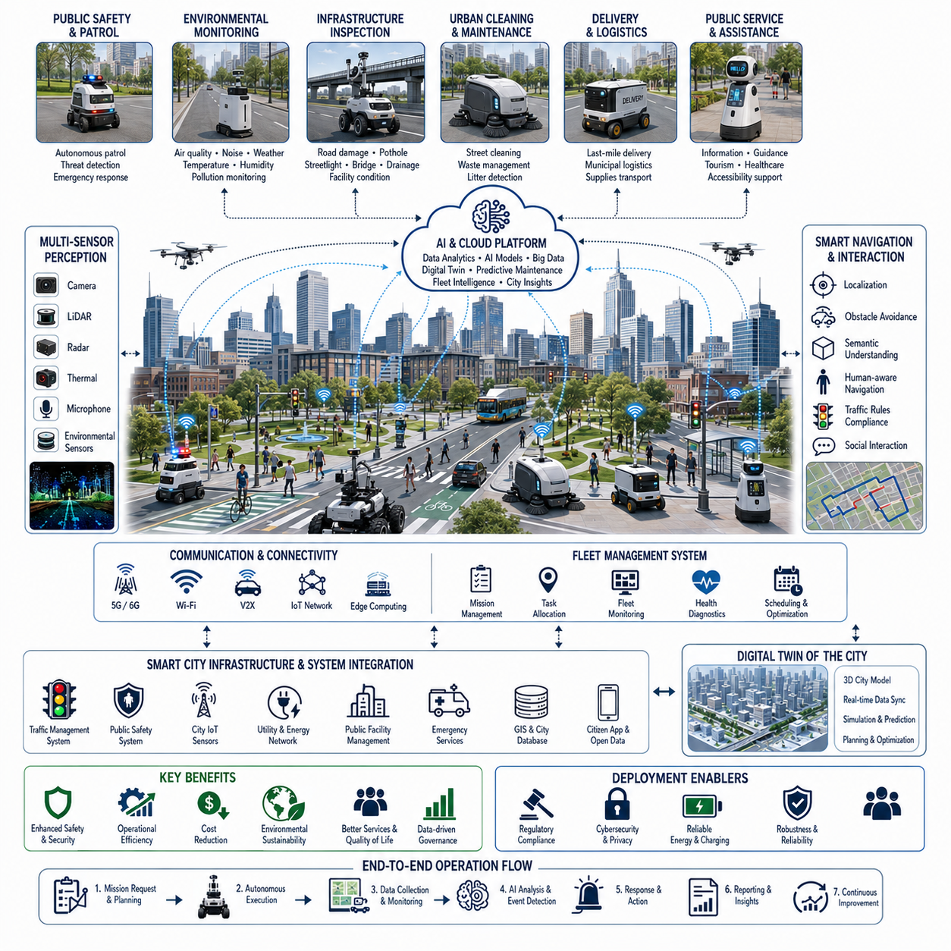
Smart city robot deployment represents the large-scale integration of autonomous mobile robots into urban environments where they continuously interact with people, infrastructure, transportation systems, public services, and digital information networks. Unlike isolated industrial robot installations, smart city deployments require robots to function as cooperative members of a complex cyber-physical ecosystem. Navigation therefore becomes only one component of a much broader intelligent urban platform that integrates perception, communication, cloud computing, artificial intelligence, digital twins, public safety, environmental monitoring, infrastructure management, and municipal operations. The success of a smart city robot deployment depends not only on individual robot performance but also on how effectively autonomous systems collaborate with existing city infrastructure while providing measurable improvements in urban efficiency, sustainability, safety, and quality of life.
A smart city deployment begins with defining service objectives rather than selecting robot hardware. Different cities possess different priorities depending on population density, transportation networks, economic activities, environmental conditions, and public services. Some municipalities emphasize public safety through autonomous patrol robots, while others prioritize environmental monitoring, urban cleaning, infrastructure inspection, last-mile delivery, healthcare support, tourism assistance, or intelligent transportation management. Each application influences robot hardware, sensor configuration, communication requirements, fleet architecture, navigation strategies, regulatory compliance, and operational scheduling. Consequently, deployment planning focuses on integrating robots into municipal workflows rather than introducing autonomous machines as independent technologies.
Urban environments present some of the most challenging navigation conditions encountered by autonomous robots. Sidewalks, bicycle lanes, pedestrian crossings, public squares, parks, transportation terminals, shopping districts, residential neighborhoods, industrial zones, and mixed-use developments all exhibit different traffic patterns and environmental characteristics. Dynamic obstacles include pedestrians, cyclists, scooters, wheelchairs, pets, parked vehicles, delivery trucks, construction equipment, temporary barriers, outdoor events, and emergency responders. Robots must continuously adapt their navigation behavior while respecting local traffic regulations, pedestrian priority, accessibility requirements, and socially acceptable movement patterns. Safe navigation therefore depends not only on obstacle avoidance but also on understanding human intentions, cultural expectations, and urban etiquette.
Localization within smart cities requires significantly greater robustness than many industrial environments. High-rise buildings create Global Navigation Satellite System signal reflections and shadowing that reduce positioning accuracy. Underground passages, tunnels, dense vegetation, bridges, and enclosed public spaces further complicate localization. Consequently, urban robots combine Real-Time Kinematic Global Navigation Satellite Systems, inertial measurement units, LiDAR localization, visual simultaneous localization and mapping, wheel odometry, semantic landmarks, infrastructure beacons, and cloud-assisted localization into a unified positioning framework. Multi-sensor fusion continuously estimates robot position while evaluating confidence levels so that navigation behavior can adapt whenever localization uncertainty increases.
Perception systems form the foundation of intelligent urban operation. Multiple RGB cameras provide detailed scene understanding while depth cameras estimate nearby geometry. LiDAR generates accurate three-dimensional obstacle information independent of lighting conditions. Radar maintains reliable detection during rain, fog, dust, or nighttime operation. Thermal cameras identify overheating infrastructure, fire hazards, or people requiring assistance under poor visibility. Microphone arrays may detect emergency sirens, accidents, abnormal sounds, or public safety events. Environmental sensors monitor temperature, humidity, air quality, particulate matter, noise pollution, radiation, and weather conditions. These heterogeneous sensing modalities are fused into a comprehensive environmental representation that simultaneously supports navigation, infrastructure monitoring, and municipal services.
Semantic understanding significantly enhances autonomous behavior within cities. Rather than merely recognizing obstacles, robots identify sidewalks, crosswalks, traffic lights, bicycle lanes, bus stops, building entrances, charging stations, public facilities, parking areas, construction zones, emergency access routes, and restricted regions. Semantic maps associate physical locations with functional meaning, enabling context-aware decision making. For example, robots automatically reduce speed near schools during arrival hours, increase caution around hospitals, avoid crowded public events when alternative routes exist, and prioritize emergency vehicle access corridors. Semantic awareness transforms navigation from geometric path following into intelligent urban behavior.
Mission planning within smart cities is highly dynamic because municipal priorities continuously evolve. Patrol robots may interrupt routine surveillance to investigate emergency alarms. Environmental monitoring robots automatically increase inspection frequency after severe weather. Delivery robots adapt schedules according to traffic congestion and customer availability. Infrastructure inspection robots respond to newly reported road damage or utility failures. Public service robots assist during festivals, sporting events, or disaster response operations. Event-driven mission planning enables robots to continuously reprioritize tasks according to changing operational objectives while maintaining efficient utilization across the entire robotic fleet.
Communication infrastructure connects autonomous robots with municipal command centers, cloud platforms, edge computing resources, traffic management systems, Internet of Things devices, and emergency services. High-bandwidth wireless communication enables real-time transmission of video, sensor data, localization information, diagnostics, environmental measurements, and operational status. Edge computing executes latency-sensitive perception, navigation, and safety functions while cloud services perform large-scale data analytics, long-term storage, predictive maintenance, fleet optimization, and city-wide artificial intelligence. Robust communication architectures incorporate redundant networking technologies to maintain reliable connectivity despite interference, infrastructure failures, or temporary network congestion.
Artificial intelligence serves as the central decision-making capability for smart city robots. Deep neural networks recognize pedestrians, vehicles, bicycles, animals, road signs, traffic signals, infrastructure defects, waste accumulation, flooding, smoke, fire, vandalism, and numerous other urban phenomena. Multi-modal foundation models integrate visual, spatial, linguistic, and environmental information into unified situational awareness. Rather than executing isolated perception tasks, AI continuously interprets city dynamics, predicts future events, estimates uncertainty, and recommends optimal responses. Human operators remain responsible for strategic oversight while autonomous systems increasingly manage routine operational decisions with minimal supervision.
Human-aware navigation becomes particularly important because smart city robots operate continuously alongside diverse populations. Elderly individuals, children, tourists, visually impaired pedestrians, cyclists, maintenance workers, and emergency responders each exhibit distinct movement behaviors. Robots predict pedestrian trajectories, estimate social comfort zones, maintain appropriate interpersonal distances, communicate navigation intentions using visual signals or audio messages, and generate trajectories that appear natural and predictable. Socially compliant navigation significantly improves public acceptance while reducing unnecessary interactions that could inconvenience pedestrians.
Traffic coordination extends beyond individual robot navigation toward city-scale mobility management. Robots exchange planned trajectories with centralized traffic management platforms and neighboring autonomous systems. Intelligent intersections allocate crossing priorities according to current traffic conditions, pedestrian density, emergency vehicle movement, and municipal policies. Sidewalk congestion prediction enables robots to select alternative routes before bottlenecks develop. Fleet-level scheduling minimizes unnecessary overlap while balancing workloads across distributed service areas. Such cooperative traffic management increases operational efficiency without degrading public mobility.
Digital twins play an essential role throughout deployment and operation. A city-wide digital twin integrates three-dimensional building models, transportation infrastructure, utility networks, environmental sensors, historical traffic patterns, weather forecasts, construction schedules, public events, and real-time robot telemetry into a continuously evolving virtual representation of the city. Simulation validates navigation algorithms, communication architectures, fleet coordination strategies, emergency response procedures, and infrastructure modifications before deployment. During operation, digital twins support predictive analytics, operational optimization, maintenance planning, and strategic decision making by continuously synchronizing virtual and physical urban environments.
Infrastructure monitoring represents one of the highest-value applications for autonomous urban robots. Vision systems identify pavement deterioration, road cracks, potholes, damaged traffic signs, streetlight failures, bridge defects, drainage blockage, vegetation overgrowth, graffiti, litter accumulation, damaged public furniture, and illegal dumping. Thermal cameras detect overheating electrical equipment or abnormal energy losses. Environmental sensors monitor flooding risk, air pollution, temperature distribution, and noise exposure. Continuous autonomous inspection provides municipalities with up-to-date infrastructure health information that supports predictive maintenance instead of reactive repair.
Environmental sustainability benefits substantially from distributed robotic sensing. Mobile environmental monitoring complements fixed sensor stations by collecting high-resolution spatial measurements throughout the city. Robots continuously measure particulate matter, greenhouse gases, volatile organic compounds, noise pollution, ultraviolet radiation, temperature, humidity, and localized weather conditions. Data collected from multiple autonomous platforms improves urban climate models, supports pollution mitigation strategies, optimizes green infrastructure planning, and enables evidence-based environmental policy development. Long-term environmental datasets further contribute to climate resilience and sustainable urban planning.
Public safety applications extend beyond conventional security patrols. Robots identify traffic accidents, fires, flooding, fallen pedestrians, hazardous material spills, damaged infrastructure, suspicious objects, and abnormal crowd behavior. Multi-modal artificial intelligence evaluates event severity before notifying emergency responders. Robots autonomously reposition themselves to collect additional information while maintaining safe distances. High-resolution video, thermal imagery, environmental measurements, and precise localization provide emergency services with enhanced situational awareness before personnel arrive at incident locations. These capabilities improve response speed while reducing uncertainty during emergency management.
Autonomous public service robots increasingly provide assistance directly to citizens. Interactive information kiosks guide tourists through unfamiliar districts, multilingual conversational systems answer public inquiries, delivery robots transport municipal supplies, healthcare robots support elderly populations, and accessibility robots assist individuals with disabilities. Language-guided interaction enables natural communication while cloud-based knowledge systems provide continuously updated municipal information. Such robots become visible components of daily urban life, extending public services beyond traditional government facilities.
Fleet management coordinates hundreds or thousands of autonomous robots operating simultaneously across an entire metropolitan area. Robots performing different municipal functions share communication infrastructure, localization services, charging facilities, maintenance resources, and digital maps. Centralized fleet management allocates missions according to robot capabilities, battery status, geographic proximity, maintenance schedules, and operational priorities. Dynamic workload balancing maximizes utilization while minimizing redundant travel and unnecessary energy consumption. Fleet coordination also supports cooperative missions in which multiple specialized robots jointly respond to complex urban events.
Energy management becomes increasingly significant at metropolitan scale. Charging infrastructure must accommodate diverse robot types while minimizing electrical demand peaks. Intelligent scheduling coordinates autonomous charging according to electricity pricing, renewable energy availability, predicted mission demand, and battery health. Opportunity charging during idle periods increases operational availability without interrupting municipal services. Long-term battery analytics support predictive replacement planning, reducing operational costs and improving system reliability throughout the fleet lifecycle.
Reliability engineering addresses continuous operation under highly variable urban conditions. Robots encounter heavy rain, snow, ice, fog, dust, extreme temperatures, strong sunlight, electromagnetic interference, communication disruptions, vandalism attempts, unexpected obstacles, and infrastructure failures. Self-diagnostic systems continuously evaluate sensor performance, actuator health, communication quality, computational resources, and localization confidence. Graceful degradation strategies maintain safe operation whenever partial subsystem failures occur. Autonomous recovery behaviors include route replanning, sensor reconfiguration, communication fallback, temporary mission suspension, and automatic return to maintenance facilities when necessary.
Cybersecurity becomes increasingly critical because smart city robots interact with essential municipal infrastructure. Secure communication protocols protect operational data while authentication mechanisms prevent unauthorized control. Encryption safeguards citizen privacy, sensor information, and municipal databases. Artificial intelligence continuously monitors network traffic for abnormal behavior indicative of cyberattacks. Secure software update mechanisms ensure that deployed robots remain protected against newly discovered vulnerabilities throughout long operational lifetimes. Cyber resilience therefore becomes as important as mechanical reliability in maintaining public trust.
Regulatory compliance governs every aspect of public deployment. Robots must satisfy transportation regulations, accessibility standards, privacy legislation, environmental policies, electromagnetic compatibility requirements, functional safety standards, and cybersecurity frameworks. Ethical considerations include transparent AI decision making, responsible data collection, privacy preservation, fairness, accessibility, and accountability. Public engagement during deployment planning improves citizen acceptance while providing valuable feedback for operational refinement. Successful smart city deployment therefore requires collaboration among engineers, municipal governments, regulators, emergency services, infrastructure operators, and local communities.
Performance evaluation extends beyond conventional robotic metrics toward comprehensive urban impact assessment. Navigation accuracy, obstacle avoidance success, mission completion rate, fleet utilization, battery efficiency, communication reliability, and localization precision remain important technical indicators. However, municipalities additionally evaluate infrastructure maintenance cost reduction, environmental improvements, emergency response acceleration, public safety enhancement, operational efficiency, citizen satisfaction, energy consumption, sustainability outcomes, and long-term economic return. Continuous performance measurement supports evidence-based policy decisions while guiding future technology investment.
A representative deployment illustrates the integration of these technologies. Consider a medium-sized smart city operating several hundred autonomous robots responsible for security patrols, environmental monitoring, infrastructure inspection, municipal delivery, and public information services. During routine operation, patrol robots monitor parks, transportation hubs, and commercial districts while environmental robots measure localized air quality and noise pollution. Infrastructure inspection robots identify developing pavement cracks and damaged streetlights before failures become hazardous. Delivery robots transport medical supplies between municipal facilities, and interactive service robots assist tourists at transportation terminals. Suddenly, severe rainfall causes localized flooding near a major intersection. Environmental monitoring robots detect rapidly rising water levels while infrastructure robots identify blocked drainage systems. Nearby patrol robots automatically reroute pedestrians away from hazardous areas while transmitting live video and thermal imagery to the municipal command center. Traffic management systems immediately modify traffic signals to redirect vehicles, and delivery robots dynamically avoid flooded routes without disrupting essential logistics. The digital twin continuously updates flood predictions using incoming sensor data, enabling emergency responders to prioritize interventions according to real-time situational awareness. After the event, all collected operational data becomes part of the city's historical knowledge base, improving predictive models and future disaster preparedness.
This deployment demonstrates that smart city robotics is fundamentally an ecosystem rather than a collection of independent autonomous machines. Individual robots contribute sensing, mobility, and local decision making, while cloud computing, digital twins, artificial intelligence, communication infrastructure, municipal information systems, and coordinated fleet management transform these capabilities into city-scale intelligence. As robotics foundation models, multimodal reasoning systems, world models, embodied artificial intelligence, edge computing, and autonomous collaboration continue to advance, future smart cities will increasingly function as integrated cyber-physical organisms in which distributed autonomous robots continuously perceive, understand, predict, and optimize urban operations. These intelligent robotic ecosystems will enhance sustainability, resilience, public safety, infrastructure reliability, environmental stewardship, and citizen quality of life while enabling municipalities to manage growing urban complexity with unprecedented efficiency and adaptability.

23.8 Industrial Failure Analysis
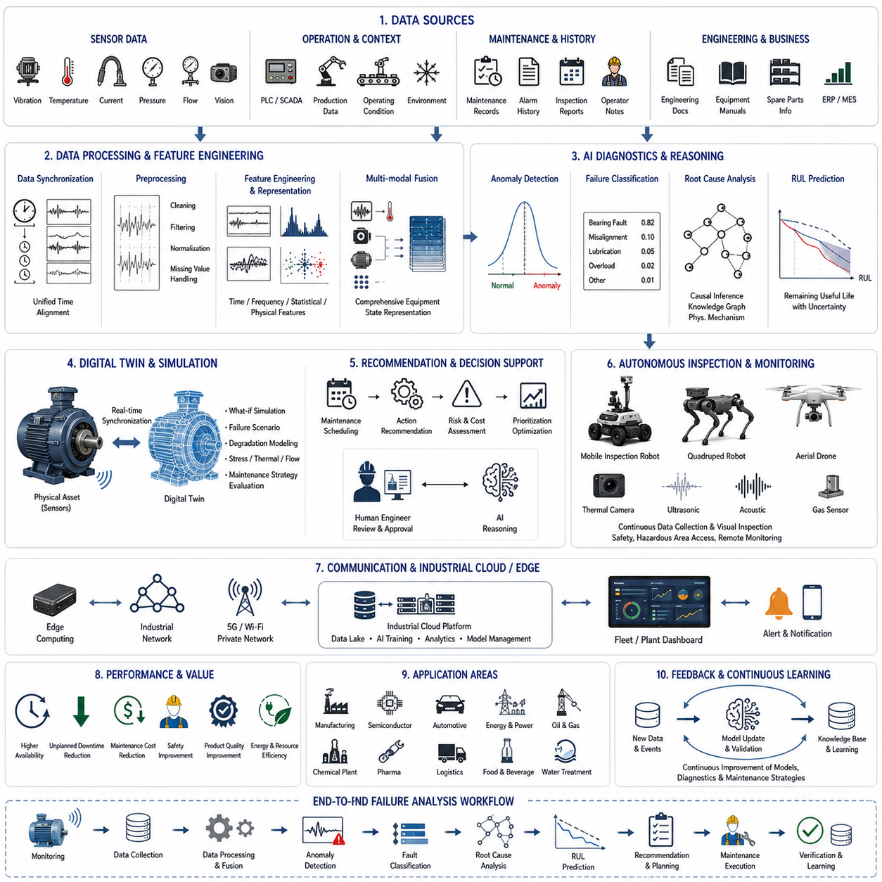
Industrial failure analysis represents one of the most valuable applications of modern robotics, artificial intelligence, digital twins, and industrial foundation models because it transforms raw operational data into actionable knowledge about the causes, progression, prediction, and prevention of equipment failures. Traditional failure analysis often begins only after a machine has already malfunctioned, requiring engineers to investigate historical logs, inspect damaged components, and reconstruct the sequence of events manually. Modern intelligent manufacturing shifts this paradigm toward continuous monitoring, autonomous diagnosis, predictive reasoning, and proactive intervention. Instead of asking why a failure occurred after production has stopped, intelligent industrial systems continuously estimate equipment health, identify early warning signals, simulate future degradation, and recommend maintenance actions before failures affect production.
The primary objective of industrial failure analysis is not merely identifying broken components but understanding the complete causal chain that connects operating conditions, physical degradation, sensor observations, maintenance history, environmental influences, and production requirements. Every industrial machine continuously interacts with mechanical forces, electrical systems, hydraulic circuits, thermal processes, control algorithms, operators, and surrounding environmental conditions. Failures rarely result from a single isolated cause. Instead, they emerge through complex interactions among multiple subsystems whose relationships may evolve over weeks, months, or years. Consequently, intelligent failure analysis requires integrating heterogeneous data sources into a unified understanding of machine behavior across both temporal and physical dimensions.
Industrial environments include manufacturing plants, semiconductor fabrication facilities, automotive assembly lines, logistics centers, power generation facilities, chemical processing plants, steel production sites, food processing factories, pharmaceutical manufacturing systems, mining operations, oil and gas facilities, water treatment plants, and numerous other mission-critical infrastructures. Each environment possesses unique operational characteristics, failure mechanisms, maintenance strategies, regulatory requirements, and economic priorities. Despite these differences, all industrial systems share a common objective: maximizing equipment availability while minimizing operational cost, production interruptions, safety risks, and unplanned maintenance activities.
Failure analysis begins with comprehensive data acquisition. Modern industrial equipment generates enormous quantities of sensor information through programmable logic controllers, supervisory control and data acquisition systems, industrial Internet of Things devices, embedded controllers, machine vision systems, thermal cameras, vibration sensors, acoustic sensors, electrical current monitors, hydraulic pressure sensors, temperature probes, flow meters, torque sensors, encoder measurements, and numerous additional sensing modalities. Beyond sensor data, valuable information also exists within maintenance records, operator observations, production schedules, inspection reports, quality control databases, engineering documentation, equipment manuals, and enterprise resource planning systems. Intelligent failure analysis integrates these diverse information sources into a unified operational knowledge base.
Time synchronization across all data sources represents a fundamental requirement for accurate failure diagnosis. Individual sensors may sample data at frequencies ranging from milliseconds to hours. Production logs, maintenance events, alarm histories, inspection records, and environmental measurements often originate from independent systems using different clocks. Without precise synchronization, engineers may incorrectly interpret causal relationships between events. Modern industrial architectures therefore employ deterministic industrial networks, synchronized clocks, precision timing protocols, and unified event timestamps that align every observation within a common temporal framework. Accurate temporal alignment enables reconstruction of complete failure sequences with high confidence.
Signal preprocessing significantly influences diagnostic accuracy. Raw industrial sensor data frequently contains measurement noise, missing samples, calibration drift, communication interruptions, sensor saturation, electromagnetic interference, and transient anomalies unrelated to actual equipment degradation. Data cleaning removes invalid observations while interpolation reconstructs missing values where appropriate. Signal filtering suppresses measurement noise without eliminating physically meaningful behavior. Feature normalization compensates for varying operating conditions, production rates, environmental temperatures, or seasonal influences. High-quality preprocessing ensures that subsequent artificial intelligence models analyze genuine equipment behavior rather than sensor artifacts.
Feature engineering transforms raw sensor measurements into informative representations describing equipment health. Mechanical systems often reveal degradation through changes in vibration spectra, frequency harmonics, rotational imbalance, bearing characteristic frequencies, shaft misalignment signatures, gearbox meshing frequencies, or transient impact events. Electrical equipment exhibits current harmonics, voltage instability, insulation degradation, power factor variations, or switching irregularities. Thermal systems demonstrate abnormal temperature distributions, cooling inefficiencies, or heat transfer degradation. Hydraulic systems reveal pressure fluctuations, flow instability, leakage signatures, or valve response abnormalities. Intelligent feature extraction combines domain knowledge with automated machine learning techniques to represent these physical phenomena quantitatively.
Artificial intelligence increasingly automates feature learning directly from raw industrial data. Deep neural networks, transformers, graph neural networks, temporal convolutional networks, recurrent neural networks, self-supervised learning, and multimodal foundation models discover latent representations that may exceed manually engineered features in predictive performance. Rather than replacing engineering expertise, these models complement physical understanding by identifying subtle statistical patterns difficult for human analysts to recognize. Hybrid approaches combining physics-informed modeling with data-driven learning often achieve the highest diagnostic reliability because they leverage both mechanistic understanding and large-scale observational data.
Failure detection constitutes the first stage of intelligent industrial diagnostics. Anomaly detection algorithms continuously compare current equipment behavior against learned representations of normal operation. Statistical process monitoring identifies deviations from expected distributions while machine learning models estimate reconstruction error, prediction uncertainty, or latent-space abnormalities. Unsupervised learning becomes particularly valuable because industrial failures are relatively rare, making large labeled failure datasets difficult to obtain. By learning normal operating behavior rather than specific failure types, anomaly detection systems can identify previously unseen degradation patterns before catastrophic failures occur.
Failure classification extends anomaly detection by determining the probable failure mode responsible for abnormal behavior. Bearings, motors, gearboxes, pumps, compressors, conveyors, robotic joints, welding systems, machine tools, hydraulic actuators, electrical drives, and industrial controllers each exhibit characteristic degradation signatures. Multi-class classification models estimate probabilities across numerous known fault categories while simultaneously expressing diagnostic uncertainty whenever observations differ significantly from historical failure examples. Hierarchical classification frameworks further organize faults according to subsystem, component, physical mechanism, and severity level, enabling maintenance personnel to prioritize corrective actions efficiently.
Root cause analysis represents one of the most challenging aspects of industrial intelligence because observed failures frequently originate far from their visible symptoms. Increased motor vibration may result from bearing wear, shaft misalignment, structural resonance, lubrication degradation, production overload, thermal expansion, foundation movement, or control instability. Intelligent reasoning systems therefore combine causal inference, probabilistic graphical models, Bayesian networks, knowledge graphs, and industrial foundation models to distinguish correlation from causation. Rather than merely identifying abnormal sensors, these systems estimate how interacting physical mechanisms collectively produce observed equipment behavior.
Temporal reasoning significantly enhances diagnostic capability because failures evolve progressively rather than appearing instantaneously. Wear accumulation, fatigue crack propagation, corrosion, thermal cycling, lubricant degradation, contamination, electrical insulation aging, seal deterioration, and material creep each exhibit characteristic progression patterns over time. Sequence models analyze long-term historical data to estimate degradation trajectories and identify transition points where healthy operation begins evolving toward failure. Predictive temporal reasoning enables maintenance planning long before equipment reaches critical operational limits.
Digital twins provide a powerful framework for industrial failure analysis by combining physical simulation with continuously updated operational data. Virtual equipment models represent geometry, materials, structural dynamics, thermal behavior, electrical characteristics, fluid flow, and control system behavior. Real-time sensor measurements continuously synchronize physical assets with their digital counterparts. Simulation enables engineers to evaluate hypothetical failure scenarios, estimate remaining useful life, validate diagnostic hypotheses, and predict the consequences of alternative maintenance strategies without interrupting actual production. Digital twins therefore transform failure analysis from retrospective investigation into predictive operational intelligence.
Remaining useful life estimation directly supports predictive maintenance by forecasting how long equipment can continue operating safely before maintenance becomes necessary. Machine learning models combine current sensor observations, historical degradation patterns, operational loading, maintenance history, environmental conditions, and physical degradation models to estimate future equipment health. Rather than providing single deterministic predictions, modern systems quantify uncertainty through probabilistic forecasting, enabling maintenance planners to balance operational risk against production requirements. Confidence-aware prediction substantially improves maintenance scheduling under uncertain industrial conditions.
Multi-modal sensor fusion significantly improves diagnostic robustness because individual sensing modalities often provide incomplete or ambiguous information. Vibration analysis alone may detect mechanical abnormalities but cannot always distinguish thermal causes. Thermal imaging reveals overheating yet may not identify structural defects. Acoustic monitoring identifies impact events while electrical measurements characterize motor loading. Machine vision observes surface wear, leakage, corrosion, and component displacement. By integrating vibration, thermal, acoustic, visual, electrical, hydraulic, operational, and maintenance information, intelligent diagnostic systems construct comprehensive equipment health assessments with greater reliability than any individual sensor.
Foundation models increasingly transform industrial analytics by enabling generalized reasoning across diverse equipment types, operational environments, and maintenance scenarios. Instead of developing separate machine learning models for every machine, foundation models learn universal representations from massive industrial datasets spanning multiple factories, industries, and equipment categories. Fine-tuning adapts these generalized models to specific production environments while preserving broad engineering knowledge. Multi-modal industrial foundation models simultaneously interpret sensor time series, engineering documents, maintenance manuals, CAD models, inspection images, operational logs, and natural language maintenance reports within a unified reasoning framework.
Industrial knowledge graphs organize engineering expertise into structured representations linking components, failure modes, physical mechanisms, maintenance procedures, operational constraints, historical incidents, spare parts, and manufacturer recommendations. Graph reasoning enables artificial intelligence to traverse causal relationships connecting observed symptoms with probable underlying mechanisms. Knowledge graphs further support explainable diagnostics by generating human-readable reasoning pathways that justify recommended maintenance actions. Explainability becomes particularly important in safety-critical industries where engineers must understand diagnostic reasoning before authorizing expensive maintenance decisions.
Autonomous robotic inspection increasingly complements fixed industrial sensors. Mobile inspection robots equipped with high-resolution cameras, thermal imagers, LiDAR, ultrasonic sensors, gas detectors, microphones, vibration probes, and environmental monitoring systems perform routine inspections across manufacturing facilities without disrupting production. Quadruped robots inspect hazardous industrial environments inaccessible to human workers. Autonomous aerial drones evaluate elevated infrastructure, storage tanks, pipelines, transmission lines, and large industrial facilities. Inspection robots continuously enrich digital twins with visual observations that traditional stationary sensors cannot provide.
Collaborative human-machine decision making remains essential despite increasing automation. Artificial intelligence identifies anomalies, estimates failure probabilities, predicts remaining useful life, recommends maintenance actions, and prioritizes inspection activities. Human engineers contribute domain expertise, contextual understanding, operational judgment, regulatory knowledge, and strategic decision making. Interactive diagnostic interfaces present confidence estimates, causal explanations, historical precedents, simulation results, and recommended interventions in forms supporting efficient engineering evaluation rather than replacing human expertise. Effective collaboration maximizes both diagnostic accuracy and operational trust.
Communication infrastructure enables failure analysis across distributed industrial enterprises. Edge computing performs latency-sensitive monitoring and initial anomaly detection near equipment while cloud platforms aggregate historical data across multiple production sites. Fleet-wide analytics identify systematic degradation trends affecting identical machines operating under different conditions. Knowledge sharing between factories accelerates diagnosis by transferring experience gained from previous incidents. Secure industrial communication architectures protect sensitive operational data while supporting collaborative maintenance across geographically distributed manufacturing networks.
Cybersecurity increasingly influences industrial reliability because modern equipment depends heavily upon networked control systems, cloud services, remote diagnostics, and connected maintenance platforms. Failure analysis systems continuously distinguish genuine equipment degradation from abnormal cyber behavior including unauthorized control commands, sensor spoofing, communication manipulation, or malicious software. Artificial intelligence simultaneously monitors operational integrity and cybersecurity, recognizing that cyber incidents may produce physical equipment behavior resembling mechanical failures. Integrated cyber-physical security therefore becomes essential for trustworthy industrial diagnostics.
Economic optimization ensures that technical diagnostic recommendations align with production objectives. Immediate maintenance may eliminate equipment risk but interrupt valuable production. Delayed maintenance increases failure probability while preserving short-term manufacturing output. Intelligent optimization considers maintenance cost, spare part availability, workforce scheduling, production demand, contractual delivery obligations, safety risk, environmental impact, and regulatory compliance simultaneously. Multi-objective decision frameworks recommend maintenance schedules balancing technical reliability with economic performance and business priorities.
Performance evaluation measures diagnostic effectiveness using detection accuracy, false alarm rate, missed failure probability, root cause identification accuracy, remaining useful life prediction error, maintenance cost reduction, equipment availability, production uptime, mean time between failures, mean time to repair, maintenance response time, and overall equipment effectiveness. Long-term operational evaluation further examines return on investment, workforce productivity, spare part utilization, energy efficiency, safety improvements, and environmental sustainability. Continuous evaluation supports iterative refinement of artificial intelligence models, digital twins, diagnostic knowledge bases, and maintenance strategies.
A representative deployment illustrates the integration of these technologies within an advanced automotive manufacturing facility operating hundreds of industrial robots, conveyor systems, welding stations, machining centers, compressors, and automated material handling equipment. Every machine continuously streams vibration measurements, electrical current, motor temperature, hydraulic pressure, operational status, production counts, maintenance history, and environmental conditions into an integrated industrial intelligence platform. During routine production, anomaly detection identifies subtle increases in vibration within one robotic welding station. Although production quality remains acceptable, temporal degradation models estimate accelerating bearing wear while digital twin simulation predicts increased joint loading under upcoming production schedules. Multi-modal artificial intelligence combines vibration analysis, thermal imaging, motor current harmonics, maintenance records, and operational history to conclude that lubrication degradation has initiated progressive bearing failure. Remaining useful life estimation predicts approximately three weeks of safe operation with quantified uncertainty. Economic optimization determines that replacing the bearing during the upcoming scheduled weekend maintenance window minimizes production disruption while avoiding catastrophic equipment failure. Engineers review explainable diagnostic evidence through an interactive interface, approve the maintenance recommendation, and automatically reserve replacement components from inventory. Following maintenance, diagnostic models verify restored equipment health while the knowledge base records the entire incident for future learning. Production continues without unplanned downtime, maintenance cost remains significantly below emergency repair expense, and the continuously updated digital twin improves predictive capability for identical robotic systems throughout the manufacturing network.
This case study demonstrates that industrial failure analysis has evolved from isolated post-failure investigation into an intelligent, continuously operating decision-support ecosystem integrating robotics, industrial Internet of Things, multi-modal sensing, artificial intelligence, digital twins, knowledge graphs, predictive maintenance, and industrial foundation models. As world models, embodied artificial intelligence, causal reasoning, self-supervised learning, autonomous robotics, and large-scale industrial foundation models continue to mature, future manufacturing systems will increasingly understand their own operational behavior, explain emerging degradation mechanisms, coordinate autonomous inspection, optimize maintenance proactively, and continuously improve reliability across entire industrial ecosystems. These capabilities will transform industrial operations from reactive maintenance toward self-aware, self-monitoring, and ultimately self-optimizing production systems capable of maximizing safety, productivity, sustainability, and long-term operational resilience.

