Volume 05. Path Planning and Autonomous Navigation

Chapter 15. Outdoor Navigation

15.1 Outdoor Navigation Requirements
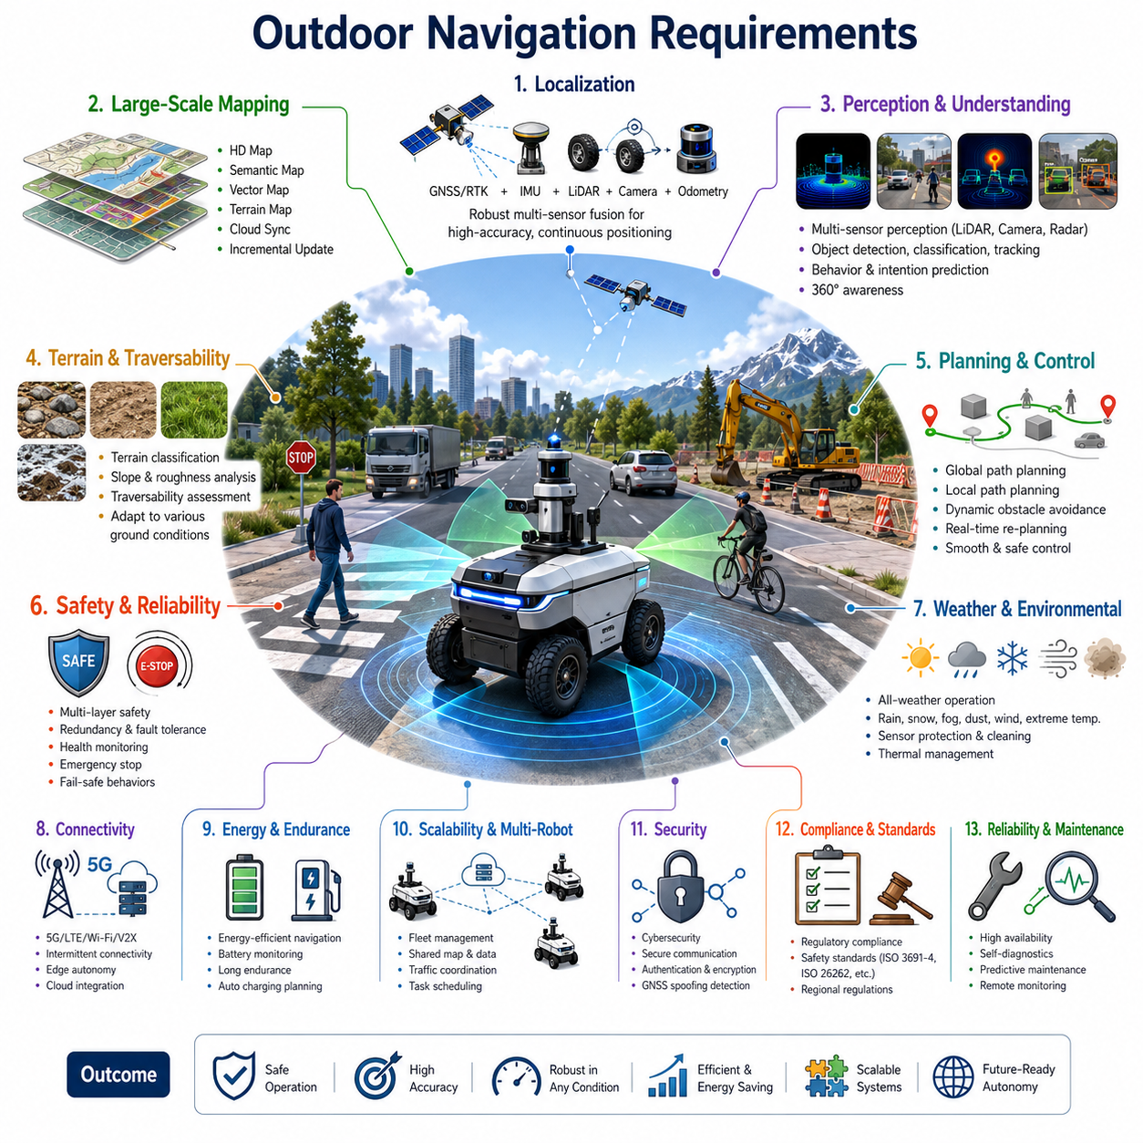
Outdoor navigation represents one of the most challenging and important capabilities in modern autonomous mobile robots (AMRs), autonomous vehicles, outdoor service robots, logistics robots, inspection robots, agricultural robots, mining robots, and smart city robotic platforms. Unlike indoor navigation, where environments are relatively structured and predictable, outdoor navigation requires robots to operate safely and efficiently in highly dynamic, large-scale, and continuously changing environments. Outdoor navigation systems must handle complex terrain conditions, varying weather, changing lighting conditions, moving vehicles, pedestrians, animals, construction zones, road obstacles, and communication limitations while maintaining reliable autonomous operation. The successful deployment of outdoor autonomous robots therefore begins with a comprehensive understanding of outdoor navigation requirements and the engineering principles needed to satisfy them. The Outdoor Navigation Requirements chapter serves as the foundation for all subsequent outdoor navigation technologies and provides the system-level requirements that influence perception, localization, mapping, planning, control, safety, and operational architecture.
The first requirement of outdoor navigation is reliable positioning and localization. An outdoor robot must always know its position, orientation, velocity, and motion state with sufficient accuracy to support safe autonomous operation. Unlike indoor environments where walls, corridors, and fixed landmarks are abundant, outdoor environments often contain large open areas with sparse features. Localization systems must therefore integrate multiple sensor modalities including GNSS, RTK GNSS, IMU, wheel odometry, LiDAR, cameras, radar, and digital maps. Reliance on a single positioning technology is generally insufficient because each technology has failure modes. GNSS may suffer from multipath reflections in urban canyons, signal blockage near tall structures, interference, or temporary outages. LiDAR localization may degrade in featureless environments such as open parking lots or agricultural fields. Camera-based localization can be affected by darkness, rain, snow, fog, and glare. Outdoor navigation systems therefore require robust sensor fusion architectures capable of maintaining localization continuity even when individual sensors experience degradation.
A second critical requirement is large-scale environment representation. Outdoor robots often operate across areas that are hundreds of meters, several kilometers, or even tens of kilometers in size. Traditional indoor occupancy maps become insufficient when navigation domains expand significantly. Outdoor navigation systems must support scalable map architectures including HD maps, semantic maps, vector maps, road network representations, terrain maps, and cloud-hosted map services. The map representation must support efficient storage, retrieval, updating, and synchronization while maintaining real-time navigation performance. Large-scale maps should also allow incremental updates as environmental changes occur over time. Construction zones, road modifications, temporary barriers, and seasonal changes can significantly alter the navigable environment and must be incorporated into the mapping infrastructure.
Environmental variability introduces another major requirement. Outdoor environments continuously change throughout the day and across seasons. Lighting conditions vary from bright sunlight to nighttime darkness. Weather conditions may include rain, snow, fog, dust, strong winds, and extreme temperatures. Vegetation growth changes terrain appearance over time. Shadows move throughout the day and can confuse perception systems. Water accumulation after rainfall can alter traversability characteristics. Outdoor navigation systems must therefore be designed with sufficient robustness to operate under highly variable environmental conditions without significant performance degradation. Sensor selection, perception algorithms, machine learning models, and navigation strategies must all account for these environmental uncertainties.
Obstacle detection and avoidance requirements are considerably more demanding outdoors than indoors. Indoor robots typically encounter predictable obstacles such as walls, furniture, and humans. Outdoor robots must detect and classify a much broader range of objects including pedestrians, bicycles, motorcycles, cars, trucks, buses, animals, road barriers, vegetation, debris, construction equipment, utility poles, drainage structures, and unexpected obstacles. The navigation system must not only detect obstacles but also estimate their trajectories, behaviors, intentions, and potential future interactions with the robot. Dynamic obstacle handling becomes particularly important in mixed-traffic environments where autonomous robots share space with human-driven vehicles and pedestrians. Safe operation requires real-time prediction of surrounding object movements and continuous adaptation of navigation plans.
Another fundamental requirement is terrain awareness and traversability assessment. Outdoor environments rarely provide perfectly flat surfaces. Robots may encounter gravel roads, dirt paths, grass fields, uneven pavement, slopes, potholes, mud, sand, loose rocks, and other challenging terrain conditions. The navigation system must continuously evaluate terrain characteristics and determine whether a given area is safe and traversable. Terrain classification algorithms may utilize LiDAR point clouds, stereo vision, depth cameras, radar measurements, and machine learning models to estimate surface properties. Traversability assessment must consider factors such as slope angle, surface roughness, wheel traction, vehicle stability, payload characteristics, and rollover risk. Navigation decisions must incorporate these assessments to avoid unsafe terrain while maintaining operational efficiency.
Safety represents the highest priority requirement in outdoor autonomous navigation. Outdoor robots frequently operate near humans, vehicles, critical infrastructure, and valuable assets. The navigation system must therefore implement multiple layers of safety mechanisms. These include perception redundancy, sensor health monitoring, emergency stop functions, safety zones, speed limitations, fail-safe behaviors, remote intervention capabilities, and fault recovery procedures. Safety architectures should be designed according to applicable functional safety standards and risk assessment methodologies. The robot must maintain safe operation even when individual components fail or unexpected situations occur. Safety monitoring systems must continuously evaluate navigation confidence levels and initiate appropriate mitigation strategies when confidence falls below acceptable thresholds.
Weather resilience is another essential requirement for outdoor navigation systems. Rain can affect LiDAR returns, camera visibility, and wheel traction. Snow can obscure landmarks, alter terrain appearance, and cover navigational features. Fog reduces visibility and degrades optical sensing performance. Dust and dirt may contaminate sensors. High temperatures can affect electronics and battery systems, while low temperatures can reduce battery capacity and mechanical performance. Outdoor robots must be engineered with environmental protection mechanisms including weather-resistant enclosures, sensor cleaning systems, thermal management solutions, and adaptive perception algorithms. Navigation performance requirements should explicitly define acceptable operating ranges across different environmental conditions.
Communication requirements play a major role in outdoor deployments. While indoor robots often operate within controlled wireless infrastructure, outdoor robots may experience intermittent connectivity, limited bandwidth, and variable network quality. Navigation systems must therefore be capable of autonomous operation even during communication outages. Cloud connectivity can enhance navigation performance through map updates, fleet coordination, remote monitoring, and advanced computation, but the robot must remain safe and functional when communication is unavailable. Edge computing architectures become critical for maintaining operational independence while still leveraging cloud resources when available.
Energy efficiency requirements become increasingly important in outdoor environments due to larger operational areas and longer mission durations. Outdoor robots often travel significantly greater distances than indoor robots and may operate for many hours without recharging opportunities. Navigation systems should therefore optimize path planning, velocity profiles, acceleration patterns, and route selection to minimize energy consumption. Energy-aware navigation strategies can extend operational endurance while maintaining mission effectiveness. Battery state monitoring, charging station planning, and mission scheduling must be integrated into the overall navigation framework.
Scalability requirements are particularly important for industrial outdoor applications. Modern outdoor robotic deployments may involve multiple robots operating simultaneously across large facilities, industrial sites, campuses, ports, airports, farms, or urban environments. Navigation architectures must support fleet-level coordination, shared mapping, traffic management, task scheduling, and conflict resolution. Multi-robot navigation systems require standardized communication protocols, centralized or distributed coordination mechanisms, and scalable software architectures capable of supporting future expansion.
Precision requirements vary depending on application domain but generally exceed those of conventional GPS navigation systems. Applications such as autonomous docking, charging, material handling, infrastructure inspection, and precision agriculture may require centimeter-level positioning accuracy. Outdoor navigation systems must therefore integrate high-precision localization technologies such as RTK GNSS, LiDAR localization, visual localization, and sensor fusion algorithms. The navigation architecture should support seamless transitions between different localization modes depending on environmental conditions and accuracy requirements.
Cybersecurity requirements are increasingly important as outdoor robots become connected components within larger digital ecosystems. Navigation systems must protect against unauthorized access, malicious attacks, GNSS spoofing, communication interception, and software tampering. Secure communication protocols, authentication mechanisms, encrypted data transmission, and secure software update processes are essential components of modern outdoor navigation architectures. Security considerations must be integrated throughout the system lifecycle rather than added as an afterthought.
Regulatory compliance requirements also influence outdoor navigation system design. Different countries and industries impose specific regulations regarding autonomous vehicle operation, safety certification, radio communication, cybersecurity, data privacy, and environmental protection. Outdoor navigation architectures must be designed with sufficient flexibility to accommodate regional regulatory variations while maintaining consistent performance and safety standards.
Operational reliability requirements typically exceed those of research or prototype systems. Industrial outdoor robots may be expected to operate continuously for thousands of hours annually with minimal human intervention. Navigation systems must therefore achieve high levels of robustness, fault tolerance, maintainability, and diagnosability. Health monitoring systems should continuously evaluate sensor status, localization quality, perception confidence, navigation performance, and system health indicators. Predictive maintenance capabilities can further improve operational availability and reduce downtime.
Future outdoor navigation systems are increasingly expected to incorporate artificial intelligence, semantic understanding, and adaptive learning capabilities. Robots must move beyond simple waypoint navigation and develop contextual understanding of their environments. Semantic reasoning allows robots to interpret roads, sidewalks, intersections, parking areas, construction zones, pedestrian pathways, and operational zones. AI-based navigation systems can continuously improve performance through experience, adapt to new environments, and support increasingly complex autonomous behaviors.
Ultimately, outdoor navigation requirements define the technological foundation upon which all outdoor autonomous robotic systems are built. Successful outdoor navigation requires the integration of robust localization, scalable mapping, advanced perception, intelligent path planning, adaptive control, comprehensive safety systems, reliable communications, energy-efficient operation, and long-term operational resilience. As autonomous robots continue expanding into industrial, commercial, agricultural, infrastructure, healthcare, defense, and smart city applications, the importance of well-defined outdoor navigation requirements will continue to grow. These requirements establish the engineering framework necessary for developing safe, reliable, scalable, and commercially viable outdoor autonomous robotic platforms capable of operating effectively in the complex and unpredictable environments of the real world.

15.2 GNSS and LiDAR-Based Navigation
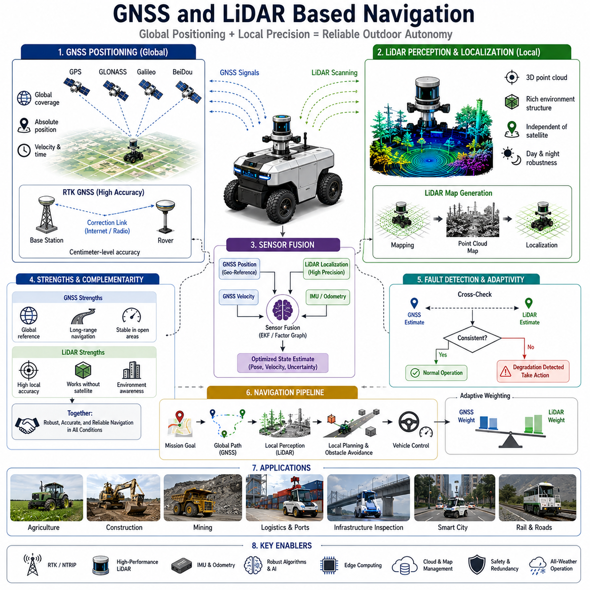
GNSS and LiDAR based navigation represents one of the most widely adopted and reliable approaches for outdoor autonomous mobile robots, autonomous vehicles, inspection robots, agricultural machines, logistics platforms, mining vehicles, construction robots, and smart city robotic systems. Outdoor environments present significant challenges for autonomous navigation because they are often large in scale, continuously changing, and subject to environmental uncertainties such as weather conditions, dynamic obstacles, lighting variations, and terrain complexity. To operate safely and accurately in these environments, autonomous robots require robust localization and navigation systems capable of maintaining precise positioning under a wide range of operating conditions. GNSS provides global positioning capability over large geographical areas, while LiDAR provides highly accurate local environmental perception and localization. When combined through sensor fusion, GNSS and LiDAR create a complementary navigation architecture that offers both global positioning awareness and local precision. This combination forms the foundation of many modern outdoor autonomous navigation systems and is increasingly regarded as the baseline architecture for industrial-grade outdoor robotics.
Global Navigation Satellite Systems provide absolute geographic positioning information using constellations of satellites orbiting the Earth. Modern GNSS systems include GPS from the United States, GLONASS from Russia, Galileo from Europe, BeiDou from China, and various regional augmentation systems. By receiving signals from multiple satellites, a GNSS receiver can estimate its position, velocity, and timing information. For outdoor autonomous robots operating across large facilities, industrial complexes, agricultural fields, transportation corridors, and urban environments, GNSS provides an essential global reference frame that allows the robot to understand its location within a larger operational area.
Standard GNSS receivers typically provide positioning accuracy ranging from several meters to sub-meter levels depending on environmental conditions and satellite visibility. While this accuracy may be sufficient for general navigation tasks, many industrial robotic applications require significantly higher precision. Autonomous docking, precision agriculture, infrastructure inspection, autonomous construction, and outdoor logistics operations often require positioning accuracy within a few centimeters. To achieve this level of performance, advanced GNSS techniques such as Real-Time Kinematic (RTK) positioning are commonly employed.
RTK GNSS improves positioning accuracy by utilizing correction information from a fixed reference station. The reference station continuously measures errors in satellite signals and transmits correction data to the mobile robot. By applying these corrections, the robot can achieve centimeter-level positioning accuracy under favorable conditions. RTK GNSS has become a standard component in outdoor autonomous systems where precise positioning is essential. Agricultural robots use RTK GNSS for accurate row following and precision spraying. Autonomous construction equipment relies on RTK positioning for excavation and grading tasks. Infrastructure inspection robots utilize high-precision GNSS to associate collected data with exact geographic coordinates.
Despite its advantages, GNSS alone is insufficient for reliable autonomous navigation. Satellite signals can be degraded by multipath reflections, atmospheric disturbances, interference, dense vegetation, urban canyons, tunnels, bridges, and nearby structures. Signal blockage may cause temporary positioning loss. Even RTK systems can experience degradation when communication links to correction stations are interrupted. Therefore, autonomous robots require complementary localization technologies capable of maintaining navigation performance when GNSS quality decreases.
LiDAR technology serves as one of the most effective complementary solutions to GNSS navigation. LiDAR sensors emit laser pulses and measure the time required for reflected signals to return. By continuously scanning the environment, LiDAR generates highly accurate three-dimensional representations of surrounding objects and structures. These point cloud datasets provide detailed geometric information about roads, buildings, vegetation, infrastructure, vehicles, terrain features, and other environmental elements.
One of the primary advantages of LiDAR is its ability to operate independently of satellite signals. Unlike GNSS, LiDAR relies on local environmental observations rather than external positioning infrastructure. This characteristic makes LiDAR particularly valuable in areas where satellite visibility is poor or unreliable. LiDAR localization systems compare real-time sensor observations against previously generated maps to estimate the robot's position with high accuracy. This process allows autonomous robots to maintain precise localization even when GNSS performance is temporarily degraded.
LiDAR-based localization typically begins with the creation of a detailed environmental map. During a mapping phase, the robot traverses the operational area while recording LiDAR point cloud data. Simultaneous Localization and Mapping algorithms process this data to generate a high-resolution map representing the environment. Once the map is available, future navigation operations utilize localization algorithms that continuously compare incoming LiDAR scans against the stored map. By identifying matching geometric features, the robot can estimate its position and orientation relative to the mapped environment.
Modern LiDAR localization systems often achieve positioning accuracies measured in centimeters. Buildings, road edges, poles, barriers, trees, fences, and other stable structures provide reference features for localization algorithms. Since LiDAR measures geometry rather than appearance, it is generally less sensitive to lighting conditions than camera-based localization systems. Daytime operation, nighttime operation, shadows, and lighting variations have relatively limited impact on LiDAR measurements compared to vision systems.
The integration of GNSS and LiDAR creates a navigation architecture that leverages the strengths of both technologies while compensating for their weaknesses. GNSS provides globally referenced positioning information and long-range navigation capability. LiDAR provides local accuracy, environmental awareness, and localization robustness. Sensor fusion algorithms combine information from both sources to generate a unified estimate of robot position and orientation.
Sensor fusion is typically performed using techniques such as Extended Kalman Filters, Unscented Kalman Filters, Particle Filters, Factor Graph Optimization, or modern graph-based localization frameworks. These algorithms continuously evaluate measurements from GNSS receivers, LiDAR sensors, IMUs, wheel encoders, and other sensors. By considering sensor uncertainties and confidence levels, the fusion system generates an optimized estimate of vehicle state.
In open outdoor environments with strong satellite visibility, GNSS may provide the primary positioning source while LiDAR serves as a validation and refinement mechanism. In urban environments where satellite signals are partially obstructed, LiDAR localization may assume greater importance. In extreme cases where GNSS becomes unavailable, LiDAR-based localization can continue supporting autonomous navigation independently. This adaptive behavior significantly improves navigation reliability and operational continuity.
Another important advantage of GNSS and LiDAR integration is improved fault detection capability. Autonomous navigation systems must continuously monitor localization quality and identify potential failures before they create safety risks. By comparing independent position estimates from GNSS and LiDAR, the system can detect inconsistencies and identify sensor anomalies. Significant deviations between sensor outputs may indicate signal degradation, sensor malfunction, map mismatch, or environmental disturbances. Automated diagnostic systems can use this information to initiate recovery behaviors, reduce operating speed, or request operator intervention.
Large-scale outdoor navigation requires more than localization alone. Path planning systems must utilize positioning information to generate safe and efficient routes toward mission objectives. GNSS provides global route guidance across large operational areas, while LiDAR contributes local environmental understanding necessary for obstacle avoidance and motion planning. The combination enables autonomous robots to navigate complex environments while responding dynamically to changing conditions.
In industrial applications such as ports, airports, logistics centers, mining operations, agricultural facilities, and smart city deployments, navigation systems often operate across environments spanning several square kilometers. GNSS supports long-distance navigation across these large areas, while LiDAR ensures precise maneuvering near infrastructure, equipment, and operational zones. This dual capability allows robots to achieve both strategic navigation and tactical precision.
Autonomous inspection robots benefit significantly from GNSS and LiDAR integration. Infrastructure inspection tasks often require precise geographic positioning of collected data. GPR inspection robots, railway inspection systems, pipeline monitoring platforms, power line inspection vehicles, and roadway assessment robots must accurately associate sensor observations with physical locations. High-precision GNSS provides geographic reference coordinates while LiDAR maintains local positioning accuracy and environmental context. The resulting dataset supports accurate reporting, change detection, maintenance planning, and digital twin generation.
Agricultural robotics represents another major application area. Modern precision agriculture requires accurate navigation through fields, orchards, vineyards, and plantations. GNSS provides field-scale navigation and route planning, while LiDAR assists with crop row detection, obstacle avoidance, terrain analysis, and vehicle positioning. Autonomous tractors, spraying robots, harvesting machines, and monitoring platforms increasingly depend on integrated GNSS-LiDAR navigation systems to maximize productivity and minimize operational errors.
Construction and mining environments introduce additional challenges due to constantly changing terrain and infrastructure. Excavation activities, earthmoving operations, temporary structures, and evolving work zones continuously alter the environment. GNSS provides stable global positioning references, while LiDAR updates local environmental models in real time. This combination allows autonomous equipment to adapt to changing site conditions while maintaining accurate positioning and safe operation.
Weather conditions also influence navigation system performance. Heavy rain, fog, snow, and dust can affect both GNSS and LiDAR measurements. GNSS signals may experience attenuation under certain atmospheric conditions, while LiDAR performance may decrease due to airborne particles and precipitation. Robust navigation architectures therefore incorporate sensor quality monitoring and adaptive fusion strategies. Confidence estimation algorithms evaluate sensor reliability in real time and adjust weighting factors accordingly. Additional sensors such as radar, cameras, and inertial measurement units may further enhance robustness under challenging environmental conditions.
Modern autonomous navigation architectures increasingly incorporate artificial intelligence and machine learning technologies to improve GNSS and LiDAR integration. AI-based localization systems can identify complex environmental patterns, improve map matching accuracy, detect localization anomalies, and adapt to environmental changes. Deep learning models may assist in feature extraction, semantic understanding, terrain classification, and sensor reliability estimation. These capabilities contribute to greater robustness and adaptability in real-world deployments.
Cloud connectivity further enhances GNSS and LiDAR based navigation systems. Cloud infrastructure can support map storage, fleet coordination, localization updates, remote monitoring, and operational analytics. Multiple robots may share mapping information and localization experiences through centralized platforms. Edge computing architectures process time-critical localization tasks locally while leveraging cloud resources for large-scale optimization and long-term data management.
Safety remains the primary design objective for GNSS and LiDAR based navigation systems. Localization uncertainty directly affects navigation safety, obstacle avoidance performance, and operational decision-making. Therefore, safety architectures must continuously evaluate localization confidence, sensor health, environmental conditions, and system performance. Redundant positioning mechanisms, fail-safe behaviors, emergency stopping strategies, and remote intervention capabilities are essential components of industrial-grade navigation systems.
As autonomous robotics continues expanding into logistics, infrastructure inspection, agriculture, construction, mining, transportation, defense, and smart city applications, GNSS and LiDAR based navigation will remain a core enabling technology. The complementary strengths of global satellite positioning and high-precision environmental perception create a robust navigation foundation capable of supporting reliable autonomous operation across diverse outdoor environments. Future developments will likely focus on tighter sensor integration, AI-enhanced localization, real-time digital twins, cloud-connected navigation ecosystems, and increasingly autonomous decision-making capabilities. Through these advancements, GNSS and LiDAR based navigation will continue to serve as one of the most important technological pillars supporting the evolution of outdoor autonomous robotic systems.

15.3 Large Scale Outdoor Path Planning
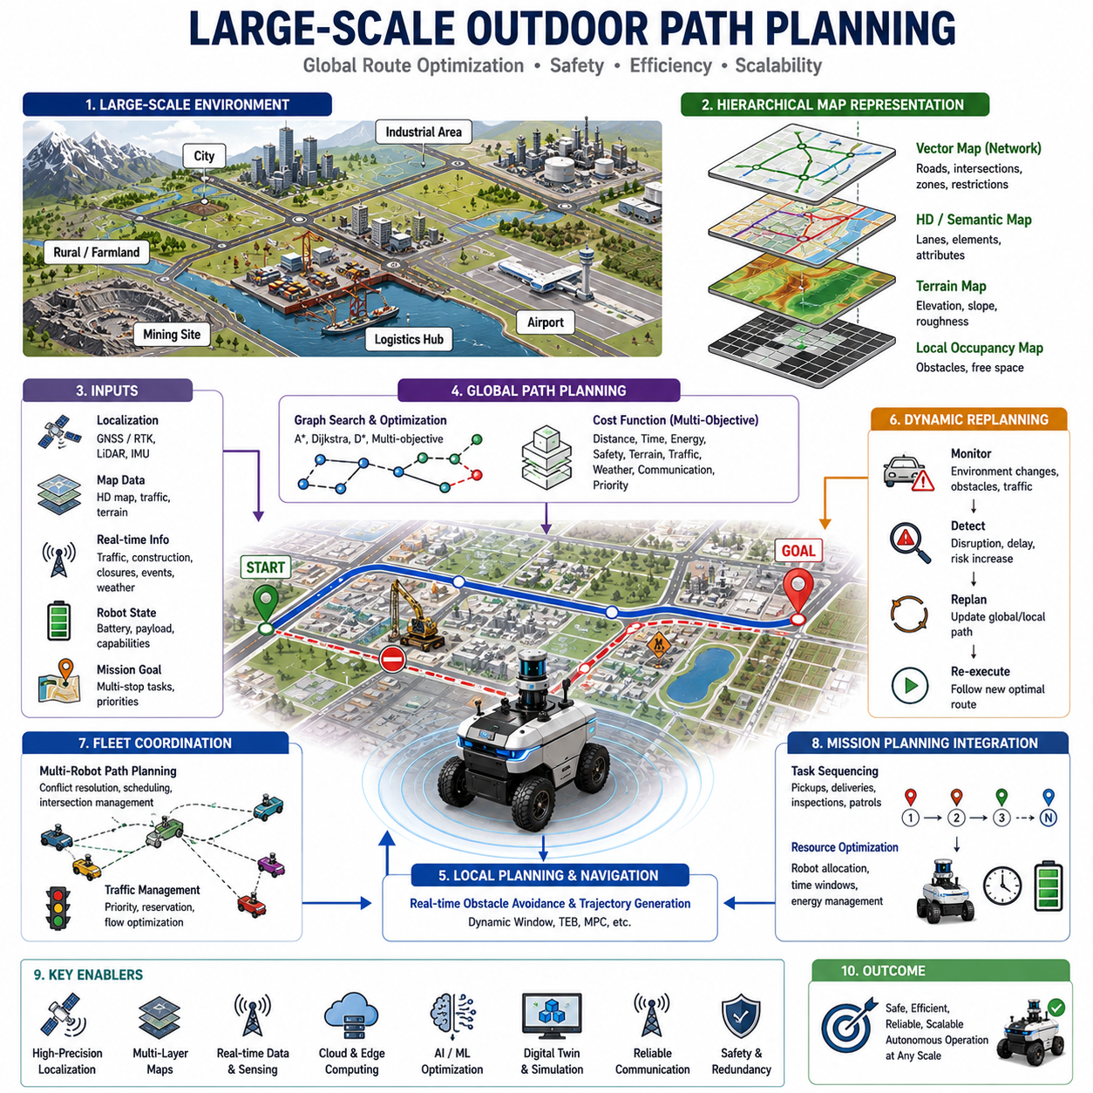
Large-scale outdoor path planning is one of the most critical capabilities required for autonomous mobile robots operating in expansive environments such as smart cities, logistics centers, airports, seaports, industrial complexes, agricultural farms, mining sites, military bases, utility corridors, railway networks, and large infrastructure facilities. Unlike indoor navigation, where operational spaces are typically confined to a building or a limited campus area, outdoor robots often operate across environments spanning hundreds of meters, several kilometers, or even hundreds of kilometers. As the operational scale increases, the complexity of path planning grows significantly due to the presence of large geographic areas, multiple transportation routes, dynamic environmental changes, varying terrain conditions, traffic interactions, communication constraints, and operational safety requirements. Large-scale outdoor path planning therefore becomes a multidisciplinary problem involving localization, mapping, route optimization, environmental understanding, traffic management, fleet coordination, and mission-level decision making.
The primary objective of large-scale outdoor path planning is to generate safe, efficient, reliable, and scalable routes that allow autonomous robots to travel from their starting locations to designated destinations while satisfying operational constraints. Unlike short-range navigation problems that primarily focus on obstacle avoidance and local maneuvering, large-scale path planning must consider strategic route selection over long distances. The navigation system must identify optimal travel corridors, evaluate alternative routes, estimate travel times, minimize energy consumption, avoid hazardous regions, and continuously adapt to changing environmental conditions. As a result, large-scale path planning is often considered a hierarchical decision-making process that integrates both global planning and local navigation capabilities.
One of the fundamental challenges in large-scale outdoor navigation is environmental scale. Traditional occupancy grid maps that work effectively for indoor environments become computationally inefficient when applied to large geographic regions. A city-scale map may contain billions of cells if represented using high-resolution occupancy grids. Such representations impose excessive storage, memory, and computational requirements. Therefore, large-scale navigation systems typically employ hierarchical map architectures that combine multiple map representations at different levels of abstraction.
At the highest level, vector maps and road network representations are commonly used to represent large transportation networks. These maps describe roads, intersections, pathways, service corridors, operational zones, restricted areas, and mission-critical infrastructure as connected graph structures. Nodes represent key locations, while edges represent traversable connections between locations. This abstraction significantly reduces computational complexity while preserving essential routing information. At lower levels, HD maps, semantic maps, terrain maps, and local occupancy maps provide detailed information necessary for precise vehicle navigation.
Graph-based planning plays a central role in large-scale outdoor path planning. Transportation networks naturally lend themselves to graph representations where path planning algorithms search for optimal routes through interconnected nodes and edges. Algorithms such as Dijkstra's algorithm, A-Star, Weighted A-Star, Lifelong Planning A-Star, D-Star Lite, and various graph optimization techniques are frequently used to compute efficient routes across large environments. These algorithms evaluate travel costs associated with different routes and identify paths that minimize overall mission objectives.
Cost functions are a crucial component of large-scale path planning systems. Unlike simple shortest-path problems, outdoor navigation often requires balancing multiple objectives simultaneously. Distance may be only one factor among many considerations. Travel time, energy consumption, terrain quality, traffic density, weather conditions, road restrictions, operational risk, communication coverage, battery state, payload characteristics, and mission priorities may all influence route selection. Modern planning systems therefore utilize multi-objective cost functions that combine multiple criteria into a unified optimization framework.
Energy efficiency becomes increasingly important as operational distances increase. Outdoor robots may travel several kilometers or operate continuously for many hours. Path planning algorithms must therefore consider battery consumption and power management when selecting routes. A shorter route may not always be the most energy-efficient route if it includes steep slopes, rough terrain, frequent stops, or congested traffic conditions. Energy-aware planners estimate expected power consumption along candidate routes and select paths that maximize operational endurance while maintaining mission effectiveness.
Terrain characteristics represent another major factor in large-scale outdoor planning. Unlike indoor environments where surfaces are generally flat and predictable, outdoor environments contain diverse terrain conditions including paved roads, gravel paths, dirt roads, grass fields, sand, mud, slopes, rocky surfaces, and uneven ground. Traversability assessment systems continuously evaluate terrain characteristics and estimate the difficulty associated with traversing specific regions. Terrain-aware planners integrate these assessments into route optimization processes to avoid unsafe or inefficient paths.
Road network understanding is particularly important for autonomous robots operating in urban and industrial environments. Large-scale path planning systems must recognize different road types, speed limits, traffic rules, access restrictions, one-way routes, pedestrian zones, loading areas, service roads, emergency corridors, and operational boundaries. Semantic information about transportation infrastructure allows planners to generate routes that comply with operational regulations while maximizing safety and efficiency.
Dynamic environmental changes present one of the most difficult challenges in large-scale navigation. Outdoor environments continuously evolve due to traffic conditions, construction activities, weather events, temporary obstacles, road closures, infrastructure modifications, and operational activities. Static routes generated at mission start may become suboptimal or even infeasible during execution. Therefore, large-scale planning systems must support continuous route monitoring and dynamic replanning capabilities.
Dynamic replanning allows autonomous robots to adapt to environmental changes while maintaining mission objectives. When unexpected obstacles or route disruptions occur, the navigation system evaluates alternative paths and generates updated routes. This process must occur efficiently to avoid significant operational delays. Incremental planning algorithms such as D-Star and Lifelong Planning A-Star are particularly valuable because they reuse previous planning results rather than computing entirely new routes from scratch.
Weather conditions significantly influence large-scale outdoor path planning. Rain, snow, fog, ice, flooding, dust storms, and strong winds can alter route safety, vehicle mobility, and sensor performance. Weather-aware navigation systems incorporate meteorological information into route planning decisions. Certain routes may become temporarily inaccessible or unsafe under specific weather conditions. Advanced planning systems continuously evaluate environmental forecasts and proactively adjust routes to minimize operational risk.
Localization accuracy directly affects large-scale navigation performance. Outdoor robots commonly utilize GNSS, RTK GNSS, LiDAR localization, visual localization, and inertial navigation systems to maintain accurate positioning. Large-scale path planners rely on precise localization information to ensure that route execution aligns with planned trajectories. Localization uncertainty must be considered during planning, particularly in environments where GNSS signals may be degraded by urban canyons, dense vegetation, tunnels, or industrial infrastructure.
Communication infrastructure plays an important role in large-scale autonomous operations. Many outdoor robots operate within connected environments supported by cellular networks, private LTE systems, 5G infrastructure, satellite communications, or industrial wireless networks. Communication-aware planning systems may incorporate network coverage maps into route selection processes. Routes with reliable communication coverage may be preferred when remote supervision, cloud processing, or fleet coordination is required. However, autonomous systems must also remain operational during temporary communication outages.
Fleet-level coordination introduces additional complexity into large-scale path planning. Modern industrial deployments often involve dozens, hundreds, or even thousands of autonomous robots operating simultaneously within shared environments. Independent route generation can lead to congestion, conflicts, deadlocks, and inefficient resource utilization. Fleet management systems therefore coordinate path planning across multiple robots to optimize overall system performance.
Multi-robot path planning algorithms allocate transportation resources, schedule route usage, reserve critical intersections, and manage traffic flows. Centralized planners may optimize routes for entire fleets, while decentralized approaches allow individual robots to coordinate through distributed communication mechanisms. Hybrid architectures frequently combine centralized mission planning with local autonomous decision making.
Mission planning represents a higher level of decision making above route generation. In many industrial applications, robots must complete complex tasks involving multiple destinations, pickups, deliveries, inspections, maintenance activities, or operational objectives. Large-scale path planning systems therefore integrate with mission management frameworks that determine task sequences, operational priorities, and resource allocations. Route optimization becomes part of a broader mission optimization process.
Cloud-based navigation architectures are increasingly common in large-scale outdoor deployments. Cloud platforms provide centralized map management, route optimization services, fleet coordination, traffic monitoring, operational analytics, and digital twin integration. Robots access cloud-generated route information while maintaining local autonomy for real-time decision making. This edge-cloud collaboration enables scalable deployment across geographically distributed operational environments.
Digital twin technologies further enhance large-scale path planning capabilities. Digital twins provide virtual representations of physical environments that continuously synchronize with real-world conditions. Traffic patterns, infrastructure status, weather information, terrain changes, and operational events can be integrated into digital twin platforms. Path planners utilize this information to generate more accurate and adaptive routes while supporting simulation-based validation and predictive operational analysis.
Artificial intelligence increasingly contributes to large-scale outdoor navigation. Machine learning models can predict traffic congestion, estimate terrain traversability, forecast environmental changes, optimize energy consumption, and improve route selection strategies. Reinforcement learning techniques may enable robots to learn navigation policies through operational experience. AI-powered planners continuously improve performance by analyzing historical mission data and identifying opportunities for optimization.
Safety remains the highest priority throughout the path planning process. Large-scale outdoor navigation systems must consider operational hazards including vehicle interactions, pedestrian traffic, infrastructure constraints, environmental risks, and equipment limitations. Safety constraints are incorporated into planning algorithms to ensure that generated routes remain within acceptable risk boundaries. Redundant route options, emergency recovery strategies, fail-safe behaviors, and risk-aware planning mechanisms contribute to overall system safety.
Industrial applications demonstrate the importance of large-scale path planning across diverse sectors. Autonomous logistics vehicles utilize large-scale planning to transport goods across warehouses, ports, and distribution centers. Agricultural robots navigate vast farming areas while optimizing field coverage. Mining vehicles coordinate transportation routes across large extraction sites. Infrastructure inspection robots travel along pipelines, railways, roadways, and utility networks. Smart city robots support public services across urban environments. Each application introduces unique requirements while relying on the same fundamental planning principles.
As autonomous systems continue expanding into increasingly complex outdoor environments, large-scale path planning will become even more important. Future navigation systems will integrate real-time digital twins, AI-driven optimization, cloud-native fleet management, predictive environmental modeling, semantic world understanding, and autonomous mission generation. Navigation will evolve from simple route computation toward comprehensive operational intelligence capable of managing large robotic ecosystems across entire cities, industrial regions, transportation networks, and national infrastructure systems.
Ultimately, large-scale outdoor path planning serves as the strategic intelligence layer of autonomous navigation. It transforms geographic information, environmental understanding, operational objectives, and system constraints into executable navigation plans that enable safe, efficient, and reliable autonomous operations. As outdoor robotics continues advancing across logistics, agriculture, mining, infrastructure inspection, construction, defense, transportation, and smart city applications, large-scale path planning will remain one of the most essential technologies enabling truly autonomous operation at scale.

15.4 Weather and Lighting Challenges
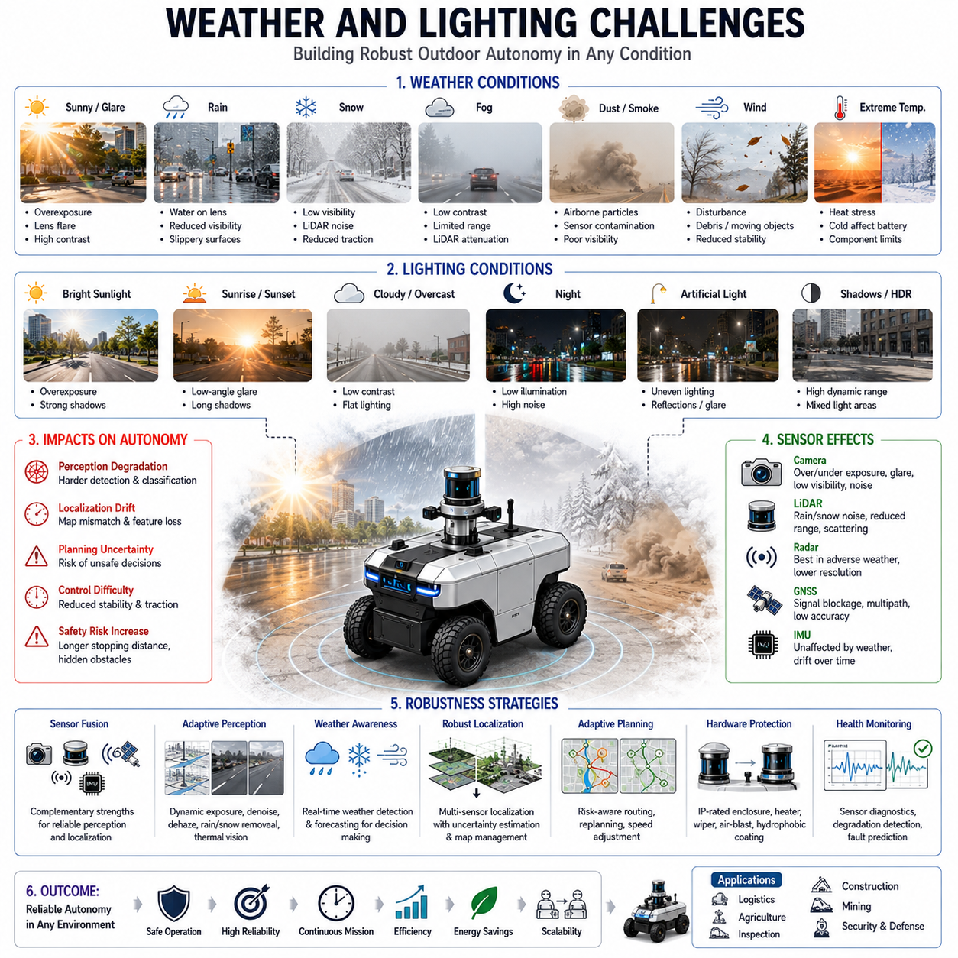
Weather and lighting conditions represent some of the most significant challenges in outdoor autonomous navigation. Unlike indoor environments, where illumination, temperature, and environmental conditions are relatively stable and predictable, outdoor environments are continuously affected by changing weather patterns, seasonal variations, atmospheric conditions, and natural lighting cycles. Autonomous mobile robots operating outdoors must maintain reliable perception, localization, path planning, obstacle avoidance, and safety performance under a wide range of environmental situations. Rain, snow, fog, dust, strong sunlight, shadows, nighttime darkness, glare, and rapidly changing illumination can significantly degrade sensor performance and navigation accuracy. Consequently, weather and lighting robustness has become one of the most important design considerations in modern outdoor autonomous robotic systems.
The primary challenge associated with outdoor operation is environmental variability. A robot may operate in bright sunlight during one portion of a mission, encounter heavy rain later in the day, and continue working under low-light conditions during evening hours. Unlike controlled environments, outdoor conditions cannot be managed by the robot itself. Instead, the navigation system must be designed to continuously adapt to changing environmental factors while maintaining operational safety and reliability. This requirement affects nearly every subsystem of the robot, including perception sensors, localization algorithms, mapping systems, planning modules, communication systems, power management systems, and safety architectures.
Lighting conditions are among the most influential factors affecting autonomous navigation. Vision-based perception systems depend heavily on environmental illumination. Camera sensors rely on reflected light to capture images, and their performance can vary dramatically depending on brightness levels. During bright daylight conditions, excessive sunlight may create overexposed regions, washed-out imagery, lens flare, and high dynamic range challenges. In contrast, nighttime conditions reduce image quality, increase sensor noise, and limit object visibility. Autonomous robots must therefore operate across a lighting spectrum ranging from intense midday sunlight to complete darkness.
Direct sunlight introduces several unique challenges. Low-angle sunlight during sunrise and sunset can create strong glare effects that obscure important environmental features. Reflections from glass surfaces, metallic structures, water bodies, and vehicle windows can produce false detections or reduce object recognition accuracy. Camera-based object detection systems may struggle to distinguish pedestrians, vehicles, obstacles, and road boundaries when exposed to extreme lighting contrasts. Shadows created by buildings, trees, and infrastructure can further complicate perception by introducing visual patterns that resemble physical obstacles.
High dynamic range environments present another significant challenge. Outdoor scenes often contain areas of extreme brightness and extreme darkness simultaneously. For example, a robot may navigate through a roadway where one side is directly illuminated by sunlight while the other side remains shaded by nearby structures. Standard imaging sensors may not capture sufficient detail across the entire brightness range. Advanced HDR imaging techniques, adaptive exposure control, image enhancement algorithms, and AI-based perception models are frequently employed to address these limitations.
Nighttime navigation introduces a different set of challenges. Reduced ambient illumination decreases visibility and affects camera performance. Object recognition, lane detection, terrain analysis, and semantic understanding become more difficult under low-light conditions. Artificial illumination from streetlights, vehicle headlights, industrial lighting systems, and facility infrastructure may partially compensate for reduced natural light, but these sources often create uneven illumination patterns and additional visual artifacts. Autonomous robots operating at night frequently rely on sensor fusion architectures combining cameras, LiDAR, radar, thermal cameras, and inertial sensors to maintain navigation performance.
Thermal imaging has emerged as an important complementary sensing technology for nighttime operation. Unlike conventional cameras, thermal sensors detect infrared radiation emitted by objects. This capability allows robots to identify humans, animals, vehicles, and infrastructure even in complete darkness. Thermal perception is particularly valuable for security robots, patrol robots, search-and-rescue systems, and infrastructure inspection platforms operating under low-light conditions.
Weather conditions create additional complexities beyond lighting variation. Rain is one of the most common environmental challenges encountered by outdoor robots. Rain affects both sensor performance and vehicle mobility. Water droplets can accumulate on camera lenses, LiDAR windows, radar covers, and protective sensor enclosures, reducing measurement quality. Heavy rainfall may attenuate laser signals, decrease visibility, and introduce noise into perception data. Road surfaces become slippery, increasing braking distances and reducing tire traction. Path planning systems must therefore adjust navigation strategies based on current weather conditions.
LiDAR systems are particularly sensitive to precipitation effects. Rain droplets reflect laser pulses and may generate false measurements within point cloud data. While modern filtering algorithms can eliminate many precipitation-induced artifacts, heavy rainfall can still reduce effective sensing range and localization accuracy. Similar challenges occur during snowfall, where snowflakes introduce noise and obscure environmental features. Autonomous navigation systems must continuously evaluate LiDAR data quality and adapt sensor fusion strategies when measurement confidence decreases.
Snow presents additional challenges beyond sensor interference. Accumulated snow can alter the appearance of roads, pathways, landmarks, and environmental structures. Features used for localization may become partially or completely covered. Surface friction characteristics change significantly, affecting vehicle dynamics and stopping distances. Deep snow may create previously nonexistent obstacles or reduce traversability in certain areas. Navigation systems operating in snowy environments must integrate weather awareness, terrain assessment, and adaptive mobility control to maintain safe operation.
Fog is another particularly challenging weather condition for autonomous navigation. Dense fog reduces visibility and limits the effective range of optical sensors. Cameras experience reduced image contrast and object visibility. LiDAR performance may also degrade due to light scattering within suspended water droplets. Radar often performs better under foggy conditions because radio frequency signals are less affected by atmospheric obscurants. Consequently, radar becomes an increasingly important sensing modality during adverse weather operation.
Dust, smoke, and airborne particles create similar challenges in industrial, agricultural, mining, and construction environments. Dust clouds generated by vehicles, excavation equipment, harvesting machinery, or industrial processes can obscure sensor measurements and reduce perception performance. Autonomous systems operating in such environments require robust sensor protection mechanisms, adaptive filtering algorithms, and multi-modal sensor fusion architectures capable of maintaining situational awareness despite environmental interference.
Wind conditions can influence navigation performance in several ways. Strong winds affect lightweight robotic platforms by introducing external disturbances that impact trajectory tracking and vehicle stability. Airborne debris generated by wind may create temporary obstacles or interfere with sensor measurements. Wind-driven rain, snow, or dust further amplifies environmental complexity. Advanced control systems must compensate for wind disturbances while maintaining stable vehicle operation.
Seasonal variations introduce long-term environmental changes that affect navigation performance. Vegetation growth alters environmental appearance throughout the year. Trees, shrubs, grass, and crops may significantly change the geometry and visual characteristics of navigation environments. Localization systems relying on environmental features must account for these seasonal changes. Maps generated during one season may not perfectly match observations collected during another season. Long-term autonomy therefore requires adaptive mapping and localization strategies capable of accommodating environmental evolution.
Temperature extremes also influence autonomous navigation systems. High temperatures may affect electronic components, battery performance, processor reliability, and sensor operation. Thermal management systems become essential for maintaining stable operation in hot climates. Low temperatures reduce battery capacity, increase mechanical resistance, and may impair sensor performance. Outdoor robots must be designed with environmental protection systems capable of operating across expected temperature ranges.
Localization performance is particularly vulnerable to weather and lighting challenges. Visual localization systems depend heavily on consistent environmental appearance. Lighting changes, shadows, weather effects, and seasonal variations can reduce map matching accuracy. LiDAR localization generally exhibits greater robustness because it relies on geometric features rather than visual appearance. However, even LiDAR-based localization may experience degradation when environmental structures become obscured by snow, vegetation growth, or severe weather conditions. Multi-sensor localization architectures combining GNSS, LiDAR, cameras, IMUs, and radar provide the highest levels of reliability.
Weather-aware path planning represents an increasingly important area of research and development. Rather than treating environmental conditions as external disturbances, modern navigation systems explicitly incorporate weather information into planning decisions. Route selection algorithms may avoid flooded areas, icy roads, muddy terrain, or regions affected by severe weather. Dynamic risk assessment models continuously evaluate environmental hazards and adjust navigation behavior accordingly.
Artificial intelligence plays an increasingly important role in addressing weather and lighting challenges. Deep learning models trained on diverse environmental datasets can improve perception robustness under adverse conditions. AI-based image enhancement algorithms restore visibility in low-light environments. Neural network models can classify weather conditions, estimate sensor reliability, predict environmental hazards, and adapt navigation strategies in real time. Machine learning approaches also support anomaly detection and sensor fault diagnosis during challenging operational scenarios.
Sensor fusion remains one of the most effective approaches for mitigating weather and lighting challenges. No single sensor performs optimally under all environmental conditions. Cameras provide rich semantic information but are sensitive to illumination. LiDAR offers accurate geometry but can be affected by precipitation. Radar performs well in adverse weather but provides lower spatial resolution. Thermal cameras excel at nighttime detection but offer limited scene detail. By combining complementary sensing modalities, autonomous systems achieve greater robustness than any individual sensor could provide independently.
Protective hardware design is equally important. Outdoor robots frequently incorporate environmental protection features such as IP-rated enclosures, heated sensor windows, lens cleaning systems, windshield wipers, air-blast cleaning mechanisms, hydrophobic coatings, thermal management systems, and weather-resistant sensor housings. These engineering solutions help maintain sensor performance despite environmental exposure.
Testing and validation under diverse weather and lighting conditions are essential components of outdoor autonomous system development. Simulations provide valuable initial evaluations, but real-world testing remains indispensable. Autonomous robots must demonstrate reliable operation across different times of day, seasons, weather conditions, and geographic regions. Comprehensive validation programs ensure that navigation systems maintain acceptable safety and performance levels under realistic operating conditions.
As outdoor robotics continues expanding into logistics, agriculture, infrastructure inspection, construction, mining, security, defense, and smart city applications, weather and lighting robustness will remain a critical requirement. Future navigation systems will increasingly integrate advanced sensor technologies, AI-driven environmental understanding, adaptive autonomy, weather forecasting integration, digital twin simulation, and predictive risk assessment. Through these advancements, autonomous robots will become progressively more capable of operating safely and efficiently under the highly variable environmental conditions that characterize real-world outdoor environments.

15.5 Unstructured Environment Navigation
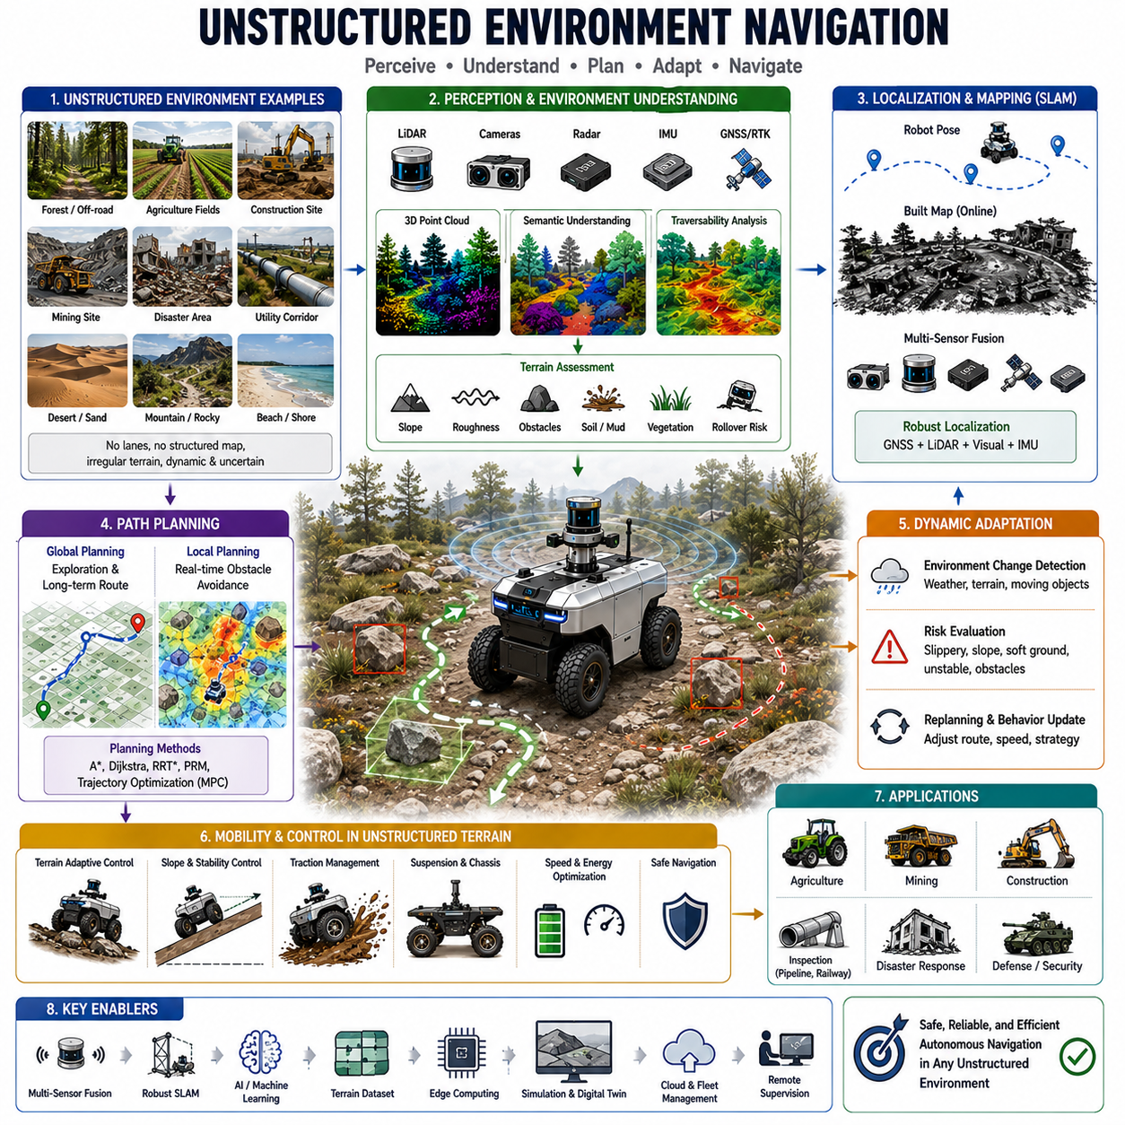
Unstructured environment navigation represents one of the most challenging and advanced areas of autonomous robotics. Unlike structured environments such as warehouses, factories, hospitals, office buildings, and urban roads where predefined maps, lane markings, road boundaries, and well-defined navigation rules exist, unstructured environments are characterized by uncertainty, irregularity, incomplete information, and continuous environmental change. Autonomous robots operating in such environments must navigate safely and effectively despite the absence of clearly defined paths, predictable landmarks, or reliable infrastructure. As outdoor autonomous robots expand into agriculture, mining, construction, forestry, military operations, disaster response, infrastructure inspection, and remote exploration, the ability to navigate unstructured environments has become a critical capability for next-generation autonomous systems. The importance of this topic is reflected within the Outdoor Navigation section of modern autonomous navigation architectures.
An unstructured environment can be broadly defined as any environment where navigable paths are not explicitly specified and where environmental conditions may change dynamically without prior notice. Unlike roads, corridors, or designated pathways, unstructured environments often contain irregular terrain, natural obstacles, uncertain boundaries, variable surface conditions, and incomplete environmental information. Examples include forests, agricultural fields, mountainous regions, deserts, beaches, mining sites, construction zones, disaster areas, pipelines, utility corridors, offshore facilities, and military operational zones. In these environments, autonomous robots cannot simply follow predefined routes but must continuously interpret their surroundings and make navigation decisions in real time.
One of the most significant challenges in unstructured environment navigation is the absence of reliable prior maps. In structured environments, robots typically rely on HD maps, semantic maps, occupancy maps, or predefined route networks. However, in many unstructured environments, accurate maps may not exist or may become obsolete quickly due to environmental changes. Construction sites evolve daily as equipment and materials move. Forest environments change due to vegetation growth, fallen trees, and seasonal variations. Disaster areas may experience continuous structural changes following earthquakes, floods, landslides, or storms. Consequently, autonomous robots must generate and update environmental representations dynamically while simultaneously performing navigation tasks.
Simultaneous Localization and Mapping plays a central role in unstructured navigation. SLAM enables robots to construct maps while estimating their own position within the environment. Unlike structured indoor environments where landmarks are stable and easily recognizable, unstructured environments often contain ambiguous features and repetitive patterns. Rocks, vegetation, dirt paths, and natural terrain may lack distinctive characteristics. Therefore, advanced SLAM systems must integrate multiple sensing modalities including LiDAR, cameras, radar, GNSS, IMUs, wheel odometry, and environmental semantics to achieve robust localization performance.
Perception becomes considerably more difficult in unstructured environments. Structured environments often contain clearly defined objects such as walls, doors, shelves, vehicles, and pedestrians. In contrast, unstructured environments contain highly variable objects with irregular shapes and appearances. Trees, bushes, rocks, mud, water, debris, uneven ground, and natural terrain features do not conform to predictable geometric models. Autonomous perception systems must therefore classify and interpret complex environmental elements while distinguishing traversable regions from hazardous areas.
Terrain understanding is one of the most important capabilities required for unstructured navigation. Unlike paved roads and indoor floors, natural terrain exhibits significant variation in elevation, roughness, slope, traction, and stability. A robot must evaluate whether a surface is safe for traversal before committing to a path. Terrain assessment systems analyze characteristics such as surface geometry, slope angle, obstacle density, soil conditions, vegetation coverage, wheel sinkage potential, and rollover risk. These analyses enable robots to estimate traversability and avoid dangerous regions.
Traversability analysis extends beyond simple obstacle detection. In many unstructured environments, obstacles may not be clearly separable from the surrounding terrain. For example, a shallow ditch may appear traversable while concealing significant risk. Soft soil may visually resemble stable ground but cause vehicle immobilization. Wet grass may reduce traction unexpectedly. Navigation systems must therefore estimate not only the geometry of the environment but also its physical properties and mobility implications.
Three-dimensional perception is particularly important for unstructured navigation. LiDAR sensors generate detailed point clouds that capture terrain geometry and obstacle structures. Stereo cameras and depth cameras provide additional depth information. Radar sensors contribute environmental awareness under adverse weather conditions. By combining these sensing modalities, robots can construct rich environmental models that support navigation decision-making in complex terrain.
GNSS-based localization remains valuable in many outdoor unstructured environments, particularly where satellite visibility is available. Agricultural robots, mining vehicles, and utility inspection robots frequently utilize RTK GNSS to maintain centimeter-level positioning accuracy across large operational areas. However, GNSS alone is insufficient because signal quality may degrade under dense vegetation, mountainous terrain, urban infrastructure, or geological formations. Multi-sensor localization architectures therefore combine GNSS with LiDAR localization, visual localization, and inertial navigation systems.
Path planning in unstructured environments differs fundamentally from traditional road-based navigation. Structured navigation often relies on graph-based routing algorithms operating on predefined road networks. Unstructured environments generally lack such networks. Instead, path planners must generate routes directly from terrain observations and environmental assessments. The planner continuously evaluates alternative trajectories while balancing safety, efficiency, mobility, and mission objectives.
Sampling-based planning methods such as Rapidly Exploring Random Trees and Probabilistic Roadmaps are frequently employed in unstructured navigation because they can efficiently explore high-dimensional configuration spaces. These methods generate candidate paths through complex terrain while respecting vehicle kinematic constraints and environmental hazards. Optimization-based planners further refine these trajectories to improve smoothness, energy efficiency, and safety. Such techniques form an important foundation for outdoor navigation systems operating beyond structured road networks.
Dynamic environmental adaptation is another essential capability. Unstructured environments often contain moving obstacles, changing terrain conditions, and evolving operational constraints. Construction equipment may alter site layouts. Agricultural fields may change due to crop growth and harvesting activities. Disaster response environments may experience secondary collapses or debris movement. Autonomous robots must continuously reassess environmental conditions and adapt navigation strategies accordingly.
Weather conditions significantly influence unstructured environment navigation. Rain, snow, fog, dust, and wind affect both sensing performance and terrain characteristics. A dirt road that is easily traversable under dry conditions may become impassable following heavy rainfall. Snow can conceal obstacles and alter terrain geometry. Dust storms can reduce visibility and sensor effectiveness. Therefore, weather-aware navigation systems must integrate environmental monitoring and adaptive decision-making capabilities.
Vehicle mobility modeling becomes increasingly important as terrain complexity increases. Different vehicle platforms exhibit different mobility characteristics. Wheeled robots, tracked vehicles, articulated platforms, legged robots, and hybrid systems each possess unique strengths and limitations. Navigation systems must account for vehicle-specific capabilities when evaluating terrain traversability. A path that is safe for a tracked vehicle may be unsuitable for a wheeled robot. Consequently, path planning and terrain assessment must be tightly integrated with vehicle dynamics and mobility constraints.
Slope navigation represents a particularly challenging aspect of unstructured mobility. Steep inclines introduce risks associated with wheel slip, reduced traction, vehicle instability, and rollover. Navigation systems continuously monitor slope angles, center-of-gravity positions, tire-ground interactions, and stability margins. Real-time stability assessment enables robots to avoid dangerous slopes and maintain safe operation across uneven terrain.
Obstacle handling in unstructured environments is considerably more complex than in structured settings. Obstacles may vary widely in size, shape, material properties, and mobility characteristics. Trees, rocks, ditches, fences, vegetation, debris, equipment, water bodies, and terrain discontinuities all present different navigation challenges. Advanced perception systems must classify obstacle types and estimate associated risks. Navigation planners then determine whether obstacles should be avoided, crossed, traversed, or manipulated.
Semantic understanding increasingly contributes to unstructured navigation performance. Rather than treating all environmental features as geometric obstacles, semantic navigation systems interpret the meaning of environmental elements. For example, a robot may recognize roads, trails, crop rows, drainage channels, utility corridors, work zones, hazardous regions, and operational areas. This higher-level understanding supports more intelligent navigation decisions and improves mission efficiency.
Artificial intelligence plays an increasingly important role in unstructured navigation. Machine learning models assist with terrain classification, obstacle recognition, traversability prediction, environmental understanding, and decision making. Deep neural networks trained on large datasets can identify subtle terrain characteristics that may be difficult to capture using traditional rule-based approaches. Reinforcement learning techniques allow robots to learn navigation strategies through experience and adapt to previously unseen environments.
Multi-modal sensor fusion is essential for achieving robust navigation performance. No single sensor provides sufficient information under all conditions. Cameras offer rich visual information but may be affected by lighting changes. LiDAR provides accurate geometry but can be influenced by precipitation and airborne particles. Radar performs well in adverse weather but provides lower resolution. GNSS offers global positioning but may experience signal degradation. By integrating multiple sensor modalities, autonomous systems achieve greater reliability and environmental awareness.
Human-robot collaboration is often necessary in highly complex unstructured environments. While autonomous systems increasingly handle routine navigation tasks independently, certain situations may require human supervision or intervention. Remote operators can provide strategic guidance when environmental uncertainty exceeds autonomous decision-making capabilities. Shared autonomy frameworks allow robots and humans to collaborate effectively while maximizing operational efficiency.
Industrial applications demonstrate the growing importance of unstructured environment navigation. Agricultural robots navigate crop fields, orchards, vineyards, and plantations. Mining vehicles operate across large extraction sites with constantly changing terrain. Construction robots traverse dynamic work zones filled with equipment and materials. GPR inspection robots travel along utility corridors, road shoulders, railway infrastructure, and undeveloped terrain. Military and security robots operate in highly unpredictable environments where navigation uncertainty is unavoidable. These applications require advanced navigation systems capable of functioning beyond structured operational boundaries.
Testing and validation of unstructured navigation systems present unique challenges. Environmental variability makes comprehensive testing difficult because no two operational scenarios are identical. Validation programs must therefore include diverse terrain types, weather conditions, obstacle configurations, operational tasks, and environmental disturbances. Simulation environments provide valuable initial testing capabilities, but real-world field testing remains essential for evaluating system robustness and operational readiness.
Future developments in unstructured environment navigation will likely involve deeper integration of artificial intelligence, world models, semantic reasoning, digital twins, cloud robotics, and embodied intelligence. Navigation systems will increasingly move beyond simple path planning toward comprehensive environmental understanding and autonomous decision-making. Robots will learn from operational experience, share knowledge across fleets, and continuously improve their ability to navigate unfamiliar environments.
Ultimately, unstructured environment navigation represents one of the highest levels of autonomous mobility. It requires the integration of perception, localization, mapping, terrain understanding, path planning, vehicle control, safety management, artificial intelligence, and adaptive decision-making into a unified operational framework. As autonomous robots continue expanding into agriculture, construction, mining, infrastructure inspection, defense, environmental monitoring, and disaster response, mastery of unstructured environment navigation will become one of the defining capabilities that separates truly autonomous robotic systems from conventional automated machines.

15.6 Outdoor Obstacle Handling
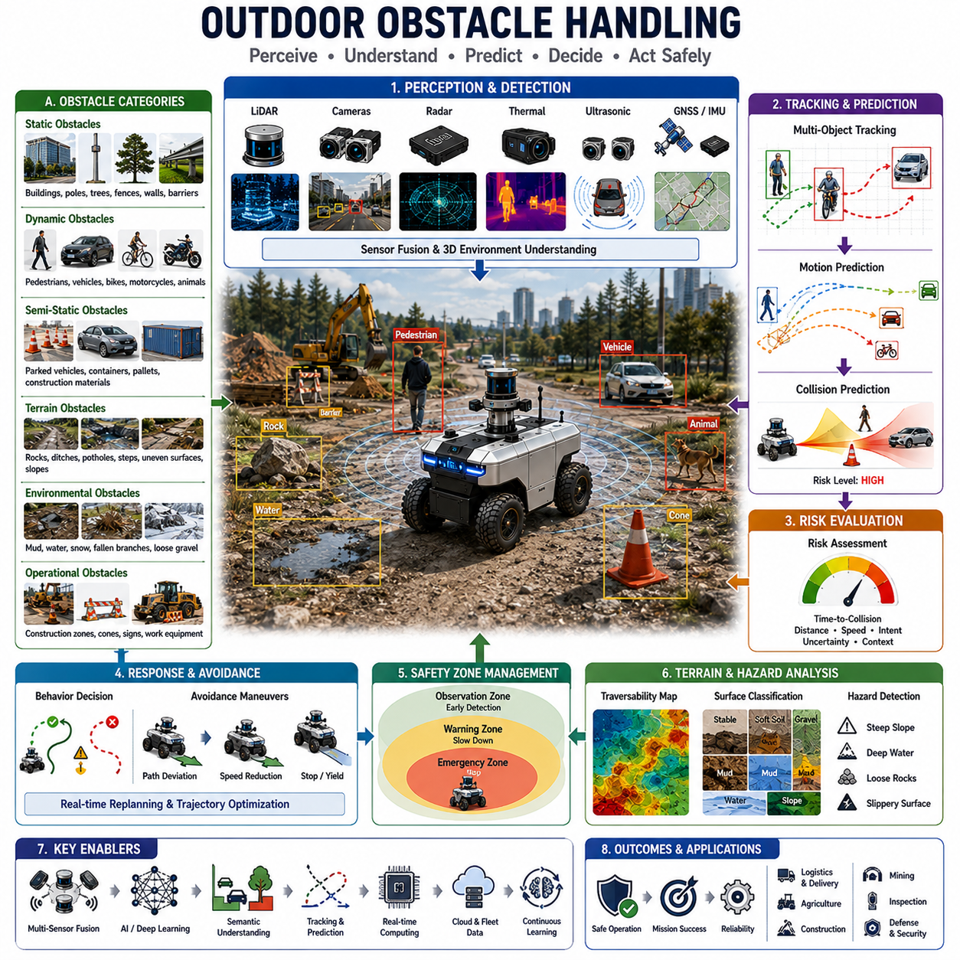
Outdoor obstacle handling is one of the most critical components of autonomous navigation systems operating in real-world environments. While localization, mapping, and path planning determine where a robot should go, obstacle handling determines whether the robot can safely and successfully reach its destination. Outdoor environments are inherently dynamic, unpredictable, and highly diverse. Unlike indoor facilities where obstacles are generally well-defined and relatively static, outdoor environments contain an enormous variety of objects, terrain features, moving entities, environmental hazards, and unexpected conditions that may interfere with robot operation. As autonomous robots become increasingly deployed in logistics, agriculture, construction, mining, infrastructure inspection, defense, smart cities, and public service applications, robust outdoor obstacle handling has become a fundamental requirement for safe and reliable autonomous operation.
Outdoor obstacles can be broadly categorized into static obstacles, dynamic obstacles, semi-static obstacles, terrain-related obstacles, environmental obstacles, and temporary operational obstacles. Static obstacles include objects that remain fixed in position for extended periods, such as buildings, utility poles, fences, walls, barriers, trees, drainage structures, signposts, and permanent infrastructure. Dynamic obstacles include pedestrians, vehicles, bicycles, motorcycles, animals, construction equipment, and other moving objects. Semi-static obstacles include parked vehicles, temporary barriers, containers, pallets, maintenance equipment, and construction materials that may remain stationary for a period of time but can eventually move. Environmental obstacles include mud, water accumulation, snowbanks, fallen branches, loose rocks, vegetation growth, and weather-related hazards. Effective obstacle handling systems must detect, classify, track, predict, evaluate, and respond appropriately to all of these obstacle categories.
The first stage of outdoor obstacle handling is obstacle perception. Autonomous robots must continuously observe their surroundings and identify potential hazards before they become safety risks. Modern outdoor robots utilize a combination of LiDAR, cameras, radar, ultrasonic sensors, thermal cameras, depth cameras, GNSS, and inertial sensors to construct a comprehensive understanding of the environment. Each sensing technology contributes unique strengths and limitations. LiDAR provides highly accurate geometric information and three-dimensional obstacle measurements. Cameras provide rich semantic understanding and object classification capabilities. Radar performs reliably under adverse weather conditions such as rain, fog, snow, and dust. Thermal cameras improve detection of humans and animals during nighttime operations. Sensor fusion combines these complementary capabilities to achieve robust obstacle perception.
Obstacle detection begins with identifying objects that occupy physical space within the robot’s operational environment. Point cloud processing algorithms analyze LiDAR measurements to identify geometric structures that protrude above the ground plane. Vision systems employ object detection networks to recognize pedestrians, vehicles, machinery, infrastructure, animals, and other relevant objects. Semantic segmentation systems classify each pixel or point within the environment according to object category. The result is a structured environmental representation that supports higher-level navigation decisions.
Accurate obstacle classification is essential because different obstacle types require different responses. A stationary utility pole requires simple avoidance. A pedestrian crossing the robot’s path requires predictive motion analysis and safe yielding behavior. A construction vehicle operating nearby may require larger safety margins and additional caution. An animal may behave unpredictably and necessitate conservative avoidance strategies. Therefore, obstacle handling systems must move beyond simple detection and develop semantic understanding of environmental elements.
Obstacle tracking is particularly important for dynamic environments. Once an obstacle has been detected, the robot must continuously estimate its position, velocity, acceleration, heading, and motion behavior. Tracking algorithms utilize sensor observations collected over time to generate stable object trajectories. Kalman filters, particle filters, multiple hypothesis tracking systems, and deep learning-based tracking frameworks are commonly used for this purpose. Accurate tracking enables the robot to understand how obstacles are moving and anticipate future interactions.
Motion prediction extends obstacle tracking by estimating future obstacle trajectories. Outdoor navigation often requires robots to operate in environments shared with humans and vehicles. Predicting future motion allows the robot to proactively avoid potential conflicts before they occur. Human motion prediction is particularly challenging because pedestrians frequently change direction, stop unexpectedly, or behave unpredictably. Advanced prediction systems utilize behavioral models, social interaction models, and machine learning techniques to estimate likely future movements.
Collision prediction forms the next layer of obstacle handling. Once the robot understands both its own trajectory and the predicted trajectories of surrounding objects, it can evaluate the likelihood of future collisions. Collision prediction algorithms calculate future occupancy regions, trajectory intersections, time-to-collision metrics, and risk probabilities. If collision risk exceeds acceptable thresholds, the navigation system initiates avoidance maneuvers or emergency responses. This predictive capability allows robots to react before dangerous situations develop.
Safety zone management plays a central role in outdoor obstacle handling. Autonomous robots typically maintain multiple protective zones around their vehicles. Immediate safety zones trigger emergency braking when obstacles enter critical distances. Warning zones initiate speed reduction and increased caution. Observation zones monitor potential future conflicts. Dynamic safety zones adapt according to robot speed, payload, terrain conditions, environmental complexity, and operational context. Faster vehicle speeds require larger safety zones, while operations near humans often demand more conservative safety margins.
Outdoor environments introduce unique challenges associated with obstacle diversity. Unlike indoor robots that primarily encounter walls, furniture, and people, outdoor robots face highly varied obstacles with unpredictable shapes, sizes, and behaviors. Trees, bushes, rocks, potholes, drainage ditches, utility infrastructure, temporary construction barriers, uneven terrain, and environmental debris all present different challenges. Obstacle handling systems must therefore support generalized environmental understanding rather than relying solely on predefined object categories.
Terrain-related obstacle handling is particularly important in outdoor environments. Not all obstacles are discrete objects. Many hazards are embedded within the terrain itself. Examples include steep slopes, soft soil, loose gravel, mud, deep sand, water accumulation, sinkholes, erosion zones, and unstable surfaces. These hazards may not appear as traditional obstacles but can significantly affect vehicle mobility and safety. Traversability analysis systems continuously evaluate terrain characteristics and identify regions that should be avoided.
Vegetation presents another unique challenge. Agricultural robots, forestry robots, and outdoor inspection systems frequently encounter grass, crops, bushes, branches, and dense vegetation. Not all vegetation should be treated as an obstacle. Some vegetation may be safely traversable, while other vegetation may conceal hidden hazards. Semantic perception systems help distinguish between traversable vegetation, non-traversable vegetation, and potentially hazardous environmental features.
Water handling is an important component of outdoor obstacle management. Water puddles, flooded areas, drainage channels, streams, and standing water may introduce significant operational risks. Water depth estimation becomes essential because shallow puddles may be traversable while deeper water may damage equipment or cause immobilization. Multi-modal perception systems utilize visual appearance, LiDAR measurements, radar signatures, and terrain models to estimate water hazards and determine safe navigation strategies.
Construction environments introduce some of the most complex obstacle handling requirements. Construction sites contain moving machinery, temporary barriers, excavation zones, material stockpiles, unstable terrain, and constantly changing layouts. Autonomous robots operating in these environments must continuously update environmental models and adapt navigation strategies in real time. Dynamic replanning capabilities become essential because obstacle configurations may change throughout the mission.
Agricultural environments present different challenges. Crops grow over time, altering environmental geometry. Farm equipment moves unpredictably. Soil conditions vary depending on irrigation, weather, and seasonal factors. Agricultural robots must navigate through rows, around vegetation, and across diverse terrain while minimizing crop damage. Obstacle handling systems must therefore incorporate agricultural semantics and operational objectives.
Mining environments introduce large-scale heavy equipment interactions. Autonomous mining vehicles operate alongside haul trucks, excavators, loaders, and support vehicles. These machines possess significant mass and limited maneuverability, creating unique safety requirements. Obstacle handling systems must maintain large protective distances, predict heavy equipment behavior, and coordinate navigation within highly dynamic operational environments.
Weather conditions significantly influence obstacle perception and handling performance. Rain, snow, fog, dust, and low-light conditions degrade sensor performance and increase environmental uncertainty. LiDAR may experience measurement noise due to precipitation. Cameras may suffer reduced visibility. Radar becomes increasingly important under adverse conditions because it maintains reliable performance despite environmental obscurants. Robust obstacle handling architectures dynamically adjust sensor weighting and perception strategies based on environmental conditions.
Artificial intelligence increasingly enhances outdoor obstacle handling capabilities. Deep learning models improve object detection, classification, segmentation, tracking, and behavior prediction. AI systems can recognize complex environmental patterns, estimate obstacle risk levels, and identify previously unseen object categories. Reinforcement learning approaches may enable robots to learn obstacle avoidance strategies through experience and simulation-based training.
Human-aware obstacle handling has become a major research and development area. Autonomous robots operating near people must not only avoid collisions but also behave in socially acceptable ways. Human-aware navigation considers personal space, movement intentions, social conventions, and comfort zones. Robots may slow down when approaching pedestrians, yield appropriately at crossings, and select paths that minimize perceived intrusion into personal space.
Multi-robot environments introduce additional obstacle handling complexity. Other robots become dynamic obstacles that must be detected, tracked, and coordinated. Fleet management systems often facilitate communication between robots, allowing cooperative obstacle avoidance and coordinated navigation behaviors. Shared situational awareness significantly improves operational efficiency and safety.
Path planning and obstacle handling are tightly integrated. Obstacle information continuously influences route generation and trajectory optimization. Local planners generate obstacle-aware trajectories that maintain safety margins while preserving navigation efficiency. Real-time replanning mechanisms enable robots to adapt to unexpected obstacles and environmental changes without disrupting mission execution.
Emergency response mechanisms serve as the final layer of obstacle handling. When collision risk becomes unavoidable or perception confidence decreases below acceptable thresholds, the robot must transition into safe operating states. Emergency braking, controlled stopping, safe retreat maneuvers, remote operator intervention, and fail-safe behaviors ensure that safety remains the highest priority under all operating conditions.
Testing and validation of obstacle handling systems require comprehensive evaluation across diverse environments and scenarios. Static obstacles, dynamic obstacles, mixed traffic environments, adverse weather conditions, nighttime operation, terrain hazards, sensor failures, and emergency situations must all be systematically tested. Simulation platforms provide scalable testing environments, while real-world field validation confirms operational robustness.
Future outdoor obstacle handling systems will increasingly incorporate foundation models, world models, semantic reasoning, digital twins, embodied intelligence, and collaborative perception technologies. Robots will not only react to obstacles but also understand environmental context, predict future developments, reason about complex situations, and coordinate with other autonomous systems. Obstacle handling will evolve from reactive avoidance toward proactive environmental understanding and intelligent decision-making.
Ultimately, outdoor obstacle handling serves as the safety intelligence layer of autonomous navigation. It transforms raw sensor observations into actionable knowledge that enables robots to operate safely in complex and unpredictable environments. As autonomous systems continue expanding into logistics, agriculture, mining, construction, infrastructure inspection, defense, and smart city applications, advanced obstacle handling capabilities will remain one of the most important technological foundations supporting reliable and trustworthy autonomous operation.

15.7 Outdoor Field Testing
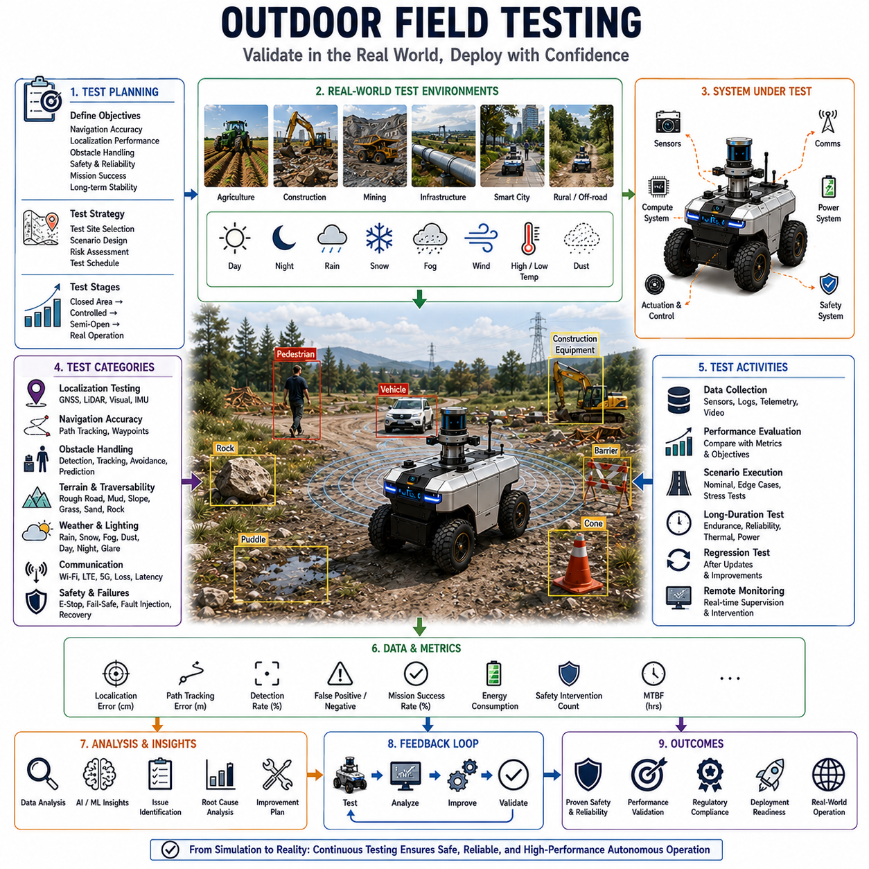
Outdoor field testing is one of the most important phases in the development and validation of autonomous navigation systems. While simulations, laboratory experiments, and controlled testing environments provide valuable opportunities for algorithm development and initial verification, they cannot fully replicate the complexity, uncertainty, and variability of real-world outdoor environments. Autonomous robots intended for logistics, agriculture, mining, infrastructure inspection, construction, defense, smart city services, and public safety applications must ultimately demonstrate reliable performance under actual operational conditions. Outdoor field testing serves as the critical bridge between prototype development and commercial deployment, ensuring that navigation systems function safely, reliably, and efficiently in real-world environments.
The primary purpose of outdoor field testing is to evaluate system performance under realistic operating conditions. Unlike laboratory environments where variables can be controlled and repeated precisely, outdoor environments present numerous unpredictable factors including changing weather conditions, varying lighting environments, dynamic obstacles, communication interruptions, terrain variability, environmental noise, and human interactions. Testing under these conditions provides valuable insight into system robustness and reveals limitations that may not appear during simulation-based development.
A comprehensive field testing program begins with clearly defined objectives. Testing objectives typically include navigation accuracy verification, localization performance assessment, obstacle detection validation, path planning evaluation, vehicle control analysis, communication reliability assessment, safety system verification, mission completion measurement, and long-term operational stability analysis. Well-defined objectives ensure that field testing produces measurable and actionable results that can guide further system development.
Test site selection plays a critical role in field testing effectiveness. Different applications require different operational environments. Agricultural robots may be tested in crop fields, orchards, vineyards, and open farmland. Mining vehicles require testing within active extraction sites. Infrastructure inspection robots may operate along roads, railways, pipelines, power transmission corridors, and utility networks. Smart city service robots may be tested in pedestrian zones, campuses, industrial parks, and urban environments. Selecting representative testing environments ensures that collected performance data accurately reflects real-world operating conditions.
Field testing typically progresses through multiple development stages. Initial testing often occurs within controlled outdoor environments where risk can be carefully managed. These environments may include dedicated proving grounds, closed facilities, test tracks, or restricted operational zones. Once basic functionality is validated, testing gradually expands into more complex environments that increasingly resemble actual deployment conditions. This staged approach reduces risk while systematically increasing operational complexity.
Localization testing is one of the most fundamental aspects of outdoor field validation. Autonomous robots rely on accurate position estimation to perform navigation tasks safely. Field testing evaluates GNSS performance, RTK correction reliability, LiDAR localization accuracy, visual localization robustness, inertial navigation performance, and sensor fusion effectiveness. Test scenarios often include open-sky conditions, urban canyon environments, partially obstructed GNSS environments, dense vegetation areas, and regions with varying infrastructure density. These tests determine how localization accuracy changes under different environmental conditions.
Navigation accuracy assessment measures how closely the robot follows planned trajectories. Deviations between planned paths and actual vehicle movement provide valuable information regarding localization quality, path tracking performance, vehicle control precision, and environmental influences. Metrics such as lateral tracking error, heading error, waypoint accuracy, path completion rate, and mission success rate are commonly used to evaluate navigation performance.
Obstacle handling validation is another critical component of outdoor field testing. Autonomous robots must demonstrate the ability to detect, classify, track, predict, and safely avoid obstacles under realistic conditions. Field testing includes encounters with pedestrians, vehicles, bicycles, animals, construction equipment, temporary barriers, environmental hazards, and terrain obstacles. Different obstacle scenarios help evaluate perception system performance and validate collision avoidance algorithms under operational conditions.
Dynamic obstacle testing is particularly important because moving objects introduce uncertainty and unpredictability. Human behavior, vehicle movement, and animal activity are often difficult to model accurately within simulations. Field testing allows engineers to observe how autonomous systems respond to complex real-world interactions and identify opportunities for improvement in prediction and decision-making algorithms.
Terrain evaluation represents a major focus area for outdoor robots operating beyond paved roads. Field testing often includes operation on gravel roads, dirt paths, grass fields, mud, sand, rocky surfaces, slopes, uneven terrain, and mixed-surface environments. These tests evaluate vehicle mobility, traversability analysis, traction management, suspension performance, and stability control. Real-world terrain testing is especially important because mobility performance often depends on factors that are difficult to model accurately in simulation.
Weather testing is essential for understanding environmental robustness. Outdoor robots may encounter rain, snow, fog, wind, dust, extreme temperatures, and varying humidity levels. Field testing under different weather conditions evaluates sensor performance, localization reliability, obstacle detection accuracy, communication stability, vehicle dynamics, and overall mission performance. Weather-related testing often reveals failure modes that remain hidden under ideal operating conditions.
Lighting variation testing is equally important. Autonomous robots frequently operate across daytime, nighttime, dawn, dusk, and mixed-light environments. Camera-based perception systems are particularly sensitive to lighting changes. Field testing evaluates system performance under direct sunlight, shadows, glare, low-light conditions, artificial illumination, and rapidly changing lighting environments. These evaluations help validate perception robustness and sensor fusion effectiveness.
Communication testing examines the reliability of wireless connectivity during autonomous operation. Outdoor robots commonly depend on Wi-Fi, LTE, private LTE, 5G, satellite communication, or industrial wireless networks. Field testing measures network coverage, latency, bandwidth availability, packet loss, connection stability, and recovery behavior during communication interruptions. Since communication infrastructure may vary significantly across operational environments, real-world testing is essential for understanding connectivity limitations.
Fleet testing becomes increasingly important as multi-robot deployments grow in scale. Fleet-level field testing evaluates traffic coordination, mission scheduling, route optimization, communication management, conflict resolution, and operational efficiency across multiple autonomous robots. These tests validate fleet management systems and ensure that multiple robots can safely share operational environments without creating congestion or safety hazards.
Safety validation remains the highest priority throughout all testing activities. Autonomous systems must demonstrate safe behavior under normal operation, abnormal conditions, and failure scenarios. Field testing includes emergency stop verification, obstacle avoidance validation, fail-safe behavior assessment, fault recovery evaluation, remote intervention testing, and safety zone management analysis. Safety engineers carefully design testing procedures to minimize risk while thoroughly evaluating system behavior.
Failure testing intentionally introduces faults into the system to evaluate robustness and recovery capabilities. Examples include sensor failures, GNSS outages, communication interruptions, power fluctuations, localization degradation, perception failures, and software faults. These tests help determine whether the robot can safely detect abnormal conditions and transition into appropriate recovery modes.
Long-duration endurance testing provides insight into operational reliability over extended periods. Many autonomous systems are expected to operate continuously for hours, days, or even months. Endurance testing evaluates component reliability, thermal management, battery performance, sensor stability, software robustness, and maintenance requirements. Long-term testing often reveals issues that do not appear during short-duration evaluations.
Data collection represents one of the most valuable outcomes of field testing. Autonomous robots generate large volumes of sensor data, localization information, vehicle telemetry, perception results, control commands, and operational logs. These datasets support performance analysis, algorithm improvement, machine learning development, anomaly investigation, and future validation efforts. High-quality field datasets are often considered strategic assets within autonomous robotics programs.
Performance metrics provide objective measures of system capability. Common field testing metrics include localization accuracy, obstacle detection rate, false positive rate, false negative rate, path tracking error, mission completion percentage, energy consumption, communication uptime, safety intervention frequency, operational efficiency, and mean time between failures. Quantitative metrics allow engineers to compare different system versions and track development progress over time.
Field testing also supports regulatory compliance and certification activities. Many autonomous systems must satisfy safety standards, industry regulations, operational guidelines, and customer requirements before deployment. Testing evidence provides documentation that demonstrates system compliance and supports certification processes. This is particularly important for robots operating in public environments, industrial facilities, transportation infrastructure, and safety-critical applications.
Digital twin technologies increasingly complement outdoor field testing programs. Digital twins provide virtual representations of operational environments and continuously synchronize with real-world data. Field testing data can be used to calibrate digital twin models, while digital twins can generate new testing scenarios and support predictive performance analysis. This integration creates a feedback loop between simulation and real-world validation.
Artificial intelligence plays an increasingly important role in test analysis. Machine learning algorithms can identify performance patterns, detect anomalies, classify failure modes, estimate operational risk, and recommend optimization opportunities. AI-driven analytics help engineers extract insights from large testing datasets and accelerate system improvement cycles.
Collaborative testing involving customers, operators, regulators, and system developers often provides additional value. Real-world stakeholders contribute operational knowledge, identify practical requirements, and evaluate system usability. Their feedback helps ensure that autonomous systems satisfy both technical specifications and operational expectations.
As autonomous robotics technology continues to advance, outdoor field testing methodologies are also evolving. Future testing programs will increasingly integrate automated test generation, cloud-based analytics, digital twins, AI-assisted validation, continuous deployment pipelines, and large-scale fleet evaluation. Testing environments will become more sophisticated while maintaining strong connections to real-world operational conditions.
Ultimately, outdoor field testing serves as the final proving ground for autonomous navigation systems. It transforms theoretical algorithms, simulation results, and laboratory prototypes into validated operational capabilities. Through systematic evaluation across diverse environments, weather conditions, obstacle scenarios, and mission objectives, field testing ensures that autonomous robots can safely and reliably perform their intended functions in the real world. As autonomous systems continue expanding into logistics, agriculture, construction, mining, infrastructure inspection, defense, and smart city applications, comprehensive outdoor field testing will remain one of the most essential activities supporting successful deployment and long-term operational success.

15.8 Outdoor Navigation Case Studies
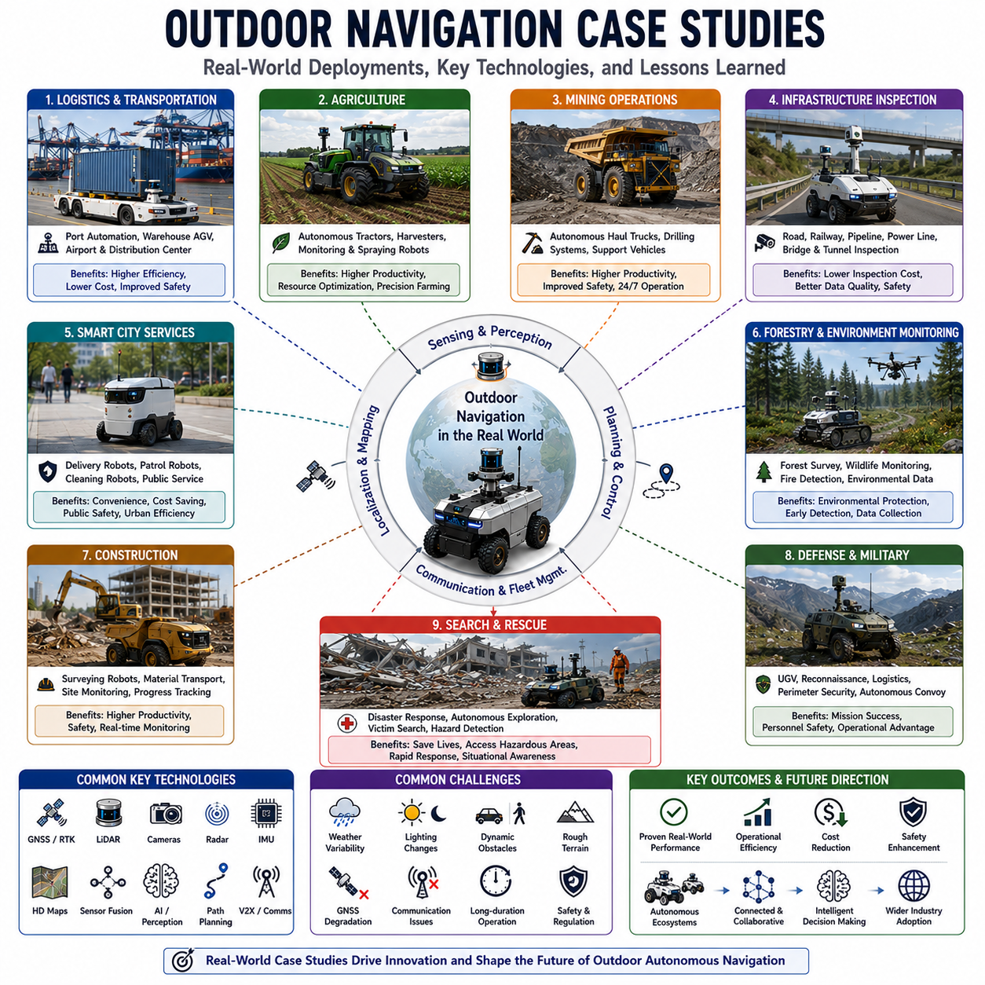
Outdoor navigation has evolved from a research-oriented discipline into a foundational technology supporting numerous commercial, industrial, governmental, and military applications. While theoretical algorithms, simulation environments, and laboratory testing provide essential foundations for autonomous navigation development, real-world deployment ultimately determines the practical value of any navigation system. Outdoor navigation case studies provide valuable insights into how autonomous robots operate under real operational conditions, how navigation technologies perform in diverse environments, and how engineering challenges are addressed in practical deployments. By examining successful implementations across various industries, researchers and developers can better understand the strengths, limitations, and future directions of outdoor autonomous navigation systems.
One of the most widely adopted applications of outdoor navigation can be found in autonomous logistics and transportation systems. Large logistics facilities, ports, airports, and distribution centers increasingly utilize autonomous vehicles to transport goods between storage areas, loading docks, warehouses, and transportation hubs. These environments often cover hundreds of hectares and involve continuous vehicle movement, dynamic obstacles, complex traffic patterns, and varying environmental conditions. Autonomous logistics vehicles operating in such environments rely on GNSS-based positioning, LiDAR localization, HD maps, obstacle avoidance systems, and fleet management platforms to coordinate transportation tasks. Real-world deployments have demonstrated significant improvements in operational efficiency, reduced labor dependency, lower operational costs, and enhanced safety performance.
Port automation represents one of the most mature examples of large-scale outdoor autonomous navigation. Modern container terminals operate thousands of containers daily across vast operational areas. Autonomous container transport vehicles navigate between ship unloading zones, storage yards, and loading areas while interacting with cranes, trucks, human workers, and other autonomous vehicles. These systems employ centimeter-level GNSS positioning, multi-sensor perception, centralized fleet management, and real-time route optimization. Case studies from large international ports have demonstrated the feasibility of fully autonomous container movement under continuous operation, highlighting the importance of robust localization, obstacle handling, and fleet coordination technologies.
Agricultural robotics provides another compelling case study for outdoor navigation. Modern agriculture increasingly depends on autonomous tractors, harvesting machines, crop monitoring robots, spraying systems, and precision farming platforms. Agricultural environments present unique navigation challenges including large operational areas, varying terrain conditions, seasonal changes, crop growth, weather variations, and limited infrastructure. Autonomous agricultural vehicles typically utilize RTK GNSS, machine vision, terrain analysis, and path planning systems to navigate fields with high precision. Real-world deployments have demonstrated improved productivity, reduced chemical usage, optimized resource allocation, and increased farming efficiency.
Autonomous tractors provide a particularly valuable example of precision outdoor navigation. These vehicles often operate in large open fields where centimeter-level path accuracy is required to maximize crop yield and minimize overlap between passes. RTK GNSS provides highly accurate positioning, while onboard perception systems detect obstacles such as animals, equipment, vehicles, and field workers. Path planning systems optimize coverage patterns to maximize efficiency while minimizing fuel consumption. Numerous commercial deployments have demonstrated the ability of autonomous tractors to perform planting, cultivation, spraying, and harvesting operations with minimal human supervision.
Mining operations represent some of the most demanding environments for autonomous navigation. Large open-pit mines cover extensive areas characterized by rough terrain, steep slopes, dust, heavy machinery, and continuously changing operational conditions. Autonomous haul trucks, drilling systems, and support vehicles operate alongside human-operated equipment in highly dynamic environments. Mining navigation systems integrate GNSS, LiDAR, radar, vehicle-to-vehicle communication, terrain modeling, and centralized operational management. Case studies from autonomous mining operations have shown significant improvements in productivity, safety, and equipment utilization while reducing human exposure to hazardous conditions.
One of the key lessons from mining deployments is the importance of environmental robustness. Dust, vibration, extreme temperatures, and continuous terrain modifications challenge navigation systems in ways that rarely occur in controlled environments. Successful mining systems employ redundant sensors, adaptive localization methods, fault-tolerant architectures, and extensive safety monitoring to maintain reliable operation despite harsh environmental conditions.
Infrastructure inspection robots represent another rapidly growing application area. Roads, railways, pipelines, power transmission lines, utility corridors, bridges, tunnels, and underground infrastructure require regular inspection to ensure operational safety and reliability. Traditional inspection methods often require significant labor, equipment, and operational disruptions. Autonomous inspection robots provide a safer and more efficient alternative.
Road inspection robots equipped with cameras, LiDAR, thermal sensors, and Ground Penetrating Radar can autonomously navigate road networks while collecting infrastructure condition data. These systems identify pavement cracks, subsurface voids, utility anomalies, thermal abnormalities, and structural defects. Outdoor navigation plays a critical role because inspection routes often span many kilometers and require operation under varying traffic, weather, and lighting conditions. Field deployments have demonstrated the feasibility of continuous autonomous inspection while reducing inspection costs and increasing data collection frequency.
Railway inspection robots provide another valuable case study. Rail infrastructure extends across large geographic regions and often traverses remote or difficult-to-access areas. Autonomous railway inspection systems utilize GNSS, LiDAR, machine vision, and track-following algorithms to navigate rail corridors while inspecting tracks, sleepers, overhead lines, and surrounding infrastructure. These systems improve maintenance planning and help prevent infrastructure failures before they impact operations.
Pipeline inspection applications illustrate the challenges of long-distance outdoor navigation. Oil, gas, water, and utility pipelines often extend hundreds or thousands of kilometers through diverse terrain. Inspection robots operating along these corridors must navigate forests, deserts, mountains, agricultural areas, and urban regions. Navigation systems integrate GNSS positioning, terrain-aware planning, obstacle handling, and communication management to support reliable long-range operation. Real-world deployments demonstrate the value of autonomous navigation for reducing operational costs while improving inspection coverage.
Smart city deployments provide some of the most complex outdoor navigation case studies. Urban environments contain dense traffic, pedestrians, bicycles, public transportation systems, dynamic obstacles, changing infrastructure, and highly variable environmental conditions. Autonomous delivery robots, security patrol robots, maintenance robots, cleaning robots, and public service robots increasingly operate within these environments.
Autonomous delivery robots operating in urban areas demonstrate the integration of navigation, perception, obstacle avoidance, and human interaction technologies. These robots navigate sidewalks, pedestrian crossings, mixed-use pathways, and public spaces while interacting safely with people and vehicles. Real-world deployments have highlighted the importance of semantic understanding, human-aware navigation, social behavior modeling, and adaptive obstacle handling.
Security and patrol robots provide another important urban navigation application. These systems operate continuously across campuses, industrial parks, airports, and public facilities. Navigation systems must support day-night operation, adverse weather conditions, dynamic obstacle avoidance, and long-duration autonomous missions. Successful deployments demonstrate the value of integrating thermal imaging, AI-based threat detection, GNSS navigation, and fleet management systems.
Construction environments present unique challenges due to their dynamic nature. Autonomous construction robots operate in environments where layouts change daily as equipment, materials, and structures move. Navigation systems must continuously update environmental models while adapting to evolving operational conditions. Case studies involving autonomous surveying robots, material transport vehicles, and construction monitoring systems demonstrate the importance of dynamic mapping, adaptive planning, and robust obstacle handling.
Forestry and environmental monitoring applications further illustrate the complexity of outdoor navigation. Forest environments often contain dense vegetation, uneven terrain, limited GNSS visibility, seasonal changes, and environmental uncertainty. Autonomous robots performing ecological surveys, wildfire monitoring, forest inventory analysis, and environmental assessments must combine LiDAR-based localization, visual perception, terrain analysis, and adaptive path planning. Successful deployments demonstrate the ability of autonomous systems to operate in environments where traditional navigation methods are insufficient.
Military and defense applications represent some of the most advanced outdoor navigation case studies. Autonomous ground vehicles, reconnaissance platforms, logistics robots, perimeter security systems, and unmanned convoy vehicles operate in highly unpredictable environments characterized by uncertain terrain, dynamic threats, communication limitations, and operational complexity. Navigation systems emphasize robustness, redundancy, adaptability, and mission resilience. Lessons learned from military deployments frequently influence commercial autonomous navigation technologies.
Search-and-rescue operations provide valuable examples of navigation under extreme uncertainty. Natural disasters, earthquakes, floods, landslides, and industrial accidents often create environments where maps become outdated, infrastructure is damaged, and environmental conditions are highly unpredictable. Autonomous robots deployed in these scenarios must rapidly build environmental models, navigate hazardous terrain, locate survivors, and support emergency response teams. Field deployments have demonstrated the importance of autonomous exploration, terrain understanding, obstacle handling, and human-robot collaboration.
Outdoor navigation case studies consistently reveal several common success factors. Multi-sensor fusion significantly improves reliability because no single sensing modality performs optimally under all conditions. Redundant localization architectures combining GNSS, LiDAR, cameras, radar, and inertial sensors provide greater robustness than any individual technology. Adaptive planning systems capable of responding to environmental changes outperform static navigation approaches. Comprehensive field testing remains essential for validating system performance under real-world conditions.
These case studies also highlight recurring challenges. Environmental variability remains one of the most difficult problems. Weather changes, lighting variations, seasonal effects, terrain modifications, and unexpected obstacles continue to challenge autonomous systems. Communication reliability, long-duration operation, maintenance requirements, and safety certification remain important considerations for large-scale deployments.
Artificial intelligence increasingly enhances outdoor navigation performance across all application domains. Machine learning models improve perception, localization, path planning, obstacle prediction, terrain classification, and decision-making capabilities. Digital twin technologies provide virtual testing environments that accelerate development and validation. Cloud robotics enables centralized fleet management and large-scale operational optimization. These technologies continue to expand the capabilities of autonomous navigation systems.
Future outdoor navigation deployments will likely involve increasingly autonomous, connected, and intelligent robotic ecosystems. Multiple robot types will collaborate across shared environments, exchange information in real time, and coordinate mission execution. Navigation systems will evolve beyond simple movement planning toward comprehensive environmental understanding, predictive reasoning, and adaptive decision-making.
Ultimately, outdoor navigation case studies provide practical evidence that autonomous navigation has matured from a research concept into a transformative operational technology. Across logistics, agriculture, mining, infrastructure inspection, smart cities, construction, environmental monitoring, defense, and emergency response applications, real-world deployments demonstrate the ability of autonomous robots to operate safely and effectively in complex outdoor environments. The lessons learned from these deployments continue to shape the next generation of navigation technologies and will play a critical role in the future expansion of autonomous robotic systems worldwide.

