Volume 05. Path Planning and Autonomous Navigation

Chapter 21. Navigation Debugging

21.1 Navigation Debugging Methodology
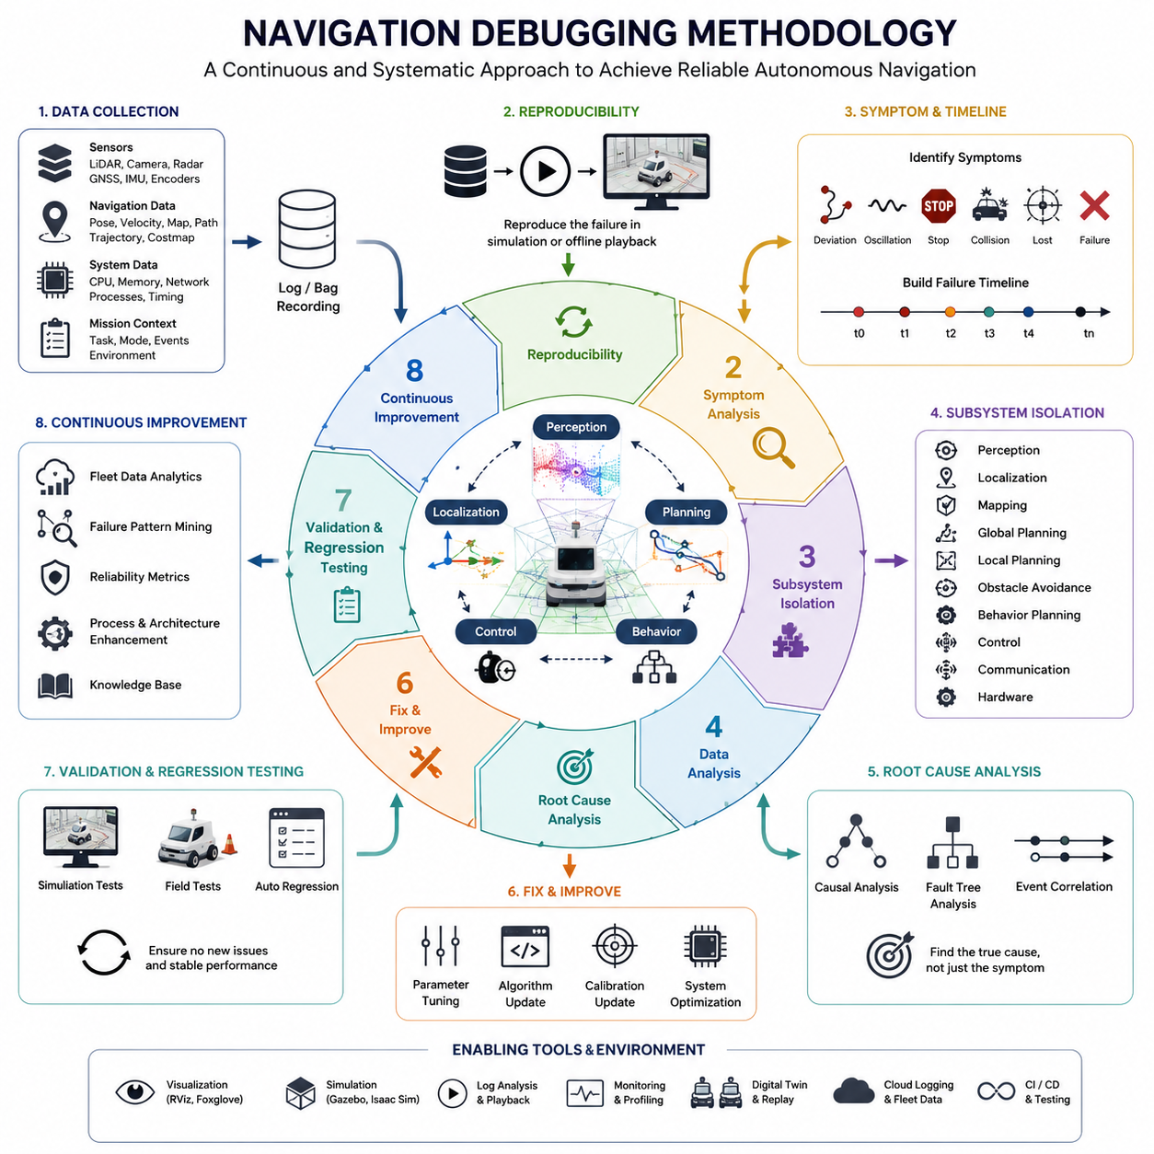
Navigation debugging is one of the most critical engineering activities in the development of Autonomous Mobile Robots (AMRs), outdoor autonomous robots, logistics robots, towing robots, hospital service robots, and industrial inspection platforms. While modern navigation systems integrate sophisticated localization, mapping, perception, path planning, trajectory generation, behavior planning, and motion control technologies, failures still occur frequently in real-world environments. Robots may stop unexpectedly, oscillate near obstacles, deviate from planned paths, lose localization accuracy, generate invalid trajectories, or fail to complete missions. A systematic navigation debugging methodology is therefore essential for identifying root causes, reproducing failures, validating corrective actions, and ensuring reliable autonomous operation. Within the navigation engineering lifecycle, debugging is not merely a reactive process performed after failures occur; it is a continuous engineering discipline that supports development, testing, deployment, maintenance, and long-term operational reliability. This chapter introduces a comprehensive methodology for debugging autonomous navigation systems and provides practical guidance for developing robust debugging workflows applicable to both indoor and outdoor robotic platforms.
A navigation system typically consists of multiple interconnected subsystems operating simultaneously. These subsystems include perception modules, localization engines, map management systems, global planners, local planners, obstacle avoidance systems, behavior planners, vehicle controllers, communication layers, and fleet management services. Because navigation performance emerges from the interaction of all these components, navigation failures rarely originate from a single source. Instead, most failures result from a chain of events propagating through multiple layers of the software and hardware architecture. Effective debugging therefore requires a holistic understanding of the entire navigation stack and its dependencies. Engineers must learn to analyze system behavior across different abstraction levels rather than focusing solely on individual modules.
The first principle of navigation debugging is reproducibility. A bug that cannot be reproduced cannot be reliably fixed. Whenever a navigation failure occurs, engineers should immediately capture sufficient operational data to reproduce the issue under controlled conditions. This data may include sensor streams, robot states, localization outputs, path planning results, trajectory commands, control signals, network traffic, CPU utilization, GPU utilization, environmental conditions, and mission context. ROS2 bag recordings are particularly valuable because they allow engineers to replay complete operational scenarios offline while preserving system timing relationships. A reproducible failure transforms an unpredictable field issue into a manageable engineering problem that can be systematically analyzed and resolved.
A structured debugging methodology begins with symptom identification. Symptoms represent observable manifestations of failures rather than the failures themselves. For example, a robot may appear to drift away from its intended path, repeatedly replan its route, stop unexpectedly, oscillate during obstacle avoidance, collide with obstacles, fail to dock, become trapped in local minima, or lose localization completely. Engineers should document these symptoms precisely using measurable quantities whenever possible. Instead of describing a failure as “poor navigation,” it is more useful to specify that localization error increased to two meters after entering a corridor, causing repeated path replanning and eventual mission failure. Precise symptom descriptions significantly improve debugging efficiency and reduce ambiguity during root cause investigations.
Once symptoms are documented, engineers should establish a failure timeline. Navigation failures often evolve gradually rather than occurring instantaneously. A detailed timeline helps identify the sequence of events leading to the failure. For example, localization uncertainty may begin increasing after a robot enters a featureless corridor. The local planner may subsequently generate unstable trajectories due to inaccurate pose estimates. Obstacle avoidance algorithms may then interpret environmental structures incorrectly, causing repeated emergency stops. By reconstructing the timeline, engineers can identify the earliest anomaly rather than focusing solely on the final visible failure.
The next step involves subsystem isolation. Because navigation systems contain numerous interacting components, isolating affected subsystems significantly narrows the search space. Engineers should determine whether the issue originates primarily within perception, localization, mapping, planning, control, communication, or hardware layers. For example, if localization outputs remain stable while path generation becomes erratic, attention should focus on planning algorithms rather than SLAM systems. Conversely, if localization covariance increases dramatically before trajectory failures occur, localization becomes the primary debugging target. Subsystem isolation reduces complexity and enables more focused investigations.
Data collection forms the foundation of effective navigation debugging. Engineers should collect synchronized logs from all relevant modules. Sensor recordings should include LiDAR scans, camera images, radar measurements, GNSS data, IMU readings, wheel encoder information, and safety sensor outputs. Navigation logs should capture robot poses, velocity estimates, global paths, local trajectories, obstacle maps, costmaps, behavior states, and controller outputs. System-level information such as CPU utilization, memory consumption, network latency, disk activity, and process scheduling should also be recorded. In large-scale fleet systems, cloud-side logs and traffic management records must additionally be preserved. Comprehensive data collection prevents information loss and enables detailed post-event analysis.
Visualization is one of the most powerful debugging tools available to navigation engineers. Complex failures often become immediately apparent when visualized graphically. Engineers should use visualization tools to display localization estimates, sensor observations, map overlays, global routes, local trajectories, obstacle boundaries, safety zones, and vehicle footprints. RViz, Foxglove Studio, custom dashboards, and digital twin visualization systems are commonly used for this purpose. Visual inspection frequently reveals issues that remain hidden within numerical logs, such as map misalignment, incorrect obstacle inflation, coordinate frame inconsistencies, or planner oscillations.
Coordinate frame verification is a fundamental aspect of navigation debugging. Many navigation failures arise from incorrect transformations between coordinate systems. Robots commonly operate using multiple frames such as map, odom, base_link, sensor frames, GNSS frames, and world frames. Even small transformation errors can produce significant navigation degradation. Engineers should verify transformation consistency, timestamp synchronization, frame hierarchy correctness, and spatial alignment between sensors and robot models. A single calibration error may propagate throughout the navigation stack and generate misleading symptoms in downstream modules.
Localization debugging focuses on evaluating pose estimation accuracy and stability. Engineers should analyze localization confidence metrics, covariance estimates, loop closure behavior, GNSS signal quality, sensor fusion performance, and map matching results. Drift accumulation, localization jumps, pose discontinuities, delayed updates, and inconsistent heading estimates are common indicators of localization problems. In outdoor robots, GNSS multipath effects, signal blockage, and atmospheric disturbances frequently contribute to localization errors. Indoor systems may experience challenges related to repetitive structures, dynamic environments, and insufficient environmental features.
Path planning debugging examines how navigation algorithms generate routes through the environment. Engineers should verify map validity, costmap generation, obstacle representation, planner parameters, heuristic functions, and replanning logic. A planner may generate inefficient paths due to incorrect cost assignments, excessive obstacle inflation, outdated maps, or invalid environmental representations. Debugging planners often requires comparing expected routes against generated routes while analyzing decision-making processes at critical intersections and constrained spaces.
Local planning and trajectory generation require special attention because these modules directly influence robot motion. Engineers should evaluate velocity profiles, acceleration constraints, trajectory smoothness, collision avoidance decisions, and controller interactions. Common issues include oscillatory behavior, unstable steering commands, excessive braking, failure to recover from obstacles, and inability to satisfy vehicle kinematic constraints. Visualization of trajectory candidates often helps reveal why planners select undesirable motions under specific environmental conditions.
Obstacle avoidance debugging becomes increasingly important in dynamic environments. Engineers should verify object detection accuracy, tracking consistency, obstacle classification reliability, prediction quality, and avoidance decision logic. False positives may cause unnecessary stops, while false negatives can create safety hazards. Dynamic obstacle handling should be analyzed using recorded interactions with pedestrians, forklifts, vehicles, and other robots. Engineers must confirm that predicted trajectories align with actual obstacle movements and that safety margins remain appropriate under varying operating conditions.
Behavior planning debugging focuses on high-level decision-making processes. Behavior planners often manage state transitions between navigation modes such as cruising, obstacle avoidance, docking, charging, reversing, parking, elevator interaction, and emergency recovery. Incorrect state transitions can produce navigation failures even when lower-level modules function correctly. Engineers should examine state machine logs, behavior tree execution traces, recovery actions, mission priorities, and decision policies to ensure logical consistency and robustness.
Performance profiling is another critical component of navigation debugging. Modern robotic systems execute computationally intensive algorithms on embedded hardware platforms. Excessive CPU load, GPU saturation, memory leaks, thread contention, and communication bottlenecks may introduce latency that degrades navigation performance. Engineers should monitor execution times, scheduling delays, sensor processing rates, message frequencies, and network performance to identify computational bottlenecks. Real-time requirements must be verified continuously to ensure deterministic system behavior.
Simulation-based debugging provides a safe and repeatable environment for investigating failures. High-fidelity simulators such as Gazebo, Isaac Sim, and digital twin platforms enable engineers to reproduce complex scenarios without risking physical hardware. Simulation environments can replicate challenging conditions including dense pedestrian traffic, adverse weather, localization degradation, sensor failures, communication interruptions, and extreme terrain conditions. Controlled experimentation within simulation accelerates root cause analysis and facilitates regression testing after corrective actions are implemented.
Field reproduction remains indispensable despite advances in simulation technology. Certain failures emerge only under real-world operating conditions and cannot be fully replicated in synthetic environments. Environmental complexity, sensor noise characteristics, lighting variations, weather conditions, electromagnetic interference, and human interactions often introduce behaviors absent from simulations. Engineers should therefore establish repeatable field-testing procedures capable of recreating operational scenarios with sufficient consistency to validate debugging hypotheses.
Root cause analysis represents the culmination of the debugging process. Rather than addressing symptoms, engineers must identify underlying causes. Techniques such as fault trees, causal graphs, event correlation analysis, and statistical investigation support systematic root cause identification. The goal is not merely to restore functionality but to understand why the failure occurred and how similar failures can be prevented in the future. Effective root cause analysis frequently reveals opportunities for architectural improvements extending beyond the immediate issue.
Corrective actions should be validated through rigorous regression testing. Navigation systems are highly interconnected, and modifications intended to solve one problem may introduce new failures elsewhere. Engineers should execute comprehensive test suites covering previously validated scenarios, edge cases, safety-critical conditions, and operational stress situations. Automated testing frameworks and continuous integration pipelines help ensure that navigation performance remains stable throughout ongoing development activities.
A mature navigation debugging methodology ultimately evolves into a continuous improvement process. Operational data collected from deployed robots should feed into engineering workflows that identify recurring failure patterns, prioritize reliability improvements, refine testing procedures, and enhance system architectures. As fleets expand and environments become increasingly complex, data-driven debugging strategies become essential for maintaining scalable navigation performance. Successful AMR organizations treat debugging not as a temporary troubleshooting activity but as a core engineering capability that directly influences safety, reliability, customer satisfaction, and long-term product success.
The future of navigation debugging is expected to incorporate AI-assisted diagnostics, automated anomaly detection, digital twin validation, cloud-based log analysis, fleet-wide failure correlation, and predictive reliability monitoring. Advanced robotic systems will increasingly utilize machine learning models capable of identifying abnormal navigation behavior before failures occur. Combined with comprehensive telemetry infrastructures and intelligent engineering tools, these technologies will transform navigation debugging from a reactive process into a proactive discipline. For next-generation AMRs, outdoor autonomous robots, towing platforms, hospital service robots, and large-scale fleet systems, navigation debugging methodology will remain one of the most important foundations for achieving safe, robust, and scalable autonomous operation.

21.2 Path Planning Error Analysis
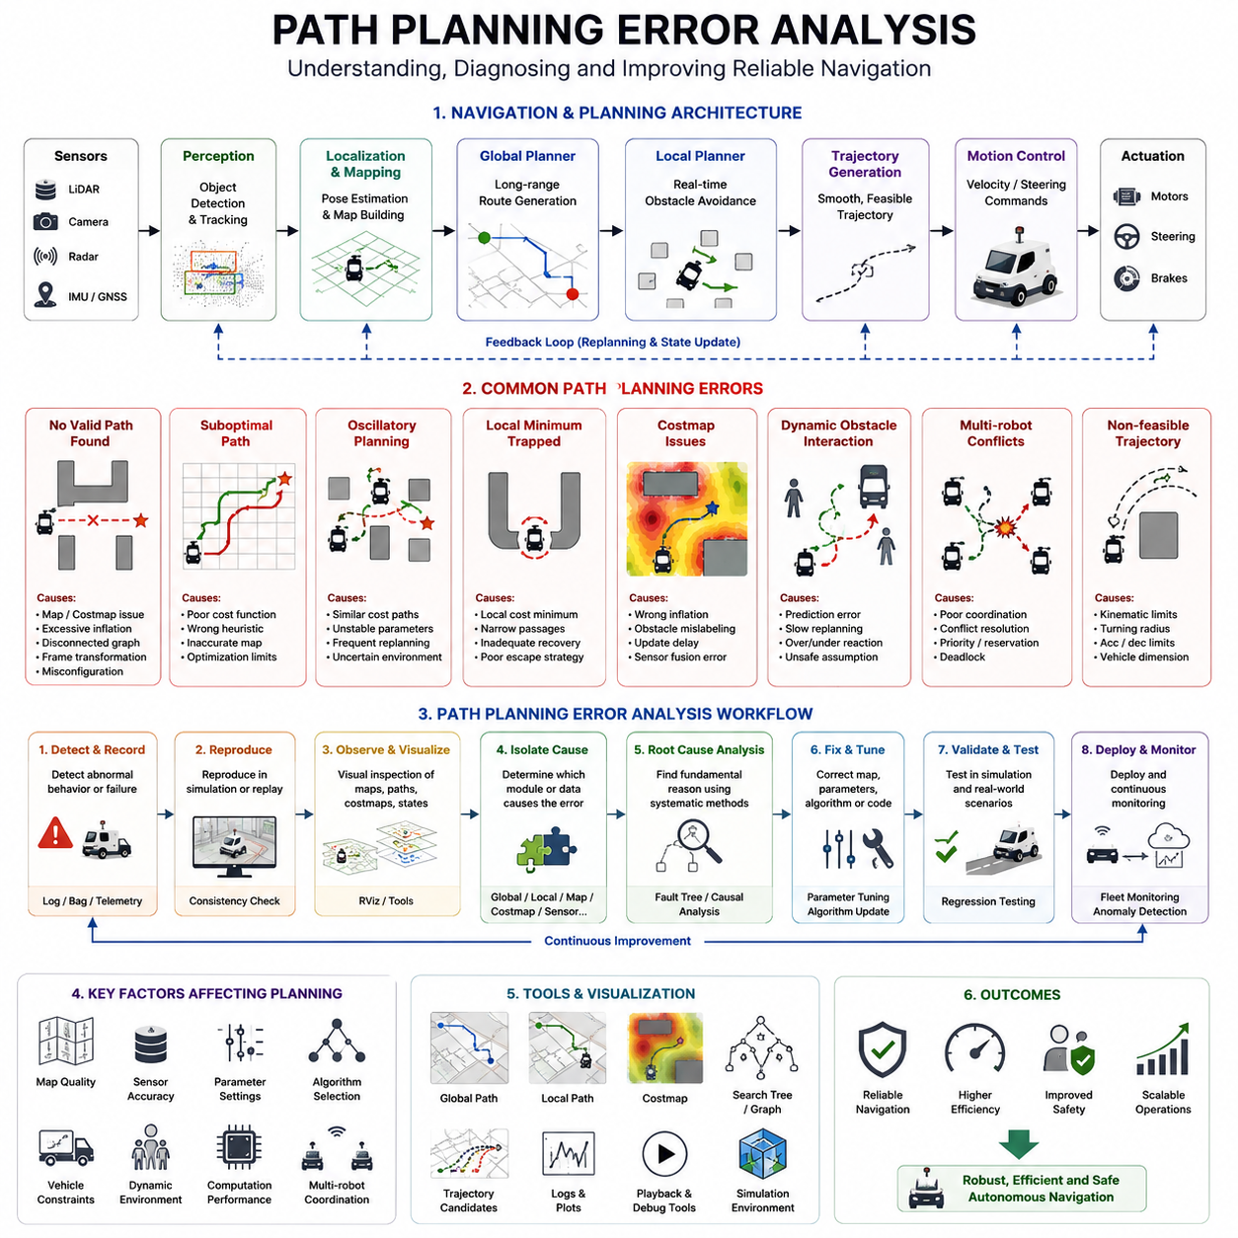
Path planning is one of the most fundamental capabilities of an Autonomous Mobile Robot (AMR). It serves as the decision-making layer that transforms a navigation goal into a feasible route through the environment while satisfying operational constraints, safety requirements, vehicle kinematics, and mission objectives. Regardless of whether the robot operates in a warehouse, hospital, factory, logistics center, smart city, outdoor industrial facility, or inspection site, the success of autonomous navigation depends heavily on the reliability and robustness of the path planning system. When path planning errors occur, the consequences may range from reduced efficiency and increased mission completion time to navigation failure, traffic congestion, emergency stops, and even safety incidents. Therefore, understanding path planning failures and establishing systematic error analysis methodologies are critical for the development of reliable autonomous robotic systems.
Path planning error analysis is the engineering process of identifying, classifying, reproducing, diagnosing, and resolving failures associated with route generation and navigation decision-making. Unlike localization errors, which primarily affect the robot’s understanding of its position, path planning errors affect how the robot chooses to move through the environment. These errors may originate from environmental representations, map inaccuracies, algorithmic limitations, parameter misconfigurations, sensor uncertainties, software defects, computational constraints, or interactions with other navigation subsystems. Since path planning is closely connected to localization, perception, obstacle avoidance, trajectory generation, behavior planning, and motion control, failures often propagate across multiple layers of the navigation architecture.
A modern navigation system generally consists of a global planner and a local planner. The global planner generates an optimal route from the current position to the destination using information from static maps and long-range environmental knowledge. The local planner continuously refines the route based on nearby obstacles, dynamic changes, vehicle constraints, and real-time sensor inputs. Errors may occur in either planning layer, and effective analysis requires understanding the interaction between these components.
One of the most common path planning errors involves failure to generate a valid path. In this situation, the planner reports that no feasible route exists even though a valid path appears to be available. Such failures often result from incorrect obstacle inflation parameters, corrupted maps, disconnected graph structures, excessive safety margins, coordinate transformation errors, or planner configuration issues. Engineers must investigate map representations, costmap generation processes, obstacle boundaries, and planner assumptions to determine why the algorithm rejects otherwise feasible solutions.
Another frequently observed problem is suboptimal path generation. Although the planner successfully generates a route, the resulting path may be unnecessarily long, inefficient, or operationally undesirable. The robot may choose a route that includes excessive turns, unnecessary detours, repeated corridor traversals, or inefficient traffic interactions. Such behavior often originates from improperly tuned cost functions, inaccurate heuristic calculations, incomplete environmental models, or planner optimization limitations. In large industrial facilities, even small inefficiencies can accumulate into substantial operational losses when hundreds of robots operate simultaneously.
Oscillatory planning behavior represents another important class of path planning errors. In this scenario, the planner repeatedly changes its route selection without converging toward a stable solution. The robot may alternate between multiple candidate paths, continuously replan, or become trapped in cycles of indecision. Oscillatory behavior often emerges when cost differences between competing routes are minimal, when environmental uncertainty fluctuates rapidly, or when planner parameters create unstable decision boundaries. Such behavior reduces navigation efficiency and may confuse nearby human workers or vehicles.
Local minima represent a well-known challenge in autonomous navigation. A robot may become trapped in a situation where all locally optimal actions prevent progress toward the global goal. For example, the robot may remain stationary near obstacles, repeatedly move back and forth, or execute endless avoidance maneuvers without escaping the constrained environment. Local minima are particularly common in cluttered environments, narrow corridors, loading zones, docking stations, and areas with dense dynamic obstacles. Effective error analysis requires understanding how the planner evaluates costs and whether recovery strategies are sufficiently robust.
Costmap-related failures are among the most frequent causes of path planning problems. Costmaps convert environmental information into numerical representations used by planning algorithms. If obstacles are incorrectly represented, inflated excessively, or updated inconsistently, planners may generate invalid routes or fail entirely. Engineers should verify obstacle inflation parameters, update frequencies, sensor fusion results, decay mechanisms, and map synchronization processes. Visual inspection of costmaps often reveals anomalies that are difficult to identify through numerical logs alone.
Map quality significantly influences planning performance. Errors in static maps can propagate directly into path planning decisions. Misaligned walls, missing obstacles, inaccurate floor boundaries, duplicated structures, or incomplete environment representations may cause planners to generate unsafe or inefficient routes. In large-scale outdoor systems, map inaccuracies may originate from GNSS drift, SLAM errors, environmental changes, or outdated survey data. Regular map validation and maintenance are therefore essential components of path planning reliability.
Coordinate frame inconsistencies frequently contribute to path planning anomalies. Modern robotic systems operate using multiple coordinate frames, including map, odom, base_link, sensor frames, and world references. Even small transformation errors can produce significant path distortions. Engineers should verify coordinate transformations, timestamp synchronization, frame hierarchy consistency, and calibration accuracy whenever unexplained planning behavior occurs.
Dynamic obstacle interactions introduce additional complexity. A path that appears valid in a static environment may become infeasible when people, forklifts, vehicles, or other robots enter the operational area. Path planning algorithms must continuously adapt to changing conditions while maintaining stability and predictability. Excessive replanning frequency can produce oscillations, whereas insufficient replanning responsiveness may lead to collisions or deadlocks. Error analysis should evaluate how the planner responds to dynamic environmental changes and whether prediction models accurately capture obstacle behavior.
Multi-robot environments create unique planning challenges. Shared pathways, intersections, corridors, elevators, and docking stations introduce resource contention problems. Robots may block one another, create deadlocks, or generate conflicting routes. In fleet-level systems, path planning errors often emerge from coordination failures rather than individual robot decisions. Engineers must therefore analyze fleet scheduling algorithms, traffic management policies, reservation systems, and priority assignment mechanisms in addition to individual planner behavior.
Heuristic design plays a crucial role in graph-based planning algorithms such as A* and its variants. Poor heuristic selection can dramatically reduce planning efficiency or produce suboptimal routes. Overly aggressive heuristics may sacrifice solution quality, while conservative heuristics increase computational burden. Error analysis should include evaluation of heuristic admissibility, consistency, computational complexity, and scalability across different operational environments.
Sampling-based planners such as RRT, RRT*, and PRM introduce different failure modes. Insufficient sampling density may prevent discovery of feasible paths, while excessive sampling may increase computational costs beyond acceptable limits. Environmental complexity, narrow passages, high-dimensional configuration spaces, and dynamic constraints can further complicate sampling-based planning performance. Engineers should analyze sampling distributions, convergence behavior, exploration efficiency, and solution robustness when diagnosing errors in these algorithms.
Trajectory feasibility represents another important aspect of path planning analysis. A mathematically valid path may not be physically executable by the robot. Vehicle dimensions, steering limitations, turning radius constraints, acceleration limits, payload effects, terrain conditions, and stability requirements must all be considered. This issue becomes particularly important for large outdoor robots, towing AMRs, autonomous forklifts, and heavy industrial platforms. Path planners must generate routes that respect both environmental and vehicle constraints.
Computational performance often influences path planning reliability. Real-time autonomous systems operate under strict timing requirements. If planning algorithms require excessive computation time, navigation decisions may become outdated before execution. CPU overload, memory limitations, inefficient algorithms, excessive map resolution, and large search spaces can contribute to computational bottlenecks. Engineers should monitor planning latency, execution frequency, resource utilization, and worst-case performance metrics during error analysis.
Path replanning behavior deserves special attention. Replanning enables robots to adapt to changing environments, but excessive replanning may destabilize navigation. Frequent route changes can create unpredictable behavior and increase mission completion times. Conversely, insufficient replanning may prevent adaptation to dynamic obstacles. Effective error analysis requires balancing responsiveness and stability while evaluating replanning thresholds, triggering conditions, and planner update frequencies.
Environmental uncertainty introduces additional challenges. Sensor noise, localization drift, incomplete perception, communication delays, and temporary environmental changes may all influence path planning decisions. Robust planning systems must tolerate uncertainty without producing unstable behavior. Engineers should analyze planner sensitivity to environmental disturbances and evaluate performance under degraded sensing conditions.
Visualization tools are essential for understanding path planning failures. Engineers should inspect global routes, local trajectories, obstacle maps, costmaps, planner search trees, graph structures, and trajectory candidates. Visualization frequently reveals root causes that remain hidden within log files. Modern debugging workflows commonly integrate RViz, Foxglove Studio, digital twin environments, and custom analysis dashboards to support comprehensive investigation.
Simulation environments provide controlled conditions for reproducing planning failures. Platforms such as Gazebo, Isaac Sim, and digital twins allow engineers to recreate problematic scenarios repeatedly while modifying environmental parameters and algorithm configurations. Simulation-based testing accelerates root cause identification and supports regression validation after corrective actions are implemented.
Field testing remains indispensable because real-world environments often expose failure modes not captured in simulation. Lighting variations, weather conditions, surface properties, human behavior, sensor degradation, communication disruptions, and unexpected obstacles introduce complexities that challenge path planning systems. Effective error analysis therefore combines simulation-based investigation with structured field validation.
Root cause analysis should focus on identifying fundamental contributors rather than merely correcting visible symptoms. Techniques such as fault tree analysis, causal dependency mapping, statistical analysis, and event correlation help reveal underlying mechanisms responsible for planning failures. Understanding why an error occurred enables engineers to implement robust long-term solutions rather than temporary fixes.
Once corrective actions are implemented, comprehensive regression testing must verify that previously identified issues are resolved without introducing new problems. Test suites should include nominal scenarios, stress conditions, edge cases, dynamic obstacle interactions, multi-robot coordination situations, and degraded sensing environments. Automated testing frameworks significantly improve validation efficiency and support continuous integration workflows.
As autonomous systems continue to evolve, path planning error analysis is increasingly becoming a data-driven discipline. Large fleets generate vast quantities of operational information that can be mined to identify recurring failure patterns, planner weaknesses, environmental risk factors, and optimization opportunities. Future navigation systems are expected to incorporate AI-assisted diagnostics, anomaly detection algorithms, predictive planning validation, and autonomous debugging capabilities. These technologies will enable robots not only to detect planning failures but also to diagnose and correct them automatically before operational disruptions occur.
Ultimately, path planning error analysis is not simply a troubleshooting activity. It is a foundational engineering practice that directly influences navigation reliability, operational efficiency, safety, scalability, and customer trust. Whether developing indoor logistics robots, hospital service robots, towing AMRs, autonomous forklifts, outdoor inspection platforms, smart city robots, or large-scale fleet management systems, a rigorous and systematic approach to path planning error analysis remains essential for achieving dependable autonomous navigation performance in complex real-world environments.

21.3 Localization and Map Debugging
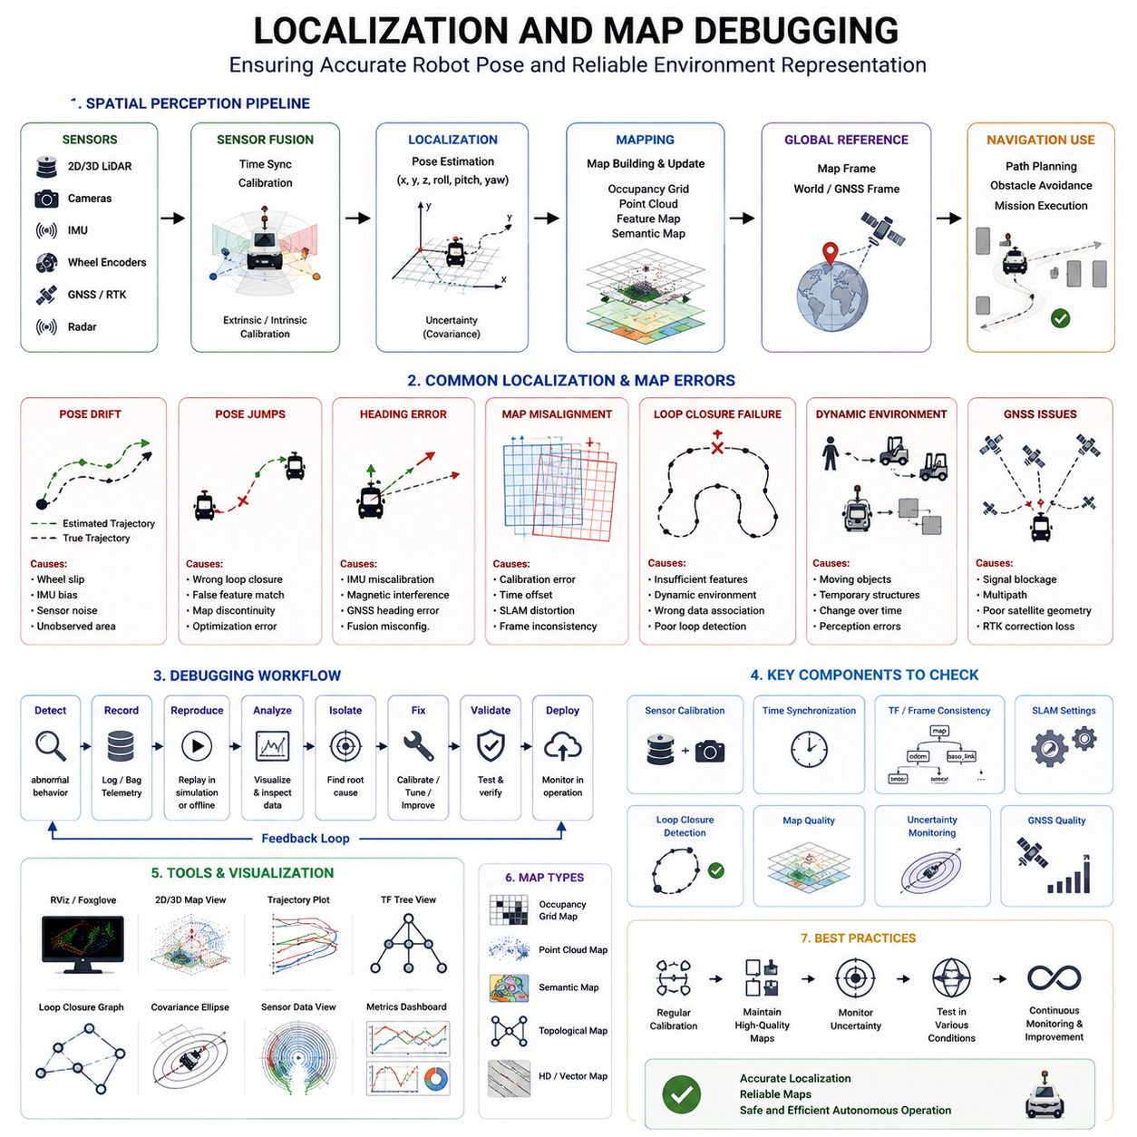
Localization and mapping are among the most critical foundations of autonomous navigation systems. Regardless of how advanced a robot’s perception, planning, control, or artificial intelligence capabilities may be, successful navigation cannot be achieved if the robot does not know where it is or if its understanding of the environment is inaccurate. Localization provides continuous estimates of the robot’s position and orientation within a reference coordinate system, while mapping provides a structured representation of the surrounding environment. Together, these functions form the spatial intelligence layer of an Autonomous Mobile Robot (AMR), enabling path planning, obstacle avoidance, mission execution, fleet coordination, and autonomous decision-making. When localization or mapping failures occur, navigation performance can deteriorate rapidly, resulting in path planning errors, collision risks, mission failures, inefficient routing, and operational downtime. Therefore, localization and map debugging represent a fundamental engineering discipline within the development and deployment of autonomous robotic systems.
Localization and map debugging is the systematic process of identifying, reproducing, analyzing, and correcting errors related to pose estimation, map generation, map maintenance, coordinate transformations, and environmental representations. Unlike navigation debugging, which often focuses on motion behavior and route generation, localization and map debugging concentrate on the robot’s spatial understanding of the world. These debugging activities are essential not only during development but also throughout the operational lifecycle of a robot because environments continuously change and localization performance can degrade over time.
A modern localization system typically combines multiple sensor modalities to estimate robot pose. Common sensors include wheel encoders, inertial measurement units (IMUs), 2D LiDARs, 3D LiDARs, RGB cameras, depth cameras, radar systems, GNSS receivers, RTK correction systems, and visual landmarks. Sensor fusion algorithms integrate these measurements to generate robust pose estimates under varying environmental conditions. Simultaneously, mapping systems construct and maintain environmental representations that support navigation. These maps may include occupancy grids, point clouds, feature maps, semantic maps, topological maps, HD maps, digital twins, and hybrid environmental models. Because localization and mapping depend on numerous interconnected components, debugging requires a comprehensive understanding of the entire spatial perception pipeline.
One of the most common localization problems is pose drift. Drift occurs when the estimated position gradually diverges from the robot’s actual location. Small errors accumulate over time due to wheel slippage, sensor noise, calibration inaccuracies, environmental ambiguities, and estimation uncertainty. In indoor environments, drift may cause robots to miss docking stations, collide with structures, or fail to reach precise destinations. In outdoor environments, drift can significantly impact large-scale navigation and fleet coordination. Effective debugging begins by quantifying drift rates, identifying contributing factors, and evaluating how errors accumulate under different operational conditions.
Pose jumps represent another frequently encountered localization anomaly. In this situation, the robot’s estimated position changes suddenly despite minimal physical movement. Pose jumps often occur when localization algorithms incorrectly match sensor observations to environmental features or when loop closure mechanisms introduce erroneous corrections. Such discontinuities can severely disrupt navigation systems because planners and controllers rely on continuous and consistent pose estimates. Engineers should investigate sensor observations, map matching algorithms, feature associations, and optimization processes whenever sudden pose changes are observed.
Heading estimation errors can also significantly degrade navigation performance. A robot may correctly estimate its position while maintaining an incorrect orientation estimate. Even small heading errors can lead to substantial path deviations over long distances. These problems frequently originate from IMU calibration issues, magnetic disturbances, GNSS heading inaccuracies, visual odometry drift, or sensor fusion configuration problems. Debugging heading estimation requires careful examination of rotational measurements, orientation fusion strategies, and reference frame consistency.
Map alignment errors are among the most important mapping-related challenges. Maps may become spatially distorted due to inaccurate sensor calibration, timing mismatches, SLAM optimization errors, or environmental ambiguities. Misaligned maps can cause walls to appear shifted, corridors to become distorted, or obstacles to occupy incorrect locations. Since navigation systems depend heavily on map accuracy, even small alignment errors may propagate throughout the navigation stack and produce widespread operational issues.
Coordinate frame inconsistencies frequently contribute to localization and mapping failures. Modern robotic systems use multiple coordinate frames such as map, odom, base_link, sensor frames, vehicle frames, GNSS frames, and world frames. Transformations between these coordinate systems must remain consistent, accurate, and synchronized. Errors in frame definitions, calibration parameters, or transformation chains can produce localization anomalies that appear difficult to diagnose. Engineers should therefore verify transformation trees, temporal consistency, and spatial alignment whenever localization behavior appears abnormal.
Sensor calibration is a fundamental prerequisite for reliable localization. Extrinsic calibration determines the spatial relationships between sensors and the robot body, while intrinsic calibration defines sensor-specific measurement characteristics. Calibration errors can introduce systematic biases that affect localization accuracy. For example, a misaligned LiDAR may generate distorted environmental representations, while an improperly calibrated camera may produce incorrect visual feature observations. Comprehensive calibration verification should therefore be integrated into localization debugging workflows.
Time synchronization issues frequently produce subtle localization failures. Modern robotic systems process large quantities of sensor data arriving at different rates and with varying latencies. If sensor timestamps become inconsistent, fusion algorithms may combine observations that correspond to different physical moments. Such discrepancies can introduce localization errors that are difficult to reproduce and diagnose. Engineers should verify synchronization mechanisms, clock sources, timestamp generation methods, and communication delays across all localization-related subsystems.
SLAM debugging represents a major component of localization and map analysis. Simultaneous Localization and Mapping algorithms continuously estimate robot position while constructing environmental maps. Errors in SLAM systems may manifest as map distortions, localization drift, incorrect loop closures, inconsistent trajectories, or optimization failures. Effective SLAM debugging requires examination of feature extraction processes, scan matching algorithms, graph optimization procedures, loop closure detection mechanisms, and sensor fusion architectures.
Loop closure failures deserve particular attention because they directly influence long-term localization accuracy. Loop closure occurs when a robot revisits a previously mapped location and recognizes it as a known environment. Successful loop closure reduces accumulated drift and improves map consistency. However, incorrect loop closures may introduce severe map distortions and localization jumps. Engineers should evaluate feature matching confidence, environmental uniqueness, geometric consistency, and optimization outcomes when analyzing loop closure behavior.
Dynamic environments create additional localization challenges. Most localization systems assume that maps represent relatively stable environments. However, hospitals, factories, warehouses, logistics centers, airports, and public spaces often contain moving objects, temporary structures, changing inventories, and evolving layouts. Dynamic elements can confuse localization algorithms and reduce map reliability. Effective debugging requires distinguishing between static environmental features and transient objects while evaluating localization robustness under varying operational conditions.
GNSS-based localization systems introduce their own unique failure modes. Outdoor robots frequently rely on GNSS and RTK technologies for global positioning. Although these systems can achieve high accuracy under ideal conditions, performance may degrade due to signal blockage, multipath reflections, atmospheric disturbances, satellite geometry limitations, and interference sources. Urban canyons, industrial facilities, tunnels, dense vegetation, and large metallic structures often create particularly challenging conditions. Debugging GNSS localization requires analysis of satellite visibility, correction signal quality, positioning confidence metrics, and environmental influences.
Multi-sensor fusion architectures are designed to improve localization robustness, but they also increase debugging complexity. Fusion algorithms must correctly integrate information from LiDARs, cameras, IMUs, GNSS receivers, wheel encoders, radar systems, and other sensors. If one sensor becomes unreliable, fusion systems may produce unexpected behaviors depending on weighting strategies, confidence estimates, and fault handling mechanisms. Engineers must therefore evaluate sensor contributions individually and collectively when diagnosing localization failures.
Map quality assessment plays a central role in map debugging. Maps should accurately represent environmental geometry, navigable regions, obstacles, semantic information, and operational constraints. Engineers should inspect maps for missing structures, duplicated features, distorted geometry, incorrect obstacle representations, incomplete coverage, and outdated information. High-quality maps are essential for reliable navigation, whereas poor map quality often becomes the root cause of recurring operational problems.
Occupancy grid maps are commonly used in indoor navigation systems. Debugging these maps involves verifying obstacle boundaries, free-space representations, inflation parameters, map resolution, update rates, and consistency across different operational conditions. Inaccuracies within occupancy grids may lead to planning failures, inefficient routes, and unexpected obstacle avoidance behaviors.
Point cloud maps introduce additional considerations. Large-scale outdoor robots frequently utilize 3D point cloud representations generated from LiDAR systems. Engineers should analyze point density, registration quality, spatial consistency, sensor alignment, and environmental coverage. Sparse or inconsistent point clouds may reduce localization accuracy and limit navigation reliability.
Semantic maps have become increasingly important in advanced robotic systems. These maps contain not only geometric information but also semantic knowledge regarding objects, locations, operational zones, and environmental context. Debugging semantic maps requires validating classification accuracy, object associations, environmental annotations, and consistency between semantic and geometric layers.
Visualization tools are indispensable for localization and map debugging. Engineers should visualize robot trajectories, localization estimates, sensor observations, occupancy grids, point clouds, semantic overlays, transformation frames, uncertainty ellipses, and loop closure events. Visualization often reveals patterns and anomalies that remain hidden within numerical logs. RViz, Foxglove Studio, digital twin platforms, cloud-based dashboards, and custom debugging tools provide valuable support for spatial analysis.
Data recording and replay capabilities significantly enhance debugging efficiency. ROS2 bag files enable engineers to reproduce operational scenarios, analyze historical failures, compare algorithm versions, and evaluate corrective actions. Replay-based debugging allows systematic investigation without requiring repeated field testing, thereby accelerating root cause analysis and validation processes.
Simulation environments provide controlled conditions for evaluating localization and mapping performance. Platforms such as Gazebo, Isaac Sim, CARLA, and digital twin environments allow engineers to inject sensor noise, environmental disturbances, calibration errors, and communication delays while observing system behavior. Simulation supports rapid experimentation and helps isolate specific failure mechanisms before field deployment.
Field testing remains essential because real-world environments often expose challenges not captured within simulations. Environmental variability, weather conditions, lighting changes, electromagnetic interference, infrastructure modifications, and human activity introduce complexities that significantly influence localization performance. Structured field testing methodologies are therefore required to validate localization robustness under realistic operational conditions.
Root cause analysis forms the core of effective localization debugging. Rather than correcting visible symptoms alone, engineers must identify underlying mechanisms responsible for localization degradation. Techniques such as fault tree analysis, sensor dependency analysis, temporal correlation analysis, graph-based diagnostics, and statistical evaluation help reveal causal relationships among observed failures. A thorough understanding of root causes enables development of durable corrective actions rather than temporary workarounds.
Corrective actions may include recalibration, sensor replacement, algorithm refinement, parameter optimization, map reconstruction, synchronization improvements, environmental modifications, or architectural redesign. Once changes are implemented, comprehensive regression testing should verify that performance improvements are achieved without introducing new failure modes. Validation procedures should encompass nominal scenarios, degraded conditions, dynamic environments, long-duration missions, and edge-case situations.
As autonomous robotic systems continue to expand in scale and complexity, localization and map debugging are increasingly evolving into data-driven engineering disciplines. Large fleets generate extensive operational datasets that can be analyzed to identify recurring localization anomalies, environmental risk factors, sensor degradation trends, and map quality issues. Future systems are expected to incorporate AI-assisted diagnostics, automated anomaly detection, predictive maintenance mechanisms, self-calibrating sensor architectures, and autonomous map verification capabilities.
Ultimately, localization and map debugging are not merely troubleshooting activities. They represent foundational engineering practices that determine the reliability, safety, efficiency, scalability, and operational success of autonomous robotic systems. Whether developing warehouse AMRs, hospital service robots, autonomous forklifts, towing robots, outdoor inspection platforms, smart city robots, or large-scale fleet management solutions, rigorous localization and map debugging methodologies remain indispensable for achieving dependable autonomous navigation in real-world environments.

21.4 Obstacle Avoidance Debugging
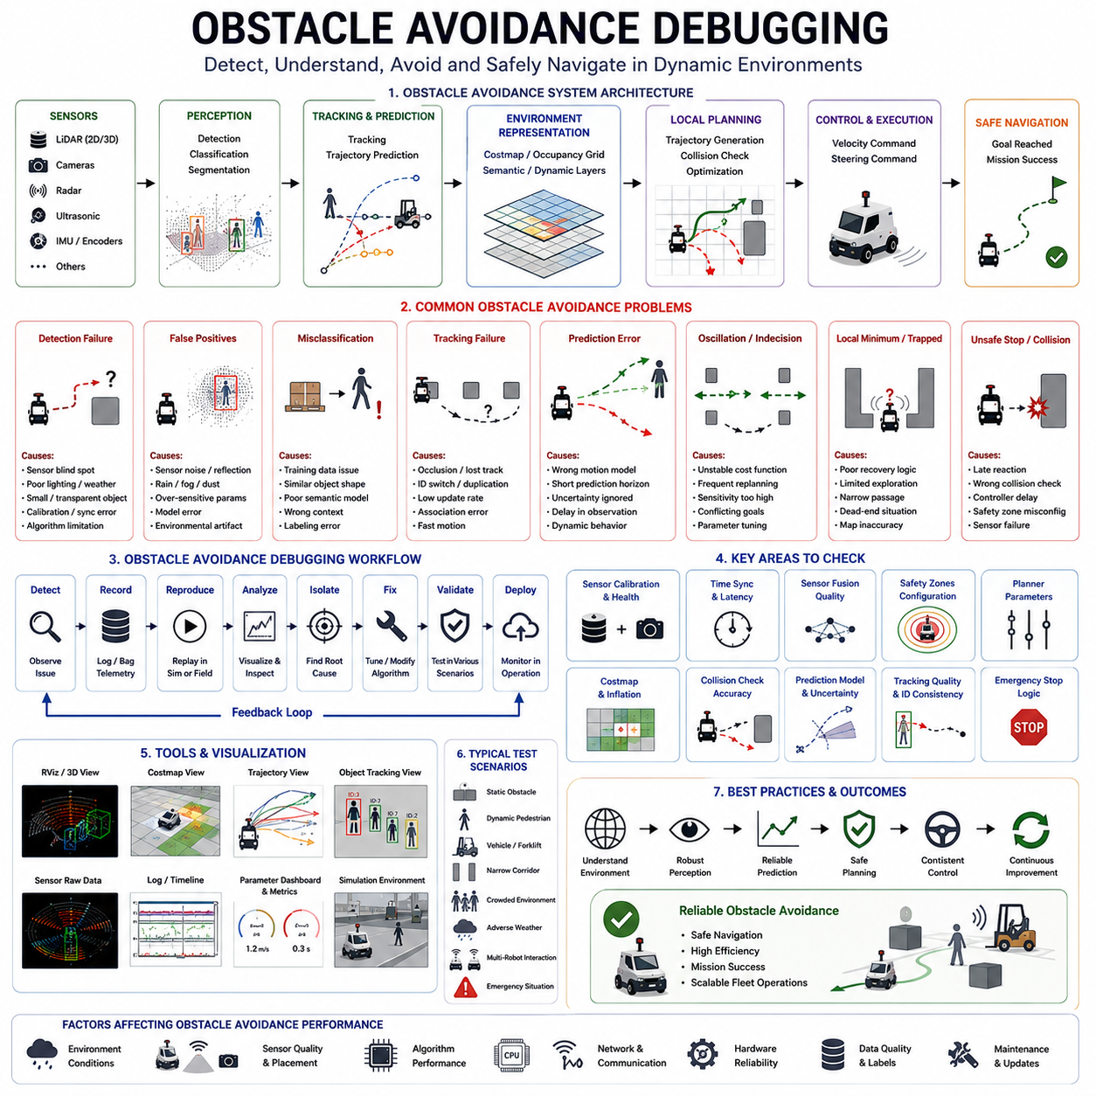
Obstacle avoidance is one of the most critical capabilities in autonomous navigation systems because it directly influences safety, operational reliability, navigation efficiency, and mission success. Regardless of whether an Autonomous Mobile Robot (AMR) operates in a warehouse, factory, hospital, airport, logistics center, smart city environment, agricultural field, mining site, or outdoor industrial facility, the robot must continuously detect, classify, track, predict, and avoid obstacles while maintaining progress toward its assigned destination. Unlike path planning, which focuses on determining an optimal route, obstacle avoidance deals with real-time reactions to environmental changes. It is the subsystem responsible for ensuring that navigation decisions remain safe and feasible when unexpected objects, moving agents, environmental changes, or operational uncertainties are encountered. When obstacle avoidance systems fail, the consequences can range from minor operational inefficiencies to severe collisions, equipment damage, mission interruption, safety incidents, and large-scale fleet disruptions. Therefore, obstacle avoidance debugging represents a fundamental engineering activity within the development, deployment, and maintenance of autonomous robotic systems.
Obstacle avoidance debugging is the systematic process of identifying, reproducing, analyzing, diagnosing, and correcting failures associated with obstacle perception, obstacle representation, collision prediction, avoidance decision-making, recovery behaviors, and safety responses. Unlike localization debugging, which focuses on spatial accuracy, or path planning debugging, which focuses on route generation, obstacle avoidance debugging concentrates on how the robot responds to obstacles within its immediate operating environment. Since obstacle avoidance depends on perception systems, sensor fusion architectures, localization modules, planning algorithms, behavior planners, vehicle controllers, and safety systems, debugging requires a holistic understanding of the entire navigation architecture.
Modern obstacle avoidance systems typically integrate multiple sensing technologies. Common sensor configurations include 2D LiDARs, 3D LiDARs, RGB cameras, depth cameras, radar systems, ultrasonic sensors, thermal cameras, stereo vision systems, and GNSS-based contextual awareness. Sensor fusion algorithms combine information from these heterogeneous sources to create a comprehensive understanding of the environment. The resulting environmental representation forms the foundation upon which collision prediction and avoidance decisions are made. Because numerous subsystems contribute to obstacle avoidance performance, failures can originate from multiple sources and propagate throughout the navigation stack.
One of the most common obstacle avoidance failures involves obstacle detection errors. Detection failures occur when the robot fails to recognize an object that should have been detected. Such failures may result from sensor blind spots, insufficient sensor coverage, poor environmental conditions, inadequate detection algorithms, calibration errors, synchronization problems, or object characteristics that challenge perception systems. Small obstacles, transparent surfaces, reflective materials, low-profile objects, hanging structures, and unusual environmental features frequently expose weaknesses in obstacle detection capabilities. Effective debugging begins with determining whether obstacles were properly observed by the sensor system before investigating higher-level decision-making processes.
False positive detections represent another major source of obstacle avoidance problems. In these cases, the robot incorrectly identifies obstacles that do not actually exist. False positives may cause unnecessary stopping, excessive replanning, oscillatory behavior, inefficient routing, and reduced productivity. Common causes include sensor noise, environmental reflections, lighting artifacts, rain, dust, fog, snow, electromagnetic interference, perception model errors, and improper filtering parameters. Debugging false positives requires analyzing raw sensor data, detection confidence scores, filtering pipelines, and environmental conditions present during the failure.
Object classification errors can significantly influence avoidance behavior. A robot may detect an obstacle correctly but assign it to the wrong category. For example, a stationary pallet may be classified as a moving vehicle, a human worker may be classified as static infrastructure, or a temporary object may be treated as permanent environmental structure. Classification errors can alter safety margins, avoidance strategies, prediction models, and navigation priorities. Engineers should therefore evaluate classification accuracy and investigate how semantic understanding influences avoidance decisions.
Object tracking failures represent another important class of obstacle avoidance problems. Detection alone is insufficient for navigating dynamic environments. Robots must continuously estimate object trajectories, velocities, accelerations, and future positions. Tracking failures occur when objects are lost, duplicated, fragmented, or incorrectly associated between successive observations. Such failures may cause unstable avoidance behavior, incorrect collision predictions, and unexpected navigation decisions. Engineers should analyze track continuity, association algorithms, sensor update rates, and tracking confidence metrics when investigating these issues.
Collision prediction errors frequently emerge in dynamic environments containing pedestrians, forklifts, vehicles, mobile robots, and other moving entities. Obstacle avoidance systems often rely on predictive models to estimate future interactions between the robot and surrounding objects. If prediction algorithms underestimate risk, collisions may occur despite apparently correct obstacle detection. Conversely, overestimation of risk may result in unnecessary stops and inefficient navigation. Debugging collision prediction requires evaluating trajectory forecasts, uncertainty estimates, motion models, and prediction horizons under various operational scenarios.
Local planner interactions play a critical role in obstacle avoidance performance. In many navigation architectures, obstacle avoidance is implemented within the local planning layer. The local planner evaluates candidate trajectories, predicts potential collisions, and selects safe movements while attempting to maintain progress toward the goal. Problems may arise when planners generate trajectories that violate safety constraints, fail to account for obstacle motion, or become trapped in local minima. Engineers should examine trajectory generation processes, collision evaluation logic, optimization parameters, and candidate path selection criteria during debugging activities.
Oscillatory avoidance behavior is frequently observed when robots encounter complex obstacle configurations. The robot may repeatedly switch between alternative avoidance strategies without committing to a stable solution. Examples include alternating left-right avoidance decisions, repeated stopping and restarting, or continuous replanning without forward progress. Oscillation often results from unstable cost functions, inconsistent obstacle representations, excessive sensitivity to environmental changes, or poorly tuned planner parameters. Such behavior not only reduces efficiency but may also confuse nearby humans and vehicles.
Local minima represent a persistent challenge in obstacle avoidance systems. A robot may enter a configuration where all locally optimal actions prevent progress toward the global objective. This situation often occurs in narrow corridors, crowded intersections, loading docks, warehouse aisles, hospital hallways, and constrained industrial environments. Recovery mechanisms must be capable of recognizing these situations and initiating appropriate escape strategies. Debugging local minima requires analyzing planner decision processes, environmental geometry, obstacle configurations, and recovery behavior effectiveness.
Dynamic obstacle avoidance introduces significantly greater complexity than static obstacle handling. Humans, vehicles, forklifts, drones, mobile equipment, and other robots exhibit unpredictable behaviors that challenge traditional planning algorithms. Human-aware navigation systems must account not only for physical safety but also for social comfort, behavioral expectations, and contextual interactions. Engineers must evaluate avoidance behavior under realistic dynamic conditions while ensuring that navigation remains both safe and efficient.
Sensor fusion debugging is particularly important for obstacle avoidance systems. Different sensors possess unique strengths and weaknesses. LiDAR systems provide accurate geometric measurements but may struggle with transparent surfaces. Cameras provide semantic information but are sensitive to lighting conditions. Radar systems perform well in adverse weather but may offer lower spatial resolution. Effective fusion combines these complementary capabilities while mitigating individual limitations. Debugging fusion architectures requires examining sensor contributions, confidence weighting mechanisms, synchronization accuracy, and fault tolerance behavior.
Environmental conditions often expose weaknesses in obstacle avoidance systems. Rain, snow, fog, dust, direct sunlight, darkness, reflective surfaces, glass walls, metallic structures, water puddles, and uneven terrain can all degrade perception quality. Outdoor robots face particularly challenging environmental variability. Effective debugging should therefore include analysis under diverse environmental conditions rather than relying solely on laboratory testing.
Safety zone configuration plays a central role in obstacle avoidance behavior. Most industrial robots define multiple safety regions surrounding the vehicle. These zones may include warning areas, deceleration zones, protective stop regions, and emergency stop boundaries. Improper safety zone configuration can produce either excessive conservatism or insufficient protection. Engineers should verify safety distances, velocity-dependent zone scaling, sensor coverage, and compliance with relevant safety standards when analyzing avoidance-related incidents.
Emergency stop behavior represents the final protective layer within obstacle avoidance architectures. Emergency stops should occur only when necessary while maintaining maximum reliability. False emergency stops reduce productivity and disrupt operations, whereas missed emergency stops create unacceptable safety risks. Debugging emergency stop systems requires evaluating trigger conditions, reaction times, safety controller performance, sensor reliability, and failure handling mechanisms.
Multi-robot environments introduce additional obstacle avoidance challenges. Robots operating within shared spaces must avoid not only static infrastructure and human workers but also other autonomous systems. Failures may occur when robots misinterpret each other's intentions, fail to coordinate movements, or create deadlocks. Engineers should investigate fleet management systems, traffic coordination algorithms, communication mechanisms, and reservation protocols when debugging multi-robot obstacle avoidance issues.
Visualization tools are essential for understanding obstacle avoidance failures. Engineers should visualize sensor observations, obstacle detections, object tracks, predicted trajectories, collision zones, safety boundaries, local costmaps, candidate trajectories, planner decisions, and control outputs. Visualization often reveals root causes that remain hidden within numerical logs. Tools such as RViz, Foxglove Studio, digital twin platforms, and custom fleet monitoring dashboards significantly improve debugging efficiency.
Data recording and replay capabilities provide powerful support for obstacle avoidance debugging. ROS2 bag files enable engineers to replay operational scenarios, compare algorithm versions, reproduce failures consistently, and validate corrective actions. Replay-based debugging eliminates the need to repeatedly recreate hazardous field conditions while enabling systematic analysis of complex interactions.
Simulation environments offer valuable opportunities for obstacle avoidance testing. Platforms such as Gazebo, Isaac Sim, CARLA, and digital twins allow engineers to evaluate robot behavior under controlled conditions. Simulated pedestrians, vehicles, forklifts, weather conditions, sensor failures, communication disruptions, and environmental changes can be introduced systematically. Simulation accelerates experimentation and supports comprehensive validation before deployment.
Field testing remains indispensable because many obstacle avoidance challenges emerge only in real-world environments. Human behavior, environmental variability, operational complexity, sensor degradation, infrastructure changes, and unexpected events frequently expose limitations that simulations cannot fully replicate. Structured field validation procedures are therefore necessary to ensure operational readiness.
Root cause analysis is the central objective of obstacle avoidance debugging. Engineers must identify why failures occurred rather than merely correcting visible symptoms. Techniques such as fault tree analysis, event correlation analysis, causal dependency modeling, statistical investigation, and temporal sequence analysis help reveal underlying causes. A thorough understanding of failure mechanisms enables the implementation of robust corrective actions and long-term reliability improvements.
Corrective measures may involve sensor recalibration, perception model retraining, algorithm optimization, parameter tuning, planner modification, safety zone redesign, hardware upgrades, communication improvements, or architectural changes. Once modifications are implemented, comprehensive regression testing must verify that new issues have not been introduced. Validation should include nominal operations, dynamic obstacle interactions, adverse environmental conditions, multi-robot scenarios, degraded sensing conditions, and long-duration missions.
As autonomous robotic systems continue to evolve, obstacle avoidance debugging is becoming increasingly data-driven. Large fleets generate extensive operational datasets that reveal recurring failure patterns, environmental risk factors, sensor degradation trends, and algorithmic weaknesses. Future obstacle avoidance systems are expected to incorporate AI-assisted diagnostics, automated anomaly detection, predictive safety monitoring, self-adaptive planning algorithms, and autonomous debugging capabilities. These technologies will enable robots not only to avoid obstacles but also to continuously improve avoidance performance throughout their operational lifecycles.
Ultimately, obstacle avoidance debugging is not simply a troubleshooting process. It is a foundational engineering practice that directly determines the safety, reliability, efficiency, scalability, and operational success of autonomous robotic systems. Whether developing warehouse AMRs, hospital service robots, autonomous forklifts, towing robots, outdoor inspection platforms, agricultural robots, smart city systems, or large-scale fleet operations, rigorous obstacle avoidance debugging methodologies remain essential for achieving dependable autonomous navigation in complex real-world environments.

21.5 ROS2 Log and Bag Analysis
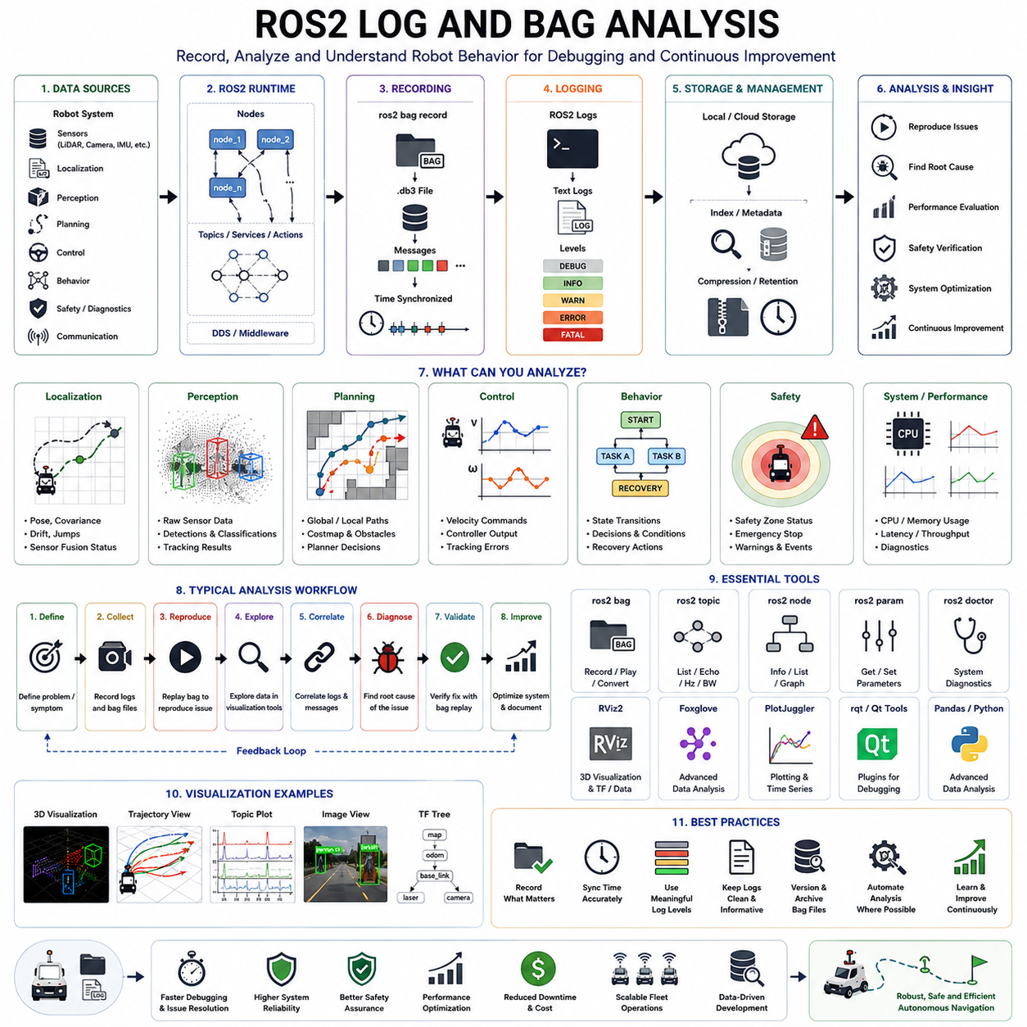
ROS2 Log and Bag Analysis is one of the most important debugging and validation activities in autonomous robotic systems. Modern Autonomous Mobile Robots (AMRs), outdoor autonomous robots, autonomous forklifts, towing robots, inspection robots, hospital service robots, and large-scale fleet systems generate enormous amounts of operational data during daily operation. Every sensor measurement, localization update, path planning result, obstacle detection event, controller command, system warning, error message, and communication transaction may be recorded for later analysis. Unlike traditional software debugging, robotic systems operate in highly dynamic physical environments where failures may be caused by complex interactions among sensors, algorithms, hardware components, communication networks, and environmental conditions. Because many failures are difficult or impossible to reproduce consistently in real-world environments, ROS2 logging and bag recording have become indispensable tools for understanding system behavior, reproducing failures, validating fixes, and improving long-term system reliability.
ROS2 logs provide textual records of software execution and system events, while ROS2 bag files provide time-synchronized recordings of messages exchanged among ROS2 nodes. Together, these two mechanisms form the foundation of modern robotic debugging workflows. Logs explain what the software believed was happening, while bag files preserve what actually happened within the robotic system. Effective analysis of both data sources enables engineers to reconstruct operational scenarios, identify anomalies, trace failure sequences, and verify system performance with a level of detail that would otherwise be impossible to achieve.
A ROS2-based robotic system typically consists of dozens or even hundreds of nodes operating simultaneously. Localization nodes, perception pipelines, sensor drivers, planning modules, behavior managers, controllers, safety monitors, fleet management interfaces, cloud communication gateways, and diagnostic services continuously exchange information through topics, services, and actions. Each node generates logs describing internal states, warnings, errors, configuration parameters, initialization processes, and runtime decisions. Simultaneously, sensor streams and control messages flow through the ROS2 middleware. Understanding system behavior therefore requires the ability to analyze both event logs and recorded message traffic in a synchronized manner.
The primary objective of ROS2 log analysis is to understand the sequence of events that occurred during system operation. Logs provide visibility into software behavior that may not be observable through sensor data alone. When a navigation failure occurs, logs can reveal whether localization confidence decreased, whether planners rejected candidate paths, whether communication timeouts occurred, whether sensor drivers experienced errors, or whether safety systems triggered emergency responses. By examining timestamped log entries, engineers can reconstruct the timeline leading to a failure and identify the first anomaly that initiated the cascade of events.
ROS2 bag analysis focuses on recorded message data rather than textual descriptions. Bag files capture topic messages exactly as they were transmitted during operation. This allows engineers to replay complete robotic scenarios offline while preserving timing relationships among sensors, algorithms, and control systems. Unlike traditional debugging methods, bag replay enables repeated investigation of the same event without requiring repeated field testing. Engineers can analyze identical situations multiple times, evaluate alternative algorithms, compare software versions, and validate corrective actions using the same dataset.
One of the most important principles in ROS2 bag analysis is reproducibility. A failure that occurs once in the field may never occur again under identical conditions. However, if the relevant topics were recorded, engineers can reproduce the event indefinitely through offline replay. This transforms unpredictable operational failures into repeatable engineering problems. Reproducibility significantly accelerates root cause analysis and reduces dependence on costly field investigations.
Time synchronization plays a critical role in log and bag analysis. Modern robots often contain dozens of sensors operating at different frequencies. Cameras may run at 30 Hz, LiDARs at 10 Hz, IMUs at 200 Hz, wheel encoders at 100 Hz, GNSS receivers at 20 Hz, and control loops at 50 Hz or higher. If timestamps are inconsistent or improperly synchronized, engineers may draw incorrect conclusions from recorded data. Therefore, verification of clock synchronization, timestamp integrity, and message ordering should be among the first steps in any bag analysis workflow.
Localization debugging frequently relies on bag analysis. Engineers may examine pose estimates, covariance values, odometry outputs, GNSS measurements, IMU data, LiDAR observations, and SLAM outputs to determine why localization performance degraded. Drift accumulation, pose jumps, heading errors, delayed updates, and loop closure anomalies often become evident when visualizing recorded localization data. By replaying localization topics alongside sensor observations, engineers can identify discrepancies between expected and actual system behavior.
Path planning analysis is another major application of ROS2 bag files. Engineers can inspect global paths, local trajectories, costmaps, obstacle representations, planner outputs, and vehicle commands to determine why navigation decisions were made. Path planning failures often involve subtle interactions between localization accuracy, environmental representations, obstacle information, and planner configuration parameters. Bag replay enables detailed examination of these interactions and supports systematic evaluation of planning algorithms.
Obstacle avoidance debugging benefits enormously from recorded sensor data. Engineers can review LiDAR scans, camera images, radar detections, obstacle classifications, object tracks, collision predictions, and avoidance decisions. By comparing raw sensor observations against processed outputs, it becomes possible to identify failures in detection, classification, tracking, prediction, or planning subsystems. Such analysis is particularly important for understanding near-miss incidents, unexpected stops, oscillatory behavior, and collision events.
Behavior planning analysis focuses on high-level decision-making processes. Modern robotic systems often utilize state machines, behavior trees, task schedulers, or AI-based decision frameworks. Logs generated by these systems reveal state transitions, decision conditions, recovery actions, mission execution progress, and exception handling behavior. Engineers can use these records to determine why a robot selected a particular behavior and whether the decision-making process operated as intended.
Communication analysis is another important aspect of ROS2 debugging. Distributed robotic systems rely heavily on middleware communication. Message delays, packet losses, network congestion, Quality of Service (QoS) mismatches, and DDS configuration problems may significantly impact system performance. ROS2 logs frequently contain warnings related to communication failures, while bag files provide evidence of message timing and delivery behavior. Combined analysis helps identify communication bottlenecks and synchronization issues.
Performance analysis represents a critical use case for log data. CPU utilization, memory consumption, thread scheduling, execution latency, GPU workloads, and message throughput can all influence robotic performance. Engineers should correlate performance metrics with navigation behavior to determine whether computational bottlenecks contributed to failures. In many cases, navigation degradation is not caused by algorithmic errors but rather by insufficient computational resources or excessive processing delays.
Sensor debugging is heavily dependent on bag analysis. Engineers can inspect raw sensor streams to evaluate calibration quality, synchronization accuracy, noise characteristics, environmental influences, and hardware reliability. LiDAR point clouds, camera images, radar detections, IMU measurements, GNSS signals, and wheel encoder outputs can be examined independently and collectively. Sensor-related failures often become obvious when raw data is reviewed directly rather than relying solely on processed outputs.
Visualization tools play an essential role in ROS2 log and bag analysis. Platforms such as RViz, Foxglove Studio, PlotJuggler, rqt, and custom dashboards allow engineers to explore recorded data interactively. Robot trajectories, localization estimates, sensor observations, obstacle detections, planner outputs, controller commands, and diagnostic metrics can be visualized simultaneously. Visualization frequently reveals patterns that remain hidden within textual logs or numerical datasets.
Data filtering and extraction techniques are important when working with large bag files. Industrial robots may generate hundreds of gigabytes of data during extended missions. Efficient analysis often requires extracting relevant topics, reducing data volumes, filtering specific time intervals, and focusing on events associated with failures. Engineers should develop standardized workflows for isolating critical information without losing important contextual data.
Root cause analysis is one of the primary objectives of ROS2 log and bag analysis. Rather than merely observing failures, engineers seek to identify the underlying mechanisms responsible for those failures. Logs reveal software decisions and system events, while bag files reveal actual operational behavior. Combining these perspectives allows engineers to move beyond symptoms and discover true causal relationships. Techniques such as event correlation, temporal analysis, dependency tracing, and fault tree analysis are commonly applied during investigations.
ROS2 bag replay provides a powerful validation mechanism following corrective actions. Once software modifications have been implemented, engineers can replay previously recorded datasets through updated algorithms and compare outputs against historical behavior. This approach enables rapid regression testing without requiring repeated field operations. Large collections of bag files often evolve into valuable benchmark datasets supporting continuous software validation and performance measurement.
Fleet-level robotic systems generate particularly large volumes of operational data. Hundreds of robots operating simultaneously may produce terabytes of logs and bag recordings. Cloud-based analysis platforms are increasingly used to aggregate, index, search, and analyze these datasets. Automated analytics pipelines can identify recurring failure patterns, performance degradation trends, localization anomalies, communication issues, and safety-related events across entire fleets.
Artificial intelligence is beginning to transform ROS2 log and bag analysis. Machine learning models can automatically detect anomalies, classify failure types, identify unusual system behavior, and recommend likely root causes. Instead of manually reviewing thousands of log entries, engineers can leverage AI-assisted diagnostic systems to focus their attention on the most relevant events. As robotic deployments continue to scale, such automation will become increasingly important.
Best practices for ROS2 logging include maintaining consistent log formats, using meaningful severity levels, including contextual information, recording configuration parameters, and preserving precise timestamps. Effective logging should provide sufficient information for debugging without generating excessive noise. Similarly, bag recording strategies should prioritize critical topics while balancing storage requirements, computational overhead, and operational constraints.
Long-term operational reliability depends heavily on effective log and bag analysis practices. Organizations that systematically collect, analyze, and learn from operational data are able to improve software quality, reduce downtime, enhance safety, accelerate development cycles, and increase customer satisfaction. Over time, accumulated logs and bag recordings become a valuable knowledge base documenting system behavior across diverse environments and operating conditions.
As autonomous robotics continues to advance, ROS2 log and bag analysis will evolve from a reactive debugging activity into a proactive operational intelligence capability. Future robotic systems are expected to incorporate automated data collection, cloud-native analytics, AI-assisted diagnostics, predictive failure detection, digital twin validation, and self-monitoring architectures. These capabilities will allow robots not only to record operational data but also to interpret that data autonomously and initiate corrective actions before failures occur.
Ultimately, ROS2 Log and Bag Analysis is far more than a debugging technique. It is a foundational engineering methodology that enables visibility into complex robotic systems, supports systematic root cause analysis, accelerates software development, improves operational reliability, and strengthens safety assurance. Whether developing warehouse AMRs, hospital robots, autonomous forklifts, towing vehicles, outdoor inspection platforms, GPR inspection robots, smart city robotic services, or large-scale fleet management systems, mastery of ROS2 log and bag analysis remains essential for building robust, scalable, and dependable autonomous navigation solutions.

21.6 Field Reproduction and Testing
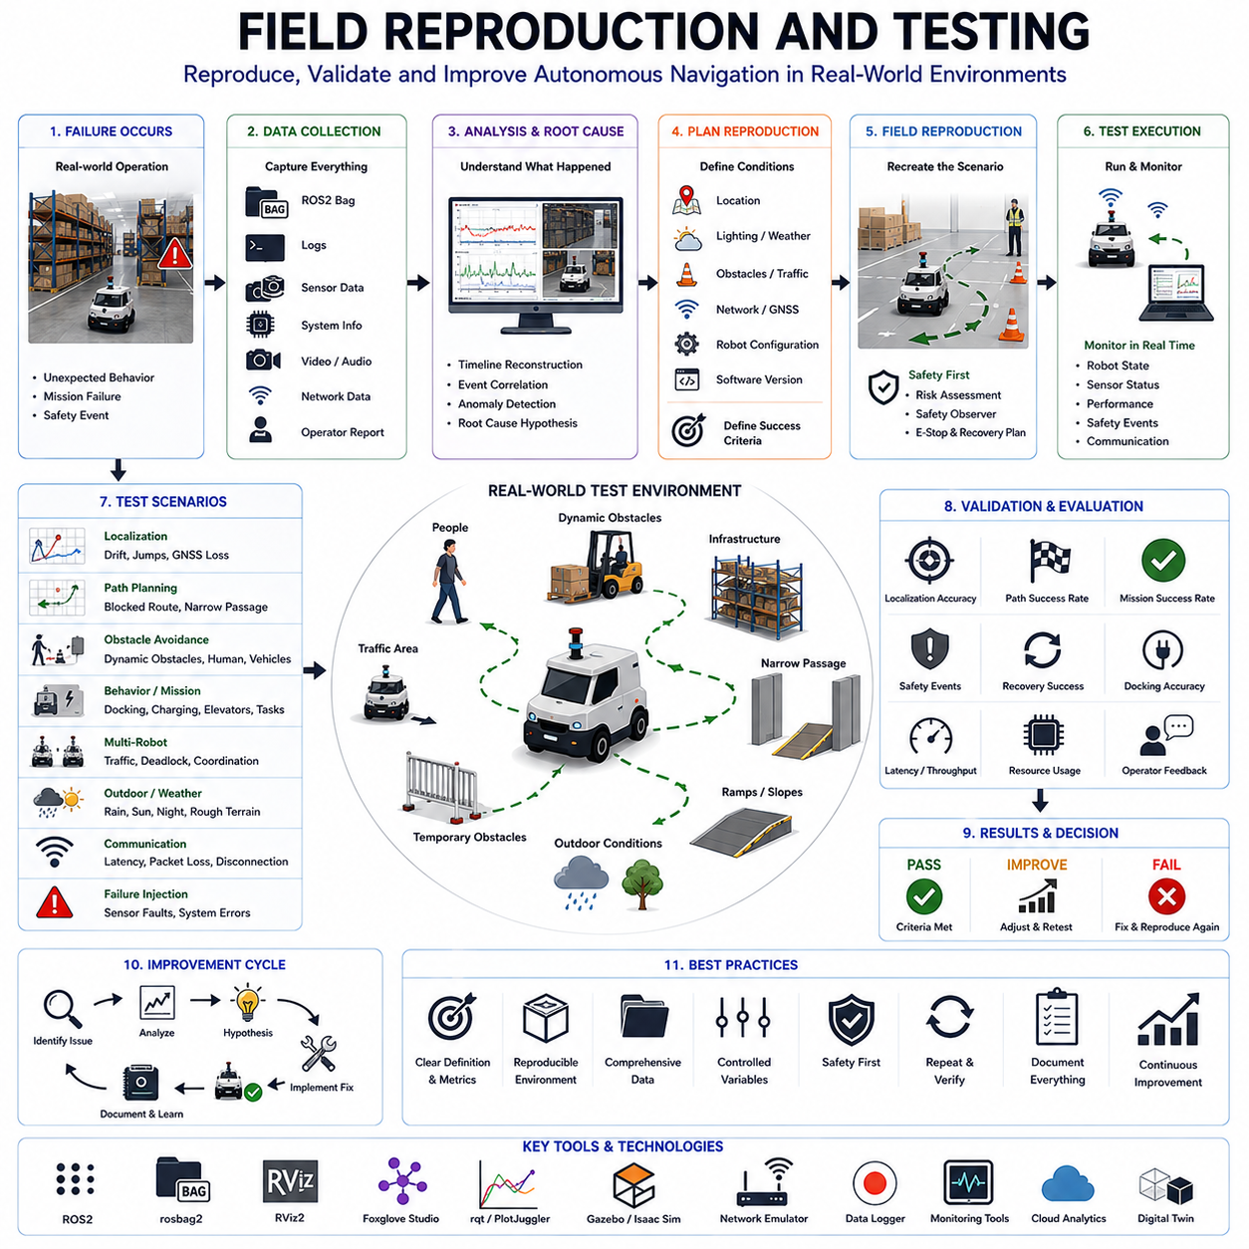
Field Reproduction and Testing is one of the most important activities in autonomous navigation engineering because many navigation failures only appear under real-world operating conditions. While simulation environments, laboratory experiments, and offline analysis tools provide valuable insights during development, they cannot fully replicate the complexity, variability, and unpredictability of real environments. Autonomous Mobile Robots (AMRs), outdoor autonomous robots, autonomous forklifts, towing robots, hospital service robots, inspection robots, and fleet management systems operate in environments that contain dynamic obstacles, changing infrastructure, varying weather conditions, communication disturbances, sensor degradation, human interactions, and countless unforeseen situations. Consequently, the ability to reproduce failures in the field and systematically validate corrective actions is essential for achieving reliable, safe, and scalable autonomous navigation systems. Field reproduction and testing transform isolated incidents into repeatable engineering problems and provide the final validation layer before large-scale deployment.
Field reproduction refers to the process of recreating operational failures under controlled real-world conditions. The objective is not merely to observe the failure again but to understand the exact sequence of events, environmental factors, system states, and triggering conditions that contributed to the problem. Successful reproduction enables engineers to gather additional data, verify root-cause hypotheses, evaluate alternative solutions, and measure the effectiveness of corrective actions. Without reproducibility, debugging often relies on assumptions, incomplete observations, and speculative reasoning. Therefore, reproducibility serves as the foundation of scientific troubleshooting within autonomous robotic systems.
Many navigation failures are difficult to reproduce because they arise from the interaction of multiple factors. A localization drift event may occur only under a specific combination of lighting conditions, sensor noise, wheel slip, and environmental geometry. A path planning failure may require a particular arrangement of obstacles, traffic patterns, and map inaccuracies. A communication disruption may appear only under heavy network load combined with specific mission timing. Field reproduction methodologies therefore focus on identifying all contributing factors and systematically controlling them during testing.
The first step in field reproduction is failure characterization. Engineers must clearly define what constitutes the failure. Symptoms should be described using objective and measurable criteria rather than subjective observations. For example, instead of stating that the robot “lost navigation,” a more precise description would specify that localization error exceeded two meters, causing repeated path replanning and eventual mission termination. Clear definitions improve communication among engineering teams and establish quantifiable success criteria for testing.
Once the failure has been characterized, engineers should reconstruct the failure timeline. Logs, ROS2 bag recordings, sensor data, diagnostic reports, operator observations, fleet management records, and environmental information should be combined to establish a chronological sequence of events. Understanding the timeline helps identify the earliest anomaly rather than focusing solely on the final visible symptom. In many cases, the actual root cause occurs long before the operational failure becomes apparent.
Environmental documentation plays a crucial role in field reproduction. Real-world environments contain numerous variables that influence robotic behavior. These variables may include lighting conditions, weather, floor materials, terrain characteristics, obstacle placement, human activity levels, traffic density, GNSS signal quality, wireless communication coverage, and infrastructure configurations. Engineers should document these conditions thoroughly because seemingly minor environmental differences can dramatically affect reproducibility.
Test site preparation is another important aspect of field reproduction. The testing environment should replicate operational conditions as accurately as possible while maintaining appropriate safety controls. In warehouse environments, obstacle arrangements, shelving layouts, vehicle traffic, and inventory placement may need to be recreated. In outdoor environments, terrain conditions, route configurations, environmental obstacles, and communication infrastructure should closely match those present during the original incident. The objective is to minimize differences between the reproduction environment and the original operational scenario.
Safety management remains a fundamental requirement throughout all reproduction activities. Navigation failures often involve situations that could create risks to personnel, equipment, or infrastructure. Engineers should establish risk assessments, safety protocols, emergency stop procedures, exclusion zones, observation positions, and recovery plans before initiating testing. Safety observers should monitor robot behavior continuously and possess authority to terminate testing if unsafe conditions arise.
Data collection infrastructure must be configured before testing begins. Comprehensive recording enables detailed post-test analysis and prevents the loss of critical information. ROS2 bag recording, diagnostic logging, network monitoring, system performance monitoring, video recording, environmental sensing, and external measurement systems should be activated whenever feasible. Time synchronization across all recording systems is particularly important because accurate correlation of events depends on consistent timestamps.
Controlled variable testing represents a powerful approach to field reproduction. Rather than attempting to recreate every aspect of the original incident simultaneously, engineers systematically vary individual factors while holding others constant. This methodology enables isolation of causal relationships and reduces debugging complexity. For example, localization failures may be investigated by independently varying lighting conditions, sensor configurations, vehicle speeds, map versions, and environmental structures. Controlled experimentation often reveals hidden dependencies that are difficult to identify through passive observation.
Localization-related field testing frequently focuses on evaluating pose estimation robustness under realistic operating conditions. Engineers may investigate drift accumulation, heading stability, loop closure performance, GNSS reliability, sensor fusion behavior, and environmental influences. Long-duration routes, repetitive navigation loops, feature-poor environments, dynamic obstacle scenarios, and degraded sensor conditions are commonly used to challenge localization systems and expose weaknesses.
Path planning reproduction tests examine how navigation algorithms respond to complex environmental conditions. Engineers may recreate intersections, narrow corridors, congestion zones, deadlock scenarios, blocked routes, dynamic obstacles, and temporary infrastructure changes. Such tests help evaluate route generation, replanning behavior, obstacle avoidance integration, and recovery mechanisms. By reproducing problematic navigation situations, developers can verify whether algorithm modifications successfully address identified deficiencies.
Obstacle avoidance testing often requires carefully designed dynamic scenarios. Human participants, vehicles, forklifts, mobile robots, moving barriers, and unexpected obstacles may be introduced into the environment according to predefined procedures. Engineers evaluate detection performance, tracking accuracy, collision prediction quality, avoidance strategies, safety margins, and emergency response behavior. These tests are particularly important because many obstacle avoidance failures emerge only during real-world interactions with unpredictable moving entities.
Behavior planning validation focuses on higher-level decision-making processes. Field tests may evaluate task execution logic, recovery behaviors, mission management, state transitions, docking procedures, charging operations, elevator interactions, multi-floor navigation, and fleet coordination. Engineers verify that behavior planners respond appropriately to both nominal and abnormal situations while maintaining consistency with operational requirements.
Multi-robot field testing introduces additional complexity because interactions among robots often generate emergent behaviors that are difficult to predict. Traffic congestion, deadlocks, communication delays, resource contention, shared infrastructure usage, and fleet-level optimization decisions may all contribute to operational failures. Reproducing these situations requires coordinated testing involving multiple robots operating simultaneously within realistic mission scenarios.
Outdoor autonomous systems present unique field reproduction challenges. Weather conditions, sunlight variations, GNSS signal quality, terrain changes, vegetation growth, environmental clutter, and infrastructure modifications introduce significant variability. Engineers must often conduct repeated testing across different times of day, seasons, and weather conditions to fully characterize system behavior. Long-term field validation becomes particularly important for outdoor deployments because environmental conditions evolve continuously.
Communication testing is another important component of field reproduction. Wireless networks may experience latency, packet loss, bandwidth limitations, interference, and coverage gaps. Cloud-connected robotic systems depend heavily on communication reliability. Engineers should evaluate system behavior under degraded network conditions and verify that robots maintain safe operation when communication quality deteriorates. Network emulation tools may be used to reproduce specific communication failures observed in the field.
Performance testing focuses on evaluating computational behavior under realistic operational loads. CPU utilization, GPU workloads, memory consumption, storage performance, message throughput, and latency characteristics may differ significantly between laboratory and field environments. Real-world deployments often expose performance bottlenecks that remain hidden during development. Field reproduction therefore includes monitoring computational resources and correlating performance metrics with observed navigation behavior.
Failure injection techniques provide valuable opportunities for systematic testing. Engineers intentionally introduce faults into the system to evaluate robustness and recovery capabilities. Examples include sensor failures, localization degradation, communication interruptions, actuator faults, map corruption, software crashes, and environmental disturbances. Controlled fault injection helps verify that safety systems and recovery mechanisms function correctly under adverse conditions.
Regression testing is a critical phase following corrective action implementation. Once a suspected root cause has been addressed, engineers must verify that the original failure no longer occurs while ensuring that new problems have not been introduced. Regression test suites should include both the original failure scenario and a broad range of additional operational situations. Automated validation procedures improve consistency and support long-term quality assurance efforts.
Quantitative performance metrics are essential for objective evaluation. Metrics may include localization accuracy, path completion rate, obstacle avoidance success rate, mission completion time, energy consumption, docking accuracy, recovery frequency, communication reliability, safety event frequency, and fleet throughput. By measuring performance consistently across repeated tests, engineers can determine whether modifications produce statistically significant improvements.
Digital twin technologies increasingly complement field reproduction activities. High-fidelity digital twins enable engineers to compare real-world behavior against simulated predictions, identify discrepancies, and accelerate root-cause analysis. Field data collected during testing can be used to improve simulation accuracy, creating a feedback loop that enhances both virtual and physical validation processes.
Documentation is a frequently overlooked but essential aspect of field testing. Every test should record objectives, procedures, environmental conditions, system configurations, software versions, observed outcomes, collected data, identified anomalies, and corrective actions. Comprehensive documentation ensures knowledge retention, facilitates collaboration among engineering teams, and supports future investigations.
Root-cause verification represents the ultimate goal of field reproduction. Engineers must demonstrate not only that a corrective action eliminates the observed failure but also that the identified root cause genuinely explains the original behavior. Multiple independent tests should support the conclusion. Premature assumptions often lead to incomplete fixes and recurring operational issues. Rigorous verification minimizes this risk and increases confidence in deployed systems.
As autonomous robotic systems become increasingly complex, field reproduction and testing are evolving into highly structured engineering disciplines supported by automation, analytics, cloud infrastructure, and artificial intelligence. Future testing platforms are expected to incorporate automated scenario generation, AI-assisted anomaly detection, autonomous fault injection, predictive risk assessment, digital twin synchronization, and continuous fleet-wide validation. These technologies will improve reproducibility, reduce debugging time, and enhance system reliability across large-scale deployments.
Ultimately, Field Reproduction and Testing is not simply a validation exercise. It is a foundational engineering methodology that bridges the gap between laboratory development and real-world deployment. By systematically recreating operational failures, collecting comprehensive data, validating hypotheses, and verifying corrective actions, organizations can improve safety, increase reliability, accelerate development cycles, and build greater confidence in autonomous navigation systems. Whether applied to warehouse AMRs, hospital robots, towing vehicles, autonomous forklifts, outdoor inspection platforms, GPR survey robots, agricultural machines, or large-scale fleet operations, rigorous field reproduction and testing remain indispensable for achieving dependable autonomous operation in complex real-world environments.

21.7 Performance Profiling
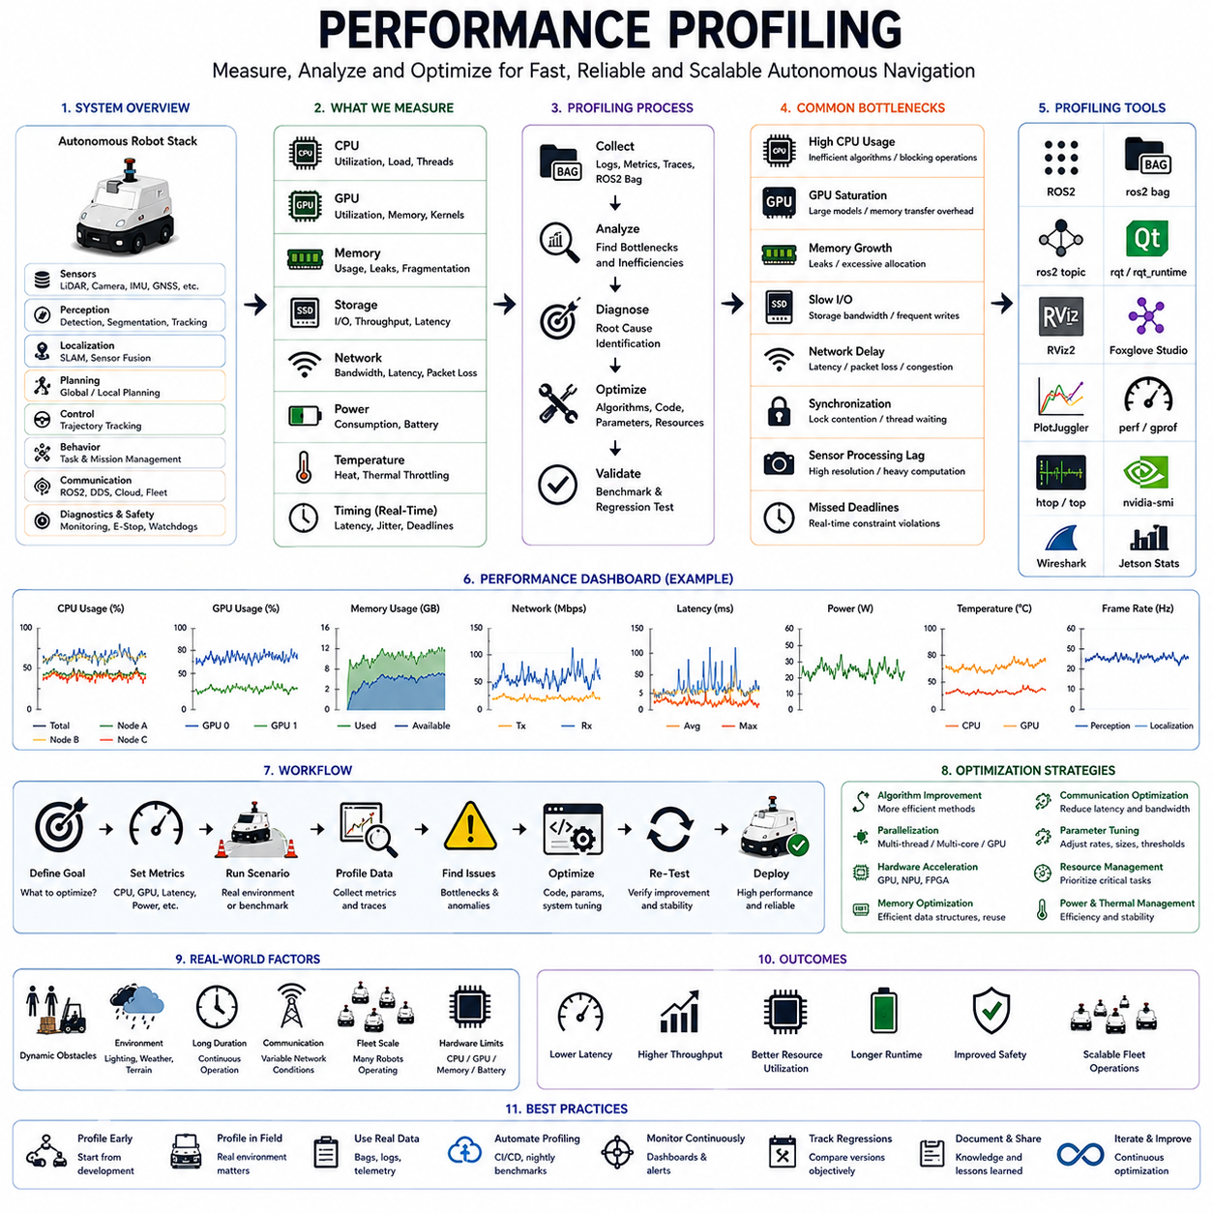
Performance profiling is a critical engineering discipline in autonomous navigation systems because the reliability, responsiveness, safety, and scalability of a robotic platform depend not only on algorithmic correctness but also on computational efficiency. Modern Autonomous Mobile Robots (AMRs), outdoor autonomous robots, autonomous forklifts, towing robots, hospital service robots, inspection robots, and fleet management systems execute large numbers of computationally intensive tasks simultaneously. Localization, mapping, perception, sensor fusion, path planning, trajectory generation, obstacle avoidance, behavior planning, communication, diagnostics, and safety monitoring all compete for processing resources. Even when individual algorithms function correctly, insufficient computational performance can lead to delayed decisions, missed sensor updates, degraded navigation quality, unstable control behavior, and safety risks. Therefore, performance profiling has become an essential activity throughout the development, testing, deployment, and maintenance lifecycle of autonomous robotic systems.
Performance profiling is the systematic process of measuring, analyzing, and optimizing the computational behavior of robotic software and hardware systems. The objective is to understand how resources such as CPU, GPU, memory, storage, network bandwidth, and power are consumed during operation. Unlike traditional debugging, which focuses primarily on identifying functional failures, performance profiling seeks to identify inefficiencies, bottlenecks, scalability limitations, and timing issues that may impact overall system performance. Effective profiling enables engineers to improve responsiveness, reduce latency, increase throughput, optimize resource utilization, and ensure reliable operation under real-world conditions.
Modern autonomous navigation systems consist of multiple software layers operating simultaneously. Sensor drivers continuously acquire data from LiDARs, cameras, radar systems, IMUs, GNSS receivers, wheel encoders, and safety devices. Perception modules process raw sensor data to identify objects, obstacles, terrain characteristics, and environmental features. Localization algorithms estimate robot pose using sensor fusion techniques. Path planners generate routes, local planners calculate trajectories, controllers execute motion commands, and communication systems exchange information with fleet management platforms. Each component contributes to overall system workload, and inefficiencies within a single subsystem may propagate throughout the navigation stack.
One of the primary goals of performance profiling is identifying computational bottlenecks. A bottleneck occurs when a specific process consumes excessive resources or delays overall system execution. For example, an object detection neural network may monopolize GPU resources, preventing localization algorithms from receiving timely updates. Alternatively, excessive CPU utilization within a mapping module may delay path planning calculations. Profiling helps engineers determine which components limit overall system performance and prioritize optimization efforts accordingly.
CPU profiling is among the most common forms of performance analysis. Autonomous robots typically execute dozens of concurrent processes, each competing for processor time. Engineers analyze CPU utilization to determine how computational resources are distributed among different tasks. High CPU usage may indicate inefficient algorithms, excessive polling rates, unnecessary computations, blocking operations, or suboptimal software architectures. CPU profiling tools provide detailed insights into function execution times, thread activity, scheduling behavior, and processor load distribution.
Multi-threaded systems introduce additional complexity. Modern robotic software frequently relies on parallel execution to improve performance. Localization, perception, planning, and communication tasks often run concurrently across multiple CPU cores. While parallelism improves throughput, it can also introduce synchronization delays, race conditions, deadlocks, and resource contention. Profiling multi-threaded applications requires understanding thread interactions, lock usage, scheduling policies, and execution dependencies. Engineers must identify situations where threads spend excessive time waiting rather than performing productive work.
GPU profiling has become increasingly important as robotic systems incorporate artificial intelligence and deep learning technologies. Object detection, semantic segmentation, visual localization, terrain classification, anomaly detection, and predictive modeling frequently execute on GPUs. Although GPUs provide significant computational acceleration, they can also become performance bottlenecks if workloads are not optimized properly. Engineers analyze GPU utilization, memory allocation, kernel execution times, data transfer overhead, and inference latency to ensure efficient operation. Profiling is particularly important in edge computing environments where GPU resources are limited.
Memory profiling focuses on understanding how memory resources are allocated, utilized, and released during system operation. Memory leaks, fragmentation, excessive allocation, and inefficient data structures can significantly degrade long-term system performance. Autonomous robots often operate continuously for extended periods, making memory stability particularly important. A memory leak that appears insignificant during a short laboratory test may cause system failure during multi-day field deployments. Profiling tools help engineers identify abnormal memory growth patterns and optimize resource management strategies.
Storage performance is another important consideration. Robotic systems generate large volumes of sensor data, logs, diagnostics, maps, and ROS2 bag recordings. Slow storage devices can introduce delays during data recording, retrieval, and processing. Engineers profile storage throughput, input/output latency, file access patterns, and database performance to ensure that storage subsystems do not interfere with real-time operation. High-speed NVMe storage solutions are increasingly used to support data-intensive robotic workloads.
Network profiling is essential for connected robotic systems. Modern robots frequently exchange information with cloud services, fleet management platforms, remote operators, and other robots. Network latency, bandwidth limitations, packet loss, and communication jitter can affect navigation performance and operational reliability. Engineers analyze communication traffic, message rates, transmission delays, Quality of Service (QoS) behavior, and network utilization to identify communication bottlenecks. Network profiling becomes particularly important in large-scale fleet deployments where hundreds of robots share common infrastructure.
Real-time performance analysis is a core aspect of autonomous navigation profiling. Many robotic functions operate under strict timing requirements. Localization updates may be required at 50 Hz, obstacle detection at 30 Hz, control loops at 100 Hz, and safety monitoring at even higher frequencies. Missing deadlines can degrade navigation performance or create safety hazards. Profiling therefore includes measurement of execution latency, scheduling jitter, deadline compliance, and worst-case execution times. Engineers must verify that critical tasks consistently meet real-time requirements under both nominal and peak-load conditions.
Sensor processing performance represents another important profiling domain. LiDAR point clouds, camera images, radar returns, GNSS measurements, and IMU data must be processed within limited time windows. Increasing sensor resolution and sampling frequency improve environmental awareness but also increase computational demands. Engineers profile sensor processing pipelines to determine whether data can be processed in real time while maintaining acceptable resource utilization. Bottlenecks in sensor processing often propagate into localization, perception, and planning subsystems.
Localization profiling focuses on measuring the computational efficiency of pose estimation algorithms. SLAM systems, sensor fusion architectures, visual odometry pipelines, scan matching algorithms, and GNSS integration modules all contribute to localization workload. Profiling helps engineers evaluate update rates, optimization latency, feature extraction costs, map matching performance, and scalability across different environmental conditions. Efficient localization is essential for maintaining accurate navigation while preserving computational resources for other tasks.
Path planning profiling examines how efficiently planning algorithms generate navigation solutions. Global planners, local planners, trajectory optimizers, and collision-checking modules may consume significant computational resources, particularly in large or dynamic environments. Engineers measure planning times, replanning frequencies, optimization costs, search space complexity, and memory utilization. Profiling results help determine whether planning algorithms remain scalable as environmental complexity increases.
Obstacle avoidance systems require particularly careful performance analysis because safety depends on timely decision-making. Engineers measure detection latency, tracking update rates, collision prediction times, avoidance planning performance, and emergency response delays. Even small computational delays may significantly affect collision avoidance performance when robots operate at higher speeds or in dynamic environments.
Behavior planning and mission management systems also benefit from profiling. State machines, behavior trees, task schedulers, AI-based decision frameworks, and fleet coordination algorithms contribute to overall system workload. Profiling these components helps identify inefficiencies in decision-making processes and improves operational responsiveness.
ROS2 middleware performance is another important area of investigation. Autonomous navigation systems often depend heavily on message passing between distributed software components. Engineers analyze topic bandwidth, message frequencies, serialization overhead, DDS performance, QoS settings, and communication latency. Poor middleware configuration can significantly impact system performance even when individual algorithms operate efficiently.
ROS2 bag recording introduces additional computational overhead that must be considered during profiling. Recording large volumes of sensor data may affect system responsiveness if storage performance becomes constrained. Engineers should evaluate bag recording impact under realistic operational conditions and implement strategies such as selective topic recording, compression, and distributed storage management when necessary.
Power consumption profiling is increasingly important for battery-powered robotic systems. Computational performance and energy efficiency are closely related. High CPU and GPU utilization increase power consumption, reduce operating time, and generate additional heat. Engineers analyze power usage across different workloads to identify opportunities for optimization. Energy-aware profiling becomes particularly important for outdoor robots, long-duration missions, and battery-constrained platforms.
Thermal profiling complements power analysis by evaluating heat generation and thermal management effectiveness. Excessive temperatures may trigger processor throttling, reduce performance, accelerate hardware degradation, and increase failure rates. Engineers monitor thermal behavior under realistic operating conditions and verify that cooling systems maintain acceptable temperatures during peak workloads.
Field performance profiling often reveals issues that remain hidden during laboratory testing. Real-world environments introduce larger datasets, more dynamic obstacles, greater communication complexity, longer mission durations, and higher operational variability. Engineers should therefore conduct profiling activities in representative deployment environments rather than relying solely on synthetic benchmarks.
Visualization tools significantly improve profiling effectiveness. Performance dashboards, timeline visualizations, flame graphs, resource utilization charts, execution traces, and real-time monitoring systems help engineers understand complex interactions among system components. Visualization often reveals hidden bottlenecks and performance anomalies that are difficult to identify through raw numerical data alone.
Performance benchmarking provides objective methods for comparing software versions, hardware platforms, algorithm configurations, and system architectures. Standardized benchmark scenarios enable quantitative evaluation of optimization efforts and support data-driven decision-making. Benchmarking also facilitates regression testing by ensuring that performance improvements do not introduce unintended degradations elsewhere in the system.
Root-cause analysis remains an essential component of performance profiling. Engineers must understand why bottlenecks occur rather than merely observing their existence. Excessive CPU usage, memory growth, communication delays, and processing latency often have deeper architectural causes. Identifying and addressing these root causes enables sustainable long-term improvements rather than temporary fixes.
Optimization strategies may include algorithm redesign, software refactoring, parallelization, hardware acceleration, GPU offloading, memory management improvements, communication optimization, parameter tuning, and architectural restructuring. Effective optimization balances performance improvements against maintainability, reliability, scalability, and development complexity.
Artificial intelligence is beginning to influence performance profiling methodologies. Machine learning models can automatically detect performance anomalies, predict resource bottlenecks, identify inefficient code paths, and recommend optimization strategies. Future robotic systems may continuously monitor their own performance and adapt resource allocation dynamically in response to changing operational conditions.
As autonomous robotic systems continue to evolve, performance profiling is becoming increasingly important for ensuring scalability. Small inefficiencies that appear insignificant in a single robot may become major operational challenges when deployed across hundreds or thousands of robots. Profiling therefore plays a critical role not only in individual robot optimization but also in large-scale fleet engineering.
Ultimately, Performance Profiling is not simply a software optimization exercise. It is a foundational engineering methodology that enables autonomous robotic systems to achieve reliable real-time operation, efficient resource utilization, scalable deployment, and long-term operational stability. Whether developing warehouse AMRs, hospital service robots, autonomous forklifts, towing robots, outdoor inspection platforms, GPR survey robots, smart city robotics systems, or large-scale fleet management solutions, systematic performance profiling remains essential for delivering high-performance autonomous navigation systems capable of operating safely and efficiently in complex real-world environments.

21.8 Navigation Debugging Checklists
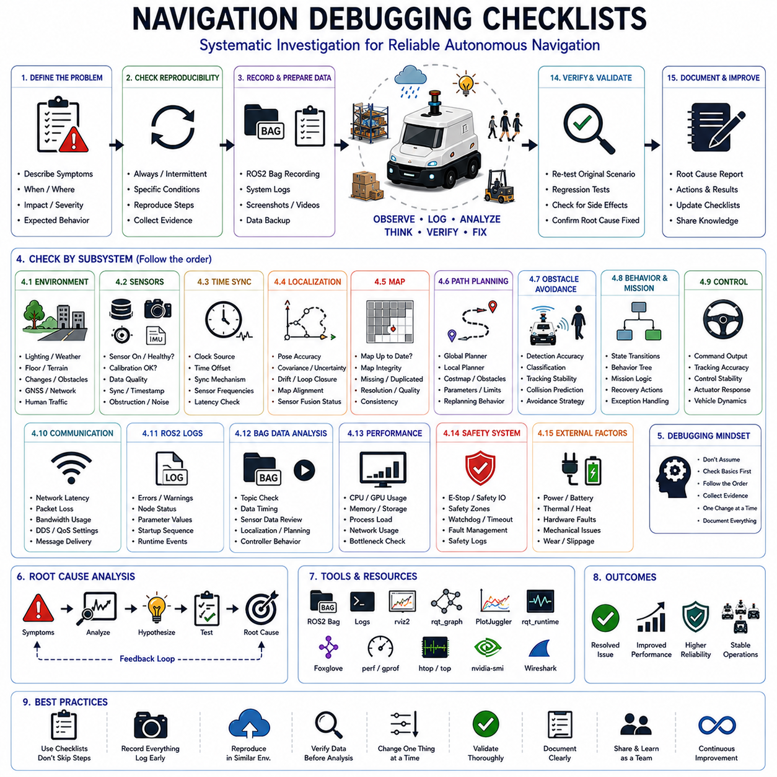
Navigation debugging is one of the most important engineering activities in the development and operation of autonomous robotic systems. Modern Autonomous Mobile Robots (AMRs), autonomous forklifts, towing robots, hospital service robots, inspection robots, outdoor autonomous platforms, smart city robots, and large-scale fleet management systems depend on complex interactions among sensing, perception, localization, mapping, planning, control, communication, and safety subsystems. When navigation failures occur, the root causes are often distributed across multiple layers of the system architecture. A robot that fails to reach its destination may actually be experiencing localization drift, map inconsistencies, communication delays, sensor degradation, planner configuration errors, or controller instability. Consequently, effective navigation debugging requires a systematic and repeatable methodology that guides engineers through the investigation process. Navigation debugging checklists provide such a framework by ensuring that critical diagnostic steps are not overlooked and that troubleshooting efforts proceed in a structured and efficient manner. A well-designed debugging checklist reduces diagnostic time, improves reproducibility, enhances communication among engineering teams, and increases overall system reliability.
A navigation debugging checklist serves as a structured decision-support tool rather than a simple list of tasks. It helps engineers evaluate system behavior from multiple perspectives while avoiding assumptions and premature conclusions. In complex robotic systems, the most visible symptom is often not the actual cause of the failure. For example, repeated obstacle avoidance maneuvers may appear to be a perception problem when the underlying issue is inaccurate localization. Similarly, path planning failures may originate from map corruption rather than deficiencies in the planning algorithm itself. A systematic checklist encourages engineers to validate foundational assumptions before investigating higher-level components.
The first phase of any navigation debugging checklist focuses on failure identification and problem definition. Before technical analysis begins, engineers must establish a clear and measurable description of the observed issue. Vague statements such as “navigation is unstable” or “the robot is behaving strangely” provide little diagnostic value. Instead, the failure should be described using objective metrics and observable behaviors. Examples include repeated path replanning, localization error exceeding a specified threshold, obstacle avoidance oscillation, route generation failure, mission timeout, excessive control error, or unexpected emergency stop activation. Precise problem definition establishes the foundation for all subsequent debugging activities.
After defining the failure, engineers should verify reproducibility. Reproducibility is one of the most important characteristics of an engineering problem because it enables systematic investigation and validation of corrective actions. If a failure cannot be reproduced, engineers must rely on logs, recorded data, and historical observations. The checklist should therefore include procedures for determining whether the issue occurs consistently, intermittently, or under specific environmental conditions. Understanding reproducibility often provides valuable clues regarding root causes.
Environmental verification represents another essential component of navigation debugging. Real-world environments frequently contribute to navigation anomalies. Lighting conditions, weather, floor materials, terrain characteristics, infrastructure modifications, wireless network coverage, GNSS visibility, human activity levels, and obstacle distributions may all influence robot behavior. Engineers should document environmental conditions carefully and compare them with conditions under which the system previously operated successfully. Changes in the environment often explain unexpected navigation failures.
Sensor health verification is a fundamental step in every debugging checklist. Autonomous navigation depends heavily on reliable sensor data. Engineers should confirm that all sensors are operational, calibrated correctly, synchronized properly, and producing valid measurements. LiDAR systems should be checked for missing scans, reduced point density, contamination, or mechanical issues. Camera systems should be inspected for lens obstructions, exposure problems, focus degradation, and synchronization errors. IMUs, GNSS receivers, radar systems, wheel encoders, ultrasonic sensors, and safety scanners should undergo similar verification procedures. Sensor health assessments frequently identify the root causes of navigation failures before more advanced analysis becomes necessary.
Time synchronization verification is often overlooked but critically important. Modern navigation systems integrate data from multiple sensors operating at different frequencies. Even small timing discrepancies can significantly degrade localization accuracy, sensor fusion performance, obstacle detection quality, and planning reliability. The debugging checklist should include verification of timestamp consistency, clock synchronization mechanisms, communication delays, and sensor update frequencies. Engineers should ensure that all subsystems reference a common time source and that synchronization tolerances remain within acceptable limits.
Localization verification typically forms the next stage of navigation debugging. Engineers should evaluate pose estimates, covariance values, heading accuracy, drift accumulation, loop closure performance, map alignment quality, and sensor fusion consistency. Localization errors frequently propagate into path planning, obstacle avoidance, and control subsystems. A robot that appears to be making poor planning decisions may actually be operating with incorrect positional information. Therefore, localization accuracy must be validated before investigating higher-level navigation functions.
Map validation is equally important. Navigation systems rely heavily on environmental representations for route generation and obstacle avoidance. Engineers should verify that maps accurately represent current operating conditions and contain no corruption, distortions, missing structures, duplicated features, or outdated information. Occupancy grids, point cloud maps, semantic maps, topological maps, and digital twins should all be inspected depending on the navigation architecture. Even minor map inconsistencies can generate widespread navigation anomalies.
Path planning verification focuses on understanding how navigation routes are generated and evaluated. Engineers should examine planner inputs, generated paths, costmaps, obstacle representations, search algorithms, optimization parameters, and replanning behavior. Global planners and local planners should both be evaluated because failures may originate in either component. The debugging checklist should include procedures for visualizing planned trajectories and comparing them against expected behavior under similar environmental conditions.
Obstacle avoidance validation is another critical element. Engineers should verify obstacle detection accuracy, classification quality, object tracking consistency, collision prediction performance, safety zone configurations, and avoidance strategy selection. Dynamic obstacles require particular attention because prediction errors can lead to unstable navigation behavior. The checklist should encourage comparison between raw sensor observations and processed obstacle representations to identify discrepancies introduced during perception processing.
Behavior planning verification focuses on higher-level decision-making processes. Modern navigation systems often rely on state machines, behavior trees, mission managers, and task schedulers to coordinate navigation activities. Engineers should verify state transitions, decision conditions, recovery behaviors, mission execution logic, and exception handling mechanisms. Incorrect behavior planning may produce navigation anomalies even when localization, perception, and planning systems function correctly.
Controller verification examines the final execution layer of the navigation stack. Engineers should analyze velocity commands, steering commands, actuator responses, trajectory tracking accuracy, control loop stability, and vehicle dynamics. Poor control performance may manifest as navigation instability, overshoot, oscillation, or failure to follow planned trajectories. The debugging checklist should include procedures for comparing commanded motion against actual vehicle behavior.
Communication diagnostics are increasingly important in modern robotic systems. Distributed architectures, cloud connectivity, fleet coordination, and remote monitoring depend on reliable communication networks. Engineers should evaluate network latency, packet loss, bandwidth utilization, Quality of Service settings, DDS performance, and message delivery consistency. Communication problems often produce intermittent failures that are difficult to diagnose without systematic analysis.
ROS2 log analysis represents a central element of most navigation debugging workflows. Logs provide visibility into internal software behavior and system events. Engineers should review warnings, errors, diagnostic messages, initialization sequences, parameter values, and runtime state transitions. Log analysis frequently reveals software conditions that are not apparent from sensor data alone. A debugging checklist should include structured procedures for reviewing logs and correlating them with observed system behavior.
ROS2 bag analysis complements log analysis by providing access to recorded operational data. Engineers should verify that relevant topics were recorded, examine message timing relationships, inspect sensor observations, evaluate localization outputs, review planner decisions, and analyze controller behavior. Bag replay enables repeatable investigation of failures and supports regression testing after corrective actions are implemented.
Performance profiling should also be included in navigation debugging checklists. High CPU utilization, GPU saturation, memory leaks, storage bottlenecks, and network congestion can all affect navigation quality. Engineers should monitor resource utilization during failure conditions and determine whether computational constraints contributed to observed behavior. Performance issues often appear as navigation problems even when navigation algorithms themselves remain correct.
Safety system verification is essential whenever navigation failures occur. Emergency stop systems, protective safety zones, watchdog timers, fault management systems, and recovery procedures should all be evaluated. Engineers must confirm that safety mechanisms function correctly under both nominal and fault conditions. A failure within the safety architecture can significantly increase operational risk.
Field reproduction procedures represent one of the most valuable sections of a navigation debugging checklist. Engineers should document test conditions, environmental parameters, software versions, configuration settings, and operational procedures necessary to reproduce observed failures. Reproducibility supports root-cause analysis and enables objective validation of corrective actions. Without reproducibility, debugging efforts often become speculative and inefficient.
Root-cause analysis should conclude every debugging investigation. Engineers must distinguish between symptoms and underlying causes while validating causal relationships through evidence rather than assumptions. Techniques such as fault tree analysis, dependency analysis, event correlation, statistical investigation, and hypothesis testing help establish confidence in diagnostic conclusions. The debugging checklist should require documentation of supporting evidence for each identified root cause.
Corrective action validation represents the final stage of the debugging process. After implementing modifications, engineers should execute regression tests covering both the original failure scenario and a broad range of related operating conditions. Validation should confirm not only that the original issue has been resolved but also that no new problems have been introduced. Comprehensive regression testing strengthens confidence in deployed solutions and reduces the likelihood of recurring failures.
Standardized navigation debugging checklists provide additional organizational benefits. They improve consistency across engineering teams, reduce dependence on individual expertise, facilitate training of new personnel, support quality assurance processes, and improve communication among development, testing, operations, and maintenance teams. Over time, organizations can refine checklists based on accumulated operational experience, creating a continuously improving knowledge base that enhances future debugging efficiency.
As autonomous robotic systems continue to increase in complexity, navigation debugging checklists are evolving into intelligent diagnostic frameworks. Future systems are expected to integrate automated health monitoring, AI-assisted diagnostics, anomaly detection, predictive failure analysis, digital twin validation, and autonomous root-cause investigation. These technologies will transform debugging from a reactive activity into a proactive reliability engineering process.
Ultimately, Navigation Debugging Checklists are not merely administrative tools. They are structured engineering methodologies that guide systematic investigation, reduce diagnostic uncertainty, improve reproducibility, accelerate troubleshooting, and enhance operational reliability. Whether applied to warehouse AMRs, hospital robots, autonomous forklifts, towing platforms, outdoor inspection systems, GPR survey robots, smart city robotic services, or large-scale fleet management environments, comprehensive navigation debugging checklists remain indispensable for achieving safe, reliable, and scalable autonomous navigation in real-world deployments.

