Volume 05. Path Planning and Autonomous Navigation

Chapter 03. Local Path Planning

03.1 Local Planner Architecture
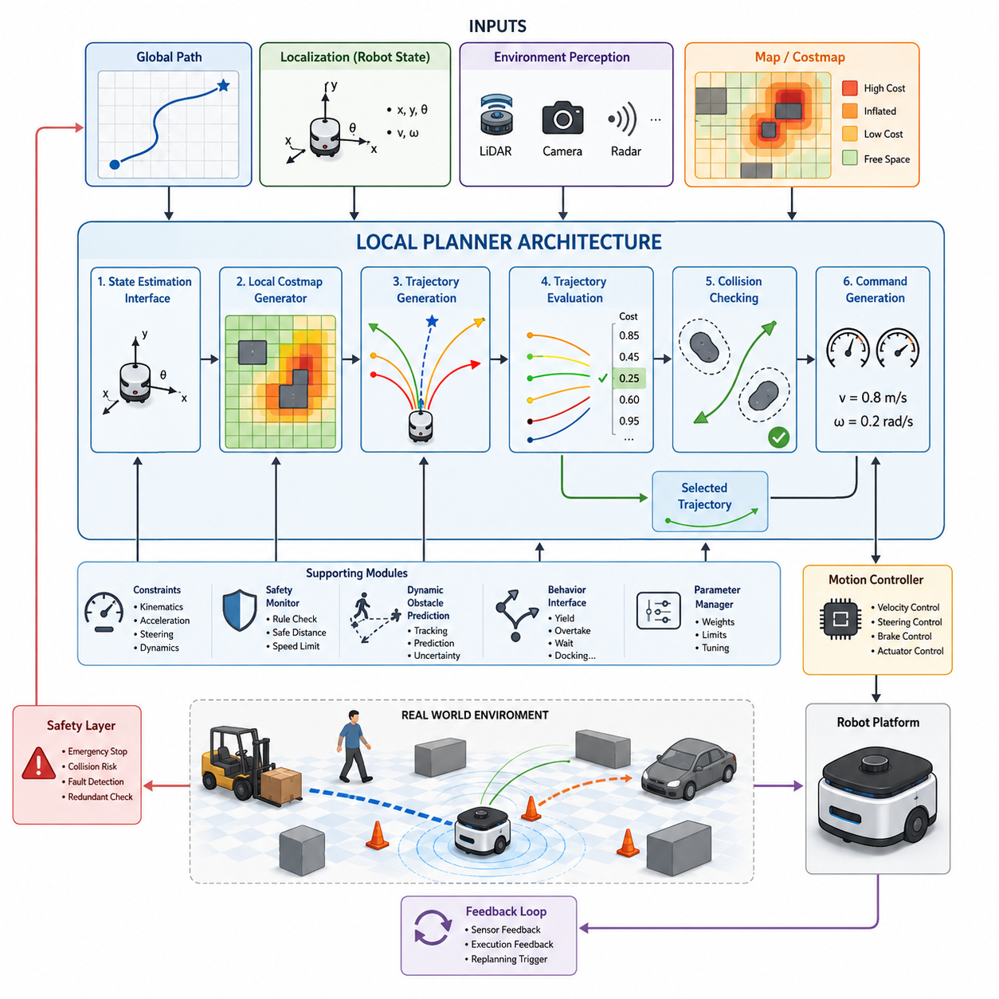
Local Planner Architecture is one of the most critical components in an autonomous mobile robot navigation system because it directly determines how the robot moves through its environment in real time. While a global planner generates a long-range route from the current position to a target destination, the local planner is responsible for transforming that route into executable motion commands that respect the robot’s kinematic limitations, dynamic constraints, safety requirements, and environmental conditions. The local planner operates continuously during robot movement and serves as the bridge between high-level path planning and low-level motion control. Within the overall navigation stack, it functions as the decision-making layer that evaluates nearby obstacles, predicts potential collisions, selects safe trajectories, and generates velocity commands that guide the robot toward its goal. The importance of the local planner becomes increasingly evident in dynamic environments where unexpected obstacles, moving people, vehicles, or changing terrain conditions can invalidate previously planned routes.
The architecture of a local planner typically begins with the reception of information from multiple upstream subsystems. These inputs generally include the global path generated by the global planner, the current robot pose provided by the localization system, environmental representations such as occupancy grids or cost maps, and real-time obstacle information obtained through perception sensors. The local planner continuously combines these data sources to maintain an updated understanding of the robot’s immediate surroundings. Unlike the global planner, which may compute a route over hundreds of meters or even kilometers, the local planner focuses only on a limited region surrounding the robot. This local operational window enables high-frequency updates and rapid reaction to environmental changes.
One of the primary functions of the local planner is trajectory generation. Rather than following the global path exactly, the planner creates multiple candidate trajectories that are physically feasible for the robot. These trajectories represent possible future motions based on the robot’s current position, velocity, steering angle, acceleration limits, and dynamic characteristics. Candidate trajectories are evaluated against a variety of criteria including safety, efficiency, smoothness, energy consumption, goal alignment, and obstacle avoidance. The planner then selects the most suitable trajectory and converts it into velocity commands for execution by the motion controller.
A typical local planner architecture contains several interconnected modules. The first module is the state estimation interface. This component receives position, orientation, velocity, and acceleration estimates from localization and sensor fusion systems. Accurate state estimation is essential because all subsequent planning calculations depend on the robot’s current state. Any localization error directly affects trajectory prediction and may lead to navigation failures. Therefore, local planners are often tightly integrated with localization systems such as SLAM, GNSS-RTK, LiDAR localization, visual localization, or multi-sensor fusion frameworks.
The second module is environmental perception integration. This subsystem receives obstacle information from various sensors including 2D LiDAR, 3D LiDAR, RGB cameras, depth cameras, radar systems, ultrasonic sensors, and thermal cameras. Sensor fusion algorithms combine observations into a unified environmental representation. The resulting obstacle map allows the planner to identify free space, occupied regions, dynamic objects, and navigation hazards. In industrial environments, additional information may include restricted areas, safety zones, loading docks, pedestrian crossings, and operational boundaries.
The third module is the local cost map generator. Cost maps are fundamental elements of most navigation architectures because they transform raw sensor observations into a structured representation suitable for planning. Each cell in the cost map contains a numerical value representing traversal difficulty or collision risk. Obstacles typically receive high costs while free space receives low costs. Inflation layers are often added around obstacles to maintain safe clearance distances. Dynamic cost updates allow the system to respond immediately to environmental changes. Cost maps can incorporate not only obstacle information but also terrain roughness, slope conditions, traffic rules, and operational constraints.
Trajectory generation is the next major component within the local planner architecture. Various algorithms can be used to generate candidate trajectories. Some planners rely on sampling methods that explore possible velocity combinations. Others use optimization-based approaches that minimize objective functions. The Dynamic Window Approach generates trajectories by evaluating feasible velocity commands within the robot’s acceleration limits. Timed Elastic Band optimization treats trajectory planning as a constrained optimization problem and continuously adjusts path points to satisfy obstacle avoidance and kinematic constraints. Model Predictive Control predicts future robot behavior over a finite horizon and computes optimal control actions. Regardless of the specific method, the trajectory generation module seeks to identify safe and efficient motion candidates.
Trajectory evaluation forms another critical subsystem. Once candidate trajectories have been generated, each option must be scored according to predefined criteria. Safety is generally the highest priority. Trajectories that intersect obstacles or violate safety margins are immediately rejected. Remaining candidates are evaluated based on factors such as distance to obstacles, alignment with the global path, progress toward the goal, smoothness of motion, energy efficiency, passenger comfort for human-carrying robots, and stability constraints for heavy-load vehicles. Multi-objective cost functions are often employed to balance competing requirements. The trajectory with the lowest overall cost is selected for execution.
Collision checking is deeply integrated into the trajectory evaluation process. Every candidate trajectory is projected into the future and tested against predicted obstacle positions. Static obstacle checking verifies clearance from fixed structures such as walls, machinery, or infrastructure. Dynamic obstacle checking predicts the future motion of moving objects including pedestrians, vehicles, forklifts, and other robots. Advanced planners incorporate uncertainty models to account for sensor noise and prediction inaccuracies. Collision avoidance mechanisms ensure that the robot maintains safe operating distances under all conditions.
The command generation module converts the selected trajectory into executable motion commands. Depending on the robot platform, these commands may consist of linear velocity and angular velocity, steering angle and speed commands, wheel velocity references, or more complex actuator control signals. Motion commands are transmitted to the vehicle control layer, which executes them through motor controllers, steering actuators, braking systems, and drive mechanisms. Continuous feedback monitoring ensures that actual robot motion matches planned motion.
A key architectural characteristic of local planners is their real-time operation. Unlike global planners that may update once every few seconds, local planners often operate at frequencies between 10 Hz and 100 Hz. High-frequency operation is necessary to maintain responsiveness in dynamic environments. Real-time constraints impose strict requirements on computational efficiency. Algorithms must generate, evaluate, and select trajectories within milliseconds. Hardware acceleration using GPUs, dedicated AI processors, or optimized numerical libraries is increasingly used to support advanced planning algorithms.
Dynamic obstacle handling represents one of the most challenging aspects of local planner design. Traditional planners assume static environments, but modern autonomous robots frequently operate among humans, vehicles, and other moving entities. Dynamic obstacle handling requires object detection, tracking, behavior prediction, and trajectory adaptation. The planner must anticipate future interactions rather than merely reacting to current observations. Predictive planning techniques estimate future obstacle positions and proactively adjust robot trajectories to avoid conflicts before they occur.
Safety architecture is another essential element. Local planners are often integrated with multiple safety layers. A safety monitor continuously verifies that planned trajectories comply with operational constraints. Emergency stop systems override planning outputs when imminent collisions are detected. Safety LiDAR zones can dynamically adjust allowable robot speeds based on obstacle proximity. Functional safety architectures frequently include redundant monitoring systems that independently validate navigation decisions. This layered approach ensures robust operation even when individual components experience failures.
For outdoor autonomous robots, local planner architecture becomes even more complex. Environmental conditions may include uneven terrain, slopes, loose surfaces, vegetation, weather effects, and GNSS uncertainties. The planner must account for vehicle stability, wheel slip, traction limitations, and terrain traversability. Terrain-aware cost maps are often employed to represent navigational risks associated with different surface conditions. Heavy-duty outdoor robots may additionally incorporate rollover prevention constraints, payload stability considerations, and slope safety limits.
In towing AMRs and trailer-based autonomous systems, local planning requires specialized trajectory generation mechanisms. The planner must consider articulation angles, trailer dynamics, off-tracking effects, and reverse driving behaviors. Simple path-following approaches are insufficient because trailer motion introduces nonlinear constraints. Advanced planners utilize vehicle models that capture the coupled behavior of the tractor and trailer. Reverse parking, docking, and coupling operations require extremely precise local planning capabilities.
The integration between local planning and behavior planning is another important architectural consideration. Behavior planners operate at a higher decision-making level and determine navigation objectives such as yielding, overtaking, waiting, docking, charging, or rerouting. The local planner executes these behavioral decisions by generating appropriate motion trajectories. Clear interfaces between behavior planning and local planning simplify system design and improve scalability.
Modern navigation architectures increasingly incorporate artificial intelligence into local planning systems. Machine learning models can predict obstacle behavior, estimate traversability, optimize trajectory selection, and improve navigation performance through experience. Reinforcement learning approaches enable robots to learn navigation policies directly from interaction with the environment. Hybrid architectures combine classical optimization methods with AI-based prediction systems to achieve both reliability and adaptability.
Cloud and edge computing are also influencing local planner architectures. Although trajectory generation typically remains on the robot due to latency requirements, cloud systems can provide additional situational awareness, traffic coordination, map updates, and fleet-level optimization. Edge computing platforms such as NVIDIA Jetson systems enable sophisticated local planning algorithms to operate directly on the robot while maintaining real-time performance.
Testing and validation are essential components of local planner development. Simulation environments such as Gazebo, Isaac Sim, and digital twin platforms allow engineers to evaluate planner behavior under diverse scenarios before field deployment. Validation typically includes obstacle avoidance tests, dynamic interaction scenarios, narrow corridor navigation, emergency stop performance, docking accuracy, rough terrain traversal, slope handling, and multi-robot coordination. Performance metrics often include trajectory smoothness, path tracking accuracy, computation latency, obstacle clearance, success rate, and recovery capability.
Ultimately, Local Planner Architecture serves as the operational intelligence layer that transforms navigation objectives into safe and efficient robot motion. It continuously interprets environmental information, evaluates potential actions, predicts future interactions, and generates executable trajectories that guide the robot toward its destination. As autonomous robots become more capable and are deployed in increasingly complex environments, local planner architectures will continue to evolve toward greater intelligence, adaptability, safety, and autonomy. Their role as the real-time decision-making core of navigation systems ensures that they remain one of the most important technologies in the development of modern AMRs, autonomous vehicles, service robots, industrial robots, outdoor autonomous platforms, and next-generation embodied AI systems.

03.2 Obstacle-Aware Local Planning
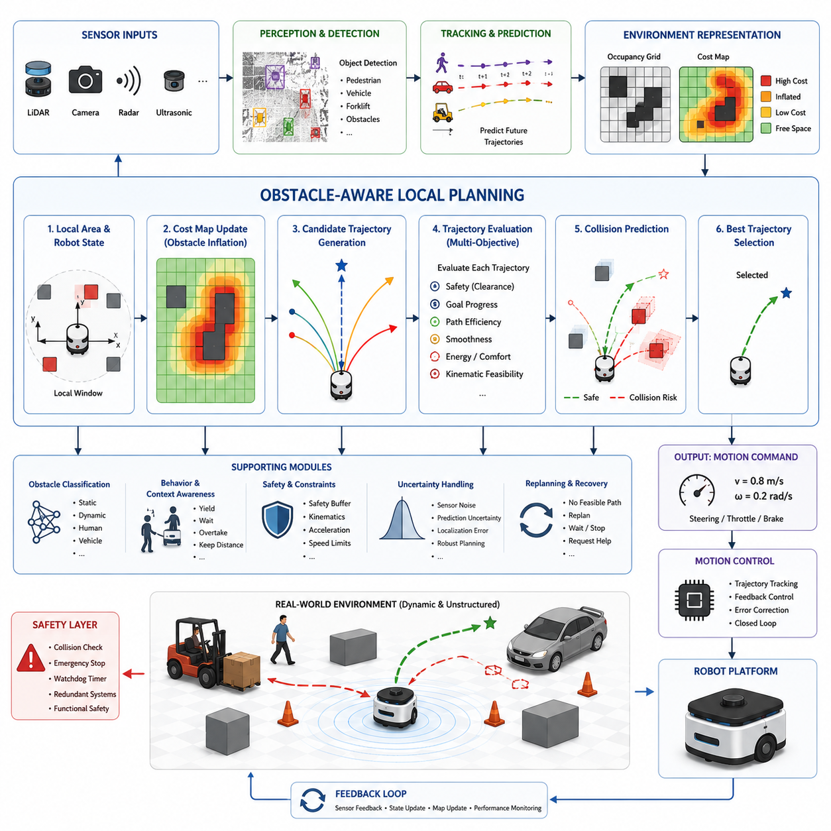
Obstacle-Aware Local Planning is a fundamental capability of autonomous mobile robots because it enables safe navigation in environments containing static and dynamic obstacles. While global path planning determines a long-range route toward a destination, obstacle-aware local planning focuses on the robot’s immediate surroundings and continuously modifies motion commands to avoid collisions while maintaining progress toward the goal. In real-world environments, obstacles rarely remain fixed or predictable. People walk through corridors, forklifts move across warehouses, vehicles enter roadways, construction equipment appears unexpectedly, and environmental conditions change continuously. As a result, a robot must possess the ability to perceive obstacles, evaluate risks, predict future interactions, and generate safe trajectories in real time. Obstacle-aware local planning provides this capability and serves as one of the most critical operational layers within modern autonomous navigation systems.
The primary objective of obstacle-aware local planning is to transform environmental awareness into safe motion decisions. This process begins with obstacle perception. The navigation system receives information from multiple sensors including LiDAR, cameras, radar, ultrasonic sensors, depth cameras, thermal sensors, and GNSS-supported perception systems. These sensors provide observations about the environment surrounding the robot. Sensor fusion algorithms combine the incoming information into a coherent representation of nearby objects, free space, navigation hazards, and environmental boundaries. The resulting environmental model serves as the foundation for local planning decisions.
Obstacle-aware planning differs significantly from traditional path-following approaches. A simple path-following controller attempts to remain close to a predefined route regardless of environmental conditions. Such systems often fail when unexpected obstacles appear. Obstacle-aware planners, however, continuously evaluate the local environment and modify trajectories whenever necessary. Rather than blindly following the global path, the planner dynamically balances multiple objectives including obstacle avoidance, path efficiency, goal progression, motion smoothness, energy efficiency, and safety compliance.
One of the most important concepts in obstacle-aware planning is environmental representation. Raw sensor data alone cannot support efficient decision making. The planner requires a structured model that describes obstacle locations and navigation costs. Cost maps are among the most widely used representations. A cost map divides the environment into cells, assigning each cell a numerical value that represents traversal difficulty or collision risk. Free space receives low costs, while obstacles receive high costs. Inflation layers expand obstacle boundaries to ensure safe clearance distances. Dynamic updates allow the cost map to reflect changing environmental conditions in real time.
Occupancy grids are another common environmental representation. In an occupancy grid, each cell stores the probability that the corresponding area is occupied by an obstacle. As new sensor observations become available, probabilities are continuously updated. Occupancy grids provide a probabilistic framework that helps manage sensor uncertainty and incomplete observations. This approach is especially valuable in crowded environments where obstacle positions may change frequently.
Obstacle-aware local planning relies heavily on accurate obstacle detection. Detection systems identify the presence, location, size, and shape of objects within the robot’s operating environment. Traditional methods often use geometric processing of LiDAR point clouds, while modern systems increasingly employ deep learning models for object detection and classification. Detection algorithms can identify pedestrians, vehicles, forklifts, pallets, machinery, walls, barriers, and other navigation-relevant entities. Accurate detection is essential because planning quality depends directly on environmental understanding.
After obstacles are detected, tracking systems estimate their motion over time. Static obstacle avoidance is relatively straightforward because obstacle positions remain fixed. Dynamic obstacle avoidance is significantly more complex because moving objects require future state prediction. Tracking algorithms estimate object velocity, direction, acceleration, and behavioral patterns. Kalman Filters, Extended Kalman Filters, Particle Filters, and advanced AI-based tracking systems are commonly used to maintain continuous estimates of object motion.
Prediction plays a central role in obstacle-aware planning. The planner must anticipate where obstacles will be located in the future rather than merely reacting to their current positions. Human pedestrians may suddenly change direction. Forklifts may enter intersections unexpectedly. Vehicles may accelerate or decelerate without warning. Prediction models estimate likely future trajectories of dynamic objects and provide critical information for collision avoidance. Advanced systems incorporate uncertainty estimation to account for unpredictable behavior and sensor noise.
Collision prediction mechanisms continuously evaluate future interactions between the robot and surrounding obstacles. The planner projects candidate robot trajectories into the future and compares them against predicted obstacle movements. Potential collisions are identified before they occur, enabling proactive avoidance behavior. This predictive approach significantly improves safety compared to purely reactive systems that respond only after obstacles enter predefined danger zones.
Trajectory generation is one of the core functions within obstacle-aware local planning. The planner generates multiple feasible trajectories that satisfy vehicle kinematic and dynamic constraints. Each candidate trajectory represents a possible future motion. Candidate trajectories may differ in curvature, speed profile, steering behavior, obstacle clearance, and travel time. The planning algorithm evaluates these alternatives and selects the trajectory that best satisfies navigation objectives while maintaining safety.
Various planning algorithms are used for obstacle-aware local navigation. The Dynamic Window Approach evaluates feasible velocity combinations and selects commands that maximize progress while avoiding obstacles. Timed Elastic Band planners optimize path geometry while respecting obstacle constraints and vehicle dynamics. Model Predictive Control predicts future system behavior over a finite horizon and computes optimal control inputs. Artificial Potential Field methods use virtual attractive and repulsive forces to guide navigation. Hybrid approaches often combine multiple techniques to achieve improved robustness and performance.
Obstacle avoidance decisions depend on both obstacle proximity and obstacle behavior. Nearby static obstacles require precise path adjustment, while moving obstacles may require more complex decision-making. For example, a robot approaching a pedestrian may need to slow down, stop temporarily, yield right-of-way, or select an alternate route. Obstacle-aware planners therefore incorporate behavioral reasoning mechanisms that adapt navigation strategies according to environmental context.
Human-aware navigation represents a specialized area of obstacle-aware planning. Humans are fundamentally different from static obstacles because their behavior is unpredictable and influenced by social expectations. Robots operating in hospitals, airports, offices, and public spaces must navigate in ways that humans perceive as safe and comfortable. Human-aware planners maintain larger safety margins around people, avoid sudden movements, predict pedestrian intentions, and generate socially acceptable trajectories. Such capabilities improve user acceptance and operational safety.
Industrial environments introduce unique challenges for obstacle-aware planning. Warehouses contain forklifts, moving pallets, automated equipment, storage racks, and human workers. Factories may include restricted zones, production machinery, and narrow pathways. Construction sites involve constantly changing layouts and unpredictable equipment movements. Effective obstacle-aware planning systems must accommodate these complex operational conditions while maintaining high productivity and safety.
Outdoor autonomous robots face even greater planning challenges. Environmental conditions may include uneven terrain, vegetation, weather effects, slopes, mud, gravel, and unstructured obstacles. Outdoor obstacle-aware planners often integrate terrain analysis, traversability estimation, and environmental classification into the planning process. A path that is physically obstacle-free may still be unsafe if the terrain cannot support stable vehicle operation. Consequently, outdoor planners must consider both geometric obstacles and terrain-related risks.
Heavy-duty autonomous vehicles and towing robots require additional considerations. Large payloads increase stopping distances and reduce maneuverability. Towing systems introduce trailer dynamics and articulation constraints that affect obstacle avoidance behavior. The planner must account for the full vehicle footprint rather than only the primary robot chassis. During turning maneuvers, trailer off-tracking can create collision risks that would not be apparent when considering only the towing vehicle. Obstacle-aware planning for such systems therefore requires advanced vehicle modeling and predictive control.
Safety is the highest priority within obstacle-aware local planning architectures. Every candidate trajectory undergoes extensive safety evaluation before execution. Collision checking algorithms verify obstacle clearance throughout the predicted motion horizon. Safety buffers compensate for localization uncertainty, sensor noise, and control inaccuracies. Emergency stop systems continuously monitor collision risk and intervene when necessary. Many industrial systems employ redundant safety layers that independently validate planner outputs to ensure compliance with functional safety requirements.
The relationship between obstacle-aware planning and robot control is highly interconnected. Planning algorithms generate desired trajectories, but successful execution depends on accurate vehicle control. Deviations between planned and actual motion can compromise safety. Feedback control systems continuously monitor vehicle state and adjust commands to minimize tracking error. This closed-loop interaction ensures that planned trajectories remain achievable under real-world operating conditions.
Modern obstacle-aware planning increasingly incorporates artificial intelligence and machine learning. Deep neural networks improve obstacle detection accuracy and enable semantic understanding of environmental context. Reinforcement learning algorithms can learn obstacle avoidance policies through simulation and real-world experience. World models provide predictive representations of future environmental states. However, most industrial systems continue to combine AI techniques with traditional planning algorithms to maintain reliability, interpretability, and safety certification compatibility.
Cloud-connected navigation systems are also expanding the capabilities of obstacle-aware planning. Fleet management platforms can share obstacle information among multiple robots. Cloud services can provide updated maps, traffic information, and global situational awareness. Nevertheless, obstacle-aware local planning remains primarily an edge-computing function because collision avoidance decisions require extremely low latency and high reliability. Real-time execution on platforms such as Jetson Orin, Jetson Thor, or industrial edge computers is therefore essential.
Simulation plays a critical role in developing obstacle-aware planning systems. Digital twins and simulation platforms such as Isaac Sim and Gazebo allow engineers to evaluate planner behavior under thousands of scenarios before deployment. Simulated environments can include moving pedestrians, vehicles, forklifts, narrow corridors, intersections, blind corners, and emergency situations. Such testing enables comprehensive validation without exposing people or equipment to unnecessary risk.
Performance evaluation typically focuses on several key metrics. Collision-free navigation is the most fundamental requirement. Additional metrics include obstacle clearance distance, path efficiency, computation latency, navigation success rate, trajectory smoothness, energy consumption, recovery capability, and human comfort. Industrial deployments often establish strict acceptance criteria for each metric before operational approval.
Failure handling is another essential component of obstacle-aware planning. Situations may arise in which no safe trajectory can be found. Environmental congestion, blocked pathways, sensor failures, or localization uncertainties may prevent normal operation. Recovery behaviors allow the robot to stop safely, wait for obstacles to clear, perform local replanning, request assistance from fleet management systems, or return to a predefined safe state. Robust recovery mechanisms are critical for maintaining operational reliability in complex environments.
As autonomous robotics continues to advance, obstacle-aware local planning is evolving toward increasingly intelligent and predictive systems. Future planners will combine perception, prediction, semantic understanding, world models, and decision-making into unified navigation frameworks. These systems will not simply avoid obstacles but will understand environmental intent, anticipate future interactions, coordinate with humans and other robots, and optimize navigation behavior across entire fleets. Such developments will enable safer, more efficient, and more autonomous operation in factories, hospitals, logistics centers, smart cities, agricultural environments, construction sites, and next-generation autonomous robotic ecosystems.

03.3 Dynamic Window Approach
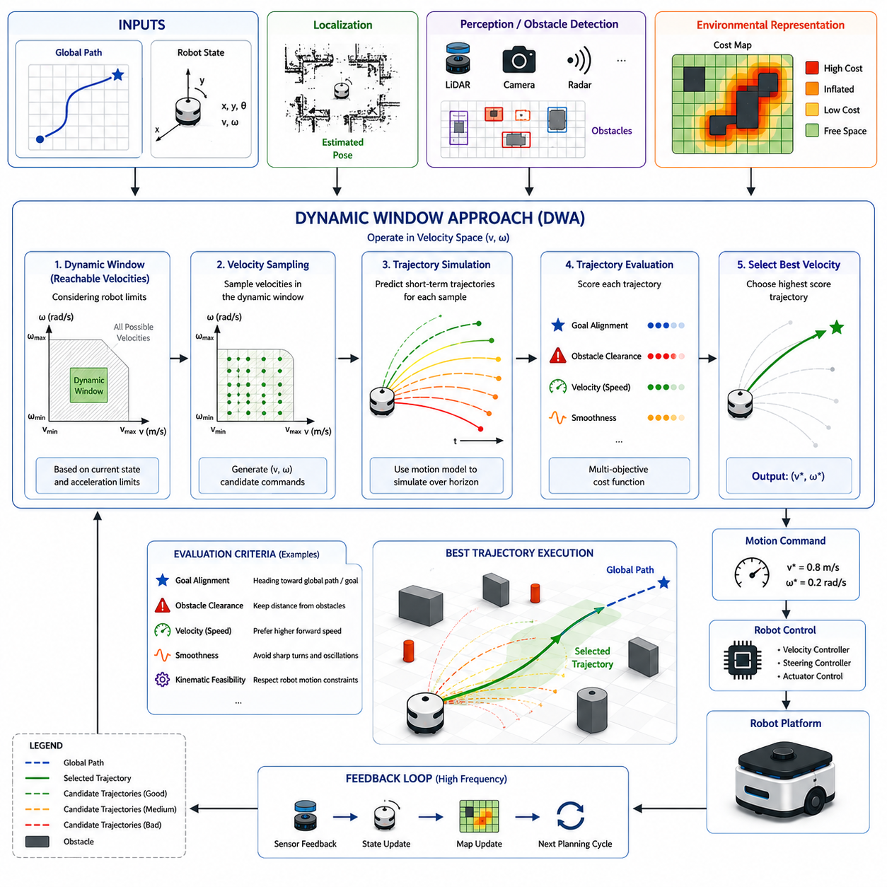
Dynamic Window Approach (DWA) is one of the most widely used local path planning algorithms in autonomous mobile robots and autonomous navigation systems. It was originally developed to address the challenge of generating safe and feasible motion commands in dynamic environments while respecting the kinematic and dynamic constraints of the robot. Unlike traditional path planning algorithms that generate complete paths before execution, DWA operates in real time and continuously evaluates the robot's current state, surrounding environment, and motion capabilities to determine the most appropriate velocity command. Because of its computational efficiency, robustness, and ability to react quickly to changing conditions, DWA has become a standard component in many commercial AMRs, service robots, warehouse robots, hospital delivery robots, and outdoor autonomous platforms.
The fundamental idea behind Dynamic Window Approach is that a robot should only consider motions that it can physically achieve within a short time horizon. Rather than searching the entire configuration space or generating long trajectories, DWA evaluates a limited set of velocity commands that are dynamically reachable based on the robot’s current velocity, acceleration limits, and control capabilities. This restriction significantly reduces computational complexity and allows the algorithm to operate at high frequencies suitable for real-time navigation.
The Dynamic Window Approach operates within the local planning layer of the navigation stack. The global planner provides a long-range path from the current position to the destination. The localization system continuously estimates the robot’s pose using technologies such as LiDAR SLAM, Visual SLAM, GNSS-RTK, odometry, IMU fusion, or multi-sensor localization frameworks. The perception system provides information about nearby obstacles using sensors such as LiDAR, cameras, radar, depth sensors, and ultrasonic sensors. DWA integrates these inputs and computes motion commands that move the robot safely toward its goal while avoiding collisions.
A key concept in DWA is the velocity space representation. Instead of planning directly in Cartesian space, DWA performs planning in velocity space. The robot’s possible movements are represented by combinations of linear velocity and angular velocity. For car-like vehicles, steering angles and vehicle speeds may also be included. The algorithm searches this velocity space and identifies candidate motion commands that satisfy dynamic constraints and navigation objectives.
The dynamic window itself represents the set of velocities that the robot can reach within a given control cycle. Every robot has acceleration and deceleration limits. Even if a robot is theoretically capable of traveling at high speed, it cannot instantly change from one velocity to another. DWA accounts for these physical limitations by restricting the search space to reachable velocities. This ensures that generated commands are physically executable and prevents unrealistic motion planning.
The process begins by defining the robot’s current velocity state. The planner determines the range of linear and angular velocities that can be achieved during the next planning interval. These limits are computed using maximum acceleration, maximum deceleration, current speed, and actuator constraints. The resulting velocity region forms the dynamic window. Only velocity commands within this window are considered for evaluation.
Once the dynamic window has been established, the planner generates candidate velocity samples. Each sample represents a possible motion command. For every candidate, the planner simulates the robot’s future motion over a prediction horizon. The resulting trajectory is analyzed to determine its suitability. Hundreds or even thousands of candidate trajectories may be evaluated during a single planning cycle.
Trajectory simulation is a critical component of DWA. Each velocity sample is propagated forward using the robot’s motion model. Differential drive robots, skid-steer platforms, omnidirectional robots, Ackermann steering vehicles, and articulated systems require different motion models. The simulation predicts where the robot will be located if a particular velocity command is executed for a specified duration. The generated trajectory forms the basis for subsequent evaluation.
Obstacle avoidance is one of the most important functions of Dynamic Window Approach. During trajectory evaluation, the planner checks whether simulated trajectories intersect with obstacles. Collision detection algorithms calculate the minimum distance between the robot and nearby obstacles. Unsafe trajectories are discarded immediately. Safe trajectories receive scores based on obstacle clearance. Trajectories that maintain larger distances from obstacles are generally preferred because they provide greater safety margins and robustness against uncertainty.
Goal-directed behavior is another essential component of DWA. The planner must not only avoid obstacles but also make progress toward the destination. Therefore, candidate trajectories are evaluated according to how effectively they guide the robot toward the goal. Trajectories that align with the global path and reduce the remaining distance to the destination receive higher scores. This balancing of obstacle avoidance and goal progression allows the robot to navigate efficiently while maintaining safety.
Velocity optimization is also incorporated into the evaluation process. Higher speeds generally improve operational efficiency and reduce travel time. However, excessive speed can compromise safety and reduce obstacle avoidance performance. DWA uses scoring functions to balance speed, safety, and navigation effectiveness. The optimal trajectory is selected by maximizing an objective function that combines multiple evaluation criteria.
The standard DWA objective function typically consists of three primary components. The first component evaluates heading alignment toward the goal. The second component evaluates obstacle clearance and collision risk. The third component evaluates forward velocity and travel efficiency. Weighted combinations of these factors produce an overall score for each candidate trajectory. The trajectory with the highest score becomes the selected motion command.
One of the greatest advantages of DWA is its computational efficiency. Because planning occurs directly in velocity space and considers only dynamically reachable motions, the algorithm can execute at frequencies ranging from 10 Hz to over 100 Hz depending on hardware capabilities. This real-time responsiveness makes DWA particularly suitable for environments containing moving obstacles and rapidly changing conditions.
Dynamic obstacle avoidance introduces additional complexity into the planning process. Traditional DWA was originally designed primarily for static obstacles. Modern implementations extend the algorithm to handle moving objects such as pedestrians, forklifts, vehicles, and other robots. Dynamic obstacle tracking systems estimate future obstacle positions, allowing trajectory evaluation to account for predicted interactions rather than only current obstacle locations.
In human-populated environments, DWA often incorporates human-aware navigation principles. Pedestrians exhibit unpredictable behavior and require larger safety margins. Modern implementations may dynamically adjust obstacle costs around humans, reduce robot speed in crowded environments, and generate trajectories that appear more natural and socially acceptable. These enhancements improve both safety and user acceptance.
The integration of DWA with cost maps is fundamental to its operation. Cost maps provide a structured representation of environmental risk. Static obstacles, restricted zones, inflation layers, and dynamic objects are encoded into the cost map. During trajectory evaluation, candidate motions are scored according to the accumulated costs encountered along their predicted paths. This allows DWA to naturally incorporate environmental constraints into navigation decisions.
Localization accuracy significantly influences DWA performance. Because trajectory generation depends on the robot’s estimated position and orientation, localization errors can lead to poor navigation decisions. Modern navigation systems therefore combine DWA with highly accurate localization technologies such as LiDAR-based localization, Visual-Inertial Odometry, GNSS-RTK, and multi-sensor fusion frameworks. Improved localization accuracy directly enhances obstacle avoidance reliability and path tracking performance.
The Dynamic Window Approach is particularly effective for indoor autonomous mobile robots. Warehouses, factories, hospitals, airports, and office environments often contain structured layouts and relatively predictable obstacle configurations. In such settings, DWA provides an excellent balance between computational efficiency, safety, and navigation performance. Many ROS and ROS 2 navigation stacks have historically used DWA as a default local planner because of its proven reliability.
Outdoor autonomous robots present additional challenges for DWA. Rough terrain, variable traction, weather effects, slopes, vegetation, and large open spaces require more sophisticated environmental understanding. Traditional DWA may not fully account for terrain traversability or vehicle stability constraints. Consequently, outdoor implementations often extend DWA by incorporating terrain costs, slope limitations, traction estimation, and rollover prevention mechanisms.
Heavy-duty industrial robots and autonomous vehicles also require modifications to the standard DWA framework. Large vehicles possess longer stopping distances and more complex dynamic behavior. Simple velocity-space planning may not adequately capture vehicle dynamics under high-speed operation. Hybrid approaches that combine DWA with Model Predictive Control are frequently employed to improve performance in such applications.
Towing AMRs introduce even greater complexity. Trailer dynamics, articulation angles, reverse driving behavior, and off-tracking effects significantly affect trajectory feasibility. Standard DWA assumes relatively simple robot kinematics and may not directly support towing systems. Specialized extensions are therefore required to account for multi-body vehicle dynamics and trailer constraints.
One limitation of DWA is its local nature. Because the planner focuses on short-term motion decisions, it can occasionally become trapped in local minima. For example, the robot may repeatedly oscillate near obstacles or fail to find a path through narrow passages even when a valid solution exists. Integration with a robust global planner helps mitigate these limitations. Recovery behaviors, replanning mechanisms, and behavior-level decision making further improve overall navigation reliability.
Another challenge involves parameter tuning. DWA performance depends heavily on parameters such as velocity limits, acceleration limits, prediction horizon length, obstacle weighting, goal weighting, and sampling density. Improper parameter settings can lead to overly conservative behavior, excessive oscillation, inefficient motion, or increased collision risk. Extensive simulation and field testing are therefore necessary to achieve optimal performance.
Simulation environments play a crucial role in DWA development and validation. Platforms such as Gazebo, Isaac Sim, Webots, and digital twin systems allow engineers to evaluate planner behavior across thousands of scenarios. Dynamic obstacles, narrow corridors, crowded environments, intersections, docking operations, and emergency situations can be reproduced safely within simulation. Performance metrics typically include obstacle clearance, navigation success rate, path efficiency, computational latency, travel time, energy consumption, and recovery capability.
Recent advances in artificial intelligence are influencing the future evolution of Dynamic Window Approach. Machine learning techniques can optimize parameter selection, improve obstacle prediction, and enhance trajectory evaluation. Reinforcement learning may be used to learn improved scoring functions. Hybrid AI-assisted DWA architectures combine the reliability of classical planning methods with the adaptability of data-driven approaches.
Cloud and edge computing technologies further extend DWA capabilities. Edge computing platforms such as NVIDIA Jetson Orin NX, Jetson AGX Orin, Jetson Thor, and industrial GPU systems provide sufficient computational resources for high-frequency trajectory evaluation. Cloud systems can provide fleet-level coordination, traffic optimization, shared obstacle information, and map updates while preserving real-time local decision making on the robot itself.
As autonomous robotics continues to evolve, Dynamic Window Approach remains one of the most influential and practical local planning algorithms ever developed. Its ability to generate dynamically feasible motions, react rapidly to environmental changes, integrate naturally with obstacle avoidance systems, and operate efficiently on embedded hardware has ensured its widespread adoption across numerous robotic domains. Future navigation systems will likely continue to build upon the principles established by DWA, combining them with advanced perception, prediction, artificial intelligence, and world modeling technologies to create increasingly intelligent, safe, and autonomous robotic platforms.

03.4 TEB Local Planner
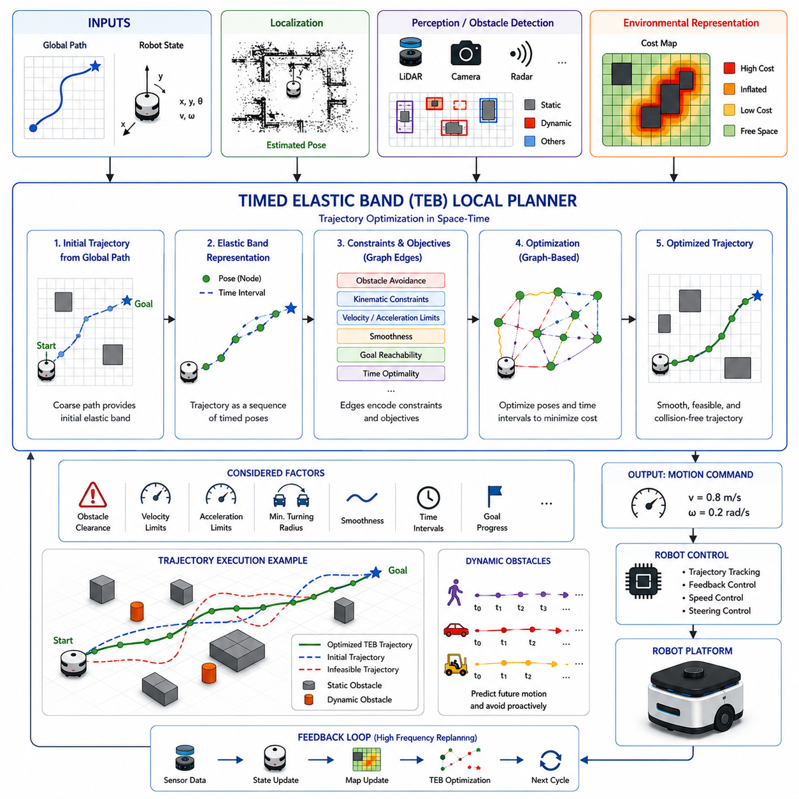
The Timed Elastic Band (TEB) Local Planner is one of the most advanced and widely adopted local path planning algorithms in modern autonomous mobile robot navigation systems. Unlike traditional local planners that primarily operate in velocity space, TEB approaches navigation as a trajectory optimization problem. It simultaneously considers the robot’s kinematic constraints, dynamic constraints, obstacle avoidance requirements, temporal behavior, and goal-reaching objectives within a unified optimization framework. Because of its ability to generate smooth, efficient, and dynamically feasible trajectories, TEB has become a popular choice for autonomous mobile robots operating in complex environments such as warehouses, factories, hospitals, logistics centers, service facilities, and outdoor autonomous platforms.
The fundamental idea behind TEB is to represent a robot trajectory as an elastic band stretched between the robot’s current position and the target location. The trajectory consists of a sequence of poses connected by temporal intervals. Instead of treating the path as a fixed geometric curve, TEB treats it as a flexible structure that can be continuously deformed and optimized. The planner adjusts both the spatial arrangement of trajectory points and the timing between them, allowing it to find a trajectory that satisfies multiple constraints simultaneously.
The name “Timed Elastic Band” originates from this representation. The elastic band analogy reflects the ability of the trajectory to stretch, compress, bend, and reshape itself in response to environmental conditions. The time component differentiates TEB from purely geometric path planners by explicitly incorporating temporal information into the optimization process. As a result, TEB can reason not only about where the robot should move but also about when it should occupy specific positions along its path.
Within a typical navigation architecture, the global planner first generates a coarse path from the robot’s current position to the destination. This global path serves as a reference rather than a strict trajectory. The TEB planner receives the global path, the robot’s current state, environmental information from perception systems, and various motion constraints. Using these inputs, it constructs an initial trajectory and continuously optimizes it as the robot moves through the environment.
A distinguishing feature of TEB is its graph-based optimization formulation. The trajectory is represented as a graph in which nodes correspond to robot poses and temporal intervals. Edges represent constraints and objectives that influence the trajectory. Examples include obstacle avoidance constraints, velocity limits, acceleration limits, turning radius constraints, goal-reaching objectives, path smoothness requirements, and timing optimization criteria. The optimization process attempts to minimize a global objective function that incorporates all these factors.
Trajectory optimization in TEB is performed iteratively. Starting from an initial path, the optimizer continuously adjusts the positions of trajectory points and their associated time intervals. The optimization seeks to minimize trajectory cost while satisfying all constraints. This process is repeated at high frequency, allowing the planner to react dynamically to environmental changes. The resulting trajectory is both spatially and temporally optimized.
One of the major advantages of TEB is its ability to explicitly handle robot kinematics. Different robots possess different motion capabilities. Differential-drive robots, skid-steer platforms, omnidirectional robots, Ackermann steering vehicles, and articulated systems all have unique kinematic constraints. TEB incorporates these constraints directly into the optimization process. Generated trajectories therefore remain physically feasible and executable by the actual robot platform.
Obstacle avoidance is deeply integrated into the TEB optimization framework. Obstacles are represented as constraints that exert virtual repulsive forces on the trajectory. When obstacles are detected, the optimizer automatically modifies the trajectory to maintain safe clearance distances. Unlike reactive obstacle avoidance methods that make local corrections after trajectory generation, TEB incorporates obstacle information directly into the trajectory optimization process. This often produces smoother and more efficient navigation behavior.
The planner supports both static and dynamic obstacle avoidance. Static obstacles such as walls, machinery, shelving units, barriers, and infrastructure elements are incorporated into the optimization problem through geometric constraints. Dynamic obstacles such as pedestrians, vehicles, forklifts, and other robots require prediction of future motion. TEB can integrate dynamic obstacle tracking information and modify trajectories proactively based on predicted future interactions rather than reacting only to current obstacle positions.
Temporal optimization is one of the defining characteristics of TEB. Traditional path planners often focus solely on geometric path quality. TEB optimizes both trajectory geometry and execution timing. The planner determines not only the shape of the path but also the speed profile along the path. This allows the robot to accelerate, decelerate, or pause when necessary. The explicit treatment of time enables smoother motion and more natural obstacle avoidance behavior.
Velocity and acceleration constraints play an important role in the optimization process. Every robot has maximum velocity, acceleration, deceleration, and angular velocity limits. Exceeding these limits may result in unstable motion or mechanical stress. TEB incorporates these constraints directly into the optimization objective, ensuring that generated trajectories remain within safe operational boundaries.
Trajectory smoothness is another critical objective. Sudden changes in velocity, acceleration, or curvature can negatively affect navigation performance, passenger comfort, payload stability, and energy efficiency. TEB minimizes abrupt trajectory changes and generates smooth continuous motion. This characteristic is particularly valuable for robots carrying sensitive payloads, medical equipment, or fragile materials.
The ability to handle narrow passages is one of TEB’s most recognized strengths. Traditional local planners often struggle in constrained environments because they evaluate only short-term motion commands. TEB considers an entire optimized trajectory and can therefore reason about future spatial constraints. This allows the planner to navigate effectively through doorways, corridors, docking stations, storage aisles, and other confined spaces.
TEB performs exceptionally well in environments requiring precise maneuvering. Docking operations, charging station alignment, elevator entry, automatic parking, trailer positioning, and pallet engagement often demand highly accurate motion planning. The optimization-based nature of TEB allows it to generate trajectories that satisfy strict positional and orientation requirements while maintaining smooth motion characteristics.
Multi-objective optimization forms the foundation of TEB’s decision-making process. Numerous factors influence trajectory quality simultaneously. These include obstacle clearance, travel time, trajectory length, smoothness, energy consumption, goal progression, velocity limits, acceleration limits, and vehicle-specific constraints. TEB combines these objectives into a unified optimization framework and searches for solutions that balance competing requirements.
The optimization engine typically relies on sparse graph optimization techniques. Libraries such as g2o are commonly used to solve the underlying optimization problem efficiently. Sparse optimization methods enable real-time performance despite the complexity of the optimization process. The graph structure allows TEB to scale effectively while maintaining computational efficiency suitable for embedded robotic systems.
A significant advantage of TEB compared with Dynamic Window Approach is its ability to reason over an entire trajectory horizon rather than evaluating isolated velocity commands. DWA focuses primarily on short-term motion selection, whereas TEB optimizes a complete future trajectory. This broader planning horizon often results in smoother navigation, improved obstacle avoidance, and more efficient goal-reaching behavior.
Localization accuracy directly affects TEB performance. The planner assumes that the robot’s current pose estimate is sufficiently accurate. Errors in localization can distort trajectory optimization and lead to suboptimal navigation decisions. Consequently, TEB is frequently combined with advanced localization technologies including LiDAR localization, Visual SLAM, GNSS-RTK, Visual-Inertial Odometry, and multi-sensor fusion systems.
TEB is widely used in ROS and ROS 2 navigation frameworks. It became especially popular as an alternative to DWA because of its superior trajectory quality and enhanced support for complex kinematic constraints. Many industrial robotics companies have adopted TEB for production systems requiring smooth navigation, reliable obstacle avoidance, and advanced maneuvering capabilities.
Outdoor autonomous robots can also benefit from TEB, although additional considerations are often required. Outdoor environments introduce terrain variability, slope conditions, traction limitations, weather effects, and large-scale navigation challenges. Extended TEB implementations may incorporate terrain costs, stability constraints, slope limitations, and traversability analysis into the optimization framework.
Heavy-duty autonomous vehicles and industrial robots present additional complexity. Large robots possess significant inertia and longer stopping distances. TEB can incorporate these characteristics through velocity and acceleration constraints. More advanced implementations may integrate vehicle dynamics models to further improve planning accuracy for high-mass systems.
Towing AMRs represent a particularly challenging application. Trailer articulation introduces nonlinear constraints that cannot be adequately addressed using simple kinematic models. Specialized TEB extensions can model trailer geometry, articulation angles, off-tracking behavior, and reverse-driving dynamics. These capabilities make TEB suitable for advanced logistics and industrial towing applications.
Dynamic obstacle avoidance benefits greatly from TEB’s predictive capabilities. By incorporating future obstacle motion into the optimization process, the planner can generate trajectories that proactively avoid conflicts. This predictive behavior improves safety and reduces abrupt trajectory modifications. In crowded environments, the robot can anticipate pedestrian movements and adjust its path smoothly rather than reacting suddenly.
Human-aware navigation can also be integrated into the TEB framework. Social navigation constraints encourage the robot to maintain comfortable distances from people, avoid cutting across pedestrian paths, and exhibit predictable motion behavior. These enhancements improve safety, user acceptance, and overall operational quality in public environments.
One challenge associated with TEB is parameter tuning. The optimization framework contains numerous weighting factors that influence planner behavior. Improper parameter selection can result in overly aggressive trajectories, excessive conservatism, oscillatory motion, or reduced obstacle clearance. Achieving optimal performance often requires extensive simulation and field testing.
Computational complexity is another consideration. Although sparse graph optimization enables real-time execution, TEB generally requires more computational resources than simpler local planners such as DWA. Modern edge computing platforms including NVIDIA Jetson Orin NX, Jetson AGX Orin, Jetson Thor, and industrial GPU-based systems provide sufficient performance for most practical deployments.
Simulation plays a critical role in TEB development and validation. Environments such as Isaac Sim, Gazebo, Webots, and digital twin platforms allow engineers to evaluate planner behavior across thousands of scenarios. Testing typically includes obstacle avoidance, narrow corridor navigation, docking operations, dynamic obstacle interaction, emergency situations, recovery behaviors, and multi-robot coordination.
Performance evaluation focuses on trajectory smoothness, obstacle clearance, computational latency, navigation success rate, travel time, energy efficiency, path tracking accuracy, and recovery capability. Comparative studies frequently demonstrate that TEB produces smoother trajectories and better obstacle avoidance performance than many traditional local planning approaches.
Recent developments in artificial intelligence are influencing the future evolution of TEB. Machine learning techniques can improve obstacle prediction, optimize parameter tuning, and enhance trajectory evaluation. Hybrid architectures combining optimization-based planning with AI-driven perception and prediction systems are becoming increasingly common. These approaches preserve the reliability of classical optimization while leveraging the adaptability of data-driven methods.
As autonomous navigation systems continue to advance, TEB remains one of the most sophisticated and practical local planning algorithms available. Its ability to optimize complete trajectories, explicitly model temporal behavior, handle complex kinematic constraints, and integrate obstacle avoidance within a unified optimization framework makes it exceptionally well suited for modern autonomous robots. Future robotic systems will likely continue building upon the principles established by TEB, combining optimization, perception, prediction, and artificial intelligence to achieve increasingly intelligent, safe, and efficient autonomous navigation.

03.5 Velocity and Acceleration Control
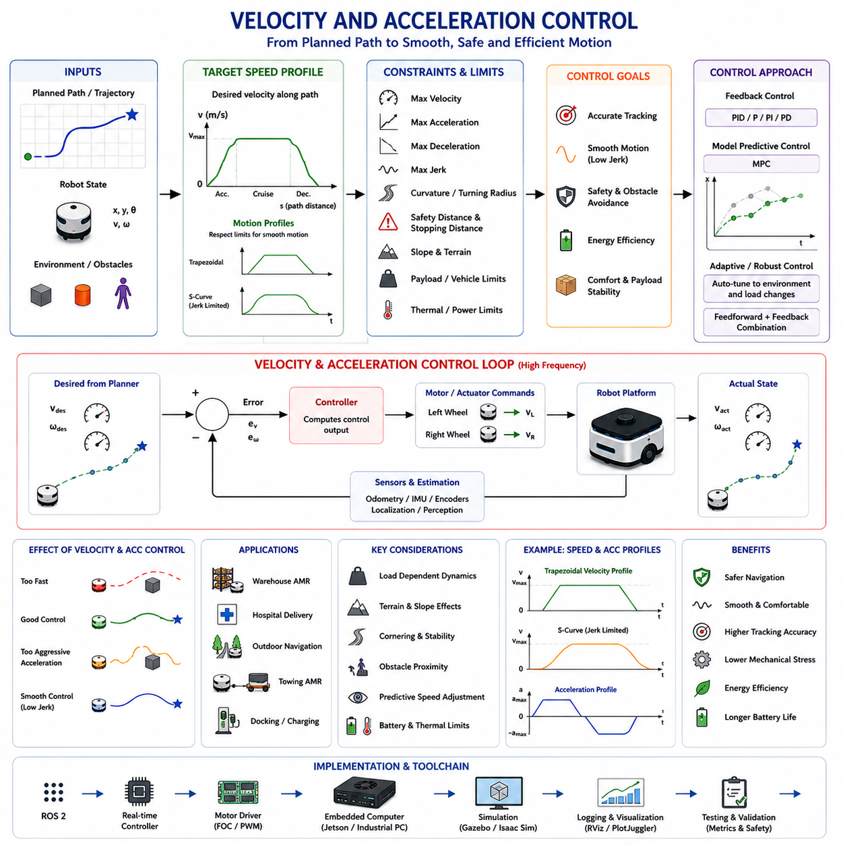
Velocity and Acceleration Control is one of the most fundamental components of autonomous mobile robot navigation because it directly determines how a robot moves through its environment. While path planning algorithms define where the robot should travel, velocity and acceleration control determine how the robot follows the planned path safely, efficiently, and smoothly. Even the most sophisticated path planner becomes ineffective if the robot cannot accurately execute the generated trajectory. Therefore, velocity and acceleration control serve as the bridge between navigation planning and physical vehicle motion, transforming planned trajectories into executable motor commands. This topic belongs to the Local Path Planning section because real-time speed regulation and acceleration management are critical elements of local trajectory execution and obstacle-aware navigation.
In autonomous navigation systems, velocity refers to the rate of positional change over time, while acceleration refers to the rate of velocity change. Both quantities must be controlled continuously throughout robot operation. Velocity determines how fast the robot travels, whereas acceleration governs how quickly the robot can increase or decrease speed. Together, these variables influence safety, efficiency, comfort, energy consumption, mechanical stress, and overall navigation performance.
The importance of velocity and acceleration control becomes evident when considering real-world operating conditions. Robots rarely move at constant speed. They must accelerate when departing from a stationary position, decelerate when approaching goals, slow down near obstacles, stop at intersections, adjust speed when encountering pedestrians, and modify acceleration according to environmental conditions. Effective navigation therefore requires continuous regulation of both velocity and acceleration rather than simple speed commands.
Modern navigation architectures typically separate planning and control into multiple layers. Global planners generate long-range routes. Local planners generate collision-free trajectories. Velocity and acceleration controllers execute these trajectories while respecting robot dynamics and environmental constraints. This layered structure allows each subsystem to focus on specific aspects of navigation while maintaining overall system stability.
Velocity control begins with the definition of desired speed profiles. A speed profile describes how the robot's velocity should evolve along a planned trajectory. Instead of moving at maximum speed continuously, the robot follows a velocity schedule that accounts for path curvature, obstacle proximity, safety requirements, vehicle limitations, and operational objectives. The resulting motion is smoother, safer, and more energy efficient.
Trajectory-following controllers continuously compare desired velocity with actual velocity. Any discrepancy generates corrective control actions. Feedback control systems such as PID controllers, Model Predictive Controllers, adaptive controllers, and robust control algorithms are commonly used to minimize tracking error. Accurate velocity tracking ensures that the robot follows the intended trajectory with high precision.
Acceleration control is equally important because sudden changes in velocity can create instability and discomfort. Excessive acceleration may cause wheel slip, payload movement, mechanical stress, or loss of traction. Excessive deceleration may create dangerous stopping behavior or destabilize carried loads. Acceleration constraints therefore serve as essential safety and performance boundaries.
A key concept in velocity and acceleration control is motion profiling. Motion profiles define how velocity changes over time while respecting acceleration limits. Common profiles include trapezoidal velocity profiles and S-curve velocity profiles. Trapezoidal profiles consist of acceleration, constant velocity, and deceleration phases. S-curve profiles introduce smooth transitions between acceleration phases, reducing jerk and improving motion quality.
Jerk represents the rate of change of acceleration. Although often overlooked in basic navigation systems, jerk significantly influences ride quality, mechanical wear, and payload stability. Abrupt acceleration changes can produce vibrations, oscillations, and discomfort. Advanced velocity controllers therefore incorporate jerk limitations to generate smoother motion trajectories.
Path curvature strongly influences velocity selection. When a robot travels along a straight path, higher velocities are generally permissible. As path curvature increases, velocity must be reduced to maintain stability and avoid excessive lateral forces. This relationship becomes especially important for high-speed autonomous vehicles and outdoor mobile robots operating on uneven terrain.
Cornering behavior illustrates the interaction between velocity and acceleration control. During turns, centripetal acceleration increases with both velocity and curvature. If speed is too high, the robot may experience wheel slip, reduced steering performance, or rollover risk. Navigation systems therefore calculate safe cornering velocities based on vehicle dynamics and environmental conditions.
Differential-drive robots, omnidirectional robots, skid-steer vehicles, Ackermann steering platforms, and articulated systems each require different velocity control strategies. Differential-drive robots regulate left and right wheel velocities independently. Omnidirectional robots coordinate multiple wheel vectors simultaneously. Ackermann vehicles control steering angles and forward velocity together. Articulated systems introduce additional dynamic constraints related to joint motion and multi-body interactions.
Industrial AMRs operating in warehouses and factories often use velocity control to balance productivity and safety. High speeds improve throughput and reduce task completion times. However, increased velocity reduces reaction time and increases stopping distance. Industrial navigation systems therefore dynamically adjust velocity according to environmental context, maintaining efficient operation without compromising safety.
Obstacle-aware velocity control is an important feature of modern navigation systems. As obstacles approach, the robot gradually reduces speed rather than waiting until emergency braking becomes necessary. Dynamic safety zones expand and contract according to velocity, ensuring that stopping distances remain sufficient under all operating conditions. This behavior improves both safety and motion smoothness.
Human-aware navigation introduces additional velocity constraints. Robots operating near people must move predictably and comfortably. Sudden acceleration or abrupt braking may startle pedestrians and reduce trust in robotic systems. Human-aware controllers therefore employ conservative acceleration profiles, reduced velocities, and smoother trajectory execution when humans are nearby.
Stopping distance is a critical consideration in velocity control. Stopping distance depends on current velocity, deceleration capability, surface traction, payload mass, and environmental conditions. Accurate estimation of stopping distance allows navigation systems to determine safe operating speeds and maintain sufficient obstacle clearance.
Outdoor autonomous robots face unique velocity control challenges. Terrain conditions, slopes, weather effects, surface friction, vegetation, mud, gravel, and uneven ground all influence vehicle dynamics. Velocity limits must adapt continuously to environmental conditions. Traversability analysis and terrain classification systems often provide input to velocity controllers, allowing robots to reduce speed in difficult terrain.
Slope navigation requires special attention. Uphill travel demands increased propulsion effort, while downhill travel requires controlled braking. Excessive downhill acceleration can create safety hazards, especially for heavy robots. Velocity control systems therefore incorporate slope estimation and gravity compensation mechanisms to maintain stable operation.
Heavy-payload robots present additional challenges because vehicle mass directly affects acceleration and braking performance. A robot carrying a 500 kg payload behaves differently from the same robot operating without load. Navigation systems must account for load-dependent dynamics when calculating velocity and acceleration limits. Failure to do so may result in unsafe stopping behavior or trajectory tracking errors.
Towing AMRs represent one of the most demanding applications of velocity and acceleration control. When towing trailers weighing several tons, acceleration capability decreases significantly while stopping distance increases. Trailer dynamics introduce oscillations, articulation constraints, and off-tracking effects. Velocity controllers must therefore coordinate towing vehicle motion with trailer behavior to maintain stability and safety.
Model Predictive Control has become increasingly popular for advanced velocity and acceleration regulation. MPC predicts future system behavior over a finite horizon and optimizes control inputs accordingly. Unlike traditional feedback controllers that react primarily to current errors, MPC anticipates future conditions and generates proactive control actions. This predictive capability improves trajectory tracking accuracy and dynamic performance.
Adaptive control methods further enhance navigation performance by adjusting controller parameters in response to changing operating conditions. Vehicle mass, terrain characteristics, tire wear, payload distribution, and environmental factors may all vary during operation. Adaptive controllers compensate for these variations automatically, maintaining consistent performance across diverse scenarios.
Artificial intelligence is increasingly influencing velocity control strategies. Machine learning models can estimate terrain properties, predict vehicle behavior, optimize speed profiles, and improve energy efficiency. Reinforcement learning approaches can learn optimal velocity control policies through simulation and real-world experience. Nevertheless, safety-critical industrial systems typically combine AI techniques with conventional control theory to ensure reliability and predictability.
Energy efficiency is closely related to velocity and acceleration control. Aggressive acceleration consumes more energy and increases battery usage. Frequent stop-and-go behavior reduces operational efficiency. Smooth acceleration profiles, optimized cruising speeds, and predictive deceleration strategies can significantly extend battery life and increase operational range.
Thermal management considerations also influence velocity control. High acceleration demands increase motor current consumption and generate additional heat. Prolonged operation at high speeds may elevate temperatures within motors, motor drivers, batteries, and power electronics. Advanced control systems monitor thermal conditions and adjust performance limits when necessary to prevent overheating.
Safety-certified navigation systems often incorporate multiple layers of velocity supervision. Functional safety controllers independently monitor speed limits and acceleration constraints. If primary control systems fail or generate unsafe commands, safety controllers intervene to reduce speed or initiate emergency stops. This layered architecture is essential for compliance with industrial safety standards.
Real-time implementation requires high-frequency control loops. Velocity controllers commonly operate at frequencies ranging from tens to hundreds of Hertz. Motor controllers may run at even higher rates. Low-latency communication between navigation, control, and actuation subsystems ensures accurate and responsive motion execution.
Simulation plays a critical role in developing velocity and acceleration control systems. Platforms such as Isaac Sim, Gazebo, Webots, and digital twin environments allow engineers to evaluate controller behavior under a wide variety of conditions. Acceleration performance, braking behavior, obstacle interactions, payload variations, slope navigation, emergency stopping, and fault conditions can all be tested before field deployment.
Performance evaluation typically includes velocity tracking error, acceleration tracking error, stopping distance accuracy, energy efficiency, passenger comfort, payload stability, response time, overshoot, settling time, and safety compliance. These metrics provide quantitative measures of controller effectiveness and support system validation activities.
Debugging velocity control systems often involves analysis of recorded telemetry data. Engineers examine commanded velocity, measured velocity, acceleration profiles, motor currents, steering angles, localization accuracy, and obstacle information. ROS 2 bag files, control logs, simulation replay tools, and visualization platforms provide valuable insight into system behavior and facilitate root-cause analysis.
In large-scale robotic fleets, velocity control becomes part of a broader traffic management strategy. Fleet management systems may impose speed restrictions in specific zones, coordinate robot interactions at intersections, and optimize overall traffic flow. Local velocity controllers then enforce these constraints while maintaining smooth and safe motion execution.
Future velocity and acceleration control systems will become increasingly intelligent and predictive. Integration with world models, semantic understanding, AI-based behavior planning, and fleet-level optimization will allow robots to anticipate environmental changes before they occur. Rather than simply responding to immediate conditions, future systems will proactively adjust velocity profiles according to predicted human behavior, traffic patterns, mission priorities, weather conditions, and operational objectives.
As autonomous mobile robots continue to expand into factories, hospitals, logistics centers, outdoor industrial sites, agricultural environments, smart cities, and infrastructure inspection applications, velocity and acceleration control will remain one of the most critical elements of autonomous navigation. It serves as the final layer that converts planning decisions into physical motion, ensuring that robots move safely, efficiently, comfortably, and reliably while operating in increasingly complex real-world environments.

03.6 Real-Time Path Adjustment
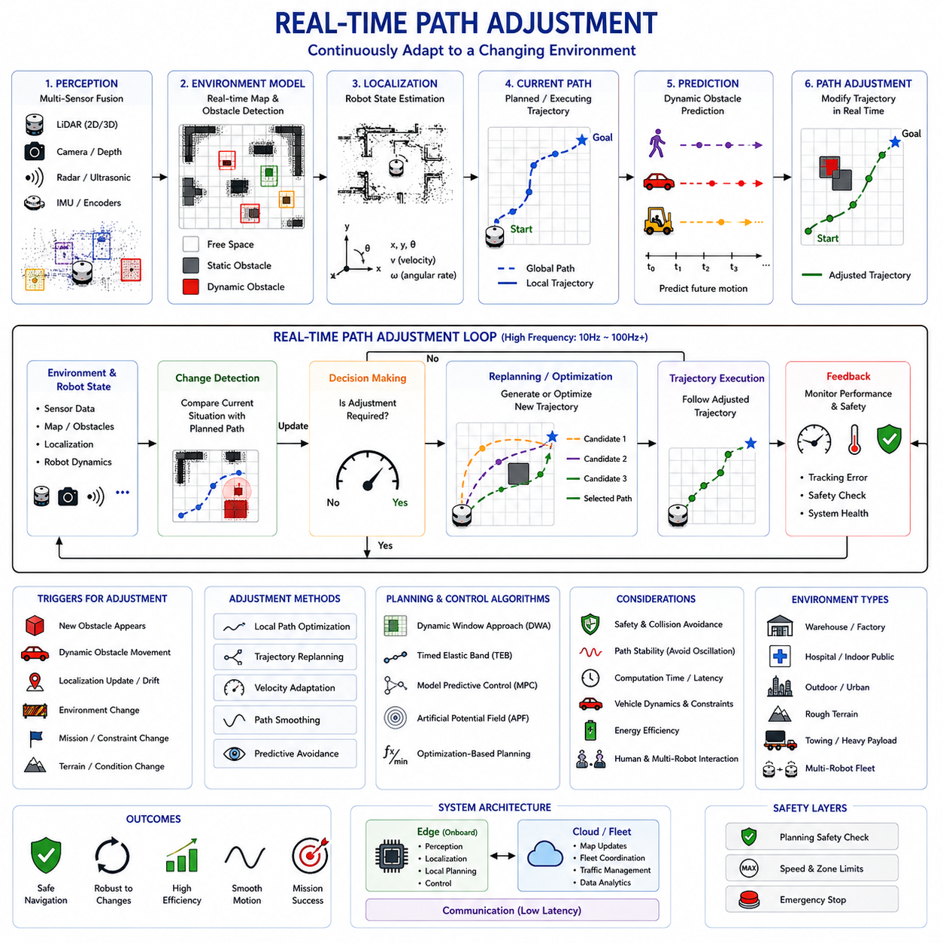
Real-Time Path Adjustment is a critical capability within autonomous navigation systems that enables robots to continuously modify their planned trajectories in response to changing environmental conditions. While global path planning determines a long-range route from a starting position to a destination and local planning generates executable trajectories within a limited horizon, real-time path adjustment provides the dynamic adaptation layer that allows robots to respond immediately to unexpected events, newly detected obstacles, environmental changes, localization updates, and operational constraints. Without real-time path adjustment, even the most accurate path planner would become ineffective in real-world environments where conditions continuously evolve.
The fundamental purpose of real-time path adjustment is to maintain safe, efficient, and reliable navigation despite uncertainty and environmental variability. Autonomous robots rarely operate in perfectly static environments. Warehouses contain moving forklifts and workers. Hospitals experience continuous pedestrian traffic. Outdoor environments include vehicles, weather changes, animals, vegetation, and terrain variations. Industrial facilities frequently change layouts due to operational activities. In such environments, precomputed paths rapidly become outdated. Real-time path adjustment allows the navigation system to update its trajectory continuously while maintaining progress toward mission objectives.
At the highest level, real-time path adjustment can be viewed as a closed-loop navigation process. Sensors continuously observe the environment. Perception systems interpret sensor data and construct an environmental model. Localization systems estimate the robot’s current state. Planning algorithms compare the planned trajectory with the current situation and determine whether adjustments are required. Updated trajectories are generated and immediately executed by the control system. This continuous feedback loop enables autonomous navigation under dynamic and uncertain conditions.
A key characteristic of real-time path adjustment is responsiveness. The navigation system must detect environmental changes and modify its trajectory within a sufficiently short period of time. Delayed reactions can result in inefficient navigation, collision risks, mission failure, or unsafe operation. Consequently, real-time path adjustment algorithms are designed to operate at high frequencies, often ranging from 10 Hz to over 100 Hz depending on the application and computational resources available.
Environmental perception serves as the foundation of real-time path adjustment. The robot must first understand its surroundings before any trajectory modifications can be made. Modern robots utilize a diverse sensor suite that may include 2D LiDAR, 3D LiDAR, RGB cameras, depth cameras, radar systems, ultrasonic sensors, thermal cameras, GNSS receivers, IMUs, and wheel encoders. Sensor fusion algorithms combine these heterogeneous data sources into a coherent environmental representation that supports navigation decision-making.
Localization updates are another important trigger for path adjustment. Even highly accurate localization systems experience small estimation errors. As the robot moves, accumulated uncertainty may alter the estimated position relative to the original planned trajectory. Real-time path adjustment continuously incorporates updated localization information, ensuring that navigation decisions remain consistent with the robot’s actual position and orientation.
Obstacle detection is one of the most common reasons for trajectory modification. When a previously unknown obstacle appears within the planned path, the navigation system must rapidly generate an alternative route. Static obstacles such as pallets, equipment, barriers, and construction materials may block previously accessible areas. Dynamic obstacles including pedestrians, vehicles, forklifts, and other robots introduce additional complexity because their positions continue to change over time.
Dynamic obstacle handling requires predictive capabilities. Reactive avoidance alone is often insufficient because by the time a moving obstacle reaches a dangerous position, it may be too late to generate a safe response. Real-time path adjustment systems therefore incorporate prediction models that estimate future obstacle trajectories. These predictions allow the robot to anticipate interactions and modify its path proactively rather than reactively.
Trajectory replanning is a central mechanism within real-time path adjustment. Replanning may involve minor modifications to an existing trajectory or complete regeneration of a new local path. The choice depends on the severity of environmental changes. Small deviations can often be handled through local optimization, while significant environmental disruptions may require substantial path restructuring.
Local path optimization plays an important role in maintaining smooth navigation behavior. Rather than generating entirely new paths for every environmental update, many systems optimize existing trajectories incrementally. This approach reduces computational overhead and prevents unnecessary path oscillations. Optimization algorithms continuously adjust trajectory geometry, timing, velocity profiles, and obstacle clearance while preserving overall navigation objectives.
Real-time path adjustment is closely related to obstacle-aware local planning. Algorithms such as Dynamic Window Approach, Timed Elastic Band, Model Predictive Control, Artificial Potential Fields, and optimization-based planners all incorporate path adjustment mechanisms. These algorithms continuously evaluate candidate trajectories and select those that best satisfy current environmental conditions and operational constraints.
Model Predictive Control provides particularly powerful real-time adjustment capabilities. MPC predicts future vehicle behavior over a finite horizon and repeatedly solves an optimization problem using updated environmental information. Because optimization is performed continuously, the generated trajectory automatically adapts to changing conditions. This predictive framework allows MPC to anticipate future disturbances and generate smooth corrective actions.
Timed Elastic Band planners also excel at real-time path adjustment. The trajectory is represented as an elastic structure that can deform in response to obstacles, environmental changes, and updated constraints. Rather than generating entirely new trajectories, TEB continuously reshapes the existing trajectory, producing smooth navigation behavior while maintaining computational efficiency.
Velocity adaptation represents another essential aspect of real-time path adjustment. Not all adjustments require geometric path changes. In many cases, modifying velocity profiles alone can resolve potential conflicts. For example, slowing down may allow a pedestrian to pass safely without requiring a path deviation. Similarly, acceleration adjustments can improve safety near obstacles, intersections, or narrow passages.
Human-aware navigation introduces additional adjustment requirements. Humans exhibit unpredictable behavior and often move in socially meaningful ways. Robots operating near people must adapt not only to physical obstacles but also to social expectations. Real-time path adjustment systems may modify speed, trajectory shape, clearance distance, and motion timing to ensure comfortable and socially acceptable interactions.
Multi-robot environments create another layer of complexity. Warehouses, factories, hospitals, and logistics centers increasingly deploy fleets of autonomous robots operating simultaneously. Each robot becomes a dynamic obstacle for other robots. Real-time path adjustment therefore extends beyond individual navigation and becomes part of coordinated traffic management. Fleet management systems often provide shared situational awareness and traffic coordination information that influences local trajectory modifications.
Industrial environments present unique path adjustment challenges. Temporary work zones, moving machinery, material handling equipment, and changing operational conditions frequently alter navigable space. Real-time path adjustment allows robots to continue operating safely despite these changes without requiring complete remapping or mission interruption.
Outdoor autonomous robots encounter even greater variability. Terrain conditions may change due to weather, erosion, vegetation growth, mud, snow, or debris. GNSS quality may fluctuate. New obstacles may appear unexpectedly. Real-time path adjustment systems must therefore integrate terrain analysis, traversability estimation, and environmental classification into the trajectory modification process.
Terrain-aware adjustment becomes particularly important for outdoor navigation. A path that appears geometrically feasible may become unsafe due to slippery surfaces, excessive slope angles, unstable ground, or soft soil conditions. Real-time traversability analysis enables robots to identify such hazards and modify trajectories accordingly.
Heavy-duty autonomous vehicles require special consideration because of their substantial inertia and longer stopping distances. Path adjustments must account for vehicle dynamics, braking performance, load distribution, and stability constraints. Aggressive maneuvers that may be acceptable for lightweight robots can become unsafe for heavy industrial platforms.
Towing robots introduce additional complexity because the motion of the trailer must be considered alongside the towing vehicle. Trailer articulation angles, off-tracking effects, reverse driving constraints, and multi-body dynamics influence feasible path adjustments. Advanced planning systems incorporate these factors into real-time trajectory modification algorithms.
Safety remains the highest priority throughout the path adjustment process. Every candidate trajectory must satisfy collision avoidance requirements, vehicle dynamic constraints, operational safety margins, and regulatory standards. Independent safety monitors often validate adjusted trajectories before execution. Emergency stop systems remain active as a final protection layer should planning algorithms fail to generate safe alternatives.
Path stability is another important consideration. Excessively frequent trajectory changes can produce oscillatory behavior, reduced efficiency, passenger discomfort, and unpredictable robot motion. Real-time adjustment systems therefore balance responsiveness with stability. Minor environmental fluctuations should not trigger unnecessary path modifications. Instead, planners use filtering, hysteresis mechanisms, and confidence thresholds to determine when adjustments are truly necessary.
Computational efficiency directly influences adjustment quality. Because environmental conditions may change rapidly, planning algorithms must generate updated trajectories within strict time constraints. High-performance embedded computing platforms such as NVIDIA Jetson Orin NX, Jetson AGX Orin, Jetson Thor, and industrial GPU-based computers enable increasingly sophisticated real-time adjustment algorithms while maintaining low latency.
Artificial intelligence is becoming increasingly important within real-time path adjustment systems. Machine learning models improve obstacle detection, motion prediction, environmental understanding, and trajectory evaluation. Reinforcement learning approaches can learn adaptive adjustment policies through simulation and operational experience. World models provide predictive representations of future environmental states that support proactive navigation decisions.
Cloud and edge computing architectures further enhance path adjustment capabilities. Edge systems perform latency-sensitive local computations, while cloud systems provide fleet coordination, shared environmental knowledge, traffic optimization, and map updates. This hybrid architecture combines real-time responsiveness with large-scale situational awareness.
Simulation plays a vital role in developing and validating real-time path adjustment algorithms. Platforms such as Isaac Sim, Gazebo, Webots, CARLA, and digital twin environments allow engineers to test thousands of scenarios involving dynamic obstacles, changing environments, traffic interactions, emergency situations, and complex operational conditions. Such testing improves reliability while reducing development risk.
Performance evaluation focuses on metrics such as trajectory smoothness, obstacle clearance, navigation success rate, path efficiency, computation latency, recovery capability, energy consumption, mission completion time, and safety compliance. These metrics provide quantitative evidence of adjustment effectiveness under diverse operating conditions.
Failure recovery mechanisms are closely linked to real-time path adjustment. Situations may arise in which no safe trajectory can be found due to congestion, environmental uncertainty, localization failure, or blocked routes. Recovery strategies may include stopping safely, waiting for obstacles to clear, performing local exploration, requesting fleet assistance, or triggering higher-level mission replanning. Robust recovery capabilities are essential for long-term autonomous operation.
As autonomous navigation technology continues to advance, real-time path adjustment is evolving from reactive trajectory modification toward predictive and intelligent adaptation. Future systems will combine perception, localization, planning, prediction, world models, semantic understanding, and artificial intelligence into unified navigation architectures capable of anticipating environmental changes before they occur. Rather than merely responding to immediate obstacles, future robots will understand environmental intent, predict future interactions, coordinate with humans and other robots, and optimize trajectories continuously at both local and fleet-wide levels.
In modern autonomous robots, real-time path adjustment represents the operational intelligence that transforms static plans into adaptive behavior. It enables robots to function safely and effectively within complex, dynamic, and unpredictable environments while maintaining efficiency, reliability, and mission success. As robotics systems become more capable and widely deployed, real-time path adjustment will remain one of the foundational technologies that enable truly autonomous navigation.

03.7 Local Path Failure Handling
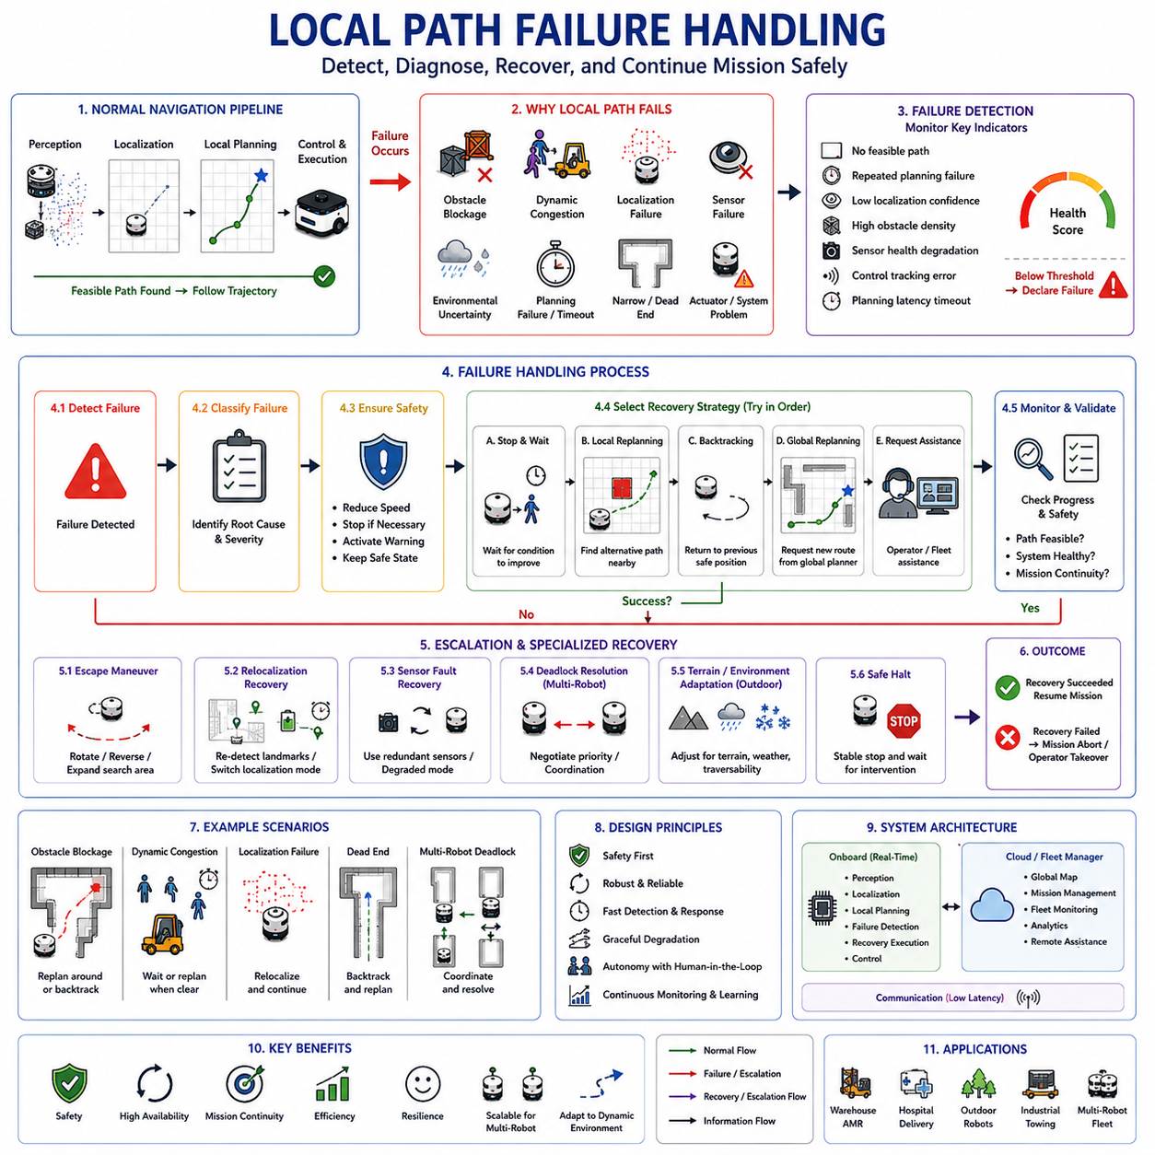
Local Path Failure Handling is a critical component of autonomous navigation systems because real-world environments are inherently uncertain, dynamic, and unpredictable. Even the most advanced local path planning algorithms cannot guarantee that a feasible trajectory will always be available. Obstacles may completely block a passage, localization accuracy may degrade, sensor failures may occur, environmental conditions may change unexpectedly, or dynamic objects may create situations in which no safe path can be generated. Under such circumstances, the navigation system must recognize that normal path planning has failed and execute appropriate recovery actions. Local Path Failure Handling provides the mechanisms that allow autonomous robots to respond safely and intelligently when local navigation objectives cannot be achieved through standard planning procedures.
The primary objective of local path failure handling is not simply to recover navigation functionality but to maintain overall system safety, operational reliability, and mission continuity. A failure-handling system must first detect that a failure has occurred, determine the root cause of the failure, evaluate available recovery options, select an appropriate corrective strategy, and continuously monitor recovery progress. This process transforms navigation failures from mission-ending events into manageable operational situations.
Local path failures can occur for many reasons. One of the most common causes is obstacle blockage. A previously available route may become completely obstructed by pallets, equipment, vehicles, construction materials, or temporary barriers. In warehouses, loading operations may temporarily block aisles. In hospitals, patient beds and medical equipment may obstruct corridors. In outdoor environments, fallen branches, parked vehicles, debris, or construction zones may prevent passage. When the planner cannot find a collision-free trajectory around such obstacles, a local path failure is generated.
Dynamic obstacle congestion represents another major source of planning failure. Unlike static obstacles, moving obstacles continuously change position. High pedestrian density, heavy forklift traffic, multiple interacting robots, or vehicle congestion may create situations in which safe navigation becomes temporarily impossible. Even though a path may theoretically exist, uncertainty regarding obstacle motion may prevent the planner from identifying a safe trajectory within the required planning horizon.
Localization failures frequently lead to local path planning failures. Every planning algorithm depends on accurate estimates of the robot’s position and orientation. If localization uncertainty becomes excessive, the planner can no longer guarantee that generated trajectories are safe. Localization degradation may result from sensor occlusion, poor environmental features, GNSS signal loss, repetitive structures, adverse weather conditions, lighting changes, or sensor malfunction. Under such circumstances, navigation systems often suspend normal path execution and initiate specialized recovery procedures.
Sensor failures can also trigger path planning failures. Modern autonomous robots depend on multiple perception sensors including LiDAR, cameras, radar, ultrasonic sensors, depth cameras, IMUs, and GNSS receivers. Failure of one or more sensors may reduce environmental awareness below acceptable safety thresholds. Navigation systems must therefore evaluate sensor health continuously and determine whether sufficient information remains available to support safe operation.
Environmental uncertainty is another important contributor to navigation failure. Dust, fog, rain, snow, smoke, reflections, transparent surfaces, moving vegetation, and changing lighting conditions can all degrade perception quality. In some situations, environmental uncertainty may prevent reliable obstacle detection or localization. Failure handling mechanisms must recognize such conditions and adapt navigation behavior accordingly.
Path planning algorithms themselves may encounter computational failures. Optimization-based planners may fail to converge. Sampling-based planners may be unable to identify feasible solutions within available computation time. Numerical instability, parameter tuning issues, software errors, or hardware resource limitations may also contribute to planning failures. Robust navigation architectures therefore include monitoring systems that verify planner performance continuously.
One of the most important aspects of local path failure handling is failure detection. The navigation system must determine when normal operation is no longer possible. Failure detection mechanisms monitor metrics such as path generation success rates, trajectory feasibility, obstacle clearance, localization confidence, sensor health, control performance, and planning latency. When predefined thresholds are exceeded, the system declares a navigation failure and transitions to recovery mode.
Failure classification is typically performed immediately after detection. Not all failures require the same response. Obstacle blockage, localization degradation, dynamic congestion, sensor malfunction, computational instability, and actuator problems each require different recovery strategies. Effective classification allows the navigation system to select the most appropriate corrective action rather than applying generic recovery procedures.
Safety always remains the highest priority during failure handling. Whenever uncertainty increases or safe navigation cannot be guaranteed, the robot must transition into a safe operational state. In many cases, this involves reducing speed, stopping motion, activating warning indicators, notifying supervisory systems, and maintaining a stable position until recovery actions can be executed. Safety-oriented behavior prevents failures from escalating into accidents.
Stop-and-wait recovery is one of the simplest and most commonly used failure-handling strategies. When a temporary obstruction blocks the path, the robot stops and waits for conditions to improve. This approach is particularly effective when dealing with moving pedestrians, forklifts, vehicles, or temporary congestion. By avoiding unnecessary replanning and aggressive maneuvering, stop-and-wait behavior often improves both safety and efficiency.
Local replanning is another common recovery mechanism. Rather than abandoning the mission entirely, the navigation system attempts to generate an alternative trajectory around the obstacle. Local replanning algorithms may modify path geometry, adjust velocity profiles, alter obstacle avoidance parameters, or expand the planning horizon. Successful local replanning allows the robot to continue toward its goal without requiring intervention from higher-level systems.
Global replanning becomes necessary when local recovery fails. If the local planner repeatedly fails to find a feasible solution, the navigation system may request a new route from the global planner. Global replanning considers larger-scale environmental information and may identify alternative corridors, routes, or navigation strategies that are unavailable within the local planning horizon.
Backtracking behavior is frequently used when robots become trapped in dead ends or highly constrained environments. The robot retraces a portion of its previous path until it reaches a location where alternative navigation options become available. Backtracking is particularly useful in narrow corridors, storage aisles, underground facilities, inspection tunnels, and cluttered industrial environments.
Escape maneuvers represent specialized recovery techniques designed to resolve local minima. Local minima occur when the planner becomes trapped in a situation where no locally optimal action appears available despite the existence of a valid solution. Examples include oscillation near obstacles, repeated turning behavior, and inability to exit confined spaces. Escape behaviors may involve reversing, rotating in place, expanding search regions, or temporarily relaxing optimization constraints.
Recovery behaviors often incorporate incremental escalation strategies. The system begins with minimally disruptive recovery actions and gradually increases intervention intensity if failures persist. For example, a robot may first wait briefly, then attempt local replanning, followed by backtracking, global replanning, and finally operator assistance requests. This hierarchical approach minimizes unnecessary disruptions while maintaining robust recovery capability.
Human intervention mechanisms remain important even in highly autonomous systems. Certain failures may exceed the capabilities of autonomous recovery algorithms. Persistent localization failures, severe sensor degradation, hardware faults, environmental hazards, or unexpected operational conditions may require assistance from human operators. Modern fleet management systems typically provide remote monitoring interfaces that allow operators to assess and resolve complex failure scenarios.
Multi-robot environments introduce unique failure-handling challenges. Robot-to-robot interactions can create deadlocks in narrow corridors, intersections, and shared workspaces. Deadlock resolution mechanisms coordinate navigation priorities, communication protocols, and traffic management strategies to restore system flow. Fleet-level coordination often plays a critical role in resolving such situations.
Localization recovery is a specialized branch of failure handling. When localization confidence drops below acceptable thresholds, navigation systems may initiate relocalization procedures. These procedures may involve revisiting known landmarks, performing active scanning behaviors, integrating additional sensor data, switching localization modes, or requesting external positioning assistance. Successful relocalization restores navigation capability without requiring mission termination.
Sensor fault recovery is equally important. Redundant sensor architectures allow navigation systems to continue operating despite individual sensor failures. Sensor fusion frameworks can dynamically adjust weighting factors according to sensor health. In some cases, degraded navigation modes may be activated, reducing speed and operational complexity while maintaining essential functionality.
Outdoor autonomous robots face additional recovery challenges. Terrain conditions, weather changes, vegetation growth, GNSS degradation, and environmental variability can significantly affect navigation performance. Failure-handling systems for outdoor robots often integrate terrain assessment, environmental classification, weather monitoring, and mobility estimation into recovery decision-making processes.
Heavy-duty autonomous vehicles require particularly conservative failure responses because of their mass, momentum, and stopping distances. Recovery actions must account for vehicle dynamics, payload stability, braking limitations, and operational safety margins. Aggressive maneuvers that may be acceptable for lightweight robots are often inappropriate for large industrial vehicles.
Towing robots introduce further complexity. Trailer articulation constraints, reverse-driving limitations, off-tracking effects, and multi-body dynamics significantly influence recovery behavior. Specialized failure-handling strategies are often required to safely recover towing systems from constrained situations.
Artificial intelligence is increasingly being applied to navigation failure handling. Machine learning models can classify failure types, predict recovery success probabilities, optimize recovery strategy selection, and identify emerging failure patterns. Reinforcement learning approaches can learn effective recovery policies through extensive simulation and operational experience. However, safety-critical recovery decisions typically remain governed by deterministic safety frameworks.
Simulation plays a vital role in developing and validating failure-handling systems. Platforms such as Isaac Sim, Gazebo, Webots, CARLA, and digital twin environments allow engineers to evaluate recovery behavior under thousands of failure scenarios. Obstacle blockages, sensor failures, localization degradation, deadlocks, environmental uncertainty, and emergency situations can all be tested systematically before deployment.
Performance evaluation focuses on metrics such as recovery success rate, recovery time, mission completion rate, safety compliance, operational availability, navigation efficiency, human intervention frequency, and overall system resilience. These metrics help quantify the effectiveness of failure-handling architectures and guide continuous improvement efforts.
Fleet management systems increasingly integrate navigation failure monitoring and recovery coordination. Centralized platforms can analyze failure trends across entire robot fleets, identify recurring environmental issues, optimize traffic flow, and coordinate recovery resources. This fleet-level perspective significantly improves operational reliability in large-scale deployments.
Future local path failure-handling systems will become increasingly predictive and autonomous. Rather than merely responding to failures after they occur, advanced systems will anticipate emerging problems and take preventive action before navigation capability is compromised. World models, semantic understanding, predictive analytics, and AI-driven decision-making will allow robots to recognize potential failure conditions early and adjust behavior proactively.
As autonomous robots expand into increasingly complex environments, local path failure handling will become even more important than path planning itself. The ability to recover safely from unexpected situations ultimately determines whether autonomous systems can achieve long-term operational reliability. A robot that never encounters failures exists only in simulation; a robot that can recognize, manage, and recover from failures safely is capable of operating effectively in the real world. Local Path Failure Handling therefore represents one of the foundational technologies required for truly resilient and dependable autonomous navigation systems.

03.8 Local Path Testing and Debugging
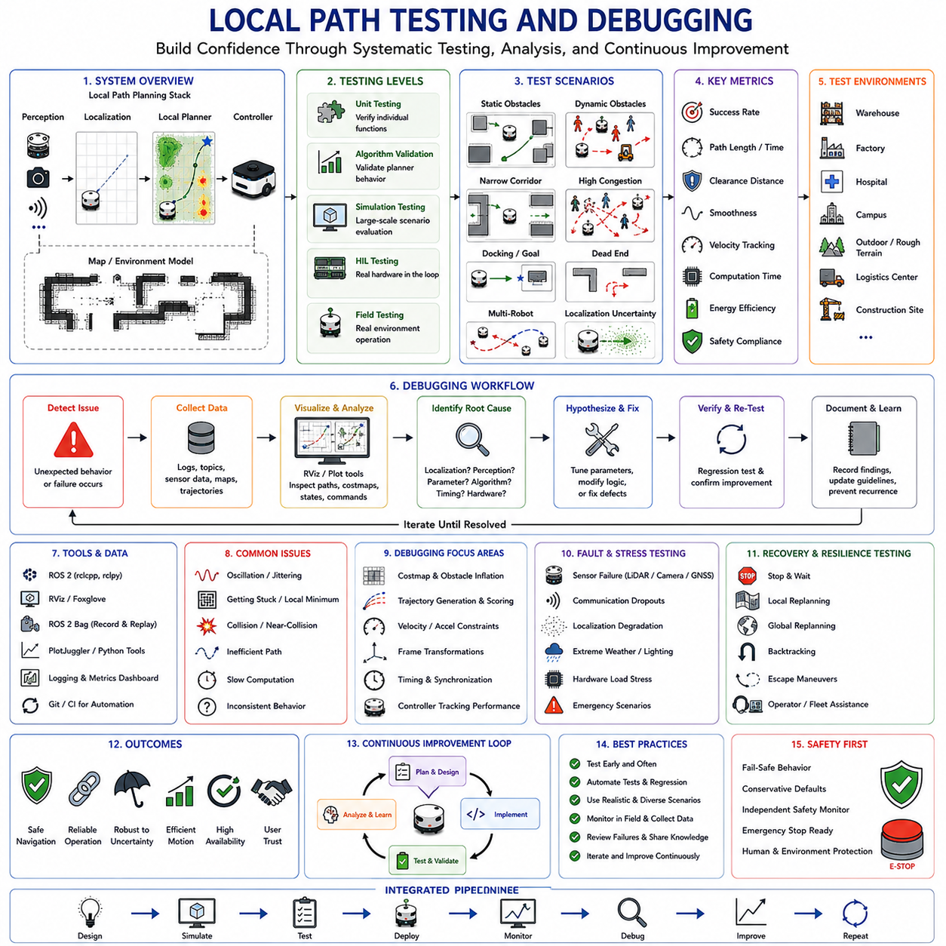
Local Path Testing and Debugging is a fundamental discipline in autonomous robot development because the effectiveness of a local path planning system cannot be determined solely through theoretical design or simulation results. Local planners operate at the interface between perception, localization, decision-making, and vehicle control, making them highly sensitive to real-world uncertainties and system integration challenges. Even when a local planner performs perfectly in simulation, unexpected behaviors may emerge when deployed on physical robots operating in dynamic environments. Consequently, systematic testing and debugging are essential for ensuring navigation safety, reliability, robustness, and operational efficiency.
The primary objective of local path testing is to verify that the navigation system can consistently generate safe, feasible, and efficient trajectories under a wide variety of operating conditions. The purpose of debugging is to identify the root causes of navigation failures, performance degradation, unexpected behaviors, and safety risks. Together, testing and debugging form the foundation of quality assurance for autonomous navigation systems.
Local path planning is significantly more complex to validate than many other software systems because navigation behavior emerges from interactions among multiple subsystems. Perception systems provide environmental information. Localization systems estimate robot position. Mapping systems represent the environment. Local planners generate trajectories. Vehicle controllers execute commands. Communication systems exchange data among components. A defect in any subsystem may manifest as a navigation problem even when the planner itself is functioning correctly. Effective testing therefore requires a holistic system-level perspective.
Testing activities typically begin with unit-level verification. Individual components of the local planner are evaluated independently to ensure correct functionality. Cost map generation, obstacle inflation, trajectory generation, collision checking, velocity sampling, optimization routines, and scoring functions are tested under controlled conditions. Unit testing helps identify algorithmic errors before full system integration begins.
Algorithm validation represents the next stage of testing. The objective is to determine whether the planner behaves according to its theoretical design. Developers verify that obstacle avoidance functions correctly, trajectory optimization converges appropriately, velocity constraints are respected, acceleration limits are enforced, and recovery behaviors activate when necessary. Controlled simulation environments provide repeatable conditions that facilitate algorithm evaluation.
Simulation plays a central role in local path testing because it allows developers to explore thousands of scenarios safely and efficiently. Platforms such as Isaac Sim, Gazebo, Webots, CARLA, and digital twin environments provide realistic representations of sensors, vehicle dynamics, obstacles, and environmental conditions. Simulations allow engineers to evaluate navigation behavior without exposing physical equipment or personnel to risk.
One of the most important aspects of simulation testing is scenario diversity. Simple navigation tasks rarely reveal significant weaknesses in local planning algorithms. Comprehensive testing requires a wide range of environmental conditions, including narrow corridors, dynamic obstacles, congested intersections, obstacle-rich environments, docking operations, dead ends, multi-robot interactions, emergency situations, and localization uncertainty scenarios. Diverse testing improves confidence in system robustness.
Static obstacle testing serves as a foundational validation activity. The planner must demonstrate its ability to generate collision-free trajectories around walls, barriers, equipment, shelving units, structural columns, and other fixed obstacles. Testing typically evaluates obstacle clearance distances, path smoothness, travel efficiency, and trajectory stability. Static obstacle tests establish baseline planner functionality before more complex dynamic scenarios are introduced.
Dynamic obstacle testing introduces moving objects such as pedestrians, forklifts, vehicles, and other robots. Dynamic environments present significantly greater challenges because obstacle positions change continuously. Testing focuses on collision avoidance performance, prediction accuracy, reaction times, trajectory adaptation behavior, and safety margins. Dynamic obstacle scenarios help validate the planner’s ability to operate in realistic environments.
Human interaction testing is increasingly important as autonomous robots become more common in public and industrial spaces. Human behavior is often unpredictable and difficult to model accurately. Testing evaluates how the robot responds to pedestrian movement, crowd dynamics, sudden direction changes, social navigation expectations, and personal space requirements. Successful human-aware navigation improves both safety and user acceptance.
Localization robustness testing examines planner behavior under varying levels of position uncertainty. Real-world localization systems are never perfectly accurate. GNSS degradation, SLAM drift, feature scarcity, sensor noise, and environmental changes can all reduce localization accuracy. Testing under degraded localization conditions helps determine whether the planner can maintain safe operation despite estimation uncertainty.
Sensor fault testing evaluates system resilience when perception data becomes unreliable. LiDAR failures, camera occlusions, radar interference, depth sensor degradation, GNSS loss, and communication disruptions are introduced intentionally during testing. Engineers observe how the navigation system responds and verify that appropriate recovery procedures are activated. Fault-tolerant behavior is particularly important for safety-critical applications.
Environmental stress testing explores extreme operating conditions that may challenge navigation performance. Examples include heavy rain, fog, snow, dust, smoke, low lighting, reflective surfaces, transparent obstacles, electromagnetic interference, and uneven terrain. Such testing reveals vulnerabilities that may not appear under normal operating conditions.
Performance testing focuses on quantitative measurements of navigation quality. Metrics commonly include path length, travel time, obstacle clearance distance, trajectory smoothness, velocity tracking accuracy, acceleration compliance, computational latency, energy consumption, and navigation success rate. Objective metrics provide a rigorous basis for evaluating planner performance and comparing alternative algorithms.
Real-time performance validation is particularly important because local planners operate under strict timing constraints. A planner that generates excellent trajectories but requires excessive computation time may be unsuitable for deployment. Testing therefore measures planning frequency, CPU utilization, GPU utilization, memory consumption, communication latency, and end-to-end response times. Real-time performance must remain acceptable under all expected operating conditions.
Integration testing evaluates interactions among navigation subsystems. Even when individual components perform correctly in isolation, integration issues may emerge during full system operation. Data synchronization problems, coordinate frame mismatches, timing inconsistencies, communication failures, and parameter conflicts can all affect navigation behavior. Integration testing verifies that all subsystems operate cohesively.
Hardware-in-the-loop testing bridges the gap between simulation and real-world deployment. Actual navigation software executes on production hardware while portions of the environment remain simulated. This approach allows engineers to evaluate computational performance, sensor interfaces, communication architectures, and controller behavior under realistic conditions without requiring full field deployment.
Field testing represents the final stage of validation. Physical robots operate within representative environments while engineers observe navigation behavior and collect performance data. Warehouses, factories, hospitals, campuses, agricultural fields, logistics centers, construction sites, and outdoor facilities each provide unique testing challenges. Field testing is essential because certain environmental factors cannot be fully reproduced in simulation.
Debugging begins whenever observed behavior deviates from expected behavior. Effective debugging requires systematic investigation rather than trial-and-error experimentation. Engineers first identify symptoms, then collect relevant data, formulate hypotheses, isolate potential causes, and verify corrective actions. Structured debugging methodologies significantly reduce troubleshooting time.
Logging systems are among the most important debugging tools. Navigation software records sensor data, localization estimates, cost maps, planned trajectories, controller outputs, system states, and error messages. Comprehensive logs allow engineers to reconstruct navigation events and analyze system behavior after failures occur. Without adequate logging, many navigation problems become extremely difficult to diagnose.
Visualization tools provide valuable insight into local planner behavior. Cost maps, obstacle representations, candidate trajectories, selected paths, localization estimates, and control commands can be displayed graphically. Visualization helps engineers understand planner decisions and identify unexpected interactions among system components. ROS RViz remains one of the most widely used visualization tools in robotics development.
ROS 2 bag files are particularly valuable for debugging because they capture complete navigation sessions. Engineers can replay recorded data repeatedly, enabling detailed analysis of failure scenarios without reproducing them physically. Replay-based debugging significantly accelerates problem diagnosis and supports collaborative investigation among development teams.
Trajectory analysis is a common debugging activity. Engineers examine generated paths to determine whether navigation decisions align with expectations. Excessive oscillation, abrupt direction changes, obstacle proximity violations, inefficient routes, or unstable velocity profiles may indicate underlying algorithmic or configuration issues. Detailed trajectory inspection often reveals root causes that are not immediately obvious from system logs alone.
Parameter tuning is closely related to debugging. Local planners typically contain numerous configurable parameters that influence behavior. Obstacle costs, velocity limits, acceleration constraints, prediction horizons, optimization weights, recovery thresholds, and safety margins all affect navigation performance. Improper parameter values frequently contribute to navigation failures. Structured parameter optimization improves both performance and robustness.
Collision investigation represents one of the most critical debugging activities. Any collision or near-collision event requires comprehensive analysis. Engineers examine sensor observations, localization accuracy, obstacle representations, trajectory generation, control execution, and system timing to identify contributing factors. Understanding collision causes is essential for preventing recurrence.
Failure recovery testing validates the effectiveness of recovery behaviors. Local planners must respond appropriately when navigation becomes impossible. Recovery procedures such as stop-and-wait, local replanning, global replanning, backtracking, escape maneuvers, and operator notification are evaluated under controlled failure conditions. Successful recovery behavior significantly improves operational reliability.
Multi-robot testing introduces additional complexity because robot interactions may produce unexpected emergent behaviors. Deadlocks, congestion, communication delays, traffic conflicts, and coordination failures become increasingly important as fleet size grows. Multi-robot testing verifies that navigation algorithms scale effectively beyond single-robot operation.
Outdoor autonomous robots require specialized testing methodologies. Terrain variability, weather effects, GNSS degradation, vegetation, slopes, mud, gravel, and changing environmental conditions introduce challenges rarely encountered indoors. Outdoor testing often incorporates traversability evaluation, terrain classification validation, stability assessment, and environmental adaptation analysis.
Heavy-duty industrial robots and autonomous vehicles require extensive safety-focused testing because failures may have significant consequences. Vehicle mass, inertia, braking distance, payload stability, and operational risk must all be considered during test design. Safety certification processes frequently require formal testing procedures and documented evidence of compliance.
Towing AMRs present some of the most demanding testing requirements. Trailer articulation, reverse motion, off-tracking behavior, multi-body dynamics, and coupling mechanisms introduce additional complexity. Testing must verify not only vehicle navigation but also overall system stability under diverse operational conditions.
Artificial intelligence is increasingly supporting both testing and debugging activities. Machine learning techniques can identify failure patterns, classify navigation anomalies, predict system vulnerabilities, and prioritize test scenarios. Automated testing frameworks can generate large numbers of challenging scenarios that would be impractical to create manually.
Continuous integration and continuous testing practices are becoming standard in robotics software development. Automated test suites execute whenever software changes occur, helping developers detect regressions early. Continuous validation improves software quality while reducing deployment risk.
Future local path testing and debugging systems will become increasingly automated, predictive, and data-driven. Digital twins, AI-assisted analysis, automated scenario generation, cloud-based testing infrastructures, and large-scale simulation frameworks will enable more comprehensive validation than ever before. These capabilities will support increasingly complex autonomous systems operating in diverse environments.
As autonomous robots continue to expand into industrial, commercial, medical, agricultural, logistics, and infrastructure applications, Local Path Testing and Debugging will remain one of the most important engineering activities within navigation development. Reliable autonomous navigation is not achieved solely through advanced algorithms but through rigorous validation, systematic troubleshooting, continuous improvement, and comprehensive understanding of system behavior. Effective testing and debugging transform navigation algorithms from theoretical concepts into dependable real-world operational capabilities.

