Volume 05. Path Planning and Autonomous Navigation

Chapter 04. A* and Dijkstra

04.1 Dijkstra Algorithm
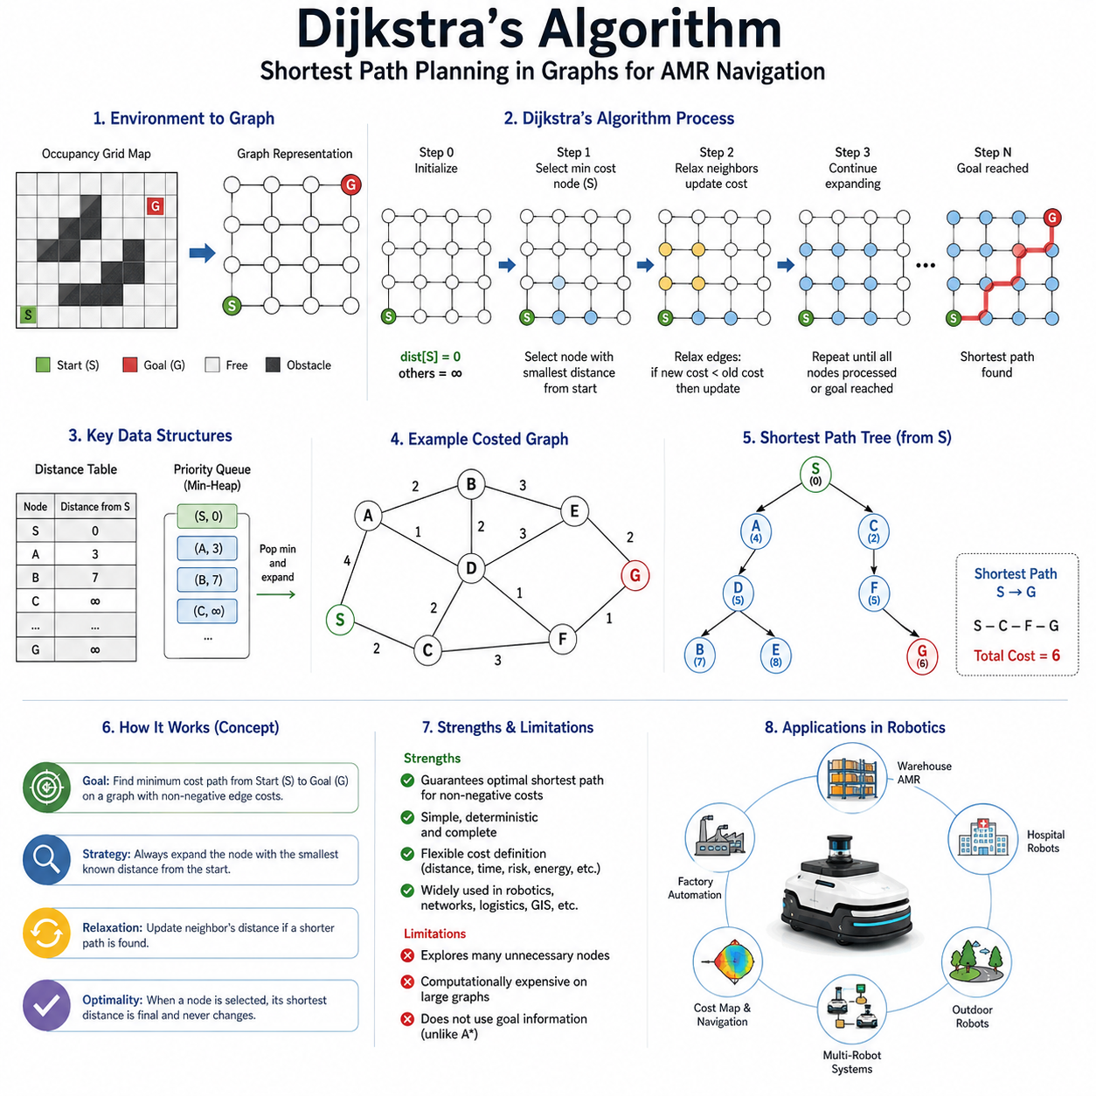
Dijkstra's Algorithm is one of the most fundamental and influential path planning algorithms in the history of computer science, robotics, autonomous navigation, transportation systems, and network optimization. It serves as the foundation for many modern path planning techniques and remains an essential component in autonomous mobile robot navigation systems. Within the context of Autonomous Mobile Robots (AMRs), Dijkstra's Algorithm provides a systematic method for discovering the shortest path between a starting position and a destination while considering the structure of the environment represented as a graph. It is particularly valuable because it guarantees the optimal shortest path when all edge costs are non-negative, making it highly reliable for industrial and commercial navigation applications. The algorithm forms a critical bridge between map representation and actual path generation, enabling robots to transform environmental knowledge into executable navigation routes. Its position within the navigation stack makes it one of the most important global path planning algorithms studied in robotics.
The origins of Dijkstra's Algorithm date back to 1956 when Dutch computer scientist Edsger W. Dijkstra developed the method to solve shortest-path problems. Since its publication, the algorithm has become a cornerstone of graph theory and optimization. Despite the emergence of more advanced algorithms, Dijkstra's method remains widely used due to its mathematical simplicity, deterministic behavior, and guaranteed optimality. In robotics, it is often introduced as the first complete path planning algorithm before progressing to heuristic-based approaches such as A*, sampling-based planners such as RRT, or optimization-based trajectory planners.
To understand Dijkstra's Algorithm, it is first necessary to understand graph-based representations of navigation environments. A graph consists of vertices, commonly referred to as nodes, and edges that connect those nodes. In a robotic navigation system, nodes may represent positions, intersections, waypoints, grid cells, or locations within a map. Edges represent traversable connections between nodes. Each edge is assigned a numerical cost representing the effort required to travel between the connected nodes. The cost may represent distance, travel time, energy consumption, terrain difficulty, risk level, or a combination of multiple navigation factors.
A robot operating in a warehouse, factory, hospital, airport, or outdoor environment typically converts its map into a graph structure before performing path planning. In grid-based maps, each cell becomes a node and neighboring cells become edges. In topological maps, important locations become nodes while corridors, roads, or paths become edges. Once the environment has been transformed into a graph, Dijkstra's Algorithm can systematically search for the minimum-cost route from the starting node to the goal node.
The core idea behind Dijkstra's Algorithm is surprisingly intuitive. The algorithm begins at the start node and progressively expands outward while maintaining the shortest known distance to every reachable node. At each step, the node with the lowest accumulated cost is selected for expansion. The algorithm then examines neighboring nodes and updates their shortest known distances if a better path is discovered. This process continues until all reachable nodes have been explored or until the destination node has been reached.
One of the key strengths of Dijkstra's Algorithm is its guarantee of optimality. When the algorithm selects a node for expansion, the shortest path to that node has already been determined. This property allows the algorithm to systematically construct the shortest path tree originating from the start position. As the search progresses, the robot gradually develops a complete understanding of the minimum travel cost to every accessible location in the environment.
The operation of the algorithm can be viewed as a wavefront propagation process. Starting from the source node, a virtual wave expands outward across the graph. Nodes closer to the source are explored first, while nodes farther away are explored later. The expansion resembles ripples spreading across the surface of water after a stone is dropped into a pond. Eventually, the wave reaches the goal node, at which point the shortest path has been identified.
An important concept in Dijkstra's Algorithm is the distance table. Each node maintains a value representing the shortest known distance from the starting node. Initially, all distances are set to infinity except for the start node, which is assigned a distance of zero. As the search progresses, these values are continuously updated whenever shorter paths are discovered. This updating process is known as relaxation. Relaxation is the fundamental operation that enables the algorithm to improve path estimates and converge toward the optimal solution.
Another critical component is the priority queue. The priority queue stores candidate nodes ordered by their accumulated distance from the start. At each iteration, the node with the smallest distance value is removed from the queue and expanded. This mechanism ensures that nodes are processed in order of increasing cost, which is essential for guaranteeing correctness and optimality.
In robotic navigation systems, Dijkstra's Algorithm is commonly applied to occupancy grid maps. An occupancy grid divides the environment into small cells that are classified as free, occupied, or unknown. Each free cell becomes a graph node, while adjacent cells are connected through edges. The edge cost is often proportional to the physical distance between cells. The resulting graph can contain thousands or even millions of nodes depending on map resolution. Dijkstra's Algorithm then searches this graph to identify the shortest route between the robot's current position and the desired destination.
The algorithm performs particularly well in environments where optimality is more important than computational speed. For example, industrial AMRs operating in factories often require highly reliable route generation. Since warehouse layouts are relatively stable and predictable, Dijkstra's Algorithm can compute globally optimal paths that maximize operational efficiency. Similarly, hospital delivery robots can use Dijkstra-based planning to ensure predictable and repeatable navigation behavior while transporting medications, laboratory samples, and medical supplies.
Outdoor autonomous robots can also benefit from Dijkstra's Algorithm. In agricultural robots, infrastructure inspection robots, mining vehicles, and security patrol robots, large-scale terrain maps can be represented as weighted graphs. Costs may incorporate terrain slope, surface roughness, energy consumption, or risk factors. Dijkstra's Algorithm then identifies routes that minimize travel effort while avoiding hazardous regions.
One of the most significant advantages of Dijkstra's Algorithm is its flexibility regarding cost definitions. Edge costs do not have to represent simple Euclidean distance. They may include multiple weighted factors. A navigation system may assign higher costs to narrow passages, crowded areas, slippery surfaces, steep slopes, or regions near obstacles. The planner naturally avoids expensive areas because they increase the total path cost. This capability allows engineers to incorporate safety, efficiency, and operational preferences directly into the planning process.
Despite its strengths, Dijkstra's Algorithm also has limitations. The most significant limitation is computational efficiency. Because the algorithm explores nodes solely based on accumulated cost and does not utilize information about the goal location, it often examines many unnecessary nodes. In large maps, this exhaustive exploration can become computationally expensive. The search region may expand in all directions, including areas far away from the desired destination. Consequently, planning time increases as map size grows.
This limitation motivated the development of heuristic-based algorithms such as A*. A* extends Dijkstra's approach by incorporating an estimate of the remaining distance to the goal. This heuristic guides the search toward the destination and significantly reduces computational effort. In fact, Dijkstra's Algorithm can be viewed as a special case of A* where the heuristic value is always zero. Understanding Dijkstra's method therefore provides a strong conceptual foundation for understanding A* and many other advanced path planning algorithms.
In modern ROS2 navigation systems, Dijkstra's Algorithm frequently appears within global planners. The planner generates a cost map that incorporates obstacle inflation, traversability information, and safety margins. Dijkstra-based search then computes the lowest-cost route through the map. The resulting path is subsequently passed to local planners such as Dynamic Window Approach (DWA) or Timed Elastic Band (TEB), which generate real-time motion commands while avoiding dynamic obstacles.
Another important application of Dijkstra's Algorithm is cost-to-go computation. Instead of planning from a start node to a single goal, the algorithm can compute the shortest distance from a goal node to every reachable location in the environment. The resulting cost field provides valuable information for navigation, obstacle avoidance, coverage planning, and multi-robot coordination. Many navigation frameworks exploit this capability to create navigation potential fields and global guidance maps.
Multi-robot systems also benefit from Dijkstra-based planning. Fleet management systems can use shortest-path calculations to estimate travel times, allocate tasks, optimize routes, and prevent congestion. In large industrial facilities containing dozens or hundreds of robots, efficient route planning becomes essential for maximizing productivity. Dijkstra's Algorithm provides a mathematically rigorous foundation for these higher-level optimization processes.
When implementing Dijkstra's Algorithm in practical robotic systems, developers must carefully consider memory usage, graph representation, and computational complexity. Sparse graph representations often improve efficiency. Binary heaps, Fibonacci heaps, and other priority queue structures can significantly reduce execution time. Parallel processing techniques may further accelerate planning performance on modern multicore processors and GPU-accelerated platforms.
Testing and validation play a crucial role in Dijkstra-based navigation development. Engineers typically evaluate path optimality, computation time, memory consumption, scalability, robustness, and reliability under various environmental conditions. Simulated environments provide controlled testing conditions, while field deployments validate real-world performance. Performance metrics commonly include path length, planning latency, obstacle clearance, navigation success rate, and energy consumption.
As autonomous robots continue to evolve, Dijkstra's Algorithm remains highly relevant. Although newer algorithms often provide faster performance, Dijkstra's method continues to serve as a benchmark for correctness and optimality. Many modern planners are extensions or variations of the original concept. Its mathematical rigor, deterministic behavior, and guaranteed shortest-path solution make it an indispensable tool in robotics, transportation, logistics, network routing, and intelligent autonomous systems.
In the broader context of autonomous navigation, Dijkstra's Algorithm represents far more than a historical path planning technique. It embodies a fundamental principle of intelligent decision-making: systematically evaluating available options to discover the most efficient route toward a goal. Whether navigating a warehouse AMR, a hospital service robot, an outdoor inspection platform, an autonomous vehicle, or a future embodied AI system, the concepts introduced by Dijkstra continue to influence the design of navigation architectures throughout the robotics industry. Its role as the foundational shortest-path algorithm ensures that it will remain an essential topic for engineers, researchers, and developers working in autonomous navigation for many years to come.

04.2 A* Algorithm
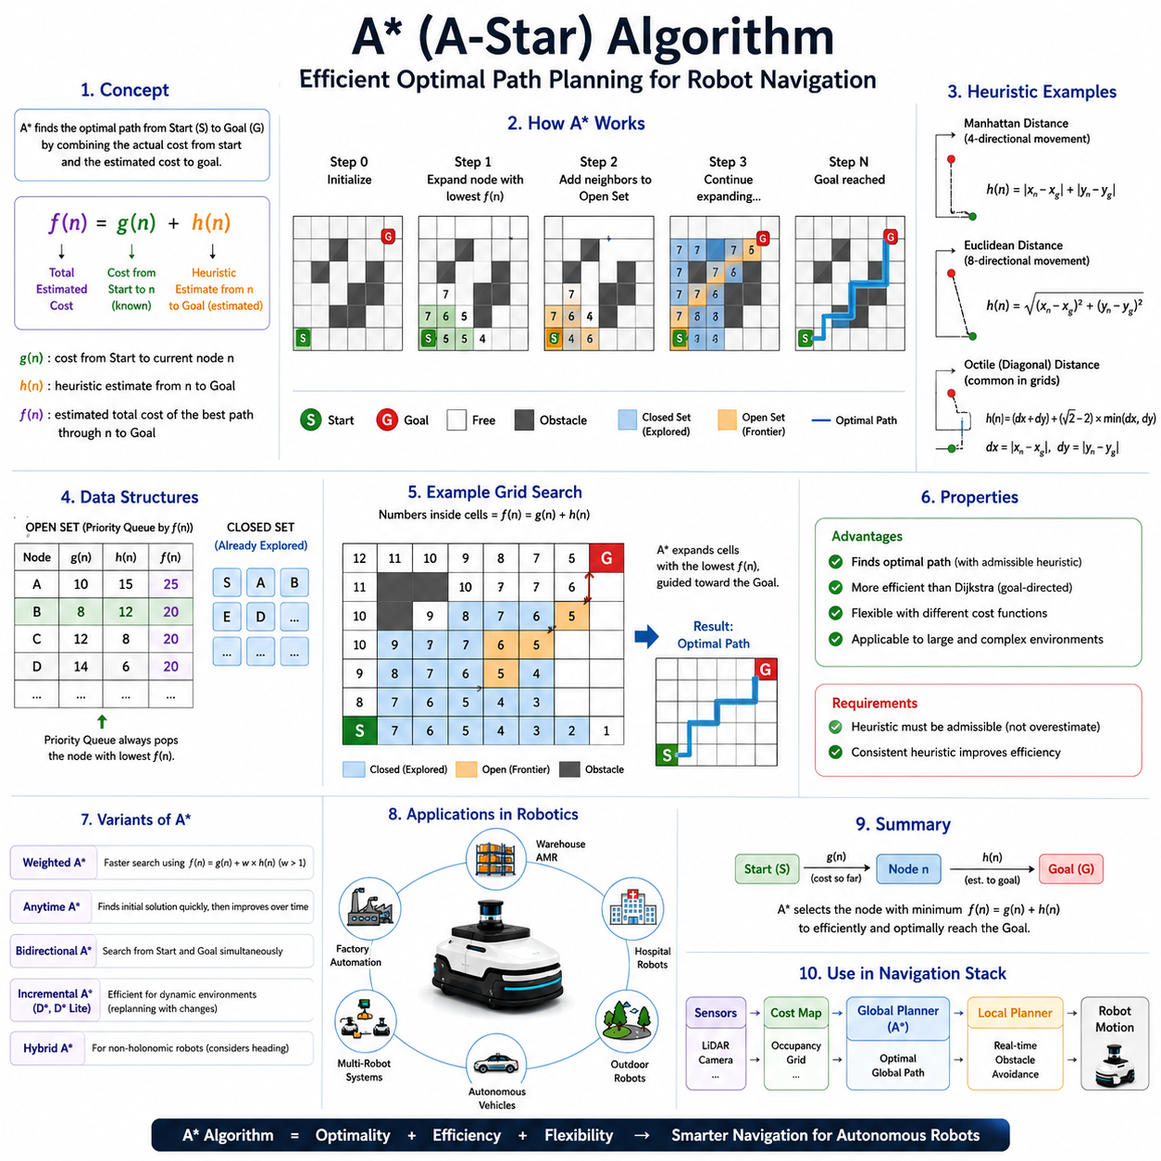
A* Algorithm, commonly pronounced as “A-Star,” is one of the most widely used path planning algorithms in robotics, autonomous vehicles, video games, logistics systems, and intelligent navigation applications. It is considered one of the most important advancements in graph-based search and shortest-path planning because it combines the guaranteed optimality of Dijkstra’s Algorithm with intelligent goal-directed search behavior. Within Autonomous Mobile Robot (AMR) navigation systems, A* serves as a foundational global path planning algorithm capable of efficiently finding an optimal path between a start position and a destination while minimizing unnecessary exploration. As a result, A* has become the de facto standard for many robotic navigation frameworks, including ROS and ROS2 navigation stacks, where reliable and computationally efficient path generation is required.
The primary objective of path planning is to determine a safe, feasible, and efficient route from a robot’s current location to a target destination. In a simple environment, the shortest path may appear obvious. However, in realistic environments containing obstacles, narrow corridors, restricted zones, dynamic constraints, and varying terrain costs, identifying the optimal route becomes a complex optimization problem. A* addresses this challenge by systematically searching through the environment while using additional knowledge about the destination to guide the search process. This goal-directed behavior dramatically improves efficiency compared to exhaustive search methods.
To understand A*, it is useful to first understand its relationship with Dijkstra’s Algorithm. Dijkstra’s Algorithm expands nodes purely based on the accumulated cost from the start position. Although this guarantees optimality, it often causes the search to expand uniformly in all directions, including areas unrelated to the destination. Consequently, many unnecessary nodes are explored. A* improves upon this behavior by introducing a heuristic function that estimates the remaining cost to the goal. Instead of considering only the cost already traveled, the algorithm also evaluates the estimated cost still required to reach the destination. This additional information allows the search to move more directly toward the target.
The central idea behind A* is remarkably elegant. Every node in the graph is assigned an evaluation score that represents the estimated total cost of traveling from the start node to the goal node through that particular node. This evaluation score consists of two components. The first component is the accumulated cost from the start position to the current node. The second component is a heuristic estimate of the remaining distance from the current node to the goal. By combining these two values, A* balances knowledge of the path already traveled with an estimate of future travel effort.
The accumulated cost is typically denoted as g(n). This value represents the exact cost of reaching node n from the starting position. The heuristic estimate is represented as h(n), which predicts the remaining cost required to reach the goal. The total evaluation function is expressed as f(n) = g(n) + h(n). The algorithm continuously selects the node with the lowest f-value for expansion. As a result, nodes that appear to lead efficiently toward the goal are prioritized, while nodes that are unlikely to contribute to an optimal solution receive lower priority.
The heuristic function is the defining feature of A*. The quality of the heuristic directly influences the efficiency of the search. A good heuristic provides a close approximation of the actual remaining distance without overestimating it. If the heuristic is too weak, the algorithm behaves similarly to Dijkstra’s Algorithm and explores many unnecessary nodes. If the heuristic is overly aggressive and overestimates the true cost, optimality may no longer be guaranteed. Therefore, heuristic design is one of the most important considerations in A* implementation.
Several heuristic functions are commonly used in robotic navigation. For grid-based environments allowing only horizontal and vertical movement, Manhattan Distance is frequently applied. This heuristic measures the sum of horizontal and vertical distances between the current node and the goal. In environments where movement is allowed in any direction, Euclidean Distance often provides a more accurate estimate. Some applications utilize Diagonal Distance, Chebyshev Distance, or customized cost-aware heuristics that incorporate environmental characteristics such as terrain difficulty, risk levels, or energy consumption.
The operation of A* begins by placing the starting node into an open set. The open set contains nodes that have been discovered but not yet fully explored. The algorithm repeatedly selects the node with the lowest evaluation score from this set. Once selected, the node is expanded and its neighboring nodes are examined. For each neighbor, the algorithm calculates the tentative path cost through the current node. If this path provides a lower cost than previously known routes, the neighbor’s information is updated accordingly. The process continues until the goal node is selected for expansion, at which point the optimal path has been found.
An important data structure used in A* is the priority queue. The priority queue maintains the open set and ensures that the node with the lowest evaluation score can be efficiently selected. Modern implementations often use binary heaps, Fibonacci heaps, or other optimized structures to improve computational performance. Alongside the open set, A* also maintains a closed set that contains nodes that have already been explored. This prevents repeated processing of the same nodes and improves overall efficiency.
The search process can be visualized as a directed wave moving toward the goal. Unlike Dijkstra’s Algorithm, which expands uniformly in all directions, A* generates a more focused search region. The heuristic pulls the search toward the destination, reducing exploration of irrelevant areas. This behavior significantly decreases computational requirements, particularly in large-scale environments.
A* is especially effective in occupancy grid maps commonly used by mobile robots. In such maps, the environment is divided into discrete cells representing free space, obstacles, and unknown regions. Each free cell corresponds to a graph node, while adjacent cells are connected through edges. The planner evaluates possible routes through these cells while considering both travel cost and estimated remaining distance. The result is a globally optimal path that efficiently guides the robot toward its destination.
In industrial AMR applications, A* is frequently used for warehouse navigation. Modern fulfillment centers contain complex layouts with storage racks, workstations, loading zones, and dynamic traffic patterns. A* enables robots to efficiently calculate routes that minimize travel distance while respecting safety constraints and operational policies. Because warehouse environments often require frequent replanning, the computational efficiency of A* is particularly valuable.
Hospital service robots also benefit from A*-based navigation. These robots transport medications, laboratory samples, meals, and medical supplies throughout healthcare facilities. Hospital environments contain numerous corridors, patient rooms, elevators, and restricted areas. A* can efficiently compute safe routes while incorporating cost penalties for crowded regions or restricted access zones. This capability improves both operational efficiency and patient safety.
Outdoor autonomous robots represent another major application domain. Security patrol robots, agricultural robots, infrastructure inspection systems, delivery robots, and autonomous vehicles frequently utilize A*-based planning. In these scenarios, edge costs may represent terrain roughness, slope angle, energy consumption, weather conditions, or operational risk. The planner naturally favors routes with lower overall cost, resulting in safer and more efficient navigation behavior.
One of the major advantages of A* is its ability to incorporate sophisticated cost functions. The path planner does not simply minimize geometric distance. Instead, it can optimize a weighted combination of multiple factors. Areas near obstacles may receive higher costs to increase safety margins. Slippery surfaces may be assigned penalties to reduce risk. Steep slopes may be discouraged to conserve energy and maintain vehicle stability. Through careful cost-map design, engineers can shape robot behavior without modifying the underlying search algorithm.
The performance of A* depends heavily on map size and heuristic quality. In small environments, computational requirements are typically modest. However, in large maps containing millions of nodes, planning complexity can become significant. Various optimization techniques have therefore been developed to improve scalability. These include hierarchical A*, weighted A*, anytime A*, bidirectional A*, incremental A*, and hybrid planning approaches that combine graph search with trajectory optimization.
Weighted A* introduces an adjustable weighting factor that increases the influence of the heuristic function. This often reduces computation time but may sacrifice strict optimality. Anytime A* quickly generates an initial solution and progressively improves path quality as additional computation time becomes available. Incremental variants such as D* and D* Lite efficiently update paths when environmental conditions change. These extensions build upon the fundamental concepts introduced by the original A* framework.
In modern ROS2 navigation systems, A* frequently operates within the Global Planner component. Cost maps generated from LiDAR, cameras, radar, and occupancy grids provide environmental information. The planner computes a collision-free global path, which is subsequently followed by local planners such as Dynamic Window Approach (DWA), Timed Elastic Band (TEB), or Model Predictive Control (MPC). The separation between global and local planning enables robots to achieve both long-range route optimization and real-time obstacle avoidance.
A* also plays an important role in multi-robot systems. Fleet management platforms use shortest-path calculations to estimate travel times, coordinate robot movement, allocate tasks, and optimize traffic flow. In large facilities containing hundreds of robots, efficient path planning contributes directly to operational productivity. A*-based routing often serves as the foundation for higher-level scheduling and dispatching algorithms.
Theoretical analysis of A* reveals several important properties. When the heuristic is admissible, meaning it never overestimates the true remaining cost, A* is guaranteed to find an optimal solution. When the heuristic is also consistent, the algorithm avoids unnecessary node re-expansion and achieves improved efficiency. These mathematical guarantees make A* highly attractive for safety-critical robotic applications where reliability and predictability are essential.
Testing and validation are critical components of A* deployment. Engineers evaluate planning latency, path optimality, memory usage, obstacle clearance, navigation success rate, and scalability across diverse environments. Simulation platforms such as Gazebo and Isaac Sim allow extensive experimentation before real-world deployment. Field testing then validates performance under realistic operational conditions involving dynamic obstacles, sensor noise, communication delays, and environmental uncertainty.
Although many advanced path planning methods have emerged, A* remains one of the most influential and practical algorithms in robotics. It offers an excellent balance between optimality, efficiency, simplicity, and adaptability. Its intuitive design makes it accessible to beginners, while its extensibility allows sophisticated customization for advanced applications. Many modern navigation algorithms are either direct extensions of A* or incorporate similar heuristic-guided search principles.
As autonomous systems continue to evolve toward greater intelligence and autonomy, A* remains a fundamental building block within navigation architectures. Whether guiding a warehouse robot through storage aisles, directing a hospital delivery robot across multiple floors, planning routes for outdoor inspection robots, coordinating autonomous vehicle traffic, or supporting future embodied AI systems, A* continues to provide a reliable and efficient mechanism for intelligent path planning. Its combination of mathematical rigor, practical effectiveness, and broad applicability ensures that it will remain one of the most important algorithms in autonomous navigation for decades to come.

04.3 Heuristic Function Design
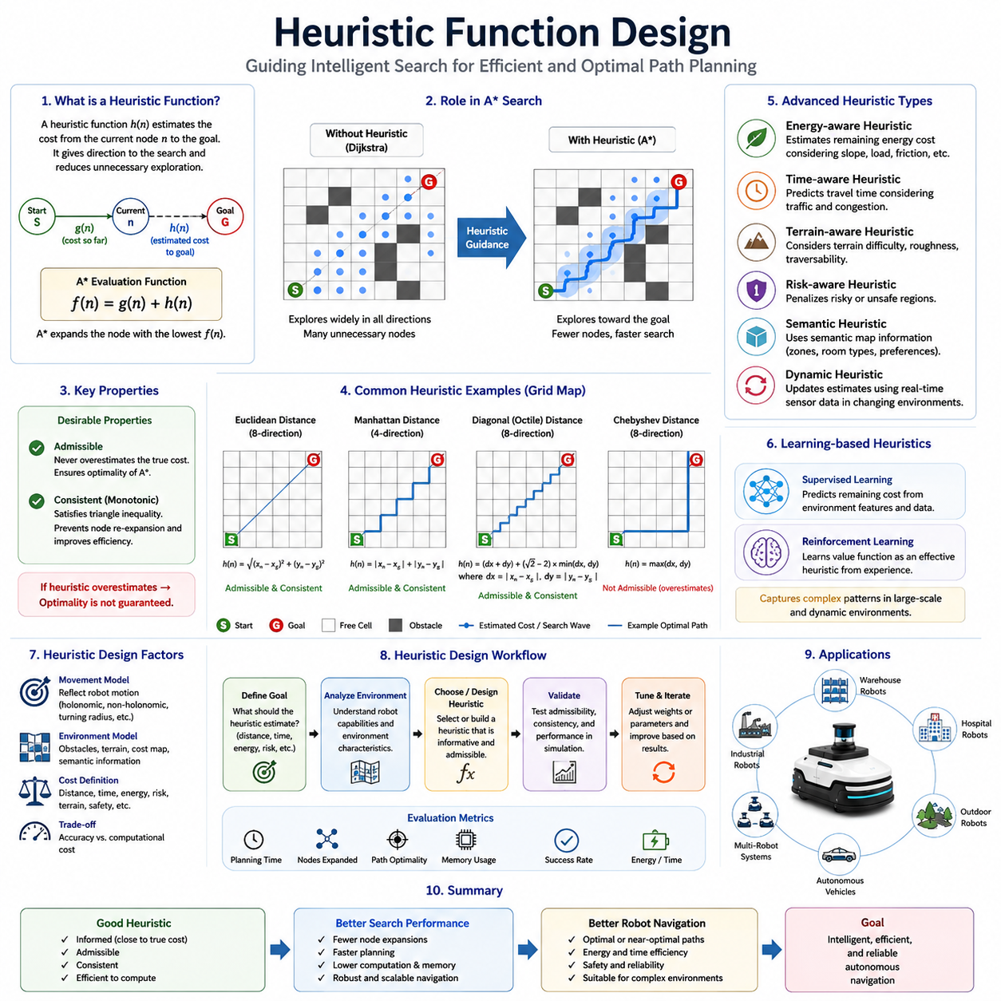
Heuristic Function Design is one of the most important topics in graph-based path planning and intelligent navigation systems. While algorithms such as Dijkstra’s Algorithm explore the environment based solely on accumulated travel cost, heuristic-based algorithms such as A* achieve significantly higher efficiency by incorporating an estimate of the remaining distance to the goal. The quality of this estimate directly influences search speed, computational complexity, memory consumption, and overall navigation performance. As a result, heuristic function design represents a critical engineering task in autonomous mobile robots, autonomous vehicles, logistics robots, warehouse automation systems, service robots, and outdoor autonomous navigation platforms. Within the context of global path planning, a well-designed heuristic function can reduce computation time by orders of magnitude while still preserving path optimality. Consequently, heuristic design has become a fundamental component of modern navigation architectures.
A heuristic function can be understood as a prediction mechanism that estimates how far a robot remains from its destination. Instead of blindly exploring all possible routes, the planner uses this estimate to guide the search process toward promising regions of the environment. The heuristic effectively provides directional intelligence to the search algorithm. Without a heuristic, a planner behaves like Dijkstra’s Algorithm, expanding nodes uniformly in all directions. With a heuristic, the planner gains the ability to focus its computational resources toward the goal and avoid unnecessary exploration.
In A* path planning, the heuristic function is represented as h(n), where n denotes the current node. The value h(n) estimates the cost of traveling from node n to the goal node. This estimate is combined with the accumulated path cost g(n) to form the evaluation function f(n). The search algorithm continuously selects nodes with the lowest evaluation scores for expansion. Consequently, the accuracy and characteristics of the heuristic function strongly influence the behavior of the planner.
The primary objective of heuristic function design is to provide an estimate that is both informative and computationally efficient. An informative heuristic closely approximates the true remaining distance to the goal. A computationally efficient heuristic can be evaluated rapidly during search. These two objectives often create trade-offs. Highly sophisticated heuristics may provide excellent estimates but require excessive computation. Extremely simple heuristics may be fast but provide little guidance. Effective heuristic design seeks an optimal balance between accuracy and efficiency.
One of the most important theoretical concepts in heuristic design is admissibility. An admissible heuristic never overestimates the actual cost required to reach the goal. In other words, the heuristic value must always be less than or equal to the true remaining path cost. This property guarantees that A* will find an optimal solution. If a heuristic overestimates the true cost, the algorithm may incorrectly discard potentially optimal paths and produce suboptimal solutions. Therefore, admissibility is a critical requirement whenever path optimality must be guaranteed.
Closely related to admissibility is the concept of consistency, sometimes referred to as monotonicity. A consistent heuristic satisfies the triangle inequality. The estimated cost from one node to the goal should never exceed the cost of moving to a neighboring node plus that neighbor’s estimated distance to the goal. Consistency ensures that once a node has been expanded, it does not need to be revisited. This property significantly improves search efficiency and simplifies implementation. Most practical navigation systems prefer consistent heuristics because they reduce computational overhead while maintaining optimality guarantees.
The simplest and most widely used heuristic in robotics is Euclidean Distance. This heuristic calculates the straight-line distance between the current position and the destination. In continuous environments where robots can move freely in any direction, Euclidean Distance provides a natural estimate of the remaining travel cost. Because it represents the shortest possible physical distance between two points, it never exceeds the true path length in environments containing obstacles. As a result, Euclidean Distance is both admissible and computationally inexpensive.
Grid-based navigation systems often employ Manhattan Distance as a heuristic. Manhattan Distance calculates the sum of horizontal and vertical separations between the current node and the goal. This heuristic is particularly appropriate when movement is restricted to four directions. In warehouse robots operating on orthogonal aisle structures, Manhattan Distance frequently provides a better estimate than Euclidean Distance because it more accurately reflects actual travel constraints.
When diagonal movement is permitted, Euclidean Distance and Manhattan Distance may become less accurate. In such cases, Diagonal Distance or Octile Distance often provides superior performance. These heuristics account for both orthogonal and diagonal motion capabilities, producing estimates that more closely match actual travel behavior. Consequently, search efficiency improves because the planner receives more accurate directional guidance.
The choice of heuristic should always reflect the movement characteristics of the robot and the structure of the environment. A heuristic that accurately models feasible robot motion generally produces better planning performance than one based solely on geometric distance. For example, differential-drive robots, Ackermann-steered vehicles, omnidirectional robots, and articulated towing robots all possess distinct motion constraints. Their corresponding heuristics should ideally reflect these differences.
In industrial navigation systems, travel cost is rarely determined by geometric distance alone. Modern robots often operate in environments containing variable terrain conditions, safety zones, traffic restrictions, human workers, equipment hazards, and energy management requirements. Under such circumstances, heuristic design becomes significantly more sophisticated. Instead of estimating only physical distance, the heuristic may incorporate expected energy consumption, predicted travel time, terrain difficulty, operational risk, or mission priorities.
Energy-aware navigation provides an important example. In battery-powered robots, minimizing distance does not necessarily minimize energy consumption. Steep slopes, rough terrain, frequent acceleration, and heavy payloads can substantially increase energy requirements. An energy-aware heuristic estimates the remaining energy needed to reach the destination rather than merely estimating travel distance. This approach can significantly extend operational endurance and improve battery utilization.
Time-aware heuristics are frequently used in logistics facilities and fleet management systems. In these environments, congestion and traffic patterns may influence travel duration more strongly than physical distance. A path that is geometrically shorter may require longer travel time due to congestion. Time-based heuristics attempt to predict these delays and guide robots toward faster routes. Such heuristics become particularly valuable in large-scale warehouses containing hundreds of simultaneously operating robots.
Outdoor autonomous navigation introduces additional challenges for heuristic design. Agricultural robots, mining vehicles, infrastructure inspection systems, and autonomous patrol platforms often operate across uneven terrain with varying traversability characteristics. A straight-line route may pass through mud, steep slopes, vegetation, ditches, or hazardous regions. Terrain-aware heuristics incorporate environmental information to estimate actual travel difficulty rather than relying solely on geometric distance.
Risk-aware navigation represents another advanced application. Certain areas within an environment may present elevated operational risks. Examples include regions near humans, machinery, hazardous materials, cliff edges, construction zones, or unstable surfaces. A risk-aware heuristic estimates both travel cost and exposure to potential hazards. This enables navigation systems to generate routes that balance efficiency and safety.
One of the most significant developments in modern robotics is the integration of semantic information into heuristic design. Semantic maps provide contextual knowledge about the environment, including object categories, room types, operational zones, and human activity patterns. A semantic heuristic can use this information to improve path planning decisions. For example, a hospital delivery robot may prefer service corridors over patient waiting areas, even if the latter provides a slightly shorter route. The heuristic effectively encodes high-level operational preferences into the navigation process.
Dynamic environments present additional complexity because heuristic values may change over time. In factories, warehouses, airports, hospitals, and public spaces, moving obstacles continuously alter the navigational landscape. Static heuristic estimates may quickly become outdated. Dynamic heuristic systems continuously update predictions using real-time sensor information, enabling planners to adapt to changing environmental conditions.
Machine learning has recently emerged as a powerful tool for heuristic generation. Traditional heuristics are manually designed using geometric and mathematical principles. Learning-based heuristics attempt to infer effective cost estimates from historical navigation data. Deep neural networks can learn complex relationships between environmental features and navigation outcomes. Such approaches have demonstrated promising performance in large-scale and highly dynamic environments where handcrafted heuristics may struggle.
Reinforcement learning provides another mechanism for heuristic optimization. Rather than explicitly defining heuristic equations, reinforcement learning systems learn value functions that estimate future navigation rewards. These learned value functions can serve as sophisticated heuristics that capture complex environmental interactions. As embodied AI and autonomous robotics continue to advance, learning-based heuristic design is expected to become increasingly important.
The computational efficiency of heuristic evaluation remains a critical consideration. A heuristic may provide highly accurate estimates, but if evaluating the heuristic requires excessive computation, overall planning performance may deteriorate. Practical navigation systems must therefore carefully balance heuristic sophistication against real-time processing requirements. In embedded robotic platforms operating under strict computational constraints, lightweight heuristics often remain preferable despite reduced accuracy.
Hybrid heuristic approaches combine multiple estimation methods to achieve improved performance. A planner may simultaneously consider geometric distance, energy consumption, terrain difficulty, safety margins, and traffic conditions. Weighted combinations of these factors produce composite heuristics tailored to specific operational requirements. Such approaches are increasingly common in industrial autonomous systems.
Heuristic design also plays an important role in hierarchical navigation architectures. Large-scale environments are frequently divided into multiple planning layers. High-level planners operate on abstract topological maps, while low-level planners operate on detailed occupancy grids. Different heuristic functions may be applied at each level. High-level heuristics prioritize strategic route selection, while low-level heuristics focus on precise obstacle avoidance and local optimization.
In ROS2 navigation systems, heuristic functions are fundamental components of global planning algorithms. Cost maps generated from LiDAR, cameras, radar, and occupancy grids provide environmental information that influences heuristic behavior. Proper heuristic design enables planners to generate efficient routes while maintaining safety, robustness, and computational efficiency. As robot fleets scale to hundreds or thousands of units, heuristic quality increasingly impacts overall system performance.
Testing and validation are essential aspects of heuristic development. Engineers evaluate heuristic performance using metrics such as planning time, node expansion count, memory consumption, path optimality, navigation success rate, energy efficiency, and computational load. Simulation platforms including Gazebo, Isaac Sim, and digital twin environments provide valuable tools for analyzing heuristic behavior before deployment in real-world systems.
As autonomous navigation technology continues to evolve, heuristic function design remains one of the most influential factors in path planning performance. The heuristic serves as the intelligence guiding the search process, determining where computational effort should be focused and which routes appear most promising. From simple Euclidean Distance calculations to sophisticated AI-driven prediction models, heuristic functions continue to shape the effectiveness of modern navigation systems.
In the broader context of robotics and autonomous systems, heuristic design represents the transition from blind search to intelligent search. Rather than merely exploring available options, the planner develops an informed expectation of future outcomes and uses this expectation to guide decision-making. This principle extends beyond path planning and appears throughout artificial intelligence, optimization, and autonomous reasoning. For autonomous mobile robots operating in increasingly complex environments, effective heuristic function design will remain a cornerstone of efficient, scalable, and intelligent navigation architectures for decades to come.

04.4 Weighted A* and Optimizations
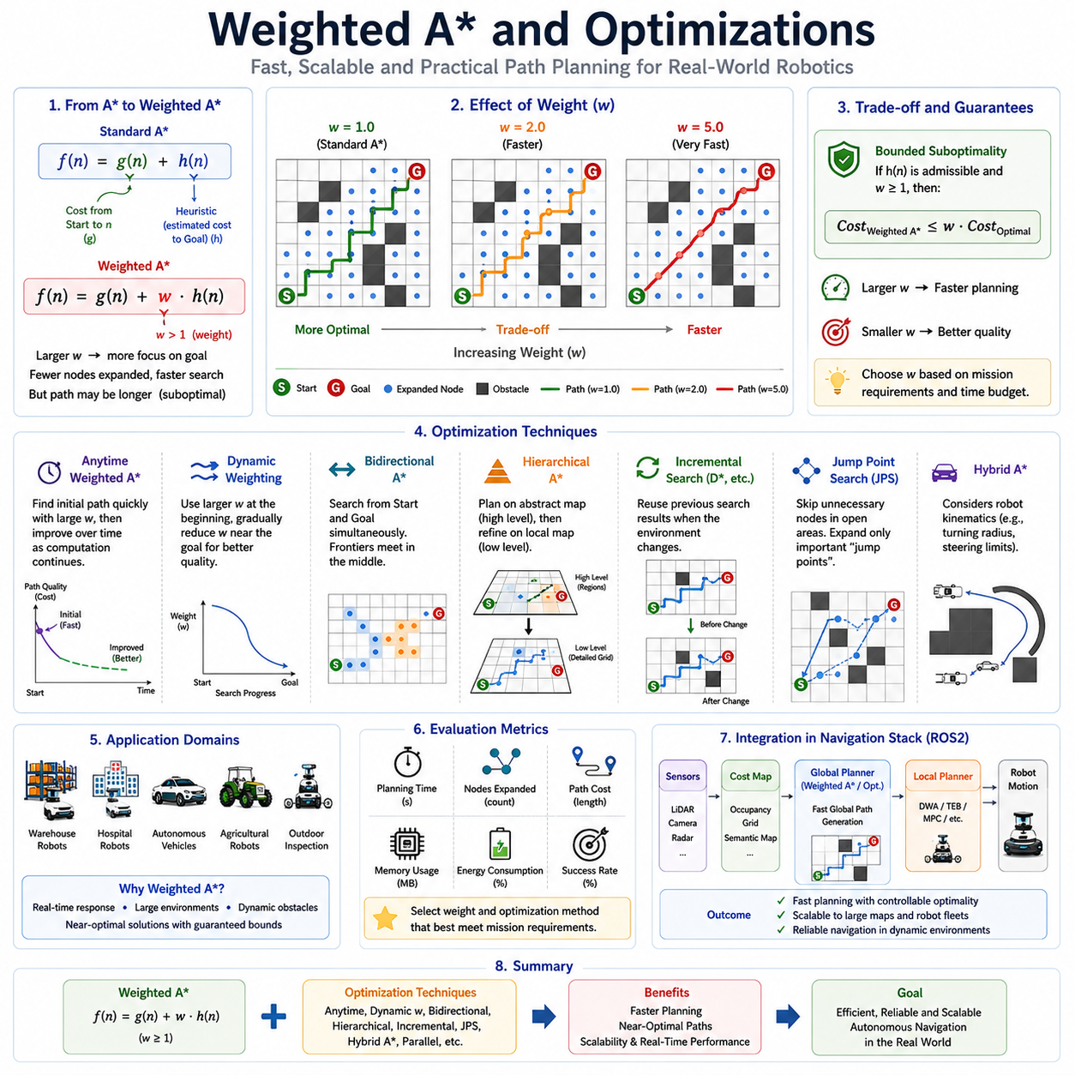
Weighted A* and A* optimization techniques represent an important evolution of classical A* path planning. While the standard A* algorithm is widely recognized for its ability to generate optimal paths efficiently, practical autonomous navigation systems often operate under strict real-time constraints that require faster planning responses than standard A* can provide. Autonomous Mobile Robots (AMRs), autonomous vehicles, warehouse robots, hospital service robots, agricultural machines, and outdoor inspection platforms frequently need to generate navigation paths within milliseconds while operating in complex and dynamic environments. In such situations, obtaining a perfectly optimal path may be less important than obtaining a very good path quickly. Weighted A* addresses this challenge by introducing a controllable tradeoff between optimality and computational efficiency, while numerous optimization techniques further improve planning speed, scalability, and real-world applicability. As a result, Weighted A* and related optimization strategies have become essential components of modern robotic navigation systems.
To understand Weighted A*, it is useful to revisit the standard A* algorithm. Classical A* evaluates nodes using the function f(n)=g(n)+h(n), where g(n) represents the accumulated travel cost from the start node to the current node, and h(n) represents the heuristic estimate of the remaining cost from the current node to the goal. This balanced combination allows A* to efficiently guide the search toward the destination while maintaining optimality, provided that the heuristic is admissible and consistent.
Although standard A* is highly effective, it still explores a considerable number of nodes in large environments. In complex maps containing thousands or millions of navigable cells, the computational burden can become significant. This challenge becomes even more pronounced in real-time robotic applications where frequent replanning is required due to changing obstacles, dynamic traffic conditions, or evolving mission objectives. Weighted A* was developed as a practical solution to this problem.
The central idea of Weighted A* is remarkably simple. Instead of treating the heuristic estimate and the accumulated path cost equally, the algorithm increases the influence of the heuristic function. The evaluation function becomes:
f(n)=g(n)+w·h(n)
where w represents a weighting factor greater than one. By multiplying the heuristic value by a weight, the planner places greater emphasis on moving toward the goal. The search therefore becomes more aggressive and goal-directed, reducing the number of explored nodes and significantly decreasing planning time.
The weighting factor directly controls planner behavior. When the weight is equal to one, Weighted A* becomes identical to standard A*. As the weight increases, the search becomes increasingly focused on the destination. Small weights typically preserve near-optimal solutions while reducing computational effort. Larger weights can dramatically improve planning speed but may result in less optimal paths. Consequently, selecting an appropriate weighting factor is one of the most important design decisions in Weighted A* implementation.
From an intuitive perspective, standard A* carefully balances exploration and exploitation. Weighted A* shifts this balance toward exploitation. Rather than extensively examining multiple alternatives, the planner follows the heuristic guidance more aggressively. This often produces excellent results in environments where the heuristic accurately reflects actual travel cost. In such cases, substantial computational savings can be achieved with minimal degradation in path quality.
One of the most attractive properties of Weighted A* is bounded suboptimality. Unlike many approximate planning methods, Weighted A* provides theoretical guarantees regarding solution quality. Under appropriate conditions, the resulting path cost will not exceed a predictable bound relative to the optimal solution. This characteristic makes Weighted A* particularly attractive for industrial and safety-critical systems where performance guarantees remain important.
Warehouse automation systems provide an excellent example of Weighted A* usage. Large fulfillment centers may contain hundreds of robots simultaneously transporting inventory. Navigation routes must be generated rapidly to support high-throughput operations. Waiting several seconds for an optimal route is often unacceptable. Weighted A* enables robots to compute near-optimal paths within significantly shorter planning times, thereby improving overall system productivity.
Hospital service robots also benefit from Weighted A* planning. Medication delivery robots, laboratory transport robots, and autonomous logistics systems frequently operate in dynamic environments where hallways become temporarily congested and obstacles appear unexpectedly. Rapid replanning is often more valuable than achieving perfect route optimality. Weighted A* allows the robot to respond quickly to changing conditions while maintaining efficient navigation behavior.
Outdoor autonomous robots represent another important application domain. Agricultural robots, security patrol systems, mining vehicles, and infrastructure inspection platforms often operate across large geographic areas. Path planning in such environments may involve enormous search spaces. Weighted A* helps maintain real-time responsiveness even when navigating across extensive terrain maps containing millions of cells or graph nodes.
The effectiveness of Weighted A* depends heavily on heuristic quality. If the heuristic closely approximates actual travel cost, increasing its influence typically produces significant computational benefits. However, if the heuristic is inaccurate, excessive weighting may cause the planner to favor poor decisions. Consequently, heuristic design remains critically important even when optimization techniques are employed.
Several adaptive approaches have been developed to address this challenge. Dynamic weighting techniques adjust the heuristic weight during the search process. Near the beginning of the search, larger weights encourage aggressive goal-directed exploration. As the search approaches the destination, the weight may gradually decrease, allowing more careful optimization of the final route. Such adaptive strategies often achieve superior tradeoffs between planning speed and solution quality.
Anytime Weighted A* represents one of the most influential extensions of the algorithm. Rather than searching exclusively for a single solution, Anytime A* rapidly generates an initial path using an aggressive weight. The planner then continues searching and incrementally improves the solution over time. If additional computation time becomes available, path quality gradually converges toward optimality. This behavior is particularly valuable in autonomous systems where planning deadlines vary depending on operational conditions.
Anytime Repairing A* further extends this concept by supporting efficient path refinement and replanning. Instead of restarting the search from scratch whenever environmental conditions change, the algorithm reuses previously computed information. This capability significantly reduces computational overhead in dynamic environments where frequent replanning is necessary.
One of the most widely studied optimization strategies is Bidirectional A*. Traditional A* searches from the start position toward the goal. Bidirectional A* simultaneously performs one search from the start and another from the goal. When the two search frontiers meet, a complete path is constructed. Because each search covers a smaller region, computational effort is often dramatically reduced. Bidirectional search can be particularly effective in large environments with relatively uniform traversal costs.
Hierarchical planning represents another major optimization approach. Instead of performing all computations at the finest map resolution, the environment is divided into multiple abstraction levels. High-level planners operate on simplified representations of the environment, while low-level planners generate detailed local routes. Hierarchical A* significantly reduces computational complexity by limiting fine-grained search to relevant regions.
Hierarchical Path-Finding A* has become especially popular in large industrial facilities, logistics centers, and outdoor navigation systems. By decomposing the environment into sectors, regions, or zones, the planner can rapidly identify strategic routes before refining local path details. This multi-resolution approach provides substantial scalability improvements.
Memory optimization is another important area of A* enhancement. Large-scale path planning often requires storing millions of nodes in memory. Techniques such as memory-bounded A*, Simplified Memory-Bounded A*, and Recursive Best-First Search reduce memory consumption while preserving much of the effectiveness of heuristic search. These approaches are particularly valuable for embedded robotic platforms with limited computational resources.
Incremental search algorithms represent a further optimization category. Dynamic environments frequently require repeated path planning. Recomputing an entire route after every environmental change is inefficient. Incremental algorithms such as D*, D* Lite, Lifelong Planning A*, and Adaptive A* reuse information from previous searches. This dramatically reduces planning latency and improves responsiveness.
Adaptive A* is particularly noteworthy because it continuously improves its heuristic estimates based on prior search experience. Each completed search provides additional information about the environment. Future searches can then leverage this knowledge to become progressively more efficient. Such adaptive behavior is highly beneficial in environments where robots repeatedly navigate similar routes.
Jump Point Search is another powerful optimization technique for grid-based maps. Traditional A* often expands numerous redundant nodes within open areas. Jump Point Search identifies symmetrical search patterns and skips unnecessary intermediate nodes. The resulting reduction in node expansions can produce substantial performance improvements while maintaining optimality.
Navigation mesh representations provide an alternative strategy for reducing computational complexity. Instead of representing the environment as a dense occupancy grid, free space is represented using larger polygonal regions. Search is then performed over the navigation mesh graph rather than individual cells. This significantly reduces graph size and improves planning efficiency in large environments.
Hybrid A* represents one of the most important developments for autonomous vehicles and nonholonomic robots. Standard A* assumes unrestricted movement between graph nodes. Real robots, however, possess kinematic constraints such as steering limits, turning radii, trailer articulation, and vehicle dynamics. Hybrid A* integrates continuous vehicle motion models into the search process, generating physically feasible trajectories rather than purely geometric paths.
Hybrid A* is particularly relevant for outdoor AMRs, autonomous vehicles, towing robots, autonomous forklifts, and agricultural machines. These platforms cannot instantaneously change direction like point-mass models. By incorporating vehicle kinematics directly into the search, Hybrid A* produces trajectories that can be executed by real robotic systems without extensive post-processing.
Parallel computing has emerged as another important optimization direction. Modern robotic platforms increasingly employ multicore CPUs, GPUs, and heterogeneous computing architectures. Parallelized search algorithms distribute node expansion tasks across multiple processing units, substantially reducing planning latency. GPU-accelerated path planning is becoming increasingly common in large-scale autonomous systems.
Cloud robotics and fleet management systems introduce additional opportunities for optimization. Instead of performing all computations onboard the robot, portions of the planning workload can be distributed across cloud servers, edge computing infrastructure, or fleet coordination platforms. Such architectures enable large-scale optimization across entire robot fleets while maintaining real-time local autonomy.
In ROS2 Navigation Stack implementations, Weighted A* and optimized variants frequently operate within global planning components. Cost maps generated from LiDAR, cameras, radar, occupancy grids, semantic maps, and digital twins provide environmental information. The planner uses optimized search techniques to rapidly generate high-quality global routes, which are then refined by local planners such as DWA, TEB, MPC, or trajectory optimization frameworks.
Evaluation of Weighted A* and optimization methods typically focuses on several key metrics. Planning time measures computational responsiveness. Node expansion count reflects search efficiency. Memory usage indicates resource requirements. Path length evaluates route quality. Energy consumption measures operational efficiency. Navigation success rate quantifies robustness under real-world conditions. Engineers carefully analyze these metrics to determine appropriate algorithm configurations for specific applications.
Simulation environments such as Gazebo, Isaac Sim, CARLA, and digital twin platforms play a critical role in optimization research. These tools enable systematic comparison of different weighting factors, heuristic functions, map representations, and planning strategies under controlled conditions. Field validation then confirms performance under realistic operational constraints.
As autonomous navigation systems continue to grow in complexity, the importance of Weighted A* and optimization techniques will only increase. Modern robots must operate in larger environments, respond to dynamic changes more rapidly, coordinate with larger fleets, and satisfy increasingly demanding performance requirements. Classical A* provides an excellent foundation, but practical deployment often requires additional optimization to achieve real-time performance.
In the broader context of intelligent navigation, Weighted A* and related optimization methods demonstrate a fundamental principle of engineering: perfect optimality is not always the most valuable objective. In many real-world systems, achieving a near-optimal solution quickly is more beneficial than obtaining a mathematically optimal solution slowly. By carefully balancing solution quality, computational efficiency, and operational constraints, Weighted A* and its optimization techniques provide a practical framework for scalable, reliable, and intelligent autonomous navigation. These methods continue to serve as essential building blocks for modern robotics, autonomous vehicles, industrial automation systems, and the future generation of embodied AI navigation architectures.

04.5 Grid Map Implementation
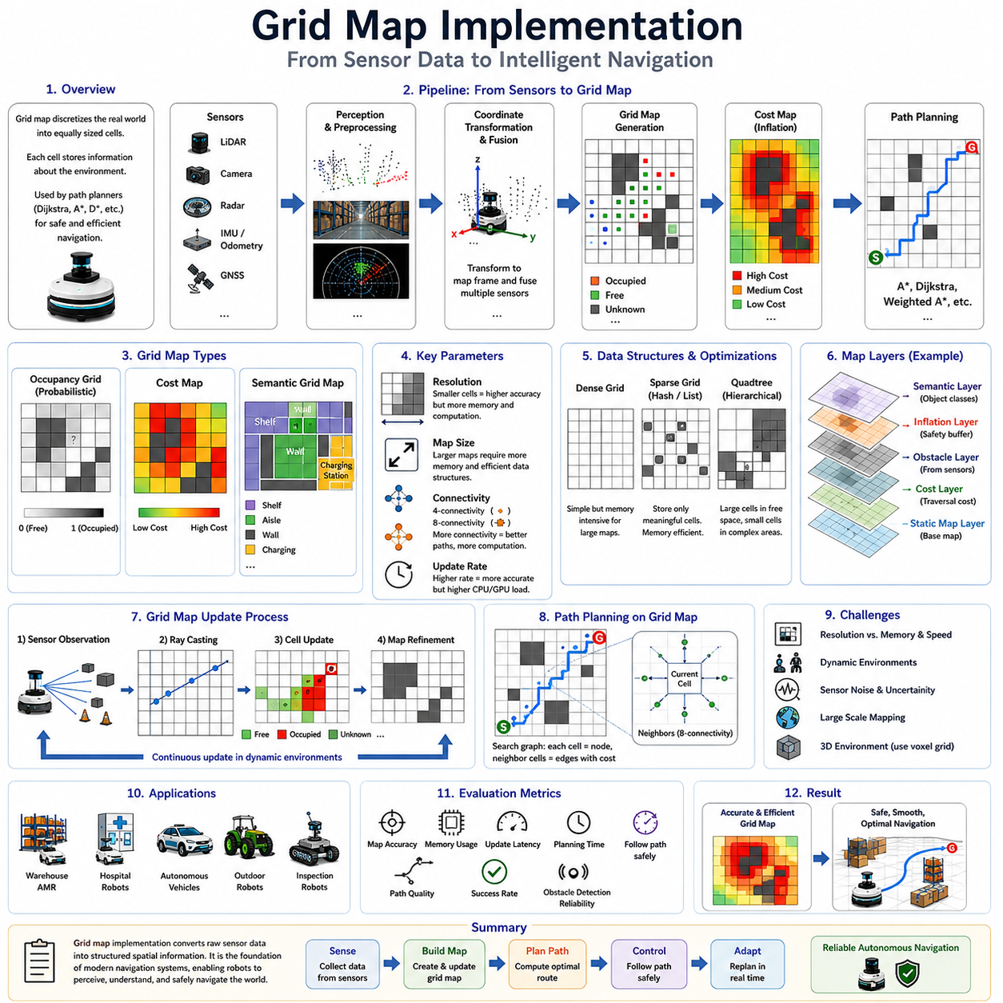
Grid Map Implementation is one of the most fundamental and widely adopted approaches in autonomous navigation, robot path planning, and mobile robotics. Nearly every modern Autonomous Mobile Robot (AMR), Automated Guided Vehicle (AGV), autonomous vehicle, service robot, warehouse robot, and outdoor inspection robot utilizes some form of grid-based environment representation as part of its navigation stack. The grid map serves as a bridge between raw sensor perception and high-level navigation decision-making, enabling robots to transform complex real-world environments into structured representations that can be efficiently processed by path planning algorithms. Within graph-based path planning frameworks such as Dijkstra, A*, Weighted A*, D*, and many modern navigation planners, grid maps provide the foundational data structure upon which navigation intelligence is built. Consequently, understanding grid map implementation is essential for engineers, researchers, and developers working on autonomous robotic systems.
A grid map represents the environment as a collection of uniformly sized cells arranged in rows and columns. Each cell corresponds to a small physical area within the real world. Depending on the mapping methodology, a cell may represent free space, occupied space, unknown space, traversable terrain, restricted zones, or areas associated with specific costs. By discretizing the environment into regular cells, complex geometric structures become easier to analyze and process computationally.
The fundamental concept behind grid mapping is spatial discretization. Real-world environments are continuous and infinitely detailed. Directly representing every physical object, surface, and obstacle would require enormous computational resources. Grid maps simplify this challenge by dividing the environment into finite cells with predefined dimensions. A 100-meter by 100-meter environment may be represented using 10-centimeter cells, resulting in a map containing one million individual grid cells. Each cell stores information about the state of that region.
One of the earliest and most influential grid-based representations is the occupancy grid map. Occupancy grids were originally developed to support probabilistic robot perception and remain widely used today. In an occupancy grid, each cell contains a probability indicating whether the corresponding region is occupied by an obstacle. Rather than assigning a simple binary value, occupancy grids allow uncertainty to be represented explicitly. This capability is particularly valuable because sensor measurements are often noisy and incomplete.
When a robot first enters an unknown environment, all grid cells are typically initialized as unknown. As sensor data is collected, individual cells are updated based on observations. Regions repeatedly detected as obstacles gradually become occupied cells. Regions consistently observed as free become traversable cells. Areas not yet observed remain unknown. Over time, the robot builds an increasingly accurate representation of the surrounding environment.
Grid resolution is one of the most important design parameters in grid map implementation. Resolution determines the physical size represented by each cell. High-resolution maps use smaller cells and capture environmental details more accurately. Low-resolution maps use larger cells and require less memory and computation. The choice of resolution directly influences navigation accuracy, memory consumption, planning speed, and obstacle representation quality.
For example, a warehouse robot operating in narrow aisles may require a map resolution of five centimeters per cell to accurately represent shelving structures and navigation corridors. In contrast, an outdoor patrol robot operating across large open areas may use cell sizes of twenty centimeters, fifty centimeters, or even one meter to reduce computational requirements. Selecting an appropriate resolution requires balancing environmental complexity against available computational resources.
Memory management becomes increasingly important as map size grows. Large facilities, industrial campuses, agricultural fields, mining sites, and smart-city deployments can easily require maps covering hundreds of thousands or millions of square meters. Storing every grid cell at high resolution may exceed available memory. Consequently, various optimization techniques have been developed to address scalability challenges.
One common solution is hierarchical grid mapping. Instead of using a single resolution throughout the environment, multiple resolutions are employed simultaneously. High-resolution representations are used near the robot or in complex regions, while lower-resolution representations describe distant or less critical areas. This multi-scale approach significantly reduces memory consumption while preserving navigation accuracy where it matters most.
Another widely used technique is sparse grid representation. Many environments contain large open spaces with relatively little information. Rather than explicitly storing every cell, sparse representations store only cells containing meaningful data. This approach is particularly effective for outdoor environments where vast areas may be uniformly traversable.
Quadtrees provide another important optimization strategy. A quadtree recursively subdivides the environment into increasingly smaller regions only where additional detail is required. Large homogeneous regions are represented using large cells, while complex regions are represented using smaller subdivisions. Quadtree-based maps can dramatically reduce memory requirements while preserving spatial fidelity.
Grid map implementation begins with coordinate transformation. Sensor measurements are typically obtained in local coordinate frames relative to individual sensors. These measurements must be transformed into a common map coordinate system. Accurate transformation requires precise knowledge of sensor positions, orientations, robot pose estimates, and coordinate frame relationships. Errors in coordinate transformation can lead to distorted maps and navigation failures.
Sensor integration plays a critical role in grid map generation. Modern robots typically employ multiple sensor modalities including LiDAR, RGB cameras, depth cameras, radar systems, ultrasonic sensors, GNSS receivers, and inertial measurement units. Each sensor contributes unique environmental information. Grid map implementation must effectively fuse these heterogeneous data sources into a unified spatial representation.
LiDAR sensors are particularly well suited for occupancy grid generation. Laser beams provide precise distance measurements to surrounding objects. Each measurement updates corresponding grid cells along the laser path. Cells traversed by the beam are typically marked as free space, while cells containing detected obstacles are marked as occupied. Repeated observations improve confidence and map accuracy.
Vision-based grid mapping introduces additional capabilities. Camera systems can contribute semantic information, surface classifications, object categories, and visual features. Rather than representing only occupancy, modern grid maps increasingly incorporate semantic layers describing environmental meaning. Such information supports higher-level navigation reasoning and context-aware decision-making.
Radar-based mapping offers important advantages in adverse weather conditions. Rain, fog, dust, smoke, and darkness can significantly degrade optical sensors. Radar systems remain effective under such conditions and provide complementary information that enhances mapping robustness. Multi-sensor fusion therefore improves reliability and environmental coverage.
Cost maps represent an important extension of occupancy grids. Traditional occupancy grids classify cells as free or occupied. Cost maps assign numerical values representing traversal difficulty, safety considerations, or operational preferences. Cells near obstacles may receive elevated costs. Narrow passages may be assigned higher penalties. Regions containing heavy pedestrian traffic may be discouraged through increased traversal costs.
Cost map generation is fundamental to modern navigation systems. The planner evaluates potential paths not only based on geometric distance but also based on accumulated traversal cost. This enables safer, smoother, and more efficient robot behavior. Cost maps are particularly important in industrial facilities, hospitals, airports, and public environments where navigation decisions must balance efficiency with safety.
Obstacle inflation is a common technique used during cost map generation. Real robots possess physical dimensions and cannot be modeled as point particles. To ensure safe navigation, obstacles are artificially expanded within the map. Cells near obstacles receive progressively higher costs, creating safety buffers that discourage risky trajectories. Obstacle inflation helps account for localization uncertainty, control errors, and dynamic disturbances.
Grid connectivity determines how neighboring cells are connected during path planning. Four-connectivity allows movement only in horizontal and vertical directions. Eight-connectivity additionally permits diagonal movement. Some advanced implementations support sixteen-connectivity or continuous-angle motion approximations. Connectivity selection influences path quality, computational complexity, and motion realism.
Path planning algorithms convert grid maps into graph structures for navigation computation. Each traversable cell becomes a graph node. Neighboring cells become graph edges. Algorithms such as Dijkstra and A* search this graph to identify optimal routes. The resulting path typically consists of a sequence of connected grid cells leading from the robot’s starting position to the desired destination.
One limitation of grid maps is discretization error. Because continuous space is approximated using finite cells, path quality depends on map resolution. Low-resolution grids may produce stair-step trajectories and geometric inaccuracies. Various post-processing techniques such as path smoothing, spline interpolation, Bézier curves, and trajectory optimization are commonly applied to improve path quality.
Dynamic environments introduce additional complexity. Traditional grid maps assume static environments. Real-world settings contain moving people, vehicles, forklifts, robots, doors, and temporary obstacles. Dynamic grid mapping continuously updates occupancy information based on real-time sensor observations. Cells may transition between free and occupied states as environmental conditions change.
Temporal grid maps extend this concept by incorporating time as an additional dimension. Rather than representing only current occupancy, temporal maps estimate future occupancy based on observed motion patterns. Such predictions support proactive obstacle avoidance and improved navigation performance in crowded environments.
Three-dimensional grid mapping has become increasingly important for advanced robotics applications. While two-dimensional grids are sufficient for many indoor navigation tasks, outdoor robots often encounter elevation changes, ramps, slopes, stairs, ditches, vegetation, and complex terrain structures. Three-dimensional voxel grids extend occupancy mapping into volumetric space, enabling richer environmental representation.
Voxel maps divide space into cubic volumes rather than planar cells. Each voxel stores occupancy, semantic, or environmental information. Voxel-based mapping is widely used in autonomous vehicles, drone navigation, mining robots, agricultural robots, and infrastructure inspection systems. Although computationally more demanding than two-dimensional grids, voxel maps provide substantially greater environmental awareness.
Modern ROS2 navigation systems rely heavily on grid map implementations. Components such as occupancy grids, cost maps, layered cost maps, inflation layers, obstacle layers, voxel layers, and semantic mapping modules collectively form the foundation of navigation functionality. Sensor data continuously updates these representations, enabling planners to generate safe and efficient routes.
Industrial AMR deployments frequently integrate grid maps with fleet management systems. Shared maps enable coordinated navigation among multiple robots. Cloud-based map servers distribute environmental information across entire robot fleets. Centralized traffic management systems utilize grid-based representations to optimize fleet-wide routing and congestion avoidance.
Testing and validation are essential aspects of grid map implementation. Engineers evaluate map accuracy, occupancy classification quality, memory efficiency, update frequency, localization compatibility, sensor fusion performance, and navigation success rates. Simulation environments such as Gazebo, Isaac Sim, CARLA, and digital twin platforms provide valuable tools for verifying mapping performance before deployment.
Performance metrics commonly include map resolution, memory usage, update latency, occupancy accuracy, path planning efficiency, obstacle detection reliability, traversal success rate, and computational load. Careful analysis of these metrics helps identify design tradeoffs and optimization opportunities.
As autonomous navigation systems continue to evolve, grid maps remain one of the most practical and versatile environment representation methods available. Although alternative approaches such as topological maps, semantic maps, navigation meshes, learned representations, and world models continue to advance, grid maps provide a reliable foundation that integrates naturally with classical and modern path planning algorithms.
In the broader context of robotics and autonomous navigation, grid map implementation represents the transformation of raw sensor observations into actionable environmental intelligence. It converts complex physical spaces into structured digital representations that can be understood, analyzed, and utilized by navigation algorithms. From warehouse AMRs and hospital service robots to outdoor inspection platforms, autonomous vehicles, agricultural robots, and future embodied AI systems, grid maps continue to serve as one of the most important building blocks of intelligent autonomous navigation architectures.

04.6 Performance and Computation Analysis
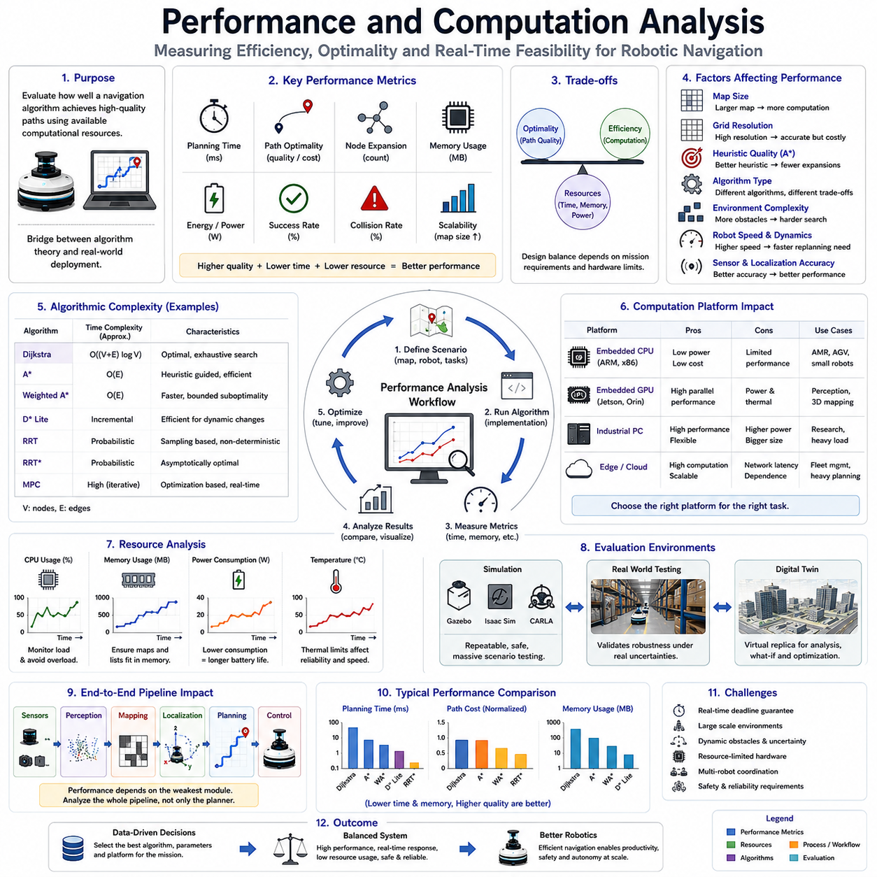
Performance and Computation Analysis is a critical discipline within autonomous navigation, robotic path planning, and intelligent mobility systems. While path planning algorithms are often evaluated based on their ability to find safe and optimal routes, practical robotic systems must also satisfy strict computational constraints. A theoretically optimal algorithm may become unusable if it requires excessive processing time, memory resources, energy consumption, or computational infrastructure. Consequently, performance analysis serves as the bridge between algorithmic theory and real-world deployment. It enables engineers to understand how navigation algorithms behave under different operating conditions and helps determine whether a particular planning method is suitable for deployment on an actual robot platform. Within Autonomous Mobile Robots (AMRs), autonomous vehicles, service robots, warehouse automation systems, outdoor inspection robots, agricultural machines, and multi-robot fleets, performance and computation analysis play a central role in achieving reliable and scalable navigation capabilities.
At its core, performance analysis seeks to answer a simple question: how effectively does a navigation algorithm accomplish its task using the available computational resources? The answer involves evaluating multiple dimensions simultaneously. A navigation planner must generate high-quality paths, respond within real-time deadlines, operate within memory constraints, maintain robustness under uncertainty, and scale to increasingly complex environments. These requirements often compete with one another, creating tradeoffs that must be carefully managed.
One of the most fundamental performance metrics is planning time. Planning time measures the duration required for an algorithm to generate a path from a starting location to a destination. In robotics, planning latency directly influences responsiveness. A robot operating in a static warehouse environment may tolerate planning times of several hundred milliseconds. In contrast, a robot navigating among moving people or vehicles may require planning updates within tens of milliseconds. Failure to satisfy timing requirements can result in degraded navigation performance, inefficient operation, or safety risks.
Path optimality represents another essential evaluation criterion. Optimality refers to how closely the generated path approximates the best possible solution according to a specified cost function. Cost functions may include travel distance, travel time, energy consumption, risk exposure, terrain difficulty, or combinations of multiple factors. Some algorithms guarantee mathematically optimal solutions, while others sacrifice optimality to achieve improved computational efficiency. Performance analysis quantifies these tradeoffs and helps determine acceptable levels of approximation.
Node expansion count is frequently used to evaluate search efficiency. Graph-based planners such as Dijkstra, A*, Weighted A*, D*, and many related algorithms operate by expanding nodes within a search space. Each node expansion requires computational effort. The total number of expanded nodes therefore serves as an indirect measure of algorithmic workload. Efficient algorithms typically explore fewer nodes while still generating high-quality solutions.
Computational complexity provides a theoretical framework for understanding algorithm behavior as problem size increases. Complexity analysis examines how computation time and memory requirements grow relative to the number of nodes, edges, or environmental features. Big-O notation is commonly used to characterize this behavior. For example, Dijkstra’s Algorithm exhibits computational complexity proportional to the number of graph nodes and edges. A* often performs more efficiently due to heuristic guidance, but its complexity remains highly dependent on map structure and heuristic quality.
Memory consumption represents another critical performance factor. Navigation algorithms frequently maintain data structures such as open lists, closed lists, occupancy grids, cost maps, search trees, graph representations, and localization states. Large environments may require millions of map cells or graph nodes. Excessive memory consumption can overwhelm embedded computing platforms and reduce overall system stability. Therefore, memory analysis is particularly important for robots operating with limited onboard computational resources.
Embedded robotic systems present unique computational challenges. Unlike cloud servers or high-performance workstations, mobile robots must operate within strict power, thermal, and hardware constraints. Navigation software often runs on embedded processors such as ARM-based systems, NVIDIA Jetson platforms, industrial PCs, or real-time controllers. Algorithms that perform well on desktop computers may become impractical when deployed on edge computing hardware. Consequently, performance analysis must always consider target deployment platforms.
Energy efficiency has become increasingly important in modern robotics. Every computational operation consumes electrical energy. Intensive navigation algorithms increase processor utilization, generate heat, and reduce battery endurance. For battery-powered AMRs, computation-related energy consumption can directly impact operational range and mission duration. Performance evaluation therefore increasingly includes measurements of processor load, GPU utilization, thermal behavior, and overall power consumption.
Map size strongly influences navigation performance. Small indoor environments may contain only a few thousand grid cells. Large warehouses, industrial facilities, airports, agricultural fields, mining sites, and smart-city deployments may contain millions of cells or graph nodes. As environmental scale increases, planning complexity often grows significantly. Scalability analysis evaluates how navigation performance changes as map size expands.
Grid resolution also affects computational requirements. High-resolution maps provide detailed environmental representations but increase memory consumption and search complexity. Low-resolution maps reduce computational burden but may degrade navigation accuracy. Engineers must carefully balance these competing factors. Resolution selection often represents one of the most important design decisions in navigation system development.
Heuristic quality plays a major role in computational performance for algorithms such as A*. Effective heuristics guide the search process toward promising regions of the environment and reduce unnecessary exploration. Poor heuristics may cause excessive node expansions and significantly increase planning time. Performance analysis frequently includes comparisons among different heuristic functions to identify optimal configurations for specific applications.
Weighted A* provides a clear example of performance-optimality tradeoffs. By increasing the influence of the heuristic function, Weighted A* often reduces computation time dramatically. However, the resulting paths may be slightly less optimal than those produced by standard A*. Performance analysis helps determine appropriate weighting factors by quantifying both computational savings and path quality degradation.
Sampling-based planners such as Rapidly-exploring Random Trees (RRT) introduce additional performance considerations. Unlike graph-search algorithms, sampling-based methods explore configuration spaces through stochastic sampling. Performance metrics include convergence speed, sampling efficiency, solution quality, and computational variability. Because sampling introduces randomness, performance analysis often requires statistical evaluation across multiple trials.
Trajectory optimization algorithms present yet another set of computational challenges. Methods such as Model Predictive Control (MPC), nonlinear optimization, spline optimization, and minimum-jerk trajectory generation involve solving mathematical optimization problems. Computational complexity depends on the number of optimization variables, constraints, prediction horizons, and solver characteristics. Real-time implementation often requires careful tuning and hardware acceleration.
Localization accuracy also influences navigation performance. Path planners rely on accurate robot pose estimates. Localization errors can cause navigation failures even when path planning algorithms perform correctly. Comprehensive performance analysis therefore examines interactions among localization, mapping, perception, and navigation subsystems. End-to-end system evaluation is often more meaningful than isolated algorithm benchmarking.
Sensor processing represents a significant portion of overall computational workload. Modern robots frequently integrate multiple LiDAR sensors, RGB cameras, depth cameras, thermal cameras, radar systems, GNSS receivers, and inertial measurement units. Sensor fusion pipelines generate substantial computational demand before navigation algorithms even begin execution. Performance analysis must therefore account for the complete navigation pipeline rather than focusing solely on path planning.
Multi-threaded software architectures are commonly employed to improve computational efficiency. Modern navigation systems often execute localization, perception, mapping, planning, control, and communication tasks concurrently. Proper thread scheduling and resource allocation can significantly improve performance. However, concurrency introduces additional complexity related to synchronization, latency, and resource contention.
GPU acceleration has become increasingly important in advanced navigation systems. Parallel processing architectures enable rapid execution of perception algorithms, sensor fusion pipelines, occupancy grid generation, semantic mapping, and certain path planning operations. Platforms such as NVIDIA Jetson Orin, Jetson Thor, RTX-based edge computers, and industrial GPU systems provide substantial computational advantages. Performance analysis frequently compares CPU-based and GPU-based implementations.
Cloud and edge computing architectures introduce new dimensions of performance evaluation. Some navigation tasks may execute locally on the robot, while others are offloaded to edge servers or cloud infrastructure. Distributed computation can improve scalability but introduces communication latency and network dependency. Engineers must carefully analyze tradeoffs between local autonomy and distributed processing.
Real-time performance analysis requires consideration of worst-case execution times rather than average performance alone. Safety-critical systems must guarantee that computational deadlines are always satisfied. Occasional latency spikes may create hazardous conditions even when average performance appears acceptable. Deterministic execution characteristics are therefore highly valued in industrial robotics applications.
Benchmarking methodologies provide standardized approaches for comparing navigation systems. Common benchmark environments include structured warehouses, office buildings, hospitals, outdoor campuses, industrial facilities, and simulated urban environments. Performance metrics typically include planning time, path length, energy consumption, memory usage, node expansion count, navigation success rate, collision frequency, and mission completion time.
Simulation platforms play a vital role in performance evaluation. Gazebo, Isaac Sim, CARLA, Webots, and digital twin environments enable controlled experimentation under repeatable conditions. Engineers can systematically vary environmental complexity, obstacle density, robot speed, sensor configurations, and computational resources to understand algorithm behavior across diverse scenarios.
Field testing remains essential despite advances in simulation technology. Real-world environments introduce sensor noise, communication delays, localization drift, weather effects, lighting variations, terrain irregularities, and unexpected human behaviors. Performance analysis must ultimately validate simulation results through extensive operational testing in realistic conditions.
Industrial AMR deployments often involve fleet-level performance considerations. Individual robot navigation performance is important, but overall system efficiency depends on coordination among multiple robots. Fleet performance metrics include traffic flow efficiency, congestion levels, task throughput, resource utilization, deadlock frequency, and system scalability. Navigation algorithms must be evaluated within the context of larger operational ecosystems.
Failure analysis provides valuable insights into performance limitations. Navigation failures may result from localization errors, mapping inaccuracies, sensor degradation, computational overload, communication interruptions, environmental changes, or algorithmic weaknesses. Systematic failure investigation helps identify bottlenecks and guide future optimization efforts.
Machine learning is increasingly applied to performance optimization. Predictive models can estimate computational workload, predict navigation bottlenecks, optimize planner parameters, and dynamically allocate resources. Learning-based approaches are beginning to complement traditional analytical performance evaluation techniques.
The emergence of digital twin technology has significantly enhanced performance analysis capabilities. Digital twins provide high-fidelity virtual representations of robotic systems and operating environments. Engineers can evaluate navigation performance under thousands of hypothetical scenarios before deployment, reducing development costs and accelerating optimization cycles.
For outdoor autonomous robots such as agricultural platforms, GPR-based infrastructure inspection robots, security patrol systems, and mining vehicles, performance analysis becomes even more challenging. Environmental variability, terrain complexity, weather conditions, and large-scale operating areas introduce significant computational demands. Robust performance evaluation is therefore essential for ensuring reliable field operation.
As robotic systems continue to evolve toward greater autonomy, performance and computation analysis will become increasingly important. Future navigation systems will integrate semantic reasoning, world models, multimodal perception, foundation models, reinforcement learning, and embodied AI capabilities. These advanced functions will dramatically increase computational requirements while simultaneously raising expectations for navigation performance.
In the broader context of autonomous navigation, performance and computation analysis represent the discipline that transforms theoretical algorithms into practical robotic solutions. An algorithm is not valuable merely because it can find a path; it is valuable because it can find an appropriate path within available computational resources and operational constraints. By systematically evaluating efficiency, scalability, robustness, resource utilization, and real-world effectiveness, performance analysis enables engineers to build navigation systems that are not only intelligent but also deployable, reliable, and economically viable. For modern AMRs, autonomous vehicles, industrial robots, and future embodied AI systems, performance and computation analysis will remain a foundational component of navigation system engineering for decades to come.

04.7 Industrial Applications
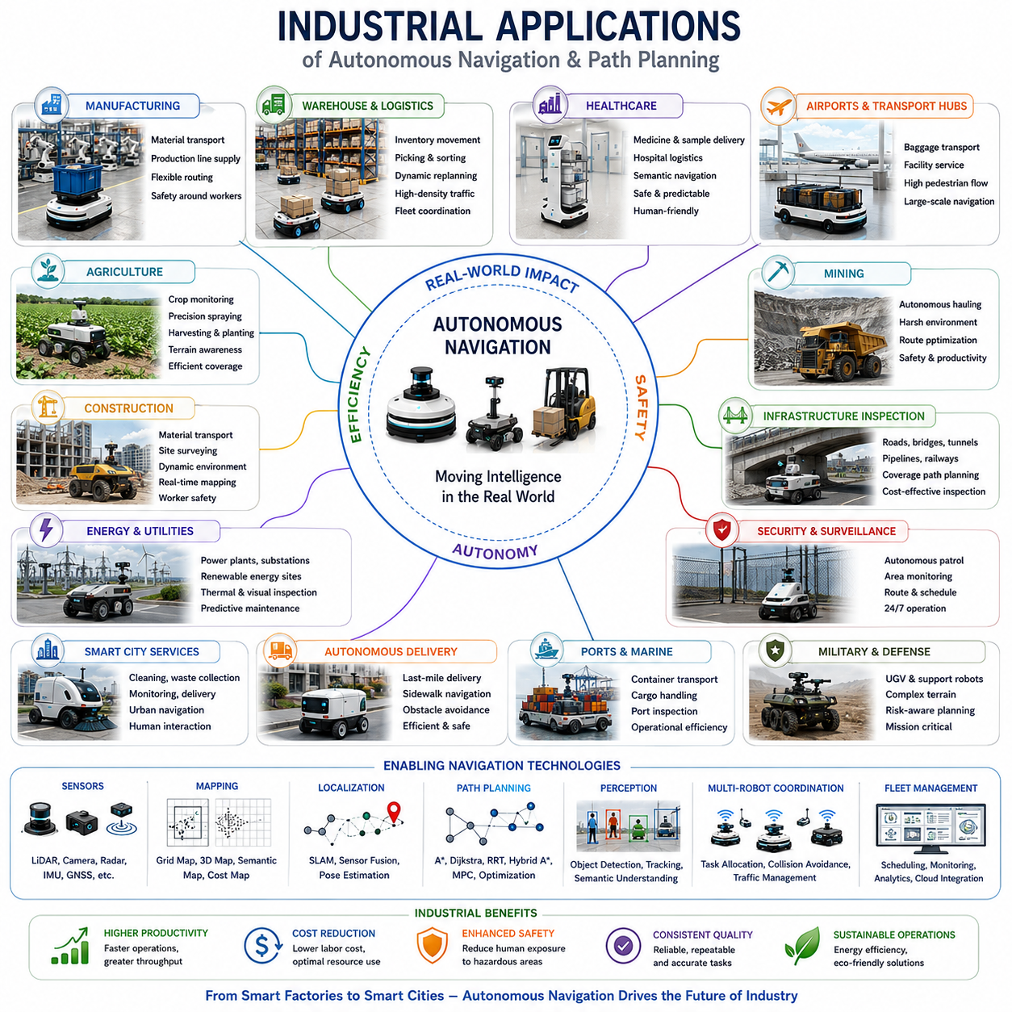
Industrial Applications of path planning and navigation technologies represent one of the most important areas of modern robotics and autonomous systems. While path planning algorithms such as Dijkstra, A*, Weighted A*, D*, Hybrid A*, and various optimization-based navigation methods are often studied from theoretical and computational perspectives, their true value emerges when deployed in real industrial environments. Today, autonomous navigation technologies are transforming manufacturing, logistics, healthcare, agriculture, mining, infrastructure inspection, transportation, security, defense, and smart city operations. The ability of autonomous systems to move safely, efficiently, and intelligently through complex environments has become a critical enabler of digital transformation and Industry 4.0 initiatives. As labor shortages, operational efficiency requirements, and safety concerns continue to increase globally, industrial navigation systems are becoming fundamental components of modern automated operations.
In manufacturing environments, autonomous navigation plays a central role in material handling and intralogistics. Modern factories contain extensive networks of production lines, storage areas, assembly stations, testing facilities, and shipping zones. Autonomous Mobile Robots and Automated Guided Vehicles transport raw materials, semi-finished products, tools, components, and finished goods throughout these facilities. Path planning systems ensure that robots select efficient routes while avoiding collisions with workers, machinery, forklifts, and other mobile assets. Navigation algorithms must continuously adapt to changing production conditions, temporary obstacles, and evolving workflow requirements. In highly automated factories, hundreds of autonomous vehicles may operate simultaneously, requiring sophisticated fleet-level navigation and traffic management strategies.
Warehouse automation represents one of the fastest-growing industrial applications of autonomous navigation. Large e-commerce fulfillment centers rely heavily on mobile robots to transport inventory between storage locations and picking stations. Navigation systems coordinate thousands of daily movements while maximizing throughput and minimizing congestion. Grid-based maps, cost maps, and graph-based route planning enable robots to identify efficient paths through densely packed storage environments. Dynamic replanning capabilities are essential because operational conditions change continuously as inventory is moved, shelves are relocated, and human workers interact with robotic systems. The efficiency of navigation algorithms directly impacts order fulfillment speed, operational costs, and overall warehouse productivity.
Distribution centers and logistics hubs require navigation systems capable of operating across large facilities with high traffic density. Autonomous transport robots move pallets, cartons, containers, and shipping materials between receiving docks, storage areas, sorting systems, and outbound loading zones. Route optimization not only affects individual robot performance but also influences overall facility efficiency. Multi-robot path planning, congestion avoidance, task allocation, and traffic coordination become increasingly important as fleet size grows. Advanced fleet management systems utilize path planning algorithms to balance workloads, optimize travel times, and minimize operational bottlenecks.
Healthcare environments present unique navigation challenges and opportunities. Hospitals, clinics, medical laboratories, and pharmaceutical facilities increasingly deploy autonomous service robots for logistics operations. These robots transport medications, laboratory samples, medical supplies, linens, meals, and equipment throughout healthcare facilities. Unlike industrial environments, hospitals contain highly dynamic human populations, sensitive patients, and strict safety requirements. Navigation systems must balance efficiency with predictability, comfort, and safety. Semantic navigation becomes particularly valuable because robots must understand contextual information such as restricted areas, emergency zones, patient rooms, and staff-only corridors. Reliable navigation contributes directly to healthcare efficiency while reducing the workload of medical personnel.
Airport and transportation hub operations have also become important application domains for autonomous navigation technologies. Airports involve complex logistics operations including baggage transport, facility maintenance, cleaning services, cargo handling, and passenger assistance. Autonomous robots can improve operational efficiency by automating repetitive transportation tasks. Navigation systems operating in these environments must handle large-scale facilities, high pedestrian density, dynamic obstacles, and continuously changing operational conditions. Robust localization and path planning are essential for maintaining reliable performance within such challenging environments.
Agricultural robotics represents a rapidly expanding field of industrial navigation. Modern agricultural robots perform tasks including crop monitoring, precision spraying, harvesting, planting, soil analysis, and autonomous transportation. Unlike structured indoor environments, agricultural fields present irregular terrain, changing environmental conditions, vegetation growth, weather influences, and varying soil characteristics. Navigation systems must account for terrain traversability, crop rows, field boundaries, obstacles, and operational efficiency. Advanced path planning algorithms enable robots to maximize field coverage while minimizing overlap, energy consumption, and crop damage. Autonomous agricultural navigation contributes to increased productivity, reduced labor dependency, and more sustainable farming practices.
Mining operations present some of the most demanding navigation challenges encountered in industrial robotics. Autonomous mining vehicles operate in harsh environments characterized by uneven terrain, dust, limited visibility, dynamic work zones, and significant safety hazards. Navigation systems must provide reliable operation despite difficult environmental conditions and limited infrastructure. Path planning algorithms optimize transportation routes for ore hauling, equipment movement, and site logistics. Autonomous navigation improves operational efficiency while reducing human exposure to hazardous conditions. As mining operations increasingly adopt automation technologies, navigation systems continue to play a critical role in enhancing productivity and safety.
Construction environments provide another emerging application area. Construction sites are inherently dynamic, with continuously changing layouts, moving equipment, temporary structures, and evolving work zones. Autonomous construction robots perform material transport, surveying, inspection, site monitoring, and equipment support functions. Navigation systems must adapt to frequent environmental changes while maintaining safe operation near human workers and heavy machinery. Dynamic mapping, real-time obstacle detection, and adaptive path planning are particularly important in these environments.
Infrastructure inspection has become one of the most significant industrial applications of autonomous navigation. Inspection robots are increasingly used to assess roads, bridges, tunnels, railways, pipelines, utility networks, power facilities, industrial plants, and public infrastructure. These systems reduce inspection costs, improve safety, and enable more frequent monitoring. Navigation algorithms guide robots through complex environments while ensuring complete inspection coverage. Coverage path planning is often as important as shortest-path planning because the objective is to inspect every relevant area rather than simply travel between two points.
Underground utility inspection represents a particularly important application for advanced navigation systems. As urban infrastructure ages, there is increasing demand for technologies capable of locating and assessing buried assets. Ground Penetrating Radar systems integrated with autonomous mobile platforms enable efficient inspection of underground utilities, pipelines, communication cables, and infrastructure networks. Navigation systems coordinate vehicle movement while maintaining sensor coverage requirements and positioning accuracy. Large-scale infrastructure inspection often involves extensive route planning, precise localization, and integration with geographic information systems.
Outdoor inspection robots operating in industrial facilities, energy installations, and utility networks require navigation systems capable of handling complex terrain and environmental conditions. These robots perform routine inspections of pipelines, substations, solar farms, wind farms, water treatment facilities, and industrial plants. Navigation algorithms optimize inspection routes while accounting for terrain characteristics, safety requirements, sensor constraints, and mission objectives. Autonomous inspection reduces operational costs while improving monitoring frequency and data quality.
Energy sector applications have expanded significantly in recent years. Autonomous robots inspect power generation facilities, electrical substations, transmission corridors, renewable energy installations, and utility infrastructure. Navigation systems enable robots to operate safely near high-voltage equipment and within large industrial sites. Thermal cameras, LiDAR sensors, visual inspection systems, and AI-based anomaly detection technologies are frequently integrated with navigation platforms to support predictive maintenance and asset management strategies.
Security and surveillance operations represent another major application area. Autonomous patrol robots are increasingly deployed in industrial parks, campuses, warehouses, transportation facilities, military bases, and critical infrastructure sites. Navigation systems coordinate patrol routes, area coverage strategies, and response behaviors. These robots often operate continuously over extended periods, requiring highly reliable localization and path planning capabilities. Route optimization contributes to improved coverage effectiveness while reducing energy consumption and operational costs.
Smart city initiatives increasingly incorporate autonomous navigation technologies into urban infrastructure management. Municipal service robots perform cleaning, waste collection, monitoring, delivery, maintenance, and inspection tasks. Navigation systems must interact safely with pedestrians, vehicles, bicycles, and public transportation systems. Urban environments present significant challenges due to scale, complexity, and environmental variability. Advanced navigation technologies are essential for enabling practical deployment within smart city ecosystems.
Autonomous delivery systems have emerged as a rapidly growing application domain. Delivery robots operate in sidewalks, campuses, residential communities, business districts, and industrial facilities. Navigation systems must safely interact with pedestrians while maintaining efficient route execution. Dynamic path planning, semantic understanding, and real-time obstacle avoidance are critical capabilities for successful operation. As last-mile delivery continues to evolve, navigation technology remains one of the key enabling factors.
Marine and port operations also benefit from autonomous navigation technologies. Ports involve large-scale logistics activities including container transportation, cargo handling, facility inspection, and security monitoring. Autonomous ground vehicles, mobile robots, and specialized inspection platforms utilize path planning algorithms to coordinate operations within complex industrial environments. Efficient navigation contributes directly to improved throughput and operational efficiency.
Military and defense applications often require navigation systems capable of operating in highly uncertain and challenging environments. Autonomous ground vehicles, logistics robots, reconnaissance platforms, and support systems must navigate complex terrain while maintaining operational effectiveness. Path planning algorithms frequently incorporate risk assessment, mission priorities, terrain analysis, and threat avoidance. Robust navigation remains a critical requirement for autonomous defense systems.
Multi-robot industrial systems represent an increasingly important area of application. Modern facilities rarely deploy individual autonomous robots in isolation. Instead, fleets of robots collaborate to accomplish shared objectives. Navigation systems must coordinate robot movement, allocate tasks, prevent congestion, avoid deadlocks, and optimize fleet-level performance. Multi-agent path planning has therefore become a major research and industrial development area.
Fleet Management Systems integrate navigation algorithms with scheduling, traffic management, mission planning, and operational analytics. These systems provide centralized coordination while allowing individual robots to maintain local autonomy. Effective fleet navigation significantly improves resource utilization, throughput, and operational scalability. Large industrial facilities may manage hundreds or even thousands of autonomous vehicles through integrated fleet management architectures.
The emergence of digital twins has further expanded industrial navigation capabilities. Digital twins provide virtual representations of robots, facilities, infrastructure, and operational environments. Navigation algorithms can be tested, optimized, and validated within simulated environments before deployment. This capability reduces development costs, accelerates deployment cycles, and improves operational reliability. Digital twin technology is becoming increasingly important for industrial robotics and autonomous systems engineering.
Artificial intelligence is transforming industrial navigation by enabling semantic understanding, predictive planning, adaptive behavior, and learning-based optimization. Modern navigation systems increasingly integrate machine learning, computer vision, reinforcement learning, and foundation models. These technologies allow robots to interpret complex environments, anticipate changes, and improve performance over time. The combination of classical path planning algorithms with advanced AI techniques represents one of the most important trends in industrial robotics.
The economic impact of autonomous navigation technologies is substantial. Improved productivity, reduced labor costs, enhanced safety, increased operational consistency, and better resource utilization contribute directly to return on investment. Organizations deploying autonomous navigation systems often achieve significant improvements in efficiency while reducing operational risks. As hardware costs continue to decrease and software capabilities continue to improve, adoption rates are expected to accelerate across multiple industries.
Looking toward the future, industrial navigation systems will become increasingly intelligent, connected, and autonomous. Integration with cloud computing, edge AI, digital twins, large-scale fleet management, semantic world models, and embodied AI architectures will expand the capabilities of autonomous systems. Robots will move beyond simple point-to-point navigation and develop deeper understanding of operational contexts, mission objectives, and environmental dynamics.
In the broader context of autonomous systems engineering, industrial applications demonstrate the practical significance of navigation technologies. Path planning algorithms, grid maps, localization systems, cost maps, semantic reasoning, and computational optimization techniques ultimately derive their value from their ability to solve real-world problems. From factories and warehouses to hospitals, farms, mines, inspection systems, infrastructure networks, and smart cities, industrial navigation technologies continue to transform how work is performed. As autonomous robotics becomes increasingly integrated into global industries, navigation systems will remain one of the most important foundations enabling safe, efficient, scalable, and intelligent automation.

04.8 Debugging and Visualization
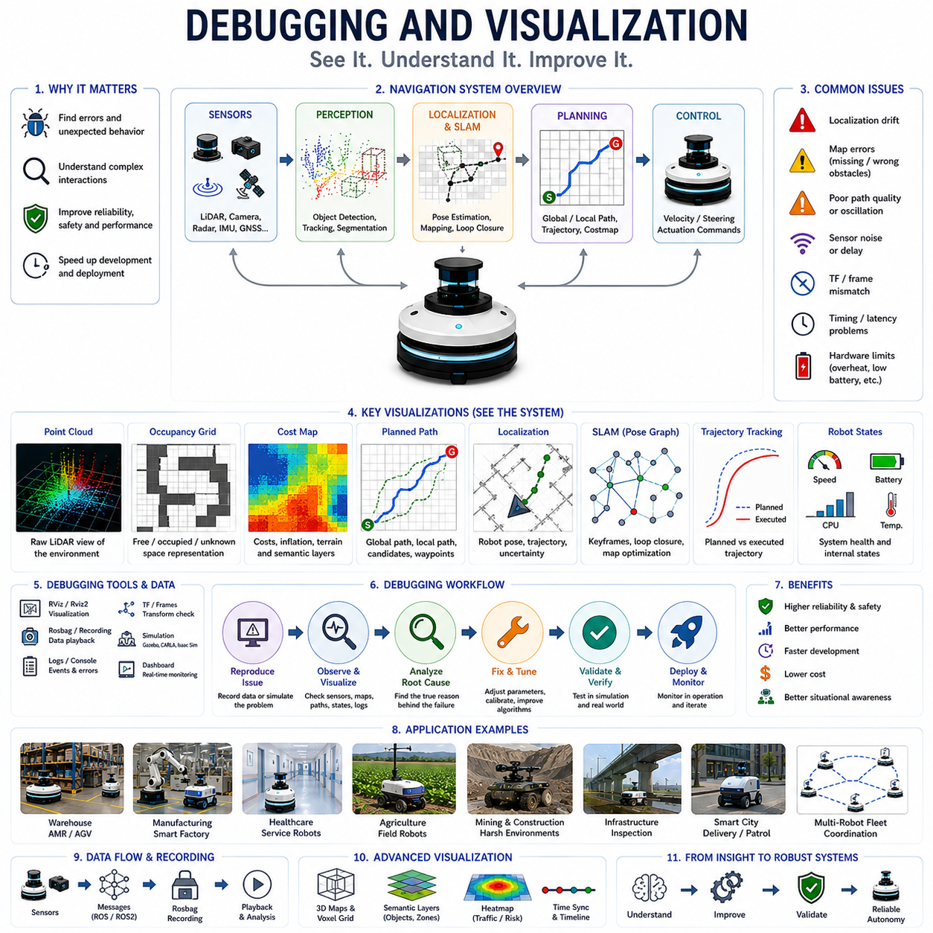
Debugging and Visualization represent some of the most critical activities in the development, validation, deployment, and maintenance of autonomous navigation systems. While algorithms such as Dijkstra, A*, Weighted A*, D*, Hybrid A*, SLAM, localization systems, and motion planners may appear mathematically correct on paper, real-world robotic systems frequently exhibit unexpected behaviors when deployed in practical environments. Navigation failures often emerge from subtle interactions among perception systems, sensor fusion pipelines, localization modules, mapping processes, path planners, motion controllers, communication systems, and hardware constraints. Consequently, debugging and visualization serve as essential tools that allow engineers to observe, analyze, understand, and improve robot behavior. Without effective debugging and visualization methodologies, the development of reliable autonomous navigation systems would be extremely difficult and time-consuming.
At a fundamental level, debugging refers to the systematic process of identifying, analyzing, and correcting errors, failures, inefficiencies, or unexpected behaviors within a robotic system. Visualization refers to the graphical representation of data, states, decisions, and environmental information that helps engineers understand what the robot is sensing, thinking, and doing. Together, these two disciplines transform complex internal computations into interpretable information that can be analyzed by developers, researchers, operators, and system integrators.
Modern autonomous robots generate enormous amounts of data during operation. LiDAR sensors may produce millions of points per second. Cameras generate high-resolution image streams. Radar sensors continuously detect objects and motion. GNSS receivers provide positioning information. IMUs generate acceleration and rotational measurements. Localization systems estimate robot pose. Mapping systems update environmental models. Path planners compute routes. Motion controllers generate steering and velocity commands. Debugging and visualization provide mechanisms for understanding how these diverse data streams interact within the overall navigation architecture.
One of the most important objectives of debugging is determining why a robot behaves differently than expected. A navigation failure may appear simple from an external perspective. A robot may stop unexpectedly, deviate from its planned route, collide with an obstacle, become lost, or fail to reach its destination. However, the root cause often lies deep within the navigation stack. Sensor noise, localization drift, mapping inconsistencies, path planning errors, timing issues, communication delays, actuator limitations, or environmental disturbances may all contribute to the observed behavior. Effective debugging requires systematic investigation of these interconnected components.
Visualization provides critical insight into robot perception. One of the most commonly visualized data sources is the LiDAR point cloud. Point cloud visualization allows engineers to observe the robot's representation of its surrounding environment. Obstacles, walls, vehicles, equipment, pedestrians, terrain features, and environmental structures become visible as three-dimensional spatial data. By examining point clouds, engineers can verify sensor performance, identify blind spots, detect calibration errors, and evaluate environmental perception quality.
Occupancy grid visualization is another fundamental debugging tool. Grid maps convert raw sensor measurements into discrete environmental representations used by path planning algorithms. Visualizing occupancy grids allows engineers to verify obstacle detection accuracy, free-space estimation, unknown regions, and map consistency. Incorrect occupancy classifications often lead directly to navigation failures. Visualization enables rapid identification of mapping errors that may otherwise remain hidden.
Cost map visualization plays a particularly important role in navigation debugging. Modern navigation systems often use layered cost maps that incorporate obstacle information, safety margins, inflation zones, terrain costs, semantic information, and dynamic obstacles. Visualizing these cost layers helps engineers understand how the planner evaluates different regions of the environment. If a robot consistently selects inefficient routes, the cause may be revealed through cost map inspection.
Path visualization is among the most intuitive debugging techniques. Planned routes can be displayed directly within the environment representation. Engineers can compare planned paths against expected behavior and environmental constraints. Visualization may include global paths, local trajectories, candidate paths, rejected alternatives, and optimization results. Observing these elements provides valuable insight into planner decision-making processes.
Localization debugging is particularly important because accurate positioning serves as the foundation of autonomous navigation. Visualization tools commonly display estimated robot pose, trajectory history, sensor measurements, map alignment, and localization uncertainty. If localization errors occur, visualization often reveals discrepancies between sensor observations and map features. Such insights are essential for diagnosing localization failures and improving system robustness.
SLAM systems benefit extensively from visualization-based debugging. Simultaneous Localization and Mapping involves complex interactions among sensor processing, feature extraction, pose estimation, loop closure detection, and map optimization. Visualizing pose graphs, landmarks, feature correspondences, loop closure candidates, and map updates helps engineers understand system behavior and identify performance bottlenecks. Without visualization, diagnosing SLAM failures can become extremely challenging.
Trajectory visualization provides insight into robot motion behavior. Planned trajectories can be compared with actual executed trajectories. Deviations may indicate controller tuning issues, actuator limitations, localization inaccuracies, terrain influences, or dynamic disturbances. Trajectory analysis is especially important for autonomous vehicles, mobile robots, towing systems, and nonholonomic platforms where motion constraints significantly influence navigation performance.
Robot state visualization extends beyond spatial information. Modern debugging systems often display velocity profiles, acceleration values, steering angles, battery status, sensor health, processor utilization, network latency, and internal algorithm states. These visualizations provide a comprehensive view of system behavior and help engineers identify interactions among different subsystems.
Time synchronization represents a critical debugging challenge in autonomous systems. Sensors operate at different frequencies and may experience varying communication delays. Navigation algorithms depend heavily on accurate temporal alignment of sensor measurements. Visualization tools often include timestamp analysis, message timelines, synchronization diagnostics, and latency monitoring to identify timing-related issues.
Communication debugging becomes increasingly important as robotic systems grow more complex. Modern navigation architectures often involve distributed computing, ROS2 communication frameworks, edge computing devices, cloud services, fleet management systems, and multiple onboard processors. Visualization of message flows, communication rates, bandwidth utilization, packet delays, and node interactions helps engineers diagnose communication bottlenecks and system integration issues.
ROS and ROS2 ecosystems provide some of the most widely used debugging and visualization tools in robotics. RViz serves as a central visualization platform capable of displaying point clouds, occupancy grids, robot models, TF transformations, planned paths, cost maps, sensor measurements, markers, and navigation information. Engineers frequently rely on RViz throughout the entire robot development lifecycle.
The TF visualization system provides insight into coordinate frame relationships. Autonomous robots may maintain dozens of coordinate frames associated with sensors, robot components, maps, localization systems, and control modules. Incorrect frame transformations can produce severe navigation failures. TF visualization enables engineers to verify spatial relationships and identify transformation inconsistencies.
Rosbag recording plays a crucial role in debugging workflows. Real-world failures often occur intermittently and may be difficult to reproduce. Rosbag allows engineers to record sensor data, navigation messages, and system states during operation. These recordings can later be replayed repeatedly under controlled conditions. Offline debugging significantly accelerates problem analysis and algorithm development.
Log analysis represents another important debugging methodology. Navigation systems generate extensive logs describing internal events, warnings, errors, state transitions, and performance metrics. Structured logging enables engineers to trace system behavior over time and identify conditions associated with failures. Modern logging frameworks often integrate with visualization dashboards to simplify analysis.
Simulation environments have become indispensable debugging platforms. Gazebo, Isaac Sim, CARLA, Webots, and digital twin environments allow engineers to visualize robot behavior under controlled conditions. Simulation provides repeatability, safety, scalability, and rapid experimentation. Engineers can test navigation algorithms across diverse scenarios while observing internal system behavior through detailed visualization tools.
Digital twins extend visualization capabilities by creating high-fidelity virtual representations of physical environments and robotic systems. Navigation performance can be analyzed under thousands of simulated conditions before deployment. Engineers can visualize potential failures, evaluate alternative strategies, and optimize system configurations with minimal operational risk.
Three-dimensional visualization has become increasingly important as robotic systems evolve. Traditional two-dimensional maps are often insufficient for understanding complex environments involving elevation changes, terrain structures, infrastructure elements, and three-dimensional obstacles. Modern visualization tools support volumetric maps, voxel representations, digital terrain models, semantic layers, and immersive 3D environments.
Semantic visualization provides another powerful debugging capability. Modern navigation systems increasingly incorporate semantic understanding of the environment. Objects, regions, infrastructure elements, work zones, traffic areas, safety zones, and operational constraints can be displayed as semantic overlays. Visualization helps engineers verify classification accuracy and contextual reasoning performance.
Multi-robot systems introduce unique debugging challenges. Fleet-level visualization tools display robot locations, planned routes, task assignments, traffic conditions, congestion zones, communication status, and operational efficiency metrics. Such tools help operators understand collective robot behavior and identify coordination problems that may not be visible at the individual robot level.
Performance visualization supports computational analysis and optimization. Engineers often visualize processor utilization, memory consumption, GPU workload, message frequencies, planning times, localization rates, sensor update frequencies, and network performance. Real-time performance dashboards help identify computational bottlenecks and resource limitations.
Heat maps provide valuable insight into navigation behavior. Heat maps can represent robot traffic density, obstacle occurrence frequency, localization confidence, communication quality, energy consumption, or operational risk. By visualizing spatial patterns across large environments, engineers can identify problematic regions and optimization opportunities.
Failure visualization is particularly valuable during system validation. When navigation failures occur, visualization tools can reconstruct the sequence of events leading to the incident. Sensor measurements, localization estimates, planner outputs, controller actions, and environmental conditions can be replayed and analyzed in detail. Such investigations often reveal root causes that would otherwise remain difficult to identify.
Machine learning and AI systems introduce additional debugging complexity. Deep neural networks often behave as black-box models. Visualization techniques such as attention maps, feature activations, saliency maps, semantic embeddings, confidence distributions, and explainable AI methods help engineers understand model behavior and improve trustworthiness.
Human-machine interfaces also benefit from effective visualization. Operators, supervisors, maintenance personnel, and safety managers require intuitive displays of robot status and navigation behavior. Well-designed visualization systems improve situational awareness and facilitate operational decision-making.
Industrial applications place particularly high demands on debugging and visualization systems. Warehouses, factories, hospitals, airports, agricultural operations, mining sites, infrastructure inspection systems, and autonomous vehicle deployments often involve large-scale operations and strict reliability requirements. Visualization tools enable continuous monitoring and rapid diagnosis of operational issues.
Autonomous outdoor robots face additional challenges due to environmental variability. Weather conditions, terrain changes, vegetation growth, dynamic obstacles, GNSS degradation, and long-distance operations introduce complex failure modes. Visualization systems help engineers understand environmental influences and improve navigation robustness.
Cybersecurity and system integrity monitoring are becoming increasingly important aspects of visualization. Navigation systems may visualize communication anomalies, unauthorized access attempts, sensor spoofing indicators, network disruptions, and system health metrics. Such capabilities support safe and secure operation of autonomous platforms.
As robotics systems become increasingly sophisticated, debugging and visualization technologies continue to evolve. Future systems will incorporate augmented reality, virtual reality, digital twins, AI-assisted diagnostics, predictive failure analysis, automated root-cause identification, and intelligent visualization frameworks. These capabilities will further enhance the ability of engineers to understand and optimize complex autonomous systems.
From a broader perspective, debugging and visualization serve as the eyes and analytical intelligence of robotic development. Navigation algorithms may perform millions of calculations internally, but without visualization those computations remain invisible to human developers. Visualization transforms abstract mathematical processes into understandable representations, while debugging provides structured methodologies for improving system behavior. Together, they enable the development of reliable, safe, scalable, and intelligent navigation systems.
For autonomous mobile robots, autonomous vehicles, warehouse automation platforms, hospital service robots, agricultural machines, infrastructure inspection robots, industrial fleets, and future embodied AI systems, debugging and visualization will remain indispensable disciplines. They provide the transparency, understanding, and diagnostic capabilities necessary to transform complex navigation algorithms into dependable real-world autonomous systems capable of operating safely and efficiently within increasingly challenging environments.

