Volume 05. Path Planning and Autonomous Navigation

Chapter 19. Traffic Management

19.1 AMR Traffic Management Concepts
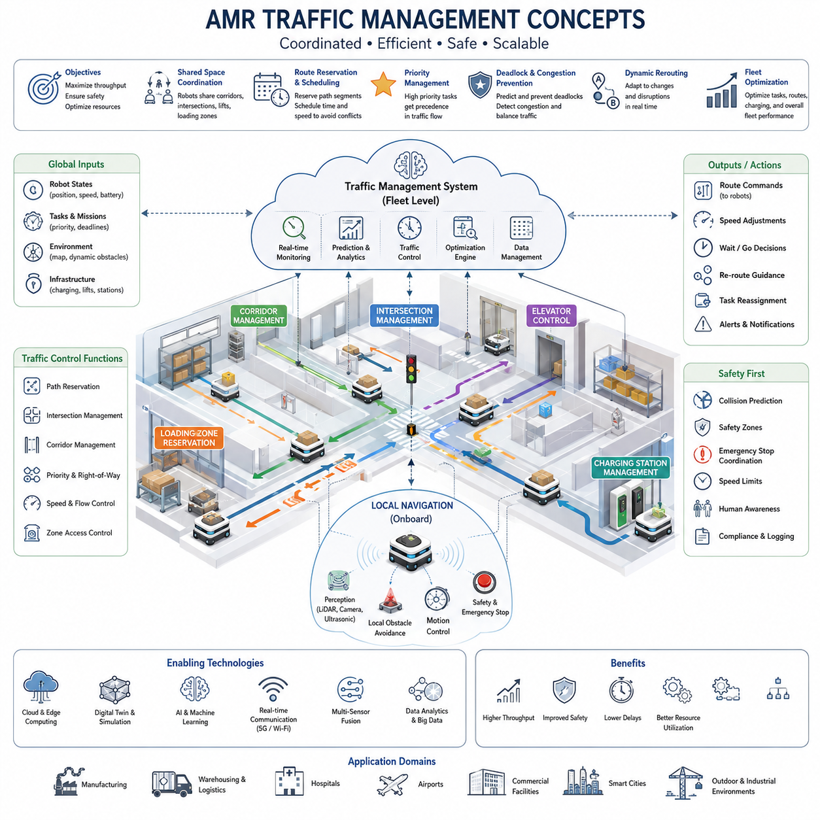
Autonomous Mobile Robot (AMR) traffic management is a fundamental capability that enables multiple robots to operate safely, efficiently, and predictably within a shared environment. As the number of robots deployed in factories, hospitals, warehouses, airports, logistics centers, smart cities, and outdoor industrial facilities continues to increase, the complexity of coordinating robot movement also grows significantly. A single robot navigating independently can rely primarily on local obstacle avoidance and path planning algorithms. However, when dozens, hundreds, or even thousands of robots simultaneously share the same infrastructure, traffic management becomes an essential system-level function that determines overall operational performance, safety, scalability, and economic value. The concepts of AMR traffic management therefore extend beyond individual robot navigation and encompass fleet-wide coordination, resource allocation, congestion control, route optimization, and real-time operational decision-making. These concepts form the foundation for modern fleet management systems and large-scale autonomous robot deployments.
Traffic management in AMR systems can be viewed as the robotic equivalent of traffic control in human transportation networks. Just as road systems require traffic signals, lane management, intersection control, priority rules, and congestion mitigation strategies, AMR deployments require mechanisms that regulate robot movement through shared operational spaces. Without traffic management, robots may block each other, create deadlocks, increase travel times, reduce productivity, and potentially compromise safety. Effective traffic management ensures that every robot can accomplish its assigned task while minimizing interference with other robots and maintaining system-wide efficiency.
The primary objective of AMR traffic management is to maximize throughput while maintaining safety and operational stability. Throughput refers to the total amount of work completed by the robot fleet over a given period of time. In a warehouse, throughput may represent the number of pallets transported per hour. In a hospital, it may represent the number of deliveries completed between departments. In a manufacturing environment, throughput may correspond to material transport cycles supporting production lines. Traffic management systems continuously monitor robot movements, task assignments, environmental conditions, and infrastructure utilization to optimize this throughput while preventing unsafe interactions.
One of the most important concepts in AMR traffic management is shared-space coordination. Multiple robots often operate within the same corridors, intersections, loading zones, charging stations, and production areas. Shared spaces become critical resources that must be allocated carefully to avoid conflicts. Traffic management systems maintain awareness of robot locations, trajectories, speeds, and destinations to coordinate access to these resources. By predicting future movements, the system can proactively prevent collisions and reduce waiting times.
Traffic management operates at multiple levels of abstraction. At the lowest level, individual robots perform local collision avoidance using onboard sensors such as LiDAR, cameras, radar, ultrasonic sensors, and depth cameras. These local systems react to nearby obstacles and immediate hazards. At a higher level, fleet traffic management systems coordinate robot movements across larger operational areas. Fleet-level coordination considers global traffic patterns, resource utilization, route reservations, and long-term optimization objectives. The combination of local autonomy and centralized coordination creates a hierarchical architecture capable of supporting large-scale deployments.
A critical concept in traffic management is route reservation. Similar to air traffic control reserving airspace or railway systems reserving track segments, AMR traffic systems can reserve specific path segments for robot traversal. Before entering a corridor, intersection, or constrained area, a robot may request access from the traffic management system. If the segment is available, the reservation is granted. If another robot already occupies or has reserved the segment, the requesting robot may wait or receive an alternative route. This approach significantly reduces collision risks and prevents traffic conflicts before they occur.
Path scheduling is another essential element of traffic management. Rather than allowing all robots to independently select the shortest route, traffic management systems consider the collective behavior of the fleet. Two robots traveling on intersecting paths may create congestion if they arrive simultaneously at a shared location. By adjusting departure times, travel speeds, or route selections, the system can smooth traffic flow and reduce bottlenecks. Path scheduling transforms navigation from a purely spatial problem into a spatiotemporal optimization problem where both location and timing must be coordinated.
Intersection management represents one of the most challenging areas of AMR traffic control. Intersections create natural conflict points where robot paths converge. Traffic management systems must determine which robot receives priority and how crossing movements are coordinated. Various approaches can be used, including stop-and-go control, reservation-based intersection access, virtual traffic lights, dynamic priority assignment, and predictive scheduling. Advanced systems evaluate robot urgency, task importance, waiting time, destination constraints, and overall fleet efficiency when determining intersection access priorities.
Corridor management is equally important in environments with narrow pathways. In factories and hospitals, corridors often support bidirectional robot movement while providing limited maneuvering space. Traffic management systems must regulate entry into these corridors to avoid blockages. Some systems implement one-way traffic policies, while others dynamically allocate corridor direction based on current demand. Predictive traffic control allows robots to negotiate corridor access before entering constrained areas, improving overall efficiency.
Priority management plays a significant role in many industrial applications. Not all robot missions have equal importance. In hospitals, emergency medication deliveries may receive higher priority than routine supply transport. In manufacturing environments, robots supporting critical production lines may take precedence over less urgent logistics tasks. Traffic management systems assign priority levels to tasks and adjust routing decisions accordingly. Priority-aware traffic control ensures that critical operations receive timely support while maintaining fairness across the fleet.
Deadlock prevention is a central objective of traffic management systems. A deadlock occurs when multiple robots block each other in a circular dependency, preventing any robot from proceeding. Deadlocks commonly arise in narrow corridors, intersections, loading areas, and densely populated operational zones. Traffic management systems continuously analyze robot trajectories and resource dependencies to identify potential deadlock scenarios before they occur. Preventive strategies include resource reservation, movement sequencing, alternative route generation, temporary holding zones, and dynamic traffic rule adjustments.
Congestion management addresses situations where excessive robot density reduces operational efficiency. Similar to traffic jams in urban transportation systems, robot congestion can significantly increase task completion times. Traffic management systems monitor traffic density, travel delays, queue lengths, and infrastructure utilization. When congestion is detected, robots may be rerouted, speeds adjusted, tasks redistributed, or operational zones temporarily restricted. Advanced traffic management platforms employ predictive analytics to anticipate congestion before it impacts performance.
Dynamic rerouting is a key capability within traffic management architectures. Operational environments continuously change due to human activity, equipment movement, temporary obstacles, maintenance operations, and emergency situations. Traffic management systems must adapt to these changes in real time. When disruptions occur, affected robots receive updated routes that avoid problematic areas while minimizing overall impact on fleet productivity. Dynamic rerouting ensures resilient operation even in highly dynamic environments.
Another important concept is traffic-aware path planning. Traditional path planning algorithms focus on minimizing distance or travel time for individual robots. Traffic-aware planning incorporates fleet-level information into route selection. A slightly longer route may be preferable if it avoids congested areas and reduces overall system delays. Traffic-aware planning considers expected traffic density, reservation availability, predicted waiting times, and historical operational data when generating routes.
Fleet-wide optimization represents the highest level of traffic management intelligence. Rather than optimizing individual robot behavior, fleet optimization seeks to maximize the performance of the entire robotic ecosystem. This may involve balancing workload distribution, minimizing empty travel, reducing charging station congestion, coordinating task assignments, and optimizing resource utilization. Fleet optimization algorithms often combine operations research techniques, artificial intelligence methods, and real-time analytics to achieve global performance objectives.
Cloud-based traffic management has become increasingly important as AMR deployments scale. Cloud platforms provide centralized visibility across large robot fleets and geographically distributed facilities. Traffic management services running in the cloud can aggregate operational data, perform large-scale optimization, and coordinate multiple fleets simultaneously. Cloud architectures enable continuous learning, predictive maintenance integration, and cross-site performance analysis. At the same time, edge computing resources ensure that critical traffic control functions remain operational even during network disruptions.
Digital twins are emerging as valuable tools for traffic management development and operation. A digital twin provides a virtual representation of the physical robot fleet and operational environment. Traffic scenarios can be simulated, analyzed, and optimized before deployment. Engineers can evaluate intersection designs, corridor configurations, traffic rules, and fleet expansion strategies within the digital environment. Digital twins support continuous improvement and reduce operational risk by enabling data-driven decision-making.
Human-aware traffic management is particularly important in environments where robots and people share the same workspace. Hospitals, airports, offices, shopping centers, and industrial facilities often require mixed human-robot traffic. Traffic management systems must account for human behavior, pedestrian flow patterns, safety regulations, and social navigation requirements. Robots may reduce speed near people, yield at crossings, avoid crowded areas, and maintain appropriate separation distances. Human-aware traffic management enhances safety while improving user acceptance of robotic systems.
Safety remains the highest priority in all traffic management systems. Traffic control policies must comply with applicable safety standards, industrial regulations, and operational requirements. Safety mechanisms include speed restrictions, exclusion zones, emergency stop coordination, collision prediction, risk assessment, and fail-safe behaviors. Traffic management systems continuously evaluate operational conditions to ensure that safety objectives are maintained even under abnormal circumstances.
Scalability is another defining characteristic of modern AMR traffic management. Small deployments may involve only a handful of robots, while large industrial facilities may operate hundreds or thousands of autonomous systems simultaneously. Traffic management architectures must scale efficiently without excessive computational overhead. Distributed coordination methods, hierarchical control architectures, cloud-native platforms, and edge-based optimization techniques contribute to scalable fleet operation.
Artificial intelligence is increasingly influencing AMR traffic management. Machine learning models can predict congestion, estimate travel times, forecast demand patterns, and optimize routing strategies. Reinforcement learning approaches can discover efficient traffic control policies through simulation and real-world experience. Large-scale operational datasets enable continuous improvement of traffic management algorithms, allowing robotic fleets to become more efficient over time.
The future of AMR traffic management will likely resemble intelligent transportation systems developed for autonomous vehicles and smart cities. Traffic management platforms will integrate real-time perception, predictive analytics, cloud intelligence, digital twins, multi-agent coordination, and AI-driven optimization into unified operational ecosystems. Robots will not only avoid collisions but actively cooperate to maximize collective productivity. Traffic management will evolve from simple conflict avoidance toward fully autonomous fleet orchestration, enabling large-scale deployments across factories, hospitals, logistics networks, industrial campuses, smart cities, and outdoor autonomous robot ecosystems. As AMR adoption continues to accelerate, traffic management concepts will become one of the most critical technological foundations supporting the next generation of intelligent robotic infrastructure.

19.2 Path Scheduling and Reservation
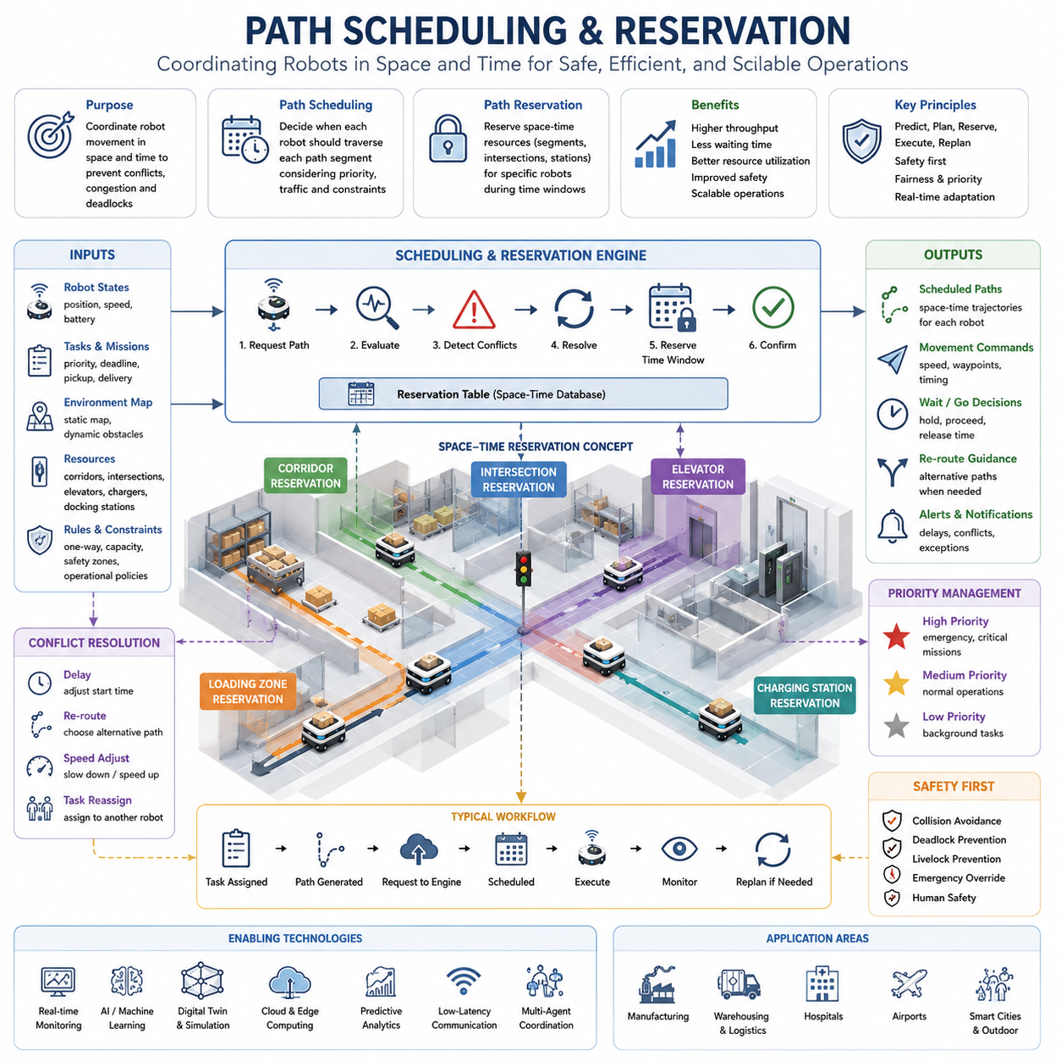
Path scheduling and reservation are among the most important technologies in modern Autonomous Mobile Robot (AMR) traffic management systems. As robot fleets grow from a few robots to dozens, hundreds, or even thousands of autonomous units operating within the same facility, simple path planning is no longer sufficient to guarantee efficient operation. While a single robot can independently calculate a collision-free path from its current position to a destination, multiple robots sharing corridors, intersections, loading stations, elevators, charging stations, and narrow passages introduce a far more complex coordination problem. Path scheduling and reservation provide the mechanisms required to organize robot movement in both space and time, ensuring that resources are used efficiently while preventing conflicts, congestion, deadlocks, and unsafe situations.
The fundamental purpose of path scheduling is to coordinate robot movement before conflicts occur. Traditional navigation systems focus primarily on determining a feasible route through an environment. However, in multi-robot environments, a path that is geometrically feasible may still be operationally problematic if multiple robots attempt to occupy the same area simultaneously. Path scheduling extends navigation planning by incorporating temporal considerations into route generation. Instead of asking only where a robot should travel, the system also determines when the robot should travel through each segment of the environment.
Path reservation complements scheduling by providing a mechanism for allocating access to shared infrastructure resources. Similar to railway systems that reserve track segments for trains or air traffic management systems that reserve airspace corridors for aircraft, AMR traffic management systems reserve navigation segments, intersections, corridors, and operational zones for specific robots during designated time intervals. Reservation systems transform robot navigation from a reactive process into a predictive and coordinated operation that significantly improves safety and efficiency.
A key concept in path scheduling is the transformation of a physical map into a spatiotemporal planning model. In conventional navigation systems, maps represent static geometry, obstacles, and free-space regions. In path scheduling systems, maps also incorporate time as an additional dimension. Each path segment becomes associated not only with a location but also with availability windows during which robots may traverse that segment. This approach allows the traffic management system to coordinate multiple robots without requiring continuous intervention.
When a robot receives a task assignment, it first generates a candidate route toward its destination. Rather than immediately executing the route, the robot or fleet management system submits the proposed path to the traffic scheduling engine. The scheduling engine evaluates the path against existing reservations, predicted traffic conditions, priority policies, and operational constraints. If conflicts are identified, the system may adjust timing, reroute the robot, or temporarily delay execution until the required resources become available.
Time-window reservation is one of the most widely used scheduling mechanisms. Each navigation segment is associated with reserved occupancy periods. A robot entering a corridor may reserve that corridor for a specific time interval based on predicted travel duration. Other robots requesting access during the same interval may be delayed, rerouted, or assigned alternative routes. By controlling access through reservation windows, the system prevents multiple robots from simultaneously occupying constrained spaces.
The concept of exclusive reservation is particularly important in narrow corridors, elevators, docking stations, charging stations, and loading zones. In such environments, only one robot can safely occupy the resource at a time. Exclusive reservation guarantees that a robot has uncontested access to the resource during its assigned time slot. This approach eliminates uncertainty and significantly reduces the risk of operational conflicts.
Shared reservation models can also be applied in larger open environments where multiple robots can safely coexist within the same region. Instead of completely excluding other robots, the system limits occupancy levels based on predefined capacity thresholds. For example, a warehouse aisle may support three simultaneous robots without congestion. The reservation system monitors occupancy and restricts additional entries when capacity limits are reached.
One of the most challenging aspects of path scheduling involves intersection management. Intersections represent high-conflict areas where robot trajectories converge. Without coordination, robots approaching an intersection may create delays, collisions, or deadlocks. Reservation-based intersection control treats the intersection as a shared resource. Robots request access before entering the intersection, and the scheduling engine assigns crossing times based on priority, arrival predictions, and overall traffic efficiency. This mechanism functions similarly to a virtual traffic signal system while maintaining greater flexibility.
Priority-aware scheduling enables traffic management systems to differentiate between mission criticality levels. Not all robot tasks have equal operational importance. Emergency deliveries in hospitals, production-critical material transport in factories, or urgent logistics operations may require expedited access to transportation resources. Scheduling algorithms incorporate priority weights that influence reservation allocation and conflict resolution decisions. Higher-priority robots may receive preferred reservation windows while lower-priority robots experience controlled delays.
Dynamic scheduling is essential because operational environments are rarely static. Human workers, forklifts, manually operated vehicles, temporary obstacles, maintenance activities, and changing task demands continuously alter traffic conditions. Dynamic scheduling systems continuously monitor fleet activity and update reservations in real time. If a robot encounters unexpected delays, reservation schedules may be recalculated to prevent cascading conflicts throughout the fleet.
Predictive scheduling represents a more advanced approach in which the system forecasts future traffic conditions before conflicts emerge. Using historical operational data, current fleet status, and predictive analytics, the scheduler estimates congestion levels, resource utilization, and expected travel times. Robots can then receive routes and schedules optimized not only for current conditions but also for anticipated future conditions. Predictive scheduling significantly improves throughput in large-scale deployments.
Reservation systems often operate on graph-based representations of navigation networks. Nodes represent intersections, stations, charging areas, or key operational locations. Edges represent navigable path segments connecting these locations. Reservation requests are applied to nodes, edges, or both. The scheduling engine maintains a reservation table containing occupancy information for each resource. This table serves as the central database used to coordinate robot movement across the facility.
Conflict detection is a critical function within reservation systems. Every new reservation request must be evaluated against existing reservations. The system analyzes temporal overlaps, spatial conflicts, resource capacities, and operational constraints. When conflicts are identified, resolution mechanisms determine the most appropriate response. Solutions may include delaying one robot, modifying route selection, adjusting travel speeds, or reassigning tasks to alternative robots.
Deadlock prevention is one of the primary motivations for path reservation. Deadlocks occur when robots wait indefinitely for resources occupied by each other. In complex environments with multiple intersections and narrow passages, deadlocks can significantly reduce productivity. Reservation systems prevent deadlocks by ensuring that robots only enter resource sequences that can be completed successfully. Some systems employ look-ahead planning to verify that future reservations remain feasible before granting access.
Livelock prevention is another important consideration. Unlike deadlocks, where robots stop moving entirely, livelocks occur when robots continuously adjust their behavior without making meaningful progress toward their destinations. Reservation-based scheduling minimizes livelock scenarios by establishing deterministic movement plans and reducing unnecessary path modifications.
Traffic flow optimization is closely connected to scheduling and reservation mechanisms. Efficient traffic flow requires balancing resource utilization across the entire facility. Overutilized corridors create bottlenecks while underutilized routes represent wasted capacity. Scheduling algorithms continuously analyze traffic density and distribute robot movement across available infrastructure. This balancing process improves throughput while reducing travel times.
Large-scale facilities often employ hierarchical scheduling architectures. At the highest level, fleet management systems allocate tasks and optimize global traffic flow. Mid-level schedulers coordinate regional traffic within specific operational zones. Local controllers manage immediate robot interactions and safety behaviors. This hierarchical approach enables scalable operation across facilities containing hundreds or thousands of robots.
Cloud-based scheduling platforms have become increasingly common in enterprise AMR deployments. Cloud infrastructure provides centralized visibility across multiple facilities and enables large-scale optimization algorithms. Reservation databases, traffic analytics, predictive models, and operational dashboards can be shared across distributed robot fleets. Cloud systems also support continuous software updates and integration with enterprise resource planning systems.
Edge computing remains important despite the benefits of cloud-based management. Time-critical scheduling decisions often require low-latency execution. Local edge servers can maintain reservation databases and execute scheduling algorithms even during temporary network disruptions. Hybrid cloud-edge architectures combine centralized optimization with resilient local control.
Artificial intelligence is increasingly integrated into scheduling systems. Machine learning algorithms can predict travel times more accurately than static models. Reinforcement learning techniques can optimize reservation strategies through continuous operational experience. Deep learning models can forecast congestion patterns and recommend traffic control policies. AI-driven scheduling systems improve efficiency as they accumulate operational knowledge.
Digital twin technology provides a powerful environment for developing and validating scheduling strategies. A digital twin replicates the physical robot fleet, infrastructure, and traffic conditions within a virtual environment. Engineers can evaluate scheduling algorithms, test reservation policies, simulate congestion scenarios, and optimize facility layouts without disrupting real-world operations. Digital twins support continuous improvement throughout the lifecycle of an AMR deployment.
Path scheduling and reservation play particularly important roles in hospitals. Delivery robots transporting medications, laboratory samples, medical equipment, meals, and linens frequently share elevators, corridors, and service areas. Scheduling systems coordinate access to these resources while prioritizing urgent medical deliveries. Similar benefits are observed in manufacturing facilities, where material transport robots support production operations that depend on predictable and reliable logistics performance.
In warehouse environments, reservation systems improve order fulfillment efficiency by coordinating robot movement within storage aisles, picking zones, packing stations, and shipping areas. By reducing congestion and minimizing waiting times, scheduling systems contribute directly to higher throughput and lower operational costs. The same principles apply to airports, logistics hubs, industrial campuses, and outdoor autonomous robot deployments.
Safety remains a fundamental consideration in all scheduling and reservation systems. While scheduling optimizes operational efficiency, safety constraints always take precedence. Emergency vehicles, human workers, unexpected obstacles, and safety-critical events can override reservation schedules when necessary. Traffic management systems must be capable of immediately adapting to changing conditions while maintaining safe operation.
The future of path scheduling and reservation will be increasingly driven by intelligent automation. Next-generation systems will combine real-time perception, predictive analytics, digital twins, cloud-native architectures, multi-agent coordination, and artificial intelligence into unified traffic management platforms. Robots will negotiate resource access autonomously, coordinate movement collaboratively, and continuously optimize fleet performance based on operational objectives. Path scheduling will evolve beyond simple reservation tables into intelligent traffic orchestration systems capable of managing massive robot populations across factories, hospitals, warehouses, smart cities, ports, airports, and outdoor industrial environments. As AMR deployments continue to expand in scale and complexity, path scheduling and reservation will remain one of the most critical technologies enabling safe, efficient, and scalable autonomous robot operations.

19.3 Intersection and Corridor Control
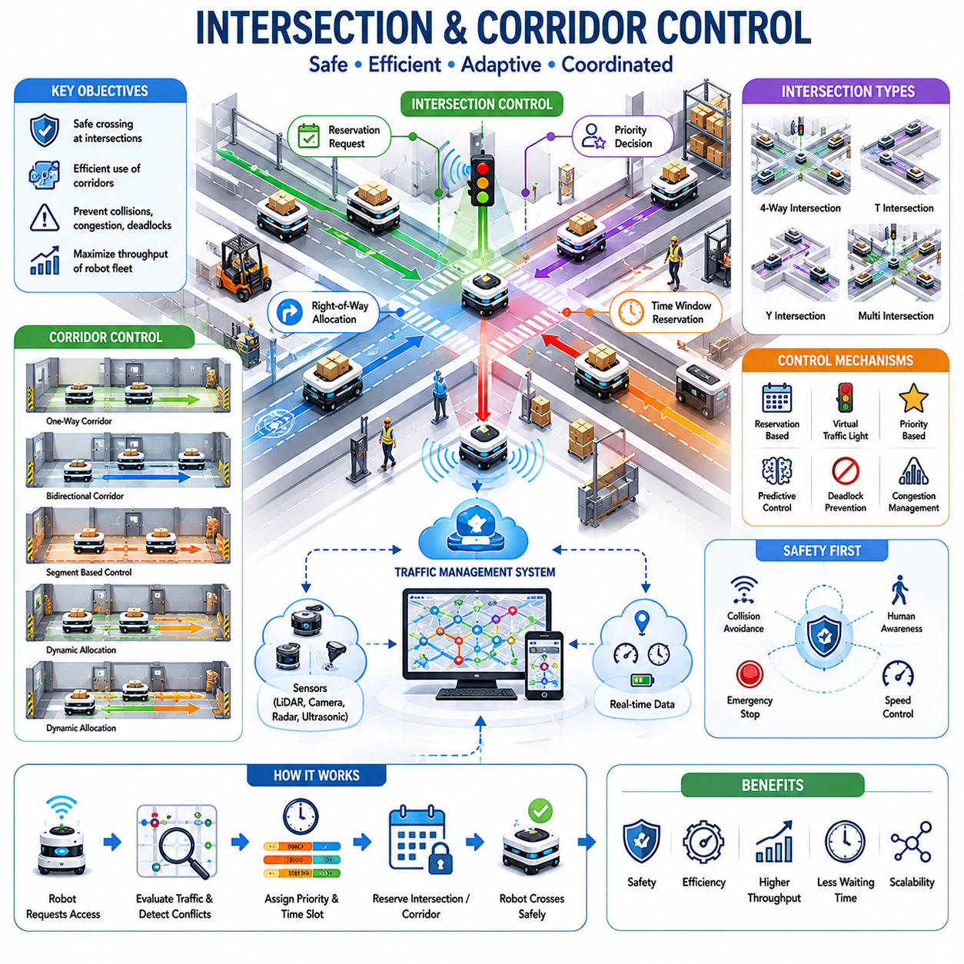
Intersection and corridor control are among the most critical components of Autonomous Mobile Robot (AMR) traffic management systems. As robot fleets scale from a few units to hundreds of robots operating simultaneously in factories, hospitals, warehouses, airports, logistics centers, and smart city environments, the efficient management of shared navigation spaces becomes essential. While path planning determines where robots should travel and path scheduling determines when they should move, intersection and corridor control govern how robots interact when their routes converge within constrained operational areas. These control mechanisms ensure safe movement, prevent congestion, minimize delays, maximize throughput, and maintain predictable fleet behavior under both normal and abnormal operating conditions.
In any multi-robot environment, intersections represent points where multiple navigation paths cross. Corridors represent shared transportation channels that connect different operational zones. Both are limited resources that cannot always accommodate unrestricted robot movement. Without proper control strategies, robots may compete for access to these areas, resulting in collisions, deadlocks, congestion, reduced efficiency, and operational instability. Intersection and corridor control systems therefore function as the robotic equivalent of road traffic signals, railway signaling systems, and air traffic management procedures.
The fundamental objective of intersection control is to regulate access to crossing points where multiple robots may arrive simultaneously. Unlike conventional road traffic systems that operate according to fixed signal schedules, AMR traffic control systems are dynamic and adaptive. Robot traffic patterns vary continuously based on mission assignments, fleet size, environmental conditions, and operational priorities. Consequently, intersection control must evaluate traffic conditions in real time and make intelligent decisions regarding right-of-way allocation, crossing order, waiting policies, and alternative routing strategies.
A typical intersection within an AMR environment may involve multiple corridors converging at a single crossing point. Robots approaching from different directions may have conflicting trajectories that cannot be executed simultaneously. The traffic management system continuously monitors robot positions, velocities, destinations, priorities, and predicted arrival times. Based on this information, the system determines which robot should proceed first and which robots should temporarily wait. This process ensures orderly traffic flow while minimizing overall delays.
One of the most common approaches to intersection control is reservation-based management. In this model, the intersection is treated as a shared resource. Before entering the intersection, a robot submits a reservation request to the traffic management system. The system evaluates current reservations, predicted conflicts, and traffic priorities before granting access. Only robots with active reservations may enter the intersection. This approach eliminates uncertainty and significantly reduces collision risk.
Time-based reservation systems extend this concept further by assigning specific time windows to each robot. Rather than simply granting access, the system determines the exact time interval during which the robot may occupy the intersection. Multiple robots can therefore share the same physical space at different times without conflict. This temporal coordination improves utilization while maintaining safety.
Virtual traffic lights provide another mechanism for intersection control. Instead of physical signals installed in the environment, the traffic management software generates digital traffic signals for approaching robots. Robots receive commands indicating whether they should proceed, slow down, stop, or wait. Virtual traffic lights can dynamically adapt to changing traffic conditions and operational priorities, providing greater flexibility than conventional fixed-timing systems.
Priority-based intersection control is particularly important in environments where certain tasks are more critical than others. In hospitals, robots transporting emergency medications or laboratory samples may require immediate access to intersections. In manufacturing facilities, robots supporting production bottlenecks may receive elevated priority. The traffic management system incorporates priority levels into its decision-making process, ensuring that critical missions experience minimal delays while maintaining overall fairness across the fleet.
Predictive intersection control represents an advanced traffic management strategy. Rather than reacting to robots as they arrive, predictive systems forecast future arrivals based on current trajectories and velocities. The system constructs a temporal model of expected traffic flow and allocates crossing opportunities before conflicts occur. This proactive approach reduces waiting times and increases intersection throughput.
Multi-robot coordination becomes increasingly complex as fleet size grows. In large-scale facilities, multiple intersections may interact with one another. Delays at one intersection can propagate throughout the navigation network, creating cascading traffic disruptions. Advanced traffic management systems therefore coordinate intersections collectively rather than independently. Network-level optimization ensures that traffic decisions made at one location contribute positively to overall fleet performance.
Corridor control addresses a different but equally important set of challenges. Corridors are frequently encountered in warehouses, hospitals, manufacturing plants, office buildings, and logistics centers. These pathways often have limited width and may not support unrestricted bidirectional traffic. When multiple robots attempt to enter the same corridor simultaneously, congestion and deadlocks can occur. Corridor control systems regulate access and movement within these constrained transportation channels.
One-way corridor policies provide a simple and effective solution for many environments. Under this approach, robots may travel only in a designated direction within a specific corridor. By eliminating opposing traffic, the risk of congestion and deadlock is significantly reduced. One-way corridors are particularly effective in high-density warehouse environments where throughput is more important than route flexibility.
Bidirectional corridors require more sophisticated control mechanisms. In such environments, robots traveling in opposite directions must coordinate their movements to avoid blocking one another. Corridor reservation systems allocate access to specific robots for designated time intervals. A robot entering the corridor reserves sufficient space and time to complete its traversal safely. Other robots must wait until the reservation expires before entering from the opposite direction.
Segment-based corridor management divides long corridors into smaller controlled sections. Each segment functions as an independently managed resource with its own reservation rules. This approach increases corridor utilization by allowing multiple robots to occupy different segments simultaneously while maintaining safe separation distances. Segment-based control is particularly beneficial in large industrial facilities where long transportation routes connect multiple operational zones.
Dynamic corridor allocation introduces additional flexibility. Rather than permanently assigning directional rules, the traffic management system continuously evaluates traffic demand and adjusts corridor usage accordingly. During periods of heavy traffic in one direction, the system may temporarily allocate additional corridor capacity to support that flow. Dynamic allocation improves throughput while adapting to changing operational conditions.
Human-aware corridor control is essential in environments where robots share space with people. Hospitals, airports, office buildings, and public facilities often involve mixed traffic scenarios. The traffic management system must account for pedestrian movement patterns, crowd density, and human behavior when controlling corridor access. Robots may reduce speed, increase separation distances, yield to pedestrians, or temporarily suspend movement when necessary.
Safety remains the highest priority in all intersection and corridor control operations. Even when reservations and schedules have been established, robots must continuously monitor their surroundings using onboard perception systems. LiDAR, cameras, radar, ultrasonic sensors, and depth sensors provide real-time situational awareness. If unexpected obstacles or safety hazards are detected, local collision avoidance systems may override traffic management instructions to prevent accidents.
Deadlock prevention is a central objective of corridor control. Deadlocks commonly occur when multiple robots enter narrow passages from opposite directions and become trapped. Advanced traffic management systems use reservation mechanisms, predictive planning, and resource allocation strategies to prevent such situations from developing. Before granting access to a corridor, the system verifies that sufficient downstream resources remain available for the robot to complete its traversal successfully.
Congestion management is another critical responsibility. High-density traffic conditions can significantly reduce operational efficiency if not managed properly. Traffic management systems continuously monitor corridor occupancy, queue lengths, waiting times, and traffic density. When congestion levels exceed predefined thresholds, corrective actions such as rerouting, speed adjustment, task redistribution, or temporary access restrictions may be implemented.
Artificial intelligence is increasingly influencing intersection and corridor control strategies. Machine learning models can predict traffic demand, estimate congestion risk, and optimize resource allocation policies. Reinforcement learning algorithms can discover efficient traffic control strategies through simulation and operational experience. AI-driven traffic management systems continuously improve their performance as they accumulate operational data.
Digital twin technology provides a powerful environment for designing and validating intersection and corridor control policies. Engineers can simulate various traffic scenarios, evaluate alternative control strategies, and identify potential bottlenecks before deploying changes in real-world facilities. Digital twins enable continuous optimization while reducing operational risk and downtime.
Cloud-based traffic management platforms provide centralized visibility across large robot fleets and multiple facilities. Intersection and corridor control algorithms can leverage cloud computing resources to perform large-scale optimization and predictive analytics. At the same time, edge computing systems ensure low-latency execution of time-critical control decisions. Hybrid cloud-edge architectures combine the strengths of both approaches to achieve scalability and resilience.
Hospital environments provide an excellent example of the importance of intersection and corridor control. Service robots transporting medications, laboratory specimens, meals, linens, and medical equipment frequently traverse narrow corridors and shared intersections. Effective traffic control ensures timely delivery while minimizing disruption to patients, healthcare staff, and visitors. Similar requirements exist in manufacturing facilities, where material transport robots support production operations that depend on predictable logistics performance.
Warehouse environments present a different set of challenges. High robot densities, narrow storage aisles, dynamic inventory movement, and aggressive throughput requirements place significant demands on traffic management systems. Corridor and intersection control mechanisms help maintain efficient flow while preventing congestion and operational bottlenecks. These systems directly contribute to improved productivity and reduced operational costs.
Outdoor autonomous robot deployments introduce additional complexity. Intersections may involve interactions with service vehicles, pedestrians, bicycles, and other autonomous systems. Weather conditions, visibility limitations, and dynamic environmental changes further complicate traffic management. Advanced control systems must integrate perception, prediction, and planning capabilities to ensure safe and efficient operation under these conditions.
Future intersection and corridor control systems will become increasingly intelligent and autonomous. Real-time perception, predictive analytics, multi-agent coordination, digital twins, cloud-native architectures, and artificial intelligence will combine to create highly adaptive traffic management ecosystems. Robots will negotiate access to shared resources, coordinate movement collaboratively, and optimize traffic flow continuously based on fleet-wide objectives. Rather than relying on predefined rules alone, future systems will dynamically adapt to changing conditions and learn from operational experience.
As AMR deployments continue to expand across industrial, commercial, healthcare, logistics, and smart city environments, intersection and corridor control will remain foundational technologies supporting safe, efficient, and scalable autonomous operations. These systems transform individual robots into coordinated fleet ecosystems capable of operating harmoniously within complex shared environments, ultimately enabling the next generation of intelligent autonomous infrastructure.

19.4 Fleet Traffic Optimization
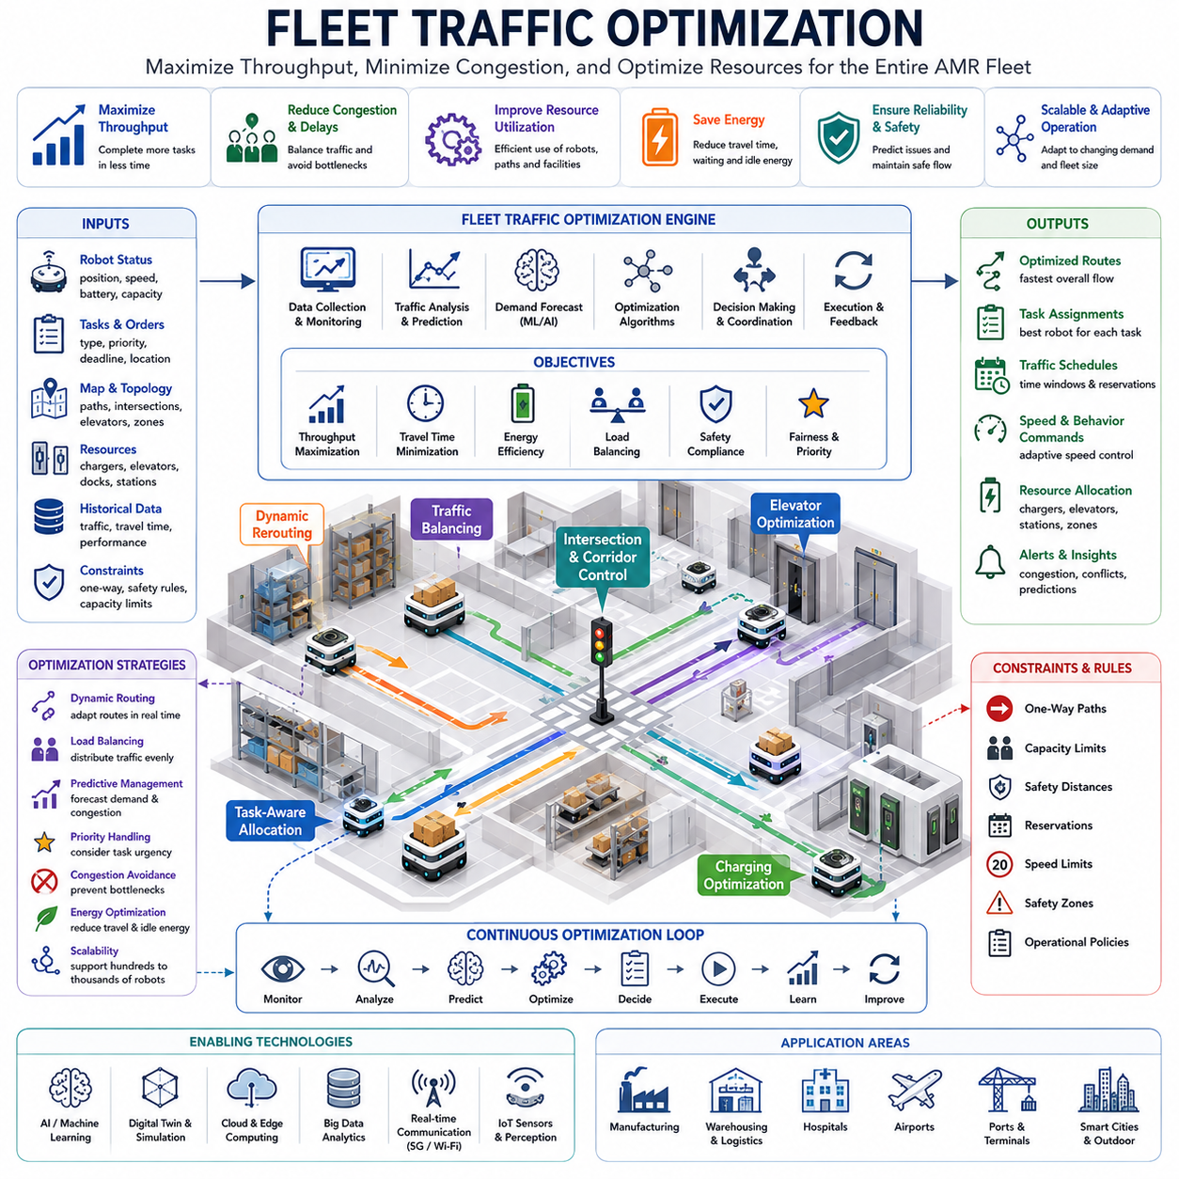
Fleet Traffic Optimization is one of the most advanced and strategically important capabilities in modern Autonomous Mobile Robot (AMR) systems. As organizations deploy increasing numbers of robots across factories, warehouses, hospitals, airports, logistics hubs, industrial campuses, and smart city infrastructures, the challenge shifts from simply controlling individual robots to optimizing the movement and coordination of the entire fleet. While path planning, scheduling, reservation, and intersection control focus on local or regional navigation efficiency, fleet traffic optimization addresses the behavior of the complete robotic ecosystem. Its primary objective is to maximize overall operational performance while minimizing congestion, delays, energy consumption, resource conflicts, and infrastructure bottlenecks.
The concept of fleet traffic optimization originates from large-scale transportation management systems. Similar to how airlines coordinate aircraft movements, ports manage container flows, and urban traffic control systems regulate vehicles across entire cities, AMR fleet optimization seeks to coordinate hundreds or thousands of robots operating simultaneously within a shared environment. The optimization process involves continuously analyzing fleet-wide conditions and making decisions that improve collective performance rather than focusing solely on individual robot efficiency.
One of the most important principles of fleet traffic optimization is the distinction between local optimization and global optimization. A route that appears optimal for a single robot may create congestion that negatively affects dozens of other robots. Similarly, the shortest path is not always the fastest or most efficient route when fleet-level traffic conditions are considered. Fleet traffic optimization therefore evaluates decisions from a system-wide perspective, seeking solutions that maximize overall throughput and operational efficiency across the entire fleet.
Throughput maximization is often considered the primary performance objective. Throughput represents the total amount of productive work completed by the robot fleet within a given period. In warehouses, throughput may correspond to completed picking tasks, pallet movements, or order fulfillment operations. In hospitals, throughput may represent successful deliveries of medications, laboratory samples, meals, linens, and medical supplies. In manufacturing environments, throughput may reflect the continuous delivery of materials supporting production operations. Fleet optimization continuously adjusts traffic flow to maximize this overall output.
A key element of fleet traffic optimization is traffic visibility. The traffic management system maintains real-time awareness of every robot's location, speed, task status, destination, battery level, operational mode, and projected trajectory. This global visibility allows optimization algorithms to understand traffic conditions throughout the entire facility. Rather than reacting only to local events, the system can anticipate future conflicts and proactively coordinate fleet movement.
Traffic density analysis plays a central role in optimization. Certain corridors, intersections, elevators, loading zones, charging stations, and transfer points naturally experience higher traffic volumes than others. The fleet management system continuously monitors occupancy levels, waiting times, queue lengths, and utilization rates across these resources. Areas experiencing excessive traffic density can be identified as emerging bottlenecks, allowing corrective actions to be implemented before performance degradation occurs.
Dynamic route optimization is one of the most frequently applied fleet-level control mechanisms. Traditional navigation systems calculate routes based primarily on distance or travel time. Fleet optimization systems incorporate additional variables including congestion levels, resource availability, expected waiting times, priority assignments, and predicted future traffic conditions. As a result, robots may be assigned routes that are not geometrically shortest but are operationally more efficient from a fleet perspective.
Load balancing represents another critical optimization strategy. In many facilities, robot traffic tends to concentrate around specific operational areas. Picking stations, production lines, loading docks, elevators, and charging stations often become hotspots that generate localized congestion. Fleet optimization algorithms distribute traffic more evenly across available infrastructure resources. By balancing robot movement throughout the environment, overall efficiency improves while bottlenecks are reduced.
Task allocation and traffic optimization are closely interconnected. Every new task assignment influences future traffic patterns. Advanced fleet management systems consider traffic conditions when assigning tasks to robots. Rather than selecting the nearest available robot, the system may assign a task to a robot that can complete it more efficiently within the broader traffic context. This integrated approach improves fleet performance while reducing unnecessary congestion.
Predictive traffic modeling significantly enhances optimization effectiveness. Historical operational data, current fleet status, environmental conditions, and workload forecasts can be used to predict future traffic demand. Machine learning models analyze recurring patterns and estimate congestion probabilities across different facility zones. The traffic management system uses these predictions to proactively adjust routing policies, task assignments, and resource allocations before problems occur.
Congestion avoidance is one of the most valuable outcomes of fleet traffic optimization. Congestion reduces productivity, increases travel time, consumes additional energy, and creates cascading delays throughout the fleet. Optimization systems continuously evaluate traffic conditions and implement corrective actions whenever congestion indicators exceed predefined thresholds. Such actions may include rerouting robots, delaying low-priority tasks, adjusting speed profiles, or redistributing workloads among different operational zones.
Fleet optimization also considers energy efficiency. Battery-powered robots consume energy during movement, acceleration, stopping, and waiting. Traffic congestion increases energy consumption because robots spend additional time operating without completing productive work. Optimization algorithms seek to minimize unnecessary movement, reduce idle waiting, and improve route efficiency. These improvements contribute directly to longer operational durations and reduced charging requirements.
Charging station optimization has become increasingly important as fleet sizes grow. Large robot deployments often share a limited number of charging stations. Without coordination, charging queues may develop, reducing fleet availability and productivity. Fleet traffic optimization systems forecast battery depletion patterns and schedule charging activities strategically. Robots are directed toward charging resources at optimal times while avoiding congestion around charging infrastructure.
Elevator optimization presents another significant challenge in multi-floor environments such as hospitals, hotels, office buildings, and distribution centers. Elevators function as shared transportation resources with limited capacity. Fleet optimization systems coordinate elevator usage across the entire robot population, minimizing waiting times and maximizing transport efficiency. Elevator scheduling becomes particularly important when large numbers of robots must move between floors during peak operational periods.
Resource utilization optimization extends beyond navigation infrastructure. Loading zones, unloading stations, transfer points, automated storage systems, production interfaces, and service areas all represent operational resources that influence traffic patterns. Fleet optimization continuously evaluates resource utilization and adjusts traffic flows to ensure balanced system performance.
Priority management is an essential component of optimization strategies. Different tasks possess varying levels of urgency and importance. Emergency deliveries in hospitals, production-critical material transport in manufacturing, and time-sensitive logistics operations require preferential treatment. Fleet optimization systems incorporate task priorities into routing, scheduling, reservation, and resource allocation decisions while maintaining fairness across the fleet.
Multi-objective optimization is commonly required because fleet management systems must balance multiple competing objectives simultaneously. Throughput maximization, travel time reduction, energy efficiency, safety compliance, resource utilization, and customer service quality may all influence optimization decisions. Advanced algorithms evaluate these objectives collectively and identify solutions that achieve the best overall balance.
Artificial intelligence is increasingly driving fleet traffic optimization. Machine learning algorithms can predict traffic demand, estimate travel times, identify congestion risks, and recommend optimal routing policies. Reinforcement learning systems can learn effective traffic control strategies through simulation and operational experience. AI-driven optimization continuously improves as larger volumes of operational data become available.
Digital twin technology provides a powerful platform for optimization development and validation. A digital twin creates a virtual representation of the robot fleet, facility infrastructure, operational workflows, and traffic conditions. Engineers can simulate thousands of traffic scenarios and evaluate alternative optimization strategies before deployment. This capability reduces risk while accelerating continuous improvement efforts.
Cloud-based fleet optimization platforms provide centralized coordination across multiple facilities and large robot populations. Cloud infrastructure supports advanced analytics, large-scale optimization algorithms, historical data processing, and enterprise integration. Fleet managers gain visibility into system performance while optimization engines continuously refine operational strategies based on evolving conditions.
Edge computing remains essential for time-critical optimization decisions. While cloud platforms provide large-scale analytical capabilities, local edge servers ensure low-latency response to rapidly changing traffic conditions. Hybrid cloud-edge architectures combine global intelligence with real-time responsiveness, providing both scalability and operational resilience.
Simulation-based optimization has become a standard practice in modern AMR deployments. Before implementing changes in live environments, engineers evaluate proposed strategies within high-fidelity simulation environments. Simulation allows safe experimentation with routing policies, reservation systems, scheduling algorithms, traffic rules, and fleet expansion scenarios. Results can then be transferred into operational systems with reduced risk.
Hospital environments illustrate the value of fleet traffic optimization particularly well. Numerous robots transport medications, meals, laboratory samples, linens, waste materials, and medical equipment throughout complex facilities. Corridors, elevators, and service areas must be shared efficiently while maintaining strict service-level requirements. Fleet optimization ensures timely delivery while minimizing interference with healthcare personnel and patients.
Warehouse operations benefit significantly from fleet optimization. High robot densities, dynamic inventory movement, variable order demand, and strict fulfillment targets create challenging traffic management requirements. Optimization algorithms improve picking efficiency, reduce congestion, balance workload distribution, and maximize facility throughput. These improvements directly impact operational profitability and customer satisfaction.
Manufacturing environments require predictable and reliable logistics support for production processes. Delays in material delivery can disrupt production schedules and reduce overall equipment effectiveness. Fleet traffic optimization ensures that logistics resources are aligned with production requirements, maintaining continuous material flow while minimizing transportation inefficiencies.
Outdoor autonomous robot deployments introduce additional optimization challenges. Larger operational areas, variable environmental conditions, vehicle interactions, pedestrian traffic, and communication constraints require more sophisticated traffic management strategies. Fleet optimization systems must coordinate navigation while accounting for weather, terrain conditions, GNSS availability, and dynamic infrastructure usage.
Scalability is a defining characteristic of successful fleet optimization systems. Small deployments may involve only a handful of robots, whereas future smart factories and logistics centers may operate thousands of autonomous machines simultaneously. Optimization architectures must support this growth without excessive computational complexity or performance degradation.
Future fleet traffic optimization systems will evolve toward fully autonomous traffic orchestration platforms. Real-time perception, predictive analytics, artificial intelligence, digital twins, cloud-native architectures, multi-agent collaboration, and self-learning algorithms will operate together as integrated traffic ecosystems. Rather than merely responding to traffic conditions, these systems will continuously predict, optimize, coordinate, and adapt fleet behavior in real time.
As AMR deployments continue to expand across industrial, healthcare, logistics, commercial, and smart city applications, fleet traffic optimization will become one of the most important technologies enabling large-scale autonomous operations. It transforms independent robots into a coordinated transportation network capable of maximizing productivity, ensuring safety, minimizing operational costs, and delivering highly efficient autonomous mobility services throughout complex environments.

19.5 Deadlock and Congestion Handling
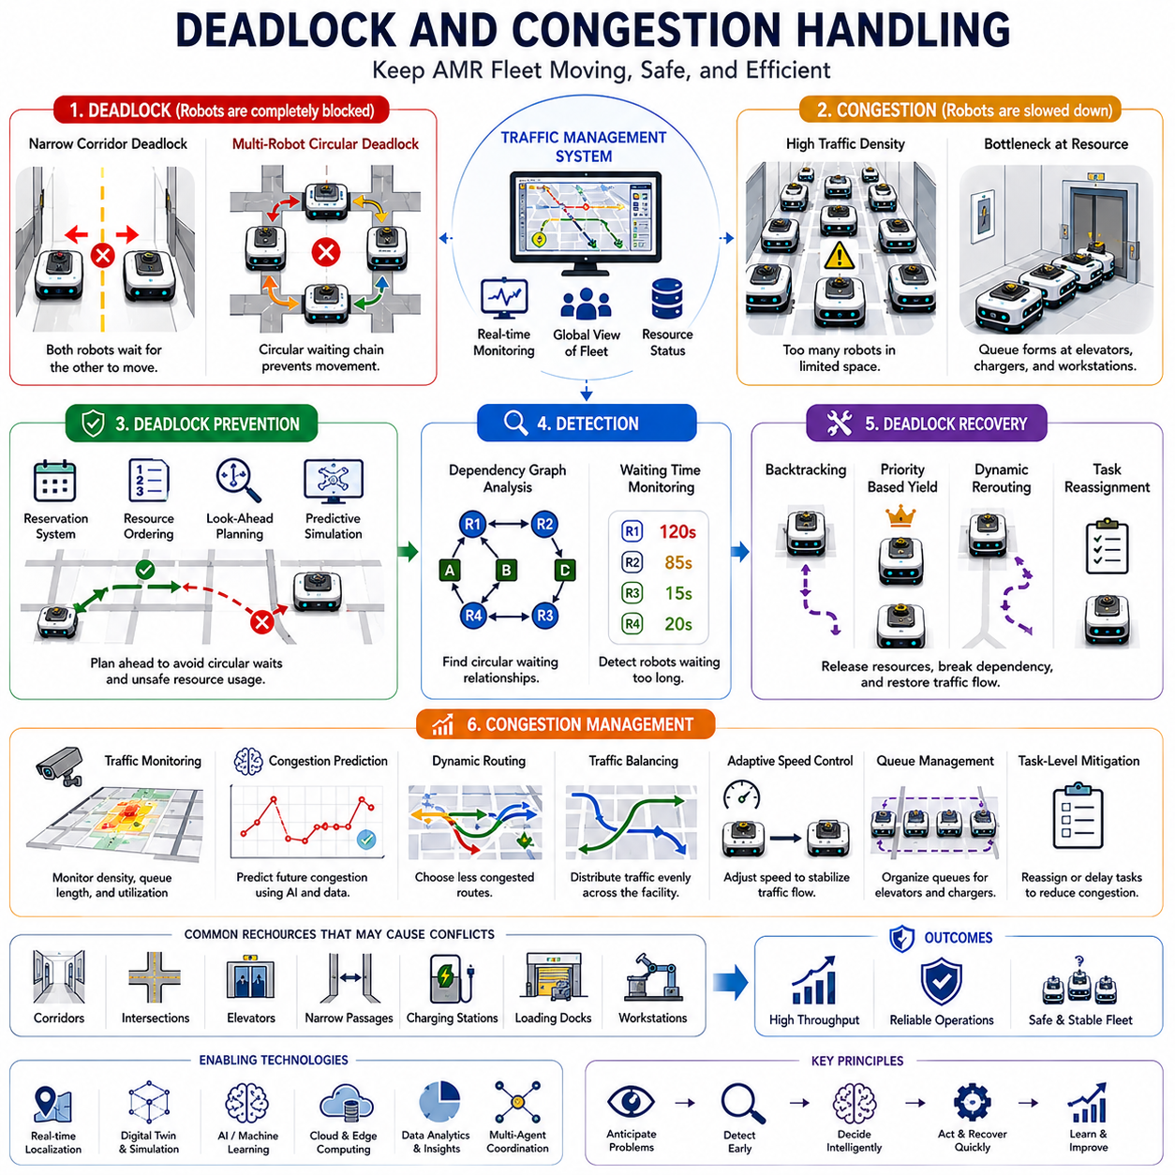
Deadlock and congestion handling are among the most critical functions of modern Autonomous Mobile Robot (AMR) traffic management systems. As robot fleets continue to expand across factories, warehouses, hospitals, airports, logistics centers, industrial campuses, and smart city infrastructures, the likelihood of traffic conflicts increases significantly. While path planning, scheduling, reservation, intersection control, and fleet optimization aim to maximize efficiency and safety, no large-scale robot deployment can completely eliminate traffic conflicts. Therefore, deadlock prevention, deadlock recovery, congestion detection, and congestion mitigation become essential capabilities for maintaining continuous and reliable fleet operations. These functions ensure that robot fleets remain productive even under heavy traffic conditions, infrastructure constraints, unexpected disruptions, and dynamic environmental changes.
A deadlock occurs when two or more robots become mutually blocked and are unable to proceed because each robot is waiting for resources currently occupied or reserved by another robot. In a deadlock situation, none of the involved robots can make progress toward their destinations. Deadlocks represent one of the most severe operational failures in multi-robot systems because they can halt traffic flow, reduce throughput, create cascading delays, and potentially affect large portions of the facility. Unlike simple delays that resolve naturally over time, deadlocks often require active intervention from the traffic management system.
The concept of deadlock is similar to resource contention problems found in computer operating systems. In computing environments, processes may become deadlocked when each process waits indefinitely for resources held by another process. AMR systems experience analogous situations when robots compete for shared navigation resources such as corridors, intersections, elevators, loading zones, docking stations, charging stations, and narrow passages. Deadlock handling therefore draws upon principles from both robotics and distributed systems engineering.
A simple example of deadlock occurs when two robots enter a narrow corridor from opposite directions. If neither robot can move backward and there is insufficient space for passing, both robots become blocked. More complex deadlocks may involve multiple robots occupying interconnected corridors and intersections. In large-scale facilities, circular dependency chains involving several robots can emerge, creating large-area traffic paralysis.
Deadlocks are particularly common in environments with constrained infrastructure. Hospitals often contain narrow service corridors and shared elevators. Manufacturing facilities may contain tightly packed production areas and restricted transport routes. Warehouses frequently utilize dense storage layouts with limited navigation space. These conditions increase the probability of resource conflicts and therefore require sophisticated deadlock management mechanisms.
One of the most effective strategies is deadlock prevention. Prevention focuses on avoiding deadlock conditions before they occur. Traffic management systems continuously evaluate robot trajectories, resource reservations, and future navigation plans. Before granting access to a shared resource, the system verifies that downstream resources remain available. If future movement cannot be guaranteed, access may be delayed until a safe path exists.
Reservation-based traffic management is widely used as a deadlock prevention mechanism. Robots reserve path segments, intersections, elevators, and other shared resources before entering them. By ensuring that resources are allocated in a controlled and predictable manner, the system reduces the likelihood of circular waiting conditions. Resource reservation transforms traffic management from a reactive process into a proactive coordination strategy.
Resource ordering is another important prevention technique. Shared resources are assigned predefined priority orders. Robots are required to request resources according to this ordering hierarchy. By enforcing a consistent acquisition sequence, circular dependencies can be eliminated. This approach is commonly used in computer systems and adapts effectively to multi-robot navigation environments.
Look-ahead planning provides additional protection against deadlocks. Rather than evaluating only immediate movements, traffic management systems analyze multiple future navigation steps. The system predicts whether a robot can successfully complete a planned route before authorizing movement. If a potential deadlock scenario is detected, alternative routes or timing adjustments can be generated proactively.
Predictive traffic simulation is increasingly used to support deadlock prevention. Digital twin environments allow traffic management systems to forecast future robot interactions based on current operational conditions. Simulation models can identify emerging deadlock risks before they affect physical operations. The traffic controller can then implement preventive actions such as rerouting, task reassignment, or reservation modifications.
Despite advanced prevention mechanisms, deadlocks may still occur under complex operational conditions. Consequently, deadlock detection becomes a critical capability. Detection systems continuously monitor robot states, resource allocations, waiting times, and dependency relationships. Algorithms analyze resource ownership graphs and identify circular waiting structures that indicate deadlock formation.
Dependency graph analysis is one of the most common deadlock detection methods. Robots and resources are represented as nodes within a graph. Edges represent waiting relationships and resource allocations. If a circular dependency is detected within the graph, the system identifies the corresponding robots as participants in a deadlock condition. This approach provides a mathematically rigorous method for deadlock identification.
Waiting time analysis offers another practical detection strategy. Robots that remain stationary beyond predefined thresholds may indicate traffic problems. While not all delays represent deadlocks, excessive waiting often serves as an early warning signal. Traffic management systems combine waiting time metrics with resource allocation information to improve detection accuracy.
Once a deadlock is detected, recovery mechanisms must be activated. Deadlock recovery aims to restore normal traffic flow while minimizing operational disruption. The simplest recovery strategy involves selecting one or more robots to retreat from their current positions. By releasing occupied resources, dependency chains can be broken and traffic movement restored.
Backtracking-based recovery is commonly employed in structured environments. Selected robots reverse along previously traversed paths until sufficient space becomes available. The traffic management system then recalculates routes and reissues movement commands. Backtracking requires accurate localization and reliable reverse navigation capabilities.
Priority-based recovery strategies determine which robots should yield during deadlock resolution. Task urgency, mission criticality, waiting time, battery status, and operational impact may all influence these decisions. High-priority robots are typically allowed to continue toward their destinations while lower-priority robots perform recovery maneuvers.
Dynamic rerouting represents another effective recovery mechanism. Instead of reversing movement, affected robots may receive alternative routes that bypass the blocked area. Modern traffic management systems continuously maintain updated navigation maps and can rapidly generate new paths when conflicts arise.
Congestion represents a different but equally important traffic management challenge. Unlike deadlocks, congestion does not necessarily prevent robot movement entirely. Instead, congestion occurs when traffic density exceeds the effective capacity of available infrastructure resources. Congestion increases travel times, reduces throughput, increases energy consumption, and decreases overall fleet efficiency.
Congestion commonly develops around intersections, elevators, charging stations, loading docks, picking zones, production interfaces, and high-demand transportation corridors. These locations function as traffic concentration points where robot movement naturally converges. Without appropriate management, localized congestion can propagate throughout the facility.
Traffic density monitoring serves as the foundation of congestion management. Traffic management systems continuously collect data regarding robot occupancy, queue lengths, waiting times, resource utilization, and movement rates. These metrics provide real-time visibility into current traffic conditions and enable early identification of congestion risks.
Congestion prediction represents an increasingly valuable capability. Machine learning models analyze historical traffic patterns, operational schedules, workload forecasts, and environmental conditions to estimate future congestion probabilities. Predictive models allow traffic management systems to implement preventive measures before bottlenecks develop.
Dynamic routing is one of the most effective congestion mitigation techniques. Rather than directing all robots along shortest-distance paths, traffic management systems consider traffic density and expected delays when generating routes. Robots may be redirected toward less congested areas even if those routes are physically longer. The result is often reduced overall travel time and improved fleet performance.
Traffic balancing distributes robot movement more evenly across available infrastructure resources. Instead of allowing certain corridors or intersections to become overloaded, traffic management systems proactively spread traffic across alternative pathways. This approach improves infrastructure utilization and reduces bottleneck formation.
Adaptive speed control provides another congestion management mechanism. Traffic management systems may reduce robot speeds in high-density areas to improve traffic stability and prevent collisions. Conversely, speeds may be increased in underutilized regions to improve throughput. Dynamic speed control enables more efficient utilization of available transportation capacity.
Queue management becomes particularly important around shared resources such as elevators and charging stations. Traffic management systems organize waiting robots into structured queues and coordinate access according to predefined policies. Efficient queue management minimizes waiting times while maintaining fairness across the fleet.
Task-level congestion mitigation addresses traffic problems before movement even begins. Task assignments can be modified to reduce traffic concentration within heavily utilized areas. For example, alternative robots may be selected for specific missions if their involvement results in lower overall traffic impact. This integration between fleet management and traffic optimization significantly improves operational efficiency.
Artificial intelligence is transforming deadlock and congestion handling. Machine learning algorithms can identify patterns associated with traffic problems and recommend preventive actions. Reinforcement learning systems can discover efficient traffic management policies through simulation and operational experience. AI-driven traffic control continuously improves its effectiveness as operational data accumulates.
Digital twin technology provides an ideal platform for evaluating deadlock and congestion handling strategies. Engineers can simulate thousands of traffic scenarios and analyze the effectiveness of different prevention, detection, and recovery mechanisms. Digital twins enable continuous optimization while minimizing operational risk.
Cloud-based traffic management systems provide centralized visibility into fleet-wide traffic conditions. Large-scale analytics platforms aggregate operational data from multiple facilities and identify recurring traffic patterns. Cloud-based optimization engines can generate globally coordinated traffic strategies that improve overall system performance.
Edge computing remains essential for time-critical traffic management functions. Deadlock recovery and congestion response often require immediate action. Local edge servers ensure low-latency execution of critical decisions even during temporary network disruptions. Hybrid cloud-edge architectures combine centralized intelligence with real-time responsiveness.
Hospital environments illustrate the importance of deadlock and congestion handling particularly well. Delivery robots transporting medications, laboratory samples, meals, and medical equipment frequently share narrow corridors and elevators with healthcare personnel. Traffic disruptions can directly affect service quality and operational efficiency. Effective traffic management ensures reliable delivery performance while maintaining safe interactions with people.
Warehouse operations face similar challenges. Large numbers of robots simultaneously perform picking, transport, storage, and replenishment tasks. High traffic density and dynamic workload patterns create significant congestion risks. Advanced traffic management systems maintain efficient flow even during peak operational periods.
Manufacturing facilities require highly predictable material transportation. Traffic disruptions can interrupt production processes and reduce overall equipment effectiveness. Deadlock prevention and congestion mitigation therefore play critical roles in maintaining production continuity and operational reliability.
Future deadlock and congestion handling systems will become increasingly intelligent, autonomous, and predictive. Real-time perception, digital twins, multi-agent coordination, cloud-native architectures, artificial intelligence, and large-scale traffic analytics will work together to create self-optimizing traffic ecosystems. Rather than merely responding to traffic problems, future systems will continuously anticipate, prevent, and resolve conflicts before they affect operations.
As robot fleets continue to grow in size, complexity, and operational importance, deadlock and congestion handling will remain foundational technologies for large-scale autonomous navigation. These capabilities ensure that robot ecosystems remain safe, efficient, scalable, and resilient, enabling the next generation of intelligent industrial, healthcare, logistics, and smart city infrastructures.

19.6 Cloud-Based Traffic Control
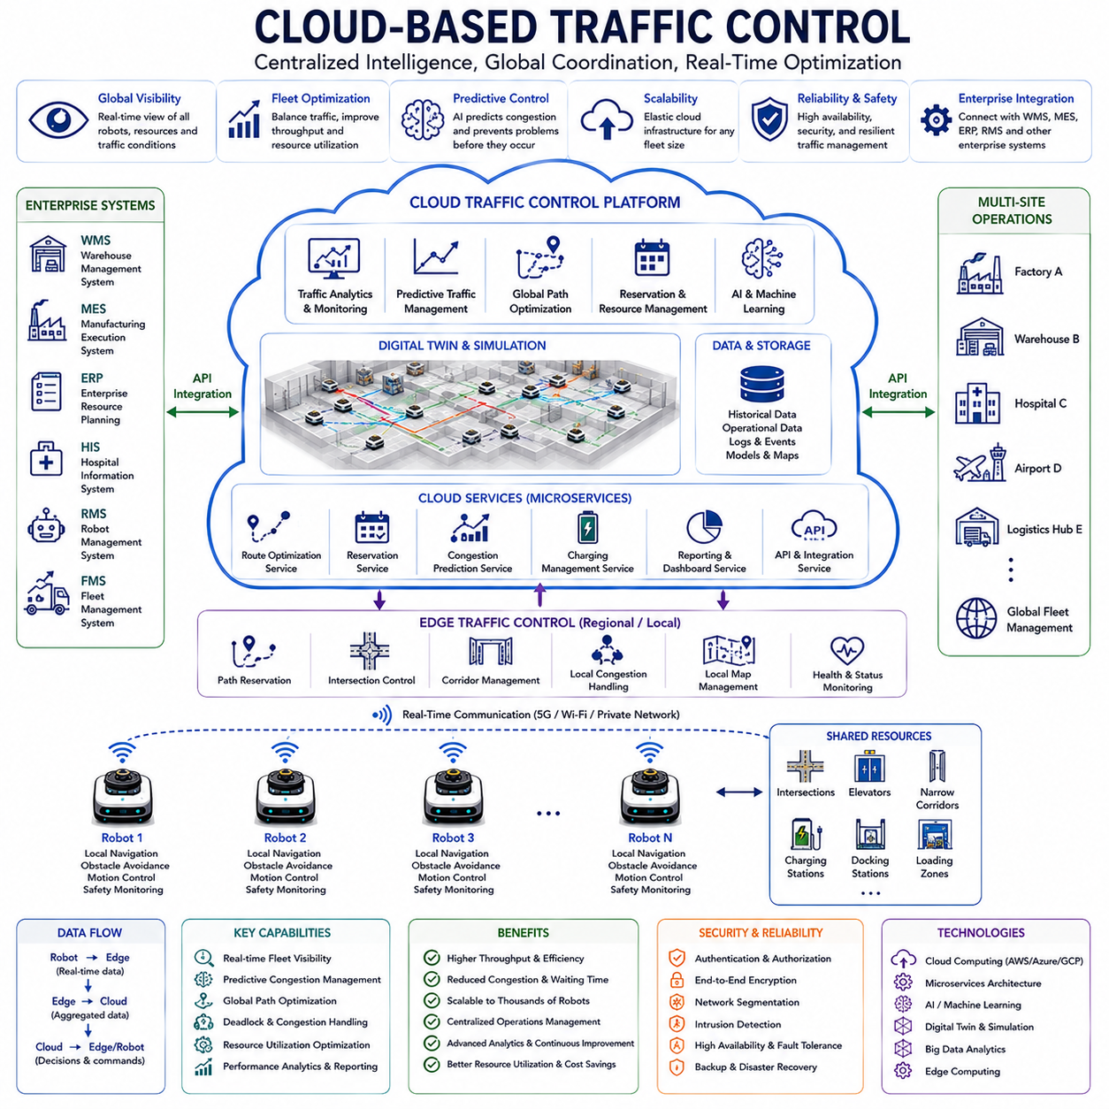
Cloud-Based Traffic Control represents one of the most significant advancements in modern Autonomous Mobile Robot (AMR) fleet management systems. As robot deployments continue to scale from individual facilities to enterprise-wide operations involving hundreds or thousands of robots distributed across factories, warehouses, hospitals, airports, logistics centers, ports, industrial campuses, and smart city infrastructures, traditional localized traffic management approaches become increasingly difficult to maintain. Cloud-based traffic control provides a centralized, scalable, intelligent, and continuously connected framework for managing robot traffic across large and geographically distributed environments. It enables real-time coordination, fleet-wide optimization, predictive traffic management, and enterprise-level visibility while supporting the growing complexity of modern autonomous robotic ecosystems.
Traditional traffic control architectures are typically deployed within a single facility and rely on local servers or edge computing devices to coordinate robot movement. While effective for small and medium-sized deployments, these architectures face limitations when robot populations grow substantially. Increasing numbers of robots generate large volumes of navigation data, reservation requests, traffic events, sensor information, operational logs, and performance metrics. Managing these resources efficiently requires computational capabilities and coordination mechanisms that extend beyond the capacity of local infrastructure. Cloud-based traffic control addresses these challenges by leveraging centralized computing resources and distributed communication architectures.
At its core, cloud-based traffic control transforms robot traffic management from an isolated local operation into a globally connected service. Rather than each facility independently managing robot movement, traffic information is aggregated within cloud infrastructure where advanced optimization algorithms, predictive analytics, digital twins, artificial intelligence models, and enterprise management systems can operate on a unified dataset. This centralized visibility allows traffic decisions to consider the entire operational ecosystem rather than individual robots or isolated facilities.
One of the most important characteristics of cloud-based traffic control is global fleet visibility. Every robot continuously reports its position, velocity, task status, battery level, operational state, destination, route information, and health metrics to the cloud platform. The traffic control system maintains a comprehensive digital representation of all active robots and infrastructure resources. Fleet operators gain real-time awareness of traffic conditions, bottlenecks, resource utilization, congestion levels, and operational performance throughout the entire deployment.
Cloud-based traffic control architectures typically follow a hierarchical design. Individual robots operate local navigation systems responsible for perception, obstacle avoidance, motion control, and immediate safety decisions. Edge servers coordinate regional traffic management functions including path reservation, intersection control, corridor management, and local congestion handling. Cloud platforms provide higher-level optimization functions such as fleet coordination, global traffic balancing, predictive planning, digital twin simulation, and enterprise integration. This hierarchical architecture combines centralized intelligence with local responsiveness.
Real-time communication forms the foundation of cloud traffic control systems. Robots continuously exchange information with cloud services through wireless communication networks such as Wi-Fi, private 5G, LTE, industrial wireless networks, or hybrid communication infrastructures. Reliable communication ensures that traffic control decisions remain synchronized across the fleet. Communication latency, reliability, bandwidth availability, and cybersecurity become critical considerations in system design.
Traffic data aggregation provides significant operational value. Every robot movement generates useful information regarding travel times, waiting times, congestion patterns, resource utilization, route efficiency, battery consumption, and environmental conditions. Cloud platforms collect and store this data within centralized databases where it can be analyzed over extended periods. Historical traffic information becomes a valuable asset for optimizing future operations and improving system performance.
Predictive traffic management represents one of the most powerful capabilities enabled by cloud-based control architectures. Machine learning algorithms analyze historical operational data, current fleet status, environmental factors, workload forecasts, and seasonal demand patterns. Using these inputs, predictive models estimate future traffic conditions before they occur. The system can proactively adjust routing policies, reservation schedules, task assignments, and resource allocations to prevent congestion and improve throughput.
Cloud-based path optimization extends traditional route planning by incorporating fleet-wide intelligence. Rather than selecting routes based solely on local conditions, the cloud platform evaluates global traffic patterns across the entire facility or enterprise. Alternative routes may be generated to balance traffic loads, reduce congestion, minimize waiting times, and improve overall fleet productivity. This optimization process continuously evolves as traffic conditions change.
Centralized reservation management provides another important advantage. Shared resources such as intersections, elevators, corridors, charging stations, docking stations, loading zones, and transfer points can be managed through cloud-hosted reservation systems. The cloud platform maintains a synchronized reservation database that coordinates resource access across all participating robots. This approach reduces conflicts while improving infrastructure utilization.
Multi-site fleet coordination becomes possible when traffic control functions operate in the cloud. Large organizations often deploy robot fleets across multiple facilities located in different cities, countries, or regions. Cloud-based platforms provide unified visibility across all locations. Fleet managers can compare performance metrics, identify operational trends, standardize traffic policies, and coordinate resources at an enterprise scale.
Cloud-based traffic control also supports dynamic workload balancing between facilities. In logistics networks and manufacturing operations, workload demands may fluctuate throughout the day. Cloud systems can monitor operational capacity and distribute tasks more efficiently across available resources. This capability improves utilization while maintaining service quality and operational flexibility.
Artificial intelligence plays a central role in cloud traffic management. AI models continuously analyze operational data and identify patterns that may not be visible through traditional rule-based approaches. Machine learning algorithms can predict congestion, estimate travel times, forecast resource demand, identify potential deadlocks, optimize task allocation, and recommend traffic control strategies. Reinforcement learning systems can further improve traffic management policies through continuous operational experience.
Digital twin integration is particularly powerful within cloud environments. A digital twin creates a virtual representation of the robot fleet, facility infrastructure, traffic flows, and operational processes. Cloud computing resources enable large-scale simulation and scenario analysis. Engineers can evaluate traffic policies, test optimization strategies, simulate peak-demand conditions, and validate infrastructure changes before deployment. Digital twins reduce operational risk while accelerating continuous improvement efforts.
Cloud-based traffic control significantly enhances deadlock and congestion management. The centralized platform possesses visibility into all active robots, reservations, and resource dependencies. Advanced analytics can identify emerging traffic problems before they impact operations. Preventive actions such as rerouting, reservation modification, task reassignment, or speed adjustments can be implemented proactively. This predictive capability improves system stability and operational efficiency.
Scalability represents one of the strongest advantages of cloud-native architectures. Traditional traffic management systems often require infrastructure upgrades as fleet size increases. Cloud platforms can dynamically allocate computational resources based on operational demand. Whether managing ten robots or ten thousand robots, cloud infrastructure can scale accordingly without requiring significant redesign of the traffic management framework.
Cloud-native microservice architectures have become increasingly common in advanced AMR deployments. Rather than implementing traffic management as a monolithic application, individual services handle specific functions such as route optimization, reservation management, congestion prediction, fleet monitoring, charging coordination, analytics, and reporting. Microservices improve scalability, reliability, maintainability, and development agility.
Cybersecurity becomes critically important in cloud-based traffic control environments. Robot fleets rely on continuous communication between cloud services, edge servers, and autonomous vehicles. Unauthorized access, data tampering, denial-of-service attacks, or communication disruptions could significantly impact operations. Consequently, cloud traffic control platforms implement strong authentication, encryption, network segmentation, access control policies, intrusion detection systems, and security monitoring frameworks.
Cloud-based traffic management also supports advanced monitoring and visualization capabilities. Operators can access dashboards displaying real-time fleet status, traffic density maps, congestion heat maps, resource utilization statistics, performance metrics, and operational alerts. Visualization tools improve situational awareness and support informed decision-making.
Operational analytics provide additional value. Traffic control systems continuously generate performance indicators including throughput, travel efficiency, waiting times, resource utilization, charging behavior, congestion frequency, deadlock incidents, and mission completion rates. Cloud analytics platforms transform this data into actionable insights that support long-term optimization and strategic planning.
Integration with enterprise systems further expands the capabilities of cloud-based traffic control. Warehouse Management Systems (WMS), Manufacturing Execution Systems (MES), Enterprise Resource Planning (ERP) systems, Hospital Information Systems (HIS), Fleet Management Systems (FMS), and Robot Management Systems (RMS) can exchange information directly with cloud traffic platforms. This integration enables end-to-end optimization across operational workflows.
Hospitals represent a compelling use case for cloud traffic control. Service robots transporting medications, laboratory samples, meals, linens, and medical equipment operate across multiple departments and floors. Cloud-based coordination enables centralized elevator scheduling, traffic optimization, task prioritization, and performance monitoring while maintaining strict service-level requirements.
Manufacturing facilities also benefit substantially. Material transport robots supporting production lines require highly reliable and predictable traffic management. Cloud systems coordinate robot movement across production areas, warehouses, staging zones, and logistics centers while continuously optimizing traffic flow based on production demands.
Warehouse and logistics operations often involve hundreds or thousands of robots operating simultaneously. Cloud-based traffic control enables large-scale route optimization, congestion prevention, charging coordination, and workload balancing. These capabilities directly improve throughput, reduce operational costs, and enhance customer service performance.
Outdoor autonomous robot deployments introduce additional challenges including larger operating areas, variable communication quality, dynamic environmental conditions, and interactions with external transportation systems. Cloud-based traffic control provides the computational resources and global coordination required to manage these complexities effectively.
Edge computing remains an essential component of cloud traffic architectures despite the benefits of centralized control. Time-critical decisions such as obstacle avoidance, emergency braking, safety zone enforcement, and immediate collision prevention must remain local. Edge servers continue operating even during temporary cloud connectivity interruptions. Hybrid cloud-edge architectures therefore provide the best balance between intelligence, scalability, responsiveness, and resilience.
The future of cloud-based traffic control will be driven by artificial intelligence, digital twins, real-time world models, large-scale simulation, autonomous optimization, and cloud-native robotics platforms. Future systems will move beyond reactive traffic management toward fully predictive and self-optimizing traffic orchestration. Robots will collaborate as intelligent agents within a continuously evolving traffic ecosystem capable of adapting automatically to changing operational conditions.
As AMR deployments continue expanding across industrial, healthcare, logistics, commercial, and smart city environments, cloud-based traffic control will become a foundational technology supporting next-generation autonomous mobility. By combining centralized intelligence, global visibility, predictive analytics, enterprise integration, and scalable computing infrastructure, cloud-based traffic control enables robot fleets to operate safely, efficiently, and autonomously at unprecedented scale.

19.7 Hospital and Factory Applications
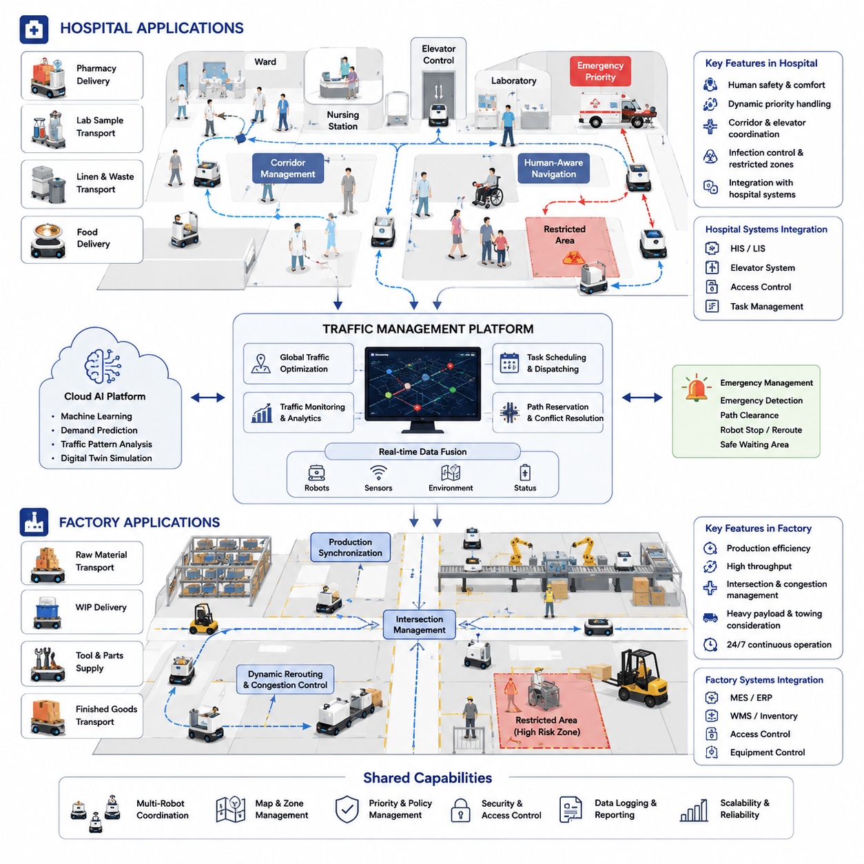
Hospital and factory environments represent two of the most demanding and influential application domains for Autonomous Mobile Robots (AMRs). While both sectors require reliable autonomous navigation, traffic management, and fleet coordination, their operational goals, environmental constraints, safety requirements, and workflow characteristics differ significantly. As AMR deployments continue to expand, traffic management systems have become a critical component that enables large-scale robot operations while maintaining efficiency, safety, predictability, and scalability. Within the broader Traffic Management chapter, Hospital and Factory Applications demonstrate how traffic control principles are translated into real-world operational environments where dozens or even hundreds of robots may operate simultaneously. This section is positioned under Traffic Management because successful deployment in hospitals and factories depends not only on individual robot intelligence but also on coordinated fleet-level navigation, intersection control, congestion mitigation, path reservation, and centralized traffic orchestration.
Hospitals present one of the most dynamic and human-centered environments for autonomous navigation. Unlike structured warehouses where robot traffic is often separated from human traffic, hospitals require robots to coexist continuously with patients, nurses, doctors, visitors, maintenance personnel, and emergency responders. Navigation systems must therefore prioritize safety, comfort, predictability, and human-aware behavior. Hospital corridors frequently experience varying levels of congestion throughout the day. During visiting hours, corridor occupancy may increase dramatically, while emergency situations may require immediate path clearance for medical personnel and equipment. Traffic management systems must recognize these changing operational conditions and dynamically adapt robot routing decisions accordingly.
A hospital AMR fleet typically performs a variety of logistics tasks. Robots transport medications from pharmacies to nursing stations, deliver laboratory samples between departments, move sterile instruments to operating rooms, transport linens and waste materials, replenish inventory in storage rooms, and support food delivery services. Each task carries different levels of urgency and priority. Medication delivery may have a higher operational priority than linen transportation, while emergency blood sample transport may require immediate access through congested corridors. Traffic management systems must therefore incorporate priority-aware scheduling mechanisms that allocate navigation resources according to operational importance.
One of the most important challenges in hospital applications is corridor management. Corridors often act as shared transportation routes connecting wards, laboratories, operating theaters, pharmacies, and service areas. Multiple robots may simultaneously request access to the same corridor segments. Without centralized coordination, traffic congestion and deadlocks can occur. Modern traffic management systems divide corridors into virtual traffic zones, allowing robots to reserve sections before entering. This reservation-based navigation approach reduces collision risks and improves overall traffic flow while ensuring that robots move predictably within human-populated environments.
Hospital elevators introduce another layer of complexity. Many healthcare facilities span multiple floors, requiring robots to coordinate with elevator systems to reach destinations efficiently. Elevator traffic management must consider both human passengers and robot users. A fleet management system may schedule elevator usage, assign robot queues, and coordinate boarding and exiting sequences. During peak periods, robots may temporarily reroute tasks or postpone noncritical deliveries to avoid excessive elevator congestion. Integration between robot fleet software and building management systems becomes essential for efficient multi-floor operations.
Emergency response scenarios create unique requirements for hospital traffic management. During emergency situations, certain corridors or departments may require unrestricted access for medical personnel. Traffic control systems must immediately recognize emergency conditions and alter robot behavior. Robots may be instructed to stop, move to predefined waiting areas, clear corridors, or reroute through secondary pathways. Such emergency traffic policies ensure that robotic operations never interfere with patient care or critical medical activities.
Human-aware navigation plays a particularly important role in hospitals. Traffic management systems must account for vulnerable populations including elderly patients, children, wheelchair users, and individuals with limited mobility. Robot navigation behaviors must emphasize smooth movement, low acceleration, predictable trajectories, and comfortable passing distances. Fleet-level traffic policies often enforce reduced speed limits in patient care zones while allowing higher speeds in service corridors or restricted logistics areas. Dynamic speed control contributes significantly to both safety and patient comfort.
Infection control requirements further influence traffic management design within healthcare facilities. Certain hospital zones may require restricted access due to contamination risks, isolation protocols, or sterile operating procedures. Traffic management software can enforce virtual zoning policies that prevent robots from crossing contamination boundaries without proper sanitization procedures. Route planning algorithms may consider infection-control constraints as additional navigation costs, ensuring compliance with healthcare regulations while maintaining efficient logistics operations.
The rise of digital healthcare infrastructure has accelerated integration between hospital information systems and robot traffic management platforms. Task scheduling can be linked directly to hospital workflows, enabling real-time coordination between medical requests and robot transportation services. For example, laboratory systems may automatically generate delivery tasks when test samples are collected. The traffic management system then determines optimal routing based on current fleet status, corridor congestion levels, elevator availability, and delivery priority. This integration improves operational efficiency while reducing manual coordination efforts.
Large hospitals often deploy dozens of robots simultaneously. In such environments, fleet-level traffic optimization becomes essential. Centralized traffic controllers continuously monitor robot locations, task queues, battery levels, and environmental conditions. Using predictive algorithms, the system can forecast congestion before it occurs and proactively adjust routes. Machine learning models may identify recurring traffic patterns associated with shift changes, visiting hours, meal delivery schedules, or laboratory processing cycles. These predictive capabilities enable traffic systems to optimize resource allocation proactively rather than reactively.
While hospitals emphasize human interaction and service-oriented logistics, factories focus primarily on production efficiency, material flow optimization, and operational throughput. Factory environments are often larger, more structured, and more automation-intensive than hospitals. Nevertheless, traffic management remains equally critical because production processes depend heavily on predictable and uninterrupted material transportation. Factory AMRs transport raw materials, components, work-in-progress inventory, finished products, tooling, packaging materials, and maintenance supplies throughout manufacturing facilities.
Modern smart factories increasingly rely on AMR fleets to replace traditional conveyor systems and fixed transportation infrastructure. This transition introduces greater flexibility but also creates more complex traffic coordination requirements. Unlike conveyor systems with predetermined paths, AMRs navigate dynamically through shared industrial environments. Traffic management systems therefore become responsible for maintaining production flow while preventing congestion and resource conflicts.
Factory traffic management typically revolves around production scheduling integration. Manufacturing execution systems generate transportation requests based on production demands, inventory levels, and assembly schedules. Traffic controllers must ensure that materials arrive at workstations precisely when needed. Delayed deliveries may interrupt production lines, while premature deliveries may create unnecessary inventory accumulation. Traffic management systems therefore optimize routes and task assignments with production objectives in mind.
Industrial intersections represent critical control points within factory environments. Multiple robots may travel between warehouses, assembly lines, inspection stations, and shipping areas. Without coordinated traffic control, intersections can become bottlenecks that reduce throughput. Reservation-based intersection management allows robots to request access before entering shared crossing zones. Advanced systems employ predictive scheduling algorithms that coordinate multiple robot movements simultaneously, maximizing intersection utilization while maintaining safe separation distances.
Factories often operate continuously for extended periods, including 24-hour production schedules. As robot fleet sizes increase, congestion management becomes increasingly important. Traffic monitoring systems continuously evaluate corridor utilization, queue lengths, travel times, and bottleneck formation. When congestion is detected, alternative routes may be generated automatically. Dynamic path planning ensures that transportation efficiency remains high even under varying production loads.
Heavy payload transportation introduces unique navigation challenges within factory applications. Towing AMRs, autonomous forklifts, and heavy-duty logistics robots possess different acceleration characteristics, turning radii, braking distances, and maneuverability limitations compared to smaller service robots. Traffic management systems must account for these differences when scheduling movements and allocating corridor access. Heavy robots may receive priority in certain situations due to limited maneuverability, while lighter robots may be rerouted to maintain overall traffic efficiency.
Safety remains a primary concern within industrial environments. Factories contain human workers, forklifts, machinery, and autonomous robots operating simultaneously. Traffic management systems establish virtual traffic rules similar to those used in urban transportation networks. Speed limits, one-way corridors, stop zones, yield zones, and restricted access areas may be defined digitally. These policies reduce operational risks while enabling predictable interactions between human-operated equipment and autonomous systems.
Production line synchronization is another important application of factory traffic management. In advanced manufacturing facilities, multiple AMRs may serve the same production cell. Traffic coordination systems ensure that transportation activities align with production schedules. Material deliveries, waste removal, and component replenishment can be synchronized with machine cycles, minimizing idle time and maximizing productivity. Such coordination transforms AMRs from simple transportation devices into active participants within manufacturing workflows.
Digital twin technology is increasingly used to enhance traffic management in both hospitals and factories. Digital twins provide real-time virtual representations of facilities, robots, infrastructure, and operational processes. Traffic controllers can simulate navigation decisions before deployment, evaluate congestion scenarios, and optimize routing strategies using predictive modeling. Digital twin environments also support operator training, system validation, and operational planning.
Cloud-based traffic management architectures further improve scalability and coordination capabilities. Centralized cloud platforms aggregate data from multiple robots, sensors, and operational systems. Global optimization algorithms analyze facility-wide traffic patterns and generate fleet-level coordination strategies. Edge computing components handle local decision-making while cloud systems provide long-term planning and optimization functions. This hybrid architecture supports large-scale deployments involving hundreds of robots across extensive hospital campuses or industrial facilities.
Artificial intelligence is increasingly enhancing traffic management capabilities in both domains. Machine learning models can predict traffic demand, identify congestion patterns, forecast task workloads, and optimize route assignments. Reinforcement learning approaches may continuously improve traffic control policies based on operational experience. AI-driven traffic management systems become progressively more efficient as they accumulate data from daily operations.
Future hospital and factory environments are expected to support highly interconnected autonomous ecosystems. Robots, elevators, doors, machinery, inventory systems, digital twins, and cloud platforms will operate as components of a unified intelligent infrastructure. Traffic management will evolve from simple path coordination into comprehensive operational orchestration. Systems will dynamically balance productivity, safety, energy consumption, maintenance requirements, and human experience simultaneously.
In hospitals, this evolution will support more responsive patient care, reduced staff workload, improved logistics efficiency, and enhanced healthcare service quality. In factories, advanced traffic management will contribute to flexible manufacturing, just-in-time production, higher throughput, and resilient industrial operations. As AMR deployments continue to expand, traffic management will remain one of the foundational technologies enabling safe, efficient, and scalable autonomous operations across both healthcare and industrial sectors. The lessons learned from hospital and factory deployments will continue to shape the future development of intelligent fleet management systems and autonomous navigation platforms worldwide.

19.8 Traffic Management Testing
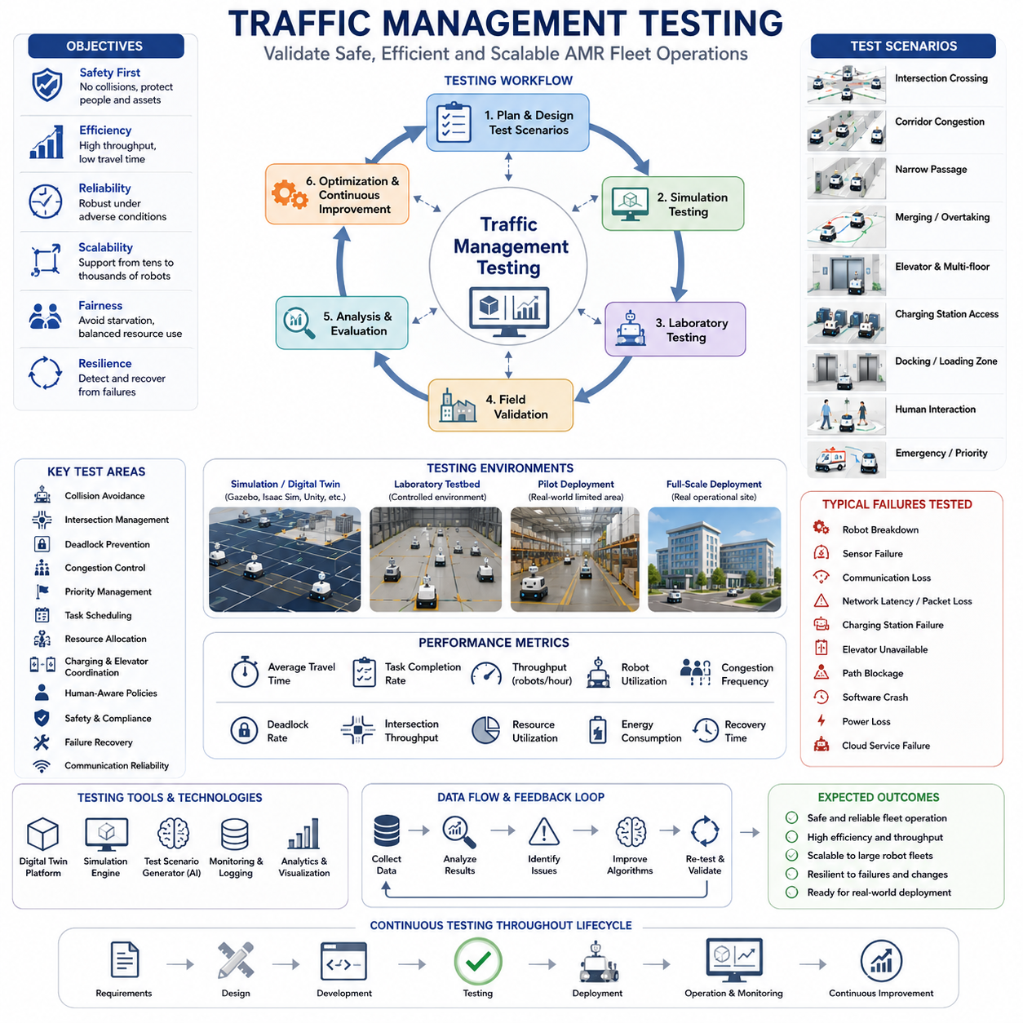
Traffic Management Testing is the final validation stage of an Autonomous Mobile Robot (AMR) traffic management system and serves as the foundation for ensuring safe, reliable, scalable, and efficient fleet operations in real-world environments. While path planning algorithms, obstacle avoidance systems, fleet management software, and cloud-based coordination architectures may perform successfully in isolated laboratory conditions, traffic management systems must ultimately prove their effectiveness under realistic operational workloads involving multiple robots, dynamic environments, human interactions, infrastructure constraints, and unexpected failures. The primary objective of traffic management testing is to verify that the entire transportation ecosystem functions as a coordinated system rather than as a collection of independent robots. The testing process evaluates how robots cooperate, share resources, resolve conflicts, avoid congestion, recover from failures, and maintain operational efficiency under varying conditions. Traffic management testing therefore represents one of the most critical validation activities in large-scale AMR deployments.
The complexity of traffic management testing increases significantly as the number of robots grows. A single robot navigation test may focus on localization accuracy, obstacle avoidance, and path-following performance. However, a fleet-level traffic management test must evaluate interactions among multiple robots competing for the same resources. Corridors, intersections, charging stations, elevators, loading zones, docking stations, and narrow passages become shared assets that require coordinated access. Testing must verify that the traffic management system allocates these resources efficiently while preventing deadlocks, collisions, bottlenecks, and starvation conditions.
The first stage of traffic management testing typically begins in simulation environments. Digital twins of factories, hospitals, warehouses, airports, logistics centers, and outdoor facilities are created using simulation platforms such as Gazebo, Isaac Sim, Webots, Unity, Unreal Engine, or custom simulation frameworks. These environments allow engineers to test hundreds of traffic scenarios without the cost and risk associated with physical deployment. Simulation-based testing enables rapid evaluation of fleet coordination algorithms, congestion control mechanisms, path reservation systems, and task scheduling strategies under controlled conditions.
Digital twin simulations provide several advantages during testing. Engineers can reproduce specific traffic conditions repeatedly, compare algorithm performance objectively, and investigate rare failure scenarios that may be difficult to encounter in real operations. Simulation also enables large-scale stress testing involving hundreds or even thousands of virtual robots operating simultaneously. Such testing helps identify scalability limitations before physical deployment begins.
One of the most fundamental testing objectives is collision avoidance validation. Traffic management systems must demonstrate that robots never collide with each other, regardless of traffic density or environmental complexity. Testing scenarios include head-on encounters, crossing intersections, merging corridors, overtaking situations, narrow passage navigation, and simultaneous resource access requests. Validation procedures verify that safety margins remain within predefined limits while maintaining efficient traffic flow.
Intersection management testing represents a particularly important category of validation. Intersections often serve as critical bottlenecks where multiple robots converge from different directions. Traffic controllers must coordinate access rights, determine movement priorities, and prevent conflicts. Testing evaluates how effectively the system handles increasing traffic volumes while maintaining throughput and avoiding excessive waiting times. Reservation-based intersection management algorithms, token-based coordination methods, and predictive scheduling approaches are commonly evaluated through extensive testing.
Corridor congestion testing examines the ability of the traffic management system to maintain smooth robot flow under heavy operational loads. Large hospitals and manufacturing facilities often contain high-traffic corridors that serve as primary transportation routes. During peak operational periods, congestion can significantly reduce system performance. Testing procedures intentionally create high-density traffic conditions and measure travel times, queue lengths, throughput rates, and congestion recovery behavior. Successful systems demonstrate stable operation even under substantial traffic loads.
Deadlock prevention testing is another critical component of validation. Deadlocks occur when multiple robots block each other while attempting to access shared resources. Such situations may completely halt fleet operations if not resolved properly. Testing scenarios intentionally create conditions that could produce deadlocks, including narrow corridors, bidirectional traffic flows, and simultaneous resource requests. Traffic management systems must demonstrate the ability to prevent deadlocks proactively or resolve them automatically when they occur.
Starvation testing evaluates fairness within the traffic control system. In poorly designed traffic management architectures, low-priority robots may experience excessive delays while higher-priority robots repeatedly receive access to critical resources. Long-term operational testing measures task completion rates, waiting times, and resource allocation fairness to ensure balanced fleet behavior across all robots and operational priorities.
Priority management validation is particularly important in hospitals, airports, and industrial facilities where tasks possess varying levels of urgency. Testing verifies that emergency deliveries, medical transport missions, production-critical material movements, and high-priority service requests receive preferential treatment when necessary. At the same time, the system must avoid excessive disruption to normal operations. Test scenarios evaluate dynamic priority adjustments, emergency overrides, and priority conflict resolution mechanisms.
Traffic management testing must also examine task scheduling performance. Modern fleet management systems continuously assign transportation tasks to available robots. Testing evaluates whether task allocation algorithms optimize travel distance, battery utilization, workload balancing, and overall operational efficiency. Performance metrics include task completion time, robot utilization rate, fleet productivity, and scheduling responsiveness under varying workload conditions.
Charging station coordination testing becomes increasingly important as fleet sizes grow. Multiple robots may require charging simultaneously while charging infrastructure remains limited. Traffic management systems must coordinate charging schedules to prevent bottlenecks and ensure continuous fleet availability. Testing evaluates charging queue management, battery-aware routing strategies, charging priority assignment, and recovery from charging station failures.
Elevator integration testing is essential for multi-floor deployments in hospitals, hotels, office buildings, and industrial facilities. Robots must coordinate elevator usage without disrupting human traffic. Testing evaluates elevator reservation systems, boarding procedures, waiting behavior, priority handling, and recovery mechanisms when elevators become unavailable. Multi-floor traffic simulations help validate overall system efficiency in vertically integrated environments.
Traffic management testing also includes docking and loading zone validation. Loading stations, unloading areas, material transfer points, and docking facilities often serve as shared operational resources. Testing verifies that robots can access these locations efficiently without creating congestion or resource conflicts. Queue management strategies, reservation mechanisms, and dynamic scheduling algorithms are evaluated extensively.
Human-robot interaction testing represents a major component of traffic management validation. Unlike fully automated environments, hospitals, factories, airports, and public facilities require robots to coexist safely with people. Traffic management systems must account for pedestrian movement, unpredictable behavior, crowd dynamics, and human safety requirements. Testing scenarios include crowded corridors, pedestrian crossings, emergency evacuations, group movements, and restricted access zones. Human-aware traffic policies are validated under realistic operating conditions.
Safety testing remains the highest priority throughout the validation process. Traffic management systems must demonstrate compliance with relevant industrial safety standards and regulations. Safety testing includes emergency stop functionality, collision avoidance performance, restricted zone enforcement, speed control verification, fail-safe operation, and recovery procedures. Validation ensures that traffic management decisions never compromise operational safety.
Environmental variability testing evaluates system performance under changing conditions. In factories, equipment movement, temporary obstacles, and layout modifications may affect traffic patterns. In hospitals, visitor traffic, emergency situations, and operational schedule changes can significantly alter environmental dynamics. Testing procedures introduce environmental variability and evaluate the adaptability of traffic management algorithms.
Communication reliability testing examines the resilience of fleet coordination systems under network disruptions. Modern traffic management architectures often rely on wireless communication, cloud services, edge computing platforms, and distributed control systems. Testing scenarios include network latency, packet loss, bandwidth limitations, communication interruptions, and cloud service failures. Traffic management systems must maintain safe operation even when communication quality degrades.
Cloud-based traffic management systems require additional validation. Testing evaluates synchronization between cloud controllers and edge devices, consistency of fleet-wide decision-making, scalability of centralized algorithms, and fault tolerance mechanisms. Large-scale simulations may involve hundreds of robots operating across multiple facilities while coordinated through cloud infrastructure. These tests verify the viability of cloud-native fleet management architectures.
Scalability testing is among the most important aspects of traffic management validation. A system that performs well with ten robots may experience significant challenges when expanded to one hundred or one thousand robots. Scalability testing gradually increases fleet size while monitoring computational load, communication bandwidth, response time, traffic efficiency, and resource utilization. Engineers identify performance bottlenecks and optimize system architecture to support future expansion.
Performance benchmarking provides quantitative measurements of traffic management effectiveness. Common metrics include average travel time, task completion rate, robot utilization, congestion frequency, deadlock occurrence rate, intersection throughput, charging station utilization, scheduling efficiency, and energy consumption. Benchmarking enables objective comparison between different traffic management strategies and provides evidence of operational readiness.
Stress testing intentionally pushes the traffic management system beyond normal operating conditions. Extreme traffic density, large task volumes, network disruptions, hardware failures, and environmental disturbances are introduced simultaneously. The objective is not merely to confirm successful operation but to understand failure modes and recovery behavior. Stress testing provides valuable insights into system robustness and operational limits.
Failure recovery testing evaluates the system's ability to respond to unexpected events. Robots may become immobilized, sensors may fail, communication links may disconnect, charging stations may become unavailable, or environmental obstacles may block critical pathways. Traffic management systems must detect failures, isolate affected components, reroute traffic, reassign tasks, and restore normal operations with minimal disruption. Recovery time and operational impact are key performance indicators.
Long-duration endurance testing verifies stability over extended periods. Traffic management systems deployed in factories, hospitals, and logistics centers often operate continuously for weeks, months, or years. Endurance tests may run continuously for hundreds or thousands of hours while monitoring performance degradation, memory usage, computational stability, communication reliability, and operational consistency. These tests help identify issues that may not appear during short-term evaluations.
Field validation represents the final stage of traffic management testing. After successful simulation and laboratory testing, systems are deployed in real operational environments. Engineers collect operational data, observe fleet behavior, measure performance metrics, and evaluate user satisfaction. Field testing provides critical insights into real-world challenges that may not be fully represented in simulation environments.
Digital twins continue to play an important role even after deployment. Operational data collected from the field can be fed back into simulation environments to improve testing accuracy and support continuous optimization. This creates a closed-loop development process in which testing, deployment, monitoring, and improvement occur continuously throughout the system lifecycle.
Artificial intelligence is increasingly enhancing traffic management testing methodologies. Machine learning algorithms can automatically generate challenging traffic scenarios, identify performance anomalies, predict congestion risks, and optimize test coverage. AI-driven validation frameworks significantly improve testing efficiency while increasing confidence in system performance.
Future traffic management testing will likely incorporate large-scale virtual environments, autonomous test generation, cloud-based validation platforms, and real-time digital twin synchronization. As AMR deployments continue to expand into hospitals, factories, airports, smart cities, logistics networks, and outdoor autonomous systems, traffic management testing will become even more important. Comprehensive validation ensures that fleets remain safe, efficient, scalable, and reliable under all operational conditions. Ultimately, traffic management testing serves as the final proof that an AMR ecosystem can successfully transition from a laboratory prototype into a mission-critical operational platform capable of supporting real-world industrial and service applications at scale.

